Supplementary Materials for

A complete pedigree-based graph workflow for rare candidate variant analysis

Charles Markello, Charles Huang, Alex Rodriguez, Andrew Carroll, Pi-Chuan Chang, Jordan Eizenga, Thomas Markello, David Haussler, Benedict Paten

Correspondence to: cmarkell@ucsc.edu, bpaten@ucsc.edu

Contents:
List of Figures 3
List of Tables 5

List of Figures

S1 | Low complexity region mapeval HG002. Mapping performance of 100 million read  pairs simulated from HG002 high confident datasets. Four different alignments are com-
 | pared across two different regions and ROC curves are plotted with a log-scaled false
 | positive rate on the x-axis and a linear-scaled true positive rate on the y-axis with mapping
 | quality as the discriminating factor. Green curves represent graph alignments against the
 | parental graph reference constructed from HG003 and HG004 illumina read graph align-
 | ments. Red curves represent alignments against the snp1kg graph reference. Purple curves
 | represent alignments to the primary GRCh38 linear graph reference. Blue curves represent
 | linear alignments against the hs38d1 reference using BWA-MEM-hs38d1. (A) Alignments
S2 | in GIAB v4.2.1 confident regions. (B) Alignments in non-1000GP confident regions. . . .  Low mappability region mapeval HG002. Mapping performance of 100 million read pairs simulated from HG002 high confident datasets. Four different alignments are com- | 10
 | pared across two different regions and ROC curves are plotted with a log-scaled false
 | positive rate on the x-axis and a linear-scaled true positive rate on the y-axis with mapping
 | quality as the discriminating factor. Green curves represent graph alignments against the
 | parental graph reference constructed from HG003 and HG004 illumina read graph align-
 | ments. Red curves represent alignments against the snp1kg graph reference. Purple curves
 | represent alignments to the primary GRCh38 linear graph reference. Blue curves represent
 | linear alignments against the hs38d1 reference using BWA-MEM-hs38d1. (A) Alignments
S3 | in GIAB v4.2.1 confident regions. (B) Alignments in non-1000GP confident regions. . . .  MHC region mapeval HG002. Mapping performance of 100 million read pairs simu- lated from HG002 high confident datasets. Four different alignments are compared across | 11
 | two different regions and ROC curves are plotted with a log-scaled false positive rate
 | on the x-axis and a linear-scaled true positive rate on the y-axis with mapping quality
 | as the discriminating factor. Green curves represent graph alignments against the parental
 | graph reference constructed from HG003 and HG004 illumina read graph alignments. Red
 | curves represent alignments against the snp1kg graph reference. Purple curves represent
 | alignments to the primary GRCh38 linear graph reference. Blue curves represent linear
 | alignments against the hs38d1 reference using BWA-MEM-hs38d1. (A) Alignments in
S4 | GIAB v4.2.1 confident regions. (B) Alignments in non-1000GP confident regions. . . . . .  CMRG region mapeval HG002.Mapping performance of 100 million read pairs simu- lated from HG002 high confident datasets. Four different alignments are compared across | 12
 | two different regions and ROC curves are plotted with a log-scaled false positive rate
 | on the x-axis and a linear-scaled true positive rate on the y-axis with mapping quality
 | as the discriminating factor. Green curves represent graph alignments against the parental
 | graph reference constructed from HG003 and HG004 illumina read graph alignments. Red
 | curves represent alignments against the snp1kg graph reference. Purple curves represent
 | alignments to the primary GRCh38 linear graph reference. Blue curves represent linear
 | alignments against the hs38d1 reference using BWA-MEM-hs38d1. (A) Alignments in
 | GIAB v4.2.1 confident regions. (B) Alignments in non-1000GP confident regions. . . . . . | 13
S5 | Single sample mapping and variant calling workflow. . . . . . . . . . . . . . . . . . . | 14
S6 | Parental phasing workflow. . . . . . . . . . . . . . . . . . . . . . . . . . . . . . . . . . | 15
S7 | Graph construction workflow. . . . . . . . . . . . . . . . . . . . . . . . . . . . . . . . | 16
S8 | Pedigree analysis workflow. . . . . . . . . . . . . . . . . . . . . . . . . . . . . . . . . . | 17
S9 | Variant annotation workflow. . . . . . . . . . . . . . . . . . . . . . . . . . . . . . . . . | 18

S10 HG002 DeepTrio default and trained ROC curves. ROC curves of DeepTrio variant calling performance of the graph-based and linear-based pipelines with respect to HG002 GIAB v4.2.1 truth variant call sets stratified by (A) HG002 high confident whole genome regions using default deeptrio models, (B) HG002 high confident whole genome regions excluding 1000GP variants using default deeptrio models, (C) HG002 high confident chr20 regions on default and trained deeptrio models, (D) HG002 high confident chr20 regions excluding 1000GP on default and trained deeptrio models. 19
S11 HG005 DeepTrio default and trained ROC curves. ROC curves of DeepTrio variant calling performance of the graph-based and linear-based pipelines with respect to HG005 GIAB v4.2 truth variant call sets stratified by (A) high confident HG005 regions using de- fault deeptrio models, (B) HG005 regions excluding 1000GP variants using default deep- trio models, (C) HG005 chr20 regions on default and trained deeptrio models, and (D)
HG005 chr20 regions exclusing 1000GP on default and trained deeptrio models. 20

List of Tables

S1 | HG002 simulated read mapping stats. Mapping statistics on HG002 simulated read  alignments against various GRCh38-based graph references and BWA-MEM-hs38d1 align-
S2 | ments against the linear GRCh38 reference. . . . . . . . . . . . . . . . . . . . . . . . . .  Non-1000GP HG002 simulated read mapping stats. Mapping statistics on HG002 simulated read alignments against various GRCh38-based graph references and BWA- | 21
 | MEM-hs38d1 alignments against the linear GRCh38 reference within non-1000GP variant
S3 S4 | dataset regions. . . . . . . . . . . . . . . . . . . . . . . . . . . . . . . . . . . . . . . . .  HG002 simulated read mapping GAM stats. GAM statistics on HG002 simulated read alignments against various GRCh38-based graph references. . . . . . . . . . . . . . . . .  Non-1000GP HG002 simulated read mapping GAM stats. GAM statistics on HG002  simulated read alignments against various GRCh38-based graph references in regions that | 22  23
S5 | don’t overlap the 1000GP variant set. . . . . . . . . . . . . . . . . . . . . . . . . . . . . .  HAP.PY HG002 DeepTrio trained high confident regions. Hap.py performance of DeepTrio using the (A) default DeepTrio model and (B) trained DeepTrio model against | 24
 | the 1000 Genomes Project grch38-based graph reference using 150bp paired-end reads
 | with respect to HG002 GIAB v4.2.1 truth variant call sets in high confidence regions on
S6 | chromosome 20. Best values for each sample are highlighted in bold text. . . . . . . . . .  HAP.PY HG005 DeepTrio trained high confident regions. Hap.py performance of DeepTrio using the (A) default DeepTrio model and (B) trained DeepTrio model against | 25
 | the 1000 Genomes Project grch38-based graph reference using 150bp paired-end reads
 | with respect to HG005 GIAB v4.2.1 truth variant call sets in high confidence regions on
S7 | chromosome 20. Best values in each column are highlighted in bold text. . . . . . . . . .  VCFeval HG002 and HG005 DeepTrio and DeepVariant performance. VCFeval per- formance of the graph-based and linear-based pipelines with respect to HG002 and HG005 | 26
 | GIAB v4.2.1 truth variant call sets stratified by (A) DeepTrio on all HG002 regions, (B)
 | DeepTrio on HG002 regions excluding 1000GP variants, (C) DeepVariant on all HG002
 | regions (D) DeepTrio on all HG005 regions, (E) DeepTrio on HG005 regions excluding
 | 1000GP variants, and (F) DeepVariant on all HG005 regions. All mapped reads were
 | called using DeepTrio and DeepVariant v1.1.0 genotyper using default models. Best val-
S8 | ues in each column are highlighted in bold text. . . . . . . . . . . . . . . . . . . . . . . .  VCFeval HG002 DeepTrio performance difficult regions. VCFeval performance of the graph-based and linear-based pipelines with respect to HG002 GIAB v4.2.1 truth variant | 27
 | call sets stratified by (A) low complexity and highly repetative regions, (B) low mappabil-
 | ity regions, (C) MHC regions, and (D) Difficult Medically Relevant Genes. All mapped
 | reads were called using DeepTrio v1.1.0 genotyper. Best values in each column are high-
S9 | lighted in bold text. . . . . . . . . . . . . . . . . . . . . . . . . . . . . . . . . . . . . . .  VCFeval HG005 DeepTrio performance difficult regions. VCFeval performance of the graph-based and linear-based pipelines with respect to HG005 GIAB v4.2.1 truth variant | 28
 | call sets stratified by (A) low complexity and highly repetative regions, (B) low mappabil-
 | ity regions, and (C) MHC regions. All mapped reads were called using DeepTrio v1.1.0
 | genotyper. Best values in each column are highlighted in bold text. . . . . . . . . . . . . . | 29

S10 VCFeval HG001 DeepTrio sample-specific difficult regions. VCFeval performance of the graph-based and linear-based pipelines with respect to HG001 GIAB v4.2.1 truth vari- ant call sets stratified by (A) union of all SV, CNV, complex and compound heterozygous variant bed files used for v4.2.1 of the GIAB benchmark for each sample, (B) regions con- taining at least two variants on one haplotype within 10bp of each other, and all variants are snps, with 50bp slop added on each side, (C) regions containing at least two variants on one haplotype within 10bp of each other, and at least one of the variants is an indel, with 50bp slop added on each side, (D) regions containing at least one variant on each haplotype within 10bp of each other, and all variants are snps, with 50bp slop added on each side and (E) regions containing at least one variant on each haplotype within 10bp of each other, and at least one of the variants is an indel, with 50bp slop added on each side. All mapped reads were called using DeepTrio v1.1.0 genotyper where Giraffe- Parent and Giraffe-1000GP used the trained model while BWA-MEM-hs38d1 and Dragen-hs38d1 used the default model that was tuned to BWA-MEM alignments. Best
values in each column are highlighted in bold text. 30
S11 VCFeval HG002 DeepTrio sample-specific difficult regions. VCFeval performance of the graph-based and linear-based pipelines with respect to HG002 GIAB v4.2.1 truth vari- ant call sets stratified by (A) union of all SV, CNV, complex and compound heterozygous variant bed files used for v4.2.1 of the GIAB benchmark for each sample, (B) regions con- taining at least two variants on one haplotype within 10bp of each other, and all variants are snps, with 50bp slop added on each side, (C) regions containing at least two variants on one haplotype within 10bp of each other, and at least one of the variants is an indel, with 50bp slop added on each side, (D) regions containing at least one variant on each haplotype within 10bp of each other, and all variants are snps, with 50bp slop added on each side and (E) regions containing at least one variant on each haplotype within 10bp of each other, and at least one of the variants is an indel, with 50bp slop added on each side.
All mapped reads were called using the DeepTrio v1.1.0 genotyper default model that was
tuned to BWA-MEM alignments. Best values in each column are highlighted in bold text. 31
S12 VCFeval HG005 DeepTrio sample-specific difficult regions. VCFeval performance of the graph-based and linear-based pipelines with respect to HG005 GIAB v4.2.1 truth vari- ant call sets stratified by (A) union of all SV, CNV, complex and compound heterozygous variant bed files used for v4.2.1 of the GIAB benchmark for each sample, (B) regions con- taining at least two variants on one haplotype within 10bp of each other, and all variants are snps, with 50bp slop added on each side, (C) regions containing at least two variants on one haplotype within 10bp of each other, and at least one of the variants is an indel, with 50bp slop added on each side, (D) regions containing at least one variant on each haplotype within 10bp of each other, and all variants are snps, with 50bp slop added on each side and (E) regions containing at least one variant on each haplotype within 10bp of each other, and at least one of the variants is an indel, with 50bp slop added on each side. All mapped reads were called using DeepTrio v1.1.0 genotyper default model that
was tuned to BWA-MEM alignments. Best values in each column are highlighted in bold text. 32 S13 VCFeval HG002 Dragen all regions. VCFeval performance of the graph-based and
linear-based pipelines with respect to HG002 GIAB v4.2.1 truth variant call sets strati- fied by (A) all regions, (B) regions excluding 1000GP variants, (C) low complexity and highly repetative regions, (D) low mappability regions, (E) MHC regions, and (F) Difficult Medically Relevant Genes. All mapped reads were called using Illuminas Dragen v3.7.5
genotyper. Best values in each column are highlighted in bold text. 33

S14 | VCFeval HG005 Dragen all regions. VCFeval performance of the graph-based and  linear-based pipelines with respect to HG005 GIAB Draft v4.2.1 truth variant call sets
 | stratified by (A) all regions, (B) regions excluding 1000GP variants, (C) low complexity
 | and highly repetative regions, (D) low mappability regions, and (E) MHC regions. All
 | mapped reads were called using Illuminas Dragen v3.7.5 genotyper. Best values in each
S15 | column are highlighted in bold text. . . . . . . . . . . . . . . . . . . . . . . . . . . . . .  HAP.PY HG002 Dragen all high confident regions. Hap.py performance of linear and graph-based pipelines against grch38-based references using 150bp paired-end reads with | 34
 | respect to HG002 GIAB v4.2.1 truth variant call sets in high confidence regions. All
 | mapped reads were called using Illuminas Dragen v3.7.5 genotyper. Best values in each
S16 | column are highlighted in bold text. . . . . . . . . . . . . . . . . . . . . . . . . . . . . .  HAP.PY HG002 Dragen all high confident regions, 1000GP excluded. Hap.py perfor- mance of linear and graph-based pipelines against grch38-based references using 150bp | 35
 | paired-end reads with respect to HG002 GIAB v4.2.1 truth variant call sets in high con-
 | fidence regions. All mapped reads were called using Illuminas Dragen v3.7.5 genotyper.
S17 | Best values in each column are highlighted in bold text. . . . . . . . . . . . . . . . . . . .  HAP.PY HG002 Dragen high confident low complexity regions. Hap.py performance of linear and graph-based pipelines against grch38-based references using 150bp paired- | 36
 | end reads with respect to HG002 GIAB v4.2.1 truth variant call sets in high confidence
 | regions. All mapped reads were called using Illuminas Dragen v3.7.5 genotyper. Best
S18 | values in each column are highlighted in bold text. . . . . . . . . . . . . . . . . . . . . .  HAP.PY HG002 Dragen high confident low mappability regions. Hap.py performance of linear and graph-based pipelines against grch38-based references using 150bp paired- | 37
 | end reads with respect to HG002 GIAB v4.2.1 truth variant call sets in high confidence
 | regions. All mapped reads were called using Illuminas Dragen v3.7.5 genotyper. Best
S19 | values in each column are highlighted in bold text. . . . . . . . . . . . . . . . . . . . . .  HAP.PY HG002 Dragen high confident MHC regions. Hap.py performance of linear and graph-based pipelines against grch38-based references using 150bp paired-end reads | 38
 | with respect to HG002 GIAB v4.2.1 truth variant call sets in high confidence regions. All
 | mapped reads were called using Illuminas Dragen v3.7.5 genotyper. Best values in each
S20 | column are highlighted in bold text. . . . . . . . . . . . . . . . . . . . . . . . . . . . . .  HAP.PY HG002 Dragen high confident hard-to-sequence medically relevant genes.  Hap.py performance of linear and graph-based pipelines against grch38-based references | 39
 | using 150bp paired-end reads with respect to HG002 GIAB v4.2.1 truth variant call sets
 | in high confidence regions. All mapped reads were called using Illuminas Dragen v3.7.5
S21 | genotyper. Best values in each column are highlighted in bold text. . . . . . . . . . . . . .  HAP.PY HG005 Dragen all high confident regions. Hap.py performance of linear and graph-based pipelines against grch38-based references using 150bp paired-end reads with | 40
 | respect to HG005 GIAB v4.2.1 truth variant call sets in high confidence regions. All
 | mapped reads were called using Illuminas Dragen v3.7.5 genotyper. Best values in each
S22 | column are highlighted in bold text. . . . . . . . . . . . . . . . . . . . . . . . . . . . . .  HAP.PY HG005 Dragen all high confident regions, 1000GP excluded. Hap.py perfor- mance of linear and graph-based pipelines against grch38-based references using 150bp | 41
 | paired-end reads with respect to HG005 GIAB v4.2.1 truth variant call sets in high con-
 | fidence regions. All mapped reads were called using Illuminas Dragen v3.7.5 genotyper.
 | Best values in each column are highlighted in bold text. . . . . . . . . . . . . . . . . . . . | 42

S23 | HAP.PY HG005 Dragen high confident low complexity regions. Hap.py performance  of linear and graph-based pipelines against grch38-based references using 150bp paired-
 | end reads with respect to HG005 GIAB v4.2.1 truth variant call sets in high confidence
 | regions. All mapped reads were called using Illuminas Dragen v3.7.5 genotyper. Best
S24 | values in each column are highlighted in bold text. . . . . . . . . . . . . . . . . . . . . .  HAP.PY HG005 Dragen high confident low mappability regions. Hap.py performance of linear and graph-based pipelines against grch38-based references using 150bp paired- | 43
 | end reads with respect to HG005 GIAB v4.2.1 truth variant call sets in high confidence
 | regions. All mapped reads were called using Illuminas Dragen v3.7.5 genotyper. Best
S25 | values in each column are highlighted in bold text. . . . . . . . . . . . . . . . . . . . . .  HAP.PY HG005 Dragen high confident MHC regions. Hap.py performance of linear and graph-based pipelines against grch38-based references using 150bp paired-end reads | 44
 | with respect to HG005 GIAB v4.2.1 truth variant call sets in high confidence regions. All
 | mapped reads were called using Illuminas Dragen v3.7.5 genotyper. Best values in each
S26 | column are highlighted in bold text. . . . . . . . . . . . . . . . . . . . . . . . . . . . . .  VCFeval Dragen-GRAPH vs Giraffe-DeepTrio confident regions. VCFeval perfor- mance of the graph-based Illumina Dragen v3.7.5 results Dragen-Graph-hs38d1 ver- | 45
 | sus the Giraffe-Parent and Giraffe-1000GP trained DeepTrio results on HG001,
 | HG002, and HG005 GIAB v4.2.1 truth variant call sets. All Giraffe-Parent and
 | Giraffe-1000GP mapped reads were called using a trained DeepTrio v1.1.0 genotyper.
S27 | Best values in each column are highlighted in bold text. . . . . . . . . . . . . . . . . . . .  Proband vs sibling analysis 15 cohort filter variant counts. Total counts of starting variants down to the filtered candidate list for each of the 15 cohort samples comprising | 46
 | 15 probands and 22 siblings. Bolded cohort IDs are cohort probands where their diag-
 | nosis has an associated CLIA-validated variant by the UDP. MF are the total number of
 | variants after passing through mendelian filters. CC, the number of candidate variants and
 | compound heterozygous pairs produced by the candidate analysis workflow. MC, the total
 | number of candidate variants and compound heterozygous pairs after merging candidates
 | together that share the same gene locus and the X-linked variant counts removed for sex-
 | independent sample comparison. DN, the number of de-novo candidate variants. HR, the
 | number of homozygous recesive variants. HM are the number of hemizygous variants.
 | XL, the number of X-linked variants. CNC, the number of variants that lie within a de-
 | pleted or haploinsufficient region. CM, the number of compound heterozygous pairs of
S28 | variants. . . . . . . . . . . . . . . . . . . . . . . . . . . . . . . . . . . . . . . . . . . . .  Candidate analysis filter variant counts on 4 additional cohort probands. Total counts of starting variants down to the filtered candidate list for 4 probands. Bolded cohort IDs are | 47
 | cohort probands where their disease was diagnosed by the UDP. MF are the total number
 | of variants after passing through mendelian filters. CC, the number of candidate variants
 | and compound heterozygous pairs produced by the candidate analysis workflow. DN, the
 | number of de-novo candidate variants. HR, the number of homozygous recesive variants.
 | HM are the number of hemizygous variants. XL, the number of X-linked variants. CNC,
 | the number of variants that lie within a depleted or haploinsufficient region. CM, the
 | number of compound heterozygous pairs of variants. . . . . . . . . . . . . . . . . . . . . | 48

S29 Candidate analysis candidate statistic counts on 4 additional cohort probands. To- tal count of variants with various annotation stats. non-CM, the set of candidate vari- ants that are not compound heterozygous variants. CM Pairs, the set of candidate variants that are compound heterozygous variants. E, counts of exonic variants based on the SnpEff annotation list (includes NON_SYNONYMOUS_CODING, FRAME_SHIFT, CODON_CHANGE_PLUS_CODON_DELETION, STOP_GAINED, START_GAINED). NE,
counts of non-exonic variants based on the SnpEff annotation list (includes anything not in the Exonic list). CV(P), ClinVar variant interpretation of either Pathogenic or Likely Pathogenic. CV(B), ClinVar variant interpretation of either Benign or Likely Benign. CV(UNK), ClinVar variant interpretation of either not present in the database or catego-
rized as not_provided, Conflicting_interpretations_of_pathogenicity, Uncertain_significance. PP(D), PolyPhen variant interpretation of either prob- ably damaging or possibly damaging. PP(B), PolyPhen variant interpretation as benign.
PP(UNK), PolyPhen variant interpretation non existant in current database. HGMD, Hu- man Gene Mutation Database annotation of Disease Mutation DM or possible Disease Mu- tation textttDM?. CADD_{E}20, number of exonic variants with a Combined Annotation Dependent Depletion Phred score of greater than or equal to 20. CADD_{NE}15, number of non-exonic variants with a Combined Annotation Dependent Depletion Phred score of greater than or equal to 15. VMM30, number of compound heterozygous pairs with a
Virtual Mendelian Model Combined score of greater than or equal to 30. 49
S30 Workflow costs. Workflow costs for various runs of the VG Pedigree workflow and the Candidate Analysis workflow on the Terra Platform. 50
S31 WhatsHap compare statistics on Chromosome 20. WhatsHap Compare statistics on Chromosome 20 joint-called and phased HG002 trio data using various phasing methods.
(A) Comparison stats of the Giraffe aligned and DeepVariant joint-genotyped VCF on GRCh37-based reference against the GIAB v3.3.2 benchmark trio-phased VCF. (B) Com- parison stats of the Giraffe aligned and DeepVariant joint-genotyped VCF on GRCh38- based liftovered reference against the GIAB v4.2.1 benchmark trio-phased VCF. Abbrevi-
ations: SE(Switch-error), SE/F(Switch/Flip-error), HD(Hamming Distance). 51
S32 WhatsHap phasing statistics on Chromosome 20. WhatsHap phasing stats on Chromo- some 20 joint-called and phased HG002 trio data using various phasing methods. (a-c) Stats for HG002, HG003, and HG004 respectively, aligned with Giraffe and DeepVari- ant trio-based joint-genotyped VCF on GRCh37-based reference. (d-f) Stats for HG002, HG003, and HG004 respectively aligned with Giraffe and DeepVariant trio-based joint-
genotyped VCF on GRCh38-based liftovered reference. 52

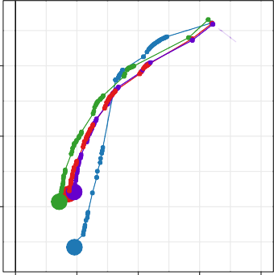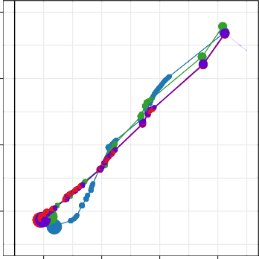0.9
0
0
0
0
60
60
60
60
0

0 0
0
60 60
60
60

0.996

0.992
TPR

0.988

1e−06 1e−05 1e−04 1e−03 1e−02
FPR

- High Confidence Regions

Giraffe-Parental Giraffe-1000GP Giraffe-Primary BWA-MEM-hs38d1

2e+07

4e+07

6e+07

0.8

0.7
TPR

0.6

1e−04 1e−03 1e−02 1e−01
FPR

- Non-1000GP Regions

Giraffe-Parental Giraffe-1000GP Giraffe-Primary BWA-MEM-hs38d1

50000
100000
150000
200000

Figure S1. Low complexity region mapeval HG002. Mapping performance of 100 million read pairs simulated from HG002 high confident datasets. Four different alignments are compared across two different regions and ROC curves are plotted with a log-scaled false positive rate on the x-axis and a linear-scaled true positive rate on the y-axis with mapping quality as the discriminating factor. Green curves represent graph alignments against the parental graph reference constructed from HG003 and HG004 illumina read graph alignments. Red curves represent alignments against the snp1kg graph reference. Purple curves represent alignments to the primary GRCh38 linear graph reference. Blue curves represent linear alignments against the hs38d1 reference using BWA-MEM-hs38d1.
- Alignments in GIAB v4.2.1 confident regions. (B) Alignments in non-1000GP confident regions.

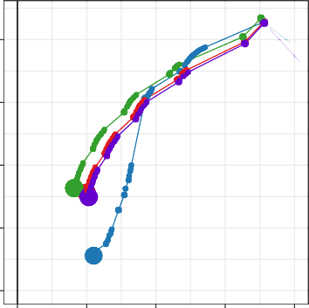0.95
0
0
0
0
60
60

60
60

0.90
TPR
0.85

0.80

0.75
1e−05 1e−04 1e−03 1e−02 1e−01
FPR
  - High Confidence Regions

4.0e+06
8.0e+06
1.2e+07
1.6e+07

0.6

0.4
TPR

0.2

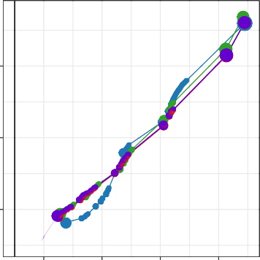1e−04 1e−03 1e−02 1e−01
0
0
0
0
60
60
60
60
FPR

  - Non-1000GP Regions

Giraffe-Parental Giraffe-1000GP Giraffe-Primary BWA-MEM-hs38d1
2e+05

4e+05
6e+05

Figure S2. Low mappability region mapeval HG002. Mapping performance of 100 million read pairs simulated from HG002 high confident datasets. Four different alignments are compared across two different regions and ROC curves are plotted with a log-scaled false positive rate on the x-axis and a linear-scaled true positive rate on the y-axis with mapping quality as the discriminating factor. Green curves represent graph alignments against the parental graph reference constructed from HG003 and HG004 illumina read graph alignments. Red curves represent alignments against the snp1kg graph reference. Purple curves represent alignments to the primary GRCh38 linear graph reference. Blue curves represent linear alignments against the hs38d1 reference using BWA-MEM-hs38d1.
- Alignments in GIAB v4.2.1 confident regions. (B) Alignments in non-1000GP confident regions.

0.99

0.98
TPR

0.97

0.96

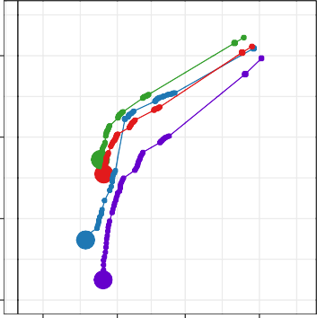3e−04 1e−03 3e−03 1e−02
0
0
0
0
60
60
60
60
FPR
  - High Confidence Regions

1e+05
2e+05
3e+05
0.7

0.6

0.5
TPR

0.4

0.3
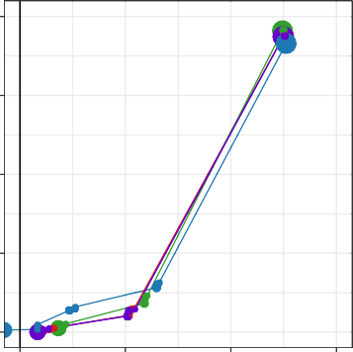
0 0
0
0
60 60 60
60
0.001 0.010 0.100 1.000
FPR

  - Non-1000GP Regions

Giraffe-Parental Giraffe-1000GP Giraffe-Primary BWA-MEM-hs38d1
1000
2000
3000

Figure S3. MHC region mapeval HG002. Mapping performance of 100 million read pairs simulated from HG002 high confident datasets. Four different alignments are compared across two different regions and ROC curves are plotted with a log-scaled false positive rate on the x-axis and a linear-scaled true positive rate on the y-axis with mapping quality as the discriminating factor. Green curves represent graph alignments against the parental graph reference constructed from HG003 and HG004 illumina read graph alignments. Red curves represent alignments against the snp1kg graph reference. Purple curves represent alignments to the primary GRCh38 linear graph refer- ence. Blue curves represent linear alignments against the hs38d1 reference using BWA-MEM-hs38d1. (A) Align- ments in GIAB v4.2.1 confident regions. (B) Alignments in non-1000GP confident regions.

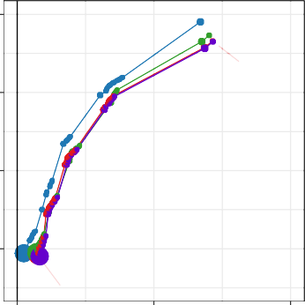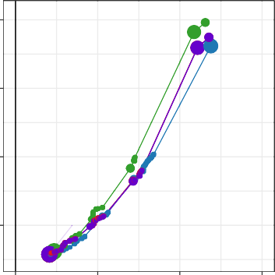0.98 0.8
0
0
0
0
60
60
60
60
0
0 0
0
60
60 60
60

0.96

0.94
TPR

0.92

Giraffe-Parental Giraffe-1000GP Giraffe-Primary BWA-MEM-hs38d1

2e+05
4e+05
6e+05

0.7

0.6
TPR

0.5

Giraffe-Parental Giraffe-1000GP Giraffe-Primary BWA-MEM-hs38d1
5000

10000

0.001 0.010 0.100
FPR

    - High Confidence Regions
0.001 0.010 0.100 1.000
FPR

    - Non-1000GP Regions

Figure S4. CMRG region mapeval HG002.Mapping performance of 100 million read pairs simulated from HG002 high confident datasets. Four different alignments are compared across two different regions and ROC curves are plotted with a log-scaled false positive rate on the x-axis and a linear-scaled true positive rate on the y-axis with mapping quality as the discriminating factor. Green curves represent graph alignments against the parental graph reference constructed from HG003 and HG004 illumina read graph alignments. Red curves represent alignments against the snp1kg graph reference. Purple curves represent alignments to the primary GRCh38 linear graph refer- ence. Blue curves represent linear alignments against the hs38d1 reference using BWA-MEM-hs38d1. (A) Align- ments in GIAB v4.2.1 confident regions. (B) Alignments in non-1000GP confident regions.

Single-sample Mapping and Variant Calling
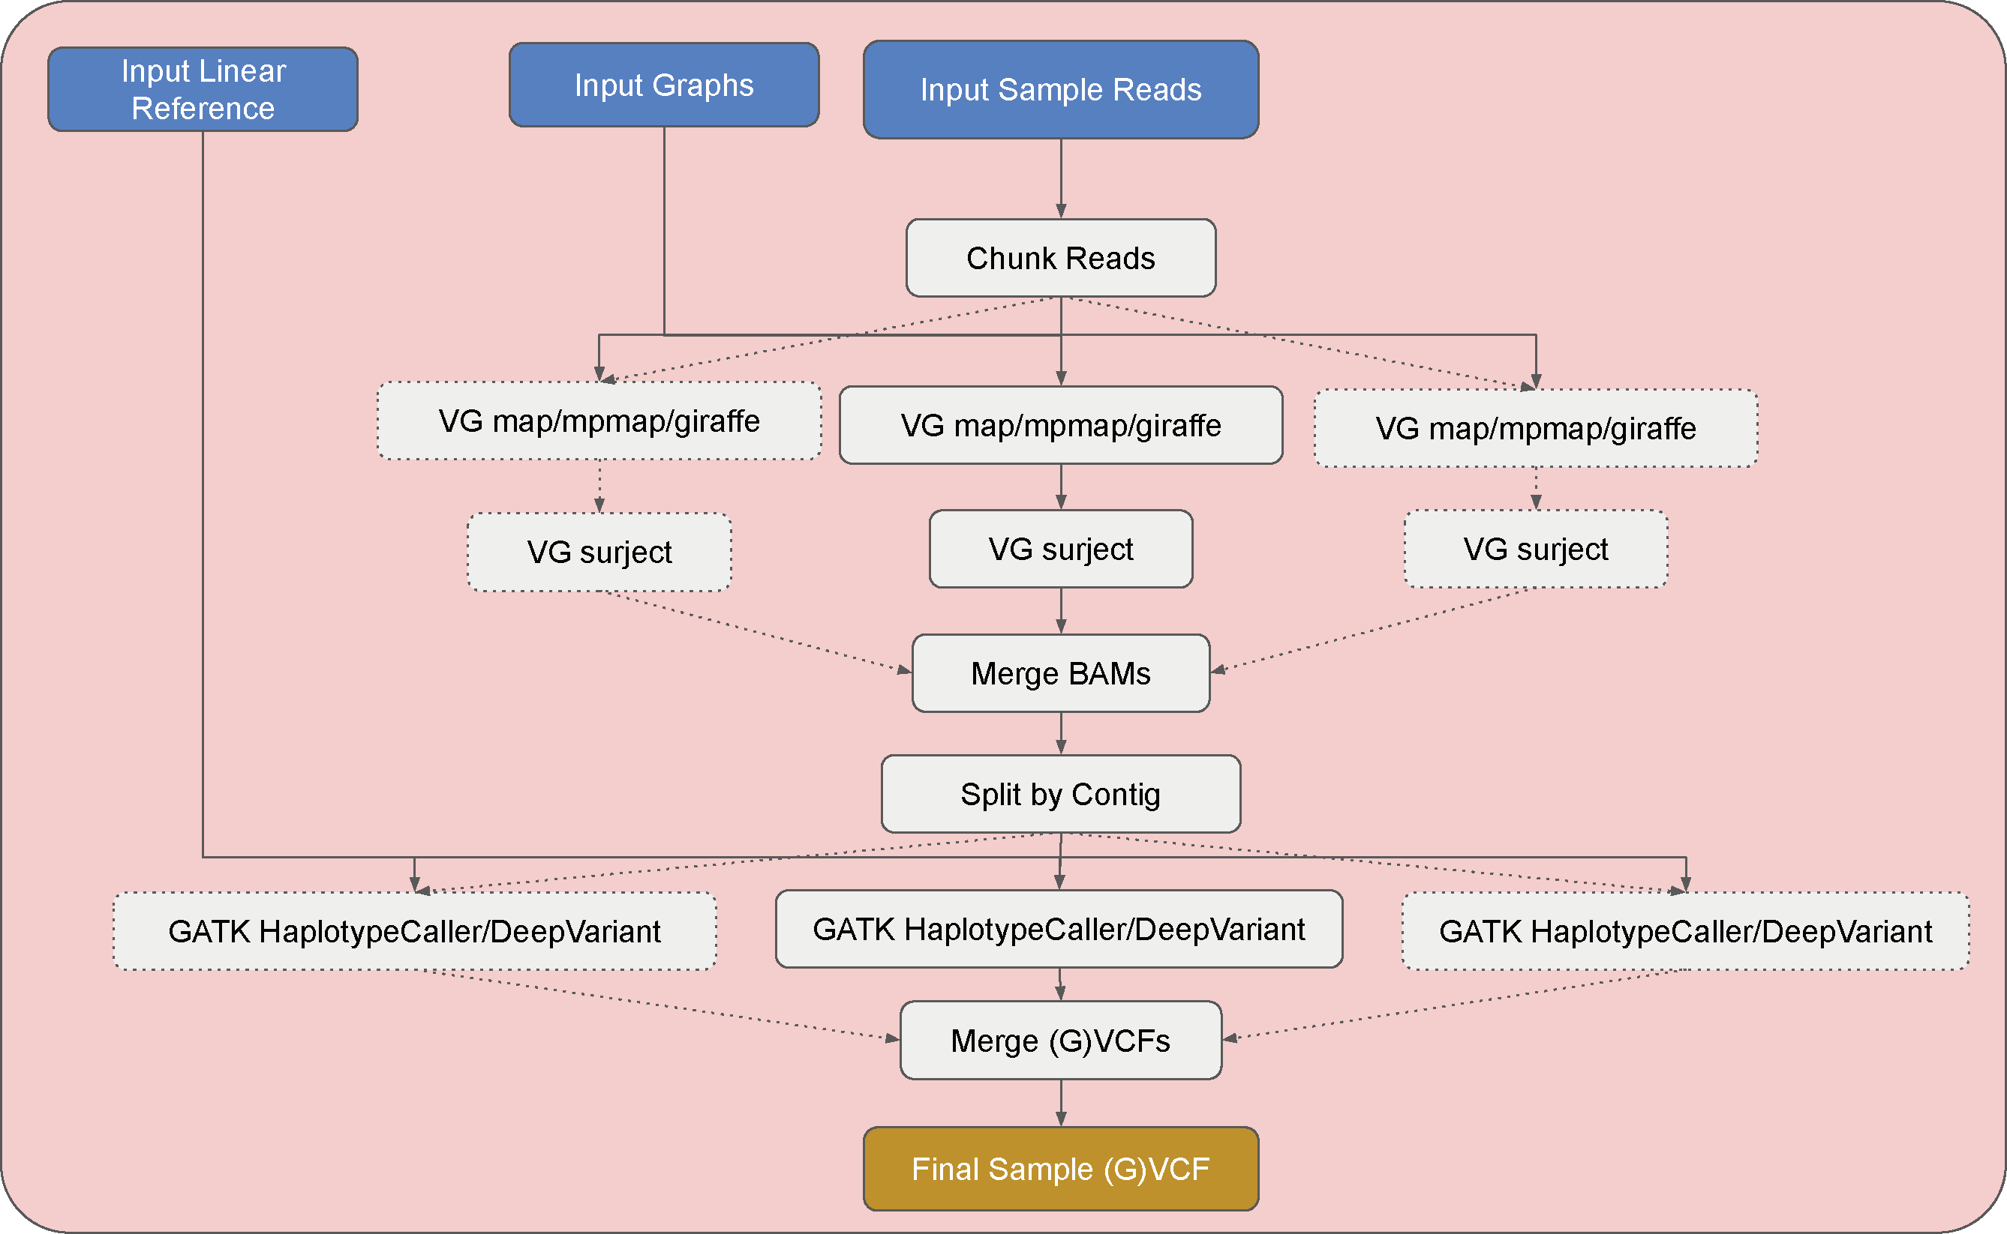

Figure S5. Single sample mapping and variant calling workflow.

Parental Phasing Workflow
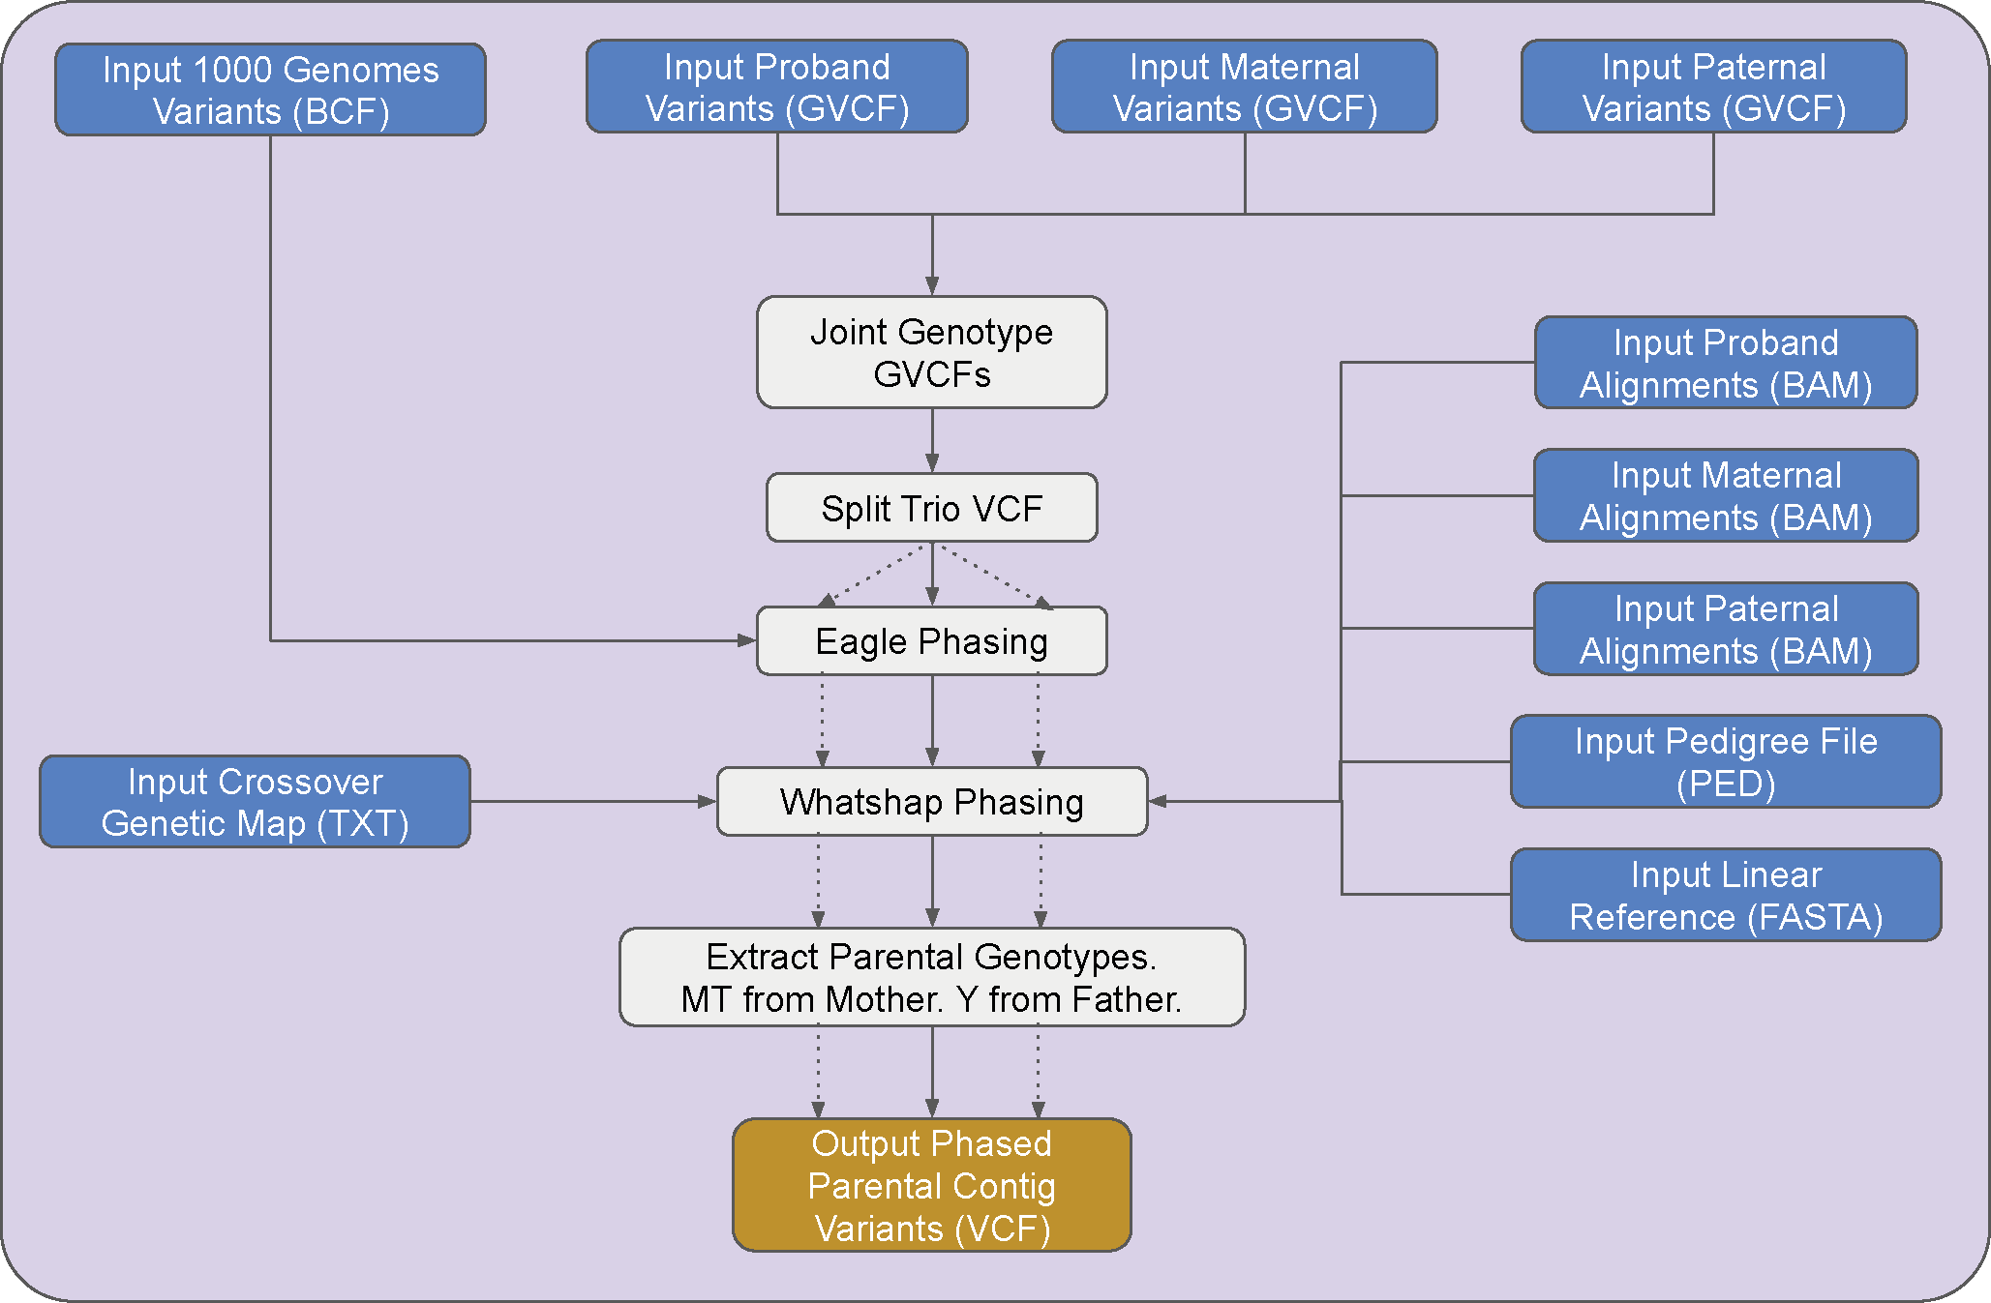

Figure S6. Parental phasing workflow.

Graph Construction Workflow
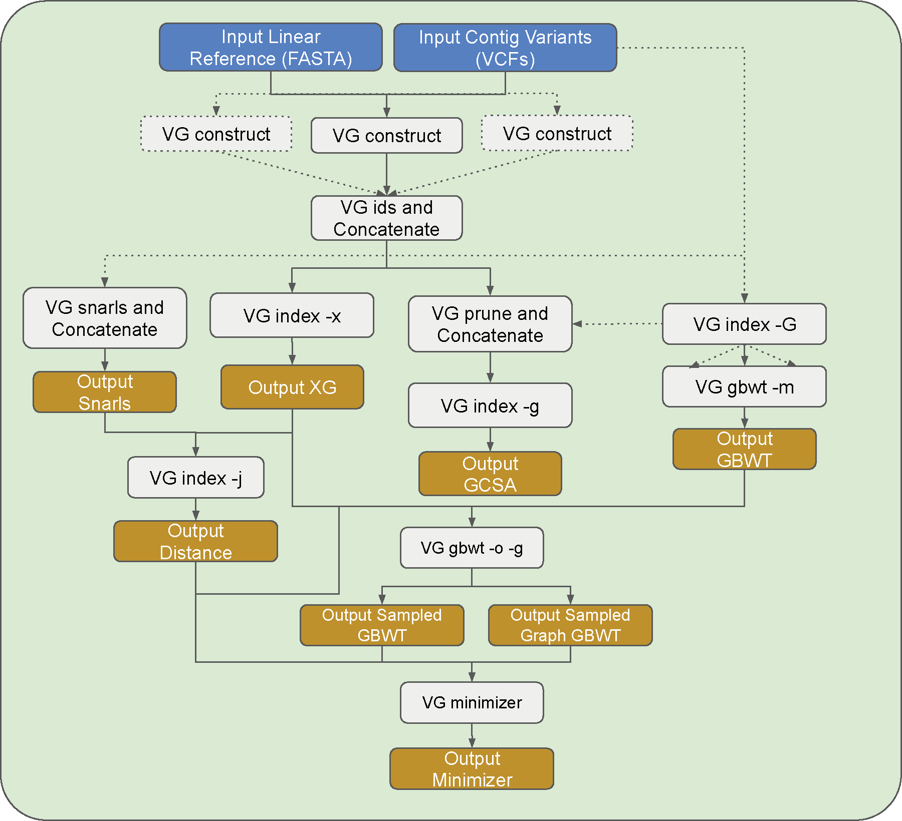

Figure S7. Graph construction workflow.

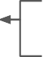
AIMs
Input Sample IDs
Genotype Filter Threshold
Input Sample Alignment (BAMs)
Pedigree Structure (.ped)
(A)
(B)
Ethnicity Matching
Sample Variant Lists (Annotated VarSifter File)
Mendelian Rescue
Variant Type Config File
(C) Mendelian-backed Phasing
Exon CADD Score Threshold
(D)
Population/Deleterious-backed Variant Filtration
Gene Config File
(E) Broad BAM Curation
(F)
(G)
Extreme Novel Variant Filter (CNC)
BAM File Noise/Pedigree-backed De-novo Filter
Output Candidate Variant List

Figure S8. Pedigree analysis workflow.

Variant Annotation Workflow
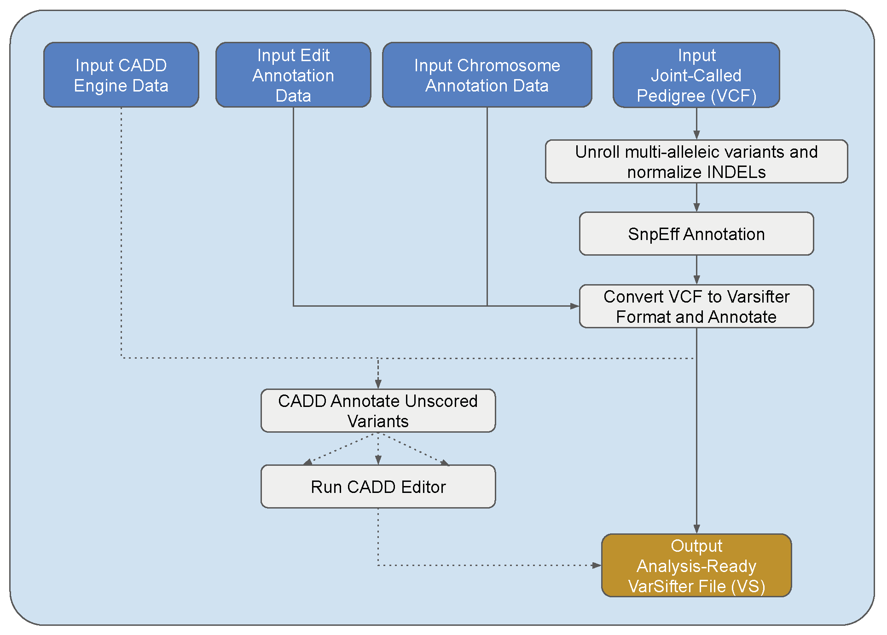

Figure S9. Variant annotation workflow.

(A) (B)

3,875,000
(baseline total = 3890524)

99.60 % 336,000
Gira e-Parent F1:0.9973
Gira e-1000GP F1:0.9970

BWA-MEM-hs38d1 F1:0.9970
Dragen-hs38d1 F1:0.9969
(baseline total = 349711)

96.0 %
Gira e-Parent F1:0.9728
BWA-MEM-hs38d1 F1:0.9701 Gira e-1000GP F1:0.9703
Dragen-hs38d1 F1:0.9688

3,874,000

335,000

3,873,000

99.55

334,000

95.5

3,872,000
True Positives

3,871,000

3,870,000

3,869,000

3,868,000

3,867,000

82,400

99.50

99.45

99.40
0 1,000 2,000 3,000 4,000 5,000 6,000 7,000 8,000
False Positives

(C)
(baseline total = 82589)

333,000

332,000

331,000

330,000

329,000

6,060

95.0

94.5

0 1,000 2,000 3,000 4,000 5,000 6,000 7,000

(D)
(baseline total = 6226)

82,380
Gira e-Parent Trained F1:0.9983
Gira e-Parent Default F1:0.9979 Gira e-1000GP Trained F1:0.9980
Gira e-1000GP Default F1:0.9980
BWA-MEM-hs38d1 F1:0.9977
Dragen-hs38d1 F1:0.9978

99.75 %
6,040
Gira e-Parent Trained F1:0.9799
Gira e-Parent Default F1:0.9754

Gira e-1000GP Trained F1:0.9764

Gira e-1000GP Default F1:0.9756
BWA-MEM-hs38d1 F1:0.9733
Dragen-hs38d1 F1:0.9740

97.0 %

82,360

82,340

82,320

82,300

99.70

99.65

6,020

6,000

5,980

96.5

96.0

82,280

82,260

82,240

82,220

0 20 40

60 80 100

99.60

120 140 160 180

5,960

5,940

5,920

0 20 40

60 80

100 120 140

95.5

95.0

Figure S10. HG002 DeepTrio default and trained ROC curves. ROC curves of DeepTrio variant calling per- formance of the graph-based and linear-based pipelines with respect to HG002 GIAB v4.2.1 truth variant call sets stratified by (A) HG002 high confident whole genome regions using default deeptrio models, (B) HG002 high con- fident whole genome regions excluding 1000GP variants using default deeptrio models, (C) HG002 high confident chr20 regions on default and trained deeptrio models, (D) HG002 high confident chr20 regions excluding 1000GP on default and trained deeptrio models.

- (B)
(baseline total = 3692296)
293,000
Giraffe-Parent F1:0.9970
Giraffe-1000GP F1:0.9967
BWA-MEM-hs38d1 F1:0.9964
Dragen-hs38d1 F1:0.9963
Giraffe-Parent F1:0.9669
Giraffe-1000GP F1:0.9634
BWA-MEM-hs38d1 F1:0.9613
Dragen-hs38d1 F1:0.99607

(baseline total = 307733)

3,676,000

3,675,000

3,674,000

3,673,000
True Positives

3,672,000

3,671,000

3,670,000

3,669,000

3,668,000

99.55 %

99.50

99.45

99.40

99.35

0 1,000 2,000 3,000 4,000 5,000 6,000 7,000 8,000 9,000

False Positives

292,000

291,000

290,000

289,000

288,000

287,000

286,000

95.0 %

94.5

94.0

93.5

93.0
0 1,000 2,000 3,000 4,000 5,000 6,000 7,000

(C)
76,950
Giraffe-Parent Trained F1:0.9978
Giraffe-Parent Default F1:0.9980

Giraffe-1000GP Trained F1:0.9982 Giraffe-1000GP Default F1:0.9981
BWA-MEM-hs38d1 F1:0.9978
Dragen-hs38d1 F1:0.9980

76,900

76,850

76,800

76,750

76,700

(baseline total = 77024)

99.90 %

99.85

99.80

99.75

99.70

99.65

99.60

4,500

4,480

4,460

4,440

4,420

4,400

4,380

4,360

4,340

4,320

4,300
(D)

(baseline total = 4592)

97.5 % 97.0 96.5 96.0 95.5 95.0 94.5 94.0
Giraffe-Parent Trained F1:0.9685

Giraffe-Parent Default F1:0.9724
Giraffe-1000GP Trained F1:0.9745 Giraffe-1000GP Default F1:0.9733
Dragen-hs38d1 F1:0.9724 BWA-MEM-hs38d1 F1:0.9684

0 50 100 150 200 250 0 20 40 60 80 100 120 140 160 180 200

Figure S11. HG005 DeepTrio default and trained ROC curves. ROC curves of DeepTrio variant calling per- formance of the graph-based and linear-based pipelines with respect to HG005 GIAB v4.2 truth variant call sets stratified by (A) high confident HG005 regions using default deeptrio models, (B) HG005 regions excluding 1000GP variants using default deeptrio models, (C) HG005 chr20 regions on default and trained deeptrio models, and (D) HG005 chr20 regions exclusing 1000GP on default and trained deeptrio models.

Pipeline | Total Correct | Total at MAPQ 60 | % Correct at MAPQ 60 | % Identity
BWA-MEM-hs38d1 | 18,114,687 | 17,733,384 | 97.89506 | NA
Giraffe-Primary | 18,109,463 | 17,808,858 | 98.34006 | 99.5028
Giraffe-1000GP | 18,111,426 | 17,813,218 | 98.35348 | 99.5997
Giraffe-Parent | 18,118,011 | 17,811,602 | 98.30881 | 99.6076
  - High Confidence Regions

Pipeline | Total Correct | Total at MAPQ 60 | % Correct at MAPQ 60 | % Identity
BWA-MEM-hs38d1 | 74,738,361 | 73,785,781 | 99.99907 | NA
Giraffe-Primary | 74,732,796 | 74,020,806 | 99.99908 | 99.5249
Giraffe-1000GP | 74,736,517 | 74,011,750 | 99.99926 | 99.6299
Giraffe-Parent | 74,752,479 | 73,978,618 | 99.99948 | 99.6465
  - Low Complexity Regions

Pipeline | Total Correct | Total at MAPQ 60 | % Correct at MAPQ 60 | % Identity
BWA-MEM-hs38d1 | 19,358,236 | 15,621,865 | 99.98379 | NA
Giraffe-Primary | 19,341,252 | 16,559,558 | 99.98702 | 99.3660
Giraffe-1000GP | 19,357,906 | 16,628,206 | 99.98794 | 99.4458
Giraffe-Parent | 19,419,540 | 16,702,174 | 99.99207 | 99.4830
  - Low Mappability Regions

Pipeline | Total Correct | Total at MAPQ 60 | % Correct at MAPQ 60 | % Identity
BWA-MEM-hs38d1 | 318,157 | 310,796 | 99.93822 | NA
Giraffe-Primary | 317,762 | 309,288 | 99.91755 | 99.0593
Giraffe-1000GP | 318,232 | 313,465 | 99.91769 | 99.4125
Giraffe-Parent | 318,583 | 314,020 | 99.92230 | 99.4847
  - MHC Regions

Pipeline | Total Correct | Total at MAPQ 60 | % Correct at MAPQ 60 | % Identity
BWA-MEM-hs38d1 | 831,328 | 781,909 | 99.87850 | NA
Giraffe-Primary | 826,982 | 781,539 | 99.84095 | 99.3621
Giraffe-1000GP | 827,118 | 781,745 | 99.84675 | 99.4776
Giraffe-Parent | 828,373 | 782,353 | 99.85007 | 99.5284
  - CMRG Regions
Table S1. HG002 simulated read mapping stats. Mapping statistics on HG002 simulated read alignments against various GRCh38-based graph references and BWA-MEM-hs38d1 alignments against the linear GRCh38 reference.

Pipeline | Total Correct | Total at MAPQ 60 | % Correct at MAPQ 60 | % Identity
BWA-MEM-hs38d1 | 2,030,502 | 1,061,413 | 99.95949 | NA
Giraffe-Primary | 2,033,842 | 1,095,548 | 99.97116 | 98.8193
Giraffe-1000GP | 2,032,683 | 1,094,500 | 99.96958 | 98.8106
Giraffe-Parent | 2,060,518 | 1,104,532 | 99.96813 | 98.8738
- High Confidence Regions

Pipeline | Total Correct | Total at MAPQ 60 | % Correct at MAPQ 60 | % Identity
BWA-MEM-hs38d1 | 359,371 | 238,397 | 99.97357 | NA
Giraffe-Primary | 358,913 | 242,866 | 99.98353 | 98.7139
Giraffe-1000GP | 358,439 | 242,622 | 99.98516 | 98.6836
Giraffe-Parent | 363,180 | 244,576 | 99.97833 | 98.7885
- Low Complexity Regions

Pipeline | Total Correct | Total at MAPQ 60 | % Correct at MAPQ 60 | % Identity
BWA-MEM-hs38d1 | 1,249,470 | 282,325 | 99.85265 | NA
Giraffe-Primary | 1,253,071 | 316,560 | 99.90649 | 98.4929
Giraffe-1000GP | 1,251,903 | 315,668 | 99.90085 | 98.4690
Giraffe-Parent | 1,279,696 | 326,888 | 99.89782 | 98.5353
- Low Mappability Regions

Pipeline | Total Correct | Total at MAPQ 60 | % Correct at MAPQ 60 | % Identity
BWA-MEM-hs38d1 | 3,168 | 1,440 | 100.00000 | NA
Giraffe-Primary | 3,213 | 1,434 | 99.51185 | 99.3212
Giraffe-1000GP | 3,219 | 1,436 | 99.51253 | 99.3531
Giraffe-Parent | 3,250 | 1,462 | 99.24761 | 99.3903
- MHC Regions

Pipeline | Total Correct | Total at MAPQ 60 | % Correct at MAPQ 60 | % Identity
BWA-MEM-hs38d1 | 23,831 | 14,387 | 99.43699 | NA
Giraffe-Primary | 24,229 | 14,400 | 99.43750 | 99.1547
Giraffe-1000GP | 24,231 | 14,390 | 99.43711 | 99.1596
Giraffe-Parent | 24,905 | 14,540 | 99.36726 | 99.2803
- CMRG Regions
Table S2. Non-1000GP HG002 simulated read mapping stats. Mapping statistics on HG002 simulated read alignments against various GRCh38-based graph references and BWA-MEM-hs38d1 alignments against the linear GRCh38 reference within non-1000GP variant dataset regions.

Pipeline | % Total Aligned | % Total Perfect | % Total Gapless | Total Softclips
Giraffe-Parent | 99.9487 | 59.9905 | 95.6780 | 91185 bp in 5180 read events
Giraffe-1000GP | 99.9484 | 59.5811 | 95.4316 | 132915 bp in 8348 read events
Giraffe-Primary | 99.9484 | 52.4840 | 94.1270 | 229332 bp in 16041 read events
- High Confidence Regions

Pipeline | % Total Aligned | % Total Perfect | % Total Gapless | Total Softclips
Giraffe-Parent | 99.9842 | 60.0246 | 95.8011 | 225652 bp in 16214 read events
Giraffe-1000GP | 99.9841 | 59.2701 | 94.9819 | 651911 bp in 46388 read events
Giraffe-Primary | 99.9843 | 51.6826 | 92.7529 | 1188358 bp in 92048 read events
- Low Complexity Regions

Pipeline | % Total Aligned | % Total Perfect | % Total Gapless | Total Softclips
Giraffe-Parent | 99.8358 | 59.3039 | 95.4556 | 219196 bp in 8690 read events
Giraffe-1000GP | 99.8339 | 57.0887 | 95.1969 | 291307 bp in 13304 read events
Giraffe-Primary | 99.8394 | 51.2567 | 94.2947 | 402816 bp in 20980 read events
- Low Mappability Regions

Pipeline | % Total Aligned | % Total Perfect | % Total Gapless | Total Softclips
Giraffe-Parent | 99.9651 | 58.9368 | 95.5042 | 58373 bp in 1170 read events
Giraffe-1000GP | 99.9639 | 57.1014 | 93.9220 | 69204 bp in 1650 read events
Giraffe-Primary | 99.9402 | 45.3226 | 91.3136 | 100793 bp in 2951 read events
- MHC Regions

Pipeline | % Total Aligned | % Total Perfect | % Total Gapless | Total Softclips
Giraffe-Parent | 99.9487 | 59.9619 | 95.5591 | 94701 bp in 2144 read events
Giraffe-1000GP | 99.9485 | 58.0663 | 94.1551 | 117680 bp in 3253 read events
Giraffe-Primary | 99.9482 | 51.0891 | 92.6229 | 133603 bp in 4128 read events
- CMRG Regions
Table S3. HG002 simulated read mapping GAM stats. GAM statistics on HG002 simulated read alignments against various GRCh38-based graph references.

Pipeline | % Total Aligned | % Total Perfect | % Total Gapless | Total Softclips
Giraffe-Parent | 99.2513 | 57.9923 | 94.7110 | 58129 bp in 2075 read events
Giraffe-1000GP | 99.2456 | 54.3073 | 94.4219 | 69967 bp in 2810 read events
Giraffe-Primary | 99.2685 | 53.4428 | 94.2612 | 75430 bp in 3136 read events
- High Confidence Regions

Pipeline | % Total Aligned | % Total Perfect | % Total Gapless | Total Softclips
Giraffe-Parent | 99.1543 | 58.4180 | 94.8943 | 6217 bp in 252 read events
Giraffe-1000GP | 99.1441 | 52.2570 | 93.1680 | 11213 bp in 593 read events
Giraffe-Primary | 99.1799 | 51.9021 | 93.1097 | 10704 bp in 608 read events
- Low Complexity Regions

Pipeline | % Total Aligned | % Total Perfect | % Total Gapless | Total Softclips
Giraffe-Parent | 98.9241 | 57.3295 | 94.5397 | 49098 bp in 1547 read events
Giraffe-1000GP | 98.9160 | 53.5318 | 94.3970 | 54949 bp in 1919 read events
Giraffe-Primary | 98.9492 | 53.1273 | 94.3692 | 58048 bp in 2094 read events
- Low Mappability Regions

Pipeline | % Total Aligned | % Total Perfect | % Total Gapless | Total Softclips
Giraffe-Parent | 99.7268 | 60.7608 | 95.4813 | 3 bp in 1 read events
Giraffe-1000GP | 99.7268 | 57.7764 | 94.5776 | 0 bp in 0 read events
Giraffe-Primary | 99.7268 | 55.9899 | 94.3464 | 53 bp in 5 read events
- MHC Regions

Pipeline | % Total Aligned | % Total Perfect | % Total Gapless | Total Softclips
Giraffe-Parent | 99.6867 | 59.2507 | 94.7993 | 2187 bp in 65 read events
Giraffe-1000GP | 99.6803 | 53.0399 | 92.5010 | 3090 bp in 139 read events
Giraffe-Primary | 99.6867 | 52.5860 | 92.2932 | 3255 bp in 143 read events
- CMRG Regions
Table S4. Non-1000GP HG002 simulated read mapping GAM stats. GAM statistics on HG002 simulated read alignments against various GRCh38-based graph references in regions that don’t overlap the 1000GP variant set.

Pipeline | Var Type | TP | FN | FP | Recall | Precision | F1
HG002 | INDELS  SNPS | 11,208  71,064 | 48  269 | 18  28 | 0.995736  0.996229 | 0.998456  0.999606 | 0.997094  0.997915
HG003 | INDELS  SNPS | 10,582  69,928 | 46  238 | 19  49 | 0.995672  0.996608 | 0.998282  0.999300 | 0.996975  0.997952
HG004 | INDELS  SNPS | 10,950  71,426 | 50  233 | 25  47 | 0.995455  0.996748 | 0.997819  0.999343 | 0.996635  0.998044
  - Default

Pipeline | Var Type | TP | FN | FP | Recall | Precision | F1
HG002 | INDELS  SNPS | 11,210  71,099 | 46  234 | 25  28 | 0.995913  0.996720 | 0.997857  0.999607 | 0.996884  0.998161
HG003 | INDELS  SNPS | 10,585  69,958 | 43  208 | 37  48 | 0.995954  0.997036 | 0.996662  0.999315 | 0.996308  0.998174
HG004 | INDELS  SNPS | 10,948  71,405 | 51  254 | 34  42 | 0.995273  0.996455 | 0.997036  0.999413 | 0.996154  0.997932
  - Trained
Table S5. HAP.PY HG002 DeepTrio trained high confident regions. Hap.py performance of DeepTrio using the
- default DeepTrio model and (B) trained DeepTrio model against the 1000 Genomes Project grch38-based graph reference using 150bp paired-end reads with respect to HG002 GIAB v4.2.1 truth variant call sets in high confidence regions on chromosome 20. Best values for each sample are highlighted in bold text.

Pipeline | Var Type | TP | FN | FP | Recall | Precision | F1
HG005 | INDELS  SNPS | 8,430  68,392 | 25  205 | 9  49 | 0.997043  0.997012 | 0.998967  0.999284 | 0.998004  0.998147
HG006 | INDELS  SNPS | 8,999  66,086 | 108  118 | 77  175 | 0.988141  0.998218 | 0.991736  0.997361 | 0.989935  0.997789
HG007 | INDELS  SNPS | 9,162  67,267 | 94  88 | 71  111 | 0.989844  0.998693 | 0.992528  0.998353 | 0.991184  0.998523
  - Default

Pipeline | Var Type | TP | FN | FP | Recall | Precision | F1
HG005 | INDELS  SNPS | 8,429  68,422 | 26  175 | 21  58 | 0.996925  0.997449 | 0.997592  0.999153 | 0.997258  0.998300
HG006 | INDELS  SNPS | 9,010  66,097 | 97  107 | 86  62 | 0.989349  0.998384 | 0.990801  0.999064 | 0.990074  0.998724
HG007 | INDELS  SNPS | 9,183  67,285 | 73  70 | 66  68 | 0.992113  0.998961 | 0.993072  0.998991 | 0.992593  0.998976
  - Trained
Table S6. HAP.PY HG005 DeepTrio trained high confident regions. Hap.py performance of DeepTrio using the
- default DeepTrio model and (B) trained DeepTrio model against the 1000 Genomes Project grch38-based graph reference using 150bp paired-end reads with respect to HG005 GIAB v4.2.1 truth variant call sets in high confidence regions on chromosome 20. Best values in each column are highlighted in bold text.

Pipeline | TP | FP | FN | Precision | Sensitivity | F1
Giraffe-Parent | 3,874,697 | 4,930 | 16,260 | 0.9987 | 0.9958 | 0.9973
Giraffe-1000GP | 3,871,969 | 3,934 | 19,021 | 0.9990 | 0.9951 | 0.9970
BWA-MEM-hs38d1 | 3,871,240 | 3,790 | 19,728 | 0.9990 | 0.9949 | 0.9970
Dragen-hs38d1 | 3,869,647 | 3,028 | 21,325 | 0.9992 | 0.9945 | 0.9969
  - DeepTrio HG002 All High Confident Regions

Pipeline | TP | FP | FN | Precision | Sensitivity | F1
Giraffe-Parent | 337,167 | 4,096 | 14,691 | 0.9880 | 0.9580 | 0.9728
Giraffe-1000GP | 334,524 | 3,036 | 17,362 | 0.9910 | 0.9504 | 0.9703
BWA-MEM-hs38d1 | 334,456 | 3,239 | 17,241 | 0.9904 | 0.9507 | 0.9701
Dragen-hs38d1 | 332,840 | 2,496 | 18,862 | 0.9926 | 0.9461 | 0.9688
  - DeepTrio HG002 All High Confident Regions, 1000GP excluded

Pipeline | TP | FP | FN | Precision | Sensitivity | F1
Giraffe-Parent | 3,873,547 | 5,993 | 17,426 | 0.9985 | 0.9955 | 0.9970
Giraffe-1000GP | 3,868,404 | 5,514 | 22,623 | 0.9986 | 0.9942 | 0.9964
BWA-MEM-hs38d1 | 3,867,786 | 5,099 | 23,169 | 0.9987 | 0.9940 | 0.9964
Dragen-hs38d1 | 3,865,635 | 4,227 | 25,328 | 0.9989 | 0.9935 | 0.9962
  - DeepVariant HG002 All High Confident Regions

Pipeline | TP | FP | FN | Precision | Sensitivity | F1
Giraffe-Parent | 3,675,759 | 5,538 | 16,931 | 0.9985 | 0.9954 | 0.9970
Giraffe-1000GP | 3,672,686 | 4,614 | 20,010 | 0.9987 | 0.9946 | 0.9967
BWA-MEM-hs38d1 | 3,671,038 | 5,100 | 21,631 | 0.9986 | 0.9941 | 0.9964
Dragen-hs38d1 | 3,669,697 | 3,933 | 22,978 | 0.9989 | 0.9938 | 0.9963
  - DeepTrio HG005 All High Confident Regions

Pipeline | TP | FP | FN | Precision | Sensitivity | F1
Giraffe-Parent | 293,972 | 4,673 | 15,392 | 0.9844 | 0.9500 | 0.9669
Giraffe-1000GP | 290,980 | 3,616 | 18,390 | 0.9877 | 0.9402 | 0.9634
BWA-MEM-hs38d1 | 290,333 | 4,451 | 18,816 | 0.9849 | 0.9389 | 0.9613
Dragen-hs38d1 | 288,921 | 3,291 | 20,242 | 0.9887 | 0.9342 | 0.9607
  - DeepTrio HG005 All High Confident Regions, 1000GP excluded

Pipeline | TP | FP | FN | Precision | Sensitivity | F1
Giraffe-Parent | 3,674,849 | 7,372 | 17,866 | 0.9980 | 0.9952 | 0.9966
Giraffe-1000GP | 3,669,103 | 7,534 | 23,650 | 0.9980 | 0.9936 | 0.9958
BWA-MEM-hs38d1 | 3,667,163 | 7,728 | 25,519 | 0.9979 | 0.9931 | 0.9955
Dragen-hs38d1 | 3,665,339 | 6,266 | 27,352 | 0.9983 | 0.9926 | 0.9954
  - DeepVariant HG005 All High Confident Regions
Table S7. VCFeval HG002 and HG005 DeepTrio and DeepVariant performance. VCFeval performance of the graph-based and linear-based pipelines with respect to HG002 and HG005 GIAB v4.2.1 truth variant call sets stratified by (A) DeepTrio on all HG002 regions, (B) DeepTrio on HG002 regions excluding 1000GP variants, (C) DeepVariant on all HG002 regions (D) DeepTrio on all HG005 regions, (E) DeepTrio on HG005 regions excluding 1000GP variants, and (F) DeepVariant on all HG005 regions. All mapped reads were called using DeepTrio and DeepVariant v1.1.0 genotyper using default models. Best values in each column are highlighted in bold text.

Pipeline | TP | FP | FN | Precision | Sensitivity | F1
Giraffe-Parent | 520,281 | 1,359 | 1,994 | 0.9974 | 0.9962 | 0.9968
Giraffe-1000GP | 520,208 | 1,240 | 2,092 | 0.9976 | 0.9960 | 0.9968
BWA-MEM-hs38d1 | 520,530 | 938 | 1,748 | 0.9982 | 0.9966 | 0.9974
Dragen-hs38d1 | 520,465 | 893 | 1,816 | 0.9983 | 0.9965 | 0.9974
    - Low Complexity Regions

Pipeline | TP | FP | FN | Precision | Sensitivity | F1
Giraffe-Parent | 262,599 | 3,550 | 14,203 | 0.9867 | 0.9487 | 0.9673
Giraffe-1000GP | 259,901 | 2,596 | 16,907 | 0.9901 | 0.9389 | 0.9638
BWA-MEM-hs38d1 | 259,050 | 2,774 | 17,749 | 0.9894 | 0.9359 | 0.9619
Dragen-hs38d1 | 257,425 | 2,025 | 19,379 | 0.9922 | 0.9300 | 0.9601
    - Low Mappability Regions

Pipeline | TP | FP | FN | Precision | Sensitivity | F1
Giraffe-Parent | 21,521 | 106 | 318 | 0.9951 | 0.9854 | 0.9902
Giraffe-1000GP | 21,489 | 136 | 350 | 0.9937 | 0.9840 | 0.9888
BWA-MEM-hs38d1 | 21,478 | 107 | 356 | 0.9950 | 0.9837 | 0.9893
Dragen-hs38d1 | 21,500 | 100 | 334 | 0.9954 | 0.9847 | 0.9900
    - MHC Regions

Pipeline | TP | FP | FN | Precision | Sensitivity | F1
Giraffe-Parent | 20,400 | 246 | 832 | 0.9881 | 0.9608 | 0.9743
Giraffe-1000GP | 20,375 | 237 | 862 | 0.9885 | 0.9594 | 0.9737
BWA-MEM-hs38d1 | 20,361 | 243 | 877 | 0.9882 | 0.9587 | 0.9732
Dragen-hs38d1 | 20,362 | 224 | 874 | 0.9891 | 0.9588 | 0.9737
    - Hard-to-sequence Medically Relevant Genes
Table S8. VCFeval HG002 DeepTrio performance difficult regions. VCFeval performance of the graph-based and linear-based pipelines with respect to HG002 GIAB v4.2.1 truth variant call sets stratified by (A) low complexity and highly repetative regions, (B) low mappability regions, (C) MHC regions, and (D) Difficult Medically Relevant Genes. All mapped reads were called using DeepTrio v1.1.0 genotyper. Best values in each column are highlighted in bold text.

Pipeline | TP | FP | FN | Precision | Sensitivity | F1
Giraffe-Parent | 378,124 | 957 | 1,413 | 0.9975 | 0.9963 | 0.9969
Giraffe-1000GP | 378,060 | 881 | 1,482 | 0.9977 | 0.9961 | 0.9969
BWA-MEM-hs38d1 | 378,205 | 721 | 1,295 | 0.9981 | 0.9966 | 0.9973
Dragen-hs38d1 | 378,157 | 695 | 1,351 | 0.9982 | 0.9964 | 0.9973
      - Low Complexity Regions

Pipeline | TP | FP | FN | Precision | Sensitivity | F1
Giraffe-Parent | 260,810 | 4,321 | 15,212 | 0.9837 | 0.9449 | 0.9639
Giraffe-1000GP | 257,763 | 3,414 | 18,259 | 0.9869 | 0.9338 | 0.9596
BWA-MEM-hs38d1 | 256,456 | 4,101 | 19,558 | 0.9843 | 0.9291 | 0.9559
Dragen-hs38d1 | 254,978 | 2,967 | 21,040 | 0.9885 | 0.9237 | 0.9550
      - Low Mappability Regions

Pipeline | TP | FP | FN | Precision | Sensitivity | F1
Giraffe-Parent | 19,671 | 191 | 898 | 0.9904 | 0.9564 | 0.9731
Giraffe-1000GP | 19,653 | 237 | 910 | 0.9881 | 0.9558 | 0.9717
BWA-MEM-hs38d1 | 19,407 | 178 | 1,159 | 0.9909 | 0.9437 | 0.9667
Dragen-hs38d1 | 19,461 | 166 | 1,101 | 0.9915 | 0.9465 | 0.9685
      - MHC Regions
Table S9. VCFeval HG005 DeepTrio performance difficult regions. VCFeval performance of the graph-based and linear-based pipelines with respect to HG005 GIAB v4.2.1 truth variant call sets stratified by (A) low complexity and highly repetative regions, (B) low mappability regions, and (C) MHC regions. All mapped reads were called using DeepTrio v1.1.0 genotyper. Best values in each column are highlighted in bold text.

Pipeline | TP | FP | FN | Precision | Sensitivity | F1
Giraffe-Parent | 369,556 | 1,280 | 4,563 | 0.9965 | 0.9878 | 0.9922
Giraffe-1000GP | 368,523 | 1,295 | 5,619 | 0.9965 | 0.9850 | 0.9907
BWA-MEM-hs38d1 | 366,035 | 1,047 | 8,044 | 0.9971 | 0.9785 | 0.9877
Dragen-hs38d1 | 366,121 | 972 | 7,949 | 0.9974 | 0.9787 | 0.9880
- complex and SVs

Pipeline | TP | FP | FN | Precision | Sensitivity | F1
Giraffe-Parent | 207,109 | 313 | 2,964 | 0.9985 | 0.9859 | 0.9922
Giraffe-1000GP | 206,287 | 275 | 3,790 | 0.9987 | 0.9820 | 0.9902
BWA-MEM-hs38d1 | 204,137 | 295 | 5,915 | 0.9986 | 0.9718 | 0.9850
Dragen-hs38d1 | 204,230 | 223 | 5,818 | 0.9989 | 0.9723 | 0.9854
- snps within 10bp slop50

Pipeline | TP | FP | FN | Precision | Sensitivity | F1
Giraffe-Parent | 38,740 | 141 | 761 | 0.9964 | 0.9807 | 0.9885
Giraffe-1000GP | 38,578 | 148 | 924 | 0.9962 | 0.9766 | 0.9863
BWA-MEM-hs38d1 | 38,105 | 79 | 1,378 | 0.9979 | 0.9650 | 0.9812
Dragen-hs38d1 | 38,153 | 77 | 1,327 | 0.9980 | 0.9663 | 0.9819
- complex indel 10bp slop50

Pipeline | TP | FP | FN | Precision | Sensitivity | F1
Giraffe-Parent | 57,488 | 143 | 392 | 0.9975 | 0.9932 | 0.9954
Giraffe-1000GP | 57,362 | 163 | 517 | 0.9972 | 0.9911 | 0.9941
BWA-MEM-hs38d1 | 57,026 | 163 | 847 | 0.9971 | 0.9854 | 0.9912
Dragen-hs38d1 | 57,077 | 157 | 795 | 0.9973 | 0.9863 | 0.9917
- comphet snp 10bp slop50

Pipeline | TP | FP | FN | Precision | Sensitivity | F1
Giraffe-Parent | 47,048 | 695 | 781 | 0.9854 | 0.9836 | 0.9845
Giraffe-1000GP | 47,075 | 706 | 769 | 0.9852 | 0.9839 | 0.9846
BWA-MEM-hs38d1 | 46,980 | 604 | 829 | 0.9873 | 0.9826 | 0.9850
Dragen-hs38d1 | 46,983 | 596 | 825 | 0.9875 | 0.9827 | 0.9851
- comphet indel 10bp slop50
Table S10. VCFeval HG001 DeepTrio sample-specific difficult regions. VCFeval performance of the graph-based and linear-based pipelines with respect to HG001 GIAB v4.2.1 truth variant call sets stratified by (A) union of all SV, CNV, complex and compound heterozygous variant bed files used for v4.2.1 of the GIAB benchmark for each sample, (B) regions containing at least two variants on one haplotype within 10bp of each other, and all variants are snps, with 50bp slop added on each side, (C) regions containing at least two variants on one haplotype within 10bp of each other, and at least one of the variants is an indel, with 50bp slop added on each side, (D) regions containing at least one variant on each haplotype within 10bp of each other, and all variants are snps, with 50bp slop added on each side and (E) regions containing at least one variant on each haplotype within 10bp of each other, and at least one of the variants is an indel, with 50bp slop added on each side. All mapped reads were called using DeepTrio v1.1.0 genotyper where Giraffe-Parent and Giraffe-1000GP used the trained model while BWA-MEM-hs38d1 and Dragen-hs38d1 used the default model that was tuned to BWA-MEM alignments. Best values in each column are highlighted in bold text.

Pipeline | TP | FP | FN | Precision | Sensitivity | F1
Giraffe-Parent | 398,897 | 1,254 | 5,131 | 0.9969 | 0.9873 | 0.9921
Giraffe-1000GP | 397,899 | 1,145 | 6,139 | 0.9971 | 0.9848 | 0.9909
BWA-MEM-hs38d1 | 396,630 | 846 | 7,419 | 0.9979 | 0.9816 | 0.9897
Dragen-hs38d1 | 396,600 | 809 | 7,449 | 0.9980 | 0.9815 | 0.9897
  - complex and SVs

Pipeline | TP | FP | FN | Precision | Sensitivity | F1
Giraffe-Parent | 215,240 | 330 | 3,208 | 0.9985 | 0.9853 | 0.9918
Giraffe-1000GP | 214,441 | 277 | 4,014 | 0.9987 | 0.9816 | 0.9901
BWA-MEM-hs38d1 | 213,187 | 213 | 5,260 | 0.9990 | 0.9759 | 0.9873
Dragen-hs38d1 | 213,193 | 167 | 5,251 | 0.9992 | 0.9760 | 0.9875
  - snps within 10bp slop50

Pipeline | TP | FP | FN | Precision | Sensitivity | F1
Giraffe-Parent | 44,265 | 150 | 606 | 0.9966 | 0.9865 | 0.9915
Giraffe-1000GP | 44,134 | 160 | 737 | 0.9964 | 0.9835 | 0.9899
BWA-MEM-hs38d1 | 43,871 | 112 | 1006 | 0.9975 | 0.9775 | 0.9874
Dragen-hs38d1 | 43,903 | 110 | 969 | 0.9975 | 0.9784 | 0.9878
  - complex indel 10bp slop50

Pipeline | TP | FP | FN | Precision | Sensitivity | F1
Giraffe-Parent | 63,416 | 120 | 410 | 0.9981 | 0.9936 | 0.9958
Giraffe-1000GP | 63,294 | 133 | 538 | 0.9979 | 0.9916 | 0.9947
BWA-MEM-hs38d1 | 63,080 | 147 | 745 | 0.9977 | 0.9883 | 0.9930
Dragen-hs38d1 | 63,111 | 143 | 717 | 0.9977 | 0.9888 | 0.9932
  - comphet snp 10bp slop50

Pipeline | TP | FP | FN | Precision | Sensitivity | F1
Giraffe-Parent | 56,912 | 566 | 598 | 0.9902 | 0.9896 | 0.9899
Giraffe-1000GP | 56,907 | 541 | 608 | 0.9906 | 0.9894 | 0.9900
BWA-MEM-hs38d1 | 56,994 | 426 | 537 | 0.9926 | 0.9906 | 0.9916
Dragen-hs38d1 | 56,992 | 432 | 540 | 0.9925 | 0.9906 | 0.9915
  - comphet indel 10bp slop50
Table S11. VCFeval HG002 DeepTrio sample-specific difficult regions. VCFeval performance of the graph-based and linear-based pipelines with respect to HG002 GIAB v4.2.1 truth variant call sets stratified by (A) union of all SV, CNV, complex and compound heterozygous variant bed files used for v4.2.1 of the GIAB benchmark for each sample, (B) regions containing at least two variants on one haplotype within 10bp of each other, and all variants are snps, with 50bp slop added on each side, (C) regions containing at least two variants on one haplotype within 10bp of each other, and at least one of the variants is an indel, with 50bp slop added on each side, (D) regions containing at least one variant on each haplotype within 10bp of each other, and all variants are snps, with 50bp slop added on each side and (E) regions containing at least one variant on each haplotype within 10bp of each other, and at least one of the variants is an indel, with 50bp slop added on each side. All mapped reads were called using the DeepTrio v1.1.0 genotyper default model that was tuned to BWA-MEM alignments. Best values in each column are highlighted in bold text.

Pipeline | TP | FP | FN | Precision | Sensitivity | F1
Giraffe-Parent | 357,867 | 998 | 5,357 | 0.9972 | 0.9852 | 0.9912
Giraffe-1000GP | 356,744 | 981 | 6,466 | 0.9973 | 0.9822 | 0.9897
BWA-MEM-hs38d1 | 354,731 | 865 | 8,488 | 0.9976 | 0.9766 | 0.9870
Dragen-hs38d1 | 354,796 | 800 | 8,435 | 0.9978 | 0.9768 | 0.9871
    - complex and SVs

Pipeline | TP | FP | FN | Precision | Sensitivity | F1
Giraffe-Parent | 208,724 | 389 | 3,739 | 0.9981 | 0.9824 | 0.9902
Giraffe-1000GP | 207,858 | 369 | 4,609 | 0.9982 | 0.9783 | 0.9882
BWA-MEM-hs38d1 | 206,066 | 353 | 6,392 | 0.9983 | 0.9699 | 0.9839
Dragen-hs38d1 | 206,132 | 298 | 6,329 | 0.9986 | 0.9702 | 0.9842
    - snps within 10bp slop50

Pipeline | TP | FP | FN | Precision | Sensitivity | F1
Giraffe-Parent | 37,209 | 158 | 895 | 0.9958 | 0.9764 | 0.9860
Giraffe-1000GP | 37,034 | 186 | 1,058 | 0.9950 | 0.9722 | 0.9834
BWA-MEM-hs38d1 | 36,637 | 133 | 1,470 | 0.9964 | 0.9613 | 0.9785
Dragen-hs38d1 | 36,736 | 119 | 1,378 | 0.9968 | 0.9637 | 0.9800
    - complex indel 10bp slop50

Pipeline | TP | FP | FN | Precision | Sensitivity | F1
Giraffe-Parent | 57,398 | 129 | 429 | 0.9978 | 0.9926 | 0.9952
Giraffe-1000GP | 57,313 | 141 | 517 | 0.9975 | 0.9911 | 0.9943
BWA-MEM-hs38d1 | 57,102 | 142 | 727 | 0.9975 | 0.9874 | 0.9924
Dragen-hs38d1 | 57,130 | 142 | 700 | 0.9975 | 0.9879 | 0.9927
    - comphet snp 10bp slop50

Pipeline | TP | FP | FN | Precision | Sensitivity | F1
Giraffe-Parent | 35,824 | 368 | 444 | 0.9898 | 0.9877 | 0.9888
Giraffe-1000GP | 35,821 | 372 | 436 | 0.9897 | 0.9880 | 0.9888
BWA-MEM-hs38d1 | 35,798 | 344 | 460 | 0.9905 | 0.9873 | 0.9889
Dragen-hs38d1 | 35,829 | 329 | 436 | 0.9909 | 0.9880 | 0.9894
    - comphet indel 10bp slop50
Table S12. VCFeval HG005 DeepTrio sample-specific difficult regions. VCFeval performance of the graph-based and linear-based pipelines with respect to HG005 GIAB v4.2.1 truth variant call sets stratified by (A) union of all SV, CNV, complex and compound heterozygous variant bed files used for v4.2.1 of the GIAB benchmark for each sample, (B) regions containing at least two variants on one haplotype within 10bp of each other, and all variants are snps, with 50bp slop added on each side, (C) regions containing at least two variants on one haplotype within 10bp of each other, and at least one of the variants is an indel, with 50bp slop added on each side, (D) regions containing at least one variant on each haplotype within 10bp of each other, and all variants are snps, with 50bp slop added on each side and (E) regions containing at least one variant on each haplotype within 10bp of each other, and at least one of the variants is an indel, with 50bp slop added on each side. All mapped reads were called using DeepTrio v1.1.0 genotyper default model that was tuned to BWA-MEM alignments. Best values in each column are highlighted in bold text.

Pipeline | TP | FP | FN | Precision | Sensitivity | F1
Giraffe-Parent | 3,876,233 | 13,399 | 14,197 | 0.9966 | 0.9964 | 0.9965
Giraffe-1000GP | 3,871,253 | 17,172 | 19,183 | 0.9956 | 0.9951 | 0.9953
BWA-MEM-hs38d1 | 3,866,486 | 22,395 | 23,955 | 0.9942 | 0.9938 | 0.9940
Dragen-hs38d1 | 3,867,357 | 17,366 | 23,081 | 0.9955 | 0.9941 | 0.9948
- All High Confident Regions

Pipeline | TP | FP | FN | Precision | Sensitivity | F1
Giraffe-Parent | 338,774 | 12,182 | 12,244 | 0.9653 | 0.9650 | 0.9651
Giraffe-1000GP | 334,036 | 15,583 | 16,986 | 0.9554 | 0.9514 | 0.9534
BWA-MEM-hs38d1 | 331,192 | 20,657 | 19,836 | 0.9413 | 0.9433 | 0.9423
Dragen-hs38d1 | 331,387 | 15,817 | 19,647 | 0.9544 | 0.9438 | 0.9491
- All High Confident Regions, 1000GP excluded

Pipeline | TP | FP | FN | Precision | Sensitivity | F1
Giraffe-Parent | 519,871 | 1,931 | 1,975 | 0.9963 | 0.9962 | 0.9963
Giraffe-1000GP | 519,416 | 2,261 | 2,432 | 0.9957 | 0.9953 | 0.9955
BWA-MEM-hs38d1 | 519,590 | 2,385 | 2,258 | 0.9954 | 0.9957 | 0.9956
Dragen-hs38d1 | 519,593 | 2,266 | 2,255 | 0.9957 | 0.9957 | 0.9957
- Low Complexity Regions

Pipeline | TP | FP | FN | Precision | Sensitivity | F1
Giraffe-Parent | 265,206 | 10,528 | 11,575 | 0.9618 | 0.9582 | 0.9600
Giraffe-1000GP | 260,558 | 13,973 | 16,223 | 0.9491 | 0.9414 | 0.9452
BWA-MEM-hs38d1 | 255,796 | 19,064 | 20,984 | 0.9306 | 0.9242 | 0.9274
Dragen-hs38d1 | 256,373 | 13,970 | 20,407 | 0.9483 | 0.9263 | 0.9372
- Low Mappability Regions

Pipeline | TP | FP | FN | Precision | Sensitivity | F1
Giraffe-Parent | 21431 | 113 | 380 | 0.9948 | 0.9826 | 0.9886
Giraffe-1000GP | 21394 | 235 | 416 | 0.9891 | 0.9810 | 0.9850
BWA-MEM-hs38d1 | 21309 | 312 | 505 | 0.9856 | 0.9769 | 0.9812
Dragen-hs38d1 | 21361 | 316 | 450 | 0.9854 | 0.9794 | 0.9824
- MHC Regions

Pipeline | TP | FP | FN | Precision | Sensitivity | F1
Giraffe-Parent | 20406 | 556 | 817 | 0.9735 | 0.9615 | 0.9675
Giraffe-1000GP | 20319 | 758 | 914 | 0.9640 | 0.9569 | 0.9605
BWA-MEM-hs38d1 | 20278 | 732 | 948 | 0.9652 | 0.9553 | 0.9602
Dragen-hs38d1 | 20310 | 636 | 921 | 0.9696 | 0.9566 | 0.9631
- Hard-to-sequence Medically Relevant Genes
Table S13. VCFeval HG002 Dragen all regions. VCFeval performance of the graph-based and linear-based pipelines with respect to HG002 GIAB v4.2.1 truth variant call sets stratified by (A) all regions, (B) regions excluding 1000GP variants, (C) low complexity and highly repetative regions, (D) low mappability regions, (E) MHC regions, and (F) Difficult Medically Relevant Genes. All mapped reads were called using Illuminas Dragen v3.7.5 genotyper. Best values in each column are highlighted in bold text.

Pipeline | TP | FP | FN | Precision | Sensitivity | F1
Giraffe-Parent | 3,676,960 | 15,137 | 15,271 | 0.9959 | 0.9959 | 0.9959
Giraffe-1000GP | 3,671,554 | 19,961 | 20,682 | 0.9946 | 0.9944 | 0.9945
BWA-MEM-hs38d1 | 3,666,629 | 25,529 | 25,603 | 0.9931 | 0.9931 | 0.9931
Dragen-hs38d1 | 3,667,062 | 20,746 | 25,172 | 0.9944 | 0.9932 | 0.9938
  - All High Confident Regions

Pipeline | TP | FP | FN | Precision | Sensitivity | F1
Giraffe-Parent | 295,692 | 13,440 | 12,950 | 0.9565 | 0.9579 | 0.9572
Giraffe-1000GP | 290,604 | 17,730 | 18,041 | 0.9425 | 0.9414 | 0.9419
BWA-MEM-hs38d1 | 287,788 | 23,311 | 20,835 | 0.9251 | 0.9323 | 0.9287
Dragen-hs38d1 | 287,890 | 18,300 | 20,739 | 0.9402 | 0.9326 | 0.9364
  - All High Confident Regions, 1000GP excluded

Pipeline | TP | FP | FN | Precision | Sensitivity | F1
Giraffe-Parent | 377,922 | 1,237 | 1,281 | 0.9967 | 0.9966 | 0.9967
Giraffe-1000GP | 377,730 | 1,395 | 1,473 | 0.9963 | 0.9961 | 0.9962
BWA-MEM-hs38d1 | 377,860 | 1,410 | 1,342 | 0.9963 | 0.9965 | 0.9964
Dragen-hs38d1 | 377,844 | 1,393 | 1,358 | 0.9963 | 0.9964 | 0.9964
  - Low Complexity Regions

Pipeline | TP | FP | FN | Precision | Sensitivity | F1
Giraffe-Parent | 263,249 | 11,319 | 12,734 | 0.9588 | 0.9538 | 0.9563
Giraffe-1000GP | 258,032 | 15,679 | 17,951 | 0.9427 | 0.9349 | 0.9388
BWA-MEM-hs38d1 | 253,309 | 21,529 | 22,667 | 0.9217 | 0.9178 | 0.9197
Dragen-hs38d1 | 253,923 | 15,752 | 22,055 | 0.9416 | 0.9201 | 0.9307
  - Low Mappability Regions

Pipeline | TP | FP | FN | Precision | Sensitivity | F1
Giraffe-Parent | 19,612 | 184 | 942 | 0.9907 | 0.9542 | 0.9721
Giraffe-1000GP | 19,586 | 322 | 973 | 0.9838 | 0.9527 | 0.9680
BWA-MEM-hs38d1 | 19,365 | 437 | 1,190 | 0.9779 | 0.9422 | 0.9597
Dragen-hs38d1 | 19,429 | 423 | 1,128 | 0.9787 | 0.9452 | 0.9616
  - MHC Regions
Table S14. VCFeval HG005 Dragen all regions. VCFeval performance of the graph-based and linear-based pipelines with respect to HG005 GIAB Draft v4.2.1 truth variant call sets stratified by (A) all regions, (B) regions excluding 1000GP variants, (C) low complexity and highly repetative regions, (D) low mappability regions, and (E) MHC regions. All mapped reads were called using Illuminas Dragen v3.7.5 genotyper. Best values in each column are highlighted in bold text.

Pipeline | Var Type | TP | FN | FP | Recall | Precision | F1
BWA-MEM-hs38d1 | INDELS  SNPS | 522,588  3,344,124 | 2,881  21,003 | 2,628  19,746 | 0.994517  0.993759 | 0.995202  0.994132 | 0.994860  0.993945
Dragen-hs38d1 | INDELS  SNPS | 522,618  3,344,971 | 2,851  20,156 | 2,478  14,869 | 0.994574  0.994010 | 0.995475  0.995576 | 0.995025  0.994792
Giraffe-1000GP | INDELS  SNPS | 522,857  3,348,629 | 2,612  16,498 | 2,493  14,664 | 0.995029  0.995097 | 0.995450  0.995641 | 0.995239  0.995369
Giraffe-Parent | INDELS  SNPS | 523,367  3,353,105 | 2,102  12,022 | 2,150  11,232 | 0.996000  0.996427 | 0.996077  0.996662 | 0.996039  0.996545
Table S15. HAP.PY HG002 Dragen all high confident regions. Hap.py performance of linear and graph-based pipelines against grch38-based references using 150bp paired-end reads with respect to HG002 GIAB v4.2.1 truth variant call sets in high confidence regions. All mapped reads were called using Illuminas Dragen v3.7.5 genotyper. Best values in each column are highlighted in bold text.

Pipeline | Var Type | TP | FN | FP | Recall | Precision | F1
BWA-MEM-hs38d1 | INDELS  SNPS | 127,809  206,391 | 2,136  17,741 | 2,051  18,657 | 0.983562  0.920846 | 0.985570  0.917379 | 0.984565  0.919109
Dragen-hs38d1 | INDELS  SNPS | 127,822  206,576 | 2,125  17,560 | 1,890  13,979 | 0.983647  0.921655 | 0.986689  0.936836 | 0.985166  0.929184
Giraffe-1000GP | INDELS  SNPS | 127,933  209,107 | 2,010  15,027 | 1,976  13,667 | 0.984532  0.932955 | 0.986103  0.938858 | 0.985317  0.935897
Giraffe-Parent | INDELS  SNPS | 128,402  213,380 | 1,542  10,755 | 1,664  10,574 | 0.988133  0.952016 | 0.988314  0.952944 | 0.988224  0.952480
Table S16. HAP.PY HG002 Dragen all high confident regions, 1000GP excluded. Hap.py performance of linear and graph-based pipelines against grch38-based references using 150bp paired-end reads with respect to HG002 GIAB v4.2.1 truth variant call sets in high confidence regions. All mapped reads were called using Illuminas Dragen v3.7.5 genotyper. Best values in each column are highlighted in bold text.

Pipeline | Var Type | TP | FN | FP | Recall | Precision | F1
BWA-MEM-hs38d1 | INDELS  SNPS | 337,671  182,392 | 1,705  514 | 1,471  919 | 0.994976  0.997190 | 0.995931  0.995016 | 0.995453  0.996102
Dragen-hs38d1 | INDELS  SNPS | 337,671  182,394 | 1,705  512 | 1,467  811 | 0.994976  0.997201 | 0.995942  0.995599 | 0.995459  0.996399
Giraffe-1000GP | INDELS  SNPS | 337,661  182,231 | 1,715  675 | 1,444  830 | 0.994947  0.996310 | 0.996005  0.995493 | 0.995476  0.995901
Giraffe-Parent | INDELS  SNPS | 337,952  182,396 | 1,424  510 | 1,295  650 | 0.995804  0.997212 | 0.99642  0.99647 | 0.996112  0.996841
Table S17. HAP.PY HG002 Dragen high confident low complexity regions. Hap.py performance of linear and graph-based pipelines against grch38-based references using 150bp paired-end reads with respect to HG002 GIAB v4.2.1 truth variant call sets in high confidence regions. All mapped reads were called using Illuminas Dragen v3.7.5 genotyper. Best values in each column are highlighted in bold text.

Pipeline | Var Type | TP | FN | FP | Recall | Precision | F1
BWA-MEM-hs38d1 | INDELS  SNPS | 16,165  239,599 | 1,385  19,596 | 1,216  17,853 | 0.921083  0.924397 | 0.931191  0.930654 | 0.926109  0.927515
Dragen-hs38d1 | INDELS  SNPS | 16,188  240,153 | 1,362  19,042 | 1,009  12,964 | 0.922393  0.926534 | 0.942300  0.948782 | 0.932240  0.937526
Giraffe-1000GP | INDELS  SNPS | 16,496  244,030 | 1,054  15,165 | 1,020  12,957 | 0.939943  0.941492 | 0.942722  0.949580 | 0.941331  0.945519
Giraffe-Parent | INDELS  SNPS | 16,771  248,401 | 779  10,794 | 789  9,740 | 0.955613  0.958356 | 0.955821  0.962268 | 0.955717  0.960308
Table S18. HAP.PY HG002 Dragen high confident low mappability regions. Hap.py performance of linear and graph-based pipelines against grch38-based references using 150bp paired-end reads with respect to HG002 GIAB v4.2.1 truth variant call sets in high confidence regions. All mapped reads were called using Illuminas Dragen v3.7.5 genotyper. Best values in each column are highlighted in bold text.

Pipeline | Var Type | TP | FN | FP | Recall | Precision | F1
BWA-MEM-hs38d1 | INDELS  SNPS | 1,640  19,753 | 37  424 | 28  239 | 0.977937  0.978986 | 0.984914  0.987936 | 0.981413  0.983441
Dragen-hs38d1 | INDELS  SNPS | 1,642  19,809 | 35  368 | 29  239 | 0.979129  0.981761 | 0.984467  0.987963 | 0.981791  0.984853
Giraffe-1000GP | INDELS  SNPS | 1,641  19,841 | 36  336 | 26  164 | 0.978533  0.983347 | 0.986014  0.991723 | 0.982259  0.987517
Giraffe-Parent | INDELS  SNPS | 1,641  19,879 | 36  298 | 17  49 | 0.978533  0.985231 | 0.990826  0.997517 | 0.984641  0.991336
Table S19. HAP.PY HG002 Dragen high confident MHC regions. Hap.py performance of linear and graph-based pipelines against grch38-based references using 150bp paired-end reads with respect to HG002 GIAB v4.2.1 truth variant call sets in high confidence regions. All mapped reads were called using Illuminas Dragen v3.7.5 genotyper. Best values in each column are highlighted in bold text.

Pipeline | Var Type | TP | FN | FP | Recall | Precision | F1
BWA-MEM-hs38d1 | INDELS  SNPS | 3,438  16,892 | 189  707 | 139  541 | 0.947891  0.959827 | 0.963641  0.968781 | 0.955701  0.964283
Dragen-hs38d1 | INDELS  SNPS | 3,446  16,911 | 181  688 | 121  462 | 0.950096  0.960907 | 0.968291  0.973250 | 0.959108  0.967039
Giraffe-1000GP | INDELS  SNPS | 3,442  16,924 | 185  675 | 151  554 | 0.948994  0.961646 | 0.960585  0.968135 | 0.954754  0.964880
Giraffe-Parent | INDELS  SNPS | 3,450  17,010 | 177  589 | 128  377 | 0.951199  0.966532 | 0.966492  0.978187 | 0.958785  0.972325
Table S20. HAP.PY HG002 Dragen high confident hard-to-sequence medically relevant genes. Hap.py per- formance of linear and graph-based pipelines against grch38-based references using 150bp paired-end reads with respect to HG002 GIAB v4.2.1 truth variant call sets in high confidence regions. All mapped reads were called using Illuminas Dragen v3.7.5 genotyper. Best values in each column are highlighted in bold text.

Pipeline | Var Type | TP | FN | FP | Recall | Precision | F1
BWA-MEM-hs38d1 | INDELS  SNPS | 414,524  3,252,342 | 2,252  23,289 | 2,264  23,261 | 0.994597  0.992890 | 0.99474  0.99290 | 0.994668  0.992895
Dragen-hs38d1 | INDELS  SNPS | 414,506  3,252,795 | 2,270  22,836 | 2,187  18,551 | 0.994553  0.993029 | 0.994918  0.994330 | 0.994735  0.993679
Giraffe-1000GP | INDELS  SNPS | 414,726  3,257,070 | 2,050  18,561 | 2,220  17,726 | 0.995081  0.994334 | 0.994844  0.994588 | 0.994963  0.994461
Giraffe-Parent | INDELS  SNPS | 415,126  3,262,094 | 1,650  13,537 | 1,844  13,267 | 0.996041  0.995867 | 0.995718  0.995950 | 0.995879  0.995909
Table S21. HAP.PY HG005 Dragen all high confident regions. Hap.py performance of linear and graph-based pipelines against grch38-based references using 150bp paired-end reads with respect to HG005 GIAB v4.2.1 truth variant call sets in high confidence regions. All mapped reads were called using Illuminas Dragen v3.7.5 genotyper. Best values in each column are highlighted in bold text.

Pipeline | Var Type | TP | FN | FP | Recall | Precision | F1
BWA-MEM-hs38d1 | INDELS  SNPS | 87,787  201,964 | 1,725  19,131 | 1,944  21,428 | 0.980729  0.913472 | 0.980132  0.904275 | 0.98043  0.90885
Dragen-hs38d1 | INDELS  SNPS | 87,779  202,069 | 1,734  19,027 | 1,827  16,531 | 0.980629  0.913942 | 0.981303  0.924536 | 0.980966  0.919209
Giraffe-1000GP | INDELS  SNPS | 87,895  204,643 | 1,617  16,461 | 1,857  15,944 | 0.981935  0.925551 | 0.981027  0.927866 | 0.981481  0.926707
Giraffe-Parent | INDELS  SNPS | 88,276  209,377 | 1,236  11,727 | 1,506  11,984 | 0.986192  0.946962 | 0.984622  0.945971 | 0.985406  0.946466
Table S22. HAP.PY HG005 Dragen all high confident regions, 1000GP excluded. Hap.py performance of linear and graph-based pipelines against grch38-based references using 150bp paired-end reads with respect to HG005 GIAB v4.2.1 truth variant call sets in high confidence regions. All mapped reads were called using Illuminas Dragen v3.7.5 genotyper. Best values in each column are highlighted in bold text.

Pipeline | Var Type | TP | FN | FP | Recall | Precision | F1
BWA-MEM-hs38d1 | INDELS  SNPS | 232,717  145,532 | 892  416 | 810  620 | 0.996182  0.997150 | 0.996721  0.995777 | 0.996451  0.996463
Dragen-hs38d1 | INDELS  SNPS | 232,708  145,529 | 901  419 | 816  593 | 0.996143  0.997129 | 0.996696  0.995960 | 0.996420  0.996544
Giraffe-1000GP | INDELS  SNPS | 232,661  145,462 | 948  486 | 864  549 | 0.995942  0.996670 | 0.996502  0.996257 | 0.996222  0.996464
Giraffe-Parent | INDELS  SNPS | 232,790  145,536 | 819  412 | 796  447 | 0.996494  0.997177 | 0.996779  0.996952 | 0.996636  0.997065
Table S23. HAP.PY HG005 Dragen high confident low complexity regions. Hap.py performance of linear and graph-based pipelines against grch38-based references using 150bp paired-end reads with respect to HG005 GIAB v4.2.1 truth variant call sets in high confidence regions. All mapped reads were called using Illuminas Dragen v3.7.5 genotyper. Best values in each column are highlighted in bold text.

Pipeline | Var Type | TP | FN | FP | Recall | Precision | F1
BWA-MEM-hs38d1 | INDELS  SNPS | 14,902  238,355 | 1,432  21,231 | 1,345  20,193 | 0.912330  0.918212 | 0.918222  0.921897 | 0.915267  0.920051
Dragen-hs38d1 | INDELS  SNPS | 14,913  238,956 | 1,421  20,630 | 1,118  14,639 | 0.913004  0.920527 | 0.931115  0.942273 | 0.921970  0.931273
Giraffe-1000GP | INDELS  SNPS | 15,195  242,776 | 1,139  16,810 | 1,077  14,608 | 0.930268  0.935243 | 0.934596  0.943244 | 0.932427  0.939227
Giraffe-Parent | INDELS  SNPS | 15,499  247,692 | 835  11,894 | 773  10,551 | 0.948880  0.954181 | 0.953066  0.959143 | 0.950968  0.956656
Table S24. HAP.PY HG005 Dragen high confident low mappability regions. Hap.py performance of linear and graph-based pipelines against grch38-based references using 150bp paired-end reads with respect to HG005 GIAB v4.2.1 truth variant call sets in high confidence regions. All mapped reads were called using Illuminas Dragen v3.7.5 genotyper. Best values in each column are highlighted in bold text.

Pipeline | Var Type | TP | FN | FP | Recall | Precision | F1
BWA-MEM-hs38d1 | INDELS  SNPS | 1,594  17,848 | 104  1037 | 74  319 | 0.938751  0.945089 | 0.960215  0.982277 | 0.949362  0.963324
Dragen-hs38d1 | INDELS  SNPS | 1,597  17,911 | 101  974 | 81  298 | 0.940518  0.948425 | 0.956708  0.983483 | 0.948544  0.965636
Giraffe-1000GP | INDELS  SNPS | 1,607  18,062 | 91  823 | 60  206 | 0.946408  0.956420 | 0.967759  0.988620 | 0.956964  0.972254
Giraffe-Parent | INDELS  SNPS | 1,613  18,098 | 85  787 | 43  72 | 0.949941  0.958327 | 0.976894  0.995998 | 0.963229  0.976799
Table S25. HAP.PY HG005 Dragen high confident MHC regions. Hap.py performance of linear and graph-based pipelines against grch38-based references using 150bp paired-end reads with respect to HG005 GIAB v4.2.1 truth variant call sets in high confidence regions. All mapped reads were called using Illuminas Dragen v3.7.5 genotyper. Best values in each column are highlighted in bold text.

Pipeline | TP | FP | FN | Precision | Sensitivity | F1
Dragen-Graph-hs38d1 | 3,713,377 | 14,580 | 8,552 | 0.9961 | 0.9977 | 0.9969
Giraffe-1000GP | 3,708,607 | 5,687 | 13,934 | 0.9985 | 0.9963 | 0.9974
Giraffe-Parent | 3,711,135 | 6,444 | 11,258 | 0.9983 | 0.9970 | 0.9976
    - HG001

Pipeline | TP | FP | FN | Precision | Sensitivity | F1
Dragen-Graph-hs38d1 | 3,878,846 | 11,982 | 11,592 | 0.9969 | 0.9970 | 0.9970
Giraffe-1000GP | 3,871,969 | 3,934 | 19,021 | 0.9990 | 0.9951 | 0.9970
Giraffe-Parent | 3,874,697 | 4,930 | 16,260 | 0.9987 | 0.9958 | 0.9973
    - HG002

Pipeline | TP | FP | FN | Precision | Sensitivity | F1
Dragen-Graph-hs38d1 | 3,679,064 | 13,750 | 13,171 | 0.9963 | 0.9964 | 0.9964
Giraffe-1000GP | 3,672,686 | 4,614 | 20,010 | 0.9987 | 0.9946 | 0.9967
Giraffe-Parent | 3,675,759 | 5,538 | 16,931 | 0.9985 | 0.9954 | 0.9970
    - HG005
Table S26. VCFeval Dragen-GRAPH vs Giraffe-DeepTrio confident regions. VCFeval performance of the graph-based Illumina Dragen v3.7.5 results Dragen-Graph-hs38d1 versus the Giraffe-Parent and Giraffe-1000GP trained DeepTrio results on HG001, HG002, and HG005 GIAB v4.2.1 truth variant call sets. All Giraffe-Parent and Giraffe-1000GP mapped reads were called using a trained DeepTrio v1.1.0 geno- typer. Best values in each column are highlighted in bold text.

Cohort ID | Sample ID | SNPs(INDELs) | MF | CC | MC | DN | HR | HM | XL | CNC | CM
UDP10618 | UDP10618 | 4596326(1662678) | 48397 | 38 | 21 | 5 | 5 | 0 | 15 | 0 | 13
UDP10618 | UDP11318 | 4599172(1662619) | 47617 | 11 | 11 | 1 | 1 | 1 | 0 | 0 | 8
UDP10815 | UDP10815 | 4670495(1695028) | 59070 | 14 | 14 | 3 | 0 | 2 | 0 | 0 | 9
UDP10815 | UDP11178 | 4671755(1695378) | 56412 | 20 | 20 | 2 | 5 | 0 | 0 | 0 | 13
UDP10898 | UDP10898 | 4598520(1706914) | 49839 | 17 | 15 | 3 | 2 | 2 | 0 | 0 | 10
UDP10898 | UDP11100 | 4599169(1707215) | 49854 | 26 | 14 | 6 | 1 | 0 | 12 | 0 | 7
UDP10915 | UDP10915 | 4594489(1729303) | 51032 | 13 | 13 | 2 | 1 | 2 | 0 | 0 | 8
UDP10915 | UDP11205 | 4595214(1729292) | 49031 | 23 | 12 | 1 | 0 | 1 | 10 | 0 | 11
UDP10934 | UDP10934 | 4596460(1792043) | 37260 | 21 | 13 | 0 | 5 | 1 | 4 | 0 | 11
UDP10934 | UDP11401 | 4597116(1792526) | 35625 | 12 | 11 | 2 | 2 | 1 | 0 | 0 | 7
UDP10934 | UDP11402 | 4597246(1792142) | 34354 | 21 | 10 | 6 | 6 | 0 | 6 | 0 | 3
UDP11136 | UDP11136 | 4529866(1687948) | 44364 | 54 | 11 | 1 | 0 | 41 | 2 | 0 | 10
UDP11136 | UDP11452 | 4531234(1691523) | 43478 | 11 | 7 | 0 | 4 | 1 | 1 | 0 | 5
UDP11628 | UDP11628 | 4620199(1780410) | 37682 | 17 | 14 | 3 | 5 | 0 | 0 | 0 | 9
UDP11628 | UDP12046 | 4620477(1781250) | 37079 | 14 | 12 | 2 | 8 | 0 | 0 | 0 | 4
UDP11628 | UDP12047 | 4620963(1781070) | 41392 | 13 | 12 | 3 | 2 | 0 | 0 | 2 | 6
UDP11732 | UDP11732 | 4801023(1846737) | 60615 | 42 | 21 | 6 | 3 | 0 | 18 | 0 | 15
UDP11732 | UDP12102 | 4801929(1846678) | 54942 | 18 | 16 | 5 | 2 | 0 | 0 | 0 | 11
UDP11732 | UDP12103 | 4803220(1846798) | 60527 | 23 | 21 | 2 | 2 | 1 | 0 | 0 | 18
UDP11854 | UDP11854 | 4579136(1731652) | 49485 | 13 | 13 | 7 | 1 | 0 | 0 | 0 | 5
UDP11854 | UDP12189 | 4579971(1732111) | 49256 | 26 | 15 | 5 | 3 | 1 | 10 | 0 | 7
UDP12531 | UDP12531 | 5103899(1518349) | 54023 | 15 | 14 | 6 | 1 | 1 | 0 | 0 | 7
UDP12531 | UDP12828 | 5105572(1518403) | 58263 | 36 | 12 | 1 | 8 | 1 | 19 | 0 | 7
UDP12531 | UDP12829 | 5106400(1518434) | 53520 | 22 | 18 | 3 | 6 | 1 | 0 | 0 | 12
UDP12639 | UDP12639 | 4766953(1422540) | 59948 | 23 | 13 | 1 | 3 | 0 | 7 | 0 | 12
UDP12639 | UDP18612 | 4770026(1422158) | 57176 | 17 | 15 | 2 | 3 | 1 | 2 | 0 | 9
UDP12925 | UDP12925 | 4888275(1447275) | 43188 | 26 | 22 | 3 | 12 | 0 | 0 | 0 | 11
UDP12925 | UDP18398 | 4891027(1447124) | 47376 | 27 | 9 | 0 | 4 | 1 | 18 | 0 | 4
UDP12925 | UDP18399 | 4889817(1447196) | 42447 | 8 | 8 | 2 | 0 | 0 | 0 | 0 | 6
UDP6540 | UDP6540 | 4561095(1686264) | 46285 | 12 | 7 | 0 | 1 | 0 | 5 | 0 | 6
UDP6540 | UDP11422 | 4562810(1686426) | 46657 | 27 | 17 | 3 | 3 | 0 | 9 | 0 | 12
UDP6603 | UDP6603 | 4804021(1886900) | 49991 | 24 | 14 | 1 | 3 | 0 | 6 | 0 | 14
UDP6603 | UDP12029 | 4804566(1887828) | 42704 | 10 | 10 | 4 | 0 | 0 | 0 | 0 | 6
UDP6603 | UDP12030 | 4805402(1887866) | 43145 | 11 | 11 | 5 | 1 | 0 | 0 | 0 | 5
 | UDP12283 | 4654603(1770554) | 37784 | 37 | 13 | 4 | 3 | 23 | 0 | 0 | 7
UDP12283 | UDP12523 UDP12524 | 4654881(1774679)  4657260(1774522) | 39409  36491 | 12  11 | 11  9 | 3  2 | 2  5 | 0  1 | 0  0 | 0  0 | 7  3
Table S27. Proband vs sibling analysis 15 cohort filter variant counts. Total counts of starting variants down to the filtered candidate list for each of the 15 cohort samples comprising 15 probands and 22 siblings. Bolded cohort IDs are cohort probands where their diagnosis has an associated CLIA-validated variant by the UDP. MF are the total number of variants after passing through mendelian filters. CC, the number of candidate variants and compound heterozygous pairs produced by the candidate analysis workflow. MC, the total number of candidate variants and compound heterozygous pairs after merging candidates together that share the same gene locus and the X-linked variant counts removed for sex-independent sample comparison. DN, the number of de-novo candidate variants. HR, the number of homozygous recesive variants. HM are the number of hemizygous variants. XL, the number of X-linked variants. CNC, the number of variants that lie within a depleted or haploinsufficient region. CM, the number of compound heterozygous pairs of variants.

Sample ID | Total | SNPs | INDELs | MF | CC | DN | HR | HM | XL | CNC | CM
UDP18482 | 5994493 | 4624043 | 1370450 | 81201 | 39 | 2 | 2 | 1 | 19 | 0 | 15
UDP18111 | 6228191 | 4807587 | 1420604 | 39220 | 12 | 1 | 3 | 3 | 0 | 0 | 5
UDN714479 | 6100463 | 4702966 | 1397497 | 30257 | 23 | 0 | 3 | 0 | 14 | 0 | 6
UDN833679 | 6194587 | 4773584 | 1421003 | 46306 | 23 | 3 | 2 | 3 | 9 | 0 | 6
Table S28. Candidate analysis filter variant counts on 4 additional cohort probands. Total counts of starting variants down to the filtered candidate list for 4 probands. Bolded cohort IDs are cohort probands where their disease was diagnosed by the UDP. MF are the total number of variants after passing through mendelian filters. CC, the number of candidate variants and compound heterozygous pairs produced by the candidate analysis workflow. DN, the number of de-novo candidate variants. HR, the number of homozygous recesive variants. HM are the number of hemizygous variants. XL, the number of X-linked variants. CNC, the number of variants that lie within a depleted or haploinsufficient region. CM, the number of compound heterozygous pairs of variants.

Sample ID | Type | Total | E | NE | CV(P:B:UNK) | PP(D:B:UNK) | HGMD | CADD_{E}20 | CADD_{NE}15 | VMM30
UDP18482 | non-CM  CM Pairs | 24  15 | 2  11 | 22  4 | NA:NA:24  NA:4:11 | NA:NA:24  5:4:6 | NA  NA | 2  NA | 16  NA | NA  15
UDP18111 | non-CM  CM Pairs | 7  5 | 0  3 | 7  2 | NA:NA:7  NA:NA:5 | NA:NA:7  NA:1:4 | NA  1 | 0  NA | 6  NA | NA  5
UDN714479 | non-CM  CM Pairs | 17  6 | 7  5 | 10  1 | NA:NA:17  NA:1:5 | 3:1:13  3:1:2 | 1  2 | 5  NA | 10  NA | NA  6
UDN833679 | non-CM  CM Pairs | 17  6 | 6  4 | 11  2 | NA:2:15  NA:NA:6 | 2:2:13  3:NA:3 | 1  NA | 6  NA | 11  NA | NA  6
Table S29. Candidate analysis candidate statistic counts on 4 additional cohort probands. Total count of variants with various annotation stats. non-CM, the set of candidate variants that are not compound heterozygous variants. CM Pairs, the set of candidate variants that are compound heterozygous variants.
E, counts of exonic variants based on the SnpEff annotation list (includes NON_SYNONYMOUS_CODING, FRAME_SHIFT, CODON_CHANGE_PLUS_CODON_DELETION, STOP_GAINED, START_GAINED).
NE, counts of non-exonic variants based on the SnpEff annotation list (includes anything not in the Exonic list).
CV(P), ClinVar variant interpretation of either Pathogenic or Likely Pathogenic.
CV(B), ClinVar variant interpretation of either Benign or Likely Benign.
CV(UNK), ClinVar variant interpretation of either not present in the database or categorized as not_provided, Conflicting_interpretations_of_pathogenicity, Uncertain_significance.
PP(D), PolyPhen variant interpretation of either probably damaging or possibly damaging.
PP(B), PolyPhen variant interpretation as benign.
PP(UNK), PolyPhen variant interpretation non existant in current database.
HGMD, Human Gene Mutation Database annotation of Disease Mutation DM or possible Disease Mutation textttDM?. CADD_{E}20, number of exonic variants with a Combined Annotation Dependent Depletion Phred score of greater than or equal to 20.
CADD_{NE}15, number of non-exonic variants with a Combined Annotation Dependent Depletion Phred score of greater than or equal to 15.
VMM30, number of compound heterozygous pairs with a Virtual Mendelian Model Combined score of greater than or equal to 30.

Workflow Run | Total Runtime | Total CPU Hours | Total Cost
HG002 Trio + HG001 VG Pedigree Workflow | 37h 2m | 7983.73 | $92.32
HG002 Trio + HG001 Canidate Analysis Workflow | 7h 56m, 8h 35m | 195.09, 213.51 | $3.68, $4.10
HG005 Trio + HG001 VG Pedigree Workflow | 38h 11m | 7062.96 | $88.22,
HG005 Trio + HG001 Canidate Analysis Workflow | 8h 43m, 9h 15m | 213.00, 237.20 | $4.07, $4.62
Table S30. Workflow costs. Workflow costs for various runs of the VG Pedigree workflow and the Candidate Analysis workflow on the Terra Platform.

Phasing Method | Total (Heterozygous) | Variants Assessed | SE Rate | SE/F Rate | HD[%]
EAGLE2 | 75444(47568) | 36853 | 1.53% | 1.01% | 39.17%
EAGLE2 + WHATSHAP | 75444(47568) | 38843 | 0.90% | 0.49% | 0.50%
WHATSHAP | 75444(47549) | 38774 | 0.88% | 0.49% | 0.49%
WHATSHAP + EAGLE2 | 75444(47568) | 36835 | 1.55% | 1.03% | 39.17%
WHATSHAP + SHAPEIT4 | 71594(44966) | 36850 | 0.76% | 0.41% | 0.41%
- WhatsHap Compare HG002 GRCh37 Chr20 Intersecting variants

Phasing Method | Total (Heterozygous) | Variants Assessed | SE Rate | SE/F Rate | HD[%]
EAGLE2 | 83331(52255) | 36288 | 0.79% | 0.59% | 49.26%
EAGLE2 + WHATSHAP | 83331(52255) | 37188 | 0.07% | 0.03% | 0.03%
WHATSHAP | 83332(52221) | 37103 | 0.07% | 0.04% | 0.04%
WHATSHAP + EAGLE2 | 83331(52255) | 36279 | 0.87% | 0.66% | 49.26%
WHATSHAP + SHAPEIT4 | 80951(50862) | 36288 | 0.08% | 0.04% | 0.04%
- WhatsHap Compare HG002 GRCh38 Chr20 Intersecting variants
Table S31. WhatsHap compare statistics on Chromosome 20. WhatsHap Compare statistics on Chromosome 20 joint-called and phased HG002 trio data using various phasing methods. (A) Comparison stats of the Giraffe aligned and DeepVariant joint-genotyped VCF on GRCh37-based reference against the GIAB v3.3.2 benchmark trio-phased VCF. (B) Comparison stats of the Giraffe aligned and DeepVariant joint-genotyped VCF on GRCh38- based liftovered reference against the GIAB v4.2.1 benchmark trio-phased VCF. Abbreviations: SE(Switch-error), SE/F(Switch/Flip-error), HD(Hamming Distance).

Phasing Method | Total Phased (SNVs) | Blocks | Median Block Size | Largest Block | Smallest Block
BASELINE | 39965(35042) | 401 | 2 | 39088 | 2
EAGLE2 | 52213(46735) | 1 | 52213 | 52213 | 52213
EAGLE2 + WHATSHAP | 56858(48422) | 429 | 3 | 55121 | 2
WHATSHAP | 56474(48171) | 430 | 3 | 54733 | 2
WHATSHAP + EAGLE2 | 52194(46717) | 405 | 3 | 49609 | 2
WHATSHAP + SHAPEIT4 | 52216(46735) | 1 | 52216 | 52216 | 52216
  - HG002 GRCh37 Chr20

Phasing Method | Total Phased (SNVs) | Blocks | Median Block Size | Largest Block | Smallest Block
EAGLE2 | 53274(47628) | 1 | 53274 | 53274 | 53274
EAGLE2 + WHATSHAP | 58190(49355) | 429 | 3 | 56453 | 2
WHATSHAP | 57843(49150) | 430 | 3 | 56102 | 2
WHATSHAP + EAGLE2 | 53255(47610) | 405 | 3 | 50725 | 2
WHATSHAP + SHAPEIT4 | 53273(47626) | 1 | 53273 | 53273 | 53273
  - HG003 GRCh37 Chr20

Phasing Method | Total Phased (SNVs) | Blocks | Median Block Size | Largest Block | Smallest Block
EAGLE2 | 54298(48484) | 1 | 54298 | 54298 | 54298
EAGLE2 + WHATSHAP | 59155(50105) | 429 | 3 | 57418 | 2
WHATSHAP | 58788(49882) | 430 | 3 | 57047 | 2
WHATSHAP + EAGLE2 | 54279(48466) | 405 | 3 | 51730 | 2
WHATSHAP + SHAPEIT4 | 54308(48493) | 1 | 54308 | 54308 | 54308
  - HG004 GRCh37 Chr20

Phasing Method | Total Phased (SNVs) | Blocks | Median Block Size | Largest Block | Smallest Block
BASELINE | 37814(33217) | 1 | 37814 | 37814 | 37814
EAGLE2 | 57780(49484) | 1 | 57780 | 57780 | 57780
EAGLE2 + WHATSHAP | 61423(52374) | 434 | 3 | 59681 | 2
WHATSHAP | 60669(52049) | 445 | 3 | 58886 | 2
WHATSHAP + EAGLE2 | 57773(49478) | 436 | 3 | 54601 | 2
WHATSHAP + SHAPEIT4 | 57838(49511) | 1 | 57838 | 57838 | 57838
  - HG002 GRCh38 Chr20

Phasing Method | Total Phased (SNVs) | Blocks | Median Block Size | Largest Block | Smallest Block
EAGLE2 | 58881(50312) | 1 | 58881 | 58881 | 58881
EAGLE2 + WHATSHAP | 62573(53184) | 434 | 3 | 60831 | 2
WHATSHAP | 61838(52878) | 445 | 3 | 60055 | 2
WHATSHAP + EAGLE2 | 58874(50306) | 436 | 3 | 55774 | 2
WHATSHAP + SHAPEIT4 | 58889(50316) | 1 | 58889 | 58889 | 58889
  - HG003 GRCh38 Chr20

Phasing Method | Total Phased (SNVs) | Blocks | Median Block Size | Largest Block | Smallest Block
EAGLE2 | 59258(50497) | 1 | 59258 | 59258 | 59258
EAGLE2 + WHATSHAP | 62289(52726) | 434 | 3 | 60547 | 2
WHATSHAP | 61546(52430) | 445 | 3 | 59763 | 2
WHATSHAP + EAGLE2 | 59251(50491) | 436 | 3 | 56147 | 2
WHATSHAP + SHAPEIT4 | 59300(50523) | 1 | 59300 | 59300 | 59300
  - HG004 GRCh38 Chr20
Table S32. WhatsHap phasing statistics on Chromosome 20. WhatsHap phasing stats on Chromosome 20 joint- called and phased HG002 trio data using various phasing methods. (a-c) Stats for HG002, HG003, and HG004 respectively, aligned with Giraffe and DeepVariant trio-based joint-genotyped VCF on GRCh37-based reference. (d-f) Stats for HG002, HG003, and HG004 respectively aligned with Giraffe and DeepVariant trio-based joint- genotyped VCF on GRCh38-based liftovered reference.

