Supplemental Materials
Relative contributions of sex hormones, sex chromosomes, and gonads to sex differences in tissue gene regulation
Montgomery Blencowe^{1,2}, Xuqi Chen^{1,3}, Yutian Zhao¹, Yuichiro Itoh^{1,3,7}, Caden N. McQuillen¹, Yanjie Han¹, Benjamin L. Shou¹, Rebecca McClusky^{1,3}, Karen Reue⁴, Arthur P. Arnold ^{1,2,3*}, Xia Yang^{1,2,4,6*}

¹Department of Integrative Biology & Physiology, University of California, Los Angeles, California USA
²Interdepartmental Program of Molecular, Cellular and Integrative Physiology, University of California, Los Angeles, California USA
³Laboratory of Neuroendocrinology of the Brain Research Institute, University of California, Los Angeles, California USA
⁴Department of Human Genetics and Molecular Biology Institute, David Geffen School of Medicine, University of California, Los Angeles, California USA
⁵Molecular Biology Institute, University of California, Los Angeles, California USA
⁶Institute for Quantitative and Computational Biosciences, University of California, Los Angeles, California USA
⁷Department of Neurology, David Geffen School of Medicine, University of California, Los Angeles, California USA

Corresponding Authors
Arthur Arnold, Ph.D.
arnold@ucla.edu
Department of Integrative Biology & Physiology, UCLA
610 Charles E Young Drive South
Los Angeles CA 90095-7239

Xia Yang, Ph.D.
xyang123@ucla.edu
Department of Integrative Biology & Physiology, UCLA
610 Charles E Young Drive South
Los Angeles CA 90095-7239

Table of Contents:
Supplemental Methods 3
Supplemental Figure S1 6
Supplemental Figure S2 8
Supplemental Figure S3 9
Supplemental Figure S4 10
Supplemental Figure S5 11
Supplemental Figure S6 12
Supplemental Figure S7 13
Supplemental Figure S8 14
Supplemental Figure S9 14
Supplemental Figure S10 15
Supplemental Tables 16
References 17

Supplemental Methods
Overall Study Design
Testosterone pellets contained 5mM testosterone (Steraloids, Inc., Newport, RI, USA) in a Silastic tube with 1.57mm interior diameter, 2.41mm outside diameter (Dow Corning, Midland, MI, USA) (Chen et al. 2013; Seney et al. 2013). These pellets produce testosterone levels in the high physiological range (Ngun et al. 2014). The estradiol pellets contained 50µg of 17beta-estradiol (Steraloids) dissolved in 25 µl sesame oil within a Silastic tube with interior diameter 1.98mm and 3.17mm outside diameter, sealed on the ends with 3mm of medical grade Silastic adhesive. The estradiol pellets provide sufficient estrogen to induce progestin receptors in the brain (Kudwa et al. 2009). Animal studies were performed under approval of the UCLA Institutional Animal Care and Use Committee.

Genotyping
DNA was extracted from tails or ears using Chelex resin (Bio-Rad, Hercules, CA). The genotype of mice was determined by PCR using the primers described in (Itoh et al. 2015) and (Burgoyne and Arnold 2016).

RNA isolation, microarray hybridization, and quality control
RNA from liver and inguinal adipose tissue was isolated using TRIzol (Invitrogen, Carlsbad, CA). Individual samples were hybridized to Illumina MouseRef-8 Expression BeadChips (Illumina, San Diego, CA) by Southern California Genotyping Consortium (SCGC) at UCLA. Two adipose samples were removed from the total of 60 after RNA quality test (degradation detected) and did not go for microarray. Principal Component Analysis (PCA) was used to identify three outliers among the adipose sample, which were removed from subsequent analyses. PCA was conducted using the prcomp R package with the correlation matrix. Sample size for liver tissue was = 5/genotype/treatment; for inguinal adipose the sample size is XXM = 14 (B = 5, E = 4, T = 5), XXF = 12 (B = 3, E = 5, T = 4), XYM = 14 (B = 4, E = 5, T = 5), and XYF = 15 (B = 5, E = 5, T = 5).
Identification of differentially expressed genes (DEGs) affected by individual sex-biasing factors
To identify DEGs, we conducted 3-way ANOVA (3WA), 2-way ANOVA (2WA), and 1-way ANOVA (1WA) using the aov R function. The 3WA tested the general effects of 3 factors of sex chromosomes, gonad, and hormonal treatments, as well as their interactions, using the formula “gene expression ~ gonad + chromosome + hormone + gonad:chromosome + gonad:chromosome + chromosome:hormone + gonad:chromosome:hormone”. Two sets of 3WA were conducted, one comparing T vs. B, and the other E vs. B, to discriminate separate effects of the two hormones. The 2WA tested the effects of sex chromosomes and gonads as well as their interactions within each hormonal treatment group (T, E, or B) separately using the formula “gene expression ~ gonad + chromosome + gonad:chromosome”. For 1WA, we tested the effects of T (comparing T vs. B) and E (comparing E vs. B) within each genotype, using the formula “gene expression ~ treatment”. We used different sets of ANOVA analysis because each address a priori questions of this study, and offers different perspectives on the roles of the three factors. The different sets of ANOVAs offer different levels of granularity of sex differences from broad overviews to specific effects on a sex-biasing factor in a given setting. For example, the 3-way ANOVA provides a general view of the effects of hormones, gonads and chromosomes as well as the interactions, and rationalizes further analyses. To test for sex chromosome and gonadal effects within a specific hormone condition, we carried out three sets of 2-way ANOVAs in which hormone condition was fixed (e.g., either blank, or estradiol, or testosterone). To further capture the effects of hormones on each specific genotype, we used a 1-way ANOVA with post hoc analysis in each genotype. Multiple testing was corrected using the Benjamini-Hochberg (BH) method, and significance level was set to FDR <0.05 to define significant DEGs. Suggestive DEGs at FDR<0.1, p<0.01 and p<0.05 were also retrieved for analyses that are less sensitive to DEG cutoffs, such as pathway analysis.

Co-expression network construction and identification of co-expression modules affected by individual sex-biasing factors
The unique strength of MEGENA compared to WGCNA is that it allows a gene to be in multiple modules and produces smaller and more functionally coherent modules. MEGENA splits gene clusters via divisive clustering based on the shortest path distance measure and a nested k-medoids clustering. At each step, the shortest path distance is minimized within each cluster, and the nested clustering process is repeated until no more compact child clusters can be identified. The Spearman correlation method with 100 permutations was implemented during the correlation analysis and p-value cut-off was set to 0.05. Module size was set from 50 to half of the vertices of planar filtered networks.

Annotation of the pathways over-represented in the DEGs and DMs
For each of the DEG sets and DMs that were significantly affected by any of the three sex-biasing factors, we conducted pathway enrichment analysis against Gene Ontology (GO) Biological Processes and KEGG pathways derived from MSigDB (with the mouse genome as our background) using Fisher’s exact test, followed by BH FDR estimation. Pathways that had >5 overlapping genes with the DEGs or DMs and FDR < 0.05 were used to annotate the functions of the DEGs or modules.
Gene regulatory network analysis
To predict potential regulators of the sex-biased DEGs, we used the Key Driver Analysis (KDA) function of the Mergeomics pipeline (Shu et al. 2016) and liver and adipose Bayesian networks (BNs). Firstly, BNs represent a class of gene regulatory networks, which can demonstrate the directed causal relationships between genes by using genetic and gene expression information of samples, as well as previously known regulatory relationships between genes. In the BNs, each edge is directed to a child node from a parent node, where the BN represents a multivariate probability distribution, and the state of each node is estimated by the states of its parent nodes. We leveraged the Reconstructing Integrative Molecular Bayesian Networks (RIMBANet) tool (Zhu et al. 2007; Zhu et al. 2008; Zhu et al. 2012) to construct tissue-specific BNs using both large human and mouse transcriptome and genome datasets for both adipose and liver (Yang et al. 2006; Wang et al. 2007; Emilsson et al. 2008; Schadt et al. 2008; Tu et al. 2012). Next, we used the KDA to predict key regulator, or key driver (KD), genes within the sex-bias DEG sets. The KDA uses a Chi-square like statistic, $χ=\frac{O-E}{\sqrt{E}- κ}$ , to identify genes (KDs) that are connected to a significantly larger number of sex-bias genes than what is expected by random chance. O and E represent the observed and expected numbers of sex-bias genes in a hub subnetwork, and E is estimated by $\frac{N_{k }N_{p}}{N}$ where N_{p} is the sex-bias gene set size, N_{k} is the hub degree, and N is the full network order. The Benjamini-Hochberg method was used to correct P-values for the multiple hypothesis testing, and candidate genes with an FDR<5% were predicted as KDs of sex-bias DEGs. KDs were ranked based on their FDR scores and the top KDs were identified. Then, subnetworks of the top KDs were extracted in each tissue BN by collecting network-neighbors of the top KDs.
Maker Set Enrichment Analysis (MSEA) to connect sex biasing DEGs with human diseases or traits
To assess the potential role of the DEGs affected by each of the sex-biasing factors in human diseases, we collected the summary statistics of human GWAS for 73 diseases or traits that are publicly available via GWAS catalog (MacArthur et al. 2017). SNPs that have linkage disequilibrium of r²>0.5 were filtered to remove redundancies. To map GWAS SNPs to genes, we used GTEx Version 7 eQTL data for liver and adipose tissues (Lonsdale et al. 2013) to derive tissue-specific genes potentially regulated by the SNPs. We then use the MSEA function embedded in Mergeomics (Shu et al. 2016), which utilizes a modified chi-square statistic for the enrichment assessment in the sex-bias DEGs, which is summarized across a range of quantile-based cutoffs for the GWAS, instead of depending on a single GWAS P-value cutoff. This test analyzes the significance of enrichment for stronger disease-GWAS P-values, by comparing the GWAS P-values of a given eSNP set against the eSNP sets that were mapped from randomly generated gene sets. Our MSEA approach is based on a set of quantile-based cutoffs and is not based on a single GWAS P-value cutoff; hence it avoids artefacts while producing more stable enrichment scores. The definition of the modified chi-square statistics used in the MSEA is: $,$ where O and E are the numbers of the observed and estimated positive findings, respectively (i.e. findings above the i-th quantile point); n is the number of quantile points (10 points were identified ranging from the top 50% to top 99.9% signals based on the GWAS P-value rankings),. For the MSEA procedure, an FDR<5% cut-off was used, which is estimated by the Benjamini-Hochberg method (Benjamini and Hochberg 1995) to identify significantly enriched sex-bias DEGs for the disease-GWASs.

Supplemental Figures

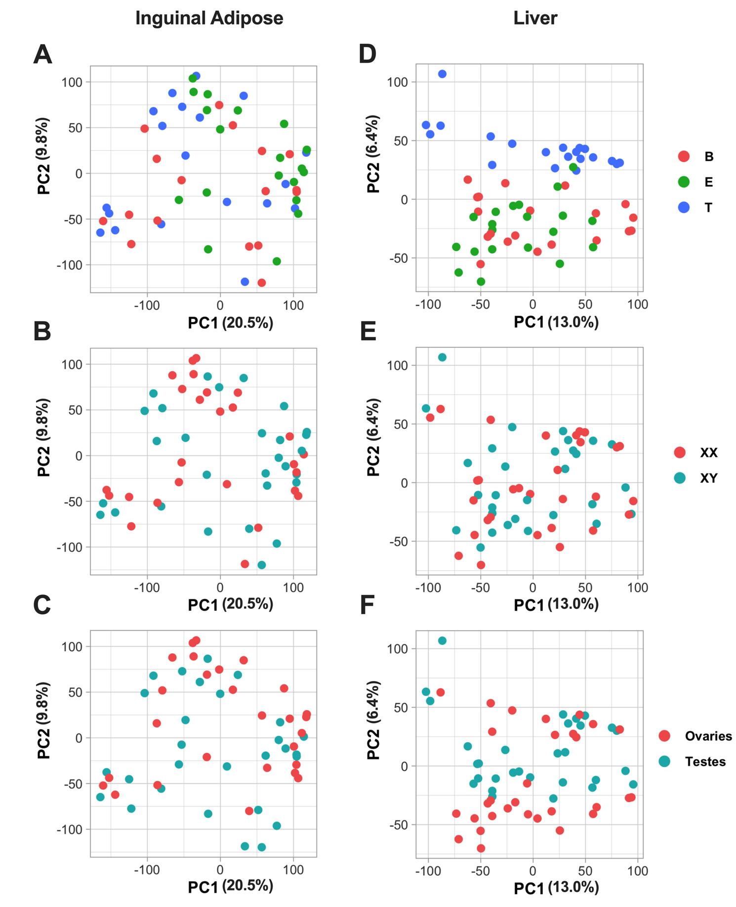
Supplemental Figure S1: PCA plots of inguinal adipose and liver samples colored by different factors
A. Inguinal adipose tissue PCA plot, with samples labelled by hormone types - blank (red), estradiol (green), and testosterone (blue). B. Inguinal adipose tissue PCA plot, with samples were labelled by sex chromosome categories - XX (red) and XY (blue). C. Inguinal adipose tissue PCA plot, with samples labelled by gonadal sex categories - ovaries (red) and testes (blue). D. Liver tissue PCA plot, with samples were labelled by hormone types - blank (red), estradiol (green), and testosterone (blue). E. Liver tissue PCA plot, with samples labelled by sex chromosome categories - XX (red) and XY (blue). F. Liver tissue PCA plot, with samples labelled by gonadal sex categories - ovaries (red) and testes (blue).

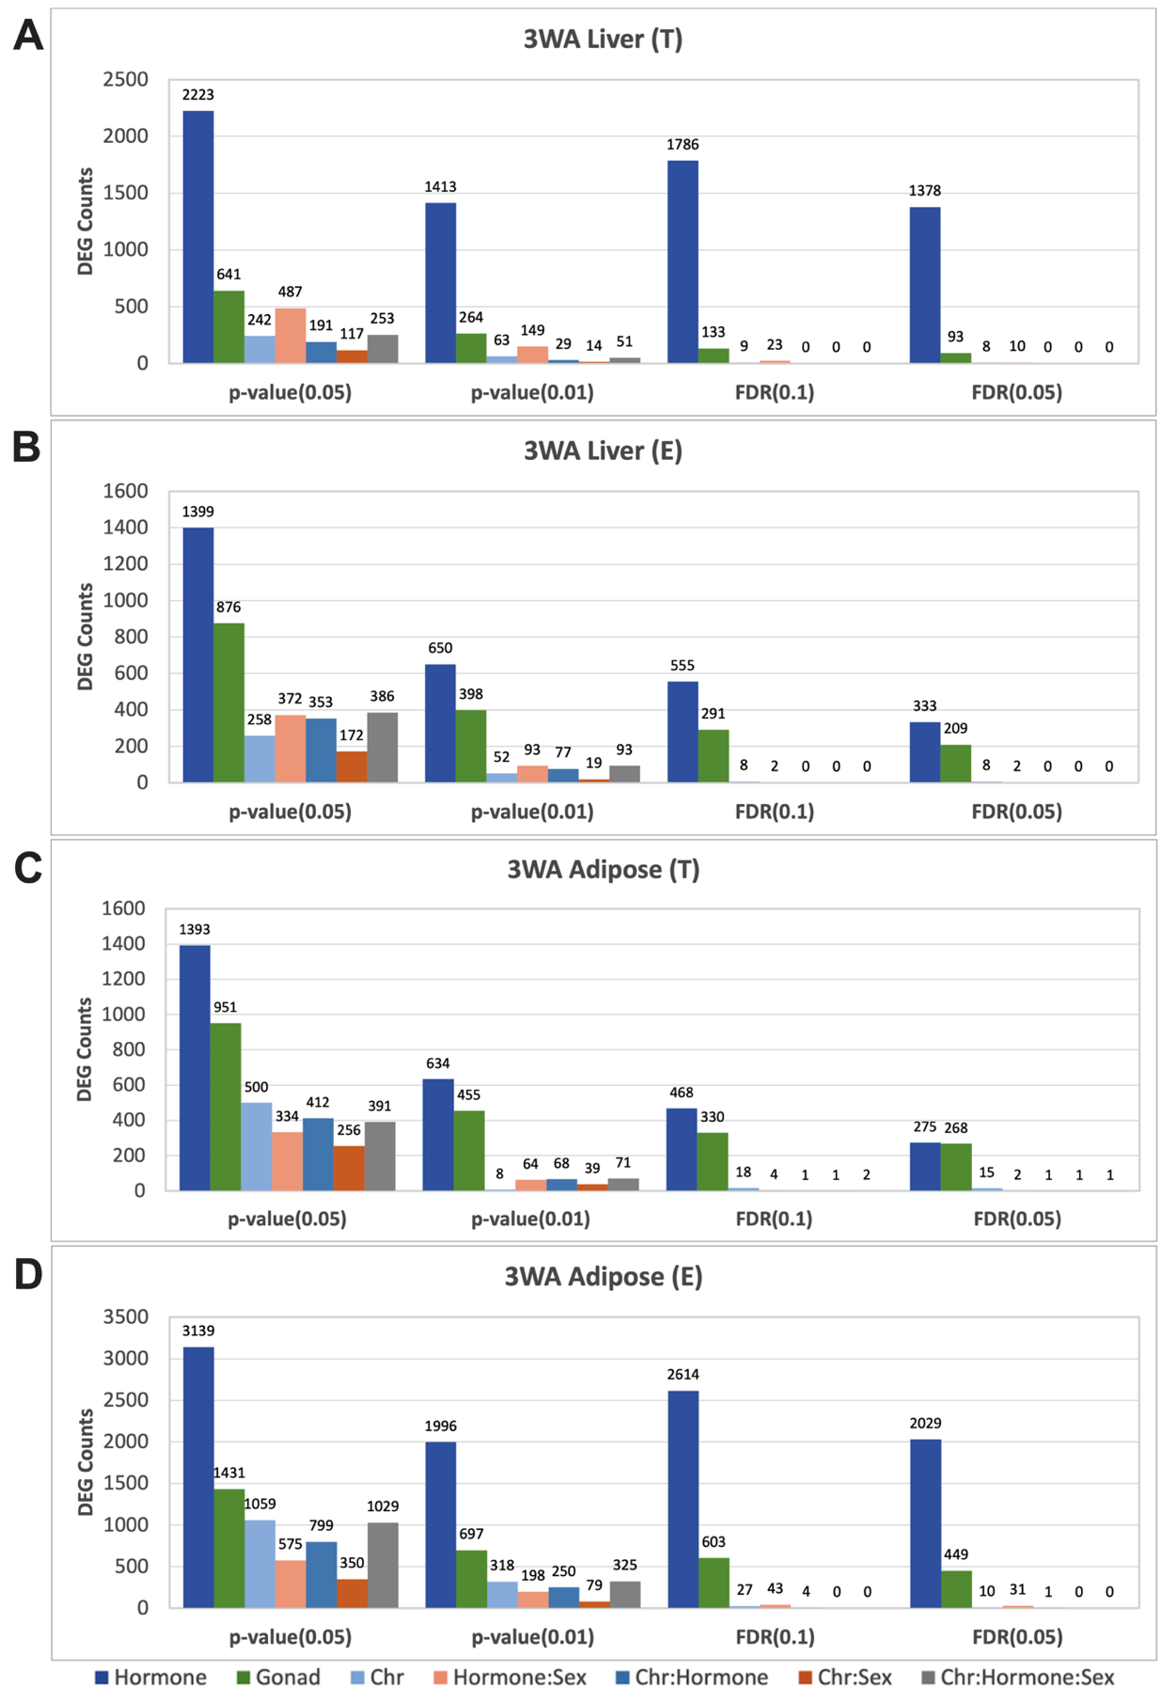

Supplemental Figure S2: Bar graphs representing the 3-way ANOVA DEG numbers across various statistical cutoffs. Across the cutoffs there is a consistent trend of which sex biasing factor produces greater influence on DEG numbers: hormones (testosterone T or estradiol E) > gonad > sex chromosome. (A) Liver 3WA DEG counts when Testosterone (T) and blank groups are considered. (B). Liver 3WA DEG counts when Estradiol (E) and blank groups are considered. (C) Adipose 3WA DEG counts when Testosterone (T) and blank groups are considered. (D) Adipose 3WA DEG counts when Estradiol (E) and blank groups are considered.
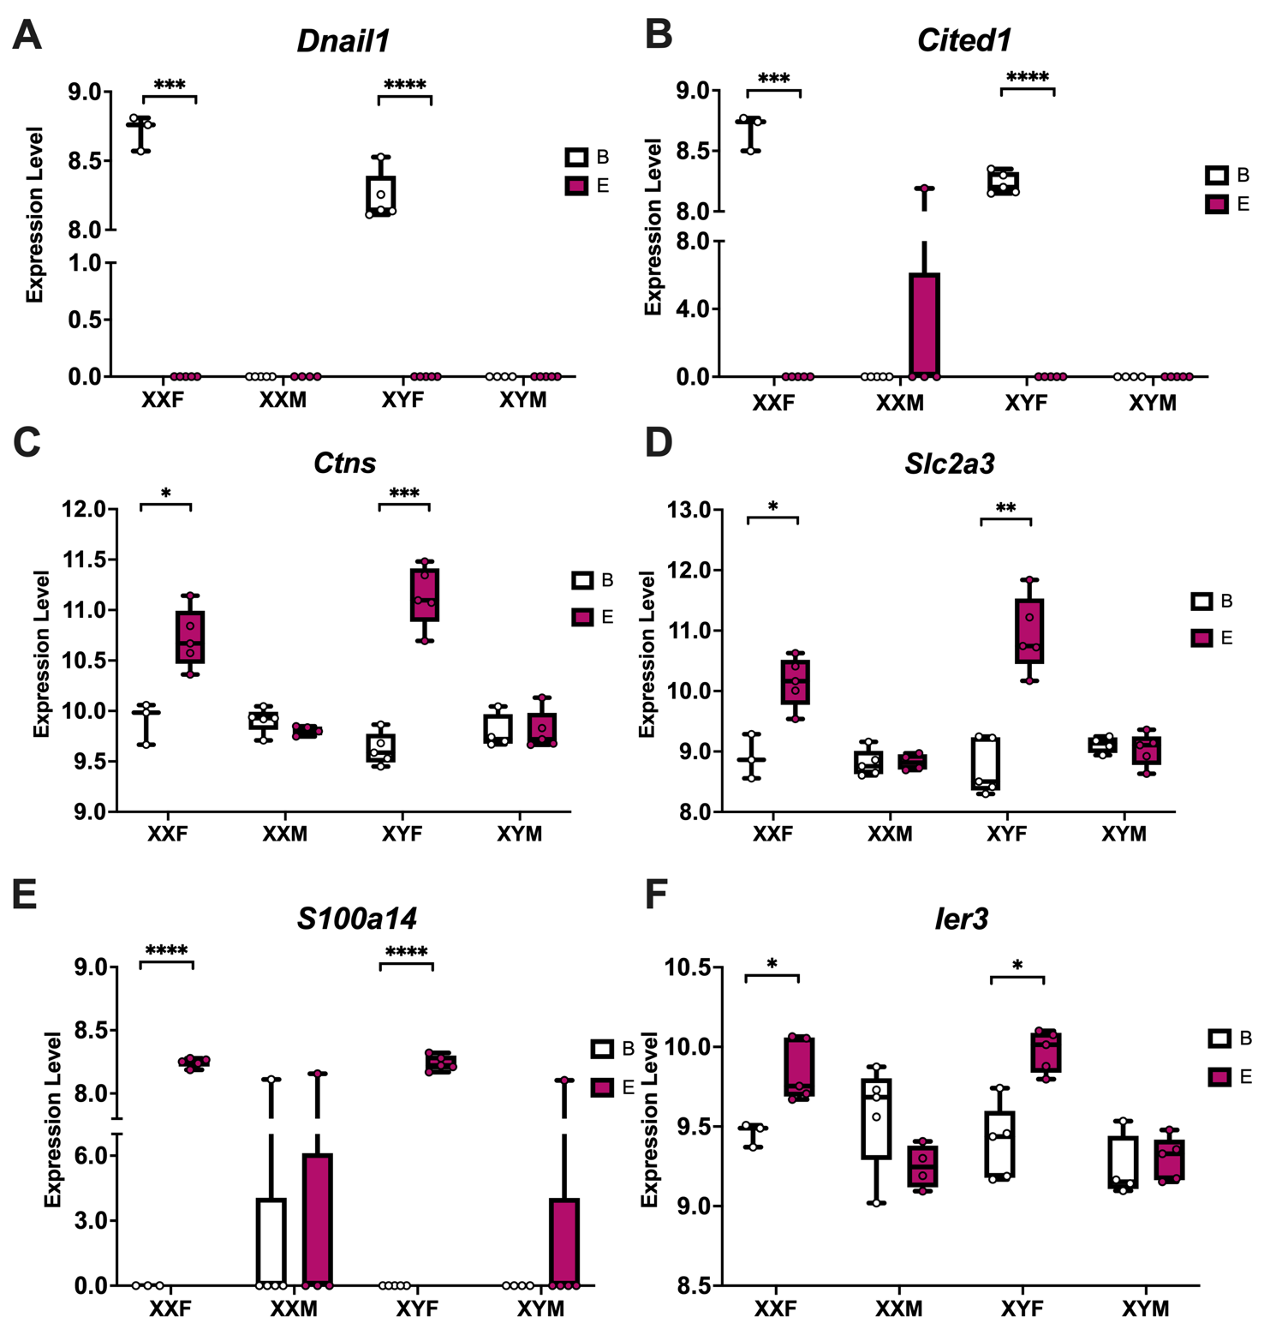

Supplemental Figure S3: Bar Plots highlighting genes that showcase significant interactions between estradiol and gonad type in adipose tissue. T-test was used to calculate within genotype statistical significance. FDR<0.0001****, FDR<0.001***, FDR<0.01**, FDR<0.05*

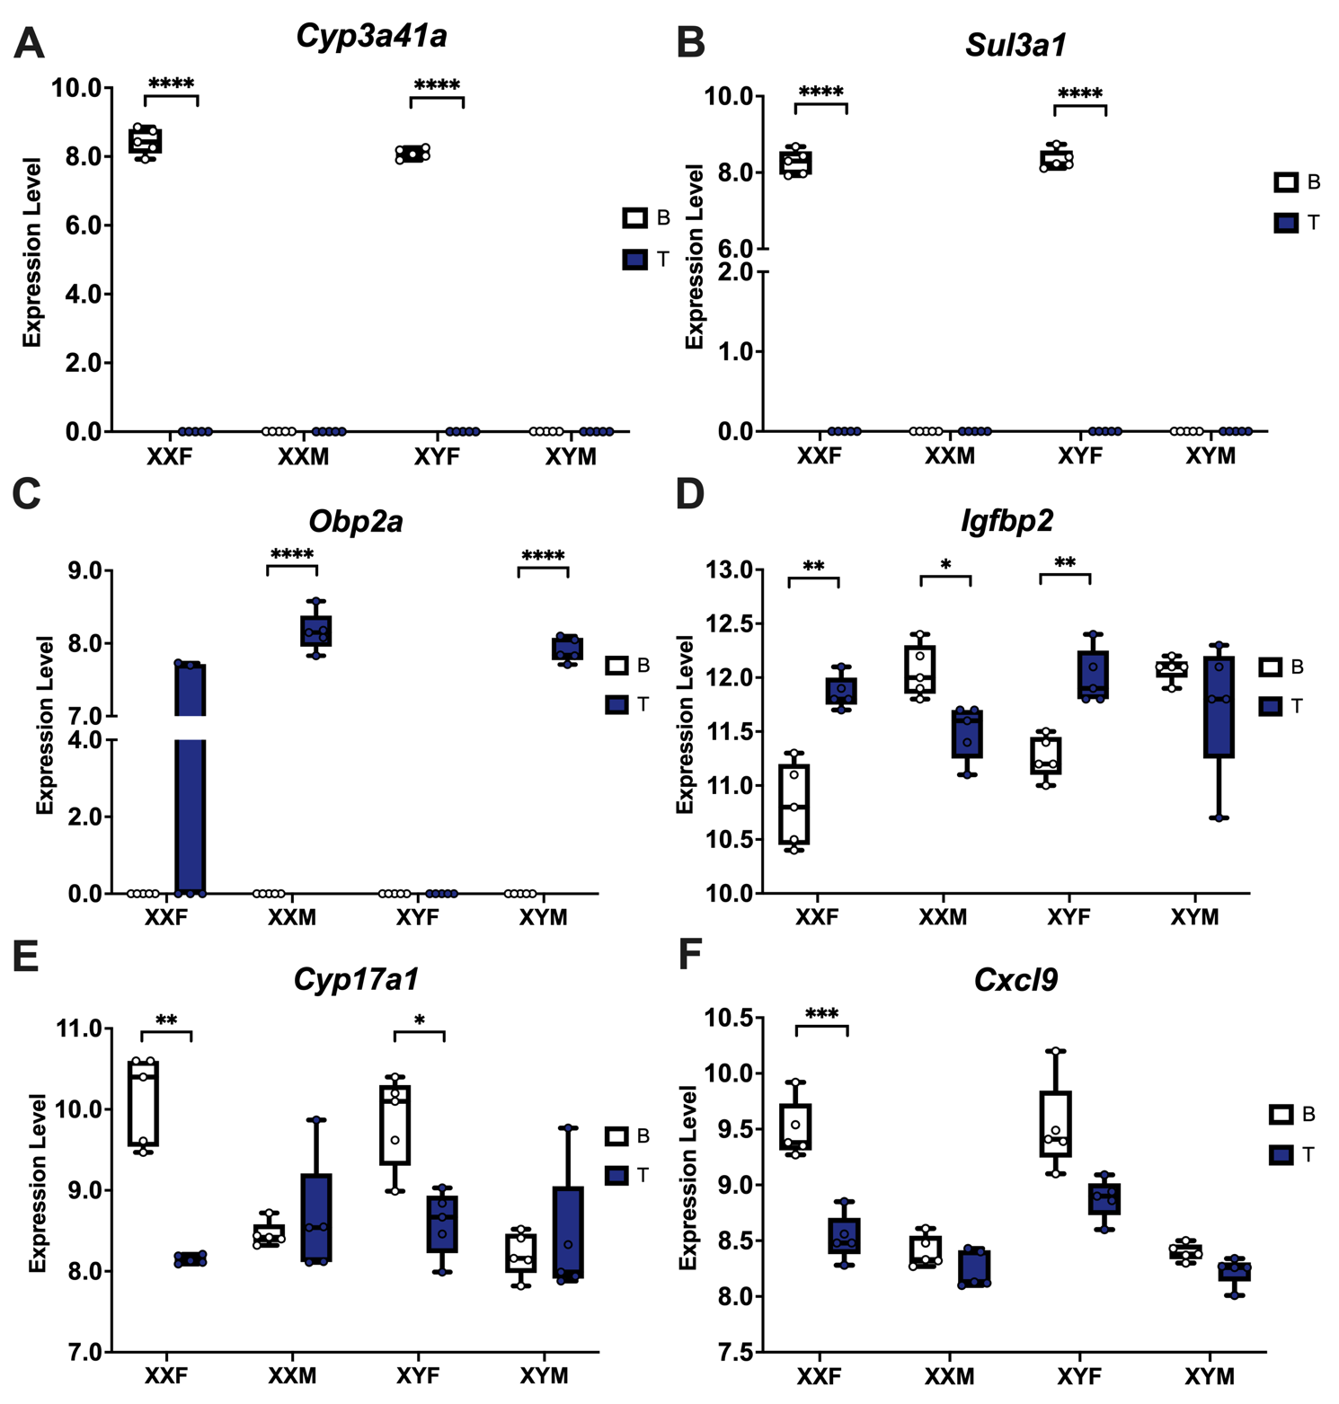
Supplemental Figure S4: Bar Plots highlighting genes that showcase significant interactions between testosterone and genotypes in liver. T-test was used to calculate within genotype statistical significance. FDR<0.0001****, FDR<0.001***, FDR<0.01**, FDR<0.05*

Supplemental Figure S5: Bar Plots highlighting genes that showcase sex bias in the human GTEx study (Oliva et al. 2020) which also show a matched sex bias through one of the sex biasing factors in adipose tissue. We highlight in the heading of each panel the statistical test conducted and their associated FDR value.

Supplemental Figure S6: Bar Plots highlighting genes that showcase sex bias in the human GTEx study (Oliva et al. 2020) which also show a matched sex bias through one of the sex biasing factors in liver tissue. We highlight in the heading of each panel the statistical test conducted and their associated FDR value.

Supplemental Figure S7: Deconvolution results for the liver, highlighting cell types that showed a statistical difference in cell type proportion between hormone treatments (A-E), gonads (F-I), and sex chromosome (J-L). * FDR<0.05, ** FDR <0.01, ns. not significant. For hormonal comparison we used the 1 Way ANOVA followed by post hoc analysis and for gonad and chromosome we used a T-test to calculate statistics.

Supplemental Figure S8: Deconvolution results for the adipose tissue, highlighting cell types that showed a statistical difference in cell type proportion between hormone treatments (A-J), gonads (K), and sex chromosome (L-O). * FDR<0.05, ** FDR <0.01, ns. not significant. 1 Way ANOVA followed by post hoc analysis to calculate statistics for those with three groups and T-test was used for those with two groups.

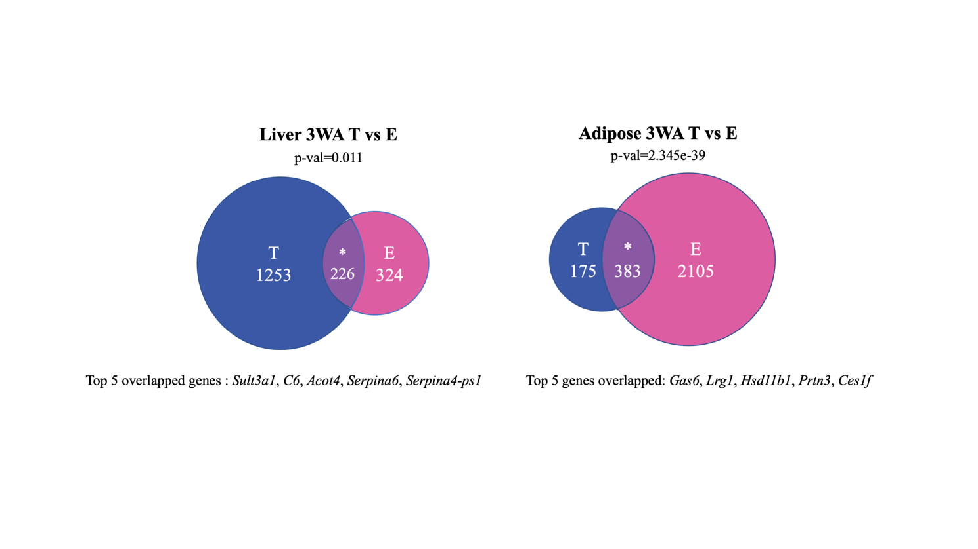
Supplemental Figure S9: Venn diagrams representing 3-way ANOVA DEG comparison between testosterone (T)- and estradiol (E)-treated group in liver and inguinal adipose tissue.

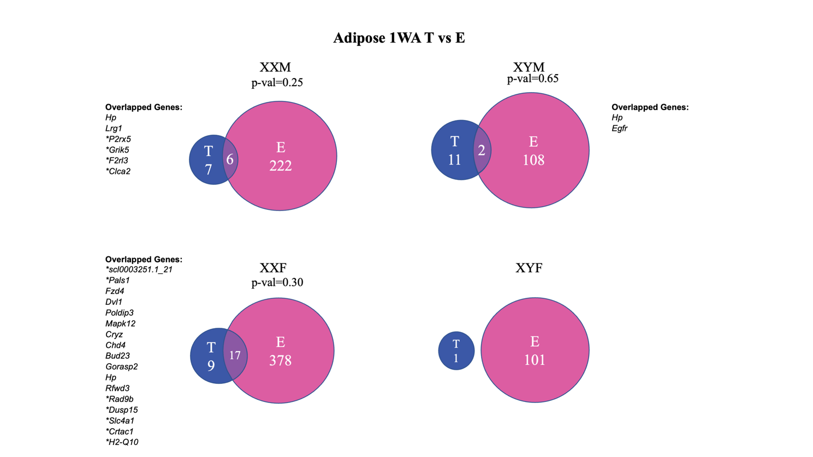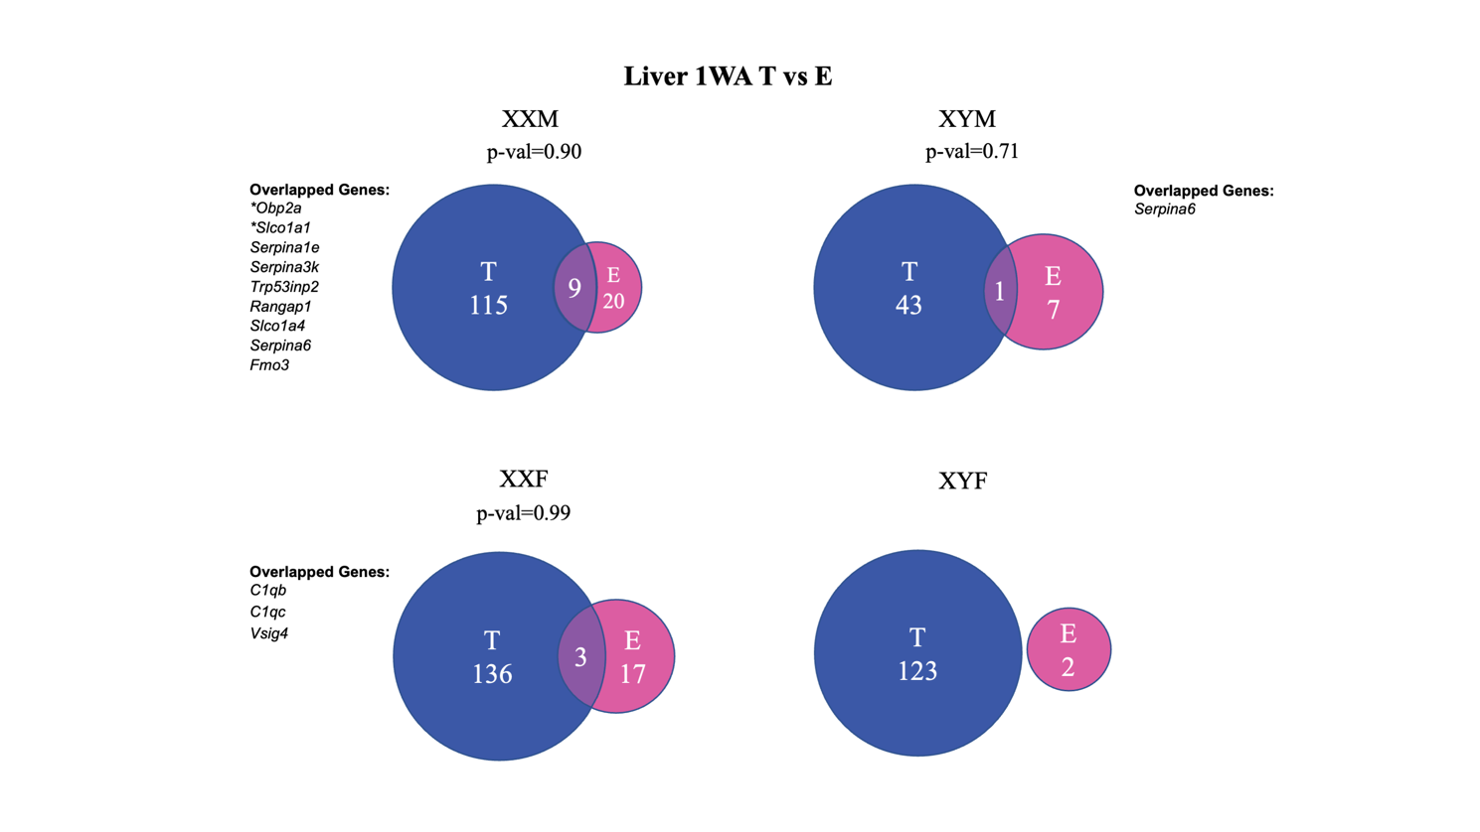

Supplemental Figure S10: Venn diagrams representing 1-way ANOVA DEG comparison between testosterone (T)- and estradiol (E)-treated group across all genotypes in liver and inguinal adipose tissue.

Supplemental Tables
Tables S1-S18 are available as separate online Excel files.

References
Benjamini Y, Hochberg Y. 1995. Controlling the false discovery rate: a practical and powerful approach to multiple testing. Journal of the Royal statistical society: series B (Methodological) 57: 289-300.
Chen X, Williams-Burris SM, McClusky R, Ngun TC, Ghahramani N, Barseghyan H, Reue K, Vilain E, Arnold AP. 2013. The Sex Chromosome Trisomy mouse model of XXY and XYY: metabolism and motor performance. Biology of sex differences 4: 1-13.
Emilsson V, Thorleifsson G, Zhang B, Leonardson AS, Zink F, Zhu J, Carlson S, Helgason A, Walters GB, Gunnarsdottir S. 2008. Genetics of gene expression and its effect on disease. Nature 452: 423-428.
Kudwa A, Harada N, Honda S-I, Rissman E. 2009. Regulation of progestin receptors in medial amygdala: estradiol, phytoestrogens and sex. Physiology & behavior 97: 146-150.
Lonsdale J, Thomas J, Salvatore M, Phillips R, Lo E, Shad S, Hasz R, Walters G, Garcia F, Young N. 2013. The genotype-tissue expression (GTEx) project. Nature genetics 45: 580-585.
MacArthur J, Bowler E, Cerezo M, Gil L, Hall P, Hastings E, Junkins H, McMahon A, Milano A, Morales J. 2017. The new NHGRI-EBI Catalog of published genome-wide association studies (GWAS Catalog). Nucleic acids research 45: D896-D901.
Ngun TC, Ghahramani NM, Creek MM, Williams-Burris SM, Barseghyan H, Itoh Y, Sánchez FJ, McClusky R, Sinsheimer JS, Arnold AP. 2014. Feminized behavior and brain gene expression in a novel mouse model of Klinefelter Syndrome. Archives of sexual behavior 43: 1043-1057.
Schadt EE, Molony C, Chudin E, Hao K, Yang X, Lum PY, Kasarskis A, Zhang B, Wang S, Suver C. 2008. Mapping the genetic architecture of gene expression in human liver. PLoS Biol 6: e107.
Seney ML, Ekong KI, Ding Y, Tseng GC, Sibille E. 2013. Sex chromosome complement regulates expression of mood-related genes. Biology of sex differences 4: 20.
Shu L, Zhao Y, Kurt Z, Byars SG, Tukiainen T, Kettunen J, Orozco LD, Pellegrini M, Lusis AJ, Ripatti S et al. 2016. Mergeomics: multidimensional data integration to identify pathogenic perturbations to biological systems. BMC Genomics 17: 874.
Tu Z, Keller MP, Zhang C, Rabaglia ME, Greenawalt DM, Yang X, Wang I-M, Dai H, Bruss MD, Lum PY. 2012. Integrative analysis of a cross-loci regulation network identifies App as a gene regulating insulin secretion from pancreatic islets. PLoS Genet 8: e1003107.
Wang SS, Schadt EE, Wang H, Wang X, Ingram-Drake L, Shi W, Drake TA, Lusis AJ. 2007. Identification of pathways for atherosclerosis in mice: integration of quantitative trait locus analysis and global gene expression data. Circulation research 101: e11-e30.
Yang X, Schadt EE, Wang S, Wang H, Arnold AP, Ingram-Drake L, Drake TA, Lusis AJ. 2006. Tissue-specific expression and regulation of sexually dimorphic genes in mice. Genome Res 16: 995-1004.
Zhu J, Sova P, Xu Q, Dombek KM, Xu EY, Vu H, Tu Z, Brem RB, Bumgarner RE, Schadt EE. 2012. Stitching together multiple data dimensions reveals interacting metabolomic and transcriptomic networks that modulate cell regulation. PLoS Biol 10: e1001301.
Zhu J, Wiener MC, Zhang C, Fridman A, Minch E, Lum PY, Sachs JR, Schadt EE. 2007. Increasing the power to detect causal associations by combining genotypic and expression data in segregating populations. PLoS Comput Biol 3: e69.
Zhu J, Zhang B, Smith EN, Drees B, Brem RB, Kruglyak L, Bumgarner RE, Schadt EE. 2008. Integrating large-scale functional genomic data to dissect the complexity of yeast regulatory networks. Nature genetics 40: 854-861.

