Supplemental Material for

Genomic environments scale the activities of diverse core promoters
Clarice KY Hong, Barak A Cohen

Content:
Supplemental Figs. S1-S11
Supplemental Tables S1-S5
Supplemental Data Legends

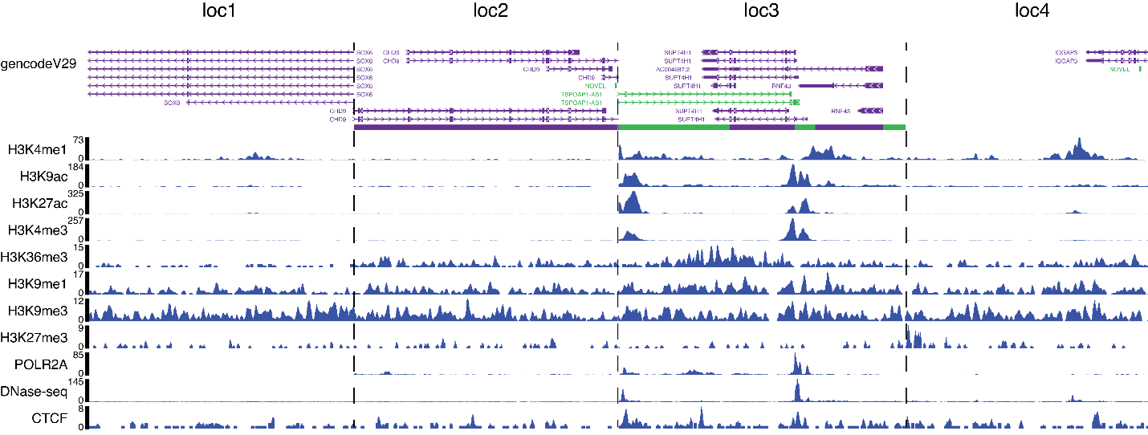
Supplemental Fig. S1
Landing pad locations have diverse chromatin marks and transcriptional activity. Each section is 10kb surrounding the location of landing pad integration.

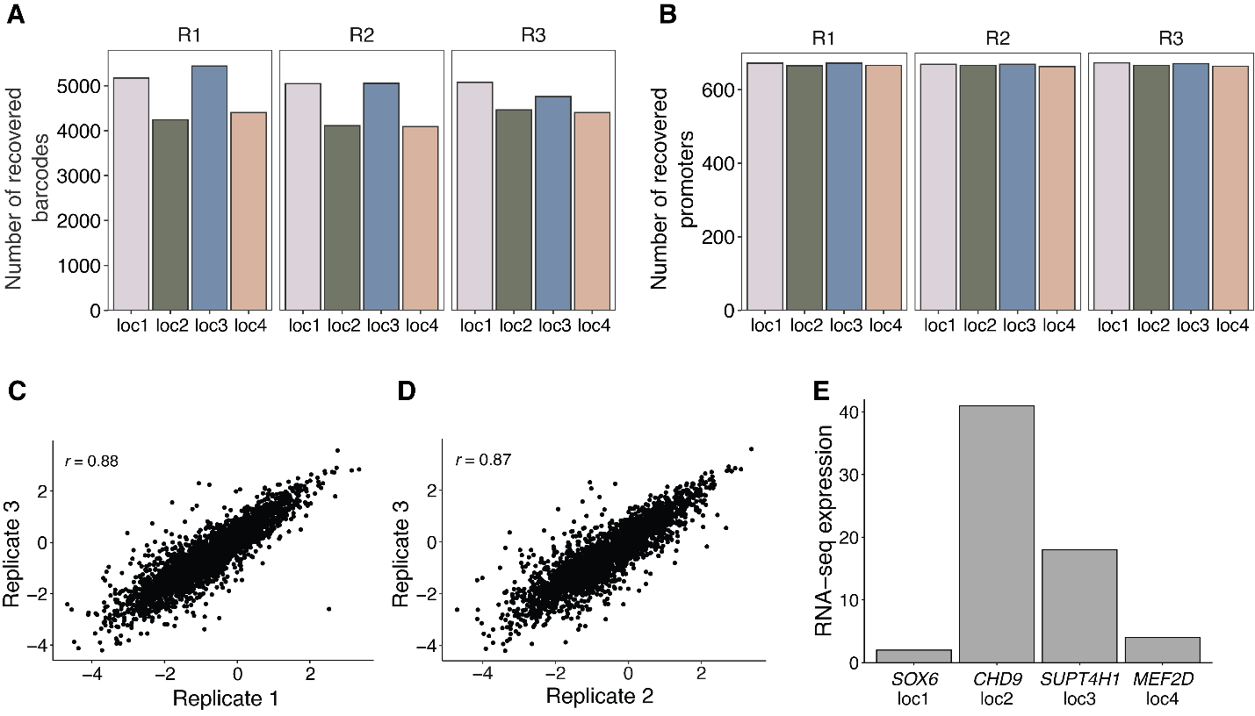

Supplemental Fig. S2.
patchMPRA measurements are robust and reproducible. (A) Number of promoter barcodes recovered from each location per biological replicate. (B) Number of promoters recovered from each location per biological replicate. (C-D) Reproducibility of core promoter measurements from independent patchMPRA transfections. (E) Expression of genes that the landing pads are located in (locs 1-3) and closest promoter (loc4) as measured by RNA-seq.
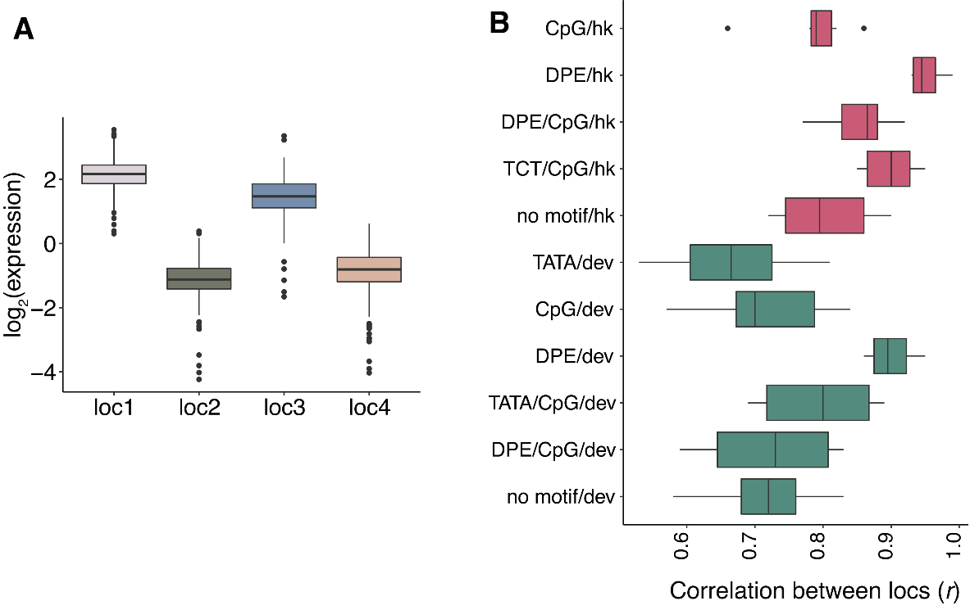
Supplemental Fig. S3
Effect of genomic locations on core promoters. (A) Expression of a library of proximal enhancers at each genomic location (Maricque et al. 2019). (B) All pairwise correlations (Pearson's r) between genomic locations for core promoters with different motifs within each class.

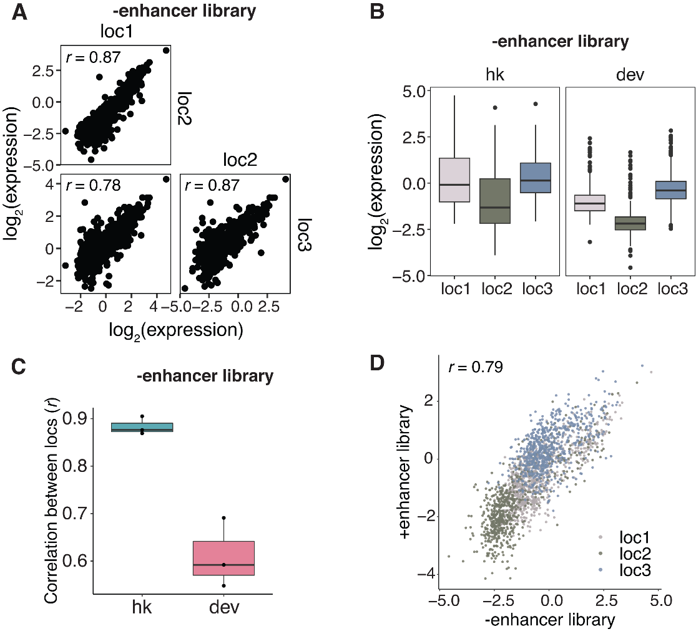

Supplemental Fig. S4
Core promoter scaling is not dependent on the proximal enhancer. (A) Pairwise correlations (Pearson's r) of core promoter activity between the different genomic locations after removing the proximal enhancer upstream of the core promoter. (B) Expression of hk and dev promoters at each genomic location without the proximal enhancer. (C) All pairwise correlations (Pearson's r) between genomic locations for hk and dev core promoters without the proximal enhancer. (D) Correlation between expression with and without the proximal enhancer at locations 1-3.

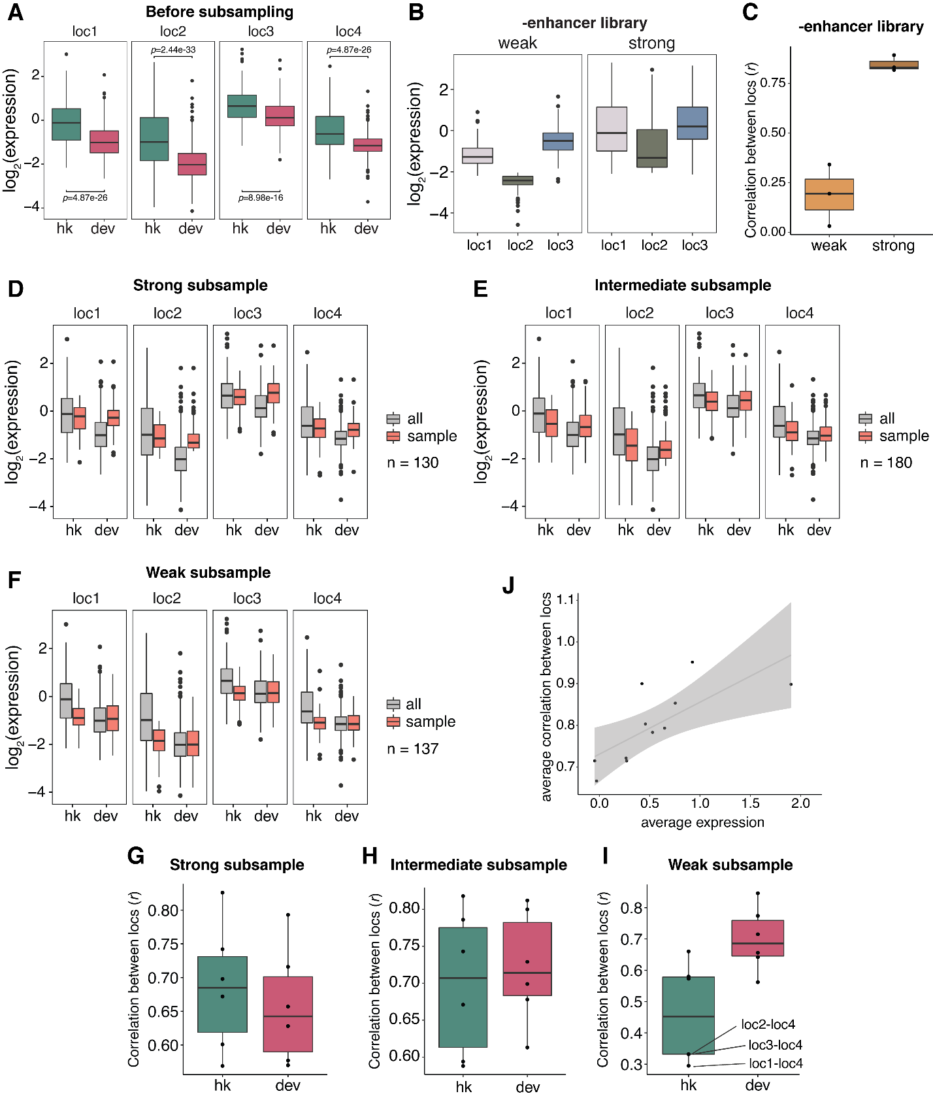

Supplemental Fig. S5
Intrinsic promoter strength explains differences between classes of core promoters. (A) Expression of all hk and dev promoters at each genomic location. p-values were calculated by Student’s t-tests. (B) The effect of genomic location on the expression of weak and strong core promoters after removing the proximal enhancer upstream of the promoter. (C) All pairwise correlations between genomic locations for weak and strong core promoters without the proximal enhancer. (D-F) Expression of hk and dev promoters at each genomic location after sampling promoters such that the two classes have equivalent strong, intermediate and weak strengths respectively. n indicates number of promoters sampled from each class for each subsample. (G-I) All pairwise correlations between genomic locations for subsampled weak, intermediate and strong hk and dev core promoters respectively. Locations with low correlations in I are highlighted. (J) The pairwise correlations of core promoters with different motifs (from Supplemental Fig. S2) are explained by the average expression of each group.

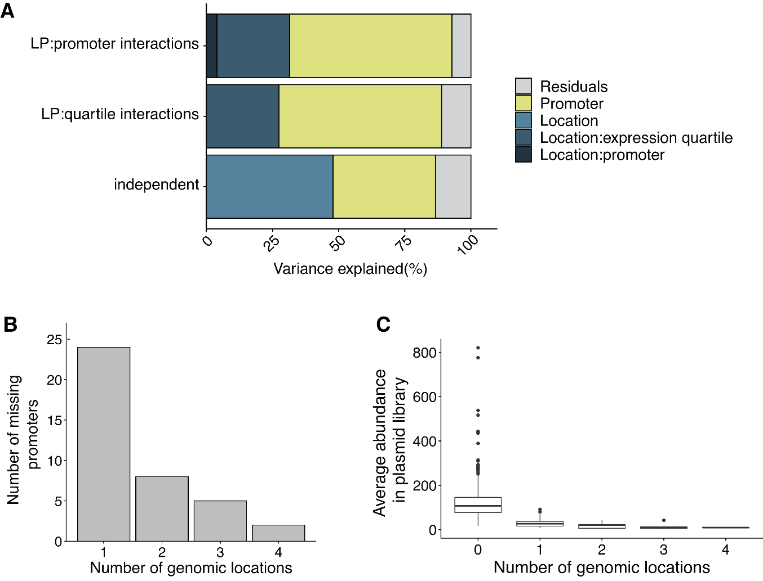
Supplemental Fig. S6
Specific interactions between landing pads and promoters are rare. (A) Variance explained by each term in models with or without interactions between genomic locations and expression quartile or promoters. (B) Number of promoters that were not detected in one, two, three or four landing pads respectively. (C) Average abundance of promoters in plasmid library that were not detected in zero, one, two, three or four landing pads respectively.

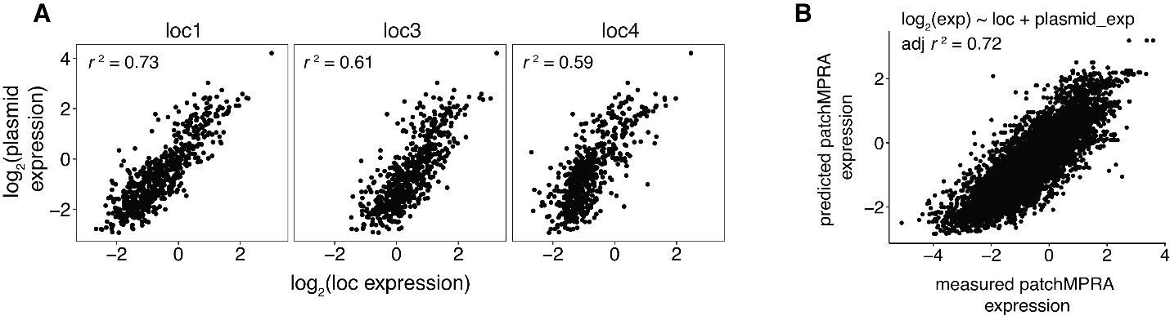
Supplemental Fig. S7
Core promoter activities in the genome reflect the promoters' intrinsic activity. (A) Correlations between expression of core promoter library measured on plasmids and at the indicated genomic location by patchMPRA. (B) Correlation between measured expression by patchMPRA and predicted expression by a linear model using core promoter intrinsic activity measured on plasmids. All correlations were calculated as Pearson’s r.

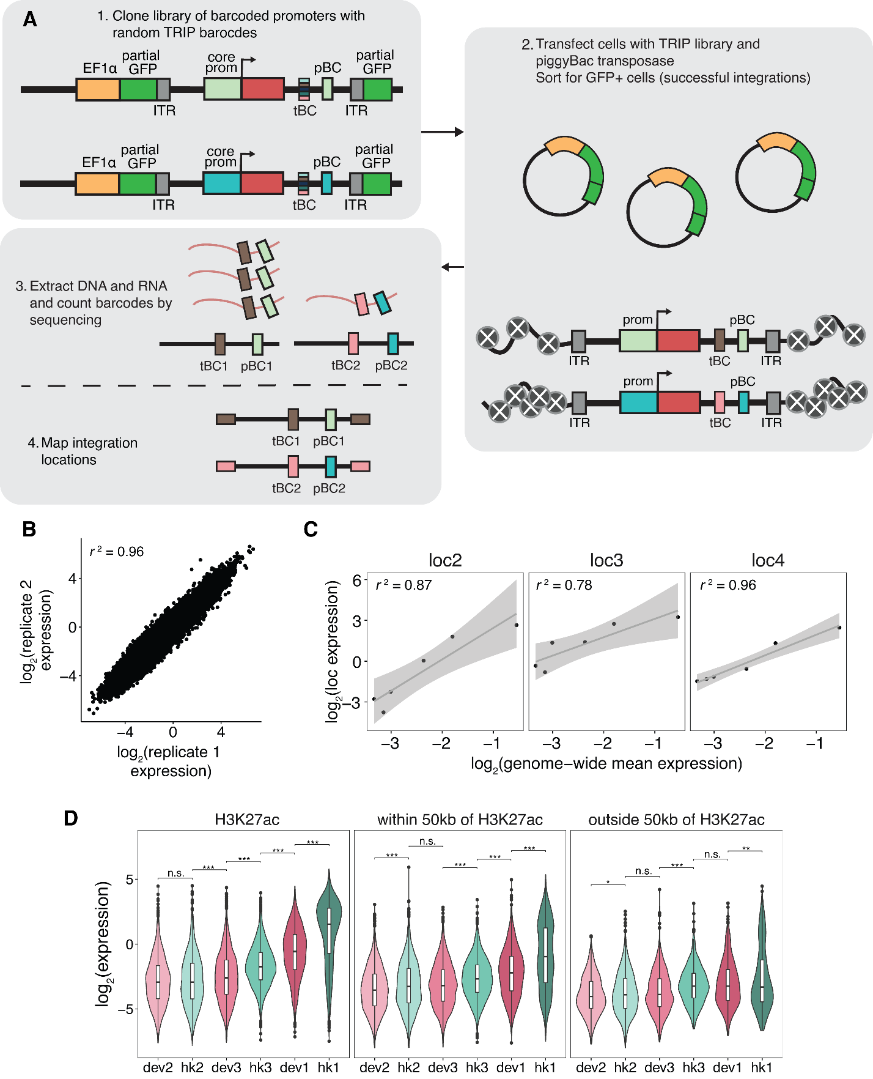

Supplemental Fig. S8

Measurements of six core promoters at thousands of genomic locations by TRIP. (A) Schematic of TRIP experiment. tBC: TRIP barcode; pBC: promoter barcode; ITR: inverted terminal repeats. (B) Reproducibility between measurements from independent DNA and RNA extractions. (C) Correlations between mean expression of core promoters measured by TRIP and at the indicated genomic location by patchMPRA. (D) Expression of core promoters at locations that overlap with H3K27ac sites, are within 50kb of H3K27ac sites or are outside 50kb of H3K27ac sites. p-values were calculated by Student’s t-tests. n.s.: not significant, * p<0.05, ** p<0.001, *** p<0.005.

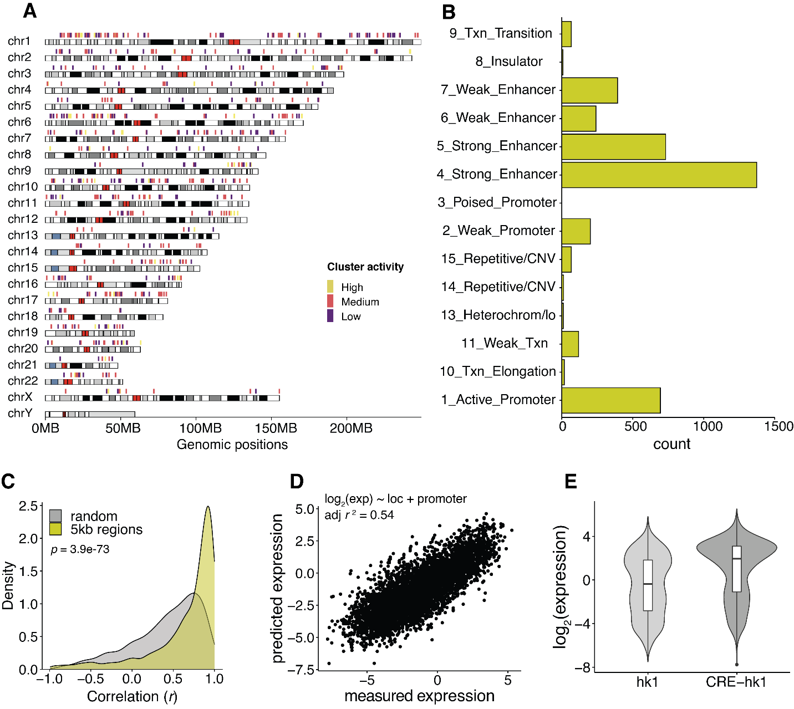

Supplemental Fig. S9

Core promoter scaling is a genome-wide phenomenon. (A) Regions with ≥4 different promoters integrated within 5kb of each other are located across the genome. Cluster activity was designated by the analysis in Fig. 5B. (B) Distribution of chromHMM annotations of defined 5kb regions. (C) For each defined 5kb region, correlations (Pearson's r) between core promoter activity measured by TRIP and by patchMPRA were calculated and all correlations were plotted as a density plot. As a comparison, we randomly grouped promoters without considering their integration locations and calculated the correlations for each group. The p value was calculated using the Mann–Whitney U test. (D) Correlation between measured expression by TRIP and predicted expression using a model assuming independence between genomic environments and core promoters. (E) Expression of all integrations of hk1 and hk1 with an upstream cis-regulatory enhancer (CRE-hk1).

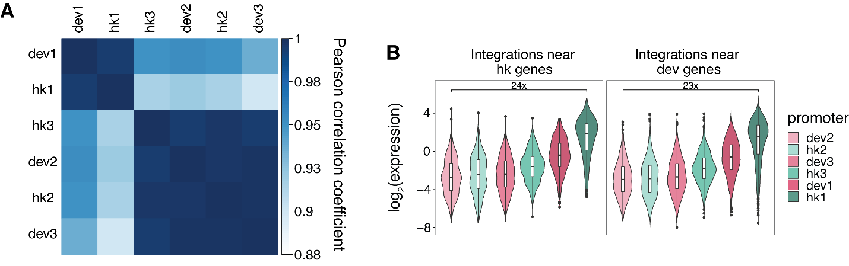

Supplemental Fig. S10

Promoter strength, not class, determines its interaction with the genomic environment. (A) Correlation coefficients between curves fitted on each promoter in Fig. 5A. (B) Hk and dev integrated core promoters behave similarly near endogenous hk or dev promoters.

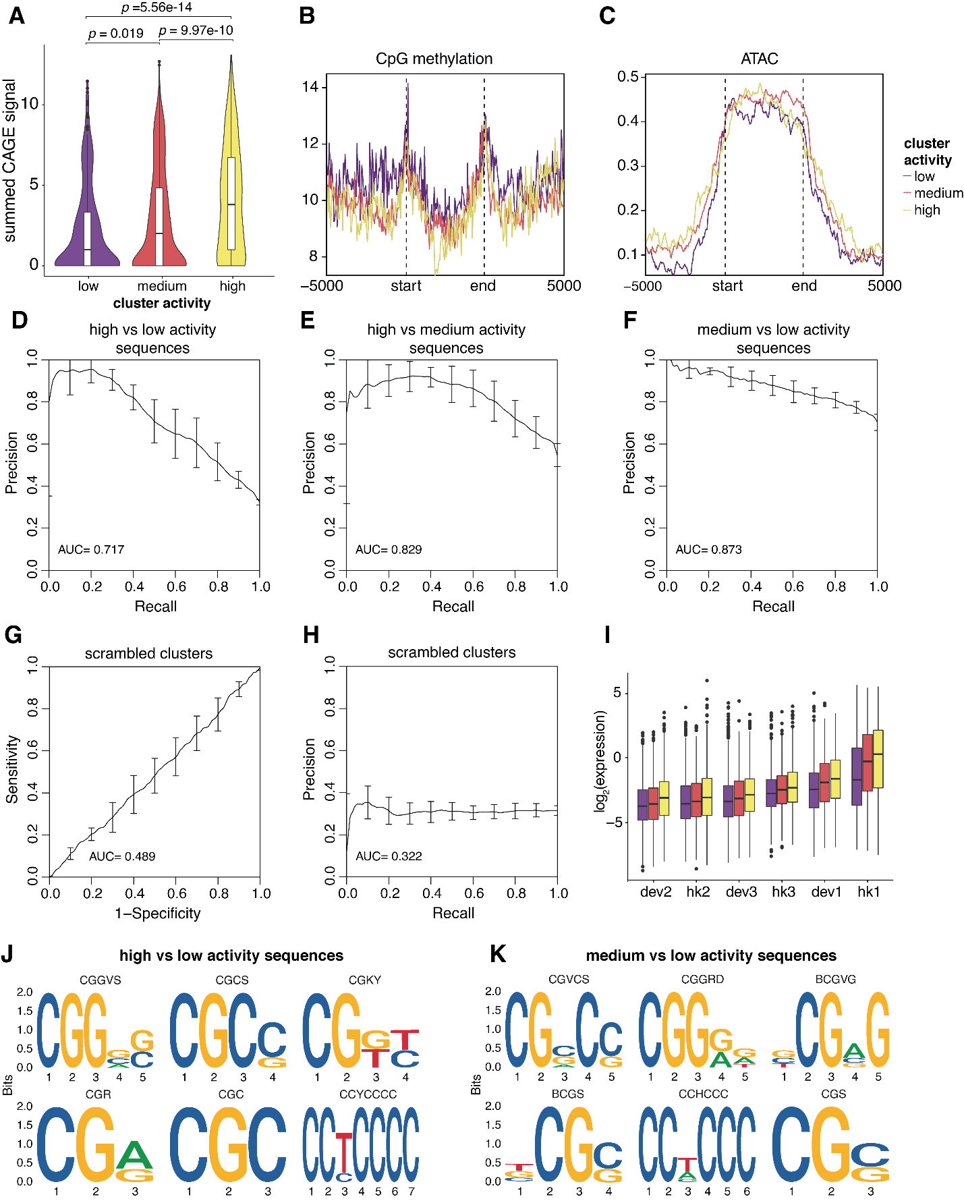

Supplemental Fig. S11

Epigenomic signatures and sequence features of different genomic activity clusters. (A) CAGE-seq signal was calculated for each genomic region, and the summed signals were plotted for each cluster. p values were calculated by Student's t-tests. (B, C) Metaplots of CpG methylation and ATAC-seq signals respectively in each genomic cluster. The start and end mark the boundaries of each genomic region, which are determined by the first and last integration in the region. The x-axis extends +/- 5kb around each genomic region. (D, E, F) Performance of gkmSVM used to classify sequences from different genomic clusters. Precision-recall curves (PRCs) were generated using five-fold cross-validation. (G, H) Performance of gkmSVM on sequences with scrambled cluster assignments. (I) TRIP integrations that were not included in the 5kb genomic region analysis were assigned to a cluster based on their sequence features from the gkmSVM, and the expression of each promoter was plotted based on their predicted clusters. (J, K) Top 6 motifs identified by de novo motif finding comparing high/low and medium/low activity sequences respectively.

Supplemental Table S1
Composition of promoter classes in the core promoter library.
Promoter class | hk/dev | Number
TATA-box | dev | 100
CpG island | hk | 100
CpG island | dev | 100
TCT | hk | 2
DPE | hk | 8
DPE | dev | 13
No known motif | hk | 100
No known motif | dev | 100
TATA-box & CpG island | dev | 63
TATA-box & DPE | dev | 2
DPE & CpG island | dev | 14
DPE & CpG island | hk | 43
TCT & CpG island | hk | 22
SCP (and mutants) | - | 4
Total |  | 676

Supplemental Table S2
Locations of four landing pads in patchMPRA.
Name | Chr | Location (hg19) | Annotation | Name in Maricque et al.
loc1 | chr11 | 16,258,750 | SOX6 Intron | LP3
loc2 | chr16 | 53,275,015 | CHD9 Intron | LP4
loc3 | chr17 | 56,426,171 | SUPT4H1 Intron | LP5
loc4 | chr1 | 156,489,766 | Intergenic | LP6

Supplemental Table S3

Promoters selected for TRIP.
Name | Oligo_id | Number of  TRIP integrations | Sequence
hk1 | chr1_153963171_153963304_+ | 6032 | GCACAAGATCCTTGCGTCATTTCCTGTAGTGTGCTCTATATAAGGGGCAGGATTTCCGCTTTCGCTCCTTTCCGGCGGTGACGACCTACGCACACGAGAACATGCCTGTGAGTGCTTTGGTCCAGGTTTCGGC
hk2 | chr7_94285368_94285501_- | 7157 | GGGATGCTGATGCTGACTGGCCAAGCTGGGAGGGAAGAAGAAAGGGAGGGGAGGGGAGAATCGAGGACGGACGGCCTAGCCAGGCCAAGAATGCAATTGCCCCGGTGGTGGGAGCTGGGAGACCCCTGTGCT
hk3 | chr1_19638753_19638886_+ | 6851 | GGGCGGGGCCTGCGGTTCCCGCGGGGGCGGTGGCGCGCGGTCAGCTGACCCGGCGGGCTTGACCCAGAAGCTGGGCCCTGGCGGCGGATCTGGACGTGGTGAGCCGGACCGGGGGCAGGTGGCAAACTTCAC
dev1 | chr17_5522677_5522810_- | 6328 | CTCGCGATAGTGAGTGAGTTCCCACGAGATCTGATGGTTTTATAAGGGGCTTCCCCGTTACTCAGCACTTCTTCTCTCCTGCCGCCATTTGAAGGACGTGTCTGCTTCCACTCCTGCCGTGATTGTCAGCTTC
dev2 | chr21_33976756_33976889_- | 7079 | TATCTCCCGATCCTCACTGCCATCTGTGCTGCCAGCATTGGGCTCTTTCTCCTTTGAGAATTCTTTGCACTTCATTGTACTCCATGCTCAGTGCTGCTCACCGTCTGCTTTATAATACAGGCCACGGTGTGCT
dev3 | chr1_1009619_  1009752_- | 7364 | CTGAGGCTTGCGGCCACACCCTTGGCCCATAGGGTATAAATAGACCTGCTTGGGAGCCCACACCCAGCAACTCACACCTGCCTCAGACCAGAGCTCTGTGCGGGTGACGGCGCACGCATTCCTTGTGTCCCCG

Supplemental Table S4

Primers used in this study
Name | Sequence | Description
CPL1 | TCTCCTCCGGCTCGCTGATTTACTTACACGG`AGTGGATA | Amplify oligo library for subcloning
CPL2 | TACATTATACGAAGTTATGTCGAC | Amplify oligo library for subcloning
CPL3 | CCTTACACGGAGTGGATA | Amplify oligo library for subcloning
CPL4 | CCCCGTAATGCAGAAGAAGA | Amplify barcodes from integrated promoter library for Illumina sequencing.
CPL5 | GCAGCGTATCCACATAGCGTAAAAG | Amplify barcodes from integrated promoter library for Illumina sequencing.
CPL6 | CTTTCCCTACACGACGCTCTTCCGATCT  (N₁₋₄)CATGGACGAGCTGTACAAGTAATC  TAGA | Add first round of adapters to promoter library amplified barcodes. Variable numbers of Ns included to phase the library for Illumina sequencing.
CPL7 | GTGACTGGAGTTCAGACGTGTGCTCTTCCGATCT(N₀₋₃)GCGGCCGCTTTAGGATCC | Add first round of adapters to promoter library amplified barcodes. Variable numbers of Ns included to phase the library for Illumina sequencing.
CPL8 | AATGATACGGCGACCACCGAGATCTACACNNNNNNACACTCTTTCCCTACACGACGCT | Add second round of adapters to promoter library amplified barcodes. N's indicated variable sequences for indexing.
CPL9 | CAAGCAGAAGACGGCATACGAGATNNNNNNNNNGTGACTGGAGTTCAGACGTG | Add second round of adapters to amplified barcodes. N's indicated variable sequences for indexing.
CPL10 | ACCATCTACATGGCCAAGAAGC | Amplify barcodes from episomal and TRIP library for Illumina sequencing.
CPL11 | ATATCAGGCGCGCCAAGCTTGGATCCGCACAAGATCCTTGCGTC | Amplify hk1 from promoter library with homology to backbone for HiFi assembly.
CPL12 | TCCTCGCCCTTGCTCACCATCCTAGGGCCGAAACCTGGACCAAA | Amplify hk1 from promoter library with homology to backbone for HiFi assembly.
CPL13 | ATATCAGGCGCGCCAAGCTTGGATCCGGGATGCTGATGCTGAACTGG | Amplify hk2 from promoter library with homology to backbone for HiFi assembly.
CPL14 | TCCTCGCCCTTGCTCACCATCCTAGGAGCACAGGGGTCTCCCAG | Amplify hk2 from promoter library with homology to backbone for HiFi assembly.
CPL15 | ATATCAGGCGCGCCAAGCTTGGATCCGGGCGGGGCCTGCGGTTC | Amplify hk3 from promoter library with homology to backbone for HiFi assembly.
CPL16 | TCCTCGCCCTTGCTCACCATCCTAGGGTGAAGTTTGCCACCTGCCCCCG | Amplify hk3 from promoter library with homology to backbone for HiFi assembly.
CPL17 | ATATCAGGCGCGCCAAGCTTGGATCCCTCGCGATAGTGAGTGAG | Amplify dev1 from promoter library with homology to backbone for HiFi assembly.
CPL18 | TCCTCGCCCTTGCTCACCATCCTAGGGAAGCTGACAATCACGGC | Amplify dev1 from promoter library with homology to backbone for HiFi assembly.
CPL19 | ATATCAGGCGCGCCAAGCTTGGATCCTATCTCCCGATCCTCACTGCCA | Amplify dev2 from promoter library with homology to backbone for HiFi assembly.
CPL20 | TCCTCGCCCTTGCTCACCATCCTAGGAGCACACCGTGGCCTGTA | Amplify dev2 from promoter library with homology to backbone for HiFi assembly.
CPL21 | ATATCAGGCGCGCCAAGCTTGGATCCCTGAGGCTTGCGGCCACA | Amplify dev3 from promoter library with homology to backbone for HiFi assembly.
CPL22 | TCCTCGCCCTTGCTCACCATCCTAGGCGGGGACACAAGGAATGCGTG | Amplify dev3 from promoter library with homology to backbone for HiFi assembly.
CPL23 | GCTCTATAAGTAAGAGCTCTCGCTTCGAGTCTAGANNNNNNNNNNNNNNNNGATCACTCGAGTTGTGGCCGGCCCTT | Oligo for adding random barcodes to TRIP library by HiFi assembly,
CPL24 | AACGCCAGGGTTTTCCCAA | Amplify barcodes from TRIP library for Illumina sequencing.
CPL25 | CTTTCCCTACACGACGCTCTTCCGATCT(N₁₋₄)CTCGCTTCGAGTCTAGA | Add first round of adapters to amplified TRIP barcodes. Variable numbers of Ns included to phase the library for Illumina sequencing.
CPL26 | GTGACTGGAGTTCAGACGTGTGCTCTTCCGATCTGCCAGGGTTTTCCCAAC | Add first round of adapters to amplified TRIP barcodes.
CPL27 | CGCATGATTATCTTTAACGTACGTCAC | Amplify TRIP barcode and associated genomic region by inverse PCR.
CPL28 | GCCAGGGTTTTCCCAAC | Amplify TRIP barcode and associated genomic region by inverse PCR.
CPL29 | ACGACGCTCTTCCGATCTGCTCGAT  (N₀₋₃)GTACGTCACAATATGATTATCTT  TCTAG | Add first round of adapters to TRIP amplified barcodes. Variable numbers of Ns included to phase the library for Illumina sequencing.
CPL30 | GTGACTGGAGTTCAGACGTGTGCTCTTCCGATCTGCCAGGGTTTTCCCAAC | Add first round of adapters to TRIP amplified barcodes. Variable numbers of Ns included to phase the library for Illumina sequencing.
CPL31 | AATGATACGGCGACCACCGAGATCTACACTCTTTCCCTACACGACGCTCTTCCGATCT | Add second round of adapters to TRIP amplified barcodes. N's indicated variable sequences for indexing.

Supplemental Table S5

Sources of epigenome datasets used in this study.
Data | Source Experiment | Source File
H3K27ac ChIP-seq | ENCSR000AKP | ENCFF437DPT
H3K4me3 ChIP-seq | ENCSR000EWA | ENCFF916MPM
PolII ChIP-seq | ENCSR388QZF | ENCFF285MBX
CAGE | FANTOM5 | chronic%20myelogenous%20leukemia%20cell%20  line%3aK562.CNhs11250.10454106G4.hg19.  ctss.bed.gz
CpG methylation | ENCSR765JPC | ENCFF867JRG; ENCFF721JMB
ATAC-seq | ENCSR868FGK | ENCFF698MIQ

Supplemental Data
Supplemental Data S1: Details of core promoter library including names, genomic locations and sequences.

Supplemental Data S2: Expression and genomic locations of TRIP integrations.

Supplemental Data S3: Locations of 5kb regions identified from TRIP data.

Supplemental Data S4: Sequence of pCPL1 with annotations.

Supplemental Data S5: Sequence of pCPL2 with annotations.

Supplemental Data S6: Sequence of pCPL3 with annotations.

Supplemental Data S7: Core promoter library patchMPRA expression.

Supplemental Data S8: Core promoter library episomal MPRA expression.

Supplemental Data S9: Sequence of pCPL4 with annotations.

