Title: Long-read assembly and comparative evidence-based reanalysis of Cryptosporidium genome sequences reveals expanded transporter repertoire and duplication of entire chromosome ends including subtelomeric regions

Authors: Rodrigo P. Baptista^{1,2}, Yiran Li², Adam Sateriale³, Mandy J. Sanders⁴, Karen L. Brooks⁴, Alan Tracey⁴, Brendan R. E. Ansell⁵, Aaron R. Jex⁵, Garrett W. Cooper⁶, Ethan D. Smith⁶, Rui Xiao², Jennifer E. Dumaine³, Peter Georgeson^{6,7,9}, Bernard J. Pope^{6,7,8,10}, Matthew Berriman⁴, Boris Striepen³, James A. Cotton⁴ and Jessica C. Kissinger^{1,2,11}

Affiliation: ¹Center for Tropical and Emerging Global Diseases; ²Institute of Bioinformatics, University of Georgia, Athens, GA, USA; ³Department of Pathology, School of Veterinary Medicine, University of Pennsylvania, Philadelphia, PA, USA; ⁴The Wellcome Sanger Institute, Hinxton, UK; ⁵Faculty of Veterinary and Agricultural Sciences, The University of Melbourne and Population Health and Immunity Division, the Walter and Eliza Hall Institute of Medical Research, Melbourne, Australia; ⁶Department of Clinical Pathology; ⁷Melbourne Bioinformatics; ⁸Department of Surgery (Royal Melbourne Hospital), Melbourne Medical School, Faculty of Medicine, Dentistry and Health Sciences, The University of Melbourne, Australia; ⁹University of Melbourne Centre for Cancer Research, Victorian Comprehensive Cancer Centre, Melbourne, Australia; ¹⁰Department of Medicine, Central Clinical School, Faculty of Medicine Nursing and Health Sciences, Monash University, Australia; ¹¹Department of Genetics, University of Georgia, Athens, GA, USA

SUPPLEMENTAL FIGURES

Fig. S1 - WGS short-read depth coverage plot for the four different assemblies analyzed in this study. CpIA Illumina reads were aligned to each indicated assembly to evaluate the number of potentially compressed regions (Supplemental Table S2). Due to the large number of scaffolds in the Ch309076 assembly (53 scaffolds), it was artificially scaffolded into chromosomes using the CpIA assembly as template using RagTag for presentation purposes only, the true scaffolding is unknown. Magnification of the PDF file reveals many lesser peaks in the plots.

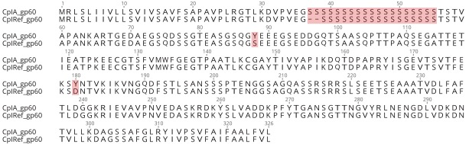
Fig. S2 - GP60 protein sequence alignment between CpIA (CPATCC_0012540) and CpIRef (cgd6_1080). The amino acid differences are highlighted.

Fig. S3 - PCR validation using CpBGF DNA, (Supplemental Table S4). Lanes 1, 2 & 3 are 1kb ladder, positive control Dnmt2 gene and no template control respectively. The remaining lanes test each orientation of the Left, L, and Right, R, inversion boundaries from Chr2, 4 and 5. Primer sequences and locations are as in Fig. 1 and Supplemental Table S4.

Fig. S4 - WGS ONT long-read depth coverage depth coverage comparing CpIRef and CpIA. CpBGF ONT reads were aligned to the CpIA and CpIRef genome assemblies using the minimap2 aligner with -ax map-ont flag and default parameters. Magnification of the PDF file reveals lesser peaks in the plots.

Fig. S5 - C-5 cytosine-specific DNA methylase alignment between the reannotated CpIA compared to other species and the available older truncated CpIRef annotation. Gene IDs for the aligned sequences are: CpIA - CPATCC_0023880; Ch30976 - GY17_00003885; CtUGA55 - CTYZ_00003377; CpIRef - cgd5_2100; CmRN66 - CMU_039710; ChUdeA01 - CHUDEA5_2100; Pf3D7 - PF3D7_0727300; A. thaliana - NP_568474.1.

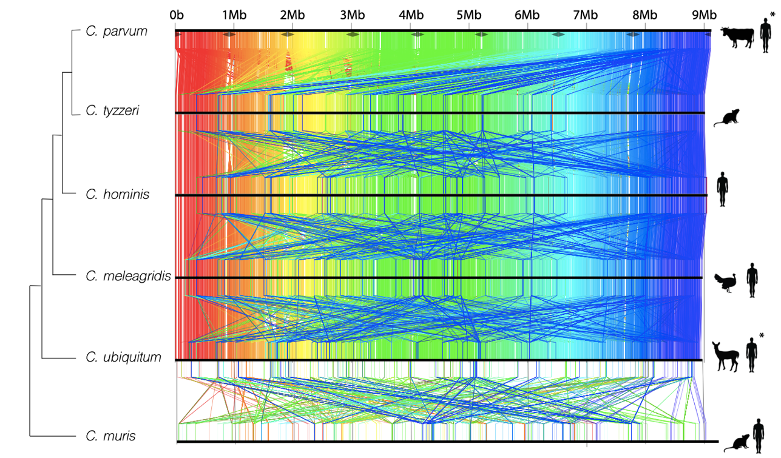

Fig. S6 - Nucleotide anchor plot between six Cryptosporidium species whole genomes. Anchors are drawn as colored lines from one sequence to the next. The color is determined by the anchor's position in the first (C. parvum) genome, making it easier to see rearrangements and where the other genomes are related. Highly conserved regions between the genomes are indicated with vertical lines between species and are colored in order from red (5′ end of chromosome 1) to blue (3′ end of chromosome 8) based on CpIA. Diagonal lines indicate rearrangements and repetitive region distribution. The cladogram topology was determined via a maximum likelihood analysis of 2,700 revisited single copy orthologs (Supplemental Table S14). Animal icons represent the major hosts for these species. *C. parvum and C. ubiquitum are zoonotic with many hosts.
Fig. S7 – Zoomed in image of the compressed subtelomeric region on the 3′ end of Chr1. CpBGF ONT long-read depth coverage is shown in blue. Red lines indicate the fold coverage of the read depth plot. All genes follow the key presented in Figure 4 except for the 5.8S rRNA which is present but not indicated.

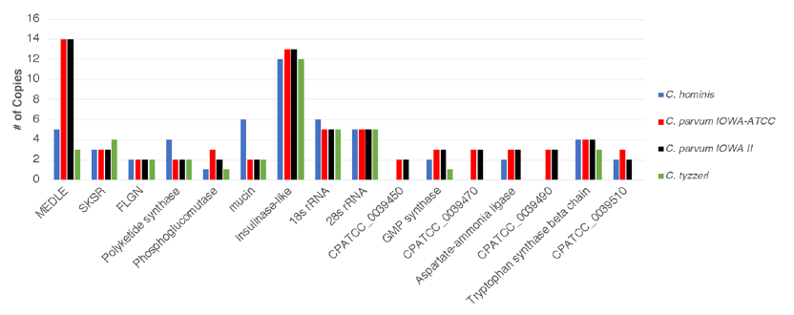
Fig. S8 - Genes located in putatively compressed regions of the new CpIA assembly. The major gene families are highlighted. Genes IDs are used to represent uncharacterized annotated protein families. Many of these genes, but not all are located in the subtelomeric repetitive region.

Fig. S9 – rRNA sequence alignment between subtelomeric rRNAs and the Chr2 rRNA. (A) 28S rRNA sequence alignment showing three gaps at positions 135, 993 and 1941; and (B) Gap-free 18S rRNA alignment.

SUPPLEMENTAL RESULTS
Improved assembly and annotation decreases the number of pseudogenes detected
While the original CpIRef and CpIA annotations have a similar number of genes, half of the CpIA genes reflect a structural alteration relative to CpIRef. 636 CDSs that were previously “incomplete genes” had missing exons or gaps added in the new assembly and annotation. They now have start and stop codons and a structure supported with RNA-seq evidence. Using RNA-seq evidence, the new annotation was also able to reduce the number of previously identified pseudogenes from 74 and 114 on the CpIRef assembly to 1 (CPATCC_0008290) in the CpIA assembly (Table 2).
Functional annotation
The top functional annotation terms observed following re-annotation were protein kinases, AAA+ATPases, TRAP, DEAD/DEAH box proteins, Ras GTPases, WD40-repeat containing proteins, ABC transporters, RNA recognition motifs, Palmitoyltransferases and insulinase-like proteases.

SUPLEMENTAL METHODS
Protein Functional Annotation
Protein sequences were divided into two major groups distributed according to their length for the I-TASSER analysis: (i) peptide sequences <750 aa; and (ii) shorter sequential segmental peptide sequences < 750 aa derived from annotated proteins >750 aa. Structures were predicted for each peptide using the I-TASSER suite and aligned to solved crystal structures in the protein data bank (PDB) using the cofactor algorithm (Roy et al. 2012). InterPro codes were assigned to the query peptide sequence via InterProScan v.5.23-62.0 (Quevillon et al. 2005) using 11 different default databases. The PFAM codes available for PDB crystal structures were transposed to InterPro codes using the R pfam.db library. The presence of at least one matching InterPro code assigned to both the query and the reference peptides was taken to indicate a greater likelihood of structural similarity of the predicted structure and considered “high-confidence”. A random forest classifier was trained to distinguish between a test set of high- and low-confidence models and was then applied to the entire predicted proteome to identify additional high-confidence-like models among unannotated proteins, as described in Ansell et. al 2019 (Ansell et al. 2019).
CpIA genes evolving under positive selection analysis
The all sites annotated combined variant call file (GVCF) from all 136 samples was parsed for the SNPGenie analysis. The GVCF was split into 16 files, representing each chromosome and each strand for the analysis. The πN/πS results were taken from the product_results.txt file which gives each πN and πS value calculated for each gene in each sample analyzed. Because of this, when comparing whole genes with more than one nucleotide difference in the population, all possible mutational pathways observed in this population were considered, per the method of (Nei and Gojobori 1986). The absolute number of synonymous and non-synonymous variants in the population was calculated by parsing the annotated GVCF file produced by SnpEff and also the sites_results.txt produced by SNPGenie. Both analyses provided the same result. All non-coding regions with variants were removed. Regions with frameshift, disruptive in-frames, missense, start and stop gain/lost variants were considered as non-synonymous variants in the SnpEff analysis. Gene product descriptions added to Table S13 column G were retrieved from CryptoDB.org. Genes reported in the literature as evolving under positive selection by other groups in the literature were reported in column H.

Comparative genomics and Phylogeny estimation
Comparative genome-wide synteny between Cryptosporidium species was performed using Murasaki v.1.68.6 (Popendorf et al. 2010) with default settings. The syntenic anchors generated are based in the genomic sequence, not by gene orthology. The cladogram topology was determined via a maximum likelihood analysis of 2,700 single copy orthologs (Supplemental Table S14) using JTT+I as the substitution model as predicted by Modeltest-NG (Darriba et al. 2020). The consensus tree was constructed from 1000 bootstrap replicates.

Multiple sequencing Alignment
Multiple sequencing alignment of Cryptosporidium gp60 and Dnmt2 was performed using MAFFT v.7 (Katoh and Standley 2013) using default parameters. Sequences were retrieved from CryptoDB v.49, PlasmoDB v.49 and BLASTN NCBI GenBank. Alignments were visualized using plain text Clustal format and Geneious Prime 2019.1.3 (Kearse et al. 2012).

Evaluation of compressed regions and CNV genes among the three close related species
For Illumina read depth coverage (RDC) analysis and detection of CNVs among the three different species, C, parvum IOWA-ATCC, C. hominis TU502 and C. tyzzeri UGA55, the alignment was performed using BWA-MEM 0.7.17 (Li and Durbin 2009) with default options and the alignment depth per base was calculated using BEDTools genomecov 2.29.2 (Quinlan and Hall 2010) and SAMtools depth 1.6 (Li et al. 2009). C. hominis was represented by a different strain (TU502_2012) in this analysis since the C. hominis 30976 strain Illumina sequencing library was generated by an amplification selection method (WGA), which would affect the read depth coverage analysis. The major differences found mainly in the compressed regions observed in the CpIA genome (Chr1 subtelomeric region) are shown in Supplemental Figure S8.
All regions with higher coverage were compared to the GFF file using BEDTools for gene detection and had their copy number estimated by dividing their average RDC by the estimated single copy coverage of the sequencing.

RNA-seq data processing
To generate the RNA-seq tracks for the WebApollo2 manual curation, all used RNA-seq reads were aligned against the CpIA genome assembly by HISAT2 (Kim et al. 2015) to generate the bam files. To verify how many annotated genes were covered by all RNA-seq data from different time-points, the bam file and the final CpIA genome annotation was submitted to HTSeq-count (Anders et al. 2015).
Chimeric Read Detection in ONT long reads
To detect and remove potential chimeric read artifacts caused by the ONT ligation kit used for C. parvum BGF sequencing as has been previously reported in other organisms (Tvedte et al. 2021). We used minimap2 (Li 2018) and yacrd (Marijon et al. 2020) to detect potential chimeric reads and remove them from the single-molecule analysis of the duplicated chromosome ends.
Searching for other genomic elements in the data
From our assembly, 72,257 left-over unassembled reads with no hits to the assembled genome were found. They were corrected using CpIA Illumina reads using Pilon and submitted to a BLASTN and BLASTX search against the nt an nr GenBank databases. We also made a custom database containing Apicomplexan organellar DNA and Proteins (Plastids and mitochondrial elements already described in the literature) to see if we could detect evidence of these organellar genome sequences. As a threshold for selection, we used relaxed e-values 1x10⁻⁶ and query coverage higher than 60%. No significant hit was found to these organellar elements.
SUPPLEMENTAL REFERENCES

Anders S, Pyl PT, Huber W. 2015. HTSeq--a Python framework to work with high-throughput sequencing data. Bioinformatics (Oxford, England) 31: 166-169.
Ansell BRE, Pope BJ, Georgeson P, Emery-Corbin SJ, Jex AR. 2019. Annotation of the Giardia proteome through structure-based homology and machine learning. Gigascience 8.
Darriba D, Posada D, Kozlov AM, Stamatakis A, Morel B, Flouri T. 2020. ModelTest-NG: A New and Scalable Tool for the Selection of DNA and Protein Evolutionary Models. Mol Biol Evol 37: 291-294.
Kim D, Langmead B, Salzberg SL. 2015. HISAT: a fast spliced aligner with low memory requirements. Nat Methods 12: 357-360.
Li H. 2018. Minimap2: pairwise alignment for nucleotide sequences. Bioinformatics (Oxford, England) 34: 3094-3100.
Marijon P, Chikhi R, Varre JS. 2020. yacrd and fpa: upstream tools for long-read genome assembly. Bioinformatics (Oxford, England) 36: 3894-3896.
Nei M, Gojobori T. 1986. Simple methods for estimating the numbers of synonymous and nonsynonymous nucleotide substitutions. Mol Biol Evol 3: 418-426.
Popendorf K, Tsuyoshi H, Osana Y, Sakakibara Y. 2010. Murasaki: a fast, parallelizable algorithm to find anchors from multiple genomes. PLoS One 5: e12651.
Quevillon E, Silventoinen V, Pillai S, Harte N, Mulder N, Apweiler R, Lopez R. 2005. InterProScan: protein domains identifier. Nucleic Acids Res 33: W116-120.
Roy A, Yang J, Zhang Y. 2012. COFACTOR: an accurate comparative algorithm for structure-based protein function annotation. Nucleic Acids Res 40: W471-477.
Tvedte ES, Gasser M, Sparklin BC, Michalski J, Hjelmen CE, Johnston JS, Zhao X, Bromley R, Tallon LJ, Sadzewicz L et al. 2021. Comparison of long read sequencing technologies in interrogating bacteria and fly genomes. G3 (Bethesda) doi:10.1093/g3journal/jkab083.

