Symer et al. - Diverse tumorigenic consequences of human papillomavirus integration in primary oropharyngeal cancers

SUPPLEMENTAL MATERIAL

TABLE OF CONTENTS

SUPPLEMENTAL METHODS 3

Supplemental FIGURES
Supplemental Fig. S1.1. Comparison of HPV breakpoint detection using SplazerS, DELLY and Hydra 5
Supplemental Fig. S1.2. Uniform distribution of virus-host insertional breakpoints across the HPV genome, stratified by viral type 6
Supplemental Fig. S1.3. HPV16 polycistronic transcript structures 7
Supplemental Fig. S1.4. Expression of polycistronic HPV transcripts in OPSCCs harboring episomal vs. integrated virus 9
Supplemental Fig. S1.5. Kaplan-Meier curves depict progression-free survival of HPV-positive OPSCC patients, stratified by virus integration status 10
Supplemental Fig. S1.6. Enrichment of homologous sequences at HPV insertional breakpoints 11
Supplemental Fig. S2.1. Statistically significant genomic hotspots of recurrent HPV integration 12
Supplemental Fig. S2.2. Expression levels of key genes at 5 recurrent hotspots of HPV integration 13
Supplemental Fig. S3.1. Additional HPV breakpoint clusters observed in an individual tumor 14
Supplemental Fig. S3.2. Linked-read sequences demonstrate that HPV integration disrupts only one haplotype 15
Supplemental Fig. S3.3. Linked-read sequencing demonstrates enrichment of HPV sequences at specific, distinct chromosomal loci 16
Supplemental Fig. S4.1. Expression of cancer genes near HPV integrants 17
Supplemental Fig. S4.2. Lack of association between maximum Z-score of genes near HPV integrants and HPV E6 and E7 expression levels 18
Supplemental Fig. S5.1. Venn diagram comparing counts of genes harboring DNA virus-host breakpoints vs. intragenic virus-host fusion transcripts 19
Supplemental Fig. S5.2. Virus-host fusion transcript junctions mapped against the HPV16 genome 20
Supplemental Fig. S5.3. Distances from HPV breakpoints to chimeric HPV transcript junction sites 21
Supplemental Fig. S5.4. Exon-by-exon expression analysis for genes with virus-host chimeric transcripts 27

SUPPLEMENTAL TABLES
Supplemental Table S1.1. Demographic, behavioral and clinical characteristics of HPV-positive OPSCC cases stratified by HPV integration status 28
Supplemental Table S1.2. Counts of HPV insertional breakpoints detected per tumor from WGS
data 31
Supplemental Table S1.3. Distribution of insertional breakpoints across HPV16 genes 32
Supplemental Table S1.4. Distribution of representative breakpoints across HPV16 genes 33
Supplemental Table S1.5. Distribution of main breakpoints across HPV16 genes 34
Supplemental Table S1.6. Expression of polycistronic transcripts in tumors harboring episomal vs. integrated HPV16 35
Supplemental Table S1.7. Identification of HPV insertional breakpoint sites in 105 tumors studied by WGS 36
Supplemental Table S1.8. Confirmation of HPV breakpoints by HPV capture-seq 37
Supplemental Table S1.9. Confirmation of virus-host insertional breakpoints by custom PCR amplification and Sanger sequencing 38
Supplemental Table S2.1. Genomic hotspots of recurrent HPV integration identified in three or more tumors out of 105 OPSCC analyzed by WGS 39
Supplemental Table S2.2. Genomic hotspots of recurrent HPV integration identified in three or more tumors by gene-centric approach 41
Supplemental Table S3.1 Genes located within 1Mbp of HPV integration sites in OPSCC GS18047 43
Supplemental Table S3.2. Enrichment of outlier expression of cancer genes in tumors harboring HPV breakpoints 45
Supplemental Table S3.3. Virus-host breakpoints are enriched near host genes annotated with specific biological processes 47
Supplemental Table S3.4. Counts of HPV insertional breakpoints detected per tumor using HPV capture-seq. 48
Supplemental Table S3.5. Identification of HPV insertional breakpoint sites in 53 HPV-positive OPSCC tumors studied by HPV capture-seq 49
Supplemental Table S3.6. Counts of insertional breakpoints in HPV-positive OPSCC tumors studied by WGS or HPV capture-seq 50
Supplemental Table S3.7. Genomic hotspots of recurrent HPV integration identified in three or more tumors from combined sets of OPSCC samples 51
Supplemental Table S4. Enrichment of genomic copy number gains at HPV breakpoints 52
Supplemental Table S5.1. Overexpressed genes occurring within +/-500 kb of an HPV breakpoint, expressed at outlier levels (Z-score ≥ 2) 55
Supplemental Table S5.2. Underexpressed genes occurring within +/-500 kb of an HPV breakpoint, expressed at outlier levels (Z-score ≤ -2) 56
Supplemental Table S5.3. HPV-linked host genomic rearrangements at insertional breakpoint clusters 59
Supplemental Table S6.1. Host genomic features of HPV insertional breakpoint sites and their relationship with protein-coding genes 60
Supplemental Table S6.2. Host genetic features of HPV insertional breakpoint sites 61
Supplemental Table S6.3. Epigenetic marks and other genomic features at HPV integrant sites 62
Supplemental Table S6.4. Frequencies and impacts of HPV insertions with chimeric transcripts in genes and samples 63
Supplemental Table S6.5. Genetic and genomic features associated with HPV chimeric transcript expression 64
Supplemental Table S6.6. Genes with intragenic HPV chimeric transcripts 67
Supplemental Table S7. List of genes expressed at outlier levels, associated with upstream HPV integrants 68

SUPPLEMENTAL REFERENCES 69

SUPPLEMENTAL METHODS

Statistical analysis of demographic characteristics and survival outcomes. Characteristics of patients with exclusively episomal vs. integrated HPV were compared by t-test or chi-squared test as appropriate. Progression-free survival, defined as date of diagnosis to cancer progression or death, was compared in tumors with exclusively episomal vs. integrated HPV by Kaplan-Meier analysis and were compared with a log-rank test.
Hotspot detection (gene-centric approach). Because annotated genes themselves are not randomly distributed in the human genome, we used a second, gene-centric approach to identify genes that are recurrently targeted by HPV integration (see Methods). To calculate the expected number of times genes would be hit within 500 kb by simulated integrants, two million in silico random integration sites were generated. The observed number of hits per gene for 238 representative HPV breakpoints as identified in WGS data was compared to this expected distribution. Genes with more breakpoints than expected by chance were identified as hotspots for integration (one-tailed binomial test, adj. p<0.01).
Gene ontology. To account for bias introduced by clustered virus-host breakpoints, simulations were run with 238 representative breakpoints. As a control, 2 million random breakpoints were generated in silico. Gene models from GENCODE v18 were used to identify ≤4 nearest neighbor genes located within 500 kb from each HPV breakpoint and each control breakpoint. Genes were annotated as per Gene Ontology Resource (www.geneontology.org). Binomial test was used to compare the observed versus expected frequencies of breakpoints found within 500 kb of genes in the Biological Process category (one-tailed test). P-values for GO terms with ≥3 virus-host breakpoints were calculated. P-values were adjusted by FDR multiple testing correction.
Linked-read sequencing. Linked-read genomic DNA libraries were prepared from selected tumors using the 10x Genomics Chromium platform, and 2 × 150 bp paired end sequences were generated at approximately 30-40× depth of coverage. Data were aligned to the hg19+HPV hybrid reference, and mapped read barcodes were identified using LongRanger v. 2.2.2 (10x Genomics). To resolve haplotypes at particular loci, germline SNVs were identified from WGS data of matched controls. Haplotype-specific barcodes were extracted using subset-bam tool (10x Genomics). The IGV browser was used to visualize alignments and haplotypes. The fraction of distinct haplotype-specific barcodes mapping in 2 kb segments at the CD274 locus of GS18047 and shared with HPV was calculated.
Associations between HPV breakpoints, annotated host genes and various genomic features. Genes containing intragenic HPV breakpoints were identified using GENCODE database (v18). Overlaps between breakpoints and chromatin marks as reported by the ENCODE project were identified using the UCSC genome browser (genome.ucsc.edu). The observed distribution of HPV breakpoints was compared to 2 million random breakpoints generated in simulations as a control. Comparisons were performed using a binomial test. P-values were adjusted by FDR multiple testing correction.

SUPPLEMENTAL FIGURES
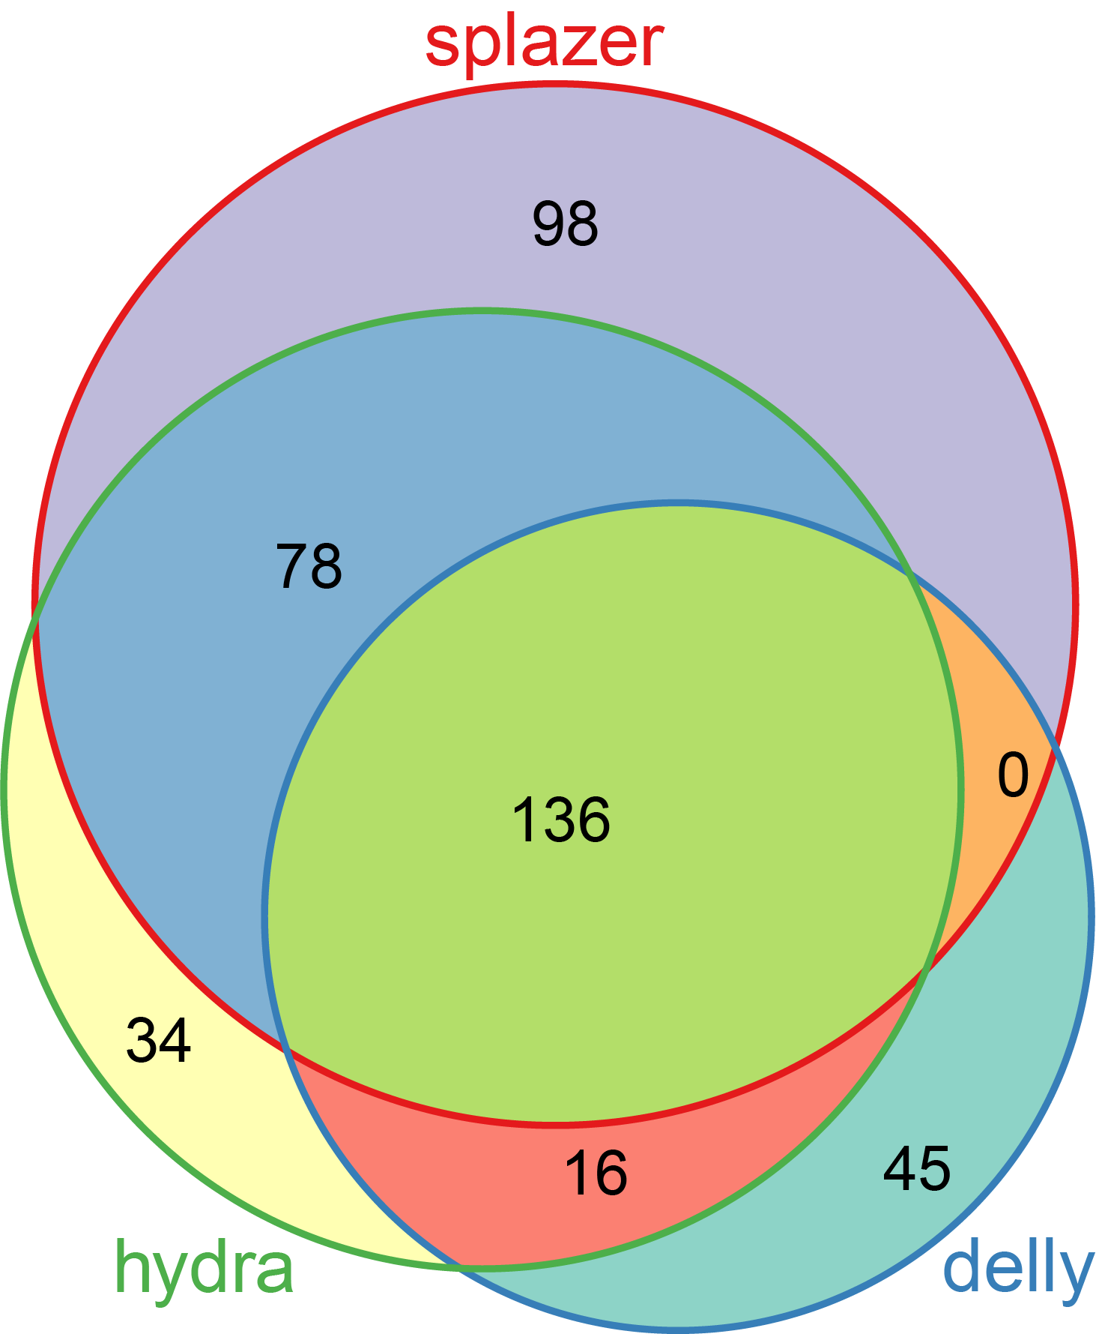

Supplemental Fig. S1.1. Comparison of HPV breakpoint detection using SplazerS, DELLY and Hydra
Three breakpoint callers (i.e. SplazerS (Emde et al. 2012), DELLY (Rausch et al. 2012), and Hydra (Quinlan et al. 2010) were used to detect HPV breakpoints. Shown in the Venn diagram are the counts of HPV breakpoints detected across 52 OPSCCs in the Ohio cohort tumors analyzed with Illumina 150-bp paired-end WGS aligned against the hg19 reference assembly (Chr. 1 – 22, X and Y). Overall, 197 breakpoints were detected by DELLY, 264 by Hydra-SV, and 312 by SplazerS. HPV breakpoints detected by two or more breakpoint callers or supported by four or more supporting pairs were selected for further analysis (N=282). Of these, 52 were supported by four or more supporting pairs from a single software program.

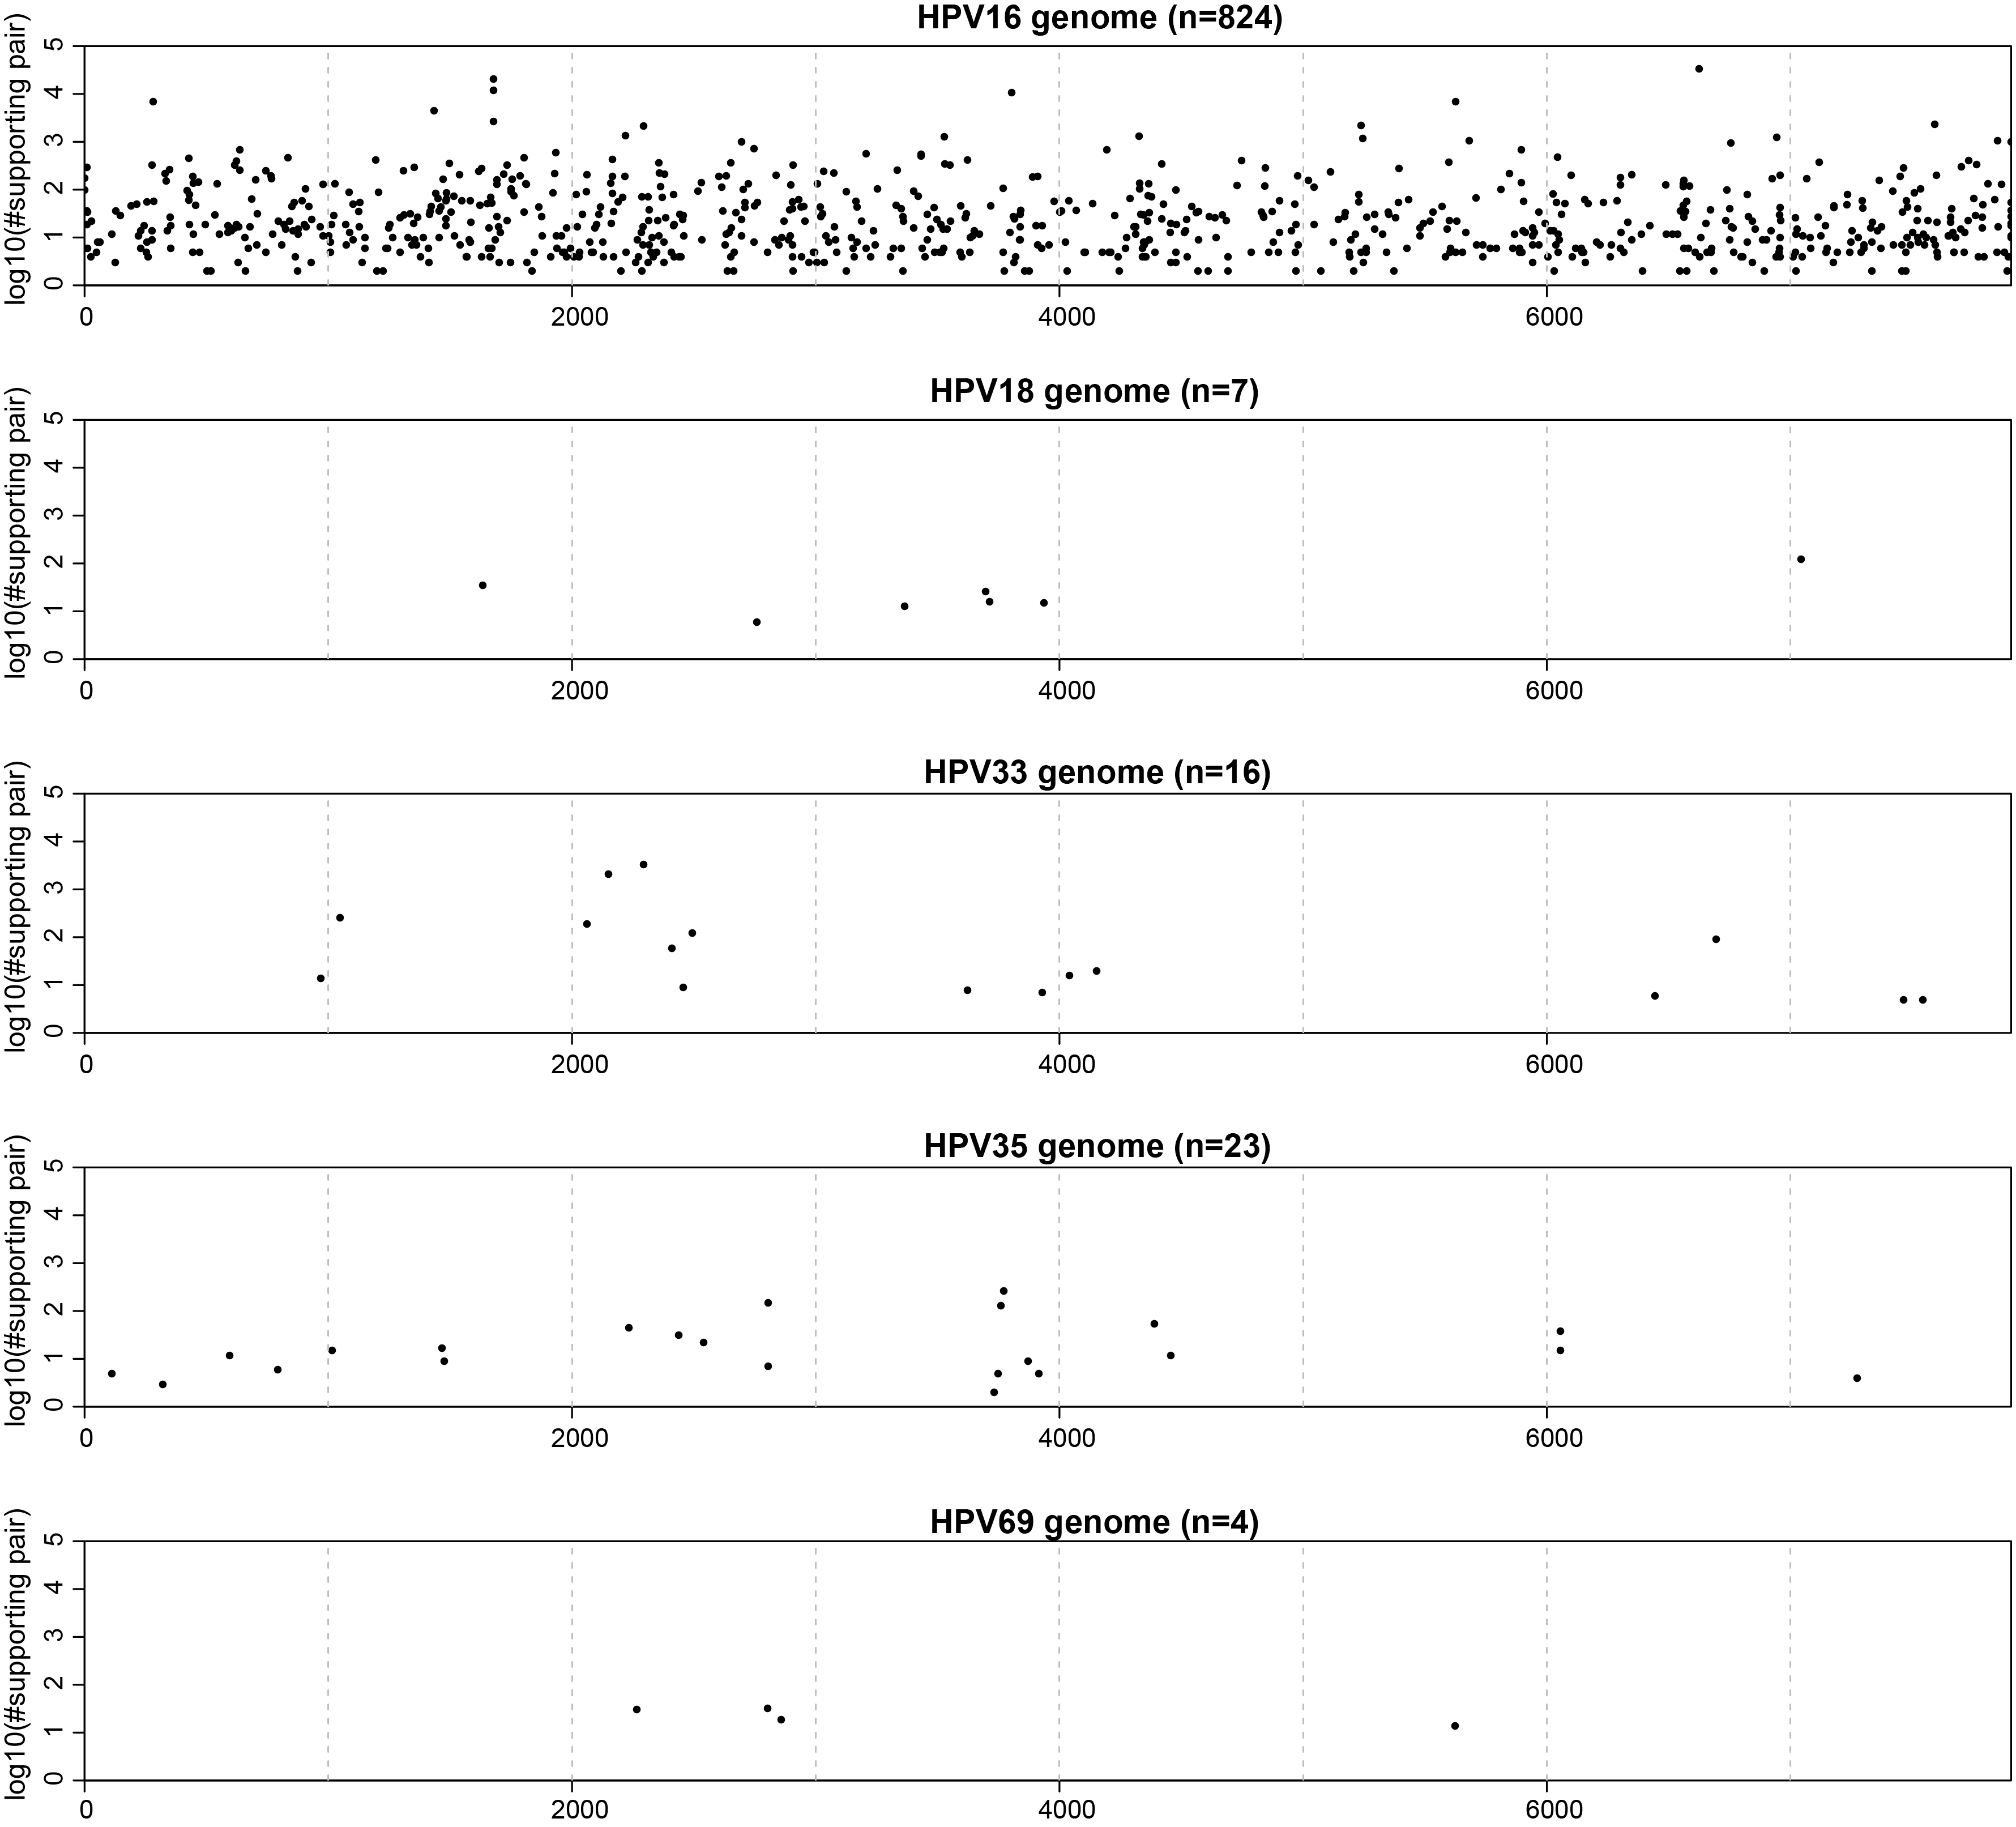

Supplemental Fig. S1.2. Uniform distribution of virus-host insertional breakpoints across the HPV genome, stratified by viral type
We detected 874 virus-host breakpoints upon analyzing WGS data from 105 HPV-positive OPSCC. Shown here are log₁₀-transformed read counts (y-axis) supporting each breakpoint mapped to the virus type-specific reference genomes (x-axis, HPV genome coordinates). Panels, top to bottom: HPV16 (n=92 tumors), HPV18 (n=2 tumors), HPV33 (n=6 tumors), HPV35 (n=3 tumors), and HPV69 (n=1 tumor). For HPV59 (n=1 tumor), no virus-host breakpoints were observed.

These data show no enrichment or depletion of virus-host breakpoints in the HPV E2 gene (Fig. 1A). We also confirmed that the E2 coding sequence [CDS] is present in part or in total in 83 of 90 HPV16-positive oropharyngeal cancers (Gillison et al. 2019). E6 and E7 DNA is present in all tumors. These data indicate that identification of breakpoints within E2, or of the presence or absence of E2 CDS, does not serve as a useful surrogate for viral integration status (Supplemental Tables S1.3 to S1.5).

Supplemental Fig. S1.3. HPV16 polycistronic transcript structures. Top, schematic depicting viral oncogenes and coordinates. Bottom, individual polycistronic transcripts with coding potential for various oncogenes (right). Reproduced from Frontiers in Bioscience 11, 2286-2302, September 1, 2006 (Zheng and Baker 2006).

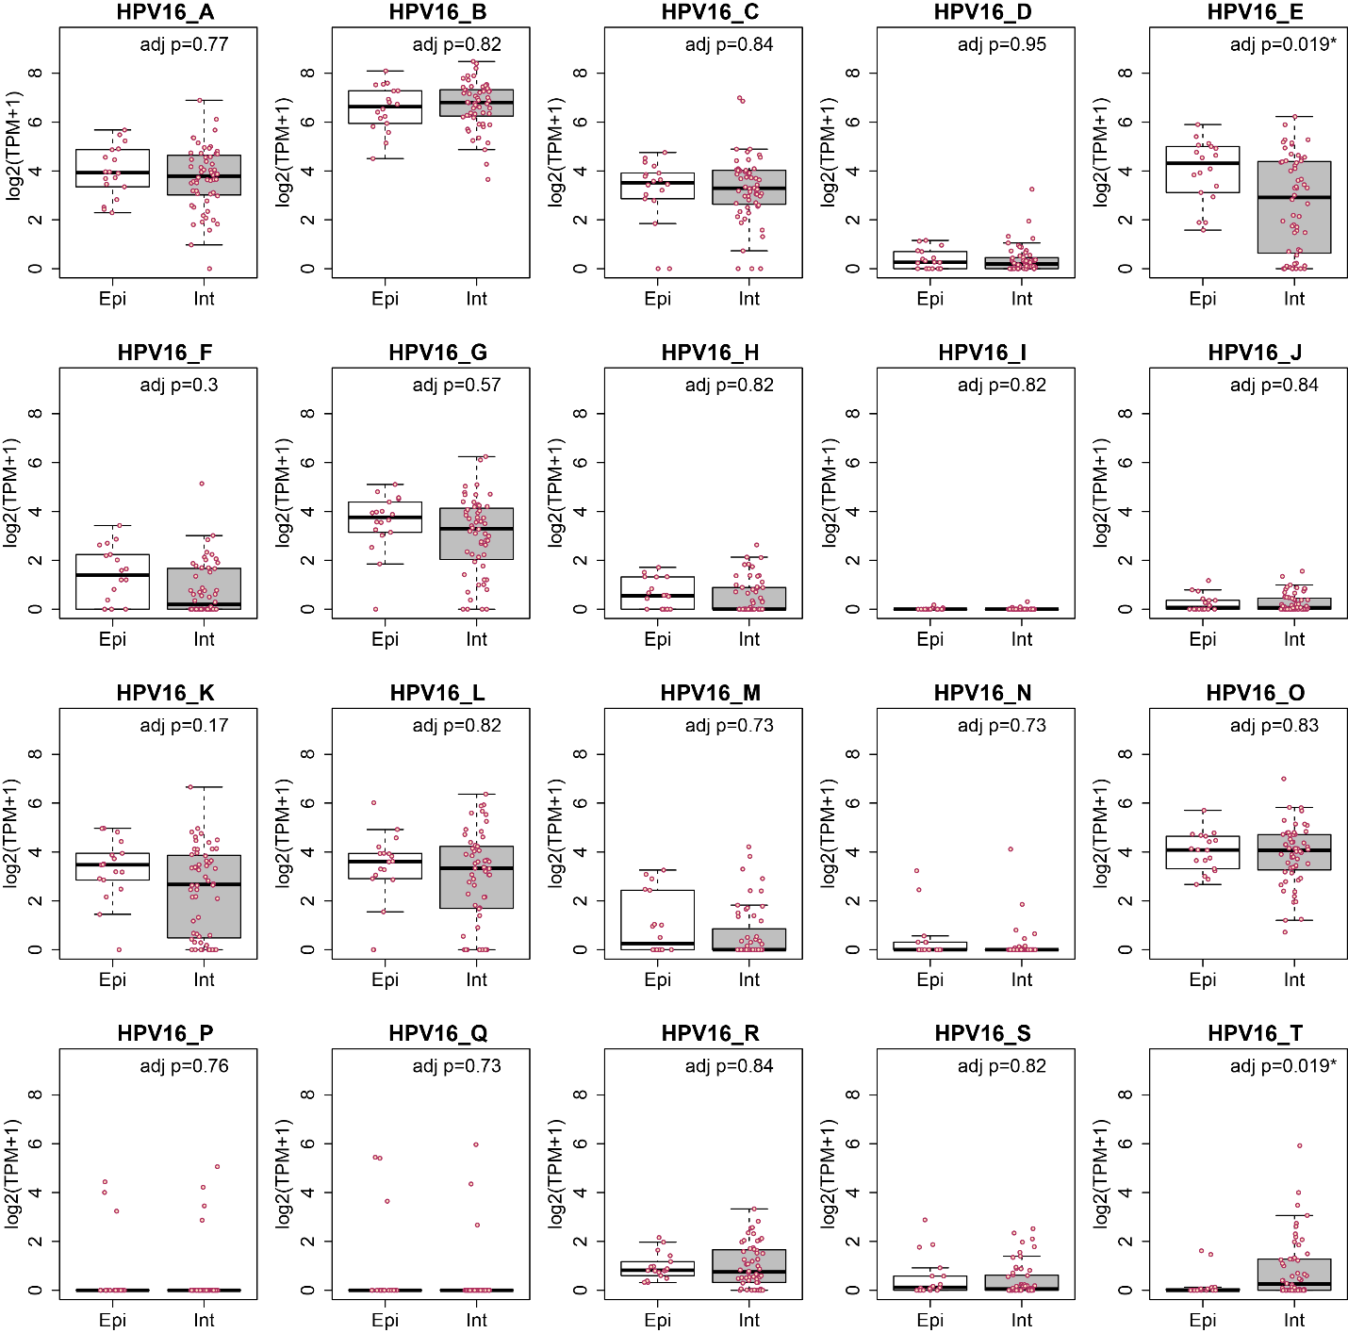

Supplemental Fig. S1.4. Expression of polycistronic HPV transcripts in OPSCC samples harboring episomal vs. integrated virus.

Shown here are box and whiskers plots depicting expression levels of 20 HPV16 polycistronic transcripts (A-T, Supplemental Fig. S1.3) (Zheng and Baker 2006) in 74 HPV16-positive OPSCCs in the Ohio cohort (Gillison et al. 2019). We focused on HPV16-positive tumors because transcript splicing isoforms are best annotated for this viral type. Ten of 20 polycistronic transcripts (e.g. F to N and P) have coding potential for HPV16 E2 (Supplemental Fig. S1.3). Of 74 tumors, 72 (97.3%) express transcripts with coding potential for E2 (i.e. TPM>1). When tumors with virus-host breakpoints (i.e. integrants) are compared to those without (i.e. episome), no significant differences in expression of polycistronic transcripts with coding potential for E2 are found. In addition, expression of polycistronic transcripts with coding potential for E6 and E7 is not significantly different in tumors with vs. without virus-host breakpoints. HPV16_E encodes E6*III and E5; HPV16_T encodes L1 (Supplemental Fig. S1.3). X-axis, viral integration status, episomal (n=18) vs. integrated (n=56). Y-axis, log₂ transformed TPM values calculated by salmon-v1.3.0. Differences in polycistronic transcript levels were assessed by t-test, and multiple testing correction was performed using FDR method. Asterisks, adj. p-value < 0.05.

Supplemental Fig. S1.5. Kaplan-Meier curves depict progression-free survival of HPV-positive OPSCC patients, stratified by virus integration status
Shown here is the proportion of progression-free survival (y-axis) over time (x-axis, days) for OPSCC patients with episomal vs. integrated HPV. Among 85 HPV-positive OPSCC patients from the Ohio cohort with available survival data, 15 patients had cancer progression. No significant difference in progression-free survival was observed for patients with episomal (n=21) vs. integrated (n=64) virus, by log-rank test (p=0.5).

Supplemental Fig. S1.6. Enrichment of homologous sequences at HPV insertional breakpoints
To confirm virus-host breakpoints called from WGS data, we randomly sampled ~10% (n=73) of all virus-host insertional breakpoints detected in Ohio cohort tumors, using custom PCR amplicons and Sanger sequencing across each (Akagi et al. 2014). The histogram shows counts of independent HPV insertional breakpoints (y-axis) having various numbers of overlapping nucleotides (x-axis) at breakpoint junctions, i.e. shared between the virus and/or host genomes at each insertion site. All tested breakpoints were confirmed to include HPV and host genome sequence junctions. Virus-virus and host-host breakpoints detected within amplicons also were counted. Evaluable sequence junctions (A) excluding (n=65) and (B) including (n=90) untemplated, inserted sequences were analyzed. Key, inset, expected (light gray) vs. observed (dark gray) counts of overlapping nucleotides. Probabilities of expected numbers of X shared nucleotides were calculated using the formula P(X) = (X + 1)
(0.25)^{X}(0.75)² (Symer et al. 2002). Expected numbers of shared nucleotides were calculated from the product of the probability of each overlap, multiplied by the total number of breakpoints (n=65). The distributions of expected vs. observed overlaps were compared by Chi-square analysis with 8 degrees of freedom for (A) evaluable breakpoints (n=65), p=9.9 x 10⁻²²⁶; all breakpoints (n=90), including untemplated nucleotides counted as 0 overlapping nucleotides p=8.3 x 10⁻¹⁵⁹.

Sample ID | count of HPV insertional breakpoints detected by WGS | count of HPV insertional breakpoints detected by HPV capture-seq | count of overlaps

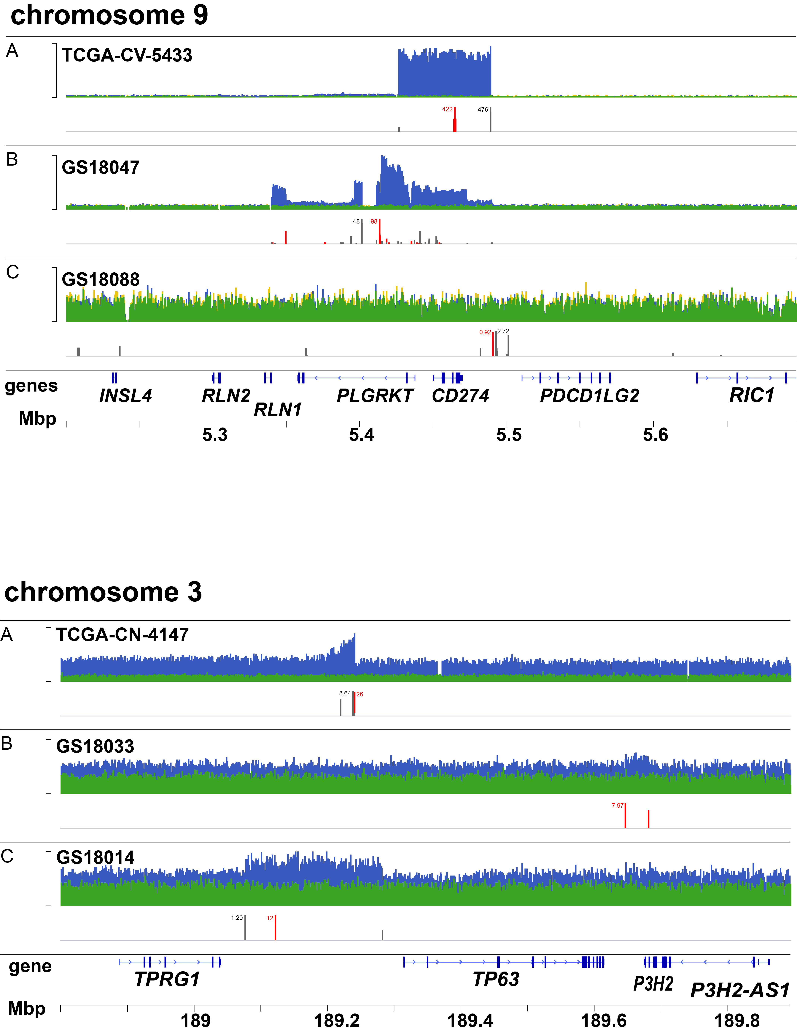
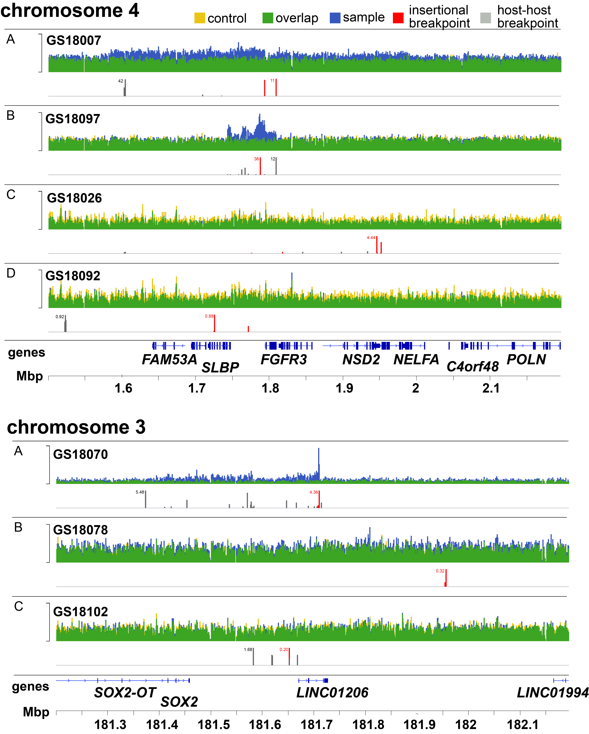

Supplemental Fig. S2.1. Statistically significant genomic hotspots of recurrent HPV integration
Shown here are IGV browser views of WGS reads mapping at four independent genomic loci, each identified as a recurrent HPV integration hotspot: upper left, Chr.4 (FGFR3 locus); upper right, Chr.9 (CD274 locus); lower left, Chr.3 (SOX2 locus); and lower right, Chr.3 (TP63 locus). Features of three or four tumors per recurrent integration hotspot are shown in tracks A, B, C, +/-D (each panel). Key, upper left panel; top, depths of WGS sequencing coverage (y-axis) for tumor (blue) and matched control (yellow) are shown with overlaps of coverage (green); bottom, counts of discordant and split reads supporting host-virus breakpoints (red) and host-host structural alteration breakpoints (gray). Bottom, each panel, annotation of RefSeq genes and chromosomal coordinates of each locus, based on human hg19 genome assembly (x-axis).

Tick marks, y-axis: anges of maximum WGS sequencing coverage depth for each tumor at each locus: upper left panel, Chr. 4, FGFR3, A: 320; B: 290; C: 400; D: 300; lower left panel, Chr. 3, SOX2, A: 1,400; B: 300; C: 300; upper right panel, Chr. 9, CD274, A: 1,200; B: 1,350; C: 300; lower right panel, Chr. 3, TP63, A: 350; B: 300; C: 250. See Fig. 2B.

Supplemental Fig. S2.2. Expression levels of key genes at 5 recurrent hotspots of HPV integration.
Transcript levels of SOX2, TP63, FGFR3, MYC, and CD274 were quantified by RNA-seq across HPV-positive OPSCCs (circles, n=103). Red fill, tumors harboring breakpoints near the genes in recurrent hotspots of integration. Empty circles, all other OPSCC studied. Box and whiskers, median (brown horizontal line), quartiles (light gray box). Top: Y-axis, log₂ transformed TPM values. Each dot represents one sample, and the red dots represent samples having HPV integration sites within 500 kb of the indicated gene. Bottom: Y-axis, Z-score of log₂ TPM value.
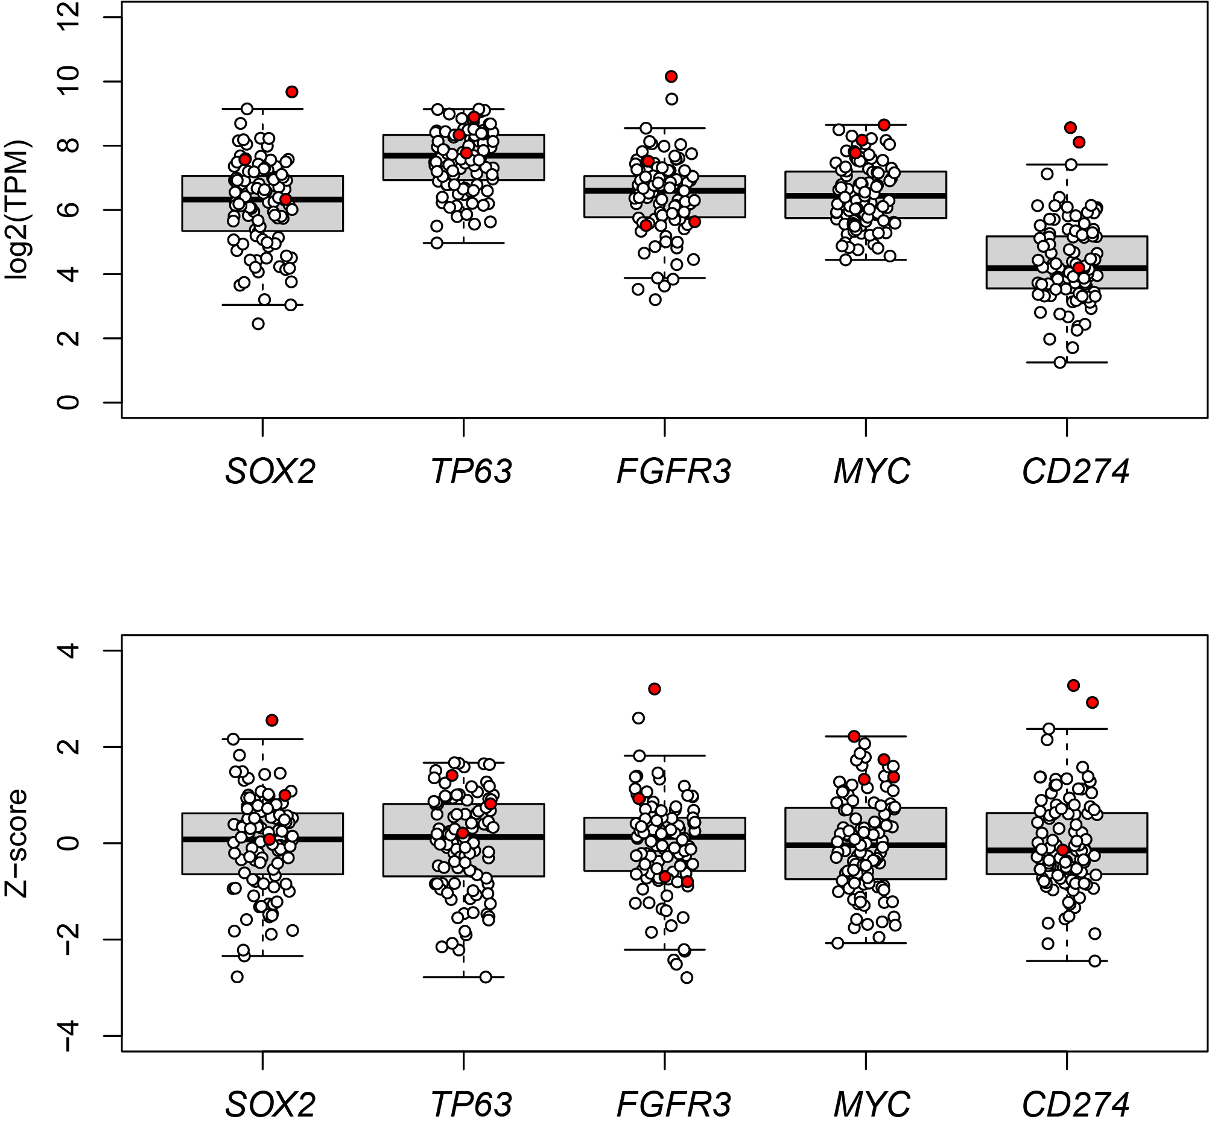

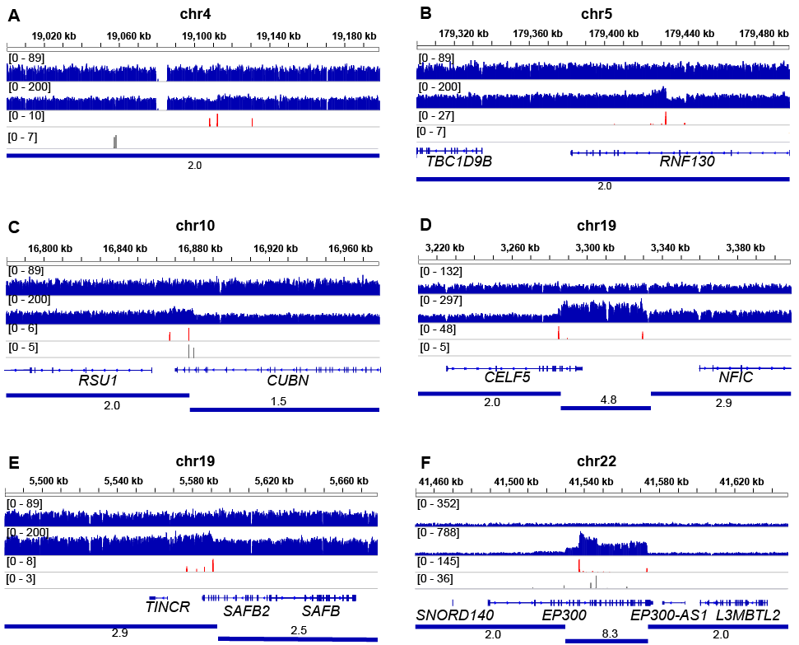
Supplemental Fig. S3.1. Additional HPV breakpoint clusters observed in an individual tumor
Shown here are IGV browser views from a single tumor GS18047 (Fig. 3) depicting six additional chromosomal regions harboring HPV breakpoint clusters, including: (A) Chr. 4:19-19.2 Mbp region (no annotated genes); (B) Chr. 5:179.3-179.5 Mbp (disrupted gene, RNF130); (C) Chr. 10:16.78-16.98 Mbp (CUBN); (D) Chr. 19:3.21-3.41Mbp (CELF5); (E) Chr. 19:5.48-5.68 Mbp (SAFB2); and (F) Chr. 22:41.45-41.65 Mbp (EP300). In each panel (top to bottom): chromosomal coordinates (top track), depth of coverage and aligned reads for normal control (second from top) and tumor (third), discordant pairs supporting virus-host breakpoints (fourth, red), host-host breakpoints (fifth, gray), and RefSeq gene schematics and ploidy estimates (bottom).

Supplemental Fig. S3.2. Linked-read sequences demonstrate that HPV integration disrupts only one haplotype
We selected 80 distinct barcodes marking individual linked-read sequence templates (rows) at random from tumor GS18047 (Supplemental Fig. S3.1), mapping to the Chr.9 CD274 locus. The IGV browser was used to visualize reads mapping to this locus and to HPV16. (A, B) Individual linked-reads (gray ovals) with unique, shared barcodes (rows, connected by dotted horizontal lines) map to Chr.9:5.31-5.51 (left) and HPV16 (right) genomic sequences for haplotypes A (top) and B (bottom). Haplotypes are defined by genomic SNVs (not shown). Haplotype A lacks barcodes shared with HPV16 sequences. By contrast, haplotype B includes barcodes mapping to HPV16 sequences. X-axis, Chr. 9 (left) and HPV16 (right) coordinates. Rows, dotted horizonal lines, linked reads connected by a unique, shared barcode; gray ovals, mapped paired reads; red, virus-host breakpoints; blue, host-host breakpoints; vertical blue lines, CD274 amplification region. See Fig. 3.

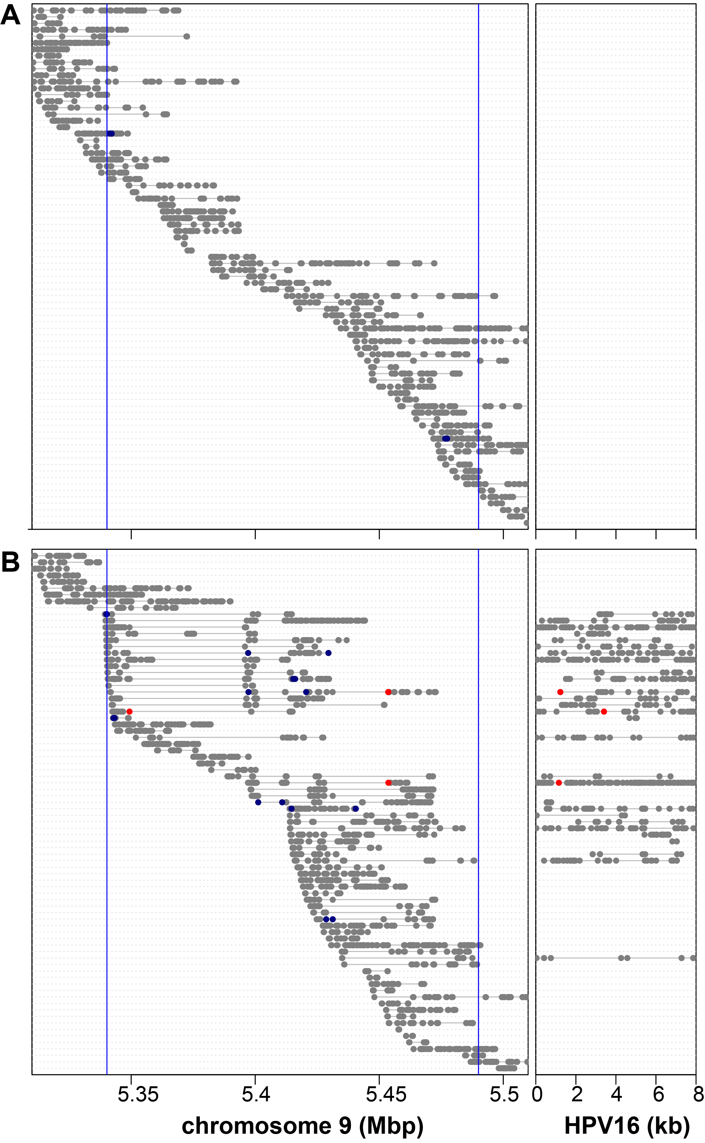
Supplemental Fig. S3.3. Linked-read sequencing demonstrates enrichment of HPV sequences at specific, distinct chromosomal loci.
Shared barcodes from linked-read sequencing data from an HPV-positive OPSCC (GS18047) confirm distinct genomic regions (x-axis, human chromosomal karyotype) connected with HPV16 sequences at significant levels (y-axis, -log₁₀ transformed p-values). The human genome was divided into overlapping 200 kb bins at 100 kb increments. Distinct barcodes of mapped linked reads were counted in each bin, as were barcodes of reads aligned to HPV16. The number of observed:expected barcodes aligning to HPV was determined for each bin, and p-values (y-axis) were calculated by binomial test (one-tailed test, greater) and adjusted by FDR method, capped at p=1 x 10⁻⁴⁰. The results confirm HPV breakpoints detected in WGS data (Fig. 3) by connecting integrants and host sequences at longer genomic distances.

Supplemental Fig. S4.1. Expression of cancer genes near HPV integrants
We identified 16 known cancer genes near HPV integrants that are expressed at outlier levels in affected tumors. Top: gene expression levels of 16 known cancer genes (x-axis) expressed at ouliter levels in at least one OPSCC sample. Y-axis, log₂ transformed TPM values. Unfilled dots, individual samples. Any samples with HPV breakpoint near indicated gene (within 500 kb) are highlighted (red dots). Bottom, Z-scores of the gene expression levels. These genes have at least one sample with HPV integration site having outlier expression (Z-score ≥ 2 or Z-score < -2).
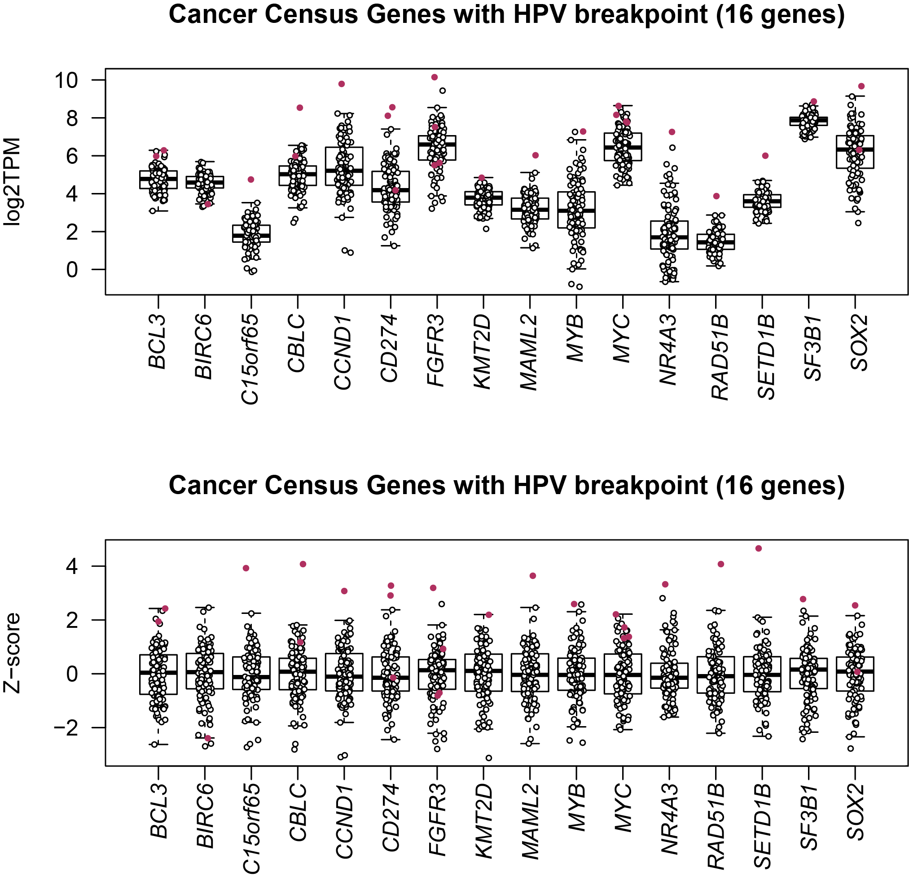

Supplemental Fig. S4.2. Lack of association between maximum Z-score of genes near HPV integrants and HPV E6 and E7 expression levels
To test the possibility that HPV E6 and E7 expression is associated with expression levels of the single most highly upregulated gene located within 500 kb of an HPV integrant in each OPSCC sample, we selected the gene in any of those genomic segments that has the maximum Z-score from each tumor, and compared these maximum Z-scores to E6 and E7 expression levels for the same sample on scatter plots. We counted the number of RNA-seq reads aligned to HPV oncogenes (left) E6; and (right) E7 and calculated their TPM values across their CDS regions. For each panel: x-axis, log transformed viral oncogene expression level; y-axis, maximum Z-score observed for all genes within +/-500 kb of HPV integration sites. Individual dots, each of the 58 Ohio cohort samples. No significant correlation was observed. Correlation coefficients and p-values are indicated in each panel, showing no significant association between these viral and maximal host gene expression levels.
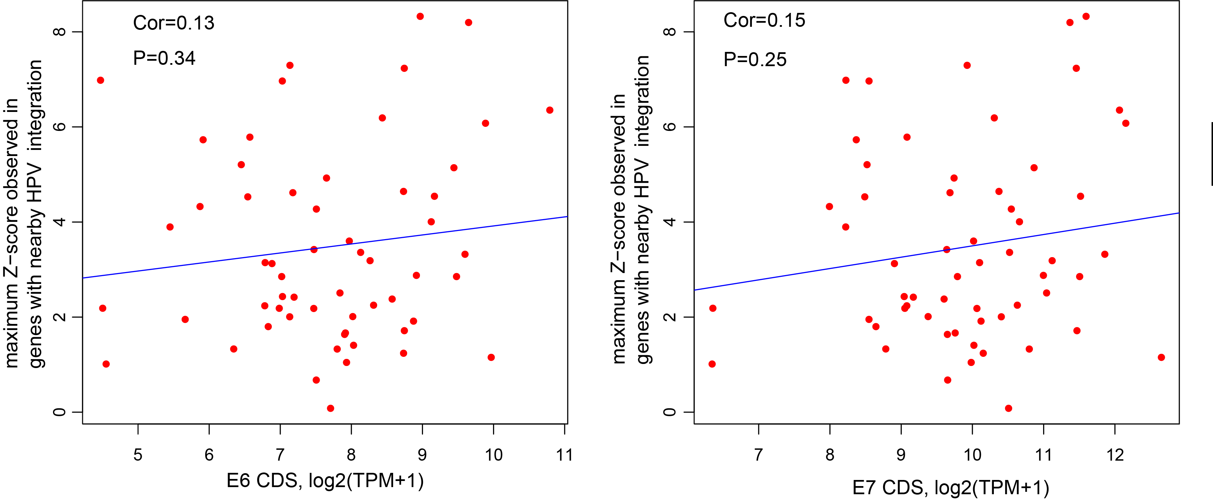

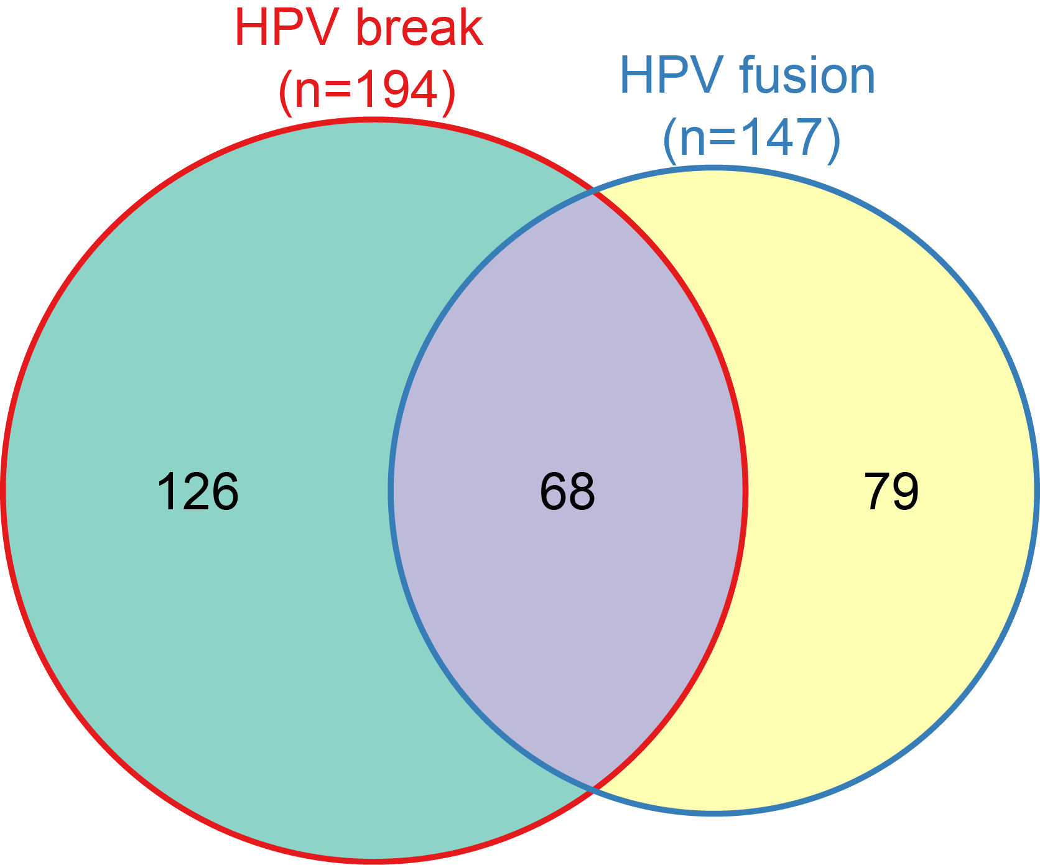

Supplemental Fig. S5.1. Venn diagram comparing counts of genes harboring DNA virus-host breakpoints vs. intragenic virus-host fusion transcripts.
We identified 194 genes harboring intragenic DNA virus-host breakpoints and 147 genes with intragenic virus-host fusion transcripts. Of these, 68 genes were disrupted both by DNA virus-host breakpoints and intragenic chimeric transcription. GENCODE v18 gene annotations were used to define genes.

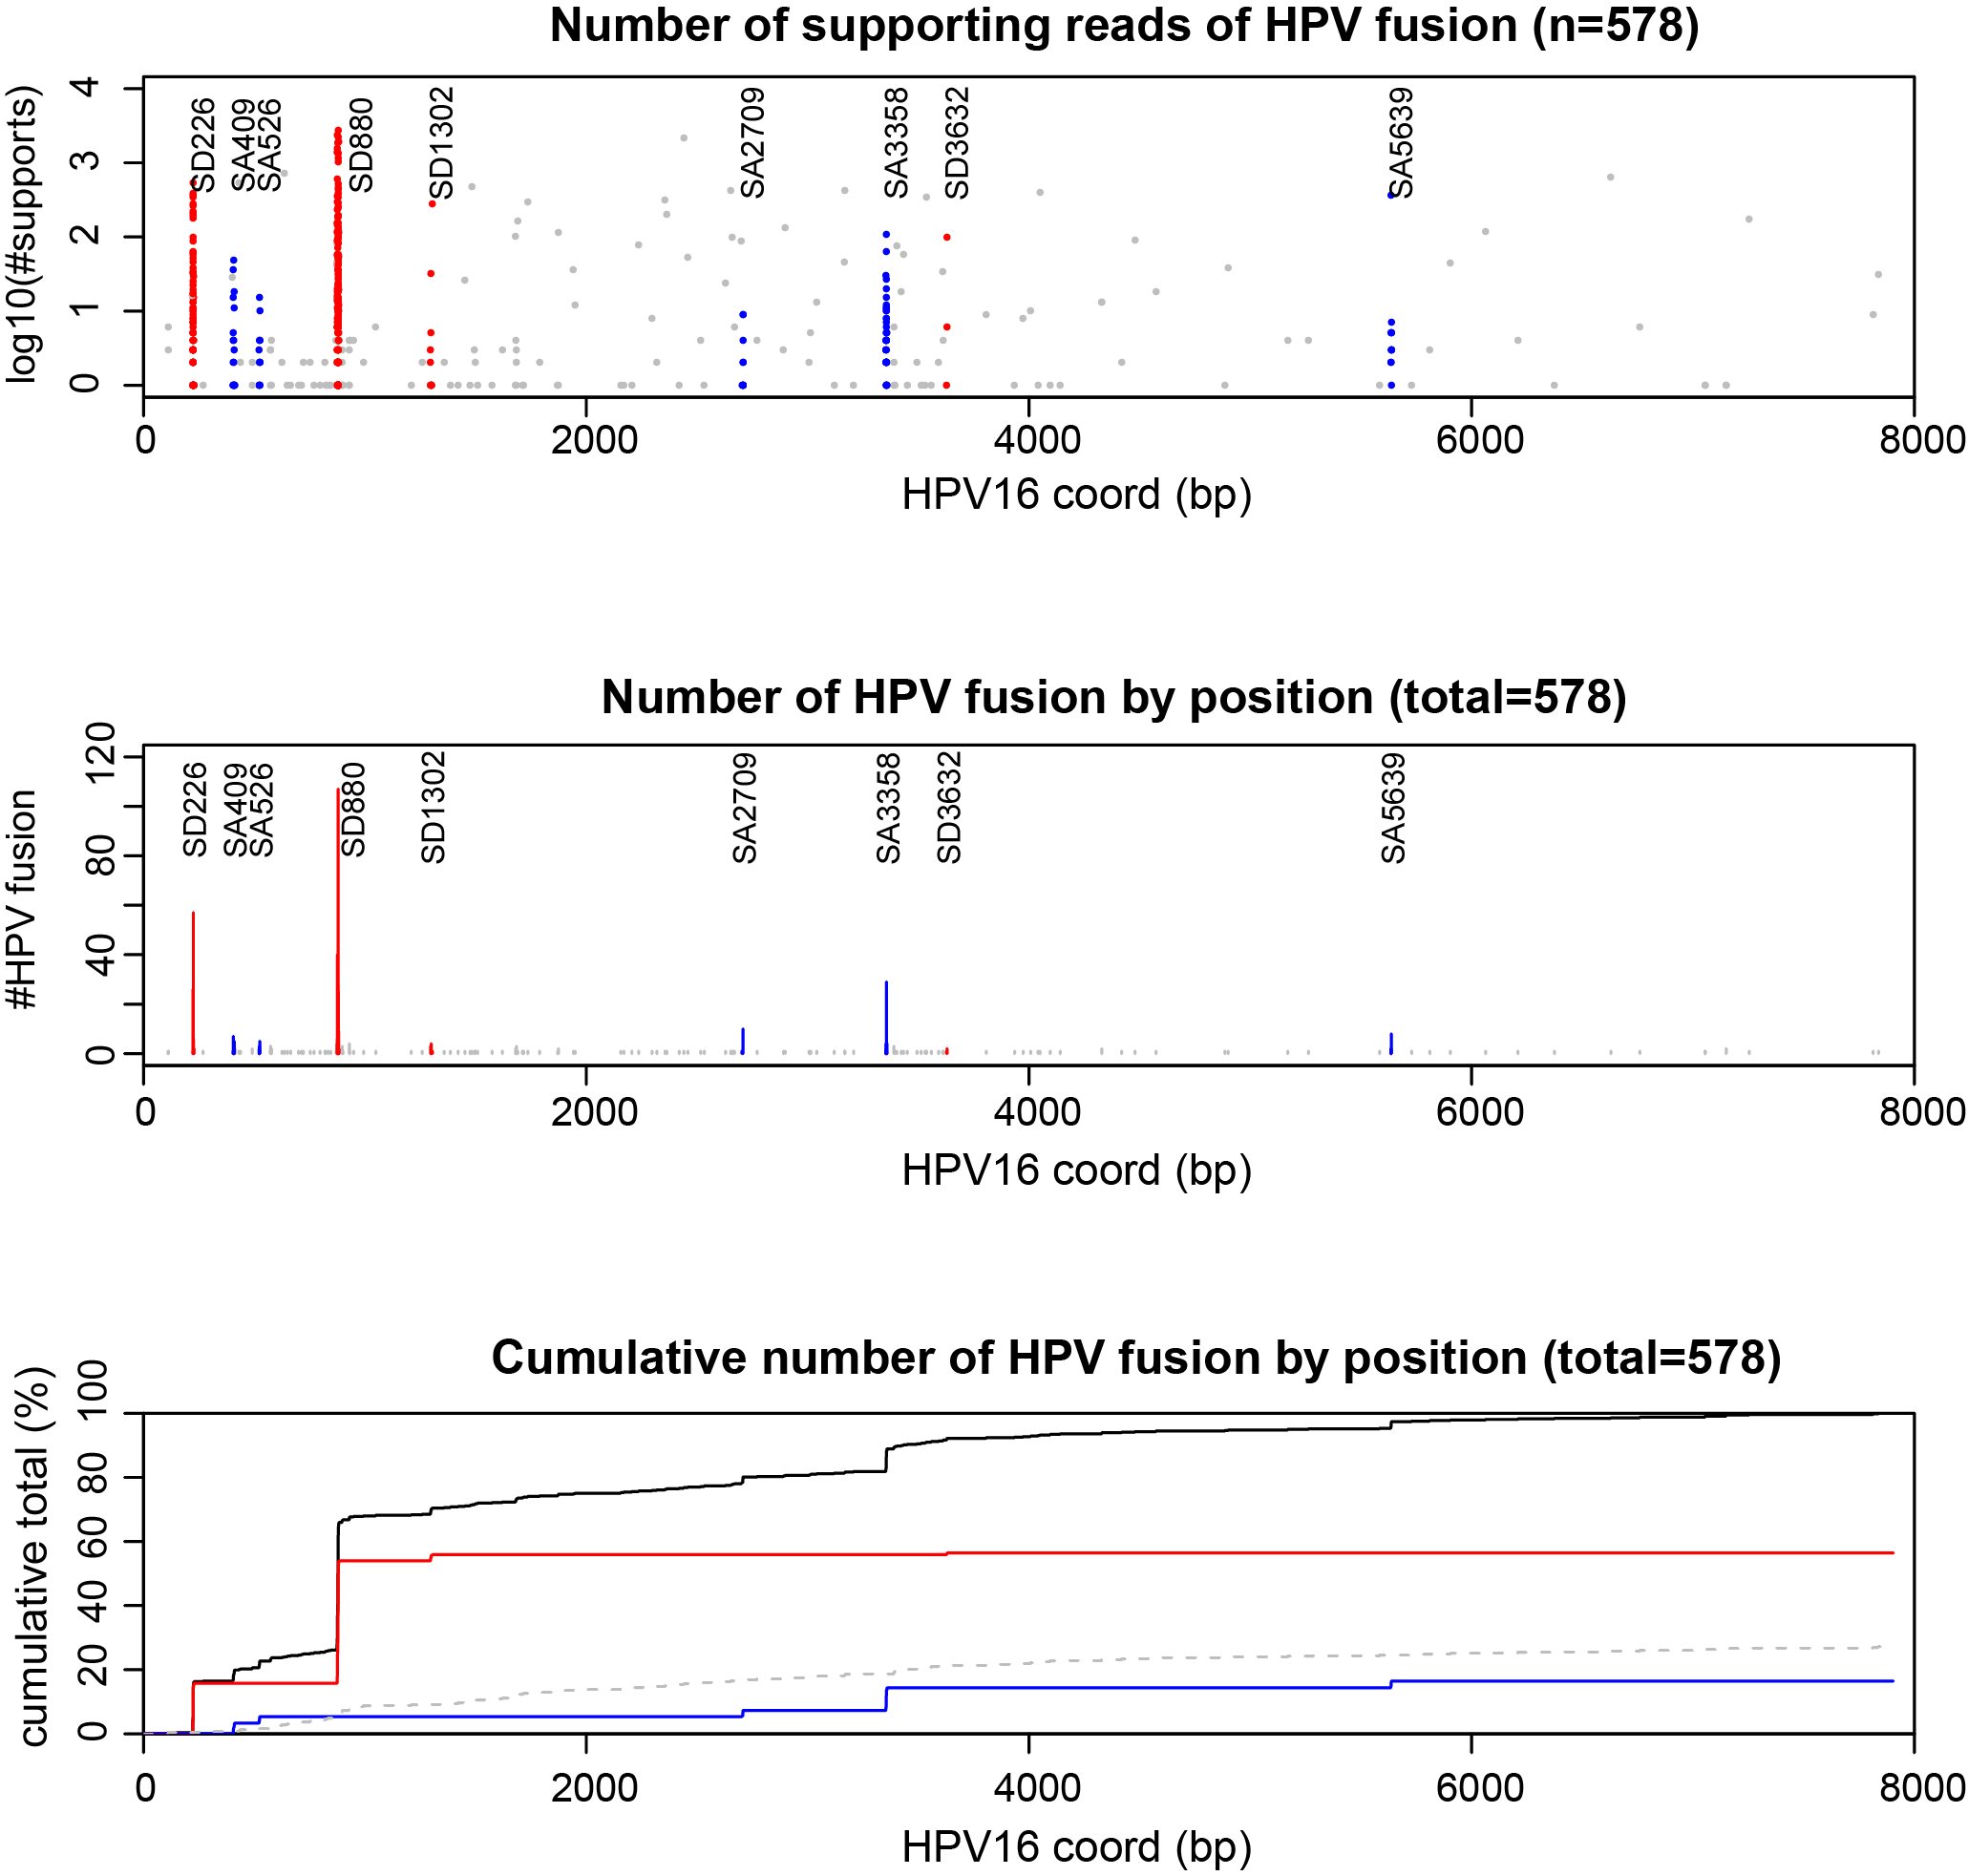

Supplemental Fig. S5.2. Virus-host fusion transcript junctions mapped against the HPV16 genome
We detected 578 virus-host fusion transcripts in HPV16 positive tumors with available RNA-seq data. Fusion transcript virus-host junctions were mapped against the HPV16 reference genome (x-axis). Top panel, log₁₀-transformed counts (y-axis) of split reads supporting junction sites of individual fusion transcripts are shown. To account for inaccuracies in transcript alignments (TopHat fusion, (Kim and Salzberg 2011)), junction sites were estimated within +/- 5 nt from known viral splice donor (SD) sites (red dots), known splice acceptor (SA) sites (blue dots), and unannotated fusion sites (gray dots). Middle, counts of independent virus-host fusion transcripts (y-axis) are mapped against the HPV16 genome (x-axis). Bottom, cumulative percentage of total counts (y-axis) of virus-host fusion transcripts are mapped against HPV16 (x-axis). Black, cumulative fractions of total virus-host fusion transcripts; red, fusion transcripts using known viral splice donor (SD) sites; blue, virus-host fusion transcripts using known viral splice acceptor (SA) sites; gray, other types of virus-host fusion transcripts (e.g. unspliced, readthrough transcripts).

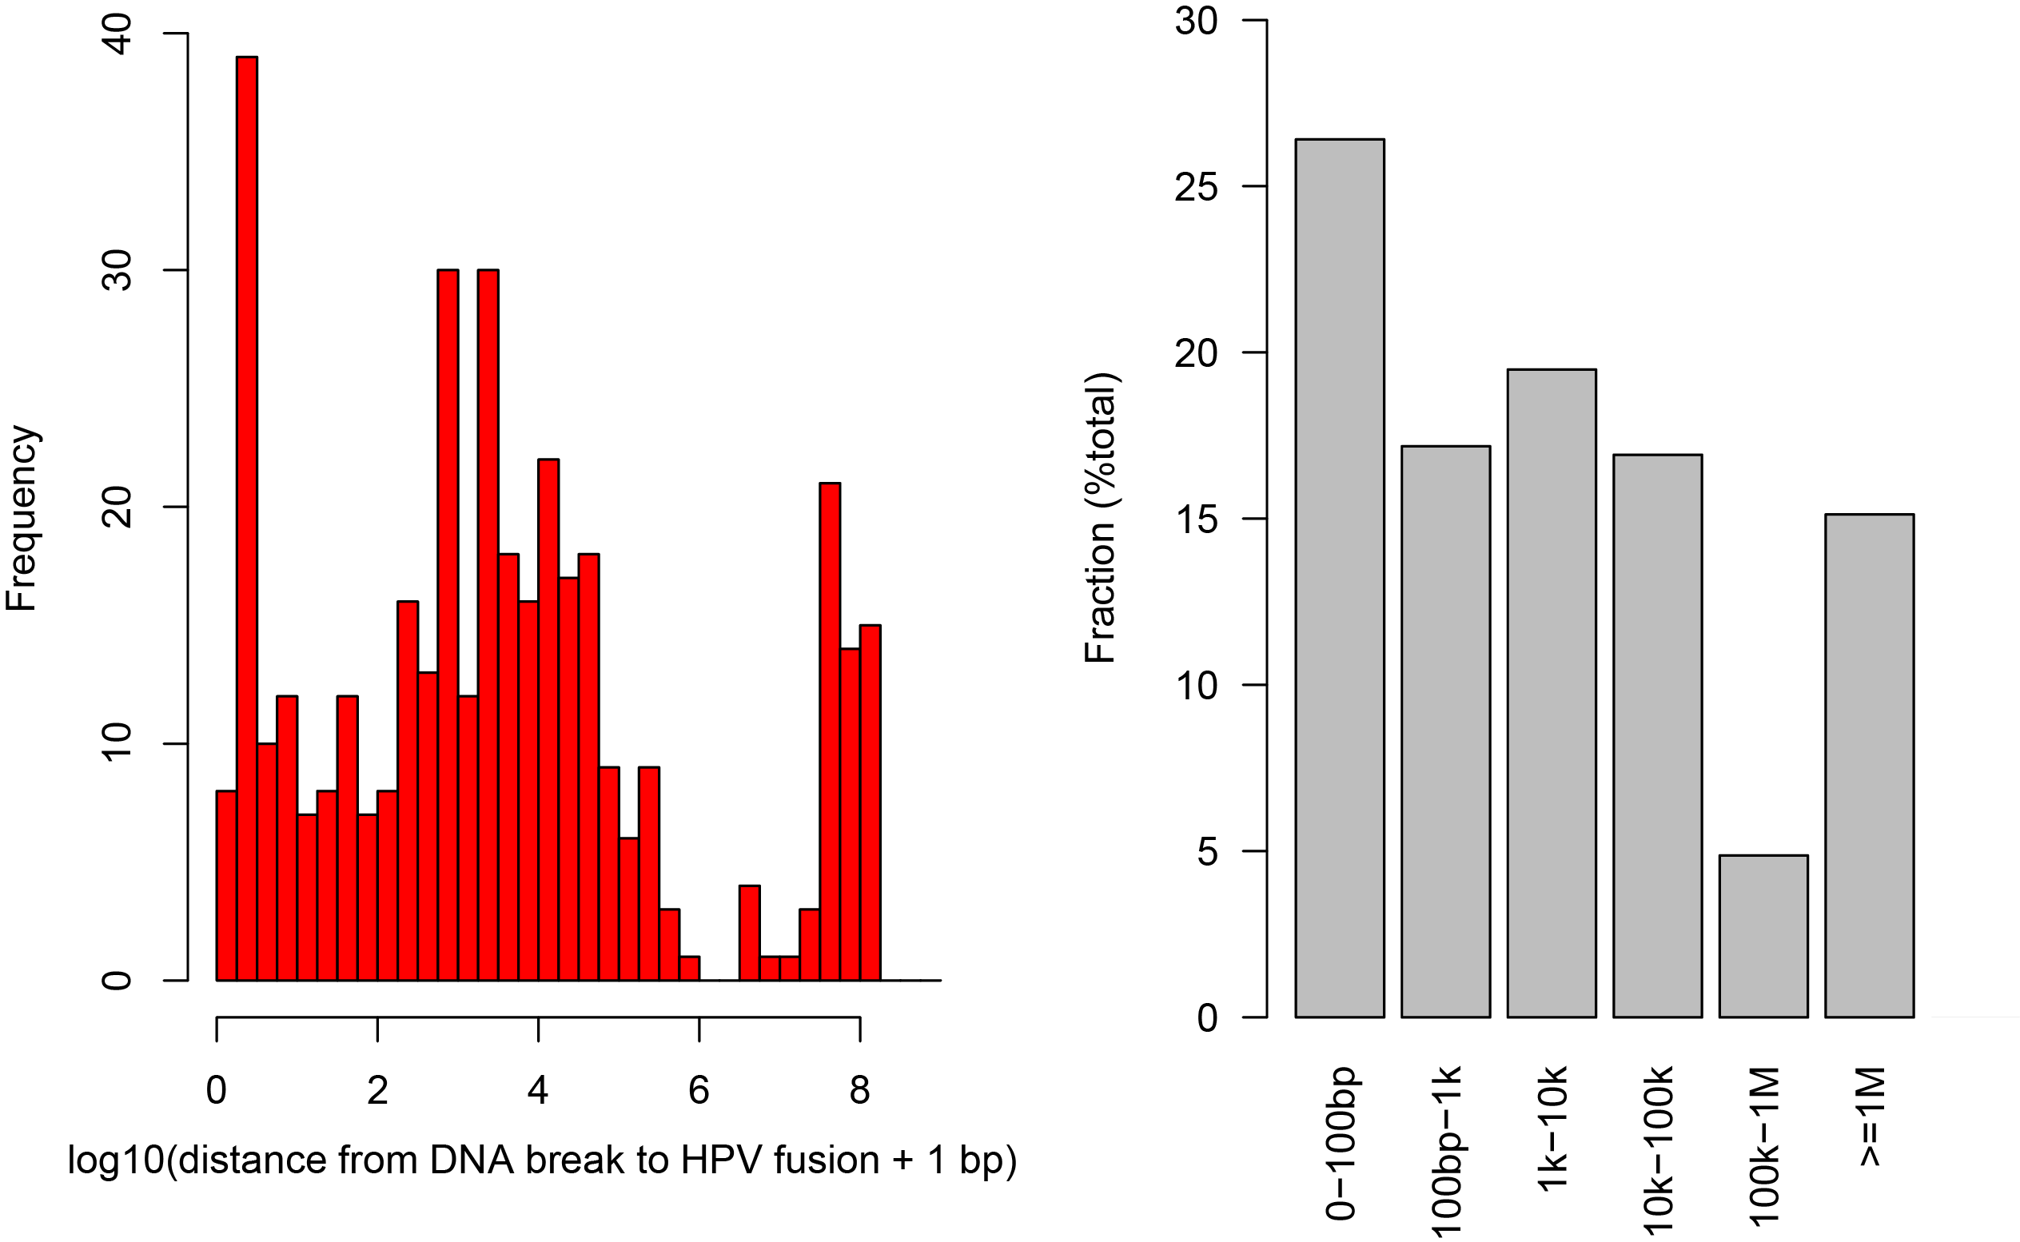
Supplemental Fig. S5.3. Distances from HPV breakpoints to chimeric HPV transcript junction sites
For OPSCC samples with HPV insertional breakpoints, we determined the genomic distances from HPV breakpoints (identified from WGS data) to chimeric HPV transcript junctions (identified from RNA-Seq data) using bedtools’ closestBed function. In analyzing 753 HPV breakpoints identified in tumors with corresponding RNA-seq data, approximately half (n=363, 48.2%) lack corresponding chimeric HPV transcript junctions mapping to the same chromosome. (Left) Shown here are (y-axis) counts of coincident events as a function of the (x-axis) log10 transformed distances from DNA insertional breakpoint to chimeric transcript junction when both map to the same chromosome (n=390). (Right) Fraction of HPV breakpoints having HPV fusion in various ranges of distances. Appromximately 80% of coincident HPV breakpoints and chimeric transcript junctions map within 100 kb of each other.

Supplemental Fig. S5.4 (1 of 6). Exon-by-exon expression analysis for genes with virus-host chimeric transcripts.
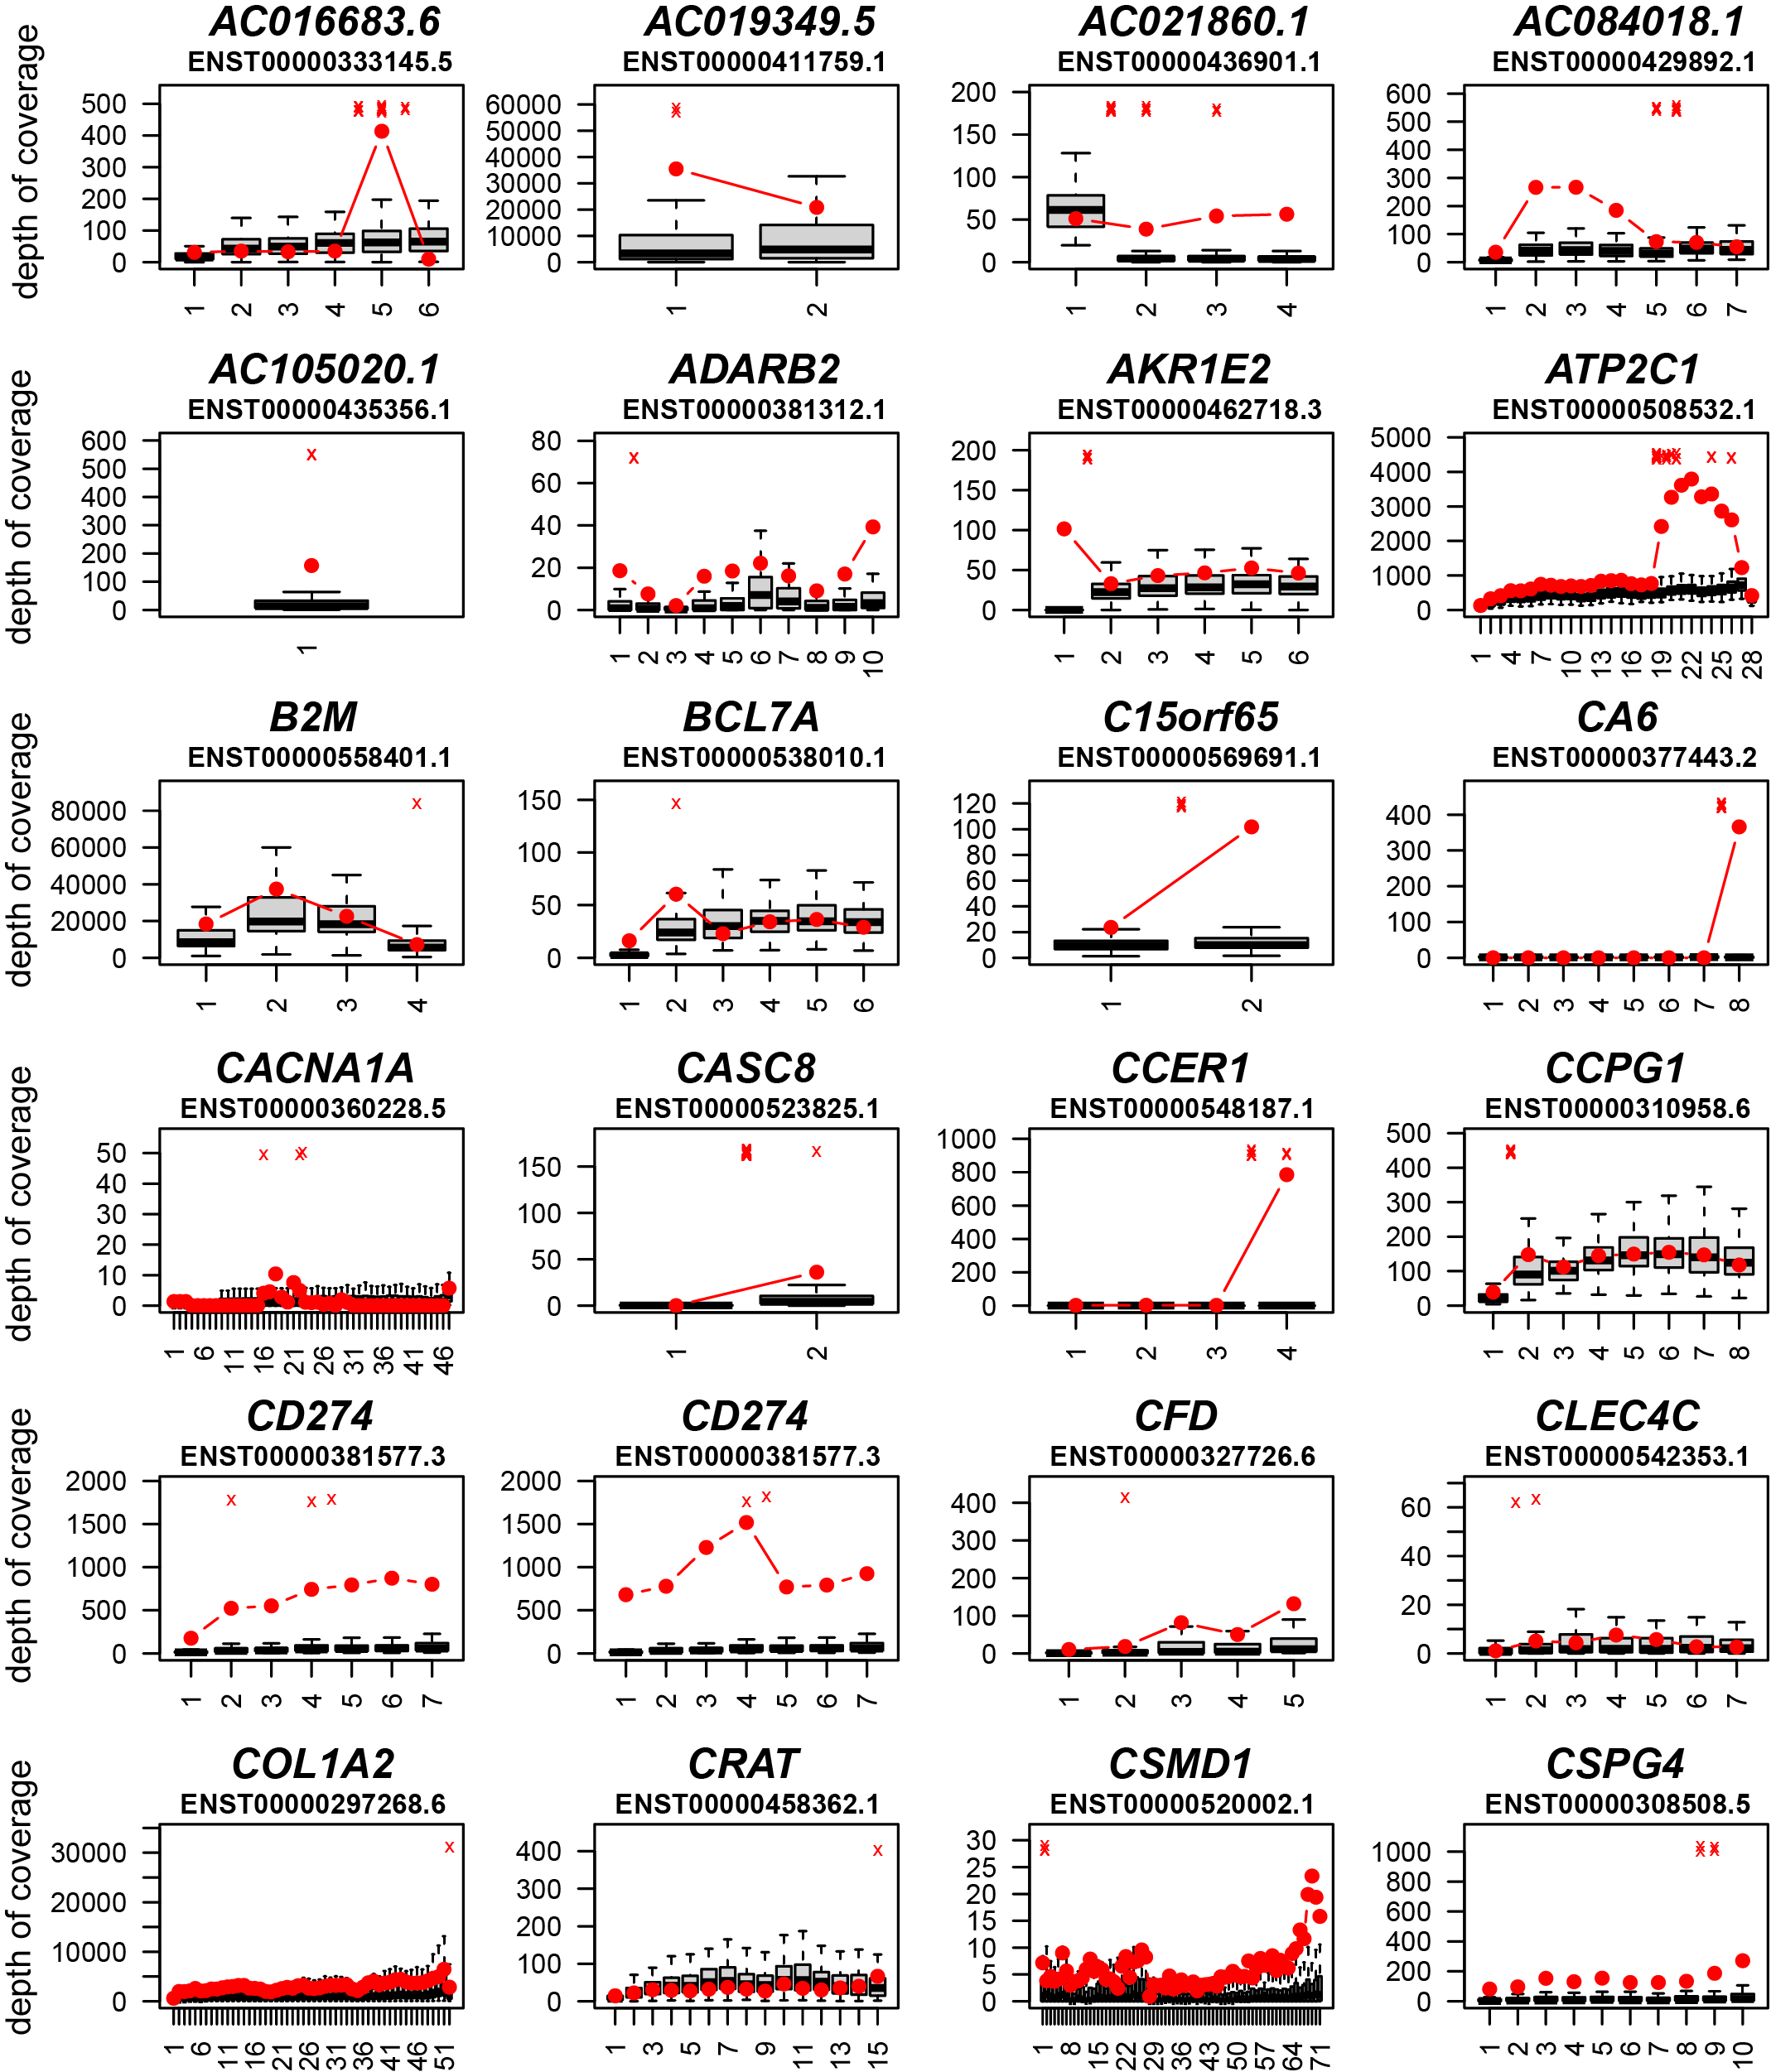
Supplemental Fig. S5.4 (2 of 6). Exon-by-exon expression analysis for genes with virus-host chimeric transcripts.

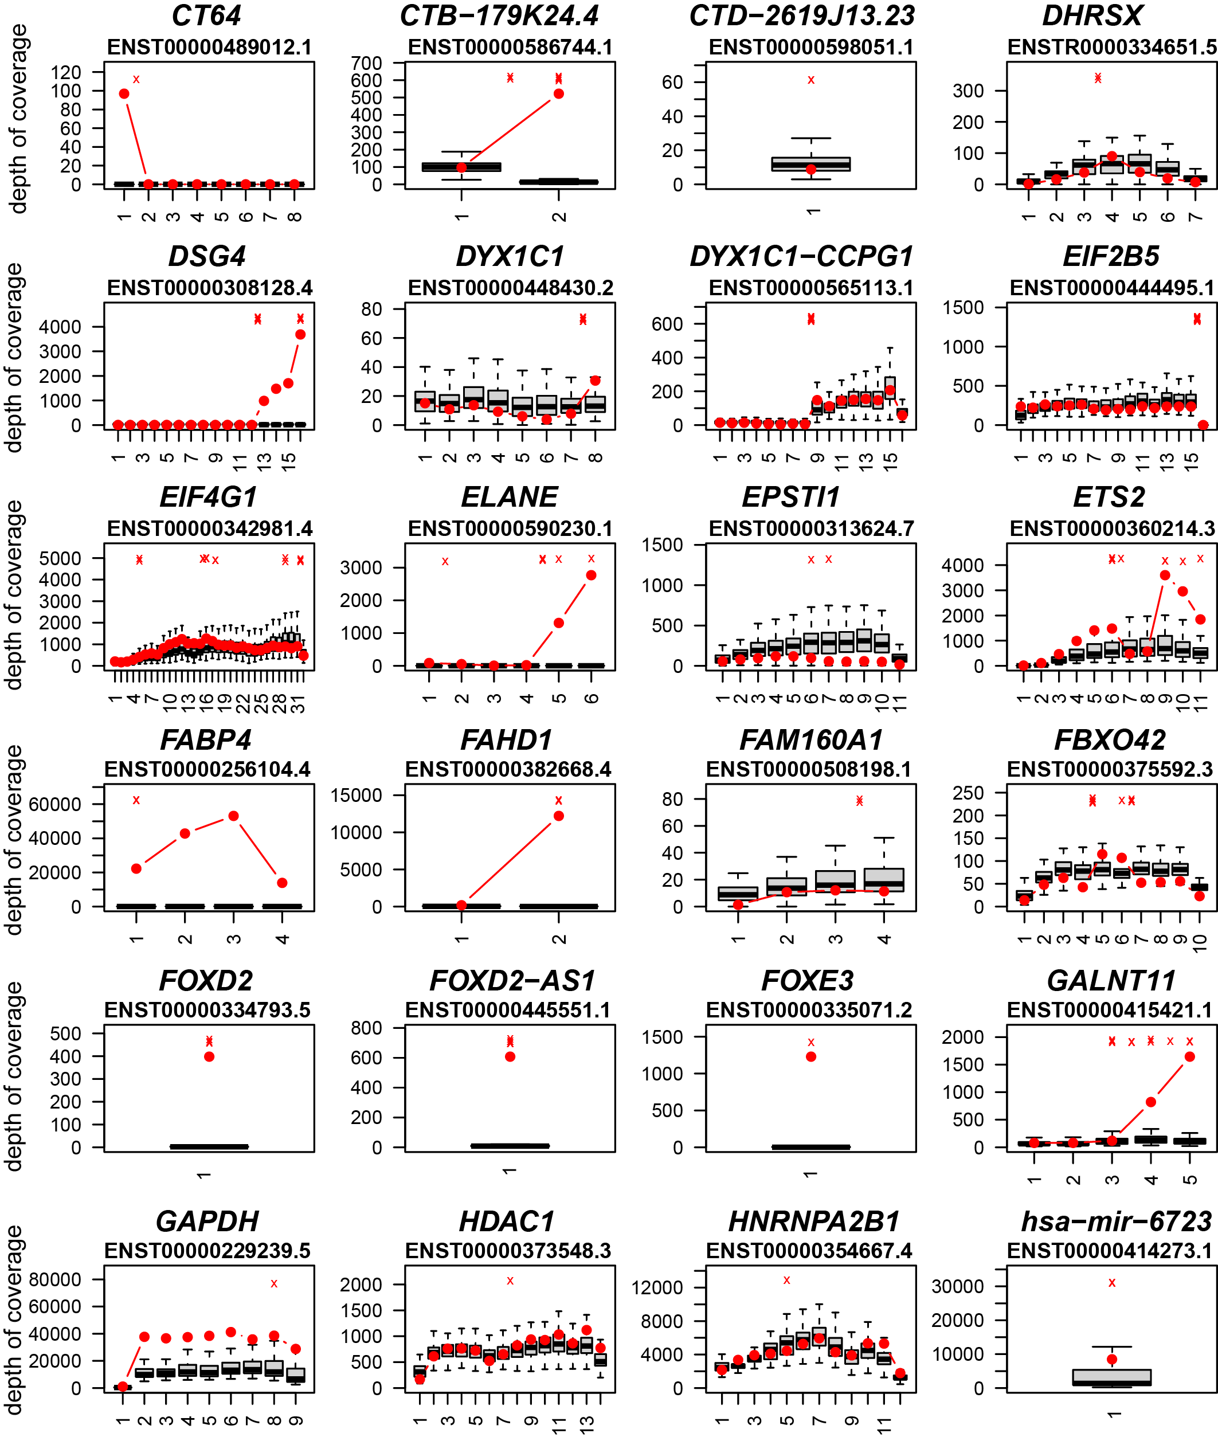
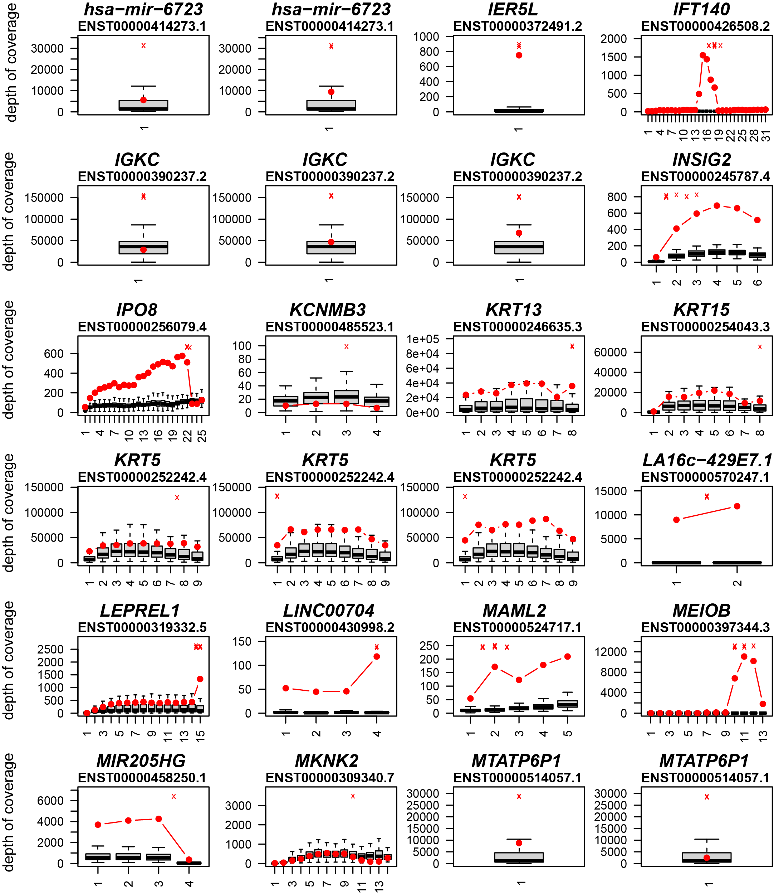
gfd
Supplemental Fig. S5.4 (3 of 6). Exon-by-exon expression analysis for genes with virus-host chimeric transcripts.

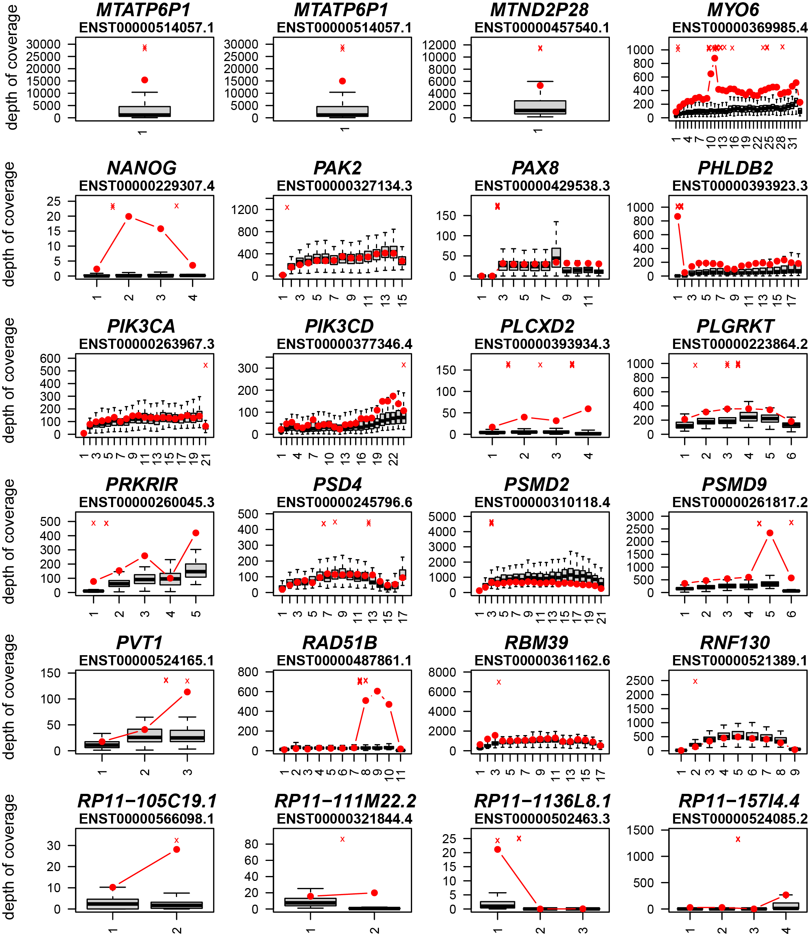
Supplemental Fig. S5.4 (4 of 6). Exon-by-exon expression analysis for genes with virus-host chimeric transcripts.

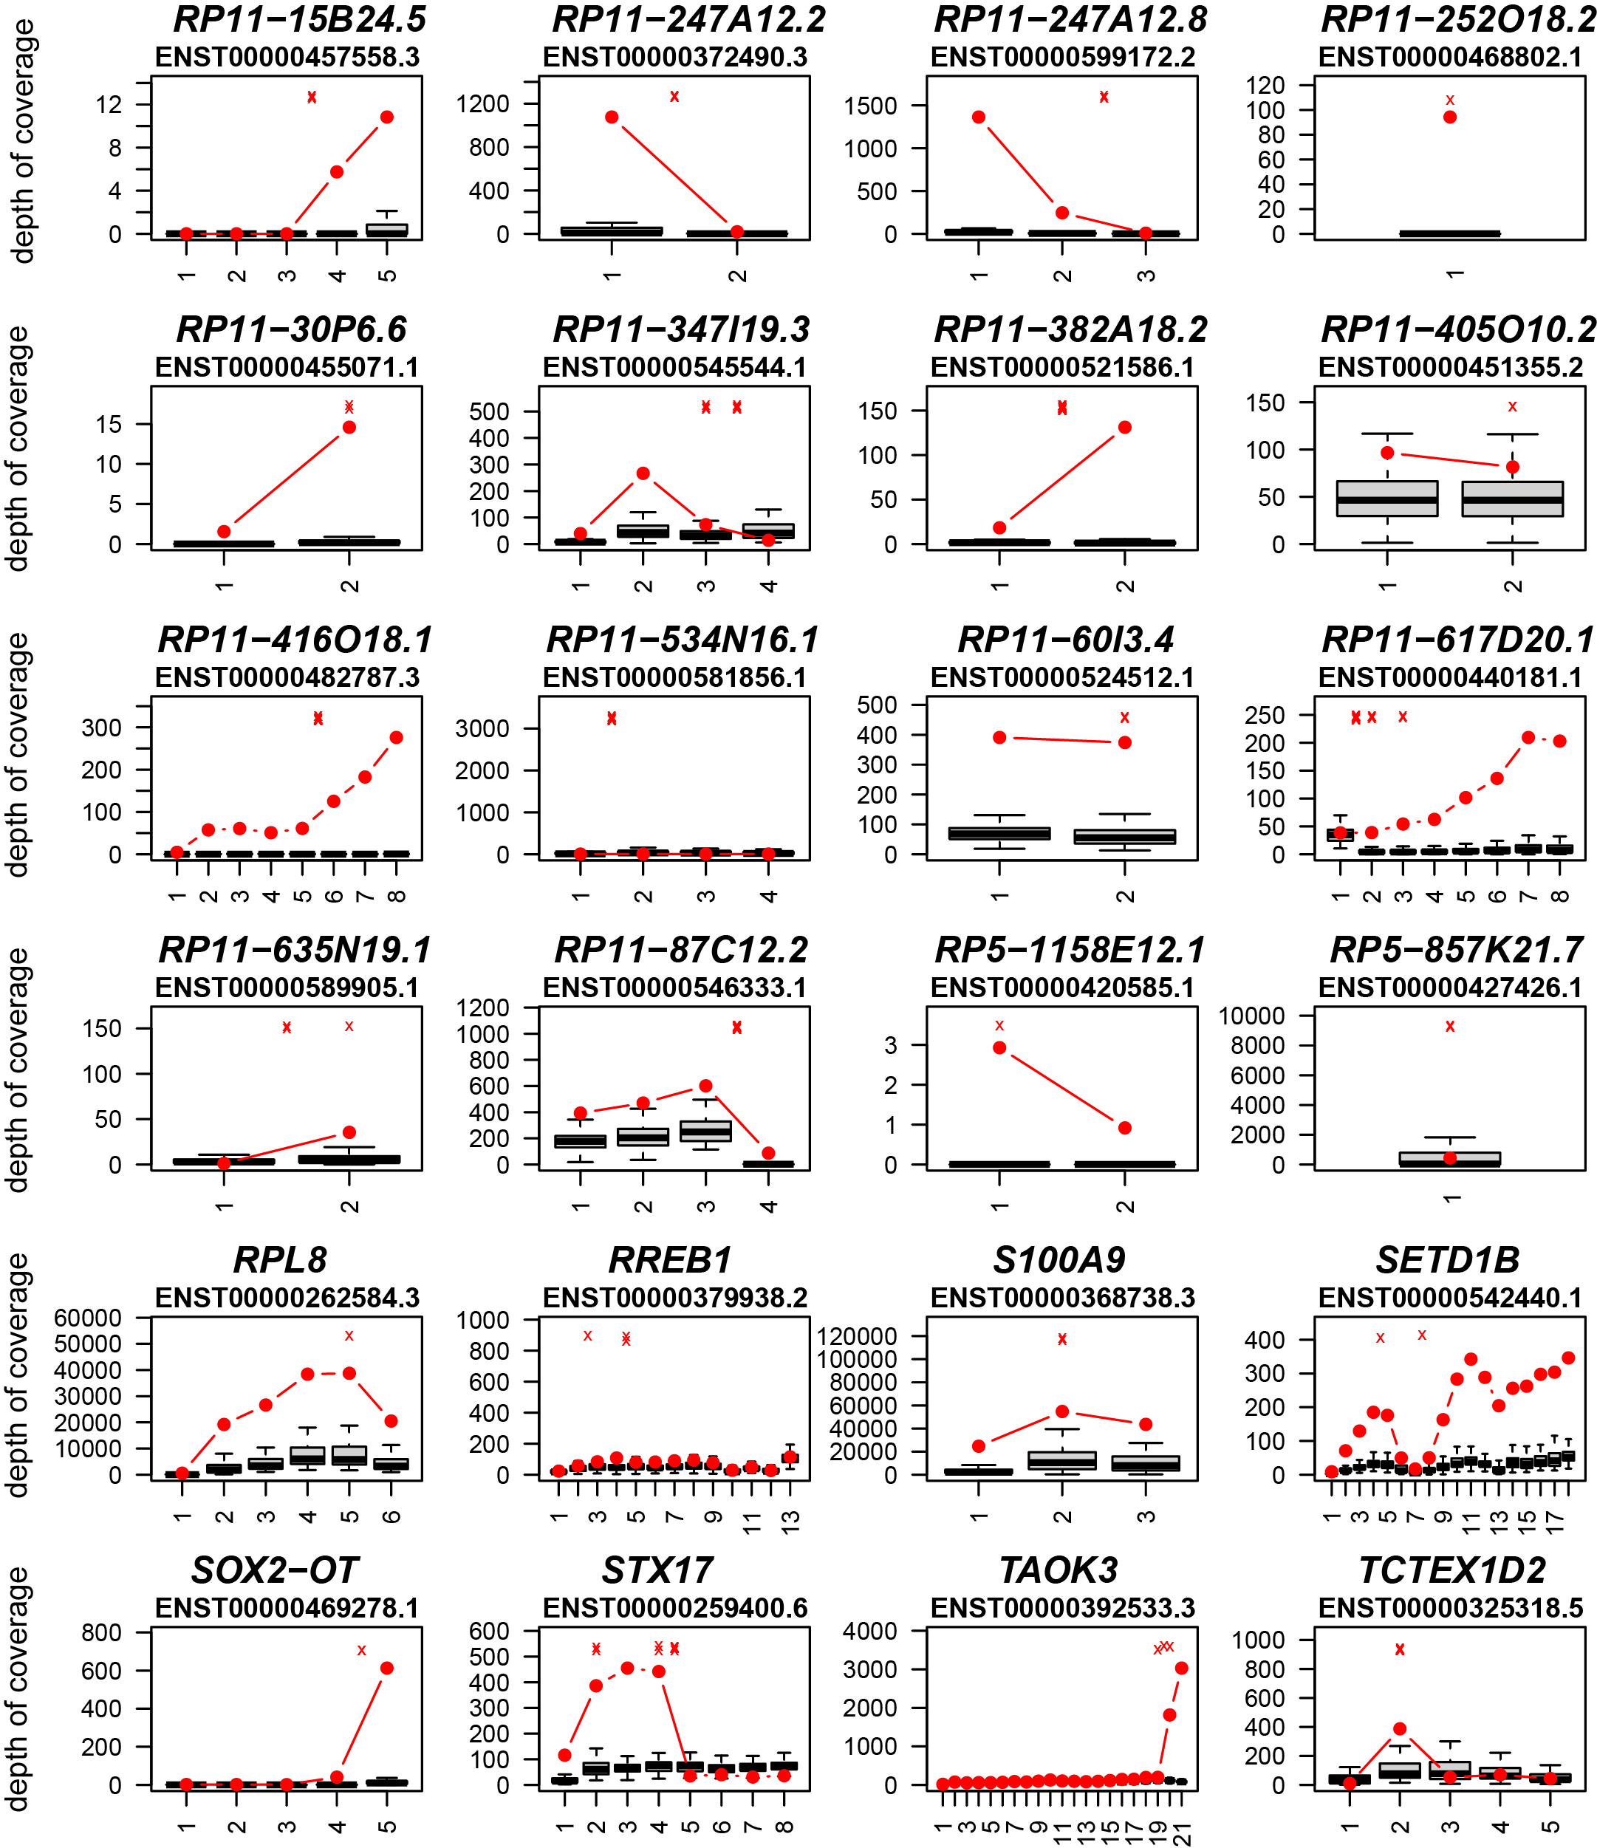
Supplemental Fig. S5.4 (5 of 6). Exon-by-exon expression analysis for genes with virus-host chimeric transcripts.

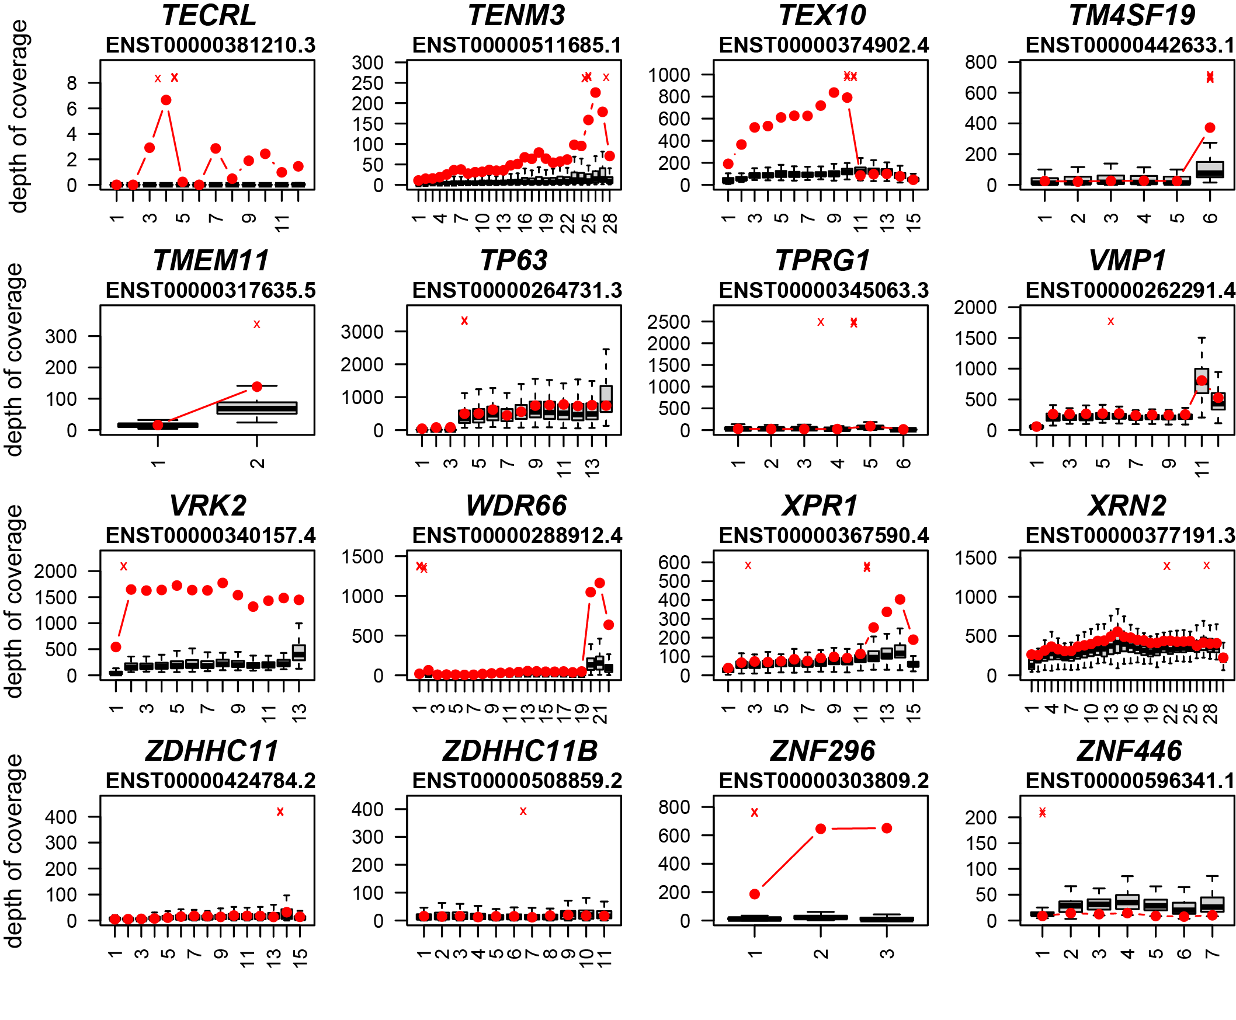
Supplemental Fig. S5.4 (6 of 6). Exon-by-exon expression analysis for genes with virus-host chimeric transcripts. Shown here are box-and-whiskers plot comparisons of the depth of RNA-seq sequencing coverage (y-axis) for each of 147 genes (panels) affected by virus-host chimeric transcripts in 103 tumors with available RNA-seq data, as analyzed using TopHat (Kim and Salzberg 2011). Depth of coverage (y-axis) is defined here as the number of RNA-seq nucleotides mapped per exon divided by the size of the exon (in nucleotides). X-axis, exon number for annotated host transcripts; red dots, depth of coverage for gene in affected tumor in which the chimeric transcript was detected; red X, position of the virus-host fusion junction; gray and black, box and whiskers, expression distribution in all other tumors indicating the interquartile range.

SUPPLEMENTAL TABLES
Variables | Integrated (n=65) | Episomal (n=21) | P-value
Age, years |  |  | 0.838
<50 | 10(15.4) | 3(14.39)
50-59 | 27(41.5) | 11(52.4)
60-69 | 23(35.4) | 6(6(28.6)
≥70 | 5(7.7) | 1(4.5)
Mean | 57.8 | 57.0 | 0.678
Median (range) | 58(39-77) | 56(40-70)
Sex |  |  | 0.410
Female | 7(10.8) | 1(4.8)
Male | 58(89.2) | 20(95.2)
Race |  |  | 0.581
White | 58(89.2) | 20(95.2)
Black | 3(4.6) | 0(0.0)
Multiple or other race | 4(6.2) | 1(4.8)
Cigarette smoking |  |  | 0.226
Never | 25(41.7) | 9(42.9)
Former | 29(48.3) | 7(33.3)
Current | 6(10.0) | 5(23.8)
Missing | 5 | 0
Lifetime cigarette pack-years |  |  | 0.339
<1 | 26(44.1) | 9(42.9)
≥1-<20 | 8(13.6) | 5(23.8)
≥20 | 25(42.4) | 7(33.3)
Missing | 6 | 0
Alcohol use |  |  | 0.304
Never | 14(23.7) | 3(15.0)
Former | 20(33.9) | 11(55.0)
Current | 25(42.4) | 6(30.0)
Missing | 6 | 0
Alcohol use |  |  | 0.721
0 | 33(55.9) | 10(47.6)
>0-<10 | 8(13.6) | 2(9.5)
≥10 | 18(30.51) | 9(42.8)
Missing | 6 | 0
Clinical T stage |  |  | 0.593
Tis/Tx | 4(6.2) | 2(9.5)
T1-T2 | 42(64.6) | 15(71.4)
T3-T4 | 19(29.2) | 4(19.1)
Clinical N stage |  |  | 0.586
Nx | 1(1.5) | 0(0.0)
N0-N2a | 28(43.1) | 7(33.3)
N2b-N3 | 36(55.4) | 14(66.7)
Supplemental Table S1.1. Demographic, behavioral and clinical characteristics of HPV-positive OPSCC cases stratified by HPV integration status. Shown are frequencies (percentages) of various characteristics (left) of 86 HPV-positive OPSCC patients in the Ohio cohort, and P-values (Chi-square test; right), unless otherwise indicated. The characteristics are stratified by HPV integration status, i.e. integrated vs. only episomal virus. Additional information including primary tumor anatomical site has been reported previously (Gillison et al. 2019).

Sample ID | HPV type | HPV copy | #HPV breakpoints | #HPV breakpoints in Chr. 1-22,X,Y | #HPV breakpoints in chrUn | #HPV breakpoints in repeat | Exclusively  Episomal HPV
GS18001 | HPV16 | 85.8 | 30 | 25 | 0 | 5 | N
GS18002 | HPV16 | 58.3 | 31 | 26 | 0 | 5 | N
GS18003 | HPV16 | 8.7 | 0 | 0 | 0 | 0 | Y
GS18004 | HPV16 | 1.1 | 2 | 2 | 0 | 0 | N
GS18005 | HPV16 | 2.0 | 5 | 4 | 1 | 0 | N
GS18006 | HPV16 | 106.5 | 11 | 11 | 0 | 0 | N
GS18007 | HPV16 | 0.2 | 4 | 4 | 0 | 0 | N
GS18008 | HPV16 | 26.1 | 1 | 0 | 1 | 0 | N
GS18009 | HPV16 | 8.8 | 0 | 0 | 0 | 0 | Y
GS18010 | HPV16 | 34.9 | 9 | 7 | 2 | 0 | N
GS18011 | HPV16 | 34.6 | 13 | 10 | 0 | 3 | N
GS18012 | HPV16 | 22.4 | 4 | 4 | 0 | 0 | N
GS18013 | HPV16 | 0.5 | 2 | 2 | 0 | 0 | N
GS18014 | HPV16 | 1.1 | 9 | 7 | 0 | 2 | N
GS18015 | HPV16 | 12.1 | 0 | 0 | 0 | 0 | Y
GS18016 | HPV16 | 13.8 | 3 | 3 | 0 | 0 | N
GS18017 | HPV16 | 21.5 | 2 | 2 | 0 | 0 | N
GS18018 | HPV16 | 36.8 | 9 | 9 | 0 | 0 | N
GS18019 | HPV16 | 7.9 | 14 | 14 | 0 | 0 | N
GS18020 | HPV35 | 27.7 | 20 | 19 | 0 | 1 | N
GS18021 | HPV16 | 0.4 | 3 | 2 | 0 | 1 | N
GS18022 | HPV16 | 0.5 | 2 | 2 | 0 | 0 | N
GS18023 | HPV16 | 32.4 | 20 | 16 | 0 | 4 | N
GS18026 | HPV16 | 182.1 | 105 | 99 | 0 | 6 | N
GS18027 | HPV16 | 0.4 | 3 | 3 | 0 | 0 | N
GS18028 | HPV16 | 29.0 | 8 | 6 | 0 | 2 | N
GS18029 | HPV16 | 3.0 | 2 | 2 | 0 | 0 | N
GS18030 | HPV16 | 40.1 | 1 | 0 | 0 | 1 | N
GS18031 | HPV16 | 6.9 | 0 | 0 | 0 | 0 | Y
GS18033 | HPV16 | 2.5 | 3 | 2 | 0 | 1 | N
GS18034 | HPV16 | 15.0 | 0 | 0 | 0 | 0 | Y
GS18035 | HPV16 | 0.3 | 3 | 3 | 0 | 0 | N
GS18036 | HPV16 | 0.5 | 2 | 2 | 0 | 0 | N
GS18037 | HPV16 | 15.1 | 1 | 1 | 0 | 0 | N
GS18038 | HPV16 | 11.1 | 0 | 0 | 0 | 0 | Y
GS18039 | HPV33 | 1.9 | 1 | 1 | 0 | 0 | N
GS18040 | HPV16 | 11.4 | 0 | 0 | 0 | 0 | Y
GS18041 | HPV16 | 5.5 | 7 | 6 | 0 | 1 | N
GS18043 | HPV16 | 58.2 | 1 | 1 | 0 | 0 | N
GS18044 | HPV16 | 16.0 | 6 | 5 | 1 | 0 | N
GS18046 | HPV16 | 40.3 | 1 | 0 | 0 | 1 | N
GS18047 | HPV16 | 83.3 | 70 | 64 | 0 | 6 | N
GS18048 | HPV33 | 1.0 | 0 | 0 | 0 | 0 | Y
GS18049 | HPV16 | 28.1 | 8 | 7 | 0 | 1 | N
GS18051 | HPV16 | 0.9 | 5 | 4 | 0 | 1 | N
GS18052 | HPV16 | 28.8 | 5 | 5 | 0 | 0 | N
GS18053 | HPV16 | 17.7 | 0 | 0 | 0 | 0 | Y
GS18055 | HPV16 | 30.5 | 3 | 2 | 0 | 1 | N
GS18059 | HPV16 | 51.6 | 8 | 7 | 0 | 1 | N
GS18061 | HPV16 | 0.4 | 2 | 2 | 0 | 0 | N
GS18062 | HPV16 | 9.8 | 25 | 24 | 0 | 1 | N
GS18063 | HPV16 | 0.9 | 3 | 2 | 0 | 1 | N
GS18065 | HPV16 | 15.1 | 0 | 0 | 0 | 0 | Y
GS18066 | HPV16 | 6.4 | 2 | 2 | 0 | 0 | N
GS18067 | HPV16 | 20.7 | 2 | 2 | 0 | 0 | N
GS18068 | HPV16 | 0.8 | 3 | 3 | 0 | 0 | N
GS18069 | HPV16 | 1.7 | 2 | 2 | 0 | 0 | N
GS18070 | HPV33 | 9.1 | 5 | 4 | 0 | 1 | N
GS18071 | HPV16 | 28.5 | 25 | 3 | 18 | 4 | N
GS18072 | HPV35 | 0.6 | 2 | 2 | 0 | 0 | N
GS18074 | HPV16 | 10.8 | 5 | 3 | 0 | 2 | N
GS18076 | HPV16 | 25.3 | 63 | 61 | 0 | 2 | N
GS18077 | HPV35 | 33.2 | 1 | 1 | 0 | 0 | N
GS18078 | HPV16 | 1.5 | 5 | 5 | 0 | 0 | N
GS18079 | HPV16 | 37.1 | 0 | 0 | 0 | 0 | Y
GS18081 | HPV16 | 7.8 | 5 | 3 | 0 | 2 | N
GS18082 | HPV16 | 33.7 | 4 | 4 | 0 | 0 | N
GS18085 | HPV59 | 10.0 | 0 | 0 | 0 | 0 | Y
GS18087 | HPV16 | 9.2 | 12 | 12 | 0 | 0 | N
GS18088 | HPV16 | 4.5 | 9 | 9 | 0 | 0 | N
GS18091 | HPV16 | 10.3 | 0 | 0 | 0 | 0 | Y
GS18092 | HPV16 | 5.8 | 15 | 15 | 0 | 0 | N
GS18093 | HPV16 | 9.1 | 0 | 0 | 0 | 0 | Y
GS18094 | HPV16 | 5.6 | 3 | 3 | 0 | 0 | N
GS18095 | HPV16 | 14.2 | 0 | 0 | 0 | 0 | Y
GS18096 | HPV16 | 51.7 | 0 | 0 | 0 | 0 | Y
GS18097 | HPV16 | 78.3 | 4 | 4 | 0 | 0 | N
GS18098 | HPV16 | 16.3 | 0 | 0 | 0 | 0 | Y
GS18099 | HPV16 | 5.4 | 0 | 0 | 0 | 0 | Y
GS18101 | HPV16 | 12.3 | 0 | 0 | 0 | 0 | Y
GS18102 | HPV33 | 7.6 | 1 | 1 | 0 | 0 | N
GS18103 | HPV18 | 0.6 | 7 | 7 | 0 | 0 | N
GS18105 | HPV18 | 0.6 | 0 | 0 | 0 | 0 | Y
GS18107 | HPV69 | 0.1 | 4 | 4 | 0 | 0 | N
GS18108 | HPV16 | 9.5 | 0 | 0 | 0 | 0 | Y
GS18109 | HPV16 | 30.1 | 8 | 8 | 0 | 0 | N
TCGA-BA-4077 | HPV16 | 15.0 | 4 | 3 | 0 | 1 | N
TCGA-BA-5153 | HPV16 | 21.2 | 3 | 3 | 0 | 0 | N
TCGA-BA-A4IH | HPV16 | 7.2 | 13 | 11 | 0 | 2 | N
TCGA-BB-4225 | HPV33 | 17.6 | 0 | 0 | 0 | 0 | Y
TCGA-CN-4741 | HPV16 | 21.4 | 19 | 12 | 0 | 7 | N
TCGA-CN-5374 | HPV16 | 14.0 | 34 | 32 | 0 | 2 | N
TCGA-CR-5249 | HPV16 | 17.3 | 3 | 2 | 0 | 1 | N
TCGA-CR-5250 | HPV16 | 5.6 | 0 | 0 | 0 | 0 | Y
TCGA-CR-6470 | HPV16 | 6.4 | 0 | 0 | 0 | 0 | Y
TCGA-CR-6472 | HPV16 | 0.8 | 2 | 2 | 0 | 0 | N
TCGA-CR-6482 | HPV16 | 246.9 | 27 | 11 | 0 | 16 | N
TCGA-CR-6487 | HPV16 | 8.4 | 12 | 12 | 0 | 0 | N
TCGA-CR-7385 | HPV16 | 15.8 | 20 | 19 | 0 | 1 | N
TCGA-CR-7404 | HPV16 | 71.0 | 53 | 48 | 0 | 5 | N
TCGA-CV-5442 | HPV16 | 1.4 | 4 | 4 | 0 | 0 | N
TCGA-CV-5443 | HPV16 | 22.5 | 9 | 9 | 0 | 0 | N
TCGA-CV-6433 | HPV16 | 30.0 | 1 | 0 | 0 | 1 | N
TCGA-CV-6961 | HPV16 | 4.4 | 7 | 5 | 0 | 2 | N
TCGA-CV-7100 | HPV33 | 31.0 | 9 | 8 | 0 | 1 | N
Supplemental Table S1.2. Counts of HPV insertional breakpoints detected per tumor from WGS data. Virus-host breakpoints are detected in 81 (77%) of 105 tumors (including in unassembled contigs and repetitive regions), while 24 (23%) tumors lack mapped breakpoints, suggesting the presence of episomal virus. In the 77 tumors with virus-host breakpoints uniquely aligned to host chromosomes, the median number of HPV breakpoints is 4 (range, 1 to 99). Columns, left to right: the unique tumor identification number, HPV type, estimated HPV copy number, counts of HPV breakpoints detected by WGS per tumor (further subdivided into location in known chromosomes, unassembled contigs, and repetitive elements), and HPV status, defining the lack of detected host-virus insertional breakpoints as “episome-only” virus (Y, yes; N, no). Viral types 105 tumors, 92 (87.6%) are HPV16 positive and 12.3% have other types (HPV33=6, HPV35=3, HPV18=2, HPV59=1, HPV69=1).

HPV type | gene | region | size | all breakpoints
 |  |  |  | #expected | #observed | ratio | p-value | FDR adjusted p-value
HPV16 | E6 | 83..559 | 477 | 43.6 | 39 | 0.895 | 5.32E-01 | 5.98E-01
HPV16 | E7 | 562..858 | 297 | 27.1 | 31 | 1.143 | 4.33E-01 | 5.57E-01
HPV16 | E1 | 865..2813 | 1949 | 178.0 | 205 | 1.152 | 2.20E-02 | 1.98E-01
HPV16 | E2 | 2755..3852 | 1098 | 100.3 | 95 | 0.947 | 6.28E-01 | 6.28E-01
HPV16 | E4 | 3332..3619 | 288 | 26.3 | 31 | 1.179 | 3.21E-01 | 5.57E-01
HPV16 | E5 | 3849..4100 | 252 | 23.0 | 15 | 0.652 | 1.10E-01 | 4.97E-01
HPV16 | L2 | 4236..5657 | 1422 | 129.9 | 117 | 0.901 | 2.26E-01 | 5.08E-01
HPV16 | L1 | 5560..7155 | 1596 | 145.8 | 136 | 0.933 | 3.79E-01 | 5.57E-01
HPV16 | URR | 7156..7905,1..82 | 832 | 76.0 | 86 | 1.132 | 2.25E-01 | 5.08E-01
HPV16 | total | 1..7905 | 7905 | 722.0 | 722 | 1.000 | NA | NA
Supplemental Table S1.3. Distribution of insertional breakpoints across HPV16 genes.
Upon identification of 722 virus-host breakpoints in HPV16-positive tumors, we mapped and counted breakpoint junctions in viral genes as shown (# observed breakpoints). We calculated the expected number of breakpoints for each viral gene, by random distribution across the viral genome, based on the relative length of each gene. P-values of enrichment were calculated using binomial test (alternative=”two-tailed test”), and adjusted p-values were calculated using the FDR method.

HPV type | gene | region | size | representative breakpoints
 |  |  |  | #expected | #observed | ratio | p-value | FDR adjusted p-value
HPV16 | E6 | 83..559 | 477 | 13.1 | 13 | 0.99 | 1.00E+00 | 1.00E+00
HPV16 | E7 | 562..858 | 297 | 8.2 | 7 | 0.86 | 8.58E-01 | 1.00E+00
HPV16 | E1 | 865..2813 | 1949 | 53.5 | 53 | 0.99 | 1.00E+00 | 1.00E+00
HPV16 | E2 | 2755..3852 | 1098 | 30.1 | 37 | 1.23 | 2.01E-01 | 4.87E-01
HPV16 | E4 | 3332..3619 | 288 | 7.9 | 13 | 1.64 | 6.95E-02 | 3.13E-01
HPV16 | E5 | 3849..4100 | 252 | 6.9 | 2 | 0.29 | 5.26E-02 | 3.13E-01
HPV16 | L2 | 4236..5657 | 1422 | 39.0 | 46 | 1.18 | 2.16E-01 | 4.87E-01
HPV16 | L1 | 5560..7155 | 1596 | 43.8 | 39 | 0.89 | 4.48E-01 | 8.06E-01
HPV16 | URR | 7156..7905,1..82 | 832 | 22.8 | 22 | 0.96 | 1.00E+00 | 1.00E+00
HPV16 | Total | 1..7905 | 7905 | 217.0 | 217 | 1.00 | NA | NA
Supplemental Table S1.4. Distribution of representative breakpoints across HPV16 genes.
Upon identification of 217 representative HPV breakpoints in HPV16-positive tumors, we mapped and counted breakpoint junctions in viral genes as shown (# observed representative breakpoints). “Representative breakpoints” are defined as HPV breakpoints supported by the highest number of discordant or split reads, out of all clustered breakpoints within 500 kb at each locus. We calculated the expected number of representative breakpoints for each viral gene, by random distribution across the viral genome, based on the relative length of each gene. P-values of enrichment were calculated using binomial test (alternative=”two-tailed test”), and adjusted p-values were calculated using the FDR method.
HPV type | gene | region | size | breakpoints having maximum supporting reads
 |  |  |  | #expected | #observed | ratio | p-value | FDR adjusted p-value
HPV16 | E6 | 83..559 | 477 | 4.3 | 5 | 1.15 | 6.23E-01 | 8.65E-01
HPV16 | E7 | 562..858 | 297 | 2.7 | 3 | 1.11 | 7.53E-01 | 8.65E-01
HPV16 | E1 | 865..2813 | 1949 | 17.8 | 19 | 1.07 | 7.84E-01 | 8.65E-01
HPV16 | E2 | 2755..3852 | 1098 | 10.0 | 9 | 0.90 | 8.65E-01 | 8.65E-01
HPV16 | E4 | 3332..3619 | 288 | 2.6 | 4 | 1.52 | 3.37E-01 | 6.42E-01
HPV16 | E5 | 3849..4100 | 252 | 2.3 | 0 | 0.00 | 1.77E-01 | 6.42E-01
HPV16 | L2 | 4236..5657 | 1422 | 13.0 | 16 | 1.24 | 3.57E-01 | 6.42E-01
HPV16 | L1 | 5560..7155 | 1596 | 14.5 | 10 | 0.69 | 2.39E-01 | 6.42E-01
HPV16 | URR | 7156..7905,1..82 | 832 | 7.6 | 10 | 1.32 | 3.36E-01 | 6.42E-01
HPV16 | Total | 1..7905 | 7905 | 72.0 | 72 | 1.00 | NA | NA
Supplemental Table S1.5. Distribution of main breakpoints across HPV16 genes. Upon identification of 72 “main” HPV breakpoints across 72 HPV16-positive tumors, we mapped and counted breakpoint junctions in viral genes as shown (# observed main breakpoints). A “main” breakpoint is defined as the single HPV breakpoint in each tumor supported by the highest number of supporting WGS reads across that tumor’s entire genome. We calculated the expected number of main breakpoints for each viral gene, by random distribution across the viral genome, based on the relative length of each gene. P-values of enrichment were calculated using binomial test (alternative=”two-tailed test”), and adjusted p-values were calculated using the FDR method.

HPV gene | Episomal tumor's mean expression log₂(TPM+1) | Integrated tumor's mean expression log₂(TPM+1) | p-value | FDR adjusted p-value
HPV16_A | 3.96 | 3.70 | 3.86E-01 | 7.73E-01
HPV16_B | 6.56 | 6.70 | 5.89E-01 | 8.15E-01
HPV16_C | 3.18 | 3.27 | 7.98E-01 | 8.40E-01
HPV16_D | 0.37 | 0.37 | 9.49E-01 | 9.49E-01
HPV16_E | 4.00 | 2.64 | 1.44E-03 | 1.89E-02 | *
HPV16_F | 1.38 | 0.78 | 6.05E-02 | 3.03E-01
HPV16_G | 3.54 | 3.02 | 1.42E-01 | 5.68E-01
HPV16_H | 0.60 | 0.50 | 5.67E-01 | 8.15E-01
HPV16_I | 0.02 | 0.01 | 5.62E-01 | 8.15E-01
HPV16_J | 0.25 | 0.27 | 7.94E-01 | 8.40E-01
HPV16_K | 3.30 | 2.42 | 2.61E-02 | 1.74E-01
HPV16_L | 3.31 | 2.98 | 4.58E-01 | 8.15E-01
HPV16_M | 0.98 | 0.61 | 2.71E-01 | 7.26E-01
HPV16_N | 0.40 | 0.15 | 2.91E-01 | 7.26E-01
HPV16_O | 4.00 | 3.89 | 6.64E-01 | 8.30E-01
HPV16_P | 0.65 | 0.28 | 3.42E-01 | 7.60E-01
HPV16_Q | 0.81 | 0.23 | 2.32E-01 | 7.26E-01
HPV16_R | 0.96 | 1.00 | 7.95E-01 | 8.40E-01
HPV16_S | 0.52 | 0.41 | 6.11E-01 | 8.15E-01
HPV16_T | 0.19 | 0.84 | 1.89E-03 | 1.89E-02 | *
Supplemental Table S1.6. Expression of polycistronic transcripts in tumors harboring episomal vs. integrated HPV16.
For each of the annotated polycistronic viral transcripts as shown in Fig. S1.3 (Zheng and Baker 2006), we calculated the mean level of expression as log-transformed TPM for all 74 HPV16- positive tumors in the Ohio cohort. Tumors without HPV integration sites (episomal tumors, n=18) were compared with tumors with HPV integration sites (n=56). P-values were calculated by t-test (two-tailed), and the multiple-testing adjustment was performed by FDR method. Asterisk, adjusted p-value < 0.05. Expression levels of each polycistronic transcript were quantified by Salmon- v1.3.0 (Patro et al. 2017). HPV16_E encodes HPV16 E6*III and E5. HPV16_T encodes L1.

See Supplemental_Table_S1_7.xlsx – Excel file
Supplemental Table S1.7. Identification of HPV insertional breakpoint sites in 105 tumors studied by WGS. Listed here for each uniquely mapped HPV insertional breakpoint is tumor sample ID, virus type, coordinates of reads mapped against the virus reference genome (start and stop coordinates of read, with latter at breakpoint site), location of integrant mapped against human genome GRCh37 reference assembly (chromosome number, start and stop coordinates of read mapped to host genome, with former at breakpoint site), number of supporting discordant pairs and split reads, classification as a representative breakpoint (i.e. for clustered insertional breakpoints, a particular breakpoint supported by the most sequence reads), and a list of up to 4 of the most closely positioned genes within +/- 500 kb from breakpoint in the reference genome.

Sample ID | count of HPV insertional breakpoints detected by WGS | count of HPV insertional breakpoints detected by HPV capture-seq | count of overlaps
GS18109 | 8 | 12 | 7
GS18041 | 6 | 6 | 6
GS18006 | 11 | 11 | 10
Supplemental Table S1.8. Confirmation of HPV breakpoints by HPV capture-seq
Three HPV-positive OPSCC samples (left) were selected arbitrarily to confirm breakpoints identified from WGS data, using HPV capture-seq involving custom Agilent SureSelect HPV16 baits (www.agilent.com). DELLY (Rausch et al. 2012) was used to detect HPV insertional breakpoints, and confirmed 23 (92%) of 25 breakpoints detected in WGS data. Shown are sample ID and counts of HPV breakpoints detected by WGS, HPV breakpoints detected by hybrid capture (HPV capture-seq), and breakpoints called by both methods. WGS, whole-genome sequencing.

See Supplemental_Table_S1_9.xlsx – Excel file
Supplemental Table S1.9. Confirmation of virus-host insertional breakpoints by custom PCR amplification and Sanger sequencing. Column headers: No., breakpoint ID number; tumor name; # reads, number of WGS reads that are discordant or split reads supporting breakpoint; junction sequence; description; HPV type; HPV start, reference viral genome coordinate of read start; HPV stop, reference viral genome coordinate of viral-host breakpoint; HPV gene; human chromosome cytoband; chrom. start, reference human genome coordinate of breakpoint; chrom. stop, reference human genome coordinate of read end; observed sequences, Sanger sequence data. Colors: red, HPV sequences; green, overlapping nucleotides shared between host and virus genomes; blue, untemplated sequences; dark blue, deletion or mutation; orange, mutation; gray, sequences not read; bold or highlighted, gene interrupted; underlined, oligonucleotide primer sequence; lowercase, repeated sequence.

Supplemental Table S2.1. Genomic hotspots of recurrent HPV integration identified in three or more tumors out of 105 OPSCC analyzed by WGS. Five independent genomic segments, each 1 Mbp length, harboring HPV integrants in ≥3 tumors were identified from 105 tumors that were studied using WGS. To account for bias introduced by clustered virus-host breakpoints in individual tumors, one million Monte Carlo simulations were run with 238 representative breakpoints, each defined as the breakpoint within 500 kb that is supported by the highest number of reads. Those segments showing significant enrichment in HPV integration are listed (empirical probability, p = 1x 10⁻⁶). Columns, left to right: chromosomal coordinates; number of tumors harboring HPV insertional breakpoints within indicated 1 Mbp segment; gene names in segments; cancer genes, as annotated in the Sanger Institute’s cancer gene census (Sondka et al. 2018); affected sample IDs.

chrom | start | stop | # tumors | genes | cancer genes | sample IDs
chr3 | 181,000,000 | 182,000,000 | 3 | LINC01206, LOC102724604, SOX2, SOX2-OT | SOX2 | GS18070, GS18078, GS18102
chr3 | 189,000,000 | 190,000,000 | 3 | MIR944, P3H2, P3H2-AS1, TP63 | TP63 | GS18014, GS18033, TCGA-CN-4741
chr4 | 1,000,000 | 2,000,000 | 4 | CRIPAK, CTBP1, CTBP1-AS, CTBP1-AS2, FAM53A, FGFR3, FGFRL1, LETM1, LOC100130872, LOC105374344, MAEA, MIR943, NKX1-1, NSD2, RNF212, SCARNA22, SLBP, SPON2, TACC3, TMED11P, TMEM129, UVSSA | FGFR3 | GS18007, GS18026, GS18092, GS18097
chr8 | 128,000,000 | 129,000,000 | 4 | CASC11, CASC19, CASC21, CASC8, CCAT1, CCAT2, MIR1204, MIR1205, MYC, PCAT1, PCAT2, POU5F1B, PRNCR1, TMEM75 | MYC | GS18020, GS18051, GS18069, GS18074
chr9 | 5,000,000 | 6,000,000 | 3 | CD274, ERMP1, INSL4, INSL6, JAK2, MLANA, PDCD1LG2, PLGRKT, RIC1, RLN1, RLN2 | CD274, JAK2, PDCD1LG2 | GS18047, GS18088, TCGA-CV-5443

region | #genes | genes
4 hit locus, chr8:128 Mbp (MYC) | 12 | CASC8 (chr8:128302061-128494384), MIR1205 (chr8:128972878-128972941), MIR1207 (chr8:129061397-129061484), MYC (chr8:128747679-128753674), POU5F1B (chr8:128426534-128432311), PVT1 (chr8:128806778-129113499), RNU1-106P (chr8:129011376-129011540), RNU4-25P (chr8:129022627-129022857), RP11-1136L8.1 (chr8:128698587-128746213), RP11-382A18.2 (chr8:128351518-128404876), RP11-382A18.3 (chr8:128304477-128304685), TMEM75 (chr8:128959125-128960591)
4 hit locus, chr4:1-2 Mbp (FGFR3) | 32 | AC016773.1 (chr4:1741077-1743830), AC078852.1 (chr4:1350368-1351863), AC078852.2 (chr4:1352266-1353249), AL132868.1 (chr4:1961767-1962113), C4orf48 (chr4:2043688-2045697), COX6B1P5 (chr4:2235977-2236226), CRIPAK (chr4:1385339-1389780), FAM53A (chr4:1619641-1686029), FGFR3 (chr4:1795033-1810599), HAUS3 (chr4:2229190-2243891), LETM1 (chr4:1813205-1857974), MAEA (chr4:1283638-1333935), MIR4800 (chr4:2251803-2251883), MIR943 (chr4:1988110-1988204), MXD4 (chr4:2249158-2264021), NAT8L (chr4:2061238-2070816), NELFA (chr4:1984440-2043630), NKX1-1 (chr4:1396719-1400119), POLN (chr4:2073644-2243848), RN7SL671P (chr4:1870786-1871064), RP11-1398P2.1 (chr4:1575788-1581980), RP11-317B7.2 (chr4:2090444-2092344), RP11-317B7.3 (chr4:2141399-2142785), RP11-572O17.1 (chr4:1714547-1715349), SCARNA22 (chr4:1976362-1976487), SLBP (chr4:1694526-1714282), TACC3 (chr4:1723226-1746898), TMEM129 (chr4:1717678-1723085), UVSSA (chr4:1341053-1381837), WHSC1 (chr4:1873150-1983934), Y_RNA (chr4:1685146-1685256), ZFYVE28 (chr4:2271308-2420390)
3 hit locus, chr3:181 Mbp (SOX2) | 9 | RN7SKP265 (chr3:181686246-181686469), RN7SL703P (chr3:181531188-181531488), RNA5SP150 (chr3:181540659-181540778), RP11-252O18.2 (chr3:181565313-181565673), RP11-252O18.3 (chr3:181584138-181584942), RP11-338L18.1 (chr3:182082934-182086044), RP11-416O18.1 (chr3:181670130-181728466), RP11-416O18.2 (chr3:181839671-181859925), SOX2-OT (chr3:180707557-181554668), SOX2* (chr3:181429713-181432221) Note: SOX2 has two hits within 500 kb, but its overlapping transcript SOX2-OT is hit by three tumors.
3 hit locus, chr3:189 Mbp (TP63) | 3 | MIR944 (chr3:189547710-189547798), RP11-600G3.1 (chr3:189363115-189363255), TP63 (chr3:189349204-189615068)
3 hit locus, chr9:5 Mb (CD274, JAK2, PDCD1LG2) | 33 | AK4P4 (chr9:5855780-5856426), AL161450.1 (chr9:5077162-5084580), CD274 (chr9:5450502-5470566), ERMP1 (chr9:5765075-5833117), HMGN2P31 (chr9:5311443-5311716), IGHEP2 (chr9:5113548-5114804), INSL4 (chr9:5231418-5235304), INSL6 (chr9:5131978-5185668), JAK2 (chr9:4985032-5128183), KIAA1432 (chr9:5629024-5776557), KIAA2026 (chr9:5881595-6007901), MLANA (chr9:5890801-5910606), MTND1P11 (chr9:5094138-5095014), MTND4P14 (chr9:5107936-5109290), MTND5P14 (chr9:5109495-5110762), MTND6P5 (chr9:5091092-5091604), PDCD1LG2 (chr9:5510544-5571282), PLGRKT (chr9:5357972-5437878), RLN1 (chr9:5334968-5339873), RLN2 (chr9:5299867-5304969), RP11-12D24.6 (chr9:5356311-5356525), RP11-12D24.7 (chr9:5418372-5418976), RP11-140C18.2 (chr9:5193338-5193558), RP11-207C16.4 (chr9:5719020-5720244), RP11-39K24.12 (chr9:5099559-5100229), RP11-39K24.13 (chr9:5100235-5101009), RP11-39K24.14 (chr9:5098340-5099325), RP11-39K24.2 (chr9:5040944-5041940), RP11-39K24.4 (chr9:5096665-5098193), RP11-39K24.7 (chr9:5110912-5112849), RP11-39K24.9 (chr9:5084998-5086112), RP11-574F11.3 (chr9:5584489-5588994), snoU13 (chr9:5890149-5890256)
Supplemental Table S2.2. Genomic hotspots of recurrent HPV integration identified in three or more tumors by gene-centric approach. Five independent genomic loci harboring HPV integrants (“hits”) in ≥3 tumors were identified from 105 tumors undergoing WGS (left). To account for bias introduced by clustered virus-host breakpoints in individual tumors, simulations were run with 238 representative breakpoints, each defined as the breakpoint within 500 kb that is supported by the highest number of reads. Those genes showing significant enrichment in HPV integration within +/- 500 kb are listed (binomial test, p < 0.05). Columns, left to right: region, “number hit locus”, counts of tumors with HPV integrants recurrently mapping within +/-500 kb of the same genes in ≥3 tumors, when compared with those of simulated control breakpoints; counts of genes in each segment; and gene names and their chromosomal coordinates (hg19 reference assembly). Bold font, cancer genes annotated in the Sanger Institute’s cancer gene census (Sondka et al. 2018).

Chr. coordinates | genes | cancer genes
Chr.2:113147568-115229009 | AC010982.1, AC010982.2, AC012442.5, AC012442.6, AC016683.5, AC016683.6, AC016724.6, AC016745.1, AC016745.3, AC017074.1, AC017074.2, AC024704.2, AC079753.1, AC079753.4, AC079753.5, AC079922.2, AC079922.3, AC104653.1, AC110769.1, AC110769.3, ACTR3, CBWD2, CHCHD5, CKAP2L, DDX11L2, DPP10, FAM138B, FOXD4L1, HMGN2P23, IGKV1OR2-108, IL1A, IL1B, IL1F10, IL1RN, IL36A, IL36B, IL36G, IL36RN, IL37, MIR1302-3, MIR4782, NT5DC4, PAX8, POLR1B, PSD4, RABL2A, RGPD8, RNU2-41P, RNU6-1180P, RNU6-744P, RP11-141B14.1, RP11-395L14.13, RP11-395L14.17, RP11-395L14.3, RP11-395L14.4, RP11-395L14.5, RP11-65I12.1, RPL23AP7, SEPHS1P7, SLC20A1, SLC35F5, snoU13, TTL, U3, WASH2P, Y_RNA | PAX8
Chr.3:84125946-86125947 | AC107025.1, AC108696.1, AC132660.1, CADM2, CADM2-AS1, CADM2-AS2, LINC00971, MIR5688, PRKRIRP2, RP11-651J20.1, RP11-735B13.2 | NA
Chr.4:18108232-20130817 | RNA5SP157, RP11-339D20.1, RP11-3J1.1, RP11-608B3.1, RP11-608O21.1, RP11-94H6.1, RP13-585F24.1 | NA
Chr.5:178368288-180442755 | AC122714.1, AC136604.1, ADAMTS2, BTNL3, BTNL8, C5orf45, C5orf60, CANX, CBY3, CNOT6, CTB-129O4.1, CTC-205M6.5, CTC-241N9.1, CTC-563A5.2, CTC-563A5.4, CTC-573N18.1, CTD-2593A12.2, CTD-2593A12.3, CTD-2593A12.4, FLT4, GFPT2, GRM6, HMGB3P22, HNRNPH1, LINC00847, LTC4S, MAML1, MAPK9, MGAT1, MGAT4B, MIR1229, MIR340, OR2AI1P, OR2Y1, PRDX2P3, RASGEF1C, RN7SKP150, RN7SL71P, RNF130, RNU1-17P, RNU6-1036P, RNU6-525P, RP11-1379J22.2, RP11-1379J22.5, RP11-252I14.1, RP11-252I14.2, RP11-281O15.4, RP11-281O15.5, RP11-281O15.7, RP11-39H3.1, RP11-443C10.1, RP11-443C10.2, RP11-443C10.3, RP11-451H23.1, RP11-451H23.2, RP11-451H23.3, RP11-798K23.1, RP11-798K23.3, RP11-798K23.4, RP11-798K23.5, RPS15AP18, RPS29P12, RUFY1, SCGB3A1, SQSTM1, TBC1D9B, Y_RNA, ZFP62, ZNF354C, ZNF454, ZNF879 | FLT4
Chr.8:87036416-89036417 | AC013751.1, AF121898.1, AF121898.2, AF121898.3, ATP6V0D2, CNBD1, CNGB3, CPNE3, CTB-118P15.2, CTD-2284J15.1, CTD-3118D11.2, CTD-3118D11.3, DCAF4L2, GOLGA2P1, NTAN1P2, PSKH2, RMDN1, RP11-216N21.2, RP11-298P6.2, RP11-298P6.5, RP11-386D6.1, RP11-386D6.2, RP11-386D6.3, SLC2A3P4, SLC7A13, SOX5P, WWP1 | CNBD1
Chr.9:4340208-6453492 | AK3, AK4P4, AL158147.1, AL158147.2, AL161450.1, AL162419.1, CD274, CDC37L1, ERMP1, GLIS3, HMGN2P31, HNRNPA1P41, IGHEP2, IL33, INSL4, INSL6, JAK2, KIAA1432, KIAA2026, MIR101-2, MIR4665, MLANA, MTND1P11, MTND4P14, MTND5P14, MTND6P5, PDCD1LG2, PLGRKT, PPAPDC2, RANBP6, RCL1, RLN1, RLN2, RNU6-694P, RP11-125K10.5, RP11-12D24.6, RP11-12D24.7, RP11-140C18.2, RP11-207C16.4, RP11-218I7.2, RP11-279E1.1, RP11-307I14.2, RP11-307I14.3, RP11-307I14.4, RP11-307L3.2, RP11-307L3.4, RP11-39K24.12, RP11-39K24.13, RP11-39K24.14, RP11-39K24.2, RP11-39K24.4, RP11-39K24.7, RP11-39K24.9, RP11-574F11.3, RP11-575C20.1, RP11-6J24.3, SLC1A1, snoU13, SPATA6L, TPD52L3, UHRF2 | CD274, JAK2, PDCD1LG2
Chr.10:15866933-17879762 | C1QL3, CUBN, FAM188A, FTLP19, MRC1L1, PRPF38AP2, PTER, PTPLA, RNU2-18P, RNU6-1075P, RP11-124N14.3, RP11-197M22.2, RP11-390B4.3, RP11-390B4.5, RP11-461K13.1, RSU1, snoR442, SNORA31, snoU13, ST8SIA6, ST8SIA6-AS1, STAM, TMEM236, TRDMT1, VIM, VIM-AS1, Y_RNA | NA
Chr.19:2284613-4329638 | AC004152.6, AC004637.1, AC005258.3, AC005262.2, AC005262.3, AC005262.4, AC005264.2, AC005624.2, AC005777.3, AC005786.3, AC005786.5, AC005786.7, AC005944.2, AC005954.3, AC005954.4, AC006130.1, AC006130.3, AC006130.4, AC006277.2, AC006538.1, AC006538.4, AC010649.1, AC016586.1, AC104537.2, AC119403.1, AES, ANKRD24, APBA3, ATCAY, C19orf71, C19orf77, CACTIN, CACTIN-AS1, CCDC94, CELF5, CREB3L3, CTC-265F19.1, CTC-265F19.2, CTC-265F19.3, CTD-2622I13.3, DAPK3, DIRAS1, DOHH, EBI3, EEF2, FSD1, FTLP5, FZR1, GADD45B, GIPC3, GNA11, GNA15, GNG7, HMG20B, LINGO3, LMNB2, LSM7, MAP2K2, MATK, MFSD12, MIR637, MRPL54, NCLN, NFIC, NMRK2, PIAS4, PIP5K1C, RAX2, RN7SL202P, RN7SL84P, RN7SL866P, RNU6-993P, S1PR4, SGTA, SHD, SIRT6, SLC39A3, SNORD37, SNORD38, SPPL2B, STAP2, TBXA2R, THOP1, TIMM13, TJP3, TLE2, TLE6, TMIGD2, TMPRSS9, ZBTB7A, ZFR2, ZNF554, ZNF555, ZNF556, ZNF57, ZNF77 | GNA11, MAP2K2
Chr.19:4576793-6590935 | AC005339.2, AC005523.2, AC005523.3, AC005594.3, AC005783.1, AC011499.1, AC024592.12, AC024592.9, AC027319.1, AC027319.2, AC104532.2, AC104532.3, AC104532.4, ACER1, ACSBG2, ALKBH7, ARRDC5, C19orf10, C19orf70, CAPS, CATSPERD, CD70, CLPP, CRB3, CTB-180A7.3, CTB-180A7.6, CTB-180A7.8, CTB-50L17.2, CTB-54O9.9, CTB-66B24.1, CTC-232P5.1, CTC-232P5.3, CTC-232P5.4, CTC-482H14.5, CTC-503J8.2, CTC-503J8.4, CTC-503J8.6, CTC-518P12.6, CTD-2396E7.10, CTD-2396E7.7, CTD-2396E7.8, CTD-2396E7.9, DENND1C, DPP9, DUS3L, FEM1A, FUT3, FUT5, FUT6, GTF2F1, HSD11B1L, KDM4B, KHSRP, LONP1, MIR3940, MIR4747, MIR7-3, MIR7-3HG, MLLT1, NDUFA11, NRTN, PLIN3, PRR22, PSPN, PTPRS, RANBP3, RFX2, RN7SL626P, RPL32P34, RPL36, SAFB, SAFB2, SLC25A23, SLC25A41, SNRPEP4, TICAM1, TINCR, TNFAIP8L1, TNFSF9, TUBB4A, UHRF1, VMAC, Y_RNA, ZNRF4 | MLLT1
Chr.22:40512969-42573528 | ACO2, ADSL, AL031594.1, AL035681.1, AL080243.1, C22orf46, CCDC134, CENPM, CHADL, COX6B1P3, CSDC2, CTA-250D10.19, CTA-250D10.23, CYP2D6, CYP2D7P1, CYP2D8P1, DESI1, DNAJB7, EP300, FAM109B, GAPDHP37, HMGN2P10, JTBP1, L3MBTL2, LINC00634, LRRC37A14P, MCHR1, MEI1, MIR1281, MIR33A, MIR378I, MIR4766, MKL1, NAGA, NDUFA6, NDUFA6-AS1, NHP2L1, OLA1P1, PHF5A, PMM1, POLR3H, RANGAP1, RBX1, RNU6-375P, RNU6-379P, RNU6-476P, RNU6-495P, RNU6ATAC22P, RP1-257I20.14, RP1-85F18.5, RP1-85F18.6, RP11-12M9.3, RP11-12M9.4, RP3-408N23.4, RP4-591N18.2, RP4-669P10.16, RP4-669P10.19, RP4-756G23.5, RP5-1042K10.10, RP5-1042K10.12, RP5-1042K10.13, RP5-821D11.7, RPL4P6, SEPT3, SGSM3, SHISA8, SLC25A17, SLC25A5P1, SMDT1, snoU13, SREBF2, ST13, TCF20, TEF, TNFRSF13C, TNRC6B, TOB2, WBP2NL, XPNPEP3, XRCC6, Y_RNA, Z83840.1, ZC3H7B | EP300, MKL1
Supplemental Table S3.1. Genes located within 1Mbp of HPV integration sites in OPSCC GS18047
Listed here are genes located within 1 Mbp of HPV integrant clusters (+/- 1 Mbp margins) in the OPSCC sample GS18047 as shown in Figure 3A. Columns, left to right: chromosomal coordinates (hg19 reference genomes), gene list, and known cancer genes as defined in cancer gene database (Sondka et al. 2018).

1) outlier expression of genes with vs without neighboring HPV integrants
category | non-outlier expression (Z < 2) | outlier expression (Z ≥ 2) | fraction (%) | ratio | p-value | FDR adjusted p-value
genes without nearby HPV | 2732863 | 63367 | 2.27% | NA | NA | NA
genes with nearby HPV | 2678 | 220 | 7.59% | 3.35 | 2.13E-52 | 1.07E-51
2) outlier expression of non-cancer genes with vs without neighboring HPV integrants
category | non-outlier expression (Z < 2) | outlier expression (Z ≥ 2) | fraction (%) | ratio | p-value | FDR adjusted p-value
non-cancer genes without nearby HPV | 2664392 | 62009 | 2.27% | NA | NA | NA
non-cancer genes with nearby HPV | 2586 | 204 | 7.31% | 3.21 | 4.57E-46 | 1.14E-45
3) outlier expression of cancer genes with vs without neighboring HPV integrants
category | non-outlier expression (Z < 2) | outlier expression (Z ≥ 2) | fraction (%) | ratio | p-value | FDR adjusted p-value
cancer genes without nearby HPV | 68471 | 1358 | 1.94% | NA | NA | NA
cancer genes with nearby HPV | 92 | 16 | 14.81% | 7.62 | 4.23E-10 | 7.05E-10
4) outlier expression of cancer vs non-cancer genes with neighboring HPV integrants
category | non-outlier expression (Z ≥ 2) | outlier expression (Z < 2) | fraction (%) | ratio | p-value | FDR adjusted p-value
non-cancer gene with nearby HPV | 2586 | 204 | 7.31% | NA | NA | NA
cancer gene with nearby HPV | 92 | 16 | 14.81% | 2.03 | 8.21E-03 | 8.21E-03
5) enrichment of cancer genes with vs without neighboring HPV integrants
category | non-Cancer gene | Cancer gene | fraction (%) | ratio | p-value | FDR adjusted p-value
without nearby HPV | 2726401 | 69829 | 2.50% | NA | NA | NA
with nearby HPV | 2790 | 108 | 3.73% | 1.49 | 6.33E-05 | 7.91E-05
Supplemental Table S3.2. Enrichment of outlier expression of cancer genes in tumors harboring HPV breakpoints
We investigated enrichment of outlier gene expression in 27,176 Gencode genes across 103 samples with WGS and RNA-seq data, resulting in 2,799,128 “gene-samples”, by associating them each with HPV integration status and cancer gene status. Genes with HPV integration sites are defined as samples having HPV breakpoints within +/-500 kb from a particular gene. We also investigated the reciprocal enrichment of cancer genes in 2,799,128 gene-samples (27,176 gencode database genes x 103 samples) by associating them each with HPV integration status. Outlier gene expression is defined for samples having gene expression levels that are 2 standard deviations above (or below) the mean expression levels of each gene across the 103 samples. We used Sanger Institute's Cancer Gene Census database (v87) to identify known cancer genes, and the statistical analysis of enrichment was performed by Fisher’s exact test.

GO ID | gene ontology | # expected | # observed | ratio | adjusted p-value | genes
GO:0046007 | negative regulation of activated T cell proliferation | 0.40 | 6 | 15.13 | 1.19E-03 | CD274, PDCD1LG2
GO:0044346 | fibroblast apoptotic process | 0.99 | 8 | 8.06 | 1.98E-03 | MYC, PIK3CA, TP63
GO:1904672 | regulation of somatic stem cell population maintenance | 0.28 | 5 | 17.59 | 1.98E-03 | PAX8, TP63
GO:0032693 | negative regulation of interleukin-10 production | 0.49 | 6 | 12.22 | 1.98E-03 | CD274, PDCD1LG2
GO:0035844 | cloaca development | 0.30 | 5 | 16.43 | 2.12E-03 | AHI1, TP63, WNT11
GO:0001844 | protein insertion into mitochondrial membrane involved in apoptotic signaling pathway | 0.82 | 7 | 8.59 | 2.51E-03 | BCL2, BMF, TP63, YWHAE, YWHAQ
GO:0007006 | mitochondrial membrane organization | 3.13 | 13 | 4.16 | 2.51E-03 | BCL2, BMF, C19orf70, LETM1, MFN1, OPA1, TP63, YWHAE, YWHAQ
GO:0015671 | oxygen transport | 0.35 | 5 | 14.30 | 3.25E-03 | IPCEF1, MYC
GO:0051204 | protein insertion into mitochondrial membrane | 0.88 | 7 | 7.93 | 3.64E-03 | BCL2, BMF, TP63, YWHAE, YWHAQ
GO:0045605 | negative regulation of epidermal cell differentiation | 0.60 | 6 | 9.96 | 3.64E-03 | HES1, REG3A, REG3G, TP63
GO:0035019 | somatic stem cell population maintenance | 2.85 | 12 | 4.21 | 3.79E-03 | DPPA4, HES1, KLF4, NANOG, PAX8, PRDM16, SOX2, TP63
GO:0072216 | positive regulation of metanephros development | 0.62 | 6 | 9.63 | 4.00E-03 | MYC, PAX8
GO:0060197 | cloacal septation | 0.20 | 4 | 19.96 | 4.62E-03 | TP63, WNT11
GO:0045617 | negative regulation of keratinocyte differentiation | 0.44 | 5 | 11.46 | 6.92E-03 | REG3A, REG3G, TP63
GO:0015669 | gas transport | 0.44 | 5 | 11.38 | 6.93E-03 | IPCEF1, MYC
GO:1900740 | positive regulation of protein insertion into mitochondrial membrane involved in apoptotic signaling pathway | 0.73 | 6 | 8.27 | 7.51E-03 | BCL2, TP63, YWHAE, YWHAQ
GO:1900739 | regulation of protein insertion into mitochondrial membrane involved in apoptotic signaling pathway | 0.73 | 6 | 8.27 | 7.51E-03 | BCL2, TP63, YWHAE, YWHAQ
GO:0045683 | negative regulation of epidermis development | 0.74 | 6 | 8.06 | 7.97E-03 | HES1, REG3A, REG3G, TP63
GO:0032689 | negative regulation of interferon-gamma production | 1.09 | 7 | 6.40 | 8.22E-03 | CD274, CD96, PDCD1LG2
GO:0046185 | aldehyde catabolic process | 0.26 | 4 | 15.56 | 8.44E-03 | AKR1A1, ALDH3B1, ESD, HAGH
GO:0002834 | regulation of response to tumor cell | 0.51 | 5 | 9.87 | 9.28E-03 | CD274, CEACAM1, PVR
GO:0002837 | regulation of immune response to tumor cell | 0.51 | 5 | 9.87 | 9.28E-03 | CD274, CEACAM1, PVR
GO:0019730 | antimicrobial humoral response | 1.95 | 9 | 4.61 | 9.47E-03 | ELANE, HTN1, HTN3, PLA2G6, PRTN3, REG1A, REG1B, REG3A, REG3G
GO:0051209 | release of sequestered calcium ion into cytosol | 4.43 | 14 | 3.16 | 9.69E-03 | ANK2, CACNA1C, CAMK2D, DHRS7C, HTR2A, ITPR1, ITPR2, JSRP1, LETM1, RASA3, TPCN2
Supplemental Table S3.3. Virus-host breakpoints are enriched near host genes annotated with specific biological processes
Shown are biological process terms for genes significantly enriched within 500 kb of a representative HPV breakpoint, identified from Gene Ontology (GO) analysis. To account for bias introduced by clustered virus-host breakpoints, simulations were run with 238 representative breakpoints, defined as the breakpoints within a cluster with the highest number of supporting reads, as identified across 105 tumors undergoing WGS analysis. As a control, 2 million random breakpoints were generated in silico. Gene models from Gencode v18 were used to identify ≤4 nearest neighbor genes located within 500 kb from each HPV breakpoint and each control breakpoint. Binomial test was used to compare the observed versus expected frequencies of breakpoints found within 500 kb of genes with specific ontology terms (one-tailed test). P-values for GO terms hit by HPV ≥3 times were calculated. P-values were adjusted by multiple testing correction (FDR) method (binomial test, adj. p-value <0.003). Column headers include GO ID, GO term, number of observed, number expected, ratio (observed/expected), adjusted p-values and genes within the GO category that are recurrently affected.

Supplemental Table S3.4. Counts of HPV insertional breakpoints detected per tumor using HPV capture-seq
Of 53 HPV-positive OPSCC samples in the MDACC cohort studied by HPV capture-seq, 51 (96.2%) are HPV16-positive, 1 (1.9%) has HPV 33 and 1 (1.9%) has HPV59. Of the 31 of these tumors with integrants (58.5%), 30 (96.8%) has HPV16 and 1 (3.2%) has type HPV33. Columns, left to right, in two groups: unique sample identification number, HPV type, and counts of HPV breakpoints detected by HPV capture-seq per tumor. We designed a custom HPV virus enrichment panel (Agilent SureSelect) to detect 15 high-risk HPV types in HPV capture-seq: HPV16, HPV18, HPV31, HPV33, HPV35, HPV39, HPV45, HPV51, HPV52, HPV56, HPV58, HPV59, HPV66, HPV68, HPV69. Each tumor was sequenced at >60 million reads (range, 63 to 354 million reads; median, 227 million reads).

Sample ID | virus type | #HPV breakpoints |  | Sample ID | virus type | #HPV breakpoints
GS21001 | HPV16 | 0 |  | GS21028 | HPV16 | 16
GS21002 | HPV16 | 2 |  | GS21029 | HPV16 | 1
GS21003 | HPV16 | 0 |  | GS21030 | HPV16 | 13
GS21004 | HPV16 | 0 |  | GS21031 | HPV16 | 0
GS21005 | HPV16 | 21 |  | GS21032 | HPV16 | 1
GS21006 | HPV16 | 0 |  | GS21033 | HPV16 | 8
GS21007 | HPV16 | 0 |  | GS21034 | HPV16 | 4
GS21008 | HPV16 | 0 |  | GS21035 | HPV16 | 0
GS21009 | HPV16 | 2 |  | GS21036 | HPV16 | 13
GS21010 | HPV16 | 0 |  | GS21037 | HPV16 | 0
GS21011 | HPV16 | 6 |  | GS21038 | HPV16 | 0
GS21012 | HPV16 | 0 |  | GS21039 | HPV16 | 0
GS21013 | HPV16 | 1 |  | GS21040 | HPV16 | 4
GS21014 | HPV16 | 0 |  | GS21041 | HPV16 | 2
GS21015 | HPV16 | 0 |  | GS21042 | HPV16 | 5
GS21016 | HPV16 | 0 |  | GS21043 | HPV59 | 0
GS21017 | HPV16 | 1 |  | GS21044 | HPV16 | 2
GS21018 | HPV16 | 1 |  | GS21045 | HPV16 | 5
GS21019 | HPV16 | 4 |  | GS21046 | HPV16 | 0
GS21020 | HPV33 | 2 |  | GS21047 | HPV16 | 3
GS21021 | HPV16 | 3 |  | GS21048 | HPV16 | 14
GS21022 | HPV16 | 0 |  | GS21049 | HPV16 | 54
GS21023 | HPV16 | 4 |  | GS21050 | HPV16 | 0
GS21024 | HPV16 | 0 |  | GS21051 | HPV16 | 2
GS21025 | HPV16 | 6 |  | GS21052 | HPV16 | 10
GS21026 | HPV16 | 6 |  | GS21053 | HPV16 | 0
GS21027 | HPV16 | 6

See Supplemental_Table_S3_5.xlsx – Excel file
Supplemental Table S3.5. Identification of HPV insertional breakpoint sites in 53 HPV-positive OPSCC tumors studied by HPV capture-seq. Listed here for each uniquely mapped HPV insertional breakpoint are the tumor sample ID, virus type, coordinates of reads mapped against the virus reference genome (start and stop coordinates of read, with latter at breakpoint site), location of integrant mapped against human genome GRCh37 reference assembly (chromosome number, start and stop coordinates of read mapped to host genome, with former at breakpoint site), number of supporting discordant pairs and split reads, classification as a representative breakpoint (i.e. out of clustered insertional breakpoints, a particular breakpoint supported by the most sequence reads), and a list of up to 4 of the most closely positioned genes within +/- 500 kb from breakpoint in the reference genome. Of 53 tumors, 51 (96.2%) are HPV16-positive, 1 (1.9%) has HPV 33 and 1 (1.9%) has HPV59. Of the 31 tumors harboring integrants (58.5%), 30 (96.8%) have viral type HPV16 and 1 (3.2%) has type HPV33.

Supplemental Table S3.6. Counts of insertional breakpoints in HPV-positive OPSCC tumors studied by WGS or HPV capture-seq. Listed here in columns, left to right: integrant detection method involving WGS (whole genome sequencing) or HPV capture-seq; total counts of HPV-positive OPSCC samples studied; counts of representative breakpoints detected; counts of independent samples harboring at least one HPV breakpoints; and the fraction of samples harboring HPV integrants.

method | #samples | #representative breaks | #samples with HPV breaks | fraction of samples with HPV integration
WGS | 105 | 238 | 81 | 77.1%
HPV capture-seq | 53 | 80 | 31 | 58.5%
total | 158 | 318 | 112 | 70.9%

Supplemental Table S3.7. Genomic hotspots of recurrent HPV integration identified in three or more tumors from combined sets of OPSCC samples. Shown here are six independent genomic segments, each 1 Mbp length, that harbor HPV integrants in ≥3 tumors were identified from a combined total of 158 HPV-positive OPSCC, including 105 Ohio cohort tumors that underwent WGS plus 53 in the MDACC cohort studied with HPV capture-seq. To account for bias introduced by clustered virus-host breakpoints in individual tumors, one million Monte Carlo simulations were run with 318 representative breakpoints, each of which is defined as the breakpoint that is supported by the highest number of reads out of all breakpoints within 500 kb. Those segments showing significant enrichment in HPV integration are listed (empirical probability, p = 7 x 10⁻⁶). Columns, left to right: chromosomal coordinates; number of tumors harboring HPV insertional breakpoints within indicated 1 Mbp segment; gene names in segments; cancer genes, as annotated in the Sanger Institute’s cancer gene census (Sondka et al. 2018); affected sample IDs.

chrom | start | stop | n_tumor | genes | cancer genes | sample IDs
Chr. 3 | 181,000,001 | 182,000,000 | 5 | SOX2, LINC01206, LOC102724604, SOX2-OT | SOX2 | GS18070, GS18078, GS18102, GS21011, GS21032
Chr. 3 | 189,000,001 | 190,000,000 | 3 | MIR944, P3H2-AS1, TPRG1, TP63, P3H2 | TP63 | GS18014, GS18033, TCGA-CN-4741
Chr. 4 | 1,000,001 | 2,000,000 | 4 | CTBP1-AS, NKX1-1, SCARNA22, MIR943, FGFRL1, RNF212, LOC105374344, TMED11P, SPON2, LOC100130872, CTBP1, CTBP1-DT, UVSSA, FAM53A, TMEM129, TACC3, FGFR3, NSD2, NELFA, MAEA, SLBP, LETM1 | FGFR3 | GS18007, GS18026, GS18092, GS18097
Chr. 8 | 128,000,001 | 129,000,000 | 5 | PCAT1, PRNCR1, CCAT2, POU5F1B, MYC, MIR1204, TMEM75, MIR1205, PCAT2, CASC19, CCAT1, CASC8, CASC11, CASC21, PVT1 | MYC | GS18020, GS18051, GS18069, GS18074, GS21040
Chr. 9 | 5,000,001 | 6,000,000 | 5 | INSL4, RLN2, RLN1, INSL6, CD274, PDCD1LG2, ERMP1, KIAA2026, JAK2, PLGRKT, RIC1, MLANA | CD274, PDCD1LG2, JAK2 | GS18047, GS18088, GS21036, GS21051, TCGA-CV-5443
Chr. 13 | 73,000,001 | 74,000,000 | 3 | MZT1, BORA, DIS3, KLF5, PIBF1 | --- | GS21019, GS21028, TCGA-CN-4741

local copy number | without HPV (n=2,930,210) |  | with HPV (n=294) |  |  | ratio | p-value | adjusted p-value
local copy number | # bins | fraction (%) | # expected bin | # observed bin | fraction (%) | ratio | p-value | adjusted p-value
loss (copy number < 1.5) | 176,065 | 6.01 | 17.06 | 10 | 3.52 | 0.59 | 9.78E-01 | 1.00E+00
normal (1.5 ≤ copy number < 2.5) | 2,575,111 | 87.88 | 249.58 | 174 | 61.27 | 0.70 | 1.00E+00 | 1.00E+00
gain (copy number ≥ 2.5) | 179,034 | 6.11 | 17.35 | 100 | 35.21 | 5.76 | 2.14E-48 | 1.07E-47
hyper-gain (copy number ≥ 4) | 14,562 | 0.50 | 1.41 | 23 | 8.10 | 16.30 | 1.23E-20 | 2.06E-20
hyper-gain (copy number ≥5) | 4,851 | 0.17 | 0.47 | 17 | 5.99 | 36.16 | 3.05E-21 | 7.62E-21
Supplemental Table S4. Enrichment of genomic copy number gains at HPV breakpoints
For this analysis, the human genome was divided into 100 kb bins, resulting in 28,821 bins covering the autosomes for each sample. We analyzed the 105 samples studied by WGS, resulting in 2.9 million bins across the samples. Copy number estimates were calculated, and HPV breakpoints were counted in each bin. We counted the number of bins with copy number loss (local copy number < 1.5), normal (1.5 ≤ local copy number < 2.5), gain (local copy number ≥ 2.5), and hyper-gain (local copy number ≥4 or local copy number ≥ 5) for bins with and without an HPV breakpoint. The table shows copy number changes in bins; number of bins in each category; fraction of such bins; expected counts (based on overall frequencies); observed counts; fraction of total; ratio (count of observed bins / count of expected bins); and p-values, calculated using binomial test (one-tailed test, greater), and adjusted for multiple testing using FDR method.

sample ID | over-expressed outlier genes (Z-score ≥ 2), # gene-samples = 220
GS18001 | ENSG00000115750.12 (TAF1B), ENSG00000119203.9 (CPSF3), ENSG00000134308.9 (YWHAQ), ENSG00000151694.8 (ADAM17), ENSG00000269973.1 (RP11-95D17.1)
GS18002 | ENSG00000230037.1 (UBBP1)
GS18004 | ENSG00000229964.1 (RP11-135A1.3)
GS18005 | ENSG00000185519.8 (FAM131C), ENSG00000232456.1 (RP11-5P18.10)
GS18007 | ENSG00000218422.2 (AC016773.1)
GS18010 | ENSG00000186543.7 (CROCCP5), ENSG00000236009.1 (RP11-293F5.1)
GS18011 | ENSG00000222493.1 (Y_RNA)
GS18012 | ENSG00000104953.14 (TLE6), ENSG00000171970.8 (ZNF57), ENSG00000267621.1 (AC004152.5)
GS18013 | ENSG00000135090.9 (TAOK3)
GS18014 | ENSG00000234535.1 (RP11-37L2.1)
GS18019 | ENSG00000233309.1 (RP11-22C13.1)
GS18020 | ENSG00000063854.8 (HAGH), ENSG00000162039.10 (MEIOB), ENSG00000180185.7 (FAHD1), ENSG00000200059.1 (Y_RNA), ENSG00000221771.1 (MIR1205), ENSG00000260541.1 (LA16c-429E7.1)
GS18022 | ENSG00000175065.7 (DSG4)
GS18023 | ENSG00000133812.10 (SBF2), ENSG00000166471.6 (TMEM41B), ENSG00000252568.1 (RNU7-28P), ENSG00000254884.1 (RP11-682B13.2)
GS18026 | ENSG00000017260.15 (ATP2C1), ENSG00000034533.7 (ASTE1), ENSG00000110801.8 (PSMD9), ENSG00000114670.9 (NEK11), ENSG00000115524.10 (SF3B1), ENSG00000115540.10 (MOB4), ENSG00000115541.6 (HSPE1), ENSG00000129315.5 (CCNT1), ENSG00000139620.8 (KANSL2), ENSG00000139718.6 (SETD1B), ENSG00000144158.4 (RP11-395L14.17), ENSG00000144381.12 (HSPD1), ENSG00000158023.5 (WDR66), ENSG00000167548.10 (KMT2D), ENSG00000174243.5 (DDX23), ENSG00000198704.5 (GPX6), ENSG00000201550.1 (RNU6-726P), ENSG00000214760.2 (RPL21P1), ENSG00000215190.4 (LINC00680), ENSG00000222017.1 (AC011997.1), ENSG00000225096.1 (XXbac-BPG55C20.7), ENSG00000225173.1 (XXbac-BPG308K3.5), ENSG00000225595.2 (XXbac-BPG308K3.6), ENSG00000239082.1 (RNU7-170P), ENSG00000250129.1 (RP11-265F19.1), ENSG00000255856.1 (RP11-87C12.5), ENSG00000256950.1 (RP11-87C12.2), ENSG00000258121.1 (RP11-722P11.4), ENSG00000258273.1 (RP11-370I10.4), ENSG00000258800.1 (CTD-2302E22.2)
GS18027 | ENSG00000197651.3 (CCER1)
GS18028 | ENSG00000218336.3 (TENM3), ENSG00000231298.2 (LINC00704), ENSG00000233117.1 (LINC00702)
GS18029 | ENSG00000006744.13 (ELAC2), ENSG00000153976.2 (HS3ST3A1), ENSG00000221698.1 (MIR548H3), ENSG00000234634.1 (AC003664.1), ENSG00000266115.1 (AC005375.1)
GS18035 | ENSG00000178234.8 (GALNT11)
GS18036 | ENSG00000069399.8 (BCL3), ENSG00000170684.4 (ZNF296), ENSG00000213892.6 (CEACAM16), ENSG00000267348.1 (CTB-179K24.4)
GS18039 | ENSG00000145349.12 (CAMK2D), ENSG00000249304.1 (RP11-26P13.2), ENSG00000250229.1 (RP11-397D21.1)
GS18041 | ENSG00000125629.10 (INSIG2)
GS18043 | ENSG00000122420.5 (PTGFR), ENSG00000162618.8 (ELTD1)
GS18047 | ENSG00000105426.10 (PTPRS), ENSG00000120217.9 (CD274), ENSG00000183617.4 (MRPL54), ENSG00000214190.2 (RP11-12D24.7), ENSG00000220937.3 (HNRNPA1P41), ENSG00000263995.1 (AC011499.1), ENSG00000265429.1 (MIR4782)
GS18049 | ENSG00000255750.1 (RP11-283G6.5), ENSG00000256234.1 (RP11-283G6.4)
GS18051 | ENSG00000131686.9 (CA6)
GS18052 | ENSG00000110888.13 (CAPRIN2), ENSG00000133704.5 (IPO8), ENSG00000197808.7 (ZNF461), ENSG00000235884.2 (LINC00941)
GS18061 | ENSG00000196355.2 (AC021860.1), ENSG00000231160.5 (RP11-617D20.1)
GS18062 | ENSG00000140320.7 (BAHD1), ENSG00000188483.6 (IER5L), ENSG00000225616.2 (RP4-604A21.1), ENSG00000244705.1 (RP11-133K1.1)
GS18063 | ENSG00000116014.5 (KISS1R), ENSG00000197561.2 (ELANE)
GS18068 | ENSG00000219986.2 (BTF3P7)
GS18070 | ENSG00000181449.2 (SOX2), ENSG00000239805.1 (RP11-252O18.2), ENSG00000242512.3 (RP11-416O18.1), ENSG00000242808.3 (SOX2-OT)
GS18074 | ENSG00000136997.10 (MYC), ENSG00000249375.3 (RP11-1136L8.1)
GS18076 | ENSG00000132763.10 (MMACHC), ENSG00000204625.6 (HCG9), ENSG00000233198.2 (RNF224), ENSG00000238024.1 (DDX39BP2)
GS18081 | ENSG00000230937.5 (MIR205HG)
GS18082 | ENSG00000080986.7 (NDC80), ENSG00000101574.9 (METTL4)
GS18087 | ENSG00000092108.16 (SCFD1), ENSG00000092140.10 (G2E3), ENSG00000100473.11 (COCH), ENSG00000100478.10 (AP4S1), ENSG00000110090.8 (CPT1A), ENSG00000110092.3 (CCND1), ENSG00000118407.10 (FILIP1), ENSG00000132740.4 (IGHMBP2), ENSG00000149716.8 (ORAOV1), ENSG00000162341.11 (TPCN2), ENSG00000172927.3 (MYEOV), ENSG00000184304.10 (PRKD1), ENSG00000196586.9 (MYO6), ENSG00000196792.7 (STRN3), ENSG00000197345.8 (MRPL21), ENSG00000207952.1 (MIR624), ENSG00000250508.1 (RP11-757G1.6), ENSG00000255606.1 (AP000439.2), ENSG00000255774.1 (AP000439.3), ENSG00000257185.1 (RP11-626P14.2), ENSG00000257636.2 (RP11-1103G16.1), ENSG00000258081.3 (RP11-384J4.2), ENSG00000258648.1 (UBE2CP1), ENSG00000258932.1 (CTD-3006G17.2), ENSG00000259799.1 (RP11-554A11.9), ENSG00000260877.1 (RP11-211G23.2), ENSG00000261347.1 (AP000439.5), ENSG00000265539.1 (MIR3164)
GS18088 | ENSG00000184384.9 (MAML2), ENSG00000199912.1 (Y_RNA), ENSG00000201549.1 (Y_RNA), ENSG00000222578.1 (RNA5SP345), ENSG00000255605.1 (RP11-644L4.1)
GS18092 | ENSG00000186564.5 (FOXD2), ENSG00000186790.4 (FOXE3), ENSG00000237424.1 (FOXD2-AS1), ENSG00000267321.1 (RP11-1094M14.11)
GS18094 | ENSG00000143324.9 (XPR1), ENSG00000225857.1 (RP11-46A10.2)
GS18097 | ENSG00000013810.14 (TACC3), ENSG00000068078.13 (FGFR3), ENSG00000090316.11 (MAEA), ENSG00000118513.14 (MYB), ENSG00000218422.2 (AC016773.1), ENSG00000224374.1 (RP1-32B1.4), ENSG00000236703.1 (MYB-AS1)
GS18103 | ENSG00000267390.1 (RP11-635N19.1)
GS18107 | ENSG00000199575.1 (SNORD114-1), ENSG00000207942.1 (MIR136), ENSG00000211574.1 (MIR770), ENSG00000254656.1 (RTL1), ENSG00000261652.2 (C15orf65)
TCGA-BA-4077 | ENSG00000182185.14 (RAD51B), ENSG00000243546.2 (RN7SL108P), ENSG00000258623.1 (CTD-2325P2.3)
TCGA-BA-A4IH | ENSG00000119508.13 (NR4A3), ENSG00000136891.9 (TEX10), ENSG00000254571.1 (RP11-60I3.4), ENSG00000255145.1 (RP11-60I3.5)
TCGA-CN-4741 | ENSG00000078124.7 (ACER3), ENSG00000137492.3 (PRKRIR), ENSG00000158636.12 (C11orf30), ENSG00000179240.4 (RP11-111M22.2), ENSG00000182704.6 (TSKU), ENSG00000188001.5 (TPRG1), ENSG00000255100.1 (RP11-21L23.3), ENSG00000271757.1 (RP11-111M22.5)
TCGA-CR-6472 | ENSG00000140990.10 (NDUFB10), ENSG00000162040.5 (HS3ST6), ENSG00000187535.9 (IFT140), ENSG00000260954.1 (LA16c-425C2.1), ENSG00000260989.1 (LA16c-395F10.2)
TCGA-CR-6482 | ENSG00000153234.9 (NR4A2)
TCGA-CR-7385 | ENSG00000177398.13 (UMODL1), ENSG00000227702.1 (LINC00111), ENSG00000252771.1 (snoU13)
TCGA-CR-7404 | ENSG00000073008.10 (PVR), ENSG00000142273.6 (CBLC), ENSG00000167384.6 (ZNF180), ENSG00000167619.7 (TMEM145), ENSG00000176395.8 (CEACAM20), ENSG00000176761.6 (ZNF285B), ENSG00000186567.8 (CEACAM19), ENSG00000212615.1 (SNORD58), ENSG00000213892.6 (CEACAM16), ENSG00000226763.3 (SRRM5), ENSG00000230666.1 (CEACAM22P), ENSG00000252200.1 (snoZ6), ENSG00000266903.1 (CTB-171A8.1), ENSG00000267242.1 (AC069278.4)
TCGA-CV-5442 | ENSG00000130803.10 (ZNF317), ENSG00000174667.2 (OR7D4)
TCGA-CV-5443 | ENSG00000120217.9 (CD274)
TCGA-CV-6961 | ENSG00000183631.4 (CXorf64), ENSG00000205622.5 (AF064858.6), ENSG00000227721.1 (RPSAP64), ENSG00000229925.1 (AP001043.1), ENSG00000229986.1 (AP001042.1), ENSG00000234035.1 (AP001044.2), ENSG00000272015.1 (SNORA62)
TCGA-CV-7100 | ENSG00000177494.5 (ZBED2), ENSG00000238025.1 (ZDHHC4P1), ENSG00000240766.1 (PLCXD2-AS1), ENSG00000240891.2 (PLCXD2)
Supplemental Table S5.1. Overexpressed genes occurring within +/-500 kb of an HPV breakpoint, expressed at outlier levels (Z-score ≥ 2)
Shown here are 220 overxpressed genes (right, Ensembl IDs and gene names) as identified within +/- 500 kb of a virus-host breakpoint, over-expressed at outlier levels (Z-score ≥ 2), identified in 75 tumors (left) with mapped HPV integrants and available RNA-seq data. GENCODE v18 gene annotation was used.

Sample ID | under-expression outlier genes (Z-score ≤ -2), n=43
GS18010 | ENSG00000271781.1 (CTD-2589H19.6)
GS18012 | ENSG00000099860.4 (GADD45B), ENSG00000104886.4 (PLEKHJ1)
GS18026 | ENSG00000148948.3 (LRRC4C), ENSG00000196967.6 (ZNF585A), ENSG00000226686.3 (AC012309.5), ENSG00000267041.1 (ZNF850), ENSG00000267381.1 (CTD-2086O20.3)
GS18036 | ENSG00000007255.6 (TRAPPC6A)
GS18041 | ENSG00000236255.1 (AC009404.2)
GS18047 | ENSG00000266983.1 (CTC-232P5.1)
GS18052 | ENSG00000075702.11 (WDR62), ENSG00000105258.4 (POLR2I), ENSG00000161277.9 (THAP8), ENSG00000167595.10 (C19orf55), ENSG00000167604.9 (NFKBID), ENSG00000181392.10 (SYNE4), ENSG00000205138.2 (SDHAF1)
GS18062 | ENSG00000038002.4 (AGA), ENSG00000075426.7 (FOSL2), ENSG00000109674.3 (NEIL3), ENSG00000163811.7 (WDR43), ENSG00000213639.5 (PPP1CB), ENSG00000229951.1 (AC104695.3), ENSG00000265706.1 (SNORD53_SNORD92)
GS18068 | ENSG00000168566.11 (SNRNP48)
GS18071 | ENSG00000018699.7 (TTC27), ENSG00000115760.9 (BIRC6), ENSG00000118193.7 (KIF14), ENSG00000118200.10 (CAMSAP2), ENSG00000162702.6 (ZNF281)
GS18109 | ENSG00000072041.12 (SLC6A15), ENSG00000133640.14 (LRRIQ1)
TCGA-CN-5374 | ENSG00000188459.3 (WASF4P)
TCGA-CR-6472 | ENSG00000260051.1 (LA16c-390E6.4)
TCGA-CR-6487 | ENSG00000084207.11 (GSTP1), ENSG00000172531.10 (PPP1CA), ENSG00000172663.4 (TMEM134), ENSG00000172830.8 (SSH3), ENSG00000173120.10 (KDM2A), ENSG00000175283.7 (DOLK), ENSG00000175505.9 (CLCF1), ENSG00000175634.10 (RPS6KB2)
Supplemental Table S5.2. Underexpressed genes occurring within +/-500 kb of an HPV breakpoint, expressed at outlier levels (Z-score ≤ -2)
Shown here are 43 genes (right, Ensembl IDs and gene names) as identified within +/- 500 kb of a virus-host breakpoint in individual OPSCC samples, that are under-expressed at outlier levels (Z-score ≤ -2), identified in 75 tumors (left) with mapped HPV integrants and available RNA-seq data. GENCODE v18 gene annotation was used.

sample ID | rearrangement region (HPV breakpoint cluster +/- 1Mbp padding)
GS18001 | chr2:8961582-10967089; chr5:28687618-30691745; chr5:90746860-92795923; chr17:104459-2104460; chr21:10122389-12122390; chrX:1176051-3211165
GS18002 | chr2:136264141-138291259; chr3:162808077-164913400; chr4:181624974-183647415; chr6:153110600-155110601; chr8:103635770-105635771; chr12:106827055-108827056; chr12:115839569-117975043; chr18:67665486-69665493
GS18004 | chr3:192580338-194583599
GS18005 | chr1:15461227-17581363; chr12:86196134-88495339
GS18006 | chr3:183018851-185174619; chr4:176356560-178378900
GS18007 | chr4:737294-2808803
GS18010 | chr1:9179462-11179463; chr1:21130919-23130920; chr5:1-1684741; chr9:109353680-111354691; chr14:43478494-45478495
GS18011 | chr8:4759692-6869936; chr12:1638920-3638921
GS18012 | chr19:1247527-3521645; chrX:146554284-148554285
GS18013 | chr12:117590141-119590230
GS18014 | chr3:177131916-179131917; chr3:188121542-190121782; chr4:113857587-115857588; chr13:32961298-34961599; chr20:48558352-50558353
GS18016 | chr2:61431223-63439248
GS18017 | chr2:146351434-148351435; chr17:20796636-22796637
GS18018 | chr3:161383643-163653162
GS18019 | chr2:175835581-177835582; chr3:102641000-104641001; chr3:162078460-164094180; chr9:83952149-85957252; chr20:13880230-16269130
GS18020 | chr1:239177207-241178576; chr8:127582825-129586087; chr11:2570685-4570686; chr11:66689529-68690522; chr11:70381616-72396914; chr16:895820-2895910; chrX:16755731-18755732
GS18021 | chr16:21623995-23624023
GS18022 | chr18:27987242-29989134
GS18023 | chr4:37340481-39345398; chr11:8327918-10396288
GS18026 | chr1:97390146-99390147; chr2:78028084-80028085; chr2:81955056-84027300; chr2:112915283-115022182; chr2:197622285-199622286; chr3:94850245-96850246; chr3:129696417-131696418; chr4:775097-2951077; chr4:59520896-61525767; chr6:1-1982089; chr6:27914577-29914578; chr6:56467963-58467964; chr6:57778760-59778832; chr6:61437424-63437425; chr6:148439626-150439627; chr8:137464260-139464261; chr9:108336186-110336187; chr11:39077434-41077435; chr12:47956150-49956174; chr12:121313389-123471621; chr14:63274477-65274478; chr19:19460288-21460289; chr19:36690401-38690402
GS18027 | chr12:90149436-92310435
GS18028 | chr4:90794923-92794924; chr4:182704873-184763059; chr10:3669786-5833901
GS18029 | chr17:12318638-14318741
GS18033 | chr3:188644713-190680434
GS18035 | chr7:150793537-152804277
GS18036 | chr19:44580991-46581033
GS18037 | chr2:122237747-124237748
GS18039 | chr4:113750819-115750820
GS18041 | chr2:117825635-119825636; chr2:118491898-120491899; chr2:123235003-125336395
GS18043 | chr1:78033856-80033857
GS18044 | chr2:140646416-142646417; chr8:3044800-5045304; chr9:27842915-30193340
GS18047 | chr2:113147568-115229009; chr3:84125946-86125947; chr4:18108232-20130817; chr5:178368288-180442755; chr8:87036416-89036417; chr9:4340208-6453492; chr10:15866933-17879762; chr19:2284613-4329638; chr19:4576793-6590935; chr22:40512969-42573528
GS18049 | chr3:108151629-110151630; chr5:164133083-166137390; chr6:56546824-58546825; chr12:25894171-27908277; chr12:27602102-29602103
GS18051 | chr1:8032972-10435160; chr8:127873263-129873272
GS18052 | chr12:29658388-31789575; chr13:68948612-70948613; chr19:35756236-37758286
GS18055 | chr13:54811607-56811991
GS18059 | chr1:188493770-190694724; chr21:8462770-10462771
GS18061 | chr4:37665407-39665878
GS18062 | chr1:27956996-29957098; chr2:27889958-29889959; chr3:173905442-175905443; chr4:177629103-179629121; chr9:130919020-132963177; chr15:39304908-41305741; chr20:844986-2846852
GS18063 | chr19:1-1854299
GS18066 | chr19:34095423-36157297
GS18067 | chrX:141664429-143664434
GS18068 | chr6:6168007-8264633
GS18069 | chr8:127384641-129418682
GS18070 | chr3:180579644-182710027
GS18071 | chr1:199457000-201457001; chr2:32141507-34141508; chr8:81754592-83754593
GS18072 | chr19:30459989-32463603
GS18074 | chr8:127727572-129793667
GS18076 | chr1:1786393-3786394; chr1:23434359-25468279; chr1:44977022-47035908; chr1:98081063-100081064; chr2:82651713-84651745; chr3:3524336-5580849; chr3:22156893-24201856; chr3:177945239-179963309; chr4:69989773-72026103; chr5:7320992-9321024; chr6:28344762-30374006; chr6:28952400-30959076; chr7:29326750-31326751; chr7:76387281-78387282; chr8:98198855-100198856; chr9:139312341-141358854; chr12:2925894-4925895; chr13:46600485-48600486; chr13:70888160-72925062; chr14:98148483-100150747; chr17:8534987-10556640; chr18:26012512-28021768
GS18077 | chr8:139393165-141393166
GS18078 | chr3:86998574-88998697; chr3:180953248-182955835
GS18081 | chr1:208581772-210642293
GS18082 | chr11:37369451-39383090; chr18:2001618-4013524
GS18087 | chr6:75552923-77573772; chr11:67936631-70320967; chr14:26290371-28290372; chr14:30036224-32036225
GS18088 | chr1:727131-3151004; chr8:138533998-140534179; chr9:4489910-6489911; chr11:94845399-96845414; chr12:362528-2362529; chr12:6954152-8954153
GS18092 | chr1:46875655-48901490; chr4:724498-2771162; chr11:38402801-40408680; chr17:32478143-34478144; chr19:40258277-42258278
GS18094 | chr1:179818635-181825730
GS18097 | chr4:787162-2787178; chr6:134555512-136555523
GS18102 | chr3:180651770-182651771
GS18103 | chr3:195042736-197479122; chr6:89783708-91792097; chr18:60048139-62048140
GS18107 | chr14:100355638-102355674; chr15:54693243-56693293
GS18109 | chr4:178577958-180577959; chr7:87555060-89555061; chr7:95917564-97920688; chr12:84169513-86169514; chr22:37566898-39567891
TCGA-BA-4077 | chr14:67683567-69741694
TCGA-BA-5153 | chr1:244807549-247154517; chr13:103835062-105835063
TCGA-BA-A4IH | chr9:101664851-104085385; chr13:113848850-115848862
TCGA-CN-4741 | chr3:188239905-190239986; chr11:75082998-77096219; chr13:72619902-74625996; chr20:60883217-62883218
TCGA-CN-5374 | chr5:106132329-108132330; chr7:76783417-78818256; chr8:42822514-44828124; chr10:6676374-8676375; chrX:11052361-13279925; chrX:45528786-47608018; chrX:47069407-49069408
TCGA-CR-5249 | chr18:1-1011152; chr18:13828875-15828876
TCGA-CR-6472 | chr16:607524-2612096
TCGA-CR-6482 | chr2:156143072-158186702
TCGA-CR-6487 | chr9:130845205-132860982; chr11:65871330-67872296
TCGA-CR-7385 | chr21:42059334-44114866
TCGA-CR-7404 | chr1:190278137-192360673; chr3:20449982-22449983; chr3:116669895-118670535; chr4:160713896-162755325; chr5:2861953-4917242; chr5:28199416-30199417; chr8:76742946-78742947; chr14:44574865-46596040; chr15:90044731-92045202; chr16:7014992-9032972; chr19:42100358-44100418; chr19:42703848-44703849; chr19:44175265-46175920; chr21:16858596-18858597
TCGA-CV-5442 | chr19:8331190-10331202
TCGA-CV-5443 | chr9:4388153-6473812
TCGA-CV-6961 | chr21:39186888-41209506; chrX:125094023-127094437
TCGA-CV-7100 | chr3:110493566-112499096; chr4:27155804-29377615; chr13:42504600-44679089
Supplemental Table S5.3. HPV-linked host genomic rearrangements at insertional breakpoint clusters The table lists HPV-positive OPSCC sample IDs (left) and human chromosomal coordinates (right, hg19 genome assembly) for 238 sites of host genomic rearrangements at HPV insertional breakpoint clusters. HPV DNA breakpoints were clustered within 500 kb segments in each tumor using bedtool’s mergeBed fusion, and +/-1 Mbp margins were added upstream and downstream of the breakpoint or cluster. Of the 238 HPV-mediated rearrangements identified, 228 were used in analysis of gene expression (i.e. sum of the square of Z-scores), while 10 HPV-linked rearrangements did not contain annotated genes.

category |  | in silico control (n=2 million) |  |  |  | all HPV breakpoints (n=756) |  |  |  |  |  | ratio |  | p-value |  | adjusted p-value
 |  | count |  | fraction (%) |  | # expected |  | # observed |  | fraction (%) |  |  |  |  |  | adjusted p-value
outside gene |  | 1190288 |  | 59.51% |  | 449.93 |  | 393 |  | 51.98% |  | 0.87 |  | 1.00E+00 |  | 1.00E+00
inside gene |  | 809712 |  | 40.49% |  | 306.07 |  | 363 |  | 48.02% |  | 1.19 |  | 1.66E-05 |  | 4.98E-05 | *
intron |  | 750758 |  | 37.54% |  | 283.79 |  | 315 |  | 41.67% |  | 1.11 |  | 1.09E-02 |  | 1.63E-02 | *
exon |  | 58954 |  | 2.95% |  | 22.28 |  | 48 |  | 6.35% |  | 2.15 |  | 9.87E-07 |  | 4.44E-06 | *
3' UTR |  | 20044 |  | 1.00% |  | 7.58 |  | 15 |  | 1.98% |  | 1.98 |  | 1.08E-02 |  | 1.63E-02 | *
5' UTR |  | 5643 |  | 0.28% |  | 2.13 |  | 5 |  | 0.66% |  | 2.34 |  | 6.52E-02 |  | 8.38E-02
CDS |  | 22768 |  | 1.14% |  | 8.61 |  | 22 |  | 2.91% |  | 2.56 |  | 8.41E-05 |  | 1.89E-04 | *
non-coding |  | 10499 |  | 0.52% |  | 3.97 |  | 6 |  | 0.79% |  | 1.51 |  | 2.10E-01 |  | 2.36E-01
promoter |  | 43067 |  | 2.15% |  | 16.28 |  | 44 |  | 5.82% |  | 2.70 |  | 6.10E-09 |  | 5.49E-08 | *
category | in silico control (n=2 million) |  |  |  | representative HPV breakpoints (n=238) |  |  |  |  |  | ratio |  | p-value |  | adjusted p-value
category | count |  | fraction (%) |  | # expected |  | # observed |  | fraction (%)
outside gene | 1190288 |  | 59.51% |  | 141.64 |  | 142 |  | 59.66% |  | 1.00 |  | 5.09E-01 |  | 6.99E-01
inside gene | 809712 |  | 40.49% |  | 96.36 |  | 96 |  | 40.34% |  | 1.00 |  | 5.43E-01 |  | 6.99E-01
intron | 750758 |  | 37.54% |  | 89.34 |  | 87 |  | 36.55% |  | 0.97 |  | 6.46E-01 |  | 7.27E-01
exon | 58954 |  | 2.95% |  | 7.02 |  | 9 |  | 3.78% |  | 1.28 |  | 2.71E-01 |  | 6.99E-01
3' UTR | 20044 |  | 1.00% |  | 2.39 |  | 3 |  | 1.26% |  | 1.26 |  | 4.27E-01 |  | 6.99E-01
5' UTR | 5643 |  | 0.28% |  | 0.67 |  | 3 |  | 1.26% |  | 4.47 |  | 3.06E-02 |  | 1.37E-01
CDS | 22768 |  | 1.14% |  | 2.71 |  | 3 |  | 1.26% |  | 1.11 |  | 5.10E-01 |  | 6.99E-01
non-coding | 10499 |  | 0.52% |  | 1.25 |  | 0 |  | 0.00% |  | 0.00 |  | 1.00E+00 |  | 1.00E+00
promoter | 43067 |  | 2.15% |  | 5.12 |  | 11 |  | 4.62% |  | 2.15 |  | 1.50E-02 |  | 1.35E-01

Supplemental Table S6.1. Host genomic features of HPV insertional breakpoint sites and their relationship with protein-coding genes
Tabulated here are counts and fractions of expected (in silico control) and observed (all or representative) HPV breakpoints in various genomic locations, as well as ratios of observed vs. expected frequencies, p-values and adjusted p-values. Host genomic features harboring individual virus-host breakpoint sites are listed (left, category). Annotated genes are defined as protein coding per the GENCODE v18 database. Genomic sites are categorized as indicated. UTR, untranslated region; CDS, coding sequence; promoter, defined as 1kb upstream from transcription start site. P-values were calculated by binomial test (one-tailed test, greater), and were adjusted by FDR multiple testing correction. *, adj. p < 0.05. Top, all HPV breakpoints (n=756); bottom, representative HPV breakpoints, defined upon clustering of neighboring HPV breakpoints within 500 kb for each sample as the breakpoints supported by the highest counts of supporting reads, using the mergeBed tool from bedtools. We identified 238 representative insertional breakpoints across all HPV-positive OPSCC.

category | in silico control (n=2 million) |  | all HPV breakpoints (n=756) |  |  | ratio | p-value | adjusted p-value
category | count | fraction (%) | # expected | # observed | fraction (%) | ratio | p-value | adjusted p-value
outside gene | 990402 | 49.52% | 374.37 | 331 | 43.78% | 0.88 | 9.99E-01 | 9.99E-01
inside gene | 1009598 | 50.48% | 381.63 | 425 | 56.22% | 1.11 | 8.96E-04 | 2.02E-03 | *
intron | 931711 | 46.59% | 352.19 | 365 | 48.28% | 1.04 | 1.85E-01 | 2.08E-01
exon | 77887 | 3.89% | 29.44 | 60 | 7.94% | 2.04 | 2.69E-07 | 1.21E-06 | *
3' UTR | 20235 | 1.01% | 7.65 | 15 | 1.98% | 1.96 | 1.16E-02 | 2.10E-02 | *
5' UTR | 5713 | 0.29% | 2.16 | 5 | 0.66% | 2.32 | 6.79E-02 | 8.73E-02
CDS | 23093 | 1.15% | 8.73 | 22 | 2.91% | 2.52 | 1.03E-04 | 3.08E-04 | *
non-coding | 28846 | 1.44% | 10.90 | 18 | 2.38% | 1.65 | 2.90E-02 | 4.35E-02
promoter | 68678 | 3.43% | 25.96 | 57 | 7.54% | 2.20 | 5.00E-08 | 4.50E-07 | *

category | in silico control (n=2 million) |  | representative HPV breakpoints (n=238) |  |  | ratio | p-value | adjusted p-value
category | count | fraction (%) | # expected | # observed | fraction (%) | ratio | p-value | adjusted p-value
outside gene | 990402 | 49.52% | 117.86 | 117 | 49.16% | 0.99 | 5.70E-01 | 6.69E-01
inside gene | 1009598 | 50.48% | 120.14 | 121 | 50.84% | 1.01 | 4.82E-01 | 6.69E-01
intron | 931711 | 46.59% | 110.87 | 109 | 45.80% | 0.98 | 6.21E-01 | 6.69E-01
exon | 77887 | 3.89% | 9.27 | 12 | 5.04% | 1.29 | 2.20E-01 | 6.61E-01
3' UTR | 20235 | 1.01% | 2.41 | 3 | 1.26% | 1.25 | 4.33E-01 | 6.69E-01
5' UTR | 5713 | 0.29% | 0.68 | 3 | 1.26% | 4.41 | 3.15E-02 | 1.42E-01
CDS | 23093 | 1.15% | 2.75 | 3 | 1.26% | 1.09 | 5.19E-01 | 6.69E-01
non-coding | 28846 | 1.44% | 3.43 | 3 | 1.26% | 0.87 | 6.69E-01 | 6.69E-01
promoter | 68678 | 3.43% | 8.17 | 16 | 6.72% | 1.96 | 8.71E-03 | 7.84E-02

Supplemental Table S6.2. Host genetic features of HPV insertional breakpoint sites. Tabulated here are counts and fractions of expected (in silico control) and observed (all or representative) HPV breakpoints in comparison with annotated host genes as per the GENCODE v18 database, as well as ratios of observed vs. expected frequencies, p-values and adjusted p-values. Host genomic features harboring individual virus-host breakpoint sites are listed (left, category). Annotated genes are defined as per the GENCODE v18 database. Genomic sites are categorized as indicated. UTR, untranslated region; CDS, coding sequence; promoter, defined as 1kb upstream from transcription start site. P-values were calculated by binomial test (one-tailed test, greater), and were adjusted by FDR multiple testing correction. *, adj. p < 0.05. Top, all HPV breakpoints (n = 756); bottom, representative HPV breakpoints, defined upon clustering of neighboring HPV breakpoints within 500 kb for each sample as the breakpoints supported by the highest counts of supporting reads, using the mergeBed tool from bedtools. We identified 238 representative insertional breakpoints across all HPV-positive OPSCC.

category | in-silico control (n=2E+6) |  |  |  | all HPV breaks (n=756) |  |  |  |  |  | ratio |  | p-value |  | adjusted p-value
category | count |  | fraction(%) |  | #expected |  | #observed |  | fraction(%) |  |  |  |  |  | adjusted p-value
CTCF | 49,989 |  | 2.5% |  | 18.9 |  | 45 |  | 6.0% |  | 2.38 |  | 1.51E-07 |  | 2.51E-07 | *
H3K4me1 | 172,565 |  | 8.6% |  | 65.2 |  | 138 |  | 18.3% |  | 2.12 |  | 5.98E-17 |  | 2.99E-16 | *
H3K4me2 | 125,259 |  | 6.3% |  | 47.3 |  | 96 |  | 12.7% |  | 2.03 |  | 6.55E-11 |  | 1.44E-10 | *
H3K4me3 | 76,491 |  | 3.8% |  | 28.9 |  | 70 |  | 9.3% |  | 2.42 |  | 2.28E-11 |  | 6.83E-11 | *
H3K9ac | 95,957 |  | 4.8% |  | 36.3 |  | 80 |  | 10.6% |  | 2.21 |  | 6.72E-11 |  | 1.44E-10 | *
H3K9me1 | 502,844 |  | 25.1% |  | 190.1 |  | 274 |  | 36.2% |  | 1.44 |  | 8.78E-12 |  | 3.29E-11 | *
H3K9me3 | 445,073 |  | 22.3% |  | 168.2 |  | 197 |  | 26.1% |  | 1.17 |  | 7.48E-03 |  | 8.63E-03 | *
H3K27ac | 99,101 |  | 5.0% |  | 37.5 |  | 77 |  | 10.2% |  | 2.06 |  | 3.43E-09 |  | 6.42E-09 | *
H3K27me3 | 334,530 |  | 16.7% |  | 126.5 |  | 84 |  | 11.1% |  | 0.66 |  | 1.00E+00 |  | 1.00E+00
H3K36me3 | 354,820 |  | 17.7% |  | 134.1 |  | 255 |  | 33.7% |  | 1.9 |  | 3.94E-26 |  | 2.96E-25 | *
H3K79me2 | 234,301 |  | 11.7% |  | 88.6 |  | 137 |  | 18.1% |  | 1.55 |  | 1.81E-07 |  | 2.72E-07 | *
H4K20me1 | 387,406 |  | 19.4% |  | 146.4 |  | 158 |  | 20.9% |  | 1.08 |  | 1.54E-01 |  | 1.65E-01
POL2B | 244,760 |  | 12.2% |  | 92.5 |  | 209 |  | 27.6% |  | 2.26 |  | 3.97E-30 |  | 5.96E-29 | *
DNase I HS | 54,887 |  | 2.7% |  | 20.7 |  | 47 |  | 6.2% |  | 2.27 |  | 3.25E-07 |  | 4.43E-07 | *
fragile sites | 432,264 |  | 21.6% |  | 163.4 |  | 217 |  | 28.7% |  | 1.33 |  | 2.80E-06 |  | 3.50E-06 | *
category |  | in-silico control (n=2E+6) |  |  |  | representative HPV breaks (n=238) |  |  |  |  |  | ratio |  | p-value | adjusted p-value
 |  | count |  | fraction(%) |  | #expected |  | #observed |  | fraction(%) |  |  |  | p-value | adjusted p-value
CTCF |  | 49,989 |  | 2.5% |  | 5.9 |  | 14 |  | 5.9% |  | 2.35 |  | 2.95E-03 | 6.32E-03 | *
H3K4me1 |  | 172,565 |  | 8.6% |  | 20.5 |  | 28 |  | 11.8% |  | 1.36 |  | 5.87E-02 | 7.34E-02
H3K4me2 |  | 125,259 |  | 6.3% |  | 14.9 |  | 27 |  | 11.3% |  | 1.81 |  | 2.19E-03 | 5.48E-03 | *
H3K4me3 |  | 76,491 |  | 3.8% |  | 9.1 |  | 21 |  | 8.8% |  | 2.31 |  | 3.74E-04 | 1.87E-03 | *
H3K9ac |  | 95,957 |  | 4.8% |  | 11.4 |  | 21 |  | 8.8% |  | 1.84 |  | 5.70E-03 | 1.02E-02 | *
H3K9me1 |  | 502,844 |  | 25.1% |  | 59.8 |  | 73 |  | 30.7% |  | 1.22 |  | 3.12E-02 | 4.25E-02 | *
H3K9me3 |  | 445,073 |  | 22.3% |  | 53.0 |  | 75 |  | 31.5% |  | 1.42 |  | 6.11E-04 | 2.29E-03 | *
H3K27ac |  | 99,101 |  | 5.0% |  | 11.8 |  | 25 |  | 10.5% |  | 2.12 |  | 3.67E-04 | 1.87E-03 | *
H3K27me3 |  | 334,530 |  | 16.7% |  | 39.8 |  | 35 |  | 14.7% |  | 0.88 |  | 8.21E-01 | 8.21E-01
H3K36me3 |  | 354,820 |  | 17.7% |  | 42.2 |  | 58 |  | 24.4% |  | 1.37 |  | 6.15E-03 | 1.02E-02 | *
H3K79me2 |  | 234,301 |  | 11.7% |  | 27.9 |  | 41 |  | 17.2% |  | 1.47 |  | 7.61E-03 | 1.14E-02 | *
H4K20me1 |  | 387,406 |  | 19.4% |  | 46.1 |  | 52 |  | 21.8% |  | 1.13 |  | 1.87E-01 | 2.00E-01
POL2B |  | 244,760 |  | 12.2% |  | 29.1 |  | 55 |  | 23.1% |  | 1.89 |  | 2.35E-06 | 3.52E-05 | *
DNase I HS |  | 54,887 |  | 2.7% |  | 6.5 |  | 16 |  | 6.7% |  | 2.45 |  | 1.01E-03 | 3.03E-03 | *
fragile sites |  | 432,264 |  | 21.6% |  | 51.4 |  | 58 |  | 24.4% |  | 1.13 |  | 1.70E-01 | 1.96E-01
Supplemental Table S6.3. Epigenetic marks and other genomic features at HPV integrant sites.
To evaluate relationships between HPV breakpoints and various epigenetic marks and other genomic feature, we analyzed ENCODE data for Normal Human Epidermal Keratinocytes (NHEK) from the UCSC genome browser hg19 (ucsc/hg19/encodeDCC). Expected numbers of breakpoints were determined from a random, in silico simulation performed 2 million times, to count hits distributed randomly across the human genome. Shown here are the epigenetic mark or other genomic features (category), in silico counts and distribution, counts of expected and observed representative HPV breakpoints, ratio and p-values. P-values were calculated by binomial test (one-tailed test, greater) and the p-values were adjusted by FDR method. (Top) All HPV breakpoints (n = 756); (bottom) representative HPV breakpoints (n = 238).

a) HPV breakpoints and proximity to chimeric transcript junctions
# uniquely aligned breakpoints | 756
# WGS samples with breakpoints | 77 (of 105, 73.3%)
distribution of # HPV breakpoints per sample | median, 4;  mean, 9.8;  range, 1-99
# breakpoints with chimeric transcript junctions within 0 - 100 bp | 103 (13.6%)
# breakpoints with chimeric transcript junctions within 100 bp - 1 kb | 67 (8.9%)
# breakpoints with chimeric transcript junctions within 1 kb - 10 kb | 76 (10.1%)
# breakpoints with chimeric transcript junctions within 10 kb - 100 kb | 66 (8.7%)
# breakpoints with HPV chimeric transcript junctions within 100 kb | 312 (41.3%)
# intragenic HPV breakpoints | 425 (56.2%)

b) genes harboring HPV breakpoints
# genes with intragenic HPV breakpoint | 194
# samples with intragenic HPV breakpoint | 61 (of 77, 79.2%)
distribution of # genes with intragenic HPV breakpoints  per sample | median, 2;  mean, 3.2;  range: 1-20
# genes with intragenic HPV breakpoints and intragenic HPV chimeric transcript | 68 (35.1%)
# genes with intragenic HPV breakpoints and outlier expression (Z-score < -2 or ≥ 2) | 44 (22.7%)

c) samples harboring HPV breakpoints
# samples studied by WGS and RNA-seq | 103
# samples with HPV breakpoint | 75 (of 103, 72.8%)
# samples with intragenic HPV breakpoint | 61 (of 75, 81.3%)
# samples with HPV breakpoint and chimeric transcript | 60 (80%)
# samples with HPV breakpoint and outlier gene expression  (gene ≤ 500 kb from breakpoint) | 58 (77.3%)
# samples with HPV breakpoint and either intragenic, chimeric transcript and/or outlier gene expression  (gene ≤ 500 kb from breakpoint) | 71 (94.7%)

Supplemental Table S6.4. Frequencies and impacts of HPV insertions with chimeric transcripts in genes and samples. Tabulated here are frequencies and impacts of HPV integration as identified from analysis of WGS and RNA-seq data at three levels: (a) HPV breakpoints and proximity to transcript junctions; (b) genes harboring HPV breakpoints; and (c) samples harboring HPV breakpoints.

category | count
a) chimeric transcripts and proximity to DNA breakpoints
# chimeric transcripts | 673
# samples (studied by WGS and RNA-seq) with breakpoint and chimeric transcript | 64 (of 75, 85.3%)
distribution of # HPV chimeric transcripts per sample | median, 8;  mean, 10.5;  range, 1-56
# chimeric transcript junctions with DNA breakpoint within 0 - 100 bp | 96 (of 673, 14.3%)
# chimeric transcript junctions with DNA breakpoint within 100 bp - 1 kb | 115 (17.1%)
# chimeric transcript junctions with DNA breakpoint within 1 kb - 10 kb | 248 (36.8%)
# chimeric transcript junctions with DNA breakpoint within 10 kb -100 kb | 129 (19.2%)
# chimeric transcripts with DNA breakpoint within 100 kb | 588 (87.4%)
# intragenic chimeric transcript | 484 (71.9%)
b) host genes and chimeric transcripts
# genes with intragenic chimeric transcript | 147
# samples (studied by WGS and RNA-seq) with intragenic chimeric transcript | 56 (of 103, 54.4%) of 103
distribution of # genes with intragenic chimeric transcript per sample | median, 2;  range, 1-11
# genes with intragenic chimeric transcript and intragenic breakpoint | 68 (of 147, 46.3%)
# genes with intragenic chimeric transcript and outlier expression | 51 (34.7%)
# genes with intragenic chimeric transcript and neo-expression | 11 (7.5%)
# genes with intragenic HPV chimeric transcript and stepwise exon-level expression change | 22 (15%)
# genes with intragenic HPV chimeric transcript and host splice acceptor | 75 (51%)
# genes with intragenic HPV chimeric transcript and host splice donor | 61 (41.5%)
# genes with intragenic HPV chimeric transcript and host-virus DNA junction readthrough | 40 (27.2%)
# genes with intragenic HPV chimeric transcript and cryptic splice site | 36 (24.5%)

Supplemental Table S6.5. Genetic and genomic features associated with HPV chimeric transcript expression
Listed here are frequencies and impacts of chimeric transcripts (top) or genes (bottom), tabulating associations between chimeric transcript expression, insertional breakpoints with various genetic and genomic features, identified from analysis of WGS data and RNA-seq data. Tx, transcripts
Sample ID | genes with intragenic HPV chimeric transcripts
GS18001 | ENSG00000169084.8 (DHRSX, n=2)
GS18002 | ENSG00000083838.11 (ZNF446, n=1), ENSG00000269106.1 (CTD-2619J13.23, n=1), ENSG00000131051.16 (RBM39, n=1)
GS18005 | ENSG00000037637.6 (FBXO42, n=9)
GS18006 | ENSG00000145191.7 (EIF2B5, n=12), ENSG00000175166.12 (PSMD2, n=4), ENSG00000114867.15 (EIF4G1, n=8)
GS18010 | ENSG00000188818.8 (ZDHHC11, n=1), ENSG00000206077.6 (ZDHHC11B, n=1)
GS18011 | ENSG00000171608.11 (PIK3CD, n=1)
GS18013 | ENSG00000135090.9 (TAOK3, n=3)
GS18014 | ENSG00000073282.8 (TP63, n=2)
GS18017 | ENSG00000186081.7 (KRT5, n=1)
GS18018 | ENSG00000099875.10 (MKNK2, n=1)
GS18019 | ENSG00000241369.1 (CT64, n=1), ENSG00000228430.4 (RP11-15B24.5, n=3)
GS18020 | ENSG00000162039.10 (MEIOB, n=8), ENSG00000180185.7 (FAHD1, n=1), ENSG00000260541.1 (LA16c-429E7.1, n=2), ENSG00000211592.2 (IGKC, n=1), ENSG00000231486.3 (AC096579.7, n=1), ENSG00000240040.1 (AC096579.13, n=1)
GS18021 | ENSG00000260905.1 (RP11-105C19.1, n=1)
GS18022 | ENSG00000175065.7 (DSG4, n=5), ENSG00000266729.1 (RP11-534N16.1, n=5)
GS18026 | ENSG00000212694.4 (AC084018.1, n=5), ENSG00000256392.1 (RP11-347I19.3, n=5), ENSG00000139718.6 (SETD1B, n=2), ENSG00000110801.8 (PSMD9, n=3), ENSG00000256950.1 (RP11-87C12.2, n=6), ENSG00000158023.5 (WDR66, n=3), ENSG00000110987.4 (BCL7A, n=1), ENSG00000125637.10 (PSD4, n=5), ENSG00000125618.12 (PAX8, n=10), ENSG00000189223.8 (AC016683.6, n=10), ENSG00000017260.15 (ATP2C1, n=27)
GS18027 | ENSG00000197651.3 (CCER1, n=7), ENSG00000164692.13 (COL1A2, n=1)
GS18028 | ENSG00000231298.2 (LINC00704, n=2), ENSG00000165568.13 (AKR1E2, n=6), ENSG00000173546.7 (CSPG4, n=3), ENSG00000203392.2 (AC105020.1, n=1), ENSG00000062716.6 (VMP1, n=1), ENSG00000188001.5 (TPRG1, n=5), ENSG00000218336.3 (TENM3, n=6)
GS18031 | ENSG00000211592.2 (IGKC, n=2), ENSG00000231486.3 (AC096579.7, n=2), ENSG00000240040.1 (AC096579.13, n=2)
GS18033 | ENSG00000090530.5 (LEPREL1, n=10)
GS18035 | ENSG00000178234.8 (GALNT11, n=14)
GS18036 | ENSG00000170684.4 (ZNF296, n=2), ENSG00000267348.1 (CTB-179K24.4, n=6)
GS18041 | ENSG00000125629.10 (INSIG2, n=7)
GS18047 | ENSG00000113269.8 (RNF130, n=1), ENSG00000107020.5 (PLGRKT, n=12), ENSG00000120217.9 (CD274, n=3)
GS18048 | ENSG00000164142.11 (FAM160A1, n=2)
GS18051 | ENSG00000131686.9 (CA6, n=8), ENSG00000249859.3 (PVT1, n=11)
GS18052 | ENSG00000133704.5 (IPO8, n=3)
GS18061 | ENSG00000196355.2 (AC021860.1, n=9), ENSG00000231160.5 (RP11-617D20.1, n=9)
GS18062 | ENSG00000188483.6 (IER5L, n=1), ENSG00000204055.4 (RP11-247A12.2, n=1), ENSG00000268050.2 (RP11-247A12.8, n=1)
GS18063 | ENSG00000197561.2 (ELANE, n=6), ENSG00000197766.3 (CFD, n=1)
GS18068 | ENSG00000124782.15 (RREB1, n=2), ENSG00000225092.2 (RP11-405O10.2, n=1)
GS18069 | ENSG00000246228.2 (CASC8, n=31), ENSG00000253929.1 (RP11-382A18.2, n=12)
GS18070 | ENSG00000242808.3 (SOX2-OT, n=2), ENSG00000239805.1 (RP11-252O18.2, n=1), ENSG00000242512.3 (RP11-416O18.1, n=13)
GS18071 | ENSG00000141837.14 (CACNA1A, n=3)
GS18074 | ENSG00000249375.3 (RP11-1136L8.1, n=5)
GS18076 | ENSG00000121879.3 (PIK3CA, n=1), ENSG00000171121.12 (KCNMB3, n=1), ENSG00000234155.1 (RP11-30P6.6, n=2)
GS18078 | ENSG00000088930.6 (XRN2, n=3)
GS18081 | ENSG00000230021.2 (RP5-857K21.4, n=2), ENSG00000237973.1 (hsa-mir-6723, n=1), ENSG00000248527.1 (MTATP6P1, n=1), ENSG00000230937.5 (MIR205HG, n=1), ENSG00000122566.16 (HNRNPA2B1, n=1)
GS18087 | ENSG00000185736.11 (ADARB2, n=2), ENSG00000028116.12 (VRK2, n=2), ENSG00000205678.3 (TECRL, n=4), ENSG00000196586.9 (MYO6, n=29), ENSG00000183117.13 (CSMD1, n=3)
GS18088 | ENSG00000184384.9 (MAML2, n=13), ENSG00000198178.6 (CLEC4C, n=2), ENSG00000111704.6 (NANOG, n=3)
GS18092 | ENSG00000186790.4 (FOXE3, n=1), ENSG00000237424.1 (FOXD2-AS1, n=5), ENSG00000186564.5 (FOXD2, n=3)
GS18094 | ENSG00000143324.9 (XPR1, n=4)
GS18097 | ENSG00000230021.2 (RP5-857K21.4, n=3), ENSG00000237973.1 (hsa-mir-6723, n=1), ENSG00000229344.1 (RP5-857K21.7, n=1), ENSG00000248527.1 (MTATP6P1, n=1), ENSG00000116478.7 (HDAC1, n=1), ENSG00000111640.10 (GAPDH, n=1)
GS18103 | ENSG00000267390.1 (RP11-635N19.1, n=3), ENSG00000145107.10 (TM4SF19, n=3), ENSG00000213123.5 (TCTEX1D2, n=3), ENSG00000180370.6 (PAK2, n=1)
GS18107 | ENSG00000260916.1 (CCPG1, n=5), ENSG00000261771.1 (DYX1C1-CCPG1, n=7), ENSG00000256061.3 (DYX1C1, n=2), ENSG00000261652.2 (C15orf65, n=2)
GS18109 | ENSG00000234613.1 (RP5-1158E12.1, n=1)
TCGA-BA-4077 | ENSG00000182185.14 (RAD51B, n=19)
TCGA-BA-A4IH | ENSG00000230021.2 (RP5-857K21.4, n=1), ENSG00000248527.1 (MTATP6P1, n=1), ENSG00000136874.6 (STX17, n=9), ENSG00000254571.1 (RP11-60I3.4, n=1), ENSG00000136891.9 (TEX10, n=4)
TCGA-BB-4225 | ENSG00000230021.2 (RP5-857K21.4, n=1), ENSG00000237973.1 (hsa-mir-6723, n=1), ENSG00000186081.7 (KRT5, n=2), ENSG00000166710.13 (B2M, n=1), ENSG00000178307.5 (TMEM11, n=1), ENSG00000171346.9 (KRT15, n=1), ENSG00000161016.11 (RPL8, n=1)
TCGA-CN-4741 | ENSG00000225630.1 (MTND2P28, n=1), ENSG00000230021.2 (RP5-857K21.4, n=2), ENSG00000248527.1 (MTATP6P1, n=1), ENSG00000163220.10 (S100A9, n=2), ENSG00000137492.3 (PRKRIR, n=3), ENSG00000179240.4 (RP11-111M22.2, n=1), ENSG00000170323.4 (FABP4, n=1), ENSG00000253859.2 (RP11-157I4.4, n=1)
TCGA-CR-5250 | ENSG00000211592.2 (IGKC, n=1), ENSG00000231486.3 (AC096579.7, n=1), ENSG00000240040.1 (AC096579.13, n=1)
TCGA-CR-6472 | ENSG00000187535.9 (IFT140, n=9), ENSG00000171401.10 (KRT13, n=1), ENSG00000229732.1 (AC019349.5, n=1)
TCGA-CR-6487 | ENSG00000095321.12 (CRAT, n=1)
TCGA-CR-7385 | ENSG00000186081.7 (KRT5, n=1)
TCGA-CV-5443 | ENSG00000120217.9 (CD274, n=2)
TCGA-CV-6961 | ENSG00000157557.7 (ETS2, n=8)
TCGA-CV-7100 | ENSG00000133106.10 (EPSTI1, n=2), ENSG00000240891.2 (PLCXD2, n=11), ENSG00000144824.15 (PHLDB2, n=6)
Supplemental Table S6.6. Genes with intragenic HPV chimeric transcripts
Listed here are tumor sample IDs (left) in which genes (right) are expressed as HPV chimeric transcripts. Listed are the Ensembl gene ID, gene symbol, and counts (n) of unique HPV chimeric transcripts detected.

Sample ID | Gene ID | Gene symbol | intragenic HPV chimeric transcript | Z-score | log₂(TPM)
GS18020 | ENSG00000260541.1 | LA16c-429E7.1 | Y | 6.19 | 3.57
GS18022 | ENSG00000175065.7 | DSG4 | Y | 5.14 | 9.22
GS18026 | ENSG00000256950.1 | RP11-87C12.2 | Y | 3.96 | 1.44
GS18036 | ENSG00000267348.1 | CTB-179K24.4 | Y | 4.33 | 3.03
GS18039 | ENSG00000250229.1 | RP11-397D21.1 | N | 6.98 | 3.75
GS18051 | ENSG00000131686.9 | CA6 | Y | 4.64 | 5.53
GS18061 | ENSG00000196355.2 | AC021860.1 | Y | 3.36 | 3.37
GS18063 | ENSG00000197561.2 | ELANE | Y | 4.92 | 3.65
GS18070 | ENSG00000239805.1 | RP11-252O18.2 | Y | 8.33 | 2.27
GS18076 | ENSG00000234155.1 | RP11-30P6.6 | Y | 3.43 | 2.25
GS18088 | ENSG00000199912.1 | Y_RNA | N | 6.97 | 1.19
GS18107 | ENSG00000254656.1 | RTL1 | N | 7.30 | 8.63
GS18109 | ENSG00000234613.1 | RP5-1158E12.1 | Y | 8.79 | 1.87
TCGA-BA-A4IH | ENSG00000254571.1 | RP11-60I3.4 | Y | 4.22 | 1.50
TCGA-CR-7385 | ENSG00000227702.1 | LINC00111 | N | 4.25 | 1.68
Supplemental Table S7. List of genes expressed at outlier levels, associated with upstream HPV integrants
Listed here are genes whose expression is associated with an upstream intergenic HPV integrant. Included are tumors (left, sample IDs) in which genes (right) are expressed at markedly upregulated levels, each of which appears to be induced by an upstream intergenic HPV integrant. These genes are otherwise completely unexpressed in >90% of control tumors lacking a nearby HPV integrant (TPM value < 1), but are over-expressed (TPM ≥ 1 and Z-score ≥ 2) in these cases. Upregulation of gene expression is associated with expression of intragenic HPV chimeric transcripts (status, Y, yes; N, no) or HPV chimeric transcripts within 10 kb. Listed here are the HPV-positive OPSCC sample ID, Ensembl gene ID, gene symbol, detection of an intragenic HPV chimeric transcript, Z-score, and log2 transformed TPM (Transcripts Per Million) values for each of the affected genes. Included here is RTL1, while C15orf65 is excluded due to its higher basal level of expression. See Fig. 7.

SUPPLEMENTAL REFERENCES
Akagi K, Li J, Broutian TR, Padilla-Nash H, Xiao W, Jiang B, Rocco JW, Teknos TN, Kumar B, Wangsa D et al. 2014. Genome-wide analysis of HPV integration in human cancers reveals recurrent, focal genomic instability. Genome Res 24: 185-199.
Emde AK, Schulz MH, Weese D, Sun R, Vingron M, Kalscheuer VM, Haas SA, Reinert K. 2012. Detecting genomic indel variants with exact breakpoints in single- and paired-end sequencing data using SplazerS. Bioinformatics 28: 619-627.
Gillison ML, Akagi K, Xiao W, Jiang B, Pickard RKL, Li J, Swanson BJ, Agrawal AD, Zucker M, Stache-Crain B et al. 2019. Human papillomavirus and the landscape of secondary genetic alterations in oral cancers. Genome Res 29: 1-17.
Kim D, Salzberg SL. 2011. TopHat-Fusion: an algorithm for discovery of novel fusion transcripts. Genome Biol 12: R72.
Patro R, Duggal G, Love MI, Irizarry RA, Kingsford C. 2017. Salmon provides fast and bias-aware quantification of transcript expression. Nat Methods 14: 417-419.
Quinlan AR, Clark RA, Sokolova S, Leibowitz ML, Zhang Y, Hurles ME, Mell JC, Hall IM. 2010. Genome-wide mapping and assembly of structural variant breakpoints in the mouse genome. Genome Res 20: 623-635.
Rausch T, Zichner T, Schlattl A, Stutz AM, Benes V, Korbel JO. 2012. DELLY: structural variant discovery by integrated paired-end and split-read analysis. Bioinformatics 28: i333-i339.
Sondka Z, Bamford S, Cole CG, Ward SA, Dunham I, Forbes SA. 2018. The COSMIC Cancer Gene Census: describing genetic dysfunction across all human cancers. Nat Rev Cancer 18: 696-705.
Symer DE, Connelly C, Szak ST, Caputo EM, Cost GJ, Parmigiani G, Boeke JD. 2002. Human l1 retrotransposition is associated with genetic instability in vivo. Cell 110: 327-338.
Zheng ZM, Baker CC. 2006. Papillomavirus genome structure, expression, and post-transcriptional regulation. Front Biosci 11: 2286-2302.

