Supplemental Materials

Supplemental Figures
- Supplemental Figure 1: Cell cycle analysis of haploid and diploid cell lines.
- Supplemental Figure 2: Quality evaluation of the replication timing profile of haploid and diploid cell lines.
- Supplemental Figure 3: All additional replication timing variants between haploid and diploid ESCs.
- Supplemental Figure 4: Haploid-delayed variants do not correspond to clonal or subclonal deletions.
- Supplemental Figure 5: Replication timing at haploid-advanced regions.
- Supplemental Figure 6: Haploid-delayed variants are not associated with fragile sites.
- Supplemental Figure 7: Identification of female ESCs with evidence of X Chromosome reactivation.
Supplemental Tables
- Supplemental Table 1: Results of GO analysis for genes found in variant regions.
- Supplemental Table 2: Haploid-delayed variants.

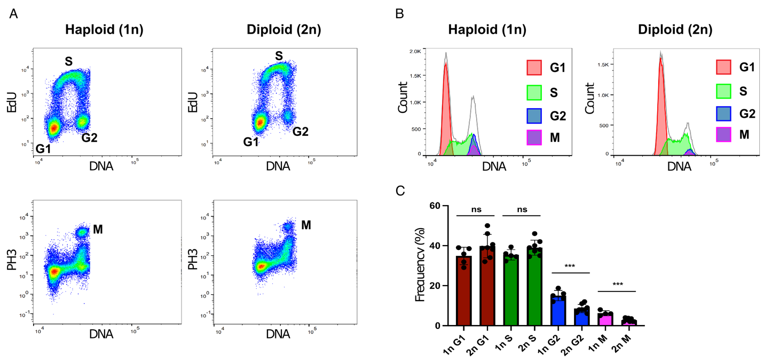
Supplementary Figure 1. Cell cycle analysis of haploid and diploid cell lines.
A. Flow cytometry analysis of cell cycle profiles for haploid and isogenic diploidized pES12 cell lines. S phase was identified as a distinct EdU-positive population, with G1 and G2 corresponding to distinct EdU-negative populations with G2 having a higher DNA content. M phase was identified as a distinct PH3-positive population.
B. Histogram representation of cell cycle profiles based on flow cytometry analysis, with total DNA-based profiles outlined in grey and cell cycle populations indicated in the legend.
C. Quantification of flow cytometry analysis comparing cell cycle phases between haploid and diploid populations (n=5 for each). Unpaired t-test was performed for each cell cycle phase. p-value for: G1=0.1337, S=0.0942, G2=0.0004, M=0.0002. The longer G2 and M phase for haploid cells is consistent with replication delays in haploid cells.

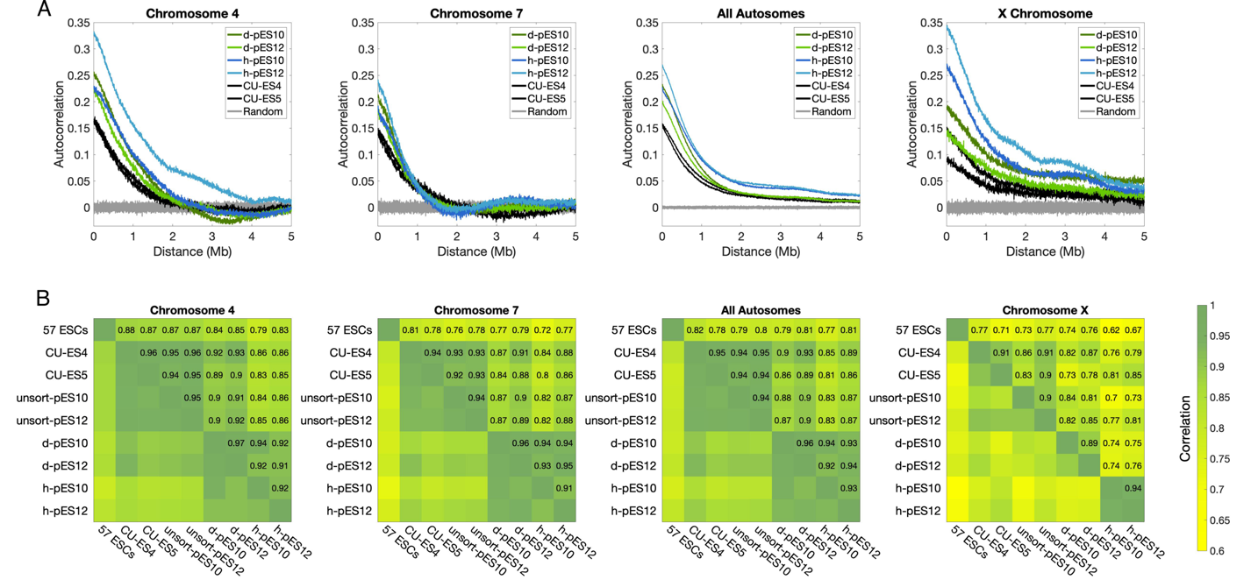
Supplementary Figure 2. Quality evaluation of the replication timing profile of haploid and diploid cell lines.
A. Autocorrelation of raw (unsmoothed) DNA replication timing profiles across two sample chromosomes (4 and 7), all autosomes combined, and the X Chromosome, for haploid, diploid, and control cell lines.
B. Pearson’s correlations of smoothed replication timing profiles across the same chromosomes as in A. “57 ESCs”: mean replication timing of 57 previously measured female ESCs with evidence of normal X Chromosome inactivation. unsort: unsorted for ploidy.

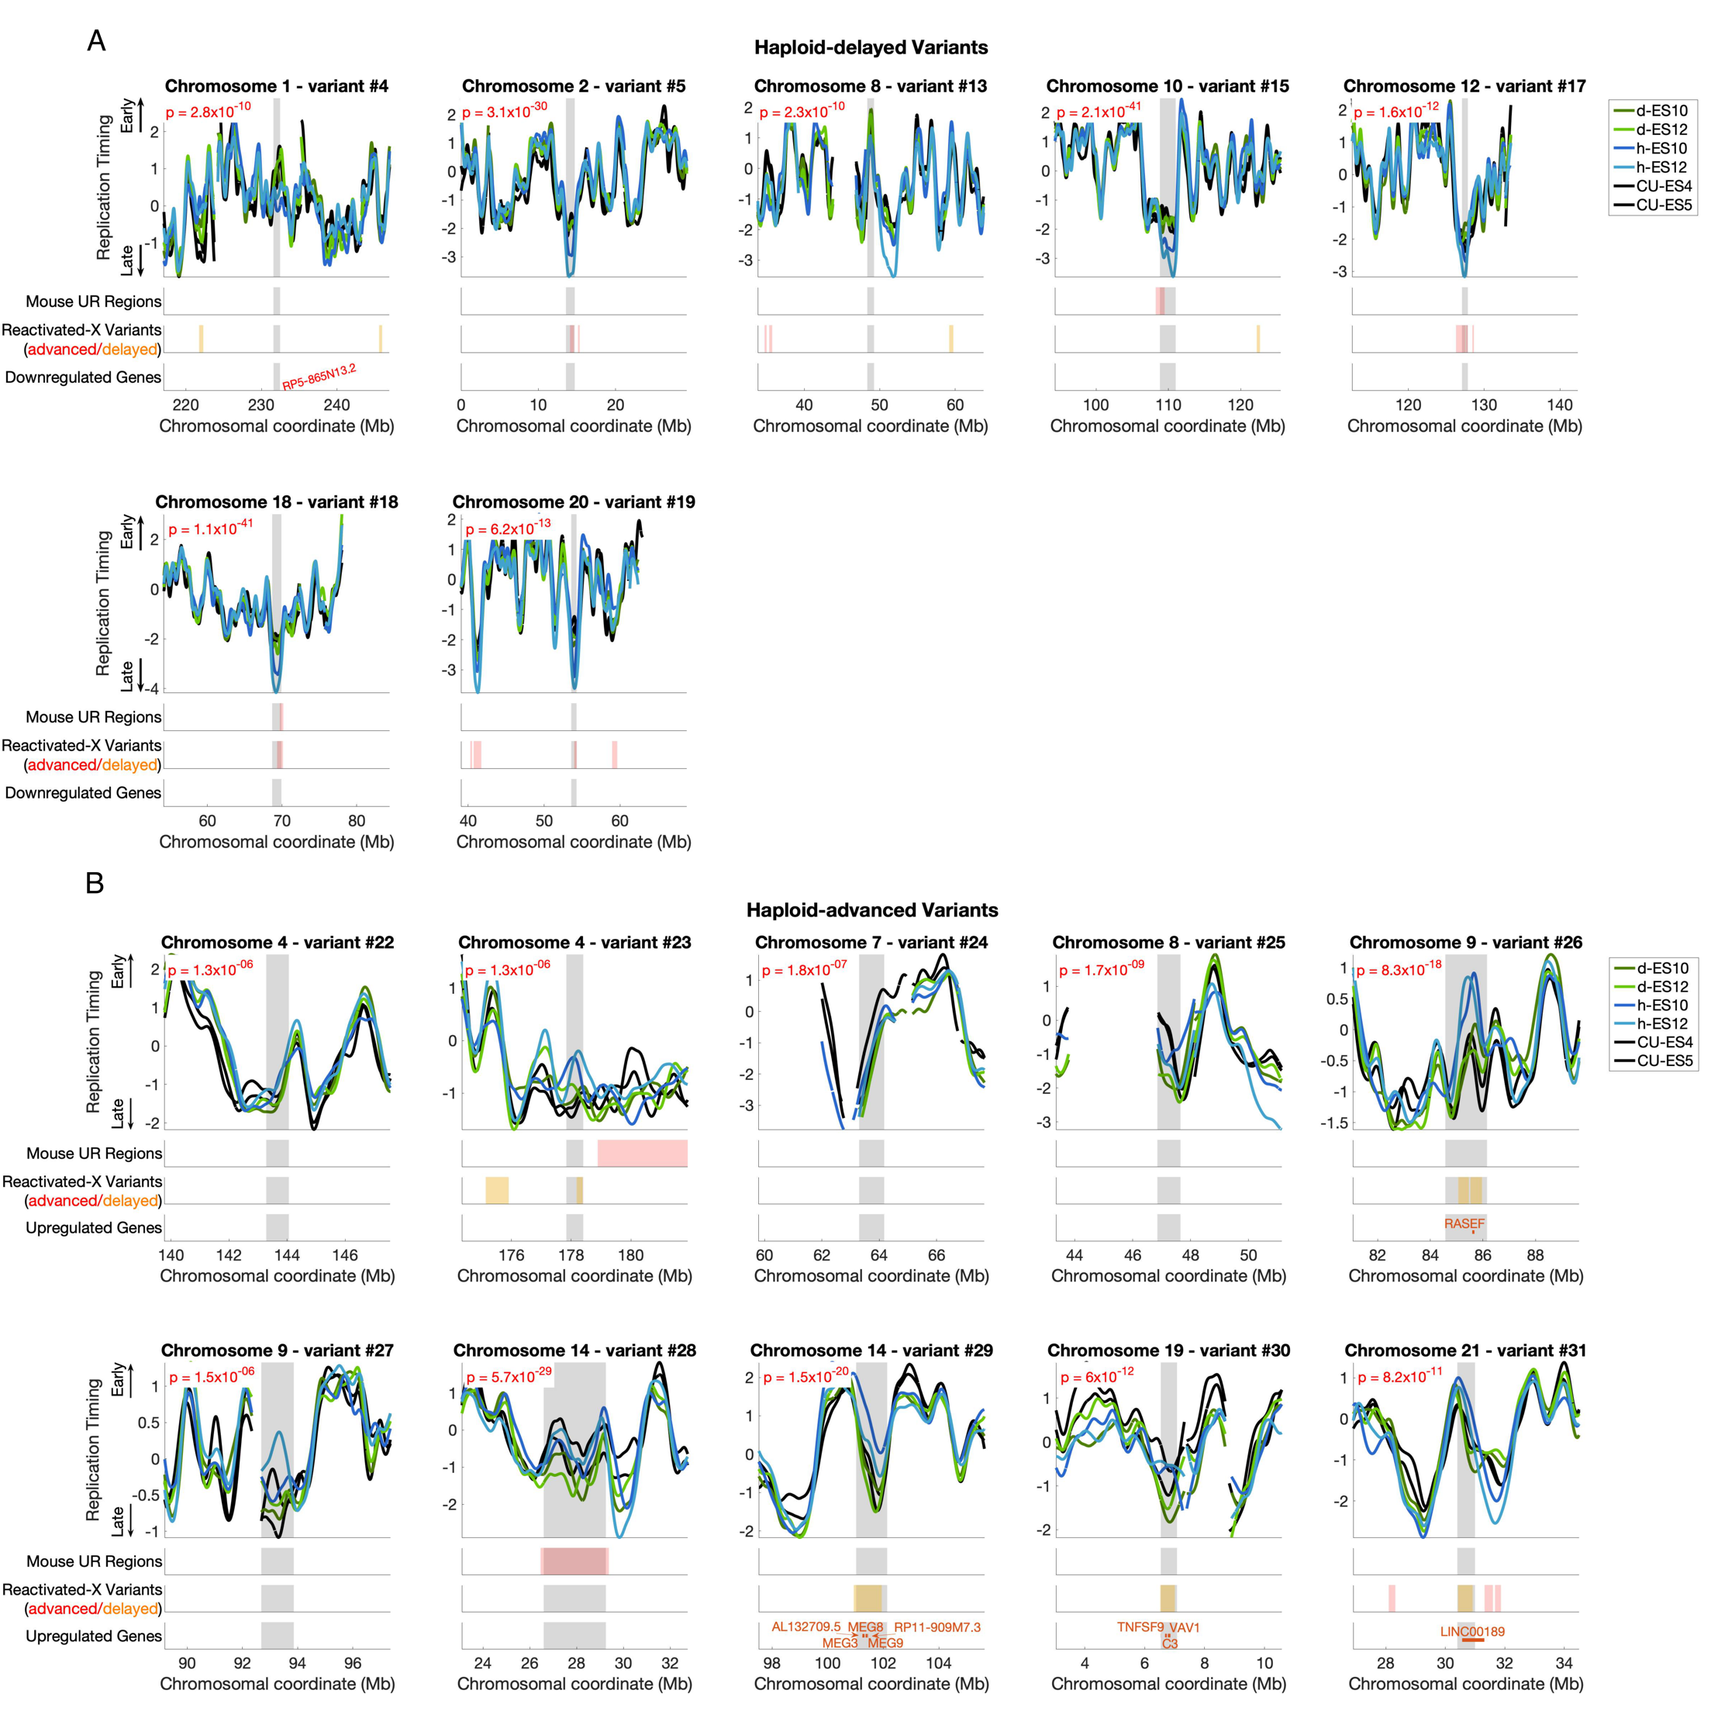
Supplementary Figure 3. All additional replication timing variants between haploid and diploid ESCs (continuation of Fig. 1).
A. All additonal haploid-delayed variants ordered by genomic position and plotted as in Fig. 1C.
B. Haploid-advanced vaiant regions, ordered by genomic position. Note that variant #28 appears to be a diploid-delay rather than a haploid-advance, as diploidized ESCs show later replication than both haploid and the two control ESCs. Upregulated rather than downregulated genes are shown within the variant region.

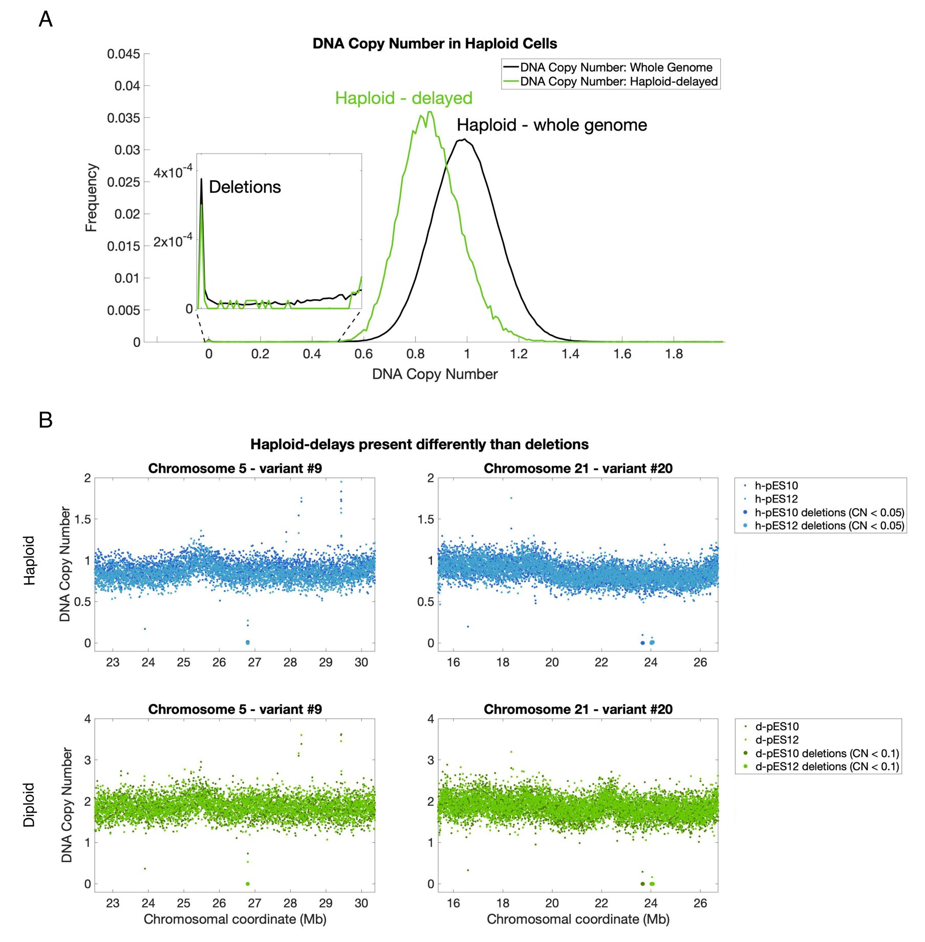
Supplementary Figure 4. Haploid-delayed variants do not correspond to clonal or subclonal deletions.
A. Haploid cell line DNA copy number at all genomic loci (black) and at haploid-delayed variants only (green). Loci with a copy number near zero (inset) are considered to represent deletions. They do not correspond to unmappable loci as loci with no reads in neither haploid, diploid, nor control (CU-ES4 / CU-ES5) cell lines were removed from further analysis. Thus, haploid-delayed variants are not attributed to chromosomal deletions (see further in Methods).
B. Raw DNA copy number profiles for the entirety of two haploid-delayed variants that contain deletions (windows with copy number less than 0.05 in haploid and 0.1 in diploid). Deletion windows are shown as larger dots, which are present in both haploid (blue) and diploid (green), and present very differently than replication delays.

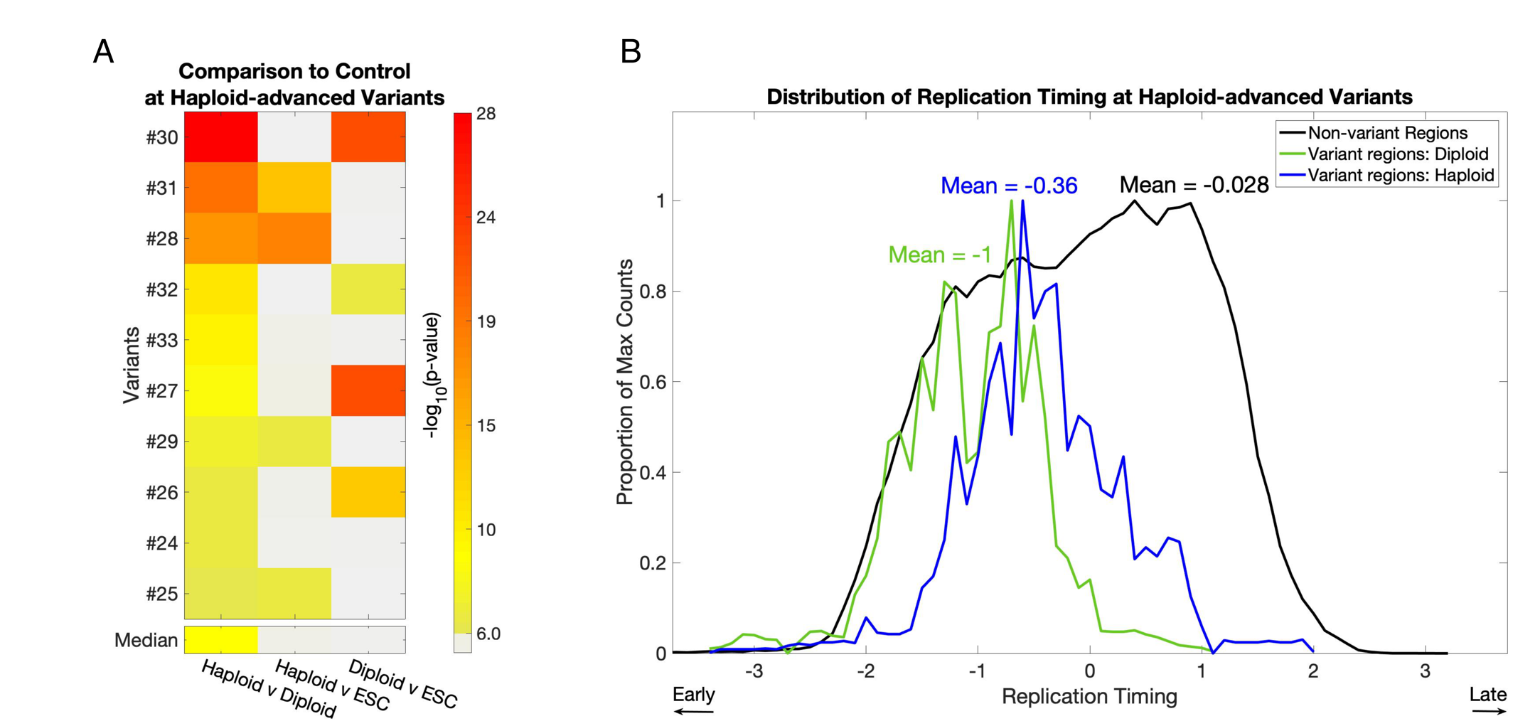
Supplementary Figure 5. Replication timing at haploid-advanced regions.
A. Same as Fig. 2C, for haploid-advanced variants. Four variants (#31, #28, #29 and #25) show significant variation between haploid cells and control ESCs, while four variants (#30, #32, #27, and #26) show significant variation between diploid cells and control ESCs (two were ambiguous).
B. Same as Fig. 2D, for haploid-advanced regions. Haploid-advanced variants on average replicate relatively late in diploids and closer to mid-S phase in haploids.

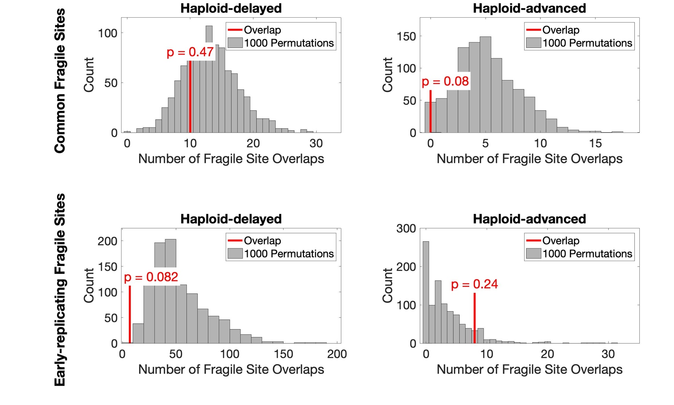
Supplementary Figure 6. Haploid-delayed variants are not associated with fragile sites. Overlap of haploid-delayed variants (left) and haploid-advanced variants (right) with common fragile sites (CFS) (Bignell et al., 2010; Fungtammasan et al., 2012; Savelyeva and Brueckner, 2014) (top) and early-replicating fragile sites (ERFS) (Barlow et al., 2013) (bottom) compared to 1000 matched permutations (Methods). The number of overlaps are shown as red lines with associated p-values. Rare fragile sites (RFS) (Bignell et al., 2010; Zlotorynski et al., 2003) did not have overlaps with either class of variants.

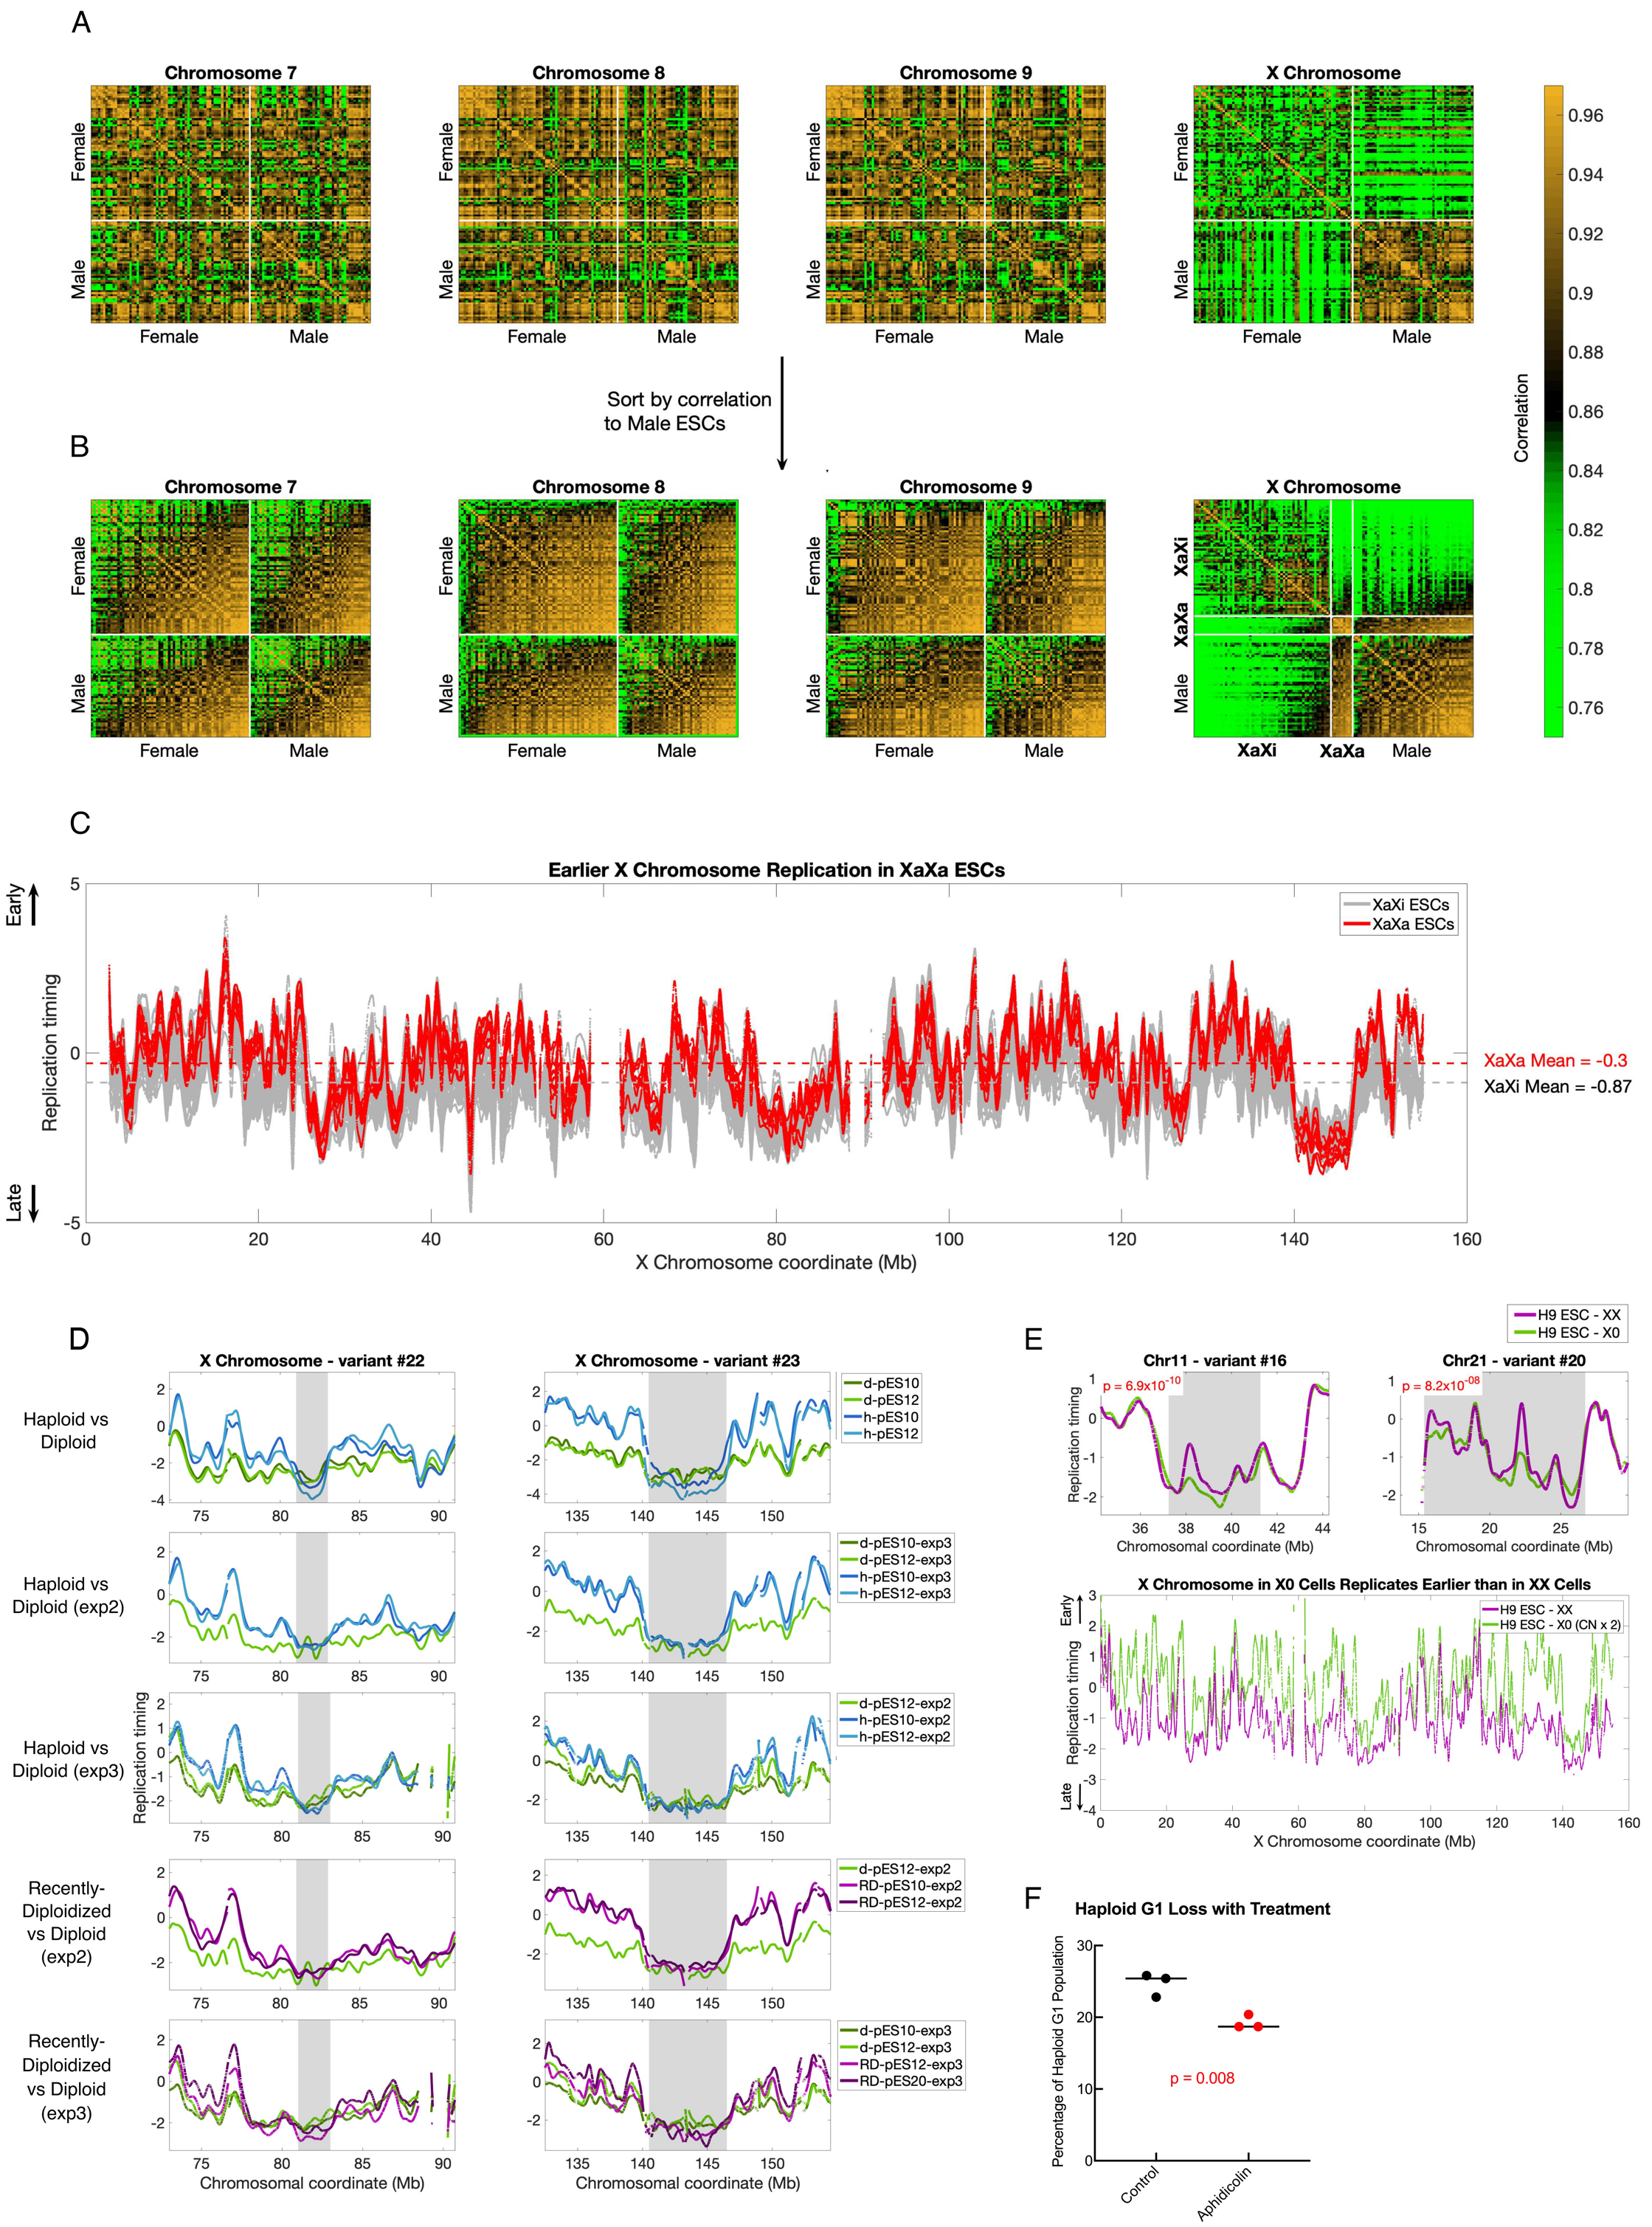
Supplemental Figure 7. Identification of female ESCs with evidence of X Chromosome reactivation.
A. Correlation matrices of replication timing across 116 ESCs on Chromosomes 7, 8, 9, and X, sorted by sex.
B. Same correlation matrices as in A, sorted first by sex, and then by mean correlation to male ESCs on each chromosome. Nine female ESCs (marked by white bars) have higher correlations to each other and to male ESCs than to other female ESCs.
C. X Chromosome replication timing profiles for nine XaXa lines (red) and 57 XaXi lines (grey), showing the earlier mean replication timing of XaXa cell lines compared to XaXi cell lines.
D. The two X Chromosome regions are consistently similar between haploid, diploid and recently diploid cell lines, which contrasts them with the remainder of the chromosome replicating earlier in haploid compared to diploid cells. This consistent deviation from the chromosome trend nominates these two regions as additional putative haploid-delayed variants.
E. Top: The two strongest regions of X0 delay at haploid delayed variants. P-values (t-test) between H9 X0 and H9 XX were calculated across haploid-delayed regions. Seventeen of 21 haploid-delayed regions and variant SCL#11 showed nominally later replication timing in X0 compared to XX, of which four were significantly delayed (Bonferroni p-value = 2.4 × 10⁻³). Bottom: Replication timing across the X Chromosome for H9 XX and H9 X0. Copy number for H9 X0, was multiplied by two before normalization.
F. Diploidization following replication delays induced by Aphidicolin. Shown are the percentage of haploid G1 cells, evaluated using flow cytometry, after 48 hrs of treatment with DMSO (control) or 0.3mM aphidicolin, followed by an additional seven days of culturing without drug. P-value was determined using a t-test.

Supplementary tables

Haploid-delayed Variants
Biological Process
 | # genes in genome | # expected in variants | # in variants |  | Fold enrichment |  |  | FDR
Keratinization | 226 | 1.05 | 23 |  | 21.95 |  |  | 1.49E-19
Cell-cell adhesion via plasma-membrane adhesion molecules | 251 | 1.17 | 9 |  | 7.70 |  |  | 3.34E-03
Gamma-aminobutyric acid signaling pathway | 26 | 0.12 | 4 |  | 33.03 |  |  | 1.00E-02
Cellular localization | 2346 | 10.99 | 0 |  | < 0.01 |  |  | 1.31E-02
Chloride transmembrane transport | 79 | .37 | 5 |  | 13.59 |  |  | 3.70E-02
Molecular Function
GABA-gated chloride ion channel activity | 12 | 0.06 | 4 |  | 71.57 |  |  | 3.53E-03
GABA-A receptor activity | 19 | 0.09 | 4 |  | 45.20 |  |  | 8.37E-03
Benzodiazepine receptor activity | 11 | 0.05 | 3 |  | 58.56 |  |  | 1.97E-02
Cell-cell adhesion mediator activity | 47 | 0.22 | 4 |  | 18.27 |  |  | 3.05E-02
Inhibitory extracellular ligand-gated ion channel activity | 16 | 0.07 | 3 |  | 40.26 |  |  | 3.18E-02
Cellular Component
intermediate filament cytoskeleton | 251 | 1.17 | 27 |  | 23.10 |  |  | 2.04E-25
postsynaptic membrane | 319 | 1.49 | 10 |  | 6.73 |  |  | 5.59E-04
GABA-A receptor complex | 19 | 0.09 | 4 |  | 45.20 |  |  | 6.07E-04
Chloride channel complex | 50 | 0.23 | 5 |  | 21.47 |  |  | 8.1E-04
Neuron part | 1714 | 7.98 | 19 |  | 2.38 |  |  | 3.81E-02
Haploid-advanced Variants
Biological Process
Methylation-dependent chromatin silencing | 13 | 0.03 | 4 |  | > 100 |  |  | 5.51E-04
Molecular Function
Methyl-CpG binding | 26 | 0.05 | 4 |  |  | 75.28 |  | 1.84E-03
11 Downregulated Genes Located at Haploid-delayed Variants
Biological Process
Cell-cell adhesion vis plasma-membrane adhesion molecules | 251 | 0.13 | 4 | 30.48 |  |  | 2.55E-02
Cell-cell adhesion | 481 | 0.25 | 5 | 19.88 |  |  | 1.39E-02
Cell adhesion | 906 | 0.47 | 6 | 12.67 |  |  | 3.92E-02
Biological adhesion | 912 | 0.48 | 6 | 12.58 |  |  | 2.04-02
Cellular Component
Intrinsic component of membrane | 5647 | 2.95 | 10 | 3.39 |  |  | 3.29E-02

Table S1: Results of GO analysis for genes found in variant regions. Nested groups were collapsed into only the most significant classification, such that when one biological process was a subset of another, and both were significant, only the most significant process is listed. Haploid-delayed variants: 97 of 180 genes were found in the GO database. Haploid-advanced variants. 41 of 168 genes were found in the GO database. Downregulated genes found in haploid-advanced variants. 11 of 13 genes were found in the GO database.

Variant number | Chr | Start | End | Exp1 p (ANOVA) | h-pES10-exp2 p (t-test) | h-pES12-exp2 p (t-test) | RD-pES10-exp2 p (t-test) | RD-pES12-exp2 p (t-test) | haploid-exp3 p (ANOVA) | RD-exp3 p-value (ANOVA)
1 | 1 | 105036062 | 107043787 | 5.57E-50 | 4.96E-08 | 2.69E-20 | 4.22E-10 | 2.30E-25 | 5.63E-24 | 1.53E-09
2 | 1 | 188051349 | 192033027 | 3.43E-188 | 4.79E-11 | 3.29E-39 | 7.26E-22 | 8.02E-66 | 5.37E-71 | 3.35E-31
3 | 1 | 192862835 | 193254343 | 7.90E-06 | 0.0586 | 0.0063 | 0.668 | 0.949 | 0.0356 | 0.123
4 | 1 | 231571593 | 232457523 | 2.81E-10 | 0.203 | 0.393 | 0.662 | 6.06E-07 | 0.473 | 0.0896
5 | 2 | 13574856 | 14708037 | 3.11E-30 | 9.02E-06 | 1.73E-13 | 0.00909 | 3.77E-15 | 5.47E-16 | 8.38E-07
6 | 3 | 294211 | 2679244 | 6.71E-92 | 2.44E-18 | 1.49E-34 | 3.65E-11 | 2.73E-69 | 1.64E-70 | 5.39E-77
7 | 4 | 43409355 | 48656695 | 2.22E-76 | 5.52E-27 | 1.78E-63 | 1.54E-36 | 2.95E-77 | 3.28E-55 | 1.26E-78
8 | 4 | 59796831 | 65081128 | 9.65E-89 | 9.40E-39 | 1.54E-62 | 2.24E-39 | 3.63E-138 | 1.48E-55 | 2.18E-66
9 | 5 | 22493289 | 30383749 | 4.48E-184 | 3.81E-12 | 1.28E-84 | 1.71E-22 | 2.28E-165 | 9.57E-122 | 3.06E-188
10 | 6 | 62248453 | 68299337 | 1.21E-113 | 5.87E-22 | 2.14E-59 | 6.11E-36 | 3.04E-143 | 3.79E-150 | 2.28E-175
11 | 8 | 3393305 | 5944692 | 8.62E-60 | 5.05E-24 | 4.11E-31 | 1.99E-14 | 2.47E-64 | 1.23E-46 | 1.38E-40
12 | 8 | 13728440 | 15002424 | 8.67E-12 | 6.69E-15 | 8.97E-17 | 2.43E-10 | 2.29E-23 | 1.14E-24 | 4.88E-42
13 | 8 | 48348584 | 49252651 | 2.27E-10 | 0.134 | 0.0971 | 0.0265 | 0.83 | 0.205 | 5.48E-11
14 | 9 | 104921528 | 106545385 | 2.04E-51 | 0.0055 | 5.12E-14 | 0.00202 | 1.87E-27 | 2.13E-15 | 6.32E-18
15 | 10 | 108818724 | 111007775 | 2.06E-41 | 1.96E-09 | 1.77E-25 | 6.37E-12 | 6.19E-36 | 3.11E-22 | 5.07E-41
16 | 11 | 37239978 | 41263106 | 4.45E-68 | 3.62E-09 | 4.52E-23 | 5.90E-12 | 6.29E-81 | 1.62E-66 | 2.91E-54
17 | 12 | 127071746 | 127843422 | 1.61E-12 | 1.19E-07 | 9.03E-11 | 2.59E-08 | 9.39E-16 | 3.41E-08 | 1.70E-14
18 | 18 | 68680542 | 69909012 | 1.14E-41 | 2.04E-06 | 5.38E-18 | 4.04E-06 | 2.61E-19 | 8.48E-21 | 9.89E-13
19 | 20 | 53569880 | 54262237 | 6.22E-13 | 0.528 | 3.25E-08 | 0.813 | 3.08E-06 | 1.36E-17 | 5.10E-12
20 | 21 | 15376752 | 26722800 | 2.49E-302 | 1.91E-51 | 1.02E-99 | 7.81E-61 | 4.92E-249 | < 2.5e-302 | 6.84E-193
21 | 21 | 31279591 | 32084063 | 3.47E-19 | 0.191 | 3.93E-08 | 0.498 | 1.62E-05 | 1.01E-23 | 6.08E-26
22 | X | 80992131 | 82965996 | N/A | N/A | N/A | N/A | N/A | N/A | N/A
23 | X | 141643047 | 146459002 | N/A | N/A | N/A | N/A | N/A | N/A | N/A

Table S2. Haploid-delayed variants. Shown are each of the 23 haploid-delayed variants with their variant number, genomic position in hg19 coordinates, and p-values in the initial and the two validation experiments including the recently diploidized cell lines. Significant p-values (p < 2.38 × 10⁻³; Bonferroni correction for 21 tests) are shown in bold. P-values for experiment 2 were calculated using a t-test comparing a given cell line to d-pES12 at the haploid-delayed variant region. P-values for experiment 3 were based on ANOVA tests of both haploid cell lines in comparison to diploid ESCs. Start and end position for X Chromosome variants are esitmates based on the points at which haploid replication timing profiles become later than diploid. Because of the doasage imbalance between haploid and diploid cells on the X Chromosome, these reigons are not amenable to the ANOVA test.

