Supplemental material for

Iterative epigenomic analyses in the same single cell

Hidetaka Ohnuki^{1*}, David J. Venzon², Alexei Lobanov^{3,4}, and Giovanna Tosato¹

Contents:

Supplemental Methods

Supplemental Figures S1-S14

Supplemental Tables
- Supplemental Code Files

References for Supplemental Methods

- Supplemental Methods

  - General reagents
In the experiments below, the following reagents were used; 10 x TBS, pH7.4 (351-086-101, Quality Biological), glycerol (15514-011, Thermo Fisher Scientific), 0.5 M EDTA, pH8.0 (15575-038, Thermo Fisher), BSA (B6917-100MG, Sigma-Aldrich), 10 x PBS, pH7.4 (70011-044, Thermo Fisher Scientific), Tween 20 (P1379-500ML, Sigma-Aldrich), 0.2 ml PCR tubes (A30588, Thermo Fisher Scientific), Tri-HCl, pH8.8 (T1588, Teknova), Ammonium sulfate (A4418-100G, Sigma-Aldrich), 2 M KCl (AM9640G, Thermo Fisher Scientific), Triton X-100 (T8787-50ML, Sigma-Aldrich), MgSO₄(M3409-10x1ML, Sigma-Aldrich), 5 M NaCl (AM9760G, Thermo Fisher Scientific), 10 mM dNTP mix (R0192, Thermo Fisher Scientific), polyethylene glycol 8000 (P5413-500G, Sigma-Aldrich), 2 M MgCl₂ (340-034-721, Quality Biological), TE buffer (351-010-131, Quality Biological) and UltraPure Water (10977-015, Thermo Fisher Scientific). Other reagents are described in each section.

  - Cell culture
K562 cells from the American Type Culture Collection (ATCC, CCL-243) were cultured in Iscove's Modified Dulbecco's Medium (12440053, Thermo Fisher Scientific) containing 10% fetal bovine serum (F2442-500ML, Sigma-Aldrich). Cells tested mycoplasma-negative by a PCR-based method (Young et al. 2010).

  - Preparation of “reusable” single cells
K562 cells were harvested by centrifuging at 1,200 x g for 5 min and washed with PBS. The cells were treated with one of the following solutions: PBS only, PBS containing 4% paraformaldehyde (PFA, 15713, Electron Microscopy Sciences), PBS containing 5% acrylamide and 4% PFA, PBS containing 20% acrylamide and 4% PFA, or PBS containing 28% acrylamide and 4% PFA. After 1-hour incubation, the cells were washed with TBS containing 2.5% BSA. Individual cells were transferred into a 0.2 ml tube containing 3 μl/tube of the acrylamide solution [PBS containing 3.88% (w/v) Acrylamide (01697-500ML, Sigma-Aldrich), 0.12% (w/v) Bis-acrylamide (M1533-25ML, Sigma-Aldrich) and 1% (w/v) ammonium persulfate (A3678-25G, Sigma-Aldrich)] using ALS CellCelector (ALS Automated Lab Solutions) or PicoPipet with a micromanipulator (Nepa Gene) under microscopy. Fifty μl of mineral oil containing 0.2% TEMED was added to the 0.2 ml tube. Polymerization was performed at room temperature for 1 hour. A cell was embedded into the outside layer of the two-layered acrylamide bead. The cell was stained with SYBR Gold (S11494, Thermo Fisher Scientific), and the presence of a single cell was confirmed using fluorescent microscopy (BZ-X710, Keyence).

  - Permeabilization of cell and nuclear membranes in “reusable” single cells
Cell membranes and nuclear membranes were permeabilized using the following protocol. Single cells were treated with 1 x TBS containing 1% Triton X-100, 1 mM EDTA and 10% glycerol (TBS-Triton) for 15 min. The cells were then serially treated with 25%, 50%, 75% and 100% methanol for 5 min each, then treated with 75%, 50% and 25% methanol. The single cell was washed with the TBS-Triton.

  - Antibody conjugation to DNA probe
Anti-H3K27ac (RRID:AB_2561016, ENCODE ID: ENCAB000ADS, 39133, Active Motif), anti-H3K27me3 (RRID:AB_2561020, ENCODE ID: ENCAB000ADT, 39155, Active Motif), anti-MED1 (RRID:AB_946345, ab60950, Abcam), anti-5hmC (A-1018, Epigentek), anti-Pol II (phospho-S5, RRID: AB_304868, ENCODE ID: ENCAB000AOD, ab5408, Abcam) antibodies and control IgG (I5006, Sigma-Aldrich) were conjugated with the DNA probes (Integrated DNA technologies) listed in Table S1. Glycerol and sodium azide were removed from all antibodies using Zeba Spin Desalting Columns according to the manufacturer's protocol (89682, Thermo Fisher Scientific).
The antibodies were activated by introducing the heterobifunctional crosslinker Succinimidyl-6-hydrazino-nicotinamide (S-HyNic, S-1002-105, TriLink Biotechnologies) according to the following procedures: S-HyNic (1 mg) was dissolved with 100 μl of anhydrous Dimethylformamide (DMF, S-4001-005, TriLink Biotechnologies), and 0.6 μl of S-HyNic/DMF was added to 100 μl of antibody solution (1 mg/ml). The antibody was incubated for 2 hours at room temperature. Extra S-HyNic was removed using the Zeba Spin Desalting Column.
To conjugate the DNA probe to the activated antibody, the heterobifunctional crosslinker N-succinimidyl-4-formyl benzamide (S-4FB, S-1004-105, TriLink Biotechnologies) was introduced into the DNA probe according to the procedure below. The DNA probes listed in Table S1 were synthesized with an amino group at 5’ end with a C12 spacer (Integrated DNA Technologies). Twenty nanomoles of the DNA probe was dissolved into 20 μl of 100 mM sodium phosphate/150 mM NaCl, pH8.0. S-4FB (1 mg) was dissolved into 50 μl of anhydrous DMF. Ten μl of S-4FB/DMF was added to the DNA probe and incubated for 2 hours at room temperature. Extra S-4FB was removed using the Zeba Spin Desalting Column.
The activated antibody and the DNA probe were mixed and incubated overnight at room temperature. Unbound DNA probe was removed by Ultrafiltration using Amicon Ultra (Molecular Cut Off 100 kDa, UFC5010, Millipore), and the buffer was exchanged to TBS containing 50% glycerol, 5 mM EDTA and 5% BSA. Antibody concentration is measured by Sandwich ELISA (Weiland and zu Dohna 1978) using a standard curve of rabbit IgG, and antibody concentration was adjusted to 1 mg/ml. The antibody conjugated to the DNA probe was stored at -20°C until use.

  - Annealing 1st random primer
In the “Annealing” step (Fig. 1B), the single cell was washed with “ThermoPol Mg (-) buffer” (20 mM Tri-HCl, pH8.8, 10 mM (NH₄)₂SO₄, 10 mM KCl and 0.1% Triton X-100) and the supernatant was removed. ThermoPol Mg (-) buffer (15 μl/tube) containing 17.5 μM of the 1st Random Primer (5’-/5Phos/CGACGCTNNNNNNNN-3’, Integrated DNA Technologies) was added to the single cell and incubated for 1 hour to deliver the random primer to the nucleus. The tube was incubated at 94 °C for 3 min and incubated on ice for 2 min or longer.

  - Extension of annealed 1st random primer
In the “Extension” step (Fig. 1B), a solution containing MgSO₄ (final concentration 2 mM), NaCl (final concentration 300 mM) and dNTPs (final concentration 1.47 mM) was added followed by addition of the DNA polymerase DeepVent Exo(-) (1 unit, M0259L, New England BioLabs) and incubation for 4 hours on ice, 2 hours at 4°C, 2 hours at 10 °C, 2 hours at 20°C and 4 hours at 25°C.

  - Antibody binding
In the “Antibody binding” step (Fig. 1B), the cell was washed and incubated with the ThermoPol Mg (-) buffer containing 300 mM NaCl, 10 mM EDTA and 1% BSA and 10% glycerol for 1 hour. Antibodies conjugated with the DNA probe were added (0.5 μg IgG/ml each) to the cell and incubated overnight on ice. The cell was washed with the ThermoPol Mg (-) buffer containing 300 mM NaCl.

  - Proximity ligation of antibody probe and a random primer
In the “Proximity joining” and “Proximity ligation” steps (Fig. 1B), the cell was incubated with ThermoPol Mg (-) buffer containing 300 mM NaCl and 0.5 μM Ligation Adapter Probe (5’-AGCGTCGTGTAGGGAA-3’, Integrated DNA Technologies) for 1 hour at 25°C. The cell was washed once with 1x Quick Ligation Reaction buffer (M0202L, New England BioLabs). Quick Ligase (1 μl) and 1 x Quick Ligation Reaction buffer (19 μl) were added and incubated for 4 hours at 15 °C and 30 min at 25°C.
The ligated product of Antibody-DNA probe + 1st Random primer was fully extended using the polymerase Bst 3.0 (M0374L, New England BioLabs). The cell was washed with ThermoPol Mg (-) buffer containing 300 mM NaCl. The polymerase solution was then added (320 unit/ml Bst 3.0 polymerase, 1.4 mM dNTPs and 2.5 mM MgSO₄ in ThermoPol buffer). The cell was incubated for 4 hours at 4°C, 1 hour at 10°C, 1 hour at 20°C, 1 hour at 30°C, 1 hour at 40°C, 1 hour at 50°C and 1 hour at 65°C.

  - Amplification of proximity ligation products
The extended products were amplified by a modified Multiple Annealing and Looping Based Amplification Cycles (MALBAC) (Lu et al. 2012; Zong et al. 2012). Two μM of the 2nd Random primer (Table S1) was added and incubated for 2 hours. The cell and the extended products were heated at 94°C for 3 min and incubated on ice for 2 min. Bst 3.0 polymerase (1 μl/tube) was added and incubated for 4 hours at 4°C, 30 min at 10°C, 30 min at 20°C, 30 min at 30°C, 30 min at 40°C, 30 min at 50°C, 60 min at 65°C and 3 min at 94°C. The supernatant was collected, and 20 μl of buffer containing 10 mM Tris-HCl, pH 7.4, 0.1 mM EDTA and 0.05% Tween 20 was added. After overnight incubation at 4°C, the supernatant was collected; supernatant collection was repeated for a total of 3 times. The collected supernatant was combined into a 0.2 ml PCR tube. Four μl of 10 x ThermoPol buffer (New England BioLabs) and dNTPs (total 1.4 mM) were added, and then the combined solution was heated at 94°C for 3 min and placed on ice for 2 min. Bst large fragment (2 μl/tube, M0275L, New England BioLabs) was added and incubated at 10°C for 45secs, 20°C for 45secs, 30°C for 45secs, 40°C for 45secs, 50°C for 45secs, 65°C for 2mins and 94°C for 20s. The tubes were then quickly quenched on ice. After quenching on ice, Bst large fragment (2 ul/tube) was added and then incubated at 10°C for 45secs, 20°C for 45secs, 30°C for 45secs, 40°C for 45secs, 50°C for 45secs, 65°C for 2mins and 94°C for 20s. The tubes were then quickly quenched on ice. The above cycles were repeated for a total of 8 times. During the steps described above, the antibody is denatured and dissociated from the target protein. In addition, the extended 1st random primer is dissociated from the genomic DNA by heating and strand displacement activity of Bst DNA polymerase. The products were collected as supernatant from the tube and transferred into a fresh PCR tube. The remainder was incubated overnight at 4 °C with 20 μl/tube of 0.05% Tween20 / 0.1x TE buffer (0.05% Tween 20, 0.1 mM EDTA in 1 mM Tris-HCl, pH 7.4). After the incubation, the original supernatant and the new supernatant were combined into the PCR tube.
The products were further amplified by PCR using a primer (5'-ATCCATAGTGTCAGCAGGCT-3’) with DeepVent exo(-) polymerase (step1: 95°C-5 min, step2: 95°C-30 sec, step3: 60°C-30 sec, step4: 72°C-30 sec, step5: repeat step2-4 20 times, step6: 72°C-5 min and step 7: 4°C-forever). DNA was purified using UltraPure Phenol:Chloroform:Isoamyl Alcohol according to the manufacturer’s protocol (15593031, Thermo Fisher Scientific). Extra primers were removed by size-selective precipitation (Paithankar and Prasad 1991) using polyethylene glycol; 200 μg/tube linear acrylamide (AM9520, Thermo Fisher Scientific) and 2 M MgCl₂ (final concentration 20 mM) were added, and then 50%(w/v) PEG8000 was added (final concentration 14%). After 20 min incubation, the tube was centrifuged at 1,3400 x g for 10 min. The pellet was washed with 80% ethanol 3 times and dried. After dissolving the pellet with 0.1x TE buffer, the amount of double-stranded DNA (dsDNA) was measured by Quant-iT PicoGreen dsDNA Assay kit (P11496, Thermo Fisher Scientific) and concentration of dsDNA was adjusted for in vitro transcription. The “reusable” single cell was stored at -20°C in TBS buffer containing 50% glycerol, 0.1% Triton X-100, 0.5% BSA and 1 mM EDTA) until the next round of experiments.

  - Removing genome-derive MALBAC byproducts by in vitro transcription and reverse transcription
MALBAC, developed to amplify genomic DNA from single cells (Lu et al. 2012; Zong et al. 2012), can amplify all types of DNA. In our system, MALBAC could amplify desired products (antibody-DNA probe + 1st random primer + genome sequence + 2nd random primer) and genome-derived byproducts. Genome-derived byproducts were removed by the following steps. The antibody-DNA probe contains a T7 promoter sequence (Table 1 and Supplemental Fig. S2). We converted the ligated products into RNA by in vitro transcription using HiScribe T7 High Yield RNA Synthesis Kit according to the manufacturer’s protocol (E2040S, New England BioLabs). DNA was digested using RNase-free DNase I according to the manufacturer’s protocol (EN0521, Thermo Fisher Scientific). RNA was purified using TRIzol LS Reagent according to the manufacturer’s protocol (10296028, Thermo Fisher Scientific). The purified RNA was converted into DNA using SuperScript IV Reverse Transcriptase according to the manufacturer’s protocol (18090010, Thermo Fisher Scientific) with a primer (5’-ATCCATAGTGTCAGCAGGCT-3’, RNase-free HPLC purified oligo, Integrated DNA Technologies) specific for the sequence in the 2nd random primer (see “Reverse transcription” part in Supplemental Fig. S2D). Second strand synthesis was performed using the DNA polymerase, DeepVent Exo (-) (1 unit/50 μl) with a 3.68 μM primer (5’-TAGCTAAGGTATCCTCCAGG-3’), 200 μM dNTPs and 1 x ThermoPol Reaction buffer. Extra sequences in the DNA products were removed by restriction-enzyme digestion with BciVI according to the manufacturer’s protocol (R0596L, New England BioLabs, see “Digestion with a restriction enzyme” in Supplemental Fig. S2F). Fragments larger than 49 bp were selected using E-gel 2% agarose (Thermo Fisher Scientific) and were extracted using Freeze ‘N Squeeze DNA Gel Extraction Spin Columns (Bio-Rad). The extracted DNA was purified using UltraPure Phenol:Chloroform:Isoamy Alcohol according to the manufacturer’s protocol (Thermo Fisher Scientific). The purified DNA was used for library construction using the Illumina TruSeq PCR free kit (Illumina) with TruSeq DNA index kit plate (96 samples, Illumina). Individual samples were labeled with unique Illumina indexes. The constructed libraries were sequenced by MiSeq, NextSeq 550 or NovaSeq 6000.

  - Cellular protein retention assay
K562 cells were harvested and washed in PBS. Cells were suspended in PBS and 0.33 x10⁵ cells were aliquoted into 0.5 ml Protein LoBind tubes (0030108094, Eppendorf). The tubes were centrifuged at 1,200 x g for 5 min. As input controls, 1x10⁵ cells were lysed with 100 μl/tube of 1 x lithium dodecyl sulfate buffer (LDS buffer, NP0007, Thermo Fisher) and stored at 4 °C until measurement. The cells were treated with PBS only, PBS containing 4% PFA, PBS containing 5% acrylamide and 4% PFA, PBS containing 20% acrylamide and 4% PFA, or PBS containing 28% acrylamide and 4% PFA. After 1-hour incubation, cells were washed with TBS containing 10% fetal bovine serum. Cells were suspended with 90 μl of the acrylamide solution and the cell suspension was transferred into 9 PCR tubes containing 50 μl/tube mineral oil containing 0.2% TEMED. After 1-hour incubation, polymerized beads (3 beads, approximately 1 x 10⁵ cells) were transferred into a PCR tube. ThermoPol Mg (-) buffer (100 μl/tube) was added and the following treatments were performed. One group was stored at 4 °C. Other groups were placed in a thermal cycler, heated at 94°C for 3 min and cooled at 4°C for 5min (number of cycles 1, 2, 5, 10 and 100). The supernatant was collected from each condition. Protein concentration was measured by Micro BCA Protein Assay kit according to the manufacturer’s protocol (23235, Thermo Fisher). Solubilized cellular proteins from non-treated cells in LDS buffer were used as 100% in calculating eluted cellular proteins from the polyacrylamide beads.

  - Agarose gel electrophoresis
In Supplemental Figure S3A, agarose gel electrophoresis was performed using 4% NuSieve GTG agarose (50081, Lonza, 0.5x TAE buffer) and the gel was stained with SYBR Gold (Thermo Fisher Scientific, #S11494). In Supplemental Figure S3B, E-Gel (2%, G521802, Thermo Fisher Scientific) was used. DNA products were visualized by the imager LAS 4000 (Fuji Film). Band intensity was measured by ImageJ software. Band intensities were normalized using a 500 ng DNA/ lane spike-in control (GeneRuler Low Range DNA ladder, SM1193, Thermo Fisher Scientific).

  - Trimming Illumina adaptor and splitting reads based on antibody barcodes
Illumina adapter sequences were trimmed using the trimming software TrimGalore (version 0.4.5, http://www.bioinformatics.babraham.ac.uk/projects/trim_galore/) with options [--paired --illumina -e 0.2 --length]. Trimmed reads were demultiplexed using antibody barcodes shown in Supplementary Table 2 by software FlexBar (version 3.0.3) (Dodt et al. 2012). Reads containing a reverse complement sequence of an antibody barcode were inverted using FastX tool kit (version 0.0.14, http://hannonlab.cshl.edu/fastx_toolkit/index.html ). Left side sequence of reads from 5’ end to an antibody barcode-ligated sequence was trimmed by FlexBar. Right side sequence of reads from 3’ end to a cell barcode was also trimmed by FlexBar.

  - Extracting unique molecular identifier
After the trimming, an 8 nucleotide sequence of the 1st random primer was removed and added to read ID as a unique molecular identifier by software UMI tools (version 1.0.1)(Smith et al. 2017).

  - Mapping to the genome
The trimmed reads are mapped to the human genome, GRCh38 using software Bowtie2 (version 2.3.5.1) (Langmead and Salzberg 2012).

  - Removing amplification duplicates
Amplification duplicates were removed by UMI tools based on the unique molecular identifier derived from 8 nt random sequences and mapped position on the genome. To count mapped reads and unique reads, the BAM file is converted into a SAM file using SAMtools. A line number of the SAM file was counted by Linux command “wc -l” and the header line number was subtracted from the counted line number shown as numbers of mapped reads and unique reads (Supplemental Figure S6A-6G).

  - Analysis of locational preservation of H3K27ac and H3K27me3 marks over repeated experiments
The unique mapped reads of 8 single cells were combined. The combined datasets of the first experiment were converted into a BED file and used as a peak file in the next step. Read distribution in genomic regions where read was detected in the first experiment was analyzed by Homer (version 4.10.4) (Heinz et al. 2010). The read distribution pattern was calculated by the Homer in the first, second and third repeated experiments. The output data were visualized as a line graph by Microsoft EXCEL.

  - Identification of reproduced reads without data aggregation from other single cells
Data in Figures 2A, 2B and Supplemental Figure S9 indicated that the antibody reads contain reproducible reads and non-reproducible reads over repeated experiments in the same single cells. The reproducible reads were evaluated to determine by the bootstrap procedure whether they reflect accidental overlap of antibody reads or meaningful redetection. The starting material consisted of 3 separate BAM files as follows.

Reads derived from antibody: Replicates 1, 2 and 3 from the same single cell
Reads derived from IgG: Replicates 1, 2 and 3 from the same single cell

The 3 BAM files were combined into one BAM file using software, SAMtools. The combined BAM file was converted to a BED file for subsequent analysis.
To count the number of reads, the human genome (hg38) was subdivided into 500 bp bins and each bin was shifted every 250 bp using the software BEDtools and saved as a BED file. The number of antibody reads and IgG reads in each genomic bin was counted using BEDtools with the option “intersect” (version 2.29.0) (Quinlan and Hall 2010). The numbers of reads counted were stored in the BED file.

$$a=number of antibody reads per bin$$

$$b=number of IgG reads per bin$$

$$\left[\begin{matrix}Bin 1 & ⋯ & a_{1}, { b}_{1} \\ ⋮ & & ⋮ ⋮ \\ Bin N & ⋯ & a_{n} , b_{n}\end{matrix} \right]$$

To correct for methodological bias and background, the number of antibody reads in each bin ($c$) was normalized by subtracting $b$ from $a$ . The calculation was performed using the Linux command “awk”, and the results were stored in the BED file.

$$c=a-b$$
$$\left[\begin{matrix}Bin 1 & ⋯ & a_{1}, { b}_{1},{ c}_{1} \\ ⋮ & & ⋮ ⋮ ⋮ \\ Bin N & ⋯ & a_{n} , b_{n}, c_{n} \end{matrix} \right]$$

To measure the frequency of accidental overlap in antibody reads, the genomic location of antibody reads was randomized. The antibody reads (replicates 1+2+3) in the BED file were shuffled using BEDtools (“randomized control” from the antibody reads). The total number of antibody reads remained the same before and after the randomization. The read number of the “randomized control” in each genomic bin was counted using BEDtools with the option “intersect”. The results were stored in the BED file.

$$a^{'}=number of the \text{randomized antibody reads} per bin$$

$$\left[\begin{matrix}Bin 1 & ⋯ & a_{1}, { b}_{1},{ c}_{1}, {a'}_{1} \\ ⋮ & & ⋮ ⋮ ⋮ ⋮ \\ Bin N & ⋯ & a_{n} , b_{n}, c_{n}, {a'}_{n}\end{matrix} \right]$$

To measure the frequency of accidental overlap of antibody reads and IgG reads, the genomic location of IgG reads was randomized using BEDtools. The BED file of IgG reads (replicates 1+2+3) was used. The read number of “randomized control” from IgG reads was counted using the combined BEDtools with the option “intersect”. The results were stored in the BED file.

$$b^{'}=number of the randomized IgG reads per bin$$

$$\left[\begin{matrix}Bin 1 & ⋯ & a_{1}, { b}_{1},{ c}_{1}, {a'}_{1}, { b'}_{1} \\ ⋮ & & ⋮ ⋮ ⋮ ⋮ ⋮ \\ Bin N & ⋯ & a_{n} , b_{n}, c_{n}, {a'}_{n}, {b'}_{n}\end{matrix} \right]$$

Accidental detection and redetection frequency of the antibody reads was calculated as follows.

$$c^{'}=a^{'}-b'$$

$$\left[\begin{matrix}Bin 1 & ⋯ & a_{1}, { b}_{1},{ c}_{1}, {a'}_{1}, { b'}_{1}, { c'}_{1} \\ ⋮ & & ⋮ ⋮ ⋮ ⋮ ⋮ ⋮ \\ Bin N & ⋯ & a_{n} , b_{n}, c_{n}, {a'}_{n}, {b'}_{n}, { c'}_{n}\end{matrix} \right]$$

The $c'$ values were calculated in each genomic bin and the results were stored in the BED file. The probability distribution of accidental detection and redetection frequency was computed with all values of $c^{'}$ throughout the genome. The large number of hypothesis tests in genome-wide association studies generates “the multiple testing problem”. To mitigate the multiple testing problem, we estimated the probability distribution of the accidental detection/redetection frequency of the antibody reads from all values of $c^{'}$ by bootstrap resampling. Resampling of 200,000 genomic bins was performed 50,000 times using the R package, “boot” (version 1.3-23). The probability distribution of the accidental redetection frequency of the antibody reads per bin was estimated in each single-cell dataset. The 99th percentile of the distribution was determined by the R package, “boot”. If the value $c$ was greater than the 99th percentile, the genomic bin was judged as containing a significant reproduced antibody reads frequency over repeated experiments compared to accidental redetection probability. The genomic bins are labeled as shown as “genomic regions with reproduced antibody reads (false-positive rates less than 1%)” in Figure 2C and 2D. The theoretical maximal distance from a 1st random primer to an antibody can be +/- 128 bp (total 256 bp range). Two reads from repeated experiments (256 bp distribution of a read + 256 bp distribution of another read) overlapping in a 500 bp bin, which have false-positive reproducibility rates of less than 1% were tentatively counted as “reproduced reads” in Figure 2D and 2F. The capacity of the “reproduced reads” to correctly identify epigenetic changes was further evaluated in the subsequent experiments.

  - Identification of unique reads with data aggregation of other single cells
For MED1, 5hmC and Pol II, co-detection was used to identify unique reads, which are common among cells, using data aggregation of other single cells. The co-detection approach is useful to increase the number of epigenetic marks, without repeating the experiments with single cells. The unique reads from 8 single cells were combined into one BAM file using SAM tools (version 1.9) (Li et al. 2009). Each randomized control was generated from reads of antibody or control IgG by BED tools. The number of reads in each bin was counted by BED tools with the option “intersect”. To estimate read enrichment over control IgG, counts of control-IgG reads were subtracted from counts of antibody reads in each bin (AbΔIgG). To estimate accidental enrichment, counts of randomized control-IgG reads were subtracted from counts of randomized antibody reads (Random AbΔRandom IgG). The 99th percentile of the Random AbΔRandom IgG was calculated by the bootstrap procedure using the R package “boot”. Regions with greater values in AbΔIgG than the 99th percentile of Random AbΔRandom IgG were considered as genomic regions with significant reads compared to the background. The numbers of genomic regions with significant reads were counted and are shown in Figures 2C and 2D. The numbers of reads in the identified genomic regions were counted and are shown in Figures 2D, 2F and Supplemental Figure S14A. These reads were considered as significant reads for further evaluation in the subsequent analyses.

  - GC bias in random priming
GC bias in random priming was analyzed using all datasets of control IgG (40 datasets from 8 single cells x 5 experiments). The 8 nt sequence of the 1st random primer was extracted and analyzed using UMItools. The number of nucleotides in the extracted 8 nt sequences was counted using Microsoft EXCEL. The number of nucleotides was converted to % of total nucleotides and shown in Supplemental Figure S7A.

  - Lorenz curves and genome coverage
Lorenz curves were generated using datasets of REpi-seq (40 datasets of control IgG from 8 single cells x 5 experiments, K562 single cells), IgG control of ChIP-seq (K562 bulk cells, ENCODE ENCFF970CZZ) and IgG control of ChIL-seq (100 cells of C2C12, SRA SRR7230533). BED files of human genome (GRCh38) and mouse genome (GRCm38) were subdivided into 10 kb bins using BEDtools with the “makewindows” option. BAM files were converted into BED files using BEDtools with the “bamtobed” option. Unique reads in each 10 kb bin were counted using BEDtools with the “intersect” option. The cumulative fraction of genomic 10 kb bins and reads was calculated as % of the whole genome and % of total reads using Microsoft EXCEL. The results are shown in Supplemental Figure S7B.

  - Distribution patterns of control reads in REpi-seq and ChIP-seq
Control IgG of REpi-seq (K562 single cells, 40 datasets from 8 single cells x 5 experiments), control IgG of ChIP-seq (K562 bulk cells, ENCODE ENCFF970CZZ) and input control of ChIP-seq (K562 bulk cells, ENCODE ENCFF089RYQ) were used for visualization. BAM files were converted to TDF files using IGVtools (version 2.8.9) with the “count” option. The TDF files were visualized using Integrated Genome Viewer (Version 2.8.9).

  - Bias derived from chromatin structure
Genomic regions were classified into 15 states by the ENCODE Project with K562 bulk cell dataset using Hidden Marcov Model (GEO GSM936088) (Ernst and Kellis 2010; Ernst et al. 2011). The datasets were downloaded as a BED file. In the BED file, state #13 comprises the heterochromatin regions, which include 1,894,878,936 bp genomic regions (61.24% of the whole genome). All other genomic regions are treated as euchromatin regions in the following analysis. The genome coordinate of the BED file was converted from hg19 to hg38 using CrossMap (Zhao et al. 2014). Input control of ChIP-seq were downloaded from ENCODE as a BAM file (ENCFF089RYQ, K562 cells). In REpi-seq, unique reads were used, which derived from control IgG in differently treated 4 single cells (4% PFA, 4% PFA+5% acrylamide, 4% PFA+20% acrylamide and 4% PFA+28% acrylamide). The BAM files were converted into BED files using BEDtools (version 2.29.2) with the “bamtobed” option. The reads in heterochromatin and euchromatin regions were counted using BEDtools with the “intersect -c” option.

  - Bias derived from nucleosome positions
A dataset of micrococcal nuclease digestion with deep sequencing (MNase-seq) (Schones et al. 2008) was downloaded from the ENCODE (ENCFF000VMN, K562 cells). All IgG reads of REpi-seq were combined (8 K562 single cells x 5 experiments) using SAMtools (version 1.11) with the “merge” option. Tag directories of these Bam files using Homer software (version 4.44.1) with the “makeTagDirectory” option. Peaks in MNase-seq were identified using Homer software with a “findPeaks -style histone -size 73 minDist 80” option. Read distribution of MNase-seq and IgG REpi-seq was computed by Homer software with “annotatePeaks.pl hg38 -size 700 -hist 10” option using the identified peak file of the MNase-seq. The results are shown in Supplemental Figure S8A.

  - Read distribution around transcription start sites
Datasets of Formaldehyde-Assisted Isolation of Regulatory Elements (FAIRE-seq) (Giresi et al. 2007) and MNase-seq were generated from K562 bulk cells by the ENOCDE (MNase-seq: ENCFF000TLD, FAIRE-seq: ENCFF000VNR) and used in the following analysis. Forty datasets of control IgG from REpi-seq were combined using SAMtools with the “samtools merge” option (8 K562 single cells x 5 experiments). Twenty-four datasets of H3K27ac from REpi-seq were combined using the SAMtools (8 K562 single cells x 3 repeated experiments). Eight datasets of RNA polymerase II from REpi-seq were combined using the SAMtools (8 K562 single cells x 1 experiment). BAM files were converted into Tag directories using Homer software with the “makeTagDirectory” option. Read distributions around transcription start sites (+/-10 kb) were computed by the Homer software with the “annotatePeaks.pl tss hg38 -size 10000 -hist 10” option (shown in Supplemental Figure S8B and S13B).

  - Redetection percentages of reads by repeated experiments
Forty-eight datasets (H3K27ac: 8 K562 single cells x 3 repeated experiments, H3K27me3: 8 K562 single cells x 3 repeated experiments) were used separately without data aggregation. Unique reads were extended +/- 128 bp using BEDops software (version 2.4.39) with an “—range -128:128 –everything” option. The 128 bp is the theoretical maximum distance from an antibody to a 1st random primer (IgG: 14.5 nm x 0.34 nm/bp = 44.12 bp (Bagci et al. 1993); Antibody-DNA probe: 77 bp, and ligation sequence of 1st random primer: 7 bp). This theoretical distance was supported by the distribution of redetected reads (Figure 2A and 2B). Redetection of a unique reads by one of the other repeated experiments was checked using BEDtools (version 2.29.2) with the “intersect -c” option. The redetection percentage in an experiment by one of other experiments was calculated using Microsoft EXCEL with the output file of BEDtools (shown in Supplemental Figure S9).

  - Precision and sensitivity of REpi-seq
The precision defined as a fraction of single-cell reads in peaks of bulk ChIP-seq were analyzed according to Ku et al. (Ku et al. 2019) using fixed width of peaks. In brief, Three BAM files of H3K27ac or H3K27me3 REpi-seq from a single cell were combined using SAMtools (3 repeated experiments/cell). The combined BAM file was converted to a BED file using BEDtools with the option “bamtobed”. Peaks of bulk ChIP-seq were identified using MACS2, version 2.2.7.1, (Feng et al. 2012) with the option “--broad” (H3K27ac: SRR3144862, and H3K27me3: SRR069083). We fixed the width of all peaks to 5 kb for H3K27ac and to 10 kb for H3K27me3 according to Ku et al. (Ku et al. 2019). Overlap of each single-cell unique read with peaks of bulk ChIP-seq was checked using BEDtools with the “intersect -c” option. The overlapped single-cell reads were counted as a confirmed read. The percentage of confirmed REpi-seq reads was calculated in each single cell. The average of 8 single cells is shown in Supplemental Figure S11A and S11B.
Peaks of bulk ChIP-seq in K562 cells were treated as putative true signals of K562 single cells (H3K27ac peaks of ChIP-seq: ENCODE ENCFF038DDS and H3K27me3 peaks of ChIP-seq: ENCODE ENCFF031FSF). The sensitivity of REpi-seq was evaluated using the detection frequency of known peaks of ChIP-seq by REpi-seq. Twenty-four datasets of H3K27ac and H3K27me3 REpi-seq were combined using SAMtools (24 H3K27ac datasets = 8 single cells x 3 repeated experiments, 24 H3K27me3 datasets = 8 single cells x 3 repeated experiments). Single-cell reads were extended +/- 128 bp using BEDops software (version 2.4.39) with an “—range -128:128 –everything” option. Detection of a ChIP-seq peak by a REpi-seq unique read was checked using BEDtools with the “intersect -c” option. The number of detected peaks was counted. The percentage of ChIP-seq peaks by REpi-seq unique reads are shown in Supplemental Figure S11C and S11D.

  - Overlap of REpi-seq RNA polymerase II (Pol II) reads with Pol II reads of bulk ChIP-seq
Unique reads of 8 single cells from Pol II were combined (8 datasets = 8 single cells x 1 experiment). Three datasets of Pol II ChIP-seq were used separately to check similarity between REpi-seq and bulk ChIP-seq in Pol II data (SRR6386690, SRR6386680 and SRR227359). Overlap of a single-cell unique read with a read of bulk ChIP-seq was checked using BEDtools with the “intersect -c” option. The overlapped single-cell reads were counted as a confirmed read. The percentage of confirmed REpi-seq reads was calculated for each bulk ChIP-seq dataset. The average of the three bulk ChIP-seq datasets is shown in Supplemental Figure S14C.

  - Promoters and enhancers enriched with reproduced reads
H3K27ac reproduced reads identified by the bootstrap procedure were used to identify promoters and enhancers enriched with the reproduced reads. A list of human promoters was downloaded from Eukaryotic Promoter Database (Dreos et al. 2017) of the Swiss Institute of Bioinformatics as a BED file (version 006, assembly: hg38). A list of human enhancers was downloaded from the Human ACtive Enhancers to interpret Regulatory variants (HACER) atlas (Wang et al. 2019). To compare the results of REpi-seq with data from bulk cell analysis, bulk ChIP-seq dataset of K562 cells was used (from ENCODE, Data set ID: ENCFF301TVL). To estimate the frequency of accidental detection, the H3K27ac reproduced reads in REpi-seq and bulk ChIP-seq were randomized using BED tools, and the generated data were used as controls. Numbers of H3K27ac reproduced reads and random control in promoters and enhancers ware counted by BED tools with the option “intersect”. Read counts were normalized based on the length of promoters or enhancers (per kilobase) and the number of input reads (per million input). The bootstrap procedure was performed for the random controls to determine the 95th percentile. The value of the 95th percentile was used to select promoters and enhancers, which have significant number of reproduced reads. The number of selected enhancers and promoters was counted for bulk ChIP-seq and REpi-seq data.

  - Enhancer classification
Enhancers in the HACER datasets were classified based on relative ratios log₂(H3K27ac/H3K27me3). Reproduced reads of H3K27ac, H3K27me3, MED1 and 5hmC in enhancers were counted using BED tools with option “map”. Reproduced read counts were normalized based on the length of enhancers (per kilobase) and based on the number of input reads (per million input). A BED file of enhancers was split based on log₂(H3K27ac/H3K27me3). Average reproduced read counts were calculated in the classified enhancers.

  - Genes interacting with active enhancers
Active enhancers were classified based on relative ratios log₂(H3K27ac/H3K27me3) calculated using reproduced reads with a p-value < 0.01. To compare the results of REpi-seq with results of bulk ChIP-seq, H3K27ac and H3K27me3 data sets of bulk ChIP-seq were used (ENCODE, dataset ID: ENCFF301TVL and ENCFF330YFF). The number of H3K27ac or H3K27me3 reproduced reads in enhancers was counted by BED tools. Read counts were normalized based on the length of enhancers (per kilobase) and based on the number of reproduced reads (per million input). Relative ratio log₂(H3K27ac/H3K27me3) was calculated from the normalized reproduced read counts, and enhancers having a value greater than 0 were selected as putative active enhancers. The putative active enhancers were separated based on cell-type specificity defined by the Human ACtive Enhancers to interpret Regulatory variants (HACER) atlas (Wang et al. 2019). A list of genes, which interact with the identified putative active enhancers was generated based on experimentally validated information in the HACER. The number of genes was counted; overlapping genes between bulk ChIP-seq and REpi-seq are shown in Figures 4A and 4B.

  - Pathway enrichment analysis
Functions of genes proximal to the putative active enhancers were analyzed by Pathway Enrichment Analysis (Kramer et al. 2014). A BED file was generated by combining BED files of enhancers (HACER) and promoters (Eukaryotic Promoter Database of the Swiss Institute of Bioinformatics). H3K27ac and H3K27me3 reproduced reads from REpi-seq and reads from bulk ChIP-seq (ENCFF301TVL and ENCFF330YFF) in enhancers and promoters were counted by BED tools. Read counts ware normalized based on the length of enhancers (per kilobase) and the number of input reads (per million input). Relative ratio log₂(H3K27ac/H3K27me3) was calculated from the normalized read counts. A list of genes was generated form HACER and the promoter datasets. The epigenetic score of a gene was calculated by the sum of epigenetic scores of proximal enhancers and promoters. The epigenetic score of genes was used as input data for Ingenuity Pathway Analysis (Qiagen). For RNA-seq data from bulk K562 and H1 cells, datasets were downloaded from the Cancer Cell Line Encyclopedia (Broad Institute) and ENCODE (dataset ID: ENCFF093NEQ). The number of reads per kilobase per million (RPKM) was converted to log₂, and the difference between K562 and H1 cells were calculated. The difference was converted into a ranking metric, and the data were converted into a text file. The text file was used as input data for Ingenuity Pathway Analysis. The top 5,000 transcripts from K562 and H1 cells were used in the Pathway Enrichment Analysis.

  - t-stochastic neighbor embedding (t-SNE)
The t-SNE plot was generated from the epigenetic status of enhancers and promoters. Bulk ChIP-seq data of H3K27ac and H3K27me3 were downloaded from ENCODE (258 datasets, the list is shown in Table S4). Reads from the bulk ChIP-seq in enhancers (HACER) and promoters (Eukaryotic Promoter Database of the Swiss Institute of Bioinformatics) were counted by BED tools. Reproduced reads of each single cell were counted by BED tools. Counts were normalized based on the length of enhancers or promoters (per kilobase) and based on the input number (per million inputs). Relative ratios log₂(H3K27ac/H3K27me3) were calculated from the normalized read counts. The log₂(H3K27ac/H3K27me3) values of enhancers and promoters were used as input data for software SeqGeq (FlowJo) and t-SNE plot was generated.

  - Visualization of K562-cell type-specific and -nonspecific, active enhancers with MED1 and 5hmC reads
Unique reads of MED1 and 5hmC in individual cells were extracted from unique reads using BED files generated in Supplemental Figure S4 by BED tools. The extracted reads (BAM files) of individual cells were converted into BED files by BED tools with option “bamtobed”. ”Genomic regions with reproduced reads” and reproduced reads of H3K27ac and H3K27me3 identified by the bootstrap procedure (false-positive rates less than 1%) were used to calculate relative ratios of log₂(H3K27ac/H3K27me3) in each single cell. Active enhancers (false-positive rates less than 5%) compared to random controls were identified by the bootstrap procedure in each single cell. Datasets of active enhancers were converted into TDF files by software IGVtools (version 2.7.2) (Robinson et al. 2011). The TDF files and BED files were visualized by Integrated Genome Viewer, and data are shown in Figure 5B-5E and Supplemental Figure S5A-S5C.

  - Number of Pol II⁺ genes per cell
Pol II reads identified by the bootstrap procedure (false-positive rates less than 1%) were used in the following analysis. The Pol II reads in each cell were converted from a BAM file to BED file using BED tools with the “bamtobed” option. The Pol II reads were counted in each gene body and 2 kb promoter (GENCODE 35). Information of gene bodies was extracted from GENCODE 35 (annotation.gtf3.gz file) using the Linux command, “grep -w gene”. The gene bodies were extended +2 kb from the transcription start sites using BEDops software with “—range -2000:0 –everything” for genes on the sense chain and with “—range 0:2000 –everything” for genes on the antisense chain. The generated BED file of the gene bodies+2kb promoter regions was used to count the Pol II reads of REpi-seq in each 2 kb promoter + gene body. BED tools performed the counting with the “intersect -c” option. When more than 1 Pol II read was detected in the 2 kb promoter and/or the gene body, the gene was counted as the Pol II⁺ gene. Pol II⁺ genes were counted in each single cell (see Supplemental Figure S14D).

  - Number of newly expressed genes per cell and co-detected genes by NASC-seq and Pol II REpi-seq
The number of newly expressed genes in 146 single cells was counted by reanalyzing datasets of new transcriptome alkylation-dependent single-cell RNA sequencing (NASC-seq, GEO GSE128273) (Hendriks et al. 2019). The number of newly expressed genes in 60 min were counted using EXCEL function “countif”. The results are shown in Supplemental Figure S14E. ENSEMBL Gene IDs were extracted from the datasets of NASC-seq when any single cell expressed a mRNA using the EXCEL filter function. ENSEMBL Gene IDs were also extracted from the BED file of Pol II⁺ genes generated in data analysis of Supplemental Figure S14D. Matched ENSEMBL Gene IDs in both NASC-seq and Pol II⁺ gene were extracted using an EXCEL function “vlookup”. The number of concordant genes in NASC-seq and Pol II⁺ genes is shown as a Venn diagram (Supplemental Figure S14F). Undetected ENSEMBL Gene IDs were also extracted from datasets of NASC-seq and REpi-seq (generated in Supplemental Figure S14D). Common undetected genes were also counted by the EXCEL function “vlookup” (shown in Supplemental Figure S14G).

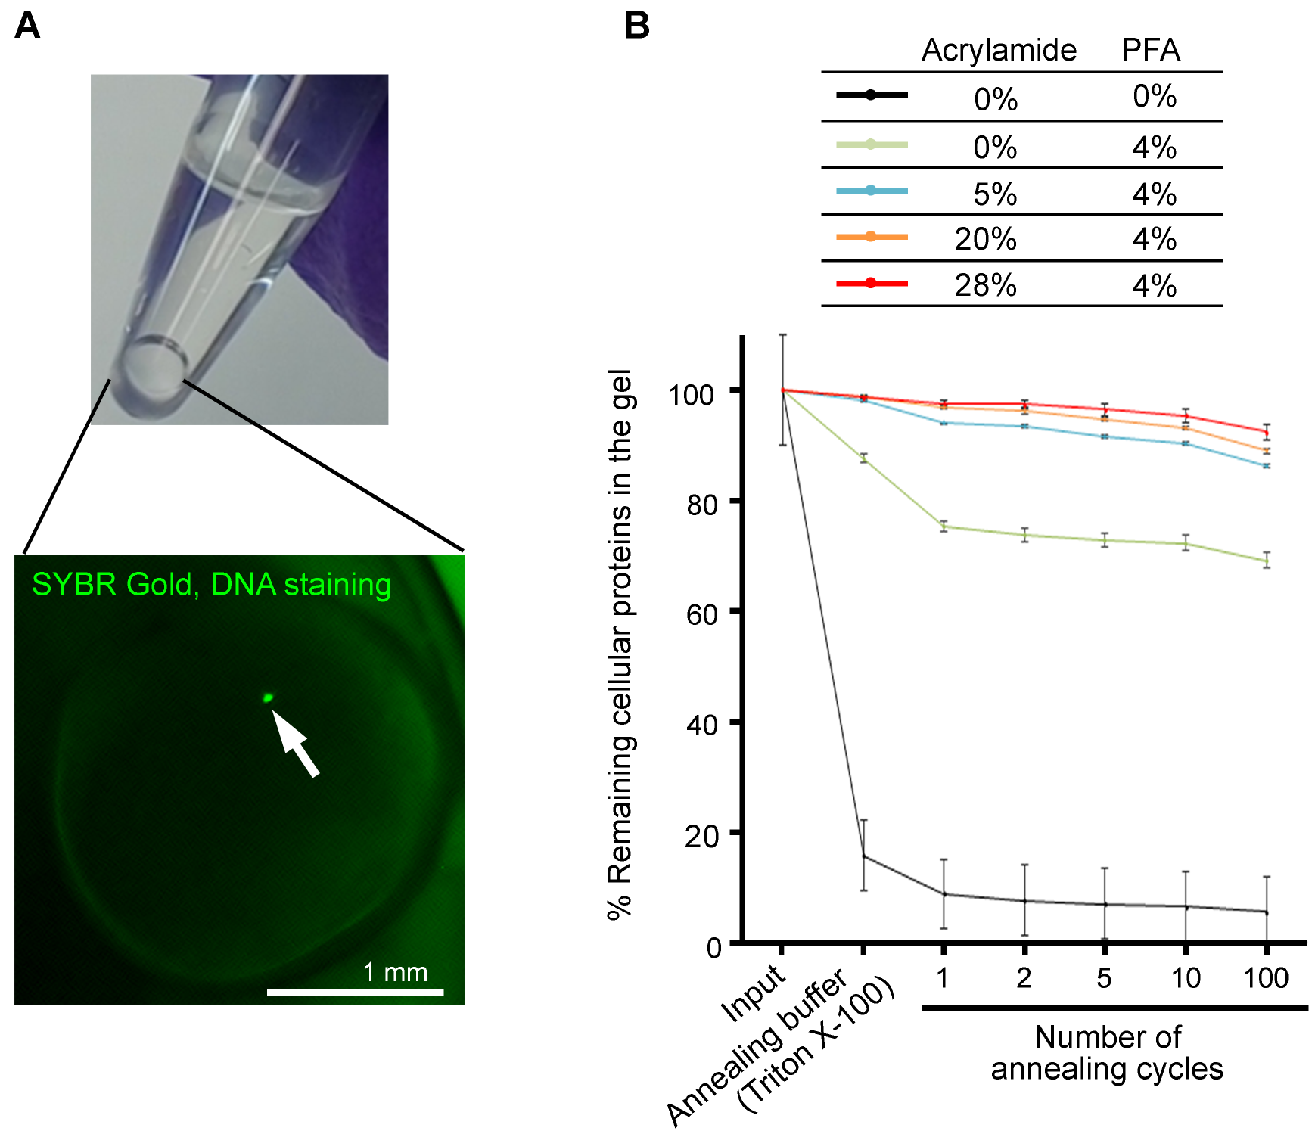

Supplemental Figure S1. Generating “reusable” single cells, related to Figure 1A
(A) A “reusable” single cell in a PCR tube. A single cell was embedded and anchored to a polyacrylamide (4%) scaffold. DNA in the cell nucleus was visualized by SYBR Gold. (B) Preservation of cellular proteins during heating and cooling cycles. Preservation of cellular proteins in non-fixed (0% acrylamide and 0% PFA), PFA-only-fixed (0% acrylamide and 4% PFA) and reusable (5-28% acrylamide and 4% PFA) single cells after heating and cooling cycles. The cells (3.33 x 10⁵ cells/tube) were mixed with PBS containing 3.88% acrylamide, 0.12% bis-acrylamide and 1% ammonium persulfate. The cells were embedded into polyacrylamide by adding mineral oil containing 0.2% N,N,N',N'-tetramethylethane-1,2-diamine. Eluted proteins were measured by Micro BCA after the heating and cooling cycles (94 °C for 3 min and 4 °C for 10 min). Inputs are total proteins from 3.33 x 10⁵ cells. Each data point represents the mean of triplicate experiments. Error bars reflect standard deviations.
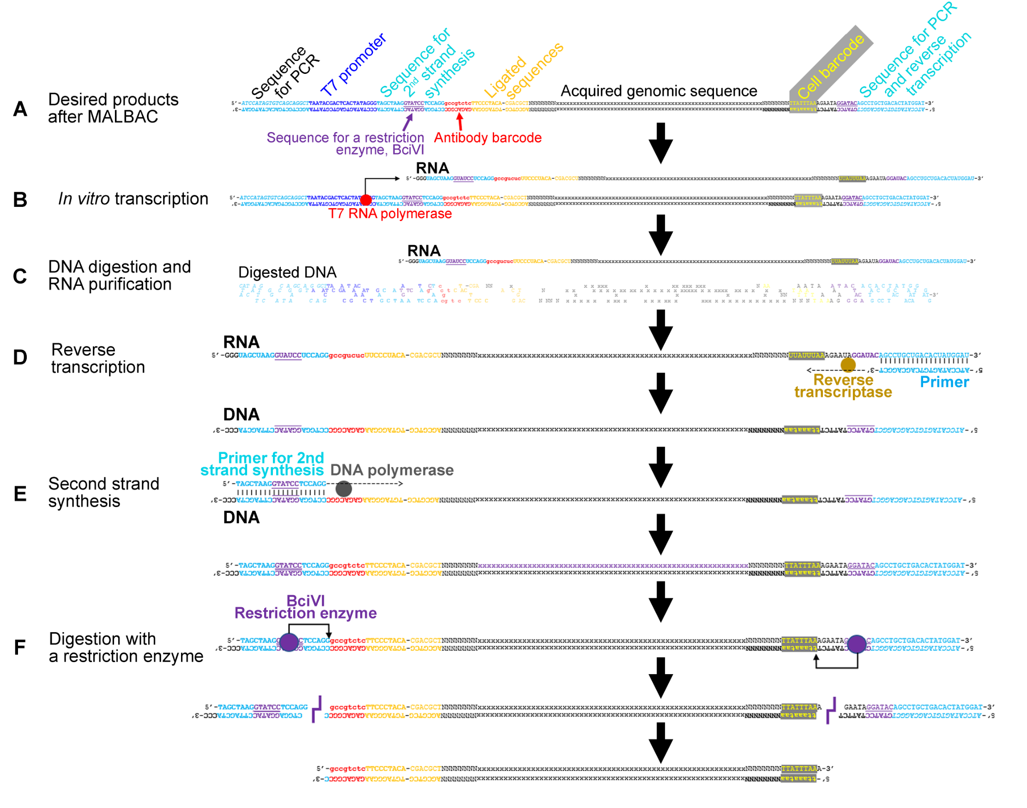

Supplemental Figure S2. Representation of a method to reduce genome-derived byproducts generated by MALBAC in the method, related to Figure 1B
(A) Desired products from MALBAC at the end of Figure 1B. (B) Conversion of the desired products into RNA by in vitro transcription using T7 promoter in the antibody probe. (C) Digestion of DNA including genome-derived byproducts of MALBAC, and RNA purification by phase separation. (D) Reverse transcription of the purified RNA. (E) Second strand synthesis using a specific primer. (F) Removal of extra sequences by digestion with the restriction enzyme BciVI.

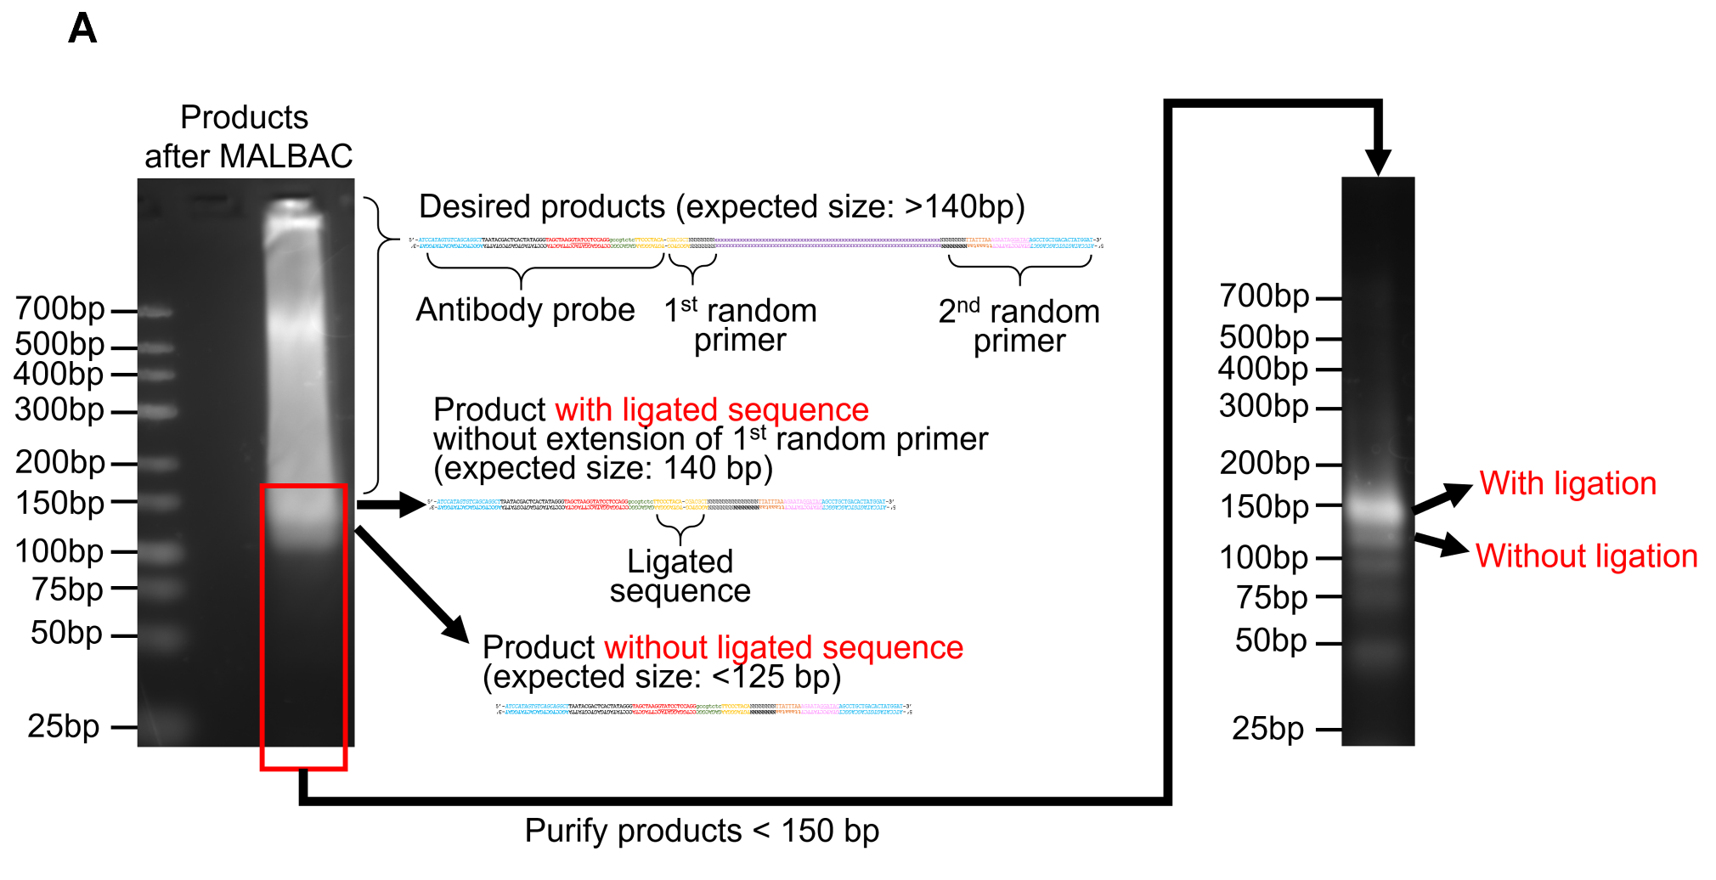

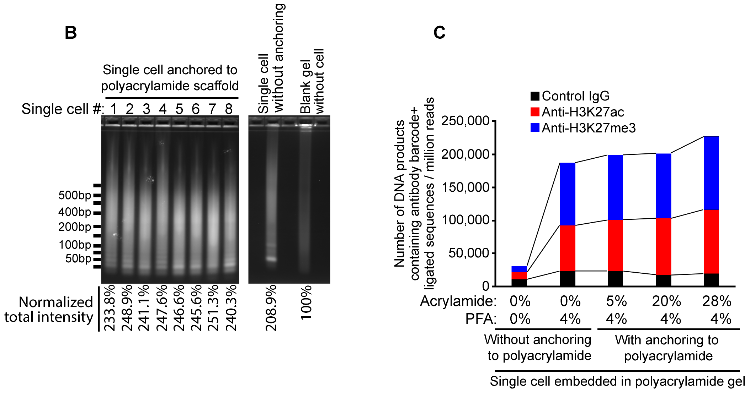

Supplemental Figure S3. DNA products from single cells embedded in a polyacrylamide gel, related to Figure 1
(A) Products after MALBAC. Single-cell products of MALBAC were separated by agarose gel electrophoresis (4% agarose gel; Nusive GTG agarose, 0.5xTAE buffer) and stained with SYBR Gold. To monitor the reactions and control the quality of MALBAC products, gel contents larger than 150 bp were selected for the reactions shown in Supplemental Figure S2. The byproducts smaller than 150 bp were further analyzed in the right panel. (B) Gel images of products at the end of the series of reactions in Supplemental Figure S2. DNA was visualized with SYBR Gold in 2% agarose gels. Band intensities were quantitated using ImageJ software and normalization using total intensity of DNA ladder marker (500 ng/lane) in each gel. (C) Number of DNA products containing sequences of the antibody probe and the first random primer. Single cells were embedded in a 4% polyacrylamide gel bead with or without anchoring the proteins to the polyacrylamide scaffold.

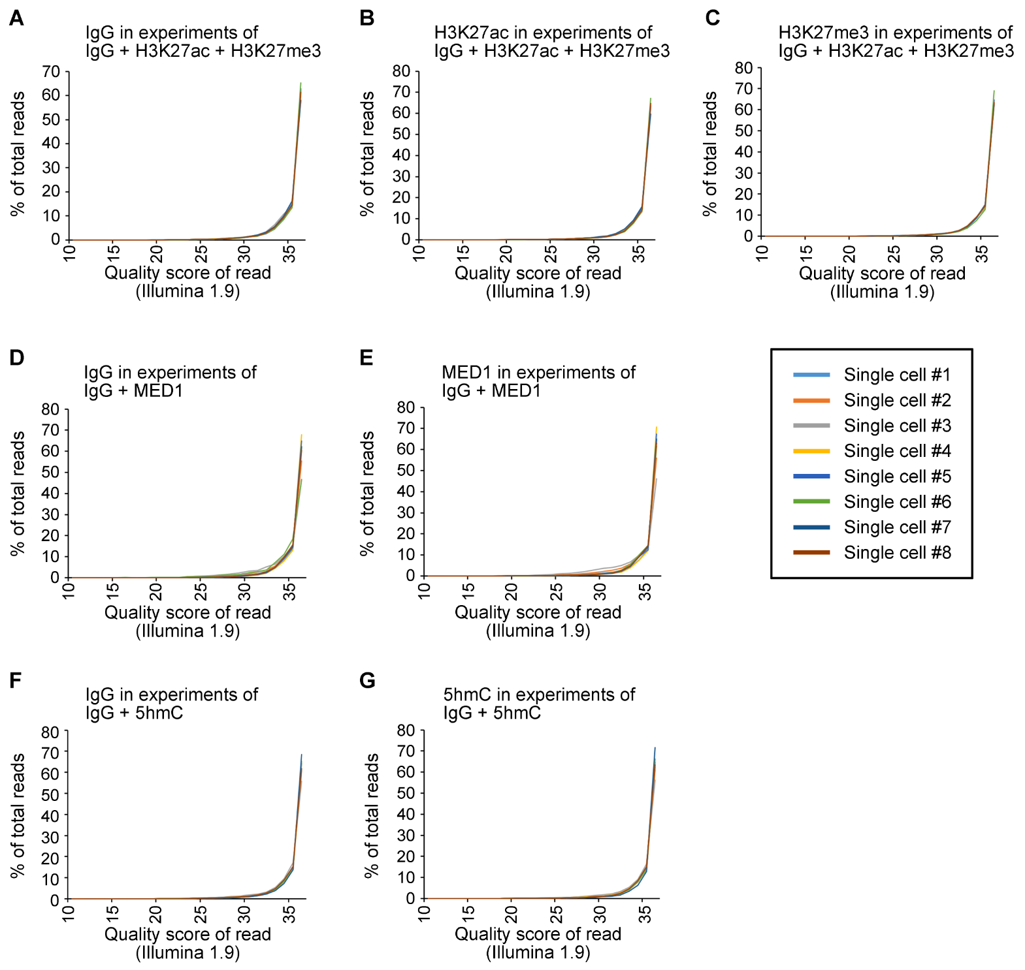

Supplemental Figure S4. Frequency of sequencing quality score in mapped reads
(A-C) Frequency of sequencing quality scores in mapped reads derived from control IgG (A), anti-H3K27ac (B) and anti-H3K27me3 (C). Control IgG, anti-H3K27ac and anti-H3K27me3 were mixed and reacted with a single cell. (D-E) Frequency of sequencing quality scores in mapped reads derived from control IgG (D) and anti-MED1 (E). Control IgG and anti-MED1 were mixed and reacted with a single cell. (F-G) Frequency of sequencing quality scores in mapped reads derived from control IgG (F) and anti-5hmC (G). Control IgG and anti-5hmC were mixed and reacted with a single cell. The generated products were sequenced and mapped to the genome. The probability of a sequence error in the mapped reads is reflected by the quality score of a read (Illumina 1.9).

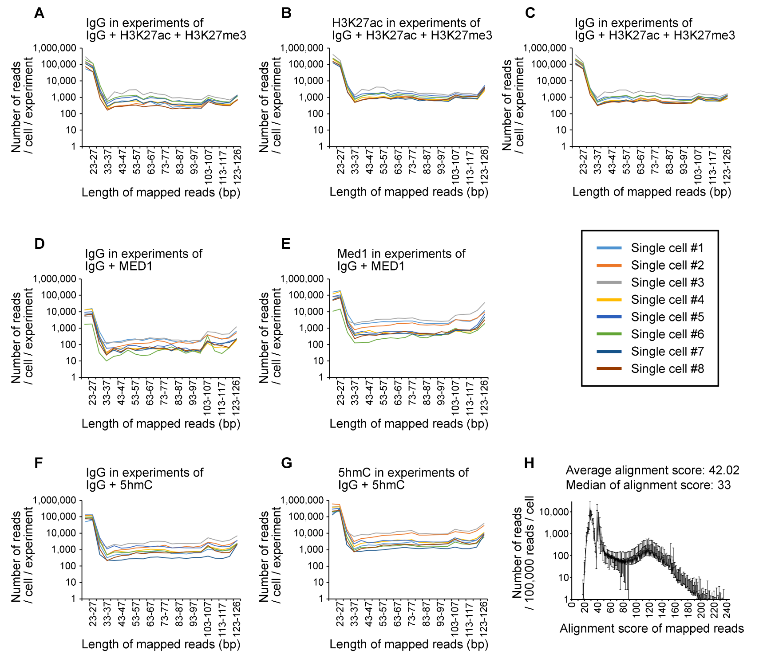

Supplemental Figure S5. Length of added genomic sequences to the random primer and mapping quality scores
(A-C) Length of added genomic sequences to the random primer of ligated products in mapped reads
derived from control IgG (A), anti-H3K27ac (B) and anti-H3K27me3 (C). Control IgG, anti-H3K27ac and anti-
H3K27me3 were mixed and reacted with a single cell. (D-E) Length of added genomic sequences to the random primer of ligated products in mapped reads derived from control IgG (D) and anti-MED1 (E). Control IgG and anti-MED1 were mixed and reacted with a single cell. (F-G) Length of added genomic sequences to the random primer of ligated products in mapped reads derived from control IgG (F) and anti-5hmC (G). Control IgG and anti-5hmC were mixed and reacted with a single cell. The generated products were sequenced and mapped to the genome. Each line indicates number of reads per cell in one experiment. (H) Frequency of mapping quality score in mapped reads to the genome. All datasets shown in supplemental Figure S5A-S5G were used. Error bar: standard deviation.
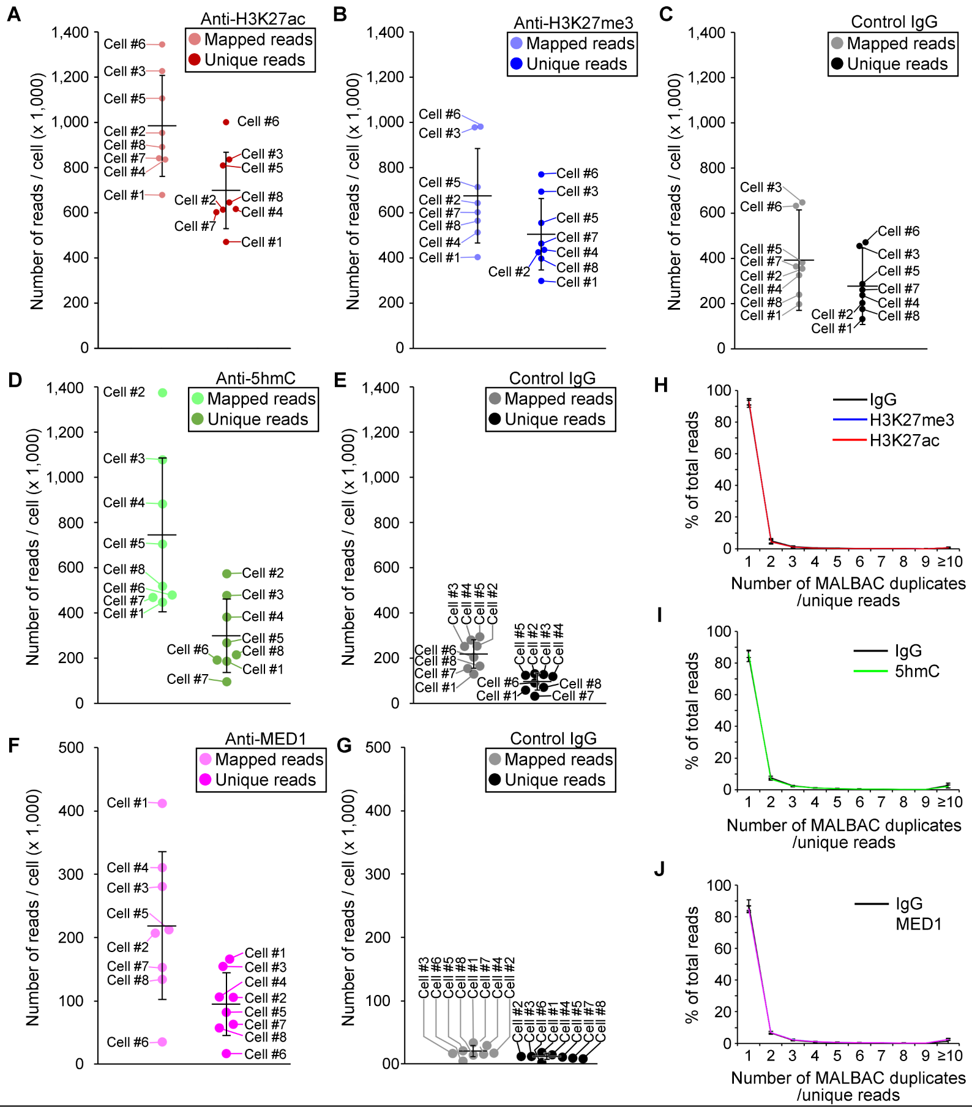

Supplemental Figure S6. Duplication rates by MALBAC
(A-G) Number of mapped reads and unique reads (reads after removal of MALBAC duplicates) per cell. The same single cells (#1-8) were reused 5 times. Anti-H3K27ac (A), anti-H3K27me3 (B) and control IgG (C) were added to a PCR tube containing a single cell. The same experiments were repeated 3 times with anti-H3K27ac, anti-H3K27me3 and control IgG. Total number of mapped and unique reads from 3 repeated experiments are shown in panels, A, B and C. The same single cells were re-analyzed with anti-5hmC (D)+ Control IgG (E) and anti-MED1 (F) + Control IgG (G). (H-J) Frequency of duplication by MALBAC in IgG + H3K27me3 + H3K27ac (H), IgG + 5hmC (I) and IgG + MED1 (J). Bar: Mean value of 8 single cells. Error bar: standard deviation.
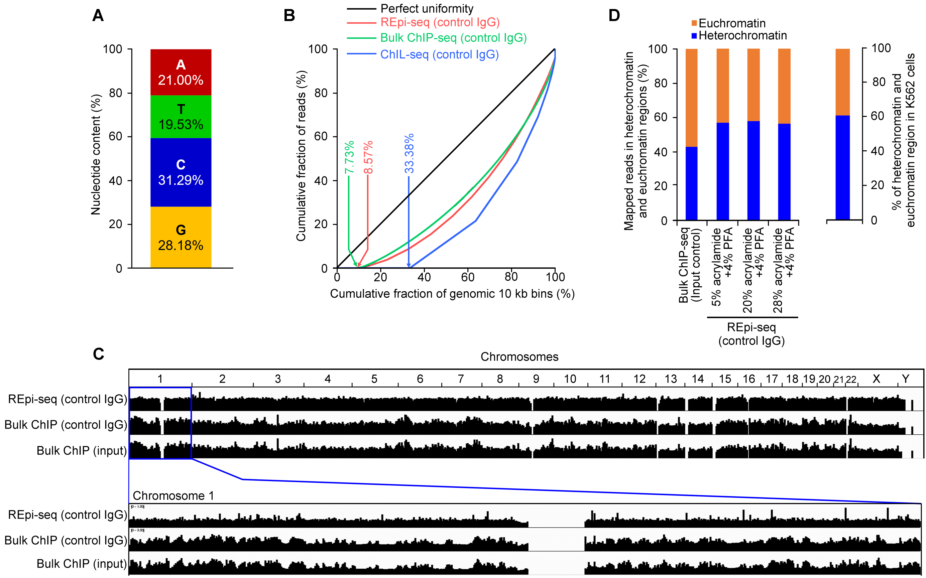

Supplemental Figure S7. Genome-wide analysis of methodological bias
(A) GC bias in random priming. Nucleotide content was analyzed in the 8nt random sequences in IgG-derived products. Forty datasets of REpi-seq with control IgG (8 single cells x 5 experiments) were combined to calculate nucleotide content. (B) Lorenz curves generated with reads from control IgG in REpi-seq (red), bulk ChIP-seq (green) and ChIL-seq (blue). Genomic regions were divided into 10 kb bins. The number of control-IgG reads was counted in each bin. Y-axis: cumulative fraction of reads; X-axis: cumulative fraction of genomic 10 kb bins. The black line indicates a perfect uniformity of read distribution, no bias. The arrows indicate the % uncovered genomic regions in REpi-seq (red), bulk ChIP-seq (green) and ChIL-seq (blue), respectively. (C) Distribution patterns of control reads as an indicator of methodological bias. Forty datasets of REpi-seq control IgG were combined and mapped to the human genome (GRCh38). MALBAC duplicates were removed using unique molecular identifiers (8 nt random sequences and 5’ positions of the mapped reads). Control IgG and input control from bulk ChIP-seq (ENCODE ENCFF970CZZ and ENCFF089RYQ) are shown as references. (D) Bias derived from chromatin structure is reduced in REpi-seq. The bar on the far right indicates the % of heterochromatin (blue) and euchromatin (orange) regions in K562 cells determined by ENCODE. The left 4 bars indicate the % reads in heterochromatin (blue) and euchromatin (orange) regions. Input control of bulk ChIP-seq is from ENCODE ENCFF089RYQ.

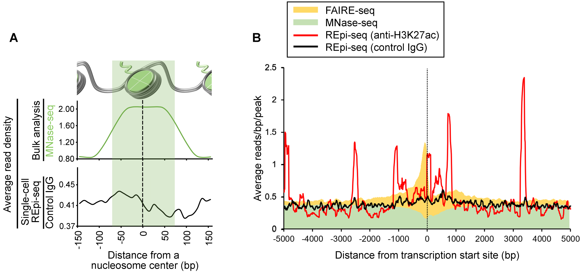

Supplementary Figure S8. Methodological bias of control IgG reads for nucleosomes
(A) Relationship between nucleosome position (MNase-seq, green line) and REpi-Seq unique reads from control IgG (black line). The green band indicates a region of DNA wrapping a nucleosome (146 bp region). (B) Methodological bias around transcription start sites. Nucleosome-free regions are indicated by a positive peak of FAIRE-seq (yellow, ENCODE ENCFF000TLD) and a negative peak of MNase-seq (green, ENCODE ENCFF000VNR). Control IgG reads in REpi-seq were used as an indicator of methodological bias (black line). Forty datasets of control IgG from REpi-seq were used (8 K562 single cells x 5 experiments, unique reads). Twenty-four datasets of H3K27ac from REpi-seq were used (8 K562 single cells x 3 repeated experiments, unique reads).

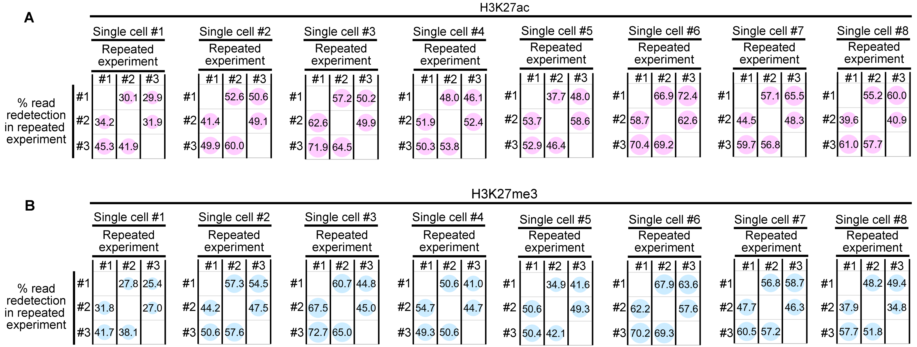

Supplemental Figure S9. Redetection percentages of unique reads by repeated experiments, related to Figure 2A and 2B
(A-B) Redetection percentages of H3K27ac (A) and H3K27me3 (B) reads in individual experiments with a reusable single cell. Repeated experiments were performed 3 times with the same reusable single cell and antibodies. Location of reads was extended +/- 128 bp, which is a theoretical maximum distance from an antibody to a random primer in the proximity ligation (the theoretical maximum distance was supported by Figure 2A and 2B). Reads were counted as a redetected read when a read in one repeated experiment overlapped with another read in one of the other two repeated experiments. The number of the redetected reads is shown as a percentage of the total number of reads detected in each experiment. Percentages are shown as a bubble chart, which reflects the percentage as circle size.

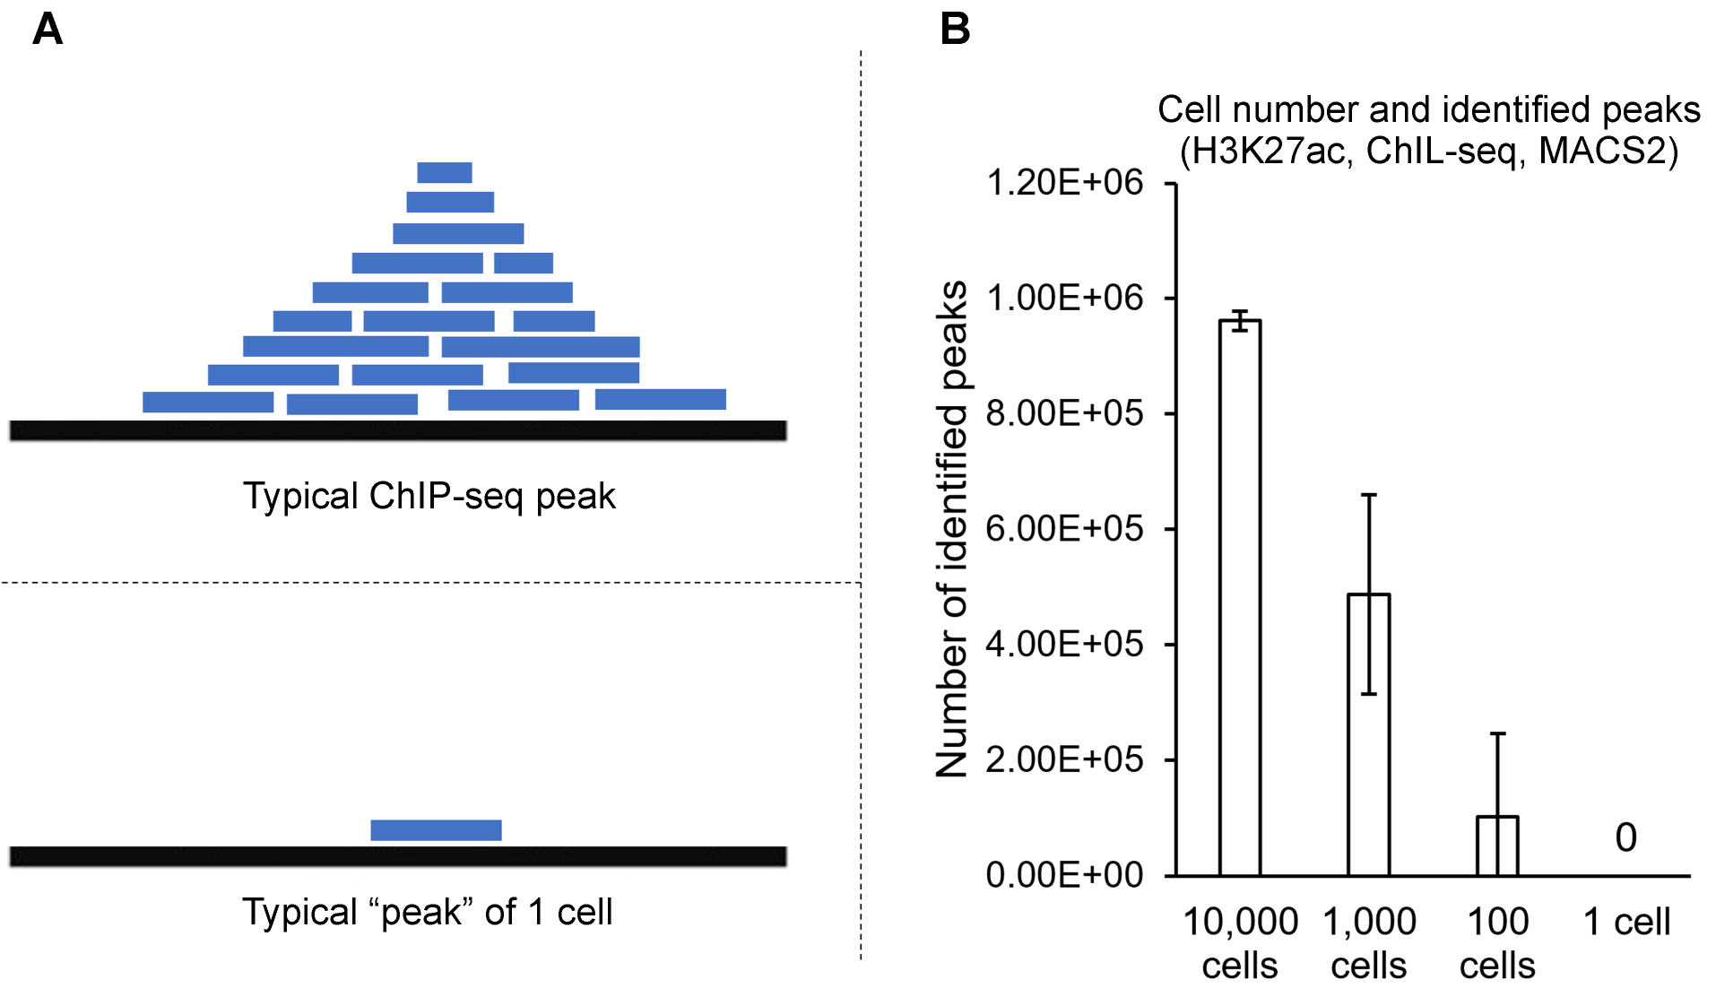

Supplemental Figure S10. Peak calling in 1 cell
(A) Schematic representation of a typical ChIP-seq peak and typical data from one cell. (B) Number of peaks identified by MACS2 peak caller with different number of cells. Data are from ChIL-seq, H3K27ac (Harada et al. 2019). In “1 cell” peak calling, datasets of 5 single cells were separately used for peak calling. Peak calling was performed with the default setting of MACS2 with the option “—broad”. Error bars: standard deviation of the mean.

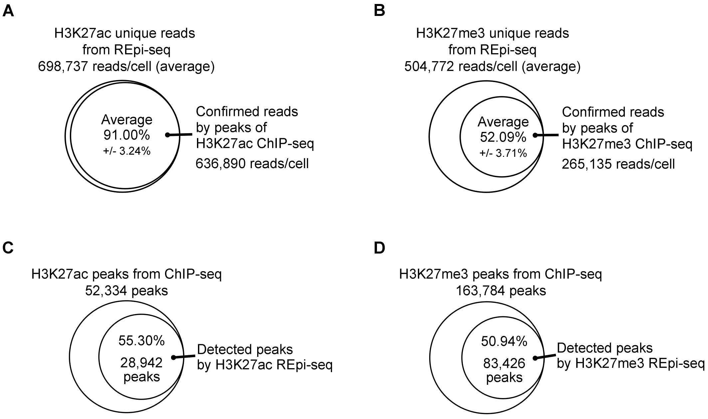

Supplemental Figure S11. Precision and sensitivity of REpi-seq for H3K27ac and H3K27me3
(A-B) Precision of REpi-seq H3K27ac (A) and H3K27me3 (B) unique reads. The precision of unique reads derived from REpi-seq was based on overlapping with known ChIP-seq peaks from K562 bulk cell analysis (H3K27ac: SRR3144862; H3K27me3: SRR069083). The percentage of REpi-seq H3K27ac and H3K27me3 reads confirmed by ChIP-seq peaks was calculated in each single cell. The results are expressed as the average percent of 8 single cells. (C-D) Sensitivity of REpi-seq at detecting H3K27ac (C) and H3K27me3 (D) known peaks. Unique reads of REpi-seq were used. H3K27ac and H3K27me3 peaks identified by ChIP-seq of K562 bulk cells in the ECODE Project (H3K27ac: ENCFF038DDS; H3K27me3: ENCFF031FSF) were recognized by REpi-seq unique reads. The results are expressed as the average percent ChIP-seq peaks recognized by REpi-seq unique reads.

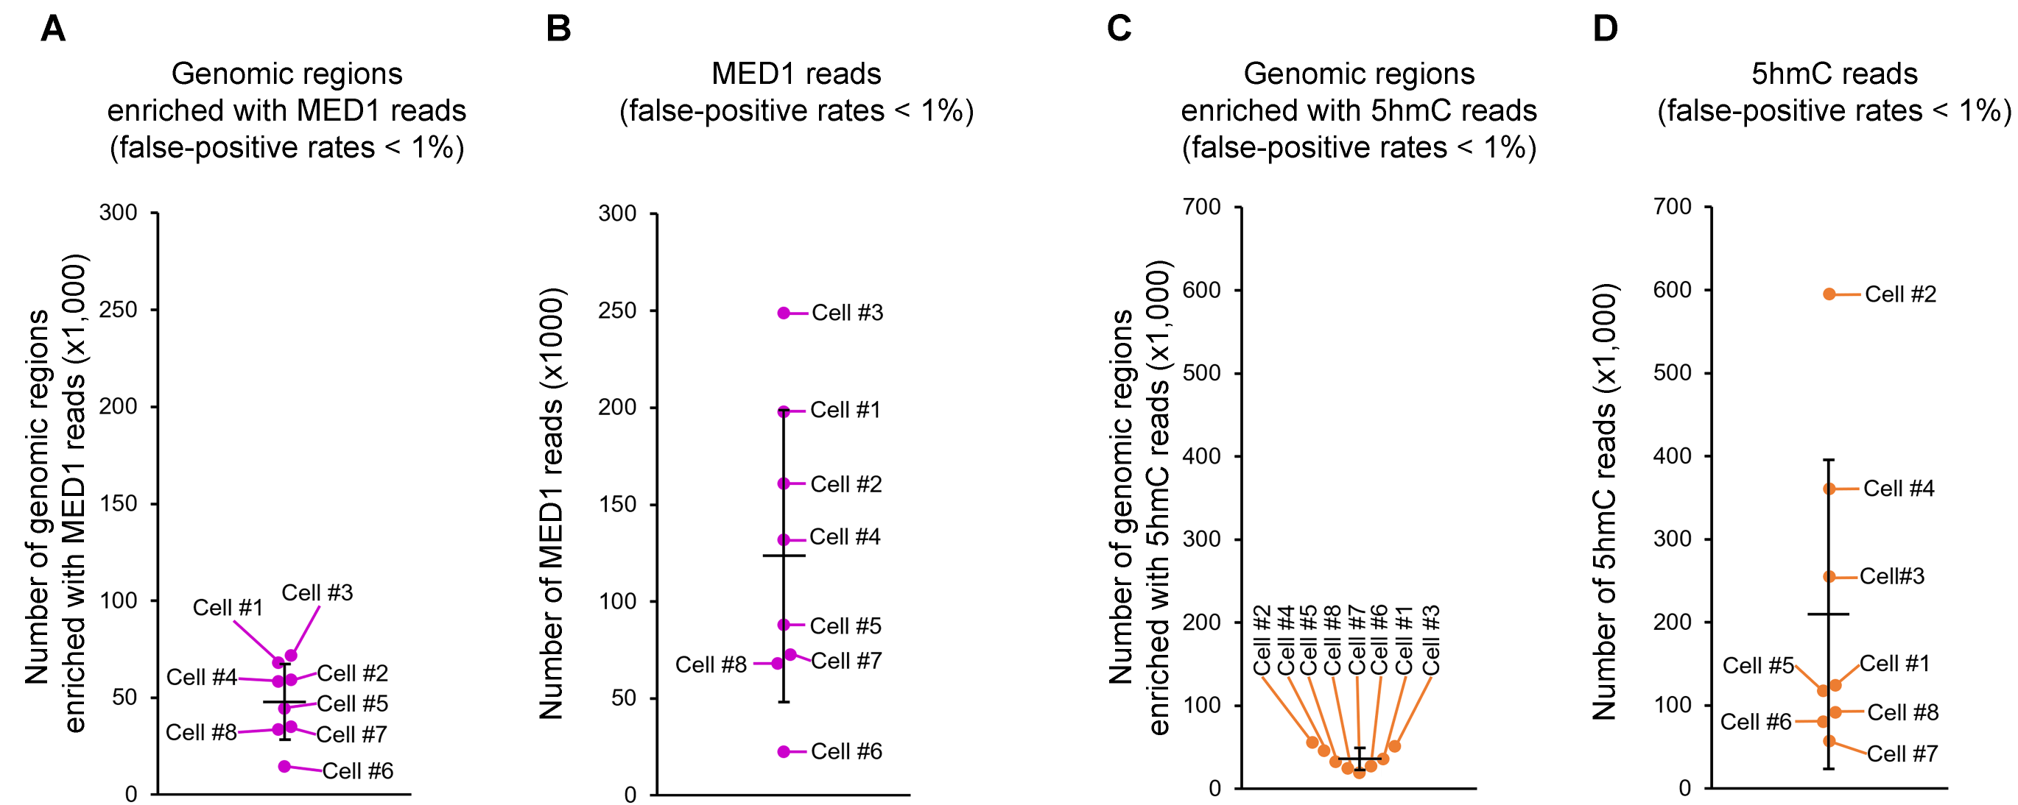

Supplemental Figure S12. Reanalysis of the same single cells with different antibodies, related to Figure 3G and 3H
(A and C) Genomic regions enriched with reads of mediator complex subunit 1 (MED1, A) and 5-hydroxymethylcytosine (5hmC, C) in individual cells. MED1 and 5hmC reads from 8 single cells were combined prior to identifying genomic regions. Genomic regions enriched with reads were determined by two criteria of the background. The first criterion is read enrichment over control IgG in a genomic region (500 bp bin size). The second criterion is significance compared to random controls of antibody and control IgG (see Method for the detail). Genomic regions in the upper 1% of the distribution were considered as regions enriched with reads over the background. (B and D) Number of MED1 (B) and 5hmC (D) reads per cell. Number of reads in the genomic regions enriched with reads was counted in each single cell.

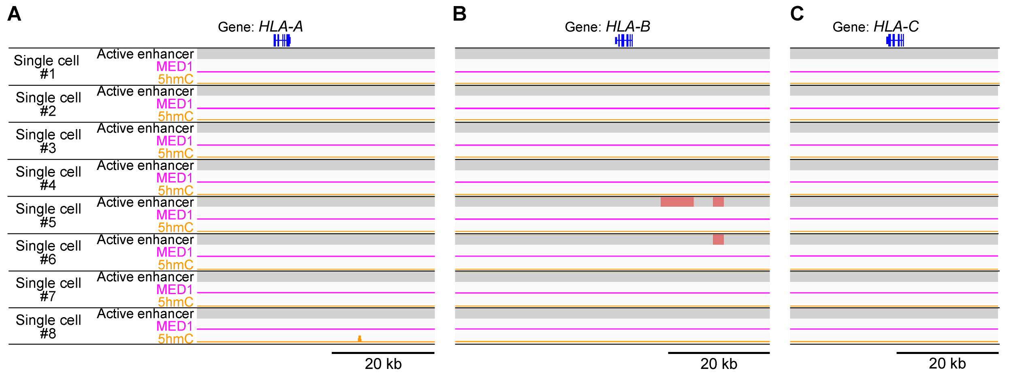

Supplemental Figure S13. Epigenetic status of known inactive loci HLA-A, HLA-B and HLA-C in K562 single cells, related to Figure 5
(A-C) Distribution of active enhancers [log₂(H3K27ac/H3K27me3)], MED1 and 5hmC in loci HLA-A, HLA-B and HLA-C known to be inactive. H3K27ac, H3K27me3, MED1 and 5hmC reads (false-positive rates less than 1%) were used as input data. Active enhancers were identified based on significant H3K27ac dominance based on the relative ratio log₂(H3K27ac/H3K27me3) compared to randomized control reads of H3K27ac and H3K27me3 (false-positive rates less than 5%, the bootstrap procedure). Known K562-cell type-specific, active enhancers of K562 cells were not detected. K562-cell type-nonspecific, active enhancers (red) are active enhancers typically not identified in bulk cell analysis of K562 cells.

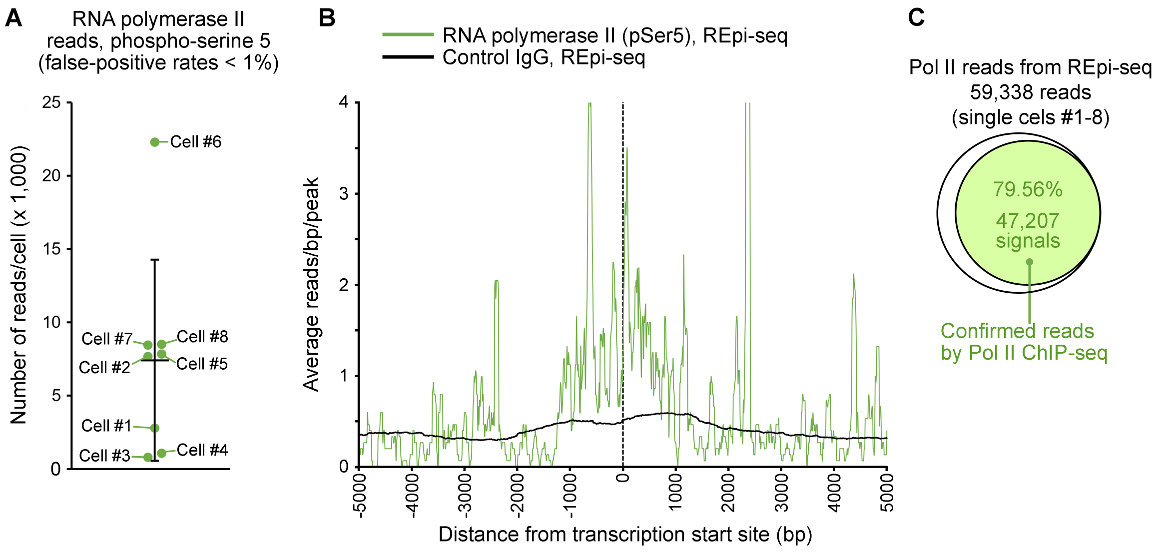

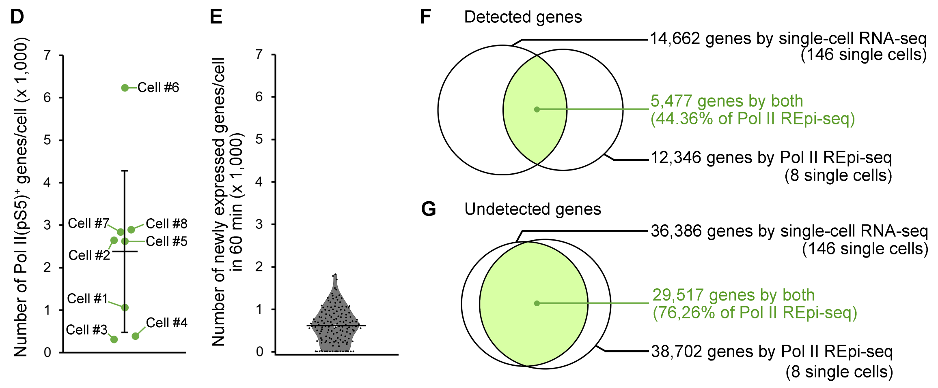

Supplemental Figure S14. REpi-seq detects phosphorylated RNA polymerase II
(A) Number of reads detected by REpi-seq with antibodies to RNA polymerase II, phosphorylated at serine 5 (Pol II). K562 single cells used in other Figures were reanalyzed by REpi-seq with anti-Poll II and control IgG. Pol II reads from 8 single cells were combined prior to the bootstrap procedure to identify significant genomic regions enriched with reads (500 bp each) compared to control IgG and stochastic noise (false-positive rates less than 1%). Pol II reads in the genomic regions were counted in each cell. (B) Pol II reads are enriched around transcription start sites (TSS). Read-distribution pattern was computed with Homer software using datasets of 8 single cells shown in panel A. (C) Pol II REpi-seq reads are confirmed by Pol II ChIP-seq. Pol II REpi-seq reads also observed in Pol II ChIP-seq of K562 bulk cells were counted as confirmed reads. Three different datasets of bulk ChIP-seq with K562 cells were separately used (SRR6386690, SRR6386680 and SRR227359). The average number of REpi-seq reads confirmed by bulk ChIP-seq is calculated from the 3 different datasets of bulk ChIP-seq. The percent confirmation of REpi-seq reads is shown. (D) Number of Pol II⁺ genes per cell. A Pol II⁺ gene is a gene in which a Pol II read was detected in the gene body and/or promoter region (TSS +/- 2 kb). (E) Number of newly expressed genes per cell in 60 min measured by new transcriptome alkylation-dependent single-cell RNA sequencing (NASC-seq). Datasets of K562 single cells (146 cells) reported by Hendriks et al. (2019) were reanalyzed. The number of transcribed genes over 60 min was counted as a newly expressed gene. Counting was performed in each cell. Each dot is representative of a single cell. (F) Number of co-detected genes in single-cell RNA-seq (NASC-seq) and Pol II REpi-seq. (G) Number of undetected genes in single-cell RNA-seq (NASC-seq) and Pol II REpi-seq. Horizontal bar: mean of 8 single cells (A and C) and mean of 146 cells (D). Error bar: standard deviation.

Supplemental Table S1. DNA components of the method
Component name | Sequence or detail of components
DNA probe conjugated with Control IgG | 5’-NH2-ATCCATAGTGTCAGCAGGCTTAATACGACTCACTATAGGGTAGCTAAGGTATCCTCCAGGtaacatctTTCCCTACA-3’
DNA probe conjugated with Anti-H3K27ac | 5’-NH2-ATCCATAGTGTCAGCAGGCTTAATACGACTCACTATAGGGTAGCTAAGGTATCCTCCAGGgccgtctcTTCCCTACA-3’
DNA probe conjugated with Anti-H3K27me3 | 5’-NH2-ATCCATAGTGTCAGCAGGCTTAATACGACTCACTATAGGGTAGCTAAGGTATCCTCCAGGcattcgggTTCCCTACA-3’
DNA probe conjugated with Anti-MED1 | 5’-NH2-ATCCATAGTGTCAGCAGGCTTAATACGACTCACTATAGGGTAGCTAAGGTATCCTCCAGGggtgcgtaTTCCCTACA-3’
DNA probe conjugated with Anti-5hmC | 5’-NH2-ATCCATAGTGTCAGCAGGCTTAATACGACTCACTATAGGGTAGCTAAGGTATCCTCCAGGaagcatggTTCCCTACA-3’
DNA probe conjugated with Anti-Pol II | 5’-NH2-ATCCATAGTGTCAGCAGGCTTAATACGACTCACTATAGGGTAGCTAAGGTATCCTCCAGGctctggctTTCCCTACA-3’
1st Random Primer | 5’-/5Phos/CGACGCTNNNNNNNN-3’
Ligation adapter probe | 5’-AGCGTCGTGTAGGGAA-3’
2nd Random Primer with Cell barcode #1 | 5’-ATCCATAGTGTCAGCAGGCTGTATCCTATTCTttaaataaNNNNNNNN-3’
2nd Random Primer with Cell barcode #2 | 5’-ATCCATAGTGTCAGCAGGCTGTATCCTATTCTagtcgatcNNNNNNNN-3’
2nd Random Primer with Cell barcode #3 | 5’-ATCCATAGTGTCAGCAGGCTGTATCCTATTCTataccactNNNNNNNN-3’
2nd Random Primer with Cell barcode #4 | 5’-ATCCATAGTGTCAGCAGGCTGTATCCTATTCTaggtatcaNNNNNNNN-3’
2nd Random Primer with Cell barcode #5 | 5’-ATCCATAGTGTCAGCAGGCTGTATCCTATTCTtggagaaaNNNNNNNN-3’
2nd Random Primer with Cell barcode #6 | 5’-ATCCATAGTGTCAGCAGGCTGTATCCTATTCTctgagcatNNNNNNNN-3’
2nd Random Primer with Cell barcode #7 | 5’-ATCCATAGTGTCAGCAGGCTGTATCCTATTCTtctatactNNNNNNNN-3’
2nd Random Primer with Cell barcode #8 | 5’-ATCCATAGTGTCAGCAGGCTGTATCCTATTCTaaggttaaNNNNNNNN-3’

Supplemental Table S2. Sequences of antibody barcodes
Antibody name | Forward sequence | Reverse complement sequence
H3K27me3 | CATTCGGG | CCCGAATG
H3K27ac | GCCGTCTC | GAGACGGC
MED1 | GGTGCGTA | TACGCACC
5hmC | AAGCATGG | CCATGCTT
Pol II | CTCTGGCT | AGCCAGAG
Control IgG | TAACATCT | AGATGTTA

Supplemental Table S3. Sequences of cell barcodes
Antibody name | Forward sequence | Reverse complementary sequence
Single cell #1 | TTAaATAA | TTATTTAA
Single cell #2 | AGTCGaTC | GATCGACT
Single cell #3 | aTAcCACT | AGTGGTAT
Single cell #4 | AGGTatCA | TGATACCT
Single cell #5 | TggAgAAA | TTTCTCCA
Single cell #6 | CTgAGCaT | ATGCTCAG
Single cell #7 | TCTATACT | AGTATAGA
Single cell #8 | AAgGTTAA | TTAACCTT

Supplemental Table S4. Datasets of bulk ChIP-seq used for t-SNE plots

Supplemental Table S5. SRA Bioproject, Biosample and Data Accession ID of single-cell data generated in this study.

4. References for Supplemental Methods
Bagci H, Kohen F, Kuscuoglu U, Bayer EA, Wilchek M. 1993. Monoclonal anti-biotin antibodies simulate avidin in the recognition of biotin. FEBS Lett 322: 47-50.
Dodt M, Roehr JT, Ahmed R, Dieterich C. 2012. FLEXBAR-Flexible Barcode and Adapter Processing for Next-Generation Sequencing Platforms. Biology (Basel) 1: 895-905.
Dreos R, Ambrosini G, Groux R, Cavin Perier R, Bucher P. 2017. The eukaryotic promoter database in its 30th year: focus on non-vertebrate organisms. Nucleic Acids Res 45: D51-D55.
Ernst J, Kellis M. 2010. Discovery and characterization of chromatin states for systematic annotation of the human genome. Nat Biotechnol 28: 817-825.
Ernst J, Kheradpour P, Mikkelsen TS, Shoresh N, Ward LD, Epstein CB, Zhang X, Wang L, Issner R, Coyne M et al. 2011. Mapping and analysis of chromatin state dynamics in nine human cell types. Nature 473: 43-49.
Giresi PG, Kim J, McDaniell RM, Iyer VR, Lieb JD. 2007. FAIRE (Formaldehyde-Assisted Isolation of Regulatory Elements) isolates active regulatory elements from human chromatin. Genome Res 17: 877-885.
Heinz S, Benner C, Spann N, Bertolino E, Lin YC, Laslo P, Cheng JX, Murre C, Singh H, Glass CK. 2010. Simple combinations of lineage-determining transcription factors prime cis-regulatory elements required for macrophage and B cell identities. Mol Cell 38: 576-589.
Hendriks GJ, Jung LA, Larsson AJM, Lidschreiber M, Andersson Forsman O, Lidschreiber K, Cramer P, Sandberg R. 2019. NASC-seq monitors RNA synthesis in single cells. Nat Commun 10: 3138.
Kramer A, Green J, Pollard J, Jr., Tugendreich S. 2014. Causal analysis approaches in Ingenuity Pathway Analysis. Bioinformatics 30: 523-530.
Langmead B, Salzberg SL. 2012. Fast gapped-read alignment with Bowtie 2. Nat Methods 9: 357-359.
Li H, Handsaker B, Wysoker A, Fennell T, Ruan J, Homer N, Marth G, Abecasis G, Durbin R, Genome Project Data Processing S. 2009. The Sequence Alignment/Map format and SAMtools. Bioinformatics 25: 2078-2079.
Lu S, Zong C, Fan W, Yang M, Li J, Chapman AR, Zhu P, Hu X, Xu L, Yan L et al. 2012. Probing meiotic recombination and aneuploidy of single sperm cells by whole-genome sequencing. Science 338: 1627-1630.
Paithankar KR, Prasad KS. 1991. Precipitation of DNA by polyethylene glycol and ethanol. Nucleic Acids Res 19: 1346.
Quinlan AR, Hall IM. 2010. BEDTools: a flexible suite of utilities for comparing genomic features. Bioinformatics 26: 841-842.
Robinson JT, Thorvaldsdottir H, Winckler W, Guttman M, Lander ES, Getz G, Mesirov JP. 2011. Integrative genomics viewer. Nat Biotechnol 29: 24-26.
Schones DE, Cui K, Cuddapah S, Roh TY, Barski A, Wang Z, Wei G, Zhao K. 2008. Dynamic regulation of nucleosome positioning in the human genome. Cell 132: 887-898.
Smith T, Heger A, Sudbery I. 2017. UMI-tools: modeling sequencing errors in Unique Molecular Identifiers to improve quantification accuracy. Genome Res 27: 491-499.
Wang J, Dai X, Berry LD, Cogan JD, Liu Q, Shyr Y. 2019. HACER: an atlas of human active enhancers to interpret regulatory variants. Nucleic Acids Res 47: D106-D112.
Weiland G, zu Dohna HG. 1978. [The suitability of the enzyme-linked immunosorbent assay (ELISA) for the demonstration of babesia antibodies in hyperimmune serums with the use of ectoantigens]. Berl Munch Tierarztl Wochenschr 91: 33-35.
Young L, Sung J, Stacey G, Masters JR. 2010. Detection of Mycoplasma in cell cultures. Nat Protoc 5: 929-934.
Zhao H, Sun Z, Wang J, Huang H, Kocher JP, Wang L. 2014. CrossMap: a versatile tool for coordinate conversion between genome assemblies. Bioinformatics 30: 1006-1007.
Zong C, Lu S, Chapman AR, Xie XS. 2012. Genome-wide detection of single-nucleotide and copy-number variations of a single human cell. Science 338: 1622-1626.

