Supplemental_Fig_S1.pdf
Supplemental Fig S1. Assembly and evaluation of Chrysopogon serrulatus and Hyparrhenia diplandra genomes. (A) Genome assembly pipeline. (B) BUSCO assessment results for both species. (C) Minimum extent of the flanking regions. The green rectangle represents the target BASCO gene; n1 is the distance between the edge of the gene and the edge of the contig on one side, while n2 is that on the other side. Distribution of minimum extent of the flanking regions for C. serrulatus (D) and H. diplandra (E). (F) Statistical summary of the two genome assemblies. Haploid genome size for each species was estimated by flow cytometry. Both genome assemblies were partially collapsed.

Supplemental_Fig_S2.pdf
Supplemental Fig S2. Positive correlation between the total CNS length (number of matched base-pairs in the maize genome) and the query genome size in five Andropogoneae species. The x axis indicates the genome sizes of query genomes. And the y axis indicates the number of base-pairs (total CNS length) in the reference (maize) genome being identified as CNS.

Supplemental_Fig_S3.pdf
Supplemental Fig S3. CNS length (bp) distribution in each of the five Andropogoneae genomes. The x-axis indicates the length of each CNS record. The y-axis indicated the number of CNS records with length following into each bin.

Supplemental_Fig_S4.pdf
Supplemental Fig S4. Enrichment of the core-And-CNSs (red), pan-And-CNSs (green), and CNSs identified by aligning sorghum genome sequence to maize genome sequence (blue) in different types of features of putative cis-regulatory sequences, including H3K9ac ChIP-seq peaks, open chromatin regions, and transcription factor binding sites (TFBSs). The open chromatin regions were identified in leaf (Ricci et al. 2019) and ear tissues (Tu et al. 2020); the 104 TFBSs were measured in leaves (Tu et al. 2020); the H3K9ac ChIP-seq peaks were determined in stems and husk leaves (Oka et al. 2017).

Supplemental_Fig_S5.png
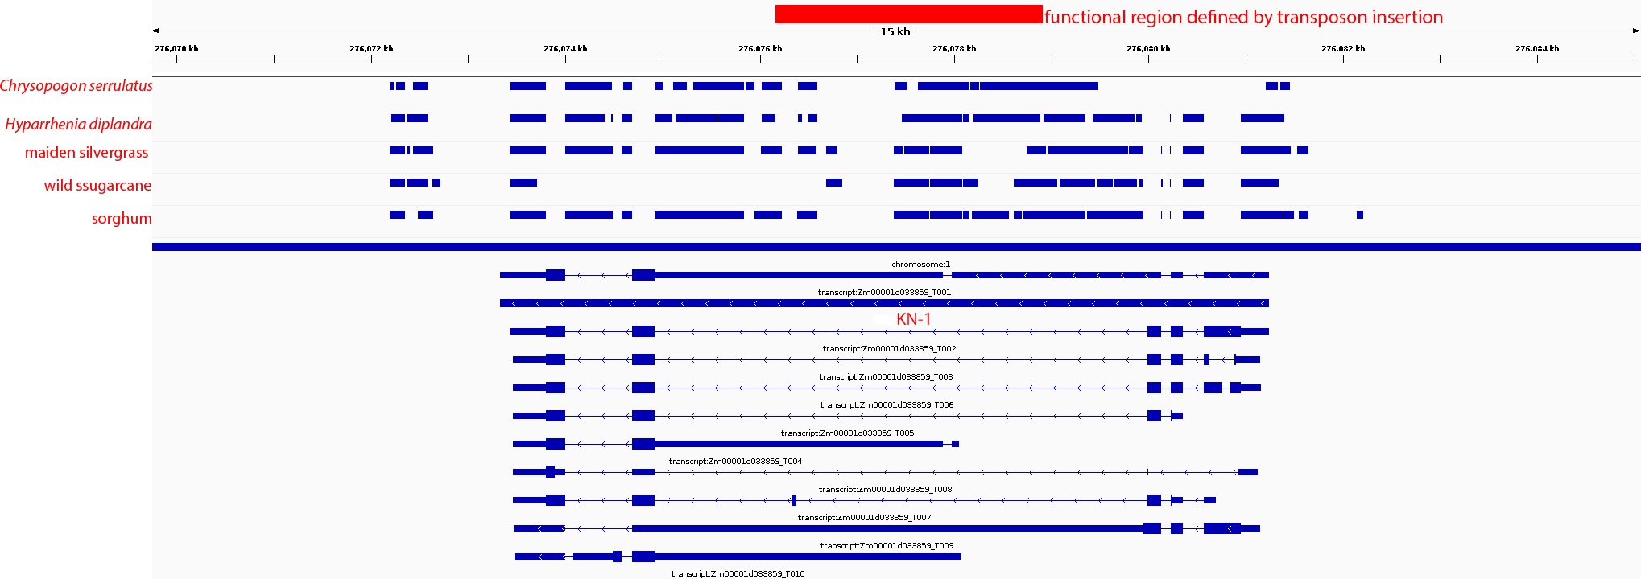
Supplemental Fig S5. Location of the CNSs identified in the third intron of maize Knotted1 (KN-1) gene. The red box indicates the estimated location of a variants that impact the function of regulatory element (Greene et al. 1994; Lai et al. 2017).

Supplemental_Fig_S6.png
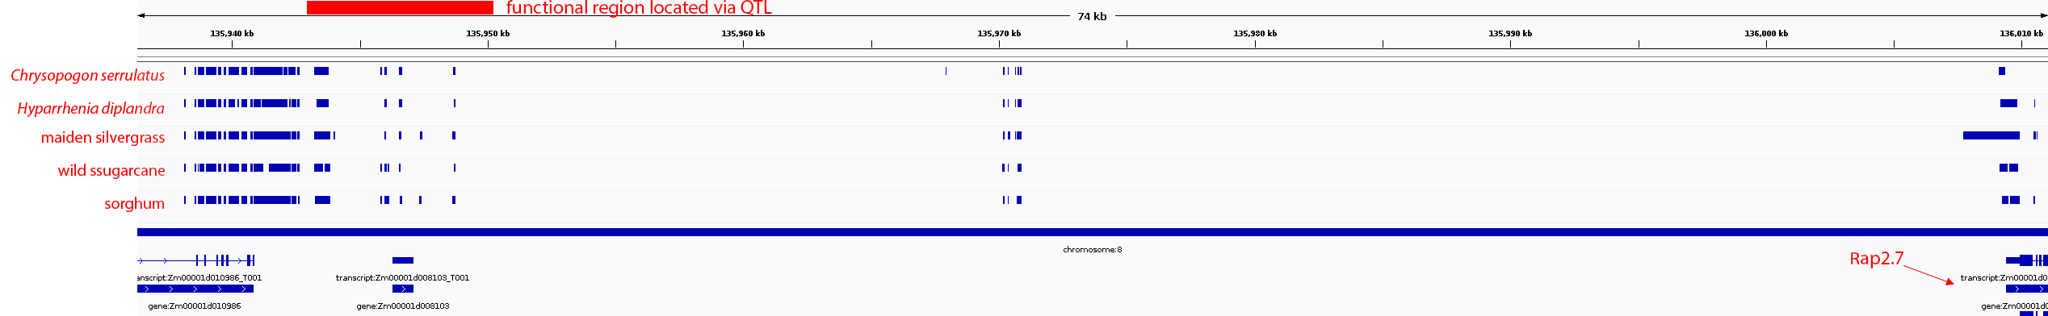
Supplemental Fig S6. Location of the CNSs identified around maize Vgt1 locus. The red box indicates the estimated location of a transposon element insertion that impacts the Rap2.7 gene function.

Supplemental_Fig_S7.png
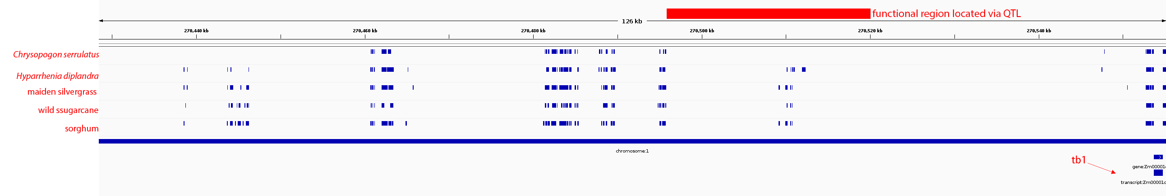
Supplemental Fig S7. Location of the CNSs identified upstream of maize tb1 (Zm00001d033673) gene. The red box indicates the estimated location of a variants that impacted the function of potential cis-regulator ∼58.7–69.5 kbp upstream of the gene (Clark et al. 2006; Studer et al. 2011).

Supplemental_Fig_S8.pdf

Supplemental Fig S8. Expression level distribution of genes with or without a pan-And-CNS detected within the 2 kbp upstream region. (A) Maximum gene expression level across 23 tissues. (B) Median gene expression level across 23 tissues. (C) Tissue specificity of gene expression measured using τ. τ value of 0 indicates a housekeeping gene, 1 indicates a tissue-specific gene. (D) Tissue specificity of gene expression measured using entropy. Lower entropy values indicate stronger tissue specificity.

Supplemental_Fig_S9.pdf
Supplemental Fig S9. Distribution of the number of identified CNS records in different genomic regions. introns (blue), 3’ UTR and < 20 kbp downstream of the nearest gene (red), 5’UTR and < 20 kbp upstream of the nearest gene (green), and > 20 kbp from the nearest gene (black). If an identified CNS followed into the 20 kbp flanking region of more than one gene, it was only counted once for the nearest gene.

Supplemental_Fig_S10.pdf
Supplemental Fig S10. Low DNA methylation loci were enriched in intergenic pan-And-CNSs. (A) CG low DNA methylation loci. (B) CHG low DNA methylation loci. The maize B73 DNA methylation data were retrieved from Xu et al. (2020), which uses a 100 bp tile as a DNA methylation locus. A 100 bp tile with an average methylation value < 0.5 was defined as a low DNA methylation locus, otherwise a high DNA methylation locus.

Supplemental_Fig_S11.pdf
Supplemental Fig S11. Enrichment of conserved elements from (Tian et al. 2020) identified in the intergenic regions of the maize genome with H3K9ac ChIP-seq peaks, open chromatin regions, and TFBSs. The total size of these conserved elements located in the intergenic regions is 16.77 Mb.

Supplemental_Fig_S12.pdf

Supplemental Fig S12. (A) Proportion of intergenic pan-And-CNSs overlapping with feature of putative cis-regulatory sequences and chromatin loop anchors. (B) From all the 79, 051 pairs of chromatin loop anchors, 77, 952 (986%) have at least one anchor overlapped with pan-And-CNS for ≥ 1 bp.

Supplemental_Fig_S13.pdf
Supplemental Fig S13. Enrichment of intergenic pan-And-CNSs in different TE superfamilies. DHH: Helitrons superfamily; DTA: hAT superfamily; DTC: CACTA superfamily; DTH: Harbinger superfamily; DTM: Mutator superfamily; DTT: Mariner superfamily: DTX: unclassified superfamily; RIL: L1 superfamily; RIT: RTE superfamily; RLC: Copia superfamily; RLG: Gypsy superfamily; RLX: unknown superfamily; RST: tRNA superfamily.

Supplemental_Fig_S14.pdf

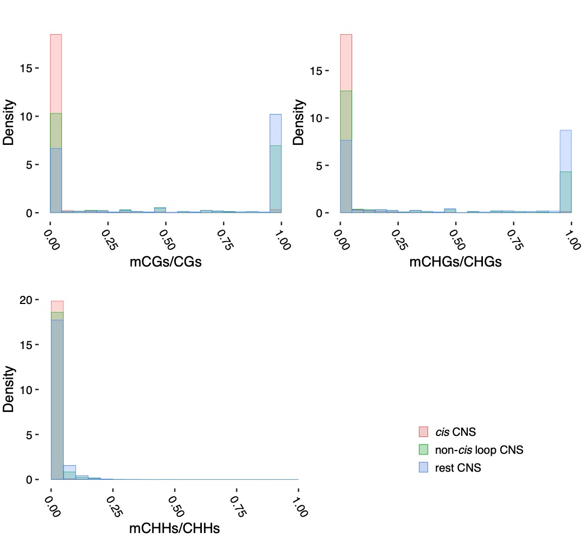
Supplemental Fig S14. DNA methylation ratio divided non-cis loop pan-And-CNSs and rest pan-And-CNSs into two distinct groups. Different DNA methylation ratios were observed for cis pan-And-CNSs (red), non-cis loop pan-And-CNSs (green), and the rest pan-And-CNSs (blue).

Supplemental_Fig_S15.pdf
Supplemental Fig S15. Enrichment of intergenic pan-And-CNSs in active regions of DNA replication in the middle (A) or late (B) S phase of the mitotic cell cycle. Those active regions of DNA replication that did not overlap with coding genes or CNSs were used as background (intergenic).

Supplemental_Fig_S16.pdf
Supplemental Fig S16. Proportion of core-And-CNSs overlapping with annotated features. Each core-And-CNS fragment can overlap with several annotated features, thus the sum of all the proportions can be greater than 1. Unknown CNSs are those CNSs that do not overlap with any used sequences.

Supplemental_Fig_S17.pdf

Supplemental Fig S17. (A) Density plots corresponding to alignment scores generated by the Smith-Waterman dynamic programming approach (illustrated in the step 4 of Fig. 1 in the main text) for pan-And-CNSs overlapping with different annotated features. (B) Density plots corresponding to CNS length (number of base-pairs) for pan-And-CNSs overlapping with different identified features.

Supplemental_Fig_S18.pdf
Supplemental Fig S18. Comparison of the proportion of maintained intergenic CNSs in the upstream regions (0-2, 2-4, and 4-6 kbp) of the top 1,500 expressed genes in each maize accession (analysis was conducted for multiple tissues separately). If a CNS is located in multiple ranges (for example, in both 0-2 and 2-4 kbp ranges), it was only counted in the range closer to the downstream gene (0-2 kbp). Dashed lines indicate the 99% one-tailed confidence interval calculated by shuffling the gene expression ranks and CNS proportions 1,000 times. Dots beyond the confidence interval are indicated by red color. Root: roots of germinating seedlings; Shoot: shoots of germinating seedlings. LMAN: adult leaves collected at night. LMAD: adult leaves collected during the day; L3base: basal part from the third leaf; L3tip: tip of the third leaf; Kern: kernels at 350-growing-degree days.

Supplemental_Fig_S19.pdf
Supplemental Fig S19. Reads mapping coverage ratio of putative functional ‘absence’ and ‘presence’ CNS alleles. For those CNS PAVs significantly associated with gene expression, we further classified all the CNSs alleles of the maize population into functional ‘absence’ and ‘presence’ alleles according to the target gene expression and compared their reads mapping coverage (Methods). The analysis was performed using the gene expression profiles of different tissues separately. (A) Roots of germinating seedlings. (B) Shoots of germinating seedlings. (C) Adult leaves collected at night. (D) Adult leaves collected during the day. (E) Tip of leaf three. (F) Base of leaf three. (G) Kernels at 350-growing-degree days. There were some CNS alleles in the ’presence’ group with low reads mapping coverage and on other side there were some CNSs in the ’absence’ group with high reads mapping coverage. It might due to the CNS loss-of-function could result from insertions or small numbers of single-nucleotide substitutions or deletions. Or those gene expressions being regulated by multiple regulatory elements with natural variation.

Supplemental_Fig_S20.pdf
Supplemental Fig S20 Distribution of distances between CNS PAVs and their associated genes in different maize tissues. The blue dashed lines indicate a distance of 2.5 Mbp. (A) 4,923 CNS PAVs significantly associated with at least one gene expression variant in roots. (B) 5,477 CNS PAVs significantly associated with at least one gene expression variant in shoots. (C) 5,378 CNS PAVs significantly associated with at least one gene expression variant in adult leaves collected at night. (D) 4,797 CNS PAVs significantly associated with at least one gene expression variant from adult leaves collected under daylight. (E) 4,504 CNS PAVs significantly associated with at least one gene expression variant in top part from the third leaf. (F) 5,477 CNS PAVs significantly associated with at least one gene expression variant in basal part from the third leaf. (G) 4,552 CNS PAVs significantly associated with at least one gene expression variant in kernels at 350-growing-degree-day.

Supplemental_Fig_S21.pdf

Supplemental Fig S21. Negative enrichment of CNS in selected regions during domestication and local adaptation.

Supplemental_Fig_S22.pdf

Supplemental Fig S22. A cartoon illustrating the proportion of CNS shared by a pair of maize paralogous genes. Syntenic genes between the maize genome and the sorghum genome were identified. Orthogroups containing two maize genes and one sorghum gene were selected for this analysis.

Supplemental_Fig_S23.pdf
Supplemental Fig S23. Correlation between CNS similarity and gene expression similarity between paralogous genes from the two subgenomes of maize. (A) The horizontal axis is the proportion of shared CNSs within the 2 kbp upstream regions, 2 kbp downstream regions, intron regions, and all (sum) of these three regions. The vertical axis is the expression similarity between pairs of homologous genes from the two subgenomes of maize measured using Pearson’s correlation (r). (B) Regression results of the correlation between CNS similarity and expression similarity.

Supplemental_Fig_S24.pdf

Supplemental Fig S24. CNS variation is associated with functional diversity between maize subgenomes. For those orthogroups (including two maize syntenic genes and one sorghum systenic gene) with their two maize genes having negative expression level correlation across 23 tissues of maize B73, we calculated sequence similarity between the major copy (the copy with longer CNS) and sorghum sequence, and sequence similarity between the minor copy (the copy with shorter CNS) and sorghum sequence separately. The sequence similarity was calculated as the number of alignment identical base-pairs/amino acid residues to the sorghum sequence length. (A) DNA sequence similarity (B) Protein sequence similarity. (C) We used the ratio of DNA sequence similarity to protein sequence similarity to compare the nonsynonymous variants to synonymous variants ratio. And the result suggested there was stronger purifying selection acting on nonsynonymous variants of the major copy.
Supplemental_Fig_S25.pdf

Supplemental Fig S25. Correlation between the total amount of sequencing data (x-axis) and the number of CNSs with > 40% of total length covered by reads (y-axis) for each maize accession. Those maize accessions used by Karl et al. (2019) were used here and the second-generation sequencing reads were published by HapMap3 (Bukowski et al. 2018). A minimum of 14 Gbp of reads (black solid line) for one accession was required to include this accession in further analyses.

Supplemental_Table_S1.docx

Supplemental Table S1 Genome sequences and annotations used in this study

species | URL
maize (Zea mays) | ftp://ftp.ensemblgenomes.org/pub/plants/release-34/fasta/zea_mays/dna/Zea_mays.AGPv4.dna.toplevel.fa.gz  ftp://ftp.ensemblgenomes.org/pub/plants/release-34/gff3/zea_mays/Zea_mays.AGPv4.34.gff3.gz
sorghum (Sorghum bicolor) | ftp://ftp.ensemblgenomes.org/pub/plants/release-42/fasta/sorghum_bicolor/dna/Sorghum_bicolor.Sorghum_bicolor_NCBIv3.dna.toplevel.fa.gz  ftp://ftp.ensemblgenomes.org/pub/plants/release-42/gff3/sorghum_bicolor/Sorghum_bicolor.Sorghum_bicolor_NCBIv3.42.gff3.gz
wild sugarcane (Saccharum spontaneum L.) | https://www.life.illinois.edu/ming/downloads/Spontaneum_genome/Sspon.HiC_chr_asm.fasta  https://www.life.illinois.edu/ming/downloads/Spontaneum_genome/Sspon.v20190103.gff3.gz
maiden silvergrass (Miscanthus sinensis) | https://genomevolution.org/coge/GenomeInfo.pl?gid=58021  assembly version V7.0, annotation version V7.1
foxtail millet (Setaria italica) | ftp://ftp.ensemblgenomes.org/pub/plants/release-42/fasta/setaria_italica/dna/Setaria_italica.Setaria_italica_v2.0.dna.toplevel.fa.gz  ftp://ftp.ensemblgenomes.org/pub/plants/release-42/gff3/setaria_italica/Setaria_italica.Setaria_italica_v2.0.42.gff3.gz

Supplemental_Table_S2.docx

Supplemental Table S2 Overlap of features of putative regulatory sequences with pan-And-CNSs

Chromatin feature | Tissue | Number of records | Number of records overlapping with pan-And-CNSs | Reference
TFBS | leaf | 144890 | 88213 (61%) | (Tu et al. 2020)
Open chromatin | leaf | 35675 | 27457 (77%) | (Tu et al. 2020)
Open chromatin | leaf | 32111 | 24693 (77%) | (Ricci et al. 2019)
Open chromatin | ear | 27075 | 20870 (77%) | (Ricci et al. 2019)
H3K9ac deposition sites | stem | 28004 | 22608 (78%) | (Oka et al. 2017)
H3K9ac deposition sites | husk leaf | 17170 | 12842 (74%) | (Oka et al. 2017)
MNase HS regions | shoot | 245373 | 150774 (61%) | (Rodgers-Melnick et al. 2016)
MNase HS regions | root | 138749 | 79136 (57%) | (Rodgers-Melnick et al. 2016)
DHSs | root | 37404 | 27203 (73%) | (Zhao et al. 2018)
DHSs | leaf | 36254 | 18954 (52%) | (Zhao et al. 2018)

Oka, Rurika, Johan Zicola, Blaise Weber, Sarah N. Anderson, Charlie Hodgman, Jonathan I. Gent, Jan-Jaap Wesselink, et al. 2017. “Genome-Wide Mapping of Transcriptional Enhancer Candidates Using DNA and Chromatin Features in Maize.” Genome Biology 18 (1): 137.
Ricci, William A., Zefu Lu, Lexiang Ji, Alexandre P. Marand, Christina L. Ethridge, Nathalie G. Murphy, Jaclyn M. Noshay, et al. 2019. “Widespread Long-Range Cis-Regulatory Elements in the Maize Genome.” Nature Plants 5 (12): 1237–49.
Rodgers-Melnick, Eli, Daniel L. Vera, Hank W. Bass, and Edward S. Buckler. 2016. “Open Chromatin Reveals the Functional Maize Genome.” Proceedings of the National Academy of Sciences of the United States of America 113 (22): E3177-84.
Tu, Xiaoyu, María Katherine Mejía-Guerra, Jose A. Valdes Franco, David Tzeng, Po-Yu Chu, Wei Shen, Yingying Wei, et al. 2020. “Reconstructing the Maize Leaf Regulatory Network Using ChIP-Seq Data of 104 Transcription Factors.” Nature Communications 11 (1): 5089.
Zhao, Hainan, Wenli Zhang, Lifen Chen, Lei Wang, Alexandre P. Marand, Yufeng Wu, and Jiming Jiang. 2018. “Proliferation of Regulatory DNA Elements Derived from Transposable Elements in the Maize Genome.” Plant Physiology 176 (4): 2789–2803.

Supplemental_Table_S3.docx

Supplemental Table S3 Maize accessions used in eGWAS using CNS PAV as independent variables

38-11Goodman-Buckler
4226
4722
A239
A441-5
A619
A632
A634
A635
A641
A654
A679
A680
A682
B103
B109
B37
B57
B64
B76
B79
B84
C103
C123
CH9
CI187-2
CI3A
CI64
CI66
CM105
CM7
CML108
CML14
CML158Q
CML228
CML247
CML254
CML277
CML281
CML311
CML314
CML328
CML331
CML333
CML38
CML45
CML52
CML69
CML77
CML91
CO106
CO125
CO255
D940Y
DE1
F6
GA209
H105W
H49
H91
H95
HP301
i1677a
I29
Ia5125
IDS69
IDS91
Il14H
ILLHy
K4
Ki11
Ki21
Ki43
Ky21
KY228
L578
M14
M162W
MEF156-55-2
Mo17
Mo47
MS1334
Mt42
N192
NC222
NC230
NC258
NC260
NC262
NC264
NC296
NC302
NC306
NC310
NC314
NC326
NC328
NC336
NC338
NC33
NC340
NC346
NC348
NC350
NC352
NC354
NC356
NC362
NC364
Oh40B
Oh43E
OH7B
Os420
Pa91
R177
SC357
SD40
Sg1533
Sg18
T234
T8
Tx303
Tzi10
Tzi16
Tzi18
Tzi25
U267Y
VA102
Va26
Va35
Va59
Va99
VaW6
Wf9
B73Htrhm
B97
CM174
CML103
DE-2
F44
KI3
Ms71
N6
Oh43
R109B
W22
W64A
WD

