- Download the data.
- The script “script_donwload_fastq” contains the commands to download all fastq data. (total 960*2 fastq files). The software sratoolkit is required to download the data. In the terminal, the contents of “script_donwload_fastq” will be shown if enter the command “less script_donwload_fastq”. The contents are shown in Figure 1.

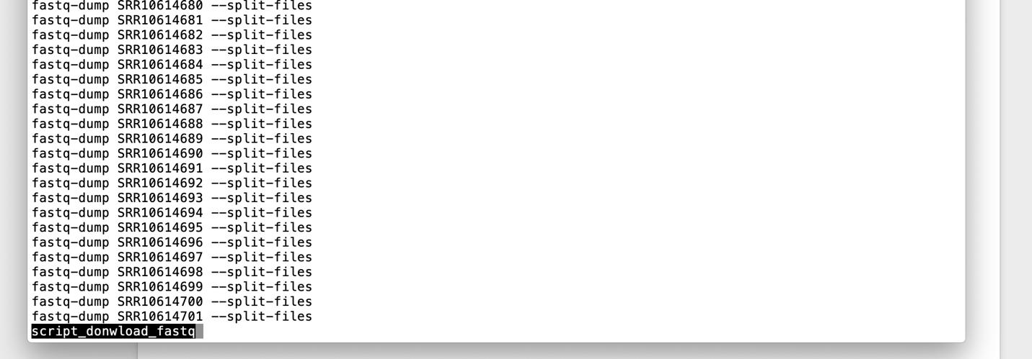
Figure 1. Contents in script_donwload_fastq
- Rename the downloaded fastq files.
  - For convention, fastq files downloaded from SRA will be renamed using the scripts “script_rename_H3K4me3_fastq” and “script_rename_H3K27me3_fastq”
  - Enter the command in terminal as shown in Figure 2
  - You can see the contents of script_rename_H3K4me3_fastq as shown in Figure 3

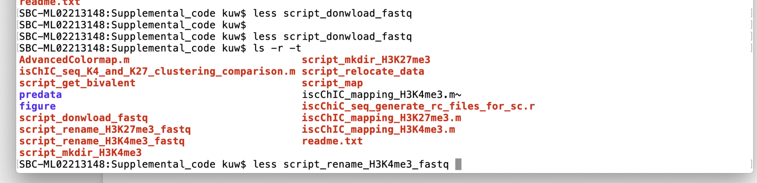
Figure 2 Command for open script_rename_H3K4me3_fastq

- Create directories for processing fastq data and relocate the fastq files
  - You can create the directory by enter the command “sh script_mkdir_H3K4me3” and “sh script_mkdir_H3K27me3”. The contents of script_mkdir_H3K4me3 is shown in Figure 4.
  - Relocate the data by enter the command “sh script_relocate_data”. The contents of script_relocate_data is shown in Figure 5.

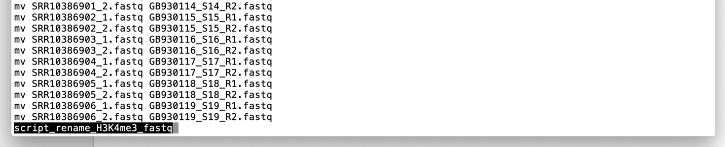
Figure 3. script_rename_H3K4me3_fastq

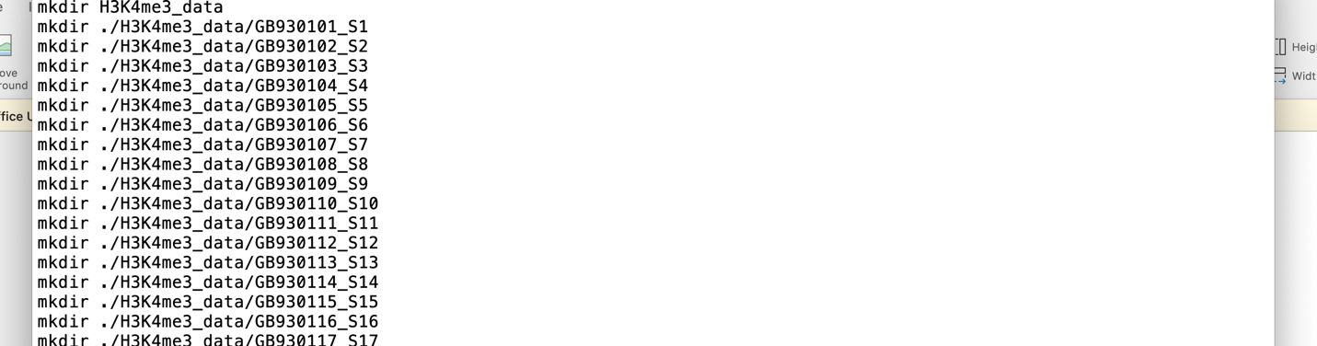
Figure 4 The contents of script_mkdir_H3K4me3

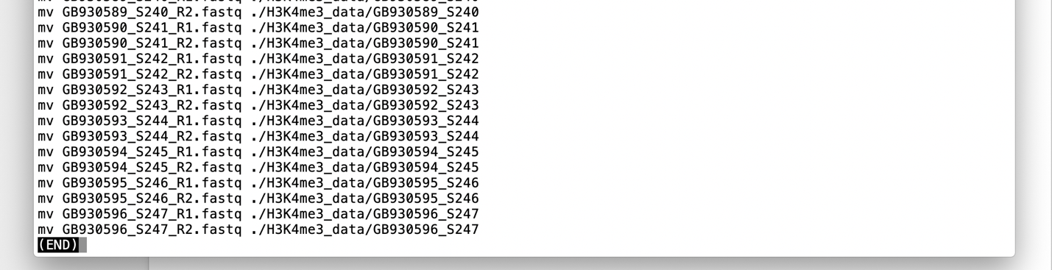
Figure 5. The contents of script_relocate_data

- Mapping fastq files to genome
  - Require Bowtie2 and Samtools
  - You can enter the command “sh script_map” to do the mapping. The contents are shown in Figure 6 and Figure 7.

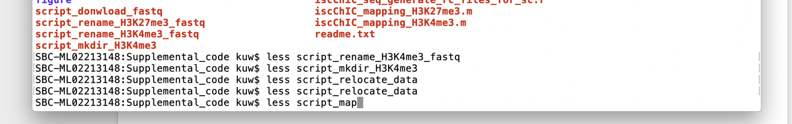
Figure 6. The command to open script_map

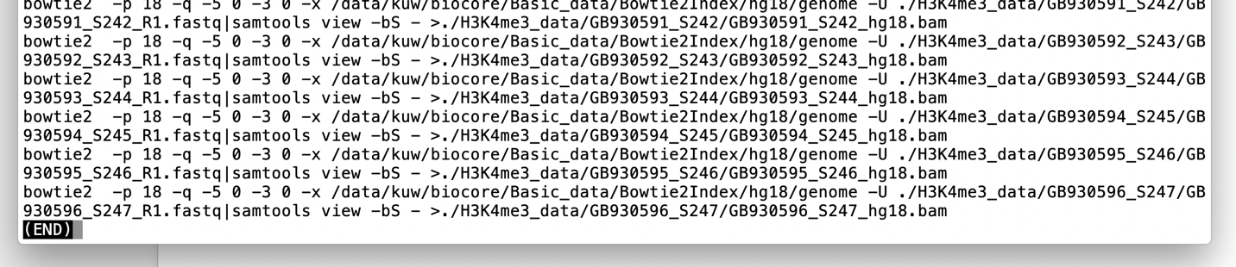
Figure 7. The content of scrip_map

- Generate the file of bivalent domains
  - Require Bedtools
  - You can enter the command “sh script_generate_get_bivalent” to get the file of bivalent comains. The contents are shown in Figure 8 and Figure 9.

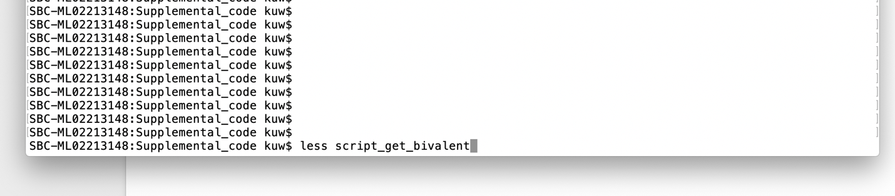
Figure 8. The command to open script_get_bivalent

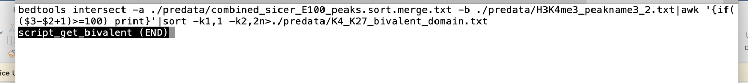
Figure 9. The contents of script_get_bivalent

