Supplemental Materials for

Profiling single-cell histone modifications using indexing chromatin immunocleavage sequencing

Wai Lim Ku^{1,2}, Lixia Pan^{1,2}, Yaqiang Cao¹, Weiwu Gao¹, Keji Zhao^{1,}*

1. Laboratory of Epigenome Biology, Systems Biology Center, National Heart, Lung and Blood Institute, NIH, Bethesda, MD, USA
2. These authors contributed equally to this work.
*Corresponding author.
Keji Zhao

Email : zhaok@nhlbi.nih.gov

Phone: 301-496-2098
Fax : 301-402-0971

Supplemental Table

Table S1. A comparison between iscChIC-seq and other methods.

Table S2. The information of the primer sequences.

Table S3. The mapping statistics of the libraries of iscChIC-seq libraries.

Table S4. The information of data sets used in this study.

Table S5. A summary for the quality test of the single cell H3K4me3 and H3K27me3 data.

Supplemental Figure

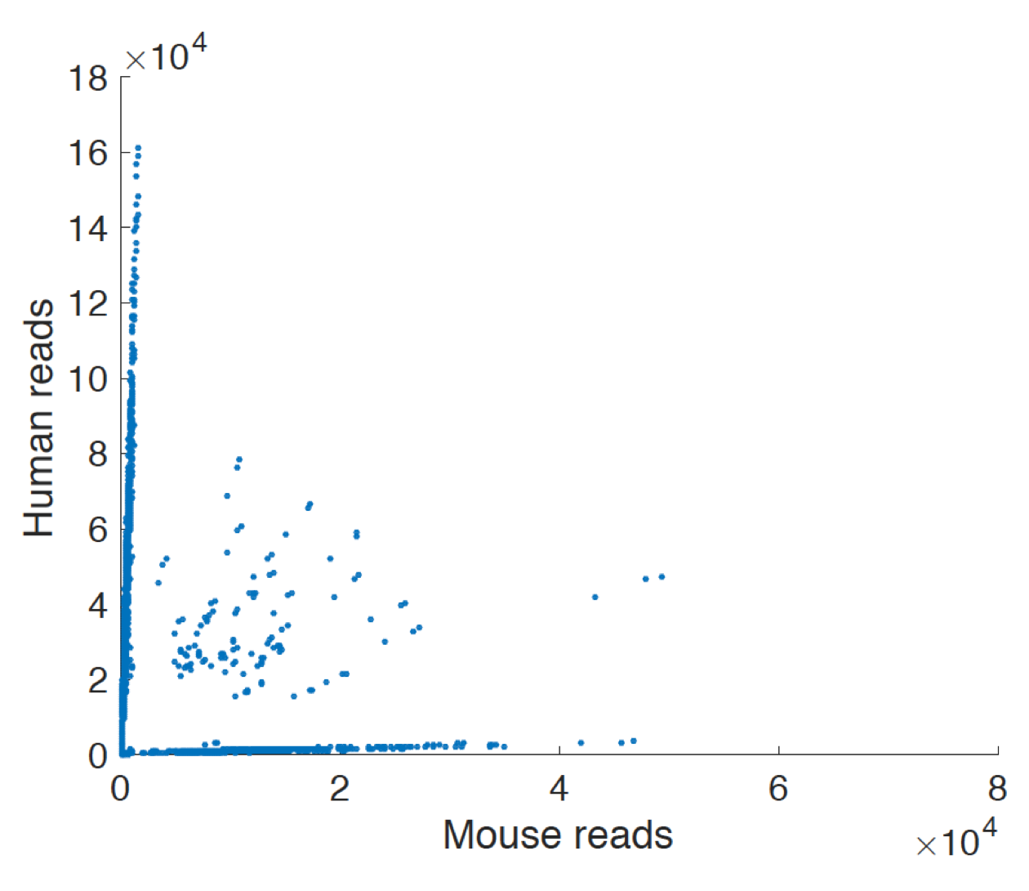
Fig. S1. Human (293T) and Mouse (3T3) cell mixing experiment. 439 mouse 3T3 cells, 2,371 human 293T cells, and 149 human and mouse doublets were identified. The collision rate is about 10%

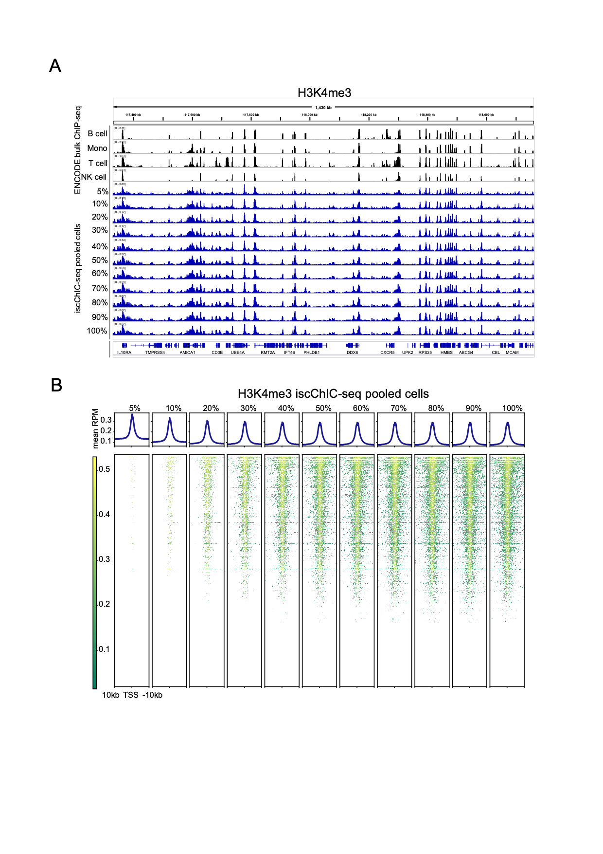
Fig. S2. Pooled H3K4me3 iscChIC-seq profiles for series of cell percentages. A) A genome browser snapshot showing tracks of aggregated H3K4me3 iscChIC-seq signals from different percentages of cells. The genomic region is same to that of Fig 2A. Cells were sorted by descending number of unique reads per cell. B) TSS profile plots and heatmaps showing aggregated iscChIC-seq signals around TSS from different percentages of cells. The plots were generated by deeptools (Ramirez et al. 2016).

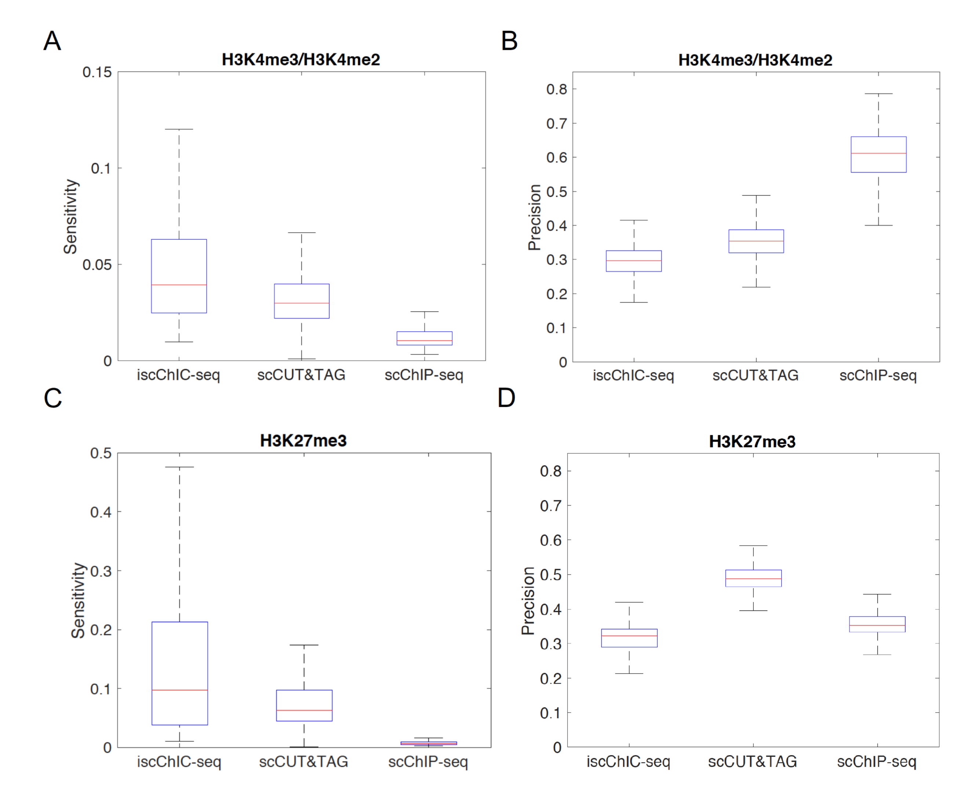
Fig. S3. A) A boxplot showing the sensitivity of histone marks from three methods, including H3K4me3 marks by iscChIC-seq, H3K4me2 marks by scCUT&Tag(Kaya-Okur et al. 2019), and H3K4me3 marks by scChIP-seq(Grosselin et al. 2019). B) Similar to Supplemental Fig. S3 Abut showing the precision. C) A boxplot showing the sensitivity of H3K27me3 from iscChIC-seq, scCUT&Tag, and scChIP-seq. D) Similar to Supplemental Fig. S3 but showing the precision.

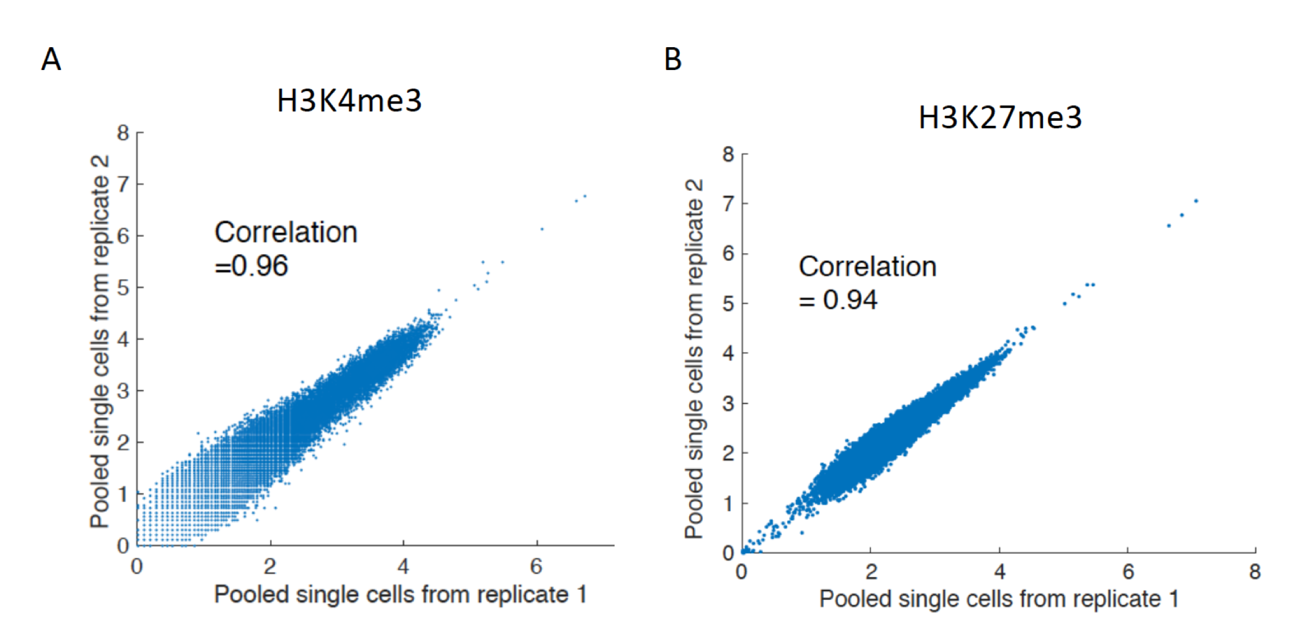

Fig. S4. Scatter plots between the pooled single cells from two replicates for H3K4me3 (left) and H3K27me3 (right) iscChIC-seq datasets.

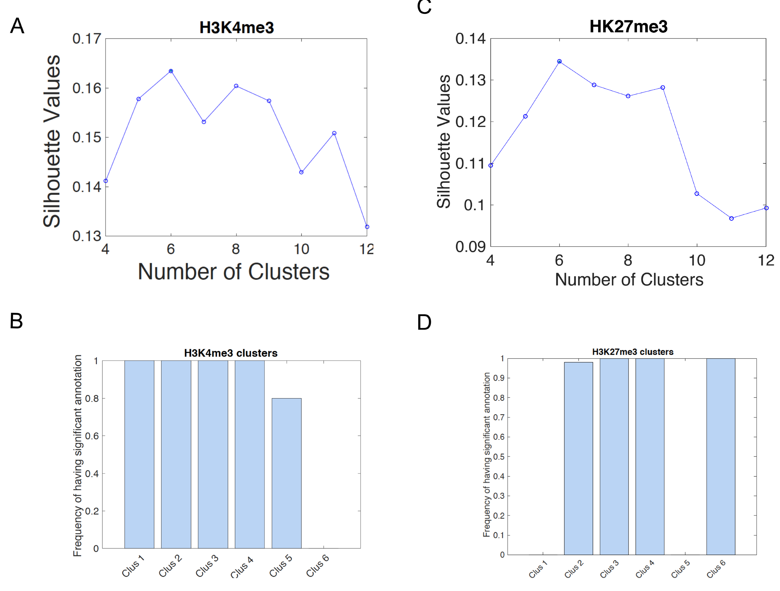
Fig. S5. Clustering analysis using the single cell H3K4me3 and H3K27me3 data. Clustering analysis using the single cell H3K4me3 and H3K27me3 data. A) The clustering method was applied to the single cell H3K4me3 data with varying the number of clusters. In each cluster, its silhouette value was plotted in the y-axis. B) The frequency of having significant annotation of H3K4me3 clusters was plotted. C) The clustering method was applied to the single cell H3K27me3 data with varying the number of clusters. In each cluster, its silhouette value was plotted in the y-axis. D) The frequency of having significant annotation of H3K27me3 clusters was plotted.

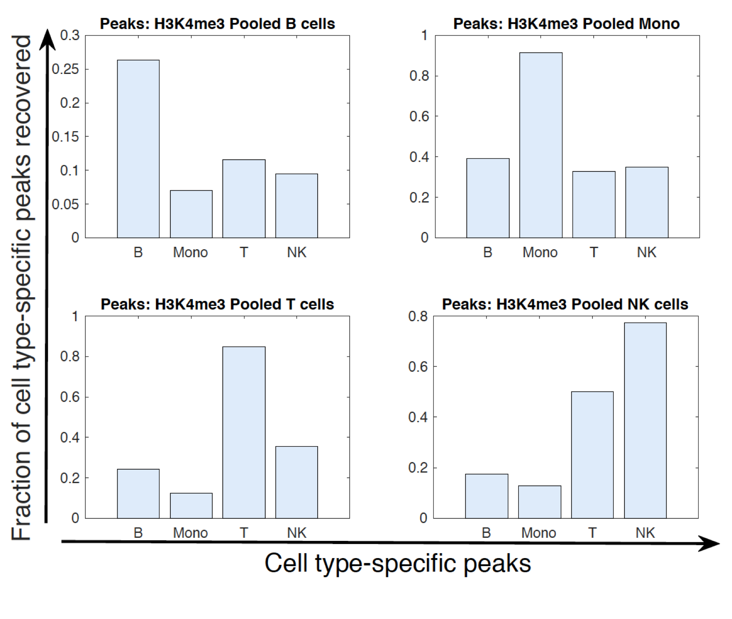
Fig. S6. For each subplot (subplots for top left, top right, bottom left, bottom right are for cluster annotated to B, Mono, T, and NK, respectively), peaks were identified for the H3K4me3 pooled cells from a cluster and compared with the cell type–specific peaks identified from H3K4me3 ENCODE data. The Y-axis is the fraction of the cell type–specific peaks recovered by the peaks identified from pooled single cell data.

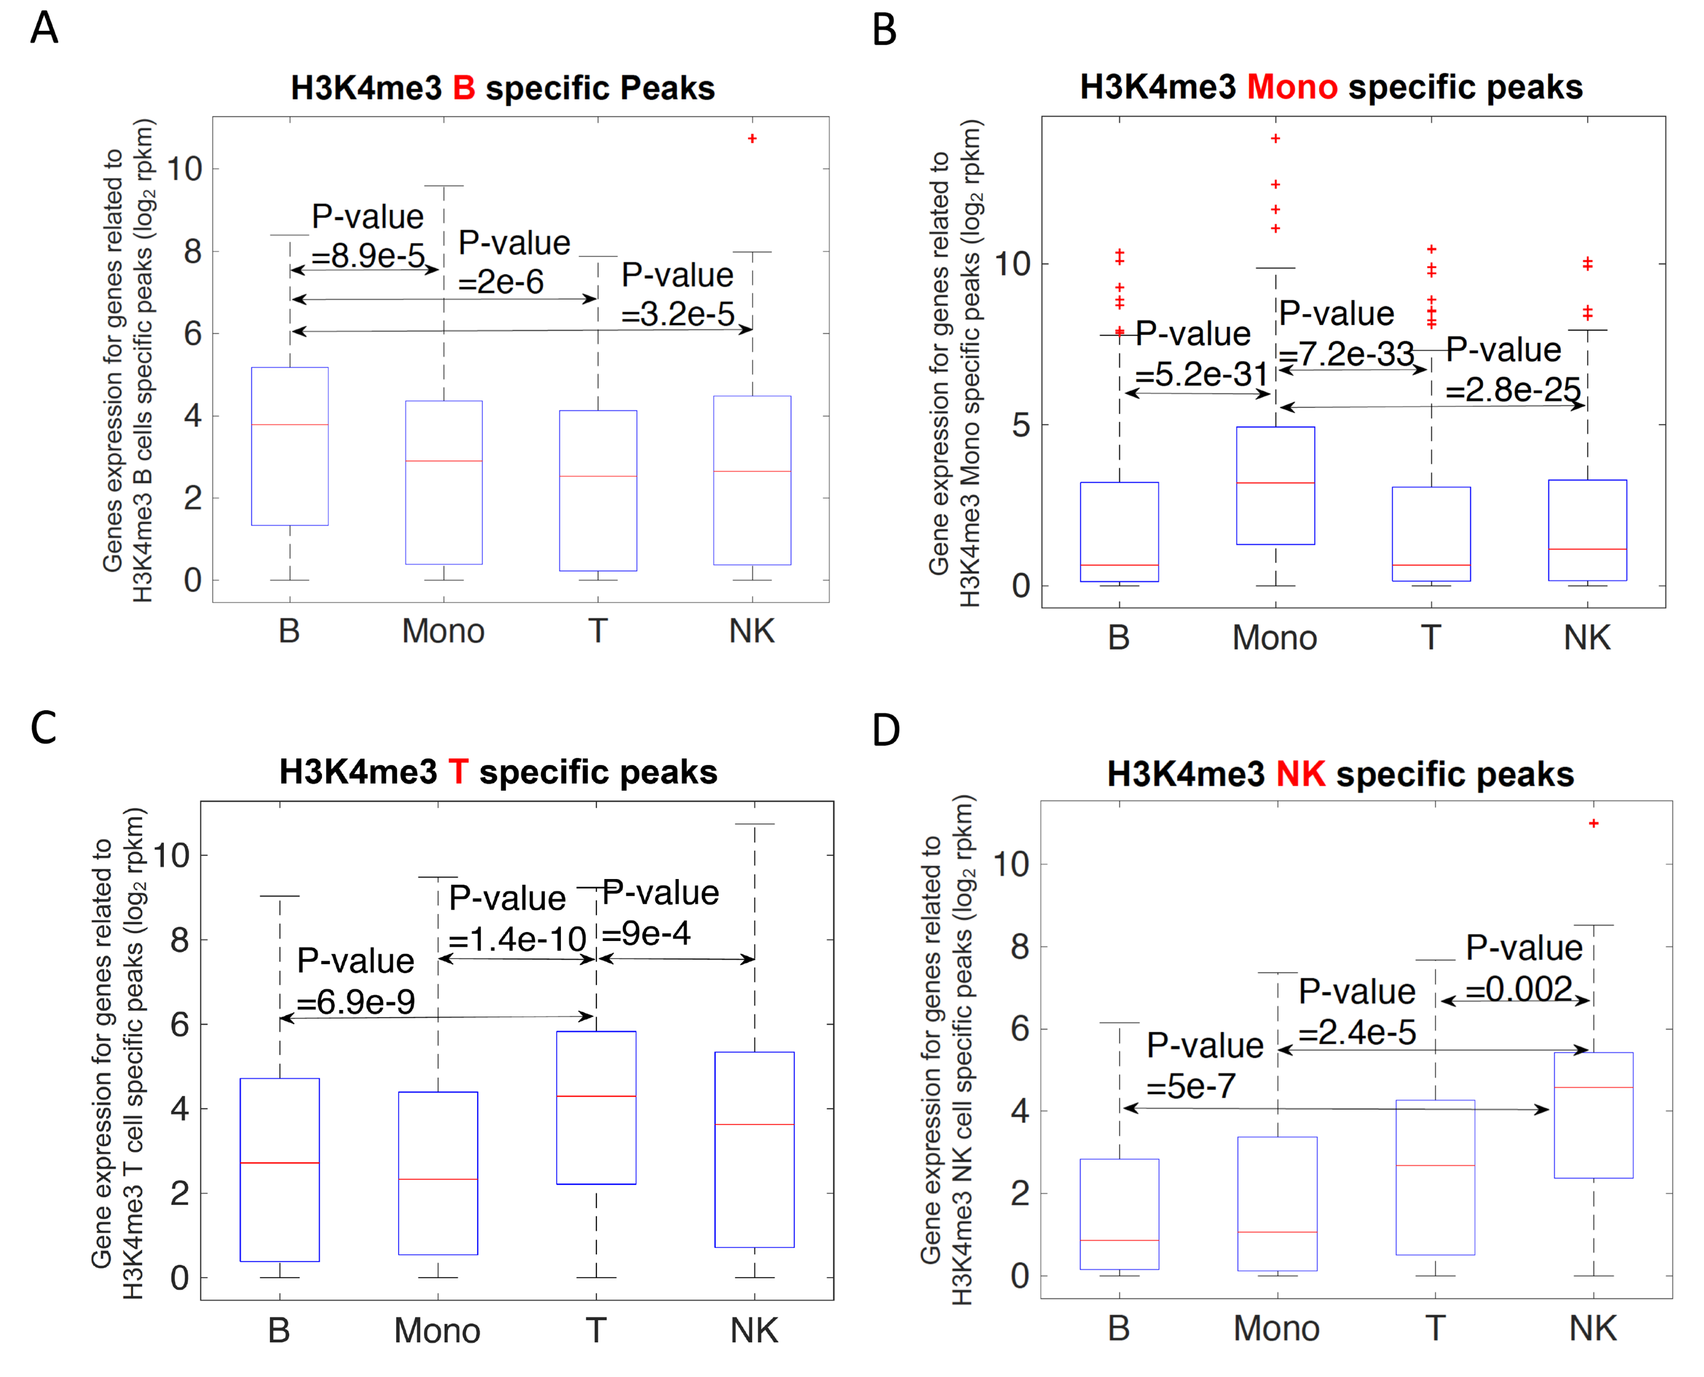
Fig. S7. Comparison of gene expression for genes related to the cell type–specific peaks that were recovered in Supplemental Fig. S6. A) Genes closely related to the recovered H3K4me3 B cell specific peaks by pooled single cells were identified. The gene expression of this set of genes were examined in B, Mono, T, and NK cells. The P-value between the gene expression of different cell types were computed using Wilcoxon’s ranksum test. B) Similar to Supplemental Fig. 7A, but for the recovered H3K4me3 Mono specific peaks. C) Similar to Supplemental Fig. 7A, but for the recovered H3K4me3 T specific peaks. D) Similar to Supplemental Fig. 7A, but for the recovered H3K4me3 NK specific peaks.

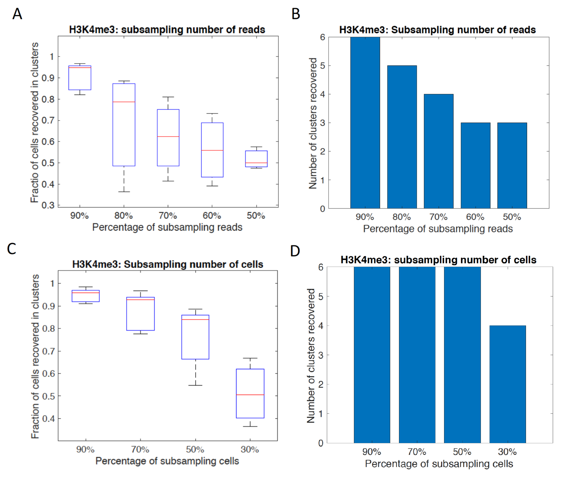
Fig. S8. A) The H3K4me3 data were subsampled using different percentage (90%, 80%, 70%, 60%, and 50%) of reads from the original set of reads for each cell. An original cluster was considered to be successfully recovered if there is only one new cluster that has more than 40% of cells overlapping with that of the original cluster. Among the recovered clusters, the fractions of cells that overlapped between the new cluster and the original cluster were shown in the Y-axis for each subsampling event. B) The numbers of original clusters recovered by the new clusters in each subsampling event were shown. C) The H3K4me3 data were subsampled using different percentage (90%, 70%, 50%, and 30%) of cells from the original set of single cells. The fractions of cells that overlapped between the new cluster and the original cluster were shown in the Y-axis for each subsampling event. D) The numbers of original clusters recovered by the new clusters in each subsampling event were shown for cell subsampling.

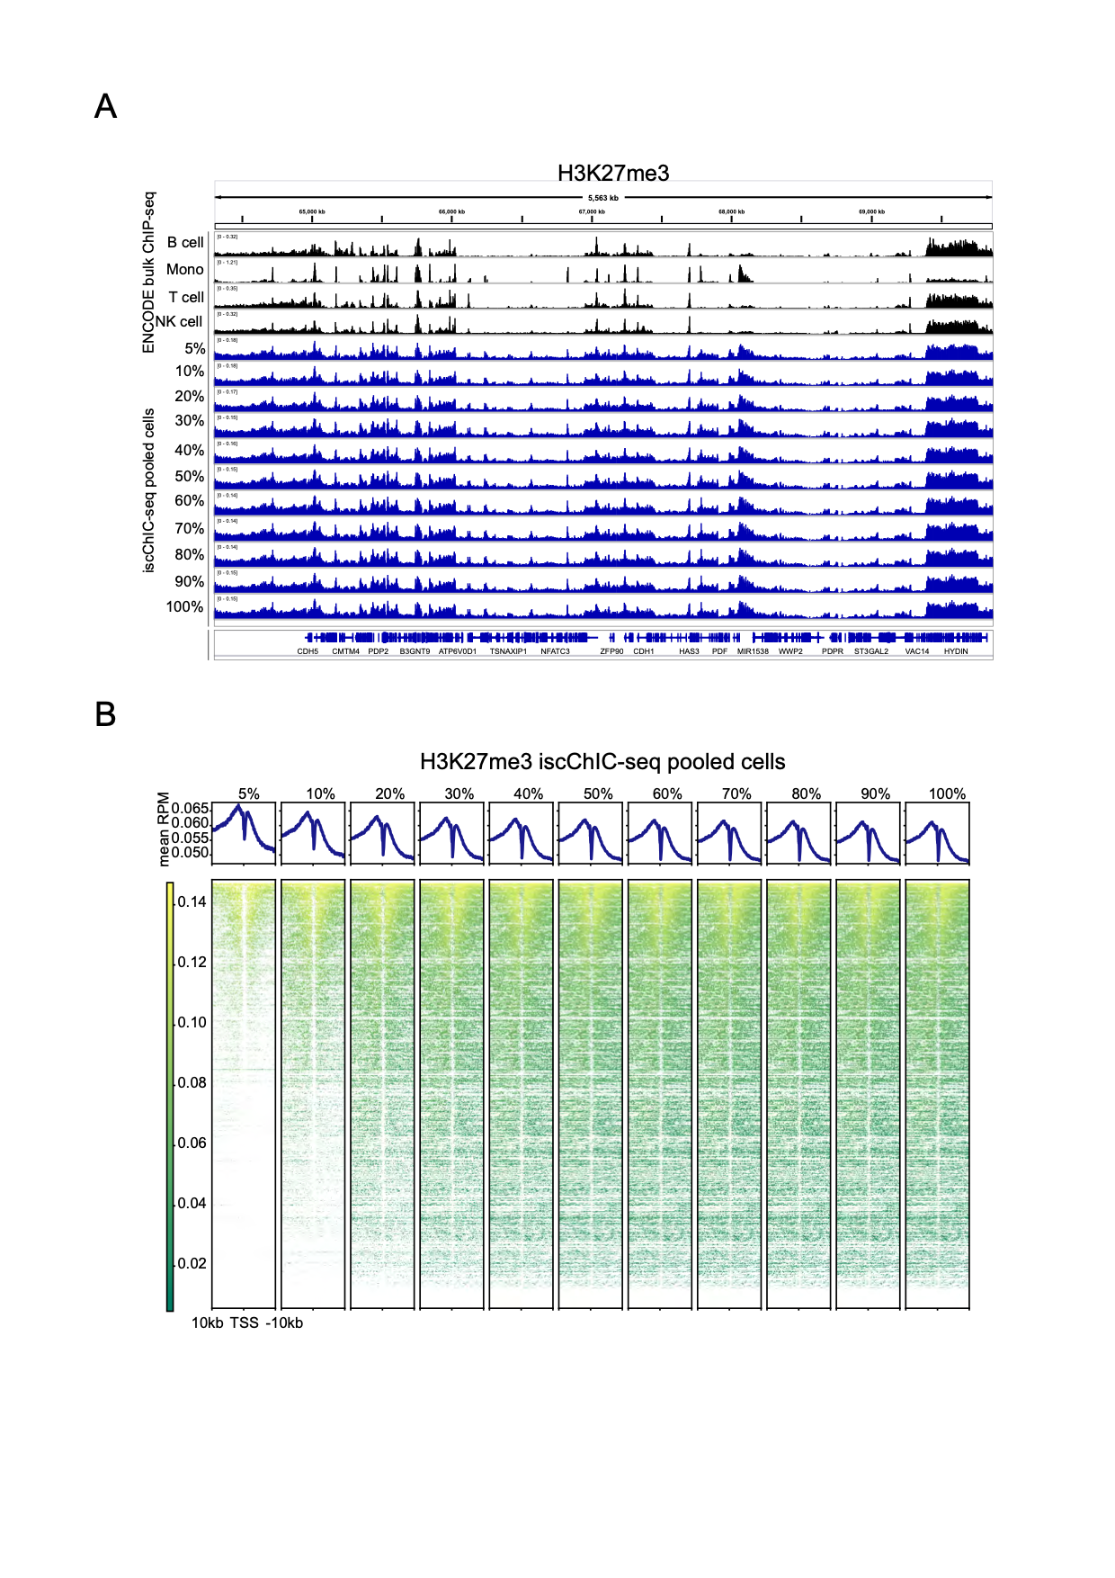
Fig. S9. Pooled H3K27me3 iscChIC-seq profiles for series of cell percentages. A) A genome browser snapshot showing tracks of aggregated H3K27me3 iscChIC-seq signals from different percentages of cells. The genomic region is same to that of Fig. 4A. Cells were sorted by descending number of unique reads per cell. B) TSS profile plots and heatmaps showing aggregated iscChIC-seq signals around TSS from different percentages of cells.

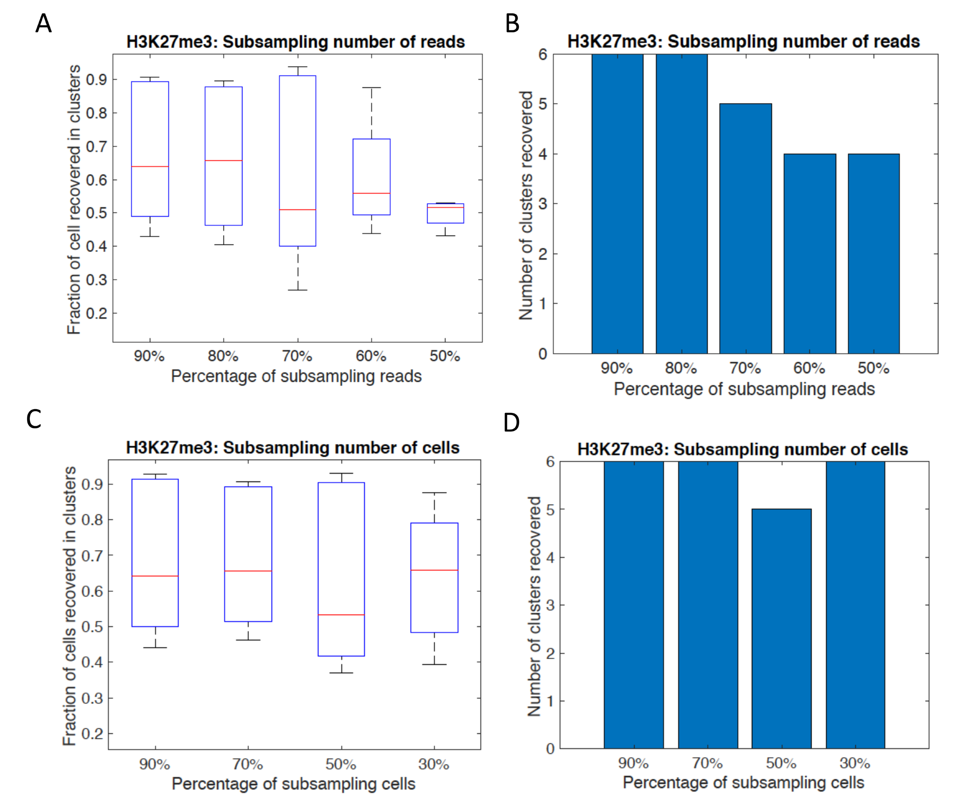
Fig. S10. Subsampling test for H3K27me3 single cell data. The analyses were similarly performed as described in Supplemental Fig. S8 for the H3K4me3 data.

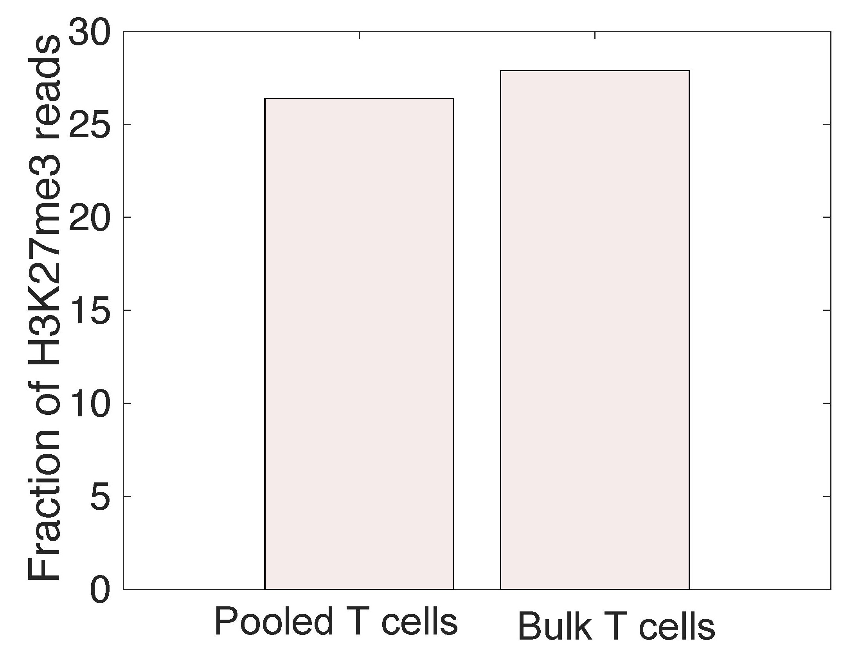

Fig. S11. Fractions of H3K27me3 reads from pooled T single cells and ENCODE bulk cell data, which overlapped with the H3K9me3 peaks detected in T cells.

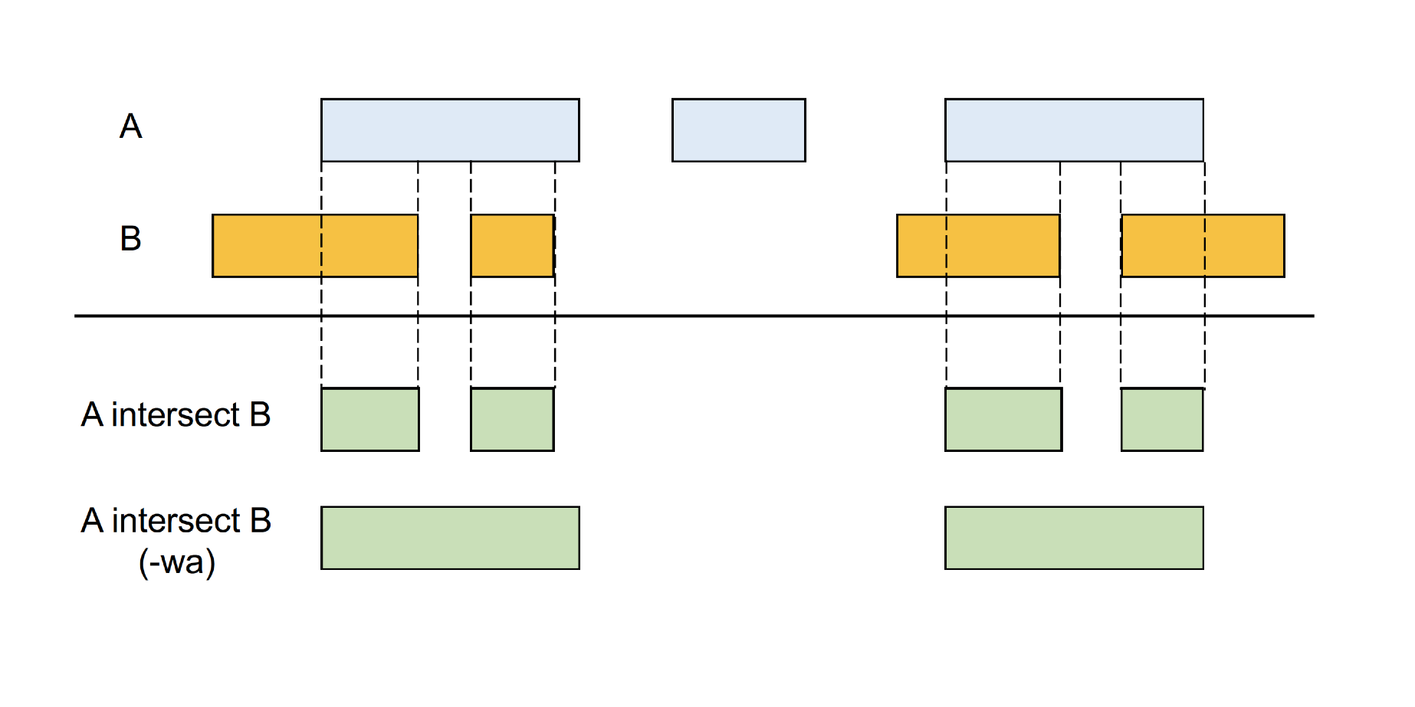
Fig. S12. A figure (Quinlan and Hall 2010) showing the functions of the command “intersect”.

Supplemental References

Ai S, Xiong H, Li CC, Luo Y, Shi Q, Liu Y, Yu X, Li C, He A. 2019. Profiling chromatin states using single-cell itChIP-seq. Nat Cell Biol 21: 1164-1172.
Carter B, Ku WL, Kang JY, Hu G, Perrie J, Tang Q, Zhao K. 2019. Mapping histone modifications in low cell number and single cells using antibody-guided chromatin tagmentation (ACT-seq). Nat Commun 10: 3747.
Grosselin K, Durand A, Marsolier J, Poitou A, Marangoni E, Nemati F, Dahmani A, Lameiras S, Reyal F, Frenoy O et al. 2019. High-throughput single-cell ChIP-seq identifies heterogeneity of chromatin states in breast cancer. Nat Genet 51: 1060-1066.
Hainer SJ, Boskovic A, McCannell KN, Rando OJ, Fazzio TG. 2019. Profiling of Pluripotency Factors in Single Cells and Early Embryos. Cell 177: 1319-1329 e1311.
Kaya-Okur HS, Wu SJ, Codomo CA, Pledger ES, Bryson TD, Henikoff JG, Ahmad K, Henikoff S. 2019. CUT&Tag for efficient epigenomic profiling of small samples and single cells. Nat Commun 10: 1930.
Ku WL, Nakamura K, Gao W, Cui K, Hu G, Tang Q, Ni B, Zhao K. 2019. Single-cell chromatin immunocleavage sequencing (scChIC-seq) to profile histone modification. Nat Methods 16: 323-325.
Ramirez F, Ryan DP, Gruning B, Bhardwaj V, Kilpert F, Richter AS, Heyne S, Dundar F, Manke T. 2016. deepTools2: a next generation web server for deep-sequencing data analysis. Nucleic Acids Research 44: W160-W165.
Rotem A, Ram O, Shoresh N, Sperling RA, Goren A, Weitz DA, Bernstein BE. 2015. Single-cell ChIP-seq reveals cell subpopulations defined by chromatin state. Nat Biotechnol 33: 1165-1172.
Quinlan AR, Hall IM. 2010. BEDTools: a flexible suite of utilities for comparing genomic features. Bioinformatics 26: 841-842.
Wang Q, Xiong H, Ai S, Yu X, Liu Y, Zhang J, He A. 2019. CoBATCH for High-Throughput Single-Cell Epigenomic Profiling. Mol Cell 76: 206-216 e207.

