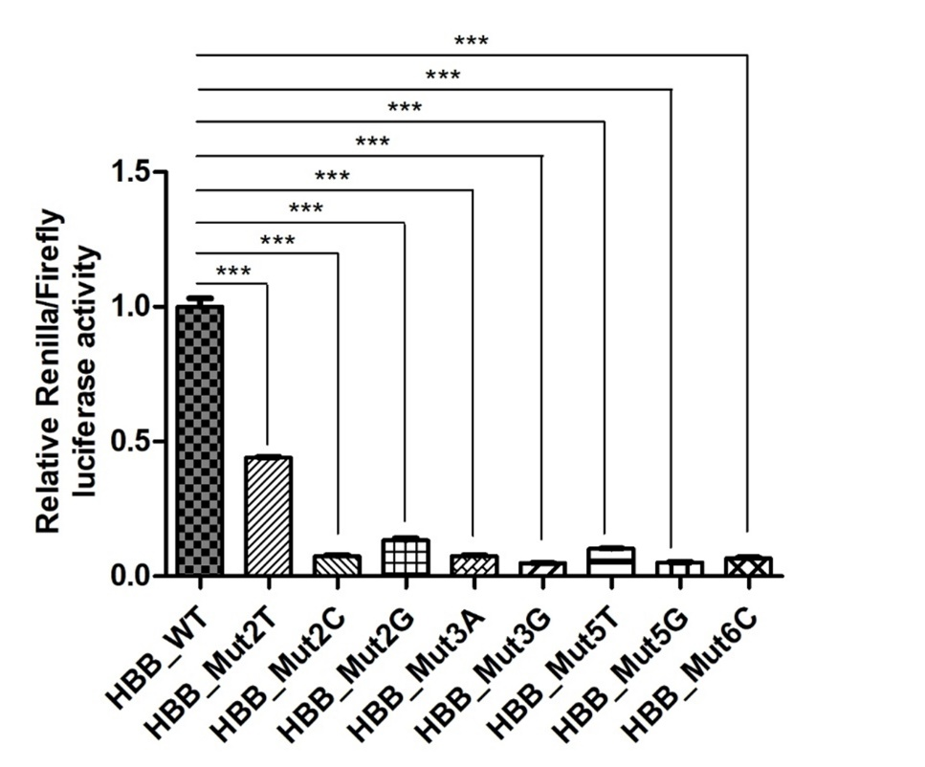
Supplemental Fig S9: Comparison of normalized Renilla luciferase activity in 293T cells transfected with mpCHECK2 of WT or different variants inside PAS of HBB. The numbers and capital letters represent the mutated position of the PAS and the bases after mutation, respectively. ***, P value < 0.001, one-way ANOVA test.

