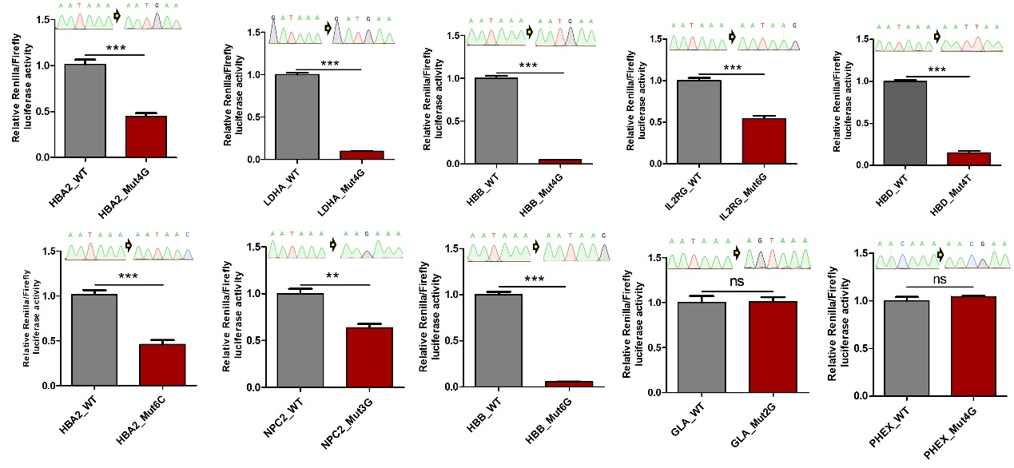
Supplemental Fig S7: Comparison of normalized Renilla luciferase activity in 293T cells transfected with mpCHECK2 of WT or database-annotated pathogenic PAS variants. The numbers and capital letters represent the mutated position of PAS and the bases after mutation, respectively. Each mutation was confirmed by Sanger sequencing, as shown on the top of each bar plot. ***, ** and ns denote P value < 0.001, 0.01 and not significant, respectively (one-way ANOVA test, nonparametric).

