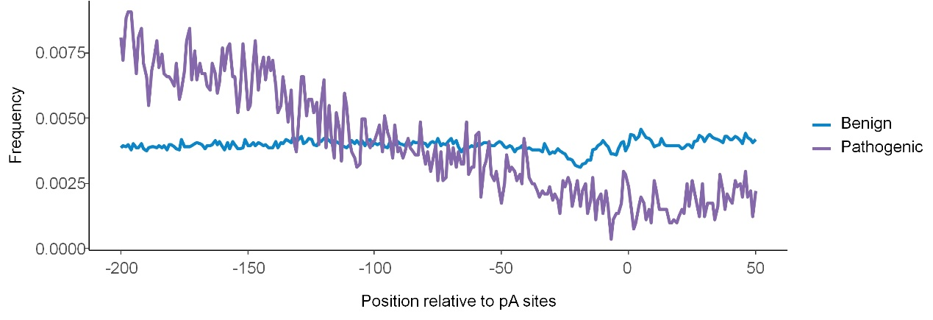
Supplemental Fig S6: Relative distribution frequency of either pathogenic (Patho) or benign variants around the poly A site. Position 0 on the X axis is the poly A site. A negative number denotes upstream distance (nt) from the polyA site.

