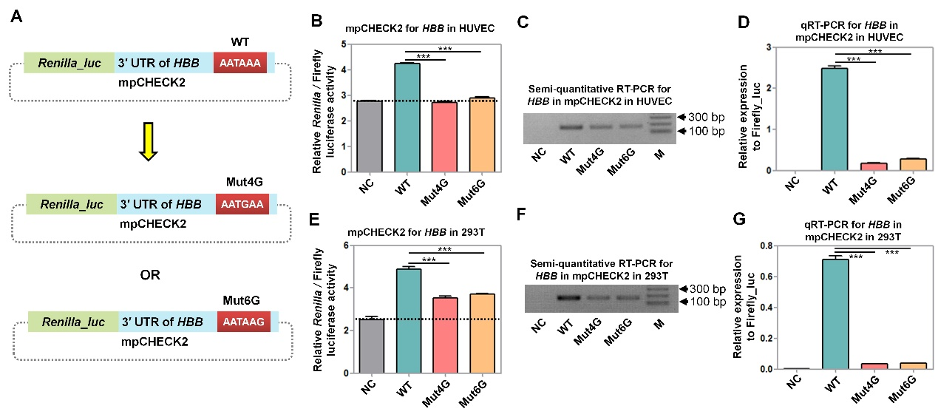
Supplemental Fig S5: Evaluation of different disease-associated variants in the PAS of the HBB gene using the mpCHECK2 vector based on both luciferase activity and RT-PCR in HUVEC and 293T cells. (a) The schematic diagram showing that the 4th and 6th position of the PAS in HBB were both changed from T (labeled WT) to G (labeled Mut4G and Mut6G) in the mpCHECK2 vector. (b) Comparison of normalized Renilla luciferase activity using the mpCHECK2 vector in HUVEC cells with NC, WT, Mut4G, and Mut6G [panel (a)]. Dashed line indicates the basal luciferase signal of NC. (c)-(d) Comparison of mRNA expression levels of NC, WT, Mut4G, and Mut6G that were transfected into HUVEC cells using both semi-quantitative PCR (c) and qRT-PCR (d). (e) Comparison of normalized Renilla luciferase activity using mpCHECK2 vector in 293T cells with NC, WT, Mut4G, and Mut6G. Dashed line indicates the basal luciferase signal of NC. (f)-(g) Comparison of mRNA expression levels among NC, WT, Mut4G, and Mut6G that were transfected into 293T cells using both semi-quantitative PCR (f) and qRT-PCR (g). All luciferase activity assays were performed with four replicates and all qRT-PCR reactions were carried out with three replicates. Data presents as the mean ± SEM. ***, P < 0.001; **, P < 0.01; ns, not significant; one-way ANOVA test.

