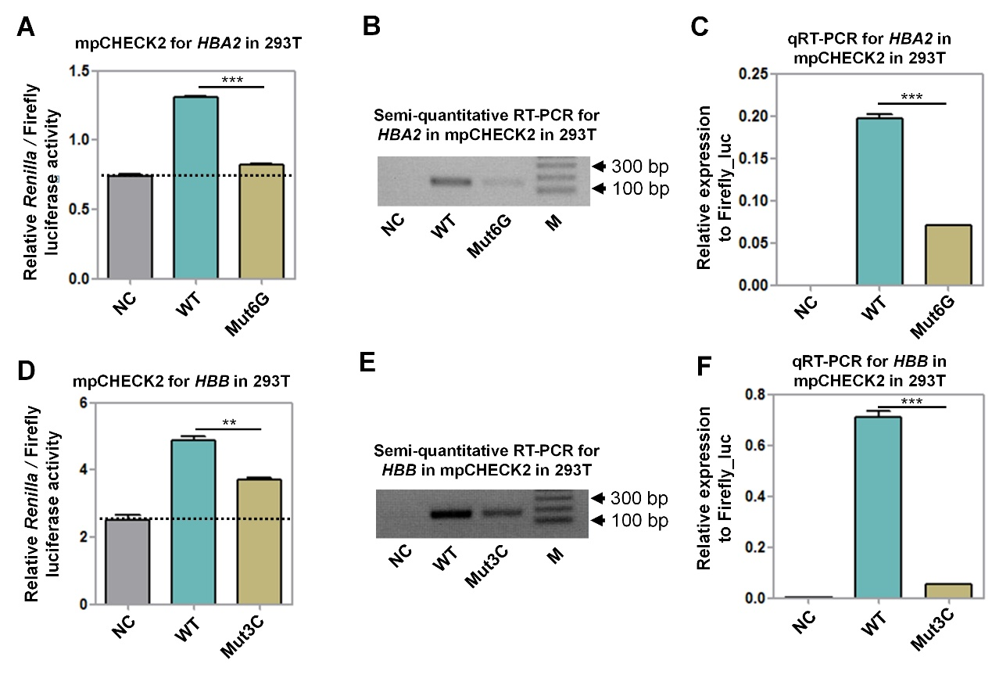
Supplemental Fig S4: Evaluation of disease-associated variants in the PAS of HBA2 and HBB genes using the mpCHECK2 vector based on both luciferase activity and RT-PCR. (a) Comparison of normalized Renilla luciferase activity using mpCHECK2 vector in 293T cells with NC, WT, and Mut6G (see Fig. 5a). Dashed line indicates the basal luciferase signal of NC. (b)-(c) Comparison of mRNA expression level among NC, WT, and Mut6G using both semi-quantitative PCR (b) and qRT-PCR (c). (d) Comparison of normalized Renilla luciferase activity using mpCHECK2 vector in 293T cells with NC, WT, and Mut3C (see Fig. 5e). Dashed line indicates the basal luciferase signal of NC. (e)-(f) Comparison of mRNA expression level with NC, WT, and Mut3C using both semi-quantitative PCR (e) and qRT-PCR (f). All luciferase activity assays were performed with four replicates and all qRT-PCR reactions were carried out with three replicates. Data presents as the mean ± SEM. ***, P < 0.001; **, P < 0.01; ns, not significant; one-way ANOVA test.

