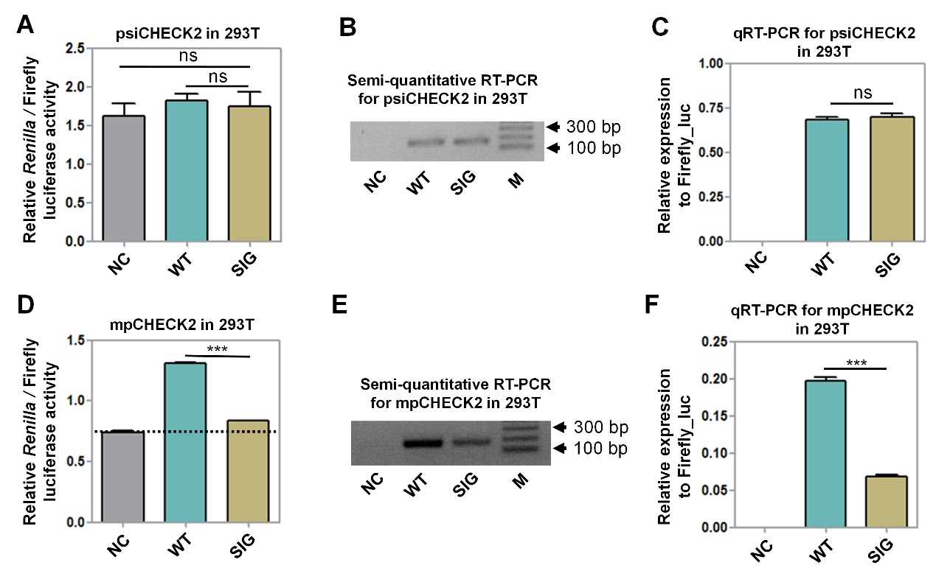
Supplemental Fig S3: The causality of disease-associated variants in the PAS of the HBA2 gene can be reliably validated by the mpCHECK2 vector based on both luciferase activity and RT-PCR. (a) Comparison of Renilla luciferase activity (normalized by firefly) using the psiCHECK2 reporter vector in 293T cells with negative control (NC), tested 3′ UTR with wild-type PAS (insertion of 3′ UTR of HBA2 with WT PAS, labeled WT) and tested 3′ UTR with PAS fully mutated (insertion of 3′ UTR of HBA2 with AATAAA changed to GGATCC, labeled SIG). (b)-(c) Comparison of mRNA expression levels of NC, WT, and SIG using both semi-quantitative PCR (b) and qRT-PCR (c). The qRT-PCR of forward (F) and reverse (R) primer pair design (see the top of Fig. 4b). M denotes molecular markers indicating size (bp) of RT-PCR products. (d) Comparison of normalized Renilla luciferase activity using mpCHECK2 vector (see Fig. 4e) in 293T cells with NC, WT, and SIG. Dashed line indicates the basal luciferase signal of NC. (e)-(f) Comparison of mRNA expression levels among NC, WT, and SIG (based on mpCHECK2) using both semi-quantitative PCR (e) and qRT-PCR (f). All luciferase activity assays were performed with four replicates and all qRT-PCR reactions were carried out with three replicates. Data presents as the mean ± SEM. ***, P < 0.001; **, P < 0.01; ns, not significant; one-way ANOVA test.

