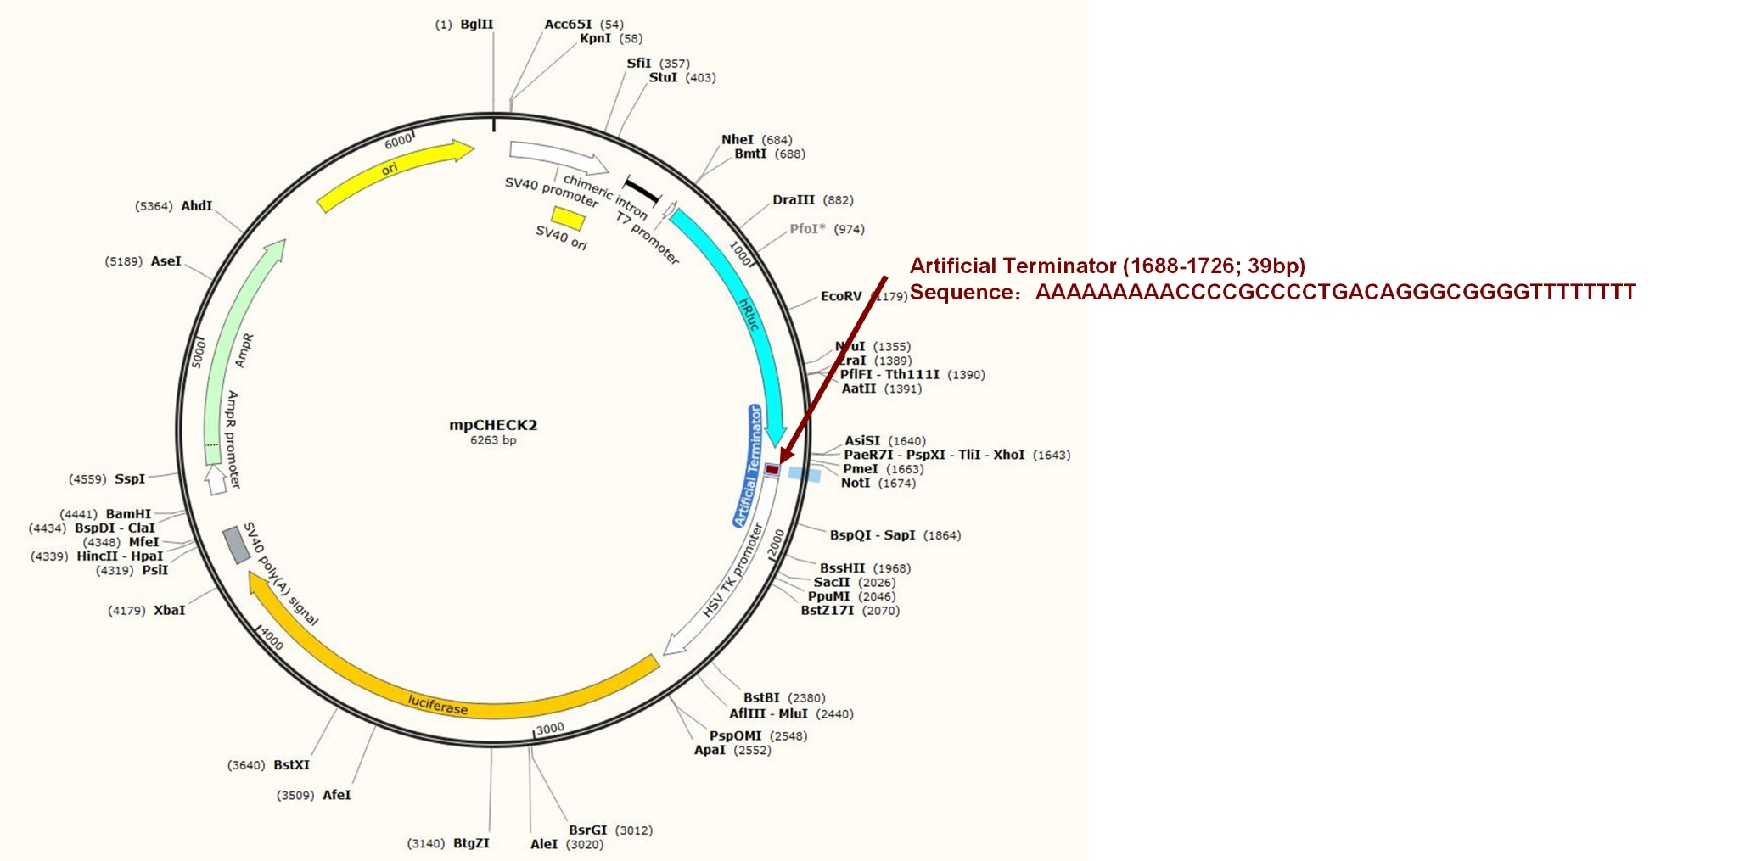
Supplemental Fig S2: The sequence and position of artificial terminator in the mpCHECK2 vector.

