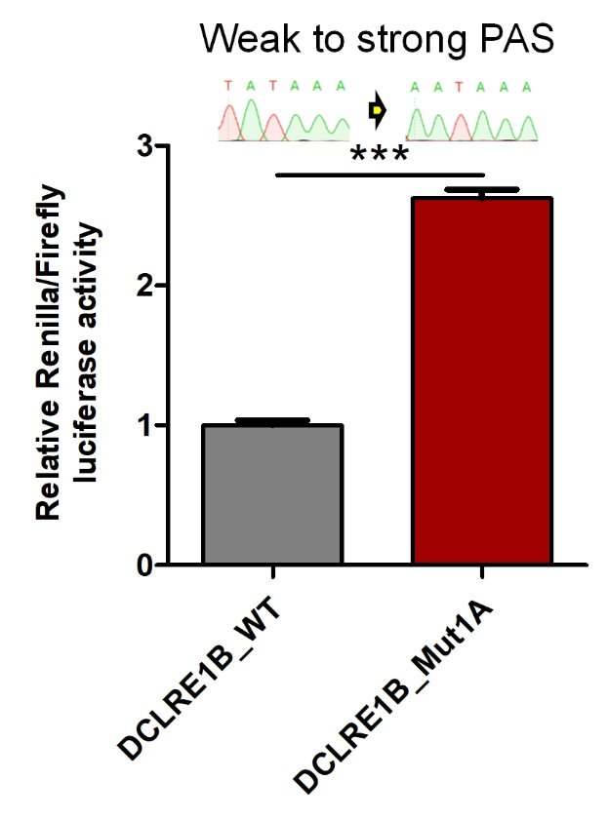
Supplemental Fig S10: Comparison of normalized Renilla luciferase activity in 293T cells transfected with mpCHECK2 of WT or database-annotated benign PAS variants in DCLRE1B. *** denotes P value < 0.001, one-way ANOVA test.

