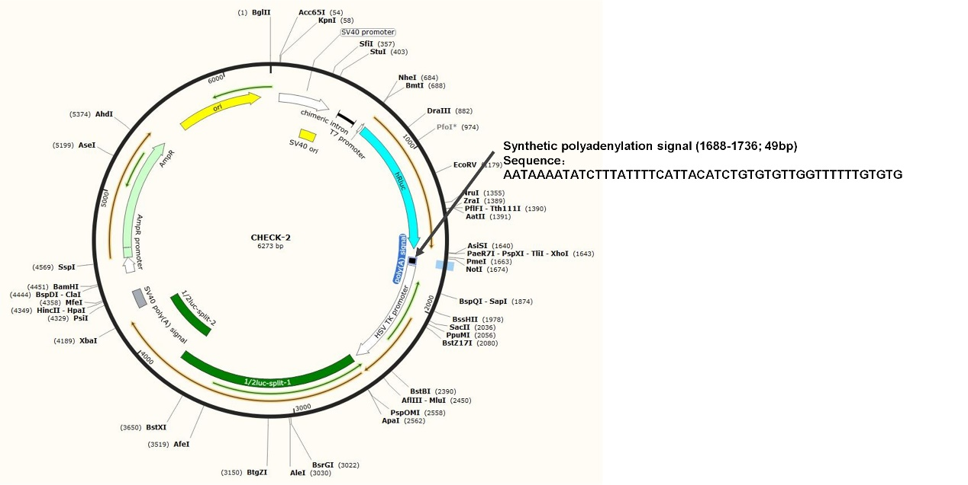
Supplemental Fig S1: The sequence and position of synthetic PAS in the original psiCHECK2 vector.

