Supplemental materials for: Improved redox homeostasis due to the upregulation of one-carbon metabolism and related pathways is crucial for yeast heterosis at high temperature

Supplemental Figures S1 – S8 (pages 2-8)

Supplemental Tables description (page 9)

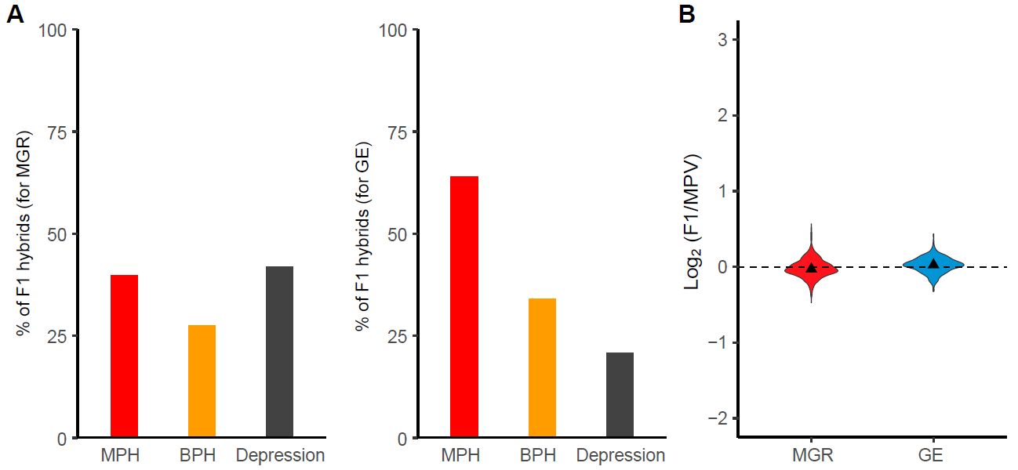

Supplemental Figure S1. Growth performance of F1 hybrids of wild S. cerevisiae strains at 30°C. (A) Proportions of F1 hybrids showing mid-parent heterosis (MPH), better-parent heterosis (BPH) and outbreeding depression. (B) Maximum growth rate (MGR) and growth efficiency (GE) of F1 hybrids relative to the average values of their parents (mid-parent value, MPV).

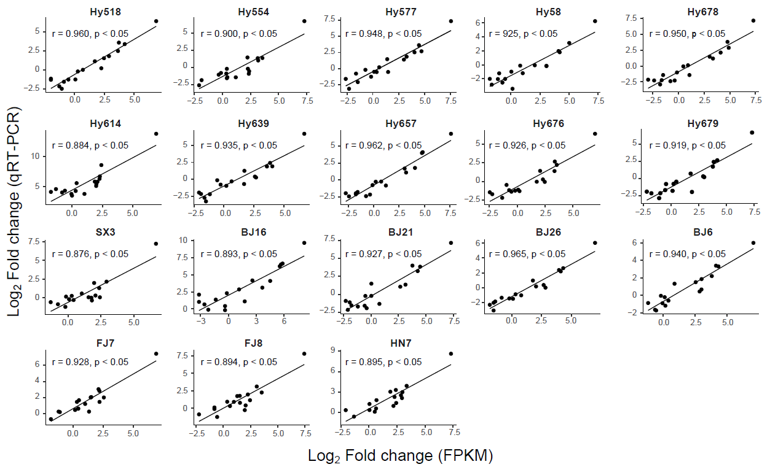

Supplemental Figure S2. Correlations between expression values of 17 actively expressed genes in each of ten selected F1 hybrids and eight parental S. cerevisiae strains determined by RNA-seq and qRT-PCR analyses.

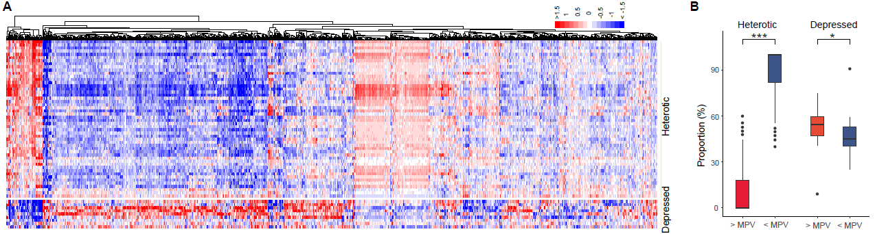

Supplemental Figure S3. Expression level variations of non-additive genes in heterotic and depressed F1 hybrids of wild S. cerevisiae at 40°C. (A) Heatmap shows the expression levels of non-additive genes in F1 hybrids relative to the average expression levels of the genes in their parents (MPV) according to the scale on the top right, which depicts the values of log₂ (F1/MPV). (B) Proportions of non-additive genes with expression levels higher or lower than MPV in heterotic and depression F1 hybrids. *, P = 0.019; ***, P = 1.9e-14 (Mann–Whitney U test).

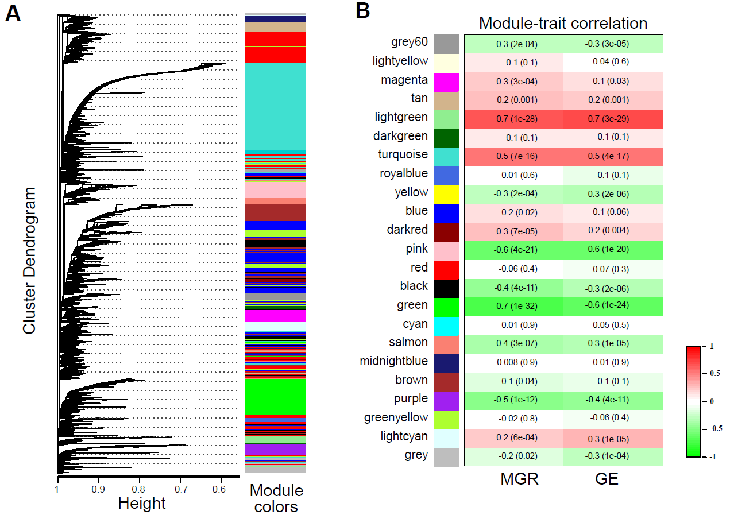

Supplemental Figure S4. Identification of co-expressed and growth fitness correlated non-additive genes in F1 hybrids of wild S. cerevisiae using the weighted gene co-expression network analysis (WGCNA) tool based on the RNA-seq and phenotypic data obtained from the hybrids growing at 40°C. (A) Gene dendrogram generated by average linkage hierarchical clustering. Correlated genes are assigned into separate modules labeled by different colors as shown on the right of the dendrogram. (B) Correlations between the expression level of each module with the maximum growth rate (MGR) and growth efficiency (GE), respectively, of the F1 hybrids tested. The correlation values ranging from 1 (positive) to -1 (negative) are shown on the left side of the brackets in which the significant (P) values of the correlation are given.

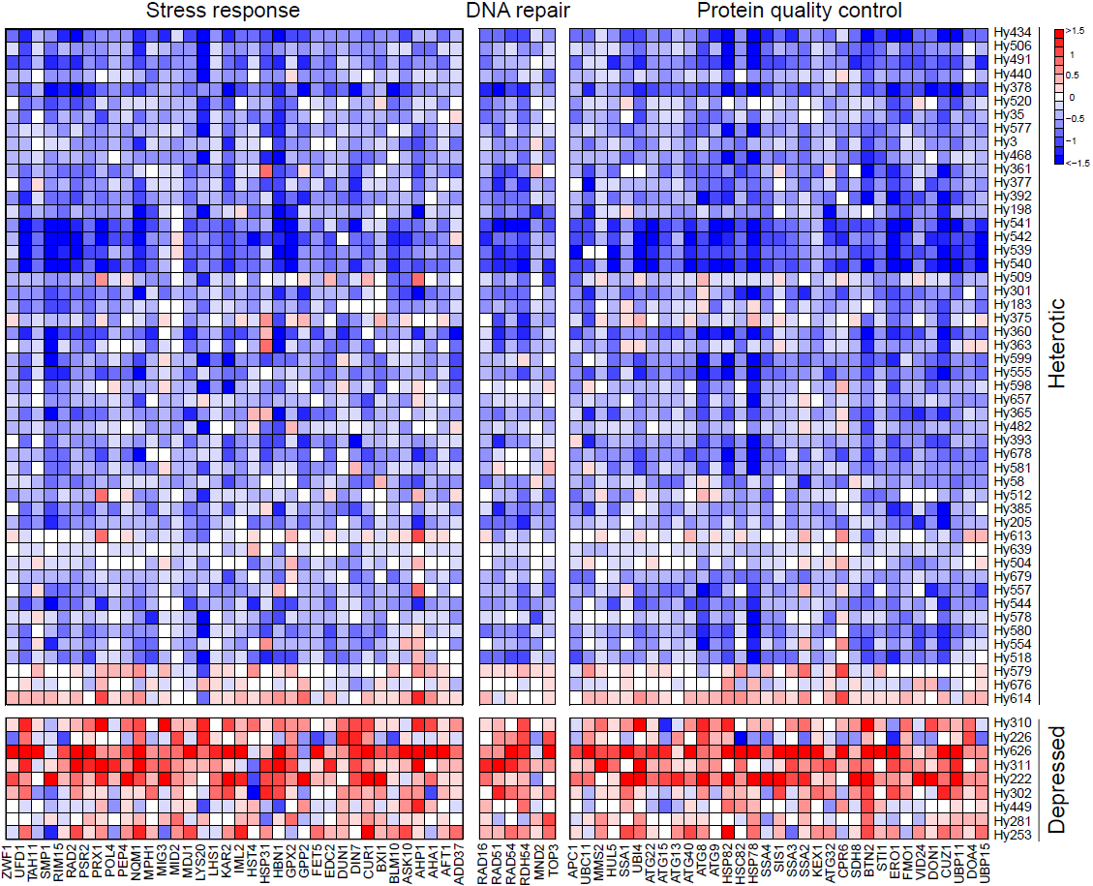

Supplemental Figure S5. Heatmap shows expression levels of key non-additive gene associated with protein quality control, DNA repair and stress response in F1 hybrids of wild S. cerevisiae relative to the average expression levels of the genes in their parents (MPV), according to the scale on the right depicting the values of log₂ (F1/MPV).

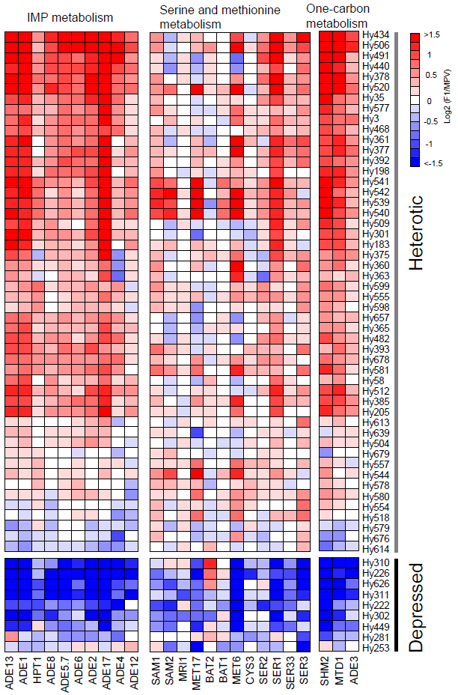

Supplemental Figure S6. Heatmap shows expression levels of key non-additive genes associated with inosine monophosphate (IMP) metabolism, serine and methionine metabolism and one-carbon metabolism in F1 hybrids of wild S. cerevisiae relative to the average expression levels of the genes in their parents (MPV) according to the scale on the right depicting the values of log₂ (F1/MPV).

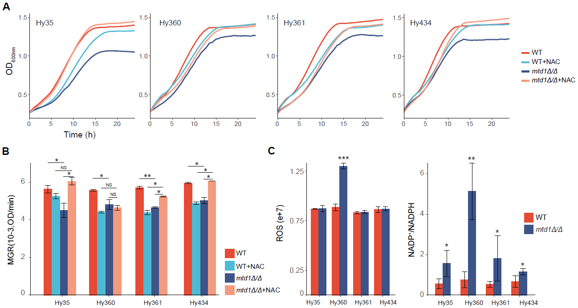

Supplemental Figure S7. Effects of MTD1 gene deletion on the growth and cellular oxidative stress of F1 hybrids of wild S. cerevisiae at 40°C. (A) Growth curves of wild types (WT) and mtd1Δ/Δ mutants of four F1 hybrids without or with 15 mM N-acetyl-L-cysteine (NAC) in the medium. (B) Maximum growth rates (MGR) of wild types and mtd1Δ/Δ mutants of four F1 hybrids without or with 15 mM NAC in the medium. (C) Comparisons of cellular reactive oxygen species (ROS) levels (left) and NADP⁺/NADPH ratios (right) between the wild types and mtd1Δ/Δ mutants of four F1 hybrids. *, P < 0.05; **, P < 0.01; ***, P < 0.001; NS, P > 0.05 (Mann–Whitney U test). The error bars indicate standard deviations (n ≥ 3).

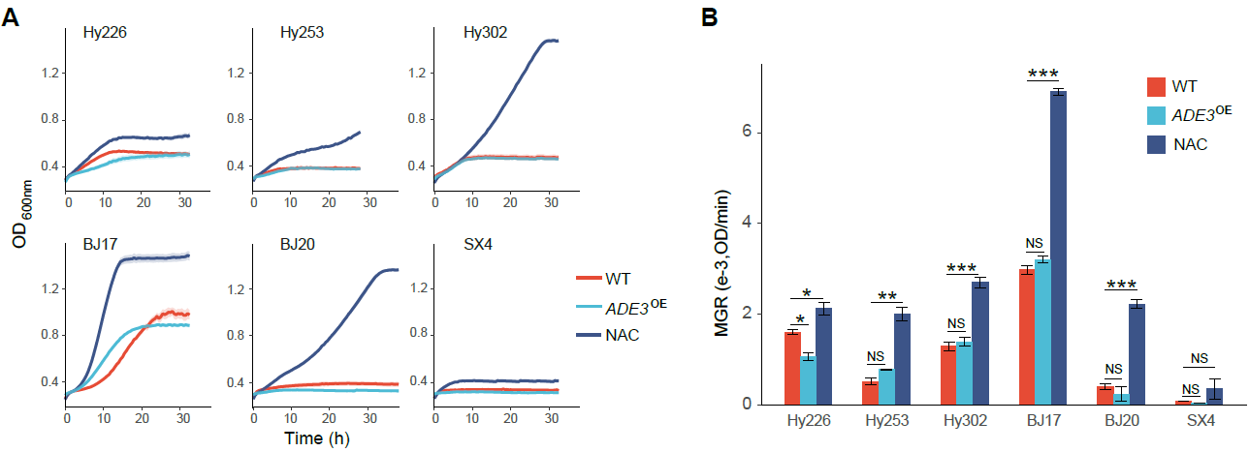

Supplemental Figure S8. Effects of artificial overexpression of ADE3 on the growth of F1 hybrids exhibiting outbreeding depression and their parental S. cerevisiae strains. (A) Growth curves and (B) maximum growth rates of three depressed F1 hybrids and their parents with or without ADE3 overexpression (ADE^{OE}) at 40°C in YPD broth with or without 15 mM N-acetyl-L-cysteine (NAC). *, P < 0.05; **, P < 0.01; ***, P < 0.001; NS, not significant, P > 0.05 (unpaired two-tailed Student’s t-test). The error bars indicate standard deviations (n ≥ 3).

Supplemental Tables description:
Table | Description
Supplemental Table S1 | List of wild S. cerevisiae strains employed and F1 hybrids obtained, genetic distances between parental strains, and growth profiles of the hybrids and the parental strains at 40°C
Supplemental Table S2 | Coefficient of determination (R²) values obtained from different models used in the analyses of the correlation between heterosis and genetic distance in S. cerevisiae and optimal mating distances (OMDs) estimated by the quadratic model.
Supplemental Table S3 | List of strains employed in RNA-seq analysis, their degrees of heterosis and parental genetic distances
Supplemental Table S4 | RNA-seq data obtained
Supplemental Table S5 | Lists of strains, genes and primers used in quantitative real-time PCR analysis and quality of the data obtained
Supplemental Table S6 | List of non-additive genes identified from each of the 59 F1 hybrids of wild S. cerevisiae employed in RNA-seq analysis
Supplemental Table S7 | Co-expressed non-additive genes (NAGs) and the NAGs with expression levels significantly correlated with the maximum growth rates or growth efficiencies of the F1 hybrids at 40°C
Supplemental Table S8 | GO terms significantly overrepresented in the non-additive genes (NAGs) in the F1 hybrids of S. cerevisiae with expression levels lower (sheet a) and higher (sheet b) than the average expression levels (MPV) of the genes in their parents
Supplemental Table S9 | Reactive oxygen species (ROS) levels in F1 hybrids and their parents growing at 40°C

