SUPPLEMENTAL INFORMATION

Table of Contents
Supplemental Fig S1. Tooth root before and after minimally destructive extraction. 4
Supplemental Fig S2. Sample quality with additional comparisons 5
Supplemental Fig S3. Read length distribution. 8
Supplemental Fig S4. C-to-T damage profiles 14
Supplemental Fig S5. C-to-T Damage Rate Comparison 15
Supplemental Fig S6. Example tooth wrapped in parafilm 16
Supplemental Note S1. Detailed Minimally Destructive Extraction Protocol – manual processing 17
Supplemental References 22

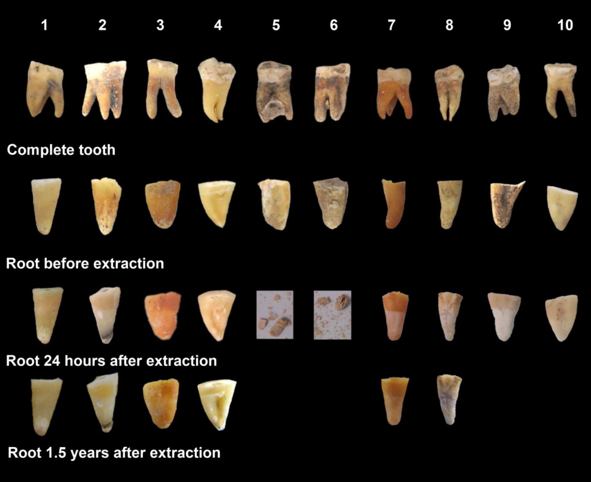

Supplemental Figure S1. Tooth root before and after minimally destructive extraction

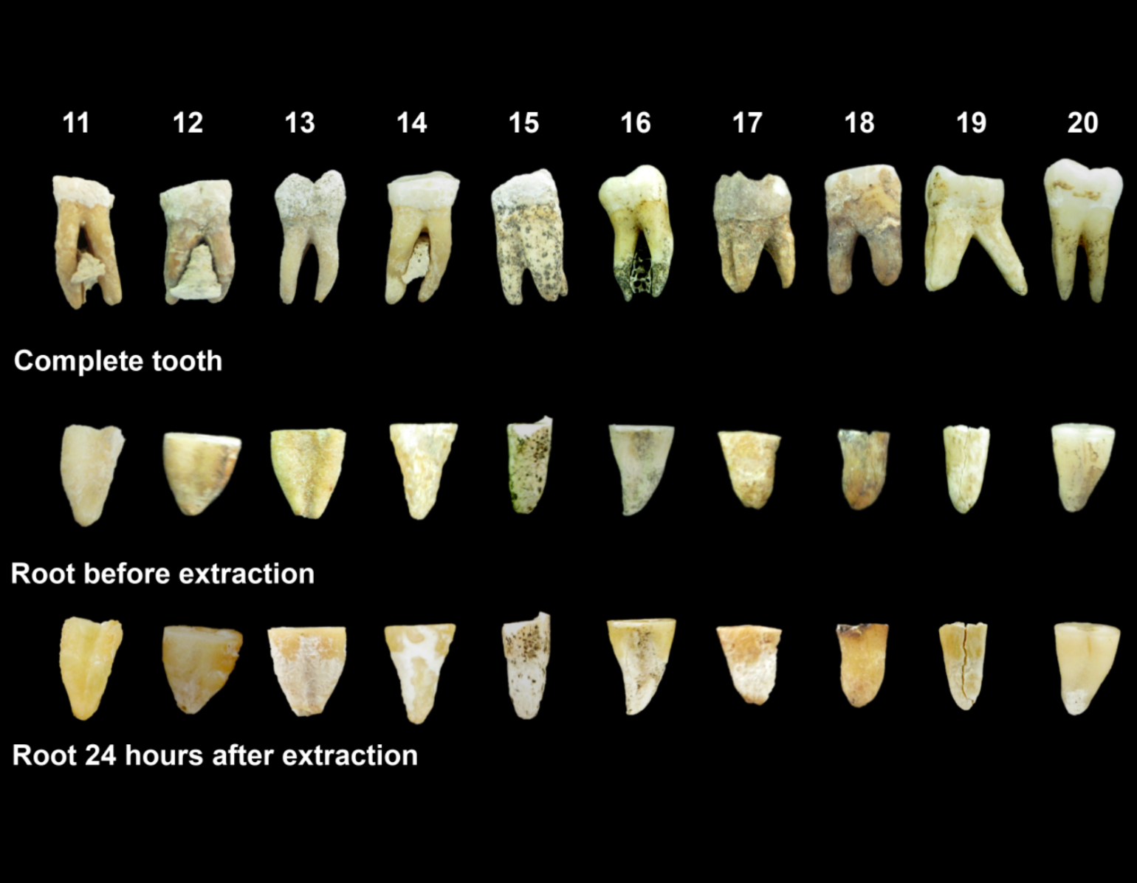

Supplemental Figure S1. Tooth root before and after minimally destructive extraction (cont.)

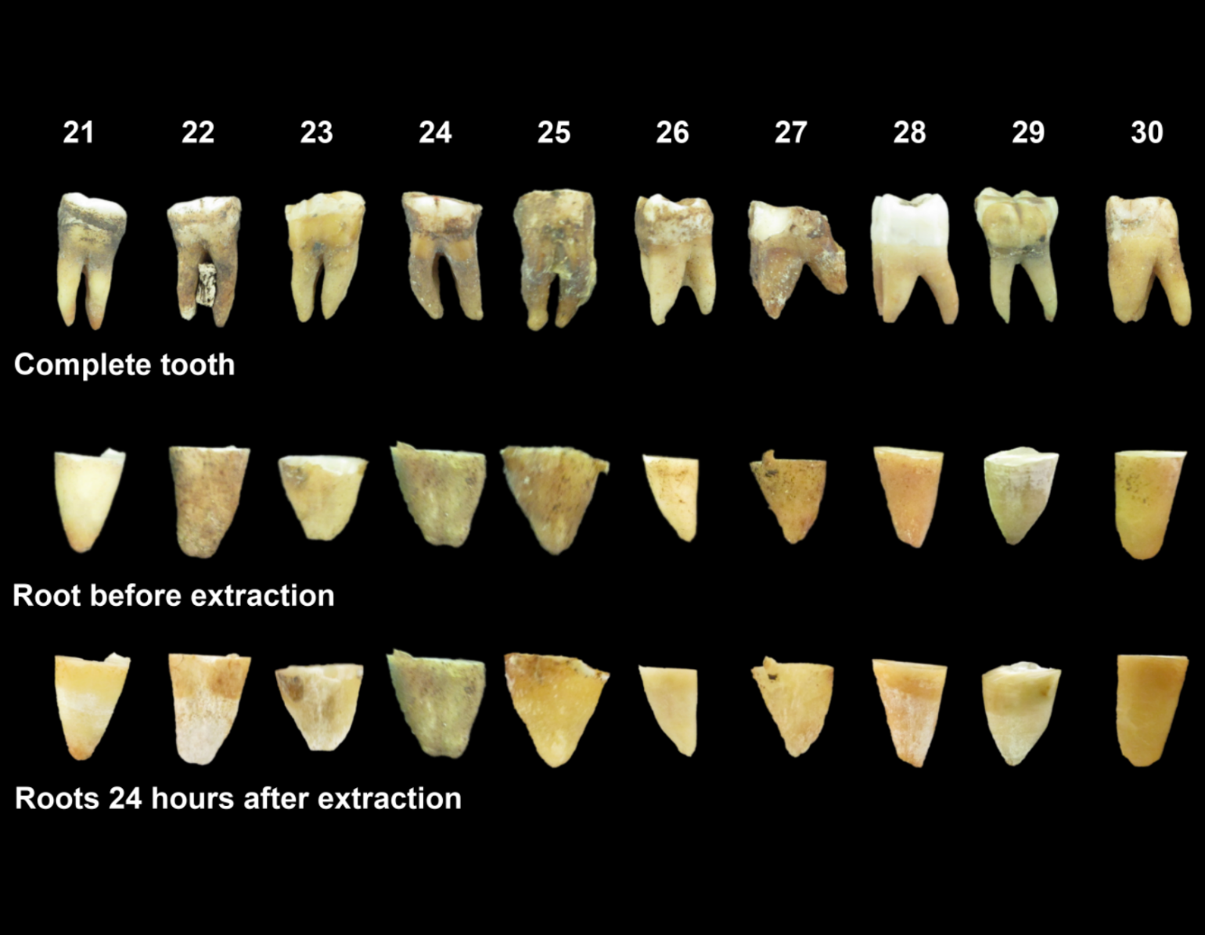

Supplemental Fig S1. Tooth root before and after minimally destructive extraction (cont.)
The complete tooth is shown prior to processing (1st row). Tooth roots are shown immediately prior to extraction (2nd row) and 24 hours after extraction (3rd row). When available, we also include images of the tooth roots ~1.5 years after extraction (4th row).

A | B
C | D

Supplemental Fig S2. Sample quality with additional comparisons
A comparison of the quality of data produced by Method MDE (Minimally Destructive Extraction), Method WTR (Whole Tooth Root), Method P (Petrous), Method D (Damgaard-style Cementum Sampling) in samples that passed quality filtering and that had data available for at least three treatment types. (A) The proportion of endogenous molecules in data obtained via shotgun sequencing is compared. (B) The complexity of each sample, as measured by the proportion of unique reads out of 1,000,000 reads sequenced. (C) The complexity of each sample, as measured by informative sequence content (D) The rate of contamination is compared by considering the rate of matching to mitochondrial consensus sequence. Error bars indicate the 95% confidence interval.

Double Stranded Libraries
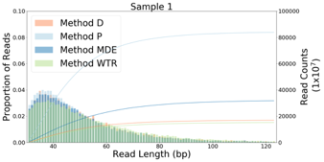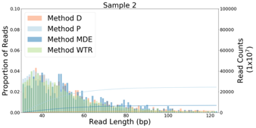

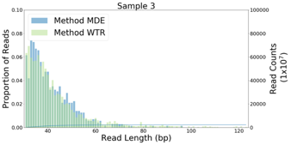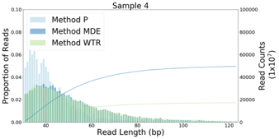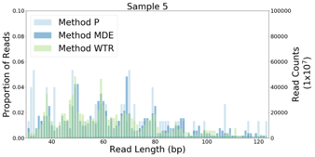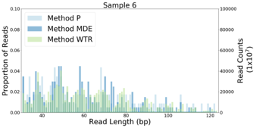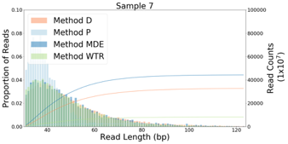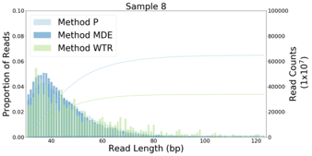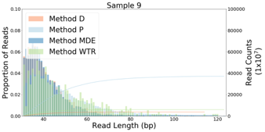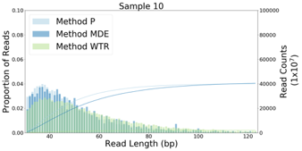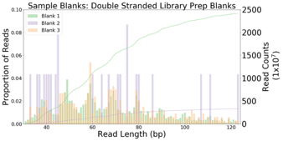

Single Stranded Libraries

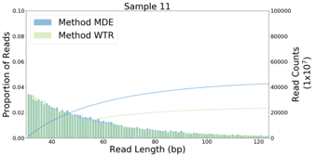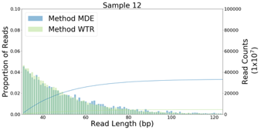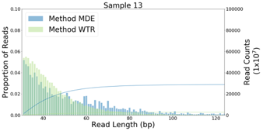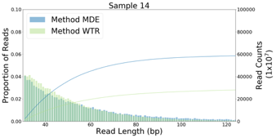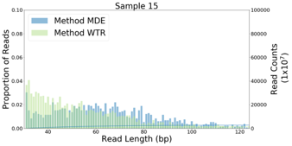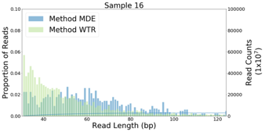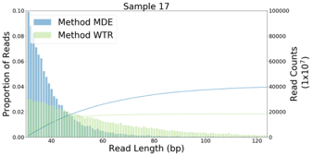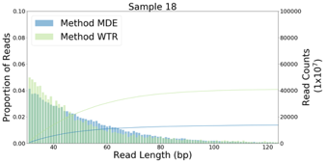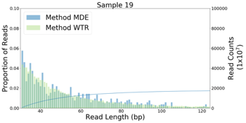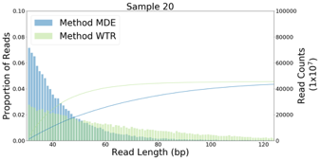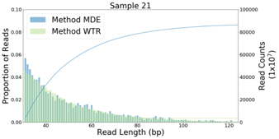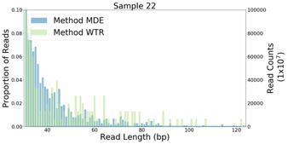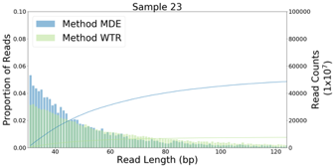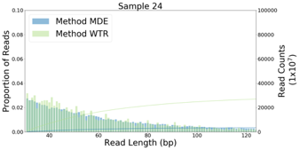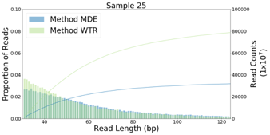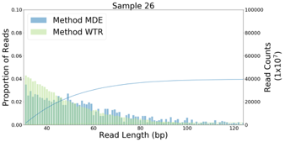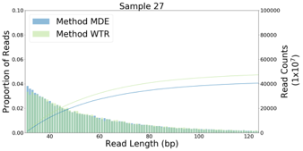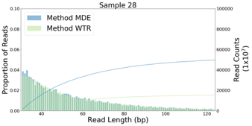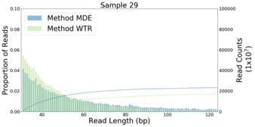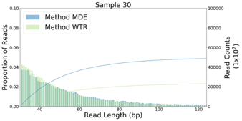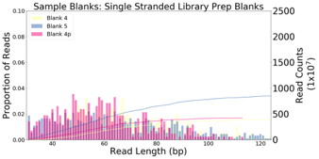

Supplemental Fig S3. Read length distribution.
A histogram showing the distribution of molecule lengths for reads sequenced pre-capture (i.e. shotgun sequencing) that align to the human genome (hg19), for extraction methods MDE, WTR, P and D. The cumulative distribution of reads is also shown, with the y-axis on the right showing the total number of reads.

Double Stranded Libraries
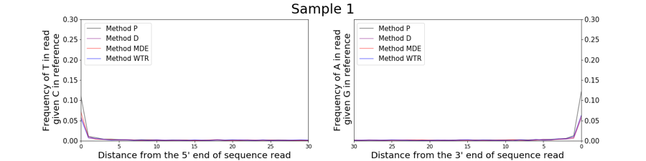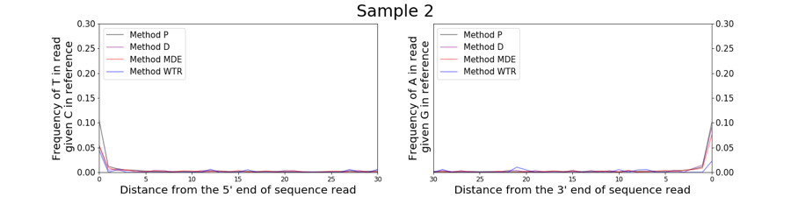
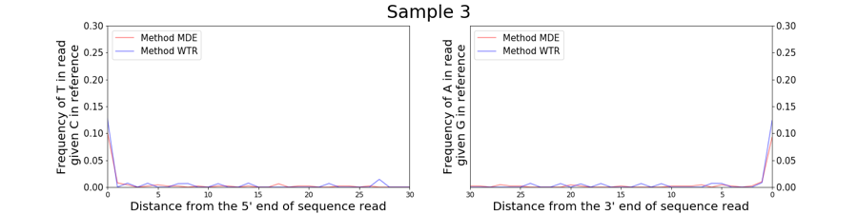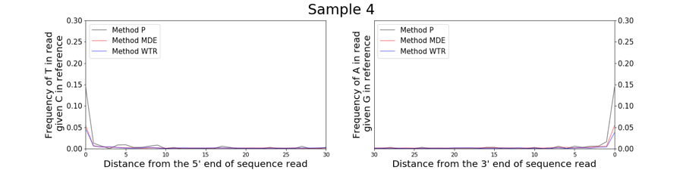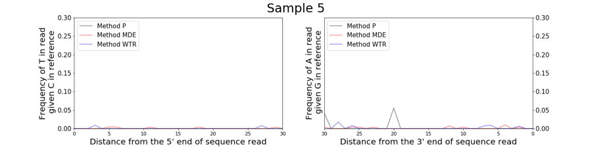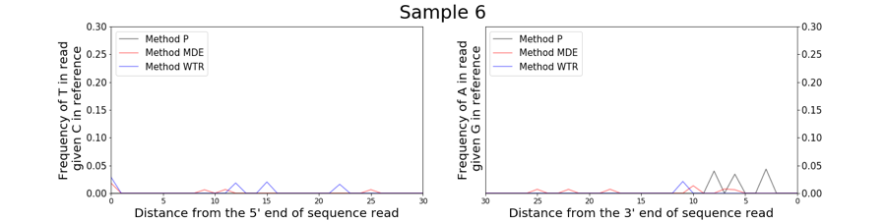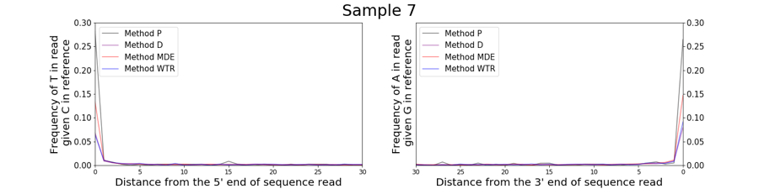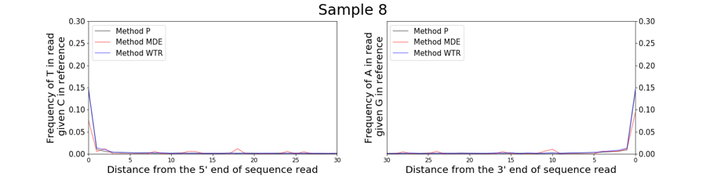
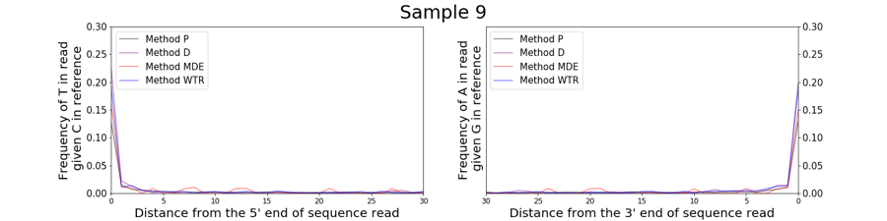
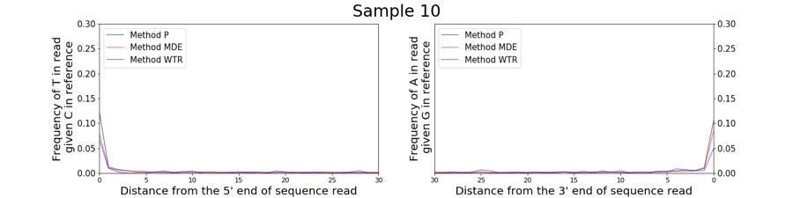
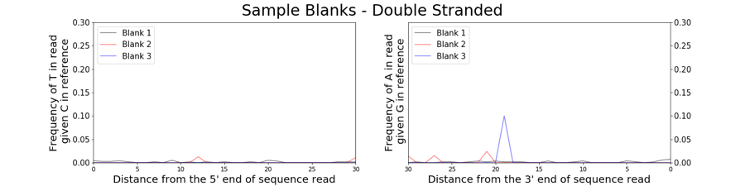
Single Stranded Libraries

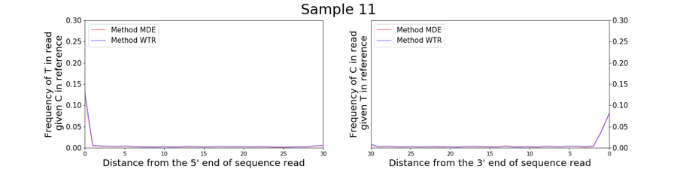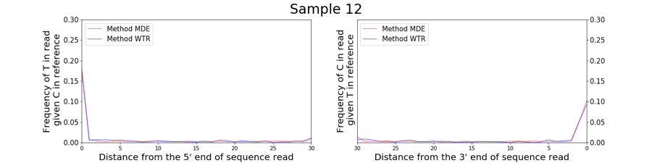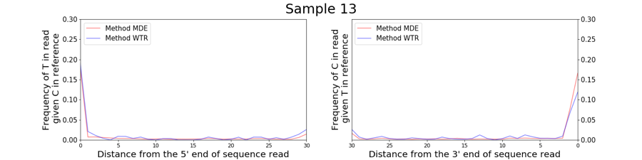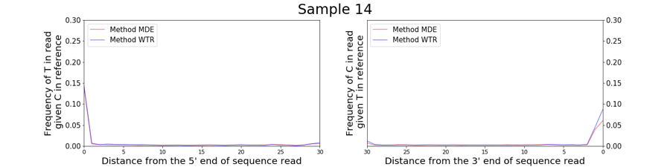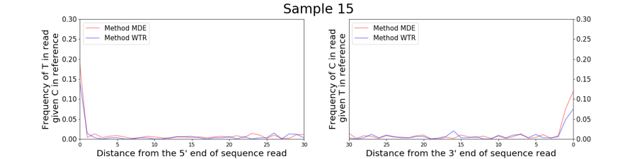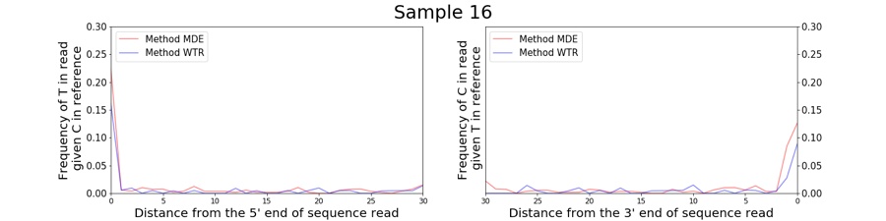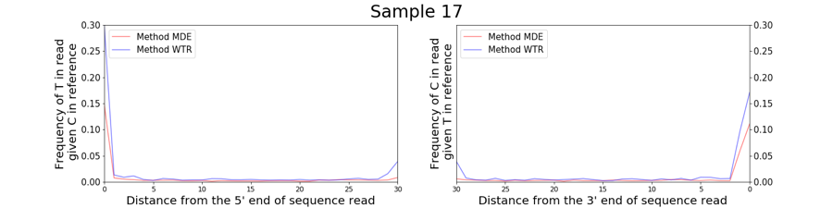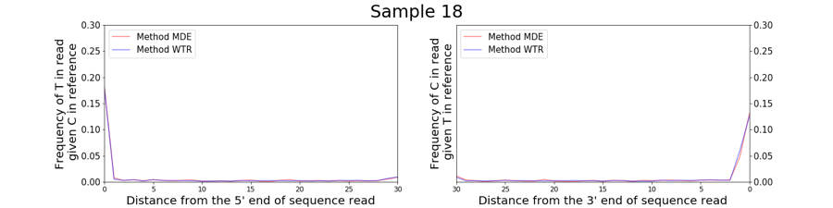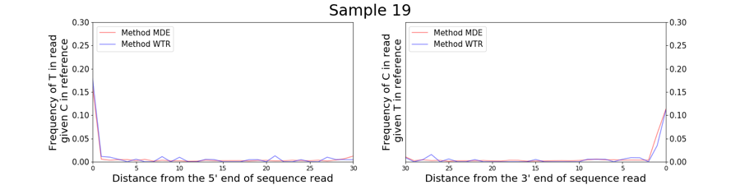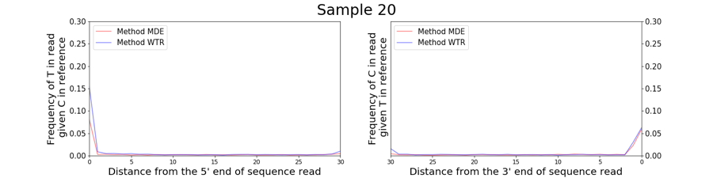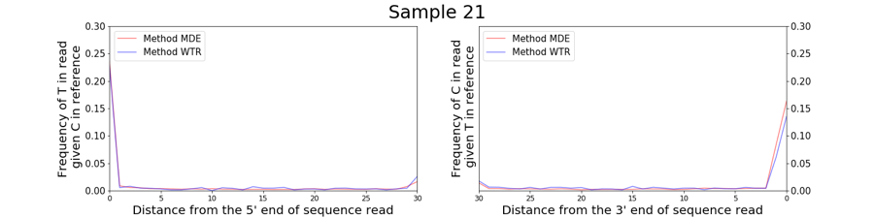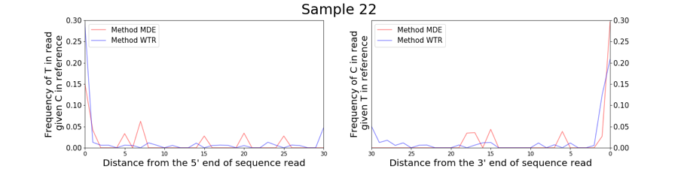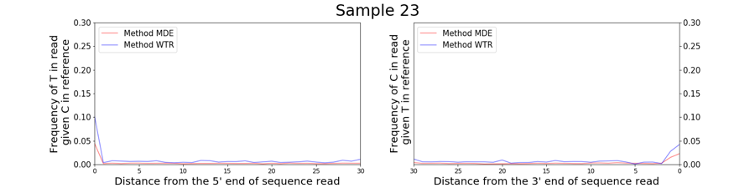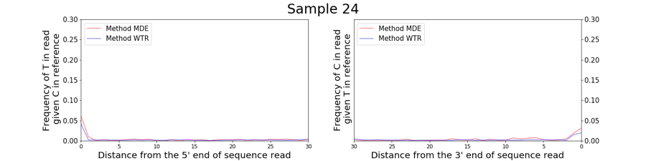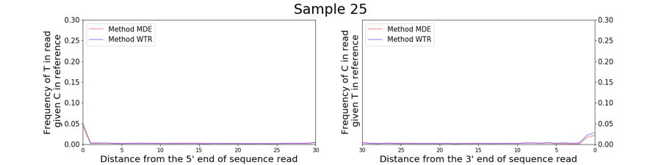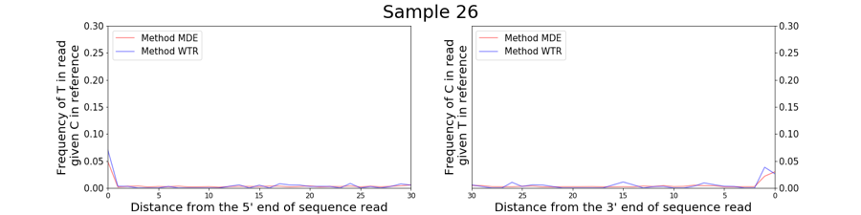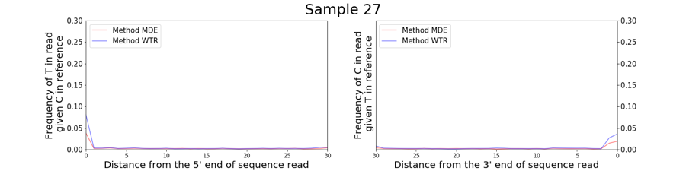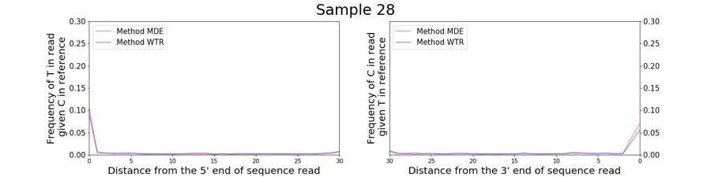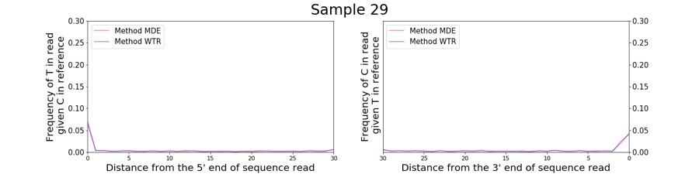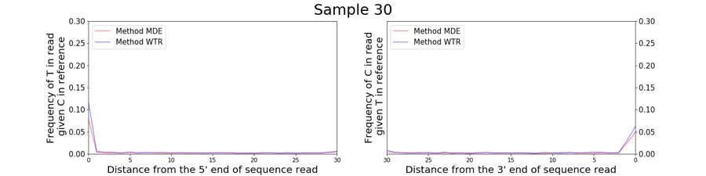
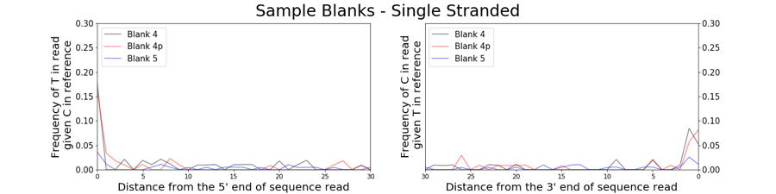

Supplemental Fig S4. C-to-T damage profiles
Damage profiles calculated and plotted for each individual using mapDamage2.0 (Jónsson et al, 2013). For each individual, we plot the frequency of misincorporations at the 30 terminal base pairs of the molecule for all libraries for pre-capture (i.e. shotgun sequencing) reads that align to the human genome (hg19). For double stranded libraries (samples 1-10), we report the rate of C-to-T misincorporations at the 5’ end and G-to-A misincorporations at the 3’ end of reads (plotted on the left and right respectively). For single stranded libraries (samples 11-30), we report the rate of C-to-T misincorporations at both the 5’ and 3’ ends of reads (plotted on the left and right respectively).

Supplemental Fig S5. C-to-T Damage Rate Comparison
A scatterplot comparing the 5’ C-to-T damage rates at the terminal ends of each molecule for libraries prepared using Method MDE vs Method WTR, P or D, that aligned to the human genome (hg19) following pre-capture (i.e. shotgun) sequencing. Double stranded libraries are represented with solid colored markers, while single stranded libraries are represented with patterned markers. The line y=x is shown in grey.

Supplemental Fig S6. Example tooth wrapped in parafilm
[A] Picture of a tooth that has been wrapped in parafilm leaving only the lower part of one of the roots exposed. Note the tail of parafilm present to allow for easier handling of the tooth. [B] A small piece of parafilm has been pressed to the bottom of the tooth root to cover any visible holes that may be present. [C] The parafilm wrapping has been sliced using a metal blade, demonstrating one method for removing the parafilm wrapping following extraction.

SUPPLEMENTAL NOTE S1
Detailed Minimally Destructive Extraction Protocol – manual processing

Required Reagents and consumables:

Reagent/Consumable | Supplier (Austria) | Cat. No. (Austria)
Water | Carl Roth | 3255.1
EDTA (0.5M) | VWR | E177-500ML
Guanidine hydrochloride | Glentham Life Sciences | GE1914
Isopropanol | Fisher | 10284200
Sodium Acetate (3M, pH 5.2) | Alfa Aesar | J61928.AK
Tween-20 | Sigma | P9416-50ML
Tris-HCl (1M, pH 8.0) | Fisher | BP1758-500
PE Wash Buffer | Qiagen | 19065
Parafilm | VWR | 291-1214
5mL microcentrifuge tubes | Eppendorf | 0030119460
50 mL conical tubes | VWR | 525-0610
High Pure Viral Nucleic Acid Large Volume Kit (incl. Proteinase K) | Roche | 05114403001
1.5 mL DNA LoBind microcentrifuge tubes | Eppendorf | 0030108051

Required Buffers:
Extraction Buffer:
 | Final Concentration | 1mL | 50mL
H₂0 | .. | 83.3 µL | 4.165 mL
EDTA (0.5M) | 0.45 M | 900 µL | 45 mL
Proteinase K (15 ng/mL)* | 0.25 mg/mL | 16.7 µL | 835 µL
* Prior to adding Proteinase K, UV-irradiate the solution for 30 minutes
Binding Buffer*:
 | Final Concentration | 50mL
Guanidine hydrochloride | 5 M | 23.9 g
Isopropanol | 40% | 20 mL
Sodium Acetate (3M) | 90 mM | 1.5 mL
Tween-20 (10%) | 0.05% | 250 µL
H₂0 | .. | Fill to 50 mL
* Store for no longer than 1 month. UV-irradiate the solution 30 minutes before use.

TET Buffer:
 | Final Concentration | 50mL
Tris-HCl (1 M, pH 8.0) | 10 mM | 500 µL
EDTA (0.5 M) | 1 mM | 100 µL
Tween-20 (10%) | 0.05 % | 250 µL
H₂0 | .. | 49.15 mL

Procedure:

- Prepare Reagents and Materials: Prepare all required buffers. Cut parafilm to the desired size (we recommend approximately 1.5 cm x 3 cm rectangle). UV irradiate all UV-insensitive reagents and materials for a minimum of 30 minutes prior to beginning extraction. NOTE: Proteinase K is UV-sensitive and should be added to the extraction buffer solution after UV irradiation.
- Physically Clean Tooth: Wipe tooth gently but thoroughly with a solution of 2% bleach using a disposable paper wipe to remove surface contamination. Next rinse or wipe tooth with 95% ethanol to remove bleach. NOTE: If the tooth has been treated with varnish or glue, we recommend trying to identify the substance used on the tooth to determine which solvent would be the most suitable, possible options include 99.5% acetone, 95% ethanol and purified water. A cleaning step involving either water or acetone should be followed by 95% ethanol rinse before performing the bleach cleaning step.
- UV Irradiation: UV irradiate tooth surface by placing it in a cross-linker or similar device for a minimum of 5-10 minutes at 254 nm. In order to be certain that the entire surface has been irradiated, turn the tooth after 5-10 minutes and continue with UV irradiation at 254 nm. After this process, ensure that the tooth is completely dry before proceeding to the next step.
- Prepare Tooth Surface: Isolate the extraction surface (we recommend targeting the lower third of the tooth root) for extraction using parafilm. Tightly wrap film around crown of the tooth and upper root surface. In cases where a hole or crack is visible in the tooth root, also cover this with a small piece of parafilm NOTE 1: We recommend leaving a small “tail” of parafilm above the crown to make it easier to remove the tooth from the tube following incubation (Supplemental Figure 6). NOTE 2: We caution users not to be too overzealous when wrapping teeth in parafilm, particularly when sampling from very poorly preserved samples. The more parafilm is used, the more difficult it is to remove following extraction. This may result in sample breakage if too much pressure is applied to a very poorly preserved sample.
- Incubate Tooth in Extraction Buffer: Place the prepared tooth in a 5mL tube with the exposed part of the root pointing down. Add 1 mL of extraction buffer. Digest for 2.5 hours at 37ºC, with gentle horizontal rotation, to allow extraction buffer to circulate around tooth root. NOTE 1: Ideal incubation time may vary depending on sample quality. An indicator of when an ideal incubation time has been reached may be when a difference in the surface level of the digested versus undigested material becomes visually apparent. NOTE 2: Be sure to use enough extraction buffer to completely cover the portion of the tooth that you are interested in sampling from. If additional extraction buffer is used, it is also necessary to proportionally increase the amount of binding buffer added to the sample in the next step.
- Prepare Binding Buffer: Add 13mL of binding buffer to a 50mL conical tube.
- Remove Tooth from Extraction Buffer (Lysate): Using a 100-1000 µL pipette tip, remove as much of the lysate from the 5mL tube as possible and transfer to the 50 mL conical tube containing binding buffer prepared in the previous step. Next, remove the tooth from the 5mL tube, and set it aside. If any lysate remains in the 5 mL tube after the tooth is removed, transfer this to the same 50mL conical tube, and mix gently. NOTE: We recommend using small, sterile forceps to remove each tooth from its 5mL tube by grasping the parafilm tail. It may also be possible to gently slide the tooth out of the 5mL tube by tilting the tube or using a sterile pipette tip. If this method is chosen, take care not to lose or contaminate any lysate that remains in the 5mL tube.
- Proceed with standard extraction cleanup: Following a procedure based on Dabney et al. (2013) and Korlević et al. (2015), continue with the DNA purification.
  - Transfer the binding buffer-lysate solution to the Roche High Pure Extender Assembly Tubes. Centrifuge the Roche High Pure Extender Assembly Tubes at 1,500 rpm for 4 minutes.
  - Disassemble the High Pure Extender Assembly, seal and place the High Pure Spin Column in a 1.5 mL collection tube. NOTE: Be sure to label the spin column tubes.
  - Dry spin the spin column for 1 minute at 6000 rpm, to remove residual binding buffer.
  - Remove the spin column from the collection tube, discarding any flow through, and place the spin column in a fresh 1.5mL collection tube.
  - Add 650uL of PE wash buffer to the spin column, and centrifuge for 1 minute at 6,000 rpm. Discard the flow-through and repeat this washing step.
  - Place the spin column in a fresh collection tube and perform a dry spin at maximum speed for 1 minute to remove any residual wash buffer. Discard the collection tube and place the spin column in a fresh, labeled 1.5mL microcentrifuge tube.
  - Elute the DNA by adding 25uL of TET buffer to the silica membrane of the spin column. Incubate for 10 minutes at 37ºC. Centrifuge at maximum speed for 30 seconds. Repeat this step to yield a total of 50uL of DNA extract.
- Clean the tooth: Remove the parafilm from the tooth, and rinse with abundant amounts of water or 75-95% ethanol in order to wash away any remaining extraction buffer from the tooth surface. Allow the tooth to air dry for a minimum of 24 hours. NOTE: Be extremely careful removing the Parafilm from teeth, as it is possible to break teeth if too much force is used. This is especially important for poorly preserved, low-density samples. It may help to use a sharp blade to cut the parafilm (Supplemental Figure 6C).

SUPPLEMENTAL REFERENCES
Anders, A. 2017. Újkőkori nőtörténet – bioszociális régészet Polgáron — Neolithic women’s history – biosocial archaeology in Polgár. Tisicum 25, 15-24.
Bickle P., Whittle, A (Eds.). 2013. The first farmers of central Europe: diversity in LBK lifeways. Oxbow Books. 49–100
Ciobanu I, Vornic V, Agulnicov S, Noroc I. 2016. Tumulul 1 de la Ciumai (com. Vinogradovca, r-nul Taraclia). Date preliminare. Arheologia Preventivă în Republica Moldova III: 29-44.
Dani J. 2002. Polgár, Kenderföld (Hajdú-Bihar megye). In: Marton E., Kisfaludi J. (ed.): Régészeti Kutatások Magyarországon 1999.(Archaeological lnvestigations in Hungary 1999). Kulturális Örökségvédelmi Hivatal- Magyar Nemzeti Múzeum. Budapest. 240-241.
Dani J, V.Szabó G. 2003. Polgár, Kenderföld, Majoros-tanya (Hajdú-Bihar megye). In: Kisfaludi J. (ed.): Régészeti Kutatások Magyarországon 1999.(Archaeological lnvestigations in Hungary 1999). Kulturális Örökségvédelmi Hivatal- Magyar Nemzeti Múzeum. Budapest. 192-194.
Dani J, Sz. Máthé M, V.Szabó G. 2003. Ausgrabungen in der bronzezeitlichen Tell-Siedlung und im Gräberfeld von Polgár–Kenderföld. (Vorbericht über die Freilegung des mittelbronzezeitlichen Gräberfeldes von Polgár–Kenderföld, Majoros-tanya) In: Kacsó, C. (Hrsg.): Bronzezeitliche Kulturerscheinungen im Karpatischen Raum. Die Beziehungen zu den benachbarten Gebieten. Ehrensymposium für A. Vulpe zum 70. Geburtstag. Bibliotheca Marmatia 2, Baia Mare 2003, 93-118, 2003.
Dani J, V.Szabó G. 2004. Temetkezési szokások a Polgár határában feltárt középső bronzkori temetőkben. / Bestattungsgebräuche in der Friedhöfen aus der mittleren Bronzezeit freigelegt in der Feldmark von Polgár.
In: Ilon, G. (szerk.): ΜΩΜΟΣ III. Őskoros Kutatók III. Összejövetelének konferenciakötete. Halottkultusz és temetkezés. Szombathely-Bozsok 2003. október 7-9; Szombathely, 2004, 91-119.
Jónsson, H, Ginolhac, A, Schubert, M, Johnson, PL, & Orlando, L. 2013. "mapDamage2. 0: fast approximate Bayesian estimates of ancient DNA damage parameters." Bioinformatics 29.13:1682-1684.
Kolozsi B. 2007. Hajdúdorog-Szállásföld Közép 1. (Hajdú-Bihar megye)
In: Régészeti Kutatások Magyarországon 2006.(Archaeological lnvestigations in Hungary 2006). Kulturális Örökségvédelmi Hivatal- Magyar Nemzeti Múzeum. Budapest. 208-209.
Kovács P, Paár F. 2014. Késő vaskori lelőhelyek a Jászságban – Előzetes tanulmány: alapok, keretek, irányok. (Late Iron Age Sites in Jászság (North-Western part of the Great Hungarian Plain) – A Preliminary Study: Principles, Frames and Directions.) Tisicum 23:33-44.
Kovács P. 2016. Szkíták és kelták öröksége. A Vaskor Régészete Jász-Nagykun-Szolnok Megyében - Legacy of Scythians and Celts. The Archaeology of the Iron Age in Jász-Nagykun-Szolnok County, Szolnoki Régészeti Tanulmányok 1. Archaeological Papers of Szolnok 1.
Hellebrandt BM. 1988. Szkíta kori temető Kesznyéten-Szérűskerten (1984-85 évi ásatás -eredménye). A Herman Ottó Múzeum Évkönyve. 107-126.
Hellebrandt BM. 2016. A Gáva-kultúra települése Köröm-Kápolna-dombon. A Herman Ottó Múzeum Évkönyve 55:11-124.
Motzoi-Chicideanu I. 2011. Obiceiuri funerare în epoca bronzului la Dunărea Mijlocie și Inferioară, Ed. Academiei Române, București.
Popovici S, Ciobanu I, Agulnikov S, Noroc I. 2016. Tumulul 8 de la Cimișlia. Considerații preliminare. Arheologia Preventiva în Republica Moldova, III, Chișinău. 19-28.
Virag C, Marta A, Hago N. 2006. Cronica cercetarilor arheologice din România. Campania 2005, CIMEC-Institutul de Memorie Culturală, Bucureşti. 383-386.
Wolf M, Simonyi E. 1995. Előzetes jelentés az M3-as autópálya 10. lelőhelyének feltárásáról. Somogyi Múzeumok Közleményei 11. 5-32

