Supplemental Material:

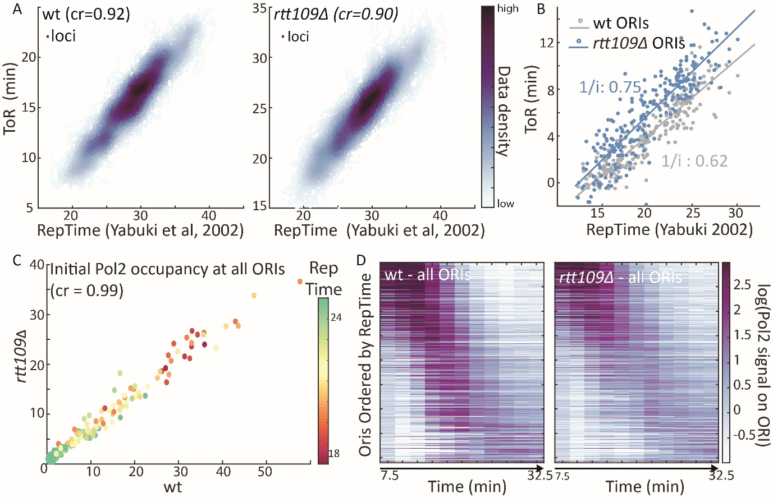

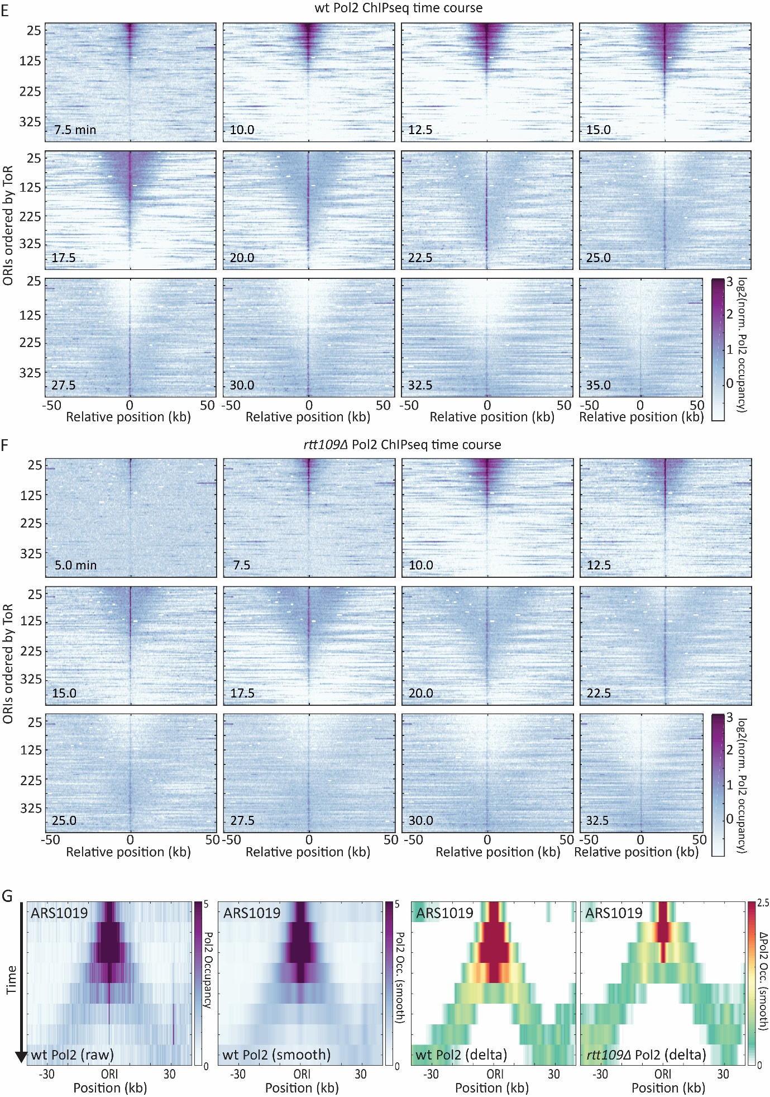
Sup. Figure 1 – Analysis of dynamic DNA/ ChIP-seq profiles
A) Comparison between calculated time of replication (ToR) for wt (left) or rtt109Δ (right) cells and published wild type replication time (RepTime, Yabuki et al. 2002) (Number indicates Pearson’s correlation between ToR and RepTime. *The ToR shift between wild-type and rtt109Δ cells is probably due to a difference in the release time from alpha factor but has no impact on the analysis.
B) Origin firing in wt (grey) and rtt109Δ (blue) cells. For each firing ORI (wt: 210 ORIs; rtt109Δ: 146 ORIs) the ToR (aligned to five earliest WT ORIs, according to Yabuki et al. (2002)) is plotted against its wild type replication time from Yabuki et al (2002) (RepTime; Line corresponds to the linear regression used to estimate initiation frequency).
C) Hierarchy of ORI firing in wt and rtt109Δ cells. Normalized Pol2 occupancy on all ORIs at the start of S-phase (7.5 min after release) of rtt109Δ cells is plotted against wild type cells (Color indicates RepTime, number indicates Pearson’s correlation between the occupancies in wt and RTT109-deleted cells).
D) ORI firing dynamics in RTT109-deleted and wt cells. Normalized Pol2 occupancy 1 kb (color coded) around the 410 ARS (from OriDB ) during the time course is shown (ORIs are ordered by RepTime).
E) Full wt Pol2 ChIP time course.
F) Full rtt109Δ Pol2 ChIP time course.
G) Processing of Pol2 ChIP-seq data for manual analysis. Left: Normalized Pol2 occupancy around an early ORI (ARS1019 of wt cells) at analyzed timepoints (7.5 to 25 min after release from top to bottom; color scale indicates Pol2 occupancy); mid-left: Pol2 occupancy around ORI after smoothing with Gaussian filter (Color indicates smoothened Pol2 occupancy); mid-right: Change in Pol2 during the time course - difference between Pol2 occupancy at a certain time and median Pol2 over the whole timecourse for each locus (Color indicates change in Pol2); right: same as mid-right for rtt109Δ cells (12.5 to 30 minutes).

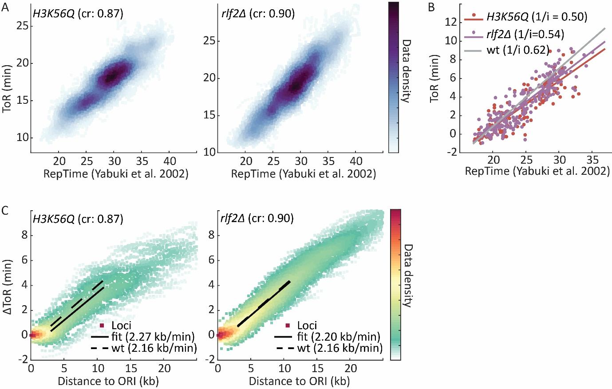

Sup. Figure 2 – Analysis of dynamic DNA-seq profiles for H3K56Q and rlf2Δ
A) Comparison between the calculated time of replication (ToR) for H3K56Q or rlf2Δ and published replication time in wild type cells (RepTime, Yabuki et al. 2002) (as Figure S1A).
B) Calculating initiation frequency for H3K56Q and rlf2Δ (as Figure S1B, grey line indicates wild type fit for comparison, ToR is adjusted to earliest firing ORIs according to Yabuki, 2002).
C) Calculating fork velocity for H3K56Q and rlf2Δ (as Figure 2C, dashed line indicates wt fit for comparison).

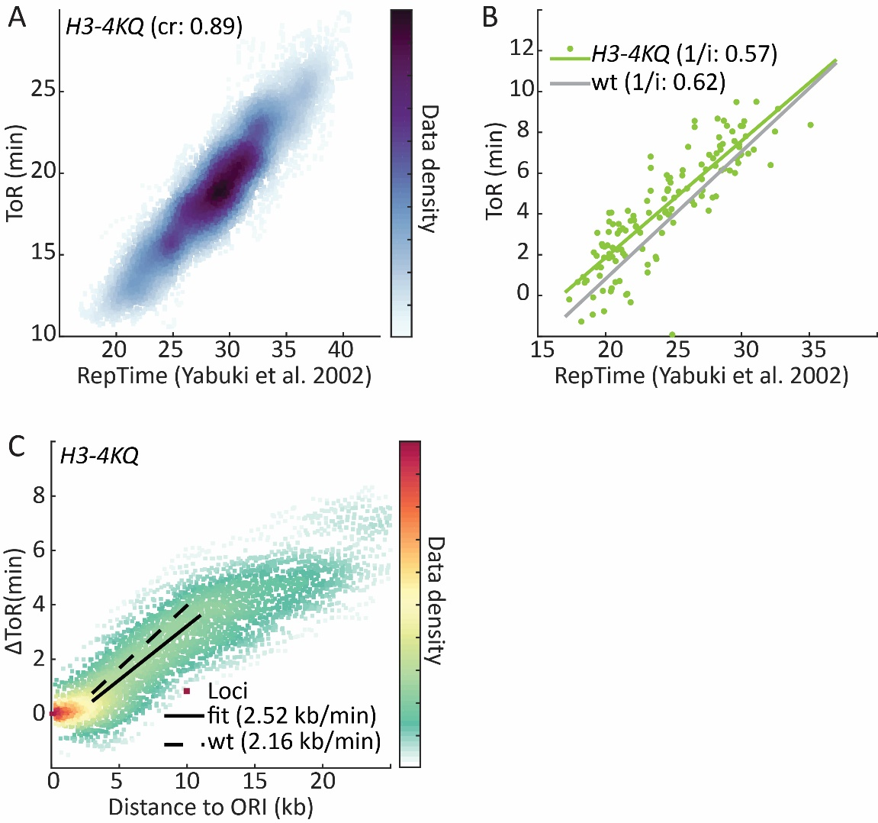
Sup. Figure 3 – Analysis of dynamic DNA-seq profiles for H3-4KQ
A) Comparison between calculated time of replication (ToR) for H3-4KQ cells and published replication time in wild type cells (RepTime, Yabuki et al. 2002) (as Figure S1A).
B) Calculating initiation frequency for H3-4KQ (as Figure S1B).
C) Calculating fork velocity for H3-4KQ (as Figure 2C).

Supplemental Table S1 - S. cerevisiae strains used in this study
Number | Strain name | Genotype | Source
 | BY4741 | MATa, his3-1, leu2-0, met15-0, ura3-0
1 | WT | BY4741
2 | WT bar1Δ | BY4741 BAR1:: BAR1Δ | This study
3 | HA-Pol2 Myc-Mcm7 | BY4741 MCM7-9Myc-kanMX, POL2-6HA-nat BAR1:: BAR1Δ | This study
4 | HA-Pol2 Myc-Mcm7 rtt109Δ | BY4741 MCM7-9Myc-kanMX, POL2-6HA-nat RTT109::KanMX BAR1:: BAR1Δ | This study
5 | cac1Δ | BY4741 CAC1::KanMX | This study
6 | rlf2Δ | BY4741 RLF2::KanMX | This study
7 | K56Q | BY4741 HHT1[56Lys- > Gln],HHT2[56Lys- > Gln] | This study
8 | K56Q bar1Δ | BY4741 HHT1[56Lys- > Gln],HHT2[56Lys- > Gln] BAR1:: BAR1Δ | This study
9 | K56R | BY4741 HHT1[56Lys- > Arg],HHT2[56Lys- > Arg] | This study
10 | K56A | BY4741 HHT1[56Lys- > Ala],HHT2[56Lys- > Ala] | This study
11 | 4KQ | BY4741 HHT1[4Lys- > Gln,9Lys- > Gln,14Lys- > Gln,18Lys- > Gln],HHT2[9Lys- > Gln,14Lys- > Gln,18Lys- > Gln] | This study
12 | 4KQ bar1Δ | BY4741 HHT1[4Lys- > Gln,9Lys- > Gln,14Lys- > Gln,18Lys- > Gln],HHT2[9Lys- > Gln,14Lys- > Gln,18Lys- > Gln] BAR1:: BAR1Δ | This study
13 | rtt109Δ -K56R | BY4741 HHT1[56Lys- > Arg],HHT2[56Lys- > Arg] RTT109::KanMX | This study
14 | Msi1Δ | BY4741 MSI1::KanMX | This study
15 | rtt109Δ -K56Q | BY4741 HHT1[56Lys- > Gln],HHT2[56Lys- > Gln] RTT109::KanMX | This study
16 | rtt109Δ -K56A | BY4741 HHT1[56Lys- > Ala],HHT2[56Lys- > Ala] RTT109::KanMX | This study
17 | 4KA | BY4741 HHT1[4Lys- > Ala,9Lys- > Ala,14Lys- > Ala,18Lys- > Ala],HHT2[4Lys- > Ala,9Lys- > Ala,14Lys- > Ala,18Lys- > Ala] | This study
18 | vps75Δ | BY4741 VPS75::KanMX | This study
19 | rtt109Δ -4KA | BY4741 HHT1[4Lys- > Ala,9Lys- > Ala,14Lys- > Ala,18Lys- > Ala],HHT2[4Lys- > Ala,9Lys- > Ala,14Lys- > Ala,18Lys- > Ala] RTT109::KanMX | This study
20 | asf1Δ | BY4741 ASF1::KanMX | Voichek et al., 2016
21 | 4KA-K56A | BY4741 HHT1[4Lys- > Ala,9Lys- > Ala,14Lys- > Ala,18Lys- > Ala,56Lys- > Ala],HHT2[4Lys- > Ala,9Lys- > Ala,14Lys- > Ala,18Lys- > Ala,56Lys- > Ala] | This study
22 | 4KA-K56R | BY4741 HHT1[4Lys- > Ala,9Lys- > Ala,14Lys- > Ala,18Lys- > Ala,56Lys- > Arg],HHT2[4Lys- > Ala,9Lys- > Ala,14Lys- > Ala,18Lys- > Ala,56Lys- > Arg] | This study
23 | rtt109Δ -K56R-4KA | BY4741 HHT1[4Lys- > Ala,9Lys- > Ala,14Lys- > Ala,18Lys- > Ala,56Lys- > Arg],HHT2[4Lys- > Ala,9Lys- > Ala,14Lys- > Ala,18Lys- > Ala,56Lys- > Arg] rtt109::KanMX | This study
24 | rtt109Δ -K56A-4KA | BY4741 HHT1[4Lys- > Ala,9Lys- > Ala,14Lys- > Ala,18Lys- > Ala,56Lys- > Ala],HHT2[4Lys- > Ala,9Lys- > Ala,14Lys- > Ala,18Lys- > Ala,56Lys- > Ala] RTT109::KanMX | This study
25 | 4KQ-K56R | BY4741 HHT1[4Lys- > Gln,9Lys- > Gln,14Lys- > Gln,18Lys- > Gln,56Lys- > Arg],HHT2[9Lys- > Gln,14Lys- > Gln,18Lys- > Gln,56Lys- > Arg] | This study
26 | rtt109Δ -K56R-4KQ | BY4741 HHT1[4Lys- > Gln,9Lys- > Gln,14Lys- > Gln,18Lys- > Gln,56Lys- > Arg],HHT2[9Lys- > Gln,14Lys- > Gln,18Lys- > Gln,56Lys- > Arg] RTT109::KanMX | This study
27 | rtt109Δ | BY4741 RTT109::KanMX | Voichek et al., 2016
28 | rtt109Δ bar1Δ | BY4741 RTT109::KanMX BAR1:: BAR1Δ | This study
29 | rtt109Δ -4KQ | BY4741 HHT1[4Lys- > Gln,9Lys- > Gln,14Lys- > Gln,18Lys- > Gln],HHT2[9Lys- > Gln,14Lys- > Gln,18Lys- > Gln] RTT109::KanMX | This study
30 | K56Q-4KQ | BY4741 HHT1[4Lys- > Gln,9Lys- > Gln,14Lys- > Gln,18Lys- > Gln,56Lys- >Gln],HHT2[9Lys- > Gln,14Lys- > Gln,18Lys- > Gln,56Lys- > Gln] | This study
31 | rtt109Δ -K56Q-4KA | BY4741 HHT1[4Lys- > Ala,9Lys- > Ala,14Lys- > Ala,18Lys- > Ala,56Lys- > Gln],HHT2[4Lys- > Ala,9Lys- > Ala,14Lys- > Ala,18Lys- > Ala,56Lys- > Gln] RTT109::KanMX | This study
32 | 4KR | BY4741 HHT1[4Lys- > Arg,9Lys- > Arg,14Lys- > Arg,18Lys- > Arg],HHT2[4Lys- > Arg,9Lys- > Arg,14Lys- > Arg,18Lys- > Arg] | This study
33 | K56Q-4KA | BY4741 HHT1[4Lys- > Ala,9Lys- > Ala,14Lys- > Ala,18Lys- > Ala,56Lys- > Gln],HHT2[4Lys- > Ala,9Lys- > Ala,14Lys- > Ala,18Lys- > Ala,56Lys- > Gln] | This study
34 | 4KQ-K56A | BY4741 HHT1[4Lys- > Gln,9Lys- > Gln,14Lys- > Gln,18Lys- > Gln,56Lys- >Ala],HHT2[9Lys- > Gln,14Lys- > Gln,18Lys- > Gln,56Lys- > Ala] | This study
35 | K9Q | BY4741 HHT1[9Lys- > Gln,],HHT2[9Lys- > Gln] | This study
36 | K9R | BY4741 HHT1[9Lys- > Arg,],HHT2[9Lys- > Arg] | This study
37 | 5KQ | BY4741 HHT1[9Lys- > Gln,14Lys- > Gln,18Lys- > Gln,23Lys- > Gln,27Lys- > Gln],HHT2[9Lys- > Gln,14Lys- > Gln,18Lys- > Gln,23Lys- > Gln,27Lys- > Gln] | This study
38 | 5KR | BY4741 HHT1[9Lys- > Arg,14Lys- > Arg,18Lys- > Arg,23Lys- > Arg,27Lys- > Arg],HHT2[9Lys- > Arg,14Lys- > Arg,18Lys- > Arg,23Lys- > Arg,27Lys- > Arg] | This study
39 | rtt109Δ 4KR | BY4741 HHT1[4Lys- > Arg,9Lys- > Arg,14Lys- > Arg,18Lys- > Arg],HHT2[4Lys- > Arg,9Lys- > Arg,14Lys- > Arg,18Lys- > Arg] RTT109::KanMX | This study
40 | HA-Pol2 Myc-Mcm7 K56Q bar1Δ | BY4741 MCM7-9Myc-kanMX, POL2-6HA-nat HHT1[56Lys- > Gln],HHT2[56Lys- > Gln] BAR1:: BAR1Δ | This study
41 | HA-Pol2 Myc-Mcm7 4KR bar1Δ | BY4741 MCM7-9Myc-kanMX, POL2-6HA-nat HHT1[4Lys- > Arg,9Lys- > Arg,14Lys- > Arg,18Lys- > Arg],HHT2[4Lys- > Arg,9Lys- > Arg,14Lys- > Arg,18Lys- > Arg] BAR1:: BAR1Δ | This study
42 | HA-Pol2 Myc-Mcm7 4KQ bar1Δ | BY4741 MCM7-9Myc-kanMX, POL2-6HA-nat HHT1[4Lys- > Gln,9Lys- > Gln,14Lys- > Gln,18Lys- > Gln],HHT2[9Lys- > Gln,14Lys- > Gln,18Lys- > Gln] BAR1:: BAR1Δ | This study
43 | sgf29Δ | BY4741 SGF29::KanMX | This study
44 | gcn5Δ | BY4741 GCN5::KanMX | This study
45 | ada2Δ | BY4741 ADA2::KanMX | This study
46 | ngg1Δ | BY4741 NGG1::KanMX | This study
47 | sgf29Δ 4KQ | BY4741 HHT1[4Lys- > Gln,9Lys- > Gln,14Lys- > Gln,18Lys- > Gln],HHT2[9Lys- > Gln,14Lys- > Gln,18Lys- > Gln] SGF29::KanMX | This study
48 | sgf29Δ 4KA | HHT1[4Lys- > Ala,9Lys- > Ala,14Lys- > Ala,18Lys- > Ala],HHT2[4Lys- > Ala,9Lys- > Ala,14Lys- > Ala,18Lys- > Ala] SGF29::KanMX | This study
49 | gcn5Δ 4KQ | BY4741 HHT1[4Lys- > Gln,9Lys- > Gln,14Lys- > Gln,18Lys- > Gln],HHT2[9Lys- > Gln,14Lys- > Gln,18Lys- > Gln] GCN5::KanMX | This study
50 | ada2Δ 4KQ | BY4741 HHT1[4Lys- > Gln,9Lys- > Gln,14Lys- > Gln,18Lys- > Gln],HHT2[9Lys- > Gln,14Lys- > Gln,18Lys- > Gln] ADA2::KanMX | This study
51 | ada2Δ 4KA | BY4741 HHT1[4Lys- > Ala,9Lys- > Ala,14Lys- > Ala,18Lys- > Ala],HHT2[4Lys- > Ala,9Lys- > Ala,14Lys- > Ala,18Lys- > Ala] ADA2::KanMX | This study
52 | ngg1Δ 4KQ | BY4741 HHT1[4Lys- > Gln,9Lys- > Gln,14Lys- > Gln,18Lys- > Gln],HHT2[9Lys- > Gln,14Lys- > Gln,18Lys- > Gln] NGG1::KanMX | This study
53 | ngg1Δ 4KA | BY4741 HHT1[4Lys- > Ala,9Lys- > Ala,14Lys- > Ala,18Lys- > Ala],HHT2[4Lys- > Ala,9Lys- > Ala,14Lys- > Ala,18Lys- > Ala] NGG1::KanMX | This study
54 | rtt109 K290Q | BY4741 RTT109[290Lys- > Gln] | This study
55 | rtt109 DD287,288AA | BY4741 RTT109[287Asp- > Ala, 288Asp- > Ala] | This study

Supplemental Table S1 – List of all strains used in the study

Supplemental Table S2 - Plasmids used in the study
Number | Name | Description | Source
1 | pMel13 | gRNA scaffold plasmid | Mans et al 2015
2 | p416 | Cas9 expression plasmid | DiCarlo et al. 2013
3 | bRA89 | Combined gRNA scaffold and Cas9 expression plasmid with Hygromycin resistance cassette | Anand et al. 2017
4 | pYM17 | HA-tagging plasmid with NatA resistance cassette | Janke et al. 2004
5 | pYM17+ | pYM17 with SpCYC1 terminator after HA-tag | This study
6 | pYM18 | myc-tagging plasmid with G418 resistance cassette | Janke et al. 2004
7 | PYM18+ | pYM18 with SpCYC1 terminator after myc-tag | This study

Supplemental Table S2 – List of all plasmids used in the study

