Supplemental_Fig_S1.png

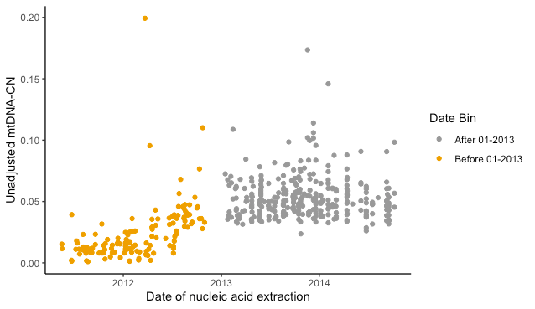

Supplemental Fig S1. mtDNA-CN is affected by nucleic acid extraction date

mtDNA-CN exhibits a batch effect associated with nucleic acid extraction date. The batch effect was identified using GTEx version 7 data (phs000424.v7.p2). All subsequent analyses were done with version 8, and version 8 whole genome sequences extracted prior to January 2013 were not downloaded.

Supplemental_Fig_S2.png

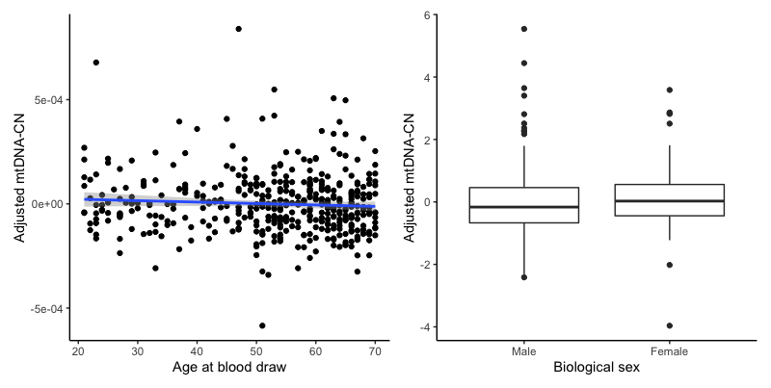

Supplemental Fig S2. mtDNA-CN in GTEx is associated with known covariates

Adjusted mtDNA-CN in GTEx decreases with age (p = 0.18) and is lower in males (p = 0.14) when compared to females. mtDNA-CN has been corrected for all other variables (age, sex, cohort, ischemic time, and cell counts deconvoluted from blood RNA-sequencing) except for the variable of interest.

Supplemental_Fig_S3.png

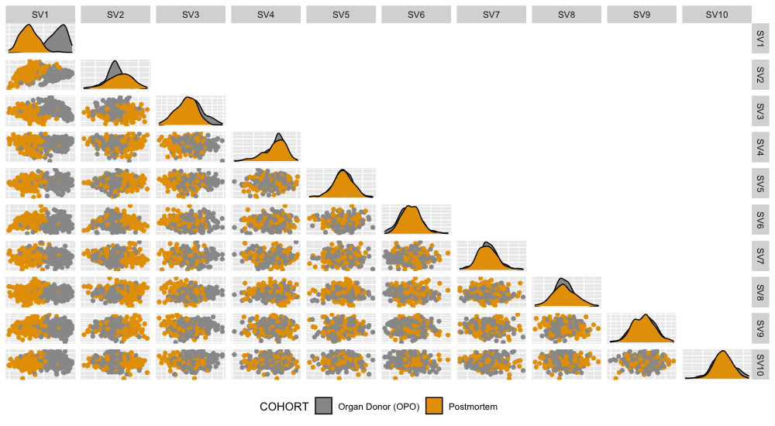

Supplemental Fig S3. Surrogate variables reveal known RNA-sequencing covariates

Surrogate variables 1 and 2 derived from whole blood RNA-sequencing capture cohort effects. Pairwise plots for the top 10 surrogate variables derived from whole blood RNA-sequencing, colored by cohort. Surrogate variables are protected from mtDNA-CN.

Supplemental_Fig_S4.pdf
Supplemental Fig S4. mtDNA-CN is associated with mitochondrial gene expression.

Forest plot of associations between blood-derived mtDNA-CN and mtDNA-encoded gene expression in whole. Effect size estimates reflect the change in standard deviations for gene expression per standard deviation in mtDNA-CN.

Supplemental_Fig_S5.png
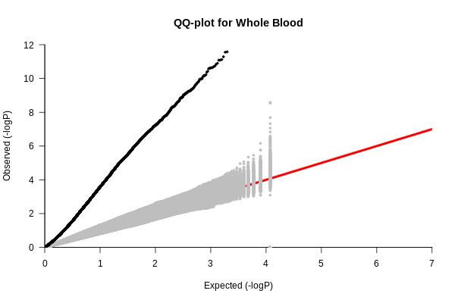

Supplemental Fig S5. P-value QQ-plot of associations between blood-derived gene expression and blood-derived mtDNA-CN

Inflation of test statistics from multiple linear regressions between gene expression in whole blood and blood-derived mtDNA-CN (black). Results from 1000 two-stage permutations (in gray) show no inflation of test statistics.

Supplemental_Fig_S6.png

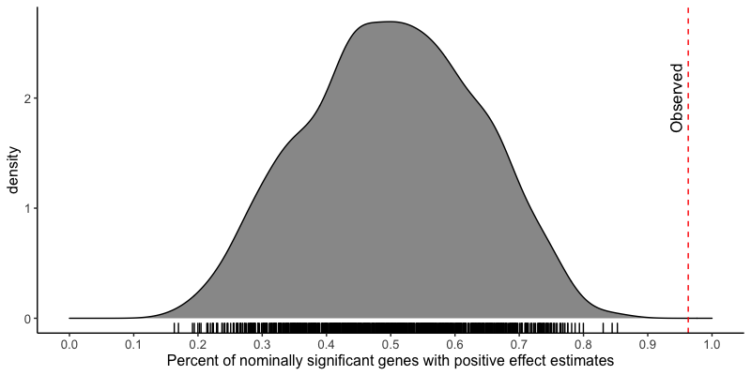
Supplemental Fig S6. Positive shift for effect size estimates between blood-derived mtDNA-CN and blood-derived gene expression.

Effect size estimates between blood-derived mtDNA-CN and gene expression in blood are significantly positively shifted. Shown in gray is the percent of nominally significant genes that were positive from multiple linear regressions between blood-derived mtDNA-CN and gene expression in whole blood for 1000 permuted datasets. Dashed red line represents the actual observed value.

Supplemental_Fig_S7.png

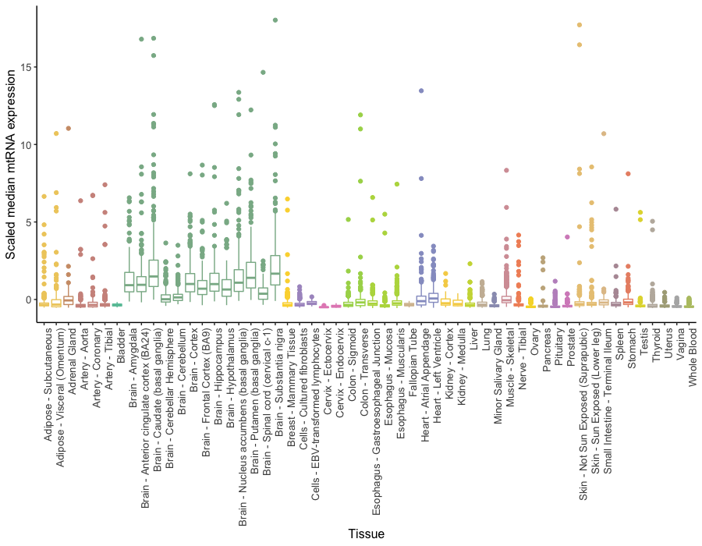
Supplemental Fig S7. Scaled median mtRNA gene expression across tissues.

Median mtRNA gene expression was scaled and tabulated by tissue. mtRNA gene expression varies widely between tissues, with notably higher expression in brain tissues.

Supplemental_Fig_S8.

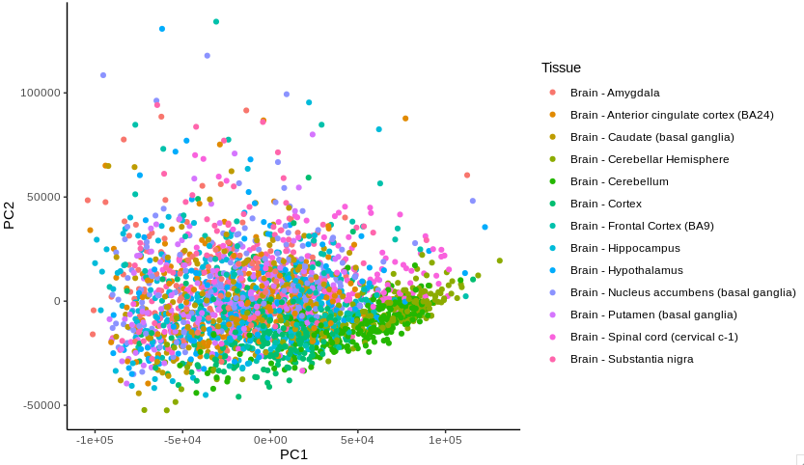
Supplemental Fig S8. Principal components analysis of brain tissues

Principal components 1 and 2 from a principal components analysis of RNA-sequencing from all brain tissues. Substantia nigra does not appear to be substantially different from the other brain tissues.

Supplemental_Fig _S9.pdf

Supplemental Fig S9. ELK1 is associated with mtDNA-CN in multiple tissues

ELK1 is nominally significantly associated with mtDNA-CN 4 out of the 18 tissues where ELK1 targets are enriched for association with mtDNA-CN. N represents number of samples for each tissue. Summary estimates calculated using a random-effects meta-analysis, excluding the effect of whole blood.

Supplemental_Fig_S10.svg
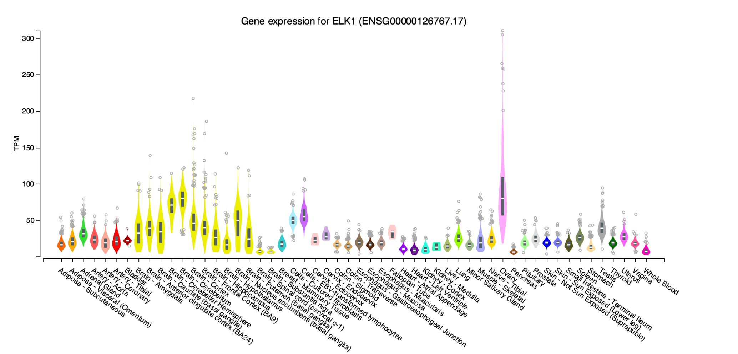
Supplemental Fig S10.

GTEx visualization showing gene expression of ELK1 in multiple tissues, downloaded on 5/9/2020 from https://gtexportal.org/home/gene/ELK1.

Supplemental_Fig_S11.pdf

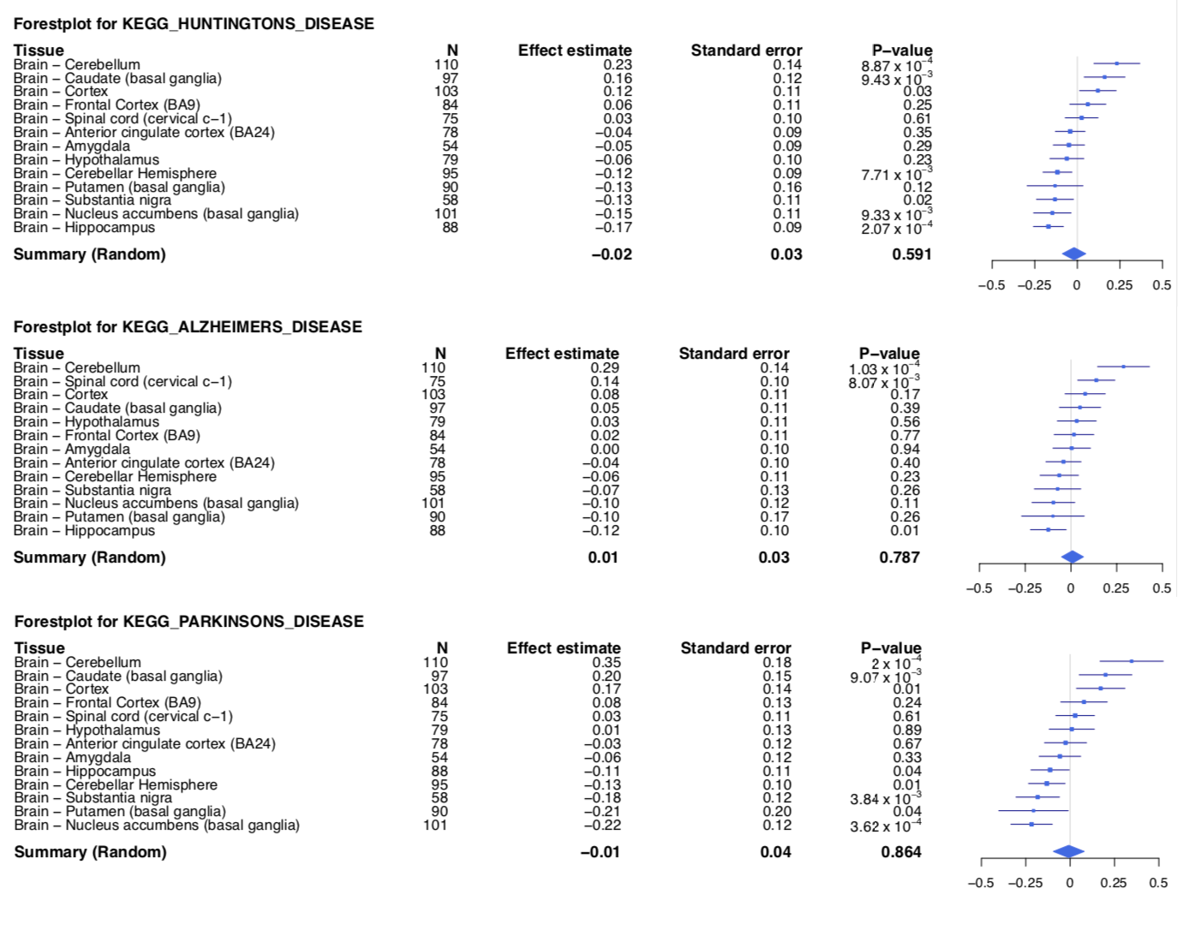
Supplemental Fig S11.
Forest plots showing enrichment for neurodegenerative disease gene sets across multiple brain tissues.

Supplemental_Fig_S12.png

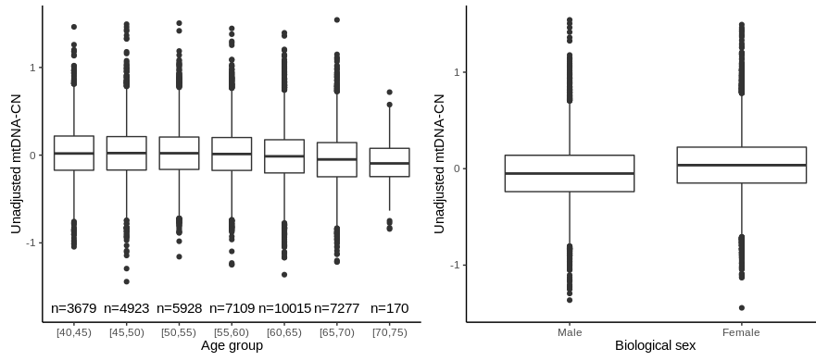

Supplemental Fig S12.

mtDNA-CN in UKBiobank decreases with age (p = 2.12e-60) and is lower in males when compared to females (p = 1.56e-182). Data has been stratified into 5-year age bins.

Supplemental_Fig_S13.png
Supplemental Fig S13.
Filtering pipeline for whole blood analysis and the number of individuals retained at each step.

Supplemental Table S1. GTEx effect size estimates between mtDNA-CN and known correlates are comparable to ARIC mtDNA-CN effect size estimates from previous literature. Power calculations are based on R² values between ARIC mtDNA-CN and correlates.

 | GTEx |  |  |  | ARIC
 | Effect estimate | Standard error | P-value |  | Effect estimate | Standard error | P-value |  | Power
Age | -0.06 | 0.05 | 0.18 |  | -0.02 | 0.005 | 0.004 |  | 28.68%
Sex (Female) | 0.15 | 0.1 | 0.14 |  | 0.46 | 0.06 | 9.95×10⁻¹⁴ |  | 79.44%
Neutrophils | -0.19 | 0.05 | 8.4×10⁻⁵ |  | -0.14 | 0.02 | 9.97×10⁻¹⁶ |  | 97.48%

Supplemental Table S2. Scaled median mtRNA expression in non-blood tissues does not seem to be significantly associated with blood-derived mtDNA-CN. Only Uterus and Heart – Left Ventricle pass nominal significant (p<0.05) for associations between blood-derived mtDNA-CN and tissue-specific mtRNA expression.

Tissue | Effect size estimate | Standard error | P-value
Whole Blood | 0.15 | 0.03 | 9.10×10⁻⁹
Uterus | 0.29 | 0.09 | 0.004
Heart - Left Ventricle | 0.12 | 0.05 | 0.017
Skin - Sun Exposed (Lower leg) | -0.05 | 0.03 | 0.055
Heart - Atrial Appendage | 0.07 | 0.04 | 0.084
Artery - Tibial | 0.05 | 0.03 | 0.111
Brain - Cerebellum | 0.07 | 0.05 | 0.130
Esophagus - Mucosa | 0.06 | 0.04 | 0.156
Cells - Cultured fibroblasts | -0.07 | 0.05 | 0.177
Breast - Mammary Tissue | 0.05 | 0.04 | 0.185
Artery - Aorta | 0.04 | 0.03 | 0.194
Brain - Putamen (basal ganglia) | -0.05 | 0.04 | 0.207
Brain - Cortex | 0.06 | 0.05 | 0.216
Nerve - Tibial | 0.04 | 0.03 | 0.237
Colon - Transverse | 0.04 | 0.04 | 0.241
Minor Salivary Gland | 0.09 | 0.09 | 0.292
Stomach | 0.06 | 0.06 | 0.292
Thyroid | 0.03 | 0.03 | 0.294
Pancreas | 0.08 | 0.08 | 0.317
Testis | 0.05 | 0.05 | 0.318
Esophagus - Gastroesophageal Junction | -0.04 | 0.05 | 0.427
Brain - Nucleus accumbens (basal ganglia) | 0.04 | 0.05 | 0.443
Brain - Caudate (basal ganglia) | 0.03 | 0.04 | 0.515
Adrenal Gland | 0.05 | 0.07 | 0.530
Lung | 0.02 | 0.04 | 0.566
Esophagus - Muscularis | 0.02 | 0.04 | 0.576
Colon - Sigmoid | 0.02 | 0.03 | 0.584
Cells - EBV-transformed lymphocytes | 0.08 | 0.16 | 0.609
Brain - Anterior cingulate cortex (BA24) | -0.02 | 0.05 | 0.635
Muscle - Skeletal | -0.01 | 0.03 | 0.667
Brain - Substantia nigra | 0.03 | 0.08 | 0.671
Spleen | 0.02 | 0.06 | 0.671
Pituitary | 0.02 | 0.05 | 0.673
Brain - Amygdala | 0.03 | 0.07 | 0.704
Vagina | 0.03 | 0.09 | 0.710
Skin - Not Sun Exposed (Suprapubic) | 0.01 | 0.02 | 0.758
Liver | 0.02 | 0.06 | 0.763
Brain - Hippocampus | -0.01 | 0.05 | 0.767
Small Intestine - Terminal Ileum | 0.01 | 0.06 | 0.798
Brain - Cerebellar Hemisphere | -0.01 | 0.06 | 0.817
Artery - Coronary | -0.01 | 0.04 | 0.849
Brain - Frontal Cortex (BA9) | 0.01 | 0.05 | 0.869
Brain - Hypothalamus | -0.01 | 0.06 | 0.873
Adipose - Subcutaneous | 0.00 | 0.03 | 0.897
Prostate | -0.00 | 0.06 | 0.980
Adipose - Visceral (Omentum) | -0.00 | 0.03 | 0.993
Brain - Spinal cord (cervical c-1) | 0.00 | 0.06 | 0.997
Ovary | 0.00 | 0.08 | 0.999

Supplemental Table S3. Genomic inflation factors for all tested tissues, represented by the median observed chi-squared value divided by the median expected chi-squared value. Bolded tissues pass the permuted genomic inflation factor cutoff and represent tissues with significant signal.

Tissue | Lambda
Whole Blood | 4.71
Brain - Putamen (basal ganglia) | 3.36
Brain - Substantia nigra | 1.69
Colon - Transverse | 1.61
Nerve - Tibial | 1.56
Esophagus - Mucosa | 1.51
Skin - Sun Exposed (Lower leg) | 1.49
Brain - Hippocampus | 1.48
Testis | 1.45
Brain - Nucleus accumbens (basal ganglia) | 1.45
Adipose - Subcutaneous | 1.43
Colon - Sigmoid | 1.41
Esophagus - Muscularis | 1.41
Breast - Mammary Tissue | 1.37
Brain - Hypothalamus | 1.35
Skin - Not Sun Exposed (Suprapubic) | 1.33
Muscle - Skeletal | 1.32
Brain - Cerebellum | 1.32
Heart - Left Ventricle | 1.31
Vagina | 1.30
Spleen | 1.29
Lung | 1.28
Pancreas | 1.28
Adrenal Gland | 1.27
Adipose - Visceral (Omentum) | 1.26
Thyroid | 1.26
Brain - Cortex | 1.26
Esophagus - Gastroesophageal Junction | 1.25
Heart - Atrial Appendage | 1.24
Brain - Caudate (basal ganglia) | 1.24
Liver | 1.23
Stomach | 1.19
Brain - Spinal cord (cervical c-1) | 1.18
Small Intestine - Terminal Ileum | 1.17
Brain - Cerebellar Hemisphere | 1.15
Artery - Tibial | 1.14
Pituitary | 1.14
Artery - Aorta | 1.13
Brain - Frontal Cortex (BA9) | 1.12
Prostate | 1.11
Ovary | 1.07
Minor Salivary Gland | 1.06
Cells - Cultured fibroblasts | 1.03
Brain - Anterior cingulate cortex (BA24) | 1.02
Artery - Coronary | 1.01
Brain - Amygdala | 0.973
Uterus | 0.928
Cells - EBV-transformed lymphocytes | 0.835

Supplemental Table S4. Spearman’s rank correlation coefficients between blood estimates and specific tissue estimates for all 700 genes that were significant in blood. Average baseline correlation is represented by the correlation for 1000 randomly selected gene sets (700 genes per set). Tissues with correlations significantly different from baseline are bolded.

Tissue | Spearman correlation for significant blood genes | Average spearman correlation for 1000 permuted random gene sets | 95% Confidence Interval
Adipose - Subcutaneous | 0.180 | 0.107 | 0.030;0.184
Adipose - Visceral (Omentum) | 0.259 | 0.151 | 0.075;0.227
Adrenal Gland | 0.188 | 0.092 | 0.015;0.169
Artery - Aorta | 0.179 | 0.107 | 0.030;0.184
Artery - Coronary | 0.008 | 0.097 | 0.016;0.178
Artery - Tibial | 0.179 | 0.101 | 0.024;0.179
Brain - Amygdala | 0.082 | 0.067 | -0.013;0.147
Brain - Anterior cingulate cortex (BA24) | 0.080 | 0.023 | -0.060;0.106
Brain - Caudate (basal ganglia) | 0.106 | 0.061 | -0.019;0.141
Brain - Cerebellar Hemisphere | 0.136 | 0.052 | -0.029;0.133
Brain - Cerebellum | 0.192 | 0.106 | 0.027;0.186
Brain - Cortex | 0.149 | 0.052 | -0.032;0.135
Brain - Frontal Cortex (BA9) | 0.188 | 0.039 | -0.040;0.118
Brain - Hippocampus | 0.139 | 0.025 | -0.058;0.108
Brain - Hypothalamus | 0.185 | 0.058 | -0.023;0.139
Brain - Nucleus accumbens (basal ganglia) | 0.224 | 0.055 | -0.025;0.134
Brain - Putamen (basal ganglia) | 0.128 | 0.091 | 0.012;0.170
Brain - Spinal cord (cervical c-1) | 0.096 | 0.095 | 0.018;0.172
Brain - Substantia nigra | 0.159 | 0.013 | -0.068;0.094
Breast - Mammary Tissue | 0.313 | 0.144 | 0.068;0.220
Cells - Cultured fibroblasts | -0.052 | -0.041 | -0.124;0.041
Cells - EBV-transformed lymphocytes | -0.045 | 0.028 | -0.050;0.105
Colon - Sigmoid | 0.111 | 0.136 | 0.058;0.214
Colon - Transverse | 0.212 | 0.107 | 0.034;0.180
Esophagus - Gastroesophageal Junction | 0.121 | 0.091 | 0.012;0.170
Esophagus - Mucosa | 0.150 | 0.164 | 0.088;0.239
Esophagus - Muscularis | 0.150 | 0.136 | 0.060;0.212
Heart - Atrial Appendage | 0.203 | 0.120 | 0.041;0.199
Heart - Left Ventricle | 0.265 | 0.189 | 0.105;0.273
Kidney - Cortex | 0.061 | 0.118 | 0.043;0.192
Liver | 0.174 | 0.072 | -0.008;0.152
Lung | 0.245 | 0.168 | 0.091;0.245
Minor Salivary Gland | 0.115 | 0.105 | 0.027;0.183
Muscle - Skeletal | 0.184 | 0.158 | 0.079;0.237
Nerve - Tibial | 0.250 | 0.080 | 0.006;0.155
Ovary | 0.097 | -0.034 | -0.112;0.044
Pancreas | 0.263 | 0.092 | 0.012;0.171
Pituitary | 0.268 | 0.088 | 0.009;0.167
Prostate | 0.146 | 0.108 | 0.029;0.187
Skin - Not Sun Exposed (Suprapubic) | 0.214 | 0.144 | 0.068;0.220
Skin - Sun Exposed (Lower leg) | 0.073 | 0.160 | 0.085;0.234
Small Intestine - Terminal Ileum | 0.192 | 0.164 | 0.088;0.239
Spleen | 0.236 | 0.125 | 0.049;0.200
Stomach | 0.198 | 0.136 | 0.058;0.214
Testis | 0.077 | 0.154 | 0.079;0.229
Thyroid | 0.055 | 0.144 | 0.069;0.219
Uterus | 0.133 | 0.090 | 0.015;0.166
Vagina | 0.176 | 0.049 | -0.028;0.126

