Supplemental Material

Evidence of widespread, independent sequence signature for transcription factor cobinding

Manqi Zhou^{1,+}, Hongyang Li^{1,+}, Xueqing Wang¹, Yuanfang Guan^{1,*}

1. Department of Computational Medicine and Bioinformatics, University of Michigan, 100 Washtenaw Avenue, Ann Arbor, MI 48109, USA

+ These authors contributed the same to this work.
* Contact: gyuanfan@umich.edu

Contents
Supplemental Figures
Supplemental Figure S1 …..………………………………….…………………………………... 1
Supplemental Figure S2 …..……………………………….……………………………………... 2
Supplemental Figure S3 …..…………………………….………………………………………... 3
Supplemental Figure S4 …..……………………………….……………………..………………. 4
Supplemental Figure S5 …..…………………………………………………….………………... 5
Supplemental Figure S6 …..………………………………………………..…………………….. 6
Supplemental Figure S7 …..………………………………………………..…………………….. 7
Supplemental Figure S8 …..………………………………………………..…………………….. 8
Supplemental Figure S9 …..…………………………………………………….……………..…. 9
Supplemental Figure S10 …..…………………………………………………………………..…. 10
Supplemental Figure S11 …..…………………………………………………………………..…. 11
Supplemental Figure S12 …..…………………………………………………………………..…. 12
Supplemental Figure S13 …..…………………………………………………………………..…. 13
Supplemental Figure S14 …..…………………………………………………………………..…. 14
Supplemental Figure S15 …..…………………………………………………………………..…. 15
Supplemental Figure S16 …..…………………………………………………………………..…. 16
Supplemental Figure S17 …..…………………………………………………………………..…. 17
Supplemental Figure S18 …..…………………………………………………………………..…. 18
Supplemental Figure S19 …..…………………………………………………………………..…. 19
Supplemental Table Legends….………………………………………………………………..…. 21
The source code….………………………………..……………………………………………..…. 22

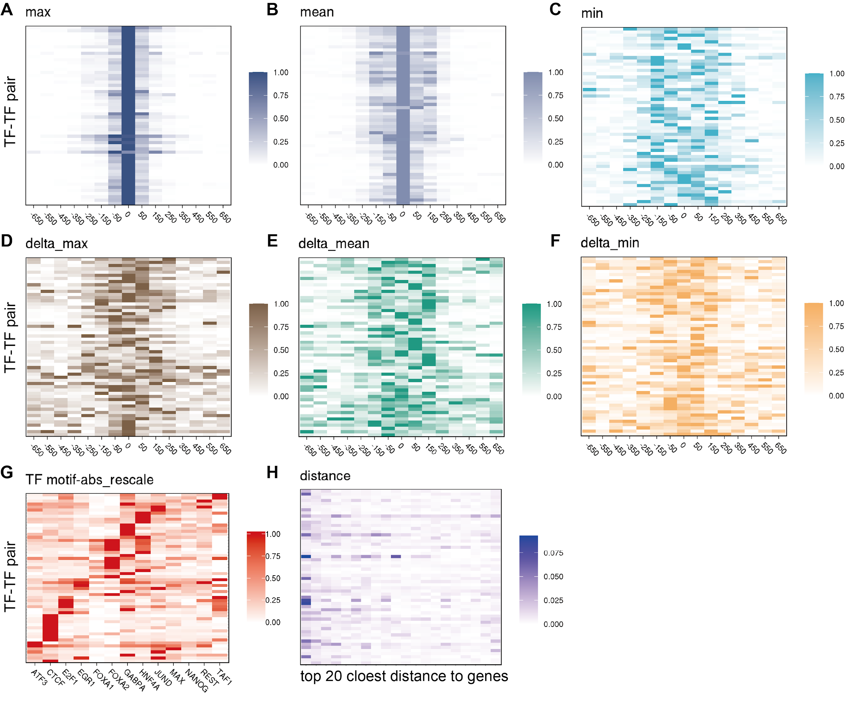

Figure S1. SHAP analysis of three types features and values are taking absolute values and rescaled by the maximal value for each TF pair-cell line combination. After training the model we can get a 526x56 matrix containing SHAP values for 526 features and 56 TF pairs. We took absolute values of the SHAP matrix to represent their feature importance. The plots are the relative slices for different features. (A-F) DNase-based feature. In each pair, values were rescaled to 0-1 among all positions. The reason to rescale is that the range of SHAP values differs largely in different pairs. So we rescaled values among each pair to the relative importance of each position in each pair. (G) TF motif features. The original motif feature is a 416x56 matrix. We calculated means for each TF related feature to represent the contribution of TFs among all TF-TF pairs and rescaled those means within each pair. (H) distance-to-gene-based features.

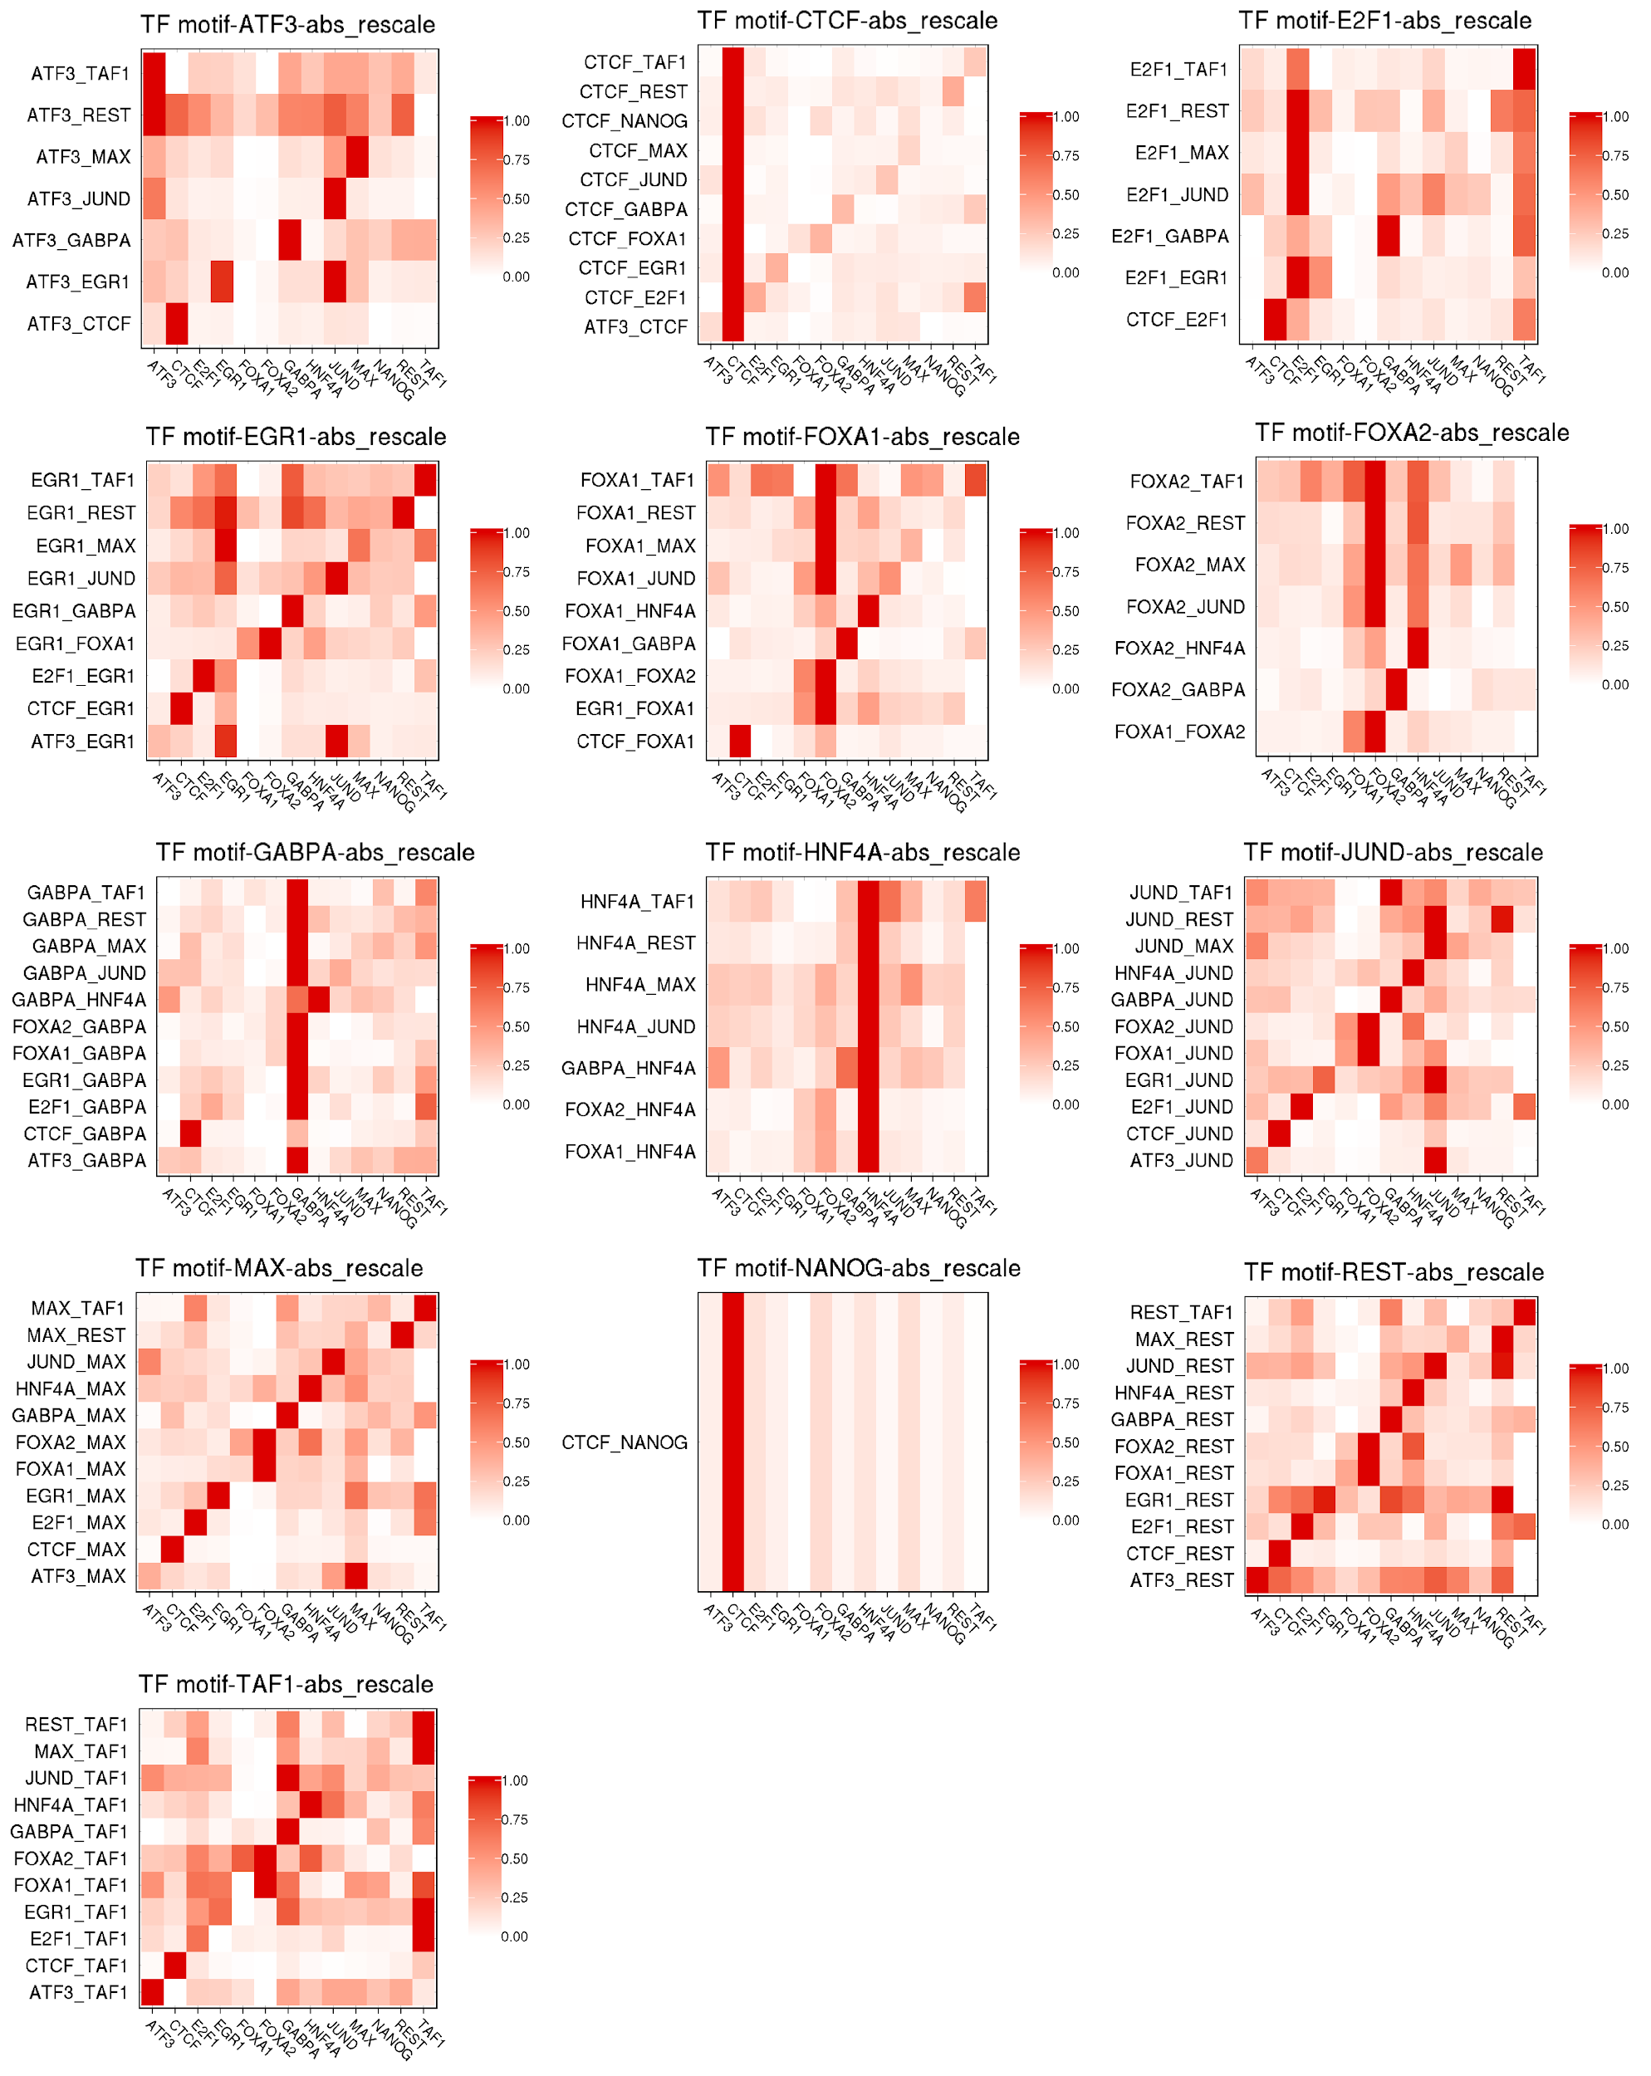

Figure S2. SHAP analysis of the contribution of TF motif features in different TF-TF pairs and values are taking absolute values and rescaled by the mean value for each TF pair-cell line combination. The 13 figures are sub-parts of Supplemental Figure 1G. The x-axis represents the 13 TF motif features, the y-axis represents pairs tied to a specific TF. For example, the figure in the first row and the first column is the rows in Supplemental Figure 1G that are related to ATF3. We can find TF cobinding effectors from the figure. To find TF-specific effectors, we first calculated means of each column in one plot. Then we selected the top3 means among the 13 values. Then, we defined it as a TF-specific effector. For TF pair-specific effectors, we collected TFs that had a higher SHAP value than the two TFs themselves.

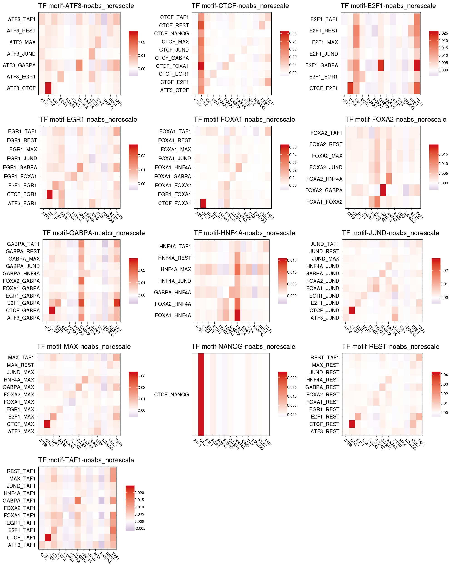
Figure S3. SHAP analysis of the contribution of TF motif features in different TF-TF pairs and values are taking original values for each TF pair-cell line combination. The sign of each value was assigned by the correlation between the gold standard and features. The x-axis represents the 13 TF motif features, the y-axis represents pairs tied to a specific TF.

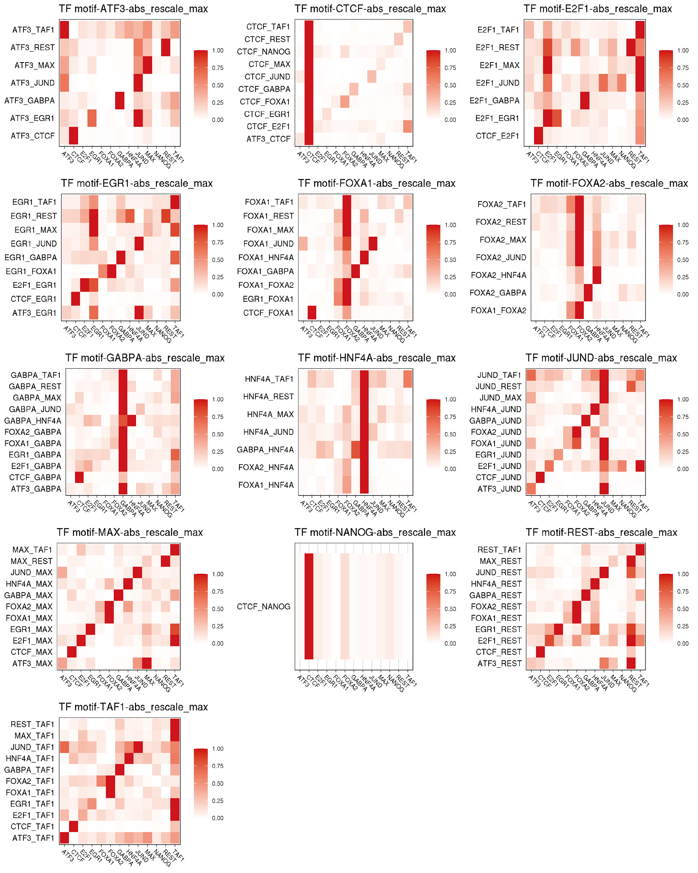

Figure S4. SHAP analysis of the contribution of TF motif features in different TF-TF pairs and values are taking absolute values and rescaled by the maximum value for each TF pair-cell line combination. Similar to Supplemental Figure 2, the x-axis represents the 13 TF motif features, the y-axis represents pairs tied to a specific TF. The difference is that in Supplemental Figure 2, the contribution of one TF motif features is calculated by averaging that TF motif features related to that TF. This plot is by taking maximum instead of mean. The patterns of taking mean and maximum do not differ much.

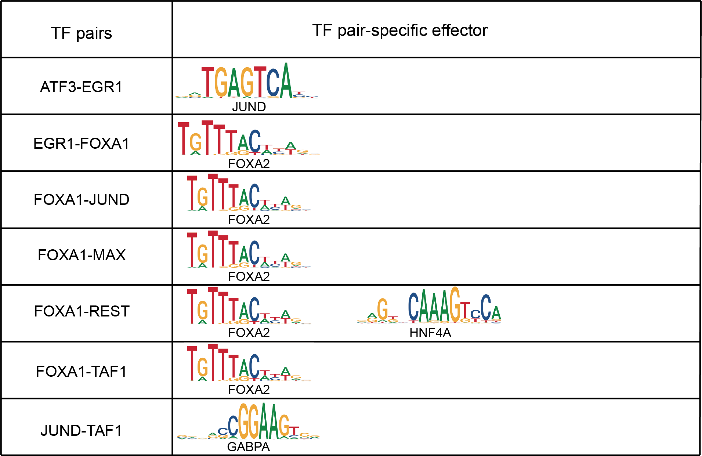Figure S5. TF pair-specific effectors, defined as TFs whose sum of absolute SHAP values are larger than both of the TFs of the pair; FOXA1-FOXA2 included.

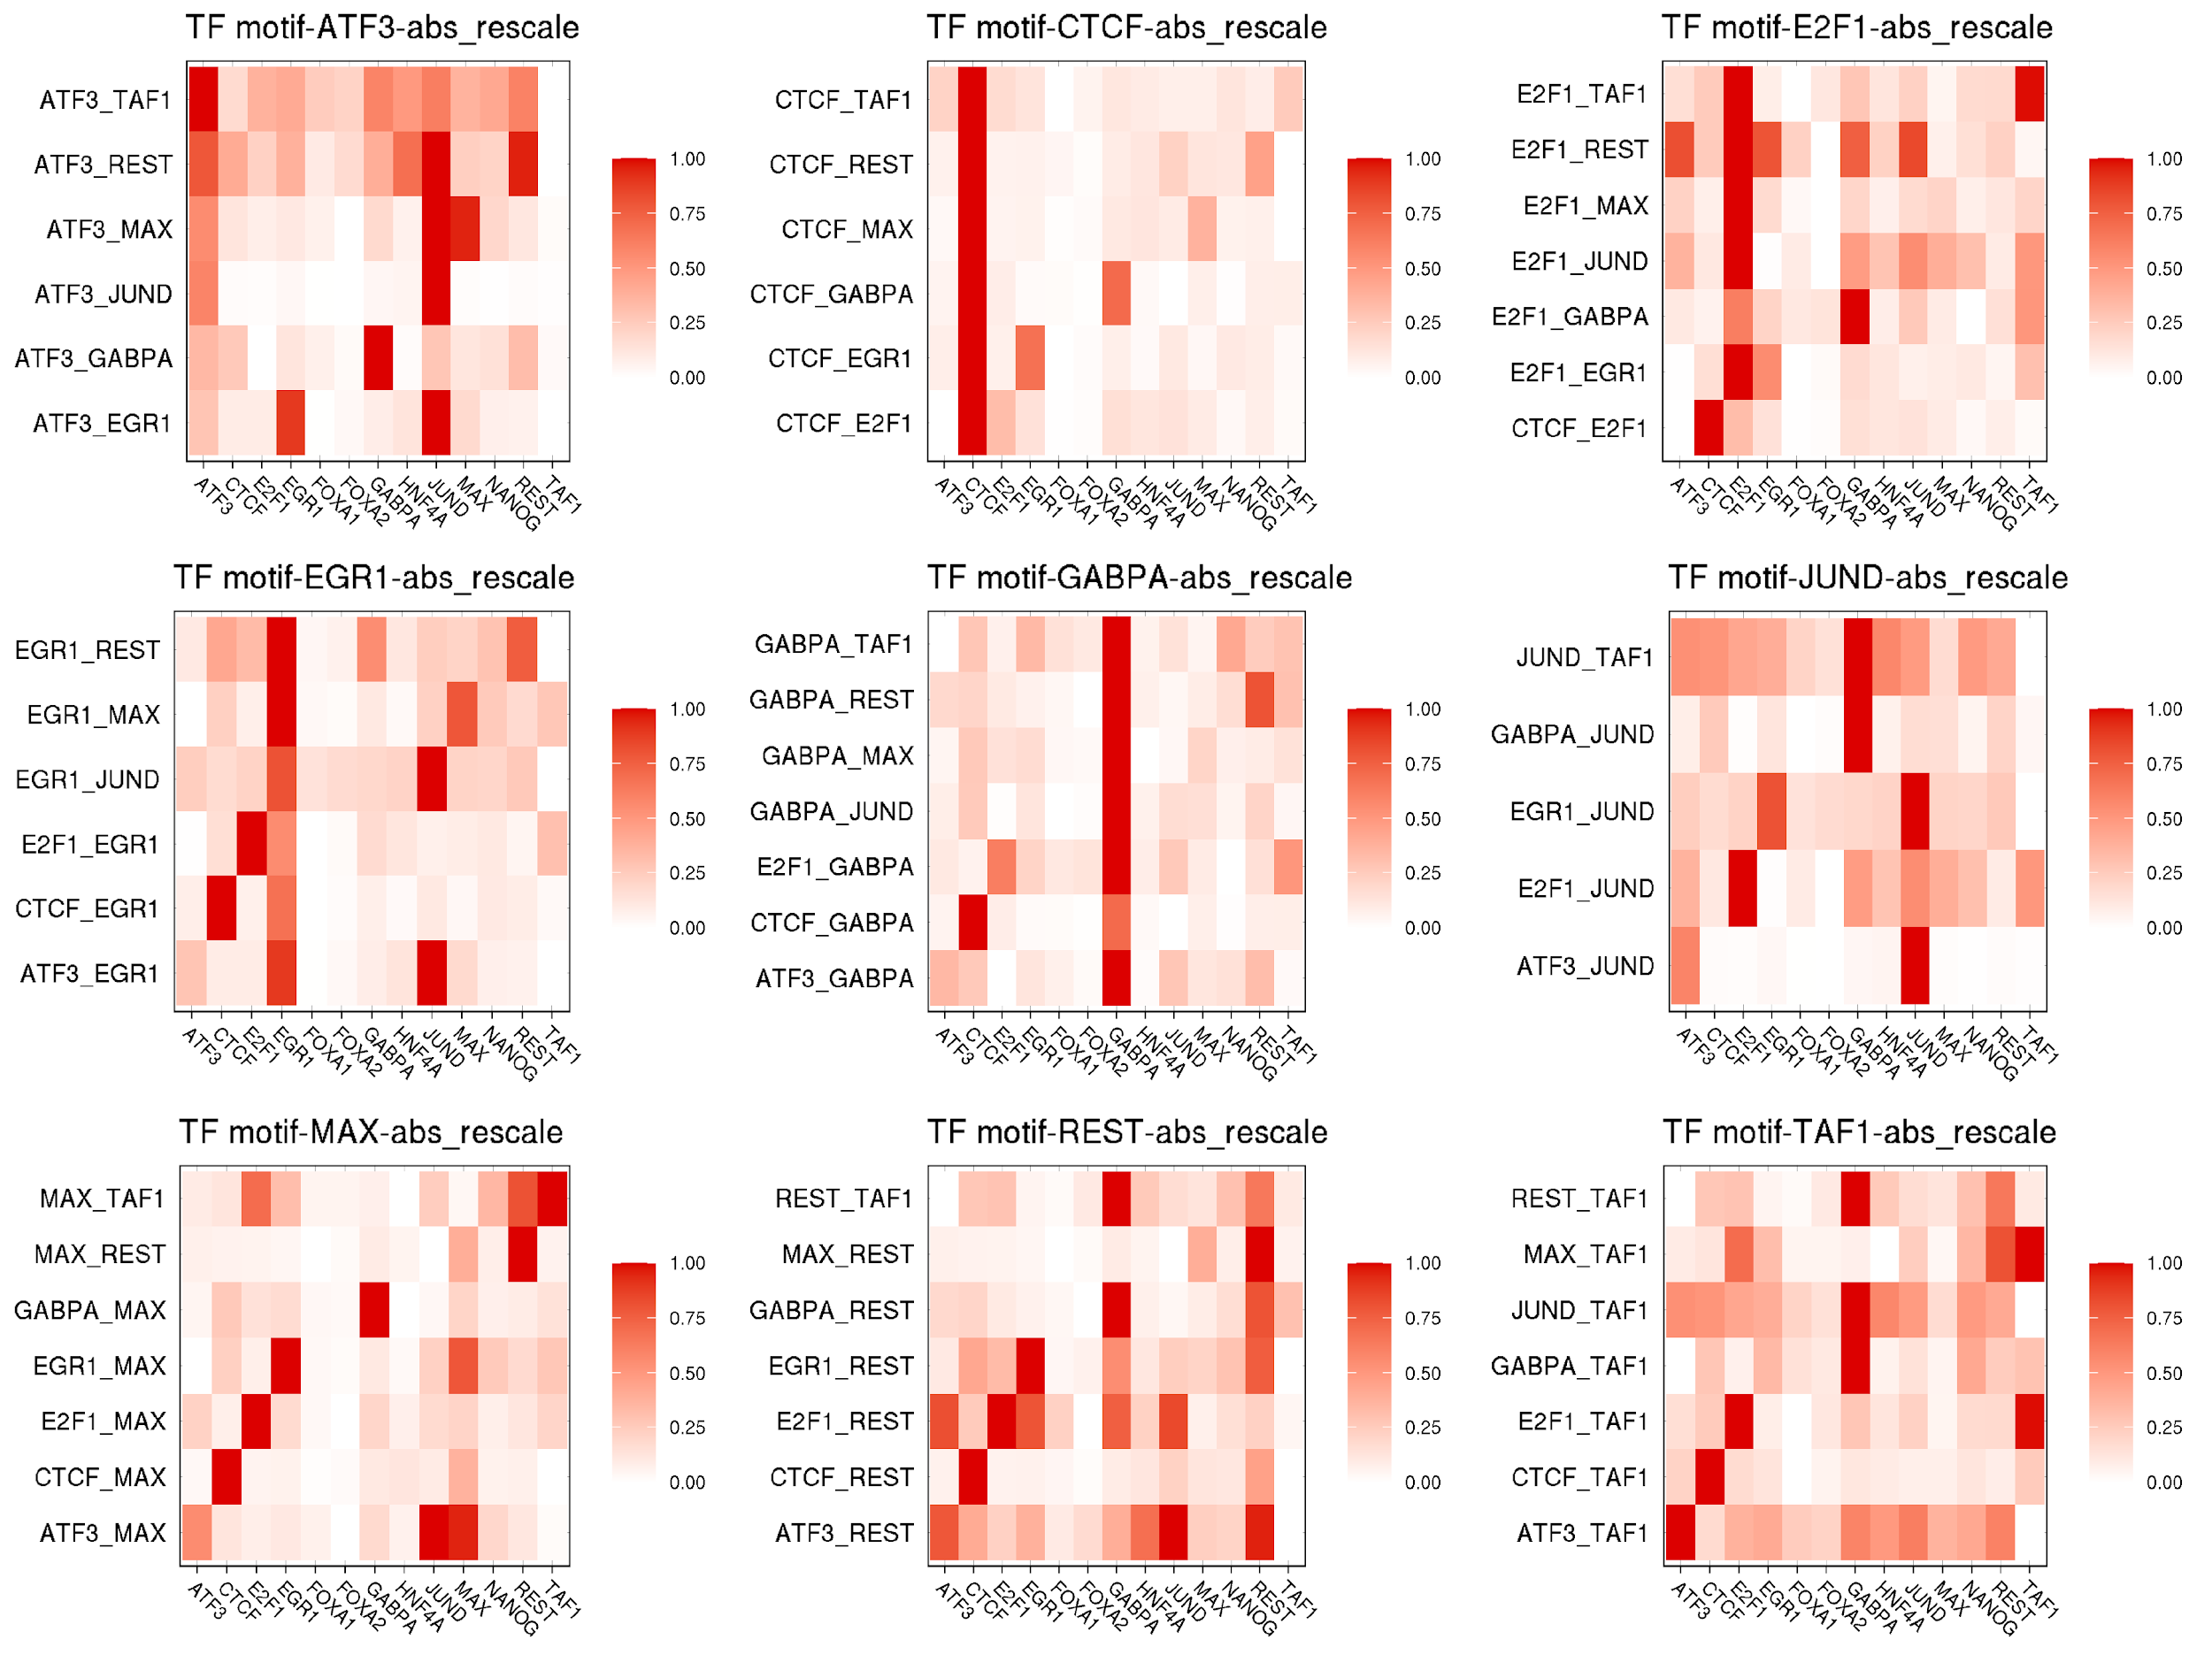
Figure S6. SHAP patterns of cell line K562 excluding HOT sites. We counted the number of binding TFs in each position for cell line K562 and then used the 99th percentile threshold to define the HOT sites. We excluded shap values in those HOT sites and plotted the pattern. The pattern is similar to that including HOT sites, which is shown in Supplementary Figure S7. The correlation between the two figures is 0.9944.

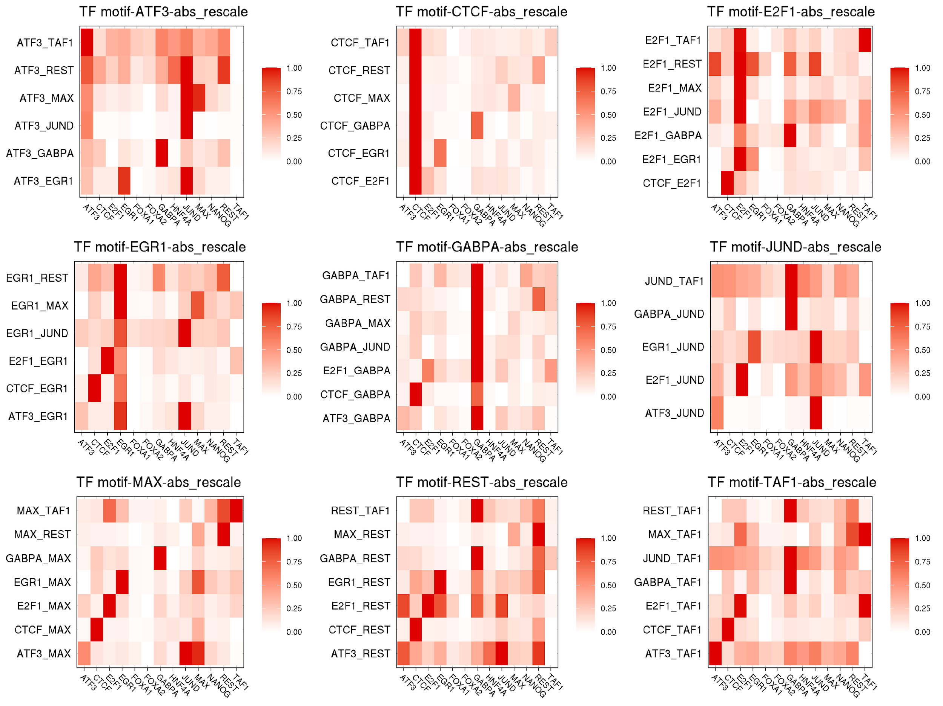
Figure S7. SHAP patterns of cell line K562 including HOT sites.

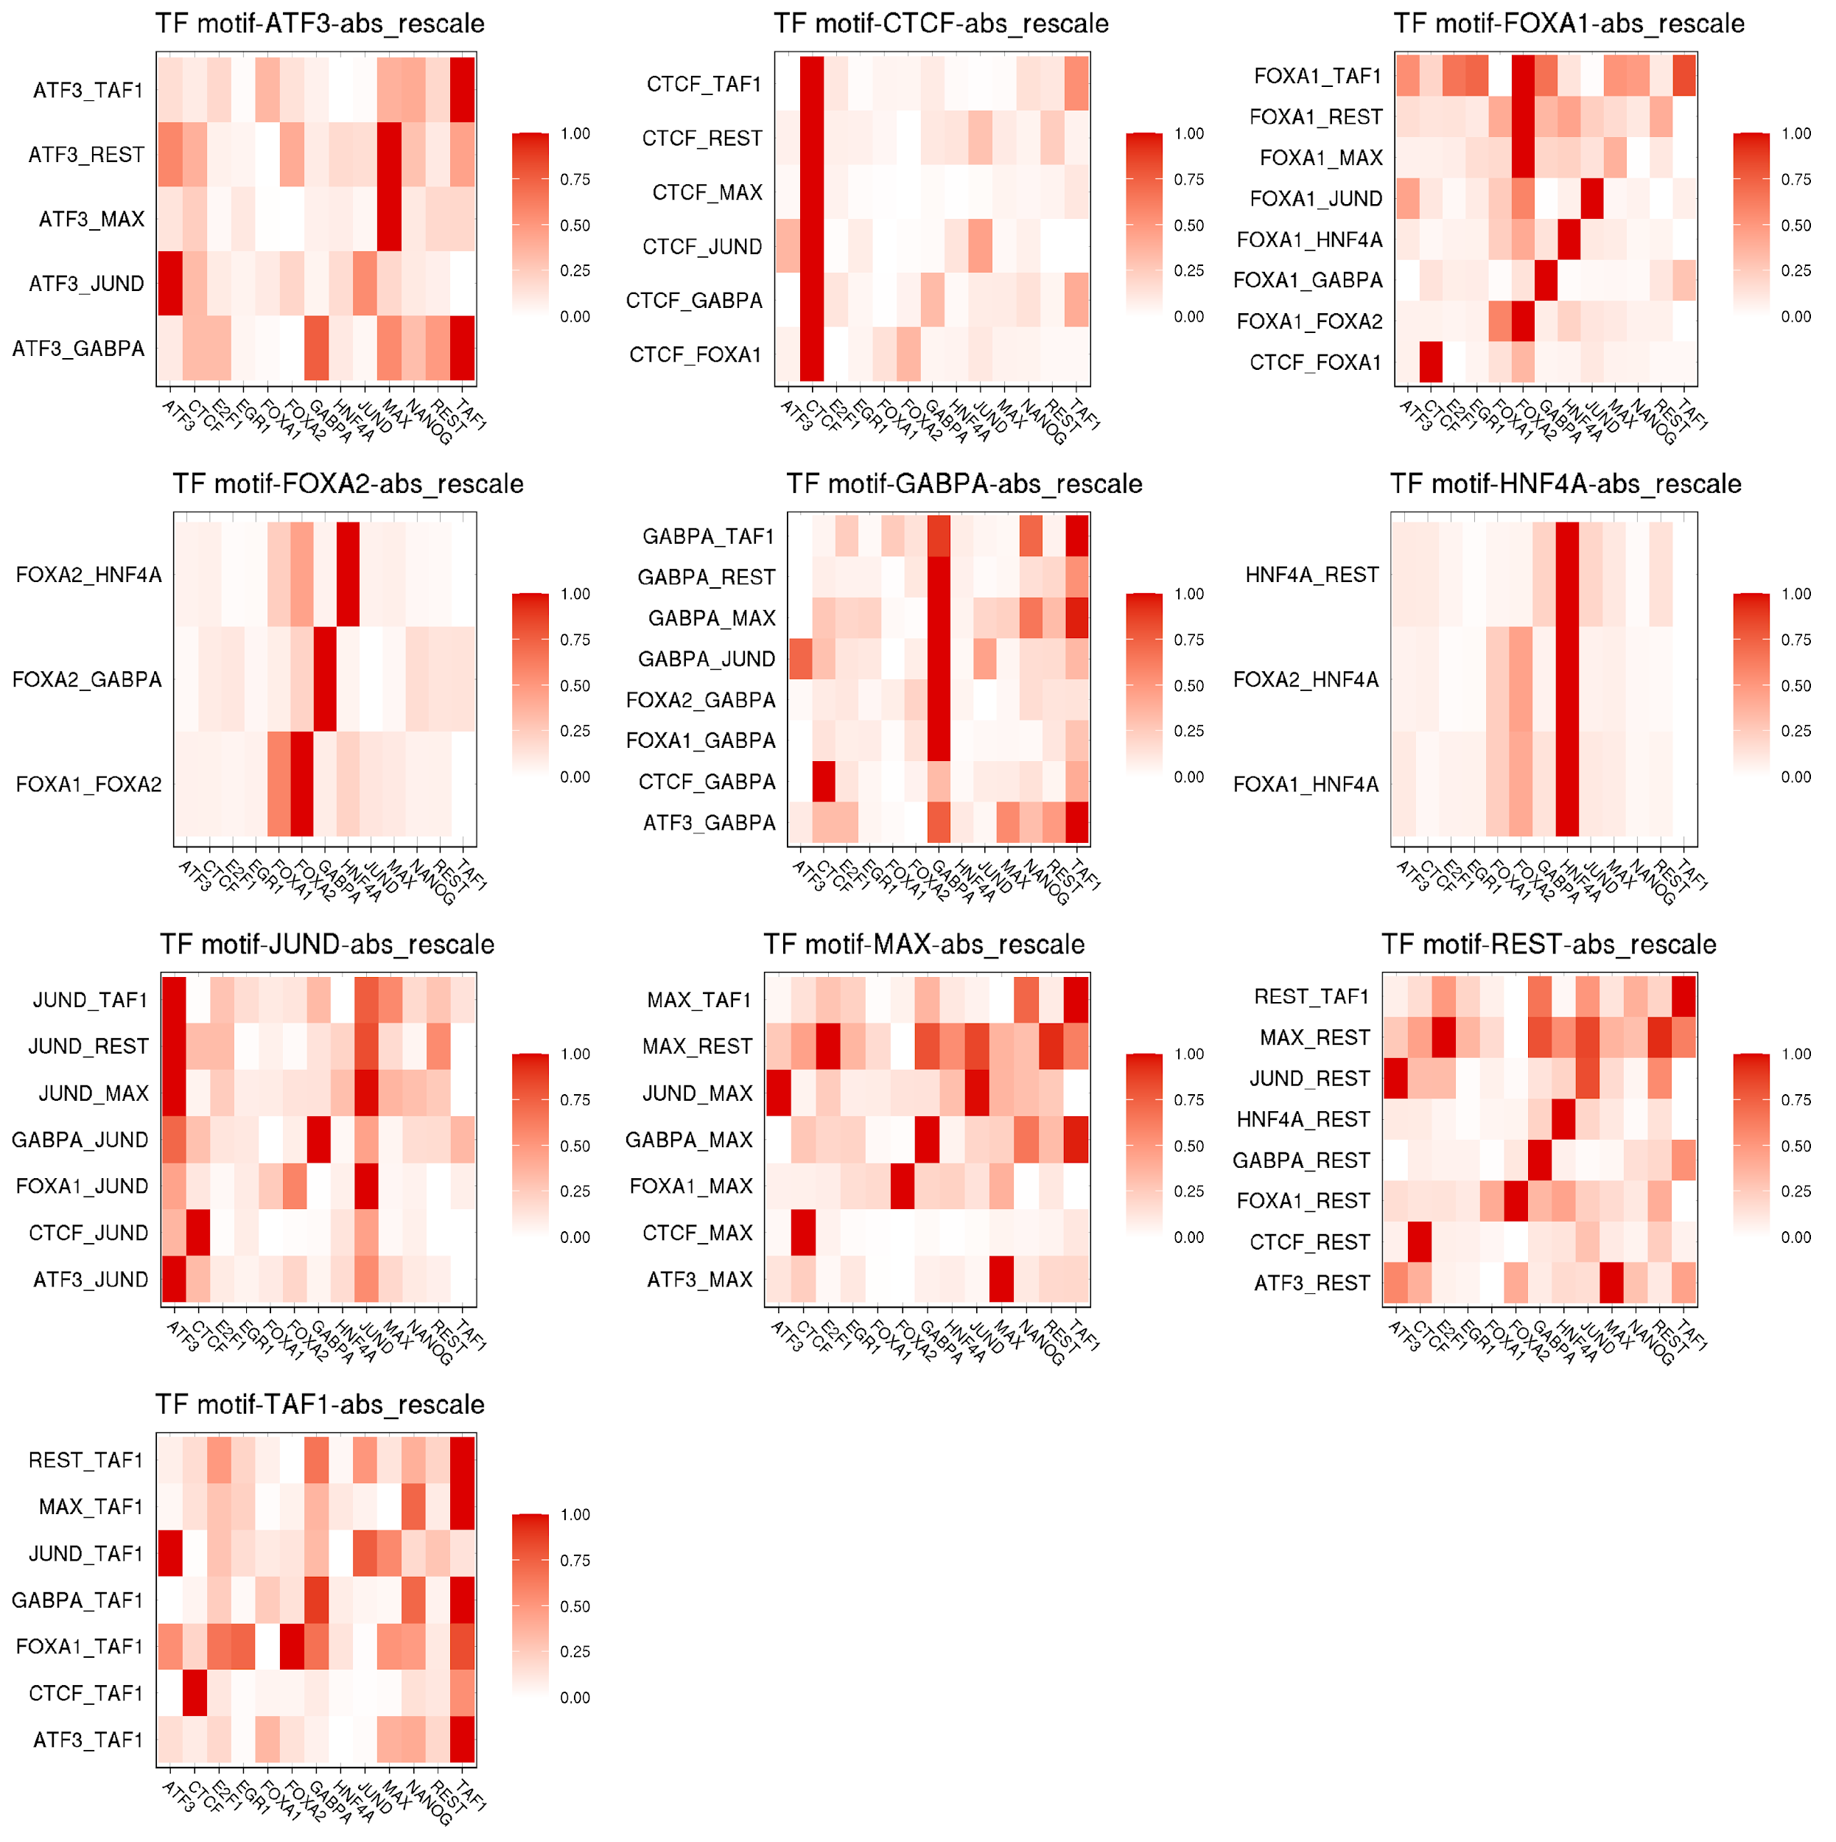
Figure S8. SHAP patterns of cell line HepG2 excluding HOT sites. We counted the number of binding TFs in each position for cell line HepG2 and then used the 99th percentile threshold to define the HOT sites. We excluded shap values in those HOT sites and plotted the pattern. The pattern is similar to that including HOT sites, which is shown in Supplementary Figure S9. The correlation between the two figures is 0.9940.

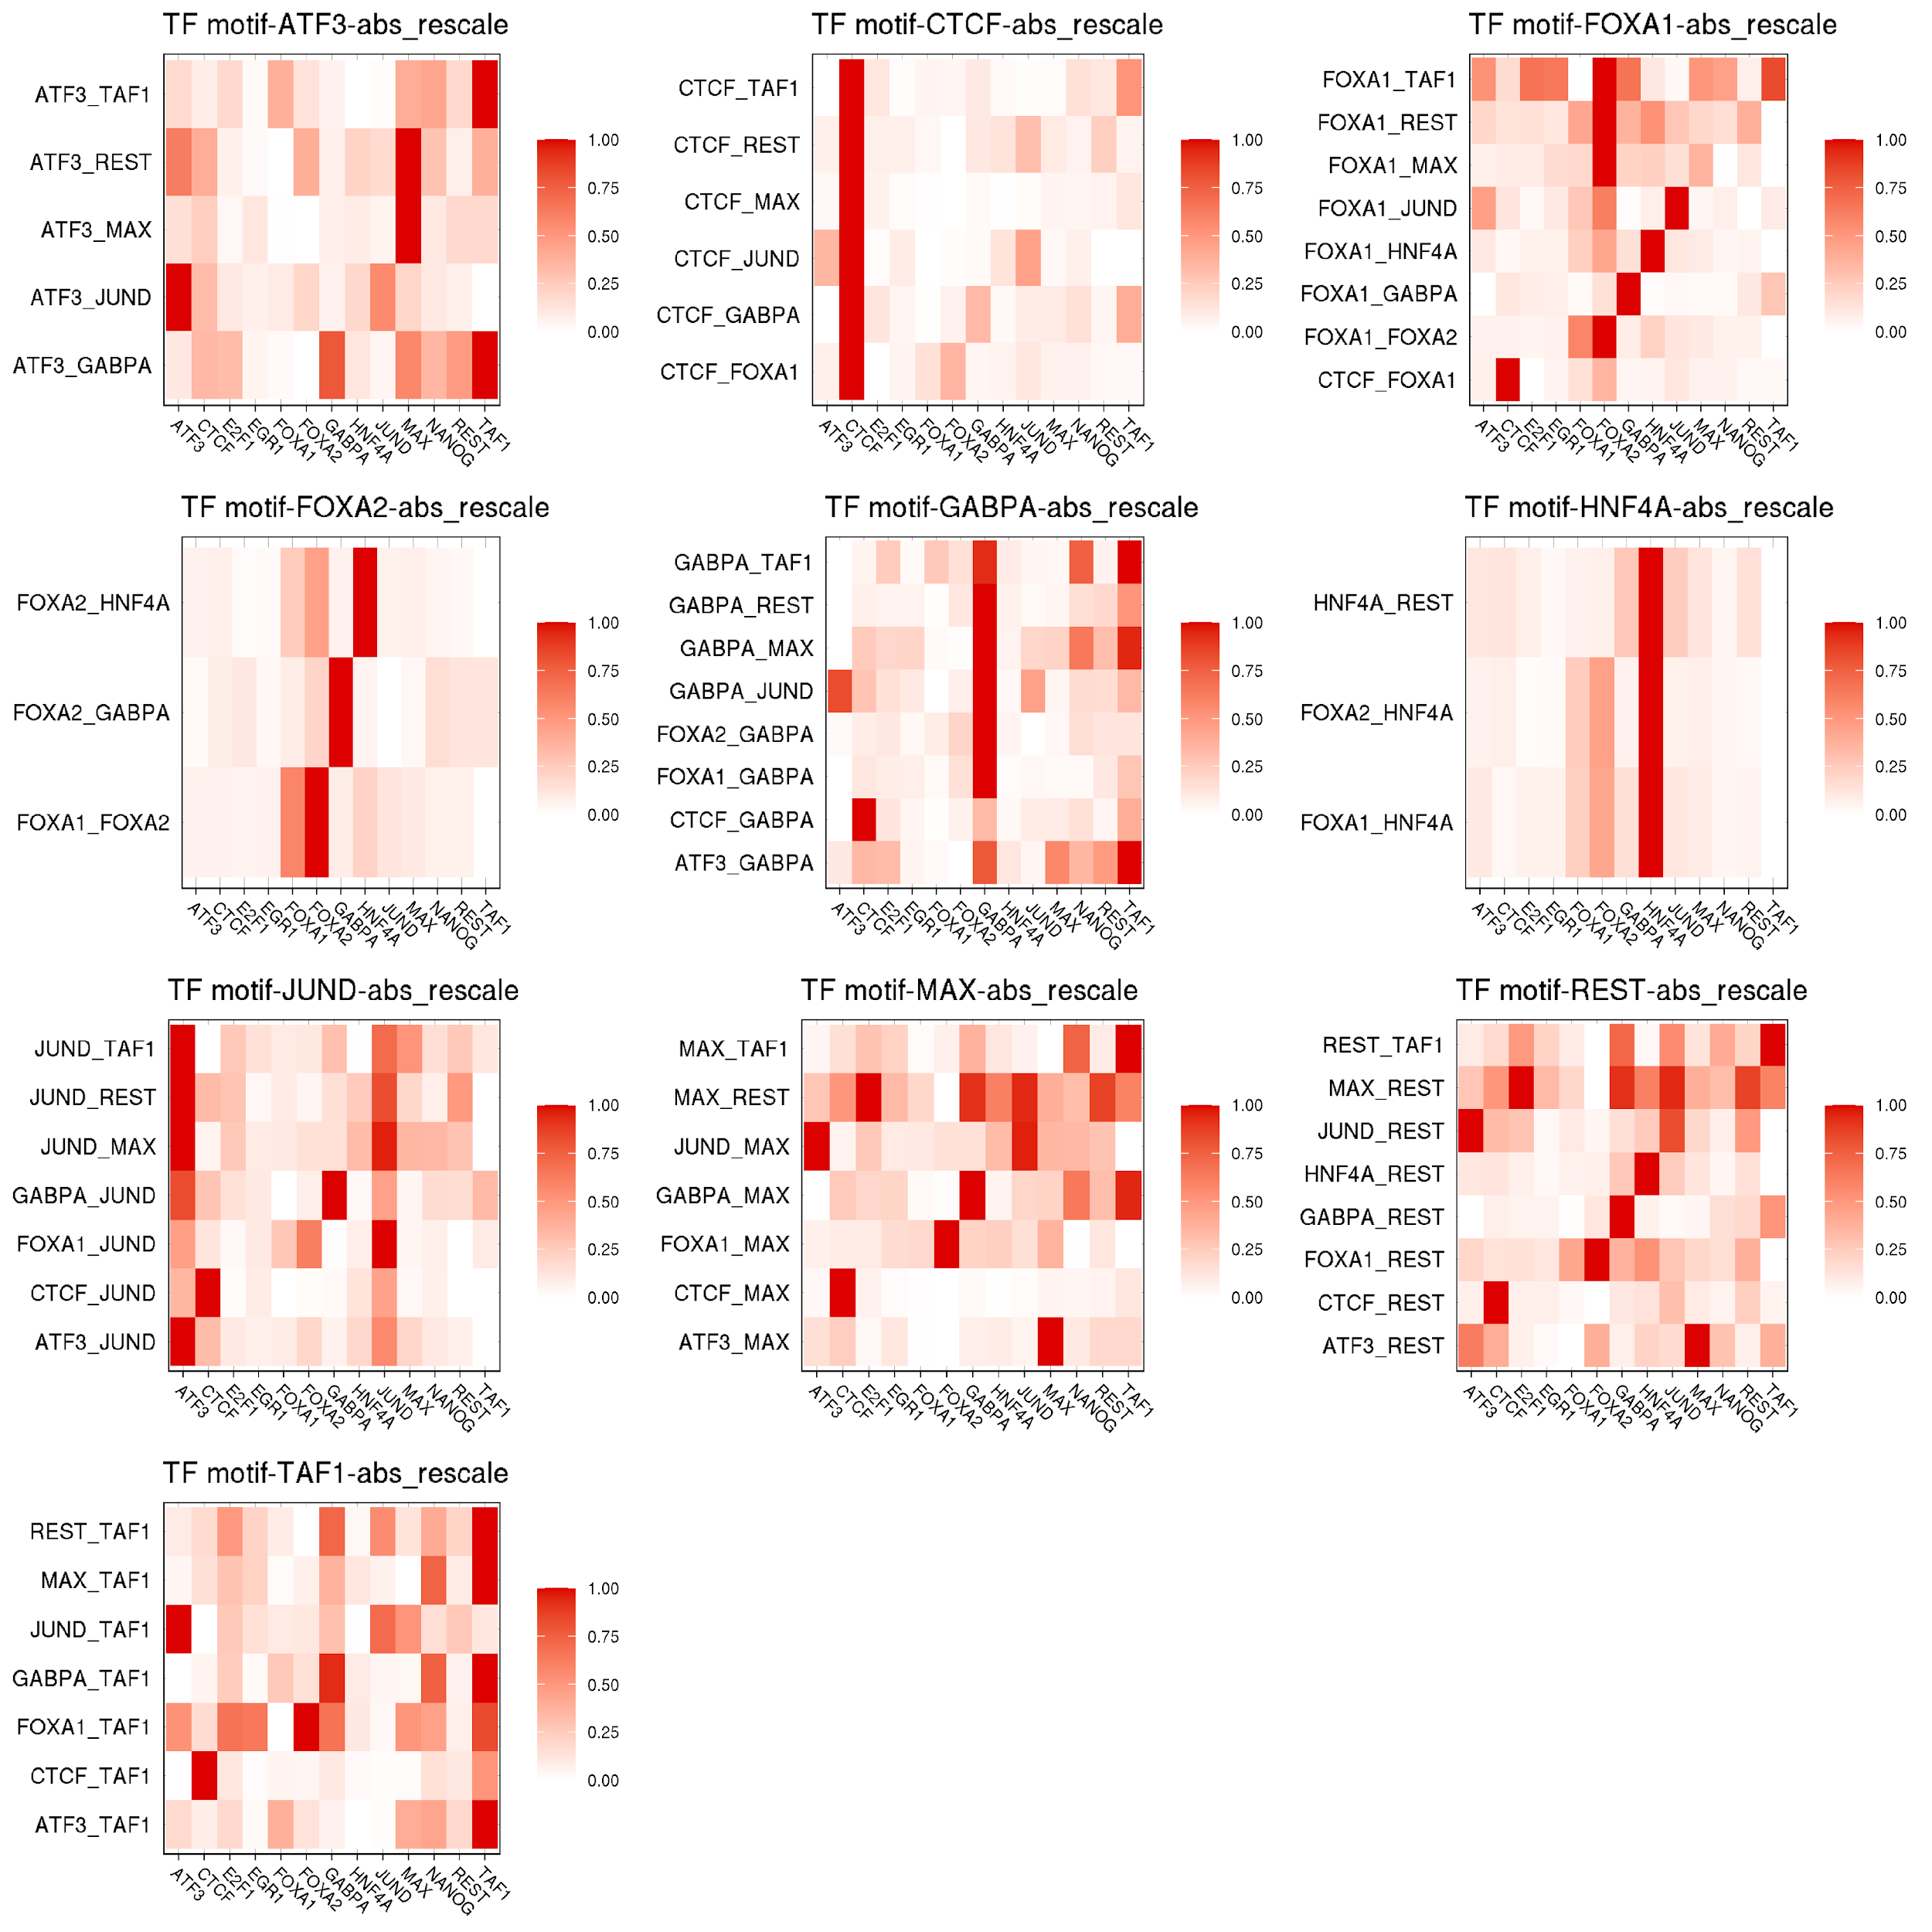
Figure S9. SHAP patterns of cell line HepG2 including HOT sites.

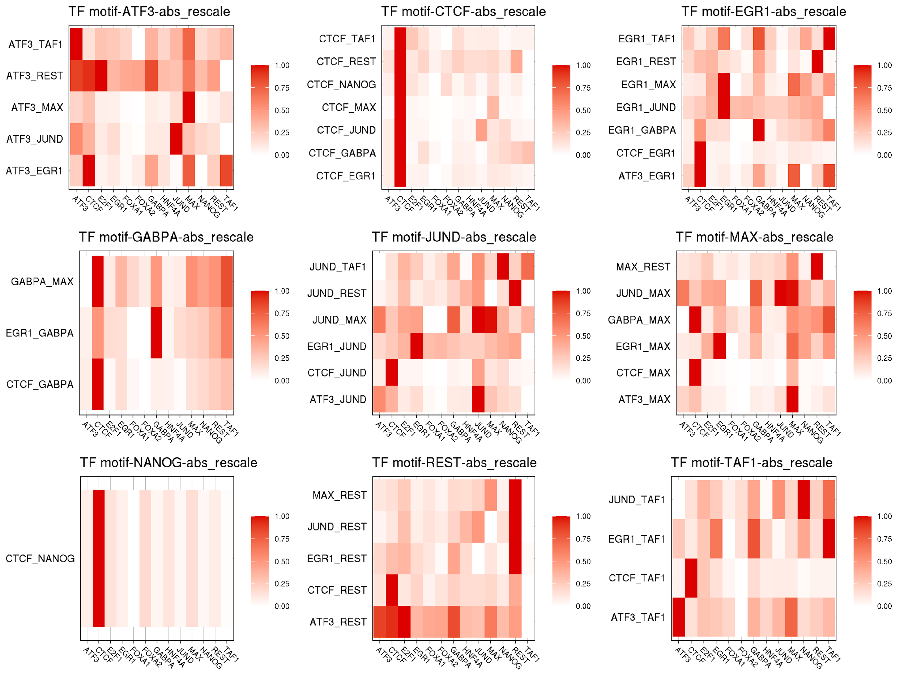
Figure S10. SHAP patterns of cell line H1-hESC excluding HOT sites. We counted the number of binding TFs in each position for cell line H1-hESC and then used the 99th percentile threshold to define the HOT sites. We excluded shap values in those HOT sites and plotted the pattern. The pattern is similar to that including HOT sites, which is shown in Supplementary Figure S11. The correlation between the two figures is 0.9995.

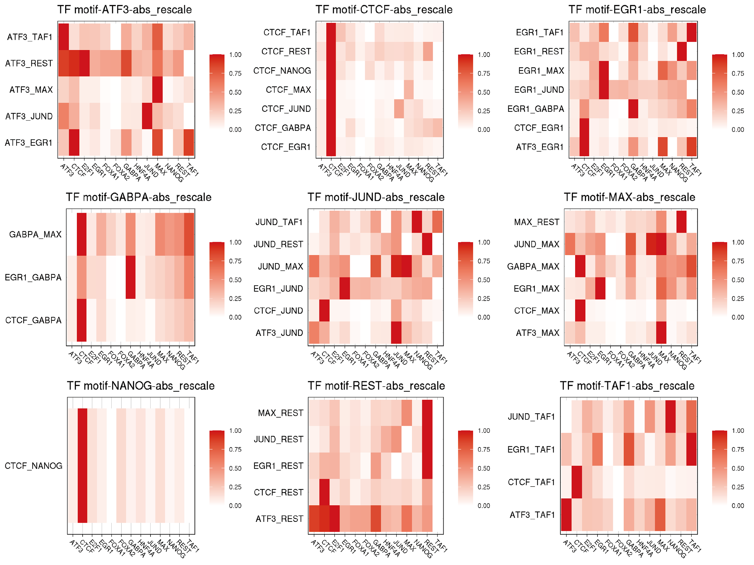
Figure S11. SHAP patterns of cell line H1-hESC including HOT sites.

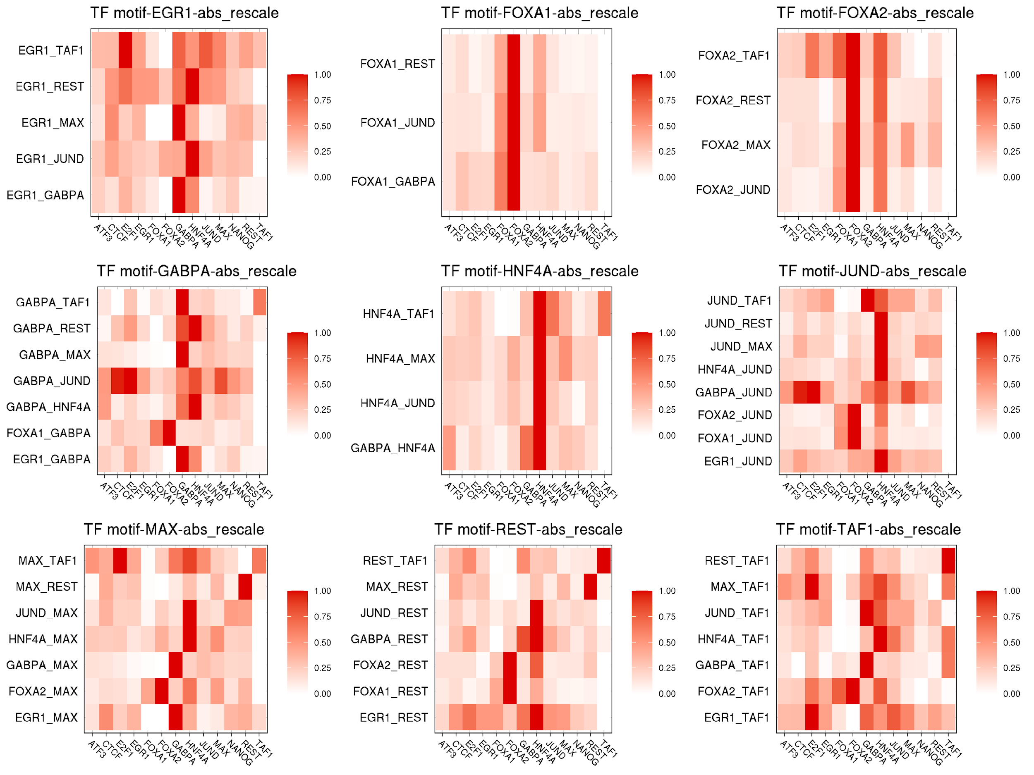
Figure S12. SHAP patterns of cell line liver excluding HOT sites. We counted the number of binding TFs in each position for cell line liver and then used the 99th percentile threshold to define the HOT sites. We excluded shap values in those HOT sites and plotted the pattern. The pattern is similar to that including HOT sites, which is shown in Supplementary Figure S13. The correlation between the two figures is 0.9961.

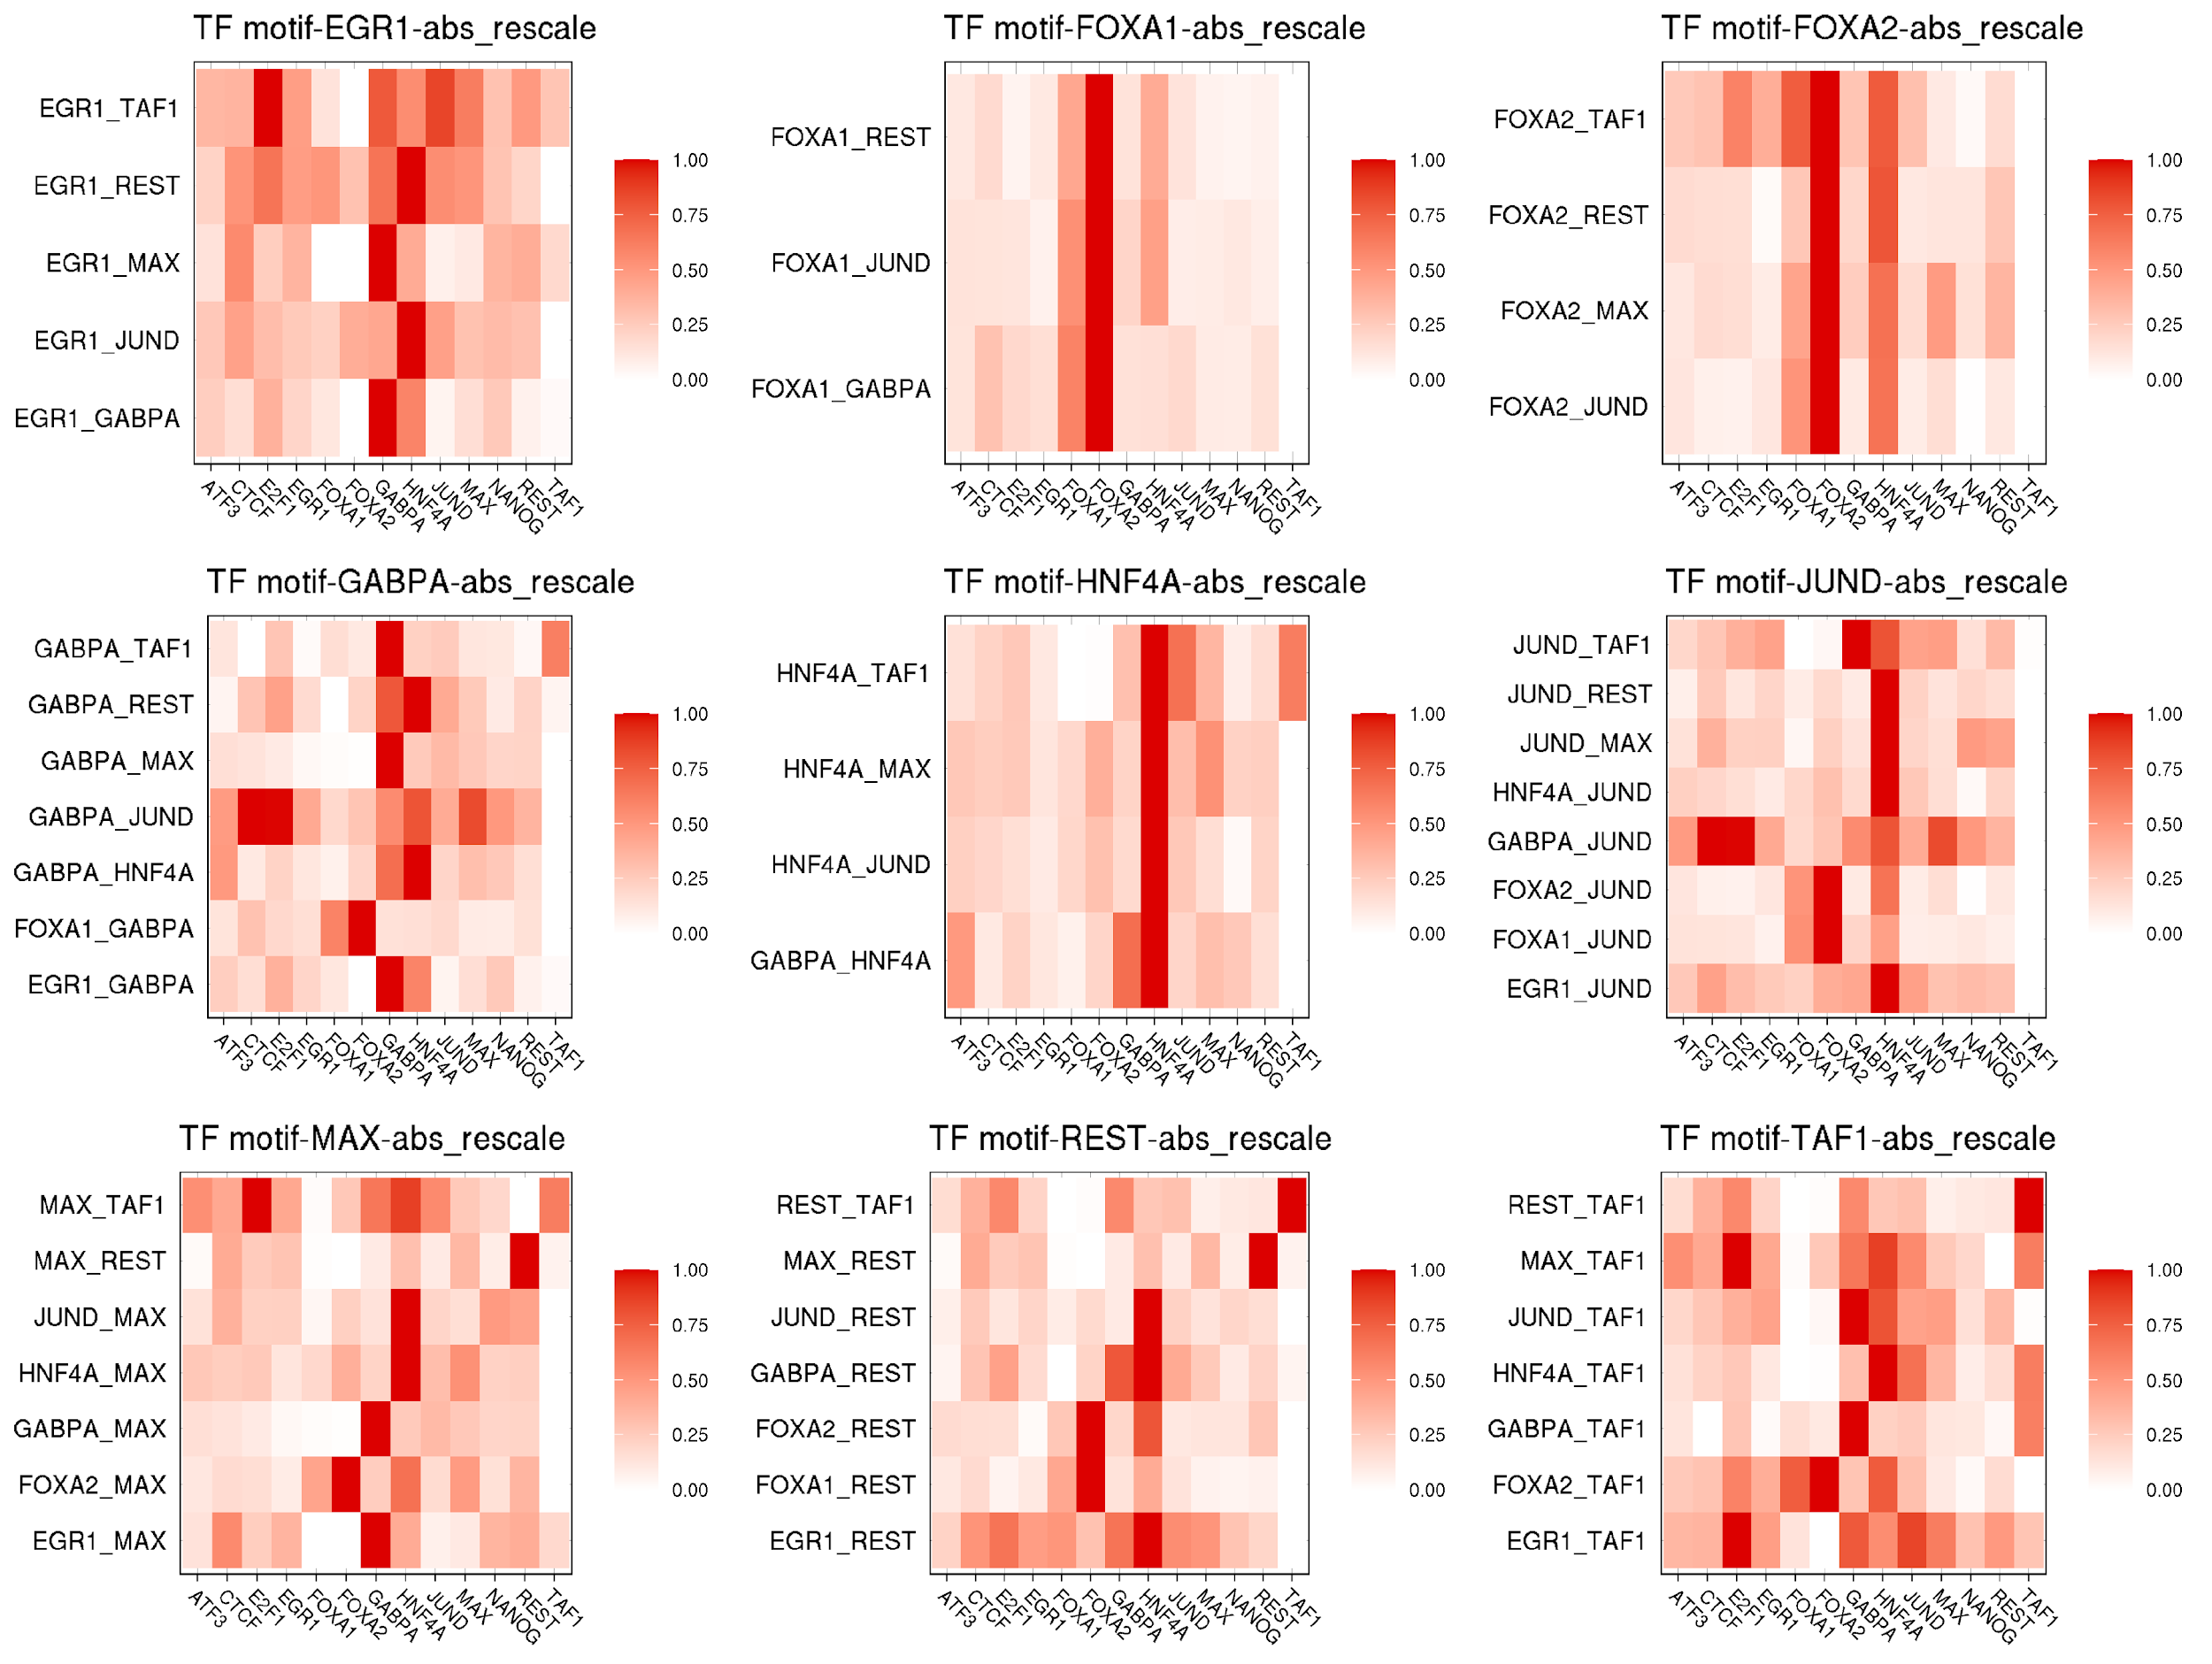
Figure S13. SHAP patterns of cell line liver including HOT sites.

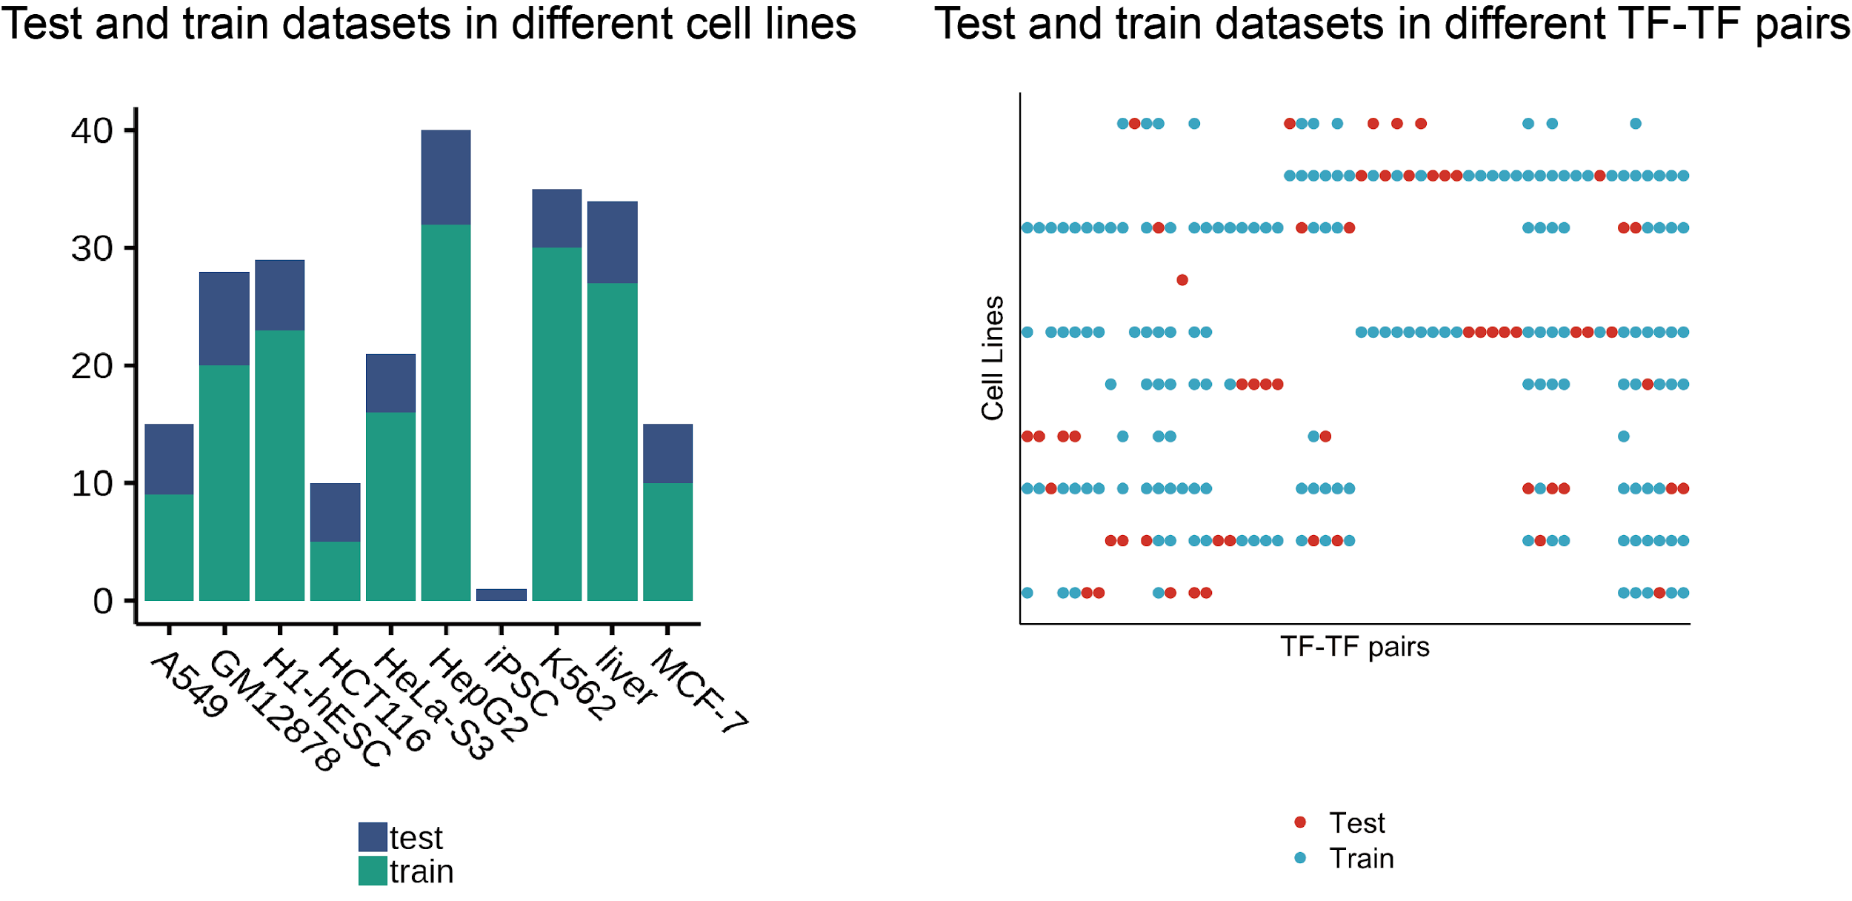

Figure S14. Construction of training and testing datasets. The split rule is that in each TF-TF pair, one cell type was selected as the test cell type, and after a proper selection, the number of test datasets in each cell type should be approximately equal. The split result was indicated by a 2-D plot on the right channel. The x-axis represented 56 TF-TF pairs and the y-axis represented 10 cell types. The blue dots denoted the 172 training datasets while the red dots symbolized the 56 testing datasets. The left channel indicated the proportion of testing and training data in cell types, where the blue bar was the testing data and the green bar was the training data. Based on the height of blue bars, it is obvious that the number of testing data is approximately equal in cell types except for iPSC, which has only one dataset.

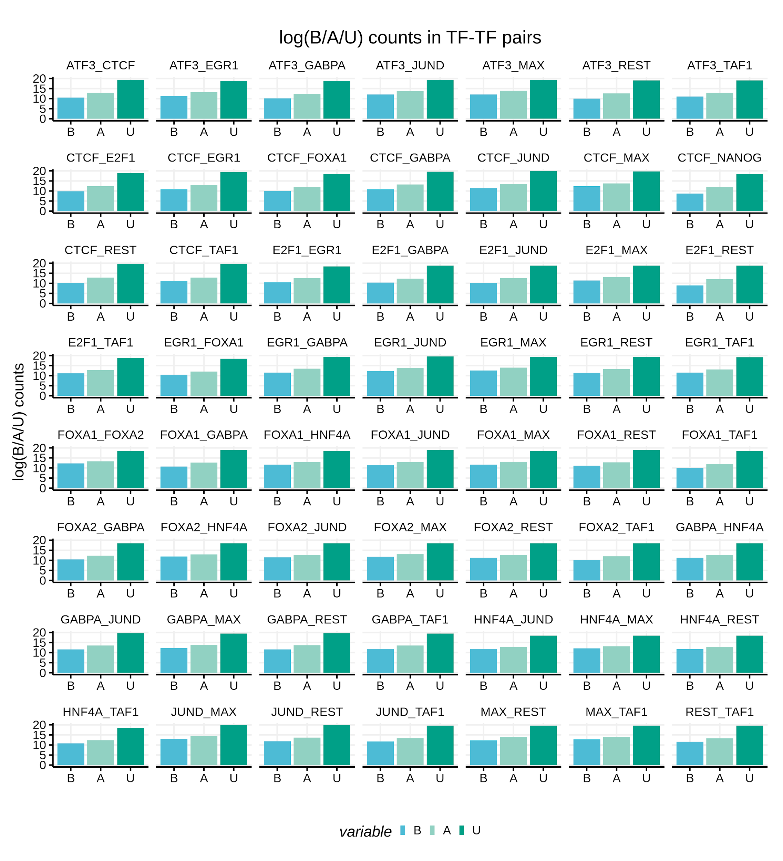

Figure S15. Counts of three different labels in TF-TF pairs According to the generating rule, there are three different labels of co-occupancy events: (i) ‘B’ represents ‘co-bound’, (ii) ‘U’ represents ‘un-co-bound’, and (iii) ‘A’ represents ‘ambiguous’. To inspect the distribution of different labels in TF-TF pairs, we averaged the count number over cell types and did a log transform on the count number of different labels. In all 56 TF-TF pairs, label ‘B’ was of the smallest proportion as indicated by the blue bar. On the contrary, label ‘U’ held the largest proportion in all TF-TF pairs since the deep blue bars had the highest height among the three color bars. Label ‘A’ also took a similar proportion as label ‘B’, but we exclude data with label ‘A’ in the further analysis.

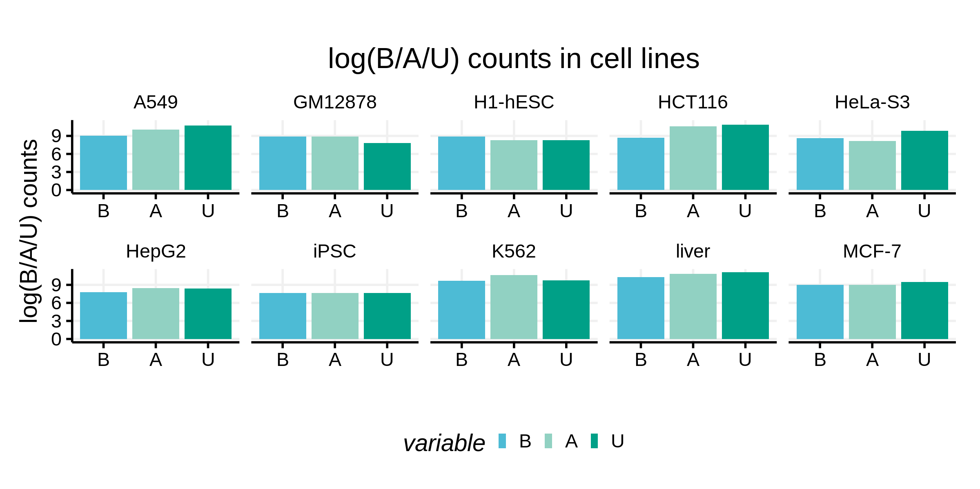

Figure S16. Counts of three different labels in cell types. To describe the count number of three different labels in cell types, we averaged the count number of different TF-TF pairs in one cell type. Different from the situation in TF-TF pairs where ‘U’ was of the largest proportion and ‘B’ was of the smallest proportion in all pairs, there was no common relationship among 10 cell types. In some cell types, like A549 and HCT116, the number of un-co-bound events was larger than the number of co-bound events. However, in other cell types like K562 and iPSC, the two counts did not differ much. In cell type GM12878, the number of co-bound events exceeded the number of un-co-bound events. Among the 10 cell types, cell types K562 and liver had the largest proportion of label ‘B’ compared with other cell types while cell types HepG2 and iPSC had the smallest proportion of label ‘B’.

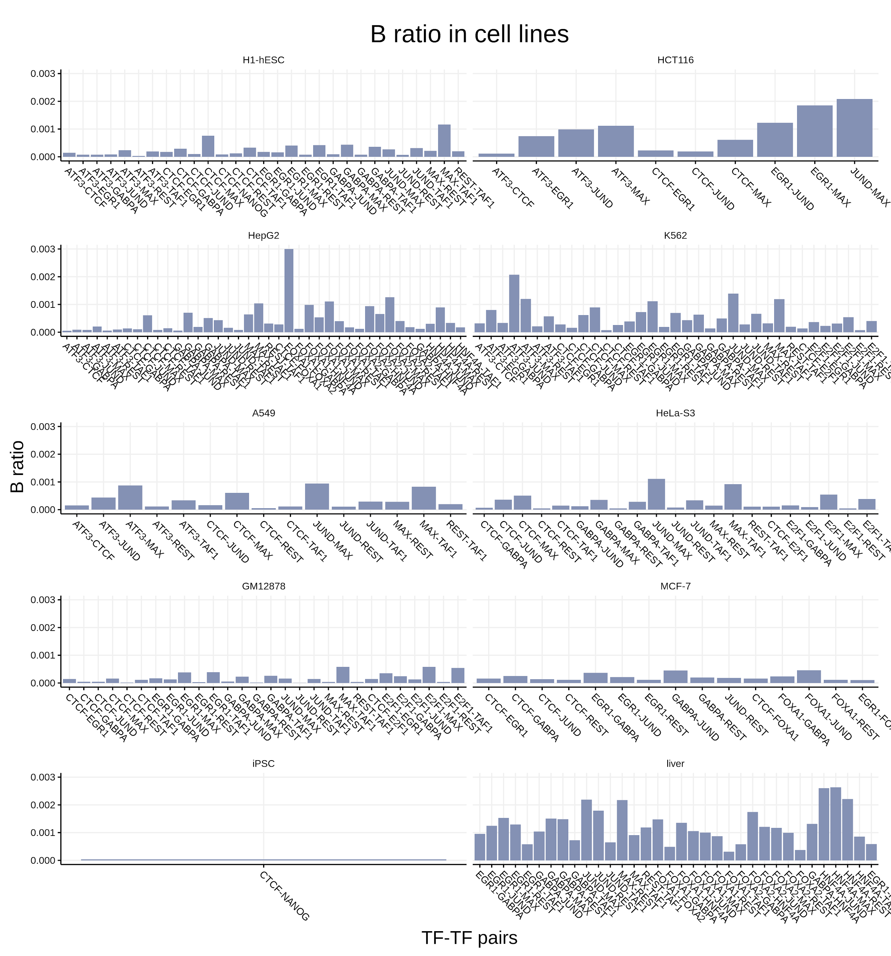

Figure S17. The proportion of ‘co-bound’ labels in different cell types and TF-TF pairs In the histograms above, each figure indicated one cell type and the horizontal axis represented different TF-TF pairs. The number of available TF-TF pair data in each cell type was different. This was because when generating the co-occupancy date, two TFs may not have data in the same cell types, thus not all TF-TF pairs had the co-occupancy date in 10 cell types. Moreover, the ratio of label ‘B’ was different both in TF-TF pairs and in the cell types. For example, in cell type HCT116, we had the co-occupancy data of 10 TF-TF pairs. Among those cell pairs, JUND-MAX had the largest label ‘B’ ratio and ATF3-CTCF had the smallest ratio. Among the 10 cell types and all possible TF-TF pairs, the ratio of label ‘B’ had the largest value in FOXA1-FOXA2 in cell type HepG2.

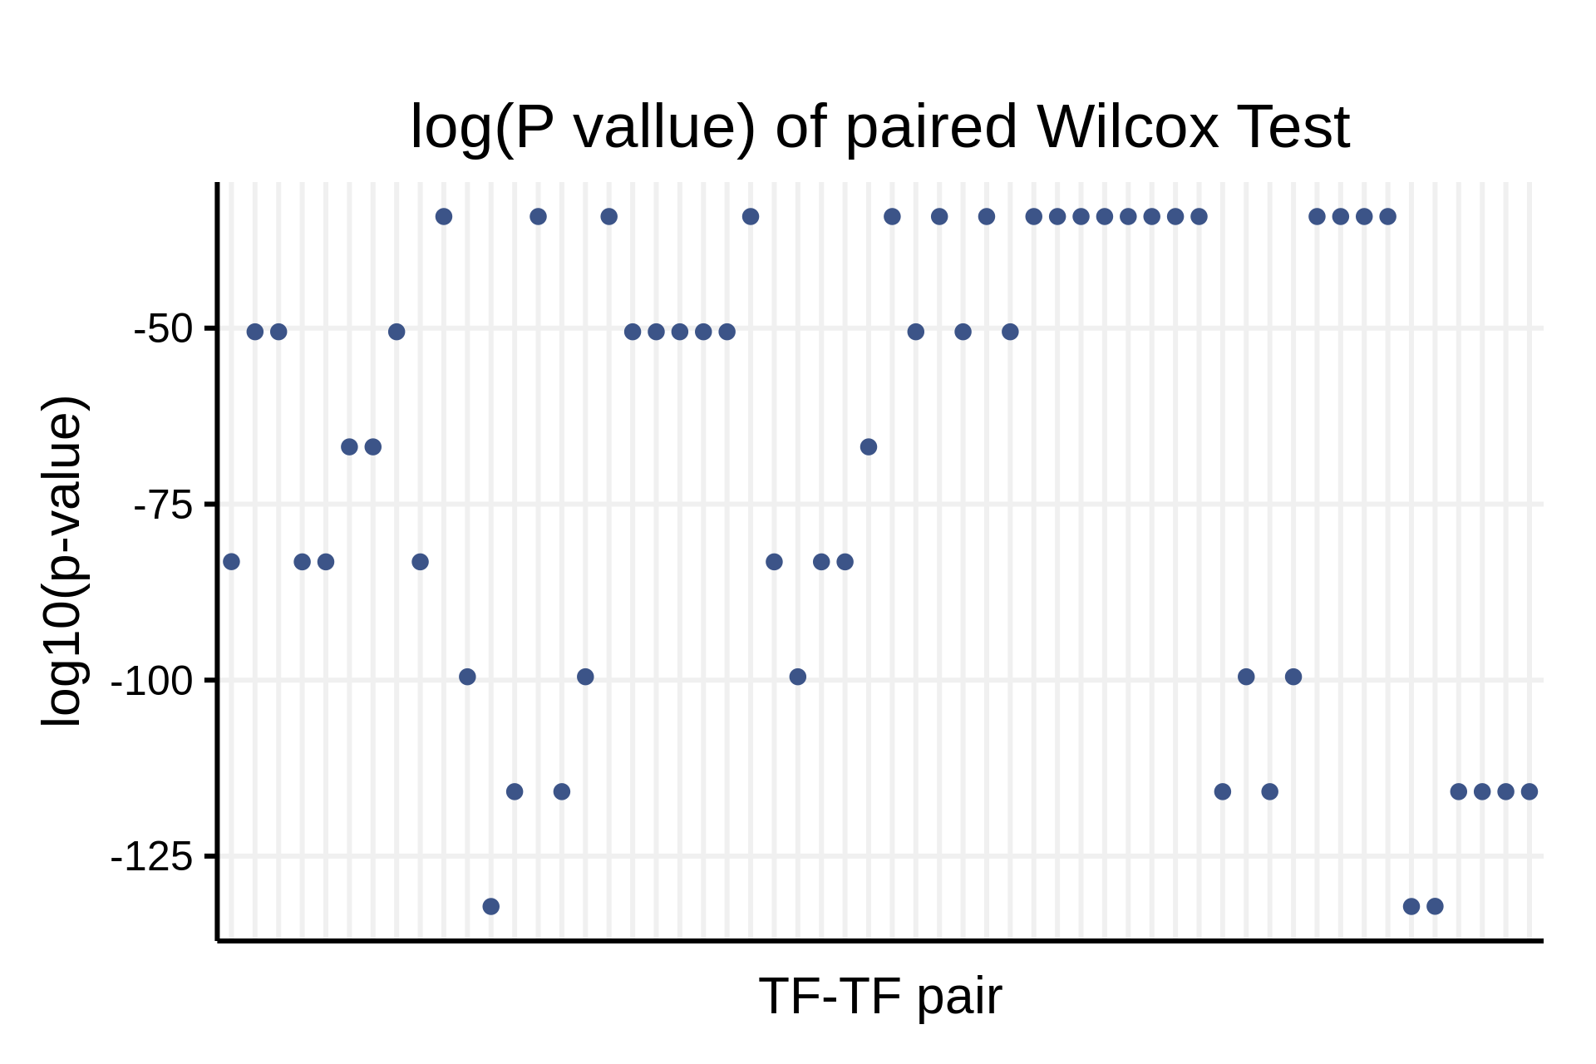

Figure S18. The log(p-value) of the paired Wilcoxon Test in different TF-TF pairs. After applying the paired Wilcoxon Test for each TF-TF pair, we got a total of 56 p-values. All p-values are smaller than 0.0001. To better distinguish those values, we did a log transformation to all collected p-values. Moreover, to control the overall familywise error rate as 0.01, all p-values should be below 0.00178. The results indicate that all TF-TF pairs significantly co-occupy.

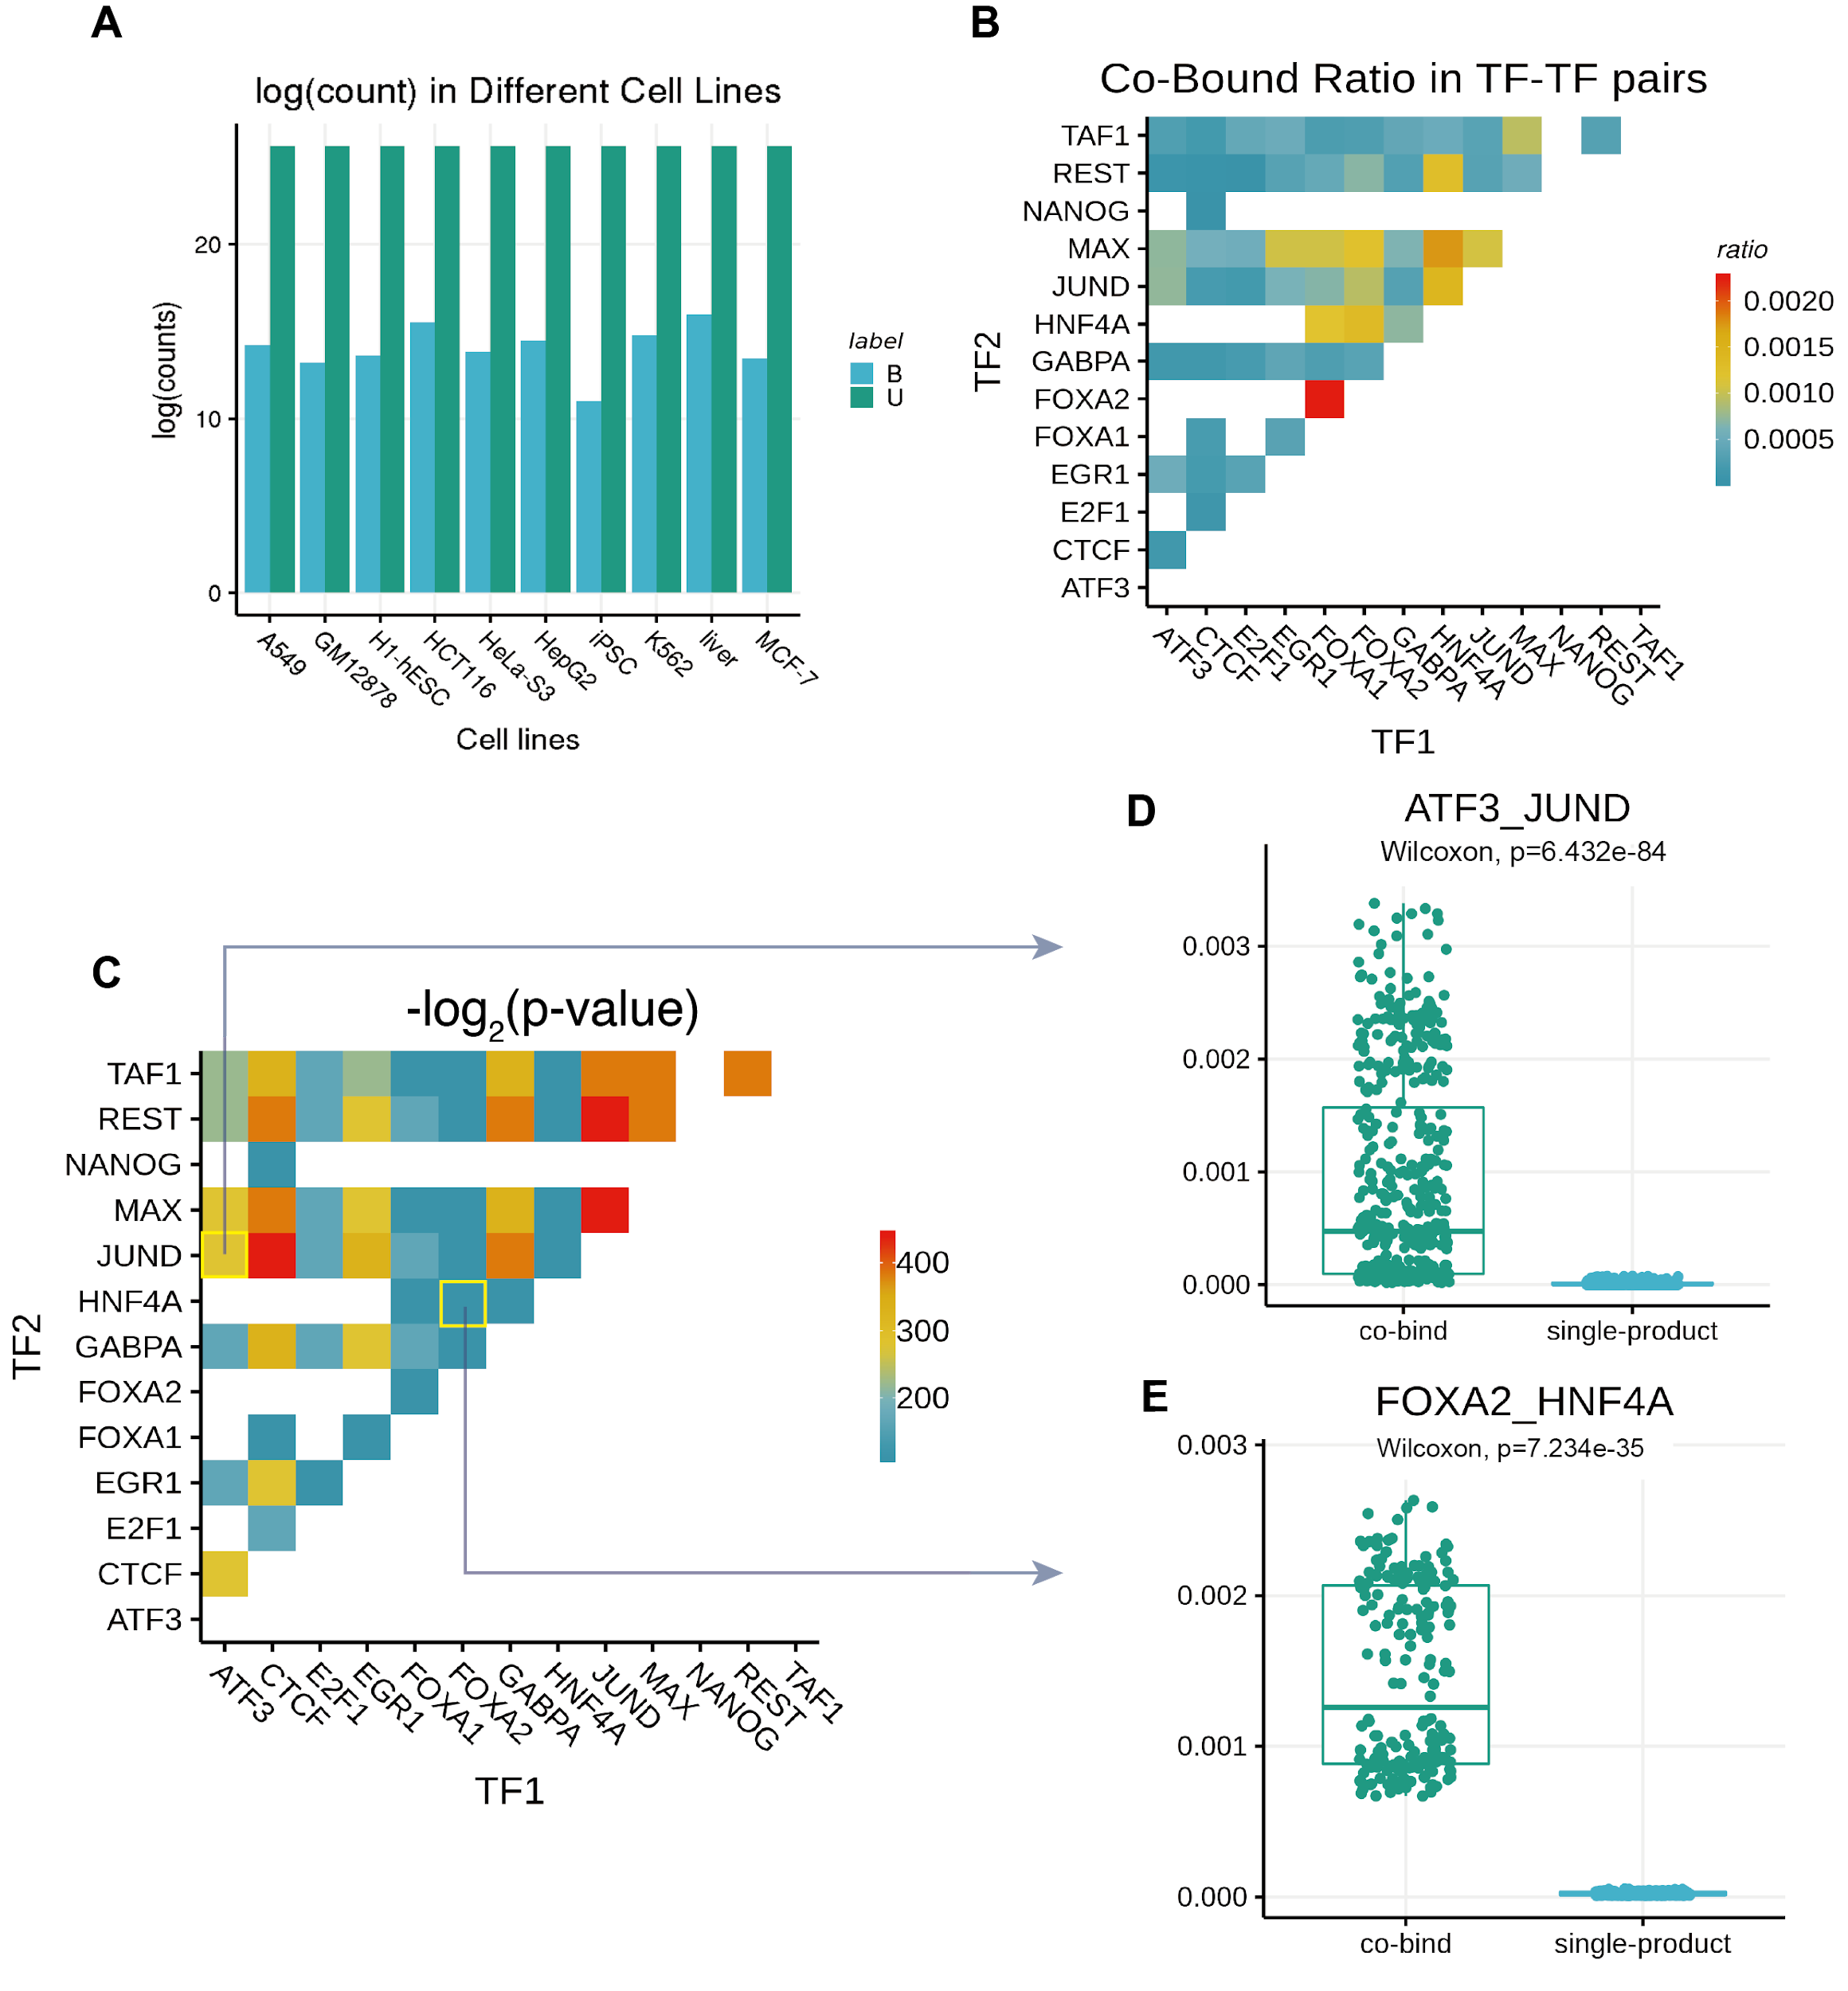Figure S19. Statistical analysis of TF-TF co-occupancy profiles. (A) Counts of co-bound (B) and un-co-bound (U) in different cell types. The y-axis represents the log values with base 2 of average counts cross TF-TF pairs in one cell type. The proportion of co-bound events is 0.000504, since TF-TF co-occupancy is a rare event. In order to better visualize the relationship between different labels, we plotted log₂(count) instead of the original count. In the 10 cell types, the proportions of B labels do not differ largely. (B) The ratio of co-bound in different TF-TF pairs. The color in each unit indicates the average value of B/(B+A+U) across all cell types. Blank positions mean that the data for that TF-TF pair is not available. The overall ratios are low though several pairs are relatively higher than others. From this plot, FOXA1-FOXA2 has the largest co-bound ratio. (C) P-values from paired Wilcoxon signed-rank test. To control the familywise error rate ^{28,37} as 0.01, all p-values should be less than 0.00178. The computation results indicate that all p-values are smaller than 0.0001, which reveals that the 56 TF-TF pairs in our study significantly co-occupy than independent occupy. (D, E) Two examples of paired Wilcoxon signed-rank test. We compared the co-bound proportion and the product of two single bound ratios in random 100 intervals with length 100,000bp for each TF-TF pair. We expect that if the p-value is smaller than 0.001, the tested TF-TF pair is significantly co-occupying in the same genome interval.

Supplementary Tables (attached excel file)
Supplementary table S1. Availability of ChIP-seq data for 13 single transcription factor binding sites on 10 cell types and TF families.
Supplementary table S2. TF-TF co-occupancy files and the split of training and testing datasets.
Supplementary table S3. The cross-cell line prediction AUROCs and AUPRCs values of 56 test TF-TF pairs
Supplementary table S4. The cross-chromosome prediction AUROCs and AUPRCs values of 56 test TF-TF pairs
Supplementary table S5. The number of single-bound (BU) and no-bound (UU) in samples.
Supplementary table S6. Two types of peak fractions of 56 TF-TF pairs in 10 different cell types.
Supplementary table S7. Counts of labels ‘B’ (co-bound), ‘U’ (un-co-bound), and ‘A’ (ambiguous) of 56 TF-TF pairs in 10 different cell types.
Supplementary table S8. P-values of statistically significant cooperative TF-TF pairs from paired Wilcoxon test.

The source code
For details, please go to https://github.com/GuanLab/Sequence_Analysis_for_TF-co-binding.git

