SUPPLEMENTARY MATERIAL
A platform for curated products from novel Open Reading Frames (nORFs) prompts reinterpretation of disease variants.

Matthew DC Neville^{1†}, Robin Kohze^{1†}, Chaitanya Erady¹, Narendra Meena², Matthew Hayden³, David N. Cooper³, Matthew Mort³, Sudhakaran Prabakaran^{1,2,4}*
¹Department of Genetics, University of Cambridge, Downing Site, CB2 3EH, UK
²Department of Biology, Indian Institute of Science Education and Research, Pune, Maharashtra, 411008, India
³Institute of Medical Genetics, Cardiff University, Heath Park, Cardiff CF14 4XN, UK
⁴St Edmund’s College, University of Cambridge, CB3 0BN, UK

*Corresponding author, email: sp339@cam.ac.uk.
†These authors contributed equally to the work.

Table of Contents

- Supplementary Figures 3

- Methods 8

Supplemental Figures

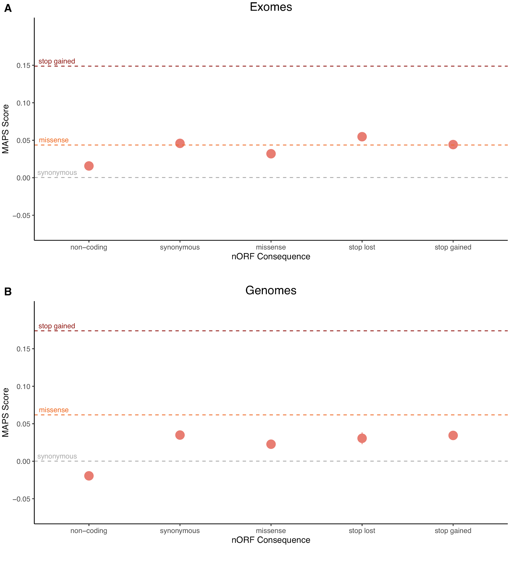
Supplemental Figure S1. Unclear selection signatures when only considering nORF consequences. The mutability-adjusted proportion of singletons (MAPS) is shown across functional categories for SNVs in gnomAD (A) exomes and (B) genomes. Each functional category is subdivided by variant annotation in nORFs. Dotted lines correspond to results from bins of only canonical annotations previously reported (Karczewski et al. 2020). Higher values indicate an enrichment of lower frequency variants, suggesting negative selection.

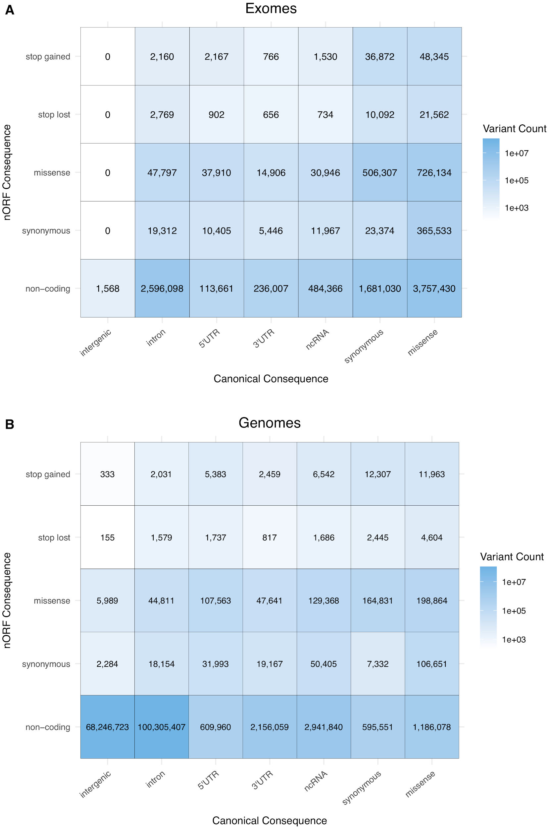

Supplemental Figure S2. Variant bin counts for gnomAD MAPS analysis. The 14.9 million and 229.9 million high-quality variants from gnomAD (A) exomes and (B) genomes respectively were binned based on their worst consequence in the context of nORFs and canonical annotations. Non-coding refers to variants annotated as non-coding by VEP (intergenic + upstream gene + downstream gene) in the context of nORFs. Bins are colored based on count on a logarithmic scale.

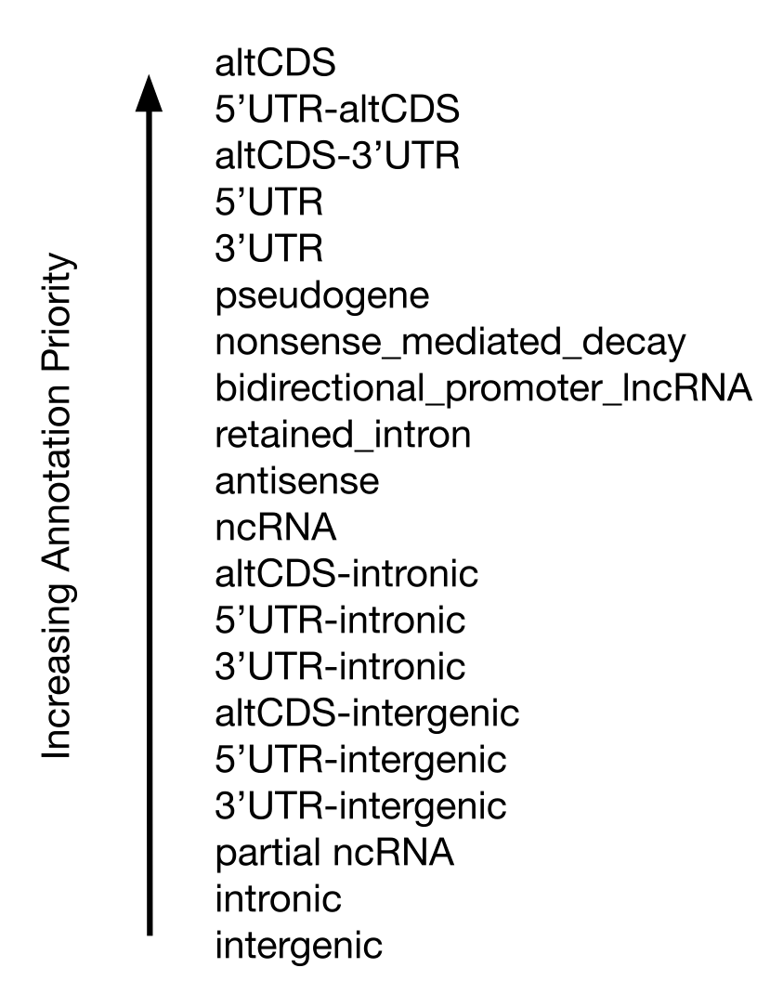
Supplemental Figure S3. Annotation Prioritization Priority. Genomic location annotation of nORFs was prioritized by first selecting overlaps with canonical CDS in an alternative frame (altCDS), altCDS-UTR combinations, and full UTR overlaps. This was followed by full overlaps with ncRNA transcripts, then by partial overlaps with protein coding transcripts, partial overlap with ncRNA transcripts, and finally intronic or intergenic regions.

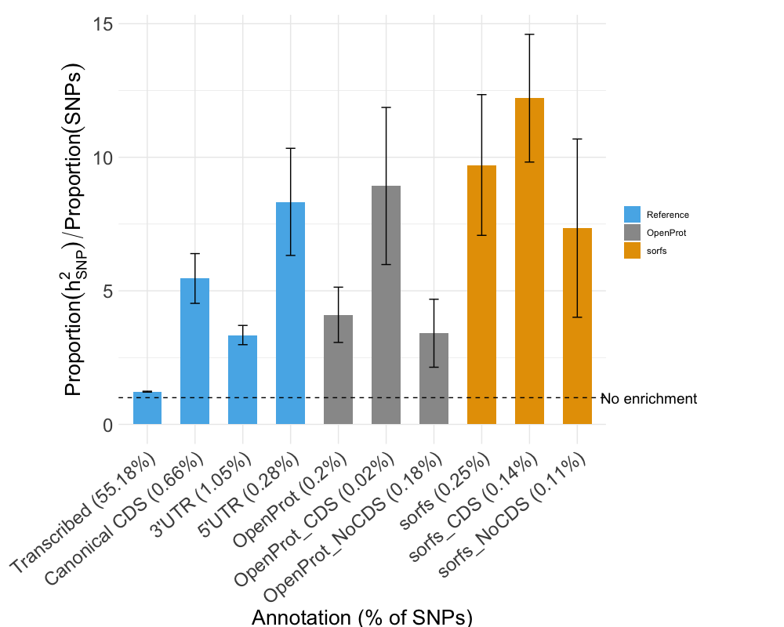

Supplemental Figure S4 Averaged heritability partitioned across 11 UK Biobank traits for nORF regions. Heritability enrichment was compared for canonical gene annotation from GENCODE vs nORF annotation for common variation enrichment (CVE), defined as the proportion of common variant heritability explained by the annotation divided by the proportion of common variants in the annotation.

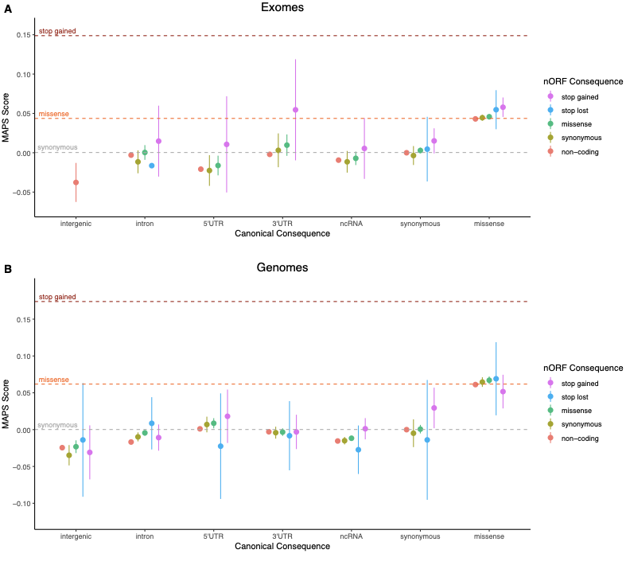

Supplemental Figure S5 MAPS calculated using only OpenProt entries. The mutability-adjusted proportion of singletons (MAPS) was calculated for 35 variant bins of SNVs from gnomAD (A) exomes and (B) genomes. The canonical annotation of the bin is indicated along the x-axis, while the nORF annotation is indicated by colour. Dotted lines correspond to results from bins of only canonical annotations previously reported (Karczewski et al. 2020). Higher values indicate an enrichment of lower frequency variants, suggesting negative selection. Bins with fewer than 100 variants are excluded.

Supplemental Methods

Selection of sources for evidence of nORFs
Three existing databases with entries that qualify as nORFs were considered for inclusion in the nORFs dataset: OpenProt (Brunet et al. 2019), sORFs.org (Olexiouk et al. 2018), and SmProt (Hao et al. 2018). SmProt was not used due to inconsistencies in data (e.g. incorrect genomic coordinate annotations) and lack of details in their methods to reanalyse the data, specifically in regards to their MS evidence (Olexiouk et al. 2018). By contrast, OpenProt and sORFs.org have shown commitment to providing consistent, verifiable, and maintained data, and were therefore used as the main sources for the nORFs dataset.

OpenProt (Release 1.3) predicts all possible ORFs with an ATG start codon and a minimum length of 30 codons that map to an Ensembl (Zerbino et al. 2018) or Refseq (O’Leary et al. 2016) transcript. They identified 607,456 alternate ORFs (altORFs) that are neither canonical ORFs, nor an isoform of those ORFs, but in non-coding regions or an alternate frame to canonical CDS. Although OpenProt maps to both Ensembl and Refseq transcripts, we focus exclusively on the Ensembl annotations for compatibility with the sORFs.org dataset and other downstream analyses. From the altORFs mapped to Ensembl transcripts, we consider the 26,480 altORFs with translation evidence from MS (21,708), ribosome profiling (5,059), or both (398).

The sORFs.org database (downloaded April 30, 2019) uses notably different inclusion criteria, annotating ‘sORFs’ with translation evidence from 43 human ribosome profiling experiments, then adding MS evidence found in publicly available datasets. The sORFs are defined as ORFs between 10 and 100 codons using any of four start codons: ‘ATG’, ‘CTG’, ‘TTG’, or ‘GTG’, and are not restricted to known transcripts.

These sORFs are identified through a translation initiation site (TIS) detection pipeline with a noise filtering step to limit false positive detection events. This process is fully described in their database paper (Olexiouk et al. 2018). Briefly, they identify all start sites genome-wide using the four most common start codons: ‘ATG’, ‘CTG’, ‘TTG’ and ‘GTG’. They then scan all start sites for an in-frame stop codon within 300nt (thereby limiting detected sORFs to 100 codons), both with and without considering transcript splicing data. They filter out unlikely translation events by implementing a threshold of at least 10% in-frame coverage and 10 ribosome profiling fragments (RPFs). As a noise filter to detect and remove false positives, they convert sORF transcripts into binary arrays of positions covered by ribosomes (1) and positions not covered (0). Then, they shuffle the array and recalculate in-frame coverage 10,000 times, allowing a probability calculation for the likelihood of a non-random translation event.

Curation of nORFs
The curation steps we performed to create a nORF dataset are detailed in Fig. 1. The final dataset that we created a) contains only nORFs with translation evidence from either MS or ribosome profiling b) contains no duplicate or highly similar entries and c) contains only ORFs clearly distinct from currently annotated canonical proteins.

We used 607,456 predicted altORFs from OpenProt and filtered to the 26,480 entries with MS or ribosome profiling evidence of translation. From over 2.1 million sORFs.org entries with ‘good’ or ‘extreme’ ORFscore (Bazzini et al. 2014), 502,056 entries with unique genomic mappings were extracted (Fig 1A). The next step involved processing similar entries in the sORFs.org dataset that shared the same stop site and amino acid sequences up to differing start sites. A characteristic example is shown in Fig 1B where in an alternative frame of the final coding exon of the MRPS21 gene, sORFs.org provides evidence for five small ORFs sharing the same end site and differing only by their start site. This is common in the sORFs.org dataset because of the ambiguity in ribosome profiling experiments to identify the correct translation start site, unless specifically using methods that search for them (e.g. ribosome profiling with antibiotics used to trap newly initiated ribosomes at start codons) (Olexiouk et al. 2018; Weaver et al. 2019). Although ideally the correct start site(s) would be identified through experiments, this data is not currently available. For consistency and simplicity, we have selected the longest ORF in these cases, which may not always represent the true translated ORF, but will always encompass all ORFs identified at these sites. We emphasize this ambiguity in the correct start site as an important limitation to be kept in mind when using the dataset. In all, the selection of the longest ORF at ambiguous start sites further reduced extracted sORFs.org entries to 209,543.

Next, the OpenProt and sORFs.org datasets were merged, 1,028 redundant entries between the datasets were removed, and 1,976 cases of ambiguous start sites between the two datasets were resolved by again taking the longest ORF, resulting in a merged total of 233,021 entries. The small number of overlapping or similar entries between the two datasets can be partly attributed to different inclusion criteria for ORFs between the databases (i.e. ORF length, start codon, transcript requirement) and the main source of entries (sORFs from ribosome profiling and OpenProt predominantly from MS).

Finally, we separated all entries that were in-frame with canonical CDS, as the translation evidence from these entries cannot be unambiguously resolved as to whether they are from a canonical protein product or an independent nORF embedded within a canonical protein. We identified 38,614 such entries and removed them, leaving a total of 194,407 entries in the final nORFs dataset. An example case is shown in Fig. 1C where two small ORFs overlap the CDS of the RICA gene. One of these ORFs is in the same frame as the RICA CDS and was therefore filtered out, whereas the second ORF is in a different frame and retained in the dataset. Following this final curation step all entries in the nORF dataset that overlap canonical CDS are in a different frame from and do not share amino acid sequence with that CDS.

Annotation of nORFs
We annotated each nORF with reference to human GENCODE (v30) gene annotations (Frankish et al. 2019). The annotation categories included nORFs mapping to UTRs or CDS of protein coding transcripts, ncRNAs, or intergenic regions. When multiple annotations were possible, due to multiple transcripts in a region, annotations were prioritized by first selecting full overlaps with protein coding transcripts, particularly those that overlap canonical CDS in an alternative reading frame (altCDS), followed by full overlaps with ncRNA transcripts, then by partial transcript overlaps, and finally intronic or intergenic regions. Our detailed prioritization summary is shown in Supplemental Fig. 3.

Database and web platform
To reduce the threshold of accessibility, databases need to be accessible with minimal requirements of tools or prior knowledge. We therefore built an online platform with Representational State Transfer (REST) application programming interface (API) functionality. This online platform acts as an entry and lookup point for individual entries, while the REST API is feature compatible with existing bioinformatics pipelines. We made the curated and annotated GRCH38 raw dataset available in .bed and .gtf format as well as downloadable nORFs.org UCSC track.

The norfs.org web platform was built with JavaScript ES6, webpack 4.5.0 and Facebook’s react.js framework in version 16.4.1. Furthermore, Gogo react 2.04 provides the CSS3 elements for a flexible dashboard layout. Google’s Firebase cloud service was utilized to host a distributed NoSQL equivalent database with REST API access.

On top of these base protocols, npm packages such as react-router (4.4.2), feature-viewer (0.1.44) and biodalliance (0.13) (Down et al. 2011) were embedded to create a professional and highly customizable layout. Specifically, biodalliance allowed the creation of a genome browser with optional additional feature tracks, and the feature-viewer was used to annotate the peptide itself with structure and potential variant annotations. Considering reproducible research guidelines, we used git as a versioning tool and uploaded the repository to GitHub under an MIT license (https://github.com/PrabakaranGroup/nORFs.org).

Stratified LD score regression (S-LDSC) heritability analysis
Heritability is a statistical concept used to describe how much of the observed variation for a phenotype is due to genetic variation (Visscher et al. 2008). S-LDSC (Finucane et al. 2015; Gazal et al. 2017) enables the estimation of heritability enrichment for functional annotations in human traits and diseases. Although it was originally restricted to partitioning heritability explained by common variants (h²_{C}), it was recently extended with the baseline-LF model (Gazal et al. 2018) to also allow the partitioning of heritability explained by low frequency (0.5%≤ MAF <5%) variants (h²_{LF}). We used S-LDSC with the baseline-LF model to estimate the heritability enrichment of nORF annotations for both common and low frequency heritability. To achieve this we had to first generate the two required inputs to S-LDSC: genome-wide association study (GWAS) summary statistics for traits of interest and an external LD reference panel with ancestry matching the GWAS population. As applied previously (Gazal et al. 2018), we obtained summary statistics for 40 heritable, complex UK Biobank (Bycroft et al. 2018) traits (downloaded from https://data.broadinstitute.org/alkesgroup/UKBB/UKBB_409K/) that were restricted to 409 K individuals with UK ancestry. We then generated an LD reference panel for UK ancestry to match the summary statistics with 3,567 UK10K (The UK10K Consortium 2015, 10) whole-genome sequencing (WGS) samples from the ALSPAC and TWINSUK cohorts.

With these inputs, we analyzed a total of 177 genomic annotations, each corresponding to a defined set of variants, for their heritability enrichment. Of the 177, 163 are together known as the previously described baseline-LF model (Gazal et al. 2018). Briefly, the baseline-LF model is made up of MAF bins, LD-related annotations, and 33 main binary annotations for both low-frequency and common variants. These main binary annotations include a number of gene related, regulatory, and conservation based annotations. We added to the analysis 14 custom annotations, from seven functional annotations doubled for common variants and low frequency variants. Of these seven, three custom annotations were nORF related: one for all nORFs, and 2 in which nORFs were split at the variant level to those regions which overlap canonical CDS (norfs_altCDS), and those which do not (nORFs_noCDS). The remaining 4 were canonical annotations from GENCODE: transcribed regions, CDS, 5’UTRs, and 3’UTRs. It should be noted that similar annotations appear to be already present in the baseline-LF model, but they were generated from a different reference set than our nORFs (UCSC 2013) (Gusev et al. 2014) and their ‘Coding’ annotation contains UTRs, which our custom annotation does not.

For the baseline-LD functional annotations and our custom annotations, we calculated common variant enrichment (CVE) and low frequency variant enrichment (LFVE) for each of the 40 UK Biobank traits. CVE is the proportion of common heritability (h²_{C}) divided by the proportion of common single nucleotide polymorphisms (SNPs) in the annotation, while LFVE is proportion of low-frequency heritability (h²_{LF}) divided by the proportion of low frequency SNPs in the annotation:
$$CVE =Prop(h{}_{C}^{2})/Prop(common SNPs)$$
$$LFVE =Prop(h{}_{LF}^{2})/Prop(low frequency SNPs)$$

Meta-analysis of results was conducted using random-effects meta-analyses in the rmeta package on 27 independent traits (Gazal et al. 2018), indicated in Table S1. All standard errors were computed using a block jackknife procedure (Bulik-Sullivan et al. 2015). Results for all traits separately are available at https://github.com/PrabakaranGroup/nORF-data-prep/.

Mutability adjusted proportion of singletons (MAPS) analysis
In addition to its importance for association studies and measures of heritability, genetic variation is also critical to evaluating natural selection at the variant level. Natural selection is an essential mechanism of evolution and acts over time to eliminate deleterious variants from populations. MAPS allows the estimation of negative selection, a proxy for functional importance, of variant classes in the genome. In this study, we apply MAPS to nORF variant classes (e.g. missense, stop lost, stop gained) to infer possible negative selection and potential signals of function.

We calculated the MAPS score for classes of variants based on their consequence in nORFs and canonical annotations to infer selection levels against these variants. MAPS was first described in the release of the Exome Aggregation Consortium (ExAC) dataset (Lek et al. 2016) and then updated with the release of gnomAD (Karczewski et al. 2019).

We calculated MAPS with gnomAD genomes and exomes by using publicly available code at https://github.com/macarthur-lab/gnomad_lof. We modified the code to include variant bins based on both nORF consequences and canonical consequences, rather than only canonical consequences. We selected five nORF consequences of interest: missense, synonymous, stop lost, stop gained, and non-coding (intergenic + upstream gene + downstream gene) and 7 canonical consequences of interest: missense, synonymous, ncRNA, 5’UTR, 3’UTR, intronic and intergenic. For each of these 35 (5x7) bins, MAPS calibrated expected variant frequencies to account for 1 surrounding base of context and CpG methylation, two factors known to influence the mutability of base pairs (Lek et al. 2016). The transformation between variant frequencies and the expected proportion of singletons was regressed against the observed proportion of synonymous variants in canonical proteins. As the MAPS score given to variant classes is a relative metric, this means that synonymous variants in canonical proteins were set as 0 and higher scores reflected more negative selection. We reported MAPS scores for bins with at least 100 variants in the gnomAD exomes or genomes dataset respectively.

P-values were calculated using a bootstrapping approach as applied previously (Whiffin et al. 2020). For a given bin with n variants, n variants were randomly sampled with replacement and used to calculate MAPS for two bins or interest: bin A and bin B. This was repeated over 10,000 permutations with the P-value being the proportion of permutations where MAPS of bin B was less than MAPS of bin A. P-values were considered significant if they passed Bonferroni correction of 18 tests for exomes and 21 for genomes.

Variant annotation
A major application of variant class importance is to the biological interpretation of specific mutations, particularly in disease contexts. A number of databases exist to catalogue disease mutations such as HGMD (Stenson et al. 2017) and ClinVar (Landrum et al. 2018) for inherited mutations and COSMIC (Tate et al. 2019) for acquired cancer mutations. For these disease mutations, the primary method of mechanistic interpretation is annotating variants for their impact in canonical protein coding genes (Gloss and Dinger 2018). In particular, loss-of-function mutations, such as nonsense, frameshift or essential splice variants, are thought to be common mechanisms of pathogenicity (MacArthur et al. 2012). However, the mechanism of many disease mutations cannot currently be explained by their impact on canonical proteins alone (Gloss and Dinger 2018). This is unsurprising given that non-coding regions make up over 98% of the genome and have diverse regulatory functions (ENCODE Project Consortium 2012). Specific examples of non-coding mechanisms include effects on gene expression from mutations at gene promoters (Fredriksson et al. 2014) or epigenetic imprinting loci (Chuang et al. 2017) and RNA stability from 5’ and 3’ UTR mutations (Zeraati et al. 2017).

Variant annotation was carried out using version 96 of VEP (McLaren et al. 2016) to investigate the consequences of variants in the context of canonical frames and nORFs. Variant sets were obtained for annotation as VCFs. These included gnomAD genomes and exomes (release 2.1.1) (Karczewski et al. 2019), HGMD (pro release 2019.2) (Stenson et al. 2017), ClinVar (release 2019 0708) (Landrum et al. 2018), and COSMIC coding and non-coding mutations (v89) (Tate et al. 2019). Each set of variants was annotated for their most severe consequence as defined by VEP with respect to a) canonical gene annotations, corresponding to GENCODE 30 in GRCh38 or GENCODE 30 lifted over to GRCh37 and b) nORF annotations provided as a custom GTF in the appropriate genome assembly.

When examining possible disease mutations that could be explained by nORF consequences, we first filtered variants from the disease mutations databases (COSMIC, HGMD, and ClinVar) to remove those with strongly deleterious annotations in canonical proteins (i.e. essential splice, frameshift, stop gained, stop lost, start lost). We then further filtered these variant sets to those with possible pathogenic consequences in nORFs (stop lost, stop gained, and frameshift).

