SUPPLEMENTARY MATERIALS

Index:
- Supplementary figures.
- Supplementary tables.
- Supplementary data legends.
- Supplementary materials and methods.

SUPPLEMENTARY FIGURES
Supplemental Figure S1. BMDMs Provide Robust Circadian Time Courses.
(A and B) Representative flow cytometry plots confirming the near total differentiation of bone marrow stem cells into macrophages using antibodies staining for F4/80 and CD11b surface markers. Flow cytometry confirmations were completed both before and after each time course. (C) A schematic of the BMDM 48-hour time course with staggered time point preparation to optimize the collection window. Four groups (G1-4) of plates each were serum shocked with 12 hour staggering between each so four time points could be processed simultaneously every 2 hours. For 6 total time courses, BMDMs were collected from the bone marrow of a single male PER2::LUC mouse on day 1 and incubated at 37°^{C} for 6 days in Dulbecco’s Modified Eagle Media (DMEM) supplemented with 10% Fetal Bovine Serum (FBS) to full confluence (red). On day 6 media was replaced with Lebovitz supplemented with 10% FBS (yellow) for 24 hours followed by 24 hours in a Leibovitz starve media containing 0% FBS (gray). BMDMs were then shocked for 2 hours in 50% FBS Lebovitz media (green) and assayed for the time course in 10% FBS Leibovitz with luciferin (black) in plates sealed with glass coverslips. (D) A representative luminescence tracing of the tracings that were used to confirm both the robust rhythmicity of PER2 as well as the synchronization between plates within and between time course experiments. Each line corresponds to a plate of macrophages.
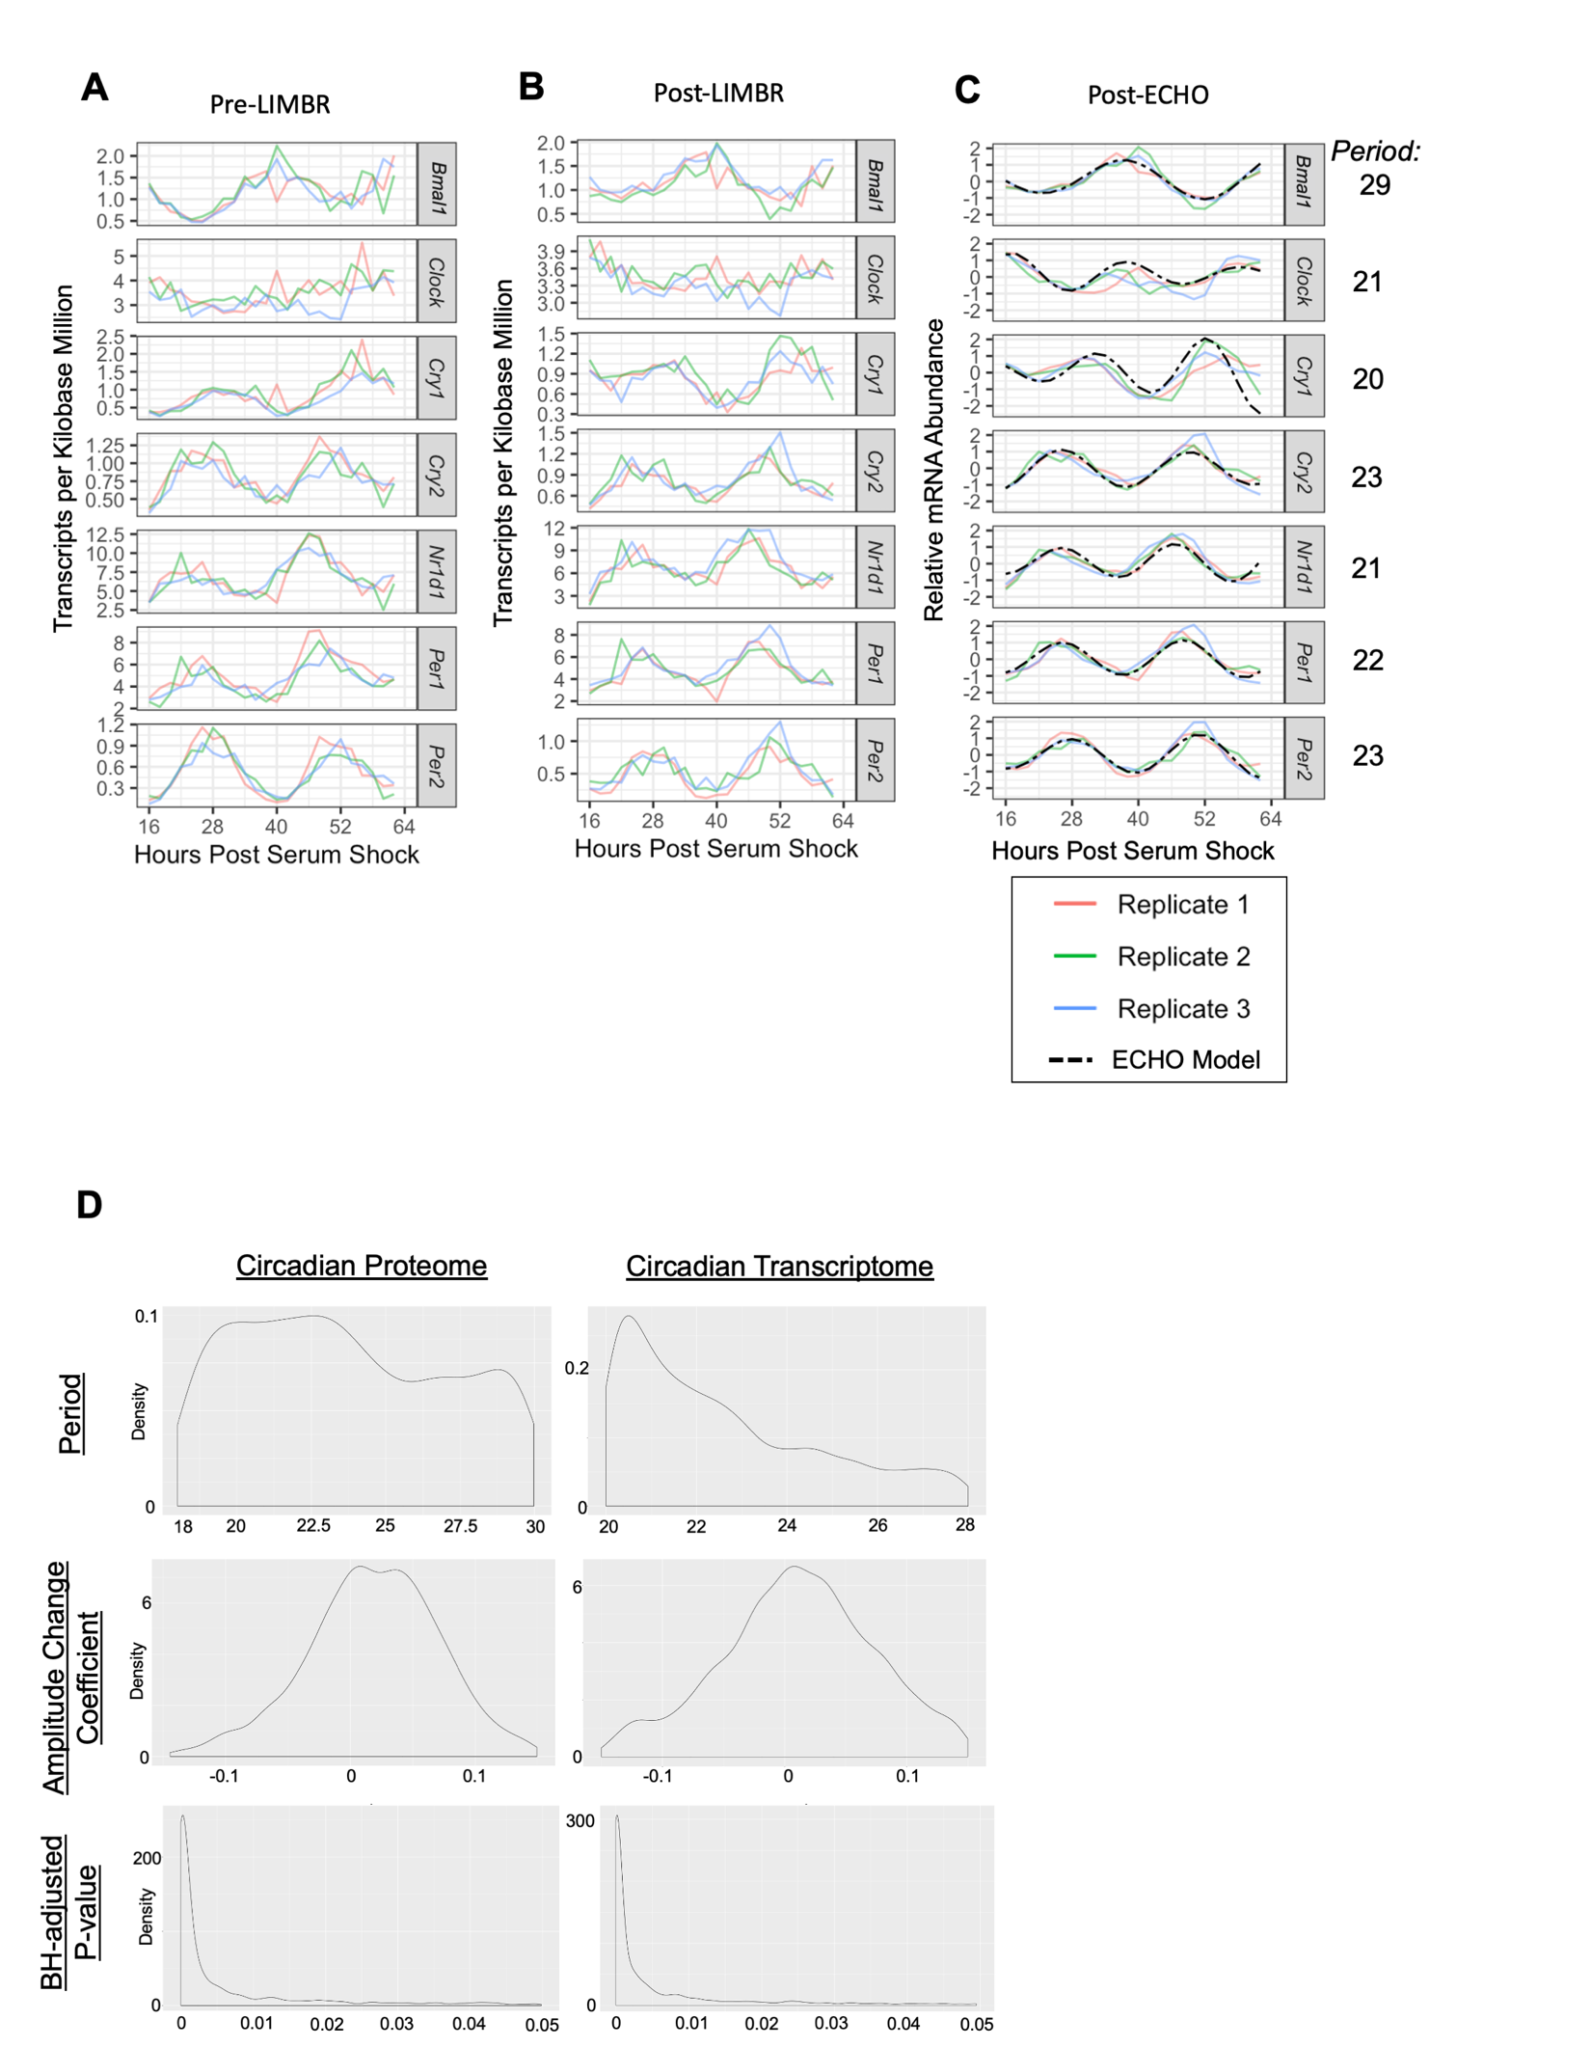
Supplemental Figure S2. ECHO Modeling of Circadian Oscillations.
RNA-seq data for clock genes prior to (A) and after (B) pre-processing steps with LIMBR. (C) Graphs of the modeled oscillator determined by ECHO for each of the clock gene transcripts plotted with corresponding replicate data. Best fitting model periods were calculated by ECHO ranged from 20-29 hours. (D) Density plots for several ECHO model parameters for the genes identified as circadian in the proteome (left panels) and transcriptome (right panels). X-axis represents parameter corresponding to panel row name.

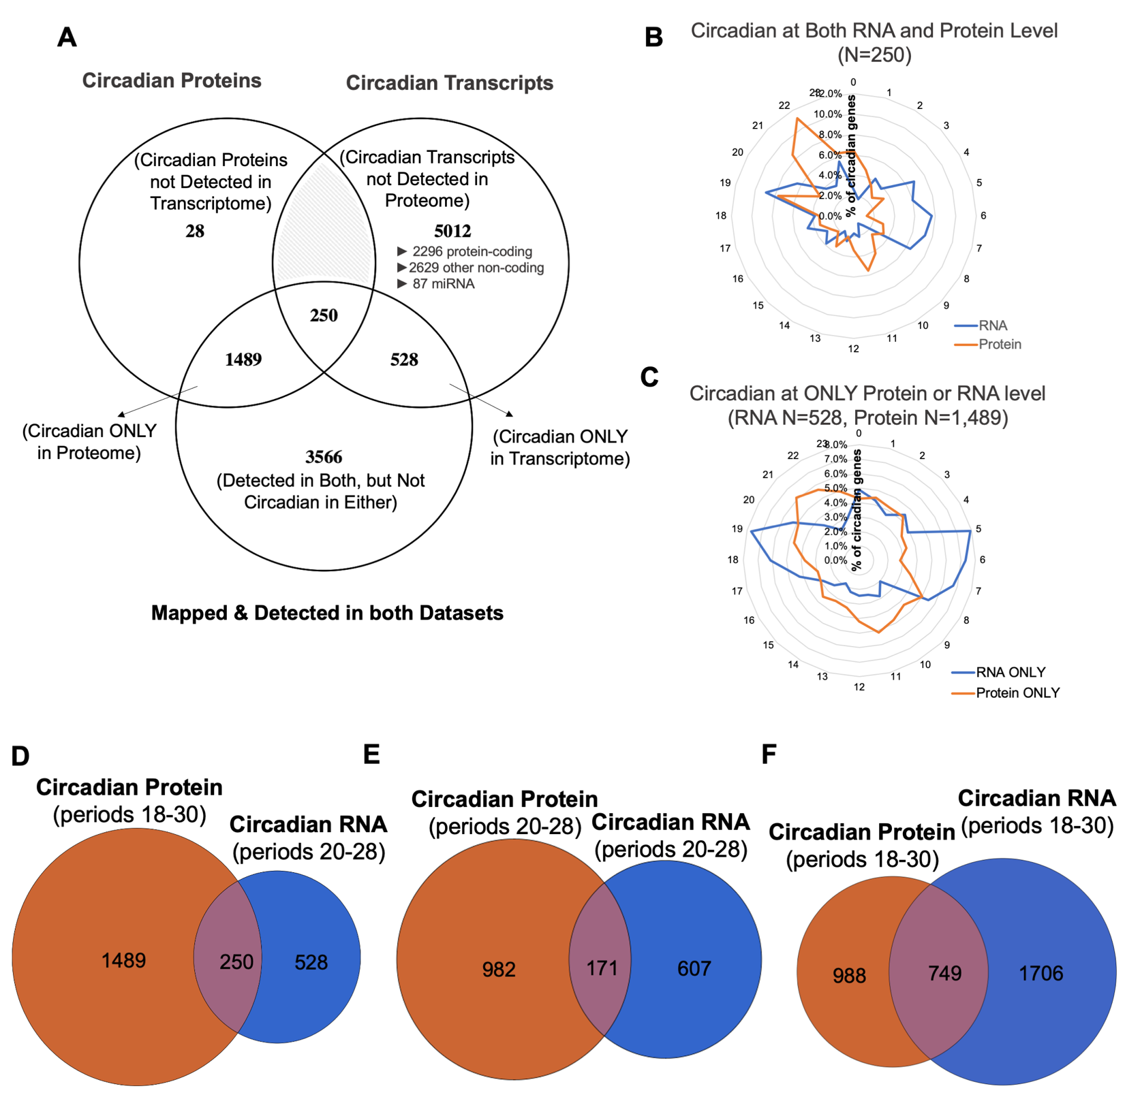
Supplemental Figure S3. Transcriptome and proteome analysis demonstrate significant discordance.
(A) Venn diagrams displaying the overlap/discordance between circadian RNAs and circadian proteins. Datasets were subset to compare which proteins and transcripts were detected in both datasets before being compared to each other to determine which proteins were rhythmic in protein, RNA, or both. The resultant oscillating transcripts and proteins were plotted on a clock style graph by Circadian time (CT) (transcripts = blue, proteins = orange) (B and C). Venn diagrams displaying the overlap between circadian RNA (blue) vs Protein (orange) with a protein period cut off of 18-30 and transcript period cutoff of 20-28 (D). More stringent cutoffs of 20-28 for both (E) and less stringent cutoffs of 18-30 for both (F) were also visualized.

Supplemental Figure S4. Phase Set Enrichment Analysis Reveals Translational and Degradative Pathways Peak in the Late Wave.
(A) Phase Set Enrichment Analysis (PSEA) of the circadian proteome peaking using mouse gene sets curated by Gene Set Knowledgebase (GSKB). The size of text corresponds to the statistical overrepresentation assuming uniform distribution and placement indicates the circadian time of day that the enriched gene set was calculated to occur. (B) Individual modeled fits of all circadian proteins with aminoacyl-ligase activity. The amino acid ligated by each gene is shown in the legend. (C) Individual modeled fits of all circadian proteins which are Eukaryotic Initiation Factors. (D) Individual modeled fits of all circadian proteins in the ubiquitin-proteasome pathway. (E) ECHO modeled fit for the E3 ubiquitin ligase CBLB (top) and its target VAV2 (bottom).

Supplemental Figure S5. Circadian Proteins in Central Metabolic Pathways.
(A) Individual modeled fits of all circadian proteins in the glycolysis pathway. Asterisk denotes protein also identified as circadian at the mRNA level. (B) Individual modeled fits of all circadian proteins in the Pentose Phosphate Pathway. Asterisk denotes protein also identified as circadian at the mRNA level. (C) Individual modeled fits of all circadian proteins in the TCA cycle. None were rhythmic at the RNA level (D) Individual modeled fits of all circadian proteins in the Electron Transport Chain. Asterisk denotes protein also identified as circadian at the mRNA level.
Supplemental Figure S6. Mitochondrial Maximal Respiration and Spare Respiratory Capacity Decreases over Time. (A) Overview of SEAHORSE protocol showing the frequency of OCR measurement and interpretation of mitochondrial dynamic being measured with each addition of various inhibitors. SEAHORSE-derived measurements for the rate of (B) Maximal respiration and (C) spare respiratory capacity. (D and E) ECHO modeled fit and replicate data for Fis1 (E), and Dnm1l (E) other identified circadian proteins potentially involved in mitochondrial fission.

Supplemental Figure S7. Impact of Zymosan/Oligomycin on the Oscillation of Per2.
Luminescence counts representing Per2 levels immediately following the addition of Zymosan or Zymosan/Oligomycin at (A) PS16 and (B) PS28 demonstrates that there is a slight immediate effect of the core rhythms of the clock, but is proportional to the PER2 level prior to zymosan addition and generally returns to baseline within the time of the 30 minute assay. (C) Long term tracings following zymosan addition shows PER2 oscillations continue despite addition of zymosan, although with phase-shift and amplitude changes depending on time of exposure to Zymosan. (D) Individual modeled fits of all circadian proteins in the NF-kB signaling pathway.

SUPPLEMENTARY TABLES

Supplemental Table S1: Summary statistics for RNA-seq experiment. (Excel File “Supplemental_Table_S1.xlsx”)

Multiplex # -> | 1 | 2 | 3 | 4 | 5 | 6 | 7 | 8
Total Peptides (<1%) | 112,412 | 113,452 | 105,827 | 121,907 | 124,280 | 130,827 | 121,987 | 124,646
Total Proteins (<1%) | 8,927 | 8,822 | 8,704 | 8,952 | 8,933 | 9,019 | 9,064 | 8,923
Total Protein IDs | 10,162 from 162,920 unique peptide sequences
Total Collapsed Proteins | 8,472 | 8,364 | 8,381 | 8,480 | 8,478 | 8,551 | 8,586 | 8,463
Quantified Proteins | 7,983 | 7,795 | 7,787 | 7,835 | 7,849 | 7,872 | 7,903 | 7,782
Shared Quantified Proteins | 6,290 proteins quantified in all 8 10-plexes

Supplemental Table S2: Summary statistics for TMT-MS experiment.

GO term (biological process complete) | GO Accession | # genes in category | # genes in list | # expected | fold Enrichment | Bonferroni P-value
translation | GO:0006412 | 310 | 18 | 3.48 | 5.18 | 2.72E-04
peptide biosynthetic process | GO:0043043 | 330 | 18 | 3.7 | 4.86 | 6.67E-04
amide biosynthetic process | GO:0043604 | 424 | 23 | 4.75 | 4.84 | 1.07E-05
peptide metabolic process | GO:0006518 | 451 | 21 | 5.06 | 4.15 | 7.03E-04
cellular amide metabolic process | GO:0043603 | 665 | 30 | 7.46 | 4.02 | 2.00E-06
organonitrogen compound biosynthetic process | GO:1901566 | 1075 | 46 | 12.05 | 3.82 | 9.90E-11
carbohydrate derivative biosynthetic process | GO:1901137 | 451 | 19 | 5.06 | 3.76 | 1.25E-02
cellular nitrogen compound biosynthetic process | GO:0044271 | 1114 | 42 | 12.49 | 3.36 | 8.87E-08
cellular macromolecule biosynthetic process | GO:0034645 | 1192 | 38 | 13.37 | 2.84 | 8.85E-05
macromolecule biosynthetic process | GO:0009059 | 1226 | 39 | 13.75 | 2.84 | 5.82E-05
carbohydrate derivative metabolic process | GO:1901135 | 793 | 25 | 8.89 | 2.81 | 4.41E-02
cellular biosynthetic process | GO:0044249 | 1981 | 60 | 22.21 | 2.7 | 1.32E-08
organic substance biosynthetic process | GO:1901576 | 2073 | 62 | 23.24 | 2.67 | 8.54E-09
biosynthetic process | GO:0009058 | 2154 | 63 | 24.15 | 2.61 | 1.38E-08
cellular nitrogen compound metabolic process | GO:0034641 | 2768 | 78 | 31.04 | 2.51 | 8.79E-11
gene expression | GO:0010467 | 1608 | 44 | 18.03 | 2.44 | 4.70E-04
cellular catabolic process | GO:0044248 | 1471 | 38 | 16.49 | 2.3 | 2.03E-02
nucleobase-containing compound metabolic process | GO:0006139 | 2170 | 53 | 24.33 | 2.18 | 7.18E-04
organonitrogen compound metabolic process | GO:1901564 | 4256 | 102 | 47.72 | 2.14 | 4.73E-11
cellular protein metabolic process | GO:0044267 | 2839 | 68 | 31.83 | 2.14 | 1.36E-05
heterocycle metabolic process | GO:0046483 | 2308 | 55 | 25.88 | 2.13 | 9.19E-04
cellular aromatic compound metabolic process | GO:0006725 | 2379 | 55 | 26.68 | 2.06 | 2.51E-03
protein metabolic process | GO:0019538 | 3411 | 78 | 38.25 | 2.04 | 2.93E-06
organic cyclic compound metabolic process | GO:1901360 | 2592 | 59 | 29.06 | 2.03 | 1.39E-03
nitrogen compound metabolic process | GO:0006807 | 5687 | 128 | 63.77 | 2.01 | 5.98E-14
cellular macromolecule metabolic process | GO:0044260 | 3948 | 87 | 44.27 | 1.97 | 1.11E-06
primary metabolic process | GO:0044238 | 6236 | 135 | 69.92 | 1.93 | 8.66E-14
cellular metabolic process | GO:0044237 | 6299 | 135 | 70.63 | 1.91 | 2.15E-13
organic substance metabolic process | GO:0071704 | 6669 | 140 | 74.78 | 1.87 | 2.03E-13
macromolecule metabolic process | GO:0043170 | 5034 | 105 | 56.45 | 1.86 | 9.47E-08
metabolic process | GO:0008152 | 7184 | 145 | 80.55 | 1.8 | 1.00E-12
cellular process | GO:0009987 | 13991 | 201 | 156.88 | 1.28 | 1.87E-05
Supplemental Table S3: Biological process category enrichments for the 250 genes that are circadian at both the mRNA and protein levels. (Excel file)

Protein | Detected | Circadian
MFN1 | YES | NO
MFN2 | YES | NO
OPA1 | YES | NO
DNM1L | YES | YES
FIS1 | YES | YES
MFF | YES | YES
MID49 | NO | -
MID51 | NO | -
DNM2 | YES | NO
Supplemental Table 4: Mitochondria fission and fusion genes detected in proteome.

 | ECHO |  |  |  |  |  | JTK
Experiment | Oscillation Type | Amplitude  Change  Coefficient | Period | P-Value | BH Adj  P-Value | BY Adj  P-Value | BY.Q | BH.Q | ADJ.P
Per2::Luc | Harmonic | 6.78E-03 | 24 | 8.66E-04 | 2.60E-03 | 4.77E-03 | 1.90E-02 | 1.04E-02 | 3.46E-03
Per1/Per2 KO | Overexpressed | -2.82E-01 | 24 | 3.44E-01 | 3.44E-01 | 6.30E-01 | 9.47E-01 | 5.17E-01 | 3.44E-01
Per2::Luc + Oligomycin | Repressed | 7.37E-01 | 24 | 2.57E-02 | 3.86E-02 | 7.07E-02 | 1 | 1 | 1

Supplemental Table S5: ECHO model parameters for phagocytosis assay data.

SUPPLEMENTARY DATA LEGENDS

Supplemental Data S1. Protein-Protein Interaction Network of the Late wave (“Supplemental_Data_S1.pdf”).
A high-resolution overview of the late active wave (CT15-3) protein-protein interaction network with individual gene symbols displayed on each node. Strings shown are high confidence (>.9) interactions and node color corresponds to a gene’s enriched reactome category. Grey coloring represents genes from enriched reactome categories that did not represent a large proportion of the protein-protein interactome or belonged to redundant categories.

Supplemental Data S2. Protein-protein interaction network of the Early wave (“Supplemental_Data_S2.pdf”).
A high-resolution overview of the late inactive wave (CT3-15) protein-protein interaction network with individual gene symbols displayed on each node. Strings shown are high confidence (>.9) interactions and node color corresponds to a gene’s enriched reactome category. Grey coloring represents genes from enriched reactome categories that did not represent a large proportion of the protein-protein interactome or belonged to redundant categories.

Supplemental Data S3. Processed RNA-seq data input and output from ECHO analysis (“Supplemental_Data_S3.csv”)

Supplemental Data S4. Processed TMT-MS data input and output from ECHO analysis(“Supplemental_Data_S4.csv”)

SUPPLEMENTARY MATERIALS AND METHODS

Animals
PER2::LUC C57BL/6J mice were acquired from Jackson Labs (Accession # 006852) and housed under 12:12 LD conditions with ad libitum access to standard rodent chow. Male mice between the ages of 3-6 months were used for all omics and phagocytosis experiments and were euthanized for tissue collection via CO₂ inhalation/cervical dislocation.

Time Course Cell Synchronization
For each time course, bone marrow was harvested from femurs and tibias of 1 mouse with needle and syringe and red blood cells were lysed (Zhang, Goncalves and Mosser, 2008). Cells were then plated at a density of 1*10⁶ in DMEM supplemented with recombinant M-CSF (0.1 µg/ml), 10% Fetal Bovine Serum (FBS), L-glutamine, penicillin/streptomicin, and gentamicin. After 3 days incubation at 37°C in 5% CO₂, additional fresh media was added and incubated another 3 days. For 4 12-hour staggered groups, non-adherent cells were then washed off with warmed PBS and media replaced with Leibovitz supplemented with MCSF and 10% FBS for 24 hours. Plates were again washed with warmed PBS and cells starved for 24 hours in Leibovitz with MCSF (Prospec CYT-439). Cells were then serum shocked for 2 hours in Liebovitz with 50% FBS and MCSF and then washed with PBS and assayed in Liebovitz with 10% FBS, MCSF, and Luciferin (Balsalobre, Damiola and Schibler, 1998). Plates were sealed with grease and glass cover slips. Luminescence over time was recorded using a LumiCycle32 luminometer (Actimetrics) to confirm synchronization of circadian rhythmicity.

Flow Cytometry
To confirm uniform differentiation of bone marrow cells into macrophages, cells were probed for macrophage-specific markers ITGAM (CD11b) and ADGRE1 (F4/80) both after 6 days of DMEM incubation as well as at the completion of each time course. Cells were lifted off the plate with Cell Stripper, washed with PBS, and incubated with Fc-receptor blocking antibodies to prevent non-specific binding and Zombie Violet to determine proportions of viable and dead cells. Heat killed cells were included as a Zombie Violet positive control. Cells were then incubated with anti-CD11b(AF488) and anti-F4/80(PerCP/Cy5.5) fluorescently conjugated antibodies (Invitrogen) and assayed with a BD LSRII flow cytometer.

Proteomics
Every 2 hours over 48 hours starting at 16 hours post serum shock, protein was extracted to determine global proteome changes over 2 circadian cycles. Triplicate independent time courses were completed for a total of 72 samples. At each time point, cells were lysed with 8M Urea buffer (8.5 pH) and lysate was flash frozen in liquid nitrogen. Multiplex proteomics was performed by Harvard’s Thermo Fisher Center for Multiplexed Proteomics using Tandem Mass Tag Mass Spectrometry (Supplemental Table 2). Protein Quantification was performed using the micro-BCA assay by Pierce and after quantification samples were reduced with DTT, alkylated, and an ~200µg aliquot was precipitated by Methanol Chloroform. Proteins were resuspended in 6M urea and digested overnight with LysC (1:50 protease:protein ratio) and Trypsin (1:100 protease:protein ratio). 8 total multiplexes were run with each containing 50 ug each of protein from 9 randomized time point samples and one common pooled sample between all multiplexes to prevent and account for batch effects. One complete set of 12 fractions from the total proteome Basic pH reverse phase fractionation from all experiments was analyzed on an Orbitrap Lumos mass spectrometer. Peptides were identified by their MS2 spectra and mapped to corresponding proteins using the SEQUEST algorithm with UniProt reference Mus musculus proteome UP000000589. Peptide spectral matches were filtered to a 1% false discovery rate and proteins were quantified only from peptides with a summed SN threshold of >=200 and MS2 isolation specificity of 0.5.

RNA-seq
Every 2 hours over 48 hours starting at 16 hours post serum shock, RNA was extracted to determine global transcriptome changes over 2 circadian cycles. Triplicate independent time courses were completed for a total of 72 samples. At each time point, cells were lysed with Qiagen’s Buffer RLT and lysate was homogenized with Qiashredder columns and flash frozen in liquid nitrogen. All samples were then processed on the same day with Qiagen’s RNeasy kit with on-column DNase digestion. rRNA depletion and RNA-seq was completed by Genewiz on an Illumina HiSeq configured with 2×150 bp paired-end output (Supplemental Table 1). Sequence reads were trimmed for adapter sequences then mapped to Mus musculus GRCm38.87 reference genome using the DRAGEN alignment software. Hit counts were calculated with HTseq and then normalized for varying gene size by calculating transcripts per million (TPM).

Phase Set Enrichment Analysis
Phase set enrichment analysis for circadian proteins was completed using the downloaded .jar tool and with default analysis parameters as defined by (Zhang et al., 2016). Murine Gene Ontology gene sets were downloaded from Gene Set Knowledgebase (Bares and Ge, 2019). Enrichment was determined versus a uniform background and using the standard cutoff of adjusted p<0.05.

Zymosan Phagocytosis Assay
Macrophages were differentiated/grown to confluence, serum shocked as described above utilizing two 12-hour staggered groups and assayed in a 32-plate lumicycle (Actimetrics). Starting at 16 hours post serum shock, every 4 hours over 24 hours, in triplicate, 11 ul of 20 mg/ml zymosan per plate (~1:100 cell:zymosan ratio) was added directly to assay media with macrophages and returned to lumicycle for incubation at 37C for 30 minutes. Prior to incubation, AF488 labeled Zymosan (Invitrogen, cat #: Z23373) was opsonized with FBS from the same lot as used for macrophage media according to manufacturer’s instructions. For the oligomycin time course, oligomycin was added to the media at the same time as zymosan to a final concentration of 1.5uM. After incubation, cells were washed 3 times with PBS and lifted from plates using CellStripper. Cells were then fixed in Neutral Buffered Formalin for 30 minutes in the dark at room temperature. Cells were then resuspended in PBS and stored at 4°C until imaging. On day of imaging cells were stained with DAPI and imaged with a Zeiss LSM 510 laser scanning confocal microscope using a 40× objective until well over 100 cells were imaged for each sample. For each image, first the number of total macrophages was counted in ImageJ using “CellCounter” plugin with the composite of brightfield/DAPI channels. Only macrophages with clearly defined borders entirely within the image bounds and a DAPI stained nucleus were considered suitable for analysis. Then the number of macrophages with positive Zymosan-AF488 signal was counted to calculate of the percent of zymosan-positive macrophages out of at least 100 total macrophages observed per time point.

Animals for Mitochondrial Experiments
WT Mice used for experiments were both male and female, aged between 8-12 weeks. These mice were bred and maintained in specific pathogen free conditions in the comparative medicine unit, Trinity College Dublin. All mice were maintained according to European Union regulations and the Irish Health Products Regulatory Authority.

Bone Marrow Derived Macrophage Differentiation for Mitochondrial Experiments
Bone marrow derived macrophages (BMDMs) were prepared from the femurs and tibia of mice. Mice were sacrificed by carbon dioxide inhalation and cervical dislocation. Hair, skin, and muscle was removed from each bone and both ends were cut using a scissors. A syringe was used to flush bone marrow with warm complete Dulbecco’s Modified Eagle’s Media (cDMEM; 10% fetal bovine serum, 1% penicillin/streptomycin) which was collected into a Falcon tube. The cell suspension was centrifuged, the supernatant was discarded, the cell pellet was resuspended in red blood cell lysis buffer, and after 3 minutes warm cDMEM was added to deactivate the lysis buffer. The cell suspension was passed through a 40μm mesh filter into a Falcon tube, centrifuged, and the supernatant was discarded. The cell pellet was resuspended in warm cDMEM supplemented with 10% L-929 fibroblast supernatant. The cell suspension was divided between 3 10cm cell culture plates and incubated in a humidified 5% CO₂ incubator at 37°C. After 6 days of growth, cells were scraped in ice cold Dulbecco’s phosphate buffered saline (PBS), collected in a falcon tube, and centrifuged. The supernatant was discarded and the cell pellet was resuspended in cDMEM. Viable macrophages were counted by haemocytometric analysis using the Countess Automated Cell Counter (Invitrogen) according to manufacturer protocol and equalized to an appropriate density.

Seahorse
50,000 BMDMs were seeded in each well of a 96-well Seahorse plate. Cells were left to adhere for several hours in a humidified 5% CO₂ incubator at 37°C in cDMEM supplemented with 10% L-929 medium. Cells were serum shocked to T16, T28, or T40 and the start time of the serum shock for each group was staggered so that each time could be analyzed by Seahorse assay simultaneously. At the appropriate time to begin the serum shock protocol for each group, media was changed to complete Leibovitz L-15 media supplemented with 10% L-929 media and 1% HEPES for 12 hours. Cell media was then changed to serum free DMEM supplemented with 1% P/S and 10% L-929 media for 12 hours. Cells were then serum shocked by replacing cell media with DMEM supplemented with 50% horse serum and 1% P/S for 2 hours. Following this, media was replaced with cDMEM supplemented with 10% L-929 medium and cells were incubated for an appropriate time before beginning the Seahorse assay. Following completion of the serum shock protocol for all groups, cells were washed with Seahorse XF DMEM Medium pH 7.4 (Agilent, 103575-100) supplemented with 10mM glucose, 1mM sodium pyruvate, and 2mM glutamine. Cells were then incubated in a non-CO₂ incubator at 37°C for 45 minutes. Mitochondrial stress test compounds (1.5mM oligomycin, 1mM FCCP, 0.5mM rotenone/antimycin a) were prepared in supplemented Seahorse XF DMEM Medium and loaded into the appropriate ports of an XFe96 Seahorse sensor cartridge. Following calibration, cells were loaded into the Seahorse XFe96 instrument and a mitochondrial stress test was carried out. Following completion of the assay normalization was carried out via PicoGreen dsDNA quantitation.

Mitochondrial Dynamics Imaging
BMDMs (0.5 × 10^6) were plated on µ-Dish 35 mm, high Glass Bottom (Ibidi, Germany) and maintained overnight at 37 ºC in a 5% CO₂ atmosphere. The cells were synchronized by serum shock as described by (Balsalobre, Damiola and Schibler, 1998). After serum shock, cells suspended in fresh 5% FBS Dulbecco’s Modified Eagle Medium. Thirty minutes before the indicated time, cells were loaded with MitoTracker Red CMXRos (Life technologies) at a final concentration of 50 nM. Cells were washed with PBS fresh; medium was placed, and cells were observed in a Leica SP8 scanning Confocal (Wetzlar, Germany), with a 63× immersion objective. Cell images were analyzed with the ImageJ software (National Institutes of Health, Bethesda, MD). For ImageJ analysis, the mitochondrial length of more than 50 mitochondrial particles per cell was measured in over 25 cells per experimental condition, out of three independent experiments. Mitochondria were then divided into two different categories, based on length, as mitochondria of less than 1 µm (fragmented) and greater than 3 µm (elongated), as described by (Park et al., 2013).

