Supplementary materials
Shao and Wang, Genome Research, 2020

Supplemental Figure S1 Evaluation of scRNA-seq reads that were mapped to TEs 3
Supplemental Figure S2 Length discrepancy between TEs and protein-coding genes cannot sufficiently explain the higher number of false positive candidates at TEs 4
Supplemental Figure S3 Examples of single cells with different percentage of TE reads 6
Supplemental Figure S4 Signal correlation between averaged mESC Smart-seq data and mESC bulk RNA-seq data 8
Supplemental Figure S5 Evaluation of TE transcripts assembled from mESC bulk RNA-seq data 10
Supplemental Figure S6 Quantifying signal at TE transcripts is applicable to scRNA-seq with 3’ end signal enrichment 11
Supplemental Figure S7 Evaluating the performance of the EM algorithm 12
Supplemental Figure S8 Evaluation of TE transcripts assembled from 37 bulk RNA-seq 14
Supplemental Figure S9 Evaluation of mouse scRNA-seq data from zygote to gastrulation 15
Supplemental Figure S10 Dynamic expression of TE transcripts and protein-coding genes during mouse pre-implantation stages 18
Supplemental Figure S11 Evaluation of mouse scRNA-seq data from gastrulation to early organogenesis 20
Supplemental Figure S12 TE transcripts that are highly expressed in extraembryonic ectoderm and are derived from LINE elements 21
Supplemental Figure S13 Examples of TE transcripts 23
Supplemental Table S1 Summary of datasets utilized in this manuscript 24
Supplemental Table S2 Genomic locations of assembled TE transcripts 24
Supplemental Table S3 Expression patterns of 146 TE transcripts with strong tissue enrichment during mouse gastrulation and early organogenesis 24

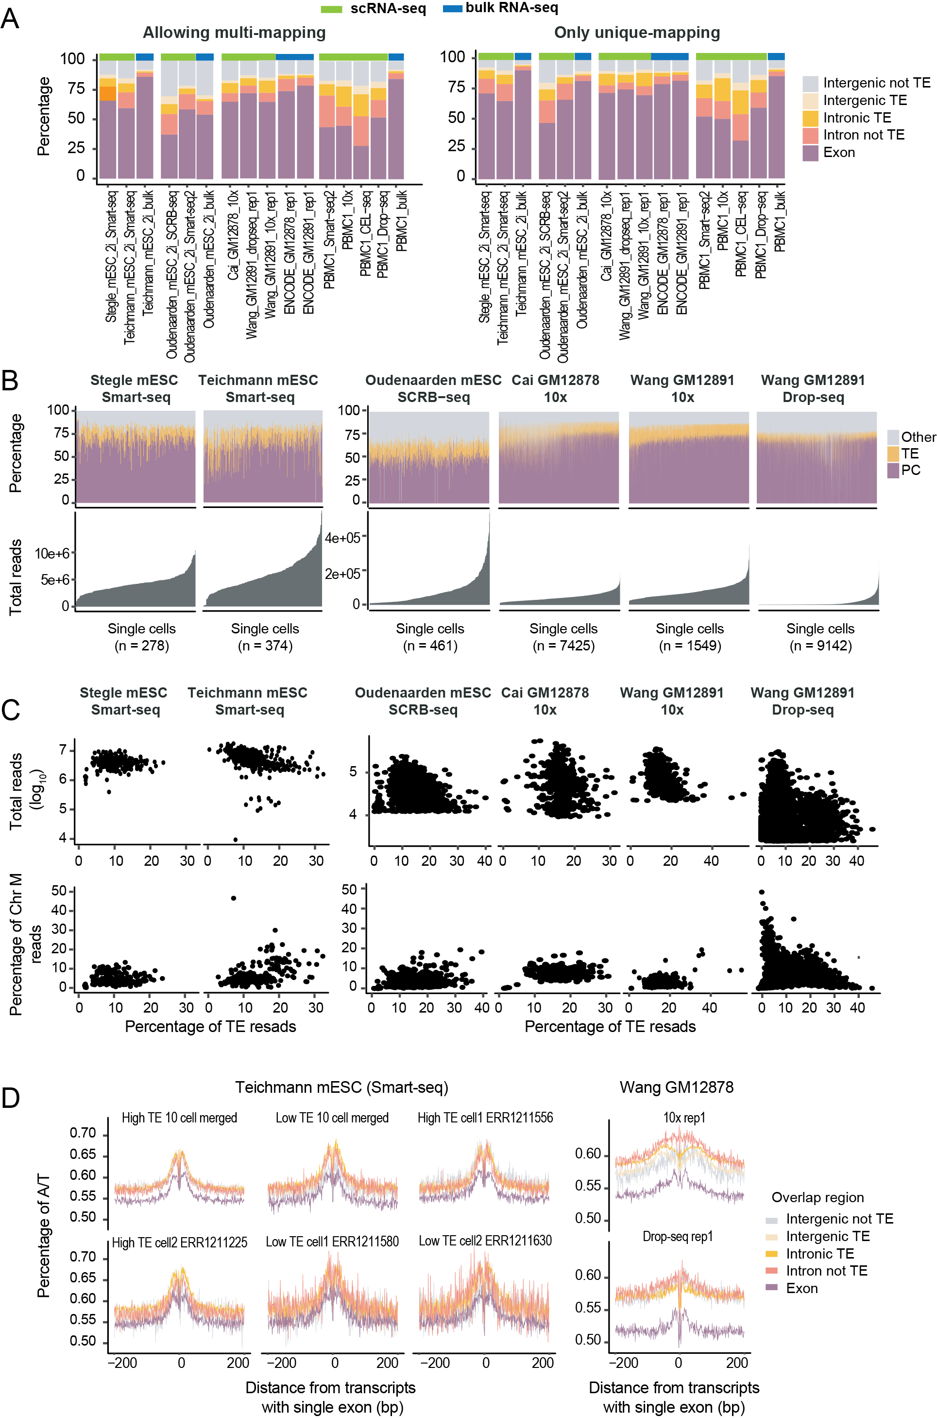

Supplemental Figure S1 Evaluation of scRNA-seq reads that were mapped to TEs
(A) Distribution of bulk RNA-seq and scRNA-seq reads in five non-overlapping genomic regions: protein-coding exons, TEs within the introns of protein-coding genes, other intronic regions of protein-coding genes, intergenic TEs, and other intergenic regions. Left: Reads mapped to multiple locations were included during signal quantification. Right: Only uniquely mapped reads were utilized.
(B) Distribution of scRNA-seq reads in single cells. Cells were arranged based on sequencing depth. PC: protein-coding exons. TE: transposable elements that do not overlap with protein-coding exons. Other: other genomic locations.
(C) Top: correlation between the percentage of TE reads and the sequencing depth of single cells. Bottom: correlation between the percentage of TE reads and that of the mitochondria reads.
(D) Regions enriched for un-spliced scRNA-seq reads tend to be flanked by AT-rich sequences. Transcripts assembly was performed using single cell data and transcripts with single exon were separated into 5 groups based on their genomic locations. A/T percentage was calculated at sequences flanking these transcripts.

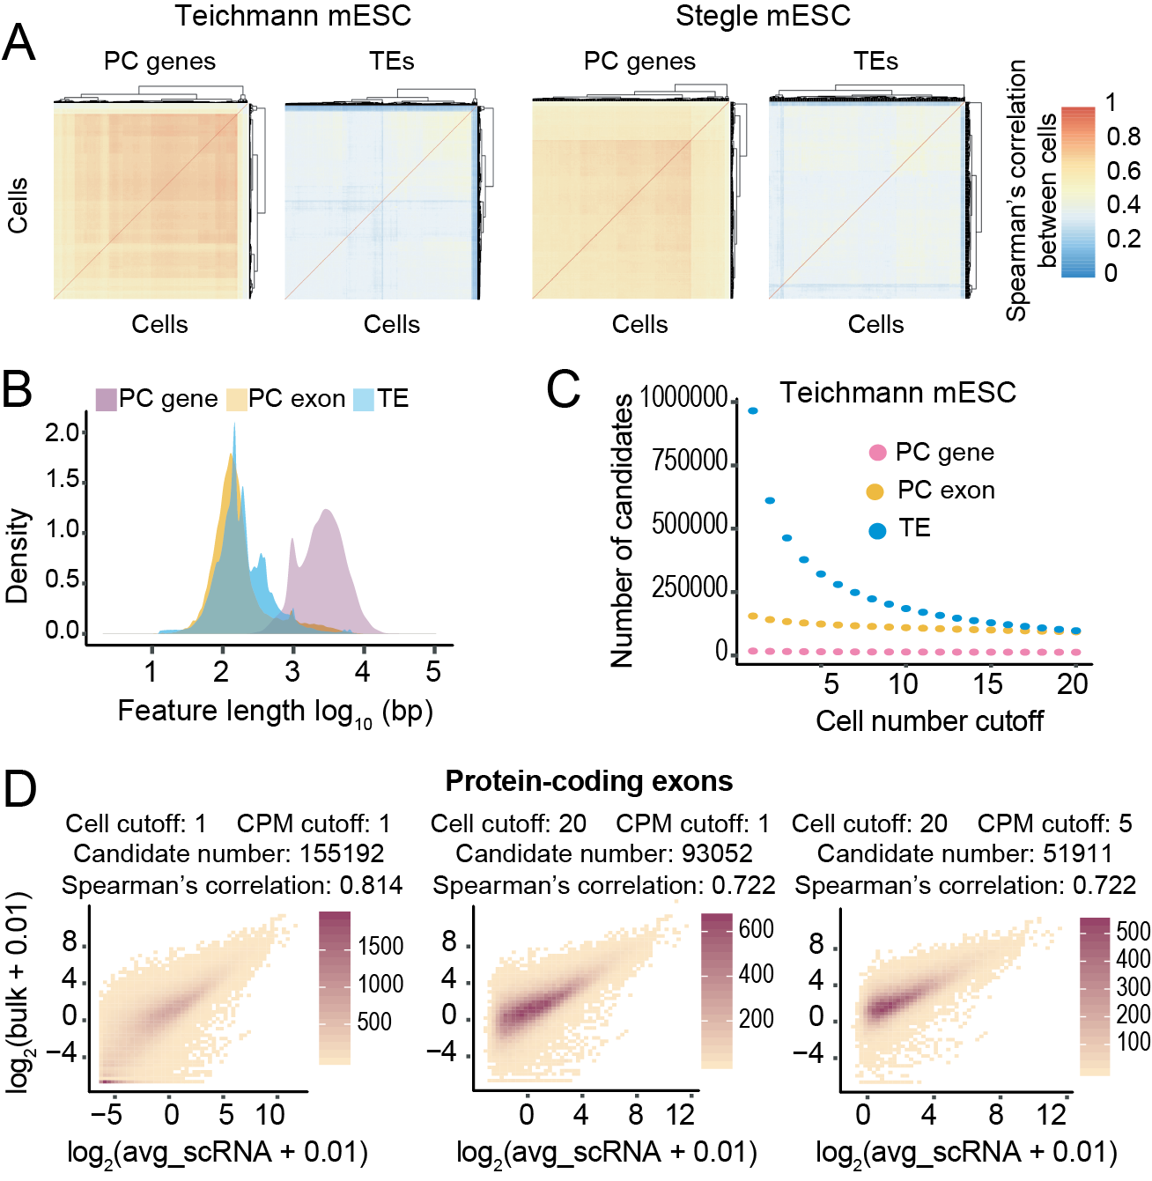

Supplemental Figure S2 Length discrepancy between TEs and protein-coding genes cannot sufficiently explain the higher number of false positive candidates at TEs
(A) Spearman’s correlation between cells using TEs or protein-coding genes as references. Higher correlation was observed at protein-coding genes.
(B) The length of full transcripts of protein-coding genes, exons of protein-coding genes and TEs.
(C) Number of candidates as a function of cell number cutoff (the minimum number of cells each candidate is expressed in. Expression cutoff: CMP >=1). Although majority of protein-coding genes and protein-coding exons were consistently detected, a large number of TE candidates were detected in less than 10 cells.
(D) Correlation between bulk RNA-seq and averaged Smart-seq signal at protein-coding exons (Teichmann lab, mESC). Cell cutoff: the minimum number of cells each candidate is expressed in. CPM cutoff: the minimum CPM value for one candidate to be considered as expressed. Color scale represents the number of candidates.

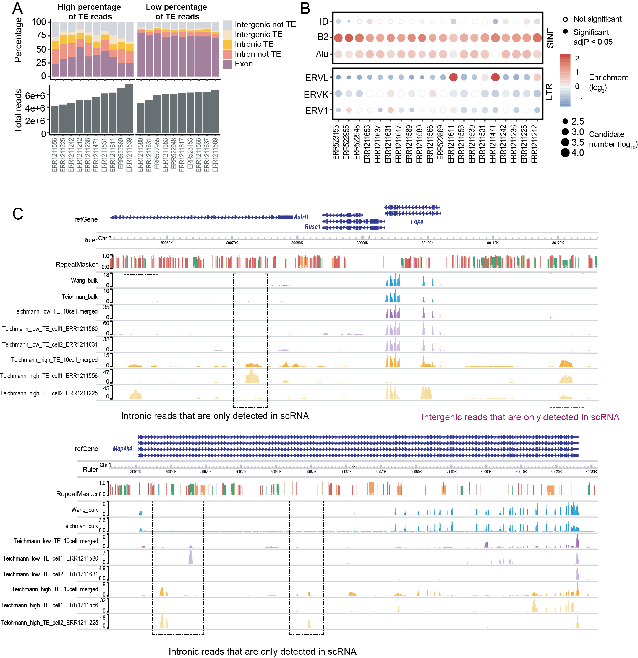

Supplemental Figure S3 Examples of single cells with different percentage of TE reads
(A) Examples of single cells with similar sequencing depth but different percentage of TE reads (Teichmann lab, mESC). Top: distribution of scRNA-seq reads at 5 non-overlapping genomic regions in single cells. Bottom: sequencing depth per cell.
(B) TE-family enrichment analysis at single cells with different percentage of TE reads (Teichmann lab, mESC).
(C) Genome browser view of mESC bulk RNA-seq, Smart-seq of four single cells and merged Smart-seq. Only uniquely mapped reads are shown.

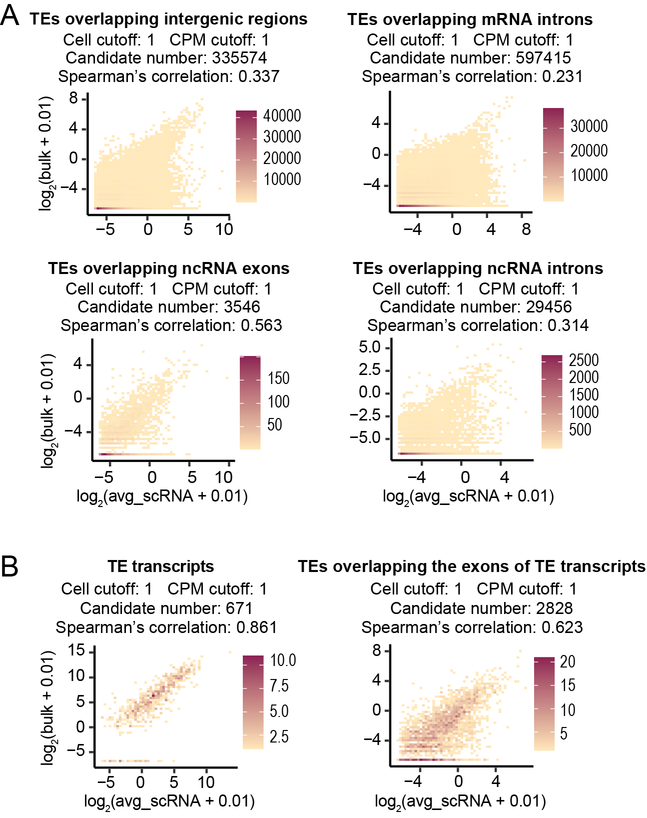

Supplemental Figure S4 Signal correlation between averaged mESC Smart-seq data and mESC bulk RNA-seq data
(A) Signal correlation between averaged scRNA-seq data and bulk RNA-seq data at TEs located within different genomic regions. Color scale represents the number of candidates.
(B) Correlation between averaged scRNA-seq data and bulk RNA-seq data at TE transcripts (left) and individual TE elements overlapping with the exons of the TE transcripts (right).

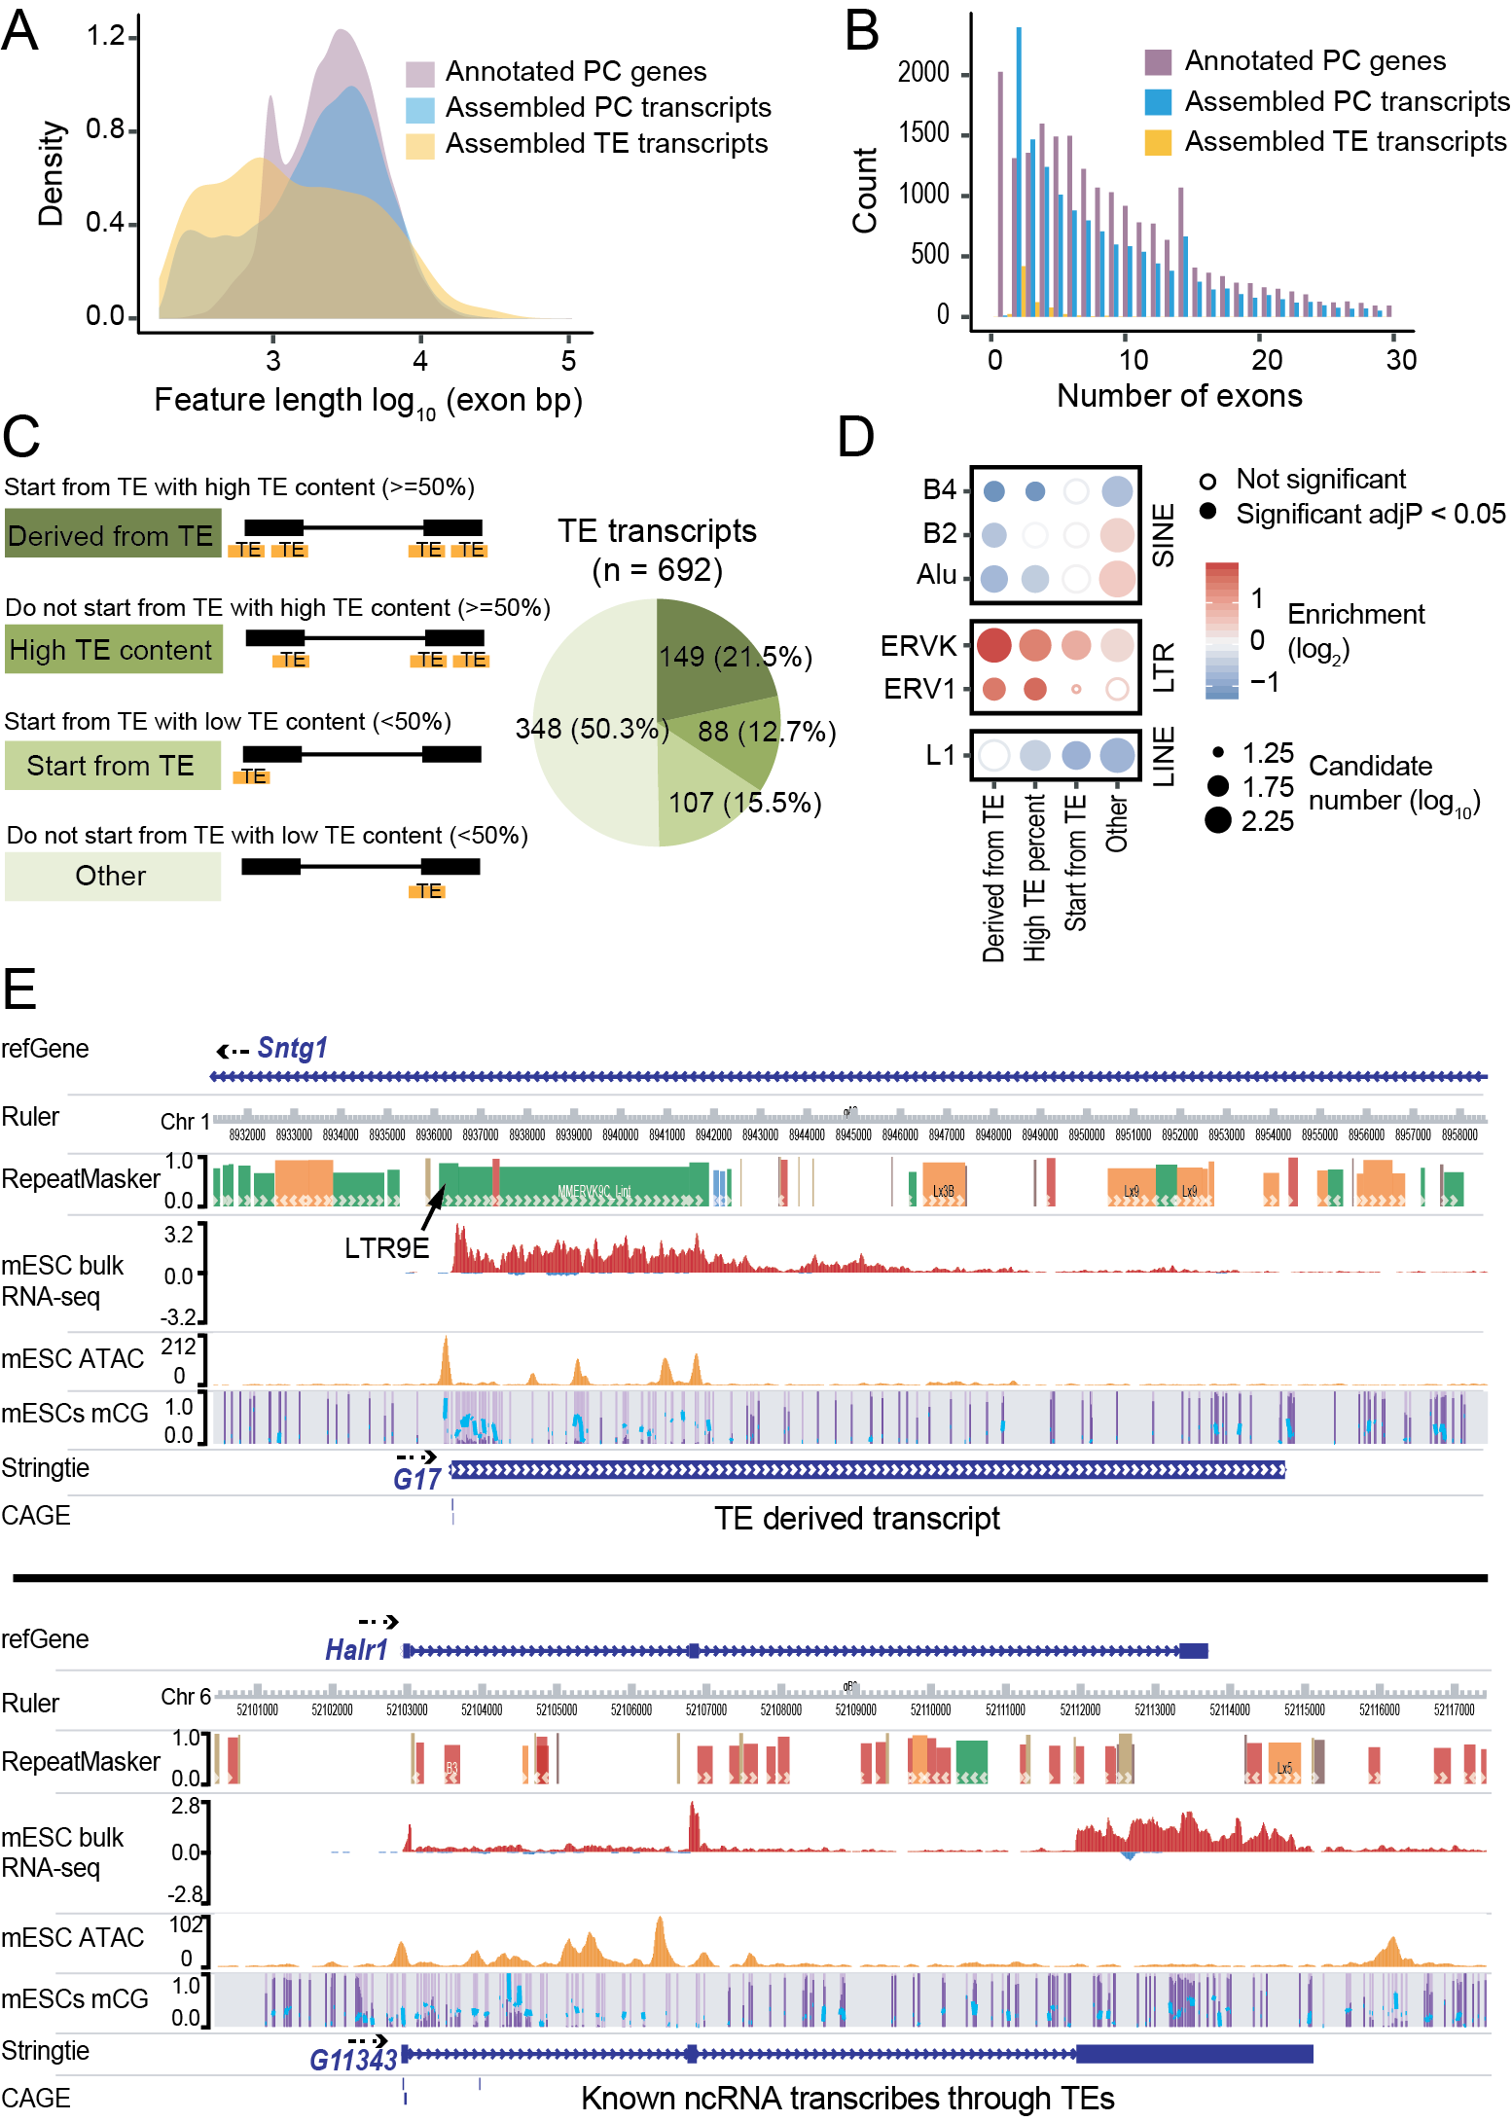

Supplemental Figure S5 Evaluation of TE transcripts assembled from mESC bulk RNA-seq data
(A) The length of protein-coding genes annotated by RefSeq, assembled transcripts that overlap with annotated protein-coding genes and assembled TE transcripts. Only exonic regions were considered.
(B) The number of exons of protein-coding genes annotated by RefSeq, assembled transcripts that overlap with annotated protein-coding genes and assembled TE transcripts.
(C) Around half of all the assembled TE transcripts either initiate from TEs or have more than 50% of their exons composed of TEs.
(D) TE-family enrichment analysis at different classes of TE transcripts. TE transcripts that initiate from TEs or have more than 50% of their exons composed of TEs are enriched for LTR elements.
(E) Genome browser view of bulk RNA-seq, ATAC-seq, CpG methylation, assembled TE transcripts (Wang lab, mESC) and FANTOM5 CAGE peaks. Only uniquely mapped reads are shown.

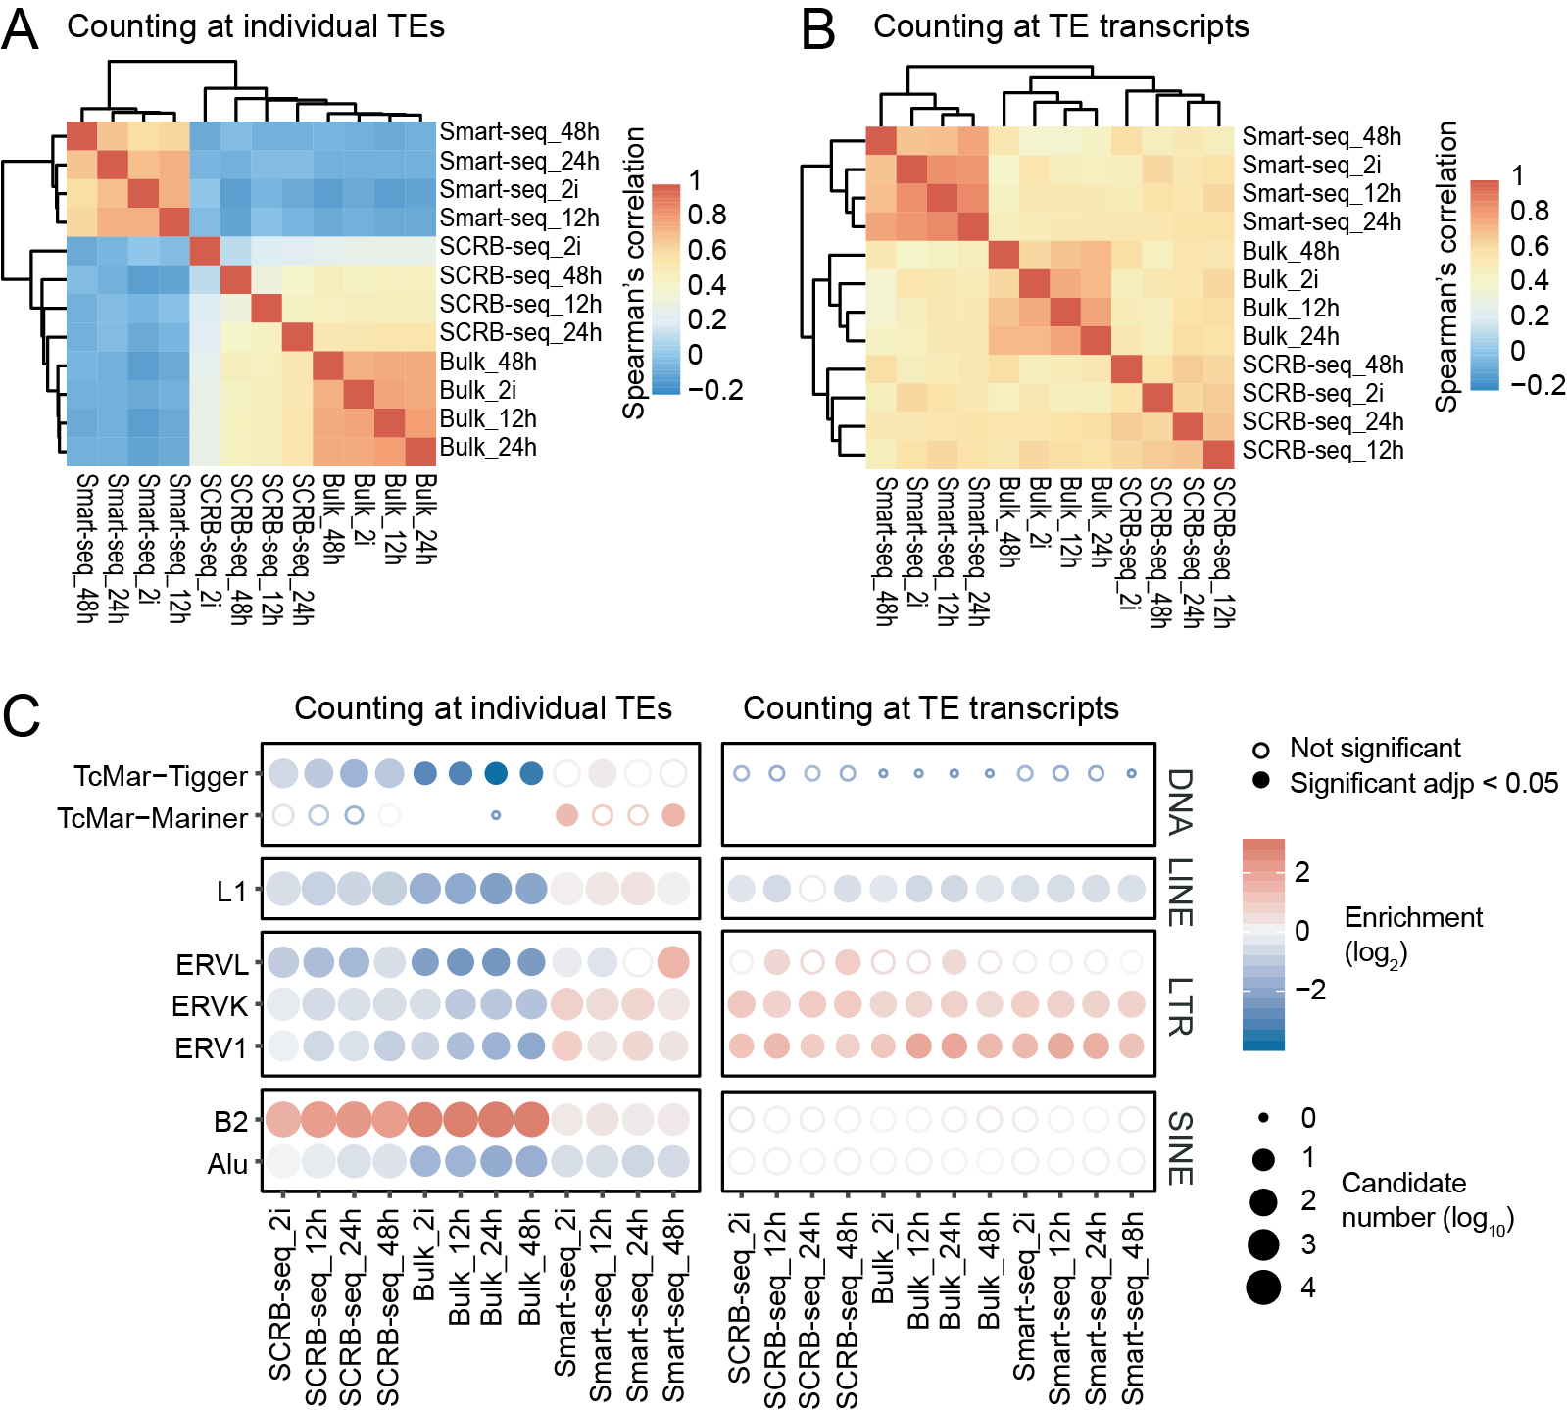

Supplemental Figure S6 Quantifying signal at TE transcripts is applicable to scRNA-seq with 3’ end signal enrichment
(A) and (B) Spearman’s correlation of datasets from a previously published mESC differentiation study, in which single cell Smart-seq2, single cell SCRB-seq and bulk RNA processed with SCRB-seq protocol were performed. Using full-length TE transcripts as reference led to significantly improved signal correlation between SCRB-seq and Smart-seq2 samples.
(C) TE-family enrichment analysis. Quantifying TE expression at transcript level allowed us to recover the enrichment of ERVs from all datasets, whereas only Smart-seq2 showed ERV enrichments when counting at individual TE.
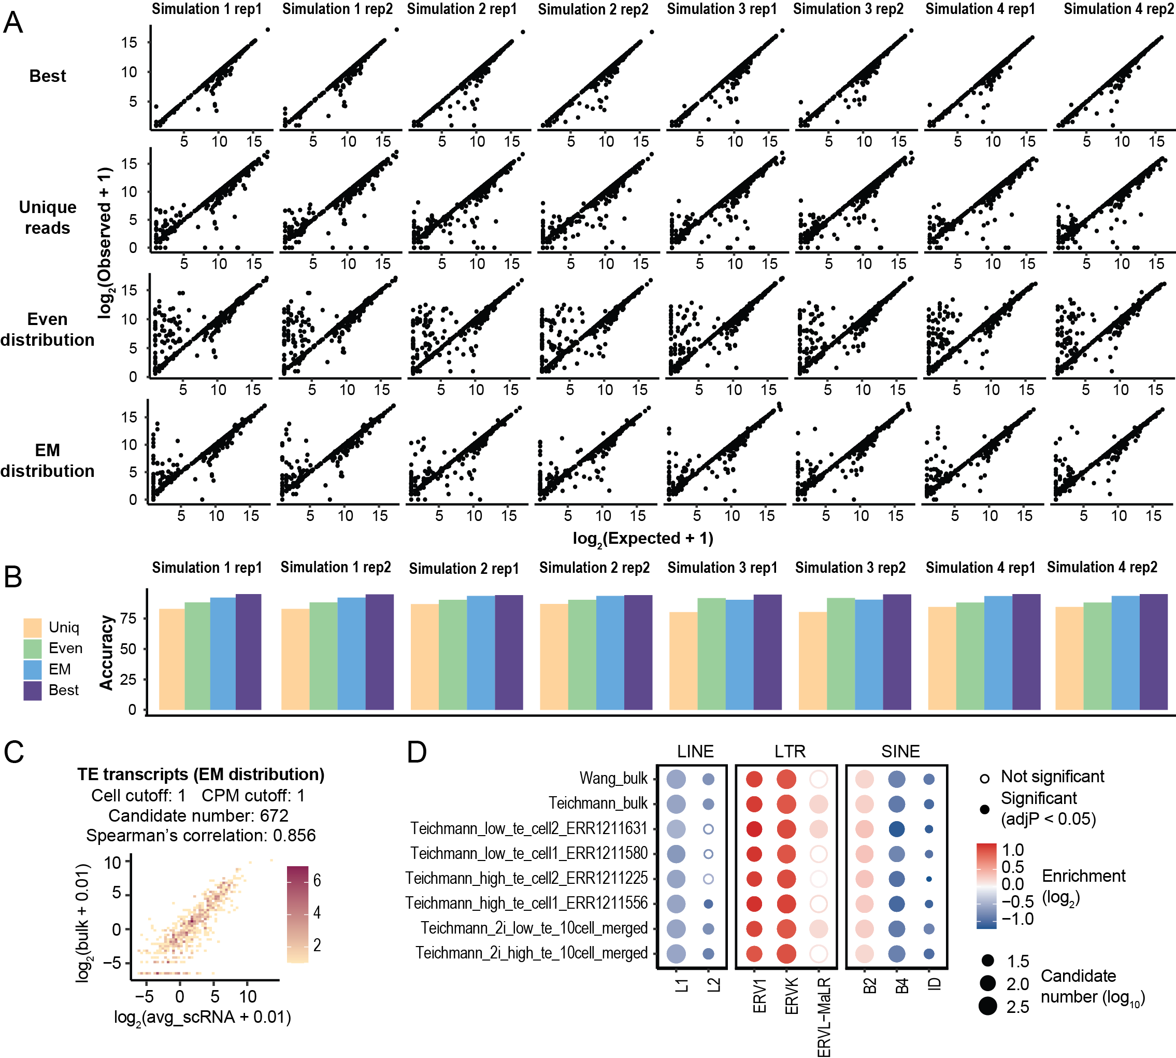

Supplemental Figure S7 Evaluating the performance of the EM algorithm
(A) Correlation between the expectation (the number of simulated reads) and observation (the number of quantified reads) at the 692 TE transcripts assembled using mESC datasets. Best: only quantifying uniquely mapped reads at TE transcripts without multiple mapped reads. Unique reads: only quantifying uniquely mapped reads at all the TE transcripts. Even distribution: quantifying both uniquely mapped reads and multiple mapped reads at all the TE transcripts. Multiple mapped reads were evenly distributed. EM distribution: quantifying both uniquely mapped reads and multiple mapped reads at all the TE transcripts. Multiple mapped reads were distributed using an EM algorithm.
(B) Performance of different quantification methods. Accuracy was determined as the percentage of observed reads that matches expectation.
(C) Correlation of averaged mESC Smart-seq signal and bulk RNA-seq signal after distributing multiple mapped reads with the EM algorithm.
(D) TE family enrichment analysis using candidates obtained with the EM algorithm.

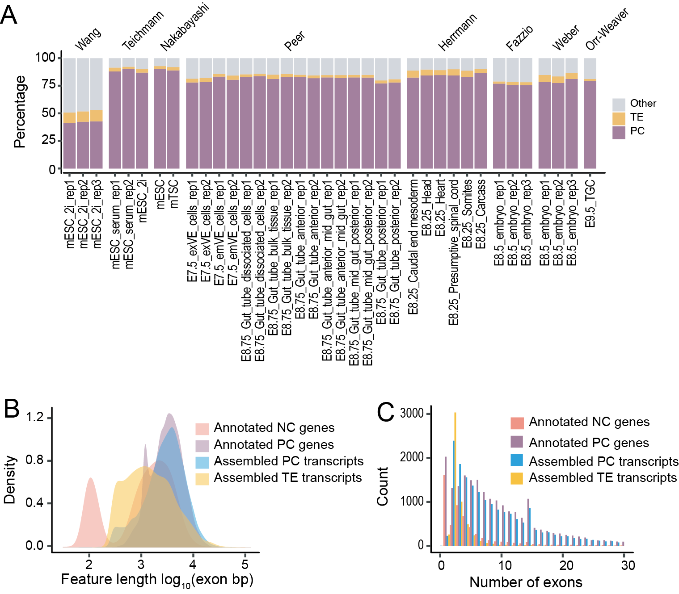

Supplemental Figure S8 Evaluation of TE transcripts assembled from 37 bulk RNA-seq
(A) Distribution of mappable reads in 37 bulk RNA-seq samples. PC: protein-coding exons defined by RefSeq. TE: transposable elements that do not overlap with protein-coding exons. Other: other genomic locations.
(B) The length of protein-coding genes annotated by RefSeq, noncoding genes annotated by RefSeq, assembled transcripts that overlap with annotated protein-coding genes and assembled TE transcripts. Only exonic regions were considered.
(C) The number of exons of protein-coding genes annotated by RefSeq, noncoding genes annotated by RefSeq, assembled transcripts that overlap with annotated protein-coding genes and assembled TE transcripts.
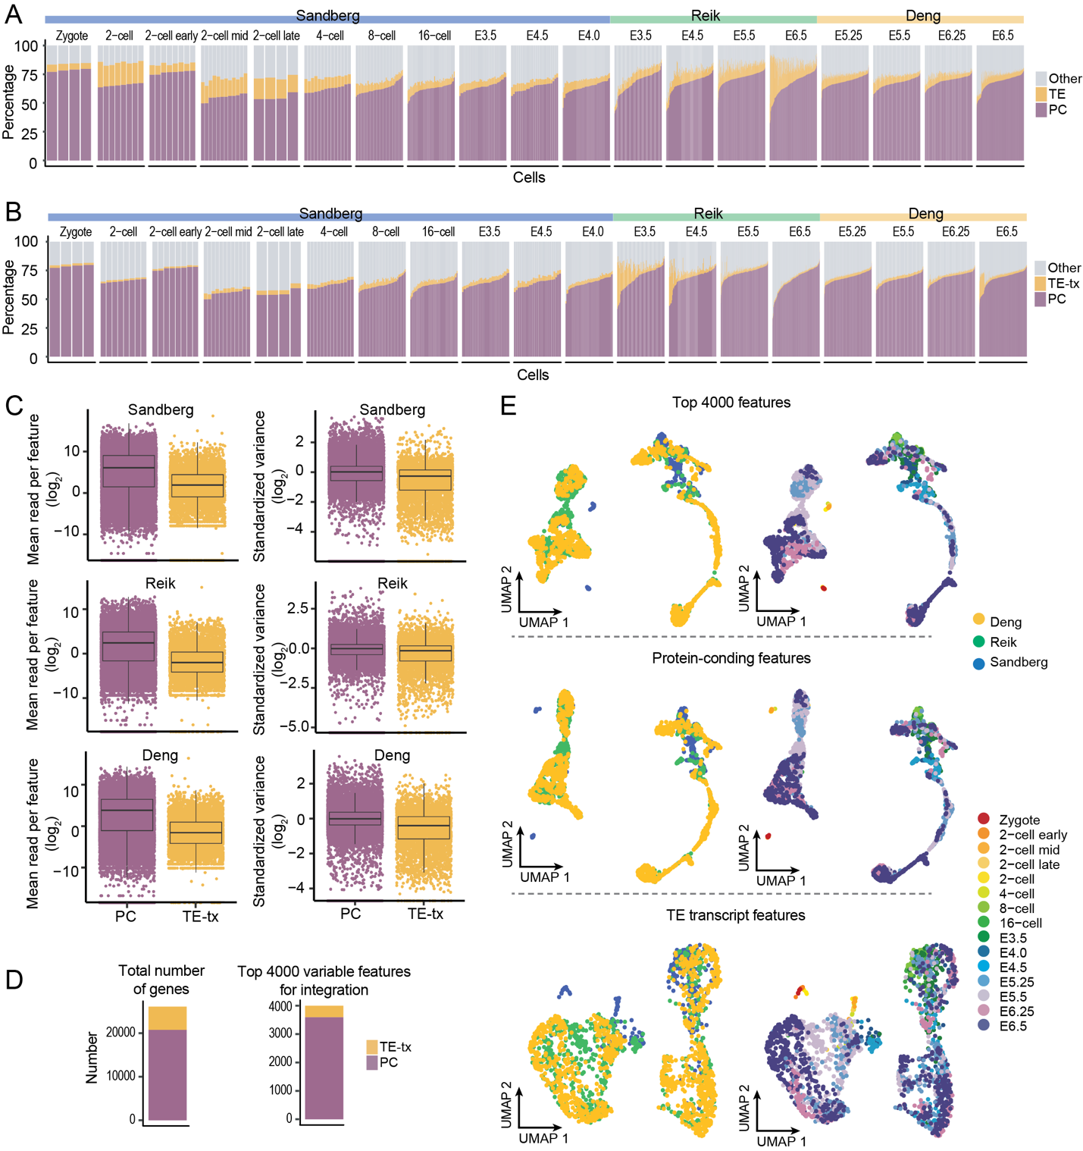

Supplemental Figure S9 Evaluation of mouse scRNA-seq data from zygote to gastrulation
(A) and (B) Distribution of mappable reads. PC: protein-coding exons defined by RefSeq. TE: transposable elements that do not overlap with protein-coding exons. TE-tx: TE transcripts. Other: other genomic locations.
(C) Left: averaged signal of protein-coding genes and TE transcripts across all the cells. Right: standardized variance of protein-coding genes and TE transcripts.
(D) The number of TE transcripts and protein-coding genes in the top 4000 variable features. Left: 5299 TE transcripts and 20779 protein-coding genes were used for scRNA-seq signal quantification. Right: among the top 4000 variable features that were used for scRNA-seq dimension reduction and integration, 410 are TE transcripts.
(E) UMAP of scRNA-seq data. scRNA-seq dimension reduction and integration were performed using the top 4000 variable features (top), the top variable features that are protein-coding genes (middle, n = 3590), or the top variable features that are TE transcripts (bottom, n = 410).

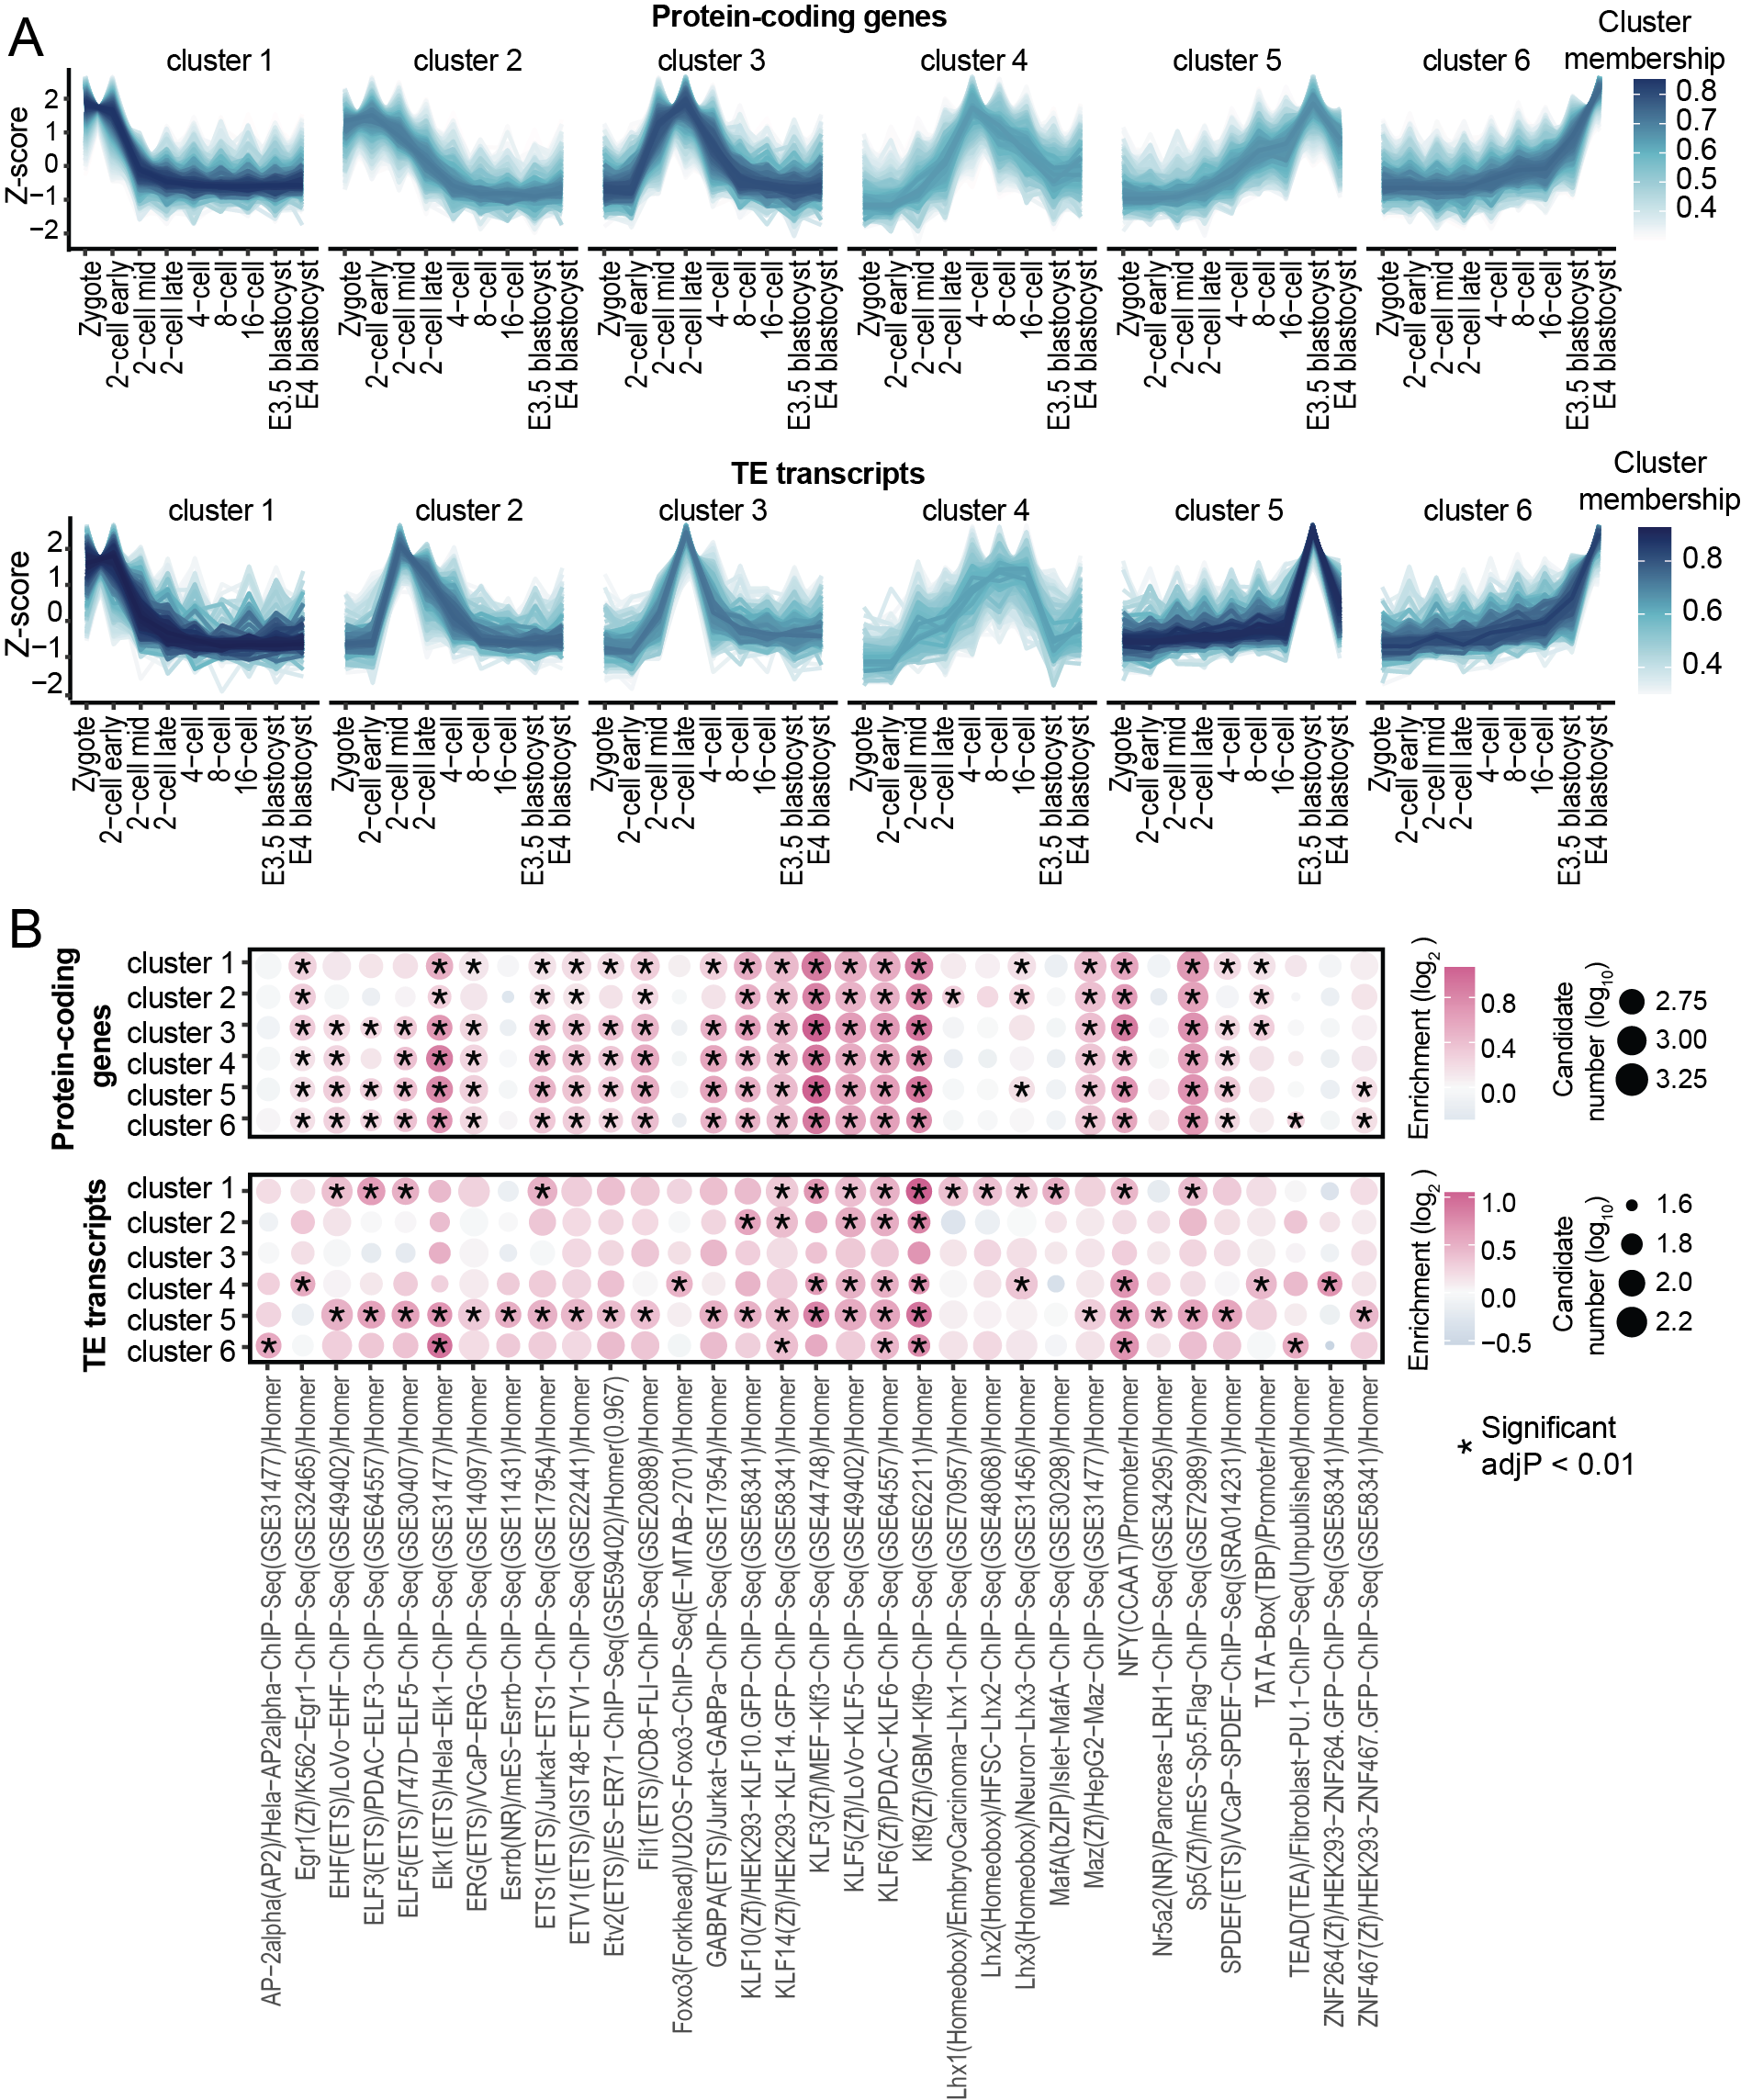

Supplemental Figure S10 Dynamic expression of TE transcripts and protein-coding genes during mouse pre-implantation stages
(A) TE transcripts and protein-coding genes were grouped into 6 clusters based on their expression patterns across pre-implantation stages.
(B) Enrichment of known motifs at the promoter region of TE transcripts and protein-coding genes. HOMER2 was run with the promoter sequences of TE transcripts and protein-coding genes (500bp upstream of the transcription start site), known motifs that are shared between TE transcripts and protein-coding genes were shown.

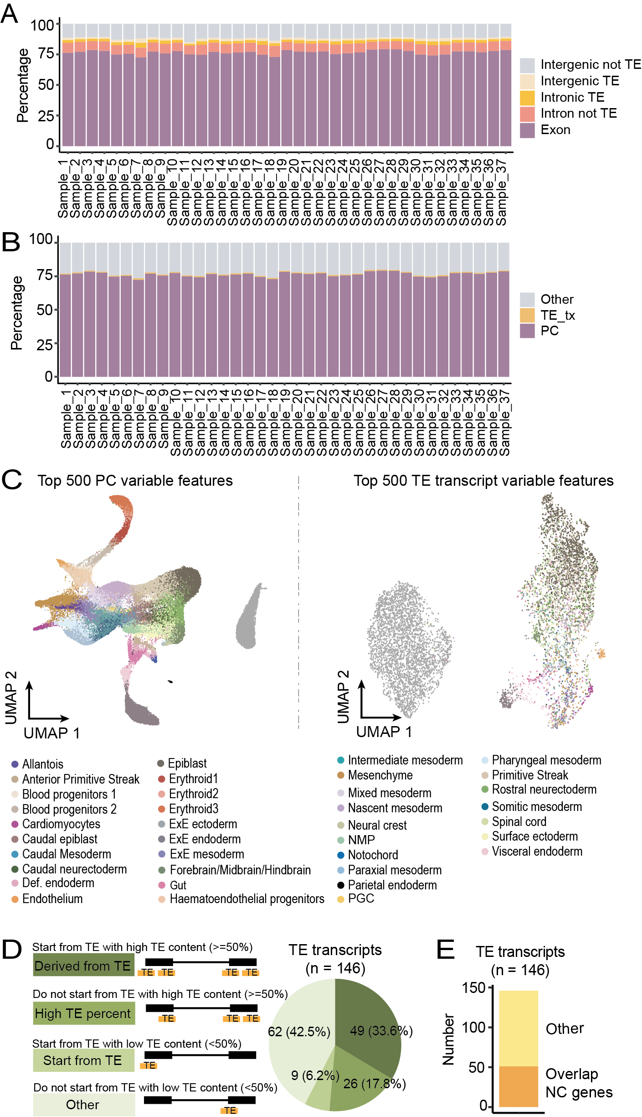

Supplemental Figure S11 Evaluation of mouse scRNA-seq data from gastrulation to early organogenesis
(A) Distribution of scRNA-seq reads in five non-overlapping genomic regions: protein-coding exons, TEs within the introns of protein-coding genes, other intronic regions of protein-coding genes, intergenic TEs, and other intergenic regions.
(B) Distribution of scRNA-seq reads in protein-coding exons, TE transcripts and other genomic regions.
(C) UMAP of scRNA-seq using the top 500 variable features that are protein-coding genes or TE transcripts.
(D) 84 of the 146 TE transcripts with strong tissue enrichment either initiate from TEs or have more than 50% of their exons composed of TEs.
(E) 51 of the 146 TE transcripts with strong tissue enrichment have been annotated by RefSeq.

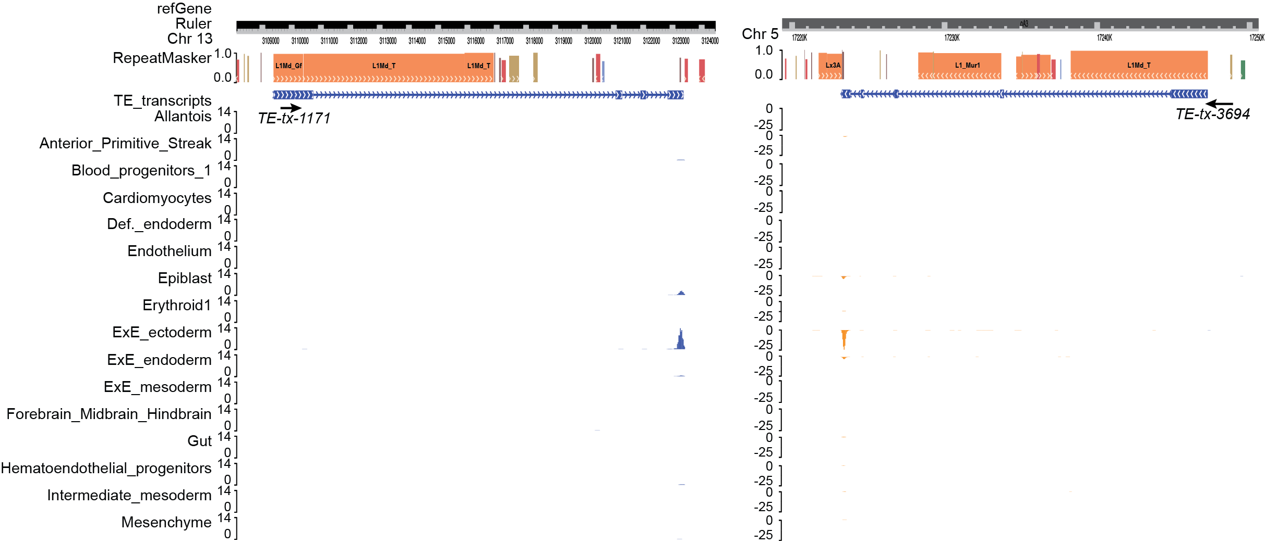

Supplemental Figure S12 TE transcripts that are highly expressed in extraembryonic ectoderm and are derived from LINE elements
Genome browser view of two TE transcripts that are highly expressed in extraembryonic ectoderm and are derived from LINE elements. Only uniquely mapped reads are shown.

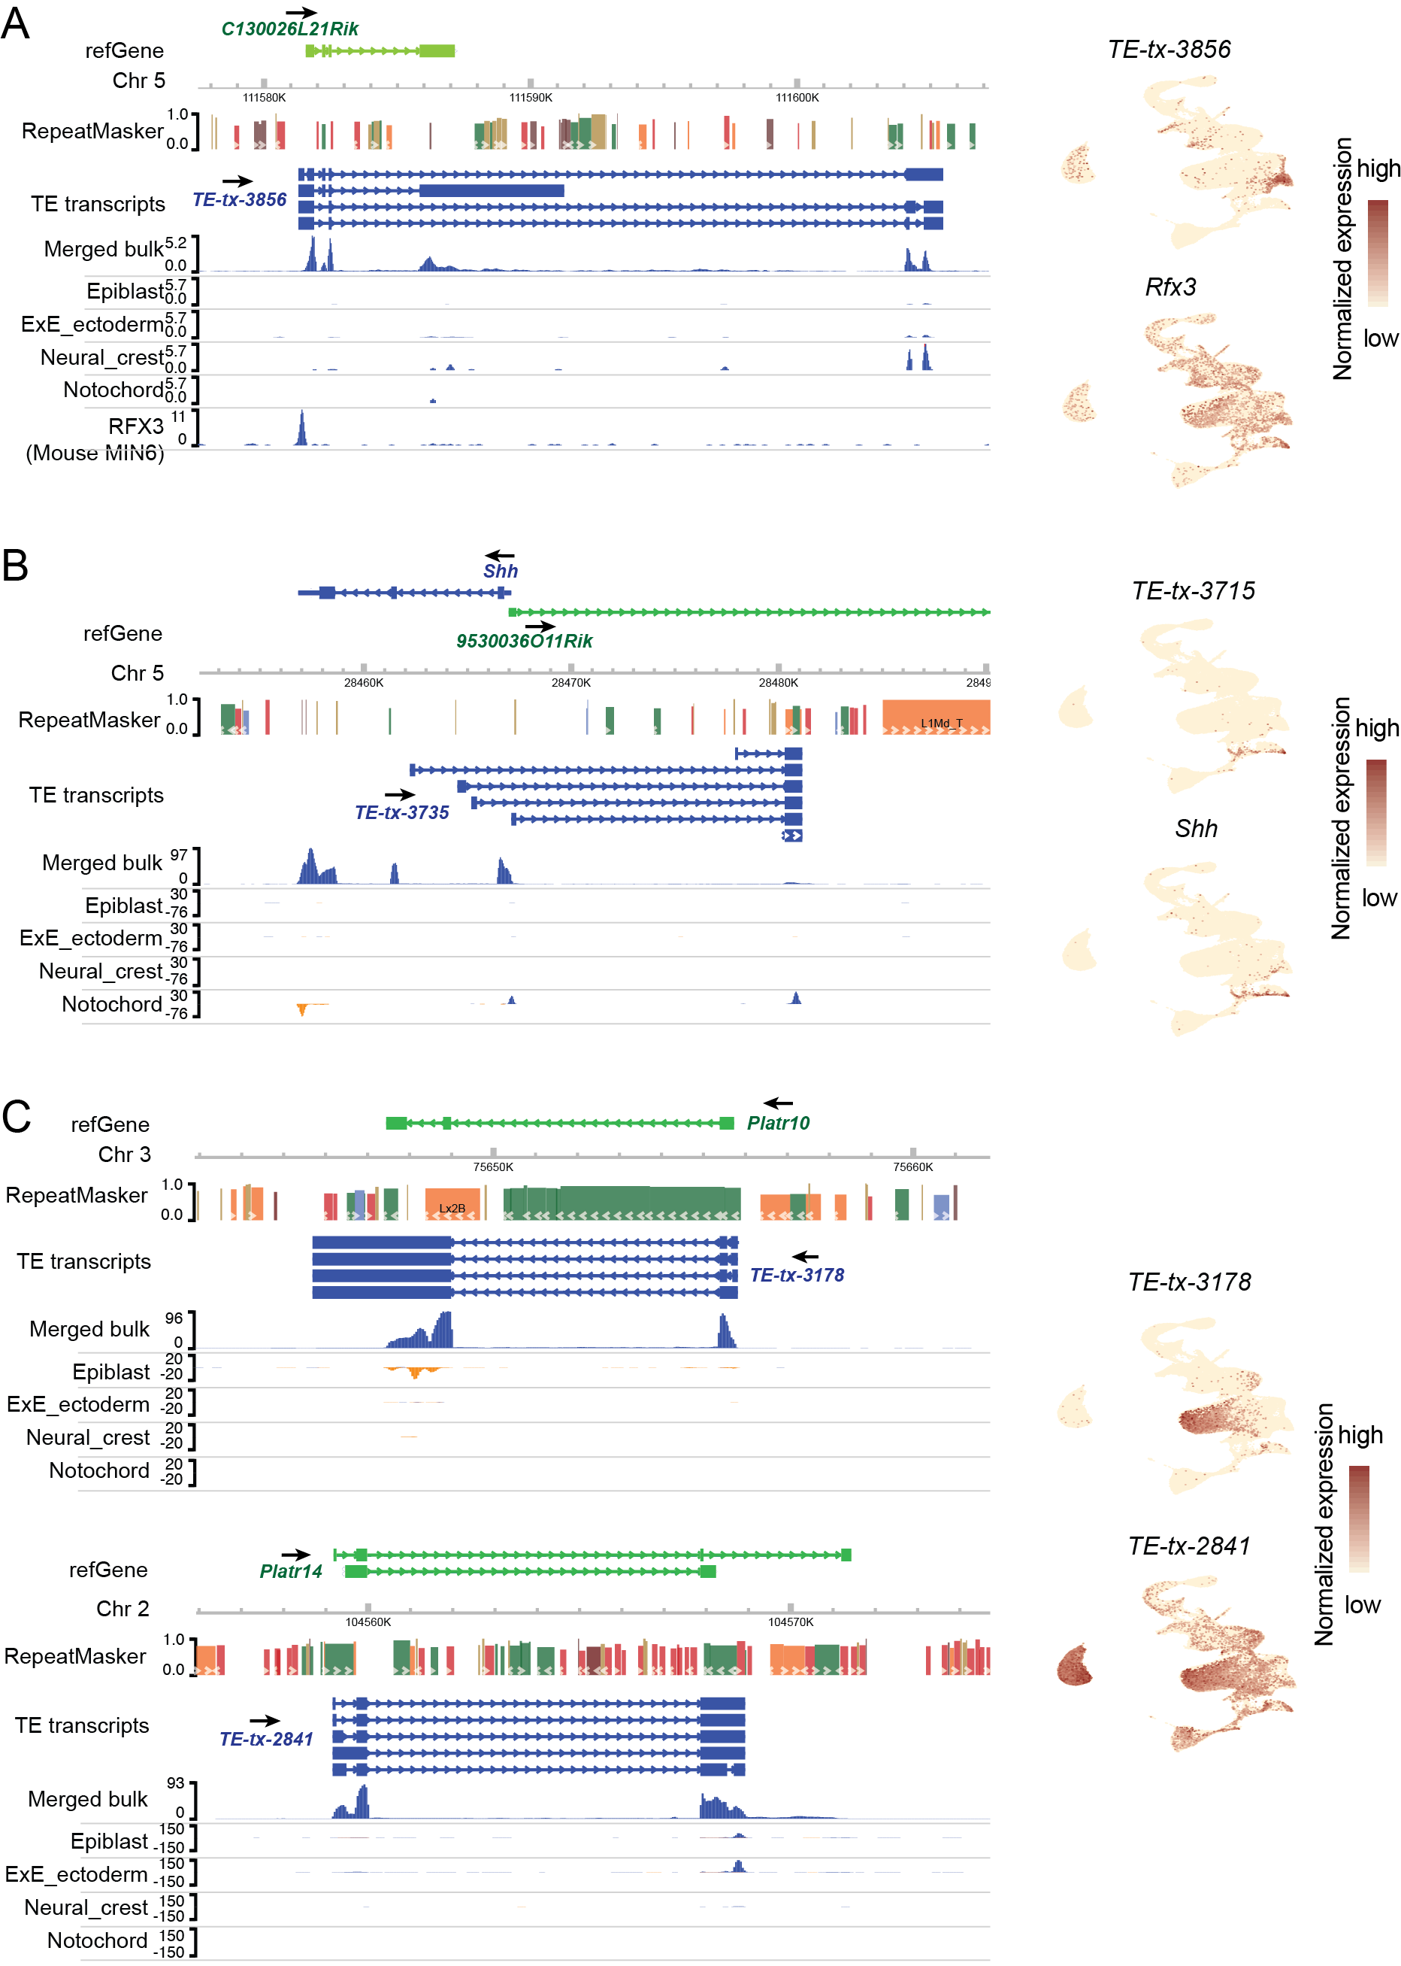

Supplemental Figure S13 Examples of TE transcripts
Left: genome browser view of assembled TE transcripts and scRNA-seq in selected tissues. Only Uniquely aligned reads were shown. RFX3 ChIP-seq track was obtained from Cistrome Data Browser (GEO: GSM1859216, CistromeDB: 56036). Right: Expression patterns of TE transcripts and related protein-coding genes.

Supplemental Table S1 Summary of datasets utilized in this manuscript
Descriptions and accession IDs of all the datasets utilized in this manuscript are listed in Supplemental_Table_S1.xlsx.

Supplemental Table S2 Genomic locations of assembled TE transcripts
Genomic locations of assembled 5299 TE transcripts are provided in Supplemental_Table_S1.xlsx.

Supplemental Table S3 Expression patterns of 146 TE transcripts with strong tissue enrichment during mouse gastrulation and early organogenesis
Expression patterns of 146 TE transcripts with strong tissue enrichment during mouse gastrulation and early organogenesis are summarized in Supplemental_Table_S3.xlsx.

