Supplemental Material to

Title: The multi-comparative 2-n-way genome suite

Authors: Gennady Churakov^{*,1†}, Fengjun Zhang^{1†}, Norbert Grundmann², Wojciech Makalowski², Angela Noll^{1,3}, Liliya Doronina¹, and Jürgen Schmitz^{*,1}

Affiliations:
¹Institute of Experimental Pathology, ZMBE, University of Münster, Münster, Germany
²Institute of Bioinformatics, Faculty of Medicine, University of Münster, Münster, Germany
³current address: Primate Genetics Laboratory, German Primate Center, Leibniz Institute for Primate Research, 37077 Göttingen, Germany
*Corresponding authors: jueschm@uni-muenster.de, churakov@uni-muenster.de
†Authors contributed equally

Supplemental Figures and Notes
Figure S1: Parameter Tutorial
Note S1: Parameters
Figure S2: 2-way Tutorial
Figure S3: n-way Tutorial
Figure S4: n-way Results Tutorial
Note S2: Examples
Figure S5: Exonization and population study

Figure S1
Parameter Tutorial: Illustration of the n-way parameters that can be optimized to perform presence/absence screening and sequence extraction of orthologous loci. Genomic coordinates are given above the lines. The area of insertion is indicated by flanking, upwards pointing arrowheads on the target genome (dotted lines). Downward pointing arrowheads flank the BED-inserts (solid lines).

Note S1
Two parameters can be set to fine-tune the search criteria and improve searches. The preset-insert parameter denotes user-defined input coordinates of interest; for example, RepeatMasker coordinates from the Target (or Query) genome. BED-insert denotes the LASTZ-generated insert in the derived 2-way alignment (an inserted sequence in one species compared with a gap in the second species). Depending on the quality of alignments and the distribution of evolutionary changes, in ideal cases, the preset-insert is identical to the BED-insert.
Min flanks (direct and reverse search; default 50 nt): determines the minimum lengths of conserved block flanks surrounding a preset-insert.
Insert/gap size (direct and reverse search; default 10 nt): determines the maximum opposite gap size by coordinates of gap regions.
Max distance (direct and reverse search for distance method; reverse search for overlap method; default 20 nt): determines the maximum allowed distance between preset-insert coordinates and BED-insert coordinates.
Max difference ratio (reverse search; default 0.3): allows not more than 30% length variation between preset-insert (query) and BED-inserts of another query.
Max overlap (direct and reverse search; only for overlap search method; default 25 nt): determines the maximum overlap of preset-inserts with the flanks of the BED-inserts.
Min coverage (direct and reverse search; only for overlap search method; default 0.7): indicates that at least 70% of the preset-inserts and BED-inserts overlap.
Extract extension (extraction; default 500 nt): extending flanks of BED-insert/gap loci in both 5'-and 3'-directions where available.
MUSCLE-based optimization (default without): Based on the MUSCLE sequence realignment results, for all sequences in a specified length range resulting symbols will be corrected.
Min target length (default 10 nt): MUSCLE-based optimization is applied to all preset-inserts ≥10 nt.
Max target length (default 250 nt): MUSCLE-based optimization is applied to all preset-inserts ≤250 nt.

Figure S2

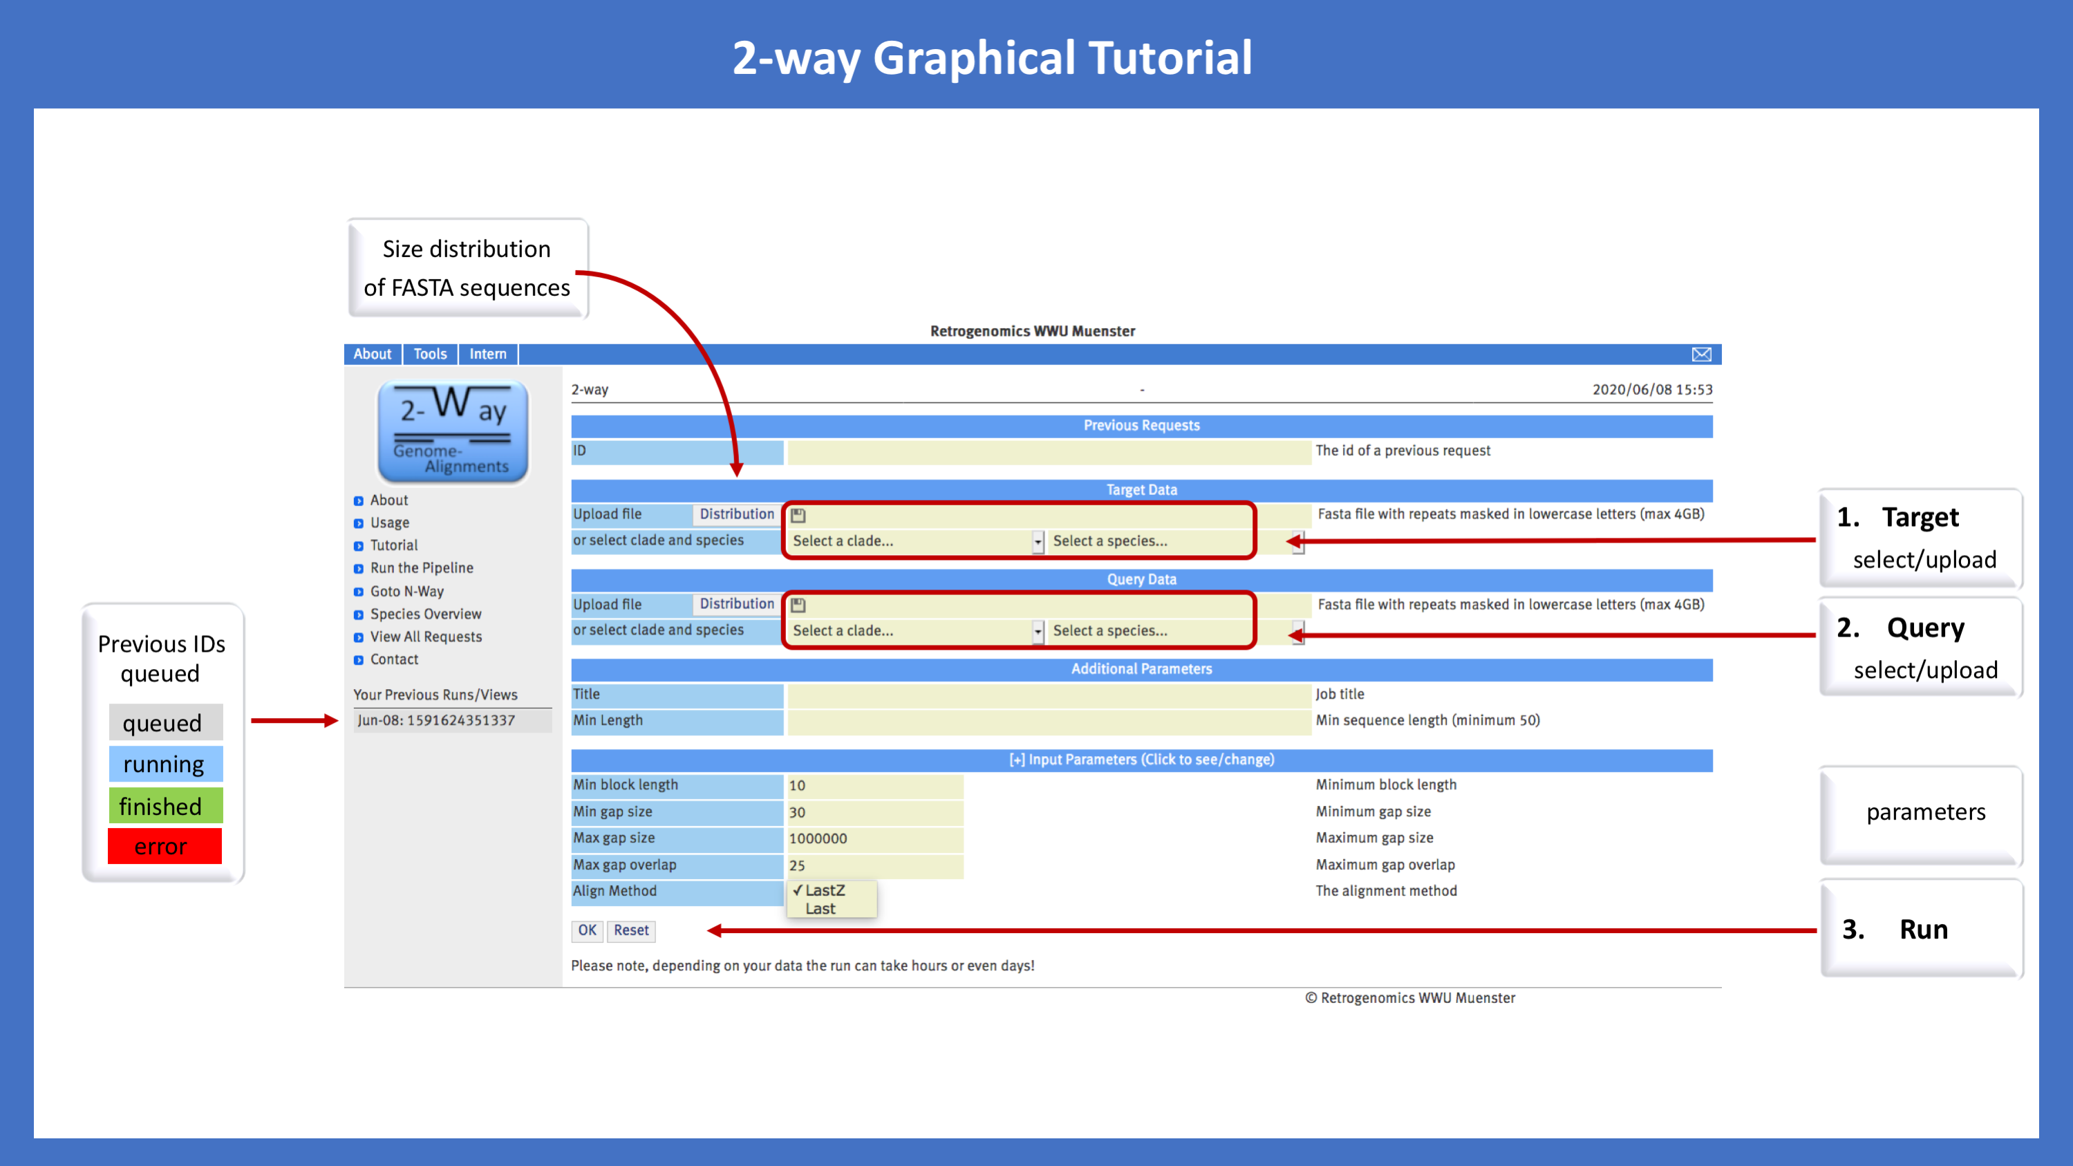

2-way Tutorial. A simple procedure to generate 2-way alignments and associated data in a few steps. (1) select or upload a Target genome in FASTA format, (2) select or upload a Query genome in FASTA format, (3) press the OK button at the bottom left to generate the alignment. To customize the size of the genome files for low-quality genomes, the size distribution of the uploaded files can be visualized (Distribution) and short reads can be excluded from analysis via the Min length parameter. Queued, running, finished, or erroneous runs are color-coded and listed as Previous IDs in the left panel. After requesting by contacting us directly, the new 2-way alignment combination can be transferred to the n-way module and organized in a client-specific project for comparisons of selected elements among genomes.

Figure S3

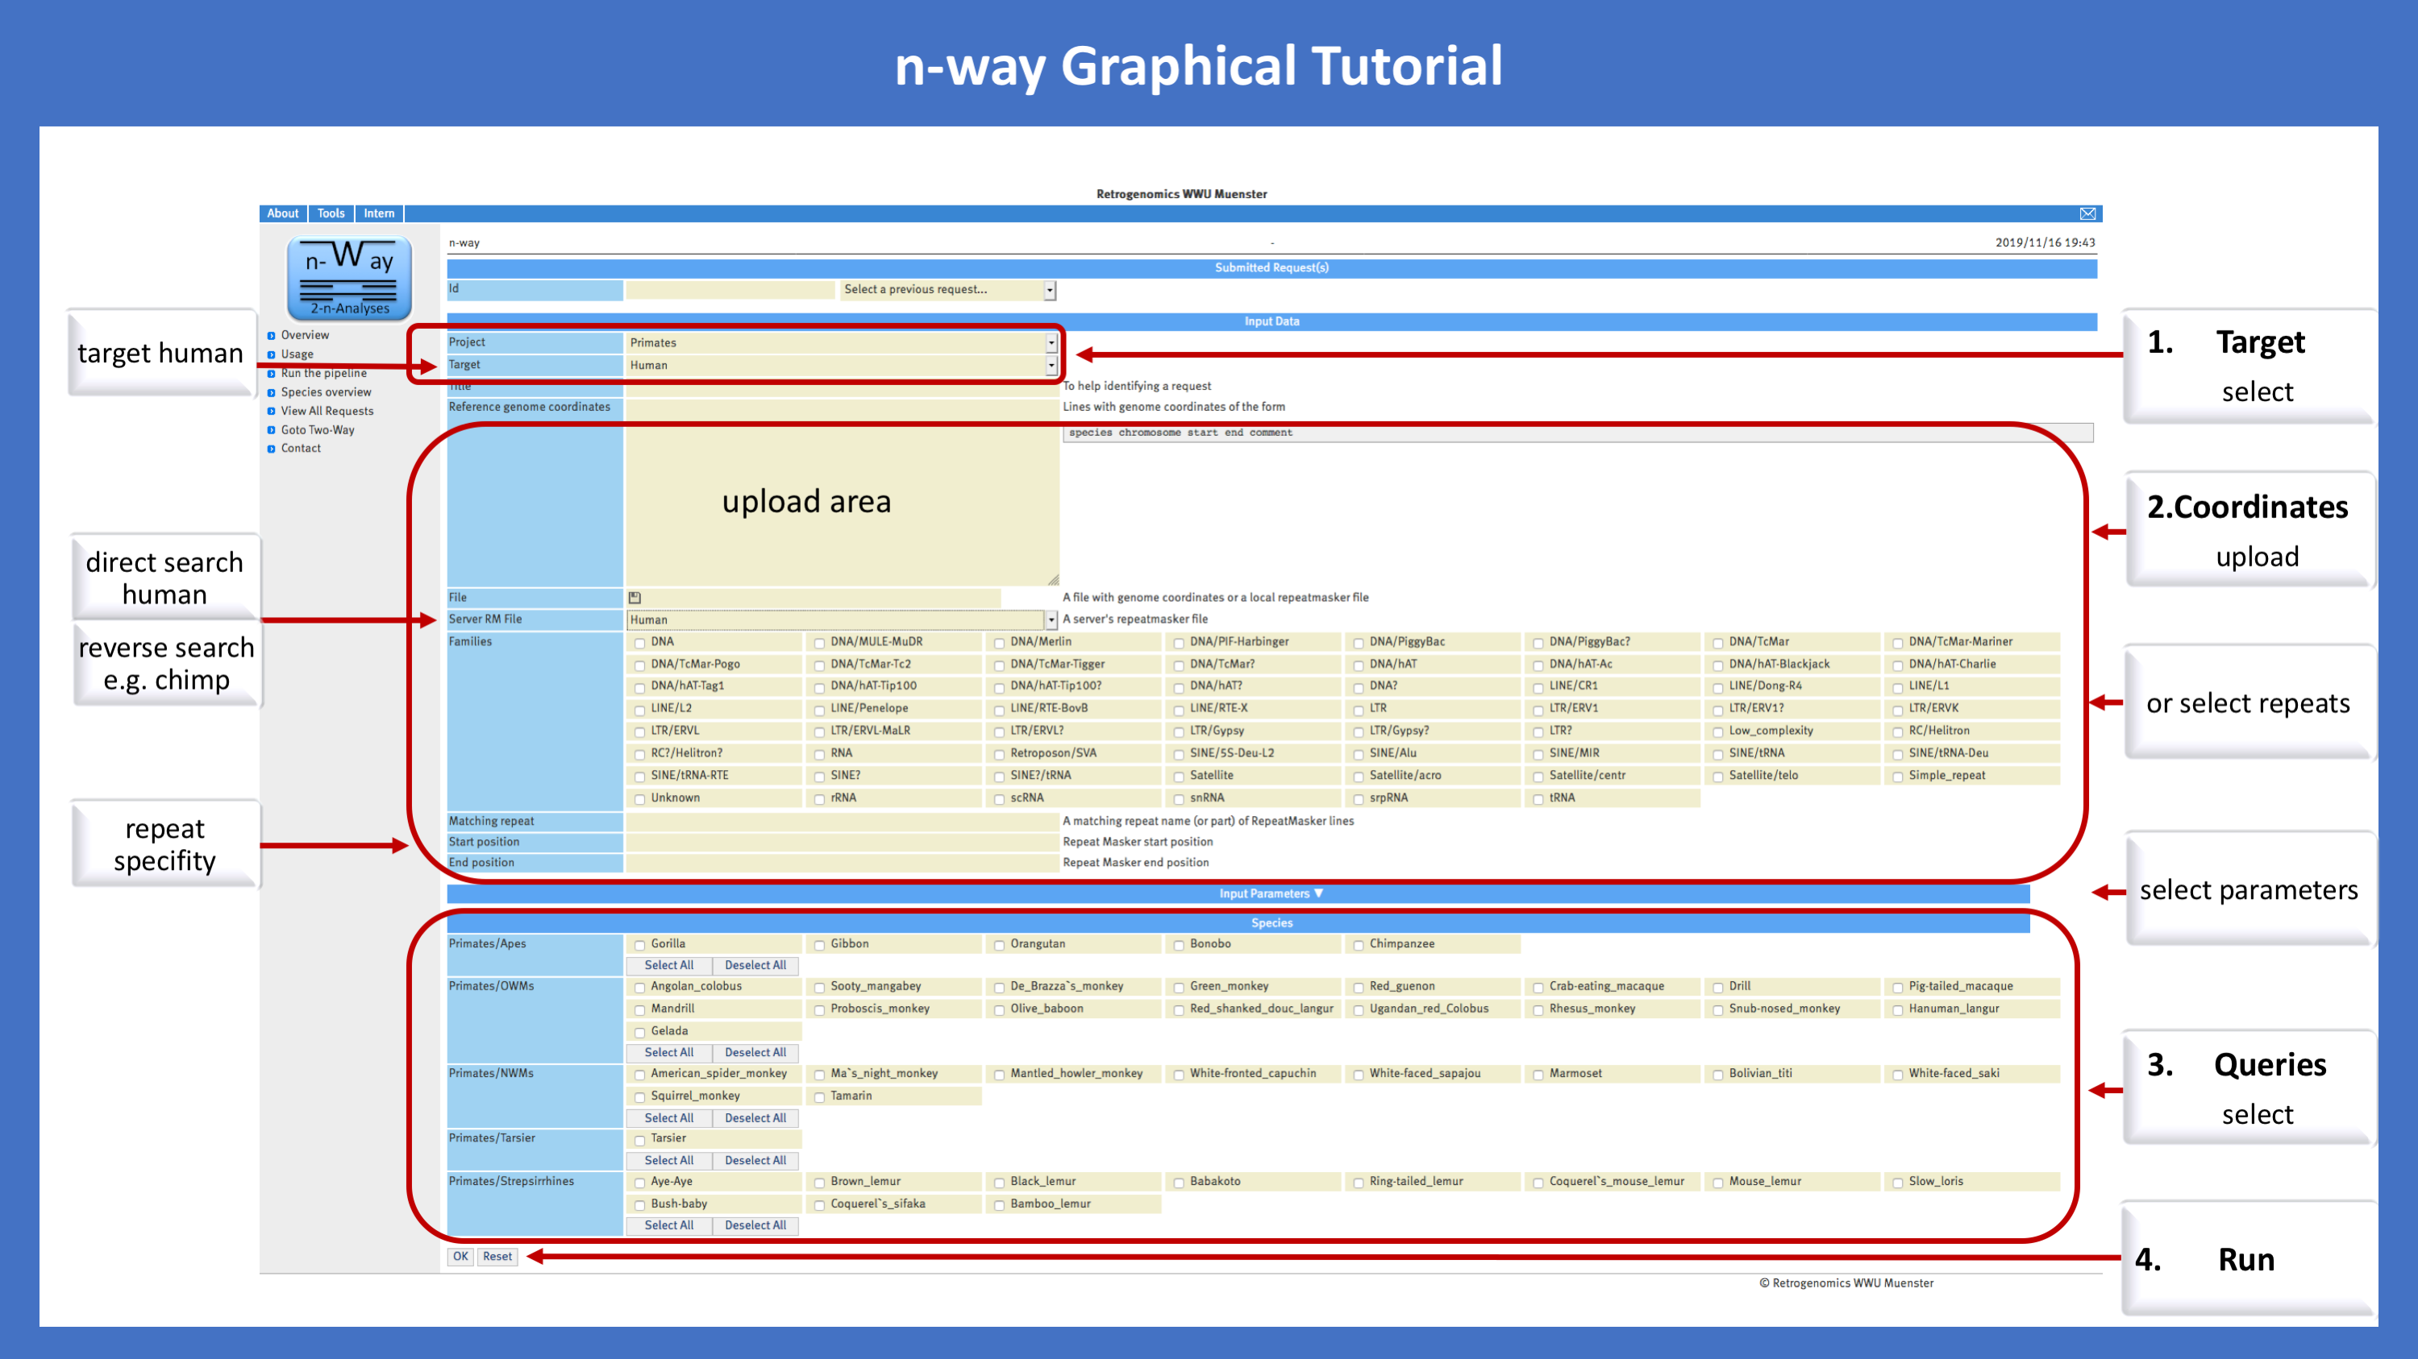

n-way Tutorial. A simple procedure to generate multiple (n)-way alignments in a few steps. (1) Select a Target genome, (2) upload the coordinates of interesting loci or select transposed elements from preexisting RepeatMasker (RM) tables. (3) select the Query genomes, (4) Run the application by pressing OK at the bottom left. To run a direct search both the Target and Server RM files must be from the same species, in this particular case., human. To run a reverse search, the Server RM File should be uploaded from one of the query sequences. All parameters for screening for diagnostic presence/absence patterns are described in the Parameter Tutorial.

Fig. S4

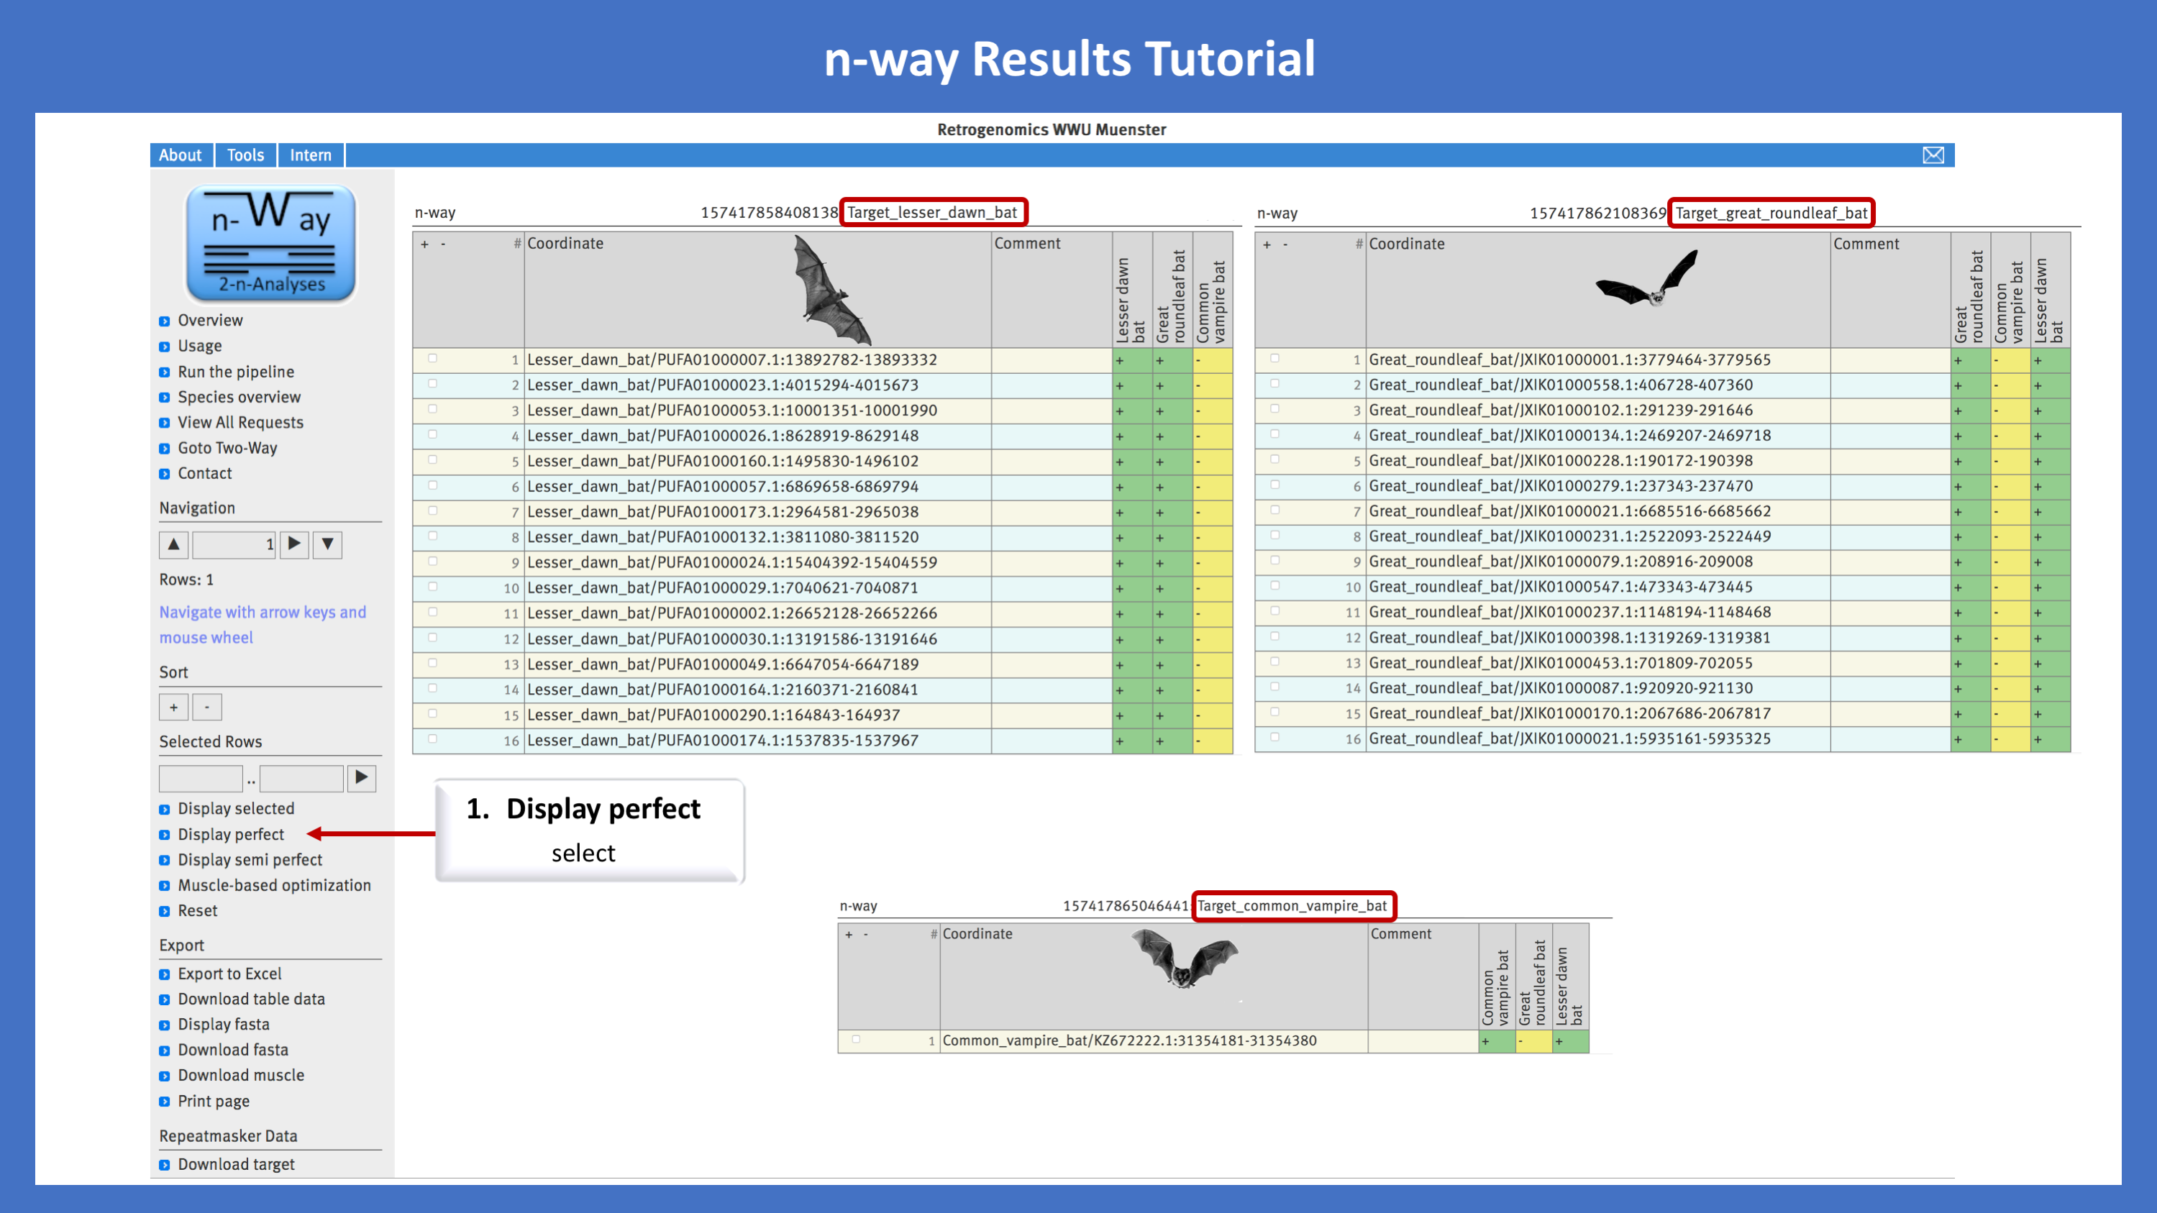

n-way Results Tutorial. The n-way Results Tutorial shown here represents three different runs of the Chiroptera example outlined in the manuscript. On this occasion, the lesser dawn bat, the great roundleaf bat, and the common vampire bat were selected as targets to conduct a multidirectional screening for evolutionary diagnostic presence/absence markers. Listed are all post-selected diagnostic loci that show perfect presence/absence patterns (Display perfect) of evolutionary informative markers. The presence or absence status of each of the screened for elements is shown for all investigated species as (+) green or (-) yellow, respectively. All data can be saved as Excel files and subsequently sorted and analyzed in Excel. The loci can be re-aligned (up to 1,000 in one step) using MUSCLE-based optimization. As a consequence, the presence/absence states might be altered. All individual loci can be downloaded as aligned fasta files.

Note S2 - Examples
Example 1: Carnivora - recovery of previously detected markers. As an example to verify the effectiveness of 2-n-way, we used genomes of four representative Carnivora species that were previously investigated in Doronina et al. (2015): (1) the giant panda (Ailuropoda melanoleuca), (2) the Weddell seal (Leptonychotes weddellii), (3) the walrus (Odobenus rosmarus), and (4) the ferret (Mustela putorius furo). All derived 2-ways (1) giant panda/Weddell seal, (2) giant panda/walrus, (3) giant panda/ferret, (4) walrus/giant panda, (5) walrus/Weddell seal, (6) walrus/ferret, (7) ferret/giant panda, (8) ferret/Weddell seal, (9) ferret/walrus were uploaded to n-way (project Carnivora, publicly available) and coordinates of previously diagnosed phylogenetic TE markers were used in an n-way run (overlap search method; without and with MUSCLE-based correction). For each previously supported hypothesis of potential Arctoidea relationships (Ursoidea plus Pinnipedia; Ursoidea plus Musteloidea, Pinnipedia plus Musteloidea) we performed two runs using different reference genomes. We considered a marker as recovered when the n-way table indicated a "perfect" presence/absence pattern.

Example 2: Catarrhini - comparison of GPAC and 2-n-way.
For our comparative approach we generated two 2-way genome alignments in 2-way tool, option lastz: human (hg38)/chimpanzee (panTro5) and human (hg38)/rhesus monkey (rheMac8). The BED-files of these 2-ways were transferred to n-way in the project Catarrhini, that contained one target (human) and two queries (chimpanzee and rhesus monkey). The input Alu elements of human were extracted from the UCSC RepeatMasker file (hg38.fa.out.gz; http://hgdownload.soe.ucsc.edu/goldenPath/hg38/bigZips/). Using fastCOEX (Doronina et al. 2017) the full-length Alus (missing ≤10 nts) located in TE-free regions (<20% TEs in 500 nt flanks) were selected and taken as n-way input coordinates. Initial run was performed with standard settings and perfect presence/absence patterns human-chimpanzee-rhesus monkey +--, ++-, +-+, and +++ were extracted from the n-way. The MUSCLE-based optimization was applied to semi-perfect cases with subsequent extraction of loci that became perfect after optimization. For GPAC the same target and queries were analyzed (human (hg38)-30 way) as well as the same Alu coordinates as analyzed by 2-n-way. The coordinates of the perfect loci were extracted and compared with the perfect loci from n-way.
Genomes analyzed in the project Catarrhini
human (Homo sapiens; hg38)
http://hgdownload.soe.ucsc.edu/goldenPath/hg38/bigZips/hg38.fa.gz
chimpanzee (Pan troglodytes; panTro5)
http://hgdownload.soe.ucsc.edu/goldenPath/panTro5/bigZips/panTro5.fa.gz
rhesus monkey (Macaca mulatta; rheMac8)
http://hgdownload.soe.ucsc.edu/goldenPath/rheMac8/bigZips/rheMac8.fa.gz
2-way alignments generated in the intron loss project
(1) human (hg38)/chimpanzee (panTro5), (2) human (hg38)/rhesus monkey (rheMac8).

Example 3: Intron loss - abundance in mammals and birds. In preliminary investigations of primate intron loss, we extracted an unexpectedly large number of potential intron losses via 2-n-way. For example, the genome of the proboscis monkey (Nasalis larvatur Charlie1.0; WGS JMHX01; https://www.ncbi.nlm.nih.gov/assembly/GCA_000772465.1/) contained 929 supposed cases of intron loss in about 277,000 annotated human introns. To verify this unexpectedly high number of lost introns we investigated a second assembly of Nasalis larvatus NasLar_v1_BIUU (WGS PVIX01) https://www.ncbi.nlm.nih.gov/assembly/GCA_004027105.1. We again found 144 cases of lost intron. A comparison of the two assemblies showed that just 10 of these loci overlapped between the two sequencing projects. Moreover, all were rejected after manually examining them to determine that the intron was completely absent in at least two closely related species (to avoid assembly errors) and that the flanking exons were intact, indicating massive problems of annotation in both of the assemblies, which we have observed in many other primates and other mammals. A partial or full mixture of genes and intron-less retropseudogenes aligned in 2-ways may impede a reliable analysis of intron loss at the species level. As a result, we also analyzed intron loss in mammals and birds for cases of shared exact deletions with proof in at least two different and independently assembled species, starting our screenings from human (hg38; NCBI RefSeq), mouse (mm10; NCBI RefSeq), cow (bosTau8; NCBI RefSeq), dog (canFam3; NCBI RefSeq), opossum (monDom5; RefSeq Genes), and zebra finch introns (taeGut2; Other RefSeq) and using standard n-way parameters without and with MUSCLE-based optimization. Intron coordinates were queried from the UCSC Table Browser (e.g., track: RefSeq Genes; output format; custom track; get output; Introns). We generated new 2-way alignments or uploaded pre-existing 2-ways from UCSC to n-way (project intron loss). To receive a clear idea of the phylogeny of intron loss, we added additional informative sequences of selected species to the 2-n-way-derived alignments (Supplemental Table 1 and Supplemental Data 1). A potential new candidate for a multitasking moonlighting function is the pancreatic progenitor cell differentiation and proliferation factor gene (PPDPF; https://www.genecards.org/cgi-bin/carddisp.pl?gene=PPDPF) that repetitively lost intron 4 throughout mammalian evolution (absent in Haplorrhini, Dermoptera, Scandentia, and Afrotherians, but present in all other investigated mammals).
Genomes analyzed in the intron loss project
human (Homo sapiens; hg38)
http://hgdownload.soe.ucsc.edu/goldenPath/hg38/bigZips/hg38.fa.gz
mouse (Mus musculus; mm10)
http://hgdownload.soe.ucsc.edu/goldenPath/mm10/bigZips/chromFa.tar.gz
cow-query (Bos taurus; ARS-UCD1.2)
https://www.ncbi.nlm.nih.gov/assembly/GCA_002263795.2
cow-target (Bos taurus; bosTau8)
http://hgdownload.soe.ucsc.edu/goldenPath/bosTau8/bigZips/bosTau8.fa.gz
dog (Canis familiaris; canFam3)
http://hgdownload.soe.ucsc.edu/goldenPath/canFam3/bigZips/canFam3.fa.gz
shrew (Sorex araneus; sorAra2)
http://hgdownload.soe.ucsc.edu/goldenPath/sorAra2/bigZips/sorAra2.fa.gz
rabbit (Oryctolagus cuniculus; oryCun2)
http://hgdownload.soe.ucsc.edu/goldenPath/oryCun2/bigZips/oryCun2.fa.gz
pika (Ochotona princeps; ochPri2)
http://hgdownload.soe.ucsc.edu/goldenPath/ochPri2/bigZips/ochPri2.fa.gz
little brown bat (Myotis lucifugus; myoLuc2)
http://hgdownload.soe.ucsc.edu/goldenPath/myoLuc2/bigZips/myoLuc2.fa.gz
large flying fox (Pteropus vampyrus; pteVam1)
http://hgdownload.soe.ucsc.edu/goldenPath/pteVam1/bigZips/pteVam1.fa.gz
opossum (Monodelphis domestica; monDom5)
http://hgdownload.soe.ucsc.edu/goldenPath/monDom5/bigZips/chromFa.tar.gz
zebra finch (Taeniopygia guttata; taeGut2)
http://hgdownload.soe.ucsc.edu/goldenPath/taeGut2/bigZips/taeGut2.fa.gz
chicken (Gallus gallus; galGal4)
http://hgdownload.soe.ucsc.edu/goldenPath/galGal4/bigZips/galGal4.fa.gz
2-way alignments used in the intron loss project
human (hg38)/mouse (mm10)
http://hgdownload.soe.ucsc.edu/goldenPath/hg38/vsMm10/hg38.mm10.net.axt.gz
human (hg38)/cow (bosTau9)
http://hgdownload.soe.ucsc.edu/goldenPath/hg38/vsBosTau9/hg38.bosTau9.net.axt.gz
human (hg38)/shrew (sorAra2)
https://hgdownload.soe.ucsc.edu/goldenPath/hg38/vsSorAra2/hg38.sorAra2.net.axt.gz
mouse (mm10)/human (hg38)
http://hgdownload.soe.ucsc.edu/goldenPath/mm10/vsHg38/mm10.hg38.net.gz
mouse (mm10)/rabbit (oryCun2)
http://hgdownload.soe.ucsc.edu/goldenPath/mm10/vsOryCun2/axtNet/
mouse (mm10)/pika (ochPri2)
http://hgdownload.soe.ucsc.edu/goldenPath/mm10/vsOchPri2/axtNet/
mouse (mm10)/little brown bat (myoLuc2)
http://hgdownload.soe.ucsc.edu/goldenPath/mm10/vsMyoLuc2/axtNet/
mouse (mm10)/large flying fox (pteVam1)
http://hgdownload.soe.ucsc.edu/goldenPath/mm10/vsPteVam1/axtNet/
cow (bosTau8)/human (hg38)
http://hgdownload.soe.ucsc.edu/goldenPath/bosTau8/vsHg38/bosTau8.hg38.net.axt.gz
cow (bosTau8)/mouse (mm10)
http://hgdownload.soe.ucsc.edu/goldenPath/bosTau8/vsMm10/bosTau8.mm10.net.axt.gz
dog (canFam3)/human (hg38)
http://hgdownload.soe.ucsc.edu/goldenPath/canFam3/vsHg38/canFam3.hg38.net.axt.gz
dog (canFam3)/mouse (mm10)
http://hgdownload.soe.ucsc.edu/goldenPath/canFam3/vsMm10/canFam3.mm10.net.axt.gz
opossum (monDom5)/human (hg38)
https://hgdownload.soe.ucsc.edu/goldenPath/monDom5/vsHg38/axtNet/
opossum (monDom5)/mouse (mm10)
https://hgdownload.soe.ucsc.edu/goldenPath/monDom5/vsMm10/axtNet/zebra finch
zebra finch (taeGut2)/chicken (galGal4)
http://hgdownload.soe.ucsc.edu/goldenPath/taeGut2/vsGalGal4/taeGut2.galGal4.net.axt.gz

Example 4: Bats - ancestral lineage sorting and echolocation. We downloaded the genomes and RepeatMasker reports of (1) the great roundleaf bat (Hipposideros armiger; Rhinolophoidea; Yinpterochiroptera) (2) the lesser dawn bat (Eonycteris spelaea; Pteropodidae; Yinpterochiroptera), and (3) the common vampire bat (Desmodus rotundus; Yangochiroptera) representing the three major lineages of Chiroptera. We used our 2-way module to generate all possible combinations of pairwise alignments and uploaded these 2-ways to n-way (project bats, publicly available) to perform three runs representing each species as a target using default parameters. Screenings were restricted to the two most abundant TinT-diagnosed TE groups: L1MA9-related (LINE) and MLT1A&B (LTR) elements (Churakov et al. 2010) that were active during the time of chiropteran diversification. From the results table, we extracted only clear cases of presence in two species and absence in the third. MUSCLE alignments were extracted using the Download MUSCLE option and we added sequence information for three additional bat species (one per lineage; Supplemental Table 2). Three outgroup species (each one from Perissodactyla, Ferae, and Cetartiodactyla) were added to detect and remove cases influenced by basal laurasiatherian ancestral ILS. The alignments are available as Supplemental Data 2.
Genomes analyzed in project bats
great roundleaf bat (Hipposideros armiger; GCA_001890085.1_ASM189008v1)
ftp://ftp.ncbi.nlm.nih.gov/genomes/all/GCA/001/890/085/GCA_001890085.1_ASM189008v1
lesser dawn bat (Eonycteris spelaea; GCA_003508835.1_Espe.v1)
ftp://ftp.ncbi.nlm.nih.gov/genomes/all/GCA/003/508/835/GCA_003508835.1_Espe.v1
common vampire bat (Desmodus rotundus; GCA_002940915.2_ASM294091v2)
ftp://ftp.ncbi.nlm.nih.gov/genomes/all/GCA/002/940/915/GCA_002940915.2_ASM294091v2.
2-way alignments generated in project bats
(1) great roundleaf bat/lesser dawn bat, (2) great roundleaf bat/common vampire bat, (3) lesser dawn bat/great roundleaf bat, (4) lesser dawn bat/common vampire bat, (5) common vampire bat/lesser dawn bat, and (6) common vampire bat/great roundleaf bat.

Example 5: Whales - incomplete lineage sorting at the root of the whale tree. We downloaded genomes and RepeatMasker reports of three representatives of cetaceans: (1) the bottlenose dolphin (Tursiops truncatus), (2) the sperm whale (Physeter catodon), and (3) the minke whale (Balaenoptera acutorostrata scammoni). We generated all possible pairwise genome 2-way alignments and uploaded them to n-way (project whales, publicly available). N-way runs with default parameters were performed and the SINEs active during whale diversification in highly conserved genomic regions that were clearly present in two of the three lineages and absent in the third were extracted using Download MUSCLE. We supplemented the alignments with three additional cetacean species (one per lineage) and included common hippopotamus (Hippopotamus amphibius) and cow (Bos taurus) as outgroups (Supplemental Table 3 and Supplemental Data 3).
Genomes analyzed in project whales
bottlenose dolphin (Tursiops truncatus; Tur_tru_Illumina_hap_v1)
ftp://ftp.ncbi.nlm.nih.gov/genomes/all/GCA/003/314/715/GCA_003314715.1_Tur_tru_Illumina_hap_v1
sperm whale (Physeter catodon; PhyCat2.0)
ftp://ftp.ncbi.nlm.nih.gov/genomes/all/GCA/900/411/695/GCA_900411695.1_PhyCat2.0
minke whale (Balaenoptera acutorostrata scammoni; BalAcu1)
ftp://ftp.ncbi.nlm.nih.gov/genomes/all/GCA/000/493/695/GCA_000493695.1_BalAcu1.0
2-way alignments generated in project whales
(1) bottlenose dolphin/sperm whale, (2) bottlenose dolphin/minke whale, (3) sperm whale/bottlenose dolphin, (4) sperm whale/minke whale, (5) minke whale/bottlenose dolphin, (6) minke whale/sperm whale.

Example 6: Primates - novel exon gain
The appearance of novel exons via the abundant Alu exonization process requires the insertion of Alu elements, e.g., into introns, and often subsequent modifications of these inserts. To gain information about the evolutionary time points of such insertions so as to follow up on the changes that led to exonization, we screened for presence/absence patterns of intronic human Alu elements that were part of the protein-coding sequences (CDS). We extracted 32,973 consensus CDS records (CCDS, Release22, ftp://ftp.ncbi.nlm.nih.gov/pub/CCDS/) from the human genome. We developed a local pipeline to screen for Alu elements among those protein-coding sequences. Based on a RepeatMasker annotation of the GRCh38/hg38 assembly, 380 candidate genes were detected with insertions of Alu elements. We then manually inspected the loci and excluded 35 duplicated or fictitious records from further analyses. The remaining 345 genes containing Alu exons were submitted to 2-n-way to examine the presence/absence patterns in related phylogroups. Genomic sequences from both exonic and their adjacent intronic regions were manually aligned and their exonization histories subsequently reconstructed (Supplemental Data 4). Genomes and 2-way alignments were from the prefabricated 2-n-way-project Primates with the Target Human.
Genomes analyzed in project Primates
human (Homo sapiens; hg38)
http://hgdownload.soe.ucsc.edu/goldenPath/hg38/bigZips/hg38.fa.gz
chimpanzee (Pan troglodytes; Clint_PTRv2)
https://www.ncbi.nlm.nih.gov/assembly/GCA_002880755.3
gorilla (Gorilla gorilla; gorGor4)
http://hgdownload.soe.ucsc.edu/goldenPath/gorGor4/bigZips/gorGor4.fa.gz
gibbon (Nomascus leucogenys; Nleu_3.0)
https://www.ncbi.nlm.nih.gov/assembly/GCA_000146795.3
rhesus monkey (Macaca mulatta; Mmul_8.01)
https://www.ncbi.nlm.nih.gov/assembly/GCA_000772875.3
marmoset (Callithrix jacchus; ASM83236v1)
https://www.ncbi.nlm.nih.gov/assembly/GCA_002754865.1
tarsier (Tarsius syrichta; Tarsius_syrichta-2.01)
https://www.ncbi.nlm.nih.gov/assembly/GCA_000164805.2
bushbaby (Otolemur garnettii; OtoGar3)
https://www.ncbi.nlm.nih.gov/assembly/GCA_000181295.3
2-way alignments generated in project Primates
(1) human (hg38)/chimpanzee (Clint_PTRv2), (2) human (hg38)/gorilla (gorGor4), (3) human (hg38)/gibbon (Nleu_3.0), (4) human (hg38)/rhesus monkey (Mmul_8.01), (5) human (hg38)/marmoset (ASM83236v1), (6) human (hg38)/tarsier (Tarsius_syrichta-2.01), (7) human (hg38)/bushbaby (OtoGar3).

Figure S5
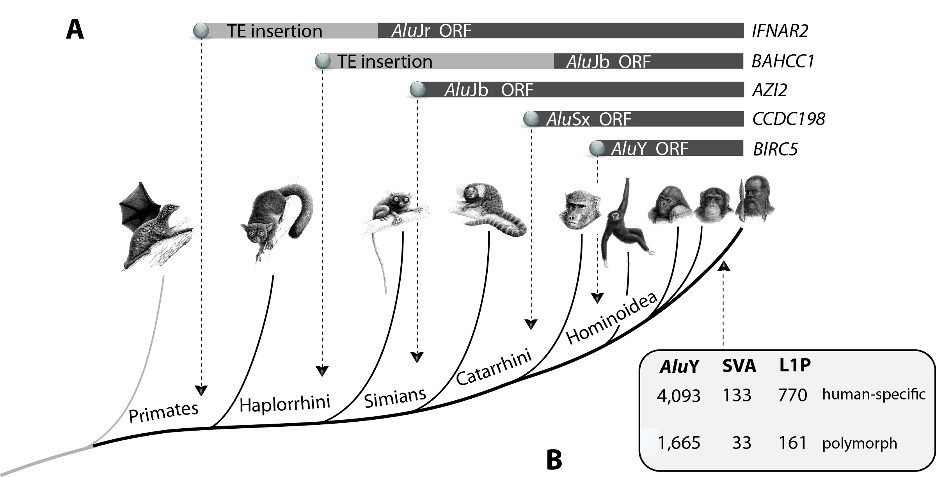

Figure S5. Simplified primate tree representing examples of 2-n-way-filtered rare genomic changes. A) Formation of novel exons from inserted Alu elements in human genes. The dotted lines indicate the Alu insertion points. The dark bars mark the time of evolutionary change in generating intact open reading frames and novel exons; the gray bars represent the time after insertion and before the acquisition of the open reading frame. Intron Alu exonization was verified in genes for IFNAR2 (exon 9/9), BAHCC1 (exon 11/29), AZI2 (exon 7/7), CCDC198 (exon 6/7), and BIRC5 (exon 3/5) among ~340 other investigated loci. B) Human-specific and polymorphic retrotransposon insertions.

Example 7: Human_Population - polymorphic TEs
The example genomes were integrated into the local genome database of the n-way project Human_Population and can be extended by request. To select human-specific TEs, the genomes of chimpanzee (Clint_PTRv2), gorilla (gorGor4), and the synthetic human genome version hg38 were added for comparison. A Chinese reference genome was selected as the target and eight 2-way alignments were generated using the different query genomes. Coordinate files from these generated 2-ways were transferred to the n-way pipeline (project Human_Population). We then performed several rounds of polymorphism screening for potentially active AluY SINEs, SVA retrotransposons, and L1P LINE retrotransposons. Only human-specific genome repeats were taken for a first search. Each round of n-way included one direct and five reverse searches from server-deposited RepeatMasker files. All searches included a preliminary MUSCLE optimization step with the following parameters: “Min target length=10”, and “Max target length=550 for AluY,” “Max target length=750” for SVA retrotransposons, and “Max target length=7,500” for L1P LINEs. On the resulting table we selected the “Display perfect” option, and sorted by “-” (i.e., absence). Only human-specific insertions (clearly absent in chimpanzee and gorilla genomes) were subsequently accepted. We excluded repetitive loci from different reverse searches using coordinate comparison against the target genome. From each round, 100 loci were randomly selected to manually examine the alignments. These analyses did not reveal any inconsistent markers. We mapped all polymorphic loci to the human chromosomes using the annotation of the standard hg38 genome excluding unmapped loci. The data are presented as Supplemental Tables 4-6.
Genomes analyzed in project Human_Population
Human.Asia.Chinese.m
https://www.ncbi.nlm.nih.gov/assembly/GCA_001708065.2
Human.Europe.Ashkenazim.m
https://www.ncbi.nlm.nih.gov/assembly/GCA_001542345.1
Human.Asia.Japanese.m
https://www.ncbi.nlm.nih.gov/assembly/GCA_003112835.1
Human.Africa.Esan.m
https://www.ncbi.nlm.nih.gov/assembly/GCA_003112855.1
Human.America.Mexican.m
https://www.ncbi.nlm.nih.gov/assembly/GCA_003112875.1
Human.Europe.Caucasian.m
https://www.ncbi.nlm.nih.gov/assembly/GCA_000002125.2
chimpanzee (Pan troglodytes; Clint_PTRv2)
https://www.ncbi.nlm.nih.gov/assembly/GCA_002880755.3
gorilla (Gorilla gorilla; gorGor4)
http://hgdownload.soe.ucsc.edu/goldenPath/gorGor4/bigZips/gorGor4.fa.gz
2-way alignments generated in project Human_Population
(1) Human.Asia.chines.m/human (hg38),
(2) Human.Asia.chines.m/gorilla (gorGor4),
(3) Human.Asia.chines.m/chimpanzee (Clint_PTRv2),
(4) Human.Asia.chines.m/Human.Europe.Ashkenazim.m,
(5) Human.Asia.chines.m/Human.Asia.Japanese.m,
(6) Human.Asia.chines.m/Human.Africa.Esan.m,
(7) Human.Asia.chines.m/Human.America.Mexican.m,
(8) Human.Asia.chines.m/Human.Europe.Caucasian.m.

References
Churakov G, Grundmann N, Kuritzin A, Brosius J, Makalowski W, Schmitz J. 2010 A novel web-based TinT application and the chronology of the primate Alu retroposon activity. BMC Evol Biol 10:376.
Doronina L, Churakov G, Shi J, Brosius J, Baertsch R, Clawson H, Schmitz J. 2015. Exploring massive incomplete lineage sorting in arctoids (Laurasiatheria, Carnivora). Mol Biol Evol. 32:3194-3204.
Doronina L, Matzke A, Churakov G, Stoll M, Huge A, Schmitz J. 2017. The beaver’s phylogenetic lineage illuminated by retroposon reads. Sci Rep 7:43562.

