Supplementary material

- Table legends.
- Supplementary figures.
- Supplementary materials and methods.
- Supplementary references

- Table legends.

Table S1. Number of raw and mapped reads for all high-throughput sequencing samples.
Table S2. Lists of enriched regions for ATAC-seq and ChIP-seq experiments along with differential analyses results and annotations.
Table S3. Raw read counts and differential analyses results at repetitive elements.
Table S4. Results of differential gene expression analyses.
Table S5. Complete results from motif enrichment and functional annotation analyses.
Table S6. List of antibodies used in ChIP-seq experiments. Nucleoside transition and retention times for Mass Spectrometry analysis.

- Supplementary figures.

Figure S1
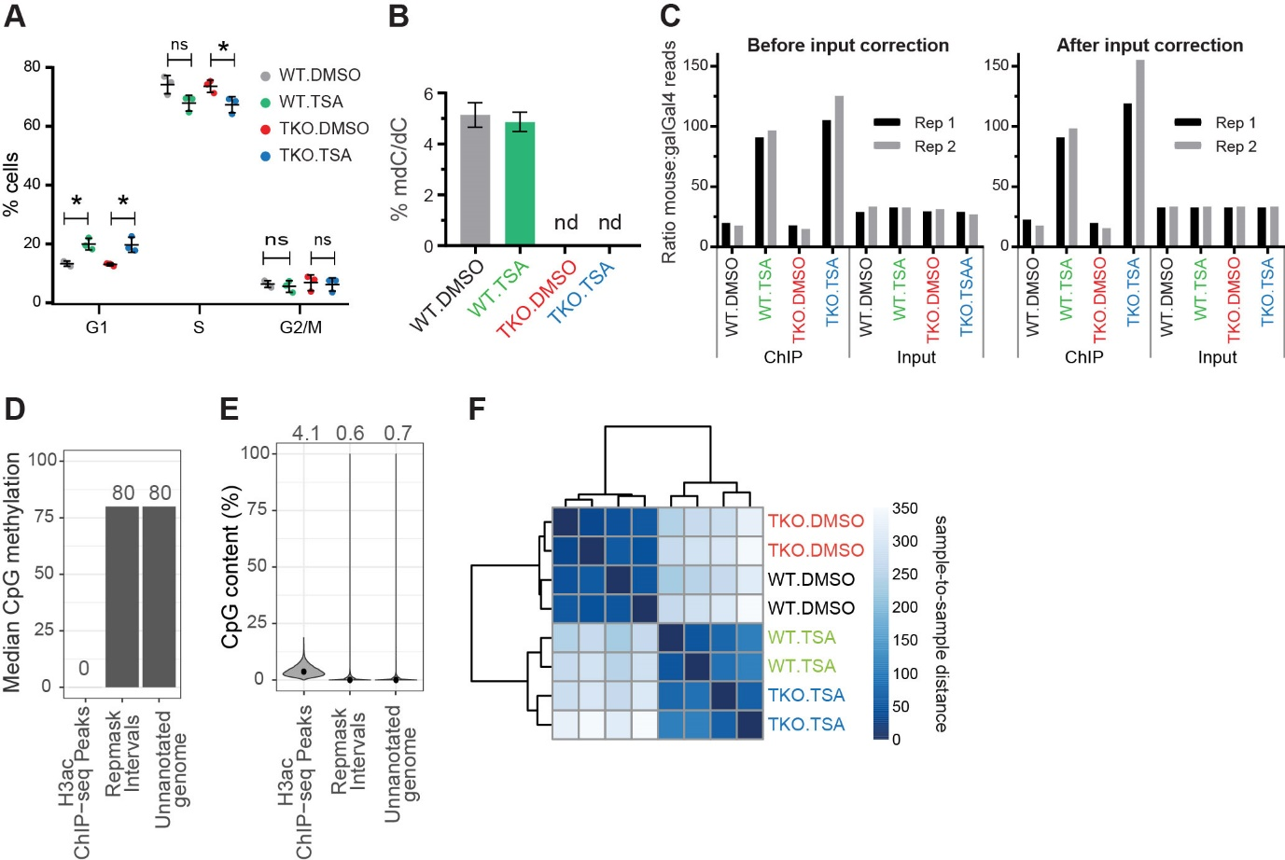
Figure S1. Disruption of HDAC activity and DNA methylation in mESCs. Related to Figure 1.
(A) Cell cycle profile after 36 h of TSA or DMSO control treatment. Interphase (G1), actively replicating (S) and mitotic (G2/M) cells were characterised using BrdU incorporation and 7-AAD staining. Each point represents the mean of two technical duplicates. Mean and SD of three biological replicates are shown, Student t-tests were used to determine significant differences: ns = non-significant (p-value > 0.05). (B) Mass spectroscopy measurements of 5mC in DMSO or TSA-treated wild-type and DNMT.TKO cells shown as a percentage of total cytosine. Data are represented as mean ± SD. nd: not detected. (C) Number of reads mapping to the mm10 versus galGal4 genomes for each sample. Data are shown before and after adjusting for the variation within input samples (see Materials and Methods, Supplementary Material and Table S1). (D) Median CpG methylation levels for genomic intervals separated into three mutually exclusive categories. Whole genome bisulfite sequencing data from E14 mESCs was obtained from Habibi et al., 2013. Exact values are shown above the bars. (E) Heatmap of sample-to-sample euclidean distances calculated using calibrated and rlog transformed read count data from every ChIP-seq peak. (F) Heatmap of sample-to-sample euclidean distances calculated using calibrated and rlog transformed read count data from every ChIP-seq peak.
Figure S2
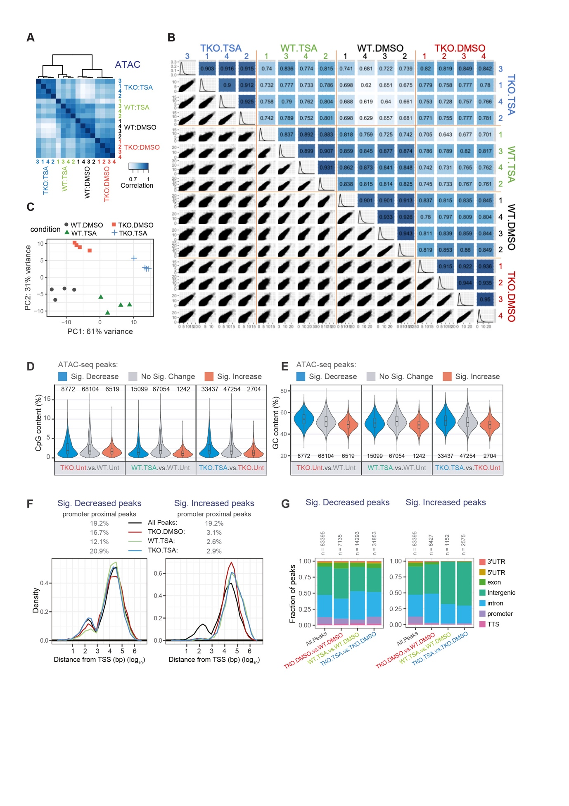

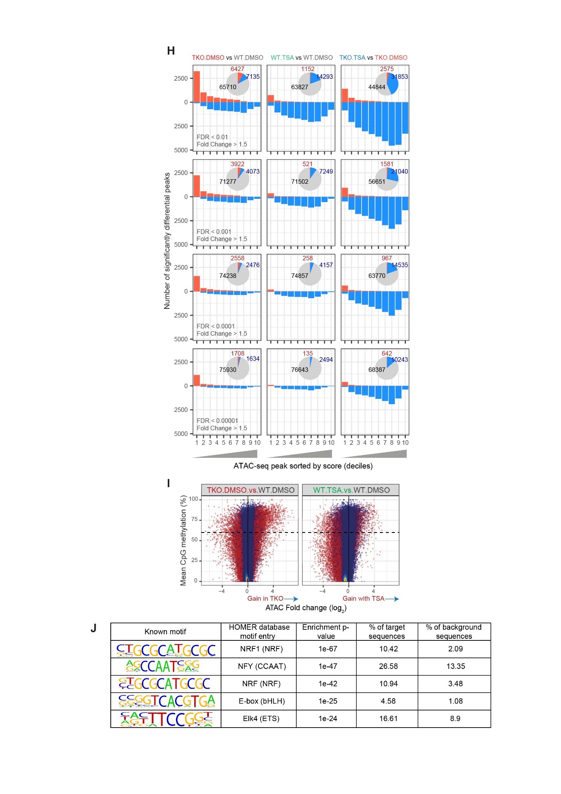
Figure S2. Global comparison of ATAC-seq datasets from different cell lines and conditions Related to Figure 2. (A) Correlation heatmaps comparing the ATAC-seq signal obtained for every sample at all identified THSs. ATAC-seq signal was calculated as the RPKM divided by the RPKM of the input control. Pearson correlation coefficients were calculated for each pair of samples and these values were used for clustering and the colour scale. Correlation heatmaps were generated in R using the dba.plotHeatmap() function of the DiffBind package (Stark and Brown, 2011). (B) Scatterplots in the lower triangle compare RPKM values at each THS for each pair of samples (4 replicates per sample) while corresponding Pearson correlation coefficients are shown in the top section. Histograms on the diagonal indicate the distribution of RPKM values. (C) Principle component analysis (PCA) plot generated using regularised log-transformed read counts from all ATAC-seq samples at every THS. The R package DESeq2 (Love et al., 2014) was used for plotting. (D) CpG or (E) GC content in sequences underlying ATAC-seq peaks, grouped according to their differential accessibility. (F) Density plots showing the distance of ATAC-seq peaks to the nearest transcription start site (TSS). The percentages of peaks that are proximal to the TSS (centre of peak within 1500 bp of TSS) are indicated above the plots. (G) Fraction of ATAC-seq peaks that overlap different genomic features. (H) THS regions were sorted according to their ATAC-seq signal in wild-type cells and grouped into ten bins of equal size (n = 8340). Bar charts indicate the number of THSs called as having significantly increased (red) or decreased (blue) accessibility per bin while pie charts summarise the total number of significantly differential calls. This was repeated using progressively more stringent false discovery rate (FDR) thresholds. (I) Scatterplots comparing the change in ATAC-seq signal with the average CpG methylation levels at 83395 ATAC-seq peak intervals. Regions with significantly differential accessibility (fold change > 1.5 and FDR < 0.01) are shown in red. The dashed line indicates 60% CpG methylation. (J) The known motifs most enriched in DNMT.TKO specific ATAC-seq peaks (target sequences) relative to background sequences. The HOMER motif database entry provides information about the transcription factor’s DNA-binding domain (DBD-family in brackets). Target sequences were restricted to those that were methylated (≥ 60% mean CpG methylation) and had at least a four-fold increase in accessibility compared to WT cells. See also Table S5.

Figure S3
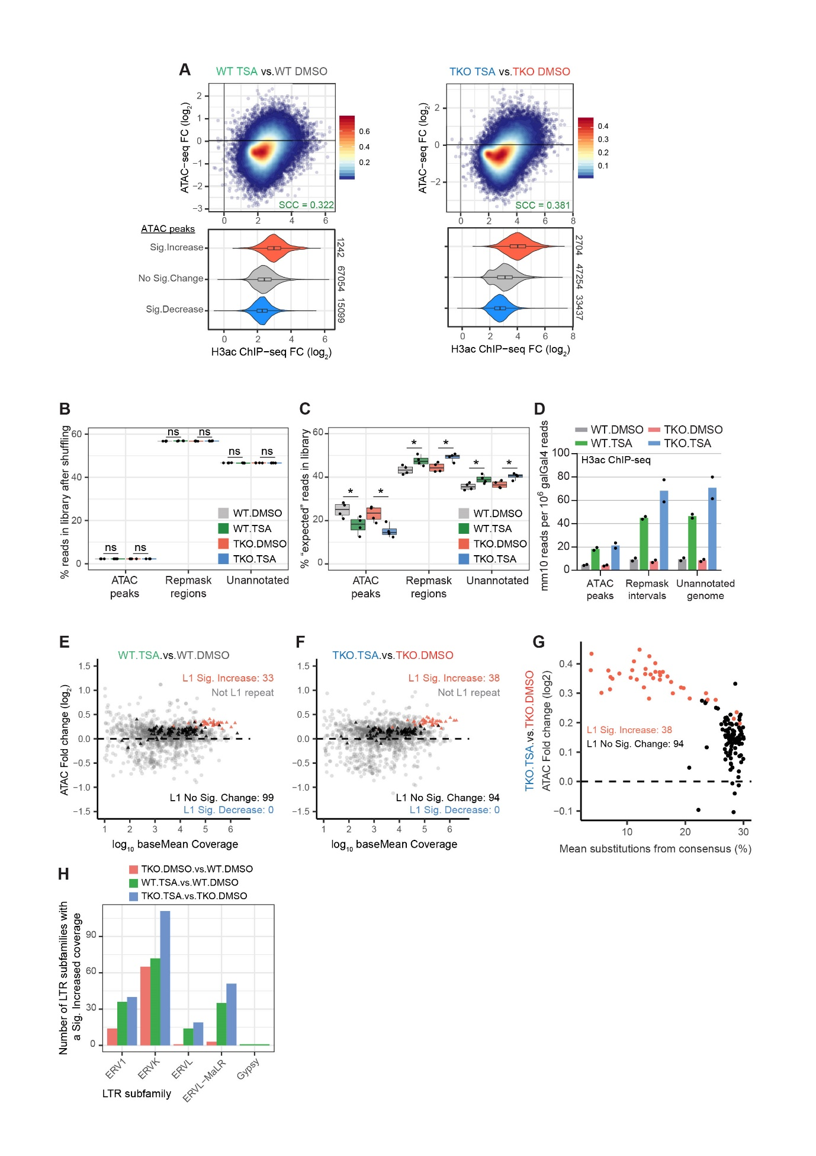
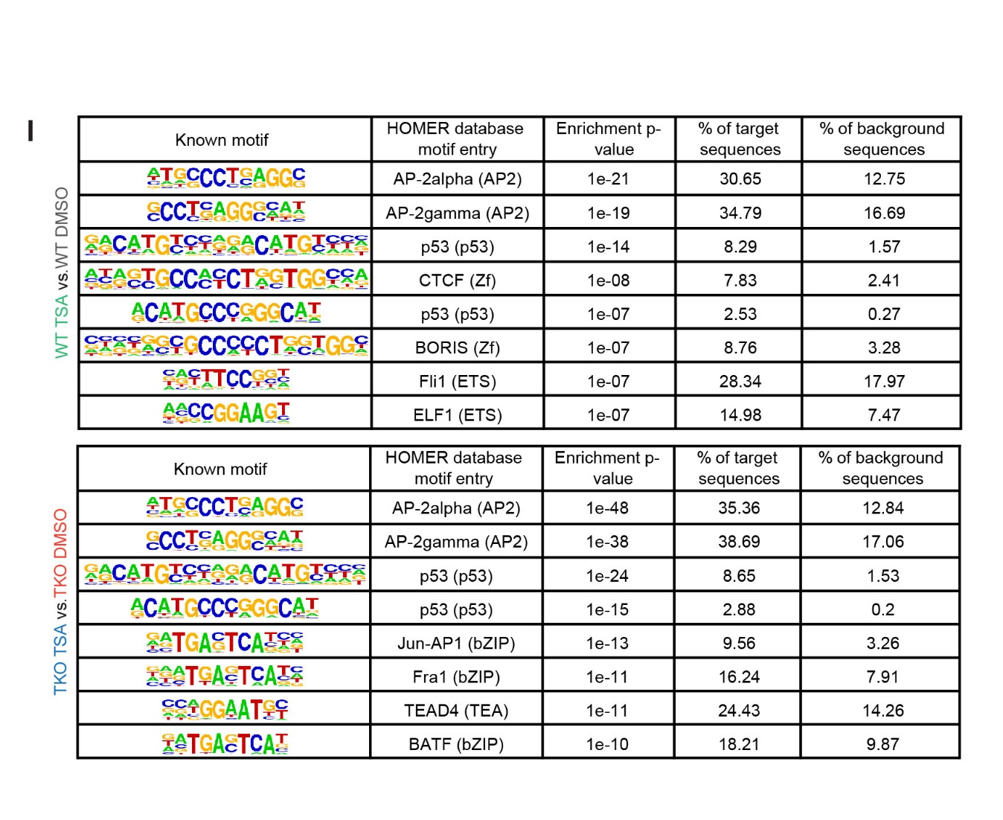
Figure S3. Increased chromatin accessibility at retrotransposons upon HDAC inhibition in mESCs. Related to Figure 2. (A) Top, scatterplots comparing changes in accessibility at every THS (n = 83395) to changes in H3ac levels. Colours indicate density of points per graph area. SCC = Spearman’s Correlation Coefficient. Bottom, distribution of H3ac ChIP-seq fold-change values for THS regions grouped according to their differential accessibility. (B) Boxplots summarising the percentage of reads from each ATAC-seq library that map to intervals split into three mutually exclusive categories, after having randomly shuffled the reads throughout the genome. Two-tailed Student t-tests were used to determine significant differences: ns = non-significant (p-value > 0.05). (C) Boxplots summarising the percentage of reads from each ATAC-seq library that map to intervals split into three mutually exclusive categories, after having randomly shuffled the non-peak reads within the “Repmask” and “Unannotated” regions. Two-tailed Student t-tests were used to determine significant differences: * p-value < 0.05; ** p-value < 0.01; ns = non-significant (p-value > 0.05). (D) Distribution of H3ac ChIP-seq reads within genomic intervals separated into three mutually exclusive categories. For every sample, the number of mm10 reads overlapping each category was divided by the total number of reads mapping to the galGal4 genome. Data are represented as mean; points indicate the values for two biological replicates. (E) MA plots comparing for each type of repetitive element, the fold change in ATAC-seq signal across all genomic copies to the baseMean ATAC-seq signal. LINE1 elements are highlighted. ATAC-seq samples generated from TSA- or DMSO-treated wild-type mESCs were compared. Differential analysis was performed using the R package DESeq2 (Love et al., 2014). Changes were deemed significant with an FDR < 0.05). See also Table S3. (F) Same as (E), except samples from TSA- and DMSO-treated DNMT.TKO mESCs were compared. (G) Scatterplot comparing for each LINE1 repeat subtype, the fold change in ATAC-seq signal to the average substitution rate (base mismatches relative to the consensus sequence in parts per 100). See also Table S3. (H) Number of LTR element types, subdivided by family, that show significantly increased ATAC-seq signal for three pairwise comparisons. See also Table S3. (I) The known motifs most enriched in THS regions TSA-treated wild-type cells (top) or TSA-treated DNMT.TKO cells (bottom) (target sequences) relative to background sequences. The HOMER motif database entry provides information about the transcription factor’s DNA-binding domain (DBD-family in brackets). Target sequences were restricted to those that had at least a four-fold increase in accessibility compared to WT or untreated cells. See also Table S5.
Figure S4
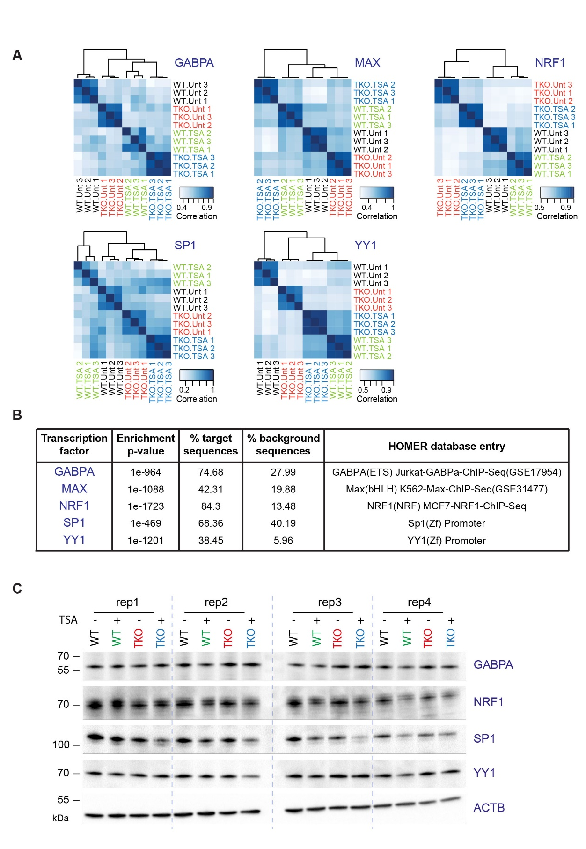
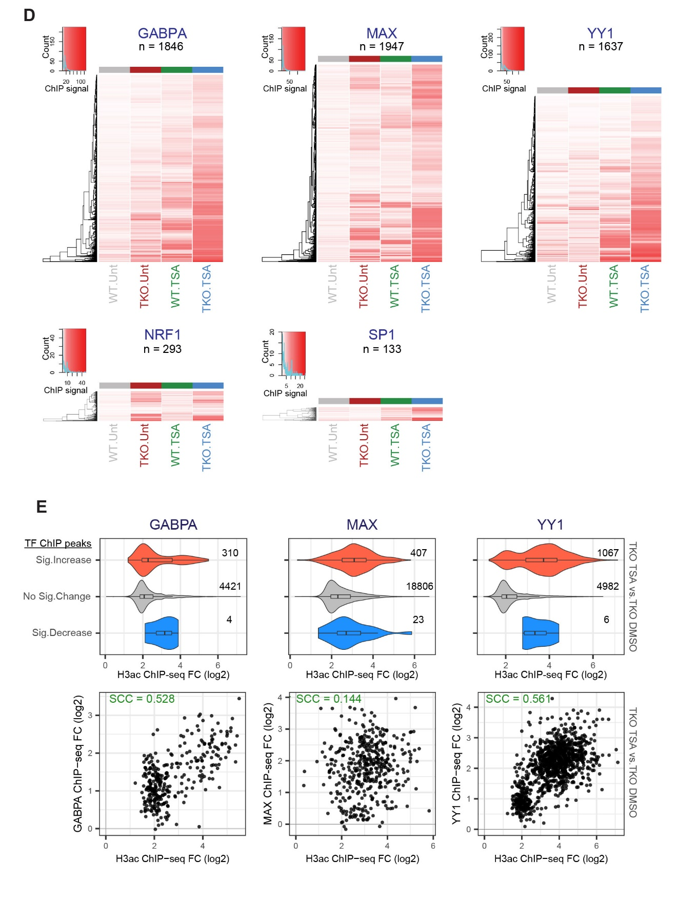
Figure S4: DNA methylation and HDAC activity can modulate transcription factors occupancy. Related to Figure 3. (A) Correlation heatmaps comparing the ChIP-seq signal obtained for every sample at all identified binding sites. ChIP signal was calculated as the RPKM of the TF ChIP-seq divided by the RPKM of the input control. Pearson correlation coefficients were calculated for each pair of samples and these values were used for clustering and the colour scale. Correlation heatmaps were generated in R using the dba.plotHeatmap() function of the DiffBind package (Stark and Brown, 2011). (B) Most enriched motifs found within transcription factors ChIP-seq peaks (target sequences) relative to background sequences. For all factors except GABPA, the motif shown is the most enriched compared to all others entries in the HOMER collection. This GABPA motif is ranked 6th most enriched, however the top 10 motifs enriched at GABPA peaks are all highly similar ETS factor motif (See Table S5). (C) Immunoblot analysis of GABPA, NRF1, SP1 and YY1 levels after 36 h TSA treatment in mESCs. Cell lysates were derived from four biological replicate experiments. (D) Heatmaps show the ChIP-seq signal for every peak region at which a significant difference in occupancy was detected between two dataset pairs (TKO.Unt vs. J1.Unt; J1.TSA vs. J1.Unt; TKO.TSA vs. TKO.Unt; or TKO.TSA vs. J1.Unt). ChIP-seq signal was calculated for each sample as the RPKM of the TF ChIP-seq divided by the RPKM of the input control. Values from three biological replicates were averaged for plotting. The heights of the heatmaps are scaled to the number of peak intervals. (E) Top, distribution of H3ac ChIP-seq fold change values for ChIP-seq peaks grouped according to their differential occupancy in TSA- versus DMSO-treated DNMT.TKO cells. Bottom, scatterplots comparing changes in TF occupancy to changes in H3ac levels at ChIP-seq peaks that are gained in TSA- versus DMSO-treated DNMT.TKO cells. SCC = Spearman’s Correlation Coefficient.

Figure S5
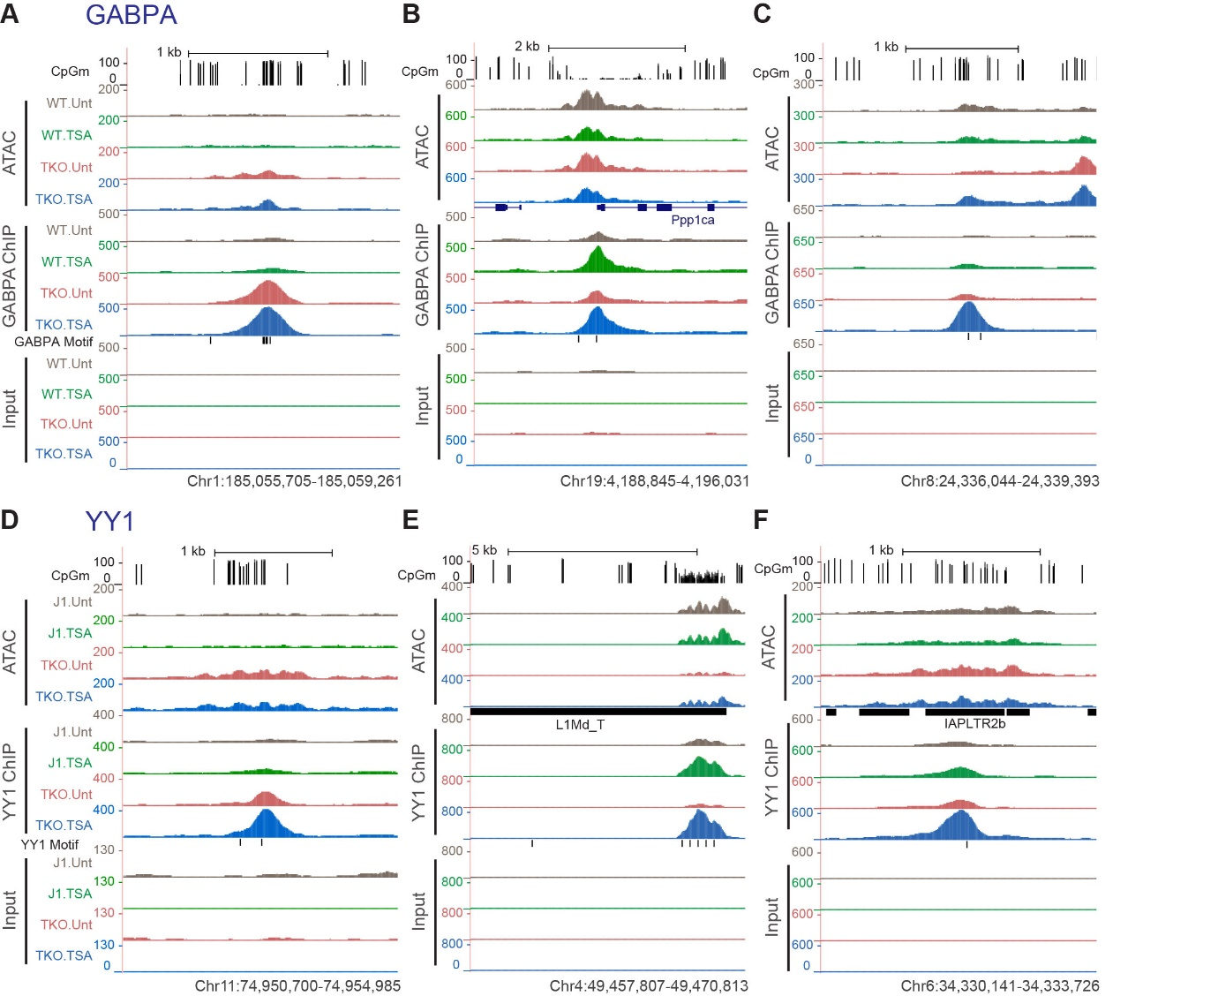
Figure S5. DNA methylation and HDAC activity can modulate transcription factors occupancy. Related to Figure 3. (A) Representative UCSC Genome Browser snapshot showing CpG methylation levels (Habibi et al., 2013), ATAC-seq, GABPA ChIP-seq and Input ChIP-seq read coverage. The position of genes and that of sequences that match the GABPA motif are shown. ATAC-seq and ChIP-seq coverage graphs were generated after merging alignments from replicate samples. Mm10 coordinates: chr1:185,055,705-185,059,261. (B) Same as (A). Mm10 coordinates: chr19:4,188,845-4,196,031. (C) Same as (A). Mm10 coordinates: chr8:24,336,044-24,339,393. (D) Representative UCSC Genome Browser snapshot showing CpG methylation levels (Habibi et al., 2013), ATAC-seq, YY1 ChIP-seq and Input ChIP-seq read coverage. The position of repeat elements and that of sequences that match the YY1 motif are shown. ATAC-seq and ChIP-seq coverage graphs were generated after merging alignments from replicate samples. Mm10 coordinates: chr11:74,950,700-74,954,985. (E) Same as (D). Mm10 coordinates: chr4:49,457,807-49,470,813. (F) Same as (D). Mm10 coordinates: chr6:34,330,141-34,333,726.

Figure S6
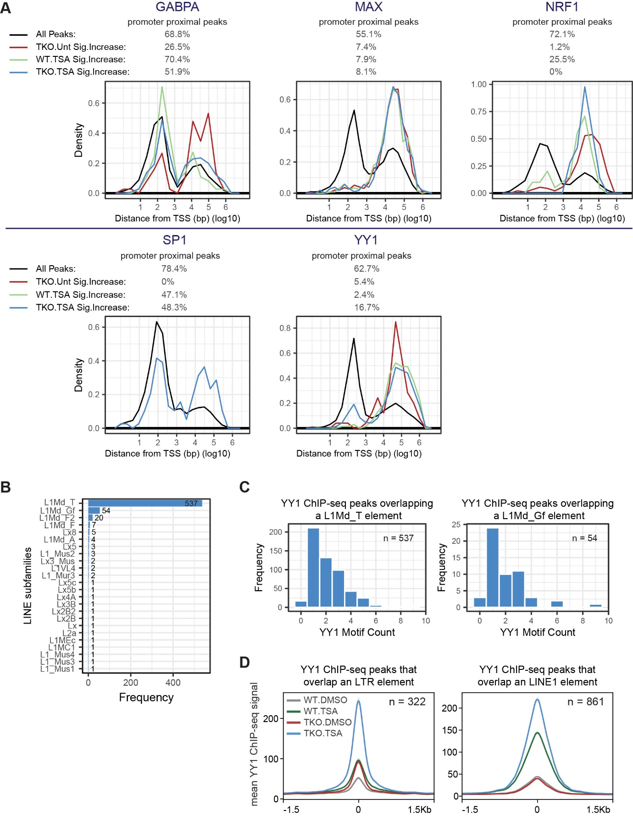
Figure S6. Characteristics of transcription factor binding sites. Related to Figure 4. (A) Density plots showing the distance of ChIP-seq peaks to the nearest transcription start site (TSS). The percentages of peaks that are proximal to the TSS (centre of peak within 1500 bp of TSS) are indicated above the plots. (B) The extent of overlap between TKO.TSA-specific YY1 ChIP-seq peaks and different subtypes of LINE elements. Only peaks with significantly increased YY1 occupancy in TSA-treated versus untreated DNMT.TKO cells and that overlap a LINE are included (n = 652). (C) Number of TKO.TSA-specific YY1 ChIP-seq peaks that harbour a cognate binding motif. Left: peaks that overlap an L1Md_T element only. Right: peaks that overlap an L1Md_Gf element only. (D) Metaplots showing the average YY1 ChIP-seq signal in 3 kb regions surrounding the centre of ChIP-seq peaks that overlap either an LTR (left) or LINE (right) elements.

Figure S7
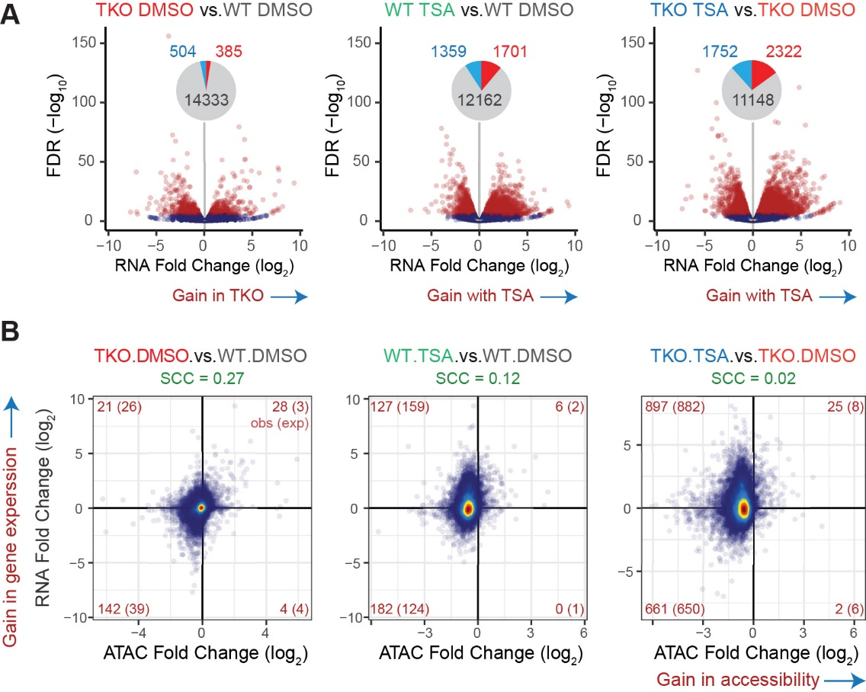
Figure S7. The impact of DNA methylation loss and HDAC inhibition on gene expression. Related to Figure 6. (A) Volcano plots representing the false discovery rate (FDR) and fold change values obtained through pairwise differential analyses of strand-specific RNA-seq read counts at 15222 genes. Genes with significantly differential expression (adjusted p-value < 10-5) are shown in red on the scatter plots and their numbers are summarised in the form of pie charts (light blue = significant decrease; red = significant increase). (B) Changes in accessibility at promoter-proximal THS regions (centre of peak within 1500 bp of TSS) were compared to changes in expression at their closest gene. The analysis was performed on 13068 THS:gene pairs involving 12356 genes. The numbers of ATAC-seq peaks associated with significant changes in both accessibility and gene expression are indicated in red in each quadrant. In brackets are indicated the expected number of sites showing both significant changes in accessibility and gene expression based on the total number of significant differential events. SCC = Spearman’s Correlation Coefficient.

Figure S8
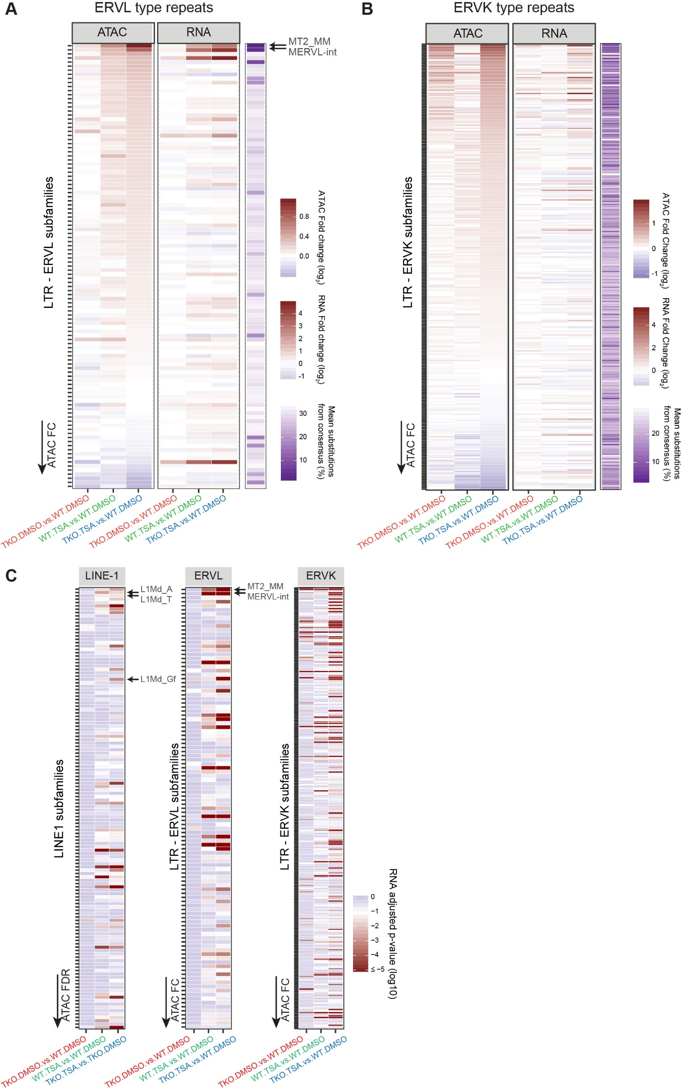
Figure S8. The impact of DNA methylation loss and HDAC inhibition on expression from retrotransposons. Related to Figure 6. (A) For each ERVL subtype (N = 109), we plotted the fold change in ATAC-seq or RNA-seq signal along with scores relating to their sequence conservation (purple). ERVL subtypes were sorted based on the fold change in ATAC-seq coverage when comparing DNMT.TKO-TSA to wild-type cells. See also Table S3. (B) For each ERVK subtype (N = 231), we plotted the fold change in ATAC-seq or RNA-seq signal along with scores relating to their sequence conservation (purple). ERVK subtypes were sorted based on the fold change in ATAC-seq coverage when comparing DNMT.TKO-TSA to wild-type cells. See also Table S3. (C) For each LINE1 (N = 132), ERVL (N=109) or ERVL subtype (N=231), adjusted p-values for the change in RNA-seq signal were plotted. LINE1, ERVL and ERVK repeat subtypes were sorted as in the heatmaps shown in figures 6D, S8B and S8A respectively. See also Table S3.

- Supplementary materials and methods.

Quantification of global 5mC by Mass Spectroscopy
Genomic DNA was extracted from mouse ES cells using the GeneJET Genomic DNA Purification Kit (Thermo Fisher Scientific) following the manufacturer’s instructions. Hydrolysis was carried out in 150 µl reactions that contained 500 ng DNA, 100 mM NaCl, 20 mM MgCl2, 20 mM Tris pH 7.9, 1000 U/ml Benzonase, 600 mU/ml Phosphodiesterase I, 80 U/ml Alkaline phosphatase, 36 µg/ml EHNA hydrochloride and 2.7 mM deferoxamine for 2 hours at 37 °C. Following lyophilisation, nucleosides were resuspended in buffer A (10 mM ammonium acetate, pH 6) with 12.5 nM standards of +3 Da mdC and hmdC.
For the analysis by HPLC– QQQ mass spectrometry, a 1290 Infinity UHPLC was fitted with a Zorbax Eclipse plus C18 column, (1.8 µm, 2.1 mm 150 mm; Agilent) and coupled to a 6495a Triple Quadrupole mass spectrometer (Agilent Technologies) equipped with a Jetstream ESI-AJS source. The data were acquired in dMRM mode using positive electrospray ionisation (ESI1). mdC and hmdC were quantified by mass spectrometry, whereas dC was quantified by HPLC-UV. The gradient used to elute the nucleosides started by a 5 min isocratic gradient composed of 100% buffer A and 0% buffer B (100% methanol) with a flow rate of 0.4 ml/min and was followed by the subsequent steps: 5-8 min, 94.4% A; 8–9 min, 94.4% A; 9–16 min 86.3% A; 16–17 min 0% A; 17– 21 min 0% A; 21–24.3 min 100% A; 24.3–25 min 100% A. The AJS ESI settings were as follows: drying gas temperature 230 °C, the drying gas flow 14 lmin⁻¹, nebulizer 20 psi, sheath gas temperature 400 °C, sheath gas flow 11 lmin⁻¹, Vcap 2,000 V and nozzle voltage 0 V. The iFunnel parameters were as follows: high pressure RF 110 V, low pressure RF 80 V. The fragmentor of the QQQ mass spectrometer was set to 380 V and the delta EMV set to +200.
The raw mass spectrometry data was analysed using the MassHunter Quant Software package (Agilent Technologies, version B.08.01). The transitions and retention times used for the characterization of nucleosides and their adducts are summarized in Table S6. For the identification of compounds, raw mass spectrometry data was processed using the dMRM extraction function in the MassHunter software.

Isolation of histone proteins and immunoblotting
Unless stated otherwise, all steps were performed on ice, spins performed in a centrifuge chilled to 4 °C and rotations set up in a cold room. Cells were lysed in lysis buffer (PBS supplemented with 0.5% (v/v) Triton X100, 1x cOmpleteTM EDTA-free Protease Inhibitor Cocktail (Roche) and 10 mM sodium butyrate) for 10 min after which nuclei were washed once with lysis buffer. Histone proteins were solubilised by incubating the nuclei in 0.2 M H₂SO₄ with rotation overnight and collected by spinning at 16,000 x g for 10 min. The histone proteins were subsequently precipitated by adding trichloroacetic acid (TCA) to a final concentration of 25% and incubating them for at least 2 hours on ice followed by the centrifugation at 16,000 x g for 10 min. Following two washes with ice-cold acetone, histone proteins were resuspended in 1x SDS-PAGE Loading Buffer (40 mM Tris-HCl pH 6.8, 80 mM DTT, 1.6% SDS, 0.08% bromophenol blue, 8% glycerol) and denatured at 95 °C for 5 min. Samples were resolved on 15% SDS-PAGE gels and analysed by immunoblotting. Histone proteins were detected by using a rabbit polyclonal anti- pan-acetyl H3/H4 antibody (Upstate, 06-866; 1:5000 dilution), a rabbit polyclonal antibody anti- pan-acetyl H3 antibody (Millipore, 06-599; 1:2000 dilution) and a rabbit polyclonal antibody against total unmodified H3 (Abcam, ab1791; 1:40000 dilution). The Santa Cruz sc-2004 goat anti-rabbit HRP-conjugated antibody was used as a secondary antibody (1:10000 dilution). The following primary antibodies were used for detecting transcription factors: anti-GABPA (Santa Cruz, sc-28312), anti-NRF1 (Abcam, ab55744), anti-SP1 (Santa Cruz, sc-17824), anti-YY1 (Santa Cruz, sc-7341). ACTB was detected using an HRP-conjugated antibody (Abcam, ab49900).

ATAC-seq sample preparation
To allow for calibration of the ATAC-seq signal between different samples, 5 x 10⁵ chicken DF-1 cells were spiked-in with 5 x 10⁶ mouse ES cells from each experimental condition. Cell mixtures were lysed in 1 ml of Lysis Buffer (50 mM KCl, 10 mM MgSO₄x7H₂O, 5 mM HEPES, 0.05% NP-40 (IGEPAL CA630), 1 mM PMSF and 3 mM DTT) by incubating at room-temperature for 1 min followed by the two washes in 1 ml ice-cold RSB Buffer (10 mM NaCl, 10 mM Tris (pH 7.4), 3 mM MgCl₂).
ATAC reactions were performed in 50 µl reactions in the presence of Tn5 reaction buffer (10 mM TAPS, 5 mM MgCl₂ and 10% dimethylformamide), 5 x 10⁴ nuclei (resuspended in H₂O) and 2 µl of 12 μM Tn5 transposase (produced in house following a protocol by Picelli et al., 2014) for 30 min at 37°C. DNA was purified using the QIAQuick MinElute columns (Qiagen) following manufacturer’s instructions.
Input samples were prepared by subjecting genomic DNA, which had been isolated from each sample prior to the ATAC reaction, to Tn5 tagmentation in reactions containing 5 ng genomic DNA, 1 µl of Tn5 and incubated at 55 °C for 7 min.
ATAC-seq libraries were prepared by 6-12 cycles of PCR amplification using custom made Illumina barcodes in the NEBNext Ultra II Q5 2x PCR Master Mix. PCR amplicons were purified and size selected using home-made SPRI beads (Rohland and Reich 2012) in two rounds (1:0.6 then 1:1.4 DNA:beads ratio). ATAC-seq libraries were quantified using the NEBNext Library Quant Kit and pooled prior to the sequencing on an Illumina HiSeq 4000 instrument at the Oxford Genomics Centre to generate 75 bp paired-end reads (Table S1). ATAC-seq experiments were performed on four biological replicates.

ATAC-seq computational analysis
Whilst we incorporated spike-ins into our ATAC-seq experiments to facilitate calibration, the number of reads mapping to the exogenous galGal4 genome varied widely between the four biological replicates of a same experimental condition (Figure M1 below). Due to this variation and the lack of a consistent trend when comparing samples from different experimental conditions, we omitted the spike-in data from our analyses.

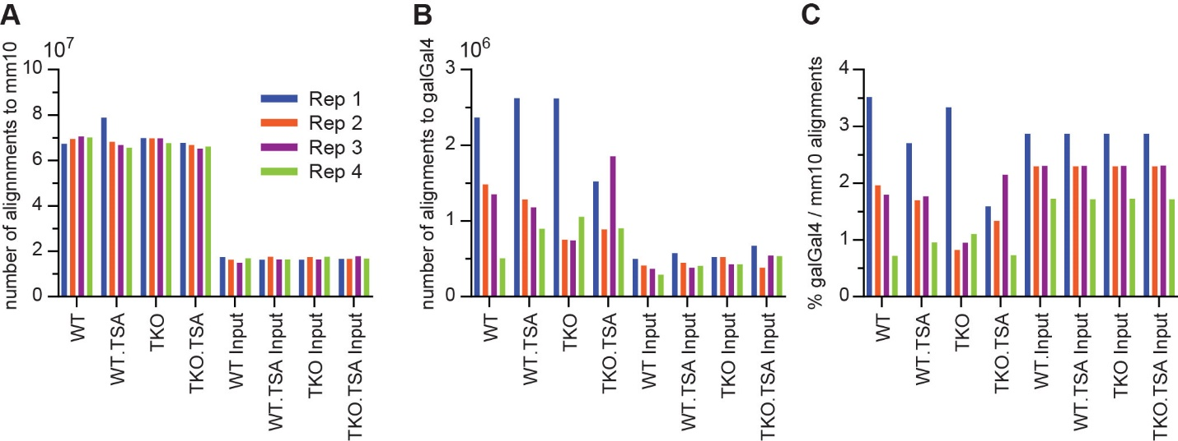
Figure M1. A. Number of uniquely mapped reads from each ATAC-seq library that align to the mm10 genome. B. Number of uniquely mapped reads from each ATAC-seq library that align to the galGal4 genome. C. Number of uniquely mapped reads from each ATAC-seq library that align to the galGal4 genome per 100 reads that align to the mm10 genome.

ATAC-seq 75 bp paired-end reads were trimmed using cutadapt (v1.16) to remove 3’ adapter sequences then aligned to a concatenated mm10+galGal4 genome using bowtie2 (v2.2.5.0) with the options --no-mixed and --no-discordant (Table S1). Reads that aligned to the exogenous galGal4 genome, reads with multiple alignments and fragments mapping to a custom “blacklist” of artificially high regions of the genome were discarded. Duplicate reads were removed. Alignment files were randomly down-sampled to retain an equivalent number of alignments in all samples. BigWig coverage files were generated using the Deeptools (Ramírez et al. 2016) function ‘bamCoverage’ (v2.4.2) with the option –bs set to 2. The coverage graphs that we displayed were generated after merging alignments from replicate samples. Enriched regions were identified using the ‘dpeak’ peak-calling algorithm of DANPOS v2.2.2 (Chen et al. 2013) with the options –m, –kd 250, -kw 150 and –p 1e-60. The R package DiffBind (Stark and Brown, 2011) was used to identify ATAC-seq peak regions with significant changes in enrichment between experimental conditions. Significant changes were determined using the DBA_DESEQ2 method applying a fold change cut-off of 1.5 and a p-value threshold of 0.01 after multiple-testing correction.

Quantification of ATAC-seq reads within different categories of genomic regions
The genomic space was segmented into three categories of regions: “ATAC-seq peaks” that were called using DANPOS ‘dpeak’ as described above; “Repmask regions” which included all genomic intervals that were annotated as repetitive based on the UCSC RepeatMasker annotation but excluded sequences that overlap with ATAC-seq peaks; and a “Unannotated” category which grouped together all remaining genomic intervals. The bedtools “intersect” command was used to count the number of alignments from each sequencing dataset that overlapped regions within each category. All alignments to the mm10 genome were counted, including those marked as having multiple alignments. Reads that overlapped two regions were counted only once: reads that only partially overlapped with an “ATAC peaks” region were included in this category while reads that overlapped a “Repmask” region and an “Unannotated” region were counted for the “Repmask” region only. We then calculated the percentage of total reads in the dataset that mapped to each category (Figure 2E).
To estimate the percentage of reads mapping outside of “ATAC peak” regions that would align to the “Repmask” and “Unnanotated“ regions by chance (random or expected distribution), we shuffled the reads with no alignment to ATAC peaks within the combined “Repmask” and “Unnanotated“ genomic space (using the bedtools “shuffle” command) and repeated the counting procedure (Figure S3B). We calculated “observed/expected” values based on the number of reads mapping to these two categories before and after shuffling (Figure 2F).

Calibrated ChIP-seq computational analysis
ChIP-seq 75-bp paired-end reads were aligned to a concatenated mm10+galGal4 genome using bowtie2 (v2.2.5.0) with the options --no-mixed and --no-discordant (Table S1). Reads that had multiple alignments were discarded and duplicate reads were removed. The number of reads mapping to the mm10 or galGal4 genome were counted and used to calculate the ratio of galGal4 to mm10 reads for both IP and inputs samples. To adjust for the variation in mouse cells used for the four experimental conditions from a single biological replicate, the number of galGal4 reads in the input samples were randomly down-sampled so that the resulting mm10:galGal4 ratio in the four input samples was equal (See Figure S1B and Table S1). Enriched regions were identified using the MACS2 function ‘callpeak’ (v2.0.10, Zhang et al., 2008) with the genome size set to 1.87 x 10⁹. Peak calling was performed independently for each biological replicate using all uniquely mapped mm10 reads. Regions identified as enriched in more than one sample from any condition were kept for downstream analyses. Biological replicate samples showed higher sample-to-sample similarity than samples from different experimental conditions (Figure S1D).
To generate bigWig coverage files calibrated to the exogenous spike-in, we first randomly down-sampled BAM files containing the mm10 alignments for a particular sample based on the number of reads mapping to the galGal4 genome for that sample (in a manner which results in an equal mm10:galGal4 reads ratio in all samples). BigWig files were subsequently created using the Deeptools (Ramírez et al. 2016) function ‘bamCoverage’ (v2.4.2) with the options –e and –bs 2. The coverage graphs that we displayed were generated after merging alignments from replicate samples.

Chromatin immunoprecipitation for transcription factors – sample preparation
Mouse ES cells were crosslinked in 1% methanol-free formaldehyde (Thermo Fisher Scientific) alone or sequentially with 2 mM disuccinimidyl glutarate (DSG) first then 1% formaldehyde (YY1 only). Immunoprecipitation was carried out on sonicated chromatin using antibodies listed in Table S6.
Chromatin was prepared from 1 x 10⁸ mouse ES cells grown to 70-90% confluency. Cells were crosslinked at room temperature for either 10 min in 1% methanol-free formaldehyde (Thermo Fisher Scientific) or 2 mM disuccinimidyl glutarate (DSG) for 1 hour followed by 10 min with 1% formaldehyde (YY1 only). Crosslinking reactions were quenched by the addition of glycine to a concentration of 200 mM. Chromatin was prepared at 4 °C by rotating the cells in 10 ml buffer LB1 (50 mM HEPES KOH pH 7.9, 140 mM NaCl, 1 mM EDTA, 10% Glycerol, 0.5% NP-40, 0.25% Triton X-100, with 1x cOmpleteTM EDTA-free Protease Inhibitor Cocktail (Roche)), 10 ml buffer LB2 (10 mM Tris-HCl pH 8.0, 200 mM NaCl, 1 mM EDTA, 0.5 mM EGTA, with 1x cOmpleteTM EDTA-free Protease Inhibitor Cocktail) and 1 ml buffer LB3 (10 mM Tris-HCl pH 8.0, 100 mM NaCl, 1 mM EDTA, 0.5 mM EGTA, 0.1% sodium deoxycholate, 0.5% N-lauroylsarcosine, 1x cOmpleteTM EDTA-free Protease Inhibitor Cocktail). Chromatin was sheared in a 1 ml milliTUBE with AFA Fiber (Covaris) using a Covaris S220 AFA ultrasonicator (set at 150 W Peak Incident Power, 8% Duty Factor, 200 Cycles/Burst) for 30 min. Following sonication, the sheared chromatin was spun at 15,000 x g for 20 min and the soluble fraction collected and aliquoted for immediate use or storage at -80 °C.
Immunoprecipitation (IP) was performed using the sheared chromatin from approximately 1 x 10⁷ cells in Chromatin Dilution Buffer (16.7 mM Tris pH 8.1, 167 mM NaCl, 0.01% SDS, 1.1% Triton X-100, 1.2 mM EDTA, freshly complemented with 1x cOmpleteTM EDTA-free Protease Inhibitor Cocktail (Roche)). Following a 30 min preclear using blocked Protein A or G agarose beads (Roche), the chromatin was incubated with 5 µg antibody overnight at 4 °C (antibodies are listed in Table S6). Immune complexes were captured with 50 µl blocked Protein A or G agarose beads by incubation for 4 h with rotation and then washed with the following buffers: Low Salt Buffer (20 mM Tris pH8.1, 150 mM NaCl, 0.2% SDS, 1% Triton X-100, 5 mM EDTA, and 5% w/v sucrose), High Salt Buffer (50 mM HEPES pH 7.5, 500 mM NaCl, 0.1% deoxycholic acid, 1% Triton X-100 and 1 mM EDTA), Lithium Chloride Buffer (10 mM Tris pH 8.0, 250 mM LiCl, 0.5% deoxycholic acid, 0.5% NP-40 and 1 mM EDTA) and twice with TE Buffer (10 mM Tris-HCl pH 8.0, 1 mM EDTA). Captured chromatin was eluted in 125 µl elution buffer (1% SDS and 0.1 M NaHCO₃) by shaking vigorously for 30 min at room temperature and then subjected to reverse crosslinking by incubating at 65 °C overnight in the presence of 200 mM NaCl. Input controls consisted of 50 µl (5%) samples of pre-cleared chromatin that were reverse crosslinked and purified as described for the IP samples. After incubation with 0.5 µg RNase A (1 h at 37 °C) and 20 µg Proteinase K (1 h at 45 °C), DNA was purified using the QIAquick PCR Purification kit (Qiagen).
For sequencing, ChIP DNA was further sonicated using a Bioruptor sonication system to obtain DNA fragments in the 100-300 bp range. Libraries were prepared and sequenced using the same procedure as described for the Native Chromatin Immunoprecipitation with exogenous spike-in experiments.

ChIP-seq computational analysis
ChIP-seq 75-bp paired-end reads were aligned to the mm10 genome using bowtie2 (v2.2.5.0) with the options --no-mixed and --no-discordant (Table S1). Reads that had multiple alignments were discarded, duplicate reads were removed as well as fragments mapping to a custom “blacklist” of artificially high regions of the genome (derived from the ENCODE Consortium Project, 2012). GC composition of reads was similar between samples, conditions and different TF (Figure M2). All alignment files from the same transcription factor ChIP were randomly down-sampled to match the number of alignments in the minimal ChIP or input sample. BigWig coverage files were generated using the Deeptools (Ramírez et al. 2016) function ‘bamCoverage’ (v2.4.2) with the options –e and –bs 2. The coverage graphs that we displayed were generated after merging alignments from replicate samples. Enriched regions were identified using the ‘dpeak’ peak-calling algorithm of DANPOS v2.2.2 (Chen et al. 2013) with the options –m, -kd 250, -kw 150 and –p 1e-100.
When visualising the GABPA ChIP-seq datasets we noticed that sequencing reads were not only enriched in a localised manner, forming the narrow peaks typically seen in transcription factor ChIP-seq data, but also within broader domains whose boundaries coincided closely with the edges of transcribed genes, particularly those with high levels of transcription. For the purposes of this study, we restricted our analysis to localised sites of GABPA ChIP-seq enrichment. While the ‘dpeak’ peak-calling algorithm is designed to identify shorter enriched regions rather than larger domains, many of the focal “peaks” called using the parameters noted above were located within the broader GABPA enriched regions. In order to filter these out, we first identified genomic domains >2000bp broadly enriched with GABPA using the DANPOS function ‘dregion’ with the options -m 1 -rd 1500 -rw 2000 and -p 1e-50. Subsequently, peaks called using dpeak (n = 10022) that overlapped with a called region were discarded unless they intersected a gene promoter (-1kb to 100bp around TSS). 4735 peaks remained, 74.7% contained a GABPA motif, compared to 56.9% before filtering.
The R package DiffBind (Stark and Brown, 2011) was used to identify ChIP-seq peak regions with significant changes in enrichment between experimental conditions. Samples were normalised to (ChIP) reads per kilobase per million reads in library (RPKM, option bFullLibrarysize = TRUE) per RPKM of input sample; and significant changes were determined using the DBA_DESEQ2 method applying a fold change cut-off of 4 and a p-value threshold of 10⁻³ after multiple-testing correction (Bonferroni correction). Figure M3 provides validation that several regions identified as differentially enriched from our ChIP-seq data using the approach described above (but not other methods) can be identified as such using qPCR.
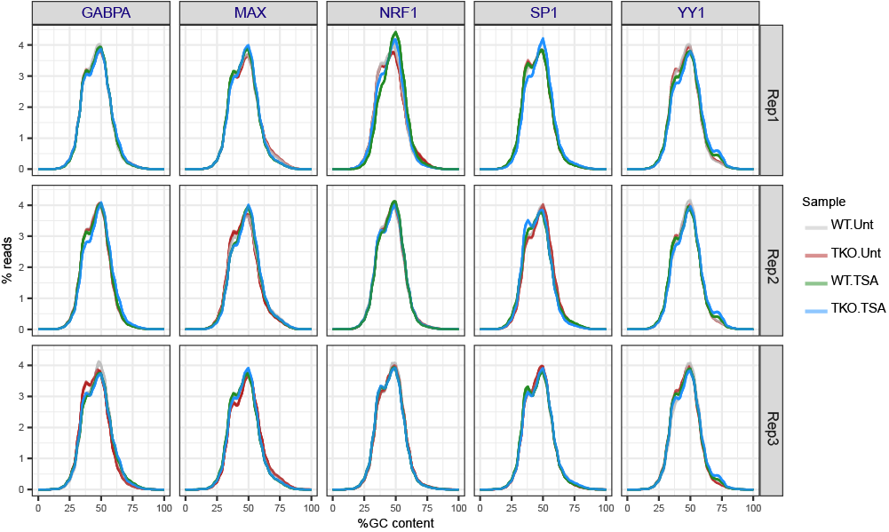
Figure M2. Average GC content for all sequencing reads. Fastqc and multiqc (Ewels et al. 2016) were used to generate these plots.

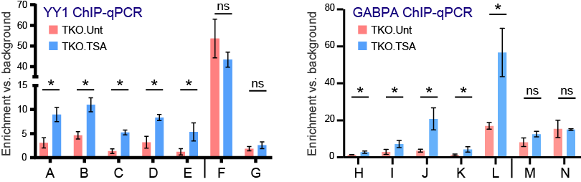
Figure M3. ChIP-qPCR performed for five loci (A-E, H-L) that we called as significantly differentially occupied between TSA- and mock-treated DNMT.TKO cells from our ChIP-seq data and two loci (F-G, M-N) that do not show any significant change in the ChIP-seq data. Enrichment values were calculated relative to the average of two background regions using the ΔCt method. Mean and SD of three biological replicates are shown, Student t-tests were used to determine significant differences: ns = non-significant (p-value > 0.05).
RNA-seq computational analysis
RNA-seq 51 bp paired-end reads were aligned to the mouse mm10 genome using TopHat (v2.0.13) (Trapnell et al. 2009) with the --library-type option fr-firststrand, --mate-inner-dist set to 100 and coverage based searching for junctions disabled (Table S1). FeatureCounts v1.4.5-p1 (Liao et al. 2014) was used to count aligned RNA-seq reads that mapped to the exons of annotated genes. Read counting was strand specific (option -s set to 2). Reads with a mapping quality below 1 were excluded. Differential analysis was performed using the R package edgeR (v3.22.3, McCarthy et al., 2012; Robinson et al., 2010) with raw read counts supplied as input. Genes with a low level of expression in all samples were filtered out using a counts per million (cpm) threshold of 1. The generalized linear model (GLM) likelihood test was used to determine differential expression between multiple groups of biological replicate samples. Genes or transcripts were considered as significantly differentially expressed if they had a p-value < 10⁻⁵ after adjusting for multiple comparisons using the Benjamini and Hochberg procedure. Strand-specific bigWig coverage files were generated using the Deeptools (Ramírez et al. 2016) function ‘bamCoverage’ (v2.4.2) with the options –-normalizeUsingRPKM, --filterRNAstrand and –bs 1. The coverage graphs that we displayed were generated after merging alignments from replicate samples.
The enrichment analysis of genes with tissue specificity was performed using the DAVID functional annotation tool (version 6.8, Huang et al., 2009a, 2009b). A functional annotation chart based on the Uniprot UP_TISSUE annotation was reported using default options.

Quantification of reads mapping to repetitive genomic features and differential analysis.
For individual ATAC-seq, ChIP-seq or RNA-seq sample, total read counts for every type of repetitive element were generated using a custom script, as detailed below. All bowtie2 alignments, including those ascribed to multi-mapping reads, were taken into account. The position and annotation of interspersed repeats and low complexity DNA sequences in the mm10 genome was obtained from UCSC (created using RepeatMasker, from the RepBase library of repetitive elements (Jurka et al. 2005)). The custom script makes use of the Samtools “view” command to count reads at genomic intervals, the Bedtools “nuc” command to determine the CpG content of genomic intervals and the ‘st’ tool (https://github.com/nferraz/st) to calculate CpG content and nucleotide substitution statistics across all copies of a repeat element type. The R package DESeq2 v1.20.0 (Love et al. 2014, 20) was used to identify repeat element types that show significant differences in coverage between conditions. A p-value threshold of < 0.05 was used to identify significant differences after correction for multiple testing using the Benjamini & Hochberg procedure.

Common computational approaches
Metaplots used to display and summarise ATAC-seq, ChIP-seq or Native H3ac ChIP-seq signals were generated using Deeptools functions (Ramírez et al. 2016). As input, these tools were provided with genome coverage files (bigWigs) created after merging alignments from biological replicate samples.
The gene annotation files for mm10 or galGal4 used in this study were downloaded from UCSC. Genomic regions, for example ChIP-seq or ATAC-seq peaks, were annotated using the HOMER script annotatePeaks.pl (Heinz et al. 2010).
The HOMER script findMotifsGenome.pl (v4.7, Heinz et al., 2010) was used to define de novo motifs that were enriched within particular sets of target genomic intervals. The same script was used to screen for the enrichment of previously known or custom motifs. The maximum log-odds score for a given position weight matrix (PWM) motif within each interval in a .BED file was determined using the HOMER annotatePeaks.pl script with the -mscore option.
All boxplots were generated using the R package ggplot2. The median is indicated by a bar, the lower and upper hinges correspond to the first and third quartiles while the upper/lower whisker extend from the hinges to the largest value no further than 1.5x the inter-quartile range.

- Supplementary references

Chen K, Xi Y, Pan X, Li Z, Kaestner K, Tyler J, Dent S, He X, Li W. 2013. DANPOS: dynamic analysis of nucleosome position and occupancy by sequencing. Genome Res 23: 341–351.
Heinz S, Benner C, Spann N, Bertolino E, Lin YC, Laslo P, Cheng JX, Murre C, Singh H, Glass CK. 2010. Simple combinations of lineage-determining transcription factors prime cis-regulatory elements required for macrophage and B cell identities. Mol Cell 38: 576–589.
Huang DW, Sherman BT, Lempicki RA. 2009a. Bioinformatics enrichment tools: paths toward the comprehensive functional analysis of large gene lists. Nucleic Acids Res 37: 1–13.
Huang DW, Sherman BT, Lempicki RA. 2009b. Systematic and integrative analysis of large gene lists using DAVID bioinformatics resources. Nat Protoc 4: 44–57.
Jurka J, Kapitonov VV, Pavlicek A, Klonowski P, Kohany O, Walichiewicz J. 2005. Repbase Update, a database of eukaryotic repetitive elements. Cytogenet Genome Res 110: 462–467.
Liao Y, Smyth GK, Shi W. 2014. featureCounts: an efficient general purpose program for assigning sequence reads to genomic features. Bioinformatics 30: 923–930.
Love MI, Huber W, Anders S. 2014. Moderated estimation of fold change and dispersion for RNA-seq data with DESeq2. Genome Biology 15: 550.
McCarthy DJ, Chen Y, Smyth GK. 2012. Differential expression analysis of multifactor RNA-Seq experiments with respect to biological variation. Nucleic Acids Res 40: 4288–4297.
Picelli S, Björklund ÅK, Reinius B, Sagasser S, Winberg G, Sandberg R. 2014. Tn5 transposase and tagmentation procedures for massively-scaled sequencing projects. Genome Res gr.177881.114.
Ramírez F, Ryan DP, Grüning B, Bhardwaj V, Kilpert F, Richter AS, Heyne S, Dündar F, Manke T. 2016. deepTools2: a next generation web server for deep-sequencing data analysis. Nucleic Acids Res 44: W160–W165.
Robinson MD, McCarthy DJ, Smyth GK. 2010. edgeR: a Bioconductor package for differential expression analysis of digital gene expression data. Bioinformatics 26: 139–140.
Rohland N, Reich D. 2012. Cost-effective, high-throughput DNA sequencing libraries for multiplexed target capture. Genome Res 22: 939–946.
Trapnell C, Pachter L, Salzberg SL. 2009. TopHat: discovering splice junctions with RNA-Seq. Bioinformatics 25: 1105–1111.
Zhang Y, Liu T, Meyer CA, Eeckhoute J, Johnson DS, Bernstein BE, Nusbaum C, Myers RM, Brown M, Li W, et al. 2008. Model-based Analysis of ChIP-Seq (MACS). Genome Biol 9: R137.

