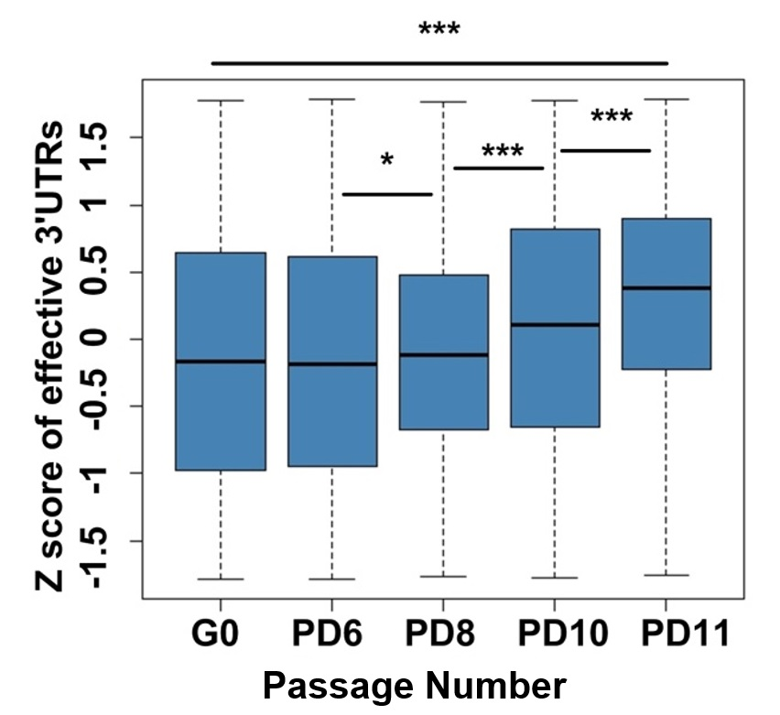

Supplemental Figure 7. Box plot for Z-score transformed effective 3′ UTRs across G0, PD6, PD8, PD10, and PD11 of MEFs. (***) P < 0.001 and (*) P < 0.05, two-tailed Wilcoxon signed rank test.

