SUPPLEMENTARY INFORMATION

Molecular barcoding of native RNAs using nanopore sequencing
and deep learning

Martin A. Smith^{1,2,3,4,#, *}, Tansel Ersavas^{1,#}, James M. Ferguson^{1,#}, Huanle Liu^{1,5}, Morghan C. Lucas^{1,5,6}, Oguzhan Begik^{1,2,5}, Lilly Bojarski¹, Kirston Barton^{1,2}, Eva Maria Novoa^{1,2,5,6,*}

¹ Garvan Institute of Medical Research, Darlinghurst 2010, NSW, Australia
² St-Vincent’s Clinical School, UNSW Sydney, Darlinghurst 2010, NSW, Australia
³ CHU Sainte-Justine Research Centre, Montreal, Canada
⁴ Department of Biochemistry and Molecular Medicine, University of Montreal, Canada
⁵ Centre for Genomic Regulation (CRG), The Barcelona Institute of Science and Technology, Dr. Aiguader 88, Barcelona 08003, Spain
⁶ Universitat Pompeu Fabra (UPF), Barcelona, Spain
# These authors contributed equally

* Correspondence to: Martin A. Smith (martinalexandersmith@gmail.com)
and Eva Maria Novoa (eva.novoa@crg.eu)

SUPPLEMENTARY FIGURES

Figure S1. Comparison of barcode segmentation strategies. (A) Distribution of extracted signal lengths for 32,716 reads (red = B_conv, green = B_roll). (B) Density plot depicting the overlap of the segmented regions extracted by B_roll and B_conv. (C) Example of barcode segmentation positions in signal data from four reads using the two tested segmentation algorithms (red = B_conv, green = B_roll).

Figure S2. Transformation of adapter raw signals into 2D images. Example illustrating how raw signal is converted into (top) Recurrence Plot and Markov Transition Field, and (bottom) Gramian Angular Summation (GASF) and Gramian Angular Difference (GADF)

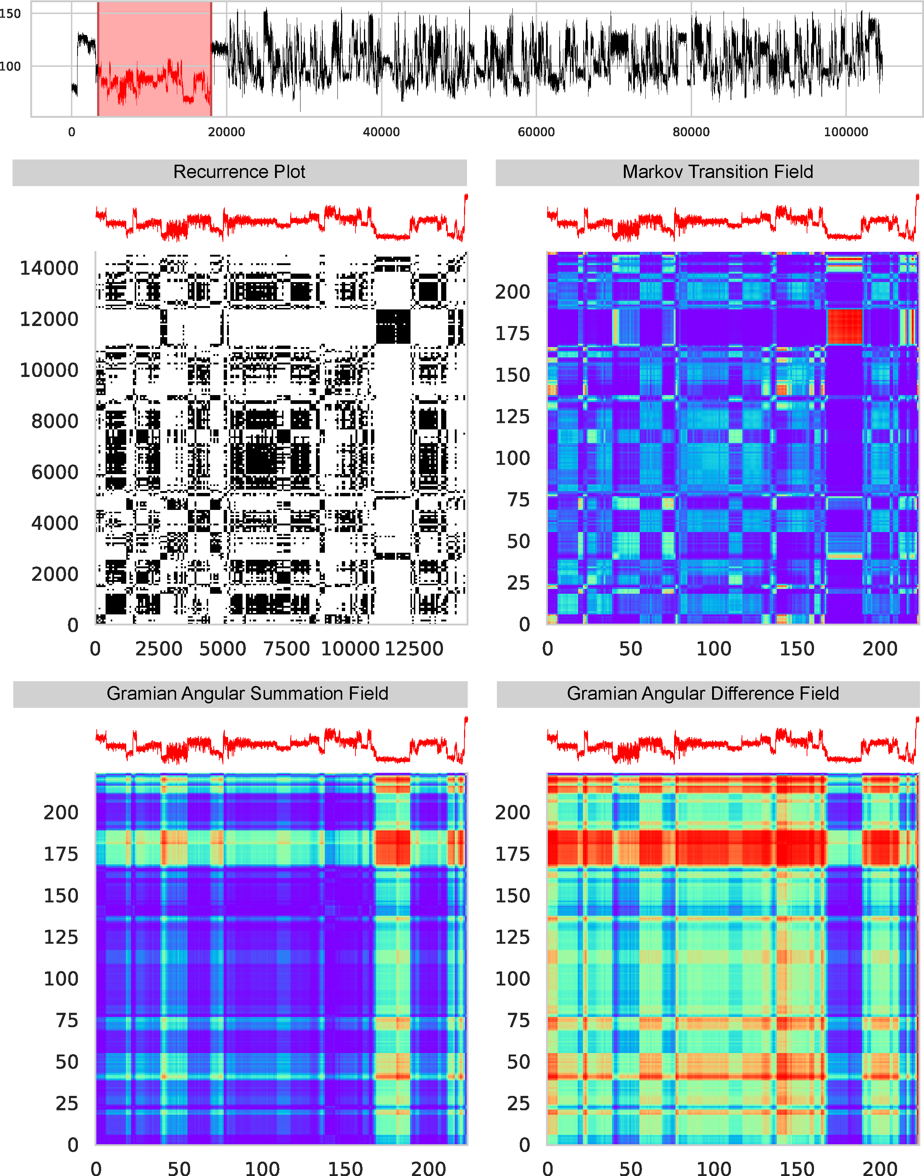

Figure S3. Comparison of the performance of DeepBinner (1D CNN) and DeePlexiCon (2D CNN) for demultiplexing direct RNA sequencing datasets. (A) Contingency tables of the performance of DeePlexiCon (left) and DeepBinner (right) on the same dataset (4,000 barcodes). (B) Accuracy of each software with increasing number of Epochs. Both the accuracy of the training (blue) and test (orange) set is shown. We find that DeepBinner’s 1D CNN achieved 61.4% accuracy (100% recovery), whereas DeePlexiCon achieved 94.2% accuracy (100% recovery), on the same dataset.

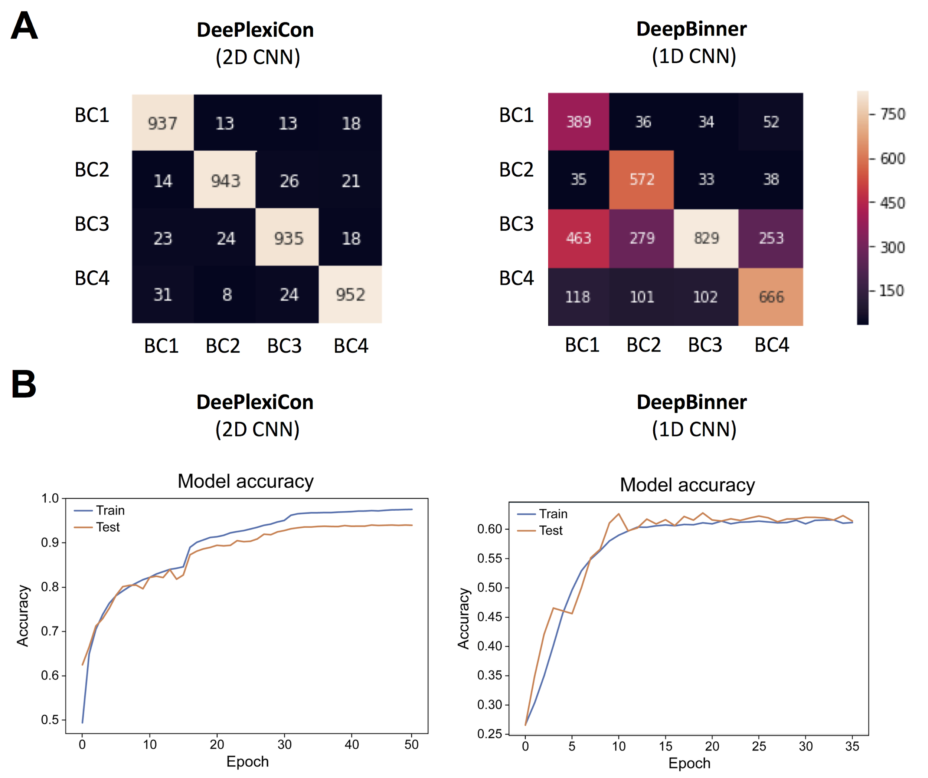

Figure S4. Performance of Deeplexicon on independent replicates (replicate 1 and replicate 5) not used for training or testing. (A) Confusion matrices for replicate 1 (left) and replicate 5 SQK-RNA002 (right). Replicate 1 was prepared using SQK-RNA001 library preparation kit and was sequenced in a R9.5 flowcell, whereas replicate 5 was prepared using SQK-RNA002 library preparation kit and sequenced in a R9.4.1 flowcell. (B) Examples illustrating chimeric artefacts during library preparation and/or errors in MinKNOW read assignment, which were most frequent in replicate 1. These artefacts impact the ability to correctly identify the adapter. The correct adapter/barcode within the RNA read is highlighted in blue; a second adapter/barcode detected within the read is shown in orange, and should belong to a different read; signal artefacts, which may affect the identification of the barcoded region, are highlighted in pink. Red circles depict a very short “open pore” state that MinKNOW software missed, and therefore failed to cut the signal into two independent reads.

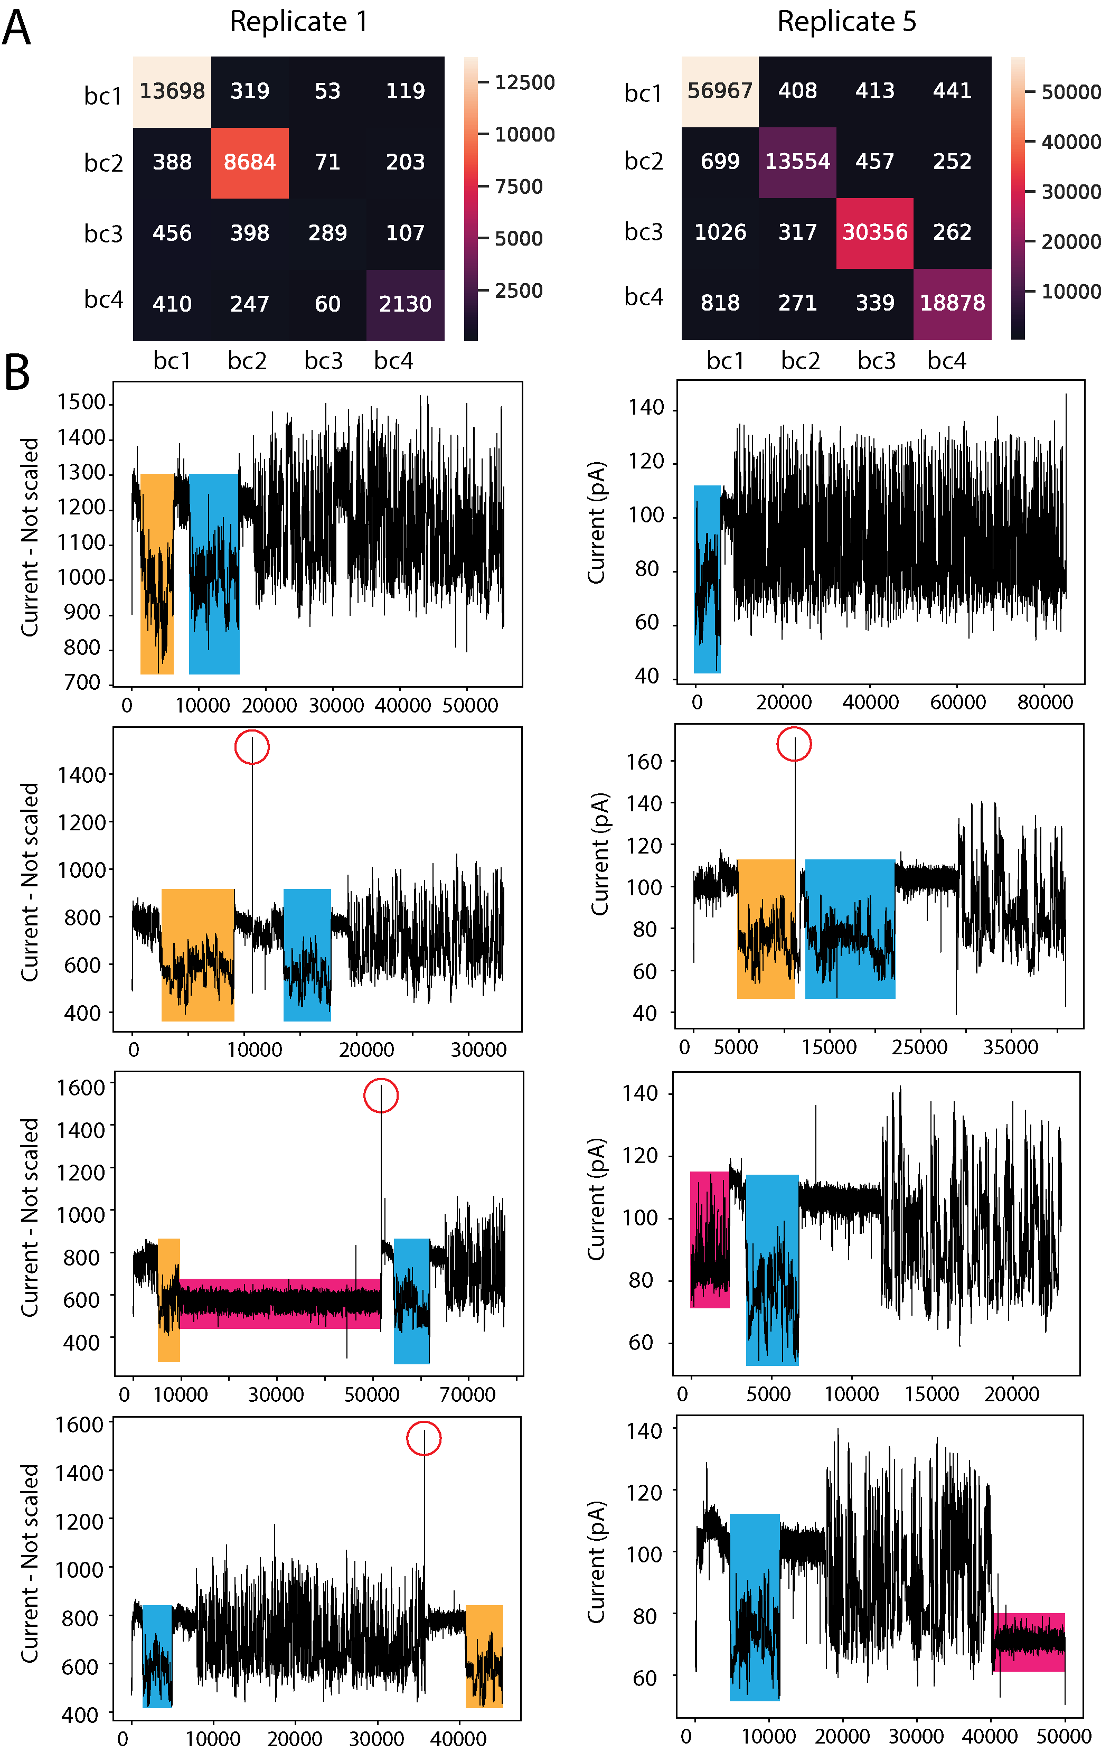

Figure S5. Quality control of the production of in vitro transcribed sequences, which were ligated to custom barcoded adapters. (A) Sequin and Curlcake plasmid digestion was confirmed by agarose gel (B,C) Correct IVT product lengths were confirmed using Bioanalyzer -in the case of sequins- (B), or TapeStation -in the case of curlcakes- (C).

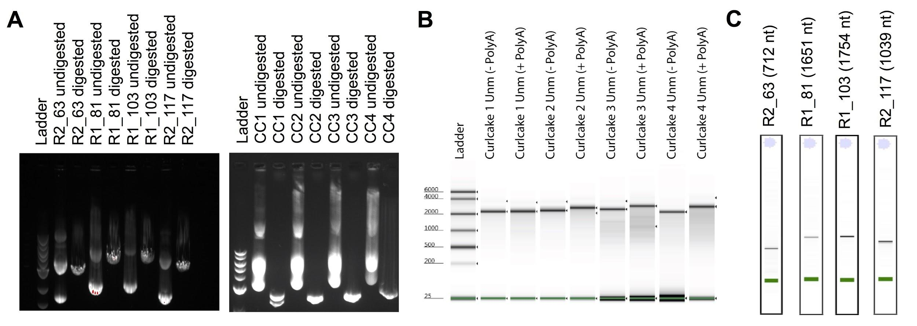

Figure S6. Robustness of the DeePlexiCon in barcode classification with regards to segmentation inaccuracies. (A) We compared the performance of DeePlexiCon ResNet-20 model on the same subset of reads, using as input distinct segmentations of the barcode signals (variations of ±150 data points in different directions). The B_roll (upper left panel) is the current segmentation method used in DeePlexiCon. This was compared to slight shifting of the barcode signal towards the right in 150 data points (upper right panel), extension in both ends of 150 data points (bottom left panel) and trimming in both ends of 150 data points (bottom right panel). (B) Accuracy and recovery of the different segmentation variations, from the same data shown in panel A. We find that accuracy and recovery are largely robust to errors in segmentation, being the worst performing scenario the one in which both 5’ and 3’ ends of the barcode segment have been trimmed (decrease of 1% accuracy).

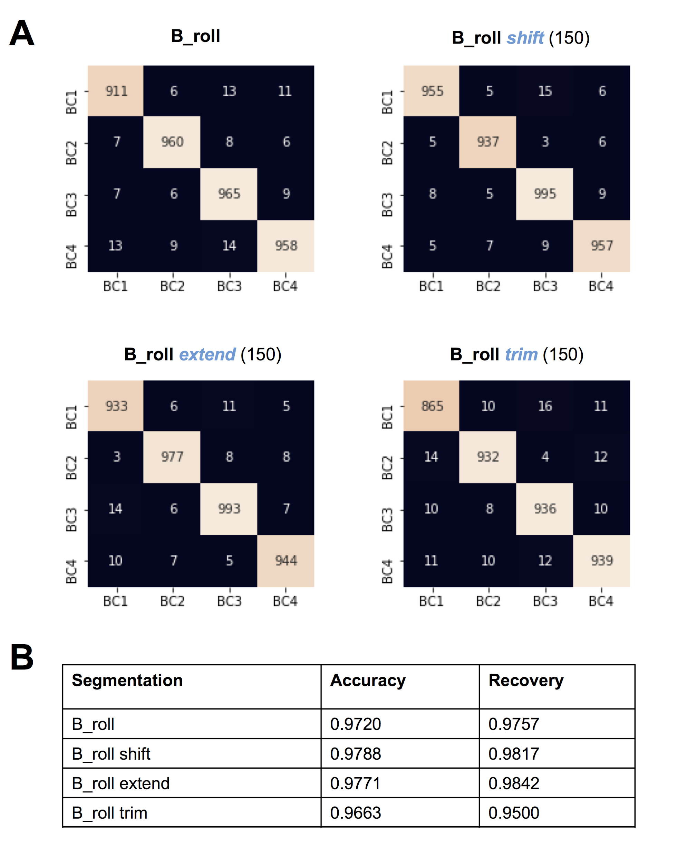

SUPPLEMENTARY TABLES

Table S1. Barcode sequences and custom oligonucleotides (oligoA and oligoB) employed to prepare barcoded direct RNA sequencing libraries.

Barcode ID | Barcode sequence | Oligo A | Oligo B | Ligated to Sequin | Ligated to Curlcake
BC1 | GGCTTCTTCTTGCTCTTAGG | 5'-/5Phos/GGCTTCTTCTTGCTCTTAGGTAGTAGGTTC-3' | 5’-GAGGCGAGCGGTCAATTTTCCTAAGAGCAAGAAGAAGCCTTTTTTTTTT-3’ | R2-63-3 | CC1 (2244bp)
BC2 | GTGATTCTCGTCTTTCTGCG | 5'-/5Phos/GTGATTCTCGTCTTTCTGCGTAGTAGGTTC-3' | 5’-GAGGCGAGCGGTCAATTTTCGCAGAAAGACGAGAATCACTTTTTTTTTT-3’ | R1-81-2 | CC2 (2459bp)
BC3 | GTACTTTTCTCTTTGCGCGG | 5'-/5Phos/GTACTTTTCTCTTTGCGCGGTAGTAGGTTC-3' | 5’-GAGGCGAGCGGTCAATTTTCCGCGCAAAGAGAAAAGTACTTTTTTTTTT-3’ | R1-103-1 | CC3 (2595bp)
BC4 | GGTCTTCGCTCGGTCTTATT | 5'-/5Phos/GGTCTTCGCTCGGTCTTATTTAGTAGGTTC-3' | 5’-GAGGCGAGCGGTCAATTTTAATAAGACCGAGCGAAGACCTTTTTTTTTT-3’ | R2-117-1 | CC4 (2709bp)

Table S2. Sequencing metrics for the three barcoded runs used to train, test and validate the demultiplexing algorithm

 | rep1 | rep2 | rep3 | rep4 | rep5
Base Caller | guppy 3.1.5 | guppy 3.1.5 | guppy 3.2.4 | guppy 3.2.4 | guppy 3.2.4
Base-called reads | 1,000,403 | 688,261 | 586,820 | 163,576 | 160,455
Total mapped reads (including ENO2 spike-in) | 36,762 | 441,447 | 547,607 | 62,889 | 143,491
Mapped reads to barcoded RNAs (sequins and CCs. MQ=60) | 33,034 | 425,145 | 124,734 | 61,007 | 139,674
Device type | MinION | MinION | GridION | MinION | MinION
Flowcell type | flo-min107 | flo-min106 | flo-min106 | flo-min106 | flo-min106
Flowcell ID | FAH30963 | FAK26690 | FAK77749 | FAL18505 | FAL15860
Sequencing kit | SQK-RNA001 | SQK-RNA001 | SQK-RNA002 | SQK-RNA002 | SQK-RNA002
Sample frequency | 3,012 | 3,012 | 3,012 | 3,012 | 3,012
Bream version | 1.10.11.1 | NA | 4.1.8 | 4.1.9 | 4.1.9
Protocols version | 1.10.16 | 1.15.10.12 | 4.1.8 | 4.1.9 | 4.1.9

Table S3. DeePlexiCon performance on each individual barcode

replicate 5 0.998 cut-off 0.1% FPR |  |  | Observed
replicate 5 0.998 cut-off 0.1% FPR |  |  | BC1 | BC2 | BC3 | BC4 | mis-assigned (%)
replicate 5 0.998 cut-off 0.1% FPR | Expected | BC1 | 41803 | 38 | 39 | 46 | 0.3
replicate 5 0.998 cut-off 0.1% FPR | Expected | BC2 | 102 | 9531 | 24 | 31 | 1.6
replicate 5 0.998 cut-off 0.1% FPR | Expected | BC3 | 40 | 19 | 20732 | 12 | 0.3
replicate 5 0.998 cut-off 0.1% FPR | Expected | BC4 | 48 | 15 | 7 | 12354 | 0.6
replicate 5 0.880 cut-off 1% FPR |  |  | Observed
replicate 5 0.880 cut-off 1% FPR |  |  | BC1 | BC2 | BC3 | BC4 | mis-assigned (%)
replicate 5 0.880 cut-off 1% FPR | Expected | BC1 | 55686 | 507 | 746 | 616 | 3.2
replicate 5 0.880 cut-off 1% FPR | Expected | BC2 | 333 | 13168 | 234 | 203 | 5.5
replicate 5 0.880 cut-off 1% FPR | Expected | BC3 | 314 | 314 | 29587 | 241 | 2.9
replicate 5 0.880 cut-off 1% FPR | Expected | BC4 | 321 | 166 | 185 | 18327 | 3.5
replicate 5 0.642 cut-off Max Accuracy |  |  | Observed
replicate 5 0.642 cut-off Max Accuracy |  |  | BC1 | BC2 | BC3 | BC4 | mis-assigned (%)
replicate 5 0.642 cut-off Max Accuracy | Expected | BC1 | 58385 | 1080 | 1484 | 1254 | 6.1
replicate 5 0.642 cut-off Max Accuracy | Expected | BC2 | 544 | 14047 | 480 | 408 | 9.3
replicate 5 0.642 cut-off Max Accuracy | Expected | BC3 | 645 | 716 | 31309 | 530 | 5.7
replicate 5 0.642 cut-off Max Accuracy | Expected | BC4 | 630 | 406 | 439 | 19525 | 7.0
replicate 5 0.214 cut-off Youlden Index |  |  | Observed
replicate 5 0.214 cut-off Youlden Index |  |  | BC1 | BC2 | BC3 | BC4 | mis-assigned (%)
replicate 5 0.214 cut-off Youlden Index | Expected | BC1 | 59606 | 1647 | 2201 | 1830 | 8.7
replicate 5 0.214 cut-off Youlden Index | Expected | BC2 | 750 | 14478 | 683 | 581 | 12.2
replicate 5 0.214 cut-off Youlden Index | Expected | BC3 | 1021 | 1146 | 32149 | 881 | 8.7
replicate 5 0.214 cut-off Youlden Index | Expected | BC4 | 938 | 621 | 722 | 20032 | 10.2

Table S4. Quality analysis of in vitro transcribed RNA products and library preparation

Synthetic construct | Qubit (ng/ul) | Nanodrop (ng/ul) | 260/280 | 260/230
Curlcake 1 | 372 | 446 | 2.10 | 2.79
Curlcake 2 | 328 | 426 | 2.09 | 2.31
Curlcake 3 | 302 | 331 | 2.17 | 2.49
Curlcake 4 | 304 | 495 | 2.13 | 2.46
Sequin 1 | 16.4 | 56.32 | 2.40 | 2.53
Sequin 2 | 182.0 | 166.48 | 2.07 | 2.11
Sequin 3 | 71.6 | 65.12 | 2.07 | 1.70
Sequin 4 | 32.8 | 80.32 | 2.24 | 2.54

Table S5. Softwares and versions used to build DeePlexiCon

System or Package | Version | Reference
Python | 3.7.3 | Python Software Foundation. Python Language Reference, version 3.7.3. Available at http://www.python.org
Pip | 19.1.1 | Python Software Foundation, Python Package Index (PyPI) Package Installer for Python. https://pypi.org/project/pip/
Tensorflow | 1.13.1 | Martín Abadi, Paul Barham, Jianmin Chen, Zhifeng Chen, Andy Davis, Jeffrey Dean, Matthieu Devin, Sanjay Ghemawat, Geoffrey Irving, Michael Isard, Manjunath Kudlur, Josh Levenberg, Rajat Monga, Sherry Moore, Derek Gordon Murray, Benoit Steiner, Paul A. Tucker, Vijay Vasudevan, Pete Warden, Martin Wicke, Yuan Yu, Xiaoqiang Zhang: TensorFlow: A system for large-scale machine learning. Available at: https://www.tensorflow.org
Keras | 2.2.4 | Keras: The Python Deep Learning Library. Chollet, F.. https://keras.io. *
Numpy | 1.16.4 | NumPy, the fundamental package for array computing with Python. https://pypi.org/project/numpy/
Matplotlib | 3.1.0 | MatPlotLib, Python Plotting Package, https://pypi.org/project/matplotlib/
Pandas | 0.25.0 | Wes McKinney. Data Structures for Statistical Computing in Python, Proceedings of the 9th Python in Science Conference, 51-56 (2010) , http://conference.scipy.org/proceedings/scipy2010/mckinney.html
PyTs | 0.8.0 | Johann Faouzi, pyts: a Python package for time series transformation and classification https://github.com/johannfaouzi/pyts **
Scikit-learn | 0.21.2 | Scikit-learn: Machine Learning in Python, Pedregosa et al., JMLR 12, pp. 2825-2830, 2011, http://jmlr.csail.mit.edu/papers/v12/pedregosa11a.html ***
Seaborn | 0.9.0 | mwaskom/seaborn: v0.9.0 (July 2018) Michael Waskom; Olga Botvinnik; Drew O'Kane; Paul Hobson; Joel Ostblom; Saulius Lukauskas; David C Gemperline; Tom Augspurger; Yaroslav Halchenko; John B. Cole; Jordi Warmenhoven; Julian de Ruiter; Cameron Pye; Stephan Hoyer; Jake Vanderplas; Santi Villalba; Gero Kunter; Eric Quintero; Pete Bachant; Marcel Martin; Kyle Meyer; Alistair Miles; Yoav Ram; Thomas Brunner; Tal Yarkoni; Mike Lee Williams; Constantine Evans; Clark Fitzgerald; Brian; Adel Qalieh, 10.5281/zenodo.1313201
PyCM | 2.4 | Haghighi, S., Jasemi, M., Hessabi, S. and Zolanvari, A. (2018). PyCM: Multiclass confusion matrix library in Python.  Journal of Open Source Software, 3(25), p.729. Available at: https://www.pycm.ir

