RNA-Bloom enables reference-free and reference-guided sequence assembly for single-cell transcriptomes

Ka Ming Nip¹, Readman Chiu¹, Chen Yang¹, Justin Chu¹, Hamid Mohamadi¹, René L. Warren¹, and Inanc Birol^{1,2}

¹ Canada’s Michael Smith Genome Sciences Centre, BC Cancer, Vancouver, BC, Canada
² Department of Medical Genetics, University of British Columbia, Vancouver, BC, Canada

SUPPLEMENTAL MATERIAL

Supplemental Figure S1. Pooling of reads from multiple cells. 2
Supplemental Figure S2. Assembly quality on mouse simulated bulk RNA-seq data. 3
Supplemental Figure S3. Assembly quality on mouse simulated and real bulk RNA-seq data. 4
Supplemental Figure S4. Assembly quality on simulated data for 384 mouse microglia cells. 5
Supplemental Figure S5. Assembly quality on real data for 260 mouse embryonic stem cells. 6
Supplemental Figure S6. Splice variants of the TREM2 gene in mouse reference genome GRCm38. 7
Supplemental Figure S7. Paired k-mers along reads and reconstructed fragments. 7
Supplemental Figure S8. Error correction in paired-end reads. 8
Supplemental Figure S9. K-mer pairs spanning candidate extensions. 9
Supplemental Figure S10. Stratification of reconstructed fragments and unconnected reads. 9

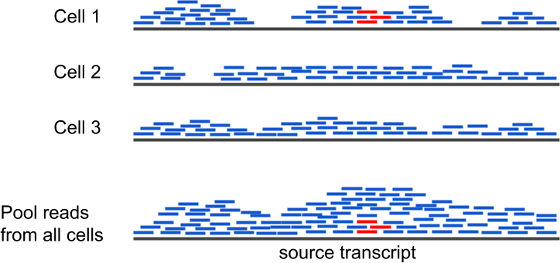

Supplemental Figure S1. Pooling of reads from multiple cells.
Transcript sequence reconstruction can be improved by pooling reads to fill in sequencing gaps and distinguish between noise and signal.

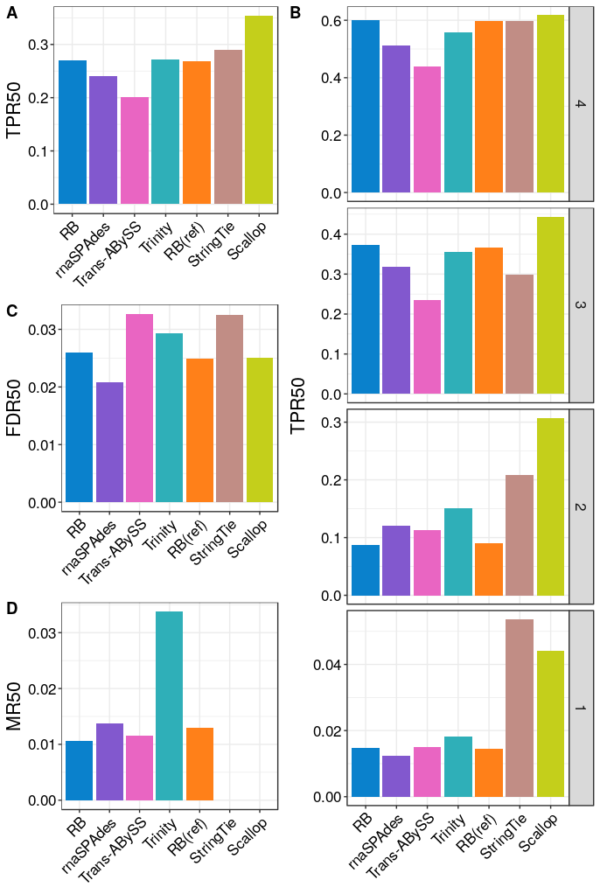

Supplemental Figure S2. Assembly quality on mouse simulated bulk RNA-seq data.
(A) True positive rate calculated based on isoforms reconstructed to at least 50% of annotated length; denoted as “TPR50”. (B) True positive rate at four transcript expression strata. Isoforms in strata 1, 2, 3, and 4 have non-zero values of transcripts per million (TPM) in the lowest quartile, second-lowest quartile, second-highest quartile, and the highest quartile, respectively. (C) False discovery rate calculated based on I50; denoted as “FDR50”. (D) Misassembly rate calculated based on I50; denoted as “MR50”.

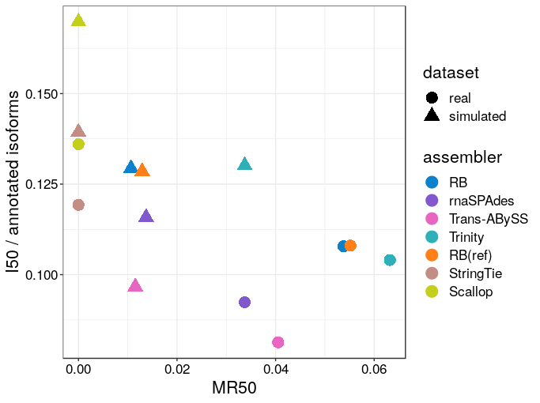

Supplemental Figure S3. Assembly quality on mouse simulated and real bulk RNA-seq data.
Assembly sensitivity was measured as the number of isoforms reconstructed to at least 50% annotated isoform length (denoted as “I50”) in each dataset normalized by the total number of isoforms in reference annotation. Misassembly rate was calculated based on I50; denoted as “MR50”.

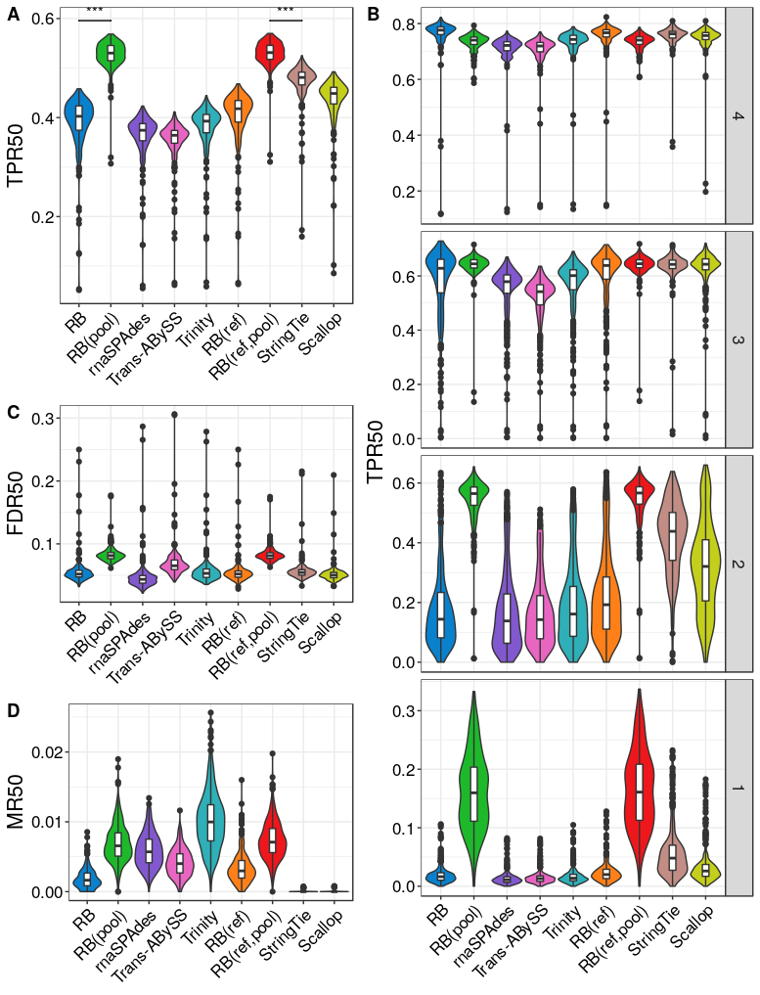

Supplemental Figure S4. Assembly quality on simulated data for 384 mouse microglia cells.
(A) True positive rate calculated based on isoforms reconstructed to at least 50% of annotated length; denoted as “TPR50”. (B) True positive rate at different transcript expression stratum. (C) False discovery rate calculated based on isoforms reconstructed to at least 50% of annotated length; denoted as “FDR50”. (D) Misassembly rate calculated based on isoforms reconstructed to at least 50% of annotated length; denoted as “MR50”. The comparison bars on top between RB(pool) and RB(ref,pool) and the next best performer in each class indicate statistical significance of the difference between distributions at p<0.001 (“***”) or no significance (“NS.”) using the Wilcoxon test.

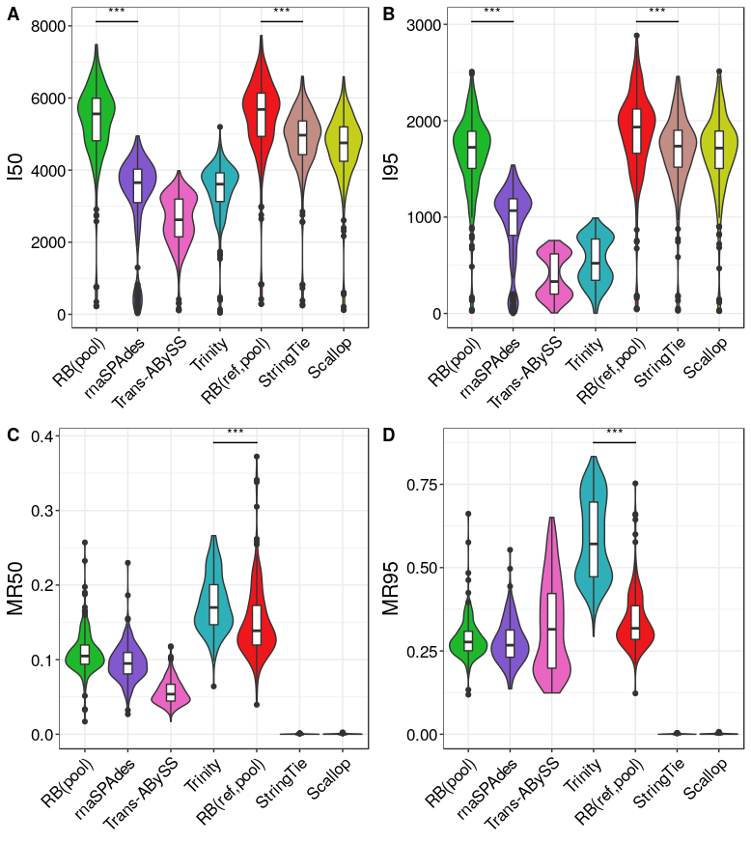

Supplemental Figure S5. Assembly quality on real data for 260 mouse embryonic stem cells.
The comparison bars indicate statistical significance of the difference between distributions at p<0.001 (“***”).

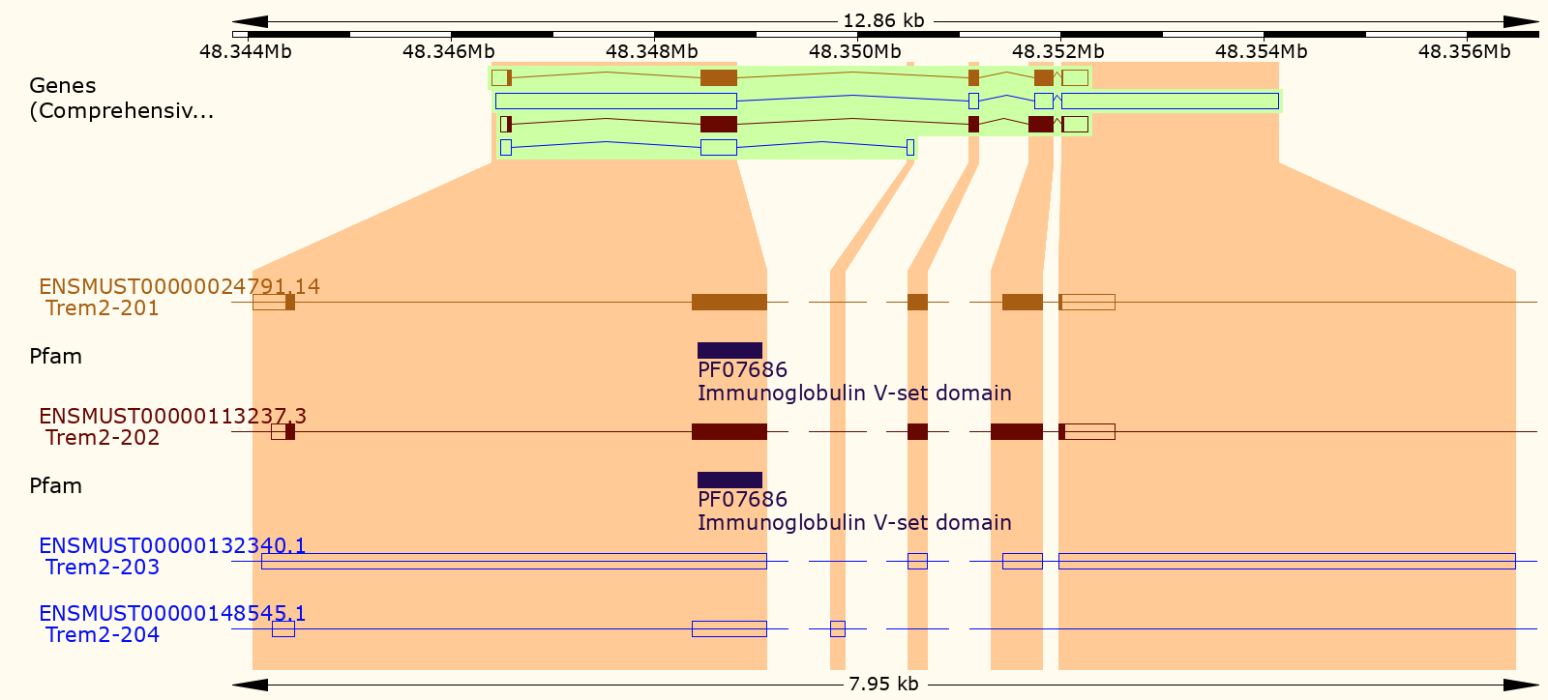

Supplemental Figure S6. Splice variants of the TREM2 gene in mouse reference genome GRCm38.
Screenshot was taken from Ensembl Genome Browser (release 99).

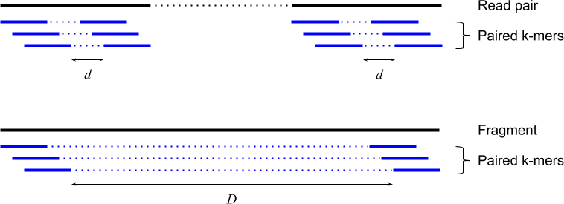

Supplemental Figure S7. Paired k-mers along reads and reconstructed fragments.
Paired k-mers are sparse representations of the sequences that they were derived from. This is analogous to a read pair being a sparse representation of its underlying fragment. The distance between read paired k-mers (ie. d) is set based on the read length and it is the same for all cells. The distance between fragment paired k-mers (ie. D) is set based on the first quartile fragment length for each cell.

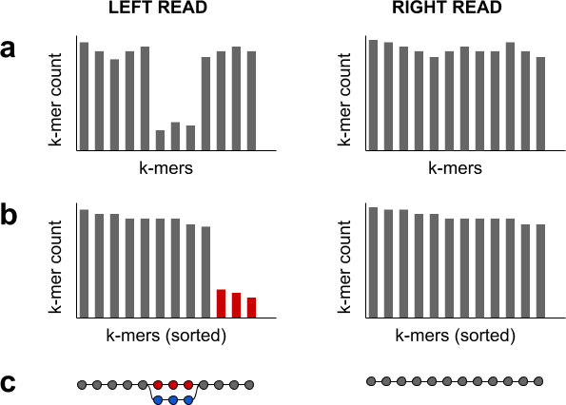

Supplemental Figure S8. Error correction in paired-end reads.
(a) Errors in paired-end reads are corrected based on k-mer counts. (b) A local k-mer count threshold is determined for each read individually. This is done by sorting the k-mer counts in descending order and then looking for the first sharp decrease (ie. ≥ 50%), where the k-mer count at the sharp decrease is set as the local k-mer count threshold. If there is no sharp decrease in k-mer counts, then the read would not be corrected. If both reads have their own local threshold, then the lower threshold is set for both reads to account for low-expressed alternative isoforms. (c) K-mers with counts lower than the threshold are marked (ie. red nodes) for replacement with an alternative branch (ie. blue nodes) in the DBG that has a higher median k-mer count, similar length, and high sequence identity (ie. ≥ 90%).

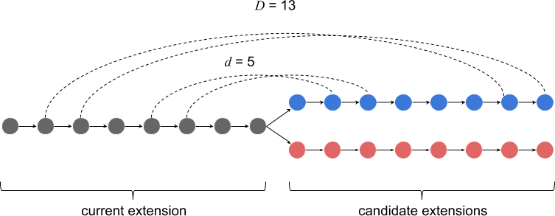

Supplemental Figure S9. K-mer pairs spanning candidate extensions.
When the current extension has reached a fork in the de Bruijn graph, k-mer pairs from reads and fragments are used to identify the best candidate extension from the branching point. In this example, read paired k-mers have a distance (d) of 5 and fragment paired k-mers have a distance (D) of 13. The blue top branch is a better candidate extension compared to the red bottom branch because it has 2 supporting read k-mer pairs and 2 supporting fragment k-mer pairs.

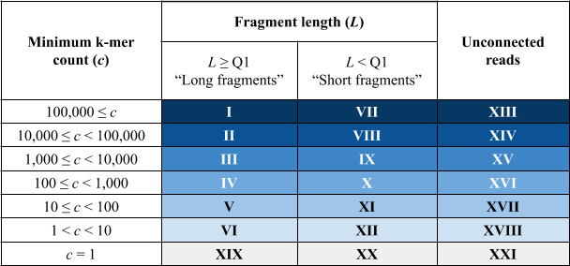

Supplemental Figure S10. Stratification of reconstructed fragments and unconnected reads.
Reconstructed fragments are stratified according to its length and minimum k-mer count. Since the fragment paired k-mers distance is set based on the first quartile fragment length, “long” fragments have at least one fragment k-mer pair while “short” fragments do not. Unconnected reads are stratified according to their minimum k-mer count only. The stratum IDs (roman numerals in the table) denotes the order in which the fragments are retrieved for extension into transcript sequences. Sequences with singleton k-mers (ie. c = 1) are extended last because they often have sequencing artifacts.

