Supplemental material for: Independent evolution of transcript abundance and gene regulatory dynamics
Supplemental Figures S1 – S12 (pages 2-13)
Supplemental note 1: Quality control of RNA-seq data (pages 15-17)
Supplemental note 2: A complementary approach for measuring regulatory similarity: direct correlation of orthologue expression across conditions (page 18)
Supplemental note 3: Consistency of gene-gene correlation across datasets (pages 19-20)
Supplemental Tables description (page 21)

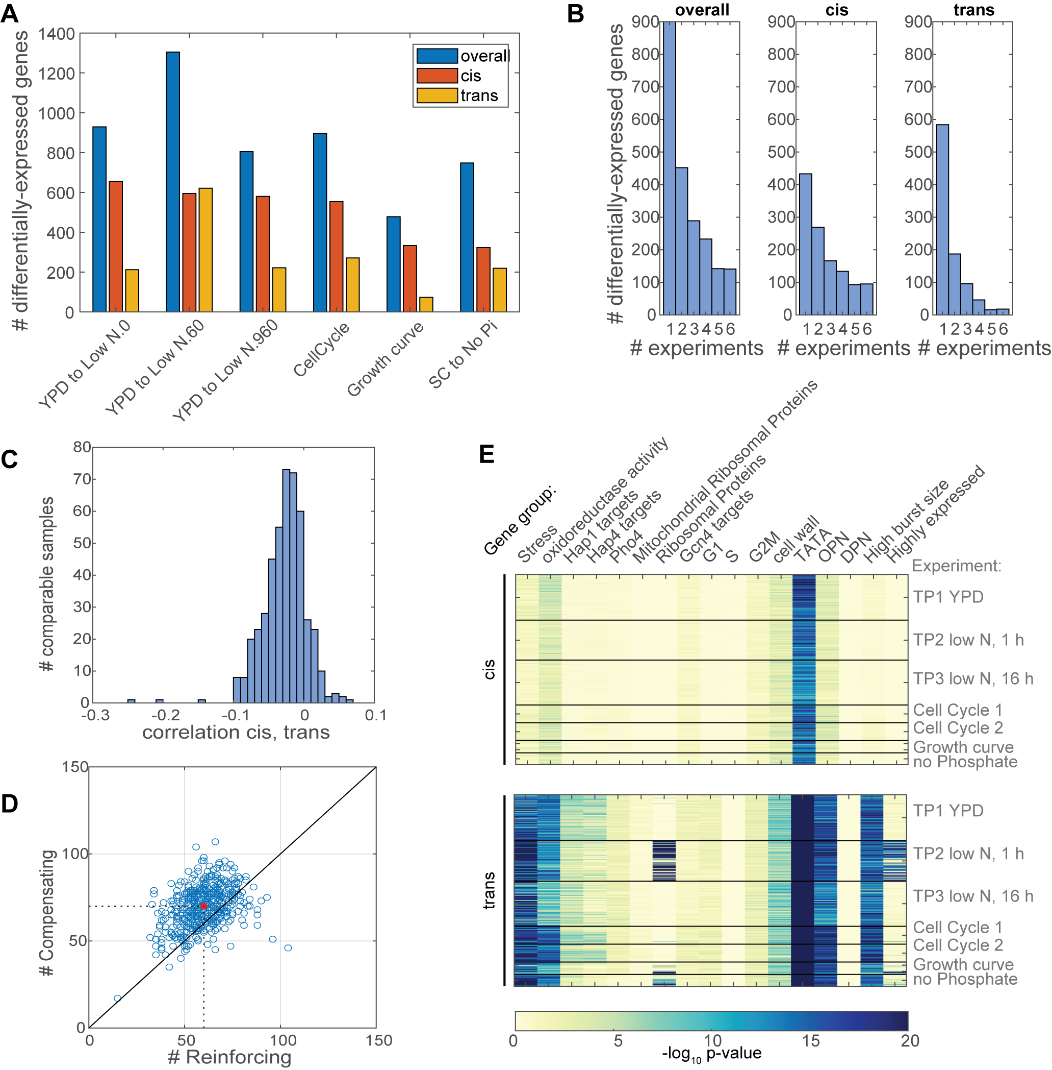
Supplemental Figure S1. Analysis of differential gene expression level. (A) Number of differentially-expressed genes per experiment: Number of genes that differentially express between species (overall), between hybrid alleles (cis) and in trans (overall-cis). The dataset comprise of four experiments, the larger of them is ‘YPD to Low N’ and is divided into three time points: 0 (6 h in YPD), 60 (60 minutes after transition to low N medium) and 960 (16 hours after transition to low N medium). The six experiments were normalized and analyzed for differential expression via DESeq2, presented here are the number of differentially expressed genes (log₂ fold change > 1, FDR-adjusted p-value < 0.05). (B) The number of differentially expressed per number of experiments. Note the number genes that are common to all experiments is bigger for cis-varying genes (95) than for trans-varying genes (18). (C) No correlation between cis and trans effects: trans effects were computed using a cross-replicate comparison of the hybrid samples, in order to avoid false-negative correlations between cis and trans effects (correlation p-value < 0.01 in 135 out of 462 comparable samples) as suggested in (Fraser 2019). (D) Number of genes with reinforcing interactions (cis and trans with the same sign) and compensating interactions (cis and trans with different signs) per comparable sample. The median number is indicated by a red dot. (E) Gene enrichment for cis and trans varying genes, per comparable sample. For each comparable sample, we listed the genes with log₂ fold change > 1 and FDR-adjusted p-value < 0.05 in at least one experiment (as in Fig. 1B), and run a hypergeometric test for enrichment with the indicated gene group (Methods). Presented are FDR-adjusted p-values.

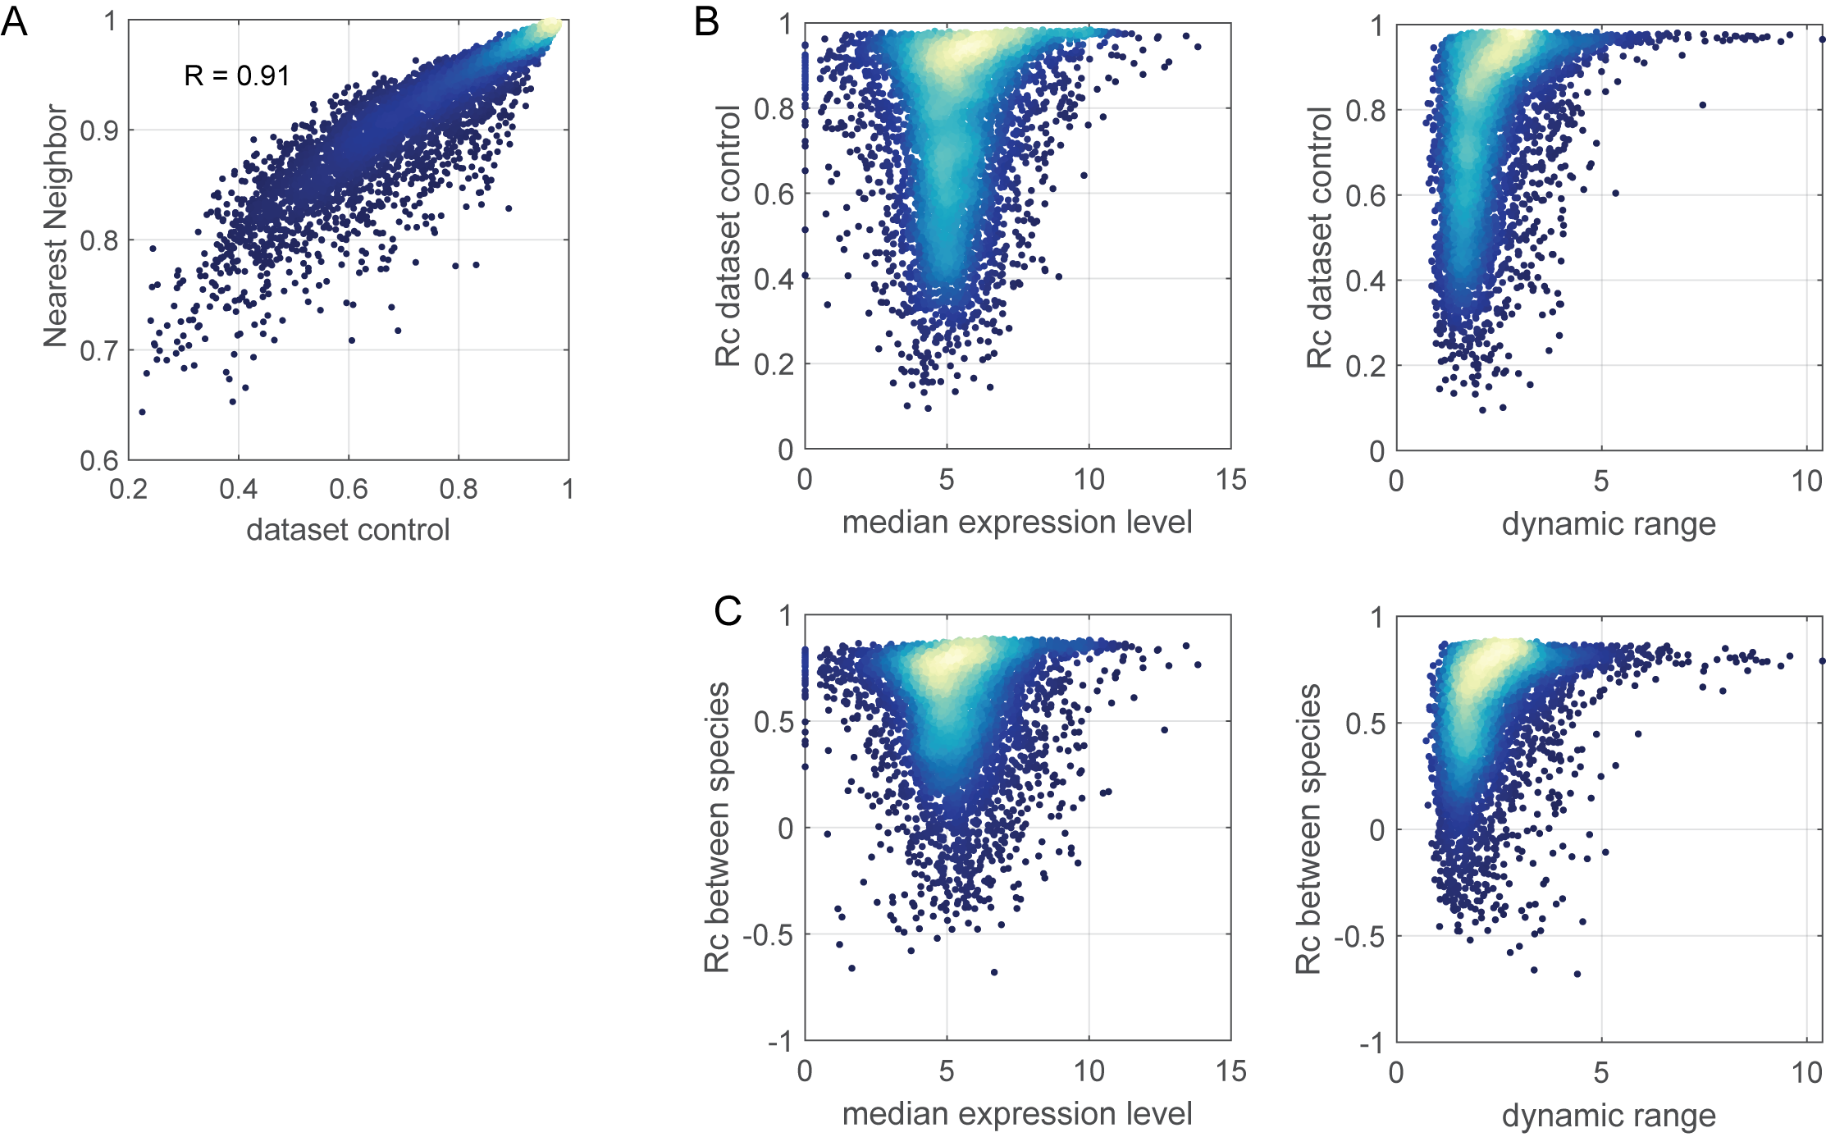

Supplemental Figure S2. Controls for comparative regulatory similarity. (A) Control measures for regulatory similarity (dataset-control and Nearest Neighbors) are highly correlated. (B) Dataset-control is not dictated by gene expression level and dynamic range: shown is the dataset control as a function of the median expression level (right) and the dynamic range (left) in the S. cerevisiae dataset. Expression level is the log₂-transformed normalized counts; dynamic range is the range between the 10th and the 90th quantile of the expression levels. Correlation between measures are 0.18 and 0.4 respectively. (C) Comparative regulatory similarity is not dictated by gene expression level and dynamic range: similar as in B, here the regulatory similarity between species is plotted as a function of the expression level in S. cerevisiae. Correlation between measures are 0.04 and 0.3 respectively.

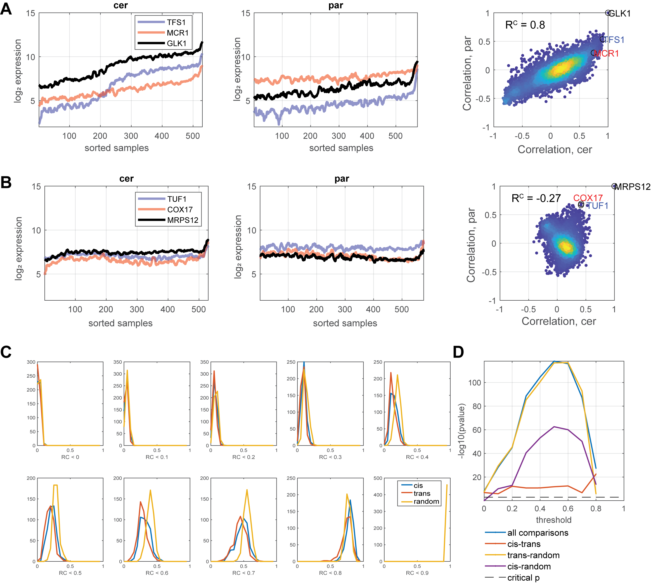

Supplemental Figure S3. Variation in expression level is independent of variation in dynamic regulation. (A) The stress-induced gene GLK1 is differentially expressed between species but present a similar co-expression pattern: Shown are expression levels of GLK1 and other stress-induced genes across samples in S. cerevisiae (left), in S. paradoxus (middle). The samples are sorted by the expression of the stress module, as defined in (Ihmels et al. 2002). The co-expression vectors of GLK1 with all expressed genes, in the two species, are presented on the right panel. (B) The mitochondrial ribosomal protein MRPS12 is expressed at similar levels between species but diverge in dynamic regulation: As in panel A, presented are the expression levels of MRPS12 with other MRP genes is S. cerevisiae and in S. paradoxus. The samples are sorted by the expression of the stress module. The co-expression vectors of MRPS12 with all expressed genes, in the two species, are presented on the right panel. (C-D) Differentially-expressed genes show a conserved regulatory similarity: the analysis in Figure 3D was repeated for different thresholds. P-values of ANOVA tests of the indicated comparison are presented for each threshold (D).

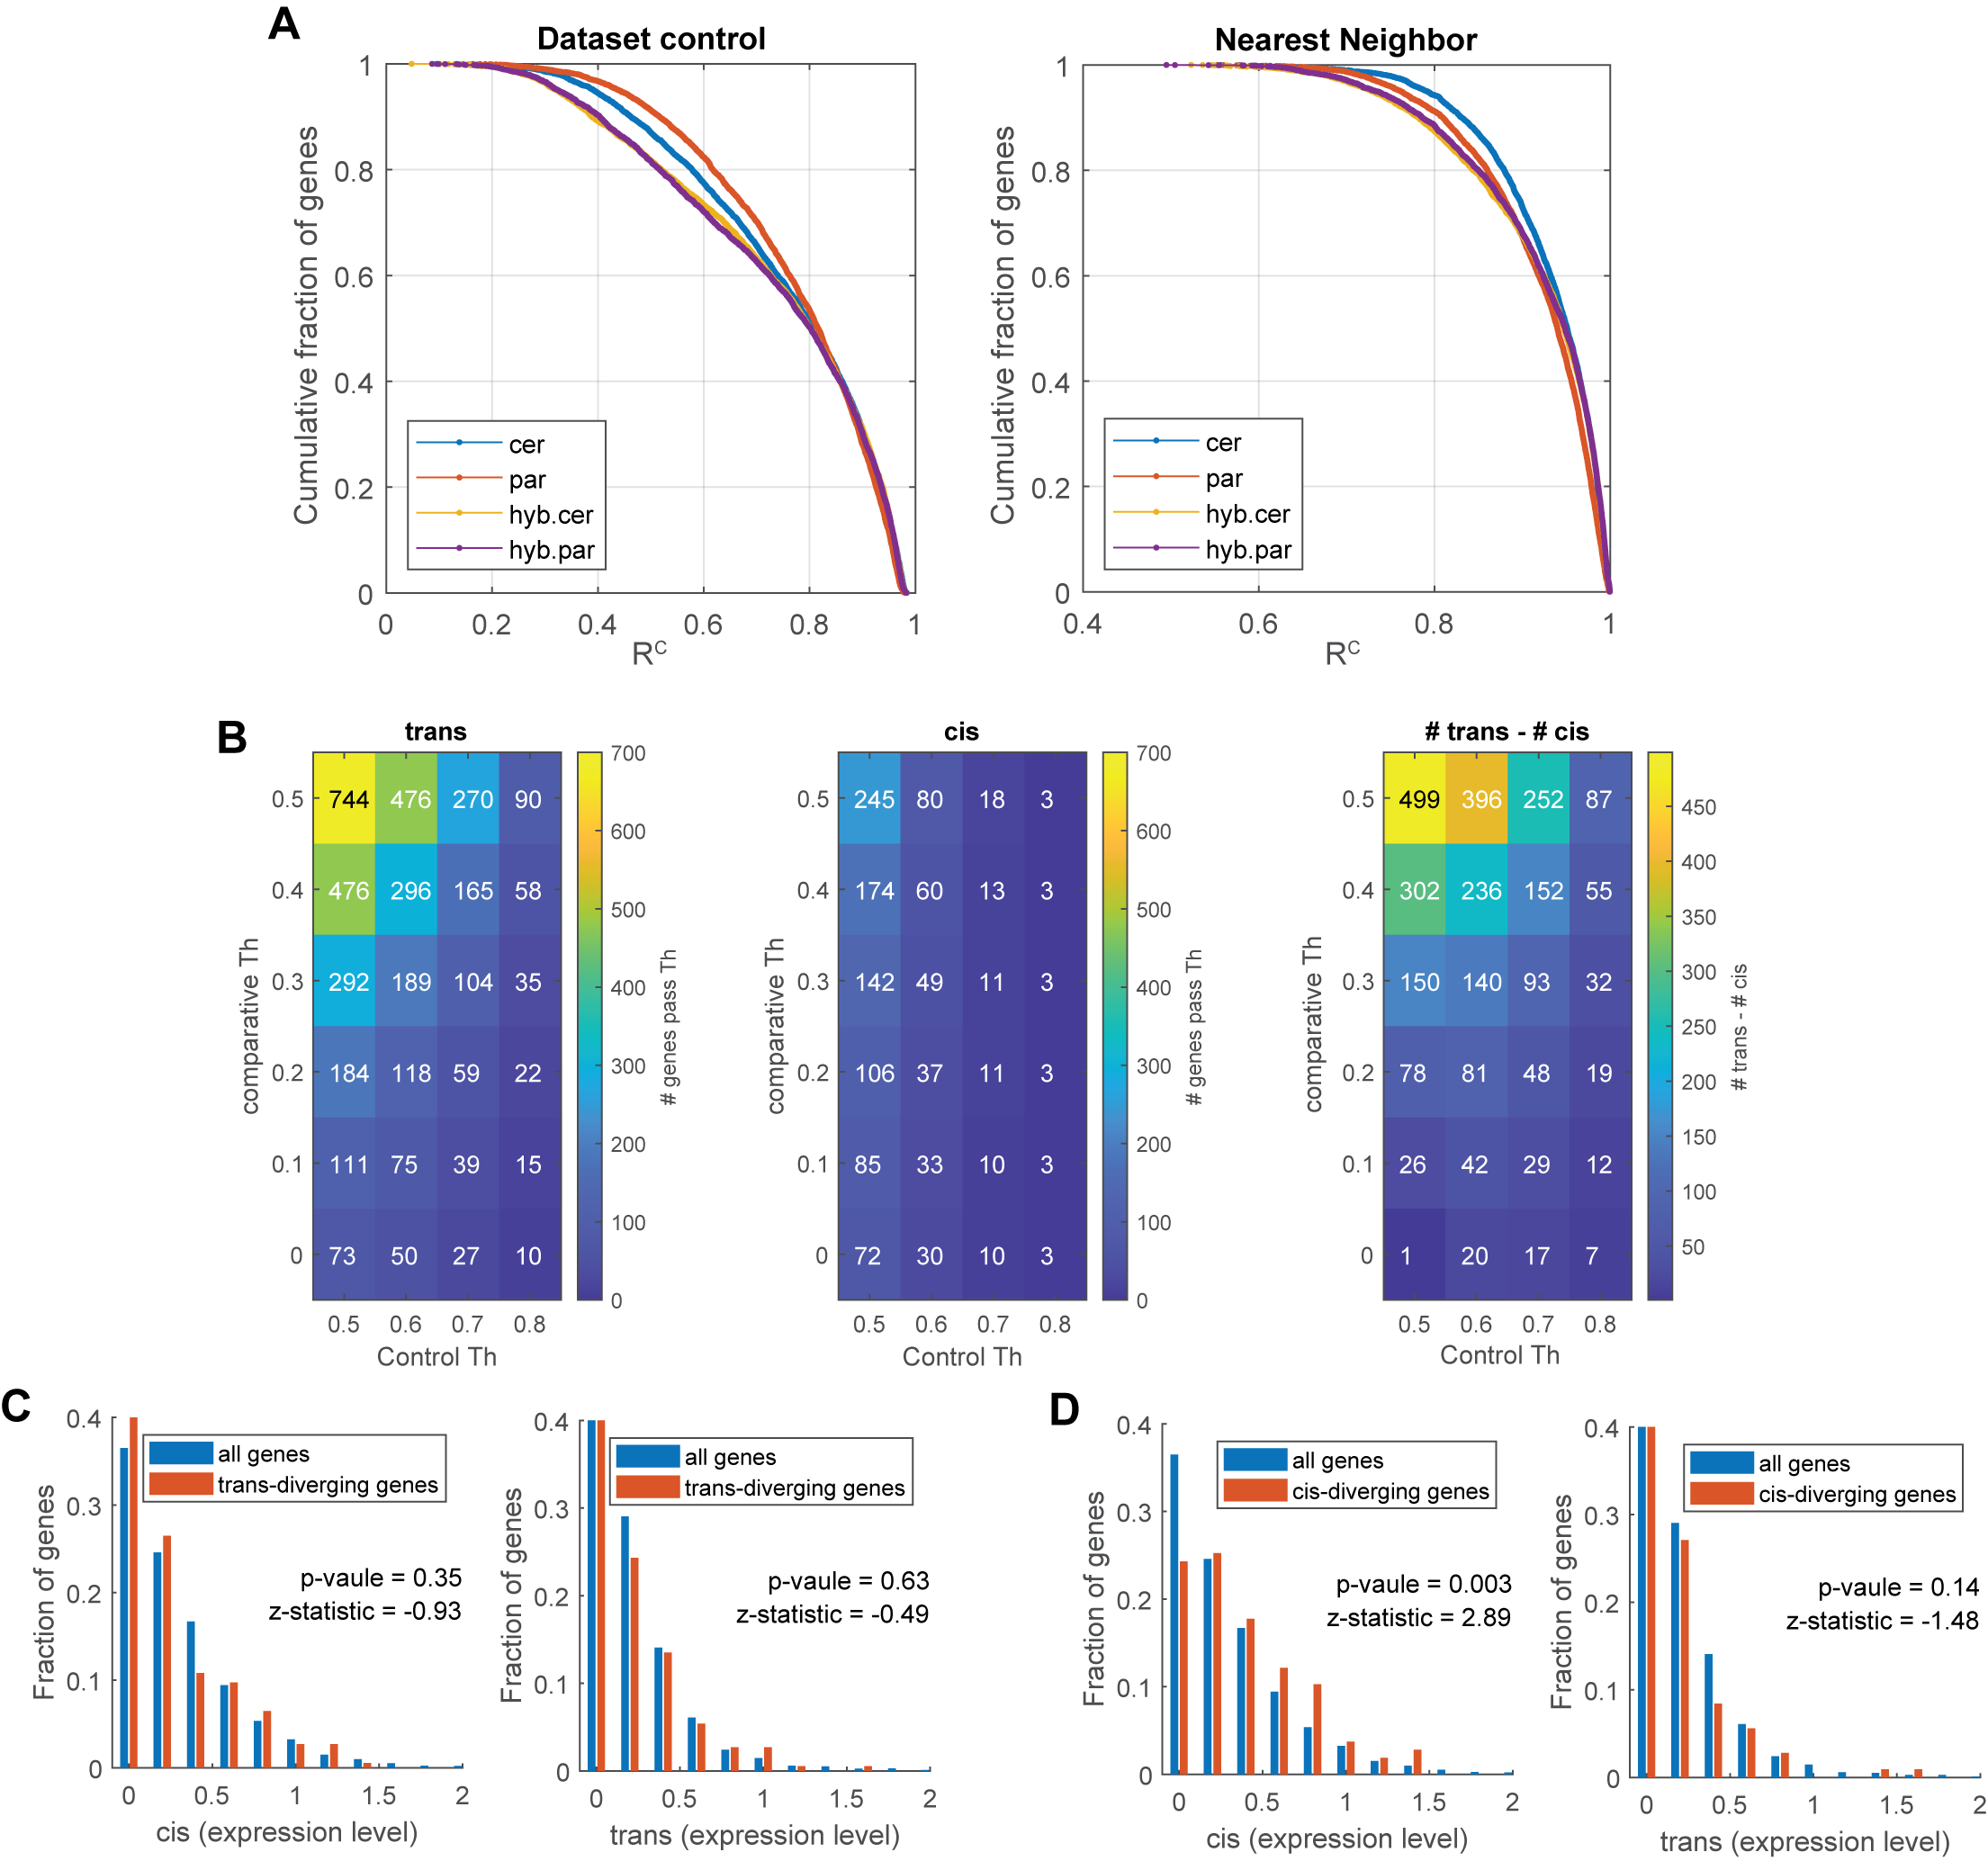
Supplemental Figure S4. Controls for: classifying variation in dynamic regulation into cis and trans effects. (A) Regulatory similarity controls (dataset-control, nearest neighbors) are similarly distributed in the four datasets. (B) The number of trans-varying genes is larger than the number of cis-varying genes for all tested thresholds. (C) Trans-variation in R^{C} is independent of cis- or trans-variation in expression level. Indicated are p-values and z-statistics of rank sum test. (D) Cis-variation in R^{C} is enriched in cis-variation in expression level, but not in trans-variation in expression level. Indicated are p-values and z-statistics of rank sum test.

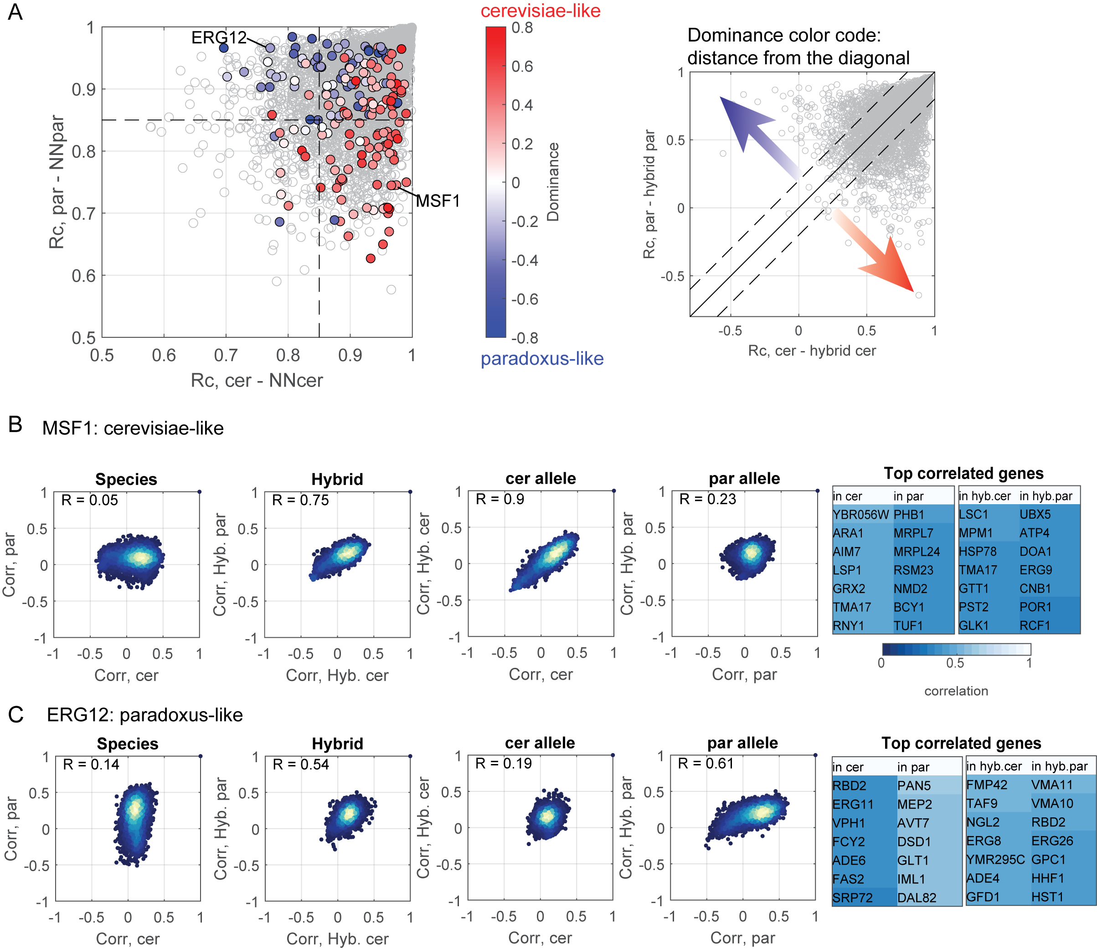
Supplemental Figure S5. In trans varying genes, the recessive variant had lost regulation. (A) The dominant species maintain the higher NN similarity: presented are the regulatory similarities between a gene to its nearest neighbor, in S. cerevisiae (x-axis) and in S. paradoxus (y-axis), as shown in Fig. 5F. Trans-diverging genes are colored. Color code resembles which of the alleles is dominant in the hybrid (cerevisiae-like or paradoxus-like) based on the similarity score of each allele with its respective parent, as shown in Fig. 5E, by distance from the diagonal line. Example genes are indicated. (B) MSF1 shows a cerevisiae-like dominance and higher similarity with its NN in S. cerevisiae: shown are co-expression vectors of the indicated species, and the genes mostly correlated with MSF1 in each genetic background. (C) ERG12 shows a paradoxus-like dominance and a higher similarity with its NN in S. paradoxus: shown as in B.

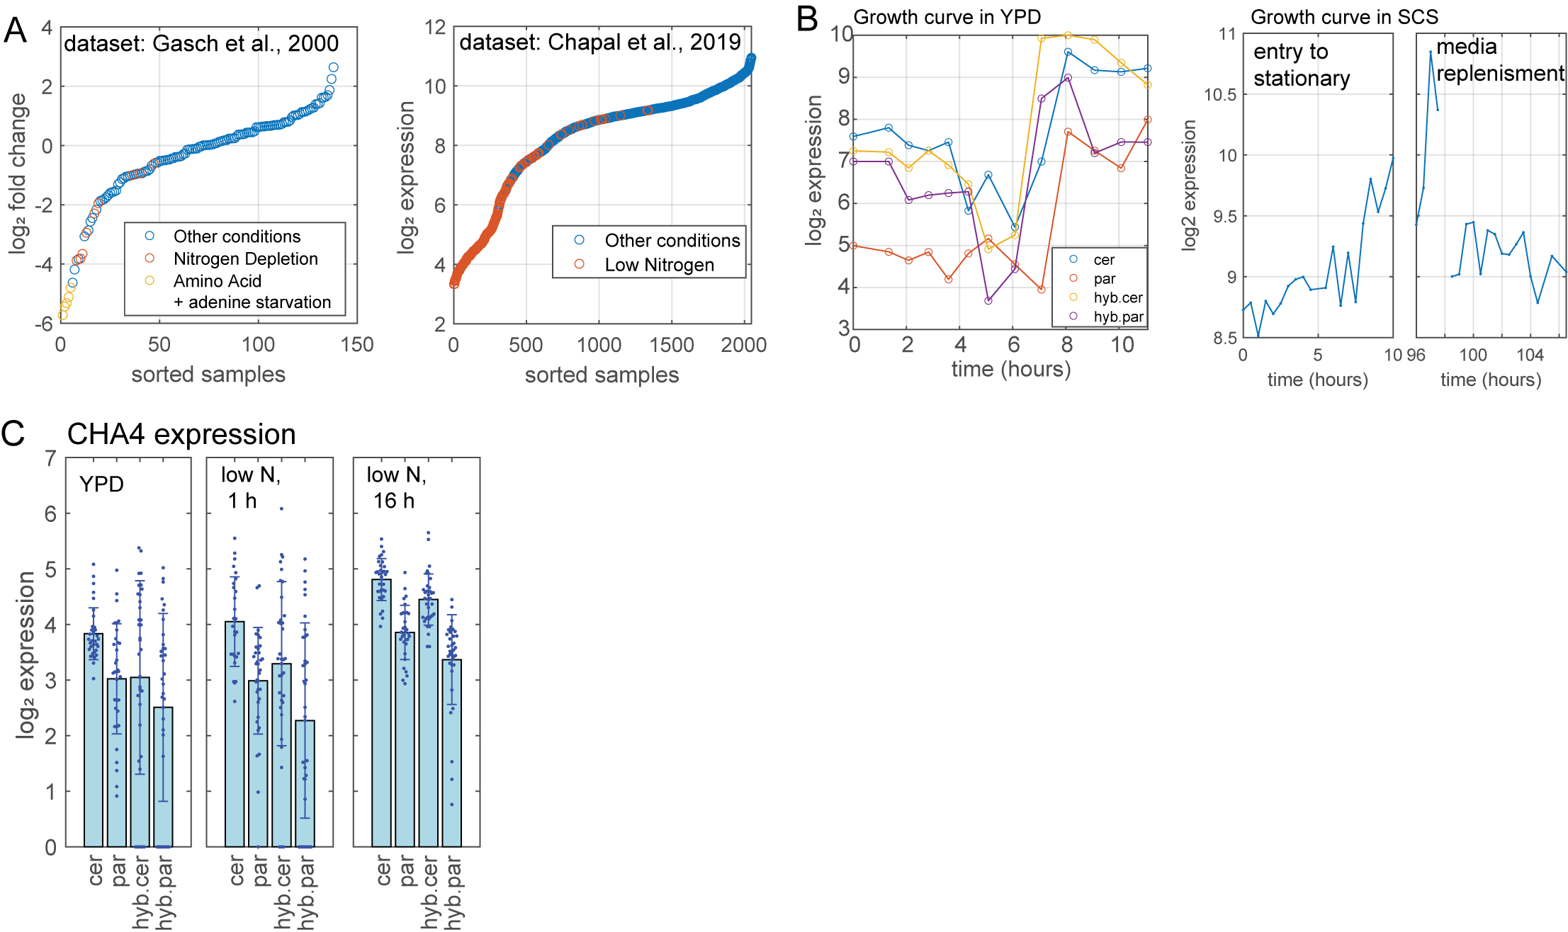
Supplemental Figure S6. Expression of CHA1 and CHA4 in different conditions. (A) CHA1 is down-regulated upon nitrogen depletion: shown is the expression of CHA1 in datasets of experiments in various stresses: Gasch et al., 2000, left, Chapal et al., 2019, right. Samples collected in nitrogen or amino acid depletion are color-coded. (B) CHA1 is up-regulated in stationary phase: expression of CHA1 along the growth curve experiment in YPD, the different genetic backgrounds are indicated (left). Expression of CHA1 in entry and exit from stationary phase in synthetic complete (SC) + glucose media (Chapal et al. 2019) (right). (C) Expression of CHA4, the TF activating CHA1, is lower in S. paradoxus: shown are expression levels from WT cells in the indicated conditions.

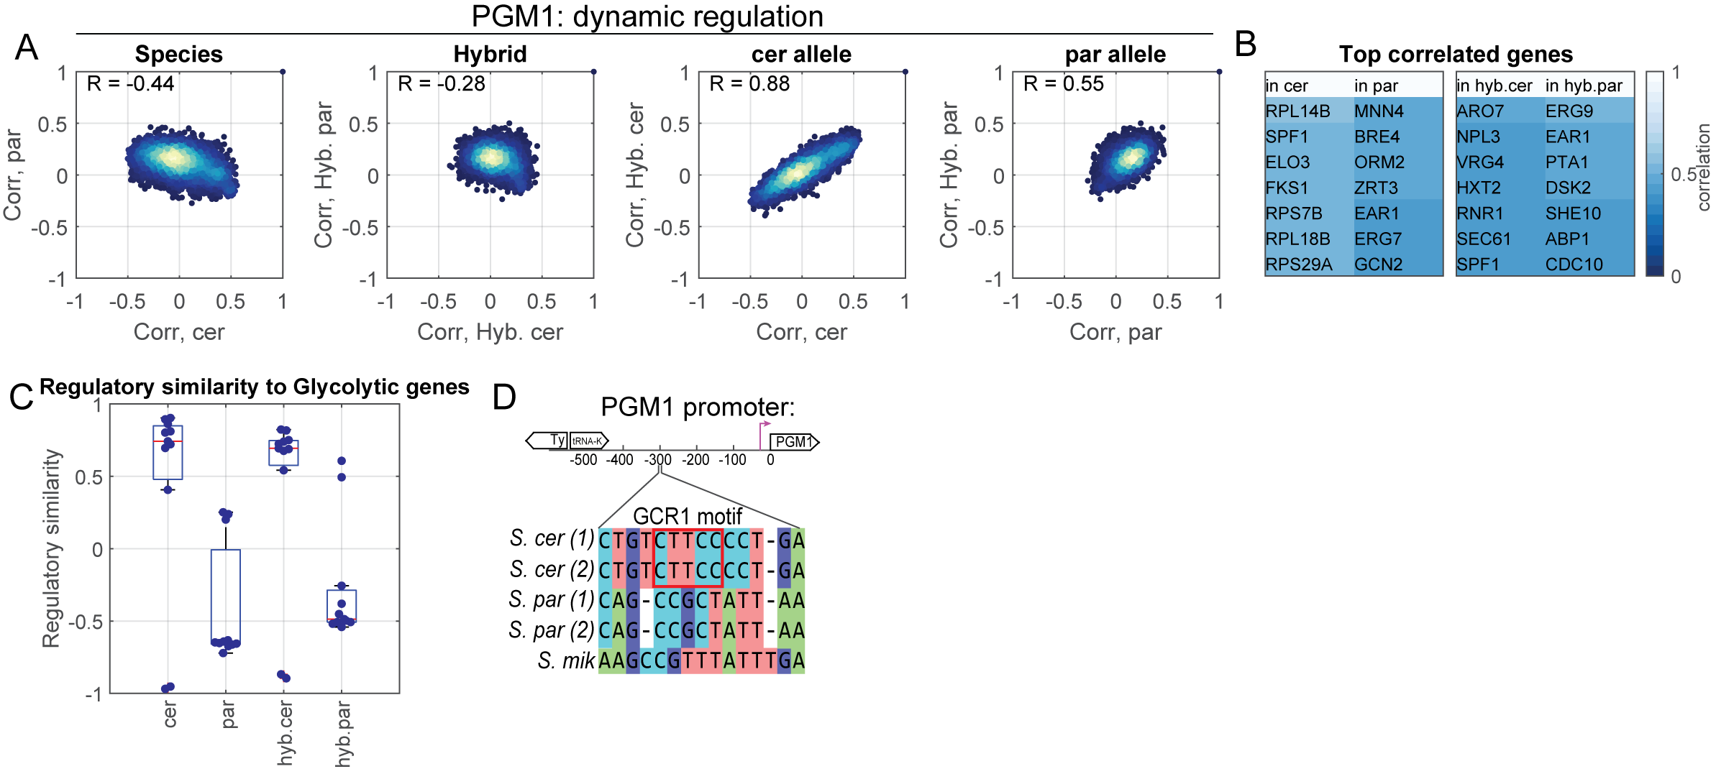
Supplemental Figure S7. PGM1 shows differential dynamic regulation in cis. (A) Scatters of co-expression vectors of PGM1 with all the genes in the genome, of the indicated comparisons, similarly to Fig. 5A. (B) Genes mostly correlated with PGM1 in each genetic background. (C) Regulatory similarity of PGM1 with glycolytic genes, shown for each genetic background. Glycolytic genes were defined as the top ten genes co-expressed with TDH3 in the SPELL (Hibbs et al. 2007) dataset: TDH3, TDH2, ENO2, TDH1, ENO1, CCW12, FBA1, PGK1, CDC19, TPI1, ADH1. (D) S. cerevisiae PGM1 promoter containing a GCR1 motif, and its comparison with the promoters of the indicated strains and species: two S. cerevisiae strains (S288c, SK1), two S. paradoxus strains (CBS432, N44) and S. mikatae. We chose to present sequences of only three species for the alignment of PGM1 promoter, because distant species present diverged sequence where multiple sequence alignment involved many gap openings.

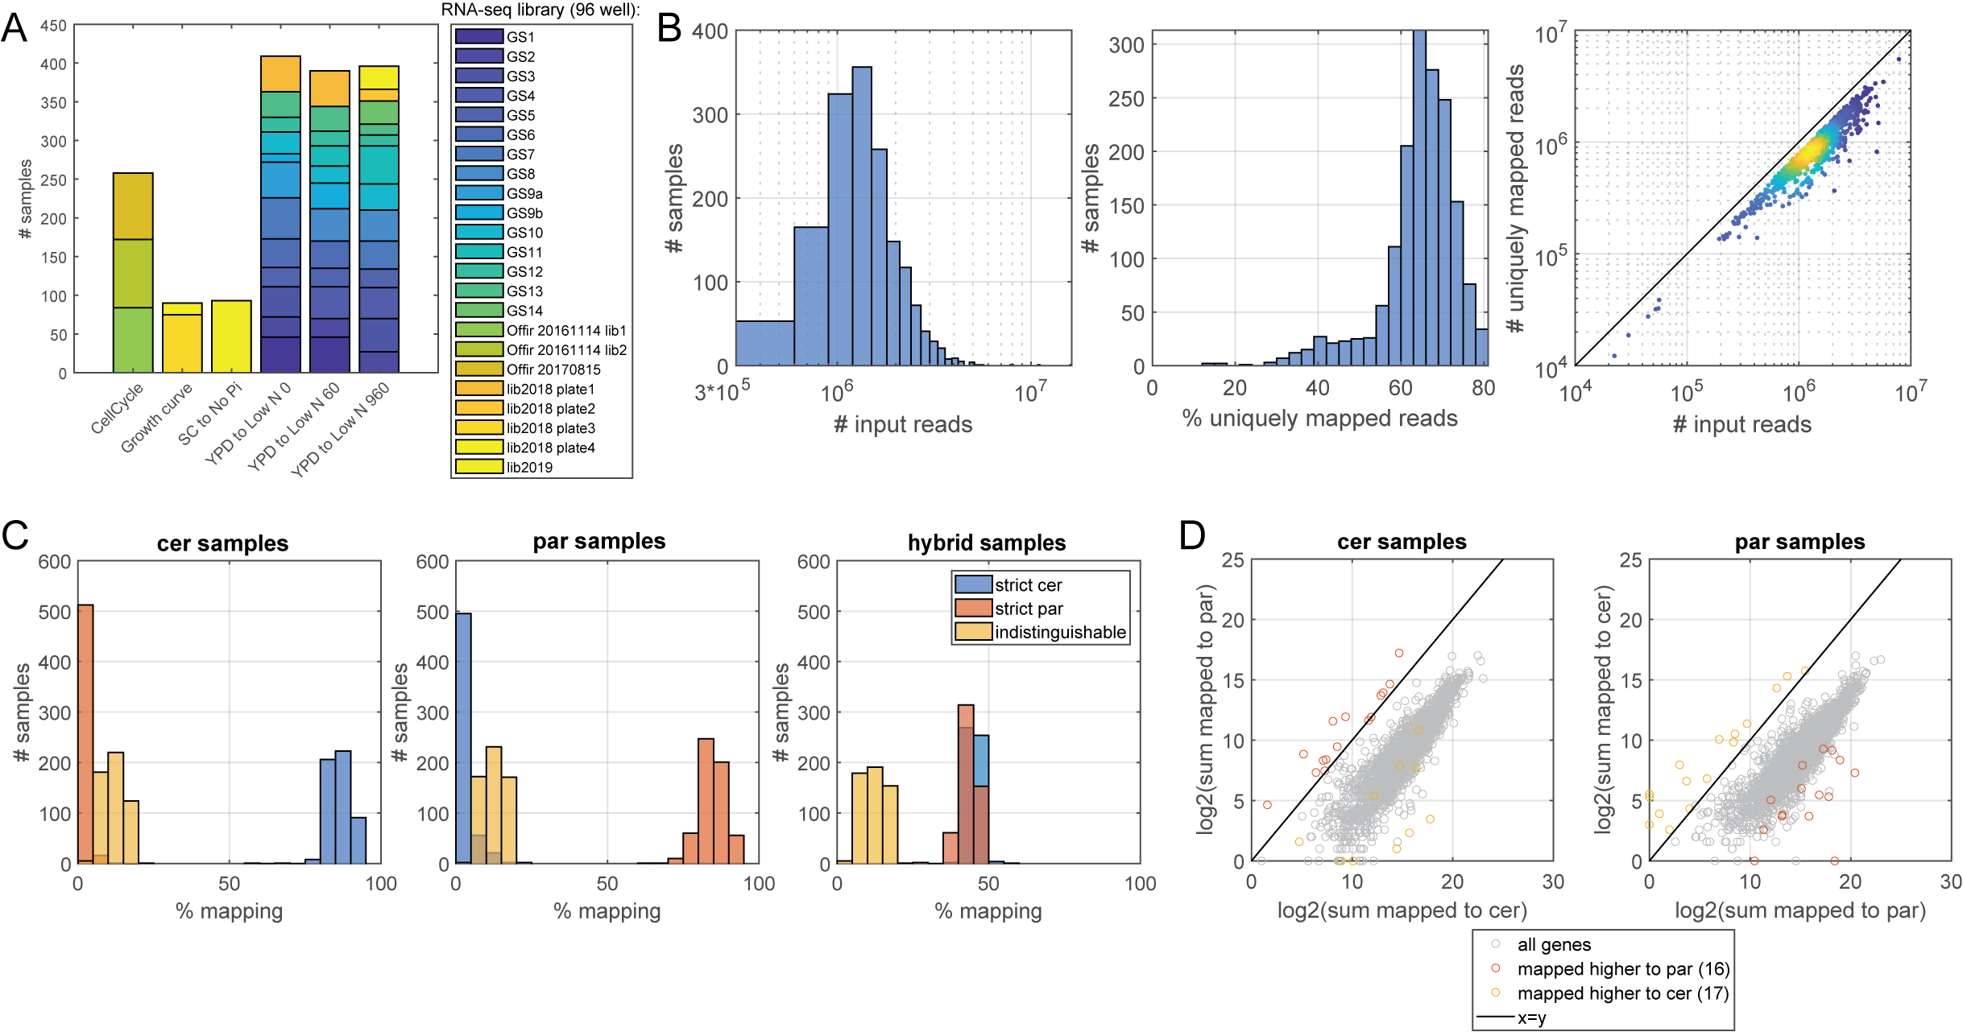
Supplemental Figure S8. Quality control of RNA-seq data. (A) RNA-seq libraries per experiment: the plot depicts which of the 23 libraries was prepared for which of the six experiments. Note that the libraries of the “YPD to low N” experiment are distributed across the three time points. (B) Read mapping quality: left: the number of input reads per sample. Middle: percent uniquely mapped reads per sample. Right: Number of uniquely mapped reads as function of the number of input reads, each dot resembles a sample. (C) Mapping per genome: The reads were mapped to the concatenated genome of the two species. The percent of reads mapped to the S. cerevisiae genome (blue), to the S. paradoxus genome (red) or indistinguishable between genomes (yellow) are plotted. (D) Erroneous mapping: erroneous mapping occurs when reads of species ‘A’ are mapped to species ‘B’ in higher rate than these are mapped to species ‘A’. Plotted here are the log₂-transformed sum of reads mapped to each genome, in S. cerevisiae samples (left) and in S. paradoxus samples (right). Erroneously-mapped genes are marked in color.

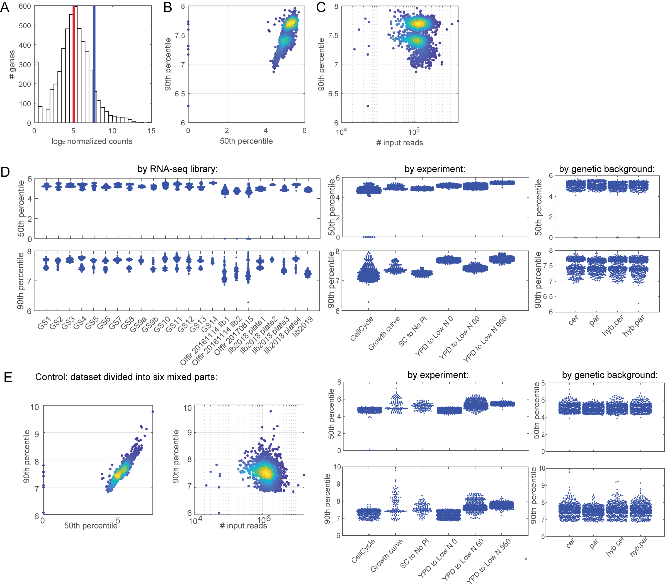
Supplemental Figure S9. Dynamic range per sample. (A) Count distribution in a single sample: Histogram of log₂-transformed, normalized counts. The 50th and the 90th percentiles are indicated in red and blue line, respectively. (B) Dynamic range varies in one order of magnitude between samples: shown are the 50th and the 90th percentiles per sample. (C) Dynamic range is not dependent on the number of input reads. (D) Dynamic range is dependent on the experiment: Shown are bee-swarm plots of the 50th and the 90th percentiles in each sample, separated by the RNA-seq library (left), by experiment (middle) and by the genetic background (right). The different experiments show an order of magnitude difference in the 90th percentile of normalized counts. (E) Control for the experiment dependency: we run DESeq on six mixed subsets of the data (that mix between experiments) to check if the dependency of dynamic range on the experiment type is an artifact. Also here, differences in dynamic range are apparent between experiments, specifically in the 90th percentile, with more that an order of magnitude between experiments. Outliers were more apparent in this design.

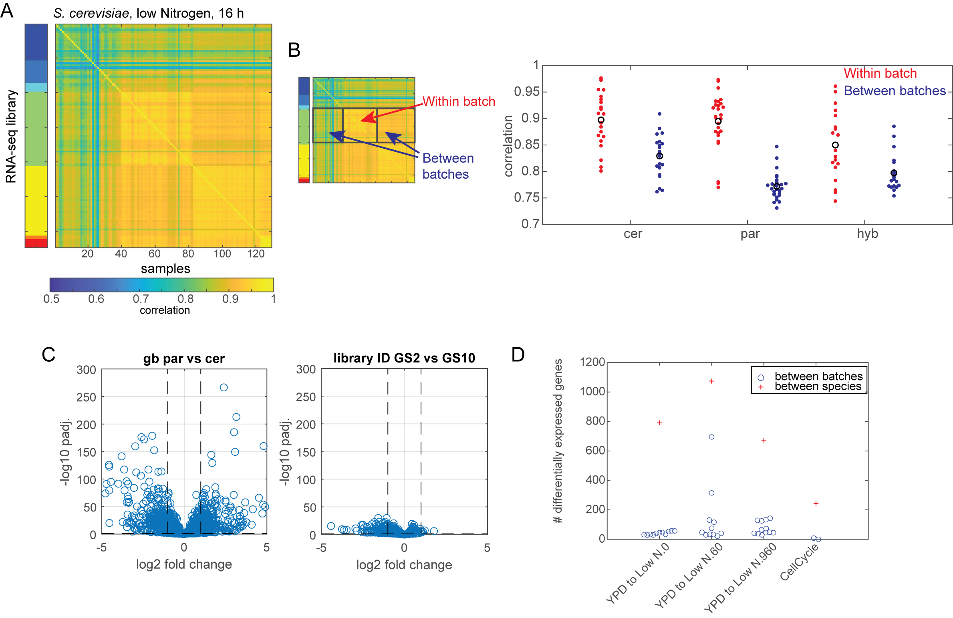
Supplemental Figure S10. Quantification of batch effects. (A) Correlation between samples reveal batch effects: shown are correlation between samples over all expressed genes, for S. cerevisiae samples of YPD_to_Low_N.960 time point. The matrix is ordered by the different RNA-seq libraries (batches). The different batches are color-coded on the left. (B) The correlation within batches is higher than the correlation between batches: shown is the mean correlation within batches and the mean correlation between batches, per genetic background. Black circle represents the mean correlation coefficient. (C-D) Species-effect is stronger than batch-effect on differential expression: Volcano plots of DESeq analysis for differential expression between species (right) and between batches (left), in the YPD_to_Low_N.960 time point (C). The number of differentially expressed genes between batches and between species, in four experiments, is plotted in D.

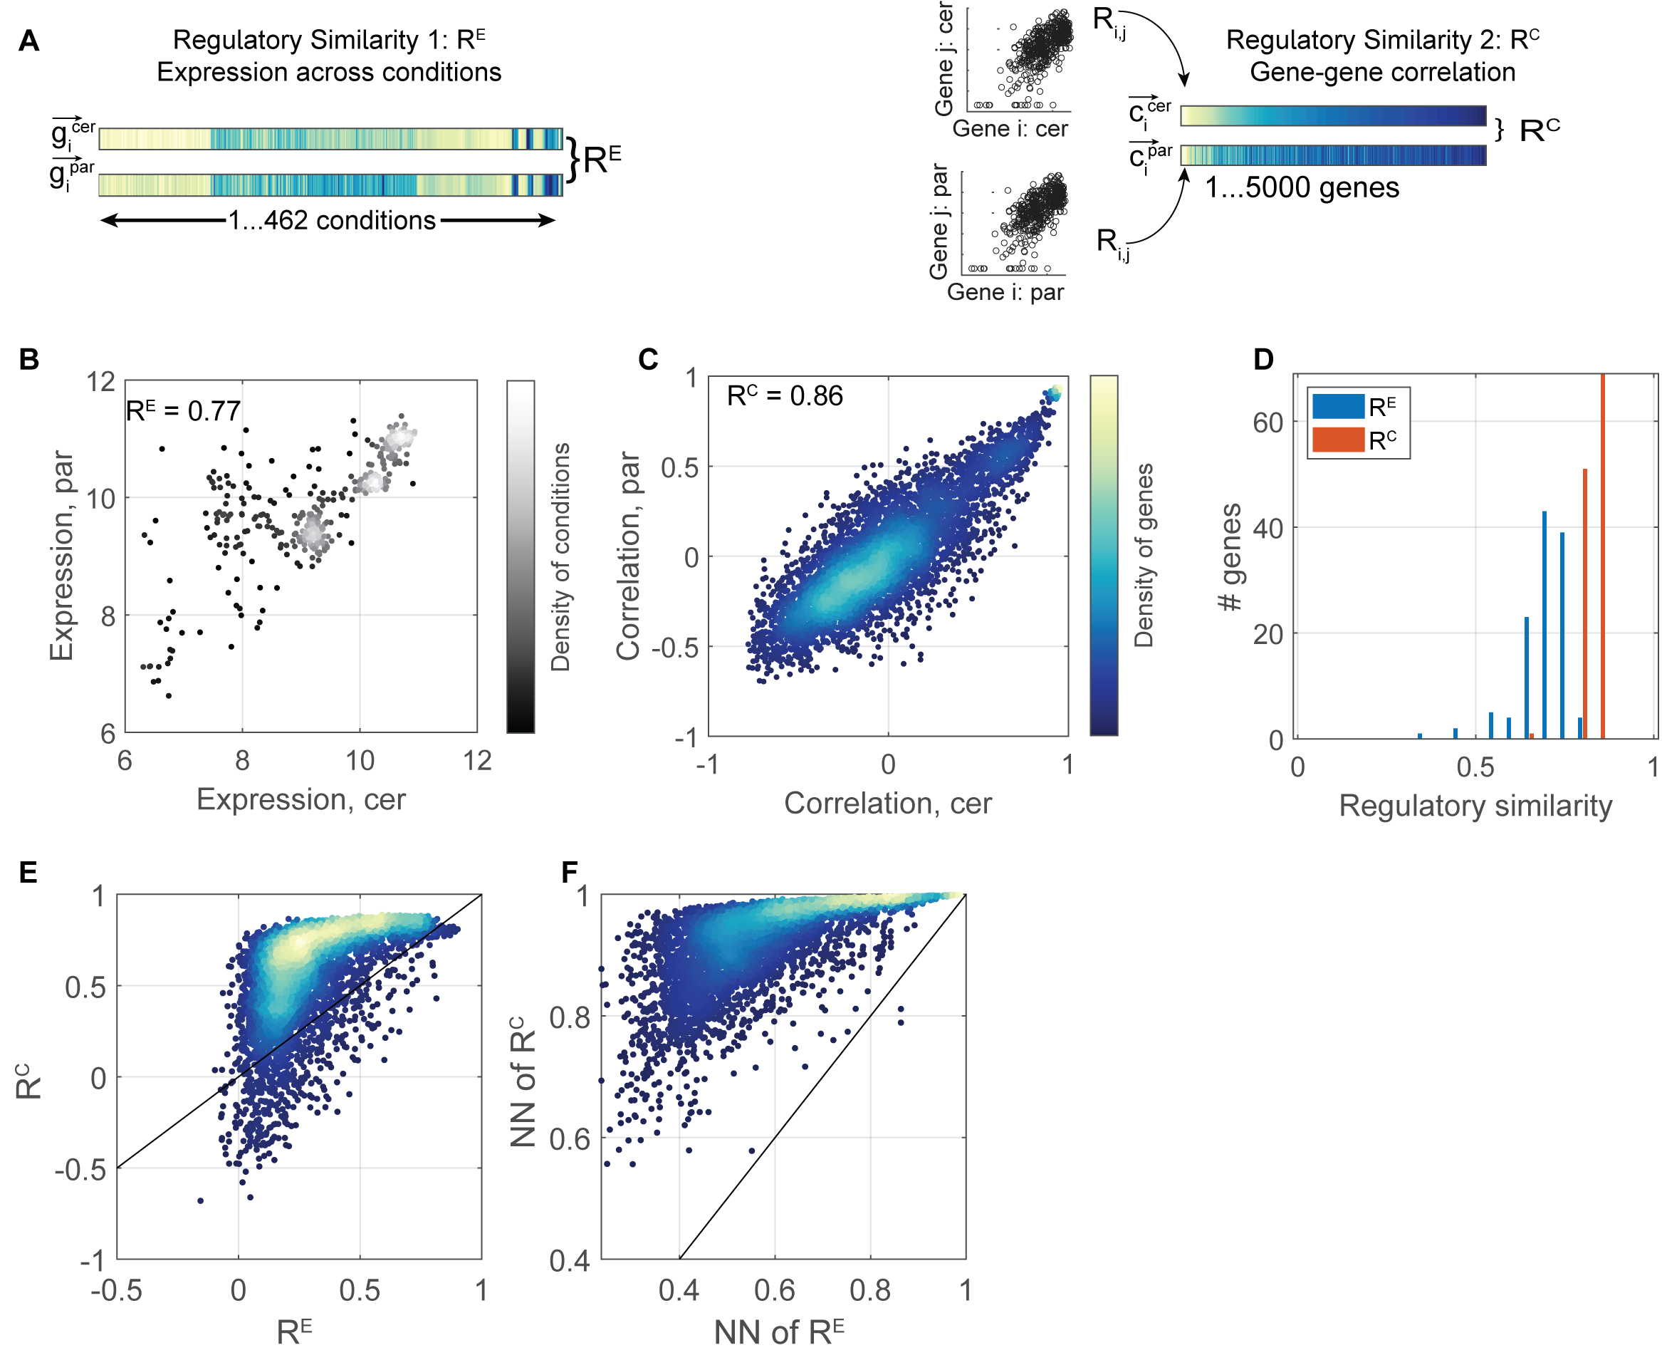
Supplemental Figure S11. Comparison of measures for regulatory similarity. (A) Measures for regulatory similarity: Regulatory similarity can be measured by directly correlating expression of orthologous genes over the set of measured conditions (R^{E}, left) or by correlating the pattern of co-expression with all other genes in the genome (R^{C}, right). R^{C} is discussed in the main text of the article. (B-D) Regulatory similarity of ribosome-coding genes: Shown is the median (log₂-transformed) expression of 152 ribosome-coding genes in S. cerevisiae and S. paradoxus at each tested condition (B) and the co-expression of this median with every gene in the genome (C). Note that both measure suggest high similarity scores. The distribution of regulatory similarities assigned to individual orthologues is shown in (D). (E-F) Correlation-based regulatory similarities (R^{C}) are higher and more tightly distributed compared to expression-based similarities (R^{E}): shown are the respective similarity scores for all orthologous (E). The nearest neighbors (NN) show the same behavior. NNs were defined as the pairs of genes with the most similar expression vector (for R^{E}), or most similar co-expression vector (for R^{C}).

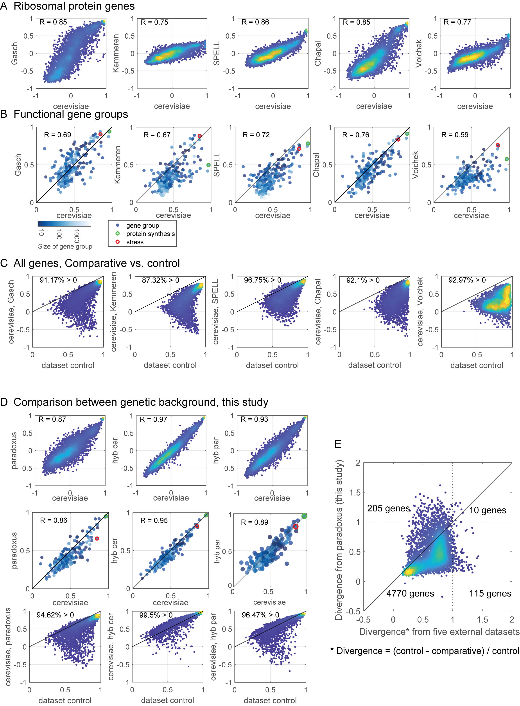

Supplemental Figure S12. Consistency of gene-gene correlation across datasets. (A) Regulatory similarity of ribosomal protein genes: the median co-expression vector of 152 ribosomal protein genes was extracted for each dataset (y-axis) and compared with S. cerevisiae dataset from this study (x-axis). (B) Consistency of functional gene groups: functional gene groups include biochemical pathways and expression modules were considered (255 groups, see Methods), where the mean correlation between genes in the group is presented, per dataset. (C) Regulatory similarity of all expressed genes: shown are the comparative R^{C} and control R^{C} of each dataset compared with S. cerevisiae dataset from this study. The percentage of genes with comparative R^{C} > 0 (y > 0) is indicated in each plot. 3998 genes, that appear in all datasets, are plotted in each graph. (D) Regulatory similarities within our dataset: plots as in A-C, comparison of S. cerevisiae to S. paradoxus and to each of the hybrid alleles. (E) Higher number of genes diverge between species than between datasets: To measure difference in regulatory patterns per gene between datasets we considered the dataset control. We normalize the similarity between two datasets (comparative R^{C}) to the mean dataset control R^{C}, a measure which we term divergence. Shown is the mean divergence score of S. cerevisiae dataset in this study from five external dataset, compared with the divergence score of S. cerevisiae from S. paradoxus (in this study). The number of genes in each quarter are indicated: the number of genes that diverge between species is larger than the number of genes that diverge between datasets of S. cerevisiae (215 genes and 125 genes, respectively).

Supplemental note 1: Quality control of RNA-seq data
Details of our expression dataset
We performed four types of time course experiments as follows: (1) Transition from YPD to low Nitrogen: we profiled yeast cultures grown to logarithmic phase for six hours in YPD, washed the cells and transferred them to low nitrogen medium, then sampled the cultures at times of one hour and 16 hours following the transition. (2) Cell Cycle time course: we arrested cells at mid-S phase using hyrdoxyurea (HU), released them from the arrest and profiled them at five minutes time intervals for three hours, during which they underwent two full cell cycles. (3) Growth curve: we profiled cells at 15 time points along the growth curve, covering logarithmic growth and entry into stationary phase. (4) Transfer to phosphate-depleted media: we transferred cells to phosphate-depleted medium and profiled them before transition and every 15 minutes following the transfer for a total of six hours. The first experimental setup was applied for wild-type cells and to the full set of 46 mutants deleted of individual transcription factors. The second experimental setup was applied to wild-type cells only. The third applied to wild-type (WT) cells and cells deleted of the Hap4 transcription factor, and the fourth to WT cells. Two time points of the fourth experiment were repeated for WT strains and for strains deleted of the Pho4 transcription factor. The full dataset comprises of 1636 samples. Of these, 530 are of S. cerevisiae, 576 are of S. paradoxus and 530 are of the hybrid. These experiments were performed in 23 barcoded RNA-seq pooled-libraries. The Tagmentation reaction (Tn5) was applied on each of the 23 libraries separately. The number of samples in the libraries varied between 30-96 and is plotted in Supplemental Fig. S8A.
Number of replicates
The number of biological replicates differs between the experiments as detailed in Supplemental Table S3 and described in the following:
- Transition from YPD to low Nitrogen: As described above, this experimental setup included three time points and was applied to wild-type and mutant cells. Wild-type cells were profiled in 27-35 repeats per time points, while each of the 46 mutant strains was profiled at 3-5 replicates.
- Cell Cycle time course: Two independent biological repeats
- Growth curve: one repeat for wild-type cells, one repeat for hap4Δ cells
- Transfer to low phosphate media: One repeat of the full time course experiment. two time points of the experiment were repeated for WT and for pho4Δ cells.
Number of input reads
Supplemental Table S4 summarizes the coverage per each sample and related mapping statistics. On average, we obtained 3 million reads per library, and 47 reads per gene. Only samples with total number of reads >150,000 were included in the analysis. Coverage was calculated only for uniquely aligned reads, which consisted of 64% of reads (Supplemental Fig. S8B). Full mapping statistics are available in Supplemental Table S4.
Mapping to a hybrid genome
All reads were mapped to the concatenated genomes of S. cerevisiae S288c and S. paradoxus CBS432 (Yue et al. 2017) as described in Methods. We decided to apply this approach following our initial analysis in which we used the more common approach of aligning to each genome individually. In this initial analysis, we encountered several biases, which were solved by shifting to co-mapping to the two genomes. Specifically, simultaneous mapping more easily detected cases in which a read can be mapped to the two genomes with equal probabilities, as well as cases where S. cerevisiae read is mapped erroneously to the S. paradoxus genome. Indeed, for the parental samples, 84-86% of the reads were mapped to the correct genome, 1-3 % were mapped to the wrong genome and 12-12.5% were indistinguishable between genomes on average (Supplemental Fig. S8C). For the hybrid samples, 43 % of the reads were mapped to S. paradoxus genome on average, 45 % to the S. cerevisiae genome and 12% indistinguishable.
Each gene has some probability of being mapped to the wrong genome. To define this probability of erroneous mapping, we mapped each of the parental samples to the combined genomes, and asked, for each, what fraction of reads were identified as coming from the other genome (Supplemental Fig. S8D). Overall, we estimate that this probability of erroneous mapping is 3% per gene. This estimate was defined based on highly expressed genes, which received a large number of reads. Specifically, of the genes that received a total of 2^20 reads in e.g. S. cerevisiae, 2^15 reads were erroneously mapped to the S. paradoxus genome. Only 33 genes were better mapped to the erroneous genome, and these were removed from the analysis and are listed in Supplemental Table S5. In addition, out of 6650 genes, 33 genes were not detected in S. cerevisiae but were detected in S. paradoxus, while 120 genes were detected in S. paradoxus but not in S. cerevisiae (Supplemental Table S5).
Dynamic range
Raw read counts were normalized and analyzed for differential expression via DESeq2. The six subsets of the data were each run on DESeq separately (defined by the four experiments, where the YPD to low N experiment is divided into three time points). An example for the result normalized counts (‘normTransform’, log2(n+1)) is presented in Supplemental Fig. S9A. To measure the dynamic range of gene expression, we considered the 50th and the 90th percentile of the normalized counts. The percentiles are correlated and vary in less than two orders of magnitude (50th percentile) and one order of magnitude (90th percentile) between the samples, not including few outliers (Supplemental Fig. S9B). The number of input reads is not correlated with the dynamic range (Supplemental Fig. S9C). To check what affects the difference in dynamic range between samples, we plotted the 50th and 90th percentiles per sample, separated by the RNA-seq library, the experiment and the genetic background (Supplemental Fig. S9D, here genetic background is referred to: S. cerevisiae, S. paradoxus, hybrid-cerevisiae and hybrid-paradoxus). We noted there is a difference in dynamic range between experiments, but there is no such difference between genetic backgrounds, which is the level of comparison we examine in the study. We reasoned that the difference in dynamic range between experiment might be an artifact because we ran DESeq on each experiment separately. To control for that, we run DESeq again on six random parts of the data that contain exactly the same number of samples per genetic background. We observed the same correlation between 50th and 90th percentiles (Supplemental Fig. S9E). The 90th percentiles varied between samples more than before (two orders of magnitude) and still varied significantly between experiments, although not in the same direction as in the first run. Dynamic range was not affected, in large, by the genetic background also in this run. We therefore used the normalized dataset obtained from the first run, as the differences in dynamic range between experiments are prominent even with a mixed design.
Batch effects
Possible effects of library preparation (batch effects) were analyzed by measuring the correlation between samples. For this, we focused on a subset of our samples which included many repeats of the same biological experiments (transition from YPD to low nitrogen) and therefore allowed direct comparison. First, we measured correlations in gene expression (Supplemental Fig. S10A, B). If batch effects dominates, samples handled together should show higher correlation as compared to samples handled in different batches. We find that the correlation between batches is generally high. We find only small differences when comparing the within or between batch correlations (R = 0.89, 0.89, 0.84 within batch for S. cerevisiae, S. paradoxus and hybrid respectively, compared to R= 0.82, 0.72, 0.79 between batches, p-values for two-sampled t-test of within batches vs. between batches: 2e-5, 5e-15, 3e-3).
Second, as an additional measure of batch effect, we calculated the number of genes that were estimated as differentially expressed between the batches and compared it to the number of genes predicted as differentially expressed between the species (using all batches) under the same criteria. To this end, we run DESeq2 with the design: ~ library_ID + gb, where library_ID stands for the different libraries and gb stands for the genetic background. We noted that different batches showed some differential expression (50-100 genes with log₂ fold change > 1 and adjusted p-value < 0.05) that was minor relative to the difference between species (600-1000 genes that pass these thresholds, Supplemental Fig. S10C,D). We also noted some outliers, where two batches resulted in 300 and 600 differentially expressed genes in YPD_to_Low_N.60, however between-species comparison in this time point results in >1000 differentially expressed genes. The cell cycle experiment was performed in only three batches, therefore including the batch effect in the DESeq model resulted in less differentially expressed genes between species (200, Supplemental Fig. S10D), compared to a model that doesn’t include the batch effect (600, Supplemental Fig. S1A). Also here, the different batches showed only few (0, 8) differentially expressed genes. Genes that appeared as differentially expressed between batches, in ten or more batch comparison (out of 36 batch comparisons) were filtered out of the differential expression analysis in Figure 1 but not from the co-expression analysis. This gene list contains 25 batch-affected genes: NTG1, BAP2, MET8, ATG12, AGP1, RVS161, TUP1, ALT2, CYC7, ECM32, HXK1, HOS2, MEP1, GND2, DAL3, ARG3, GAP1, ECM4, RPS28B, SPH1, ADI1, DDR48, NCE103, HES1, YBR085C-A. This list includes many nitrogen-responding genes, as expected for the tested conditions.

Supplemental note 2: A complementary approach for measuring regulatory similarity: direct correlation of orthologue expression across conditions
To compare expression dynamics between the two species, we considered two measures of regulatory similarity. First, we directly compared expression of orthologues across all conditions (referred as comparable samples). This was enabled by our dataset which profiled the two species under the same set of conditions (R^{E}, Supplemental Fig. S11A, left). This measure of similarity is sensitive not only to differences in transcriptional regulation, but also to differences in environmental perception or signaling processes acting upstream of the transcriptional network. Second, we compared the pattern at which each orthologue is co-expressed with all other genes in the genome (R^{C}, Supplemental Fig. S11A, right). This measure is further discussed in the article and is defined in the main text and in Figure 2.
To compare these two measures of similarity, we first considered the ribosomal protein-coding genes, which both species co-induce during rapid growth. The median expression of this group received high similarity score by both measures (Supplemental Fig. S11B,C), although co-expression similarity was somewhat higher (0.86 vs. 0.77). A clear difference between the two measures, however, appeared when comparing individual genes: expression-based similarities (R^{E}) were widespread and often low, while correlation-based ones (R^{C}) were consistently high (Supplemental Fig. S11D).
Extending the analysis to all orthologues, we find expression-based similarities (R^{E}) are relatively low and widespread while correlation-based ones (R^{C}) are significantly higher and tightly distributed (Supplemental Fig. S11E). As a control, we applied these same measures to define similarities within each individual species. We considered a nearest-neighbor (NN) control, namely pairs of genes with the most similar expression vector (for R^{E}), or most similar co-expression vector (for R^{C}). Also here, correlation-based NN similarities (R^{C}) were higher and more tightly distributed compared to expression-based ones (R^{E}) (Supplemental Fig. S11F).

Supplemental note 3: Consistency of gene-gene correlation across datasets
We wanted to test if the co-expression patterns obtained from our dataset represent the typical regulatory dynamics of S. cerevisiae. Therefore, we applied the R^{C} measure on six external gene expression datasets, listed in Table 1 below. The techniques used in these datasets are different: three of the datasets were generated via microarray, the other two were generated via RNA-sequencing. We are aware that the data obtained by these methods, in particular the dynamic range, is different, yet regulatory similarity comparison is meaningful. We chose benchmark datasets that profiled the environmental stress response (Gasch et al. 2000) and genetic perturbations (Kemmeren et al. 2014). The SPELL database encompasses a wide range of studies and is the default co-expression database in yeast (Hibbs et al. 2007). The other two datasets were generated in our laboratory in two different RNA-seq methods, and applied different environmental stresses (Chapal et al. 2019) and replication stress (Voichek et al. 2018).
Taking the ribosomal genes as an example, we observe different ranges of co-expression vectors but high R^{C} scores between the S. cerevisiae dataset from this study and the external S. cerevisiae datasets (R^{C} = 0.75 – 0.86, Supplemental Fig. S12A). We next wanted to evaluate how consistent is the co-expression of functional gene groups (such as biochemical pathways and expression modules), in our dataset compared with external datasets. The motivation here was to make sure we did not miss any important biological process that is dependent on the measured conditions. We see that the consistency of co-expression in 255 gene groups is highly similar between datasets (Supplemental Fig. S12B), where in most of the cases our dataset resulted in more consistent gene groups.
On the resolution of all expressed genes, co-expression vectors of our dataset tend to agree with these of external datasets, where regulatory similarities scores where positive for most of the genes (Supplemental Fig. S12C, the percentage of genes with y > 0 is indicated). In all the abovementioned measures, our S. cerevisiae dataset was more similar to our datasets of S. paradoxus and hybrid, than to external datasets (Supplemental Fig. S12D). Therefore, to assess true divergence in dynamic regulation, that is species-dependent and not dataset-dependent, we combined both measures of comparative and control R^{C} in the form: Divergence = (control - comparative)/control. This measure takes into account genes with low control scores, that often show low comparative score, so these will result in low divergence score. On the other hand, genes with positive-low or negative comparative score, and high control score will result in high divergence score. In these terms, our S. cerevisiae dataset is similar to the five external datasets, where only 125 genes got divergence score > 1 (Supplemental Fig. S12E). Our S. paradoxus dataset resulted in 215 genes with divergence score > 1. In this sense, our S. cerevisiae dataset is more similar to external S. cerevisiae datasets than to our S. paradoxus dataset, and genes that diverge in dynamic regulation between species are detectable.

Table 1: list of datasets compared in Supplemental Figure S12
dataset name | publication | method | number of samples
Gasch | Gasch et al., 2000 | microarray | 134
Kemmeren | Kemmeren et al., 2014 | microarray | 1487
SPELL | Hibbs et al., 2007 | microarray | 7175
Chapal | Chapal et al., 2019 | RNAseq | 2089
Voichek | Voichek et al., 2018 | RNAseq | 838
cerevisiae | this study | RNAseq | 530
paradoxus | this study | RNAseq | 576
hyb cer | this study | RNAseq | 530
hyb par | this study | RNAseq | 530

Supplemental references:
Chapal M, Mintzer S, Brodsky S, Carmi M, Barkai N. 2019. Resolving noise-control conflict by gene duplication. PLoS Biol 17: e3000289.
Fraser HB. 2019. Improving Estimates of Compensatory cis–trans Regulatory Divergence. Trends Genet 35: 3–5.
Gasch a P, Spellman PT, Kao CM, Carmel-Harel O, Eisen MB, Storz G, Botstein D, Brown PO. 2000. Genomic expression programs in the response of yeast cells to environmental changes. Mol Biol Cell 11: 4241–57.
Hibbs MA, Hess DC, Myers CL, Huttenhower C, Li K, Troyanskaya OG. 2007. Exploring the functional landscape of gene expression: directed search of large microarray compendia. Bioinformatics 23: 2692–2699.
Ihmels J, Friedlander G, Bergmann S, Sarig O, Ziv Y, Barkai N. 2002. Revealing modular organization in the yeast transcriptional network. Nat Genet 31: 370–377.
Kemmeren P, Sameith K, Van De Pasch LAL, Benschop JJ, Lenstra TL, Margaritis T, O’Duibhir E, Apweiler E, Van Wageningen S, Ko CW, et al. 2014. Large-scale genetic perturbations reveal regulatory networks and an abundance of gene-specific repressors. Cell 157: 740–752.
Voichek Y, Mittelman K, Gordon Y, Bar-Ziv R, Smit DL, Shenhav R, Barkai N. 2018. Epigenetic Control of Expression Homeostasis during Replication Is Stabilized by the Replication Checkpoint. Mol Cell 70: 1121–1133.
Yue J-X, Li J, Aigrain L, Hallin J, Persson K, Oliver K, Bergström A, Coupland P, Warringer J, Lagomarsino MC, et al. 2017. Contrasting evolutionary genome dynamics between domesticated and wild yeasts. Nat Genet 49: 913–924.

Supplemental Tables description:
Table | Description
Supplemental Table S1 | list of transcription factors deleted in the study
Supplemental Table S2 | list of strains used in the study
Supplemental Table S3 | Detailed description for every sample (summerizedExperiment for DESeq)
Supplemental Table S4 | Read alignment statistics
Supplemental Table S5 | list of genes that are not covered by RNAseq reads in either one of the species, or that mapping is biased
Supplemental Table S6 | results of differential expression analysis via DESeq for the six experiments
Supplemental Table S7 | results of R^{C}, comparative and control measures
Supplemental Table S8 | list of trans-diverging genes
Supplemental Table S9 | list of cis-diverging genes
Supplemental Table S10 | counts table: counts combined *
Supplemental Table S11 | counts table: counts strict cer *
Supplemental Table S12 | counts table: counts strict par *

* Tables S10 – S12 are output of the initial read mapping pipeline (Methods). These tables include the number of reads aligned to each gene, in each sample. Uniquely mapped reads were assigned to the orthologue with the better alignment score. ‘Counts strict cer’ contains counts of reads uniquely mapped to S. cerevisiae genome, ‘counts strict par’ contains counts of reads uniquely mapped to S. paradoxus genome and ‘counts combined’ contains a summation of all the reads: mapped to S. cerevisiae, mapped to S. paradoxus and reads that are indistinguishable between genomes.

