Supplemental Figure S1

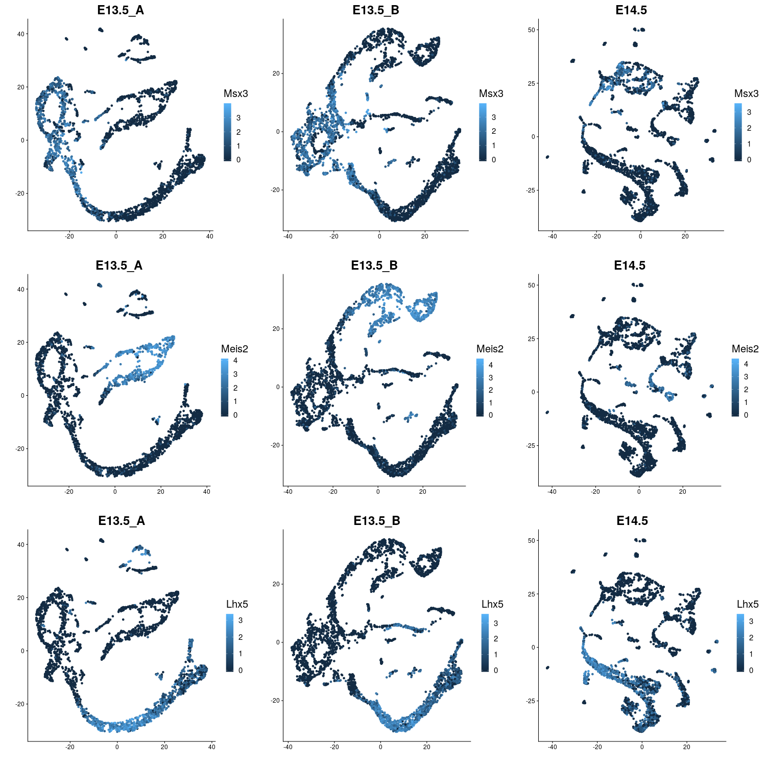
Supplemental Figure S1. Markers used to identify lineages in developing murine cerebellum. Expression of three marker genes was used to identify GABAergic (Lhx5, bottom row) and glutamatergic (Meis2, middle row) lineages as well as early progenitor cells (Msx3, top row).

