Supplemental Material

Global fitness landscapes of the Shine-Dalgarno sequence

Syue-Ting Kuo, Yuan-Ju Cheng, Ruey-Lin Jahn, Yi-Lan Chen, Yun-Ju Lee, Florian Hollfelder, Jin-Der Wen, Hsin-Hung David Chou*

*Corresponding author. Email: chouhh@ntu.edu.tw

This PDF file includes:

Supplemental Methods
Supplemental Text
Supplemental Figures S1 to S32
Supplemental Tables S1 to S4
Captions for Supplemental Files S1 to S6

Other Supplemental Material for this manuscript include the following:

Supplemental File S1. Quality and quantity of fluorescence-activated cell sorting and
deep sequencing.
Supplemental File S2. Fitness of SD genotypes in FL_{fepB}.
Supplemental File S3. Fitness of SD genotypes in FL_{arti}.
Supplemental File S4. Fitness of SD genotypes in FL_{dmsC}.
Supplemental File S5. Fitness of SD genotypes in FL_{arti-Y}.
Supplemental File S6. Scripts for data analysis.

Supplemental Methods

Growth media
Luria-Bertani (LB) broth consisted of 10 g of NaCl (Fisher Scientific), 10 g of tryptone (Becton Dickinson) and 5 g of yeast extract (Becton Dickinson) in one liter of deionized water. LBK medium, LB broth supplemented with filter-sterilized kanamycin sulfate (50 mg/l, Thermo Fisher Scientific), was used in regular cell culture. LBKG medium, LBK medium supplemented with filter-sterilized glucose (10 g/l, Sigma-Aldrich) to enhance GFP expression, was applied to culturing cells for growth assays and cell sorting.

Plasmid construction
Primers used for inverse PCR were subjected to 5’ phosphorylation by T4 polynucleotide kinase (NEB) prior to PCR reactions. All of the PCR reactions involved in plasmid construction were carried out by Phusion DNA polymerase following the manufacturer’s instruction. Four template plasmids (Supplemental Fig. S1), pYC08, pYC09, pYC20, and pHC199v, for founding the three GFP-based and one YFP-based SD libraries (FL_{fepB}, FL_{arti}, FL_{dmsC} and FL_{arti-Y}, respectively) were built through multiple steps. First, a 3.4-kb fragment of pUA139 containing a kanamycin resistance marker and the pSC101 replication origin was PCR amplified by primer pair UA139r/UA139f and digested by ApaI and SalI (Zaslaver et al. 2006). Part of this product was self-ligated by the T4 DNA ligase to create pHC162s, a plasmid devoid of fluorescent protein reporters; the remaining was ligated with an 1-kb ApaI/SalI digested fragment containing the P_{tacA}-RBS_{fae}-venus-t_{T7} cassette of pHC161v PCR amplified by primer pair MV1/MV2 to generate pHC162v (Chou et al. 2015). The P_{tacA} promoter of pHC162v was then replaced by the proD promoter (P_{proD}) along with a 55-nt mRNA leader sequence designed to insulate upstream translation activity by forming two stable RNA hairpins (Davis et al. 2011). The P_{proD}-leader fragment, produced by annealing primer pair proDf/proDr, was ligated with the 4.4-kb SalI/XbaI digested pHC162v backbone to generate pHC163v. RBS_{fae} on pHC163v was modified by inverse PCR using primer pair WH4f/WH4r. Self-ligation of this PCR product created pHC165v. To raise the plasmid copy number of pHC165v, a nonsynonymous substitution (E93K) was introduced into the repA gene of the pSC101 replication origin by inverse PCR using primer RepA93kf/RepA93r followed by self-ligation to create pHC172v (Peterson and Phillips 2008). To raise the transcription activity, P_{proD} on pHC172v was replaced by the P_{A1} promoter of phage T7 (Brunner and Bujard 1987). The P_{A1} fragment, produced by annealing primer pair PA1f/PA1r, was ligated with the 4.4-kb MluI/AseI digested pHC172v backbone to generate pHC174v1. pHC174v2, a variant of pHC174v1 bearing a mutated P_{A1} promoter (termed P_{A1}^{v2}), was also isolated since it provided sufficient YFP expression without inhibiting cell growth. Relative to P_{A1}, P_{A1}^{v2} promoter showed three-fold reduction in YFP expression due to a spontaneous deletion (∆C) in its spacer region. To insert the 30-nt RBS_{arti} bearing the canonical 9-nt SD sequence (5’-UAAGGAGGU-3’), a 0.9-kb fragment of pHC174v2 was PCR amplified using primer pair VSSR12-SD9/UA66p4, digested by XbaI and XhoI, and ligated with the 3.6-kb XbaI/XhoI digested pHC174v2 backbone, resulting in pHC199v. pHC199v served as the template plasmid of the FL_{arti-Y} SD library. In addition, two pHC199v derivatives, pHC198v and pHC202v, bearing SD of weaker translation efficiencies (5’-AUAGGAGGA -3’ and 5’-AUAGGAGCA -3’) were created by similar procedures except replacing primer VSSR12-SD9 by VSSR12-SD6 and VSSR-SD5, respectively. To replace YFP of pHC199v by GFP_{mut2}, the 0.7-kb gfp_{mut2} gene of pUA139 was PCR amplified using primer pair GFPmut2f/GFPmut2r, digested by XbaI and XhoI, and ligated with the 3.6-kb XbaI/XhoI digested pHC199v backbone to create pHC200. As excessive GFP expression of pHC200 severely inhibited growth of E. coli, several steps were taken to fine-tune its GFP expression. First, its P_{A1}^{v2} promoter was switched back to P_{proD}. This was achieved by ligating a 0.7-kb XbaI/XhoI digested fragment of pHC200 with the 3.6-kb XbaI/XhoI digested pHC172v backbone, resulting in pYC01. To elevate the GC content of the 5’ gfp_{mut2} gene without altering the protein sequence, pYC01 was amplified by inverse PCR using primer pair YC04p1/YC04p2 followed by self-ligation to generate pYC04. pYC05 was generated by ligating a 0.9-kb HindIII/XbaI digested fragment of pYC04 with the 3.5-kb HindIII/XbaI digested pHC172v backbone. pYC06 was constructed by ligating a 1.0-kb BamHI/HindIII digested fragment of pYC04 with the 3.4-kb BamHI/HindIII digested pHC162v backbone. pYC08, the template plasmid of the FL_{arti} SD library, was built by ligating a 0.9-kb BamHI/XhoI digested fragment of pYC05 with the 3.5-kb BamHI/XhoI digested pYC06 backbone. RBS_{arti} on pYC08 was replaced by RBS_{fepB} and RBS_{dmsC} to generate pYC09 and pYC20, the template plasmids of the FL_{fepB} and FL_{dmsC} SD libraries, respectively. These modifications were achieved by inverse PCR to amplify pYC08 using primer pairs YC09p1/YC09p2 and YC12p1/YC12p2 followed by self-ligation. pTK03, pYC08 derivative bearing the reverse aSD sequence (5’-AUUCCUCCA-3’) was constructed by inverse PCR using primer pair TK03p1/YC21p1 followed by self-ligation. pTK03 served as the negative control plasmid of GFP expression as its SD sequence forbade 16S rRNA-mRNA base pairing. pTK05, a FL_{arti} SD genotype used as a spike-in control for cell sorting, was generated by inverse PCR of pYC08 using primer pair TK05p1/YC19p2 followed by self-ligation. pTK06, a FL_{arti-Y} genotype used as a spike-in control for cell sorting, was generated by inverse PCR of pYC08 using primer pair YL13p1/TK06p2 followed by self-ligation. pYC39, pYC40, and pYC41 bearing the nine-guanine SD genotype (5’-GGGGGGGGG-3’) under the RBS_{arti}, RBS_{fepB}, and RBS_{dmsC} contexts, were constructed by inverse PCR of pYC08, pYC20, and pYC09 using primer pairs YC23p1/YC39p1, YC24p1/YC40p1, and YC26p1/YC41p1, respectively, followed by self-ligation. pYC29, pYC31, pTK39, pTK40, pTK41, pTK42, and pTK43 bearing poly(U) SD genotypes in RBS_{fepB}, were constructed by inverse PCR of pYC20 using primer pairs YC24p1/YC29p1, YC30p1/YC29p1, YC24p1/TK39p1, YC24p1/TK40p1, YC24p1/TK41p1, YC24p1/TK42p1, and YC24p1/TK43p1, respectively, followed by self-ligation. pYC38, a FL_{arti} genotype used in quantifying the association between the mRNA level and GFP fluorescence of the FL_{arti} genotypes, was generated by inverse PCR of pYC08 using primer pair YC23p1/YC38p1 followed by self-ligation. pYC28, pYC30, pYC34, pYC36, pYC42, and pYC43, six FL_{fepB} genotypes used in quantifying the mRNA-GFP association, were generated by inverse PCR of pYC20 using primer pairs YC28p1/YC24p1, YC30p1/YC28p1, YC24p1/YC34p1, YC24p1/YC36p1, YC24p1/YC42p1, and YC24p1/YC43p1, respectively, followed by self-ligation. pYC32, pYC33, pYC37, pYC44, pYC45, and pYC46, six FL_{dmsC} genotypes used in quantifying the mRNA-GFP association, were generated by inverse PCR of pYC09 using primer pairs YC26p1/YC32p1, YC26p1/YC33p1, YC26p1/YC37p1, YC26p1/YC44p1, YC26p1/YC45p1, and YC26p1/YC46p1, respectively, followed by self-ligation. DNA sequences in the reporter gene cassettes of the aforementioned plasmids were validated by Sanger sequencing using primer UA66p5.

Measurement of cell growth and GFP/YFP expression
Population growth and GFP/YFP expression of E. coli were monitored by a TECAN Spark 10M plate reader. Each experiment began with the inoculation of 1 μl of frozen stocks into 200 μl LBKG medium and incubated overnight at 37°C and 225 rpm. Subsequently, 1 μl of this preculture was transferred to 200 μl of LBKG medium. For each strain, three replicate cultures were grown inside the plate reader at 37°C and 216 rpm. Their optical densities (OD) at 600 nm, GFP fluorescence (excitation/emission: 488 ± 10 nm / 528 ± 10 nm), or YFP fluorescence (excitation/emission: 495 ± 10 nm / 535 ± 10 nm) were measured every 20 min. Cellular GFP/YFP expression was computed as GFP/YFP fluorescence divided by OD readouts.
Single-cell fluorescence was quantified by a BD FACSJazz cell sorter. Each experiment began with the inoculation of 1 μl of frozen stocks into 2 ml of LBKG media incubated overnight at 37°C and 225 rpm. Next day, 5 μl of this preculture was transferred to 2 ml LBKG medium and incubated under identical conditions. When OD reached 0.55-0.65 at 1 cm path length, 100 μl of this culture was mixed thoroughly with 900 μl of pre-chilled PBS and was stored on ice. For each strain, the cell sorter quantified GFP (excitation/emission: 488 nm / 513 ± 8.5 nm) and YFP fluorescence (excitation/emission: 488 nm / 542 ± 13.5 nm) of 50,000 to 200,000 cells in three replicate cultures.

Single-molecule measurement of the RBS-ribosome binding
The 30S subunit of E. coli MRE600 and RNA constructs containing synthetic RBS were prepared by procedures described previously (Marshall et al. 2008; Chen et al. 2017). Cells were grown to OD 0.55-0.65, pelleted, and stored at -80°C. Cell pellets were lysed in the 10 mM MgCl₂ buffer. The cell lysate was subjected to a 37.7% sucrose cushion and centrifuged at 33,800 rpm for 18 hr to pellet down the 70S ribosomes. The pellet was resuspended in the 1 mM Mg(OAc)₂ buffer to separate the 50S and 30S subunits. RNA constructs were synthesized by the MEGAscript SP6 Transcription Kit (Ambion) and purified by the MEGAclear Kit (Ambion). Two oligonucleotides, 5’ handle (ssDNA) and 3’ handle (ssRNA), were chemically synthesized (Supplemental Table S1). The 5’ handle contained a biotin tag and a Cy5 dye. The 3’ handle contained a Cy3 dye. RNA constructs were annealed with both handles, and the Cy3/Cy5 dye pair worked as the reporter of fluorescence resonance energy transfer (FRET) due to RNA folding. The annealed construct was diluted in the TLB buffer and immobilized on a polyethylene glycol-passivated slide chamber. Image recording was set at 50 ms/frame under illumination of the 532-nm green laser. Three replicate measurements, each consisting of the FRET time traces of 600-1100 molecules, were performed for a RNA construct at 25°C with or without 0.2 μM of the 30S subunit. FRET time traces were fitted by an empirical Bayes method to identify the unbound state and the 30S-bound state (Supplemental Fig. S15) (van de Meent et al. 2014). The apparent association rate (k_{on}) and dissociation rate (k_{off}) were computed as the reciprocals of the mean dwell time from the fitted traces in the unbound state and the 30S-bound state, respectively. The association constant (K_{a}) was calculated as k_{on} divided by k_{off}.

Protein extraction and dot blot experiments
E. coli MG1655 bearing pTK03, pYC08, pLK170110v12, pLK17011044, pLK170110v59, and pLK170110v71 (Supplemental Table S2) and the GFP-negative strain EK222 were grown in 500 ml of LBKG medium at 37°C and 225 rpm. When OD reached 0.55-0.65, cells were harvested by centrifugation at 9,000 g for 10 min at 4°C. Cells were washed with 100 ml of PBS, suspended in 8 ml of the Tris-HCl buffer (pH 8.0) containing 1% of the Protease Inhibitor Cocktail Set V (Merck Millipore, v/v) and were disrupted by sonication for 30 min at 4°C using a Misonix Sonicator 3000. Cell debris was removed by centrifugation at 17,000 g for 20 min at 4°C. The remaining cell extract was mixed with 20% glycerol (v/v) and stored at −80°C. Three replicates of protein extraction were performed. Cellular protein concentrations were quantified by Protein Assay Dye Reagent Concentrate (Bio-Rad). The amount of GFP in the cell extract was measured by dot blot experiments (Li et al. 2012). Each cell extract (containing 1 μg of total proteins) and 0-20 ng of the pure GFP protein (Abcam) was spotted on an Immobilon-PSQ PVDF membrane (Merk Millipore). The membrane was reacted with the Immobilon Western Chemiluminescent HRP Substrate (Merck Millipore), and its luminescence intensity was recorded by a Wealtec KETA CL Imaging System and quantified by ImageJ2 (Rueden et al. 2017). Linear regression of the protein quantity and the luminance intensity of pure GFP proteins was performed to generate a standard curve. After subtracting the luminescence of EK222 (i.e. the background signal of total cellular proteins), the luminescence intensity of each cell extract was converted to the absolute GFP amount based on the standard curve.

RNA extraction and quantitative PCR
E. coli MG1655 bearing nine FL_{fepB} (pYC09, pTK34, pLK170505v1, pYC28, pYC29, pYC30, pYC31, pYC36, pYC40), eleven FL_{arti} (pYC08, pYK03, pLK170110v6, pLK170110v12, pLK170110v20, pLK170110v22, pLK170110v34, pLK170110v44, pLK170110v49, pLK170110v69, pLK170110v71), and four FL_{dmsC} genotypes (pYC44, pYC46, pLK170518v2, pLK170518v4) was grown in 10 ml of LBKG medium at 37°C and 225 rpm (Supplemental Table S2). When OD reached 0.55-0.65, cells were harvested by adding 1/10th the volume of a growth-stopping solution (5% Tris-EDTA saturated phenol and 95% ethanol) followed by centrifugation at 9000 g for 5 min at 4°C. Total RNA was extracted using the RNeasy Mini Kit (QIAGEN), followed by removal of residual genomic DNA with the Turbo DNA-free Kit (Thermo Fisher Scientific). cDNA was synthesized by the High-Capacity cDNA Reverse Transcription Kit (Thermo Fisher Scientific). For each genotype, mRNA extraction and cDNA synthesis were performed twice independently. The primer pairs for detecting the gfp and gapA transcripts were YLEp5/YLEp6 and YLEp7/YLEp8, respectively (Supplemental Table S1). Real-time PCR of each cDNA sample was performed in two replicates with the iQ SYBR Green Supermix (Bio-Rad) on a CFX Connect Real-Time PCR System (Bio-Rad). For each cDNA sample, two replicates of real-time PCR were performed. The gapA gene was chosen as the reference for data normalization. Changes in gene expression were calculated by an established method (Livak and Schmittgen 2001; Chou et al. 2014).

Statistics
Scripts for data analysis were described in Supplemental File S6. Calculation of data correlation (Pearson’s r) and two-tailed t-test for the significance of correlation were implemented by the pearsonr function in the Python SciPy library (Sanner 1999). The two-tailed permutation test for the significance of correlation involved two steps and was implemented by a Python script. First, the genotypes and phenotypes in each of the FL_{fepB}, FL_{arti}, and FL_{dmsC} libraries (Supplemental File S2-4) were randomly paired to generate a permutated dataset, and its genotype-phenotype correlation was calculated by the Python pearsonr function. This procedure was repeated 10,000 times to produce a probability distribution of the Pearson’s r. Based on this distribution, the P value of the permutation test was reported as the proportion of r larger in magnitude than the r value under consideration.

Supplemental Text

Optimization of experimental systems for robust signal outputs
In order to perform high-throughput SD G-P mapping, we designed our experimental system with the aim of maximizing the signal outputs while minimizing the measurement noise and growth inhibition of E. coli. We generated SD genotypes on a copy-controlled low-copy plasmid backbone instead of inserting them into the chromosome because plasmid-based mutagenesis conferred a larger library size (Peterson and Phillips 2008), allowing us to detect up to 99.91% of all possible 262,144 genotypes in a single sort-seq experiment (Supplemental Fig. S6). A prior study yields similar conclusions by comparing protein translation from the plasmid and the E. coli chromosome (Bonde et al. 2016), suggesting the G-P associations reported by our system generally applicable. Moreover, we employed just single GFP or YFP genes as the reporter for SD-driven translation, unlike a prior study of gene expression where an additional red fluorescent protein (RFP) gene expressed at a constant level was used to calibrate single-cell variation on protein translation because of the following considerations (Kosuri et al. 2013): (1) RFP expression competed with GFP expression for the translation machinery and the energy resource − at high GFP expression levels, the RFP expression dropped and the actual GFP expression was lower than expected. (2) Due to the competition between RFP and GFP expression, more noise was introduced by the ratiometric measurement. (3) RFP expression along with strong GFP expression slowed down cell growth due to the protein burden. (4) Adding a RFP gene to the plasmid may reduce its transformation efficiency due to an increase in the construct size.
We built several plasmid constructs with different combinations of promoters and replication origins (Supplemental Table S2) and tested their influence on the growth of E. coli MG1655. We found that template plasmids (i.e. pYC08, pYC09, pYC20) bearing the P_{A1}^{v2} promoter and the pSC101 replication origin conferred high GFP expression without reducing the growth rate, while further increasing GFP expression by a stronger promoter or a higher plasmid copy number inhibited cellular growth (e.g. pYC05, Log(GFP) = 3.529 ± 0.060; Supplemental Table S2 and Supplemental Fig. S2A). As the LB growth medium provided rich nitrogen sources but was short in carbohydrates, we added glucose as the nutrient supplement and found it significantly boosting cellular GFP expression. In this study, we quantified and reported GFP expression at OD 0.55-0.65 because it was relatively steady within this interval (Supplemental Fig. S2B).

Definition of rank purity in cell sorting experiments
The purity of a rank in cell sorting experiments was defined as the percentage of 50,000 examined cells falling in that rank and the bordering ranks (i.e. +1 and -1 rank) due to the following reason: GFP expression of individual genotypes showed a log-normal distribution on flow cytometry. Upon cell sorting, a given rank mainly contained genotypes whose distribution centered on this rank. Yet it also contained a smaller proportion of genotypes whose distribution centered at the bordering ranks but with its tails extending to this rank. As such, when cells collected in this rank were re-cultured for purity examination, the observed GFP distribution would extended slightly beyond the rank range set in cell sorting experiments. Consequently, we considered cells falling in the bordering ranks into account because they likely reflected phenotypic variation of individual genotypes rather than sorting errors.

Logarithm of GFP expression as the fitness of SD
The fitness effects of mutations can be partitioned into the additive part and the non-additive part, which are defined as mutational effects and epistasis, respectively. In order to quantify them, fitness measurements need to be transformed into a linear scale under which that the amount of mutations overall correlates with the amount of fitness variation. In our experimental system, changes in the SD sequence alter the rate of translation initiation, and hence cellular GFP expression. We defined the fitness of a genotype as the logarithm of its GFP expression (Log(GFP)) because the amount of mutations in the SD sequence directly affected the SD:aSD base pairing, the SD:aSD duplex length correlated linearly with the base-pairing energy, and the base-pairing energy correlated linearly with Log(GFP). The stated relationship is consistent with our experimental results and predictions made by a RNA folding algorithm (Fig. 1B; Supplemental Fig. S4) (Lorenz et al. 2011). Moreover, it can be proven by the following formula derivation providing that cells are in a quasi-steady state:

Define
r: ribosome, m: mRNA, rm: ribosome-mRNA complex, p: protein, ∅: empty set, k_{on}: association rate, k_{off}: dissociation rate, k_{t}: translation rate, k_{d}: dilution rate, K_{a}: association constant, t: time, R: Boltzmann constant, T: absolute temperature, ∆G: change in Gibbs free energy

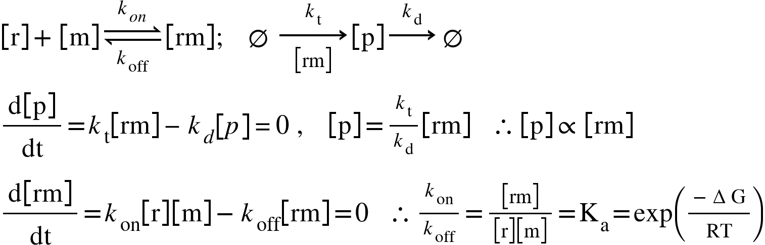

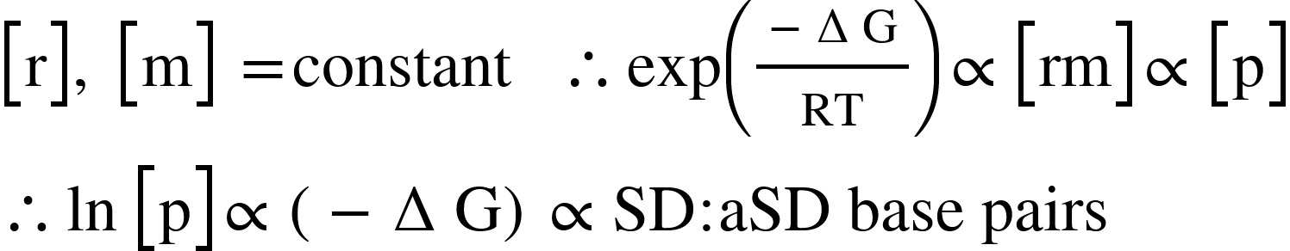

Calculation of the fitness of genotypes
The fitness of a genotype was calculated based on its read count distribution across the sorting ranks (Eq. 1, 2) and a linear regression equation (Eq. 3; Supplemental Table S4) of spike-in variants. This equation was generated by linear regression of the rank means of spike-in variants measured by sort-seq experiments and their cellular fluorescence (Log(GFP) or Log(YFP)) quantified separately by the cell sorter:

Define
v: a genotypic variant
N: total amount of sorting ranks
Rank r = {1, 2, 3, …..N-2, N-1, N}
z_{r}: read counts of v in Rank r
m: the slope of the linear regression equation of spike-in variants
b: the intercept of the linear regression equation of spike-in variants

The sum of read counts of v was
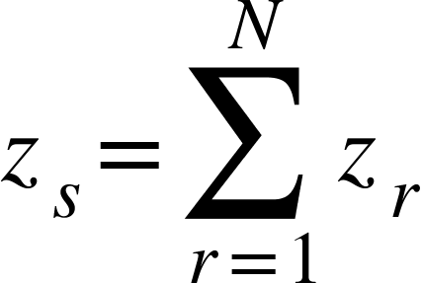 (Eq. 1)

The rank mean of v was
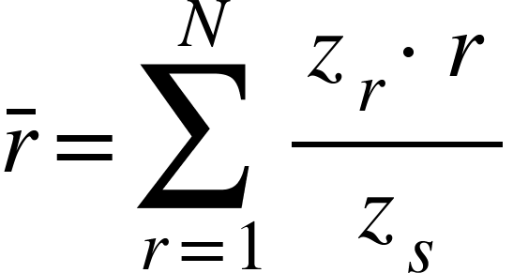 (Eq. 2)

The fitness of v was
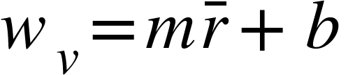 (Eq. 3)

Fitness measurements of template genotypes used for library construction
As discussed in “Results”, our sort-seq experiments measured fitness reliably for most genotypes. Nevertheless, we found sort-seq unsuitable for quantifying the fitness of template genotypes, pYC09, pYC08, pYC20, and pHC199v, used for constructing the FL_{fepB}, FL_{arti}, FL_{dmsC}, and FL_{arti-Y} libraries, respectively. The read counts of these template genotypes distributed evenly across ranks, preventing us from estimating their fitness based on the sequencing read distribution (Supplemental File S2-4). This phenomenon might result from incomplete DpnI enzyme digestion intended to eliminate template genotypes during library construction. As such, when reporting the fitness of template genotypes, we referred to their fitness directly measured by the cell sorter (pYC08: 2.861 ± 0.053, pYC09: 2.317 ± 0.034, pYC20: 3.058 ± 0.041, pHC199v: 2.804 ± 0.065) instead of fitness quantified by sort-seq experiments.

Mean fitness effects of the RBS context, single nucleotides, and pairwise epistasis
The mean fitness effects of the RBS context, single nucleotides, and pairwise epistasis were calculated as the following:

Define
v: a genotypic variant
V_{tot}: a set including total variants of a library
w_{v}: fitness of v
x, y = {1, 2, 3, 4, 5, 6, 7, 8, 9}
n = {A, U, G, C}
n_{x}, n_{y}: nucleotide at position ‘x’ or ‘y’ in SD
V(n_{x}) = {v | v’s xth nucleotide is n}
N(v) = {n_{x}, n_{y} | v’s xth or yth nucleotide}
| |: the cardinality of a set

The mean fitness effect of the RBS context (1 term), equivalent to the mean fitness of the total genotypes of a library, was
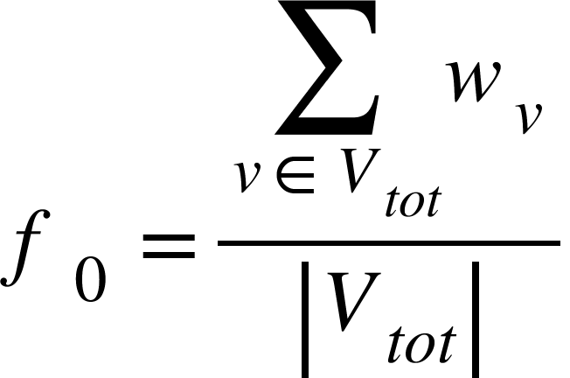 (Eq. 4)

The mean fitness effects of single nucleotides (36 terms) were
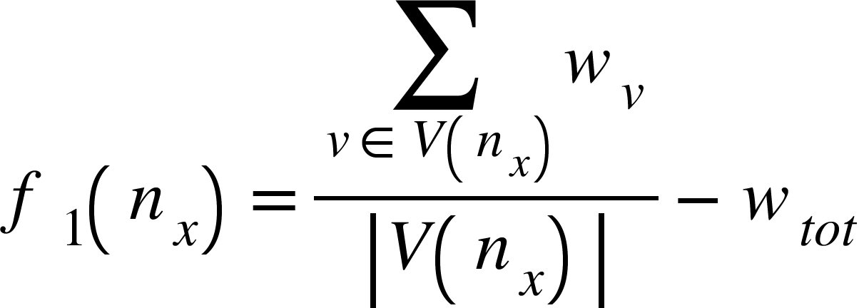 (Eq. 5)

The mean fitness effects of pairwise epistasis (576 terms) were
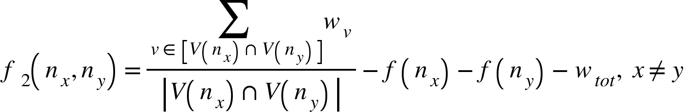 (Eq. 6)

Reciprocally, the fitness of each genotype could be predicted by summing up the mean fitness effects of the RBS context, 9 single nucleotides, and 36 types of pairwise epistasis:
(Eq. 7)

Relative importance of the SD:aSD base-pairing strength, SD:aSD base-pairing location, and RNA folding energy to fitness
As shown in Supplemental Text section “Logarithm of GFP expression as the fitness of SD”, fitness is proportional to ∆G yielded upon forming stable ribosome-mRNA complexes. Besides SD:aSD base-pairing strength, ∆G is also attributed to mRNA folding energy and the structural constraint set by the SD:aSD base-pairing location relative to the start codon. We applied multiple linear regression to evaluate the relative contribution of the three biophysical variables to fitness. The three variables of each genotype were predicted by a RNA folding algorithm (Lorenz et al. 2011). We used empirical equations derived previously to estimate the quantitative impact of the SD:aSD base-pairing location on ∆G (Salis et al. 2009). Multiple regression yielded the following linear equations for the three SD fitness landscapes, where w, x, y, and z corresponded to fitness, SD:aSD base-pairing strength, SD:aSD base-pairing location, and RNA folding energy, respectively:

FL_{fepB}: w = -0.2690x + 0.0152y + 0.0964z + 1,8526 (R² = 0.5303)
FL_{arti}: w = -0.1666x - 0.0102y + 0.0721z + 1.2032 (R² = 0.4465)
FL_{dmsC}: w = -0.1145x + 0.0056y + 0.0418z + 0.9856 (R² = 0.3410)

Among x, y and z, the x coefficients consistently showed the largest magnitude, suggesting a stronger influence of SD:aSD base-pairing strength on fitness in our experimental system.

Probability of chain-breaking mutations
The probability of chain-breaking mutations occurred in the duplex formed by two single- stranded RNA (ssRNA) made of any sequences is calculated as the following:

Define:
L: length of two position-aligned ssRNA
d: length of a duplex formed by the two ssRNA in which no mismatch interrupts its base pairing
x: nucleotide position on ssRNA, x = {1, 2, 3,..., L-2, L-1, L}
y(x): shortest length between the xth position and the edge nucleotides on ssRNA

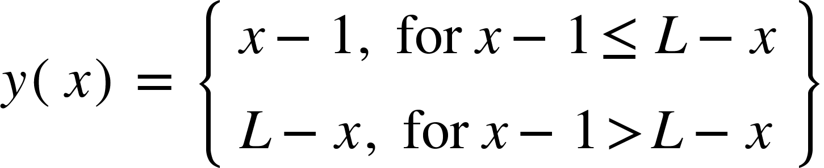 (Eq. 8)

Sum of events in which the xth position coincides with the internal nucleotides of a duplex:
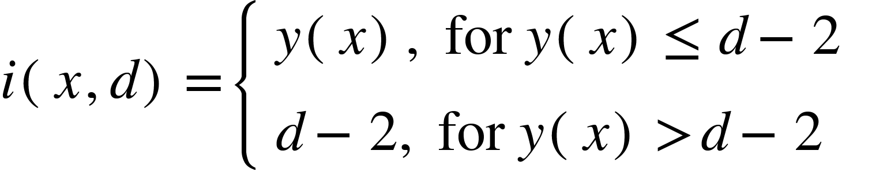 (Eq. 9)

Probability of the xth position coinciding with the internal nucleotides of a duplex:
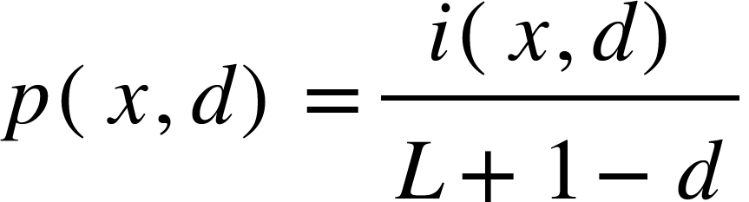 (Eq. 10)

To illustrate how the calculation of chain-breaking probability works, an example (L = 9, d = 5) is provided below. Matrix A shows all of the five possible locations in which a 5-bp duplex could be formed by two 9-nt position-aligned ssRNA. In matrix A, the top row vector indicates position x. The edge and internal nucleotides of the duplex are indicated by “E” and “I”, respectively.

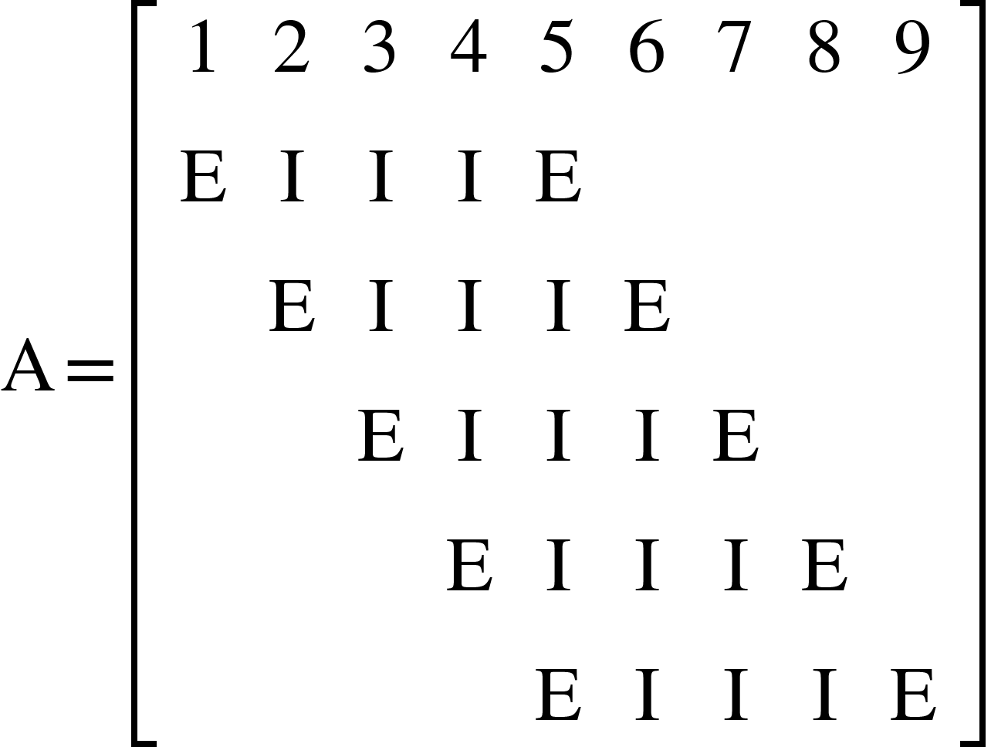

The corresponding outputs of functions y(x), i(x,d), and p(x,d) are shown by matrix M below, in which the top row vector indicates position x.

Define
m_{a,b}: the item at the ath row and bth column of matrix M
x = m_{1,*} , y(x) = m_{2,*} , i(x,d) = m_{3,*} , p(x,d) = m_{4,*}

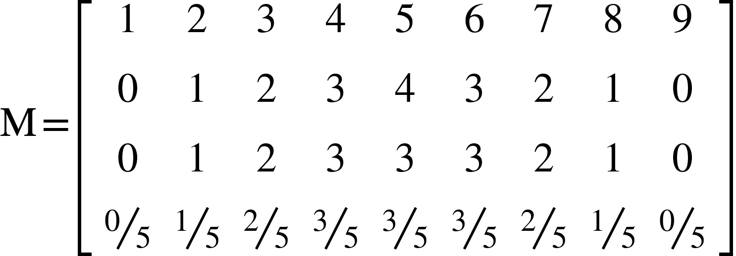

Reference

Bonde MT, Pedersen M, Klausen MS, Jensen SI, Wulff T, Harrison S, Nielsen AT, Herrgard MJ, Sommer MOA. 2016. Predictable tuning of protein expression in bacteria. Nat Methods 13: 233-236.
Brunner M, Bujard H. 1987. Promoter recognition and promoter strength in the Escherichia coli system. EMBO J 6: 3139-3144.
Chen YT, Chang KC, Hu HT, Chen YL, Lin YH, Hsu CF, Chang CF, Chang KY, Wen JD. 2017. Coordination among tertiary base pairs results in an efficient frameshift-stimulating RNA pseudoknot. Nucleic Acids Res 45: 6011-6022.
Chou HH, Delaney NF, Draghi JA, Marx CJ. 2014. Mapping the fitness landscape of gene expression uncovers the cause of antagonism and sign epistasis between adaptive mutations. PLoS Genet 10: e1004149.
Chou HH, Marx CJ, Sauer U. 2015. Transhydrogenase promotes the robustness and evolvability of E. coli deficient in NADPH production. PLoS Genet 11: e1005007.
Davis JH, Rubin AJ, Sauer RT. 2011. Design, construction and characterization of a set of insulated bacterial promoters. Nucleic Acids Res 39: 1131-1141.
Kosuri S, Goodman DB, Cambray G, Mutalik VK, Gao Y, Arkin AP, Endy D, Church GM. 2013. Composability of regulatory sequences controlling transcription and translation in Escherichia coli. Proc Natl Acad Sci USA 110: 14024-14029.
Li QZ, Lin YC, Sun YH, Song J, Chen H, Zhang XH, Sederoff RR, Chiang VL. 2012. Splice variant of the SND1 transcription factor is a dominant negative of SND1 members and their regulation in Populus trichocarpa. Proc Natl Acad Sci USA 109: 14699-14704.
Livak KJ, Schmittgen TD. 2001. Analysis of relative gene expression data using real-time quantitative PCR and the 2^{−∆∆Ct} Method. Methods 25: 402-408.
Lorenz R, Bernhart SH, Honer Zu Siederdissen C, Tafer H, Flamm C, Stadler PF, Hofacker IL. 2011. ViennaRNA Package 2.0. Algorithms Mol Biol 6: 26.
Marshall RA, Dorywalska M, Puglisi JD. 2008. Irreversible chemical steps control intersubunit dynamics during translation. Proc Natl Acad Sci USA 105: 15364-15369.
Peterson J, Phillips GJ. 2008. New pSC101-derivative cloning vectors with elevated copy numbers. Plasmid 59: 193-201.
Rueden CT, Schindelin J, Hiner MC, DeZonia BE, Walter AE, Arena ET, Eliceiri KW. 2017. ImageJ2: ImageJ for the next generation of scientific image data. BMC Bioinformatics 18.
Salis HM, Mirsky EA, Voigt CA. 2009. Automated design of synthetic ribosome binding sites to control protein expression. Nat Biotechnol 27: 946-950.
Sanner MF. 1999. Python: A programming language for software integration and development. J Mol Graph Model 17: 57-61.
van de Meent JW, Bronson JE, Wiggins CH, Gonzalez RL. 2014. Empirical Bayes methods enable advanced population-level analyses of single-molecule FRET experiments. Biophys J 106: 1327-1337.
Zaslaver A, Bren A, Ronen M, Itzkovitz S, Kikoin I, Shavit S, Liebermeister W, Surette MG, Alon U. 2006. A comprehensive library of fluorescent transcriptional reporters for Escherichia coli. Nat Methods 3: 623-628.

Supplemental Fig. S1. Structure of template plasmids. The primer pair for SD library construction and the amplified region of inverse PCR are shown as blue arrows and dashed lines, respectively. P_{A1}^{v2}, a variant of promoter A1 from phage lambda T7; RBS, ribosome binding site; FP, green or yellow fluorescent proteins; tT7, T7 terminator; kan, kanamycin resistance gene, oriV, pSC101 replication origin.

Supplemental Fig. S2. Growth and GFP expression profiles of E. coli. (A) Growth of E. coli bearing plasmids pHC162s (empty plasmid without GFP expression), pYC08 (FL_{arti} template plasmid, Log(GFP) = 2.861 ± 0.053), or pYC05 (non-template plasmid, Log(GFP) = 3.529 ± 0.060) in LBK medium. Growth rates (hr⁻¹, reported as means ± 95% confidence intervals) of pHC162s, pYC08, and pYC05 are 1.630 ± 0.127, 1.534 ± 0.153, and 1.102 ± 0.045 at OD = 0.55-0.65, respectively. (B) Relationship between the optical density (OD) of the cell culture and cellular GFP expression (GFP/OD) of E. coli bearing plasmid pYC08 in LBK medium supplemented with different amounts of glucose. (A, B) OD and GFP fluorescence are quantified by the plate reader. The grey zones correspond to the range (OD = 0.55-0.65) of sample collection for sort-seq experiments. Results from one of the five independent experiments are shown as the representative.

Supplemental Fig. S3. G-P mapping properties in FL_{arti-Y}. (A) Fitness (Log(YFP)) distribution. (B) Correlation (Pearson’s r, t-test) between the G-P mapping of FL_{arti} and FL_{arti-Y}. (C) Relationship (Pearson’s r, permutation test) between the fitness of a genotype and the individual (blue) or mean fitness (red) of its 27 single-mutation neighbors. (D) Relationship between the fitness of a genotype and the abundance of beneficial, neutral, and deleterious mutations. The library average of sort-seq measurement errors (0.108) sets the operational cutoff to distinguish the three mutation types. (E) Relationship between fitness and the nucleotide composition. (F) Relationship between the nucleotide content and fitness. Lines and bars indicate group means and standard deviations, respectively. (G) Mean fitness effects of single nucleotides. (H) Mean fitness effects of pairwise epistasis. (I) Explanatory power (R²) of the RBS context (N₀), single-nucleotides (N₁) and pairwise epistasis (N₂) on fitness. (J) Dependence of G→C mutational effects on the nucleotide positions and the background fitness. Each line, colored according to Fig. 6A, shows the mean fitness effects of G→C mutations at each nucleotide position across 20 fitness-ranked groups. (A, D, E, J) genotypes are ranked by fitness and grouped into 20 equal-size bins.

Supplemental Fig. S4. Correlation (Pearson’s r) between the SD:aSD duplex length, base-pairing energy, and fitness. (A) Correlation between the SD:aSD base-pairing energy (∆G) and the length of the longest uninterrupted SD:aSD RNA duplex. (B) Correlation between the fitness (Log(GFP)) of genotypes and the length of the longest uninterrupted SD:aSD duplex. (A, B) Genotypes are ranked vertically in terms of their duplex length. The distribution of each length-ranked group across the horizontal axis is presented as a violin plot, where medians and interquartile ranges are indicated by white circles and black lines, respectively. The patterns of base pairing between the aSD sequence and each of the 262,144 9-nt SD genotypes are predicted by a RNA folding algorithm (Lorenz et al. 2011). ∆G (predicted values ≤ 0) is shown as absolute values for simplicity. Genotypes are ranked horizontally by the base-pairing energy (A) or fitness (B) and grouped into 20 equal-size bins. Group means and standard deviations of the duplex length are indicated by red dots and bars, respectively.

Supplemental Fig. S5. Fluorescence-activated cell sorting. (A, B) The distribution of cellular fluorescence (arbitrary unit, a.u.) of each replicate library is shown separately. In each panel, a thick black line indicates the original library distribution, while thin lines in various colors indicate the fluorescence distribution of the 8 or 15 ranks of E. coli cells collected by fluorescence-activated cell sorting. (A) Three replicates of the FL_{fepB}, FL_{arti}, and FL_{dmsC} libraries. (B) FL_{arti-Y} library.

Supplemental Fig. S6. Distribution of the read counts of genotypes. (A) Three sort-seq replicate experiments of the FL_{fepB}, FL_{arti}, and FL_{dmsC} libraries. (B) One sort-seq experiment of the FL_{arti-Y} library. (A, B) Genotypes are ranked by their read counts and grouped into 19 numerical categories. The amount of detected genotypes (read count ≥1) and their mean read counts are indicated in each panel.

Supplemental Fig. S7. Quality of sort-seq experiments. (A) Relationship between the read count and the standard deviation (S.D.) of fitness (Log(GFP)) of each genotype measured by three replicate experiments. (B) Relationship between fitness and its coefficient of variation (C.V.) of each genotype. (A, B) Genotypes are ranked by read counts (A) or fitness (B) and grouped into 20 equal-size bins. Group means, medians, and interquartile ranges of S.D. are shown as red circles, blue circles, and green bars, respectively. (C) Correlation (Pearson’s r) between the fitness of genotypes in FL_{fepB}, FL_{arti}, and FL_{dmsC} characterized by three replicate experiments. The P values of all pairwise replicate correlations are below 10⁻³⁰⁰. The low-coverage zones in FL_{dmsC}, resulting from many genotypes present in just one or two replicate experiments, are marked by two red dashed circles. (D) Highlighting the two low-coverage zones (pink windows) in the fitness distribution of FL_{dmsC} characterized by three sort-seq replicate experiments. Genotypes are ranked by fitness and grouped into 20 equal-size bins.

Supplemental Fig. S8. Relationship between cellular fluorescence and GFP expression. (A) Quantification of GFP production in E. coli free of plasmids (NC) or bearing 6 different FL_{arti} genotypes by dot blot experiments. (B) Correlation (Pearson’s r = 0.997, P < 0.05) between cellular fluorescence (quantified by the cell sorter; arbitrary unit, a.u.) and GFP production. Dots and error bars indicate the means and standard deviations of three independent measurements, respectively.

Supplemental Fig. S9. Influence of translation activity on transcript stability. (A) Relationship between cellular GFP fluorescence and mRNA levels. GFP fluorescence (arbitrary unit, a.u.) and mRNA levels (fold change) of 24 genotypes (mentioned in “Methods”) from FL_{fepB}, FL_{arti}, and FL_{dmsC} were quantified by the cell sorter and qPCR, respectively. Two poly(U) RBS_{fepB} variants, 0G and 1G appeared in Fig. 4A, are indicated. The mRNA level is shown as fold changes relative to pTK03, the negative control (NC). Dots indicate the means of four independent measurements. Bars show the confidence intervals of qPCR measurements expressed as 2^{− ∆∆Ct ± S.D.}, where S.D. indicates standard deviations. The relationship between GFP fluorescence in the arithmetic scale and mRNA levels fits a linear regression model (dashed line; P < 10⁻¹²). (B) Distribution of the fitness of genotypes without (green histograms) and with normalization (Log(GFP/mRNA); blue lines) with respect to mRNA levels predicted by the linear regression model. (C) Correlation (Pearson’s r, t-test) between the fitness effects (∆Log(GFP)) of single nucleotides (36 terms; N₁) and pairwise epistasis (576 terms; N₂) estimated based on the original and normalized fitness datasets.

Supplemental Fig. S10. Influence of sequence alignment on estimating the correlation (Pearson’s r, t-test) of SD G-P associations between fitness landscapes. (A-D) Besides the RBS context and SD:aSD base pairing, the distance between the SD:aSD pairing region and the gfp start codon may alter the mRNA-ribosome binding, hence affecting the fitness (Log(GFP)) of SD genotypes. To examine this factor, the sequence of genotypes in each fitness landscape are aligned either relative to the start codon (A) or in terms of the left edge (B), the center (C), or the right edge (D) of the 9-nt SD region. Based on the sequence identity in the 7-nt overlapping positions (highlighted in red), genotypes in each fitness landscape are grouped into 4⁷ genotypic subsets, each subset consisting of up to 16 genotypes. The mean fitness of each 4⁷ genotypic subset is computed and compared between fitness landscapes. (E) The correlations (Pearson’s r) of SD G-P associations between fitness landscapes under the four aforementioned sequence alignment regimes.

Supplemental Fig. S11. G-P correlation and the distribution of mutational effects. (A) Relationship between the fitness of a genotype and the amount of beneficial, neutral, and deleterious mutations in this genetic background in the authentic fitness landscapes or the representative G-P shuffled fitness landscapes (identical to Fig. 2B). The 27 point mutations a genotype would acquire are assigned into beneficial, neutral, and deleterious categories based on an operational cutoff defined by two-fold sort-seq measurement errors (FL_{fepB} = 0.336, FL_{arti} = 0.216, and FL_{dmsC} = 0.396). Lines and bars indicate group means and standard deviations, respectively. (B) Summary of the relationships between the fitness of genetic backgrounds and the amount of beneficial, neutral, and deleterious mutations in the 10,000 G-P-shuffled fitness landscapes. The 27 point mutations a genotype would acquire are classified using sort-seq measurement errors (FL_{fepB} = 0.168, FL_{arti} = 0.108, and FL_{dmsC} = 0.198) as the cutoff. Thin dark lines indicate the averaged trend of 10,000 G-P shuffled landscapes, and the halo zones show the range of variation. (A, B) Genotypes are ranked by fitness and grouped into 20 equal-size bins, and only genotypes with their 27 single-mutation neighbors fully characterized are considered.

Supplemental Fig. S12. Nucleotide composition of genotypes belonging to the first to the tenth fitness-ranked groups (Log(GFP) = 0-1.6) in FL_{fepB}, FL_{arti}, and FL_{dmsC}. Groups containing zero or 1-3 genotypes are indicated by two and one red asterisks, respectively.

Supplemental Fig. S13. Nucleotide composition of genotypes belonging to the eleventh to the twentieth fitness-ranked groups (Log(GFP) = 1.6-3.2) in FL_{fepB}, FL_{arti}, and FL_{dmsC}. Groups containing zero or 1-3 genotypes are indicated by two and one red asterisks, respectively.

Supplemental Fig. S14. Relationship between the nucleotide content and the fitness of genotypes. Genotypes in each fitness landscape are divided into 10 groups (0 to 9) in terms of the amount of adenine, uracil, guanine, and cytosine. Red dots and bars indicate the group means and standard deviations of fitness (Log(GFP)), respectively.

Supplemental Fig. S15. RBS-30S subunit binding kinetics. (A, B) Representative time traces showing changes in the fluorescence resonance energy transfer efficiency (E_{FRET}) of a synthetic RBS (1G variant in Fig. 4A) in the (A) absence or (B) presence of the 30S subunit. (B) The red line indicates the best fitted time trace identifying the apparent 30S-bound state (E_{FRET} ~0.1) and the unbound state (E_{FRET} ~0.8). (C) The transition density plot of the same genotype in the presence of the 30S subunit. Data were extracted from the fitted line in (B) and organized in terms of E_{FRET} values before and after each state transition.

Supplemental Fig. S16. Fitness effects of A→U, A→G, A→C, U→A, U→G, and U→C mutations in FL_{fepB}. The relationships between the fitness (Log(GFP)) of a genotype and the fitness effects of A→U, A→G, A→C, U→A, U→G, and U→C mutations in this genetic background are separately examined in terms of the nine nucleotide positions of SD. In each panel, genotypes are ranked by fitness and grouped into 20 equal-size bins. Group means, medians, and interquartile ranges are shown as red circles, blue circles, and green bars, respectively.

Supplemental Fig. S17. Fitness effects of G→A, G→U, G→C, C→A, C→U, and C→G mutations in FL_{fepB}. The relationships between the fitness (Log(GFP)) of a genotype and the fitness effects of G→A, G→U, G→C, C→A, C→U, and C→G mutations in this genetic background are separately examined in terms of the nine nucleotide positions of SD. In each panel, genotypes are ranked by fitness and grouped into 20 equal-size bins. Group means, medians, and interquartile ranges are shown as red circles, blue circles, and green bars, respectively.

Supplemental Fig. S18. Fitness effects of A→U, A→G, A→C, U→A, U→G, and U→C mutations in FL_{arti}. The relationships between the fitness (Log(GFP)) of a genotype and the fitness effects of A→U, A→G, A→C, U→A, U→G, and U→C mutations in this genetic background are separately examined in terms of the nine nucleotide positions of SD. In each panel, genotypes are ranked by fitness and grouped into 20 equal-size bins. Group means, medians, and interquartile ranges are shown as red circles, blue circles, and green bars, respectively.

Supplemental Fig. S19. Fitness effects of G→A, G→U, G→C, C→A, C→U, and C→G mutations in FL_{arti}. The relationships between the fitness (Log(GFP)) of a genotype and the fitness effects of G→A, G→U, G→C, C→A, C→U, and C→G mutations in this genetic background are separately examined in terms of the nine nucleotide positions of SD. In each panel, genotypes are ranked by fitness and grouped into 20 equal-size bins. Group means, medians, and interquartile ranges are shown as red circles, blue circles, and green bars, respectively.

Supplemental Fig. S20. Fitness effects of A→U, A→G, A→C, U→A, U→G, and U→C mutations in FL_{dmsC}. The relationships between the fitness (Log(GFP)) of a genotype and the fitness effects of A→U, A→G, A→C, U→A, U→G, and U→C mutations in this genetic background are separately examined in terms of the nine nucleotide positions of SD. In each panel, genotypes are ranked by fitness and grouped into 20 equal-size bins. Group means, medians, and interquartile ranges are shown as red circles, blue circles, and green bars, respectively.
Supplemental Fig. S21. Fitness effects of G→A, G→U, G→C, C→A, C→U, and C→G mutations in FL_{dmsC}. The relationships between the fitness (Log(GFP)) of a genotype and the fitness effects of G→A, G→U, G→C, C→A, C→U, and C→G mutations in this genetic background are separately examined in terms of the nine nucleotide positions of SD. In each panel, genotypes are ranked by fitness and grouped into 20 equal-size bins. Group means, medians, and interquartile ranges are shown as red circles, blue circles, and green bars, respectively.

Supplemental Fig. S22. Fitness effects of A→U, A→G, A→C, U→A, U→G, and U→C mutations in FL_{fepB} predicted by the additive model. The relationships between the fitness (Log(GFP)) of a genotype and the predicted fitness effects of A→U, A→G, A→C, U→A, U→G, and U→C mutations in this genetic background are separately examined in terms of the nine nucleotide positions of SD. In each panel, genotypes are ranked by fitness and grouped into 20 equal-size bins. Group means, medians, and interquartile ranges are shown as red circles, blue circles, and green bars, respectively.

Supplemental Fig. S23. Fitness effects of G→A, G→U, G→C, C→A, C→U, and C→G mutations in FL_{fepB} predicted by the additive model. The relationships between the fitness (Log(GFP)) of a genotype and the predicted fitness effects of G→A, G→U, G→C, C→A, C→U, and C→G mutations in this genetic background are separately examined in terms of the nine nucleotide positions of SD. In each panel, genotypes are ranked by fitness and grouped into 20 equal-size bins. Group means, medians, and interquartile ranges are shown as red circles, blue circles, and green bars, respectively.

Supplemental Fig. S24. Fitness effects of A→U, A→G, A→C, U→A, U→G, and U→C mutations in FL_{arti} predicted by the additive model. The relationships between the fitness (Log(GFP)) of a genotype and the predicted fitness effects of A→U, A→G, A→C, U→A, U→G, and U→C mutations in this genetic background are separately examined in terms of the nine nucleotide positions of SD. In each panel, genotypes are ranked by fitness and grouped into 20 equal-size bins. Group means, medians, and interquartile ranges are shown as red circles, blue circles, and green bars, respectively.

Supplemental Fig. S25. Fitness effects of G→A, G→U, G→C, C→A, C→U, and C→G mutations in FL_{arti} predicted by the additive model. The relationships between the fitness (Log(GFP)) of a genotype and the predicted fitness effects of G→A, G→U, G→C, C→A, C→U, and C→G mutations in this genetic background are separately examined in terms of the nine nucleotide positions of SD. In each panel, genotypes are ranked by fitness and grouped into 20 equal-size bins. Group means, medians, and interquartile ranges are shown as red circles, blue circles, and green bars, respectively.

Supplemental Fig. S26. Fitness effects of A→U, A→G, A→C, U→A, U→G, and U→C mutations in FL_{dmsC} predicted by the additive model. The relationships between the fitness (Log(GFP)) of a genotype and the predicted fitness effects of A→U, A→G, A→C, U→A, U→G, and U→C mutations in this genetic background are separately examined in terms of the nine nucleotide positions of SD. In each panel, genotypes are ranked by fitness and grouped into 20 equal-size bins. Group means, medians, and interquartile ranges are shown as red circles, blue circles, and green bars, respectively.

Supplemental Fig. S27. Fitness effects of G→A, G→U, G→C, C→A, C→U, and C→G mutations in FL_{dmsC} predicted by the additive model. The relationships between the fitness (Log(GFP)) of a genotype and the predicted fitness effects of G→A, G→U, G→C, C→A, C→U, and C→G mutations in this genetic background are separately examined in terms of the nine nucleotide positions of SD. In each panel, genotypes are ranked by fitness and grouped into 20 equal-size bins. Group means, medians, and interquartile ranges are shown as red circles, blue circles, and green bars, respectively.

Supplemental Fig. S28. Impacts of A→U, A→G, A→C, U→A, U→G, and U→C mutations on SD:aSD base-pairing energy. Base-pairing energy (∆G, predicted values ≤ 0) is shown as an absolute values for simplicity. The relationships between the base-pairing energy of a SD genotype and the energy impacts (∆∆G) of A→U, A→G, A→C, U→A, U→G, and U→C mutations in this genetic background are separately examined in terms of the nine nucleotide positions of SD. In each panel, genotypes are ranked by base-pairing energy and grouped into 20 equal-size bins. Group means, medians, and interquartile ranges are shown as red circles, blue circles, and green bars, respectively.

Supplemental Fig. S29. Impacts of G→A, G→U, G→C, C→A, C→U, and C→G mutations on SD:aSD base-pairing energy. Base-pairing energy (∆G, predicted values ≤ 0) is shown as an absolute value for simplicity. The relationships between the base-pairing energy of a SD genotype and the energy impacts (∆∆G) of G→A, G→U, G→C, C→A, C→U, and C→G mutations in this genetic background are separately examined in terms of the nine nucleotide positions of SD. In each panel, genotypes are ranked by base-pairing energy and grouped into 20 equal-size bins. Group means, medians, and interquartile ranges are shown as red circles, blue circles, and green bars, respectively.

Supplemental Fig. S30. Relationship between the nucleotide content of SD and RNA folding energy within the 30-nt RBS region. SD genotypes are ranked by the amount of each nucleotide type and grouped into 10 bins (i.e. 0 to 9 nt). Lines and bars indicate group means and standard deviations of folding energy (∆G, predicted values ≤ 0; shown as absolute values for simplicity).

Supplemental Fig. S31. Impacts of A→U, A→G, A→C, U→A, U→G, and U→C mutations on the SD:aSD duplex length. The length (bp) of the longest uninterrupted SD:aSD duplex formed by each SD genotype is predicted by a RNA-folding algorithm (Lorenz et al. 2011). The relationships between the duplex length formed by a genotype and the impacts (i.e. changes in duplex length) of A→U, A→G, A→C, U→A, U→G, and U→C mutations in this genetic background are separately examined in terms of the nine nucleotide positions of SD. In each panel, genotypes are ranked by the duplex length and grouped into 10 bins (0 to 9 bp), and the amount of genotypes located at a given coordinate is indicated by the size of a grey circle. Group means, medians, and interquartile ranges are shown as red circles, blue circles, and green bars, respectively.

Supplemental Fig. S32. Impacts of G→A, G→U, G→C, C→A, C→U, and C→G mutations on the SD:aSD duplex length. The length (bp) of the longest uninterrupted SD:aSD duplex formed by each SD genotype is predicted by a RNA-folding algorithm (Lorenz et al. 2011). The relationships between the duplex length of a genotype and the impacts (i.e. changes in duplex length) of G→A, G→U, G→C, C→A, C→U, and C→G mutations in this genetic background are separately examined in terms of the nine nucleotide positions of SD. In each panel, genotypes are ranked by the duplex length and grouped into 10 bins (0 to 9 bp), and the amount of genotypes located at a given coordinate is indicated by the size of a grey circle. Group means, medians, and interquartile ranges are shown as red circles, blue circles, and green bars, respectively.

Supplemental Table S1. List of primers and oligonucleotides.

Primer | Sequence (5’-3’) | Application
HCEp165 | AATATTTGTTCTGGCGTCTGATTTTG | Construct EK222
HCEp166 | GTCTATAGTCATGATGTCAAATGAACG | Construct EK222
HCEp167 | GATTCTTTTCTCTGAGACGCCAG | Construct EK222
HCEp168 | GCGTTGTGAAGAAATGTTATTTGC | Construct EK222
K1 | CAGTCATAGCCGAATAGCCT | Construct EK222
K2 | CGGTGCCCTGAATGAACTG | Construct EK222
UA66p5 | GCTGGCAATTCCGACGT | Sanger sequencing
MV1 | GCAGGGCCCACTAGTGCA | Construct pHC162v
MV2 | GTCTGCAGGTCGACTCTAGTAAG | Construct pHC162v
UA139f | TTGGGCCCAAGCTTGTACGGGTTTTGCTGCCC | Construct pHC162v
UA139r | TTTGTCGACGCTAGCGGATCCGTGAAGACGA | Construct pHC162v
proDf | TCGACACGCGTTTACGGGCATGCATAAGGCTCGTATAATATATTCATTAATGGGAGACCACAACGGTTTCCCTCTACAAATAATTTTGTTT | Construct pHC163v
proDr | CTAGAAACAAAATTATTTGTAGAGGGAAACCGTTGTGGTCTCCCATTAATGAATATATTATACGAGCCTTATGCATGCCCGTAAACGCGTG | Construct pHC163v
WH4f | TAAGGAGGTTCCCAATGGTGAGCAAGGGCGAG | Construct pHC165v
WH4r | GAACTCTAGAAACAAAATTATTTGTAGAGGGAAAC | Construct pHC165v
RepA93Kf | AAGATTTTCCAGTGGACAAACTATGC | Construct pHC172v
RepA93r | AAAGCCTTTAACCAAAGGATTCC | Construct pHC172v
PA1f | CGCGTTATCAAAAAGAGTATTGACTTAAAGTCTAACCTATAGGATACTTACAGCCATCGAGAGGGAT | Construct pHC174v1
PA1r | TAATCCCTCTCGATGGCTGTAAGTATCCTATAGGTTAGACTTTAAGTCAATACTCTTTTTGATAA | Construct pHC174v1
VSSR12-SD9 | AATCTAGAACCTTAAGGAGGTTAAGAATGGTGAGCAAGGG | Construct pHC199v
VSSR12-SD6 | AATCTAGAACCTATAGGAGGATAAGAATGGTGAGCAAGGG | Construct pHC198v
VSSR12-SD5 | AATCTAGAACCTATAGGAGCATAAGAATGGTGAGCAAGGG | Construct pHC202v
UA66p4 | CGGATCTGCGATTCTGATAACA | Construct pHC199v
GFPmut2f | AATCTAGAACCTTAAGGAGGTTAAGAATGAGTAAAGGAGAAGAACTTTTCAC | Construct pHC200
GFPmut2r | AACTCGAGCAGGTCTGGACATTTATTTGTAC | Construct pHC200
YC04p1 | AGGTGAGGAACTGTTCACTGGAGTTGTCCCAATTC | Construct pYC04
YC04p2 | TTGGACATTCTTAACCTCCTTAAGGTTCTAGAAAC | Construct pYC04
YC09p1 | GGTTGATTTATGTCCAAAGGTGAG | Construct pYC09
YC09p2 | TCCTTATATTAATAAGGTTAATCTAGAAACAAAATTATTTG | Construct pYC09
YC12p1 | AGGAGGTGTGAGATGTCCAAAGGTGA | Construct pYC20
YC12p2 | TCGGGTTTGCCAGATAGCTCTAGAAACAAAATTATTTG | Construct pYC20
YC21p1 | TAAGAATGTCCAAAGGTG | Construct FL_{arti} variants
TK03p1 | TGGAGGAATAGGTTCTAGAAACAAAATTATTTGTAGAGG | Construct pTK03
TK05p1 | GGTAATAAGAATGTCCAAAGGTGAGGAACTG | Construct pTK05
YC19p2 | TCTCAGGTTCTAGAAACAAAATTATTTGTAGAGGGAAAC | Construct pTK05
TK06p2 | TCTTATGGAGGAATAGGTTCTAGAAACAAAATTATTTGTAGAGGGA | Construct pTK06
YL13p1 | ATGGTGAGCAAGGGCGA | Construct pTK06
YC23p1 | TAAGAATGTCCAAAGGTGAGGAAC | Construct FL_{arti} variants
YC24p1 | TGATTTATGTCCAAAGGTGAGGA | Construct FL_{fepB} variants
YC26p1 | TGAGATGTCCAAAGGTGAGG | Construct FL_{dmsC} variants
YC28p1 | TTTTTTTTTTATTAATAAGGTTAATCTAGAAACAAAATTATTTGTAGA | Construct pYC30
YC29p1 | AAAAAAAAATATTAATAAGGTTAATCTAGAAACAAAATTATTTGTAGA | Construct pYC29
YC30p1 | TAATTTATGTCCAAAGGTGAGGAAC | Construct pYC31
YC32p1 | TACCATACCCGGGTTTGCCAGATAGCT | Construct pYC32
YC33p1 | ACCCCCGAACGGGTTTGCCAGATAGCT | Construct pYC33
YC34p1 | GCTTCCTGTTATTAATAAGGTTAATCTAGAAACAAAATTATTTGTAGA | Construct pYC34
YC36p1 | AACCCCTTATATTAATAAGGTTAATCTAGAAACAAAATTATTTGTAGAG | Construct pYC36
YC37p1 | CCTCCATCGCGGGTTTGCCAGATAGCT | Construct pYC37
YC38p1 | CCCCCTCTTAGGTTCTAGAAACAAAATTATTTGTAGAGG | Construct pYC38
YC39p1 | CCCCCCCCCAGGTTCTAGAAACAAAATTATTTGTAGAGG | Construct pYC39
YC40p1 | CCCCCCCCCTATTAATAAGGTTAATCTAGAAACAAAATTATTTGTAGAG | Construct pYC40
YC41p1 | CCCCCCCCCCGGGTTTGCCAGATAGCT | Construct pYC41
YC42p1 | CACACCACCTATTAATAAGGTTAATCTAGAAACAAAATTATTTGTAGAG | Construct pYC42
YC43p1 | TCTATCCGGTATTAATAAGGTTAATCTAGAAACAAAATTATTTGTAGAG | Construct pYC43
YC44p1 | TCCACCCTCCGGGTTTGCCAGATAGCT | Construct pYC44
YC45p1 | CTTACCATTCGGGTTTGCCAGATAGCT | Construct pYC45
YC46p1 | AGCCCCCCGCGGGTTTGCCAGATAGCT | Construct pYC46
TK39p1 | AAAAACAAATATTAATAAGGTTAATCTAGAAACAAAATTATTTGTAGAG | Construct pTK39
TK40p1 | TGGAGGAATTATTAATAAGGTTAATCTAGAAACAAAATTATTTGTAGAG | Construct pTK40
TK41p1 | AAACACAAATATTAATAAGGTTAATCTAGAAACAAAATTATTTGTAGAG | Construct pTK41
TK42p1 | CAAAACAAATATTAATAAGGTTAATCTAGAAACAAAATTATTTGTAGAG | Construct pTK42
TK43p1 | CAACACAAATATTAATAAGGTTAATCTAGAAACAAAATTATTTGTAGAG | Construct pTK43
YC09SDRf | NNNNNTGATTTATGTCCAAAGGTG | Construct the FL_{fepB} library
YC09SDRr | NNNNTATTAATAAGGTTAATCTAGAAACAAA | Construct the FL_{fepB} library
YC08SDRf | NNNNNTAAGAATGTCCAAAGGTGAGGA | Construct the FL_{arti} library
YC08SDRr | NNNNAGGTTCTAGAAACAAAATTATTTGTAGAG | Construct the FL_{arti} and FL_{arti-Y} libraries
YC12SDRf | NNNNNTGAGATGTCCAAAGGTGAGG | Construct the FL_{dmsC} library
YC12SDRr | NNNNCGGGTTTGCCAGATAGCT | Construct the FL_{dmsC} library
199vSDRf | NNNNNTAAGAATGGTGAGCAAGG | Construct the FL_{arti-Y} library
ILp2 | GTCTCGTGGGCTCGGAGATGTGTATAAGAGACAGGCTTCCCAACCTTACCAGAGG | Amplicon PCR of the FL_{fepB}, FL_{arti}, and FL_{dmsC} libraries
ILp6 | TCGTCGGCAGCGTCAGATGTGTATAAGAGACAGGAACAGTTCCTCACCTTTGGACAT | Amplicon PCR of the FL_{fepB}, FL_{arti}, and FL_{dmsC} libraries
ILp6a | TCGTCGGCAGCGTCAGATGTGTATAAGAGACAGNGAACAGTTCCTCACCTTTGGACAT | Amplicon PCR of the FL_{fepB}, FL_{arti}, and FL_{dmsC} libraries
ILp6b | TCGTCGGCAGCGTCAGATGTGTATAAGAGACAGNNGAACAGTTCCTCACCTTTGGACAT | Amplicon PCR of the FL_{fepB}, FL_{arti}, and FL_{dmsC} libraries
ILp6c | TCGTCGGCAGCGTCAGATGTGTATAAGAGACAGNNNGAACAGTTCCTCACCTTTGGACAT | Amplicon PCR of the FL_{fepB}, FL_{arti}, and FL_{dmsC} libraries
IL1 | TCGTCGGCAGCGTCAGATGTGTATAAGAGACAGCCTCGCCCTTGCTCACCAT | Amplicon PCR of the FL_{arti-Y} library
IL1a | TCGTCGGCAGCGTCAGATGTGTATAAGAGACAGNCCTCGCCCTTGCTCACCAT | Amplicon PCR of the FL_{arti-Y} library
IL1b | TCGTCGGCAGCGTCAGATGTGTATAAGAGACAGNNCCTCGCCCTTGCTCACCAT | Amplicon PCR of the FL_{arti-Y} library
IL1c | TCGTCGGCAGCGTCAGATGTGTATAAGAGACAGNNNCCTCGCCCTTGCTCACCAT | Amplicon PCR of the FL_{arti-Y} library
YLEp5 | TGGGCACAAATTTTCTGTCAG | gfp qPCR
YLEp6 | CGCGAAAGTAGTGACAAGTG | gfp qPCR
YLEp7 | CGAAGTTGGTGTTGACGTTG | gapA qPCR
YLEp8 | TGTTGTCTTTAGACGGACCAG | gapA qPCR
5’ handle | Cy5-GAGACGCCCGGGCTGCAG-Biotin | Single-molecule FRET
3’ handle | CCCCAGACGCAUUGCGUUCUGUACAG-Cy3 | Single-molecule FRET

Supplemental Table S2. Plasmid list.

Plasmid | Description | ^{f}RBS sequence (upstream_SD_downstream)
pUA139 | RBS-gfp_{mut2}-t_{rrnB}, oriV_{pSC101}, ªKm^{r} | UACCCAUGGUAUGGA_UGAAUUGUA_CAAAUA
pHC161v | P_{tacA}-RBS-venus-t_{T7}, P_{sacB}-sacB, oriT_{RP4} , oriV_{R6K} , ^{b}Cm^{r} | CCUCAUAUGUCUAGA_AGGGAGAGA_CCCCGA
pHC162v | P_{tacA}-RBS-venus- t_{T7}, oriV_{pSC101}, Km^{r} | CCUCAUAUGUCUAGA_AGGGAGAGA_CCCCGA
pHC162s | oriV_{pSC101}, Km^{r}
pHC163v | P_{proD}-leader-RBS-venus-t_{T7}, oriV_{pSC101}, Km^{r} | AAUUUUGUUUCUAGA_AGGGAGAGA_CCCCGA
pHC165v | P_{proD}-leader-RBS-venus-t_{T7}, oriV_{pSC101}, Km^{r} | UUUGUUUCUAGAGUUC_UAAGGAGGU_UCCCA
pHC172v | P_{proD}-leader-RBS-venus-t_{T7}, ^{c}oriV_{pSC101}^{v2}, Km^{r} | UUUGUUUCUAGAGUUC_UAAGGAGGU_UCCCA
pHC174v1 | P_{A1}-leader-RBS-venus-t_{T7}, oriV_{pSC101}^{v2}, Km^{r} | UUUGUUUCUAGAGUUC_UAAGGAGGU_UCCCA
pHC174v2 | ^{d}P_{A1}^{v2}-leader-RBS-venus-t_{T7}, oriV_{pSC101}^{v2}, Km^{r} | UUUGUUUCUAGAGUUC_UAAGGAGGU_UCCCA
pHC198v | P_{A1}^{v2}-leader-RBS-venus-t_{T7}, oriV_{pSC101}^{v2}, Km^{r} | UUUGUUUCUAGAACCU_AUAGGAGGA _UAAGA
pHC199v | P_{A1}^{v2}-leader-RBS-venus-t_{T7}, oriV_{pSC101}^{v2}, Km^{r} | UUUGUUUCUAGAACCU_UAAGGAGGU_UAAGA
pHC200 | P_{A1}^{v2}-leader-RBS gfp_{mut2}-t_{T7}, oriV_{pSC101}^{v2}, Km^{r} | UUUGUUUCUAGAACCU_UAAGGAGGU_UAAGA
pHC202v | P_{A1}^{v2}-leader-RBS-venus-t_{T7}, oriV_{pSC101}^{v2}, Km^{r} | UUUGUUUCUAGAACCU_AUAGGAGCA_UAAGA
pTK03 | P_{A1}^{v2}-leader-RBS-^{e}gfp_{mut2}^{v2}-t_{T7}, oriV_{pSC101}, Km^{r} | UUUGUUUCUAGAACCU_AUUCCUCCA_UAAGA
pTK05 | P_{A1}^{v2}-leader-RBS-gfp_{mut2}^{v2}-t_{T7}, oriV_{pSC101}, Km^{r} | UUUGUUUCUAGAACCU_GAGAGGUAA_UAAGA
pTK06 | P_{A1}^{v2}-leader-RBS-venus-t_{T7}, oriV_{pSC101}^{v2}, Km^{r} | UUUGUUUCUAGAACCU_AUUCCUCCA_ UAAGA
pTK39 | P_{A1}^{v2}-leader-RBS-gfp_{mut2}^{v2}-t_{T7}, oriV_{pSC101}, Km^{r} | UUAACCUUAUUAAUA_UUUGUUUUU_UGAUUU
pTK40 | P_{A1}^{v2}-leader-RBS-gfp_{mut2}^{v2}-t_{T7}, oriV_{pSC101}, Km^{r} | UUAACCUUAUUAAUA_AUUCCUCCA_UGAUUU
pTK41 | P_{A1}^{v2}-leader-RBS-gfp_{mut2}^{v2}-t_{T7}, oriV_{pSC101}, Km^{r} | UUAACCUUAUUAAUA_UUUGUGUUU_UGAUUU
pTK42 | P_{A1}^{v2}-leader-RBS-gfp_{mut2}^{v2}-t_{T7}, oriV_{pSC101}, Km^{r} | UUAACCUUAUUAAUA_UUUGUUUUG_UGAUUU
pTK43 | P_{A1}^{v2}-leader-RBS-gfp_{mut2}^{v2}-t_{T7}, oriV_{pSC101}, Km^{r} | UUAACCUUAUUAAUA_UUUGUGUUG_UGAUUU
pYC01 | P_{proD}-leader-RBS-gfp_{mut2}-t_{T7}, oriV_{pSC101}^{v2}, Km^{r} | UUUGUUUCUAGAACCU_UAAGGAGGU_UAAGA
pYC04 | P_{proD}-leader-RBS-gfp_{mut2}^{v2}-t_{T7}, oriV_{pSC101}^{v2}, Km^{r} | UUUGUUUCUAGAACCU_UAAGGAGGU_UAAGA
pYC05 | P_{A1}^{v2}-leader-RBS-gfp_{mut2}^{v2}-t_{T7}, oriV_{pSC101}^{v2}, Km^{r} | UUUGUUUCUAGAACCU_UAAGGAGGU_UAAGA
pYC06 | P_{proD} -leader-RBS-gfp_{mut2}^{v2}-t_{T7}, oriV_{pSC101}, Km^{r} | UUUGUUUCUAGAACCU_UAAGGAGGU_UAAGA
pYC08 | P_{A1}^{v2}-leader-RBS-gfp_{mut2}^{v2}-t_{T7}, oriV_{pSC101}, Km^{r} | UUUGUUUCUAGAACCU_UAAGGAGGU_UAAGA
pYC09 | P_{A1}^{v2}-leader-RBS-gfp_{mut2}^{v2}-t_{T7}, oriV_{pSC101}, Km^{r} | UUAACCUUAUUAAUA_ACAGGAAGC_UGAUUU
pYC20 | P_{A1}^{v2}-leader-RBS-gfp_{mut2}^{v2}-t_{T7}, oriV_{pSC101}, Km^{r} | GCUAUCUGGCAAACCCG_AAGGAGGUG_UGAG
pYC28 | P_{A1}^{v2}-leader-RBS-gfp_{mut2}^{v2}-t_{T7}, oriV_{pSC101}, Km^{r} | UUAACCUUAUUAAUA_AAAAAAAAA_UGAUUU
pYC29 | P_{A1}^{v2}-leader-RBS-gfp_{mut2}^{v2}-t_{T7}, oriV_{pSC101}, Km^{r} | UUAACCUUAUUAAUA_UUUUUUUUU_UGAUUU
pYC30 | P_{A1}^{v2}-leader-RBS-gfp_{mut2}^{v2}-t_{T7}, oriV_{pSC101}, Km^{r} | UUAACCUUAUUAAUA_AAAAAAAAA_UAAUUU
pYC31 | P_{A1}^{v2}-leader-RBS-gfp_{mut2}^{v2}-t_{T7}, oriV_{pSC101}, Km^{r} | UUAACCUUAUUAAUA_UUUUUUUUU_UAAUUU
pYC32 | P_{A1}^{v2}-leader-RBS-gfp_{mut2}^{v2}-t_{T7}, oriV_{pSC101}, Km^{r} | GCUAUCUGGCAAACCCG_GGUAUGGUA_UGAG
pYC33 | P_{A1}^{v2}-leader-RBS-gfp_{mut2}^{v2}-t_{T7}, oriV_{pSC101}, Km^{r} | GCUAUCUGGCAAACCCG_UUCGGGGGU_UGAG
pYC34 | P_{A1}^{v2}-leader-RBS-gfp_{mut2}^{v2}-t_{T7}, oriV_{pSC101}, Km^{r} | UUAACCUUAUUAAUA_ACAGGAAGC_UGAUUU
pYC36 | P_{A1}^{v2}-leader-RBS-gfp_{mut2}^{v2}-t_{T7}, oriV_{pSC101}, Km^{r} | UUAACCUUAUUAAUA_UAAGGGGUU_UGAUUU
pYC37 | P_{A1}^{v2}-leader-RBS-gfp_{mut2}^{v2}-t_{T7}, oriV_{pSC101}, Km^{r} | GCUAUCUGGCAAACCCG _CGAUGGAGG_ UGAG
pYC38 | P_{A1}^{v2}-leader-RBS-gfp_{mut2}^{v2}-t_{T7}, oriV_{pSC101}, Km^{r} | UUUGUUUCUAGAACCU_AAGAGGGGG_UAAGA
pYC39 | P_{A1}^{v2}-leader-RBS-gfp_{mut2}^{v2}-t_{T7}, oriV_{pSC101}, Km^{r} | UUUGUUUCUAGAACCU_GGGGGGGGG_UAAGA
pYC40 | P_{A1}^{v2}-leader-RBS-gfp_{mut2}^{v2}-t_{T7}, oriV_{pSC101}, Km^{r} | UUAACCUUAUUAAUA_GGGGGGGGG_UGAUUU
pYC41 | P_{A1}^{v2}-leader-RBS-gfp_{mut2}^{v2}-t_{T7}, oriV_{pSC101}, Km^{r} | GCUAUCUGGCAAACCCG_GGGGGGGGG_UGAG
pYC42 | P_{A1}^{v2}-leader-RBS-gfp_{mut2}^{v2}-t_{T7}, oriV_{pSC101}, Km^{r} | UUAACCUUAUUAAUA_GGUGGUGUG_UGAUUU
pYC43 | P_{A1}^{v2}-leader-RBS-gfp_{mut2}^{v2}-t_{T7}, oriV_{pSC101}, Km^{r} | UUAACCUUAUUAAUA_CCGGAUAGA_UGAUUU
pYC44 | P_{A1}^{v2}-leader-RBS-gfp_{mut2}^{v2}-t_{T7}, oriV_{pSC101}, Km^{r} | GCUAUCUGGCAAACCCG_GAGGGUGGA_UGAG
pYC45 | P_{A1}^{v2}-leader-RBS-gfp_{mut2}^{v2}-t_{T7}, oriV_{pSC101}, Km^{r} | GCUAUCUGGCAAACCCG_AAUGGUAAG_UGAG
pYC46 | P_{A1}^{v2}-leader-RBS-gfp_{mut2}^{v2}-t_{T7}, oriV_{pSC101}, Km^{r} | GCUAUCUGGCAAACCCG_CGGGGGGCU_UGAG
pLK170505v1 | P_{A1}^{v2}-leader-RBS-gfp_{mut2}^{v2}-t_{T7}, oriV_{pSC101}, Km^{r} | UUAACCUUAUUAAUA_UGAGAGGUA_UGAUUU
pLK170110v6 | P_{A1}^{v2}-leader-RBS-gfp_{mut2}^{v2}-t_{T7}, oriV_{pSC101}, Km^{r} | UUUGUUUCUAGAACCU_GCUCAGGGU_UAAGA
pLK170110v7 | P_{A1}^{v2}-leader-RBS-gfp_{mut2}^{v2}-t_{T7}, oriV_{pSC101}, Km^{r} | UUUGUUUCUAGAACCU_CGCGGGAUA_UAAGA
pLK170110v12 | P_{A1}^{v2}-leader-RBS-gfp_{mut2}^{v2}-t_{T7}, oriV_{pSC101}, Km^{r} | UUUGUUUCUAGAACCU_UUACGAGGC_UAAGA
pLK170110v20 | P_{A1}^{v2}-leader-RBS-gfp_{mut2}^{v2}-t_{T7}, oriV_{pSC101}, Km^{r} | UUUGUUUCUAGAACCU_AUUAAGUAC_UAAGA
pLK170110v22 | P_{A1}^{v2}-leader-RBS-gfp_{mut2}^{v2}-t_{T7}, oriV_{pSC101}, Km^{r} | UUUGUUUCUAGAACCU_AAUAGUGAG_UAAGA
pLK170110v34 | P_{A1}^{v2}-leader-RBS-gfp_{mut2}^{v2}-t_{T7}, oriV_{pSC101}, Km^{r} | UUUGUUUCUAGAACCU_CCAGCGGGG_UAAGA
pLK170110v40 | P_{A1}^{v2}-leader-RBS-gfp_{mut2}^{v2}-t_{T7}, oriV_{pSC101}, Km^{r} | UUUGUUUCUAGAACCU_ACCCGGUGG_UAAGA
pLK170110v42 | P_{A1}^{v2}-leader-RBS-gfp_{mut2}^{v2}-t_{T7}, oriV_{pSC101}, Km^{r} | UUUGUUUCUAGAACCU_GGCUAGGAG_UAAGA
pLK170110v44 | P_{A1}^{v2}-leader-RBS-gfp_{mut2}^{v2}-t_{T7}, oriV_{pSC101}, Km^{r} | UUUGUUUCUAGAACCU_GUCAGGGAG_UAAGA
pLK170110v49 | P_{A1}^{v2}-leader-RBS-gfp_{mut2}^{v2}-t_{T7}, oriV_{pSC101}, Km^{r} | UUUGUUUCUAGAACCU_CGACGGGGG_UAAGA
pLK170110v59 | P_{A1}^{v2}-leader-RBS-gfp_{mut2}^{v2}-t_{T7}, oriV_{pSC101}, Km^{r} | UUUGUUUCUAGAACCU_GGAGUGAUC_UAAGA
pLK170110v68 | P_{A1}^{v2}-leader-RBS-gfp_{mut2}^{v2}-t_{T7}, oriV_{pSC101}, Km^{r} | UUUGUUUCUAGAACCU_GGAGGUGUU_UAAGA
pLK170110v69 | P_{A1}^{v2}-leader-RBS-gfp_{mut2}^{v2}-t_{T7}, oriV_{pSC101}, Km^{r} | UUUGUUUCUAGAACCU_AGCAGGGGU_UAAGA
pLK170110v71 | P_{A1}^{v2}-leader-RBS-gfp_{mut2}^{v2}-t_{T7}, oriV_{pSC101}, Km^{r} | UUUGUUUCUAGAACCU_AACAGGGGG_UAAGA
pLK170110v79 | P_{A1}^{v2}-leader-RBS-gfp_{mut2}^{v2}-t_{T7}, oriV_{pSC101}, Km^{r} | UUUGUUUCUAGAACCU_AUAUAGGAG_UAAGA
pLK170518v2 | P_{A1}^{v2}-leader-RBS-gfp_{mut2}^{v2}-t_{T7}, oriV_{pSC101}, Km^{r} | GCUAUCUGGCAAACCCG_AGAGGUAUU_UGAG
pLK170518v4 | P_{A1}^{v2}-leader-RBS-gfp_{mut2}^{v2}-t_{T7}, oriV_{pSC101}, Km^{r} | GCUAUCUGGCAAACCCG_UUCGGGGGU_UGAG
pLK170523v25 | P_{A1}^{v2}-leader-RBS-venus-t_{T7}, oriV_{pSC101}^{v2}, Km^{r} | UUUGUUUCUAGAACCU_AGAAGUGUU_UAAGA
pLK170523v28 | P_{A1}^{v2}-leader-RBS-venus-t_{T7}, oriV_{pSC101}^{v2}, Km^{r} | UUUGUUUCUAGAACCU_CGGGGAAGU_UAAGA
pLK170523v31 | P_{A1}^{v2}-leader-RBS-venus-t_{T7}, oriV_{pSC101}^{v2}, Km^{r} | UUUGUUUCUAGAACCU_GAGAGCGUU_UAAGA
pLK170523v35 | P_{A1}^{v2}-leader-RBS-venus-t_{T7}, oriV_{pSC101}^{v2}, Km^{r} | UUUGUUUCUAGAACCU_AAAUGUGUC_UAAGA
pLK170523v68 | P_{A1}^{v2}-leader-RBS-venus-t_{T7}, oriV_{pSC101}^{v2}, Km^{r} | UUUGUUUCUAGAACCU_UGGAGAUAU_UAAGA
pLK170523v69 | P_{A1}^{v2}-leader-RBS-venus-t_{T7}, oriV_{pSC101}^{v2}, Km^{r} | UUUGUUUCUAGAACCU_UAGGAGAUA_UAAGA
pLK170523v71 | P_{A1}^{v2}-leader-RBS-venus-t_{T7}, oriV_{pSC101}^{v2}, Km^{r} | UUUGUUUCUAGAACCU_GAGGGAGUU_UAAGA
ªKm^{r}, kanamycin resistance.
^{b}Cm^{r}, tetracycline resistance.
^{c}oriV_{pSC101}^{v2}, oriV_{pSC101} bearing the RepA(E93K) mutation.
^{d}P_{A1}^{v2}, the P_{A1} promoter of phage T7 bearing a spontaneous deletion (∆C) in its spacer region 7-bp upstream of its -10 element.
^{e}gfp_{mut2}^{v2}, the gfp_{mut2} 5` coding sequence 5`-ATGAGTAAAGGAGAAGAACTT-3` replaced by 5`-ATGTCCAAAGGTGAGGAACTG-3`.
^{f}RBS sequence defined as the 30-nt mRNA sequence immediately upstream of the gfp_{mut2} or venus reporter genes.

Supplemental Table S3. Spike-in variant list.

Reporter | Plasmidª | SD sequence (5’-3’) | Translation efficiency (Log(FP))^{b}
GFP | pTK03 | AUUCCUCCA | 0.448 ± 0.041
 | pLK170110v7 | CGCGGGAUA | 0.487 ± 0.041
 | pLK170110v6 | GCUCAGGGU | 0.801 ± 0.070
 | pLK170110v20 | AUUAAGUAC | 1.078 ± 0.037
 | pLK170110v12 | UUACGAGGC | 1.343 ± 0.043
 | pLK170110v22 | AAUAGUGAG | 1.548 ± 0.040
 | pLK170110v34 | CCAGCGGGG | 1.708 ± 0.009
 | pLK170110v40 | ACCCGGUGG | 1.911 ± 0.048
 | pLK170110v44 | GUCAGGGAG | 2.092 ± 0.051
 | pLK170110v49 | CGACGGGGG | 2.300 ± 0.027
 | pLK170110v42 | GGCUAGGAG | 2.385 ± 0.036
 | pLK170110v59 | GGAGUGAUC | 2.441 ± 0.057
 | pLK170110v69 | AGCAGGGGU | 2.598 ± 0.017
 | pLK170110v68 | GGAGGUGUU | 2.607 ± 0.035
 | pYC08 | UAAGGAGGU | 2.861 ± 0.053
 | pLK170110v79 | AUAUAGGAG | 2.879 ± 0.031
 | pTK05 | GAGAGGUAA | 2.968 ± 0.081
 | pLK170110v71 | AACAGGGGG | 3.015 ± 0.022
YFP | pTK06 | AUUCCUCCA | 0.654 ± 0.023
 | pLK170523v25 | AGAAGUGUU | 1.053 ± 0.042
 | pLK170523v35 | AAAUGUGUC | 1.204 ± 0.072
 | pLK170523v28 | CGGGGAAGU | 1.212 ± 0.031
 | pLK170523v31 | GAGAGCGUU | 1.505 ± 0.027
 | pHC202v | AUAGGAGCA | 1.777 ± 0.056
 | pLK170523v71 | GAGGGAGUU | 1.925 ± 0.033
 | pLK170523v68 | UGGAGAUAU | 2.054 ± 0.061
 | pLK170523v69 | UAGGAGAUA | 2.394 ± 0.041
 | pHC198v | AUAGGAGGA | 2.670 ± 0.045
 | pHC199v | UAAGGAGGU | 2.804 ± 0.065
ªAll plasmids bear the RBS_{arti} context.
^{b}The translation efficiency is reported in terms of cellular GFP or YFP expression. Data are reported as the means and stand deviations of the geometric means of 50,000 cells in three independent measurements.

Supplemental Table S4. Spike-in linear regression equations.

Library | Replicate | Spike-in linear regression equation  (y = ax + b)ª
Library | Replicate | a | b | R²
FL_{fepB} | 1 | 0.4105 | -0.1850 | 0.9889
 | 2 | 0.4152 | -0.1794 | 0.9915
 | 3^{b} | 0.2273 | -0.0357 | 0.9904
FL_{arti} | 1 | 0.4171 | -0.1746 | 0.9932
 | 2 | 0.4491 | -0.4194 | 0.9935
 | 3 | 0.4436 | -0.3435 | 0.9950
FL_{dmsC} | 1 | 0.4542 | -0.4283 | 0.9619
 | 2 | 0.3911 | -0.1196 | 0.9957
 | 3 | 0.4023 | -0.1156 | 0.9668
FL_{arti-Y} | 1 | 0.3294 | 0.0607 | 0.9943
ªx, rank mean; y, fitness; a, slope; b, y-axis intercept
^{b}This sort-seq experiment divided the GFP fluorescence spectrum into 15 ranks; the remaining experiments divided the GFP or YFP fluorescence spectrum into 8 ranks.

Supplemental File S1. (separate file)
Quality and quantity of fluorescence-activated cell sorting and deep sequencing.

Supplemental File S2. (separate file)
Fitness (Log(GFP)) of genotypes in FL_{fepB} quantified by three replicates of sort-seq. In each replicate, only variants with read counts ≥ 25 are considered.

Supplemental File S3. (separate file)
Fitness (Log(GFP)) of genotypes in FL_{arti} quantified by three replicates of sort-seq. In each replicate, only variants with read counts ≥ 25 are considered.

Supplemental File S4. (separate file)
Fitness (Log(GFP)) of genotypes in FL_{dmsC} quantified by three replicates of sort-seq. In each replicate, only variants with read counts ≥ 25 are considered.

Supplemental File S5. (separate file)
Fitness (Log(YFP)) of genotypes in FL_{arti-Y} quantified by sort-seq. Only variants with read counts ≥ 25 are considered.

Supplemental File S6. (separate file)
Scripts for data analysis.

