Supplementary Information for
Transcriptome reconstruction and functional analysis of eukaryotic marine plankton communities via high-throughput metagenomics and metatranscriptomics

Alexey Vorobev^{1,2,#*}, Marion Dupouy^{1†}, Quentin Carradec^{1,2}, Tom O. Delmont^{1,2}, Anita Annamalé^{1‡}, Patrick Wincker^{1,2}, Eric Pelletier^{1,2*}

¹ Metabolic Genomics, Genoscope, Institut de Biologie François Jacob, CEA, CNRS, Univ Evry, Université Paris Saclay, 91000 Evry, France;
² Research Federation for the study of Global Ocean Systems Ecology and Evolution, FR2022 / Tara Oceans GOSEE, 3 rue Michel-Ange, 75016 Paris, France;
# Current address: INSERM U932, PSL University, Institut Curie, Paris, France;
† Current address: AGAP, Univ. Montpellier, CIRAD, INRA, Montpellier SupAgro, Montpellier, France;
‡ Current address: Discngine SAS, 79 rue Ledru-Rollin, 75012 Paris, France

*Corresponding Authors:
Alexey Vorobev
INSERM U932, PSL University, Institut Curie, Paris, France
Phone: +33 (0)1-56-24-64-76
Email: voralexey@gmail.com

Eric Pelletier
CEA/Genoscope, 2 rue Gaston Crémieux, 91000 Evry, France
Phone: +33 (0)1-60-87-25-19
Email: eric.pelletier@genoscope.cns.fr

This PDF file includes:
- Materials and Methods
- Supplemental information figures S1 to S10
- Supplemental information figures S11 and S12 (separate files)
- Supplemental information tables S1 to S4 (separate files)
- Supplemental information datasets S1 and S2 (separate files)

Materials and methods
Sampling of eukaryotic plankton communities
The samples were collected during the 2009-2013 Tara Oceans expeditions from all the major oceanic provinces except the Arctic. For the majority of stations samples were collected from two depths in the photic zone: subsurface (SRF) and deep-chlorophyll maximum (DCM). Planktonic eukaryotic communities were collected in the 0.8–2000 µm range and divided into four size fractions (0.8–5 μm, 5–20 μm, 20–180 μm, and 180–2000 μm).
A low-shear and non-intrusive industrial peristaltic pump was used for the 0.8–5 μm fraction and plankton nets for the others. The volumes of filtered seawater were scaled according to known organismal concentrations within each size fraction, from 0.1 m³ for the most concentrated pico-plankton to 148 ± 136 m³ for the most-diluted meso-plankton, in order to get near-exhaustive recovery of total eukaryotic biodiversity in each sample. Water was filtered immediately after sampling. Whole-plankton communities were subsequently filtered on polycarbonate membranes, rapidly flash-frozen, and preserved in liquid nitrogen.
DNA and RNA were extracted simultaneously by cryogenic grinding of cryopreserved membranes followed by nucleic acid extraction. Metagenomic libraries were prepared manually or in a semi-automatic manner depending on the available DNA quantity. For RNA samples, a poly(A)+ RNA selection strategy was used to limit the presence of rRNA sequences. Libraries were sequenced on the Illumina HiSeq2000 instruments with a read length of 101 bp in the paired-end mode. On average, 160 million reads per sample were obtained.
Resulting reads from each metatranscriptomic sample were assembled using Velvet v.1.2.07 (Zerbino et al. 2009) with a k-mer size of 63. Isoform detection was performed using Oases 0.2.08 (Schulz et al. 2012). Contigs smaller than 150 bp were removed from further analysis. Similar sequences from more than one sample were removed using Cdhit-est v 4.6.1, with the following parameters: -id 95 -aS 90 (95% of nucleic identity over 90% of the length of the smallest sequence). For each cluster of contigs, the longest sequence was kept as a reference for the gene catalog. The resulting set of representative sequences was termed the MATOU-v1 catalog. For a more detailed workflow, see (Carradec et al. 2018).
Abundance computing and canopy clustering
The raw metagenomic (metaG) reads from 365 samples were mapped against the MATOU-v1 catalog using the BWA tool (version 0.7.4) (Li and Durbin 2009). The following parameters were used: bwa aln -l 30 -O 11 -R 1; bwa sampe -a 20000 -n 1 –N; samtools; rmdup. Low complexity reads were removed. Reads covering at least 80% of read length with at least 95% of identity were retained for further analysis. In the case of several possible best matches, a random one was picked. Unigene expression values and genomic occurrences were computed in RPKM (reads per kilobase covered per million mapped reads).
To improve the clustering efficiency, we selected unigenes detected with metagenomic reads in at least 3 different samples, and which had no more than 90% of their total genomic occurrence signal in a single sample. These 2 criteria are these are the default parameters of the canopy clustering tool (--filter_min_obs 3 and --filter_max_top3_sample_contribution=0.9). The metagenomic abundance matrix of these unigenes was submitted to the canopy clustering algorithm described in (Nielsen et al. 2014) [the original code is available in Supplemental Material and at http://www.genoscope.cns.fr/tara/] which is a density based clustering that does not taken into account the sequence composition, as opposed to the most binning tools. We used a max Pearson’s correlation difference of 0.1 to define clusters and then clusters were merged if canopy centroids’ distances were smaller than 0.05 (250k iterations, default parameters).
A total of 7,254,163 unigenes were clustered into 11,846 co-abundant gene groups (CAGs) of at least 2 unigenes. CAGs with more than 500 unigenes are hereafter termed MetaGenomic based Transcriptomes (MGTs). 924 MGTs were generated which encompassed 6,946,068 unigenes. Since this method has never been applied to eukaryotic data, a smaller cutoff of 500 unigenes was used (compared to the original method applied to prokaryote-dominated communities (Nielsen et al. 2014a)) to increase the number of resulting MGTs potentially representing individual organisms. For each sampling filter we determined the fraction of metagenomics reads captured by the unigenes that compose the MGTs (Fig S2).
Taxonomic assignment
Taxonomic assignment of the unigenes is described in (Carradec et al. 2018). Briefly, to determine a taxonomic affiliation for each of the unigenes, a reference database was built from UniRef90 (release of 2014–09–04) (Suzek et al. 2014), the MMETSP project (release of 2014–07–30) (Keeling et al. 2014), and Tara Oceans Single-cell Amplified Genomes (PRJEB6603)). The database was supplemented with three Rhizaria transcriptomes (Collozoum, Phaeodaea and Eucyrtidium, available through the European Nucleotide Archive under the reference PRJEB21821 (https://www.ebi.ac.uk/ena/data/view/PRJEB21821) and transcriptomes of Oithona nana (Madoui et al. 2017). Sequence similarities between the gene catalog and the reference database were computed in protein space using DIAMOND (version 0.7.9) (Buchfink et al. 2014) with the following parameters: -e 1E-5 -k 500 -a 8. Taxonomic affiliation was performed using a weighted Lowest Common Ancestor (wLCA ) approach and defined as the taxonomic node that covers at least 67 % of all the bitscores of the top matches (those having a bitscore equal or greater than 90% of the bitscore of the best match). Then a correction of the deepest possible taxonomic rank of the computed wLCA was performed based on the percentage of identity of the best score (95% identity → species, 80% identity → genus, 65% identity → family and 50% identity → order).
Subsequently, for each MGT, representative taxonomic level was determined by computing the deepest taxonomic node covering at least 75% of the taxonomically assigned unigenes of that MGT.
Completeness and contamination assessment
For each MGT, unigenes were further assembled using CAP3 (version date: 02/10/15) (Huang and Madan 1999). CAP3 joins overlapped reads to form contigs, corrects them by using forward-reverse constrains, constructs a multiple sequence alignment of reads, and computes a consensus sequence for each contig. Assembled contigs and singletons were pooled and completeness and contamination were computed using the Anvi’o package (ver 5.2) (Eren et al. 2015) with default parameters and a set of 83 protistan specific single copy core genes (Simão et al. 2015) for eukaryotes or a set of 139 bacterial specific single copy core genes (Campbell et al. 2013) for bacteria (Table S1). Average Nucleotide Identity (ANI) was computed using the dnadiff tool from the MUMmer package (ver 3.23) (Kurtz et al. 2004).
Functional characterization
DSYB-related unigenes identification was performed using Hidden Markov Models (HMMs) generated from 135 sequences extracted from (Curson et al. 2018). These sequences were clustered using MMseqs2 (Steinegger and Söding 2017), and for each of the 24 resulting clusters sequences were aligned using MUSCLE (Edgar 2004). HMM construction and unigenes catalog scanning were performed using HMMer (Wheeler and Eddy 2013). The DSYB hmm profile had significant matches (e-value ≤ 10⁻⁵⁰) with 1220 unigenes in the MATOU-v1 catalog, 46 of which were found in the MGT collection (Table S3).
Alma1-related unigenes identification was performed using HMMs generated from 5 sequences with demonstrated DMSP lyase activity, extracted from (Alcolombri et al. 2015). These sequences were clustered using MMseqs2 (Steinegger and Söding 2017), and for each of the 2 resulting clusters sequences were aligned using MAFFT v7.407 (Katoh and Standley 2013). HMM construction and unigenes catalog scanning were performed using HMMer (Wheeler and Eddy 2013). We identified 1069 positive unigenes (e ≤ 10⁻⁵⁰) from the MATOU-v1 catalog, 36 of them were found in the MGT collection (Table S3).
Unigene expression values were computed in RPKM (reads per kilo base covered per million of mapped reads). The expression of DSYB and Alma1-related unigenes was normalized to the total number of reads mapped to a given MGT and to the total number of reads in a given sample (Figure 4).
Comparison with reference transcriptomes.
To assess the biological validity of the resulting MGT the reference transcriptomes of Bathycoccus prasinos from the MMETSP database (release of 2014-07-30, (Keeling et al. 2014))) and the reference transcriptome of Oïthona nana from Genoscope (Madoui et al. 2017) were used. Sequence similarities between the unigenes and the reference transcriptomes were computed in protein space using DIAMOND (version 0.7.9) (Buchfink et al. 2014), with the following parameters: -e 1E-5 -k 500 -a 8, and positive matches were defined as ≥ 95% identity over at least 50 amino acids.
Identification of potential interspecies interactions
We have utilized various strategies to identify potential interspecies associations in the MGT collection. In the case of MGT-29, we demonstrated that it contained a symbiosis between a nitrogen-fixing cyanobacterium UCYN-A and a single-celled alga because the cyanobacterial genome had been sequenced and was available in the reference databases. Since MGT-29 contained unigenes taxonomically assigned to UCYN-A, we focused on the taxonomic distribution of all the unigenes in this MGT and identified the presence of an organism closely related to the host of this microbial symbiosis. We analyzed the GC content of the unigenes in MGT-29 to provide additional evidence supporting the identification of an interspecies association (Fig S10).
In other cases, we applied a more general approach. We have screened the MGT collection for potential interspecies associations by focusing on the MGTs that meet two criteria. (i) These MGTs must contain at least 10 unigenes from two different sub-kingdom taxonomic units. (ii) The number of unigenes associated with one of these taxonomic units must account for at least 5% of the number of unigenes associated with the other one. For example, MGT-29 contains 19652 unigenes assigned to Haptophyceae and 1940 unigenes assigned to cyanobacteria. All the MGTs that met these criteria are listed in Table S4.
Statistical analysis.
All statistical analyses and graphical representations were conducted in R (v 3.3.2) (R Core Team 2019) with the R package ggplot2 (v 2.2.1). The phylogenetic tree of life shown in Fig. 1 was built using iTOL (Letunic and Bork 2016). The world maps were obtained using the R packages grid (v 3.3.2) and maps (v 3.2.0). Inkscape 0.92.3 was used to finalize the figures.
Data access
Sequencing data generated in this study have been submitted to the European Nucleotide Archive (ENA) under accession number PRJEB4352 for the metagenomics data and PRJEB6609 for the metatranscriptomics data. The unigene catalog generated in this study has been submitted to the ENA under accession number ERZ480625. The MGT collection data and environmental data are available in the Supplemental Material, at https://www.genoscope.fr/tara/, and in the Pangaea database (https://www.pangaea.de/). MGT nucleic sequences in FASTA format and MGT post-assemblies generated through CAP3 are available at https://www.genoscope.fr/tara/.
References:

Alcolombri U, Ben-Dor S, Feldmesser E, Levin Y, Tawfik DS, Vardi A. 2015. Identification of the algal dimethyl sulfide-releasing enzyme: A missing link in the marine sulfur cycle. Science 348: 1466–1469.
Buchfink B, Xie C, Huson DH. 2014. Fast and sensitive protein alignment using DIAMOND. Nat Methods 12: 59–60.
Campbell JH, O\textquotesingleDonoghue P, Campbell AG, Schwientek P, Sczyrba A, Woyke T, Soll D, Podar M. 2013. UGA is an additional glycine codon in uncultured SR1 bacteria from the human microbiota. Proc Natl Acad Sci 110: 5540–5545.
Carradec Q, Pelletier E, Silva CD, Alberti A, Seeleuthner Y, Blanc-Mathieu R, Lima-Mendez G, Rocha F, Tirichine L, Labadie K, et al. 2018. A global ocean atlas of eukaryotic genes. Nat Commun 9. https://doi.org/10.1038%2Fs41467-017-02342-1.
Curson ARJ, Williams BT, Pinchbeck BJ, Sims LP, Martínez AB, Rivera PPL, Kumaresan D, Mercadé E, Spurgin LG, Carrión O, et al. 2018. DSYB catalyses the key step of dimethylsulfoniopropionate biosynthesis in many phytoplankton. Nat Microbiol 3: 430–439.
Edgar RC. 2004. MUSCLE: multiple sequence alignment with high accuracy and high throughput. Nucleic Acids Res 32: 1792–1797.
Eren AM, Esen ÖC, Quince C, Vineis JH, Morrison HG, Sogin ML, Delmont TO. 2015. Anvi’o: an advanced analysis and visualization platform for `omics data. PeerJ 3: e1319.
Huang X, Madan A. 1999. CAP3: A DNA sequence assembly program. Genome Res 9: 868–877.
Katoh K, Standley DM. 2013. MAFFT Multiple Sequence Alignment Software Version 7: Improvements in Performance and Usability. Mol Biol Evol 30: 772–780.
Keeling PJ, Burki F, Wilcox HM, Allam B, Allen EE, Amaral-Zettler LA, Armbrust EV, Archibald JM, Bharti AK, Bell CJ, et al. 2014. The Marine Microbial Eukaryote Transcriptome Sequencing Project (MMETSP): Illuminating the Functional Diversity of Eukaryotic Life in the Oceans through Transcriptome Sequencing ed. R.G. Roberts. PLoS Biol 12: e1001889.
Kurtz S, Phillippy A, Delcher AL, Smoot M, Shumway M, Antonescu C, Salzberg SL. 2004. Versatile and open software for comparing large genomes. Genome Biol 5: R12.
Letunic I, Bork P. 2016. Interactive tree of life (iTOL) v3: an online tool for the display and annotation of phylogenetic and other trees. Nucleic Acids Res 44: W242–W245.
Li H, Durbin R. 2009. Fast and accurate short read alignment with Burrows–Wheeler transform. Bioinformatics 25: 1754–1760.
Madoui M-A, Poulain J, Sugier K, Wessner M, Noel B, Berline L, Labadie K, Cornils A, Blanco-Bercial L, Stemmann L, et al. 2017. New insights into global biogeography, population structure and natural selection from the genome of the epipelagic copepod Oithona. Mol Ecol 26: 4467–4482.
Nielsen HB, Almeida M, Juncker AS, Rasmussen S, Li J, Sunagawa S, Plichta DR, Gautier L, Pedersen AG, Chatelier EL, et al. 2014. Identification and assembly of genomes and genetic elements in complex metagenomic samples without using reference genomes. Nat Biotechnol 32: 822–828.
R Core Team. 2019. R: A language and environment for statistical computing. R Foundation for Statistical Computing, Vienna, Austria. URL https://www.R-project.org/.
Schulz MH, Zerbino DR, Vingron M, Birney E. 2012. Oases: robust de novo RNA-seq assembly across the dynamic range of expression levels. Bioinformatics 28: 1086–1092.
Simão FA, Waterhouse RM, Ioannidis P, Kriventseva EV, Zdobnov EM. 2015. BUSCO: assessing genome assembly and annotation completeness with single-copy orthologs. Bioinformatics 31: 3210–3212.
Steinegger M, Söding J. 2017. MMseqs2 enables sensitive protein sequence searching for the analysis of massive data sets. Nat Biotechnol 35: 1026–1028.
Suzek BE, Wang Y, Huang H, McGarvey PB, and CHW. 2014. UniRef clusters: a comprehensive and scalable alternative for improving sequence similarity searches. Bioinformatics 31: 926–932.
Wheeler TJ, Eddy SR. 2013. nhmmer: DNA homology search with profile HMMs. Bioinformatics 29: 2487–2489.
Zerbino DR, McEwen GK, Margulies EH, Birney E. 2009. Pebble and Rock Band: Heuristic Resolution of Repeats and Scaffolding in the Velvet Short-Read de Novo Assembler. PLoS ONE 4. https://www.ncbi.nlm.nih.gov/pmc/articles/PMC2793427/ (Accessed September 18, 2019).

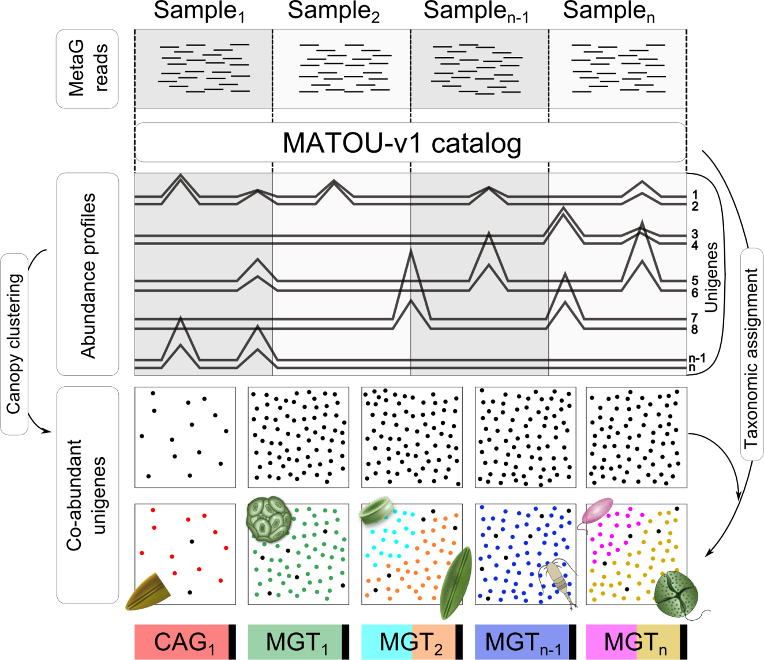

Fig. S1. Conceptual basis of the MGT approach. Metagenomic reads from a series of Tara Oceans samples were mapped against the MATOU-v1 catalog of unigenes constructed as described in Carradec et al., 2018. The canopy clustering method is adapted from Nielsen et al., 2014. The resulting gene clusters (black squares) are called co-abundance gene groups (CAGs); CAGs with more than 500 unigenes are referred to as metagenomics based transcriptomes (MGTs). Black dots in the bottom row of the black squares represent taxonomically unassigned unigenes. The possibility of having more than one taxon in an individual MGT is demonstrated by different colors of the dots in the same black square and by different colors of the rectangles at the bottom of the figure. 11,846 CAGs are composed of 7,254,163 unigenes, 924 MGTs are composed of 6,946,068 unigenes.
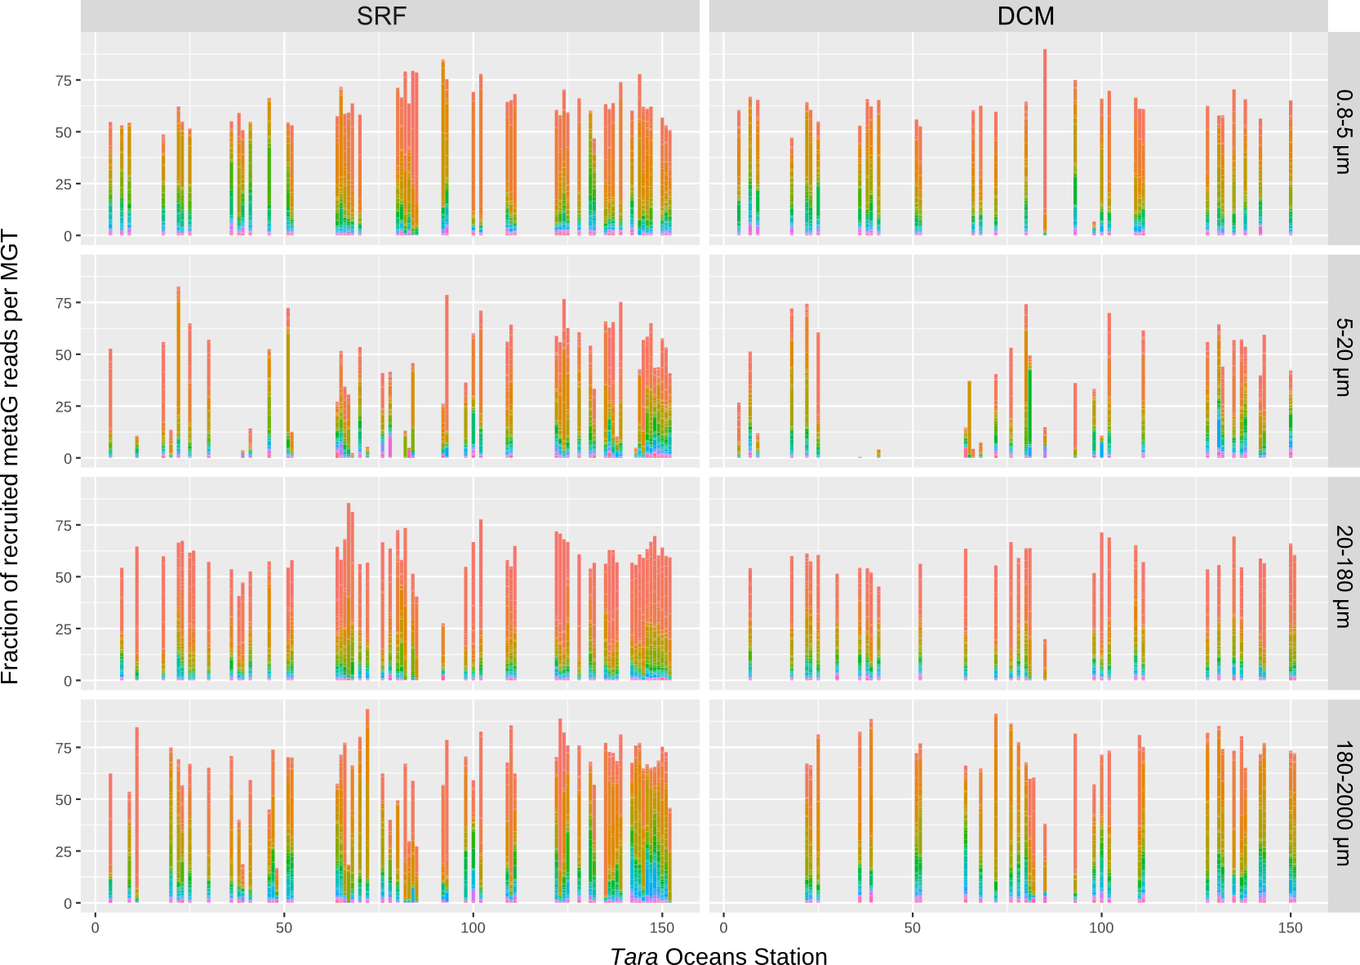

Fig. S2. Distribution of fractions of metagenomic reads recruited by MGTs across Tara Oceans stations. Metagenomic readsets were mapped onto the MGT unigenes with at least 95% of identity over at least 80% of the read length. Each bar represents a total proportion of metagenomic reads mapped onto the MATOU-v1 catalog and assigned to an MGT. Color legend - from MGT-1 in red to MGT-924 in purple. SRF - surface, DCM - deep-chlorophyll maximum.
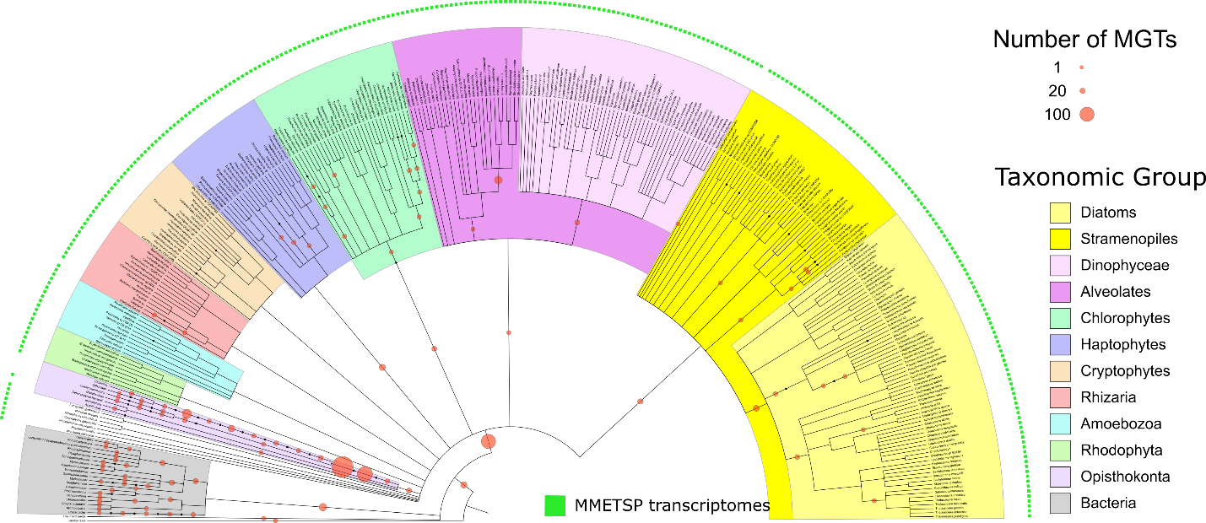

Fig. S3. A taxonomic dendrogram representing the eukaryotic tree of life demonstrates differences in taxonomic diversity of the MGT collection and the MMETSP collection. The size of the circles represents the number of MGTs positioned at a given taxonomic node. Solid green squares around the dendrogram represent taxa detected in the MMETSP collection.

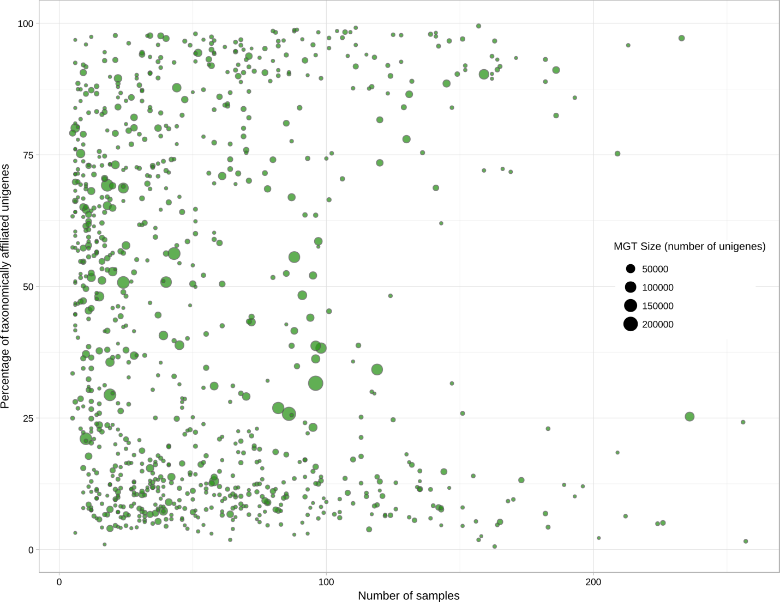

Fig. S4. Correlation between the number of samples recruiting an MGT (x axis), the number of taxonomically assigned unigenes in that MGT (y axis), and the MGT size (circle size).
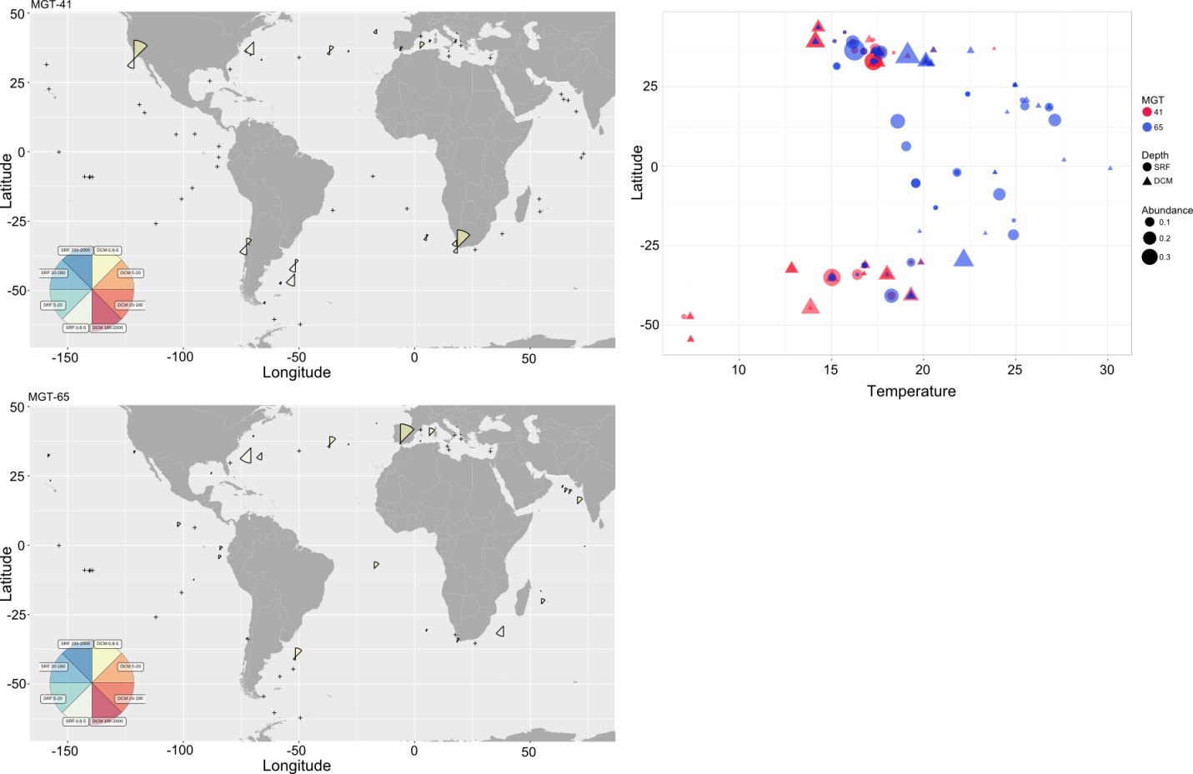
Fig. S5. Geographical distribution of MGT-41 (A) and MGT-65 (B) representing the B2 and B1 ecotypes of Bathycoccus prasinos, respectively. Panel C shows differential environmental preferences of MGT-41 and MGT-65 in relation to latitude (y axis), sea water temperature (x axis), and sampling depth (the symbol shape).
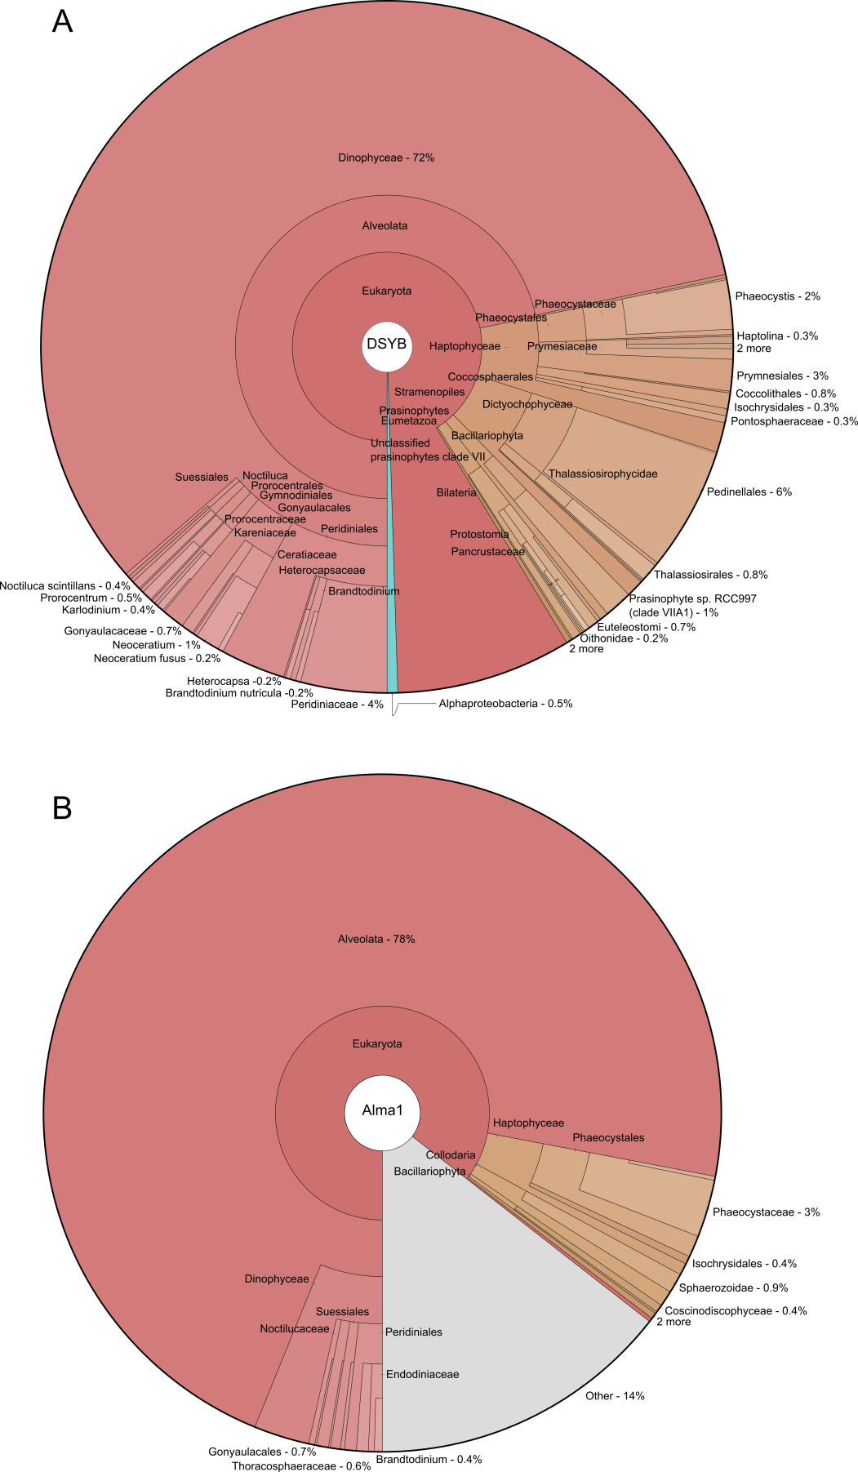
Fig. S6. Krona maps demonstrating the taxonomic diversity of DSYB-related (A) and Alma1-related (B) unigenes in the MATOU-v1 catalog.
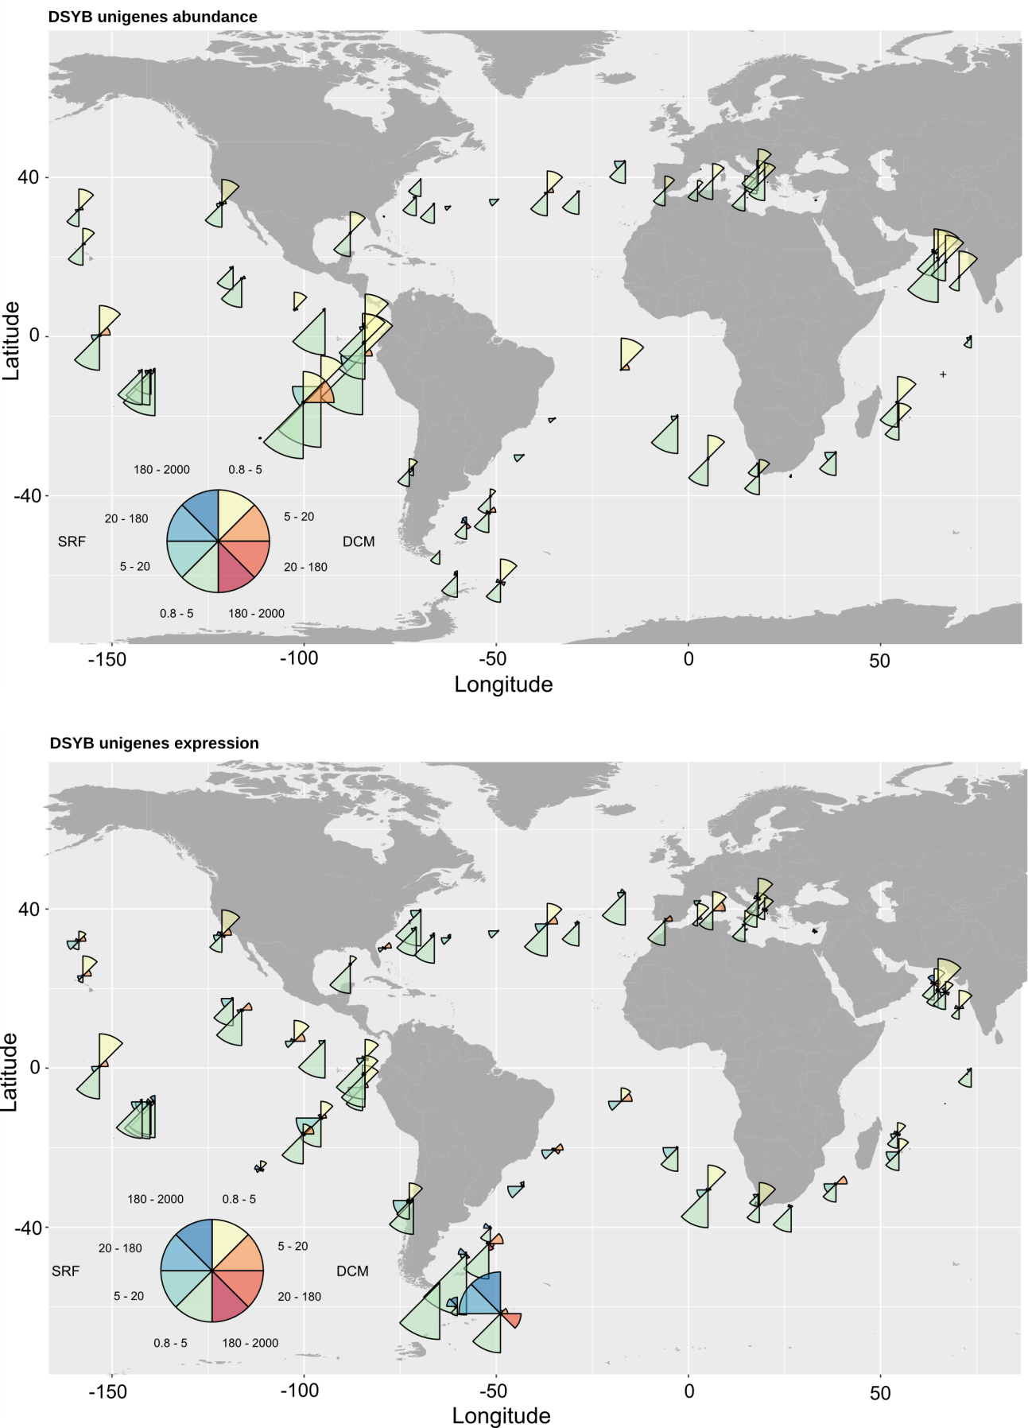
Fig. S7. Geographical distribution of DSYB-related unigenes across Tara Oceans stations based on their abundance (top) and expression (bottom).
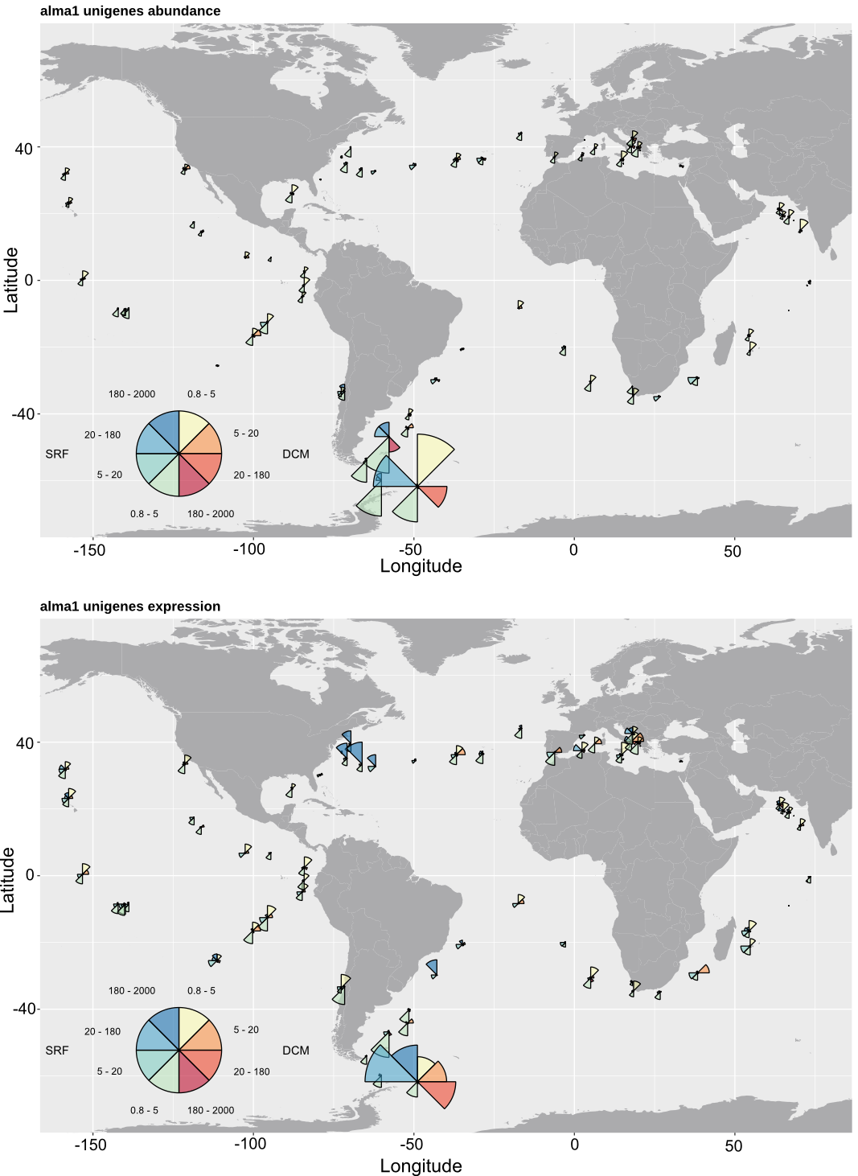
Fig. S8. Geographical distribution of Alma1-related unigenes across Tara Oceans stations based on their abundance (top) and expression (bottom).

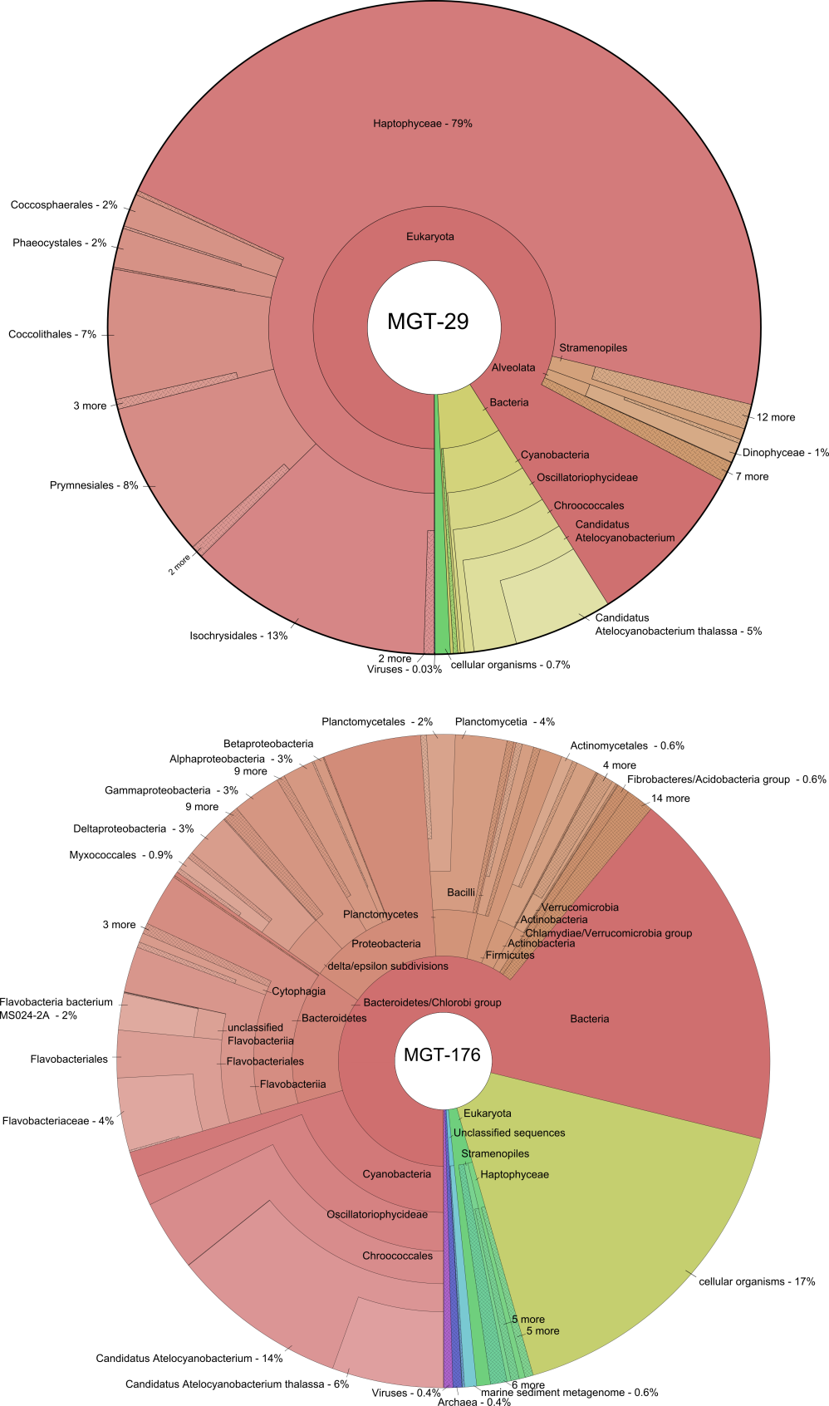

Fig. S9. Krona maps demonstrating the taxonomic diversity of unigenes within MGT-29 (A) and MGT-176 (B).
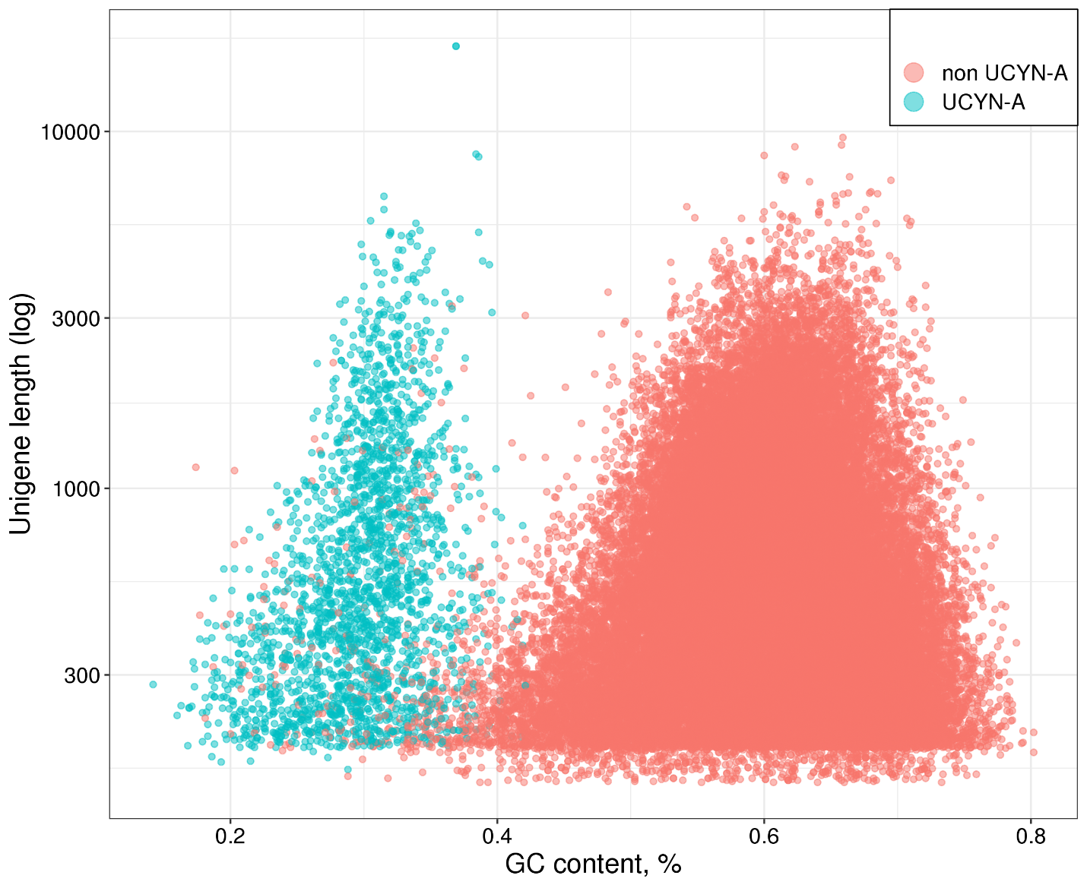
Fig. S10. The GC content of the unigenes taxonomically assigned to UCYN-A and those taxonomically assigned to the Haptophyte clade and possibly representing the potential host of an interspecies association detected in MGT-29.
Supplemental Figure S11 (separate file) – Graphical representation of taxonomic affiliation of unigenes in MGTs. O/U - other unclassified.

Supplemental Figure S12 (separate file) – Geographical distribution of MGTs across Tara Oceans stations separated by depth (SRF and DCM) and size fractions (0.8 - 5 μm; 5 - 20 μm; 20 - 180 μm; 180 - 2000 μm). For each sample, the MGTs’ abundance is defined as the third quartile of the abundance of their unigenes. Each map shows relative values. SRF - surface, DCM - deep chlorophyll maximum.

Supplemental table S1 (separate file). Major characteristics of individual MGTs, including their size, percentage of the taxonomically affiliated unigenes, global taxonomic assignment, completeness, and contamination.

Supplemental table S2 (separate file). Sequence coverage of the reference organisms (Bathycoccus prasinos and Oithona nana) by the MGTs.

Supplemental table S3 (separate file). Abundance and expression of the DSYB- and Alma1-related genes across Tara Oceans stations.

Supplemental table S4 (separate file). Potential interspecies associations detected in the MGT collection.

Supplemental dataset S1 (separate file) – Major statistical characteristics of the MGT collection and distribution of the MGTs across samples collected from the Tara Oceans expedition.
Supplemental dataset S2 (separate file) – Functional annotations of the host-related unigenes in MGT-29 based on the Kyoto Encyclopedia of Genes and Genomes (KEGG) database.

Supplemental_Code.zip - The original code of the canopy clustering algorithm described in Nielsen et al. 2014.

mgt-v1_cap3.tar.bz2 - CAP3-based MGT post assemblies, available at http://www.genoscope.cns.fr/tara/.

MGT-v1.tar.gz - MGT nucleic sequences, available at http://www.genoscope.cns.fr/tara/.

