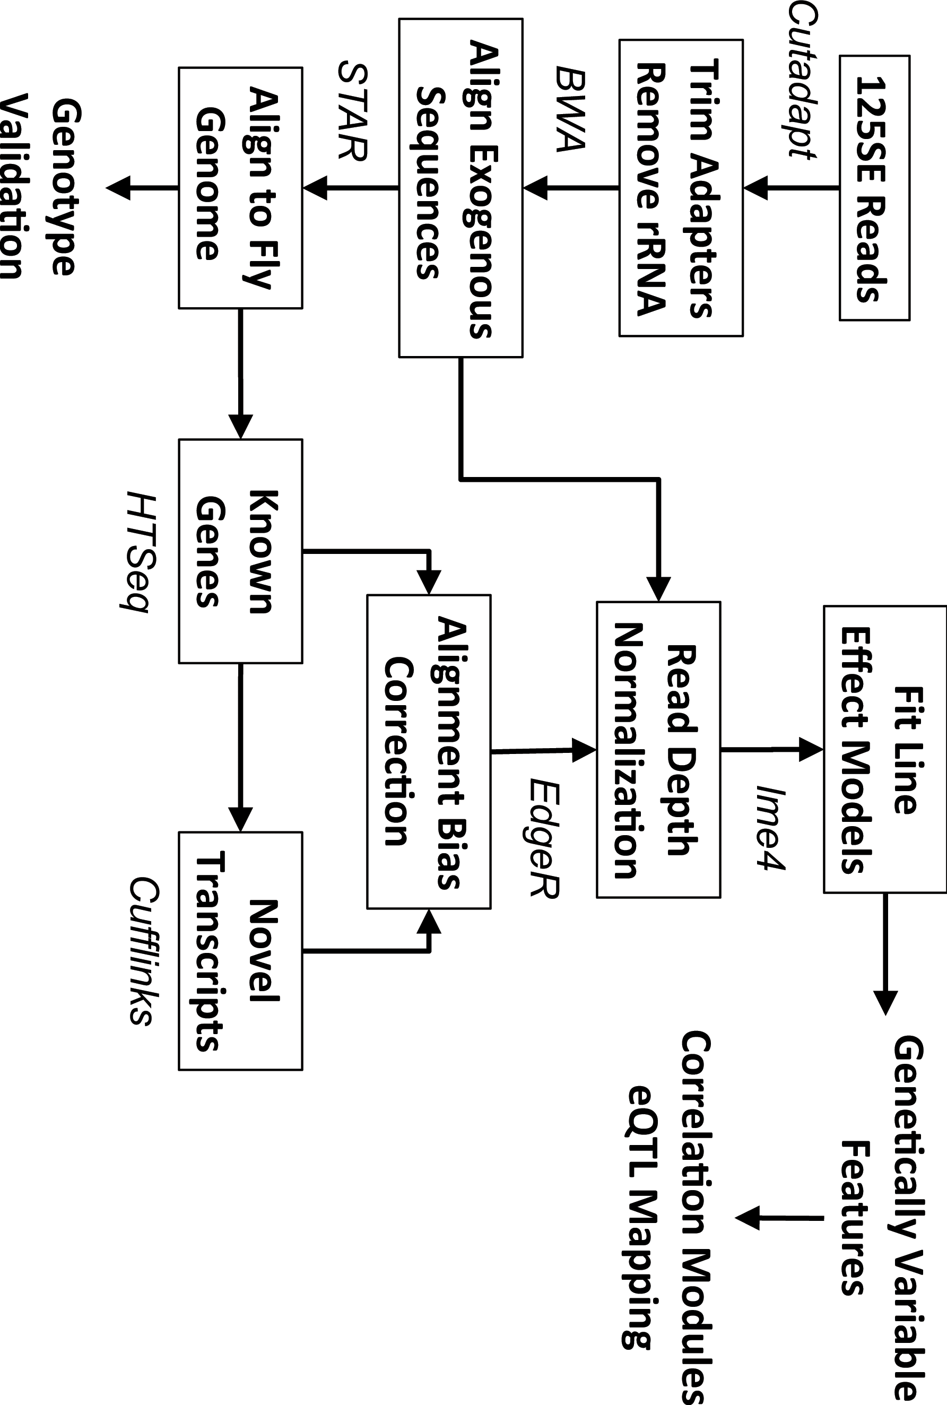
Supplemental Figure S1. Schematic of the bioinformatics pipeline used for RNAseq analysis.

