List of supplementary items
Text S1: study of the sex-linked genes that do not map onto the C. sativa Chromosome 1
Table S1: Sequencing and mapping statistics
Table S2: Mapping iterations and SEX-DETector results.
Figure S1: patterns of molecular evolution of C. sativa sex chromosomes.
Figure S2: Log-log plot of male expression versus female expression for all the C. sativa genes.
Figure S3: Venn diagram showing the numbers of sex-biased genes found by DEseq2, EdgeR and limma-voom.
Figure S4: correspondence between the assemblies of Grassa et al. (2018) and Laverty et al. (2019).

Text S1: study of the sex-linked genes that do not map onto the C. sativa Chromosome 1

192 sex-linked genes (i.e 35% of all sex-linked genes) mapped to chromosomes other than Chromosome 1 in the assembly of Grassa et al (2018). Here we tried to understand this observation. A first possibility is that these genes are false positives of the SEX-DETector method. SEX-DETector's rate of false positives was found to be low in previous work (<5%, e.g. Muyle et al. 2016, 2018; Martin et al. 2019). However, we used permissive mapping here and this could increase the rate of false positives compared to previous work. To check this possibility, we used more stringent criteria to assign a gene as sex-linked. If the sex-linked genes mapping outside Chromosome 1 (hereafter called “atypical sex-linked genes”) are false positives, their number should go down, as they most likely do match the criteria for sex-linkage less perfectly than the real sex-linked genes. However, more stringent criteria resulted in similar numbers and % of atypical sex-linked genes, except for one conservative criterion (see table below).

Table: number of sex-linked genes using different criteria. We show the number of sex-linked genes in and out of Chromosome 1 using the criterion indicated in the main text: probability of being XY (P_XY) + probability of being X-hemixygous (P_Xh) ≥ 0.8 (i.e. SEX-DETector's default criteria) and other more stringent criteria.
 | P_XY + P_Xh ≥ 0.8* | P_XY or P_Xh ≥ 0.8 | P_XY or P_Xh ≥ 0.9 | P_XY + P_Xh ≥ 0.8 and no SNP with error
All mapped sex-linked genes | 555 | 447 | 321 | 342
Sex-linked genes mapping to Chromosome 1** | 363  (65%) | 266  (60 %) | 216  (67 %) | 259  (76%)
Sex-linked genes mapping to other chromosomes** | 192  (35%) | 181  (40 %) | 105  (33 %) | 83  (24%)
* standard SEX-DETector parameters (see Methods)
** numbers and (%) are indicated

Another possibility that we explored is that the atypical sex-linked genes are true sex-linked genes, which are misplaced on the C. sativa assembly (i.e. they are incorrectly placed on other chromosomes than Chromosome 1). To check this, we mapped the C. sativa genes onto the Rosa chinensis reference genome (Raymond et al. 2018). R. chinensis has undergone few genome rearrangements since the diversification of the Rosaceae, and it belongs to the same order (Rosales) as C. sativa. If the atypical sex-linked genes map to the same genomic regions of R. chinensis as do the typical sex-linked genes (those mapping to C. sativa Chromosome 1), it would suggest that atypical sex-linked genes are true sex-linked genes. We mapped all the C. sativa genes onto the R. chinensis reference genome following the procedure described in the Method section below.

Figure: Distribution of the genes homologous to the C. sativa sex-linked genes in the R. chinensis genome. R. chinensis chromosomes are shown. In red are the windows for which the density is greater than 10% and in purple, windows for which density is greater than 7% but lower than 10%. A scale from 0 to 30% indicates the % of genes homologous to the C. sativa sex-linked genes present in the windows.
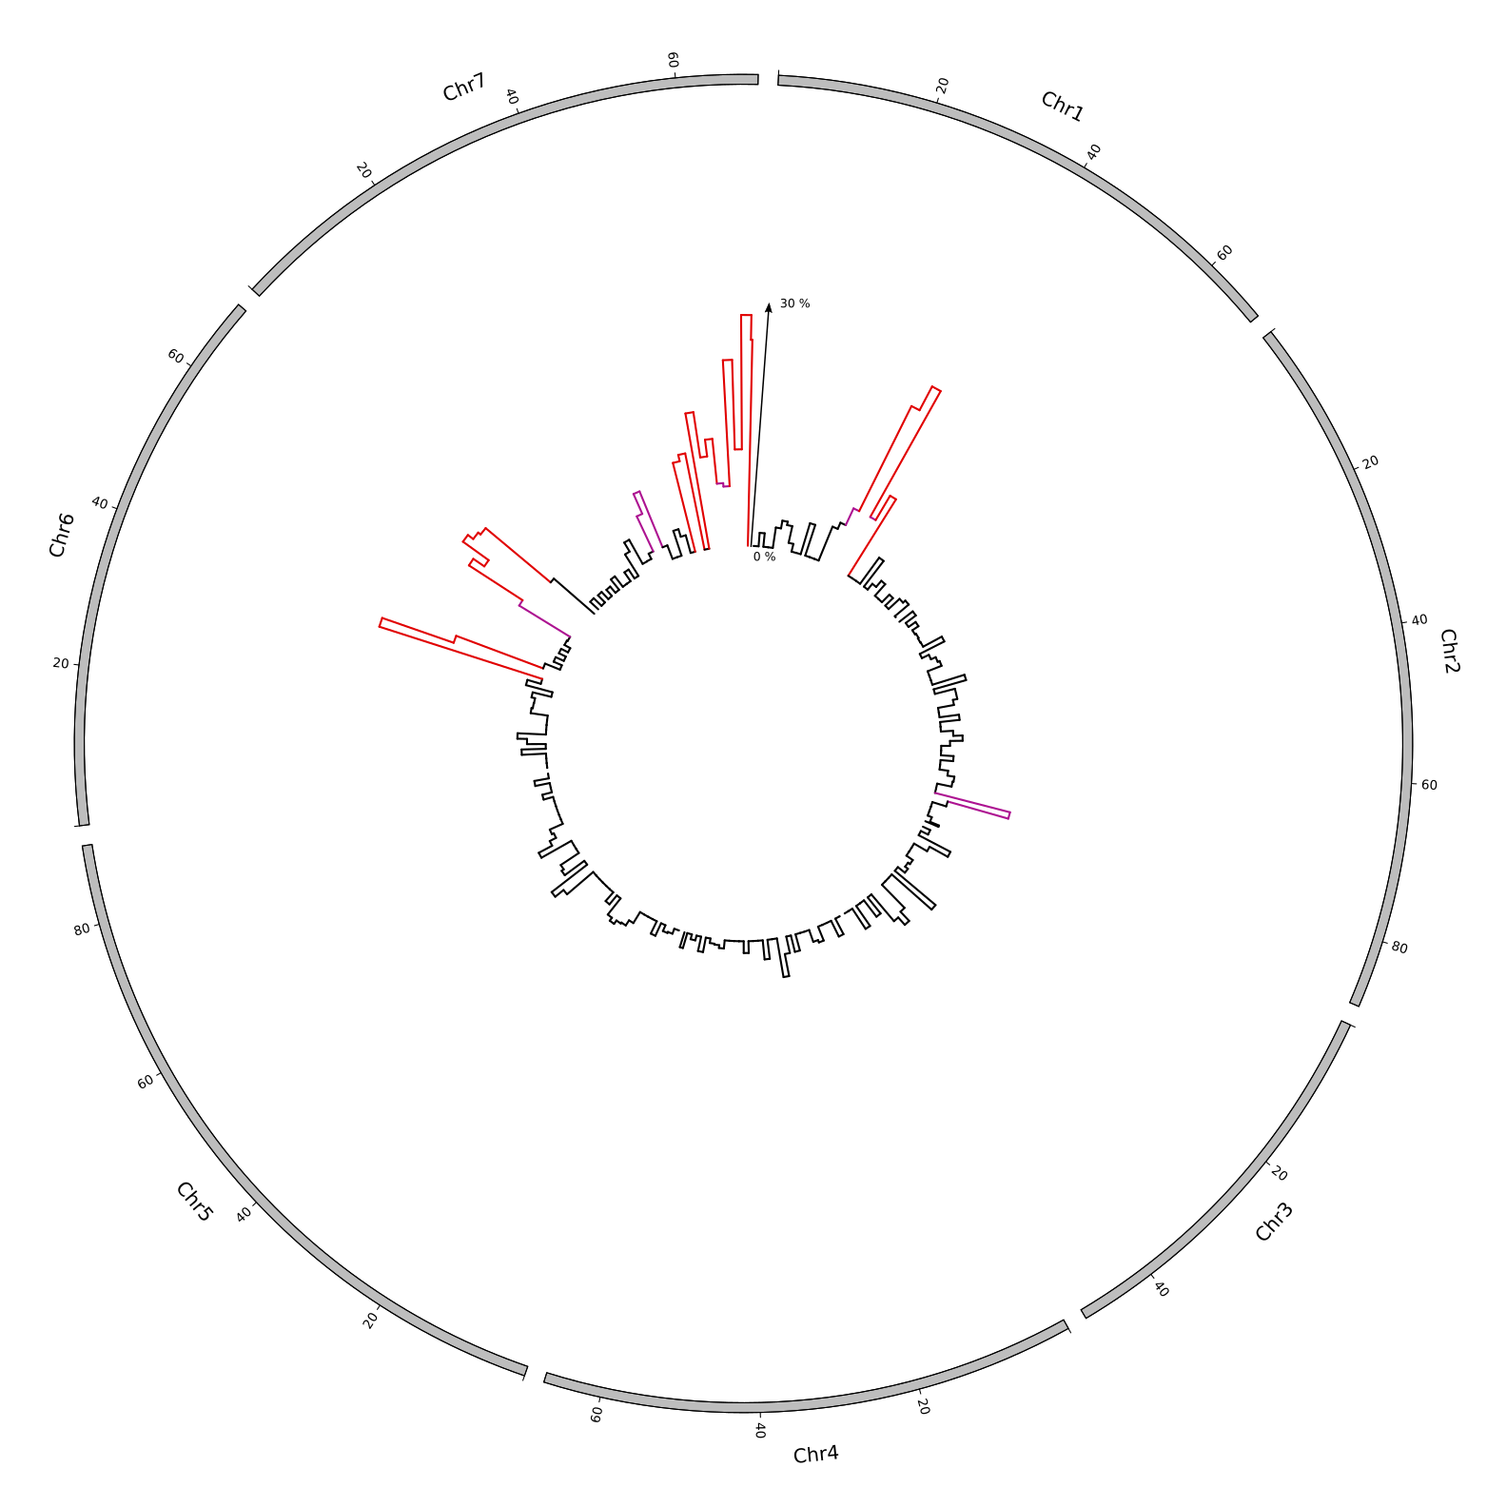

In order to identify the regions of R. chinensis homologous to the C. sativa sex chromosomes (hereafter called the SL-homologous regions), the R. chinensis genome was split in 2 Mb windows. The windows with more than 10% or 7% of genes homologous to C. sativa sex-linked genes defined the SL-homologous regions. We detected from 38 Mb to 50 Mb of such regions, using 10% and 7% threshold respectively. In those regions, we found 265 genes homologous to C. sativa sex-linked genes (including 31 atypical genes) and 304 genes homologous to C. sativa sex-linked genes (including 43 atypical genes) using 10% and 8% threshold respectively. As expected, there are several SL-homologous regions (see figure above), due to chromosomal rearrangements that have occurred since both species diverged. The degree of synteny of the sex-linked gene homologs is however high. We then tested whether the atypical sex-linked genes are enriched in the SL-homologous regions, which is expected if they are true sex-linked genes (see above). We found that atypical sex-linked genes are over-represented on the SL-homologous regions compared to non-sex-linked genes (chi2 test p-value: 2.14 x10⁻⁹ for the 10% threshold and 1.73 x 10⁻¹⁴ for the 7% threshold).

In conclusion, the pool of genes detected as sex-linked but mapping outside Chromosome 1 in the assembly of Grassa et al (2018) is most likely constituted by false positives in our analysis (permissive mapping) and by incorrectly placed genes in the assembly. This last type of error could arise if these genes are products of recent duplications, or because the sex chromosomes are often more difficult to assemble than the rest of the genome. As shown in Figure S4, there is quite some disagreement between the most recently published assemblies of the C. sativa genome, and erroneous placement has likely occurred in both. We are currently not able to quantify how many genes fall in each category (false positives vs assembly errors). Future improvements of the C. sativa genome should be able to resolve this issue.

Methods
We did a blastp of C. sativa translated transcriptome against proteome of R. chinensis (the r1.1 predicted proteome available at https://lipm-browsers.toulouse.inra.fr/pub/RchiOBHm-V2/): blastp -max_target_seqs 1 -max_hsps 1 -outfmt 6 -evalue 0.001. After the blastp we obtained 22,123 hits, of which:
- 502 sex-linked genes (among which 165 did not blast on Chromosome 1 of C. sativa)
- 20,529 inferred as autosomal or with undetermined segregation type by SEX-DETector (=non-sex-linked genes)
Circos plots were done similarly as indicated in the Methods section of the main text. The genome of R. chinensis was split in windows of 2 Mb to analyse the density of mapped C. sativa sex-linked genes along this genome (bedtools makewindows). The sex-linked and non-sex-linked densities were determined with bedtools intersect. Then, the percent of sex-linked genes for each windows was calculated by dividing the number of sex-linked by the number of sex-linked and non-sex-linked genes.

References
Muyle, A., Käfer, J., Zemp, N., Mousset, S., Picard, F., & Marais, G. A. (2016). SEX-DETector: a probabilistic approach to study sex chromosomes in non-model organisms. Genome biology and evolution, 8(8), 2530-2543.
Muyle, A., Zemp, N., Fruchard, C., Cegan, R., Vrana, J., Deschamps, C., ... & Marais, G. A. (2018). Genomic imprinting mediates dosage compensation in a young plant XY system. Nature plants, 4(9), 677.
Martin, H., Carpentier, F., Gallina, S., Godé, C., Schmitt, E., Muyle, A., ... & Touzet, P. (2019). Evolution of young sex chromosomes in two dioecious sister plant species with distinct sex determination systems. Genome biology and evolution, 11(2), 350-361.
Raymond, O., Gouzy, J., Just, J., Badouin, H., Verdenaud, M., Lemainque, A., ... & Carrere, S. (2018). The Rosa genome provides new insights into the domestication of modern roses. Nature Genetics, 50(6), 772.

Table S1: Sequencing and mapping statistics

Individuals | Total read numbers | % of mapped reads with BWA | % of mapped reads with Bowtie2 | % of mapped reads with GSNAP (iteration #4)
Mother | 48 020 391 | 84.18 | 83.20 | 88.36
Daughter 1 | 47 970 499 | 84.74 | 83.75 | 88.79
Daughter 2 | 48 038 555 | 83.53 | 82.51 | 88.93
Daughter 3 | 48 009 889 | 84.86 | 83.80 | 88.57
Daughter 4 | 48 168 799 | 84.51 | 83.43 | 88.99
Daughter 5 | 47 996 302 | 84.86 | 83.90 | 87.75
Father | 47 889 741 | 79.96 | 79.00 | 85.12
Son 1 | 48 048 469 | 83.56 | 82.54 | 87.79
Son 2 | 47 890 377 | 78.31 | 77.37 | 83.42
Son 3 | 48 031 219 | 82.77 | 81.73 | 87.11
Son 4 | 47 965 502 | 78.33 | 77.45 | 83.76
Son 5 | 48 015 625 | 81.19 | 80.15 | 86.00
Mean female - male difference | 60 583 | 3.70 | 3.66 | 2.99

Table S2: Mapping iterations and SEX-DETector results.
The Y genotyping error parameter (YGE) is shown for the different runs. YGE varies between 0 and 1; a high YGE value yields unreliable results and usually comes from mapping errors; acceptable values for YGE are around 5-10% (Muyle et al. 2016). Results are shown for gene sets with high to low minimum read numbers for SNP-calling; the former are supposed to comprise much less genotyping errors than the latter. For each run, the number of contigs for which SEX-DETector produced an assignment (autosomal and sex-linked included) is indicated.

Minimum read# per SNP | BWA | GSNAP #1 | GSNAP #2 | GSNAP #3 | GSNAP #4
150 | 0.19 (n=1345) | 0.10 (n=1500) | 0.05 (n=1533) | 0.04 (n=1522) | 0.03 (n=1527)
10 | 0.82 (n=2792) | 0.79 (n=5074) | 0.14 (n=9258) | 0.07 (n=9532) | 0.05 (n=9614)
3 | 0.84 (n=1790) | 0.82 (n=3743) | 0.82 (n=3976) | 0.10 (n=11910) | 0.07 (n=12081)

Figure S1: patterns of molecular evolution of C. sativa sex chromosomes.
A) X-Y d_{S} values for the XY gene pairs, B) Y/X expression ratio for the XY gene pairs, the black bar shows the expected value for no Y degeneration, the red bar shows the median observed here. Both are significantly different (Wilcoxon paired test p < 10⁻¹⁶). C) Dosage compensation in C. sativa. The expression levels of the X and Y alleles in males and females are shown for gene categories (n =77 for each categories, except for X-hemizygous : n = 204) with different levels of Y degeneration (measured by the Y/X expression ratio). Sex-biased genes (with strong and significant differences in male and female expression) have been removed, as we do not expect them to exhibit dosage compensation (see Muyle et al. 2012, 2018). Sex-linked genes mapping to Chromosome 1 and elsewhere in the genome have been used to prepare this figure.
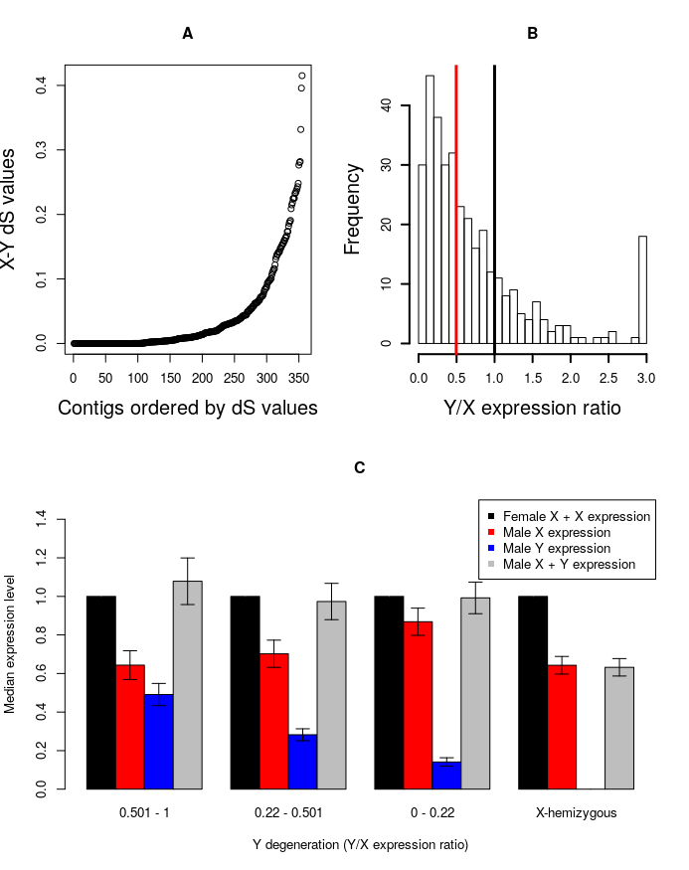

Figure S2: Log-log plot of male expression versus female expression for all the C. sativa genes.
The read lines indicate Y = X (central line) and two fold change. Genes with significant sex-biased expression are shown in orange (female-biased) or in blue (male-biased).

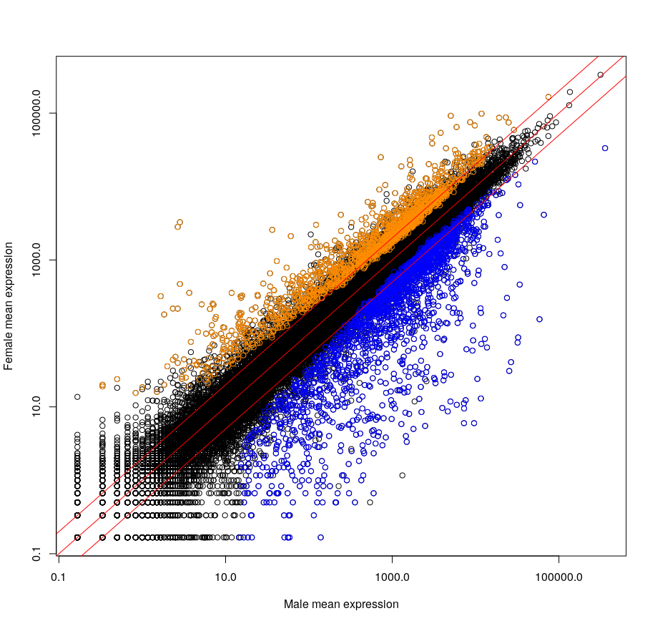

Figure S3: Venn diagram showing the numbers of sex-biased genes found by DEseq2, EdgeR and limma-voom.
Sex-biased the genes that had significant differences in expression between males and females in at least two of the three methods were retained.

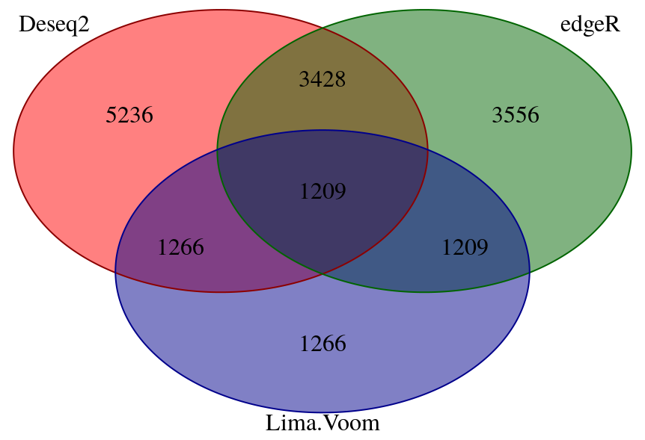

Figure S4: correspondence between the assemblies of Grassa et al. (2018) and Laverty et al. (2019).
We blasted the 30,074 sequences derived from the draft genome of van Bakel et al. (2011) to both assemblies (blastn -max_target_seqs 1 -max_hsps 1). For each gene, positions on both assemblies was used to make the links shown in the figure. Circos was used to represent graphically those links. Each Laverty et al. chromosome has a different color. The assembly of Grassa et al. is shown at the left and the one of Laverty et al. at the right. Sex-linked genes are indicated in the assembly of Laverty et al. by small bars; many sex-linked genes fall in the unassembled scaffolds in this assembly. Chromosome 1 in Grassa et al. corresponds to Chromosome 10 in Laverty et al. (one of the three candidates for being sex chromosomes mentioned in their paper). However, Chromosome 10 in Laverty et al. is much smaller than Chromosome 1 in Grassa et al., thus only part of the X Chromosome seems assembled in by Laverty et al. THCAS and CBDAS genes are indicated by two grey dots in the genome of Grassa et al.

