Identification of pathogenic variant enriched regions across genes and gene families

Supplemental Figures:

Contents

- Supplemental Fig S1. Multiple sliding window burden analysis results.
- Supplemental Fig S2. Top 10 domains overlapped by PERs
- Supplemental Fig S3. The PER viewer.
- Supplemental Fig S4. Gene-wise missense burden analysis for the voltage-gated sodium channel gene family members.
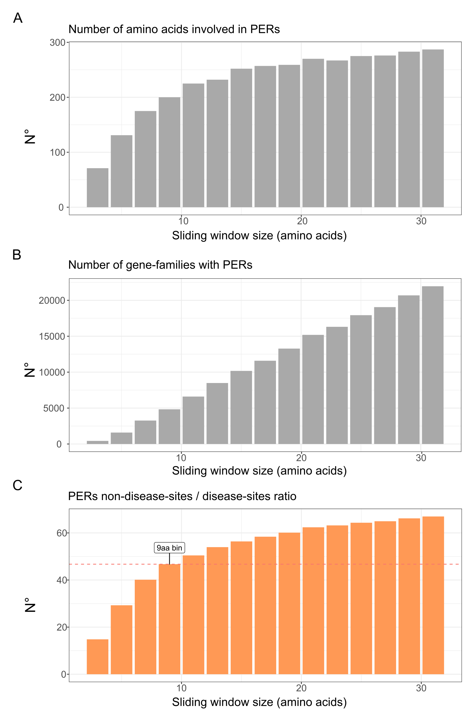
Supplemental Fig S1. Multiple sliding window burden analysis results. Summary of the results obtained with the multiple sliding window analysis performed from size 3 amino acids to size 31 amino acids. Global counts are shown for the A) total number of amino acids inside PER detected, B) Total number of genes with at least one PER detected and C) the ratio between non-disease amino acids sites and disease-associated sites inside PER.
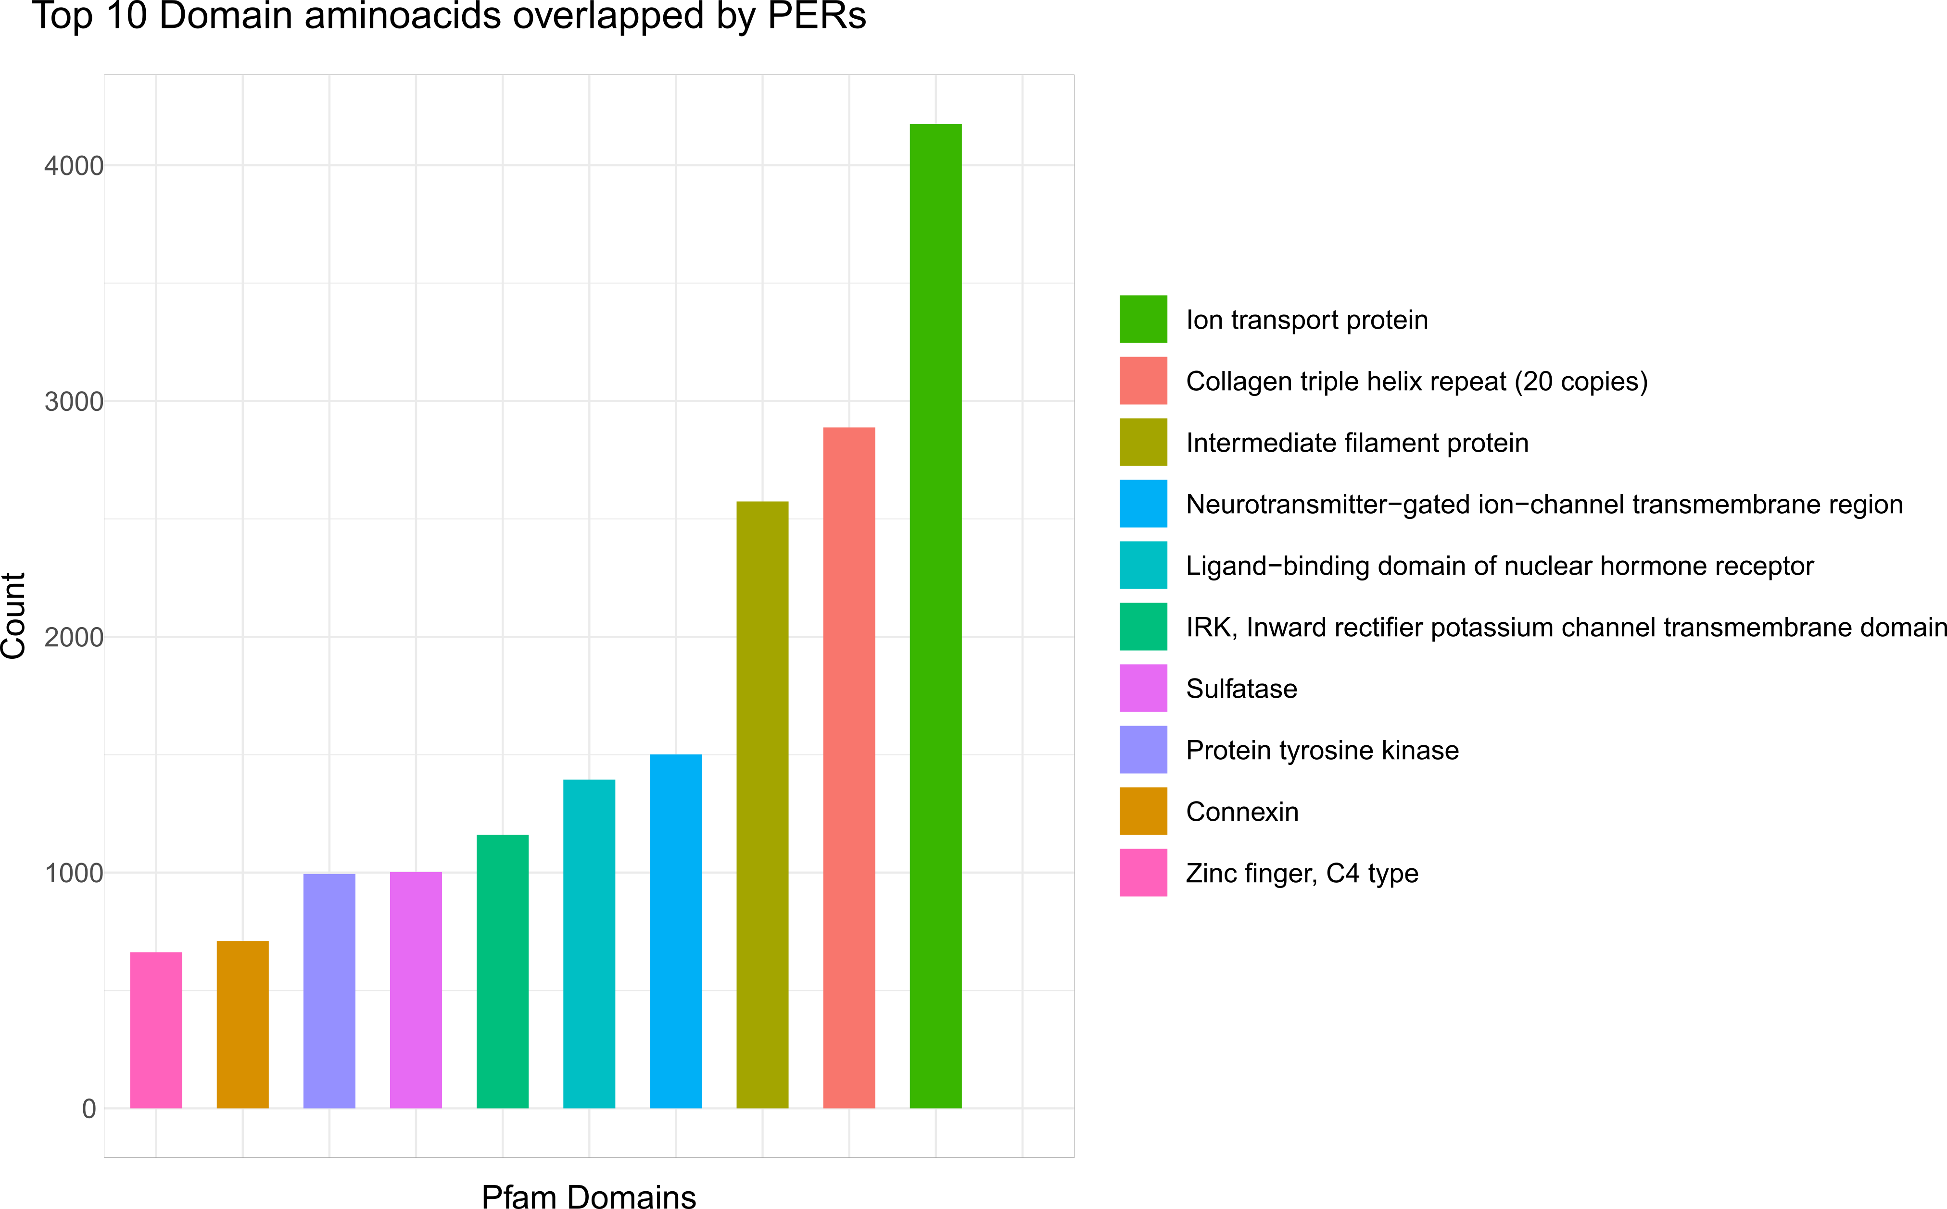

Supplemental Fig S2. Top 10 domains overlapped by PERs. Bars represent the total count of amino acids within PERs that affect Pfam domains.
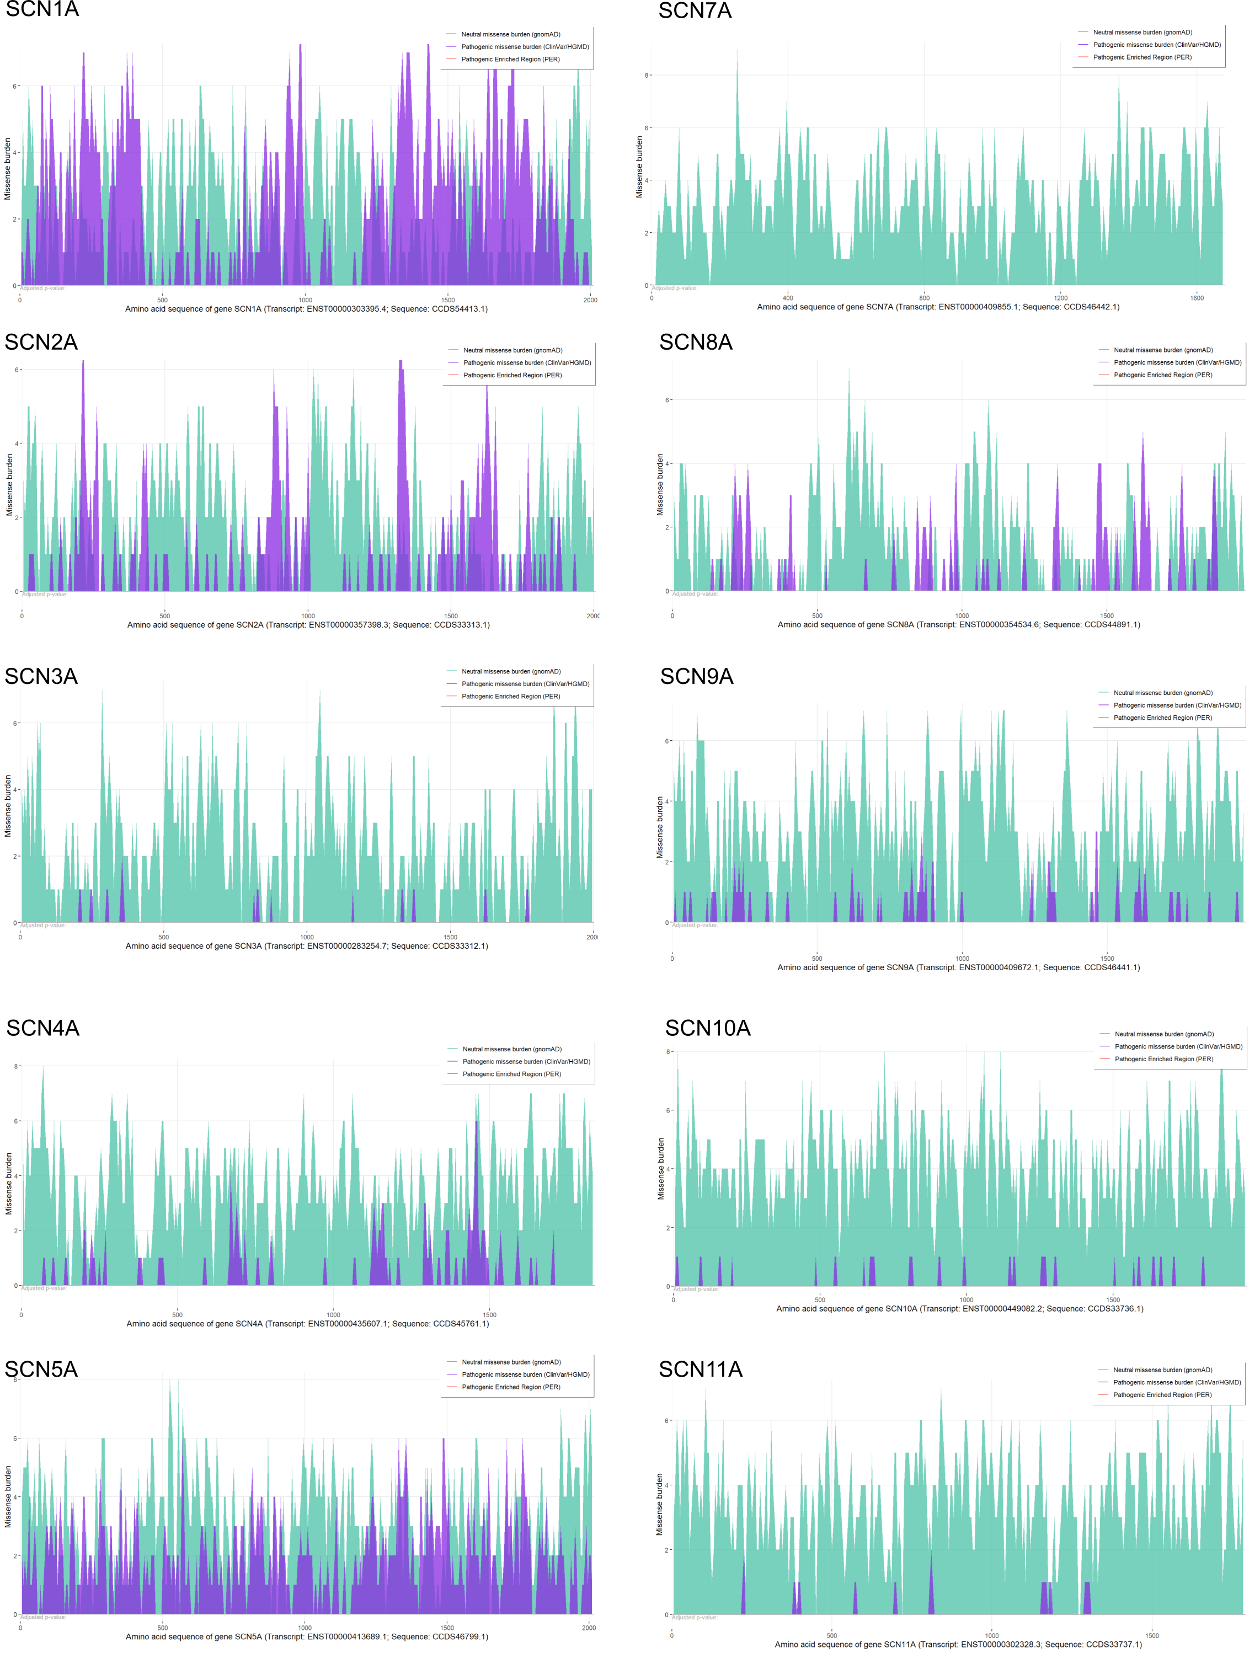
Supplemental Fig S3. Gene-wise missense burden analysis for the voltage-gated sodium channel gene family members. Gene-wise missense burden plots are shown for the 10 members of the family. Green area denotes general population burden. Purple area shows patient missense variant burden. No PERs were detected.

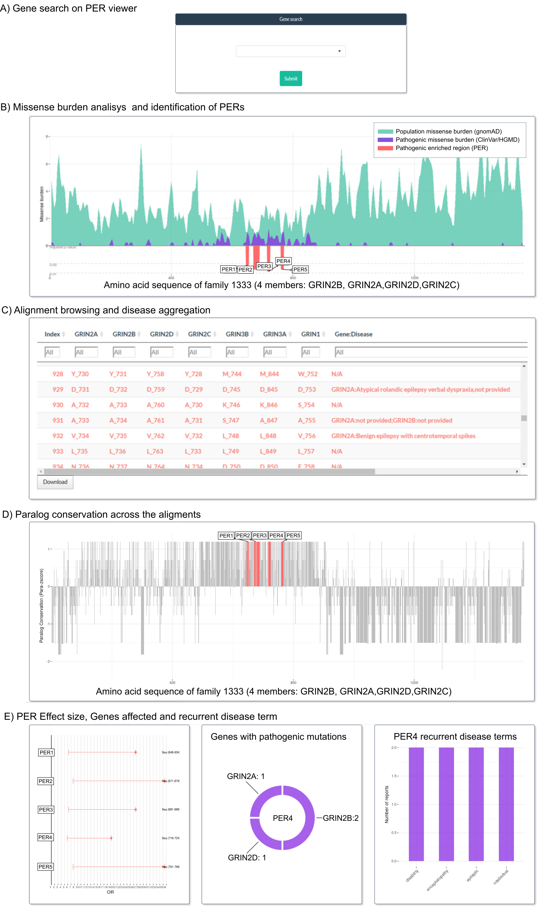
Supplemental Fig S4. The PER viewer. All burden calculations were made available through the PER viewer application (http://per.broadinstitute.org/). A) The gene search will yield burden calculations for family-wise or gene-wise approaches. B) The first graph shows population and patient missense burden in green and purple areas, respectively. PERs will be shown below burden plots in red areas proportional to their adjusted p-value. C) Table browsing over the alignment/sequence is provided in an additional tab. D) Paralog conservation is available for comparison. E) If PERs are found, individual evaluation of PERs fold enrichment (OR), Genes affected with disease associations inside PERs and recurrent disease terms found inside PERs are displayed.

