List of Supplementary Materials:

Fig S1. TFAP2A is enriched in neural crest
Fig S2. TFAP2A CUT&RUN libraries are highly concordant and enriched for the TFAP2A binding motif
Fig S3. Differential binding analysis by TFAP2A at induction and specification reveals putative neural crest enhancers

Fig S4. Expression domains of TFAP2 paralogs in the early avian embryo
Fig S5. Validation of antibody specificity via overexpression of TFAP2 paralogs

Fig S6. Stage-specific binding by TFAP2B and TFAP2C
Fig S7. Mutation of co-factor binding sites results in loss of neural crest enhancer activity
Fig S8. Proximity ligation assays indicate putative interactions between TFAP2A and TFAP2C at the neural plate border and TFAP2A and TFAP2B in the neural crest
Fig S9. A TFAP2A enhancer (TFAP2E1) drives specific reporter activity in neural crest cells
Fig S10. A TFAP2-mediated molecular switch controls the transition from induction to specification

Table S1. Number of embryos analyzed and fraction displaying phenotypes
Table S2: Global TFAP2 paralog peak coordinates at induction and specification
Table S3: Gene ontology analysis of genes associated with TFAP2A binding

Table S4: TFAP2A peak coordinates relative to neural crest GRN genes
Table S5: Differential binding analysis of TFAP2A induction and specification peaks
Table S6. Coordinates of putative enhancers dynamically regulated by TFAP2A

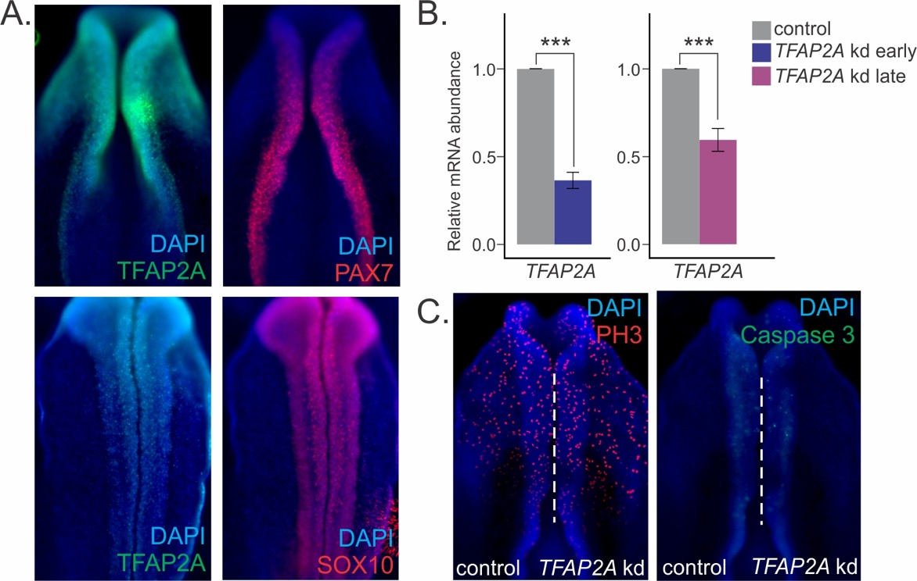

Fig S1. TFAP2A is enriched in neural crest

(A) Immunohistochemistry for TFAP2A (green) and PAX7/SOX10 (red) shows strong co-localization with neural plate border and neural crest markers. (B) Quantitative RT-PCR for TFAP2A in control vs TFAP2A DsiRNA-treatment sides of bilaterally electroporated embryos surveyed at HH8- and HH9 shows strong reduction in gene expression upon stage-specific knockdown. (C) Immunohistochemistry for cell proliferation (phospho-histone H3, red) and cell death (CASP3, green) markers in bilaterally-transfected TFAP2A DsiRNA-treated embryos. Error bars in (B) represent standard error. kd: knockdown, ***P≤0.001 (see also Table S1 for number of embryos analyzed)

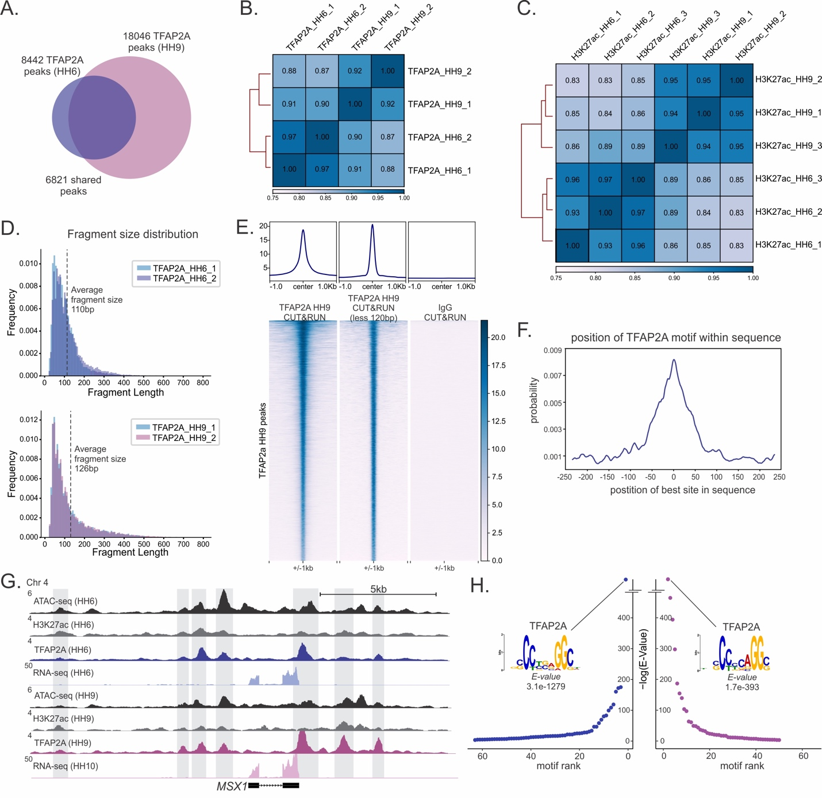

Fig S2. TFAP2A CUT&RUN libraries are highly concordant and enriched for the TFAP2A binding motif

(A) Pairwise Pearson correlation analysis of TFAP2A CUT&RUN replicates at HH6 and HH9 (two replicates per stage). Intra-stage correlations were found to be significantly higher than inter-stage correlations. (B) Pairwise Pearson correlation analysis of H3K27ac CUT&RUN replicates at HH6 and HH9 (three replicates per stage). (C) Fragment size distribution of TFAP2A CUT&RUN read pairs. The average fragment size at HH6 was 110bp, while the average fragment size at HH9 was 126bp. (D) Profiles and heatmaps of TFAP2A CUT&RUN signal, TFAP2A signal of fragments less than 120bp, and IgG signal at TFAP2A specification peaks (HH9). Little to no unspecific binding of IgG to TFAP2A peaks is detected. (E) Position of the TFAP2A motif within the 500bp region centered around TFAP2A peak summits. The TFAP2A motif is centrally-enriched. (F) CUT&RUN analysis identified 8442 total TFAP2A peaks at induction and 18046 total peaks at specification, 6821 of which were maintained between both developmental time points. (G) CUT&RUN and RNA-seq profiles at the locus of the induction/specification gene Msx1. Msx1 is occupied by stable, “shared” TFAP2A/H3K27ac peaks and is expressed at both HH6 and at HH10. (H) de novo motif enrichment analysis via MEME-ChIP reveals the TFAP2A binding motif as the top enriched motif from both HH6 and HH9 CUT&RUN datasets. Values indicate significance of motif occurrence as reported by MEME. HH: Hamburger Hamilton, bp: base pairs, kb: kilobase

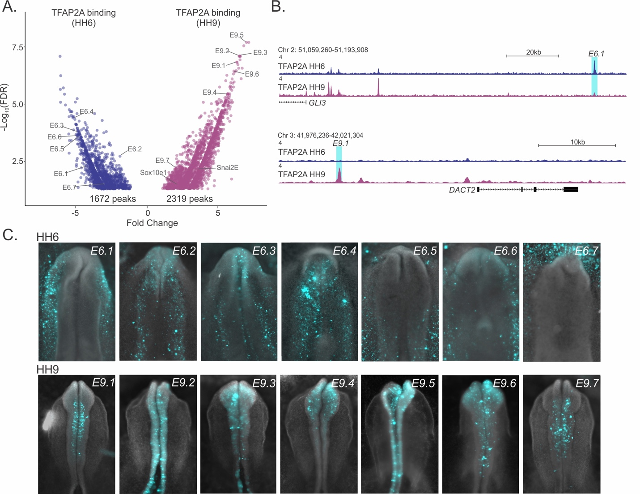

Fig S3. Differential binding analysis by TFAP2A at induction and specification reveals putative neural crest enhancers

(A) Differential binding analysis via Diffbind identified 1672 peaks significantly enriched in induction (HH6) and 2319 peaks enriched in specification (HH9). These peaks include both previously characterized (Sox1e1 and Snai2E) and novel cis regulatory elements. (B) CUT&RUN profiles for TFAP2A during induction (HH6) and specification (HH9) at putative enhancer elements. E6.1, which resides in the Gli3 locus, shows enriched binding by TFAP2A at HH6. In contrast, E9.1, which is present in the Dact2 locus, shows enriched TFAP2A binding during specification. (C) Reporter activity of 14 putative enhancer elements which display dynamic TFAP2A binding. Regions occupied by dynamic TFAP2A peaks are able to drive GFP expression, indicative of enhancer activity (also see Table S6).

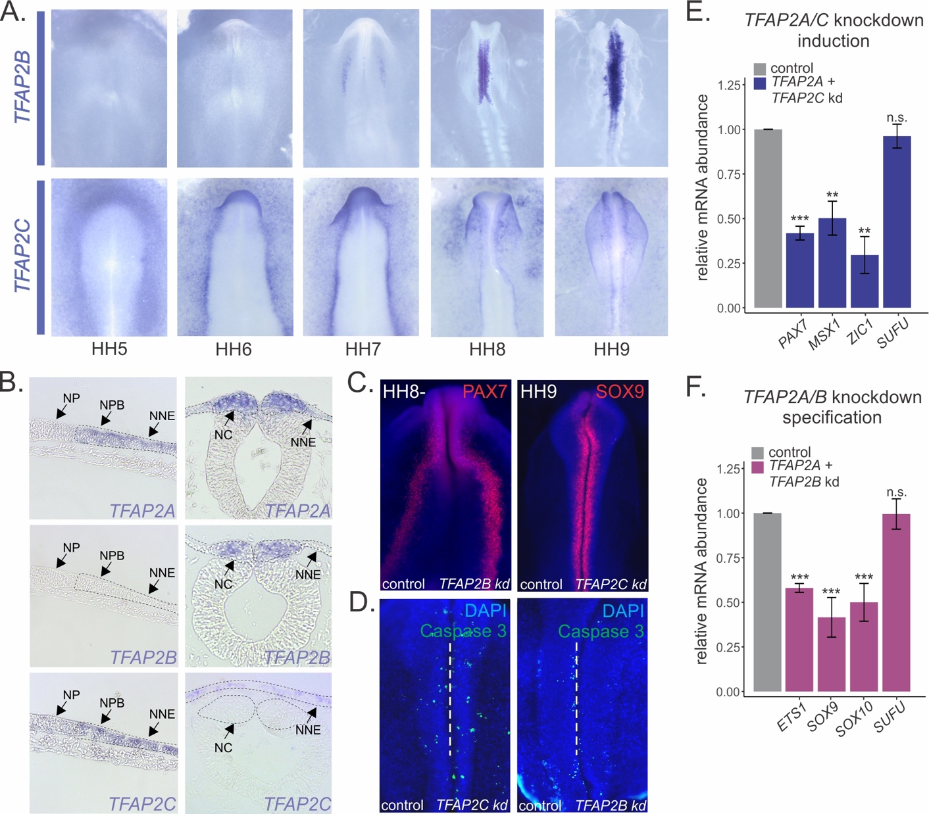

Fig S4. Expression domains of TFAP2 paralogs in the early avian embryo

(A) In situ hybridization for TFAP2B and TFAP2C in chick embryos at five developmental stages (HH5-9). (B) Transverse sections displaying TFAP2A, TFAP2B, and TFAP2C expression in the neural plate border and the neural crest. (C) Immunohistochemistry for PAX7 (red) following TFAP2B knockdown during induction, and SOX10 (red) following TFAP2C knockdown during specification. Both treatments show no effect on induction/specification. (D) Immunohistochemistry for cell death marker CASP3 in bilaterally-transfected TFAP2C morpholino-treated and TFAP2B DsiRNA-treated embryos. TFAP2B/C knockdown shows no effect on cell death. (E) Quantitative RT-PCR for induction genes Pax7, Msx1, and Zic1 in control vs TFAP2A/TFAP2C knockdown sides of bilaterally electroporated embryos, represented as fold change compared to control. Phenotypes were surveyed at HH8-. (F) Quantitative RT-PCR for specification genes Ets1, Sox9, and Sox10 in control vs TFAP2A/TFAP2B knockdown sides of bilaterally electroporated embryos, represented as fold change compared to control. Phenotypes were surveyed at HH9. The neural marker Sufu was included as a control to ensure defects were neural crest-specific. NP: neural plate, NPB: neural plate border, NNE: non-neural ectoderm, NC: neural crest, kd: knockdown, *P≤0.05, **P≤0.01, ***P≤0.001 (see also Table S1 for number of embryos analyzed)

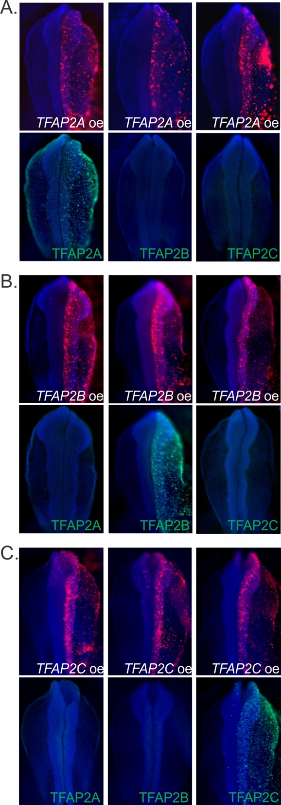

Fig S5. Validation of antibody specificity via overexpression of TFAP2 paralogs

(a-c) Embryos were bilaterally electroporated with overexpression constructs PCI-H2B-RFP-TFAP2A, PCI-H2B-RFP-TFAP2B, and PCI-H2B-RFP-TFAP2C, followed by immunostaining with anti-TFAP2A, anti-TFAP2B, and anti-TFAP2C. Ectopic expression was only detected by antibodies of the correct epitope.
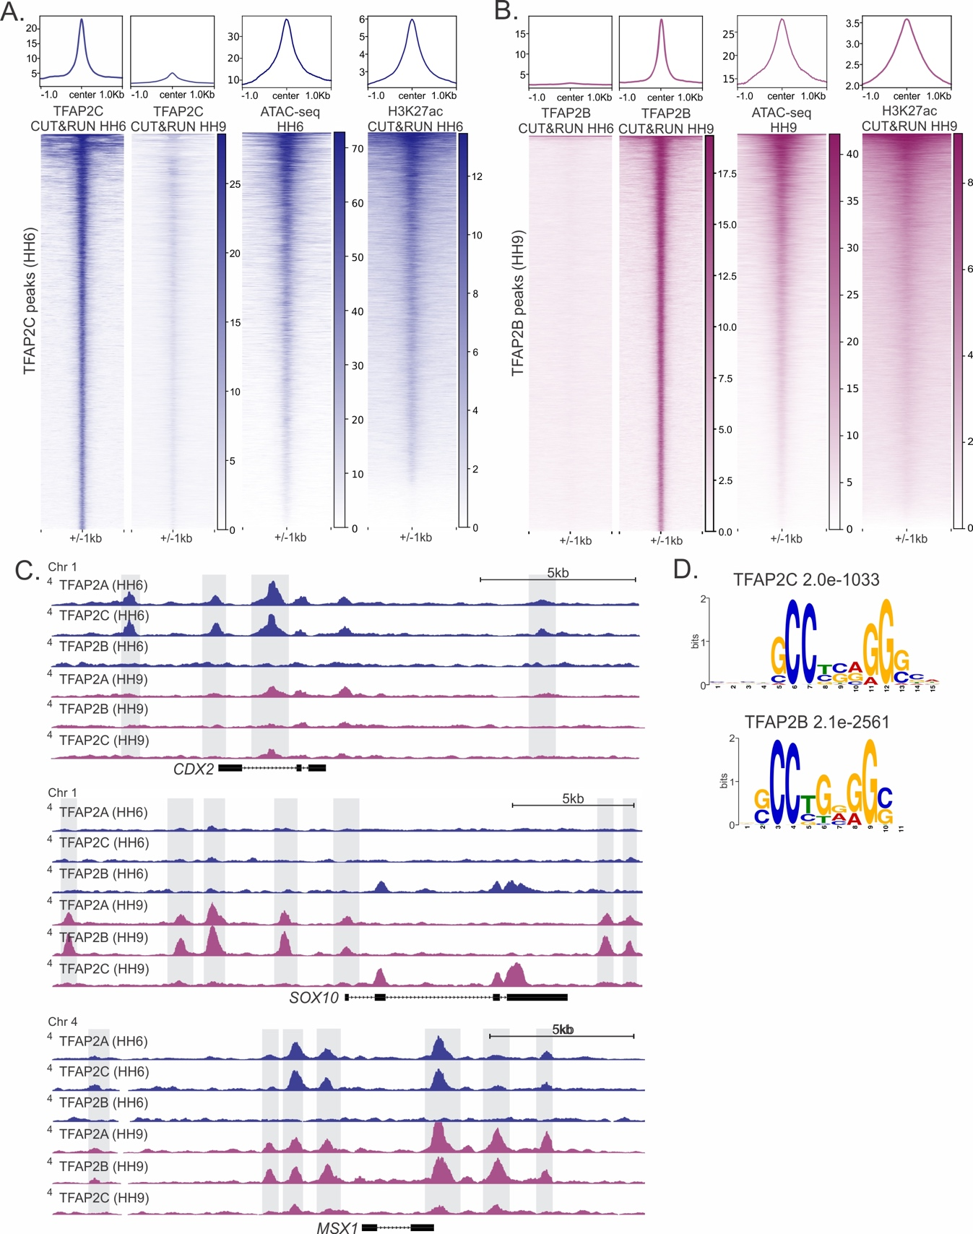

Fig S6. Stage-specific binding by TFAP2B and TFAP2C

(A) Profiles and heatmaps displaying ATAC-seq signal and CUT&RUN signal for TFAP2C (HH6), TFAP2C (HH9), and H3K27ac (HH6) at TFAP2C induction peaks (7021 peaks). TFAP2C signal is largely depleted at HH9. (B) Profiles and heatmaps displaying ATAC-seq signal and CUT&RUN signal for TFAP2B (HH6), TFAP2B (HH9), and H3K27ac (HH9) at TFAP2B specification peaks (18009 peaks). Little to no TFAP2B signal is present at HH6. (C) CUT&RUN profiles for TFAP2A, TFAP2B, and TFAP2C at induction (HH6) and specification (HH9) in the loci of Cdx2, Sox10, and Msx1. While the Cdx2 locus displays co-occupancy of TFAP2A and TFAP2C, the Sox10 locus is co-occupied by TFAP2A and TFAP2B. TFAP2A peaks are maintained in the Msx1 locus during both induction and specification, but TFAP2C and TFAP2B are only transiently present. (D) de novo motif enrichment analysis via MEME-ChIP reveals a strong enrichment for the TFAP2 consensus binding motif from TFAP2C and TFAP2B CUT&RUN datasets. Values indicate significance of motif occurrence as reported by MEME. HH: Hamburger Hamilton, kb: kilobase

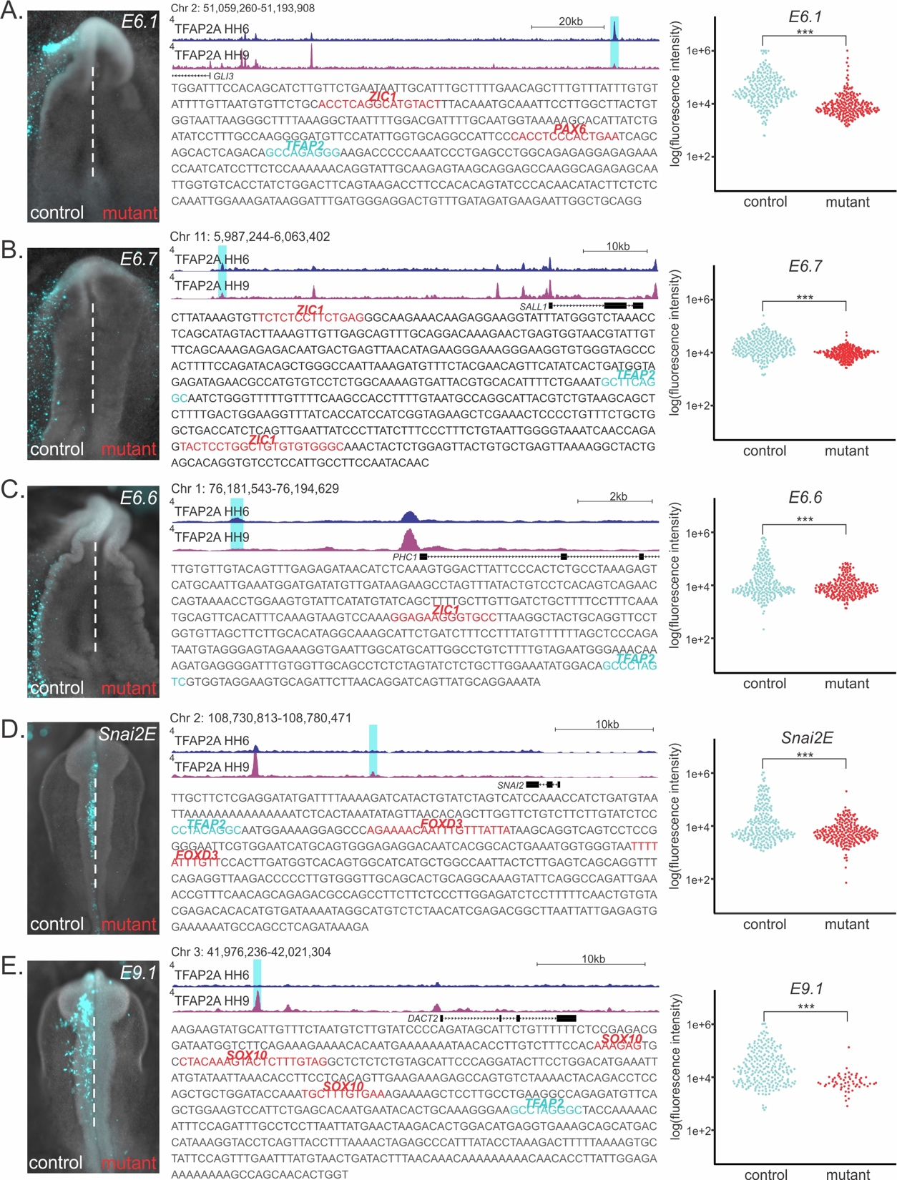

Fig S7. Mutation of co-factor binding sites results in loss of neural crest enhancer activity

Reporter activity of wild type vs mutated enhancer regions. CUT&RUN profiles display dynamic binding by TFAP2A. Sequences show predicted TFAP2A binding site (cyan), flanked by putative co-factor binding sites (red). Sequences in red were mutated for reporter analysis. Flow cytometry analysis of GFP reporter fluorescence in mcherry+ neural crest cells (electroporated with TFAP2AE1) in both wild type and mutated enhancers. Mutations result in a decrease in fluorescence intensity for all enhancers analyzed. (A) E6.1 is located within the Gli3 locus, displays enriched TFAP2A binding at HH6, and mutations in Zic1 and Pax6 binding sites result in a loss of enhancer activity. (B) E6.7 is located within the Sall1 locus, displays enriched TFAP2A binding at HH6, and mutations in two Zic1 binding sites result in a loss of enhancer activity. (C) E6.6 is located within the Phc1 locus, displays enriched TFAP2A binding at HH6, and mutations in the Zic1 binding site result in a loss of enhancer activity. (D) The previously characterized Snai2E displays enriched TFAP2A binding at HH9 and mutations in two Foxd3 binding sites result in a loss of enhancer activity. (E) E9.1 is located within the Dact2 locus, displays enriched TFAP2A binding at HH9, and mutations in three Sox10 binding sites result in a loss of enhancer activity. kb: kilobase, ***P≤0.001 (see also Table S1 for number of embryos analyzed)

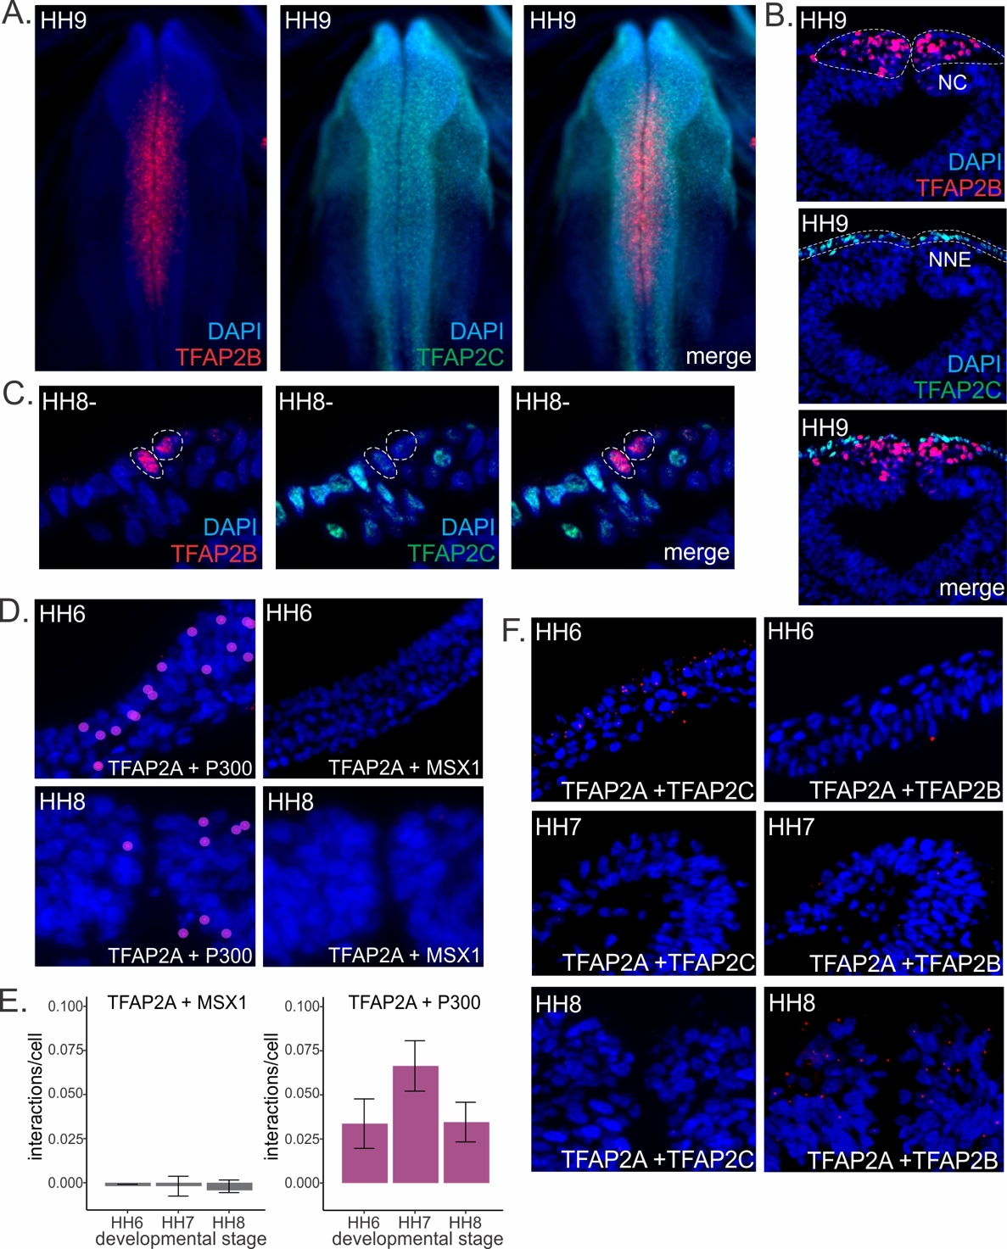

Fig S8. Proximity ligation assays indicate putative interactions between TFAP2A and TFAP2C at the neural plate border and TFAP2A and TFAP2B in the neural crest

(A) Immunohistochemistry for TFAP2B (red) and TFAP2C (green) at embryonic stage HH9. TFAP2B is localized to the neural crest, while TFAP2C is restricted to the ectoderm. (B) Transverse sections showing the non-overlapping expression of TFAP2B and TFAP2C during neural crest specification. (C) Transverse sections of the presumptive neural crest at HH8-. A decrease in TFAP2C expression is displayed in cells beginning to express TFAP2B. (D) Proximity ligation assays (PLAs) visualized in transverse sections of the neural plate border and the neural crest. Interactions between TFAP2A and its coactivator, EP300, are detected in both the neural plate border and the neural crest. In contrast, no interactions are detected between TFAP2A and the negative control, MSX1. (E) Quantification of TFAP2A interactions in embryos at three developmental stages (HH6-HH8) in the negative control, MSX1, and the positive control, EP300. Number of interactions were normalized to those detected in the neural plate/ventral neural tube to account for differences in background fluorescence. (F) Proximity ligation assays (PLAs) visualized in transverse sections at the developmental stages, HH6, HH7, and HH8. Positive TFAP2A/C interactions are enriched at the neural plate border, while TFAP2A/B interactions are enriched in the neural crest. Error bars in (E) represent standard error. HH: Hamburger Hamilton, NPB: neural plate border, NC: neural crest (see also Table S1 for number of embryos analyzed)

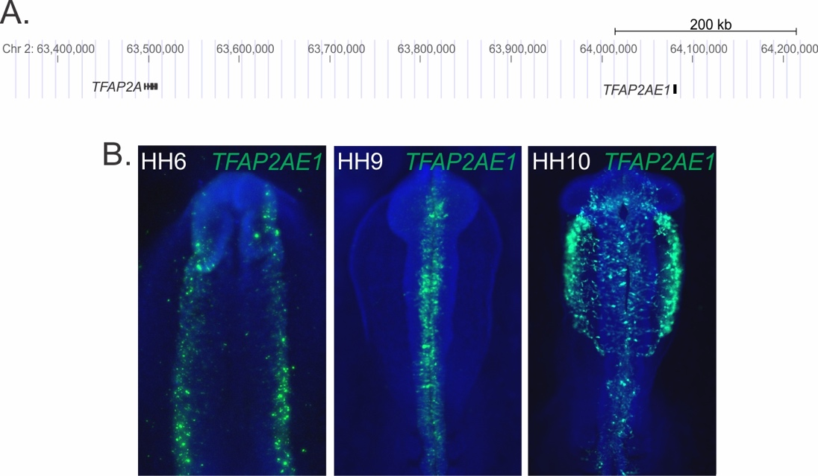

Fig S9. A TFAP2A enhancer (TFAP2AE1) drives specific reporter activity in neural crest cells.

(A) An enhancer of TFAP2A (TFAP2AE1) is located approximately 500kb downstream the TFAP2A gene body. (B) Transfection of gastrula-stage (HH4) chicken embryos with TFAP2AE1:eGFP results in eGFP expression in the neural crest lineage. Robust expression of the reporter gene is first observed at HH6, and it persists during specification (HH9) and migration (HH10).

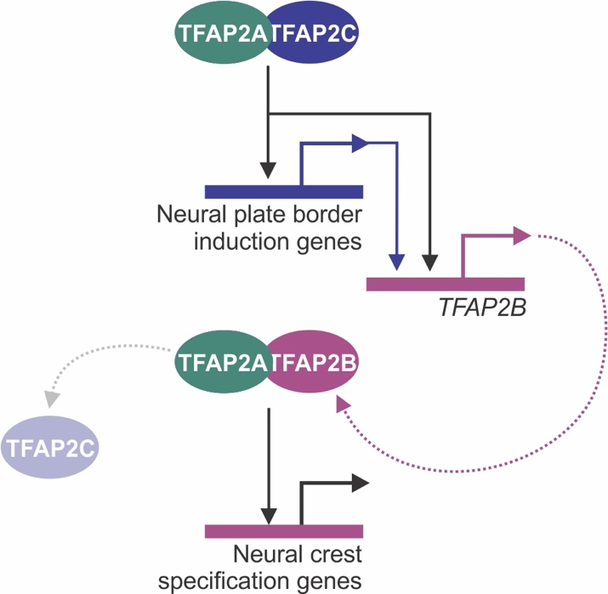

Fig S10. A TFAP2-mediated molecular switch controls the transition from induction to specification

Activation of TFAP2B expression by TFAP2A/C heterodimers results in inhibition and displacement of TFAP2C and activation of the neural crest specification program.

Table S1. Number of embryos analyzed and fraction displaying phenotypes

Figure | Embryos analyzed (n) | Fraction displaying phenotype
Figure 1c. | 3 |  | NA
Figure 1d. | 7 |  | NA
Figure 1e. | 9 |  | NA
Figure 1f. | 8 |  | 7/8
Figure 1g. | 8 |  | 6/8
Figure 3b. | 3 |  | NA
Figure 3d. – induction | 6 |  | NA
Figure 3d. – specification | 6 |  | NA
Figure 3e. – induction | 5 |  | NA
Figure 3e. – specification | 8 |  | NA
Figure 3f. | 9 |  | 7/9
Figure 3g. | 10 |  | 8/10
Figure 5f. – TFAP2A + TFAP2C | 15 |  | NA
Figure 5f. – TFAP2A + TFAP2C | 13 |  | NA
Figure 6a. | 5 |  | NA
Figure 6b. | 2 |  | 2/2
Figure 6c. | 3 |  | 3/3
Figure 6g. – TFAP2B rescue | 5 |  | NA
Figure 6g. – TFAP2C rescue | 5 |  | NA
Figure 6i. | 8 |  | 6/8
Figure 6j. | 5 |  | 1/5
Figure 6k. – Sox9E | 3 |  | 3/3
Figure 6k. – Snai2E | 2 |  | 2/2
Figure S1b. – early | 7 |  | NA
Figure S1b. – late | 9 |  | NA
Figure S1c. – PH3 | 3 |  | 3/3
Figure S1c. – CASP3 | 5 |  | 5/5
Figure S4c. – TFAP2B kd early | 3 |  | 3/3
Figure S4c. – TFAP2C kd late | 3 |  | 3/3
Figure S4d. – TFAP2C kd | 2 |  | 2/2
Figure S4d. – TFAP2B kd | 2 |  | 2/2
Figure S4e. – TFAP2B kd | 3 |  | NA
Figure S4f. – TFAP2B kd | 3 |  | NA
Figure S7a. | 3 |  | 3/3
Figure S7b. | 3 |  | 3/3
Figure S7c. | 4 |  | 4/4
Figure S7d. | 3 |  | 3/3
Figure S7e. | 4 |  | 4/4
Figure S8d. TFAP2A + MSX1 | 9 |  | NA
Figure S8d. TFAP2A + P300 | 9 |  | NA

