Quantitative prediction of enhancer-promoter interactions
P.S. Belokopytova, M.A. Nuriddinov, E.A. Mozheiko, D. Fishman and V. Fishman
Supplemental material

Supplementary Note. Effects of predictor parametrization and training parameters on prediction accuracy 2
Supplementary Figure 1. 4
Supplementary Figure 2 5
Supplementary Figure 3 6
Supplementary Figure 4 7
Supplementary Figure 5 8
Supplementary Figure 6 9
Supplementary Figure 7 10
Supplementary Figure 8 11
Supplementary Figure 9 12
Supplementary Figure 10 13
Supplementary Figure 11 14
Supplementary Figure 12 15
Supplementary Figure 13 16
Supplementary Figure 14 17
Supplementary Figure 15 18
Supplementary Figure 16 19
Supplementary Figure 17 20
Supplementary Figure 18 21
Supplementary Table 1 22
Supplementary Table 2 23
Supplementary Table 3 24
Supplementary Table 4 25
Supplementary Table 5 26
Supplementary Table 6 27
Supplementary Table 7 28
Supplementary Table 8 29
Supplementary Table 9 33

Supplementary Note. Effects of predictor parametrization and training parameters on prediction accuracy
We aimed to model interaction frequency for a pair of loci, L1 and L2, separated by a genomic region (window) W12. We wish to define predictors so that they could describe chromatin structure of L1, L2, region W12 between them, and genomic neighborhoods surrounding L1 and L2. We note that promoters and enhancers are small features, often ~1 kb in size. However, almost no Hi-C maps are currently available at this resolution, and for those that are available (such as, for example human GM12878 map) there is significant noise level at 1 kb resolution, which may affect model fitting (see estimations of noise level at Supplementary Fig. 9). For example, relative error of contact counts calculated for GM12878 data at 25 kb resolution is ~10-20%, whereas for 5 kb resolution it is much higher (30-40% for distances below 400 kb, 40-70% for distances in diapason 0.4-1.5 Mb), and for 1 kb resolution average error raises to 80-90% for distances above 100 kb (Supplementary Fig. 9). In the same time, according to the GM12878 Hi-C data, contacts at 25 kb correlate with the frequency of Enhancer-promoter interactions defined at 1 kb resolution reasonably well (25 kb vs 5 kb: R=0.75; 25 kb vs 1 kb: R=0.45; 5 kb vs 1 kb: R=0.73; Supplementary Fig. 10). Thus, we decided to predict contact frequencies at 25 kb resolution, although we show later that it is possible to predict contacts at higher resolutions as well.
We initially performed following parametrization: for each pair of loci, L1 and L2, we defined a large genomic interval I of size 1.5 Mb so that region L1-L2 would be located in the center of this interval. For each 25 kb bin within the interval I we computed average values of all available predictors. At this point we used following predictors
a.) genomic distance between L1 and L2, b.) CTCF ChIP-seq signal value for each 25 kb bin and c.) the first eigenvector value (E1 value) derived from Hi-C matrix for each bin. One should note that E1 values were introduced as predictors only at this initial step as simple numeric representation of epigenetic state of each bin. In final models we do not use E1 values, since they cannot be obtained without Hi-C data and because by definition of E1 values their multiplication should give a good estimation of interaction frequencies.
Using this parametrization, we generate 121 values describing epigenetic state and CTCF distribution for each of 60 bins in the 1.5MB neighborhood of interacting loci. Although simple multiplication of E1 values should be informative for deciphering contact frequency, this parametrization showed poor performance of Linear regression, Gradient Boosting regression and Random Forest regression (Supplementary Fig. 11). Thus, we proposed another predictors parametrization.
For CTCF dataset, we generated following sets of features. Predictors describing genomic environment outside of the loci L1 and L2: i) distance to L1 and signal values of 4 peaks located on the left side of the L1 region (8 float values); ii) distance to L2 and signal values of 4 peaks located on the right side of L2 region (8 float values). Predictor describing genomic environment between loci L1 and L2: iii.) sum of signal values of all peaks within window W12 between interacting loci L1 and L2 (single float value). Predictors, describing loci L1 and L2: iv.) sum of all signals within 25 kb neighborhood of loci L1 or L2 (two float values). For E1 data, we designed predictors similar to iii.) and iv.), but instead of summing E1 values of bins we averaged values. Lastly, we used distance between L1 and L2 as a predictor (single integer value).
As loops are formed predominantly between CTCF-sites in convergent orientation, we decided to additionally provide information about CTCF-sites orientation. For this aim, we introduced following predictors: 1.) for each CTCF peak described by predictors i) and ii) we added GimmeMotifs (van Heeringen and Veenstra, 2011) motif score of forward and reverse orientation. For those peaks where CTCF motif was not found we set the score to 0; 2.) we described up to 8 CTCF peaks located between L1 and L2 in the same way as in predictors i) and ii) (for each peak we described distance to L1 or L2, signal value and forward/reverse motif score). Finally, we calculated number of convergently oriented CTCF blocks within the L1-L2 window. For this aim, we collapsed all consequentially located CTCF sites with the same orientation into one mega-site, and counted number of pairs of mega-sites with convergent orientation within the window W12.
Finally, we also decided to use RNA-seq data for predictions. RNA-seq data was parameterized in the same way as ChIP-seq data, with FPKM values used instead of peak intensities.
Using RNA-seq, CTCF binding and orientation and E1-values as described above visibly improved hearmaps predicted by Gradient Boosting regressor (Supplementary Fig. 12). The model was able to predict TAD-like structures located at the similar positions as in experimental data. We next discarded E1-values, and found that this does not impair predictions (Supplementary Fig. 12).
To test whether using features other than CTCF, RNA-seq and genomic distance could further improve predictions, we downloaded 11 datasets for K562 cells from ENCODE (DNase-seq and ChIP-seq for H3K27ac, H3K27me3, H3K4me1, H3K4me2, H3K4me3, H3K9me3, POLR2A, RAD21, SMC3 and YY1) and used them altogether with RNA-seq, CTCF and genomic distance. This results in just slight increase (~2%) of the SCC value. Analysis of feature importance indicates that information about cohesin binding, expression and chromatin accessibility (SMC3 ChIP-seq, RNA-seq and DNase-seq) within window between interacting loci are the most important for prediction (Supplementary Fig. 2, A). Beside window information, the most important predictors are position, binding strength and motif orientation of CTCF protein (Supplementary Fig. 2, B). Testing various combinations of predictors, we found that RNA-seq data could be substituted with DNase-seq and/or information about histone modification without significant drop of prediction accuracy. Finally, we downloaded all data available for K562 and GM12878 cells from ENCODE, including additional ChIP-seq experiments, FAIRE-seq, methylation assays and etc. Although the model trained on a full set of 2669 predictors describing 137 genomic features gave the best results for both cell types, limiting input information to CTCF and RNA-seq data only results in just a little decrease of prediction rate (Supplementary Table 1). Similarly, the model trained on the full set of 123 predictors available for mouse hepatocytes performs better than model based on CTCF and RNA-seq only, however the difference in performance was reasonably small.
We also tested effect of training sample size on prediction accuracy (Supplementary Table 2). While larger training sets results in better performance, this dependence plateaued at ~300 000 contacts, without any further increase of prediction accuracy when increasing sample size above this point. However, we note that using contacts sampled from different chromosomes performed better at this sample size (see main results).
We next compared Gradient Boosting with another ensemble learning method – Random Forest (Supplementary Table 3), and found that performance of Random Forest was significantly lower. As for different implementations of Gradient Boosting, we compared sklearn and xgboost implementations and found almost no difference (Supplementary Table 3). We also tweaked of xgboost hyperparameters, such as number of estimators, maximum depth of a tree and subsampling ratio, to achieve optimal performance.
Stratum adjusted correlation coefficient (SCC) was the main metric for the evaluation of algorithm performance. We used different smoothing factors for the matrix to improve accuracy of SCC. As evident from Supplementary Table 4, increasing smoothing factor h results in increase of SCC with, plateau around h=2. Thus, we chose smoothing factor equal to two and used this values of smoothing factor for all comparisons.
Finally, we used 5 kb resolution data to train and validate Gradient Boosting repressor, and obtained very similar results as described above for 25 kb resolution data (see, for example, Fig.4 A-C, which shows predictions at 25 kb resolution, and Supplementary Fig. 4 A-C showing contacts of the same region predicted at 5 kb resolution).
Supplementary Figures

Supplementary Figure 1.
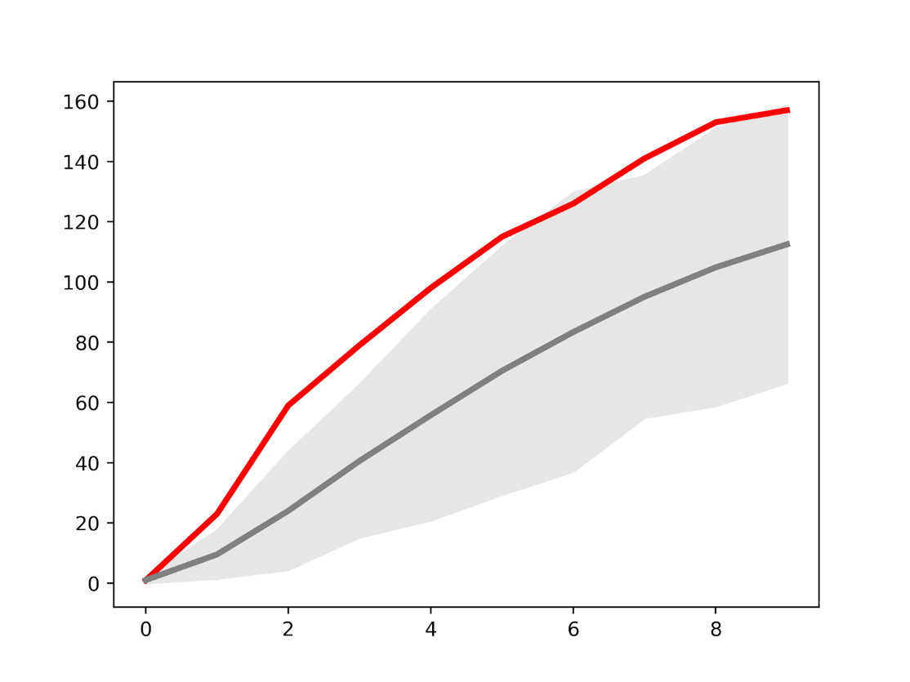
Genomic distance from nearest loop anchors (kb)
0
50
100
150
200
EP pairs
Random
Supplementary Figure 1. Promoter-enhancer interactions do not overlap Hi-C loops. Data for human macrophages presented as on Fig. 2C

Supplementary Figure 2
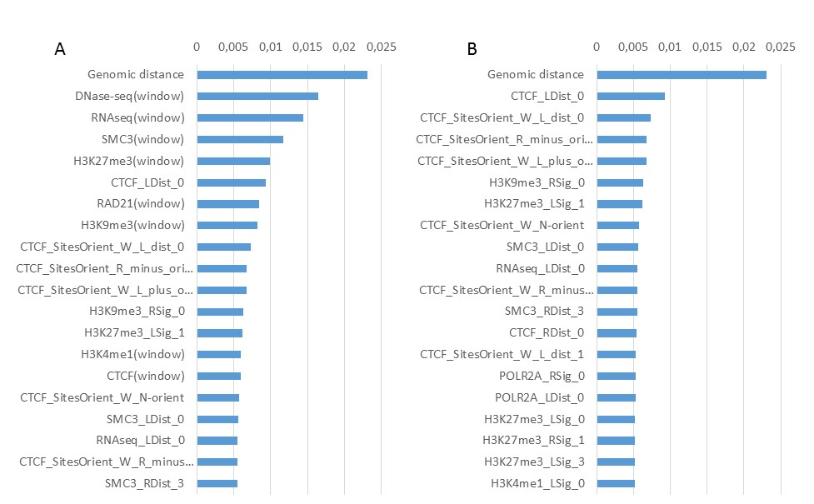
Supplementary Figure 2. Importance score for top features in K562 cells. A. 20 features with highest importance score, with window features indicates as “(window)”. B. 20 features with highest importance score, excluding window features.

Supplementary Figure 3
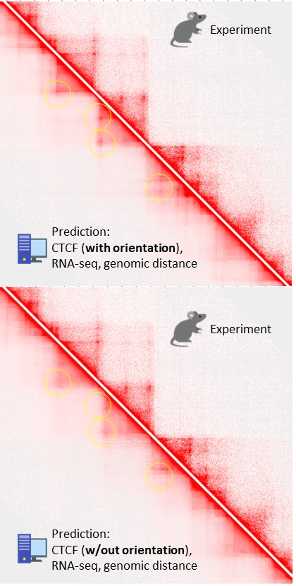
Supplementary Figure 3. Effect of CTCF directionality information on prediction of loops. Prediction of contact frequencies was performed with (top panel) or without (bottom panel) information about CTCF directionality for Chromosome 3 of K562. Loops which are not captured or less pronounces when CTCF directionality information excluded are indicated by yellow circles.

Supplementary Figure 4
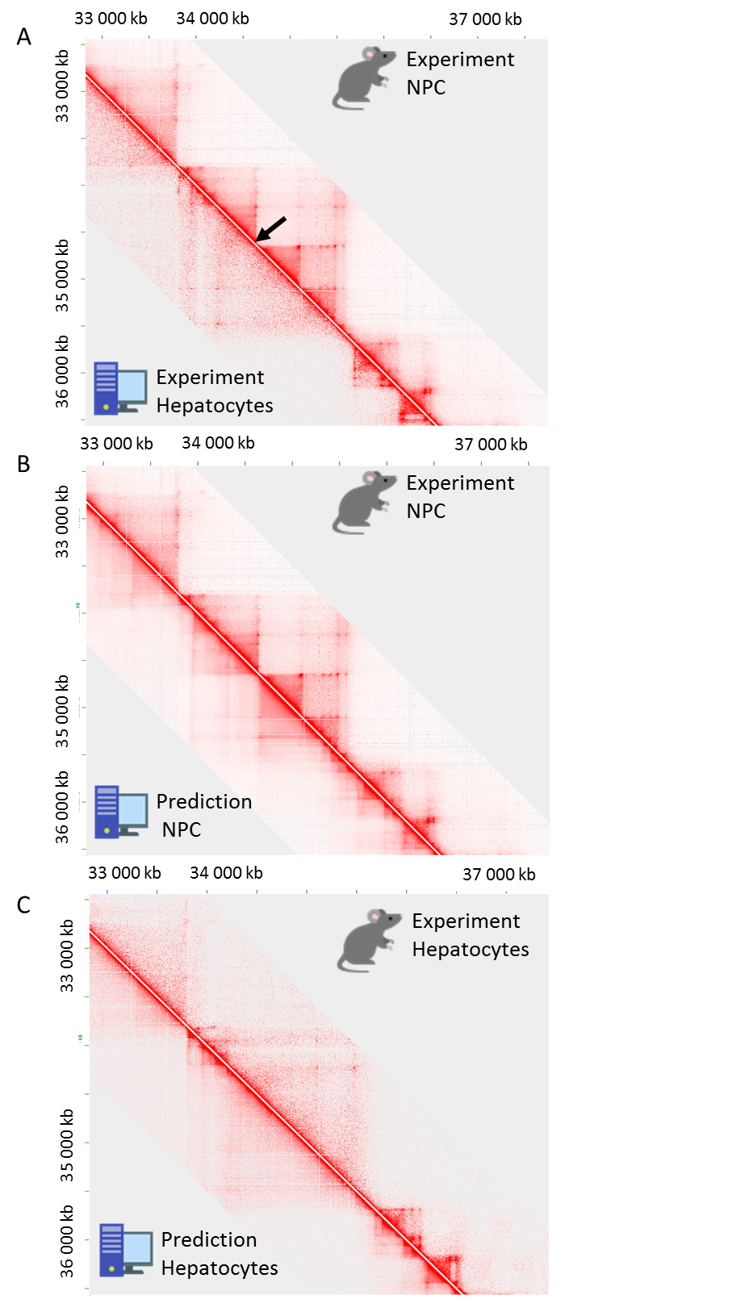
Supplementary Figure 4. Cell type-specific prediction of chromatin organization at 5 kb resolution shown for the same region as on Fig. 4 A-C.

Supplementary Figure 5

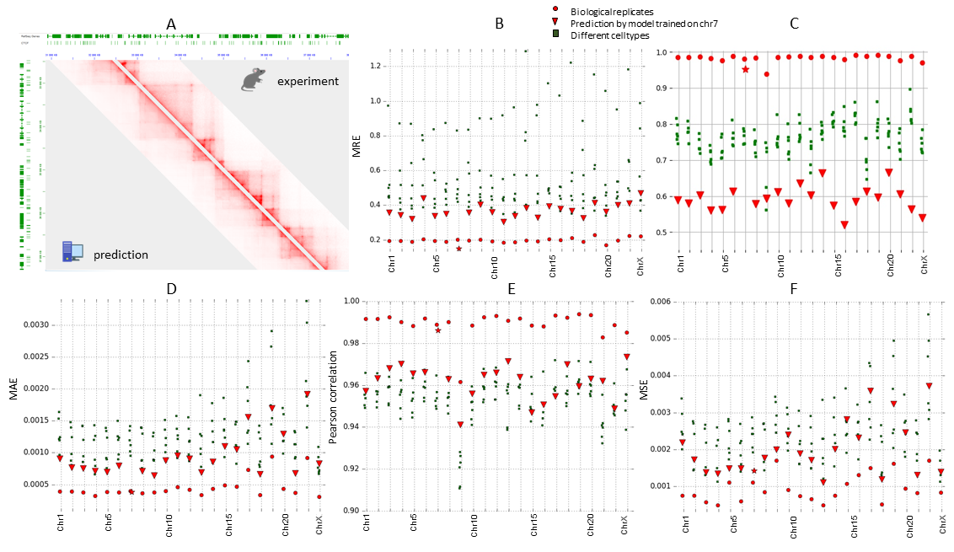

Supplementary Figure 5. 3DPredictor performance on human GM12878 data. Results are shown for 25 kb resolution as on Fig. 3

Supplementary Figure 6
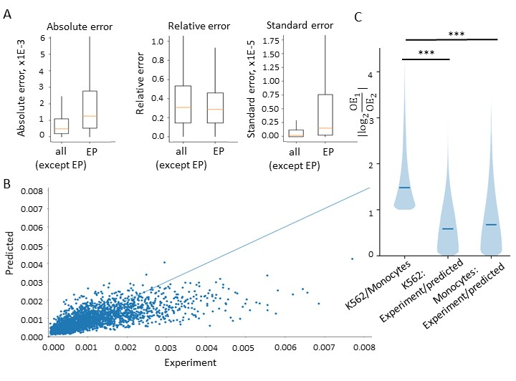Supplementary Figure 6. Prediction of EP interactions at 5 kb resolution in human cells. Results are shown as on Fig. 5

Supplementary Figure 7
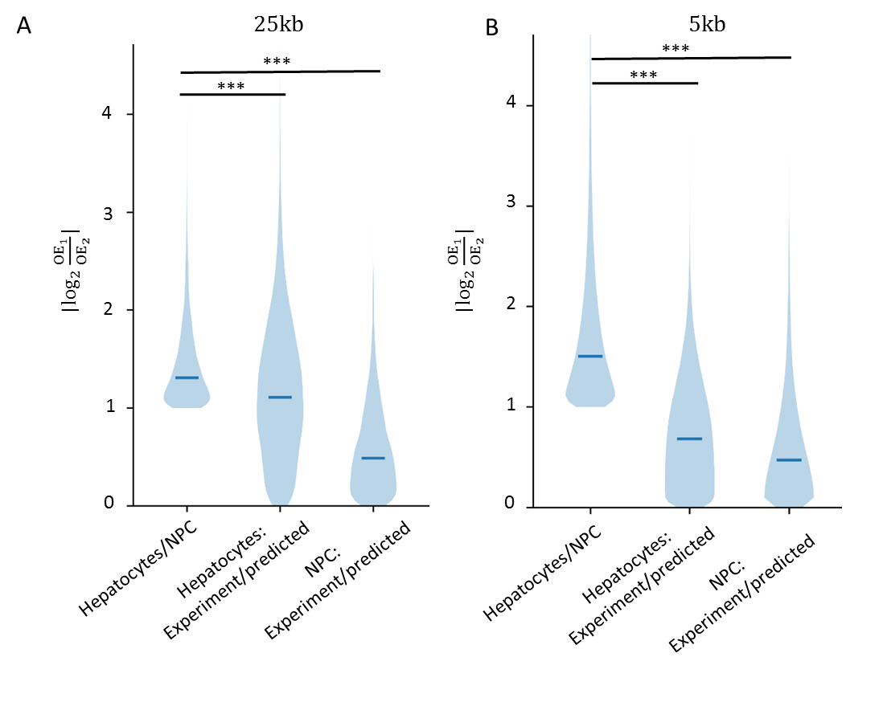
Supplementary Figure 7. Distribution of the similarity scores for cell type-specific EP interactions in different mouse cell types. Results are shown as on Fig. 5 С for 25 kb resolution (A) and 5 kb resolution (B)

Supplementary Figure 8

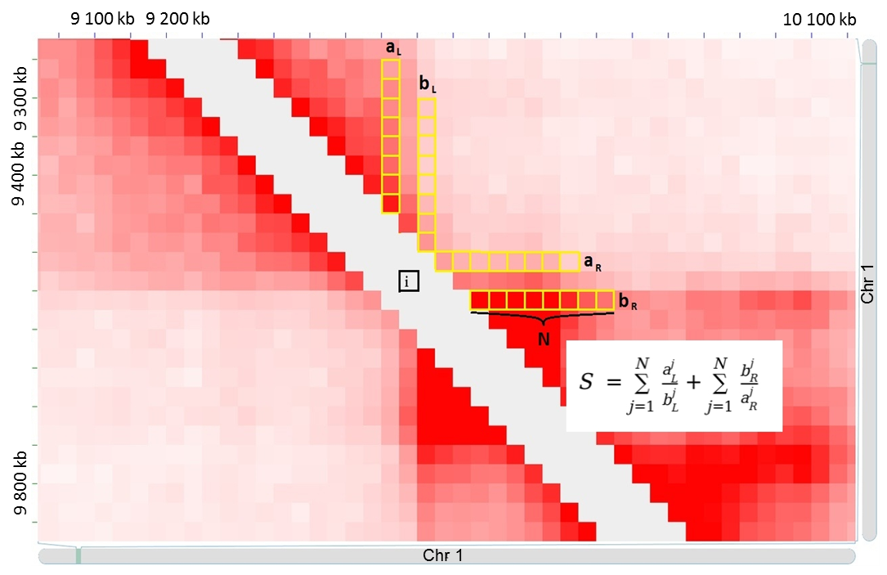
Supplementary Figure 8. Schematic representation of the insulation-based score S of genomic boundary (denoted as “i”) between two neighboring bins (denoted as “a” and “b”). On this figure, we showed a fragment of Hi-C contact matrix of hepatocytes. Contacts involved in the calculation of insulation-based score are highlighted by yellow squares. a_{L}=(a_{L}¹,a_{L}²,...,a_{L}^{N}) and a_{R}=(a_{R}¹,a_{R}²,...,a_{R}^{N}) are contacts of bin a with its genomic neighborhood. Similarly for the vicinity of the bin b.

Supplementary Figure 9
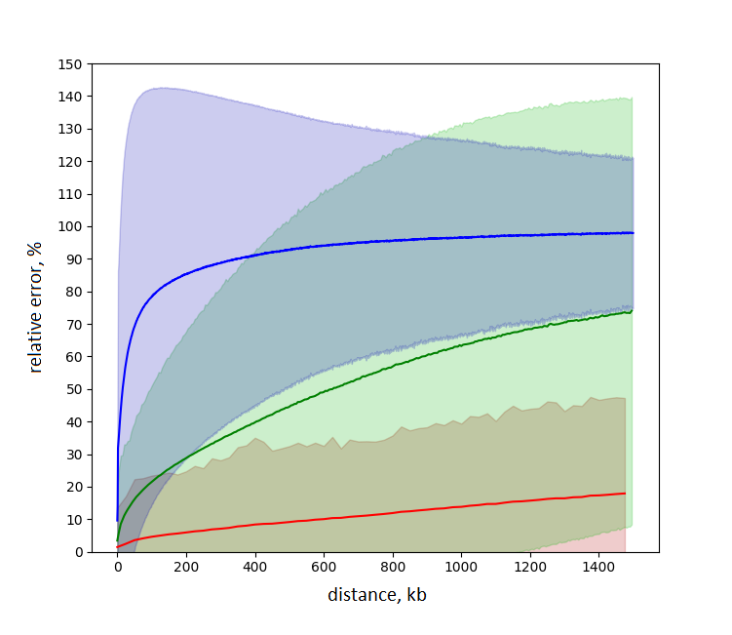
Supplementary Figure 9. Dependence of Hi-C contact count error from genomic distance and resolution of analysis. The graph shows average (line) and 3 standard deviations (colored area) of the observational errors of Hi-C contact counts for contacts sampled at different distances (X-axis) and different resolutions (green - 25 kb, red - 5 kb, blue - 1 kb). The data is presented for human GM12878 cells.

Supplementary Figure 10
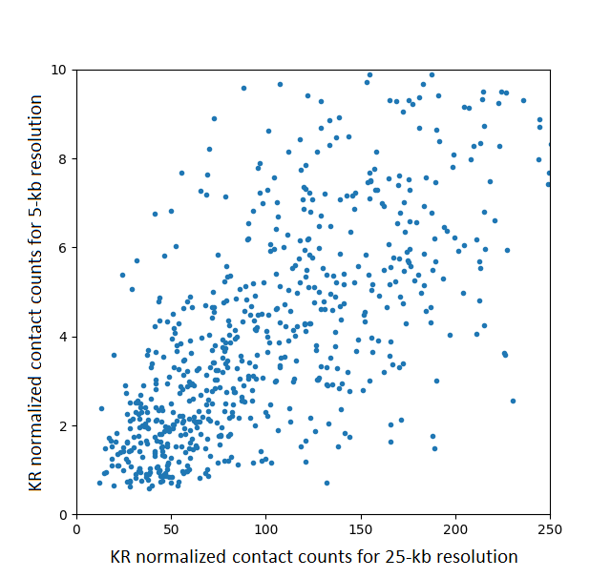
Supplementary Figure 10. Dependence between KR normalized contact counts on different resolutions

Supplementary Figure 11
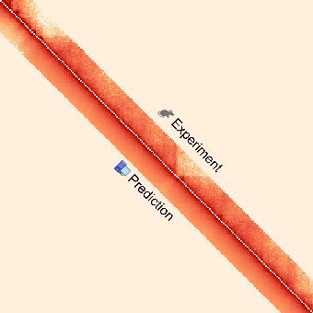
Supplementary Figure 11. Poor prediction efficiency using initial parametrization describing epigenetic state and CTCF distribution for each of 60 bins in the 1.5 Mb neighborhood of interacting loci.

Supplementary Figure 12
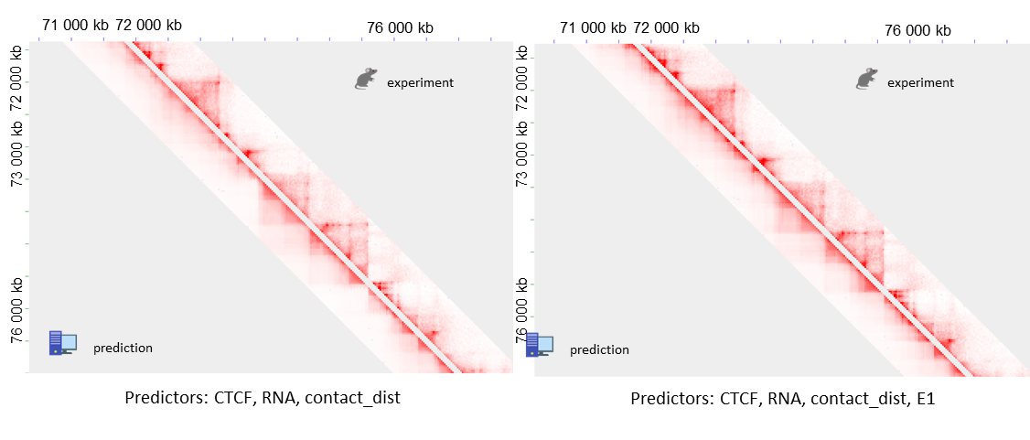
Supplementary Figure 12. Representative region on Chromosome 2 shows efficiency of 3DPredictor trained and validated on mouse hepatocyte’ data with (right panel) or without (left panel) using E1-values

Supplementary Figure 13
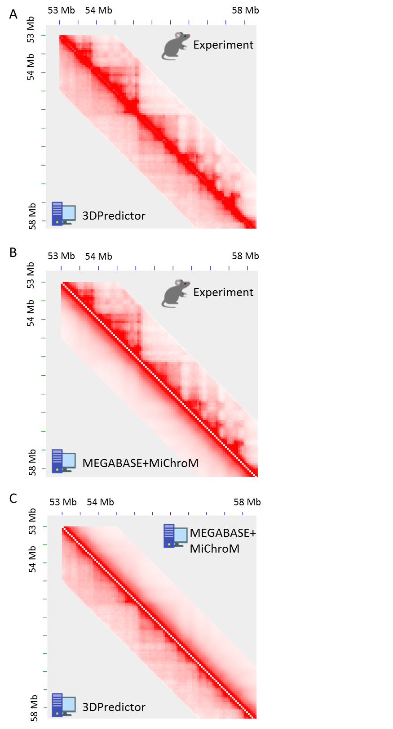
Supplementary Figure 13. Comparison of 3DPredictor and MEGABASE+MiChroM model. A-C. Hi-C maps of experimental and predicted contacts on Chromosome 4 of GM12878 cells.

Supplementary Figure 14
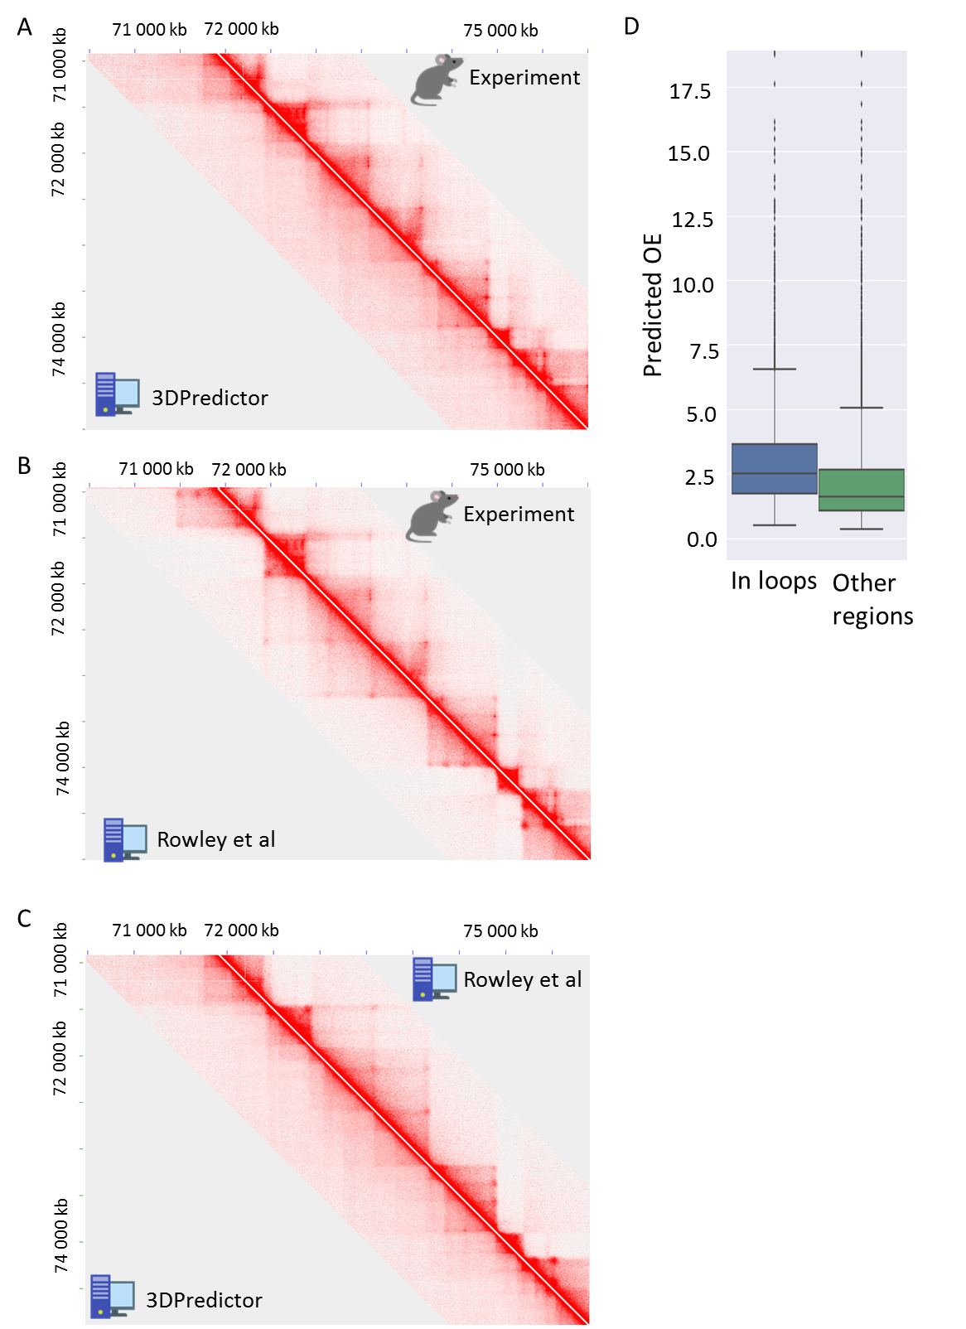
Supplementary Figure 14. Comparison of 3DPredictor and (Rowley et al., 2017) model. A-C. Hi-C maps of experimental and predicted contacts of GM12878 cells. D. Box-plot showing observed/expected ratio for 3DPredictor-derived frequencies of contact between loop anchors (“In loops”) versus other genomic interactions (“Other regions”). Loop anchors were defined using HiCCPUS on experiment GM12878 data.

Supplementary Figure 15
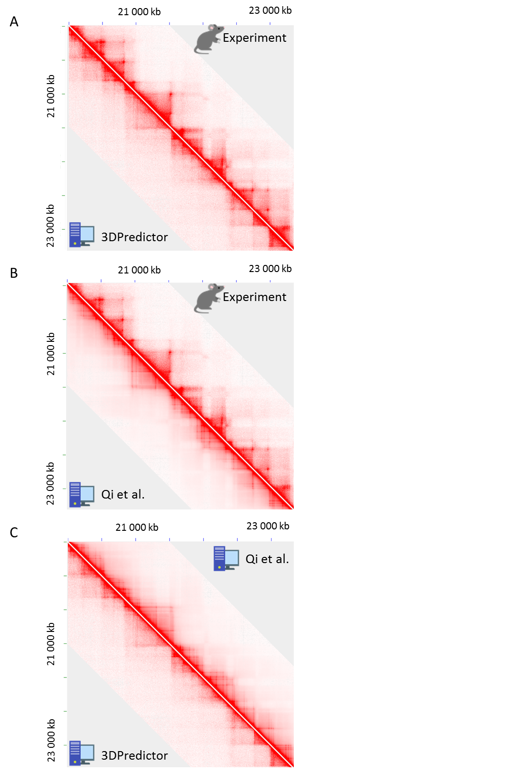
Supplementary Figure 15. Comparison of 3DPredictor and (Qi and Zhang, 2019) model. A-C. Hi-C maps of experimental and predicted contacts on Chromosome 1 of GM12878 cells

Supplementary Figure 16
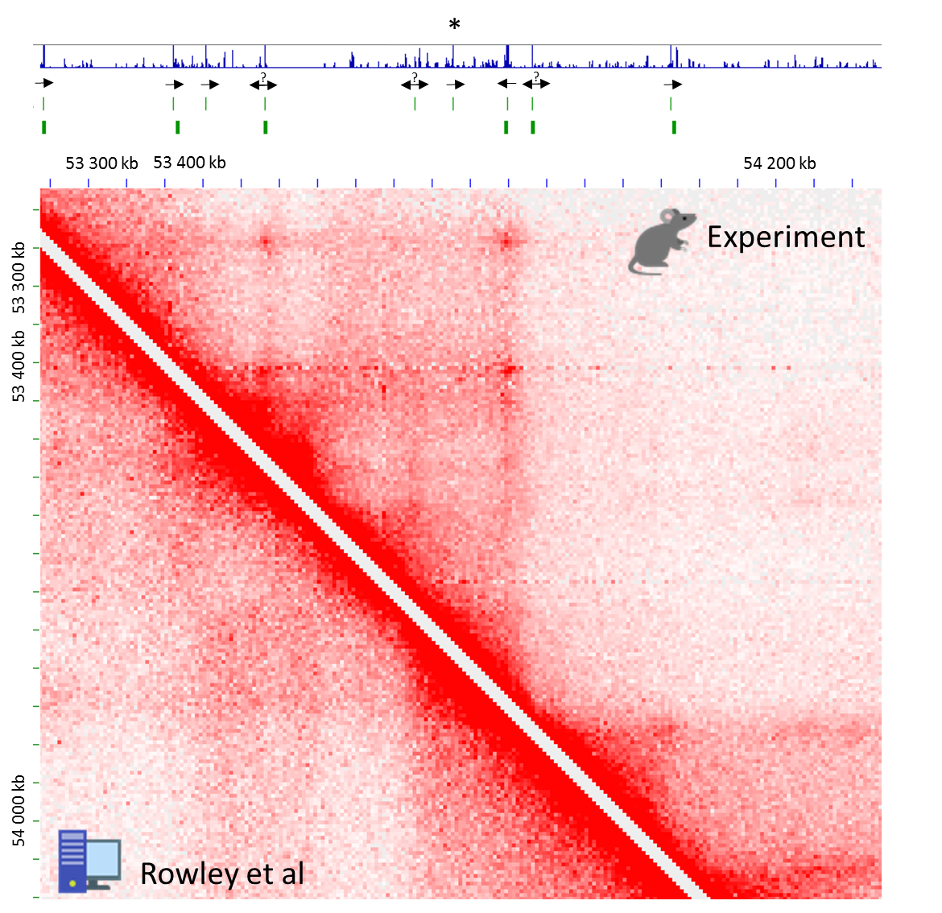
Supplementary Figure 16. Not all neighboring CTCF-sites in convergent orientation form loops. Black arrows - CTCF binding sites orientation. Not all neighboring CTCF-sites in convergent orientation form loops (asterisk).

Supplementary Figure 17
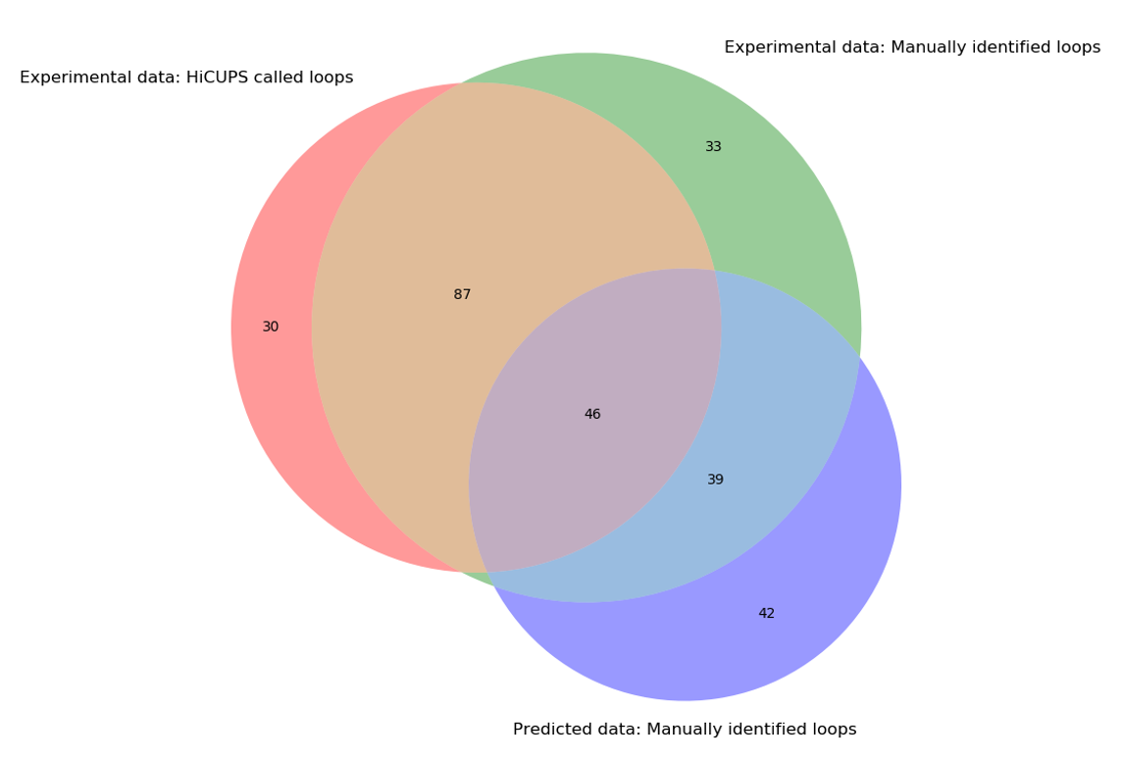
Supplementary Figure 17. 3DPredictor captures approximately half of the looping interactions.

Supplementary Figure 18
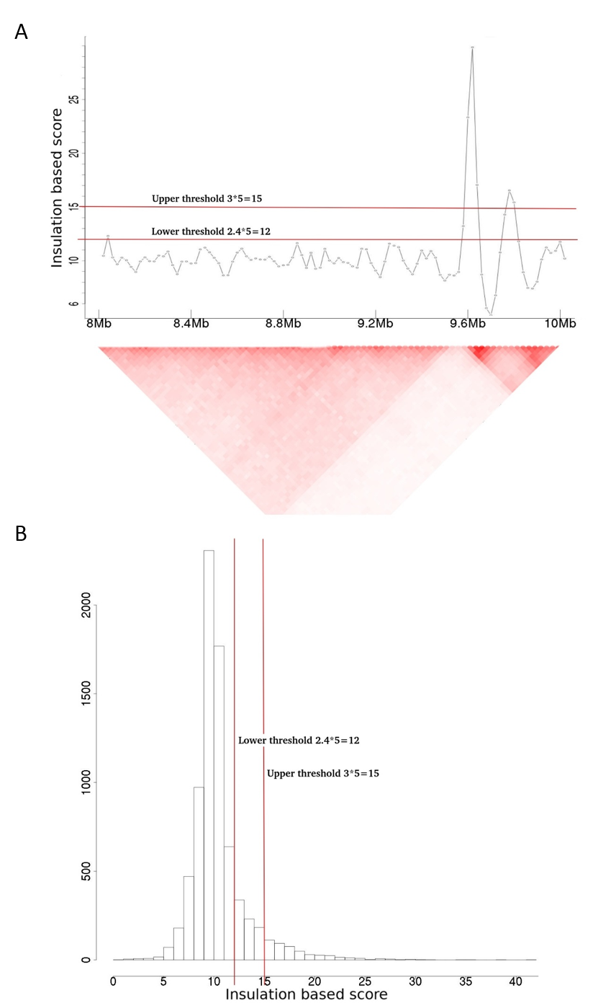
Supplementary Figure 18. Distribution of insulation scores in NPC cells. A. Insulation based score for Chromosome 1 of NPC cells. B. Distribution of insulation based score for 19 chromosomes of NPC cells.

Supplementary Tables

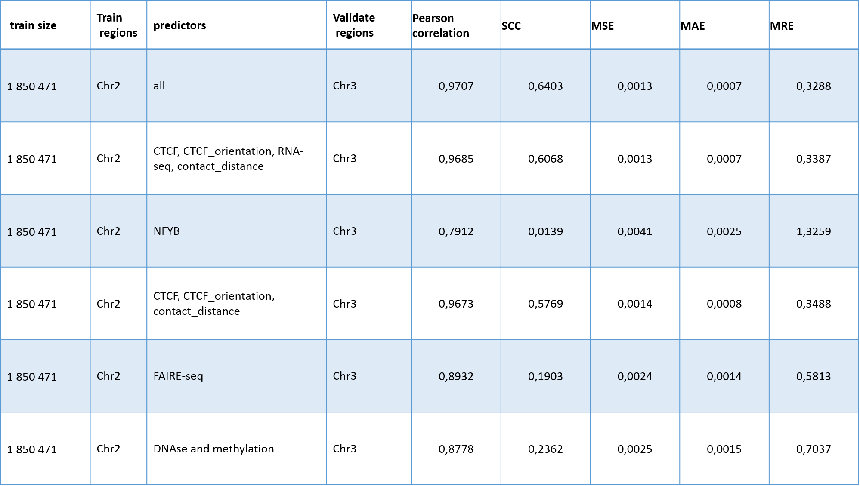
Supplementary Table 1
Supplementary Table 1. 3DPredictor efficiency on GM12878 data depends on input epigenetic information.

Supplementary Table 2
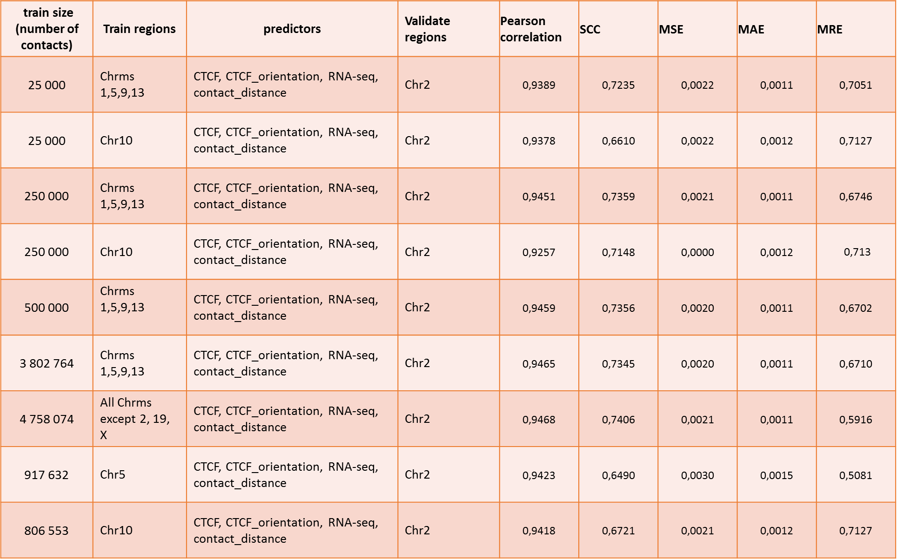
Supplementary Table 2. Effect of training sample on 3DPredictor efficiency on mouse hepatocytes.

Supplementary Table 3
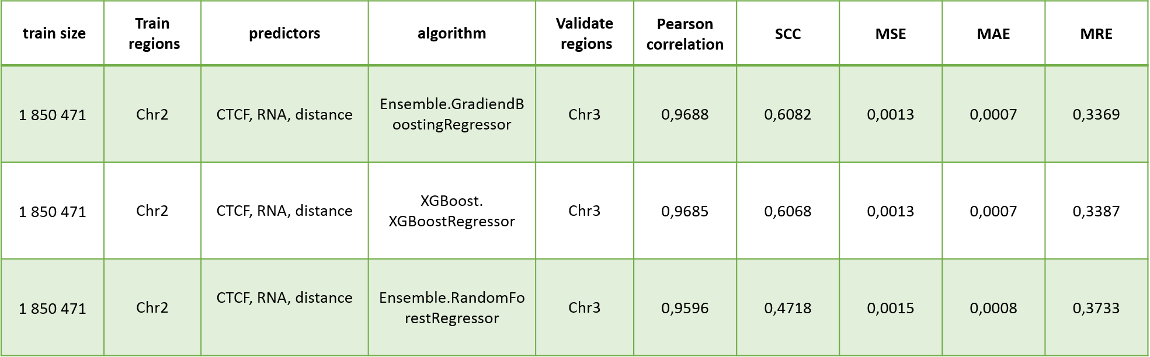
Supplementary Table 3. Comparison of Gradient Boosting (xgboost and sklearn implementations) and Random Forest performance.

Supplementary Table 4
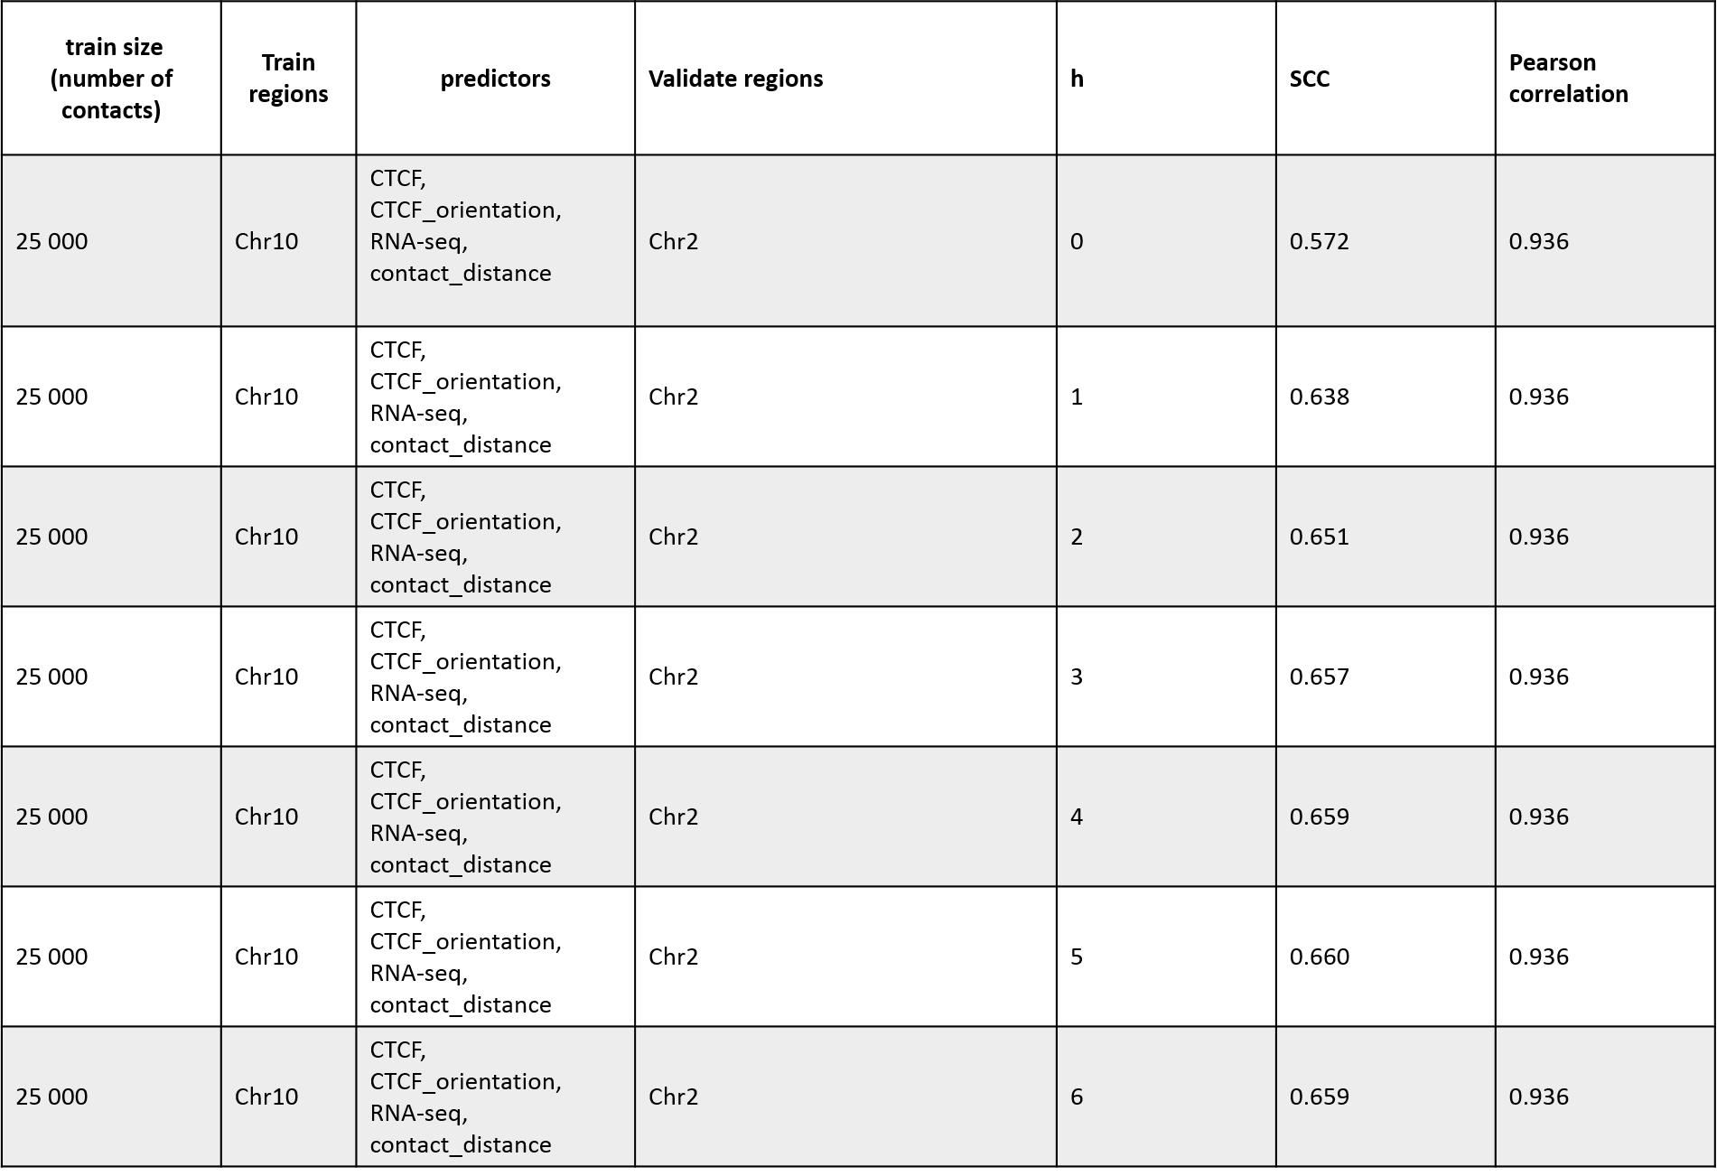
Supplementary Table 4. Effect of smoothing parameter h on the SCC values

Supplementary Table 5
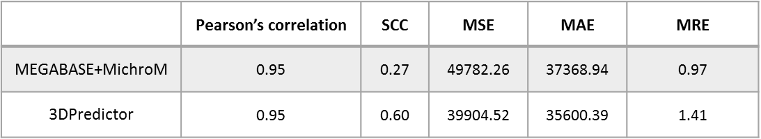
Supplementary Table 5. Comparison of 3DPredictor and MEGABASE+MiChroM model.

Supplementary Table 6
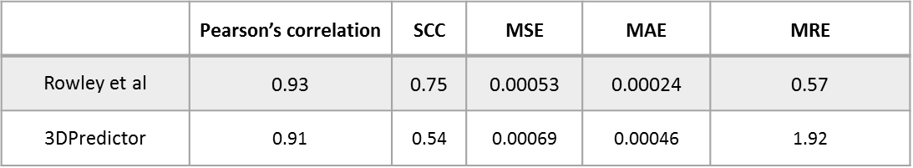
Supplementary Table 6. Comparison of 3DPredictor and (Rowley et al., 2017) model.

Supplementary Table 7
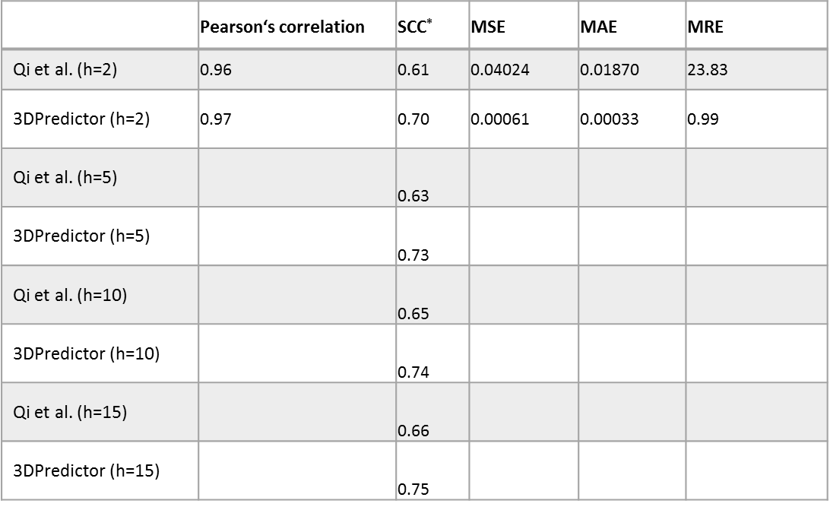
Supplementary Table 7. Comparison of 3DPredictor and (Qi and Zhang, 2019) model using different smoothing parameter h values.
* Note that we use only short- and mid-range contacts (distance between loci <=1.5 Mb) for SCC calculation, whereas Qi and Zhang use all contacts; thus obtained SCC values cannot be directly compared with those reported in (Qi and Zhang, 2019).

Supplementary Table 8
Chr | x1 | x2 | y1 | y2
5 | 4185000 | 4205000 | 4900000 | 4915000
5 | 4250000 | 4265000 | 4900000 | 4920000
5 | 12025000 | 12035000 | 12530000 | 12545000
5 | 12555000 | 12570000 | 13580000 | 13585000
5 | 12555000 | 12570000 | 13620000 | 13635000
5 | 12560000 | 12570000 | 13400000 | 13415000
5 | 14390000 | 14395000 | 14800000 | 14810000
5 | 16935000 | 16955000 | 18025000 | 18045000
5 | 16940000 | 16955000 | 17760000 | 17770000
5 | 16945000 | 16955000 | 17560000 | 17570000
5 | 18090000 | 18100000 | 18440000 | 18450000
5 | 21260000 | 21270000 | 21585000 | 21590000
5 | 21320000 | 21330000 | 21585000 | 21590000
5 | 24255000 | 24270000 | 24470000 | 24480000
5 | 24260000 | 24270000 | 24470000 | 24470000
5 | 24390000 | 24405000 | 24465000 | 24475000
5 | 27065000 | 27090000 | 27605000 | 27625000
5 | 27065000 | 27080000 | 27650000 | 27660000
5 | 27070000 | 27085000 | 27410000 | 27420000
5 | 27990000 | 28005000 | 28095000 | 28100000
5 | 28435000 | 28455000 | 29280000 | 29305000
5 | 29380000 | 29395000 | 29685000 | 29700000
5 | 30385000 | 30395000 | 30470000 | 30480000
5 | 30685000 | 30695000 | 30770000 | 30780000
5 | 30685000 | 30690000 | 30795000 | 30800000
5 | 30710000 | 30720000 | 30770000 | 30780000
5 | 30710000 | 30720000 | 30795000 | 30805000
5 | 33265000 | 33275000 | 33495000 | 33500000
5 | 34910000 | 34920000 | 35040000 | 35050000
5 | 34910000 | 34930000 | 35125000 | 35140000
5 | 35350000 | 35370000 | 35505000 | 35525000
5 | 35380000 | 35390000 | 35505000 | 35520000
5 | 35585000 | 35605000 | 35710000 | 35725000
5 | 35585000 | 35610000 | 35745000 | 35765000
5 | 35790000 | 35805000 | 35855000 | 35870000
5 | 35860000 | 35870000 | 35960000 | 35980000
5 | 35885000 | 35900000 | 35960000 | 35980000
5 | 35975000 | 35990000 | 36390000 | 36400000
5 | 36030000 | 36040000 | 36390000 | 36395000
5 | 36945000 | 36950000 | 37000000 | 37010000
5 | 38095000 | 38105000 | 38190000 | 38195000
5 | 38100000 | 38100000 | 38195000 | 38205000
5 | 38100000 | 38105000 | 38230000 | 38240000
5 | 38310000 | 38325000 | 38465000 | 38480000
5 | 38520000 | 38535000 | 38625000 | 38640000
5 | 38775000 | 38790000 | 39625000 | 39645000
5 | 44280000 | 44310000 | 45270000 | 45300000
5 | 44280000 | 44320000 | 45390000 | 45415000
5 | 44295000 | 44315000 | 44825000 | 44845000
5 | 44465000 | 44490000 | 44820000 | 44840000
5 | 44470000 | 44485000 | 45270000 | 45290000
5 | 45465000 | 45475000 | 46335000 | 46355000
5 | 45470000 | 45480000 | 45665000 | 45675000
5 | 45470000 | 45480000 | 45670000 | 45670000
5 | 45530000 | 45540000 | 45665000 | 45675000
5 | 47000000 | 47025000 | 47970000 | 47990000
5 | 48115000 | 48135000 | 48235000 | 48240000
5 | 48120000 | 48145000 | 48335000 | 48355000
5 | 49360000 | 49375000 | 49950000 | 49965000
5 | 53320000 | 53340000 | 53585000 | 53600000
5 | 62880000 | 62900000 | 63760000 | 63770000
5 | 62885000 | 62900000 | 63880000 | 63895000
5 | 62935000 | 62955000 | 63760000 | 63780000
5 | 64280000 | 64310000 | 64805000 | 64825000
5 | 64280000 | 64295000 | 64860000 | 64875000
5 | 64370000 | 64400000 | 64810000 | 64820000
5 | 64380000 | 64395000 | 64855000 | 64870000
5 | 64505000 | 64520000 | 64800000 | 64825000
5 | 65530000 | 65535000 | 65925000 | 65935000
5 | 66080000 | 66095000 | 66235000 | 66245000
5 | 66680000 | 66710000 | 66985000 | 67005000
5 | 67040000 | 67065000 | 67225000 | 67250000
5 | 67745000 | 67765000 | 68005000 | 68030000
5 | 72345000 | 72355000 | 72645000 | 72655000
5 | 72660000 | 72670000 | 72890000 | 72900000
5 | 72885000 | 72895000 | 73065000 | 73075000
5 | 73110000 | 73120000 | 73370000 | 73390000
5 | 73130000 | 73140000 | 73375000 | 73385000
5 | 73535000 | 73555000 | 73630000 | 73650000
5 | 73845000 | 73870000 | 74265000 | 74280000
5 | 73930000 | 73950000 | 74265000 | 74285000
5 | 75360000 | 75380000 | 75850000 | 75855000
5 | 75370000 | 75390000 | 75730000 | 75745000
5 | 76580000 | 76600000 | 76840000 | 76855000
5 | 89445000 | 89460000 | 89670000 | 89685000
5 | 89810000 | 89820000 | 90050000 | 90060000
5 | 90200000 | 90210000 | 90495000 | 90505000
5 | 90200000 | 90215000 | 90585000 | 90600000
5 | 90280000 | 90295000 | 90580000 | 90600000
5 | 90360000 | 90380000 | 90580000 | 90590000
5 | 92450000 | 92470000 | 92715000 | 92740000
5 | 92725000 | 92740000 | 92945000 | 92960000
5 | 96320000 | 96340000 | 97045000 | 97055000
5 | 96670000 | 96685000 | 97045000 | 97060000
5 | 98180000 | 98200000 | 98325000 | 98335000
5 | 99200000 | 99220000 | 99625000 | 99645000
5 | 99200000 | 99210000 | 99895000 | 99905000
5 | 99205000 | 99210000 | 99570000 | 99575000
5 | 99230000 | 99255000 | 99890000 | 99910000
5 | 99245000 | 99260000 | 99570000 | 99580000
5 | 99245000 | 99250000 | 99630000 | 99635000
5 | 100070000 | 100080000 | 100240000 | 100250000
5 | 100540000 | 100550000 | 100660000 | 100675000
5 | 100665000 | 100675000 | 100905000 | 100925000
5 | 100820000 | 100830000 | 100905000 | 100920000
5 | 101015000 | 101030000 | 101685000 | 101710000
5 | 101985000 | 101995000 | 102115000 | 102125000
5 | 102195000 | 102210000 | 102685000 | 102695000
5 | 102700000 | 102715000 | 102865000 | 102880000
5 | 103335000 | 103360000 | 103655000 | 103670000
5 | 103345000 | 103360000 | 103580000 | 103595000
5 | 103675000 | 103685000 | 103805000 | 103820000
5 | 103680000 | 103695000 | 103835000 | 103850000
5 | 103850000 | 103865000 | 103930000 | 103940000
5 | 103995000 | 104000000 | 104055000 | 104070000
5 | 104125000 | 104145000 | 104325000 | 104340000
5 | 104210000 | 104230000 | 104320000 | 104335000
5 | 105410000 | 105435000 | 105645000 | 105665000
5 | 105680000 | 105690000 | 105865000 | 105875000
5 | 106260000 | 106280000 | 106455000 | 106465000
5 | 106850000 | 106865000 | 107315000 | 107325000
5 | 106855000 | 106865000 | 107275000 | 107285000
5 | 106990000 | 107000000 | 107280000 | 107290000
5 | 107325000 | 107340000 | 107500000 | 107510000
5 | 110355000 | 110365000 | 110625000 | 110645000
5 | 110430000 | 110445000 | 110630000 | 110640000
5 | 110490000 | 110505000 | 110625000 | 110640000
5 | 110835000 | 110845000 | 111245000 | 111260000
5 | 112430000 | 112445000 | 112855000 | 112870000
5 | 112860000 | 112880000 | 113085000 | 113090000
5 | 112865000 | 112875000 | 113045000 | 113050000
5 | 113175000 | 113190000 | 113300000 | 113315000
5 | 113955000 | 113965000 | 114120000 | 114130000
5 | 114315000 | 114320000 | 114595000 | 114620000
5 | 114445000 | 114465000 | 114605000 | 114615000
5 | 116110000 | 116130000 | 116465000 | 116475000
5 | 117505000 | 117525000 | 117820000 | 117840000
5 | 117505000 | 117525000 | 117920000 | 117945000
5 | 117605000 | 117615000 | 117930000 | 117940000
5 | 117755000 | 117770000 | 117920000 | 117940000
5 | 118765000 | 118790000 | 119680000 | 119710000
5 | 119735000 | 119750000 | 120080000 | 120095000
5 | 120140000 | 120170000 | 120450000 | 120475000
5 | 122915000 | 122930000 | 123010000 | 123025000
5 | 123365000 | 123380000 | 123430000 | 123440000
5 | 123620000 | 123625000 | 123900000 | 123905000
5 | 123620000 | 123630000 | 123930000 | 123935000
5 | 124900000 | 124905000 | 125260000 | 125265000
5 | 124905000 | 124915000 | 125055000 | 125065000
5 | 125060000 | 125070000 | 125260000 | 125270000
5 | 129055000 | 129070000 | 129585000 | 129600000
5 | 129170000 | 129190000 | 129580000 | 129600000
5 | 130995000 | 131005000 | 131420000 | 131435000
5 | 134170000 | 134180000 | 134475000 | 134490000
5 | 134370000 | 134390000 | 134475000 | 134490000
5 | 135900000 | 135910000 | 136045000 | 136060000
5 | 136785000 | 136790000 | 136870000 | 136885000
5 | 137650000 | 137665000 | 137750000 | 137765000
5 | 139360000 | 139370000 | 139500000 | 139505000
5 | 139530000 | 139545000 | 139745000 | 139755000
5 | 140330000 | 140345000 | 140530000 | 140545000
5 | 140340000 | 140350000 | 140415000 | 140425000
5 | 142575000 | 142590000 | 142715000 | 142725000
5 | 143425000 | 143440000 | 143540000 | 143555000
5 | 143560000 | 143575000 | 143700000 | 143715000
5 | 147950000 | 147965000 | 148230000 | 148245000
5 | 149740000 | 149750000 | 149845000 | 149855000
5 | 149915000 | 149925000 | 150020000 | 150025000
5 | 150230000 | 150235000 | 150420000 | 150425000
5 | 150430000 | 150455000 | 150655000 | 150675000
Supplementary Table 8. Loop anchors manually annotated in the 3DPredictor predicted data on Chr5 of NPC.

Supplementary Table 9
Chr | x1 | x2 | y1 | y2
5 | 4910000 | 4925000 | 4190000 | 4210000
5 | 4910000 | 4930000 | 4250000 | 4275000
5 | 12525000 | 12555000 | 12015000 | 12040000
5 | 13395000 | 13410000 | 12555000 | 12570000
5 | 16195000 | 16210000 | 15830000 | 15840000
5 | 16295000 | 16310000 | 15830000 | 15840000
5 | 16865000 | 16880000 | 16300000 | 16315000
5 | 17570000 | 17585000 | 16935000 | 16950000
5 | 24470000 | 24475000 | 24390000 | 24405000
5 | 35865000 | 35875000 | 35965000 | 35970000
5 | 35965000 | 35980000 | 35885000 | 35900000
5 | 35985000 | 35985000 | 35865000 | 35875000
5 | 36390000 | 36400000 | 35975000 | 35985000
5 | 45265000 | 45295000 | 44455000 | 44485000
5 | 45395000 | 45425000 | 44280000 | 44300000
5 | 45655000 | 45670000 | 45535000 | 45545000
5 | 49950000 | 49970000 | 49365000 | 49380000
5 | 54105000 | 54125000 | 53865000 | 53880000
5 | 63755000 | 63780000 | 62885000 | 62905000
5 | 63755000 | 63775000 | 62935000 | 62945000
5 | 63875000 | 63900000 | 62890000 | 62915000
5 | 64060000 | 64080000 | 63895000 | 63915000
5 | 64795000 | 64810000 | 64640000 | 64650000
5 | 64805000 | 64825000 | 64275000 | 64290000
5 | 64860000 | 64880000 | 64280000 | 64300000
5 | 64860000 | 64875000 | 64375000 | 64385000
5 | 65235000 | 65255000 | 64995000 | 65010000
5 | 72495000 | 72510000 | 72345000 | 72365000
5 | 73375000 | 73390000 | 73125000 | 73140000
5 | 73630000 | 73645000 | 73535000 | 73545000
5 | 75140000 | 75160000 | 74790000 | 74815000
5 | 75140000 | 75160000 | 74935000 | 74955000
5 | 76840000 | 76860000 | 76585000 | 76600000
5 | 89215000 | 89235000 | 88785000 | 88800000
5 | 89220000 | 89235000 | 88920000 | 88930000
5 | 91940000 | 91960000 | 91455000 | 91470000
5 | 96765000 | 96780000 | 96260000 | 96275000
5 | 98180000 | 98195000 | 97110000 | 97130000
5 | 99570000 | 99585000 | 99240000 | 99255000
5 | 100905000 | 100920000 | 100820000 | 100830000
5 | 100910000 | 100920000 | 100665000 | 100685000
5 | 101650000 | 101670000 | 101520000 | 101535000
5 | 103840000 | 103850000 | 103670000 | 103690000
5 | 104330000 | 104345000 | 103990000 | 104005000
5 | 104330000 | 104350000 | 104060000 | 104080000
5 | 104330000 | 104345000 | 104210000 | 104230000
5 | 105485000 | 105495000 | 105395000 | 105420000
5 | 105645000 | 105665000 | 105400000 | 105415000
5 | 105855000 | 105880000 | 105685000 | 105695000
5 | 105860000 | 105880000 | 105395000 | 105420000
5 | 107280000 | 107285000 | 106990000 | 107005000
5 | 107315000 | 107330000 | 106855000 | 106870000
5 | 110630000 | 110645000 | 110345000 | 110360000
5 | 111260000 | 111280000 | 110830000 | 110840000
5 | 112860000 | 112870000 | 112425000 | 112435000
5 | 112865000 | 112870000 | 112465000 | 112470000
5 | 113045000 | 113060000 | 112465000 | 112470000
5 | 113050000 | 113060000 | 112425000 | 112440000
5 | 113715000 | 113740000 | 113360000 | 113380000
5 | 114560000 | 114575000 | 114460000 | 114470000
5 | 114605000 | 114620000 | 114455000 | 114465000
5 | 115070000 | 115090000 | 114975000 | 114985000
5 | 115230000 | 115240000 | 115120000 | 115135000
5 | 117490000 | 117505000 | 117305000 | 117315000
5 | 117490000 | 117500000 | 117385000 | 117390000
5 | 120080000 | 120100000 | 119730000 | 119755000
5 | 120085000 | 120100000 | 119775000 | 119790000
5 | 120440000 | 120455000 | 120140000 | 120155000
5 | 122335000 | 122355000 | 122255000 | 122270000
5 | 125010000 | 125025000 | 124905000 | 124910000
5 | 125255000 | 125275000 | 125095000 | 125105000
5 | 148445000 | 148455000 | 148325000 | 148335000
5 | 149175000 | 149190000 | 149045000 | 149055000
Supplementary Table 9. Loop anchors manually annotated in the experimental data on Chr5 of NPC except loops annotated by HiCCUPS.

