Extended Experimental Procedures
Cell Culture
All CAD cells (WT and knockout lines) were grown in DMEM/F12 (Gibco) supplemented with 10% fetal bovine serum (FBS) and differentiated in DMEM/F12 with no FBS added. HEK293 cells were grown in DMEM (Gibco) supplemented with 10% FBS. Cells were plated on poly-l-lysine coated plates before transfections to increase survival.

RNA-seq
For the WT and mir-138 DKO CAD cells in serum or 24-96 h without serum, strand-specific, polyA-selected libraries were constructed using the dUTP incorporation method and sequenced on an Illumina NextSeq sequencer with paired-end 75-bp reads. Samples were prepared and sequenced in duplicate or triplicate (WT 0 and 96 h without serum), yielding approximately 30-45 million read pairs per replicate. The 96 h time point was not sampled for the mir-138 DKO cells because they exhibited extensive cell death after 4 days in serum-free media. For the mir-138 DKO CAD cells transfected with either a miR-138 mimic, miR-137 mimic, or pUC19 DNA, strand-specific, polyA-selected libraries were constructed in duplicate with the Illumina’s TruSeq Stranded mRNA Library Prep Kit for Neoprep and sequenced on an Illumina NextSeq sequencer with 50 bp single-end reads, yielding 18-36 M reads per replicate.

RNA-seq Analysis
For sequencing WT and miR-138 DKO cell lines before and after serum withdrawal, cells were plated in a 6-well plate. For wells intended to differentiate, the media was replaced with serum-free media after 24 h. The serum-free samples were incubated at 37º C for an additional 24 or 96 h. RNA was collected with a Qiagen RNeasy Mini kit. Strand-specific libraries were made, and the samples were sequenced on an Illumina NextSeq sequencer in triplicate, yielding 30-45 million read pairs per replicate. Reads were aligned to the mm9 genome using STAR (Dobin et al. 2013), expression levels were quantified, and differentially expressed genes were assessed using DESeq2 (Love et al. 2014). Gene ontology enrichments were performed using the Gene Ontology Consortium powered by the Panther Classification System (Ashburner et al. 2000).

Statement on the use of mm9 assembly
We used the GRCm37 (mm9) assembly to map all sequencing reads from mouse origin in this study (RNA-seq and small RNA-seq) because many programs did not yet support the mm10 build when we started our study. Because our study primarily compares samples across different tissues or conditions rather than performing absolute analyses, realigning the reads to GRCm38 (mm10) should not significantly affect our conclusions.

Small RNA sequencing
For sequencing of mature miRNA species, total RNA was harvested from CAD cells in serum or 4 days after serum withdrawal using the miRVana kit (Thermo Fisher Scientific). 1000 ng of total RNA was used with the Bioo Scientific NEXTflex Small RNA Sequencing Kit v2 and libraries were sequenced on an Illumina HighSeq Sequencer in triplicate, yielding 9-18 M reads per replicate. Adapter sequences were trimmed from reads using cutadapt, and then reads with identical 4 bp barcodes on the 5' and 3' ends (8 bp total with a constrained distance in between) were collapsed to single reads, yielding 4-7 M unique reads remaining per replicate. Barcode sequences were trimmed from each end using cutadapt, and reads were mapped to the miRBase genome annotations using bwa with the following options: -n 1 -o 0 -e 0 -k 1, resulting in 50-66% of reads mapped per replicate. The miRNAs were filtered, requiring a minimum of 5 counts in at least one of the samples. Differential expression was assessed using DESeq (Anders and Huber 2010). Size factors used for normalization were calculated from two spike-in miRNAs from different species: dme-miR-14-5p (Drosophila) and xtr-miR-427 (Xenopus). An expression cutoff of at least 500 normalized counts in at least one sample was used to further filter down candidate miRNAs for future study.

Northern blot analysis
15 ug of total RNA was loaded in a 15% Criterion TBE-Urea gel with a ³³P-ATP 5'-labeled Decade Marker RNA ladder (Ambion), transferred to a Amersham Hybond-NX membrane (GE Healthcare), crosslinked with EDC solution for 1 hour at 60 °C, and incubated in prehybridization solution (5X SSC, 20 mM Na₂HPO₄ pH 7.2, 7% SDS, 2X Denhardt’s Solution) with 1 mg of denatured sheared salmon sperm DNA at 50 °C for 2 hours. 20 pmoles of miR-138 probe, sequence: 5'-cggcctgattcacaacaccagct-3', was end-labeled with 2 ul ³²P -ATP, >7000Ci/mmole (~150 μCi/μl) in a 20 ul reaction with 1 ul T4 PNK for 1 hour at 37 °C, and purified on a G-25 MicroSpin Column (GE). 10 ul of labeled probe was denatured at 85 °C for 5 minutes, added to the blot pre-hybridization solution and incubated overnight. The blot was washed for 30 min three times, with non-stringent wash buffer (3X SSC, 5% SDS), and once for 15 minutes with stringent wash buffer (1X SSC, 1% SDS). Blots were exposed 1 h to overnight and measured on a Typhoon FLA biomolecular imager.

miRNA expression quantitation
Total RNA was extracted using the mirVana miRNA Isolation Kit. miRNAs were amplified with the Taqman MicroRNA Assay (Applied Biosystems), in which each miRNA has a specific set of RT primers and qPCR primer/probe set. RT was performed with the TaqMan miRNA Reverse Transcription Kit, and qPCRs were run with the Taqman Universal Master Mix II (Thermo Fisher Scientific), no UNG on a Light Cycler 480 II Real-time PCR Machine (Roche). All miRNA measurements were normalized to measurements of U6 snRNA in the same sample.

Generation of miRNA KO cell lines and genotyping
miRNA KO cell lines were made by designing one gRNA to cut on either side of the precursor miRNA sequence to delete the entire hairpin region, generally following the protocol described by (Ran et al. 2013). miR-138 DKO cell lines were made sequentially by first removing the mir-138-2 locus and isolating a clonal population by FACS, and then removing the mir-138-1 locus from the isolated mir-138-2 SKO cell line. miR-138 expression analysis in the mir-138-2 SKO cell line revealed comparable miR-138 levels to the WT cells, but reduced induction of mir-138 following serum withdrawal, revealing the mir-138-1 locus as the primary source of expression but the locus mir-138-2 as necessary for proper induction (Fig. S2B). DNA was isolated from clonal populations with QuickExtract DNA Extraction Solution (Lucigen/EpicentreBio) and PCRed with (1) cel1_mir138-1_way3'_F and cel1_mir138-1_5_R primers for the mir-138-1 locus, and (2) cel1_mir138-2_F and cel1_mir138-2_R primers for the mir-138-2 locus. Sizes of PCR products from around the intended deletion sites were assessed to identify KO lines. The deletion products were cloned with the TOPO TA Cloning Kit for Sequencing (Thermo Fisher Scientific), and several colonies were prepped and Sanger-sequenced to verify the exact sequence deletion.

gRNA sequences:
mir138-1_5'_1F | CACCgcatggtgttgtgggacagc
mir138-1_5'_1R | AAACgctgtcccacaacaccatgc
mir138-1_way3'F | CACCGCCTCAGTTACACCATAGGGC
mir138-1_way3'R | AAACGCCCTATGGTGTAACTGAGGC
mir138-2_5'F | CACCgtctggtatggttgctgcagc
mir138-2_5'R | AAACgctgcagcaaccataccagac
mir138-2_3'_2F | CACCGGATGGGTAGGGTGCAACCC
mir138-2_3'_2R | AAACGGGTTGCACCCTACCCATCC
mir137_3'F | CACCgCTTAAGAATACGCGTAGTCG
mir137_3'R | AAACCGACTACGCGTATTCTTAAGc
mir137_5'F | CACCgCCGTCACCGAAGAGAGTCAG
mir137_5'R | AAACCTGACTCTCTTCGGTGACGGc

PCR primers for Cel1 assay and deletion assay:
Cel1_mir137_F | cacagctttggagccttctt
Cel1_mir137_R | CTTTCAGATCCGCACTTTGC
mir137_del_R2 | CTAAAAGCGGTCTGGGTCAC
cel1_mir138-1_5_F | CAGAGCCACCTTTGGATCAT
cel1_mir138-1_R | CAGCAGCCTCAGTTACACCA
cel1_mir138-1_3_F | TGATGCACGTAGAGCAGAGG
cel1_mir138-1_way3'_F | GCCAATCAGAGAACGGCTAC
cel1_mir138-1_way3'_R | TTCCAGACCCTCTGAGGAGA
cel1_mir138-2_F | TGGCAATCCTAGACCTCTGC
cel1_mir138-2_R | GGGGAGCAGTTCAACTCTGA

Quantitation of neuronal differentiation
CAD WT and mir-138 DKO cells were plated at 0.6e5 cells/well in a 12-well dish and media was changed to serum free media 24 hours later. Images were taken with a 10X and 20X aperture. The fraction of differentiated cells was quantified by counting any cell with a neurite at least twice the length of the cell body as differentiated, and all others as undifferentiated. Images were counted until a minimum of 100 cells was counted per replicate, and performed in triplicate. All counting was performed blinded.

miRNA target expression analysis
To assess global miR-138 and miR137 target expression changes (Fig. S2D, S3B,C), miRNA target sets were compared to background gene sets controlled for base composition and sequence conservation. Background gene sets were generated by randomly permuting the miRNA seed sequence to preserve base composition and CpG dinucleotide composition, and selecting genes that contained conserved instances of the shuffled seeds.

Cotargeting pair expression analysis
Using small RNA sequencing data from a set of human tissues (compiled by (McCall et al. 2017)), we selected a set of 28 distinct tissues, keeping the samples with the highest read counts. We calculated the Spearman correlation of miRNA expression across these tissues for all miRNA pairs, and compared these correlations between significant cotargeting miRNA pairs and all other pairs.

Luciferase reporter assays
3' UTRs were cloned into the psiCHECK-2 vector downstream of the Renilla luciferase gene using In-Fusion Cloning (Clontech). miRNA sites were mutated using QuikChange (Agilent Genomics) following manufacturer’s instructions and mutant clones were confirmed by Sanger sequencing. miRNA hairpins plus ~100bp upstream and downstream were cloned into the pRD-RIPE vector in sequence next to one another. For each well of a 24-well plate, 100 ng psiCHECK-2 reporter plasmid and 300 ng miRNA expression plasmid were cotransfected into HEK293 cells using 1 ul Lipofectamine 2000 and incubated with 1.5ug/mL doxycycline. Renilla and firefly luciferase levels were assayed 48 h later using the Dual Luciferase Reporter Assay System (Promega) and measured on a Varioskan Flash (Thermo Fisher Scientific). We normalized each Renilla/firefly ratio (R/F) from the plasmid +miR-ALL to the R/F ratio from the +miR-103 control, or to the ratio from the +empty control. Use of these two controls can provide information about the extent to which displacement of endogenous miRNAs from RISC by exogenous small RNAs may influence reporter expression. It is possible that for extreme levels of repression (e.g., 10-fold or more), the sensitivity of the assay could be reduced due to varying levels of miRNA expression to luciferase reporter expression across cells.
Because we observed repression of the Rock1 reporter by the miRNA specifically by expressing plasmid, we looked for additional non-conserved sites to the four miRNAs. Other than one 6mer site for miR-124, the 3' UTR lacks additional non-conserved target sites for these miRNAs. To further confirm that our mutated sites lacked residual activity, we mutated an additional two bp in the seed sequence yielding a total of 4 out of 7 bp in the seed mutated. We observed the same level of repression of this doubly mutated FM reporter as with our original FM plasmid, demonstrating that the repression is nonspecific and is not caused by direct binding of any of the expressed miRNAs.
For the Rcor1 reporter plasmid, we found an alternative polyadenylation site downstream of the second miR-124 site and hypothesized that these upstream sites might be more active in the shorter isoform. While we did not observe stronger repression when we made a reporter with the shorter 3' UTR, it is possible that stronger repression may occur in different contexts.

Supplemental References
Agarwal V, Bell GW, Nam J-W, Bartel DP. 2015. Predicting effective microRNA target sites in mammalian mRNAs. Elife 4: 1–38.
Anders S, Huber W. 2010. Differential expression analysis for sequence count data. Genome Biol 11: R106.
Ashburner M, Ball CA, Blake JA, Botstein D, Butler H, Cherry JM, Davis AP, Dolinski K, Dwight SS, Eppig JT, et al. 2000. Gene ontology: tool for the unification of biology. The Gene Ontology Consortium. Nat Genet 25: 25–29.
Dobin A, Davis CA, Schlesinger F, Drenkow J, Zaleski C, Jha S, Batut P, Chaisson M, Gingeras TR. 2013. STAR: ultrafast universal RNA-seq aligner. Bioinformatics 29: 15–21.
Love MI, Huber W, Anders S. 2014. Moderated estimation of fold change and dispersion for RNA-seq data with DESeq2. Genome Biol 15: 550.
McCall MN, Kim M-S, Adil M, Patil AH, Lu Y, Mitchell CJ, Leal-Rojas P, Xu J, Kumar M, Dawson VL, et al. 2017. Toward the human cellular microRNAome. Genome Research 27: 1769–1781.
Ran FA, Hsu PD, Wright J, Agarwala V, Scott DA, Zhang F. 2013. Genome engineering using the CRISPR-Cas9 system. Nat Protoc 8: 2281–2308.

Supplementary Table and Figure Summary

Table S1. Top bidirectional miRNA pairs. Related to Figure 1. (Excel File)

Table S2. miRNA expression in CAD cells. Related to Figure 1. (Excel File)

Table S3. Significantly differentially expressed genes in mir-138 DKO cells. Related to Figure 2. (Excel File)

Table S4. Expression changes of miR-138 and miR-137 targets following miRNA transfections. Related to Figure 3. (Excel File)

Figure S1. miR-138 and miR-137 are expressed across neuronal differentiation. Related to Figure 1.

Figure S2. mRNA and miRNA expression changes in mir-138 knockout cells. Related to Figure 2.

Figure S3. Gene expression changes in miR-138 and miR-137 rescue experiments. Related to Figure 3.

Figure S4. Brain-specific 3'UTR extension regions do not significantly impact cotargeting among neuronal miRNAs. Related to Figure 4.

Figure S5. miRNAs are efficiently expressed from engineered cassette plasmids. Related to Figure 5.

Figure S6. Rock1 and Rcor1 reporters reveal dynamic regulation. Related to Figure 6.

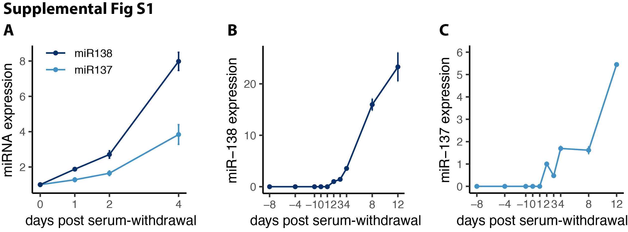
Supplemental Figure S1. miR-138 and miR-137 are expressed across neuronal differentiation, Related to Figure 1.
A) Expression of miR-138 (dark blue) and miR-137 (light blue) in CAD cells 0, 1, 2, and 4 days after serum withdrawal. Expression of B) miR-138 and c) miR-137 across differentiation of glutamatergic neurons from mESCs. All expression measurements performed by TaqMan qPCR normalized to U6 snRNA.

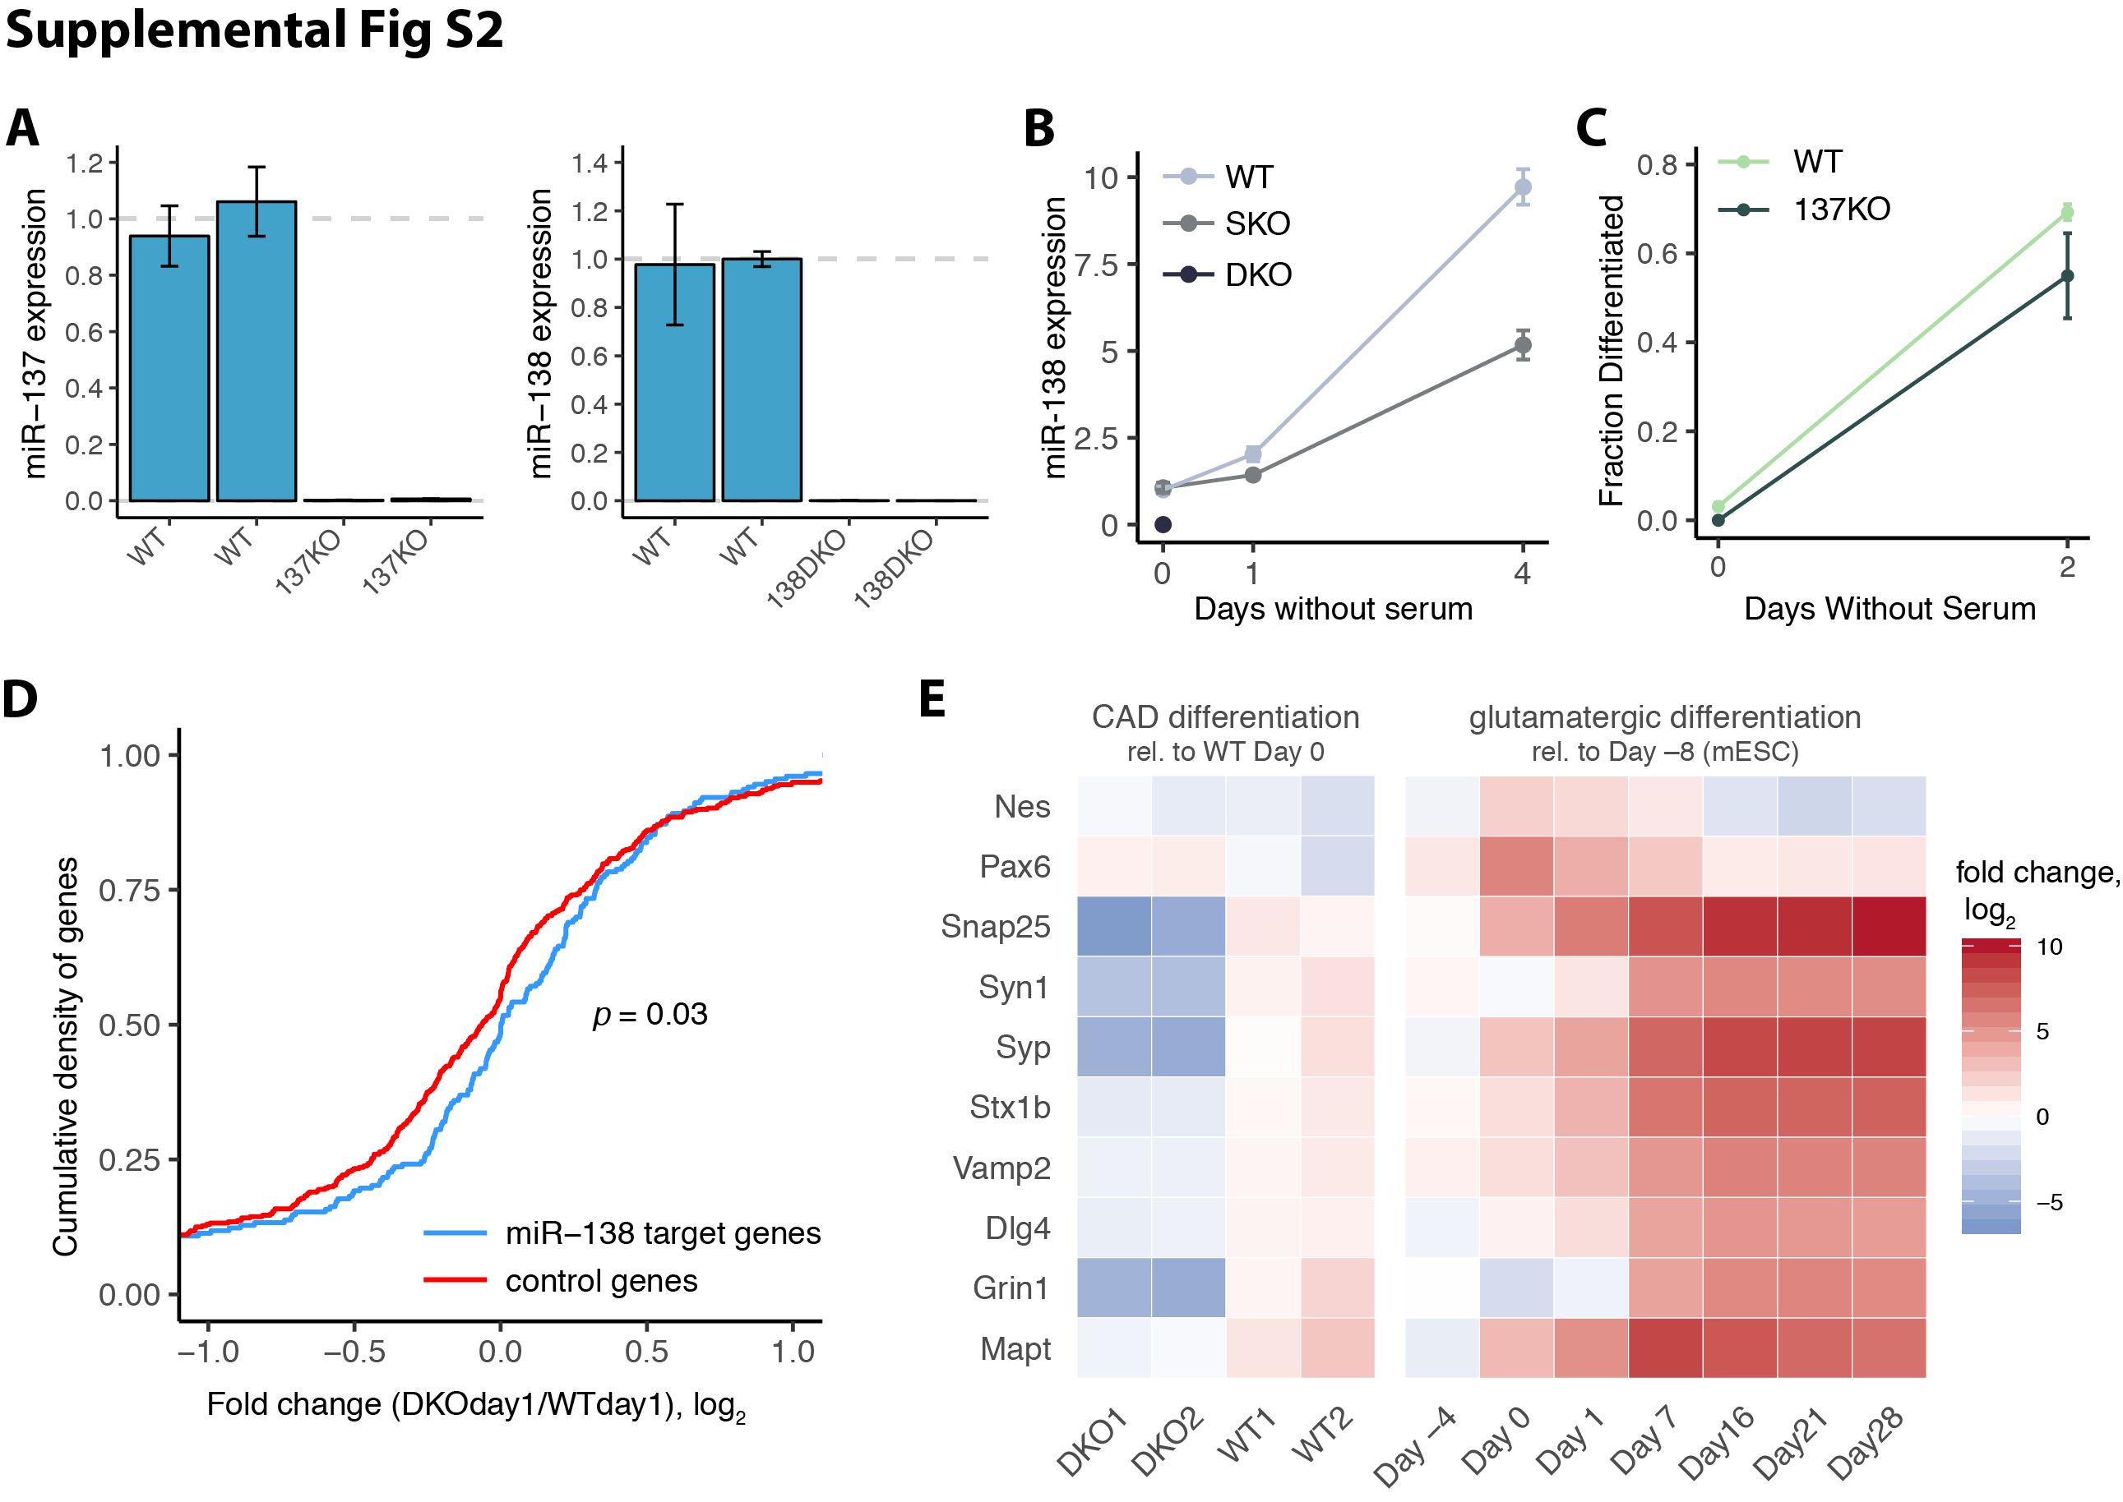
Supplemental Figure S2. mRNA and miRNA expression changes in mir-138 knockout cells, Related to Figure 2.
A) Expression of miR-137 in WT and 137KO cells or miR-138 in WT and 138DKO cells measured by TaqMan qPCR normalized to U6 snRNA. Expression in KO cells normalized to the average of the WT samples. Duplicate bars show data for biological duplicates. B) Expression of miR-138 in WT, mir-138-2 SKO, and 138DKO cells 0, 1, and 4 days after serum withdrawal, with conventions as in A). C) Quantitation of mir-137 KO (137KO) and WT cell line differentiation at 0 and 2 days after serum withdrawal. D) Empirical cumulative distribution function (ecdf) of the fold change of miR-138 targets (blue) or shuffled seed control genes (red). p = 0.03 (Wilcoxon rank-sum test). E) Fold change (log₂) in expression from CAD WT Day 0 of neuronal differentiation markers in CAD WT and 138DKO cells, and in a glutamatergic neuronal differentiation relative to Day –8 (representing mESCs). All measurements based on RNA-seq TPM values.

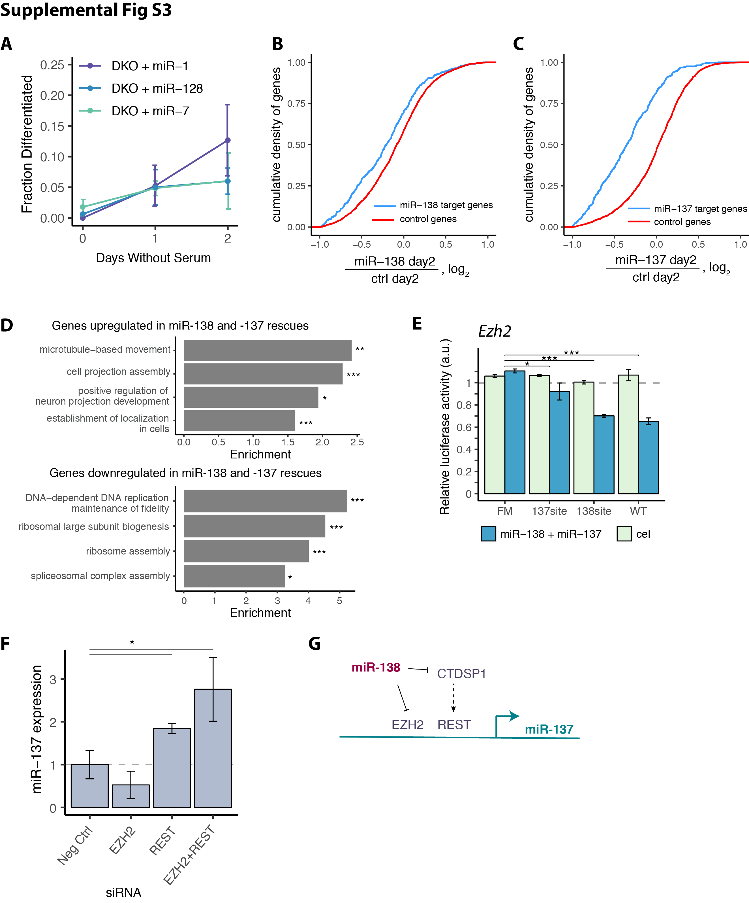
Supplemental Figure S3. Gene expression changes in miR-138 and miR-137 rescue experiments, Related to Figure 3.
A) Quantitation of differentiation of DKO cells transfected with miR-1, miR-128, or miR-7 at 0, 1, and 2 days after serum withdrawal. B) Cumulative distributions of the fold change of miR-138 or C) miR-137 targets (blue) and shuffled seed control genes (red) in the corresponding miRNA mimic transfection at Day 0 compared to the pUC19 DNA control transfection. D) Gene ontology of genes significantly up-regulated or down-regulated in both miR-138 and miR-137 mimic transfections 2 days after serum withdrawal, normalized to the pUC19 DNA transfection control. FDR-corrected significance levels are marked with asterisks. E) Renilla over firefly luciferase signal for psiCHECK-2 reporter containing the Ezh2 3' UTR with one miR-138 and one miR-137 site (WT), or with both seed site mutations (FM). Treatment with miR-138 and miR-137 or control (cel-miR-67) were normalized to transfection with no miRNA mimic added. Significance was assessed by t-test, and select comparisons are shown. F) Expression of miR-138 in WT CAD cells transfected with 10nM negative control siRNA, EZH2 siRNA, REST siRNA, or 5nM of EZH2 and REST siRNA together. Significance was assessed by t-test. G) Model of how miR-138 controls the expression levels of miR-137. * p < 0.05, ** p < 0.01, *** p < 0.001.

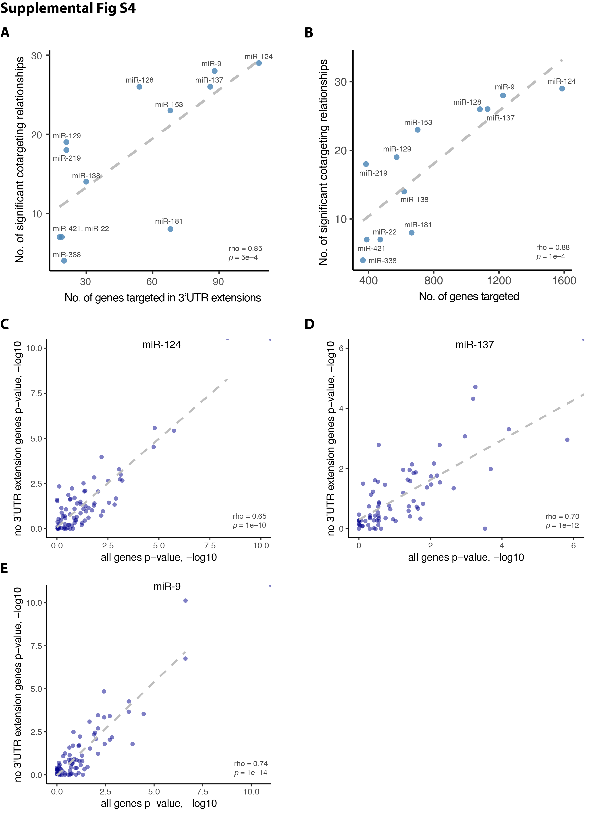
Supplemental Figure S4. Brain-specific 3'UTR extension regions modestly impact cotargeting among neuronal miRNAs, Related to Figure 4.
A) Number of genes targeted in 3'UTR extension regions and number of significant cotargeting relationships for brain-enriched miRNAs (Z-score > 2) (regression line in dashed grey, r = 0.85, p = 5 x 10^{–4}). B) Total number of genes targeted and number of significant cotargeting relationships for brain-enriched miRNAs (Z-score > 2) (regression line in dashed grey, r = 0.88, p = 1 x 10^{–4}). (C-D) –log 10 of the raw p-values from our overlap analysis performed as previously or with removing all genes targeted in a 3'UTR extension region by any miRNA (n = 692) for miR-124 (C), miR-137 (D), and miR-9 (E) (regression line in dashed grey, Spearman rho and significance displayed).

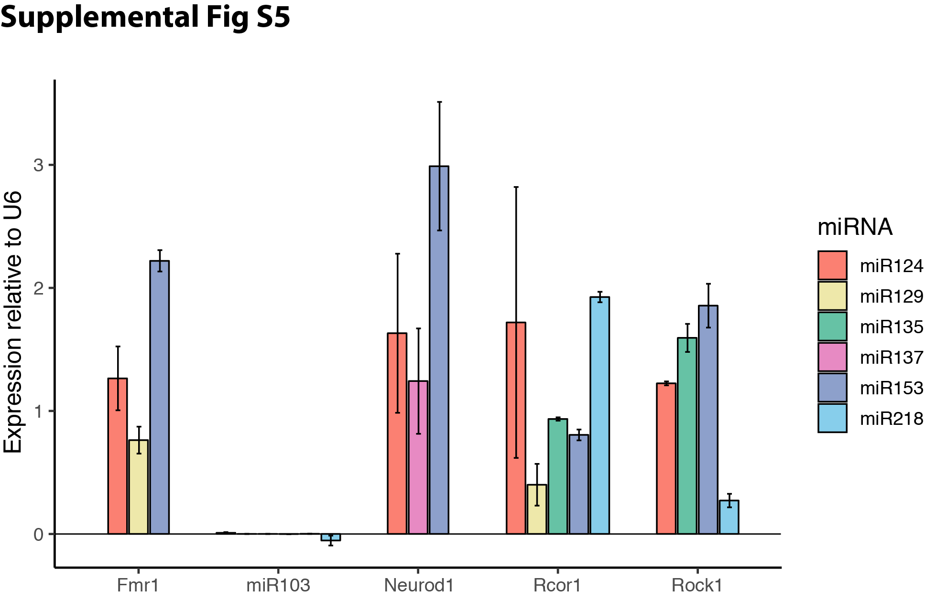
Supplemental Figure S5. miRNAs are efficiently expressed from engineered cassette plasmids, Related to Figure 5.
miRNA expression measured by TaqMan qPCR, normalized to U6 snRNA. Background expression levels (measured in samples transfected with the empty plasmid) were subtracted. miRNAs were expressed from plasmids designed for Neurod1, Fmr1, Rock1, Rcor1, and miR-103 miRNA expression plasmids.

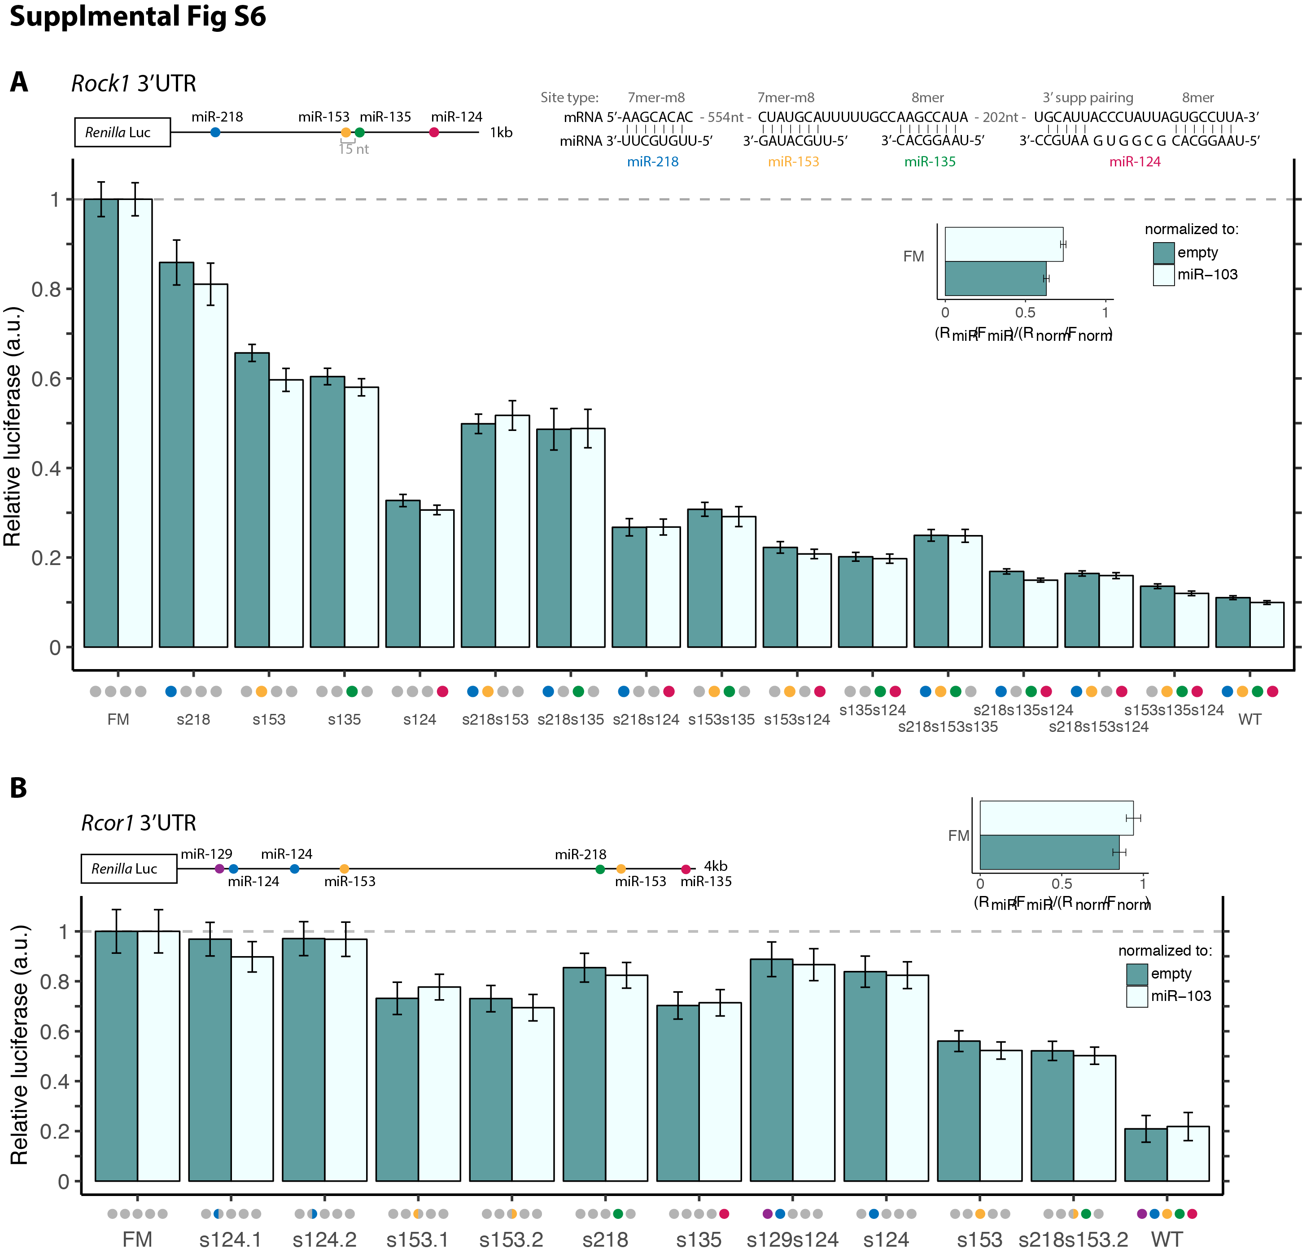
Supplemental Figure S6. Rock1 and Rcor1 reporters reveal dynamic regulation, Related to Figure 6.
A) Relative luciferase activity (Renilla/firefly) for Rock1 3' UTR cloned downstream of Renilla luciferase, with different combinations of seed site mutations. Organized as in Figure 5B,C. B) Relative luciferase activity (Renilla/firefly) for Rcor1 3'UTR cloned downstream of Renilla luciferase. Organized as in Figure 5B,C.

