Supplemental_Table_S1. Number of TR-COREs identified by CREAM for transcription regulators with ChIP-Seq data in ENCODE project for GM12878 and K562 and more than 100 TR-COREs.
GM12878 |  | K562
transcription regulator | Average number of TR-COREs among replicates | transcription regulator | Average number of TR-COREs among replicates
RUNX3 | 1334 | MAFK | 904
CTCF | 1284 | MAFF | 732
ZNF143 | 843 | JUND | 685
EBF1 | 793 | ZNF143 | 673
CMYC | 767 | TEAD4 | 657
RAD21 | 693 | RAD21 | 646
EBF | 677 | CTCF | 568
STAT1 | 593 | PU1 | 544
YY1 | 564 | ELF1 | 514
MTA3 | 531 | MAX | 498
BATF | 428 | HDAC2 | 494
TCF12 | 397 | CBX3 | 481
STAT5 | 388 | CCNT2 | 477
P300 | 385 | BHLHE40 | 470
BCL3 | 384 | HCFC1 | 463
ATF2 | 382 | ZNF384 | 463
PAX5 | 376 | IRF1 | 456
FOXM1 | 375 | SMC3 | 450
PU1 | 371 | TBLR1 | 446
NFIC | 368 | CEBPB | 442
BCLAF1 | 340 | CMYC | 429
NFATC1 | 339 | NRSF | 423
PML | 321 | CDPS | 403
TCF3 | 295 | P300 | 378
SP1 | 272 | ZNFMIZ | 376
ELF1 | 236 | NR2F2 | 364
IRF4 | 232 | ARID3A | 362
IKZF1 | 189 | EGR1 | 352
POU2F2 | 178 | RFX5 | 347
BCL11 | 177 | ZBTB7 | 338
TAF1 | 168 | HEY1 | 321
POL2 | 165 | COREST | 313
MEF2 | 162 | PML | 308
ZEB1 | 156 | ATF1 | 305
PBX3 | 150 | MAZ | 276
NFE2 | 138 | CJUN | 244
CREB1 | 134 | CHD2 | 243
SRF | 132 | CEBPD | 236
CEBPB | 129 | USF1 | 226
EGR1 | 109 | MXI1 | 219
NRSF | 106 | ZC3H1 | 218
NFKB | 103 | TRIM28 | 209
 |  | E2F6 | 208
 |  | NFYB | 205
 |  | STAT5 | 203
 |  | YY1 | 198
 |  | KAP1 | 189
 |  | ELK1 | 187
 |  | POL2 | 180
 |  | GABP | 156
 |  | ATF3 | 156
 |  | HMGN3 | 154
 |  | GATA2 | 153
 |  | BACH1 | 151
 |  | TAF1 | 148
 |  | SIN3 | 145
 |  | ETS1 | 139
 |  | GTF2 | 129
 |  | FOSL1 | 110

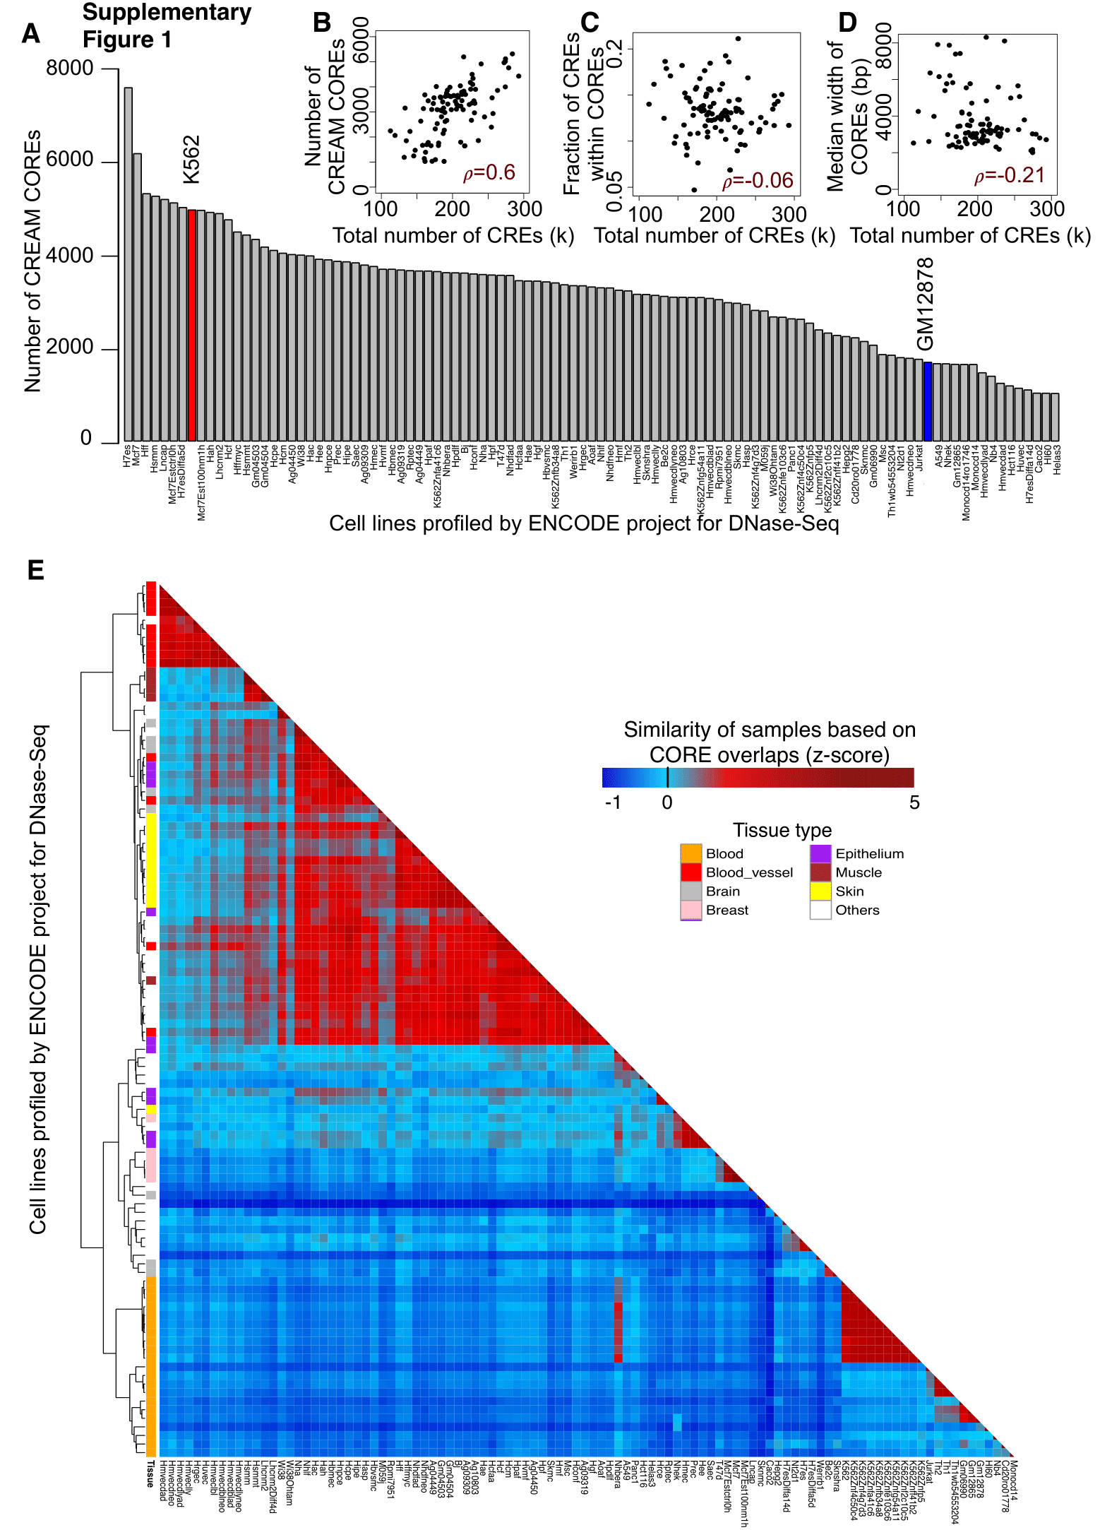

Supplemental_Fig_S1. Specificity of COREs to the cell types in ENCODE. (A) Number of COREs identified by CREAM for each cell or tissue previously profiled by the ENCODE project for DNase-seq. (B) Positive correlation in the number of COREs with the number of individual CRE per sample. (C) Independence in the fraction of CREs called within COREs versus the number of individual CRE per sample. (D) Relation between median width of COREs and the number of individual CRE per sample. (E) Heatmap of similarities based on CREAM-identified COREs across the ENCODE project cells or tissue samples based on Jaccard index of overlap in COREs.

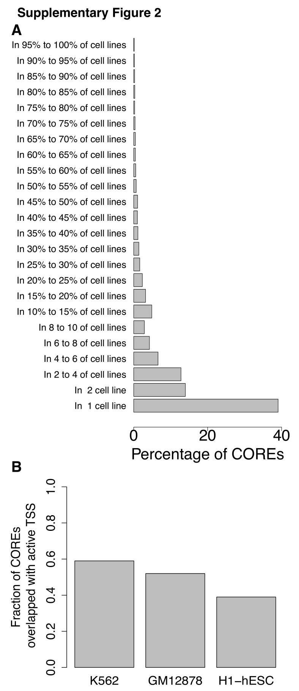

Supplemental_Fig_S2. (A) Percentage of COREs shared between different percentage of cell lines with available DNaseI profiles in The ENCODE Project Consortium (B) Fraction of COREs overlapped with active TSS in GM12878, K562 and H1-hESC cell lines.

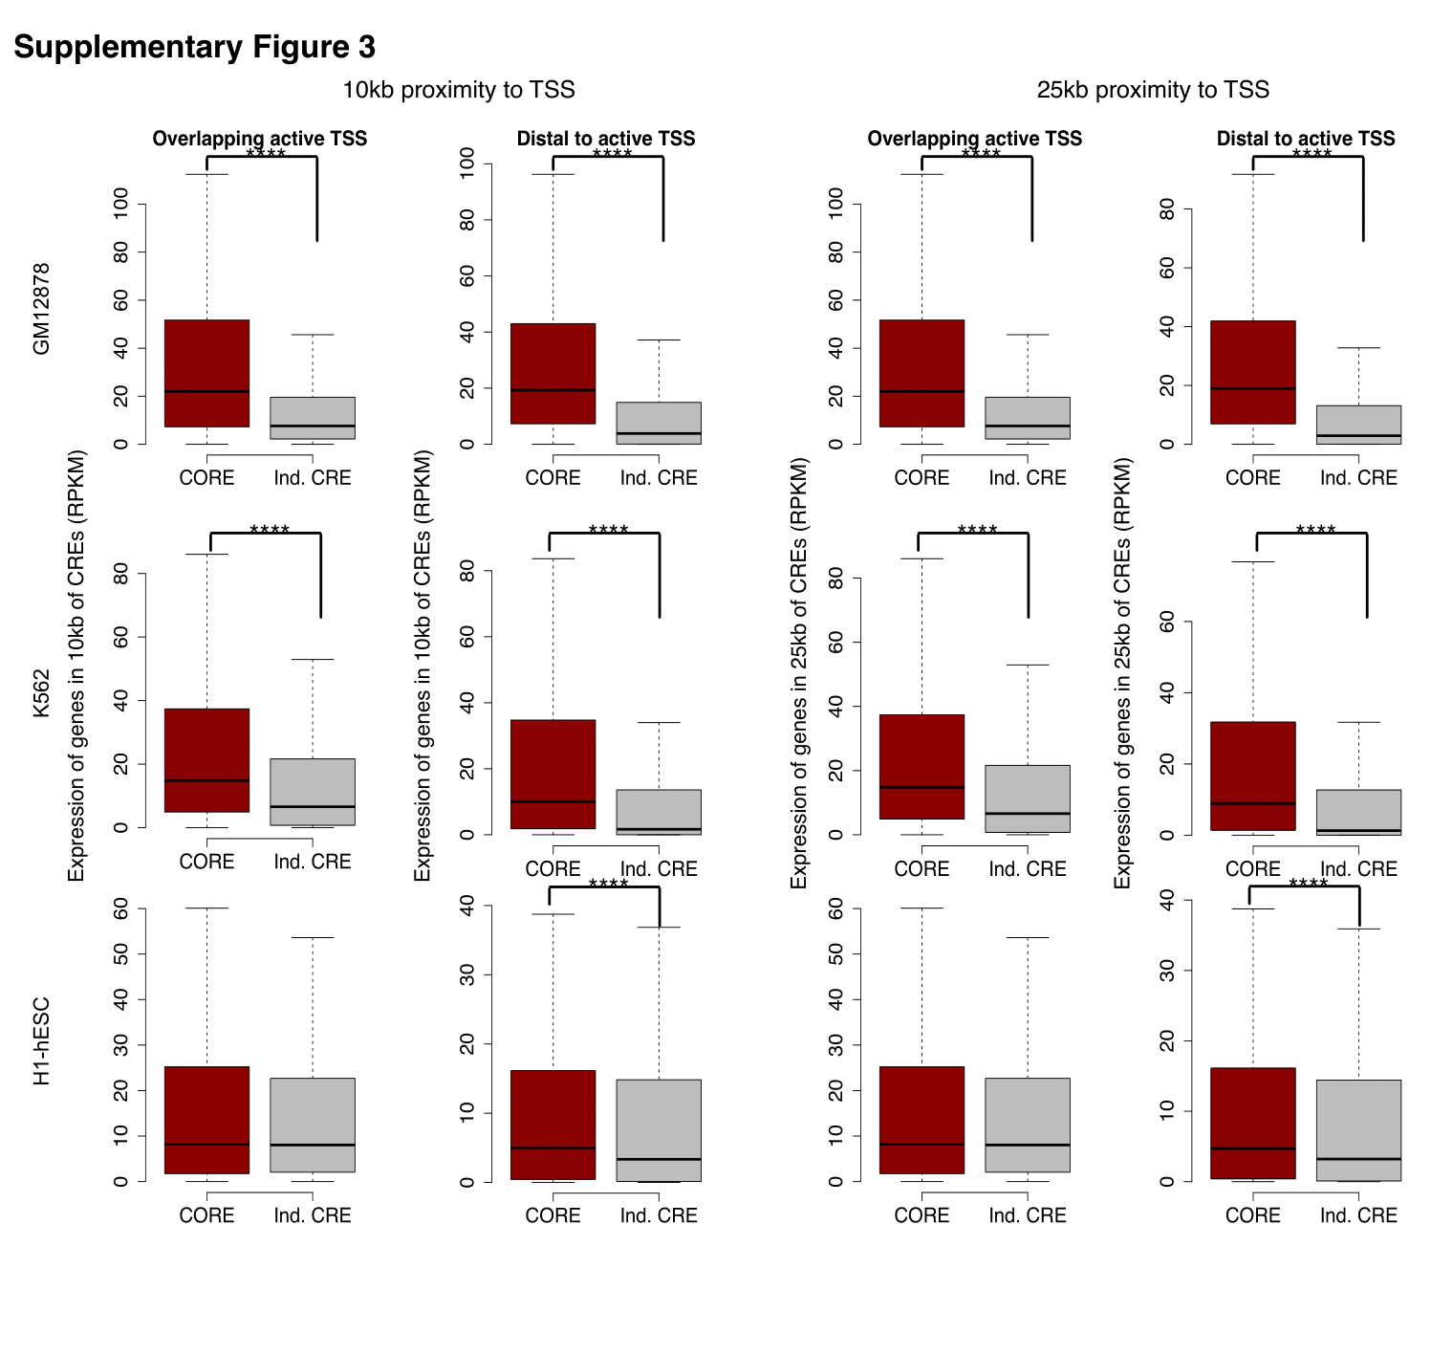
Supplemental_Fig_S3. Expression of genes in 10kb and 25kb proximity of individual CREs or COREs categorized as either overlapping or distal to active TSS in GM12878, K562 and H1-hESC cell lines.

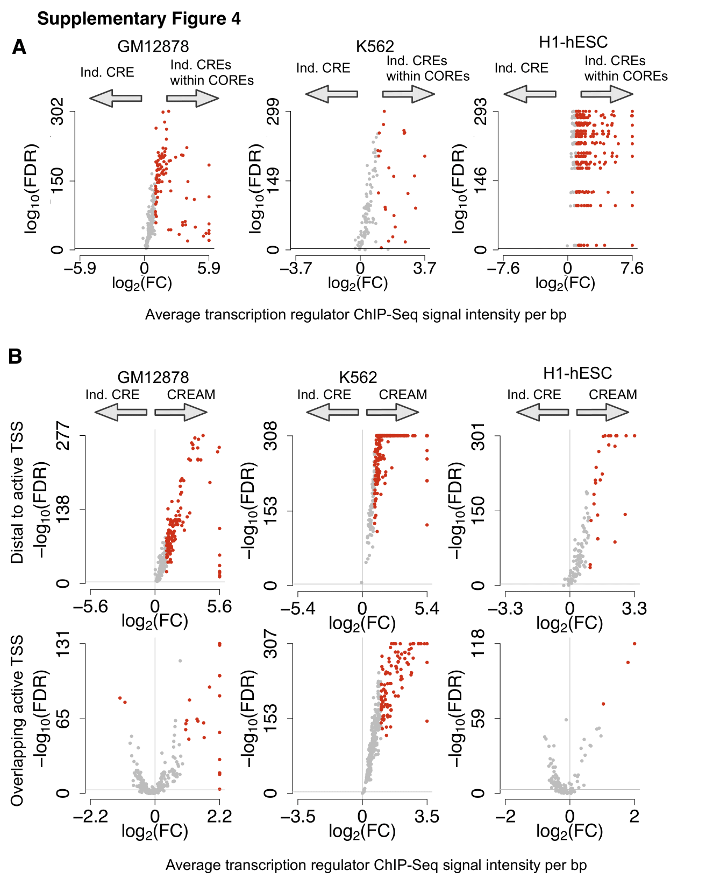

Supplemental_Fig_S4. (A) Enrichment of transcription regulator binding intensity from ChIP-seq data in COREs excluding the CRE-free gaps compared to individual CREs. (B) Enrichment of transcription regulator binding intensity from ChIP-seq data in COREs versus individual CREs categorized as either overlapping or distal to active TSS in GM12878, K562 and H1-hESC cell lines.

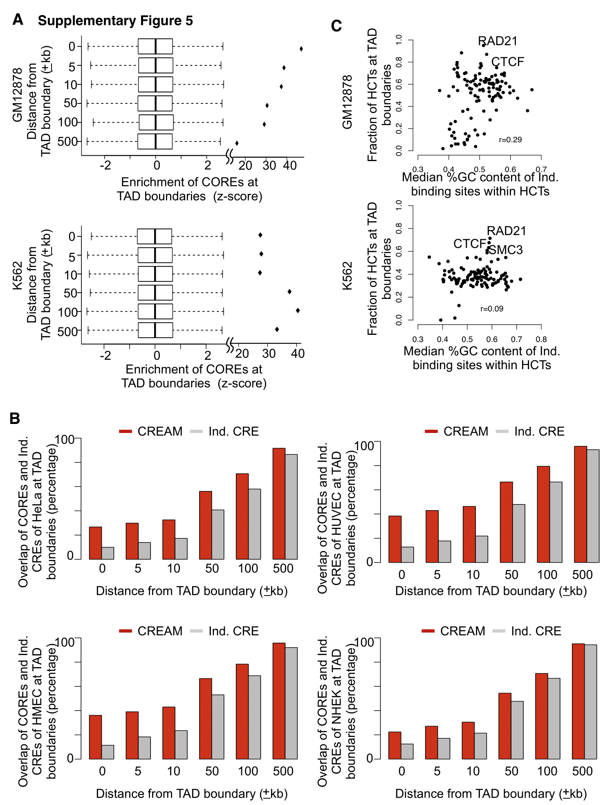

Supplemental_Fig_S5. (A) Permutation test assessing the significance of the enrichment of COREs at TAD boundaries across a range of distance cutoffs around TAD boundaries (0-500kb). (B) Enrichment of COREs and individual CREs at TAD boundaries in HeLa, HMEC, HUVEC, and NHEK cells. (C) Relationship between the percentage of TR-CORE at TAD boundary and the %GC content of the individual CREs within the COREs.

