Supplemental Information
Dynamic Reversal of Random X Chromosome Inactivation during iPSC Reprogramming
Adrian Janiszewski, Irene Talon, Joel Chappell, Samuel Collombet , Juan Song, Natalie De Geest, San Kit To, Greet Bervoets, Oskar Marin, Caterina Provenzano, Lotte Vanheer, Jean-Christophe Marine, Florian Rambow, Vincent Pasque.
Supplemental Methods 3
Supplemental Text 1: Cell culture and reprogramming methods 3
Supplemental Text 2: Immunofluorescence 4
Supplemental Text 3: Flow cytometry and cell sorting 4
Supplemental Text 4: RNA-seq reads processing 4
Supplemental Text 5: PCA and gene expression analysis 5
Supplemental Text 6: Hi-C data analysis 6
Supplemental Text 7: Chromatin immunoprecipitation 6
Supplemental Text 8: Genomic DNA qPCR 7
Supplemental Text 9: Western blot analysis 7
Supplemental Text 10: RNA FISH 8
Supplemental Text 11: Live imaging 8
Supplemental Text 13: RNA-seq library preparation 9
Supplemental Text 14: Single-cell RNA-seq data analysis 9
Supplemental Text 15: Allele-specific ChIP-seq data analysis 10
Supplemental Figures 11
Supplemental Figure S1. Analyses of Mus^{Xi-GFP}/Cast^{Xa} reporter system. 11
Supplemental Figure S2. Reactivation kinetics of individual X-linked genes during factor-induced reprogramming to iPSCs. 14
Supplemental Figure S3. RNA FISH for early (Med14, Acot9, Sat1 and Prdx4), mid (Atrx) and late genes (Klhl13 and Enox2). 15
Supplemental Figure S4. Possible predictors for XCR kinetics. 17
Supplemental Figure S5. POU5F1 and ESRRB binding to X-linked genes during reprogramming. 19
Supplemental Figure S6. Epigenetic drug screening during reprogramming to pluripotency. 20
Supplemental Figure S7. Number of NANOG+ colonies throughout reprogramming 21
Supplemental Tables 22
Supplemental Table 1: Sequencing reads mapping and quantification summary 22
Supplemental Table 2: Allele-specific distribution of mapped reads with SNPsplit 22
Supplemental Table 3: Allele-specific expression tables 22
Supplemental Table 4: Primers used for ChIP-qPCR experiment 22
Supplemental Table 5: Small compound inhibitors used in the epidrug screen 22
Supplemental References 22

Supplemental Methods

Supplemental Text 1: Cell culture and reprogramming methods
MEFs were cultured in MEF medium [DMEM (Gibco, 41966-554 052) supplemented with 10% (v/v) fetal bovine serum (FBS, Gibco, 10270-106), 1% (v/v) penicillin/streptomycin (P/S, Gibco, 15140-122), 1% (v/v) GlutaMAX (Gibco, 35050-061), 1% (v/v) non-essential amino acids (NEAA, Gibco, 11140-050), and 0.008% (v/v) beta-mercaptoethanol (Sigma-Aldrich, M7522)]. Reprogramming experiments, unless stated otherwise, were performed by conditional induction of lentivirally delivered reprogramming factors. First, passage 1 MEFs at around 70% confluency were transduced with concentrated lentiviral supernatants. Lentiviruses were generated using HEK cells separately for two constructs: tetO-FUW-OSKM, Addgene cat. 20321 (Carey et al. 2009) and FUW-M2rtTA, Addgene cat. 20342 (Hockemeyer et al. 2008) with the calcium precipitation method. Supernatants with lentiviral particles were concentrated using lenti-X-concentrator (Takara, 631231) in 1:100 ratios. Infection with a pool of equal volumes of both constructs was carried out overnight, followed by 12 hours culture in MEF medium and 1:6 split. Cells were then sorted using FACS (described below) in order to isolate homogeneous population with regard to allelic inactivation of the X-GFP transgene (either Xi-GFP or Xa-GFP). Cells were plated for reprogramming directly after sorting, 50.000 cells per one well of a 12 well plate. Reprogramming was induced by doxycycline (2 μg/ml final) in mouse ESC medium [KnockOut DMEM (Gibco, 10829-018) supplemented with 15% FBS, 1% P/S 10,000 U/mL, 1% GlutaMAX 100×, 1% NEAA 100×, 0.008% (v/v) beta-mercaptoethanol, and mouse LIF] in the presence of ascorbic acid (50 μg/ml final). The medium together with doxycycline and ascorbic acid was replaced every two days and maintained throughout entire reprogramming experiments. To derive iPSCs from picked colonies, the same conditions were used with dox and AA withdrawal after picking. STEMCCA reprogramming was carried out as previously reported (Pasque et al. 2014).

Supplemental Text 2: Immunofluorescence
Immunofluorescence staining was carried out as previously described (Pasque et al. 2014). The primary antibodies used were as follows: H3K27me3 (mouse, 1:500, Active motif, cat. 61017), H3K27ac (rabbit, 1:500, Abcam, cat. Ab4729), NANOG (rat, 1:200, eBioscence, cat. 14-5761-80). Images were captured with a Zeiss Axioimager Z1 inverted microscope coupled with an AxioCam MRc5 camera and Axio Vision software. Multi-channel images were cropped and merged in ImageJ. The number of scored cells is indicated under each plot.

Supplemental Text 3: Flow cytometry and cell sorting
For cell sorting and flow cytometry analysis cells were dissociated using trypsin digestion. For X-GFP+/- cell sorting, dissociation was followed by washing in incubation buffer (1× PBS, 0.5% BSA, 2mM EDTA) and filtered through Falcon® 40 µm Cell Strainer (Corning, cat. 352340). For details about sorting FUT4⁺ cells, as well as for flow cytometry analysis in screening approaches, dissociation was followed by wash in incubation buffer and 40 minutes of incubation with primary antibody anti FUT4 coupled with PE (Mouse IgM, R&D, FAB2155P, Clone MC-480, conc. 1 µl FUT4-PE Ab / 5 × 10⁶ cells). Stained cells were subsequently washed in incubation buffer to remove residual unbound antibody and passed through a cell strainer. Cell death exclusion was always applied by staining with DAPI (Sigma-Aldrich cat. D9542-50MG). Sorting was performed on a BD FACS Aria III or BD Influx (BD Biosciences) and performed by expert operators at KU Leuven FACS core. Flow cytometry was performed on BD Canto II HTS.

Supplemental Text 4: RNA-seq reads processing
Read quality was initially assessed using FastQC (https://www.bioinformatics.babraham.ac.uk/projects/fastqc/) (94% >Q30). For non-allele resolution analyses, reads were aligned to the mouse reference genome (mm10; GRCm38.p5) using STAR 2.5.3a (Dobin et al. 2013) supplied with the corresponding GENCODE vM16 annotation file. Mapping was done with default parameters with specified --sjdbOverhang 74 followed by conversion to sorted BAM files. On average, 83.96% of reads were uniquely mapped and only those were passed to next steps. Subsequently, the featureCounts function from the R Bioconductor package “Rsubread” (version 1.5.2) (Liao et al. 2019) was used to assign mapped reads to genomic features. For allele resolution analyses, reads were mapped to the same reference genome release in which SNP positions were substituted by N base (referred to as N-masked mm10). N-masking was performed with SNPsplit software (Version 0.3.2 released (29-03-2017)) (Krueger and Andrews 2016) supplied with the list of strain specific SNPs (129S1_SvImJ and CAST_EiJ) from Sanger Mouse Genomes project database (mgp.v5.merged.snps_all.dbSNP142.vcf.gz). N-masking was done in dual hybrid mode and resulted in the identification throughout the entire genome of 20,563,466 SNP positions unique for either strain, of which 634,730 on the X Chromosome. Next, reads were aligned to the N-masked mm10 genome using STAR 2.5.3a with parameters disabling soft-clipping of incompletely aligned reads (--alignEndsType EndToEnd --outSAMattributes NH HI NM MD). Reads aligned to the N-masked reference genome were then split into two BAM files containing only strain-specific reads (on average 10.95% for Mus and 10.25% for Cast of total mapped reads) using SNPsplit (Supplemental Table S2). Furthermore, to create count matrices with only reliable allelic information, only SNPs covered by at least 5 reads were selected and genes comprising of at least 8 of such SNPs were retained (Supplemental Table S3).

Supplemental Text 5: PCA and gene expression analysis
Processing raw read counts for non-allele-specific analysis was supported by the DESeq2 package and associated protocol (Love et al. 2014). Genes that did not express at least 10 reads in total across all libraries were discarded from further analyses. Next, PCA was plotted using plotPCA function from the DESeq2 package with input of top 500 most variable genes after rlog transformation. Unless mentioned otherwise, gene expression was presented as log₂ values after size-factor normalization for the differences in library size (DESeq2). To evaluate Xist and Tsix expression, read coverage was first calculated and normalized for library size (RPKM) using the bamCoverage function from the deepTools2 (v2.4.1) package (Ramirez et al. 2014) with --binsize 1. Next, to overcome lack of strand-specific information, ratio of exon to intron coverage at the exon:intron downstream boundary (100 bp overlap) was calculated at exon 5 and exon 1 for Xist and Tsix, respectively. For X Chromosome to autosome ratio, the mean expression of all X-linked genes (and as control Chromosome 8 and Chromosome 2 genes) was divided by the mean expression of all autosomal genes.

Supplemental Text 6: Hi-C data analysis
Hi-C data were mapped to the mouse mm10 genome, with N-masking of SNPs between FVB-NJ and CAST-EiJ from the mouse genome project (v5 SNP142). Data were processed with HiC-Pro (v2.11.0) (Servant et al. 2015) in allele-specific mode. Only pairs with both reads having MAPQ > 30 were kept and duplicates were removed. Matrix at 10kb resolution were produced using cooler cload and balance using cooler balance (Abdennur and Mirny 2019). TAD calling was performed on the non allele-specific matrix using HicExplorer (Ramirez et al. 2018) hicFindTads (parameters: -correctForMultipleTesting fdr –minDepth 250000 –maxDepth 4000000 –step 50000 –thresholdComparisons 0.1 –delta 0.01 –chromosomes chrX). To calculate contact enrichment in TADs, a matrix of Zscore (observed versus expected) was calculated for the allele-specific matrices, using the same function hicFindTads with different parameters (--correctForMultipleTesting None –minDepth 4000000 –maxDepth 10000000 –step 2000000 –thresholdComparisons 1 –delta 0 –chromosome chrX) and the average Zscore per TAD was calculated using the function hicSummarizeScorePerRegion available at http://github.com/heard-lab/HiCExplorer/tree/SummarizePerRegion.

Supplemental Text 7: Chromatin immunoprecipitation
Cells were crosslinked in 2mM DSG (Pierce #20593) for 30 min at room temperature; an additional crosslinked step was applied to the cells with 1% PFA for 10 min at RT. After that, cells were incubated with 0.125 M glycine for 5 min to quench the crosslinking agents and the cross-linking reaction. Nuclei preparation was performed using the truChIP® Chromatin shearing kit, resuspending the chromatin from 1 million cells in 100 µl of sonication buffer (D3) and transfer it to 96 microtube plate #520078, Covaris. The chromatin was sheared using a Covaris LE220 instrument with the following conditions: 5%. DF 640s, 4°C, which typically results in shear sizes for DNA between 0.5 kb and 0.2 kb. Sheared chromatin was incubated overnight with 10 µg of ESRRB antibody (RnD # PP-H6705-00), POU5F1 ab (Cell signaling #5677), or negative control IgG (Cell Signalling #2729). Then, the immunoprecipitation was performed following the ChIP-qPCR protocol described in (Marin-Bejar et al. 2017).

Supplemental Text 8: Genomic DNA qPCR
qPCR was performed using the Platinium SYBR Green qPCR SuperMix-UDG kit (Invitrogen, 11733046) on a ABI ViiA7 real-time PCR system (Applied Biosystems), following the manufacturer’s protocol. Primers spanning the promoter region of selected X-linked genes were designed (Supplemental Table S4). Signals obtained from the ChIP-qPCR were divided by signals from an input sample, each antibody is represented with the corresponding negative control, normal IgG.

Supplemental Text 9: Western blot analysis
MEFs were treated every other day with RG2833 or vehicle (DMSO) during reprogramming starting from day 2 until day 10. At day 10, cells were detached from plates with 0.25% Trypsin-EDTA (Gibco, 25200056), pelleted before addition of 100 µl of combined lysis/loading buffer per 105 cell pellets, as described before (Pasque et al. 2011; Carrette et al. 2018). 10 µl and 7.5 µl of DMSO and RG2833 treated lysates, respectively, were loaded onto a 12% Tris-HCL acrylamide gel (Bio-Rad 161-1120), electrophoresed, and transferred to nitrocellulose membranes. Membranes were blocked in PBS with 0,1% TWEEN 20 containing 5% non-fat milk. Next, membranes were incubated with primary antibody rabbit anti acetyl-Histone H3 (1mg/ml, Milipore, 3089577) overnight at 4°C. After extensive PBS 0.1% TWEEN 20 washes, membranes were incubated with a secondary HRP-conjugated goat anti-mouse IgG antibody (Bio-Rad, 1706516, 1/5000) or goat anti-rabbit IgG antibody (Bio-Rad, 1706515 1/5000) for 30 minutes at room temperature. After another round of extensive PBS 0.1% TWEEN 20 washes, protein expression was visualized using the ECL chemiluminescence reagent (Perkin-Elmer, NEL103001EA) and LAS-3000 imaging system (Fuji). Data was analyzed with ImageJ. After anti acetyl-Histone H3 staining, the membrane was stripped by 30 min incubation at 60°C in stripping buffer containing 100mM 2-mercaptoethanol, 2% SDS and 6.25 mM Tris-cl, pH 6.7. After extensive TBS 0.1% TWEEN 20 washes, blocking and subsequent incubation with primary antibody mouse anti-Histone H3 (1mg/ml, Abcam, ab24834) was done as described above.

Supplemental Text 10: RNA FISH
Cells were washed with 1× PBS and fixed with 4% paraformaldehyde/1× PBS, and serially dehydrated with 70%–100% ethanol. RNA FISH for X-linked genes was performed with double-strand DNA probes labeled with ChromaTide™ Alexa Fluor™ 594-5-dUTP (Invitrogen, C-11400) with a Bioprime™ Array CGH Genomic Labeling Module kit (Invitrogen, 18095-012) following manufacturers’ instructions, from a BAC containing Atrx (RP23-265D6), Klhl13 (RP23-103H15), Med14 (RP24-392J24), Enox2 (RP23-342O10), Acot9-Sat1 (RP23-354H3) and Acot9-Prdx4 (RP23-395KI3). Images were acquired using an Zeiss Axioimager Z1 Microscope equipped with an AxioCam MRc5 camera. Single-cell resolution analysis of biallelic expression in mESCs was determined by counting 50 cells with monoallelic, biallelic or no signal for each gene.

Supplemental Text 11: Live imaging
Images representing the activity of the X-GFP reporter and phase contrast were acquired using a Nikon Eclipse Ti2 microscope coupled with Nikon NIS Elements software. Images were exported using NIS Viewer software and cropped in ImageJ.
Supplemental Text 12: Data processing and visualization
Unless stated otherwise, analysis was conducted in R (R Core Team, 2014) and figures were produced using the package ggplot2 (Wickham 2009).

Supplemental Text 13: RNA-seq library preparation
Briefly, sorted FUT4⁺ reprogramming intermediates were immediately lysed in RLT buffer (RNeasy Micro Kit (Qiagen, 74004)) and stored in -80°C until cells from all timepoints were collected. Next, all samples were processed together to extract RNA following the manufacturer’s protocol. cDNA synthesis was done starting from 500 pg of input RNA, followed by library preparation from 80 pg of cDNA using the Nextera XT kit (Illumina, FC-131-1096). Indexing was performed with the Nextera XT index Kit V2 (Illumina, FC-131-2003). The quality of input RNA, cDNA and individual libraries was assessed using a Agilent 2100 Bioanalyzer system.

Supplemental Text 14: Single-cell RNA-seq data analysis
The data set contains cells from a 16 day time course of reprogramming, including iPSCs maintained in 2i or serum conditions. We excluded cells maintained in just serum post day 8 of reprogramming as initial analyses suggested that cells switched to 2i conditions after day 8 showed higher rate of XCR. This resulted in 27.656 cells from day 0 to day 8 (mouse ESC medium) and 26.351 cells from day 9 – day 16 and iPSCs (2i).
Pseudotime (monocle, version 2.10.0, (Trapnell et al. 2014; Qiu et al. 2017a; Qiu et al. 2017b)) analysis was performed on the filtered dataset, branches which did not lead to iPSCs were deleted as these represented unreprogrammed cells, leaving 29.082 cells with given pseudo time values ranging from 0 – 30.
Gene subsets (early – very late) and gene subset or single gene expression to autosome expression ratios were categorized/calculated as described above.
Thresholds for Acot9, Atp6ap2, Prdx4, Renbp and Idh3g high (red line in Figure S2E) was determined as the highest value on the curve when the generalized additive model was applied to the gene’s ratio to autosomes data within the pseudotimes listed. The Xist high and low thresholds (Figure S2E) were determined as any value above or below half the maximum value on the generalized additive model applied to the Xist expression data over the entire pseudotime, respectively.

Supplemental Text 15: Allele-specific ChIP-seq data analysis
Briefly, raw reads were mapped to the reference genome (mm10) using BWA (version 0.7.13) (Slater et al. 2009) with dynamic read trimming –q 5 and sorted using SAMtools (1.2) (Li et al. 2009). Unmapped reads, reads with quality <30 and PCR duplicates were discarded. PCR duplicates were marked using Picard (v 1.126) (http://broadinstitute.github.io/picard/). Read coverage was first calculated and normalized for library size (RPKM) using bamCoverage function from deepTools2 (v2.4.1) package (Ramirez et al. 2014) with --binsize 100. For allele-specific data processing of Pinter et al. 2012 data set, the Kundaje pipeline (https://github.com/kundajelab/atac_dnase_pipelines) has been adapted to accommodate the SNPsplit pipeline (described above). Briefly, additional parameter has been set for BWA alignment (-s in sampe function) to prevent soft-clipping. Next, filtered BAM files were processed with SNPsplit and the Kundaje pipeline was continued as described above.
To assess the enrichment of selected marks or TFs, first TSSs of genes with defined reactivation kinetics were selected. Where there were more than one TSS per gene, the first upstream TSS was selected. Enrichment values were calculated by summing the score within 5 kb around the TSS using bedops (2.4.35) (Neph et al. 2012). Statistical significance of differences between enrichment levels in different reactivation classes was measured using Wilcoxon rank test.

Supplemental Figures
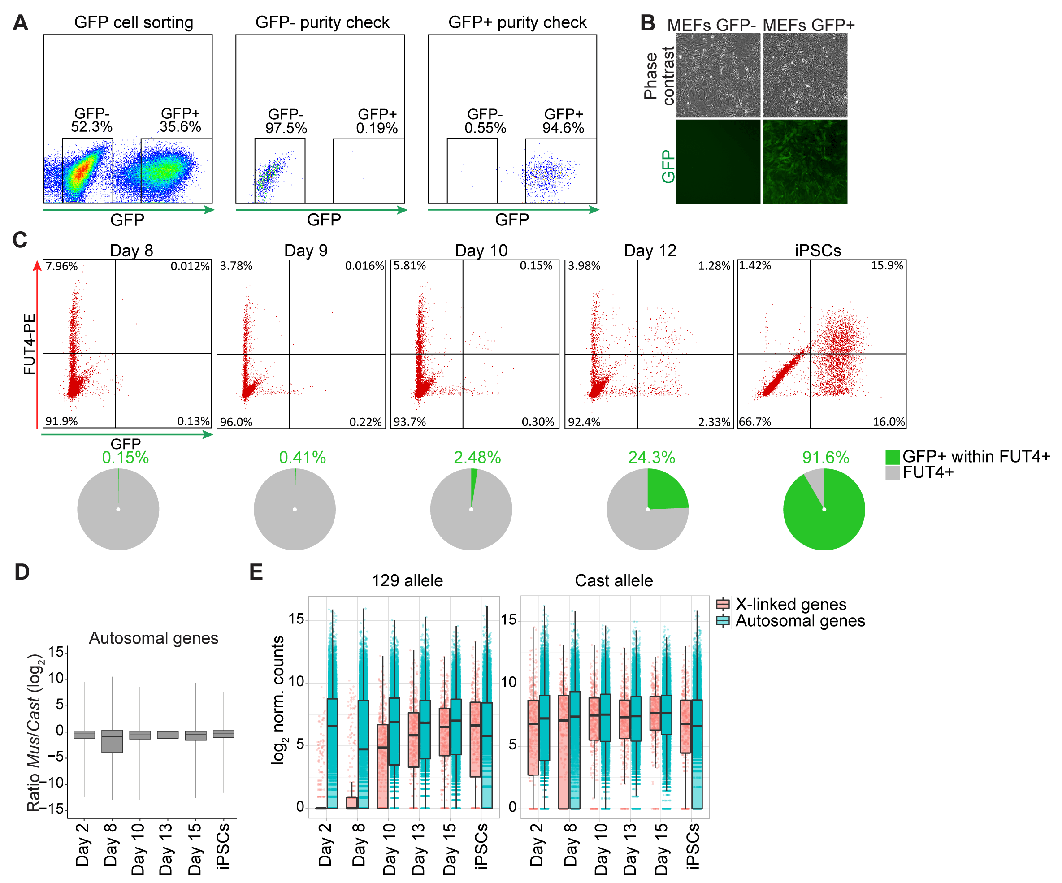

Supplemental Figure S1. Analyses of Mus^{Xi-GFP}/Cast^{Xa} reporter system.
- Density plots representing the FACS for GFP- and GFP+ Mus/Cast MEFs and the purity check for both cell populations.
- Phase contrast and fluorescent images of GFP- and GFP+ Mus/Cast MEFs populations.
- Flow cytometry analysis of FUT4+ and GFP+ cell population during reprogramming (day 8, 9, 10, 12 and iPSCs after four passages). The pie charts below refer to the proportion of GFP+ cells within FUT4+ cell populations for each reprogramming time point.
- Ratio of X-linked gene expression relative to autosomal genes (log₂ transformed normalized counts) during reprogramming time points.
- Expression levels of individual X-linked and autosomal genes (log₂ transformed normalized counts) from two alleles separately over the reprogramming time course.

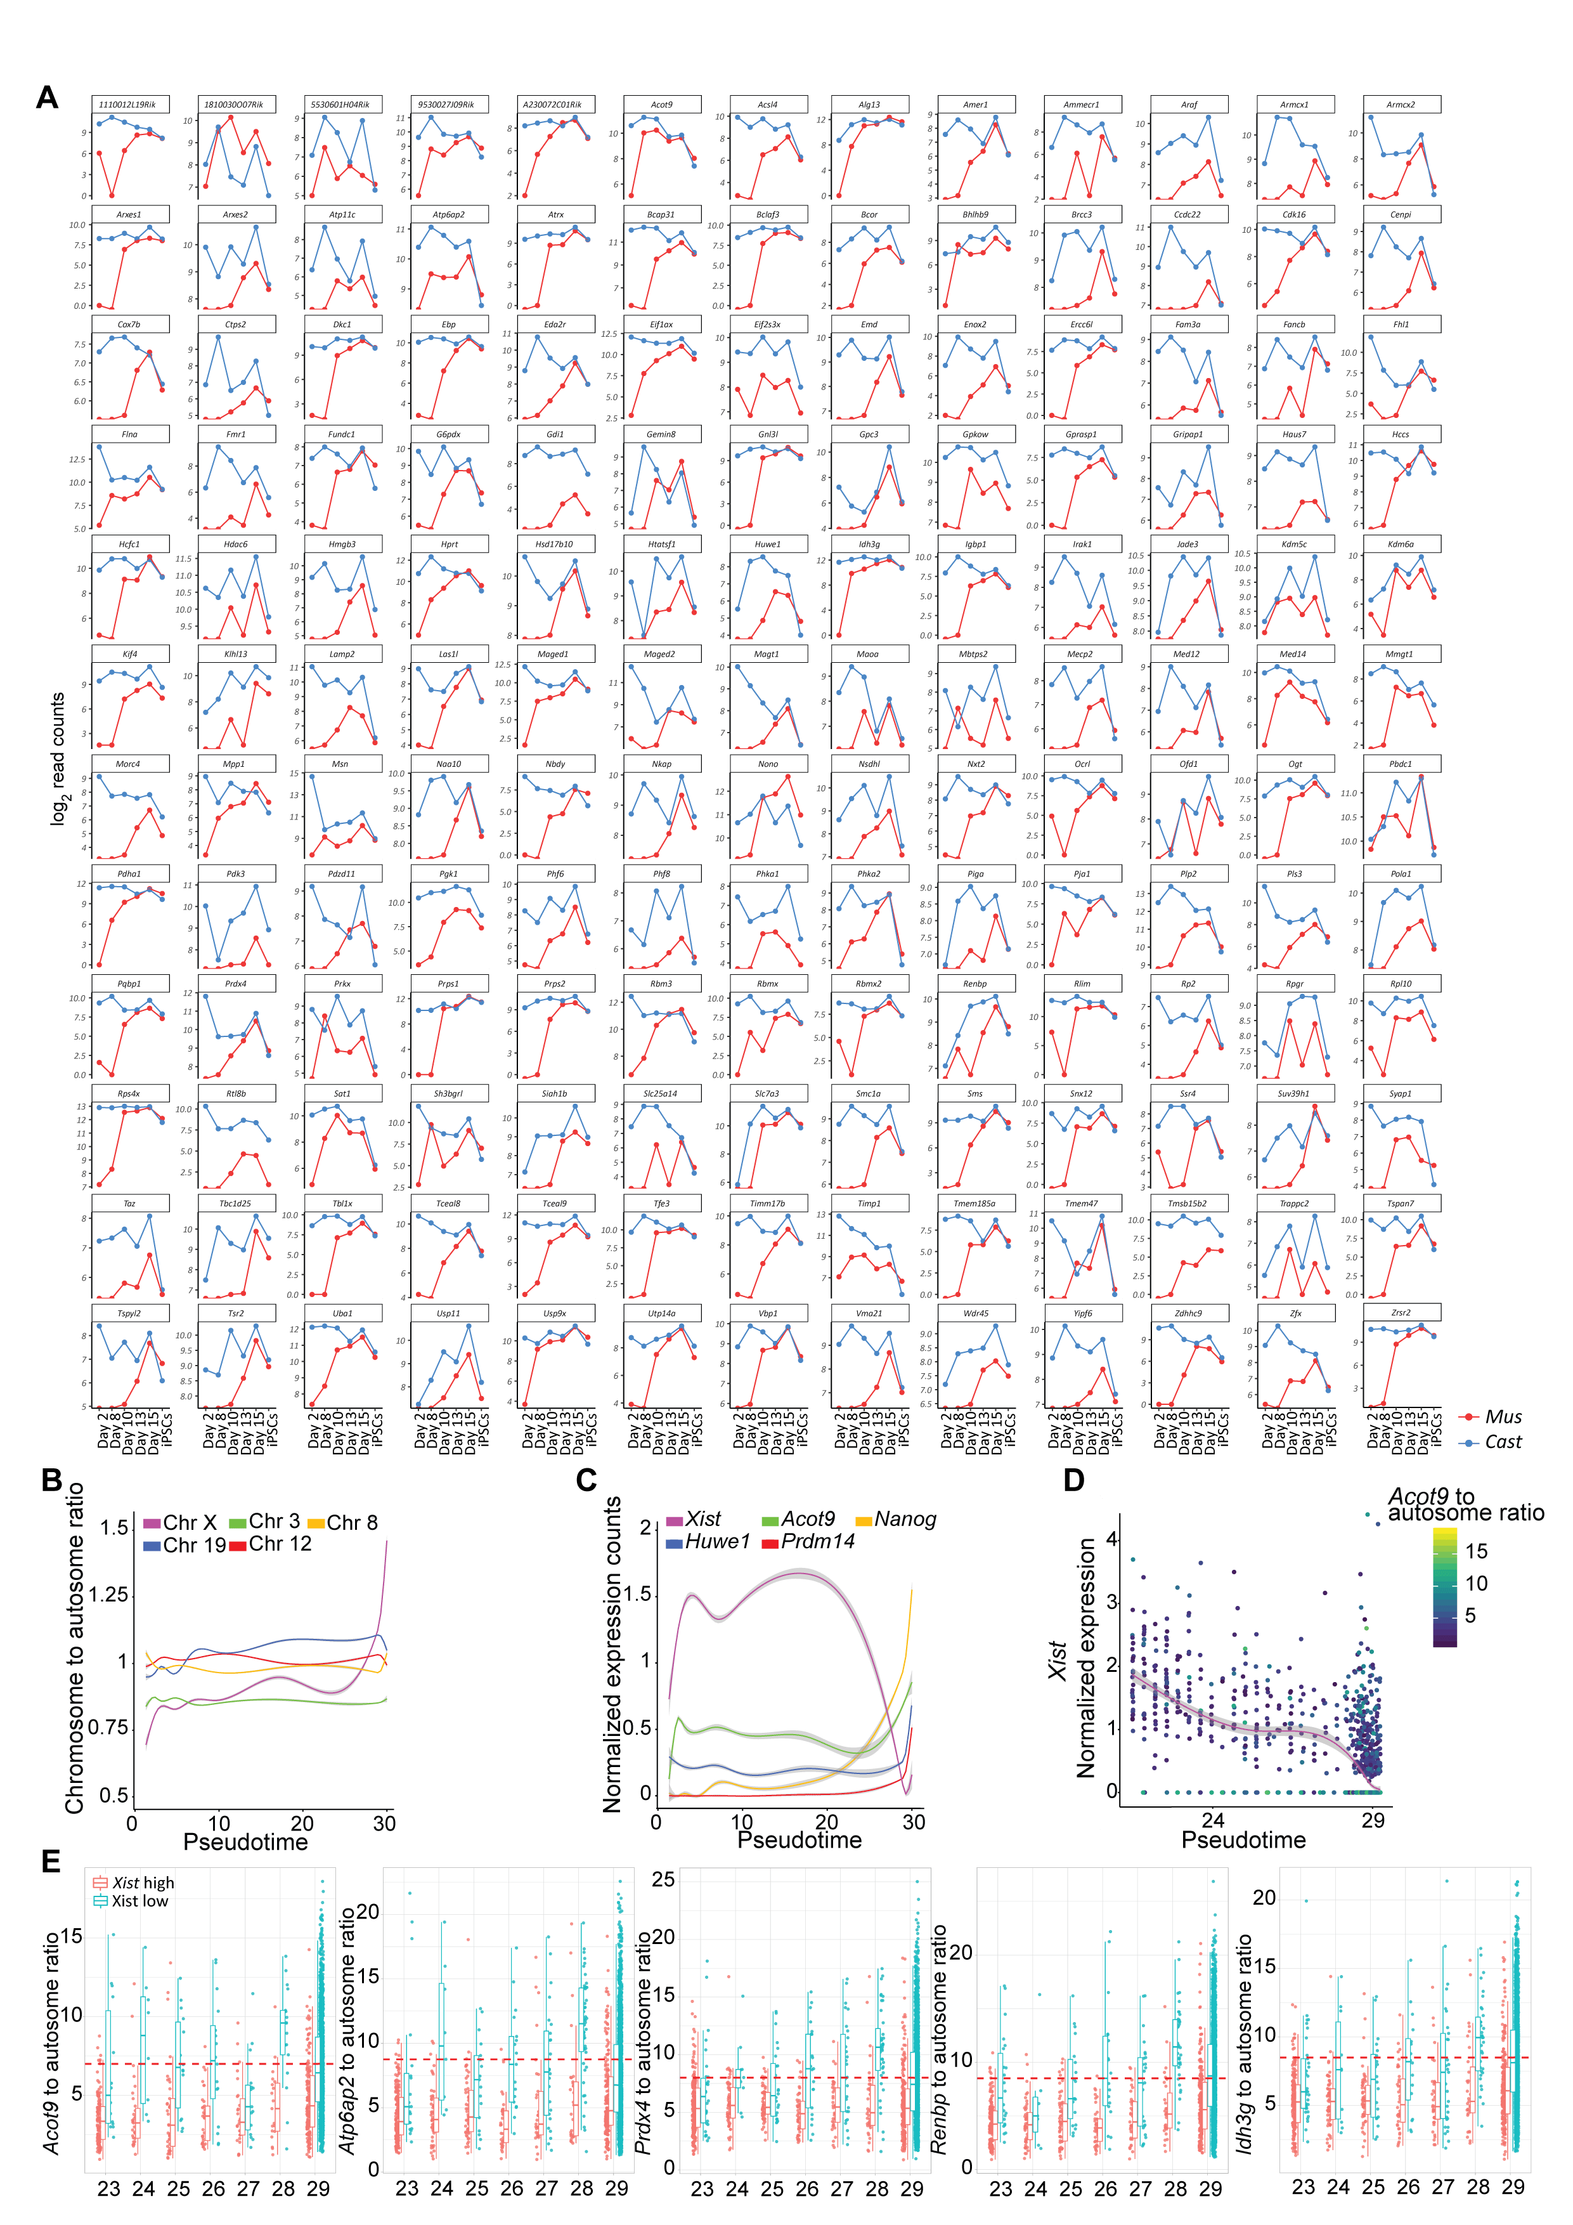

Supplemental Figure S2. Reactivation kinetics of individual X-linked genes during factor-induced reprogramming to iPSCs.
- Each graph represents the expression levels (log2 transformed read counts) of an informative X-linked gene listed in alphabetical order. The x-axis represents the different time points of reprogramming from day 2 to day 15 and iPSCs. Parental origin of the allelic expression is indicated in blue for Cast origin and in red for Mus origin.
- Mean normalized expression levels ratio of chromosome X to autosomes over the reprogramming inferred pseudotime. The curves represent the fitting of generalized additive model to the expression ratio calculated for each single-cell distributed along the pseudotime. The ratio between selected autosomes to all other autosomes has been shown as the control.
- Normalized expression levels of selected X-linked and pluripotency genes during pseudotime inferred from reprogramming trajectory. Curves represent the smoothing of generalized additive model.
- Normalized expression levels of Xist in single cells during pseudotime inferred from reprogramming trajectory. The generalized additive model was calculated for the cells at the pseudotime period that represents late reprogramming stages where cells start acquiring the pluripotent identity.
- Ratio of normalized expression levels of several early genes to mean expression of autosomal genes at different periods of pseudotime. Cells were colored according to the expression level of Xist RNA. Red horizontal line represents the threshold where the ratio of a given gene’s expression to autosomes indicates reactivation (see Methods).

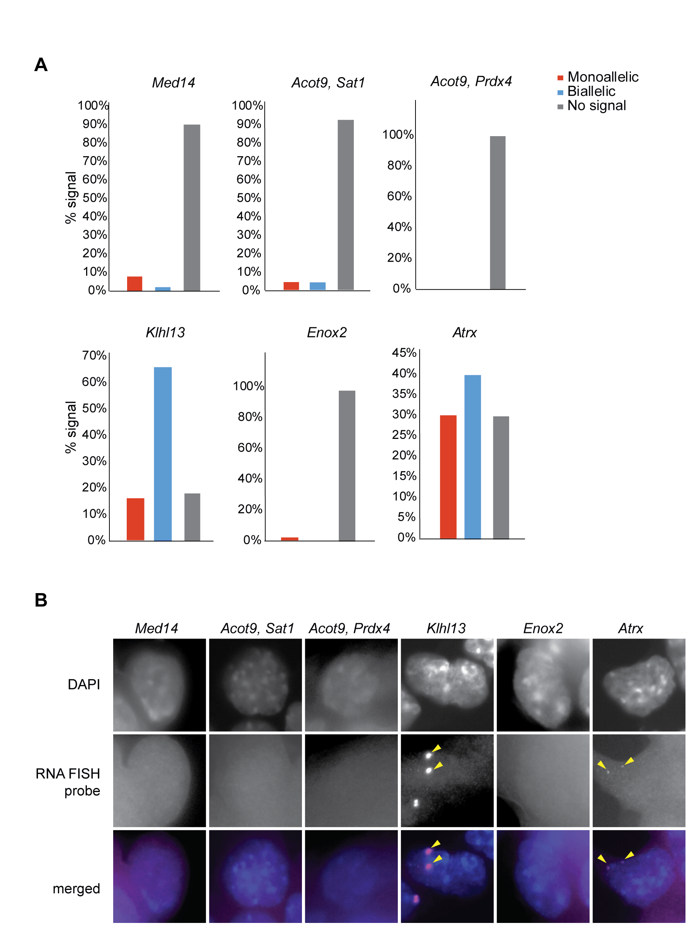

Supplemental Figure S3. RNA FISH for early (Med14, Acot9, Sat1 and Prdx4), mid (Atrx) and late genes (Klhl13 and Enox2).
- Quantification of single-cell resolution analysis of allelic expression of X-linked genes from different reactivation kinetics classes in mESCs using RNA FISH.
- Representative fluorescence images from the analysis in (A).

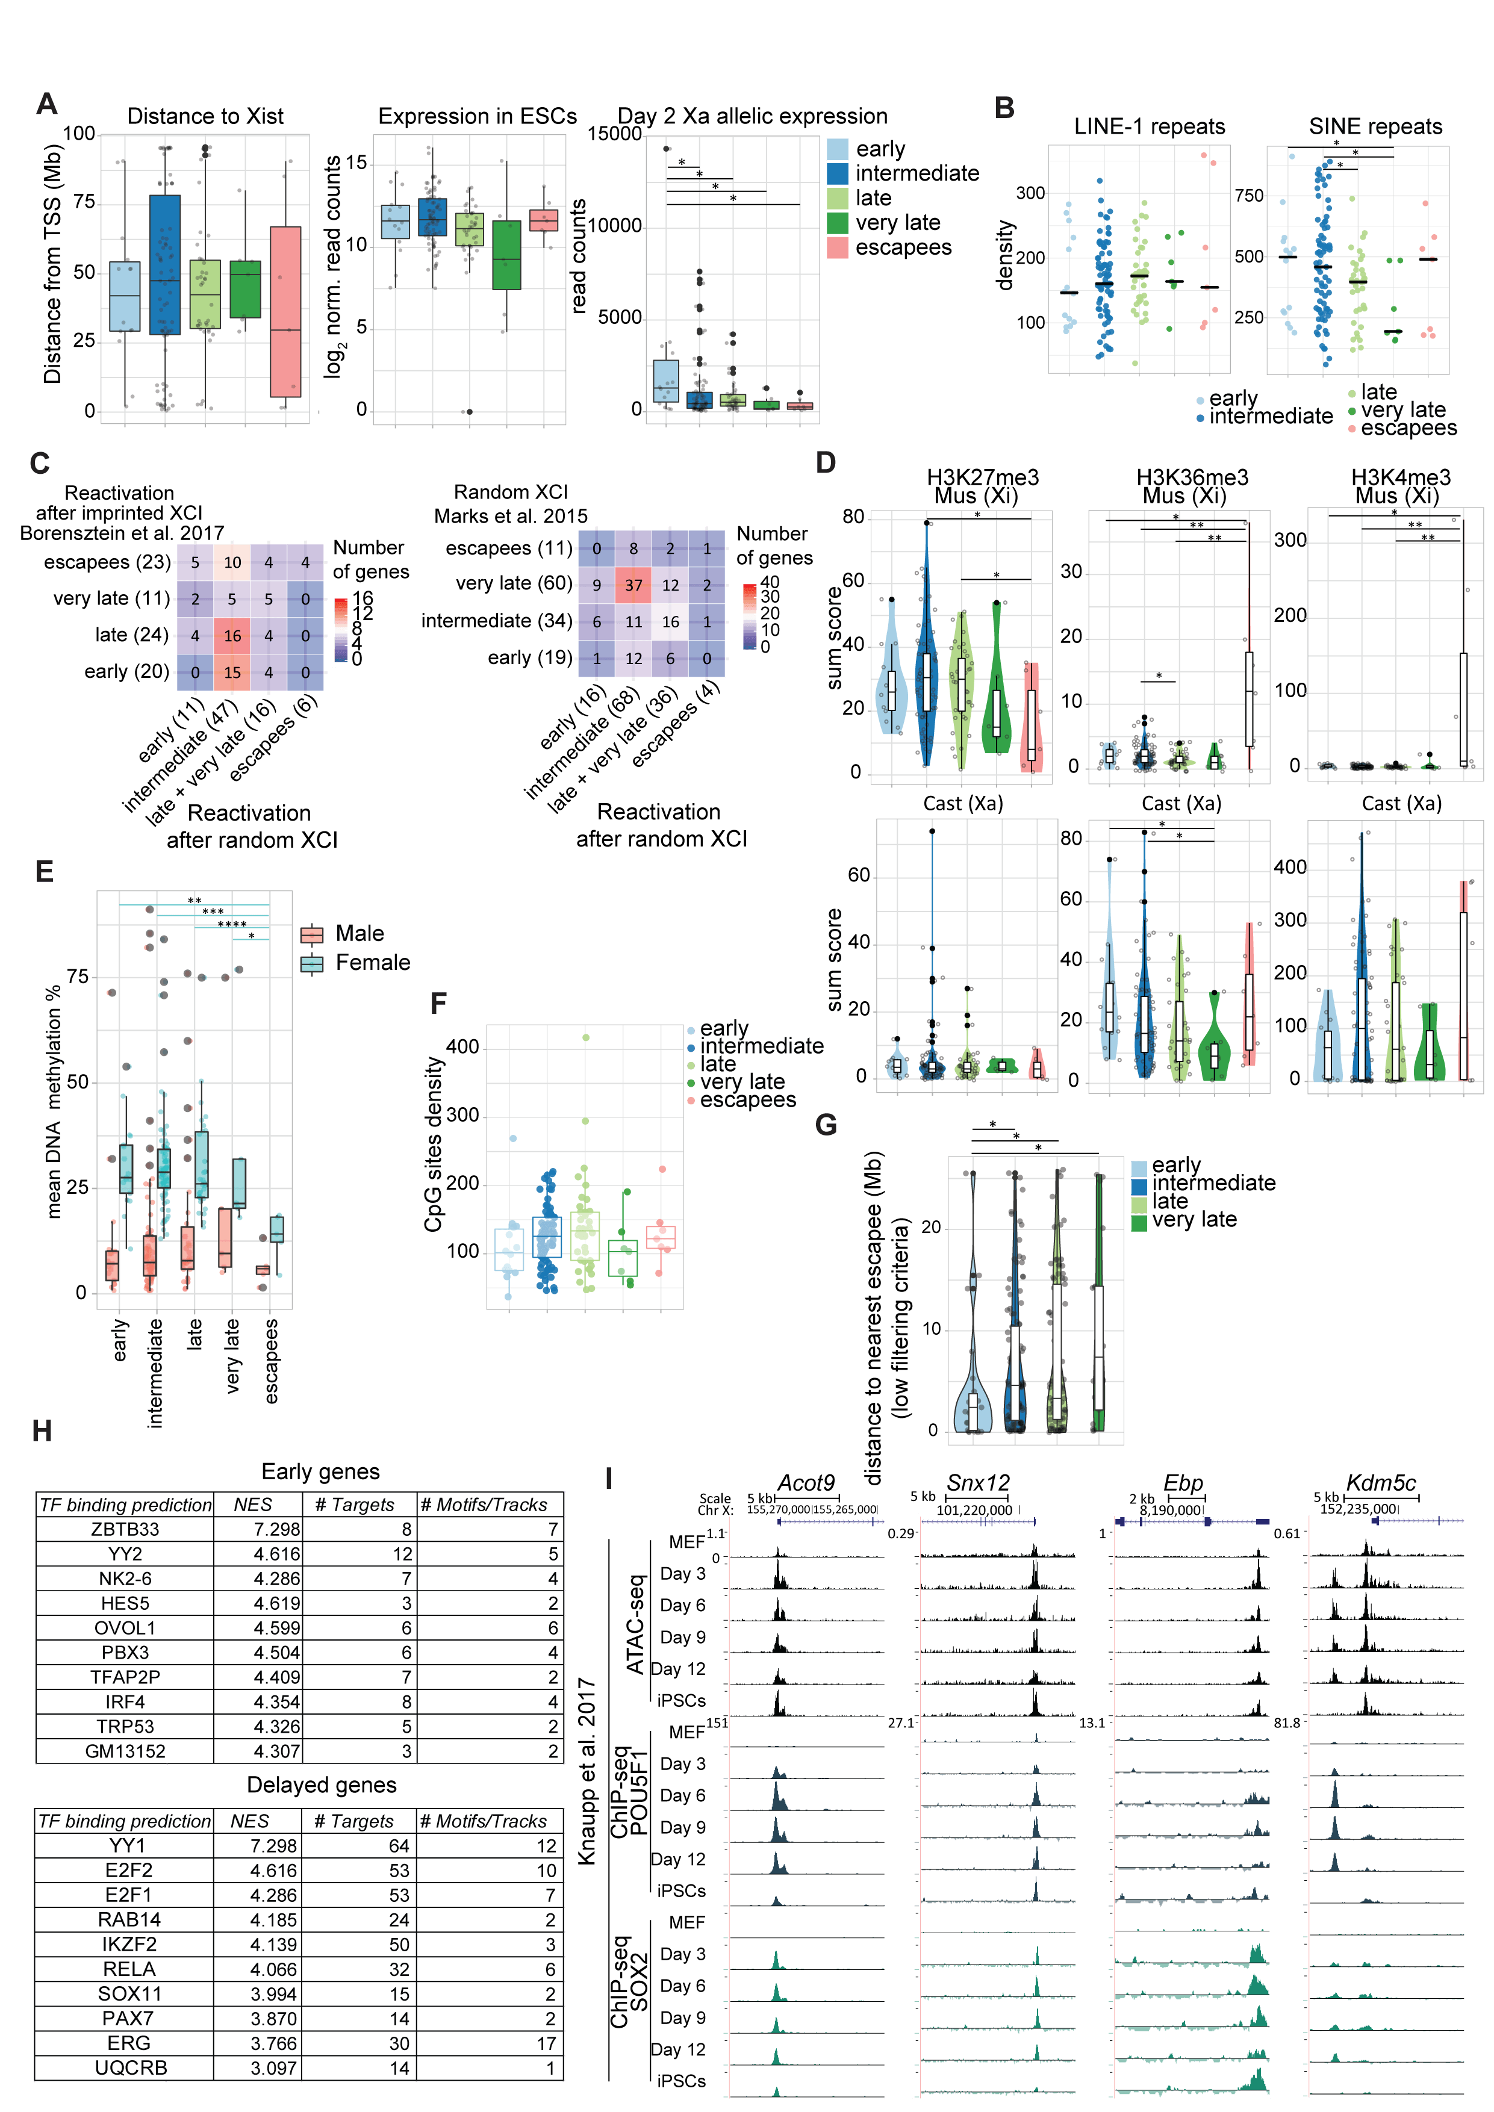

Supplemental Figure S4. Possible predictors for XCR kinetics.
- Distance to Xist TSS for each informative gene falling into each reactivation class (first), the gene expression level of each reactivation class in ESCs (middle) (log₂ transformed normalized counts in ESCs) and gene expression from the active X chromosome at the beginning of reprogramming (last). The p-values of a Wilcoxon rank test comparing levels of enrichment between different gene reactivation classes are indicated with asterisks above the violin plots (p-value<0,0001: ****, p-value=0.0001-0.001: ***, 0.001-0.01: **, p-value=0.01-0.05=significant: *, p-value≥0.05=not significant).
- Density of LINE-1 and SINE repeats 200 kb around of TSS of genes from different reactivation classes. The p-values of a Wilcoxon rank test comparing levels of enrichment between different gene reactivation classes are indicated with asterisks above the violin plots (p-value<0,0001: ****, p-value=0.0001-0.001: ***, 0.001-0.01: **, p-value=0.01-0.05=significant: *, p-value≥0.05=not significant).
- Comparison of XCR kinetics following iPSC reprogramming to that during XCR in the ICM (left) and during random XCI (right). The reactivation categories from the present study are shown in the X axis and the inactivation/reactivation categories of the comparing studies are represented in the Y axis. The number of overlapping genes for each category (early, intermediate, late + very late and escapee genes) in both data sets for each heatmap are represented by the color gradient. The proportion of genes overlapping in both datasets of each heatmap are shown.
- Enrichment levels for H3K27me3, H3K36me3 and H3K4me3 occupancy for early, intermediate, late, very late reactivated and escapee genes in MEFs. The p-values of a Wilcoxon rank test comparing levels of enrichment between different gene reactivation classes are indicated with asterisks above the violin plots (p-value<0,0001: ****, p-value=0.0001-0.001: ***, 0.001-0.01: **, p-value=0.01-0.05=significant: *, p-value≥0.05=not significant).
- Mean DNA methylation levels in female and male MEFs over the genes from each reactivation kinetics category. The p-values of a Wilcoxon rank test comparing levels of enrichment between different gene reactivation classes are indicated with asterisks above the violin plots (p-value<0,0001: ****, p-value=0.0001-0.001: ***, 0.001-0.01: **, p-value=0.01-0.05=significant: *, p-value≥0.05=not significant). The significantly different groups in female samples are highlighted by the blue line.
- Density of CpG sites within +/- 5kb window from TSS of genes from different reactivation classes.
- Violin diagram with the distance to nearest escapee (Mb) for each reactivation class with low filtering criteria (2 SNPs per X-linked reactivated gene). The significant p-values of a Wilcoxon rank test comparing the different gene reactivation classes are indicated with asterisks above the violin plots (p-value<0,0001: ****, p-value=0.0001-0.001: ***, 0.001-0.01: **, p-value=0.01-0.05=significant: *, p-value≥0.05=not significant).
- List of TFs that are predicted to be bound to the motifs enriched in early reactivated X-linked genes (upper table) and delayed reactivated X-linked genes (bottom table). NES score corresponds to the enrichment score, provided by the software used for motif discovery (see methods), of the given TF in the cluster of early or delayed genes. # Targets represents the number of X-linked genes to which the TF is predicted to be bound. # Motifs/Tracks indicates the number of motifs associated to the given TF found on the cluster of early or delayed genes.
- ATAC-seq, POU5F1 and SOX2 ChIP-seq from FUT4+ reprogramming intermediates (Knaupp et al. 2017) shown for Acot9, Snx12, Ebp and Kdm5c.

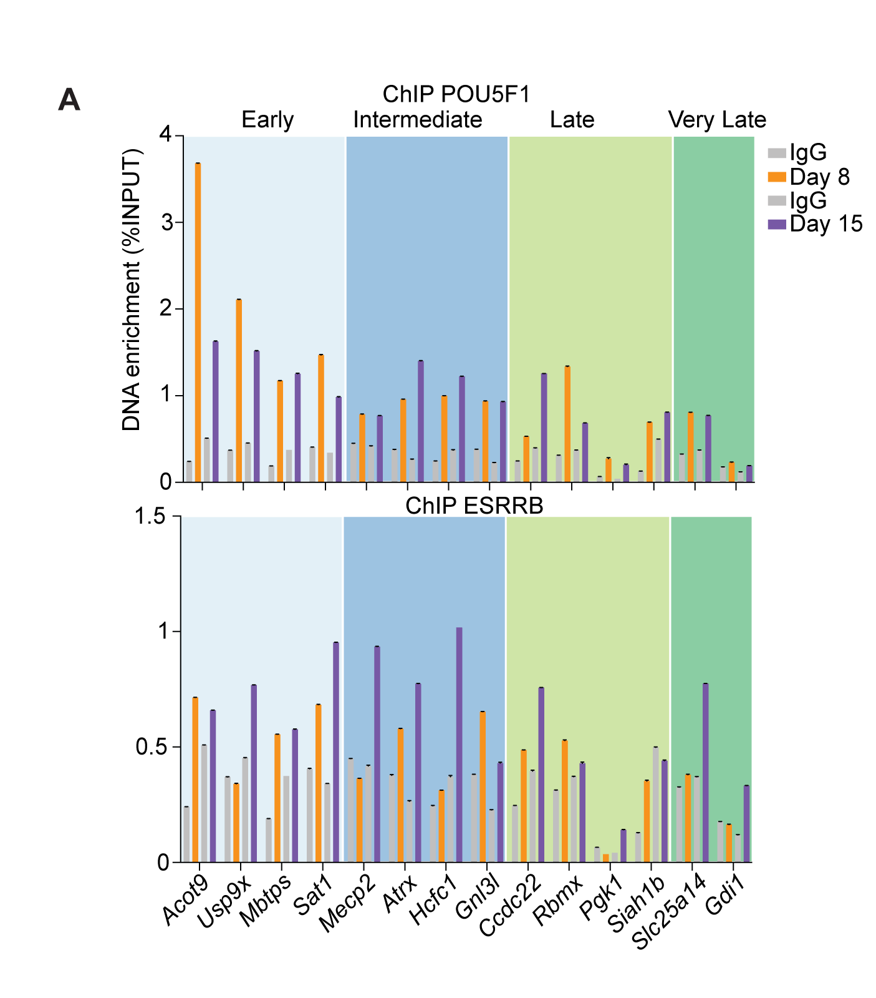

Supplemental Figure S5. POU5F1 and ESRRB binding to X-linked genes during reprogramming.
- DNA enrichment of POU5F1 and ESRRB binding to the promoter regions of selected X-linked genes during reprogramming of female MEFs. Values represent the percentage of enrichment levels over the input.

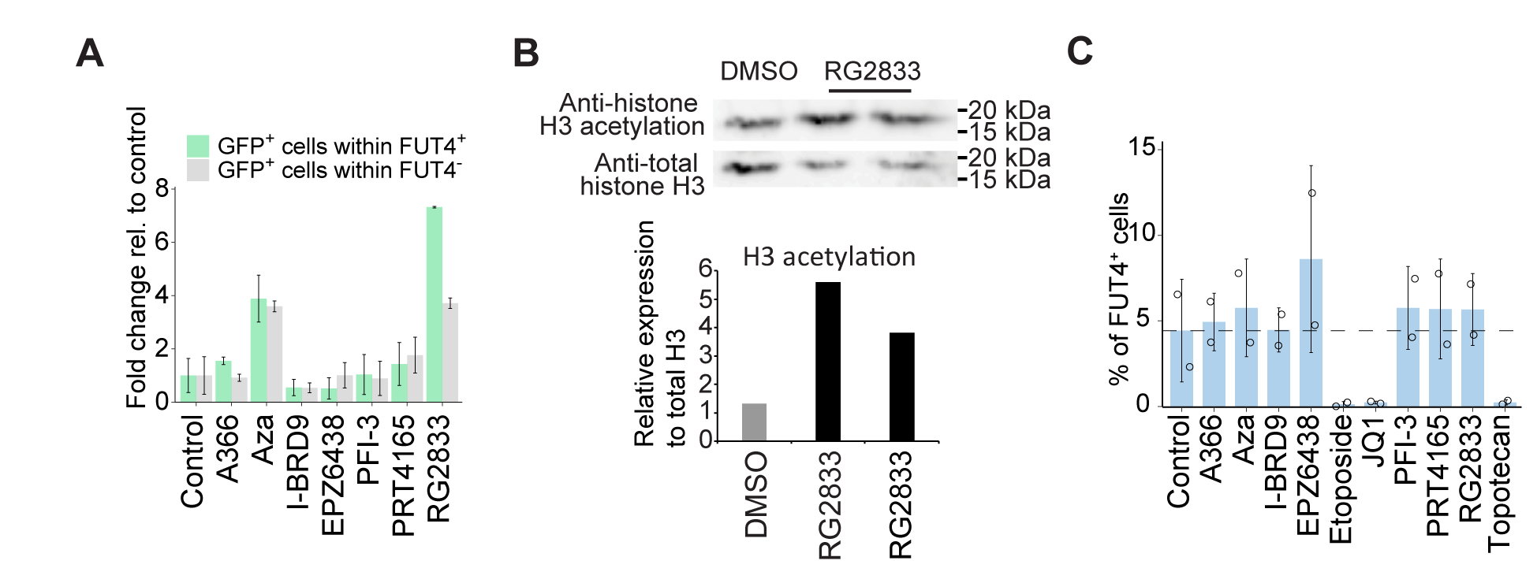

Supplemental Figure S6. Epigenetic drug screening during reprogramming to pluripotency.
- Fold change of GFP+ cells within FUT4+ cell population relative to control (green) and fold change of GFP+ cells within FUT4- cell population relative to control (grey) for each individual drug inhibitor. Error bars represent Standard Deviation. n = 2.
- Top: Western blot analysis of H3 acetylation after the treatment with RG2833. Bottom: Quantification of the analysis shown above. Bands are quantified relative to the levels of total H3.
- Proportion of FUT4+ cells at day 10 of reprogramming for each individual drug inhibitor. Error bars represent Standard Deviation. n = 2.

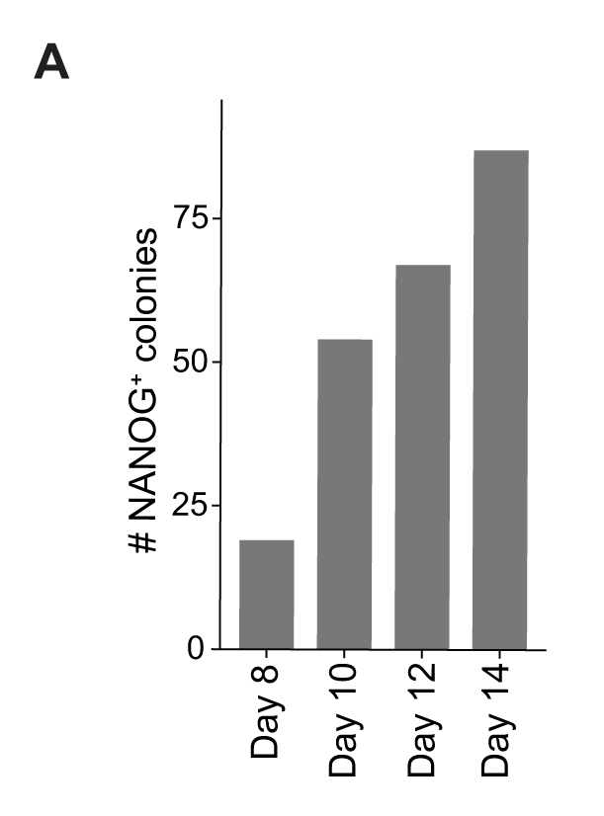

Supplemental Figure S7. Number of NANOG+ colonies throughout reprogramming
- Number of NANOG+ colonies emerging during reprogramming to iPSCs. A colony is defined as four or more closely located cells.

Supplemental Tables

Supplemental Table 1: Sequencing reads mapping and quantification summary
Table is in an excel file. This table contains, for each sample in RNA-seq experiment, the number of input reads, reads length, summary of alignment to the reference genome (% of uniquely mapped reads, % of reads mapped to multiple loci) and summary of reads quantification (% of assigned fragments (pairs of reads)).

Supplemental Table 2: Allele-specific distribution of mapped reads with SNPsplit
Table is in an excel file. This table contains, the summary report from SNPsplit pipeline performed for each sample in RNA-seq experiment.

Supplemental Table 3: Allele-specific expression tables
This table is in an excel file. It contains complete allele-specific expression information and allelic ratios for all the genes that passed the initial filtering criteria (see Supplemental Text 4-5).

Supplemental Table 4: Primers used for ChIP-qPCR experiment
This table is in an excel file.

Supplemental Table 5: Small compound inhibitors used in the epidrug screen
This table is in excel file and contains details about inhibitors used in epidrug screen experiment, including used concentrations and catalog numbers.

Supplemental References
Abdennur N, Mirny L. 2019. Cooler: scalable storage for Hi-C data and other genomically-labeled arrays. Bioinformatics doi:10.1093/bioinformatics/btz540.
Carey BW, Markoulaki S, Hanna J, Saha K, Gao Q, Mitalipova M, Jaenisch R. 2009. Reprogramming of murine and human somatic cells using a single polycistronic vector. Proc Natl Acad Sci U S A 106: 157-162.
Carrette LLG, Wang CY, Wei C, Press W, Ma W, Kelleher RJ, 3rd, Lee JT. 2018. A mixed modality approach towards Xi reactivation for Rett syndrome and other X-linked disorders. Proc Natl Acad Sci U S A 115: E668-E675.
Dobin A, Davis CA, Schlesinger F, Drenkow J, Zaleski C, Jha S, Batut P, Chaisson M, Gingeras TR. 2013. STAR: ultrafast universal RNA-seq aligner. Bioinformatics 29: 15-21.
Hockemeyer D, Soldner F, Cook EG, Gao Q, Mitalipova M, Jaenisch R. 2008. A drug-inducible system for direct reprogramming of human somatic cells to pluripotency. Cell Stem Cell 3: 346-353.
Krueger F, Andrews SR. 2016. SNPsplit: Allele-specific splitting of alignments between genomes with known SNP genotypes. F1000Res 5: 1479.
Li H, Handsaker B, Wysoker A, Fennell T, Ruan J, Homer N, Marth G, Abecasis G, Durbin R, Genome Project Data Processing S. 2009. The Sequence Alignment/Map format and SAMtools. Bioinformatics 25: 2078-2079.
Liao Y, Smyth GK, Shi W. 2019. The R package Rsubread is easier, faster, cheaper and better for alignment and quantification of RNA sequencing reads. Nucleic Acids Res 47: e47.
Love MI, Huber W, Anders S. 2014. Moderated estimation of fold change and dispersion for RNA-seq data with DESeq2. Genome Biol 15: 550.
Marin-Bejar O, Mas AM, Gonzalez J, Martinez D, Athie A, Morales X, Galduroz M, Raimondi I, Grossi E, Guo S et al. 2017. The human lncRNA LINC-PINT inhibits tumor cell invasion through a highly conserved sequence element. Genome Biol 18: 202.
Neph S, Kuehn MS, Reynolds AP, Haugen E, Thurman RE, Johnson AK, Rynes E, Maurano MT, Vierstra J, Thomas S et al. 2012. BEDOPS: high-performance genomic feature operations. Bioinformatics 28: 1919-1920.
Pasque V, Gillich A, Garrett N, Gurdon JB. 2011. Histone variant macroH2A confers resistance to nuclear reprogramming. EMBO J 30: 2373-2387.
Pasque V, Tchieu J, Karnik R, Uyeda M, Sadhu Dimashkie A, Case D, Papp B, Bonora G, Patel S, Ho R et al. 2014. X chromosome reactivation dynamics reveal stages of reprogramming to pluripotency. Cell 159: 1681-1697.
Qiu X, Hill A, Packer J, Lin D, Ma YA, Trapnell C. 2017a. Single-cell mRNA quantification and differential analysis with Census. Nat Methods 14: 309-315.
Qiu X, Mao Q, Tang Y, Wang L, Chawla R, Pliner HA, Trapnell C. 2017b. Reversed graph embedding resolves complex single-cell trajectories. Nat Methods 14: 979-982.
R Core Team (2014). R: A language and environment for statistical computing. R Foundation for Statistical Computing, Vienna, Austria. URL http://www.R-project.org/
Ramirez F, Bhardwaj V, Arrigoni L, Lam KC, Gruning BA, Villaveces J, Habermann B, Akhtar A, Manke T. 2018. High-resolution TADs reveal DNA sequences underlying genome organization in flies. Nat Commun 9: 189.
Ramirez F, Dundar F, Diehl S, Gruning BA, Manke T. 2014. deepTools: a flexible platform for exploring deep-sequencing data. Nucleic Acids Res 42: W187-191.
Servant N, Varoquaux N, Lajoie BR, Viara E, Chen CJ, Vert JP, Heard E, Dekker J, Barillot E. 2015. HiC-Pro: an optimized and flexible pipeline for Hi-C data processing. Genome Biol 16: 259.
Slater PM, Grivell R, Cyna AM. 2009. Labour management of a woman with carnitine palmitoyl transferase type 2 deficiency. Anaesth Intensive Care 37: 305-308.
Trapnell C, Cacchiarelli D, Grimsby J, Pokharel P, Li S, Morse M, Lennon NJ, Livak KJ, Mikkelsen TS, Rinn JL. 2014. The dynamics and regulators of cell fate decisions are revealed by pseudotemporal ordering of single cells. Nat Biotechnol 32: 381-386.
Wickham H. 2009. ggplot2: Elegant Graphics for Data Analysis. Springer Publishing Company, Incorporated.

