Supplemental Figures
Targeted delivery of CRISPR interference system against Fabp4 to white adipocyte ameliorates obesity, inflammation, hepatic steatosis and insulin resistance
Jee Young Chung, Qurrat Ul Ain, Yoonsung Song, Seok Beom Yong and Yong-Hee Kim
Supplemental Figure S1. Physical characteristics of (dCas9/sgFabp4)+ATS9R oligoplexes 2
Supplemental Figure S2. Transfection and cytotoxicity analyses of oligoplexes 3
Supplemental Figure S3. In vitro cellular uptake of ATS9R. Time-dependent 4
intracellular localization of ATS9R
Supplemental Figure S4. Validation of (dCas9/sgFabp4)+ATS9R oligoplexes in adipocytes 5
Supplemental Figure S5. High-fat diet induced mouse modeling protocol 6
Supplemental Figure S6. CRISPRi repression of Fabp4 in obese mice 7
Supplemental Figure S7. CRISPRi repression of Fabp4 ameliorate inflammation and 8
hepatic steatosis in obese mice.
Supplemental Figure S8. Full gel image of Figure 2C 9
Supplemental Figure S9. Full gel image of Figure 5A and 5B 10
Supplemental Figure S10. Full gel image of Supplemental Figure 4C 11
Supplemental Figure S11. Full gel image of Figure Supplemental Figure 6A and 6B 12
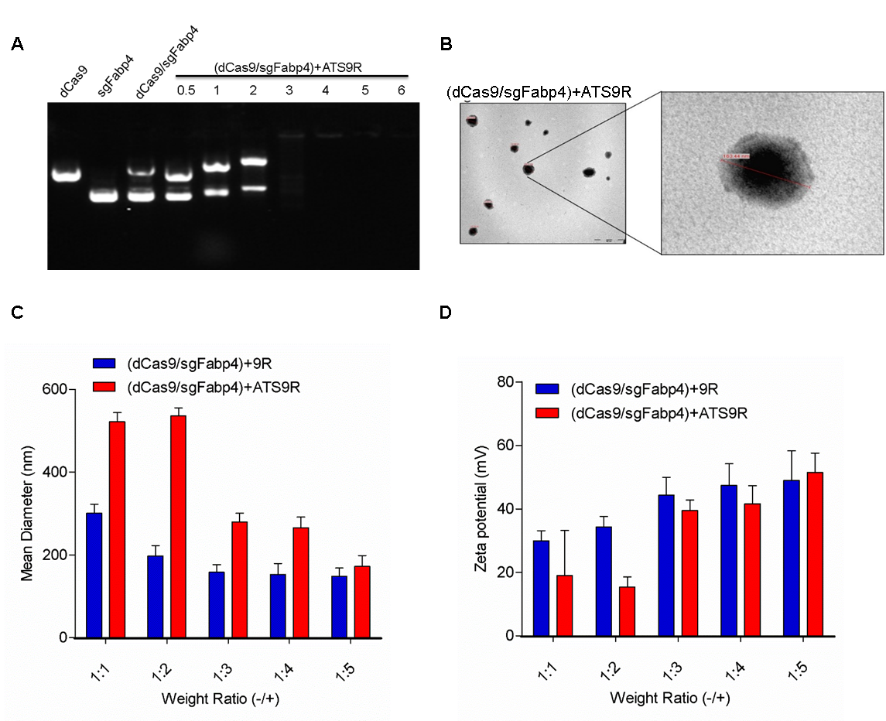
Supplemental Figure S1. Physical characteristics of (dCas9/sgFabp4)+ATS9R oligoplexes. (A) Gel retardation assay. (dCas9/sgFabp4)+ATS9R were complexed at various weight ratios (+/-) and subjected to electrophoresis. The dCas9/sgFabp4 migration was retarded by the formation of oligoplexes with the carrier. (B) Transmission electron microscope images of (dCas9/sgFabp4)+ATS9R oligoplexes. Oligoplexes were prepared with a constant amount of DNA complex and ATS9R at optimized ratios, and 100 µl of oligoplex solution was allowed to air dry on a 10×10 grid for TEM analysis. Scale bars represent 500 nm (left) and 200 nm (right). (C) Hydrodynamic diameter and (D) ζ-potential of (dCas9+/sgFabp4)+ATS9R oligoplexes for various weight ratios of ATS9R using dynamic light scattering. Data represent mean of measurements conducted in triplicate ± S.D.

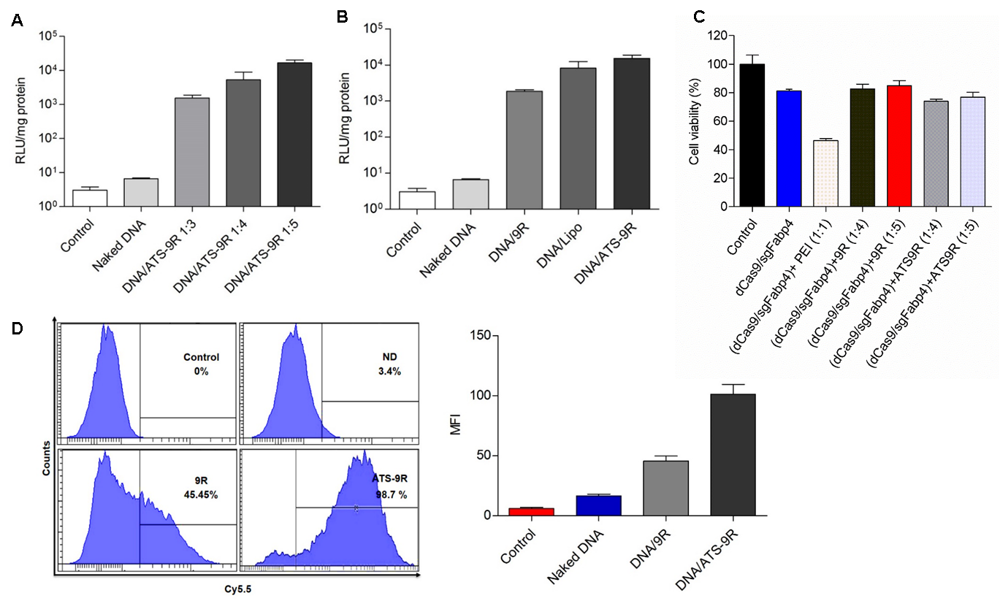
Supplemental Figure S2. Transfection and cytotoxicity analyses of oligoplexes. (A) Luciferase fluorescence intensity after cellular uptake of DNA-oligoplexes at various weight ratios was monitored after transfection. (B) Cells were treated with oligoplexes (DNA/9R, DNA/Lipo, DNA/ATS-9R) at optimized weight ratios. RLU is given as luciferase fluorescence of cells after treatment compared with that of untreated cells. Results show the mean of measurements conducted in triplicate ± S.D. (C) Cytotoxicity associated with transfection of oligoplexes was evaluated by MTT assay. 3T3-L1 cells also exhibited over 80% cell viability up to a weight ratio of 5. (D) Transfection of 3T3-L1 cells after 24 hours of exposure to Cy5.5-labeled DNA-oligoplexes was monitored by flow cytometry analysis. The graph represents the mean fluorescence intensity (MFI) relative to that of unlabeled cells.

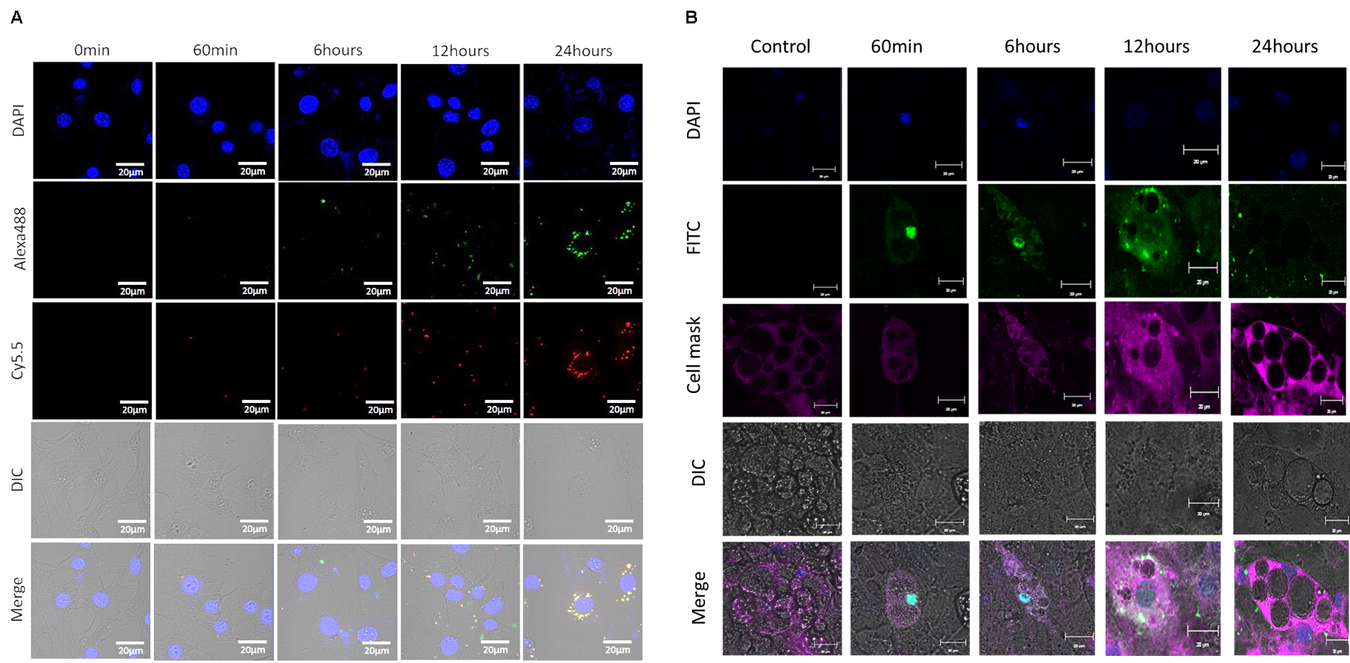
Supplemental Figure S3. In vitro cellular uptake of ATS9R. Time-dependent intracellular localization of ATS9R. (A) pre-adipocytes and (B) mature adipocytes. The adipocytes treated with FITC-conjugated ATS9R were incubated for different time points. Plasma membranes were stained with CellMask Deep Red, and nuclei were counterstained with DAPI. Scale bars = 20 μm.

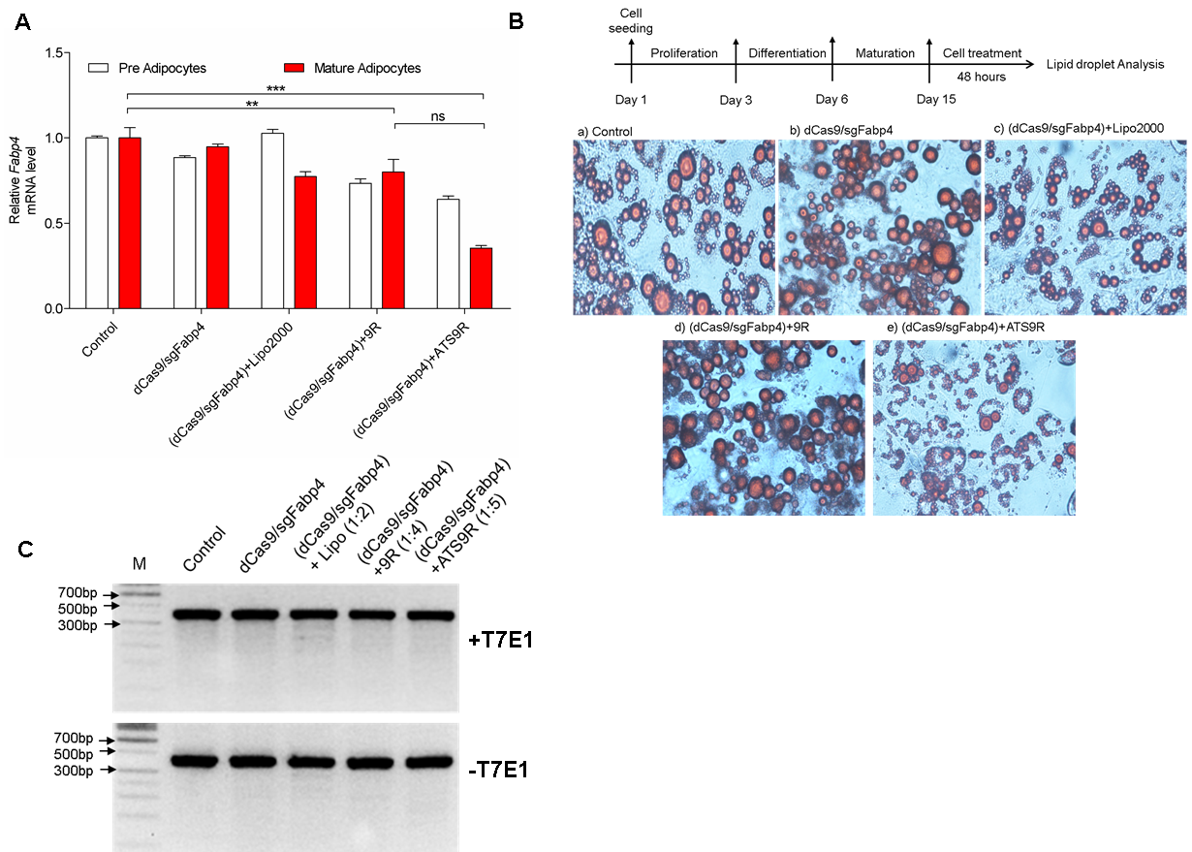
Supplemental Figure S4. Validation of (dCas9/sgFabp4)+ATS9R oligoplexes in adipocytes. (A) The dCas9/sgFabp4 was complexed with Lipofectamine2000, 9R and ATS9R. Pre-adipocytes and mature adipocytes were transfected under optimized conditions. The Fabp4 mRNA level was normalized and calculated as a value relative to the non-treated cells. (B) 3T3-L1 cells were treated as mentioned above and the lipid droplets were assessed by Oil Red O staining to evaluate gene silencing through CRISPRi-mediated delivery of dCas9 and sgRNA against Fabp4. (C) The dCas9/sgFabp4 mediated silencing was detected by T7E1 assay after 72 h post-transfection in mature adipocytes.

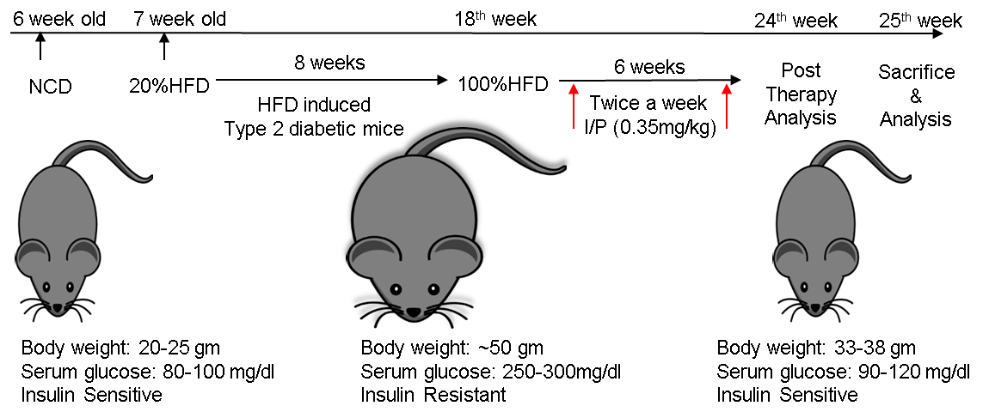

Supplemental Figure S5. High-fat diet induced mouse-modeling protocol.

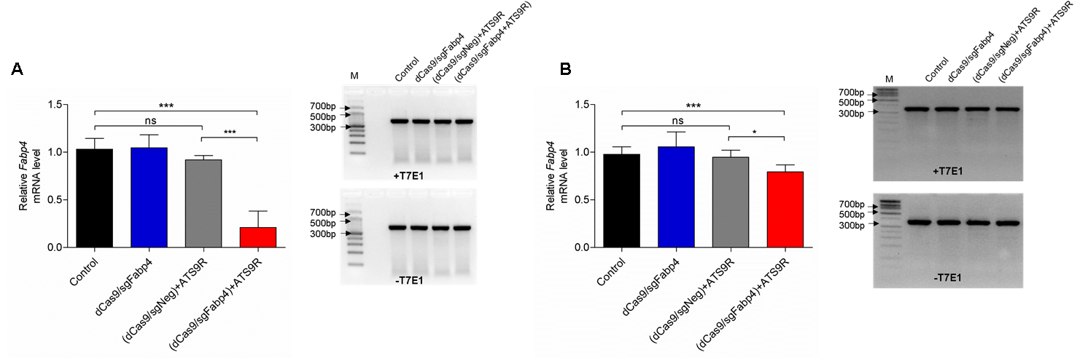
Supplemental Figure S6. CRISPRi repression of FABP4 in obese mice. Data are presented as relative mRNA levels in (A) epiWAT Fabp4 (B) subWAT Fabp4. Error bars indicate SEM (n= 3~5). Significance were computed by analysis of variance and Bonferroni’s post hoc test in comparison to control groups. *P < 0.05; **P< 0.001; ***P < 0.001 was considered significant.

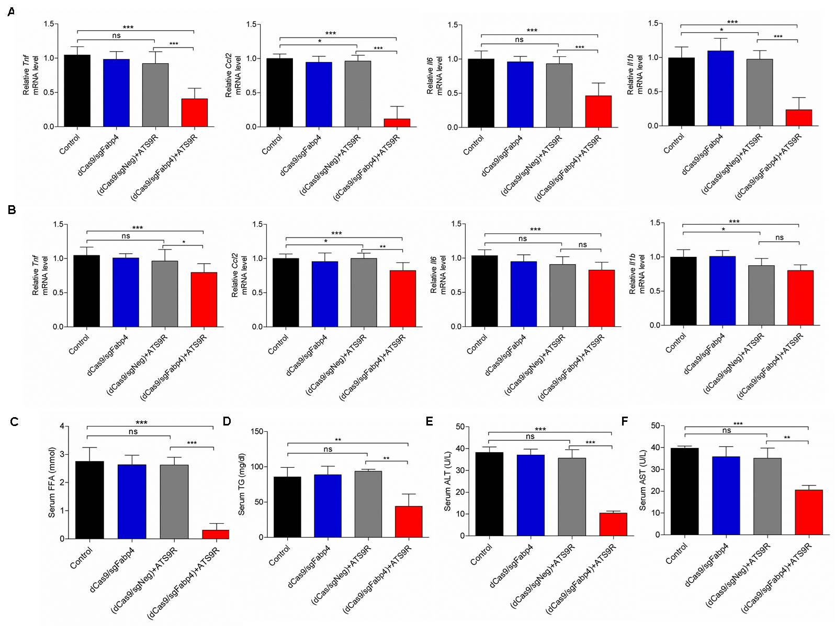
Supplemental Figure S7. CRISPRi repression of Fabp4 ameliorate inflammation and hepatic steatosis in obese mice. Data are presented as relative mRNA levels in (A) epiWAT cytokines (B) subWAT cytokines. Serum levels of (C) FFA (D) TG (E) ALT and (F) AST. Error bars indicate SEM (n= 3~5). Significance were computed by analysis of variance and Bonferroni’s post hoc test in comparison to control groups. *P < 0.05; **P< 0.001; ***P < 0.001 was considered significant.

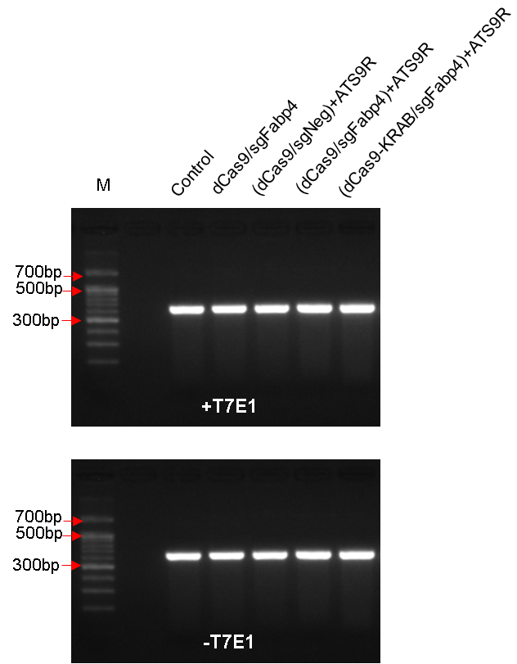
Supplemental Figure S8. Full gel image of Figure 2C. The dCas9/sgFabp4 mediated silencing was detected by T7E1 assay after 72 h post-transfection in mature adipocytes.

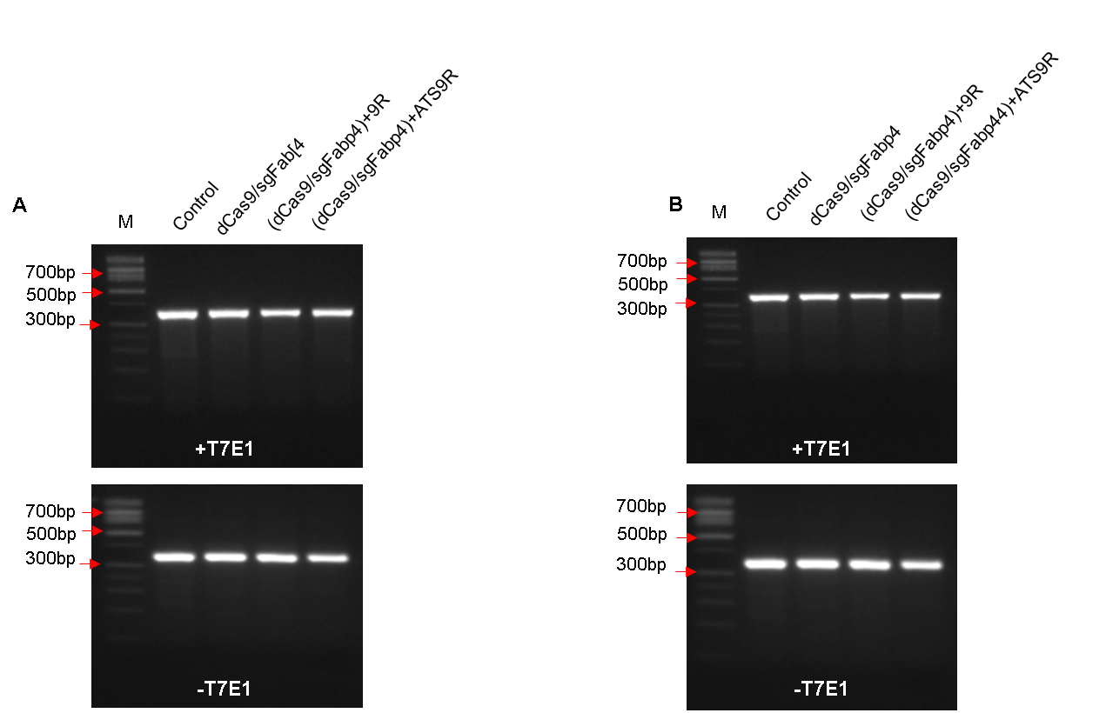
Supplemental Figure S9. Full gel image of Figure 5A and 5B. The dCas9/sgFabp4 mediated silencing was detected by T7E1 assay in (A) epiWAT and (B) subWAT.

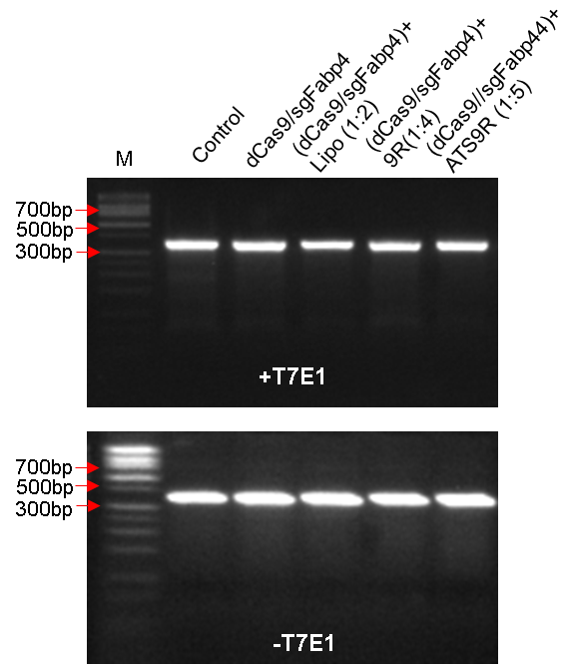
Supplemental Figure S10. Full gel image of Supplemental Figure 4C. The dCas9/sgFabp4 mediated silencing was detected by T7E1 assay after 72 h post-transfection in mature adipocytes
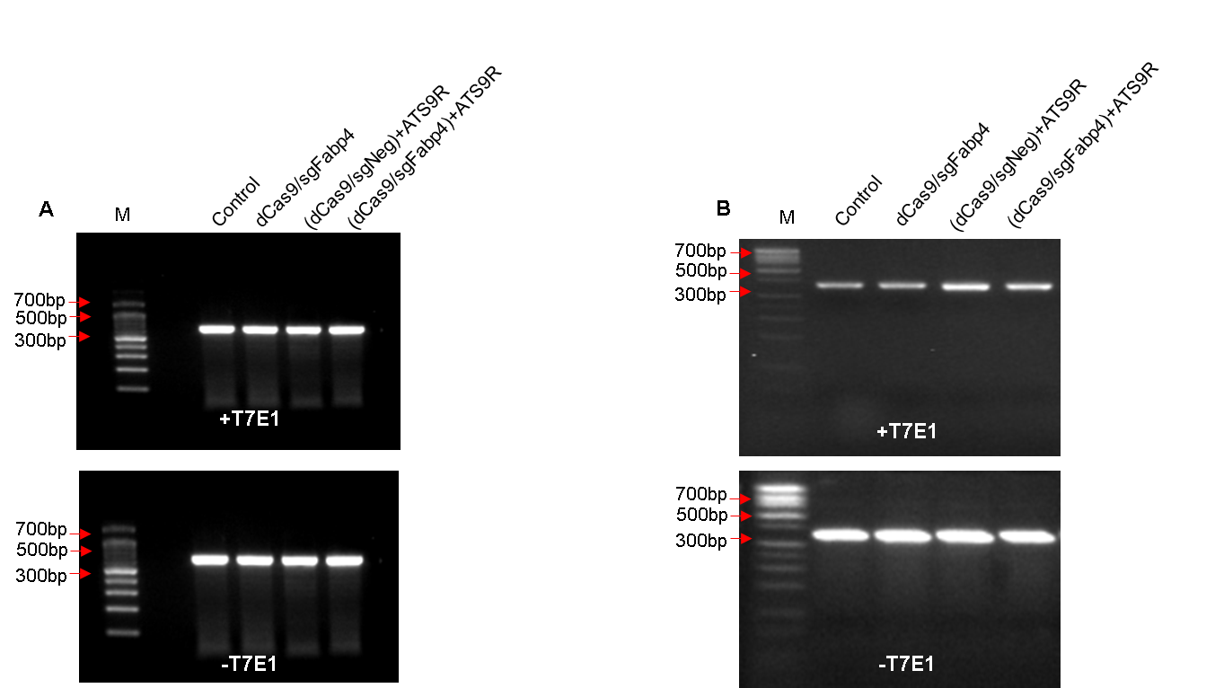
Supplemental Figure S11. Full gel image of Figure Supplemental Figure 6A and 6B. The dCas9/sgFabp4 mediated silencing was detected by T7E1 assay in (A) epiWAT and (B) subWAT.

