Contents

Contents 1
Supplemental Figures 2
References 12

Supplemental Figures

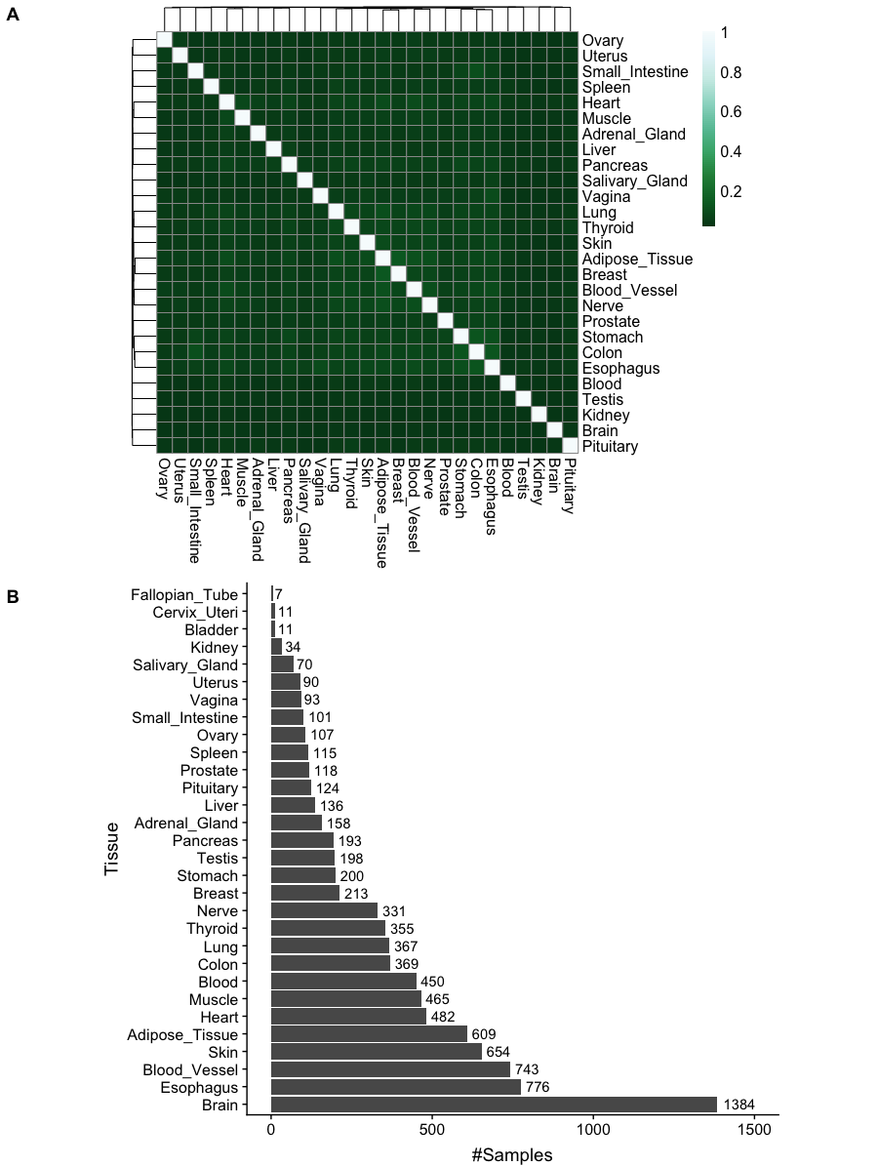

Supplemental Figure S1. A) Overlap of TF-target interactions between different GTEx normal tissues. TF-targets overlap is quantified using the Jaccard-index. B) Number of samples per tissue in the GTEx gene expression dataset.

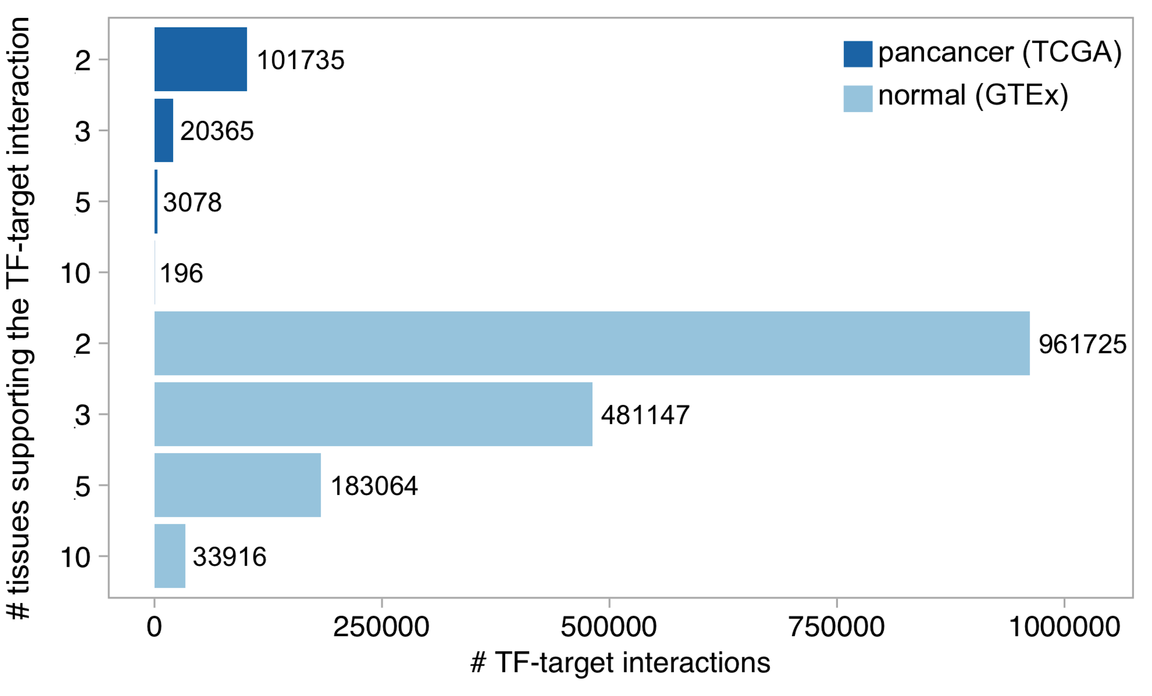
Supplemental Figure S2. Size of consensus ARACNe inferred regulons from normal GTEx and pancancer TCGA expression datasets. X-axis indicates the number of TF-targets interactions in the merged consensus regulon, while y-axis indicates the number of normal tissues or cancer types, respectively, supporting the TF-target interaction.

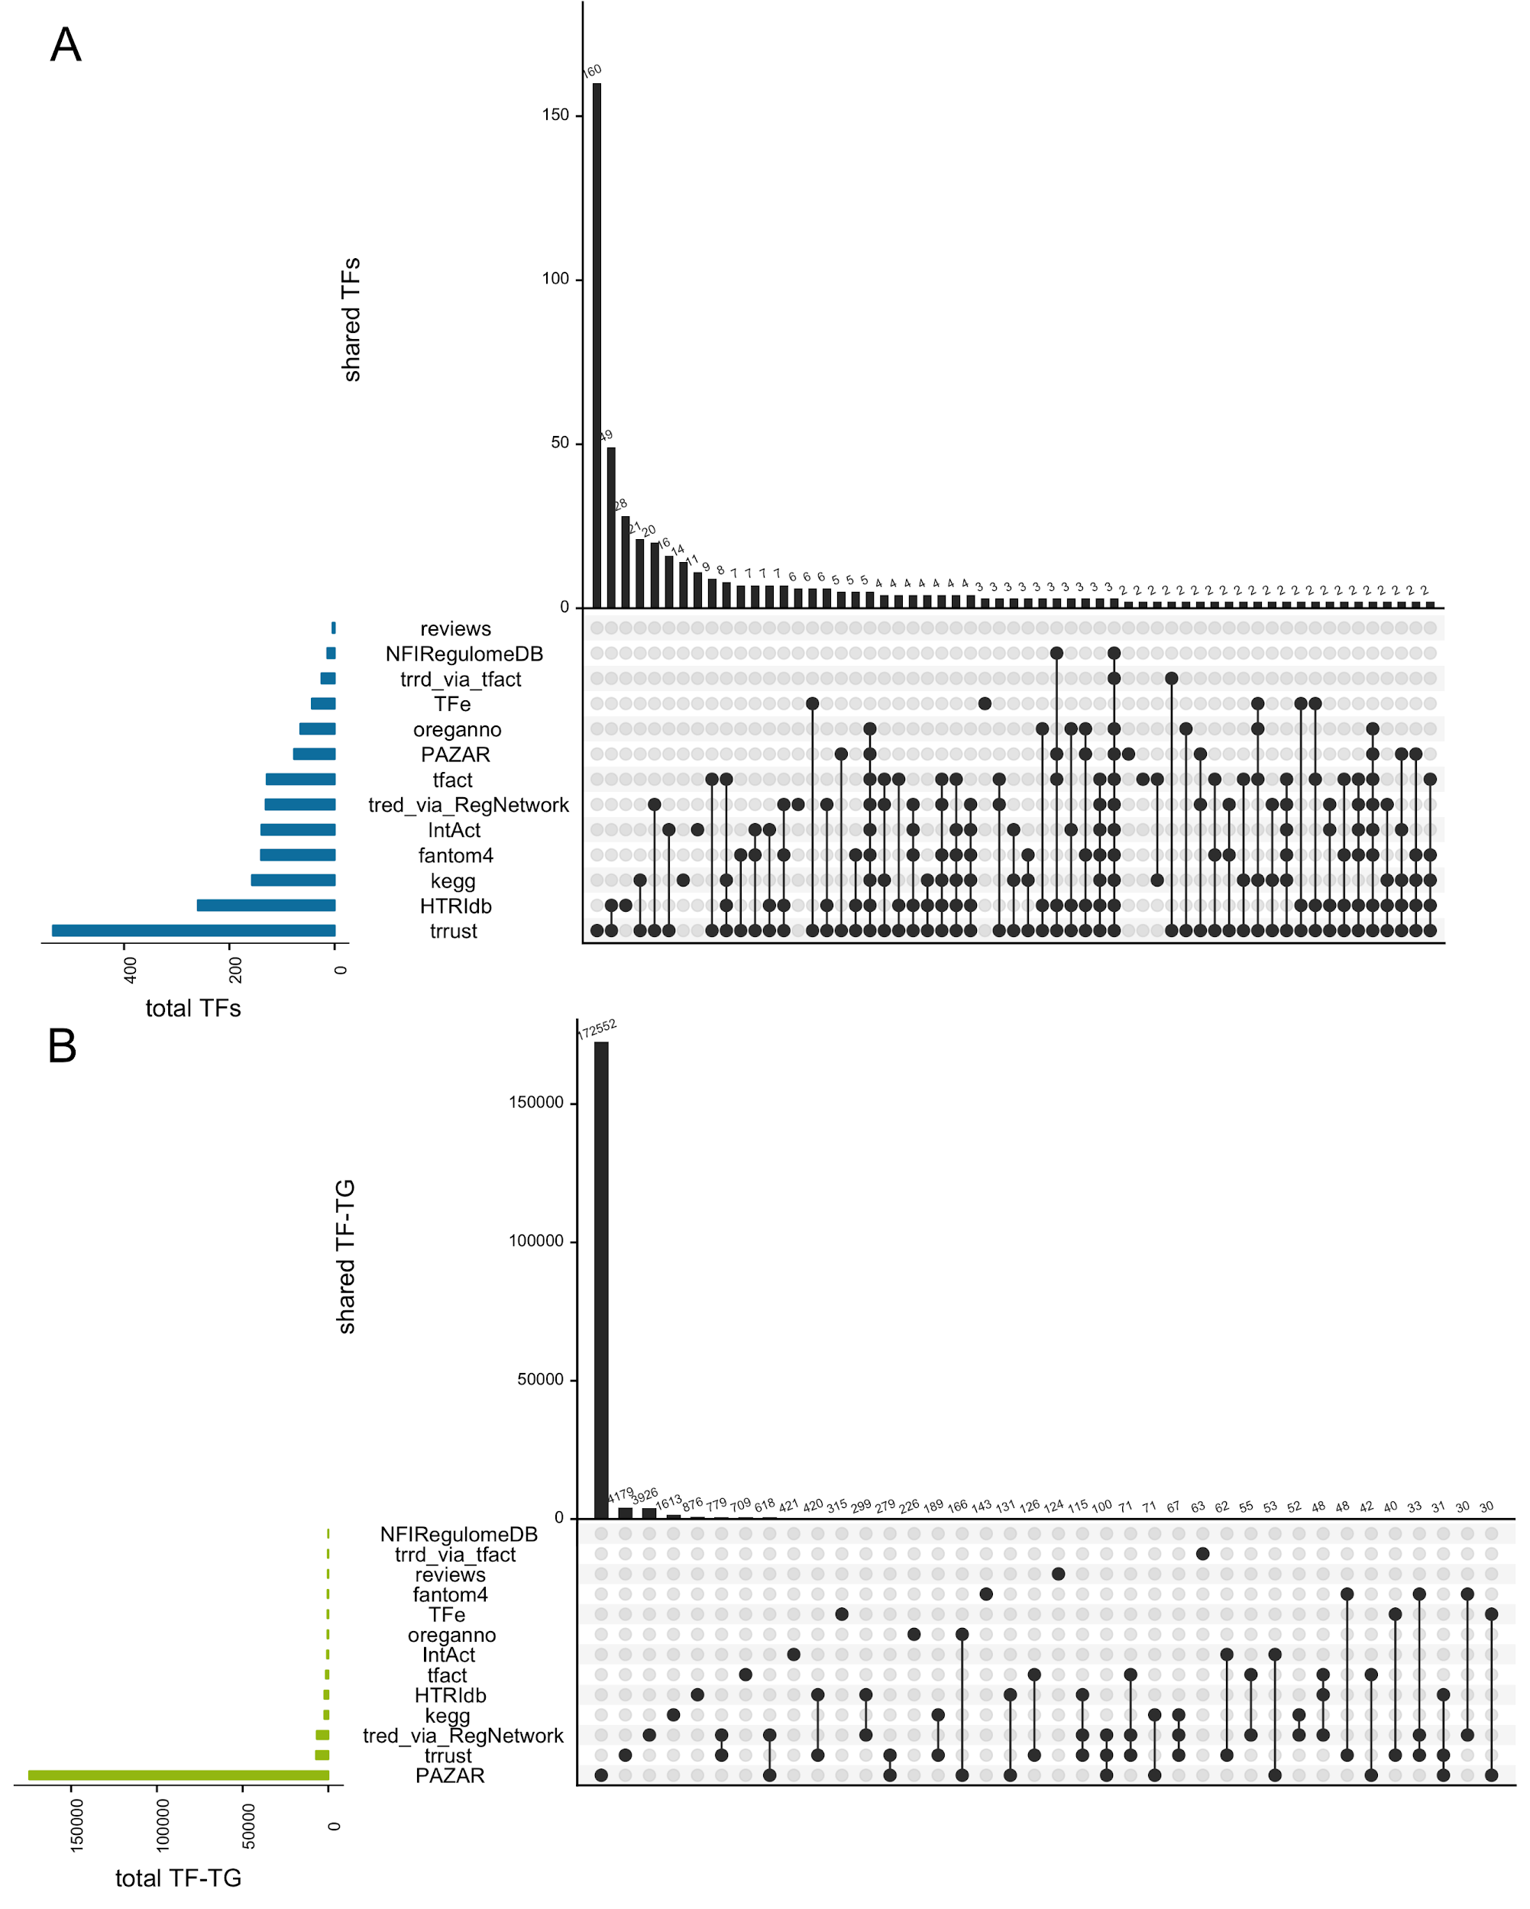
Supplemental Figure S3. TF (A) and TF-target interactions (B) overlap across curated resources. A) UpSet plot representing the TF coverage and overlaps across resources (only overlaps ≥ 2 TFs are shown). B) UpSet plot representing the TF-targets coverage and overlaps across resources (only overlaps ≥ 30 TF-target interactions are shown).

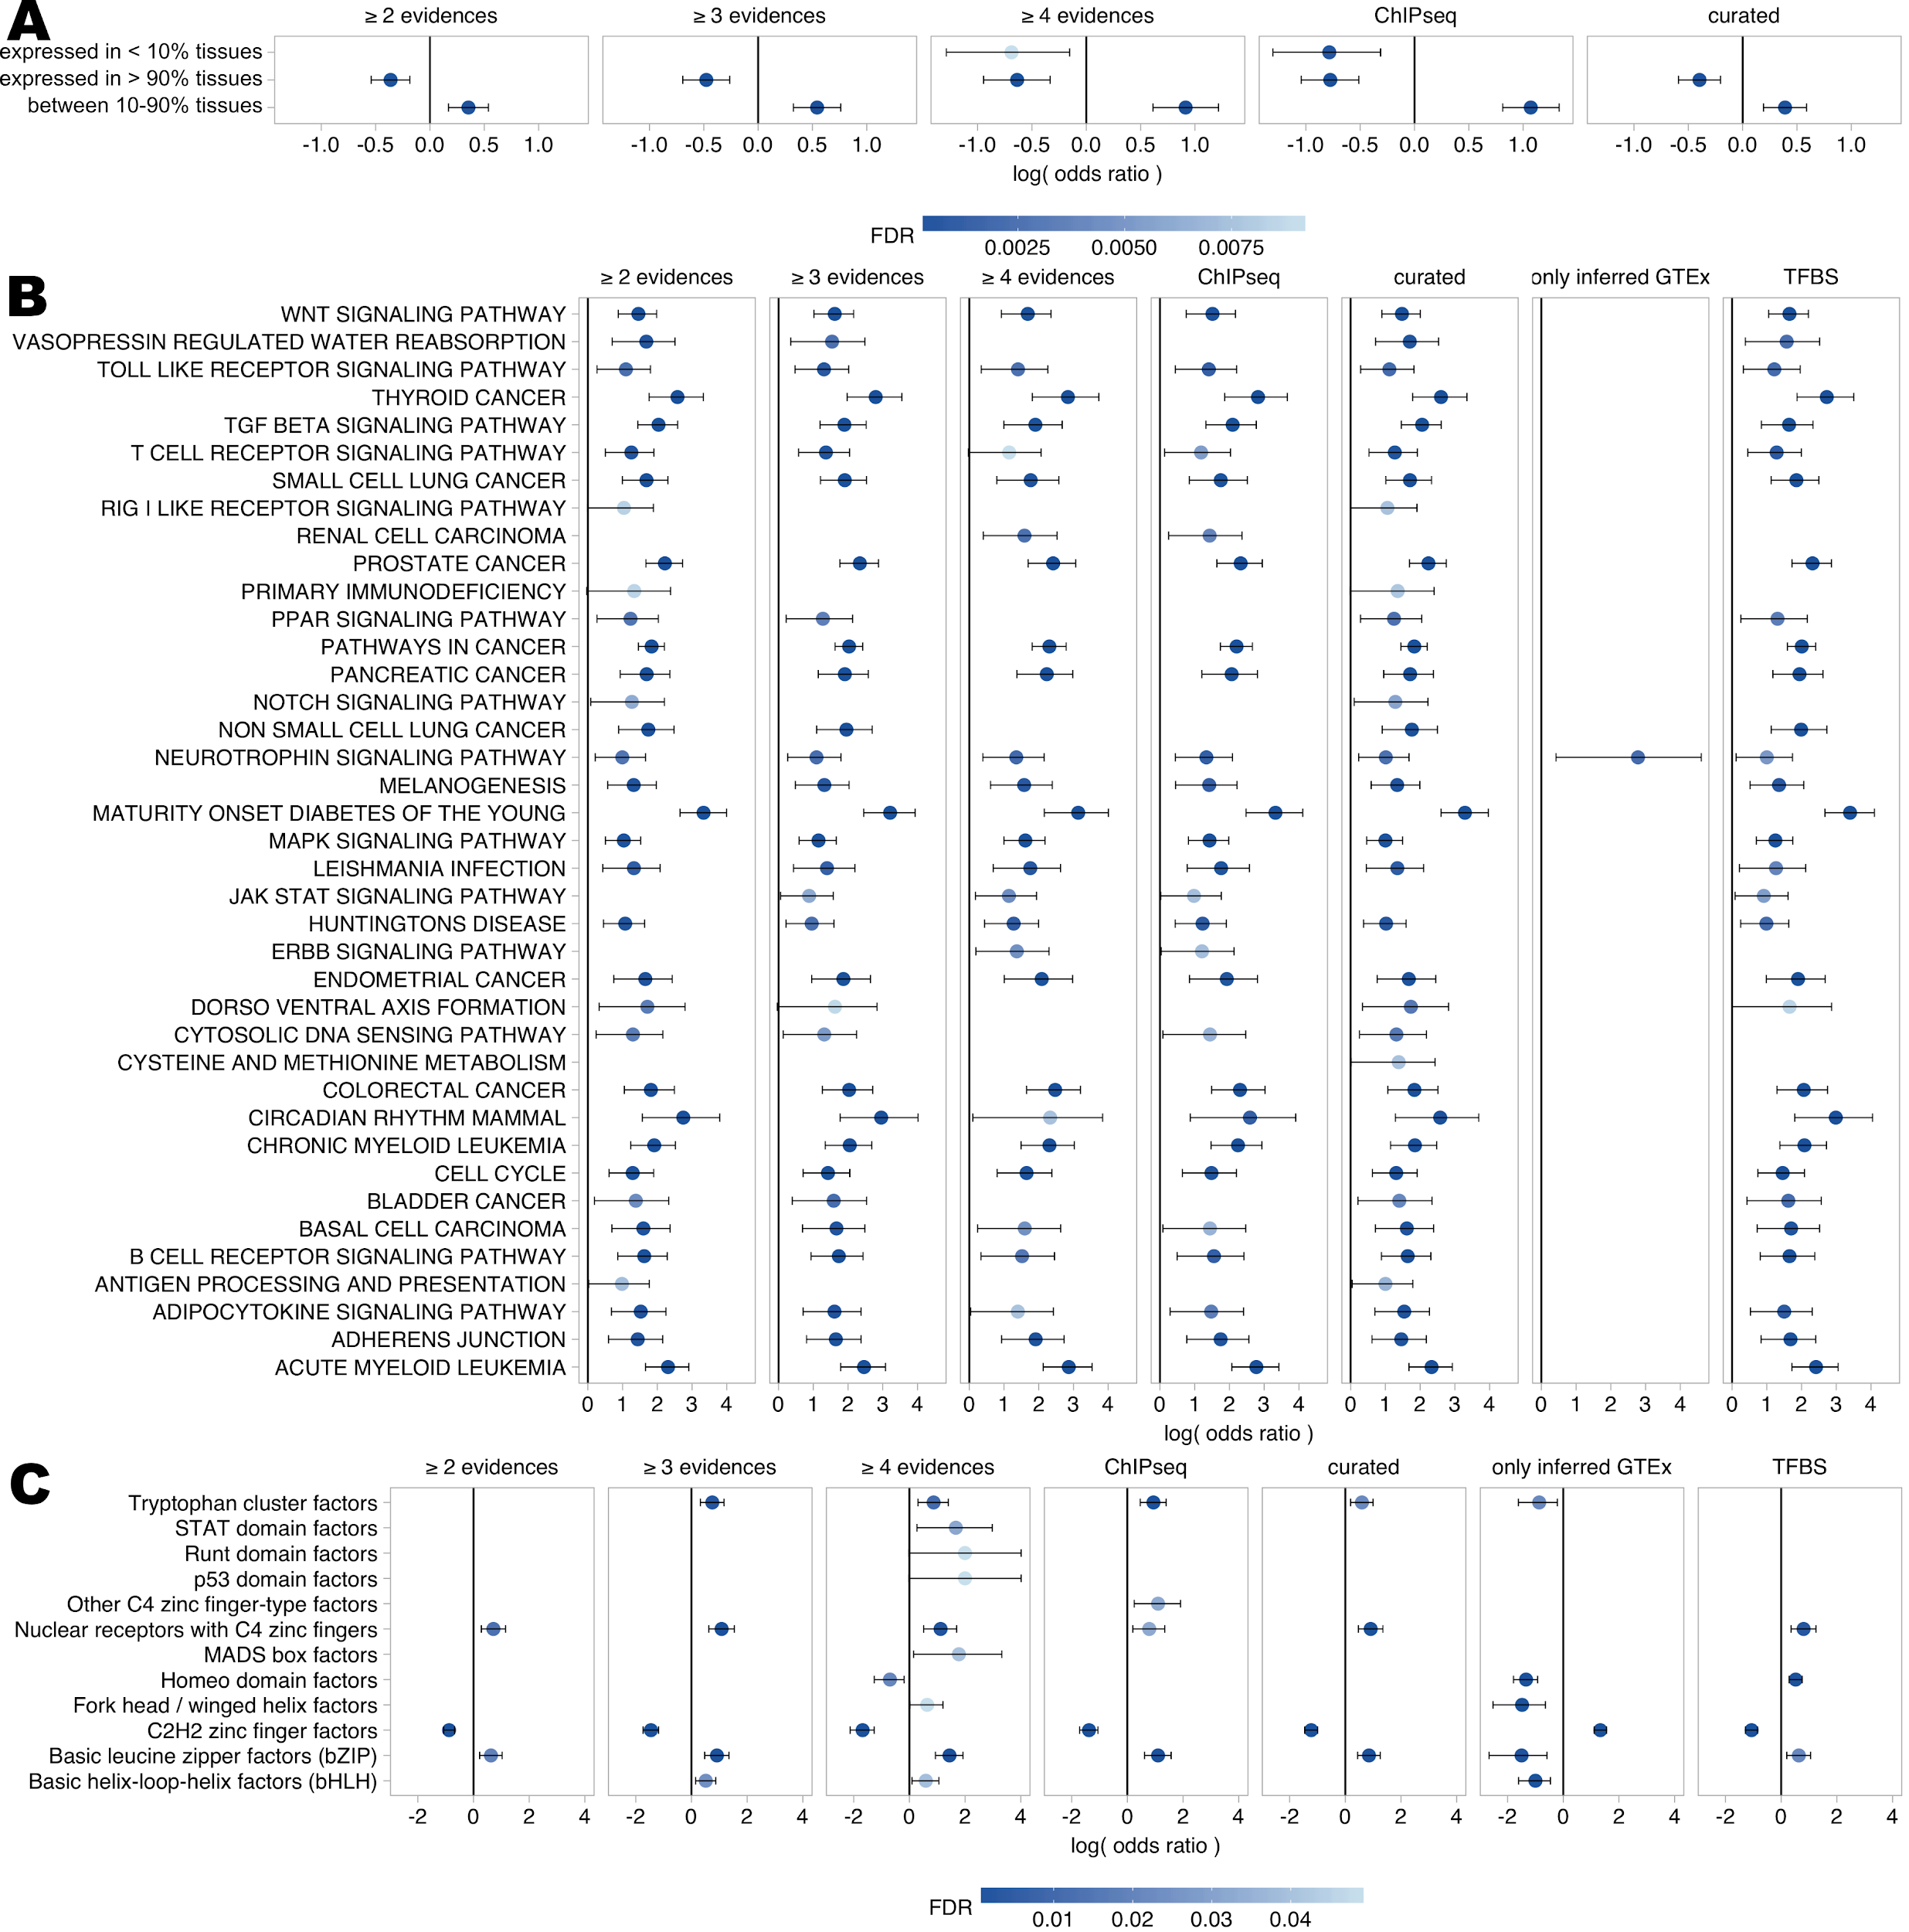
Supplemental Figure S4. Biological and research bias across resources. A) Tissues expression B) KEGG pathways and C) TF classes (from TFClass) enriched in the TFs covered by one or more lines of evidence. Dots indicate the log odds ratio while error bars indicate the confidence interval. Colors indicate the FDR. Labels “≥ 2 evidences”, “≥ 3 evidences” and “≥ 4 evidences” indicate TFs covered by any 2, 3 or 4 lines of evidence; “ChIP-seq”, “curated” and “TFBS” indicate all the TFs included by ChIP-seq, curated resources and TFBS predictions, respectively; “only inferred GTEx” includes those TFs that are exclusively covered by the regulons inferred from GTEx expression data.

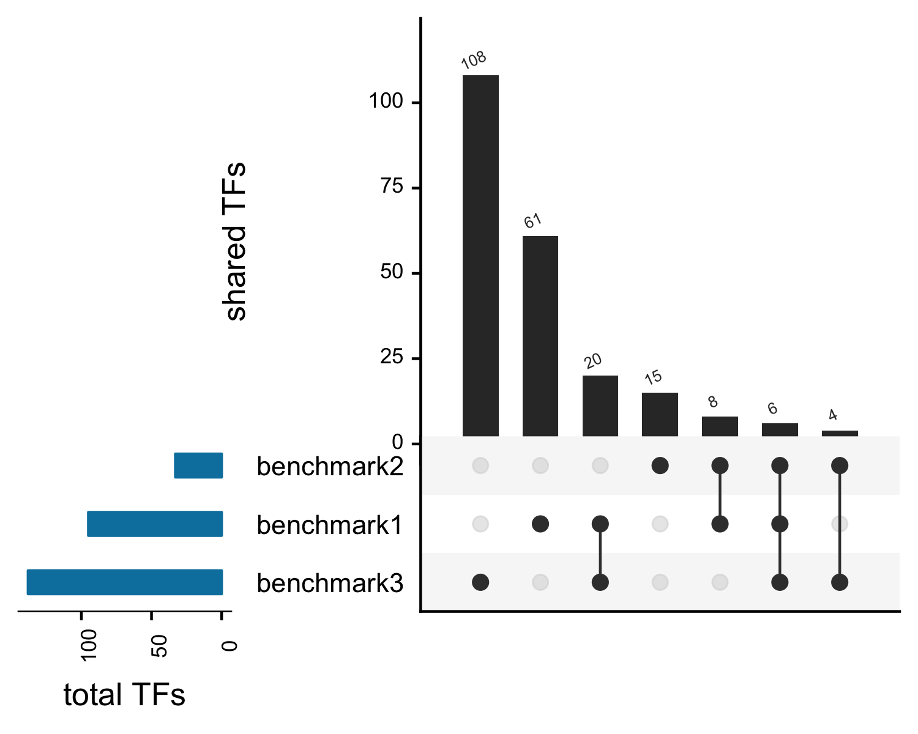
Supplemental Figure S5. TF overlap across benchmark datasets. Overlap is represented via UpSet plot where the left barplot represents the total number of TF in each benchmark; the top barplot represents the number of overlapping TFs in each intersection; and the dark circles in the matrix indicate the benchmark datasets that are part of the intersection.

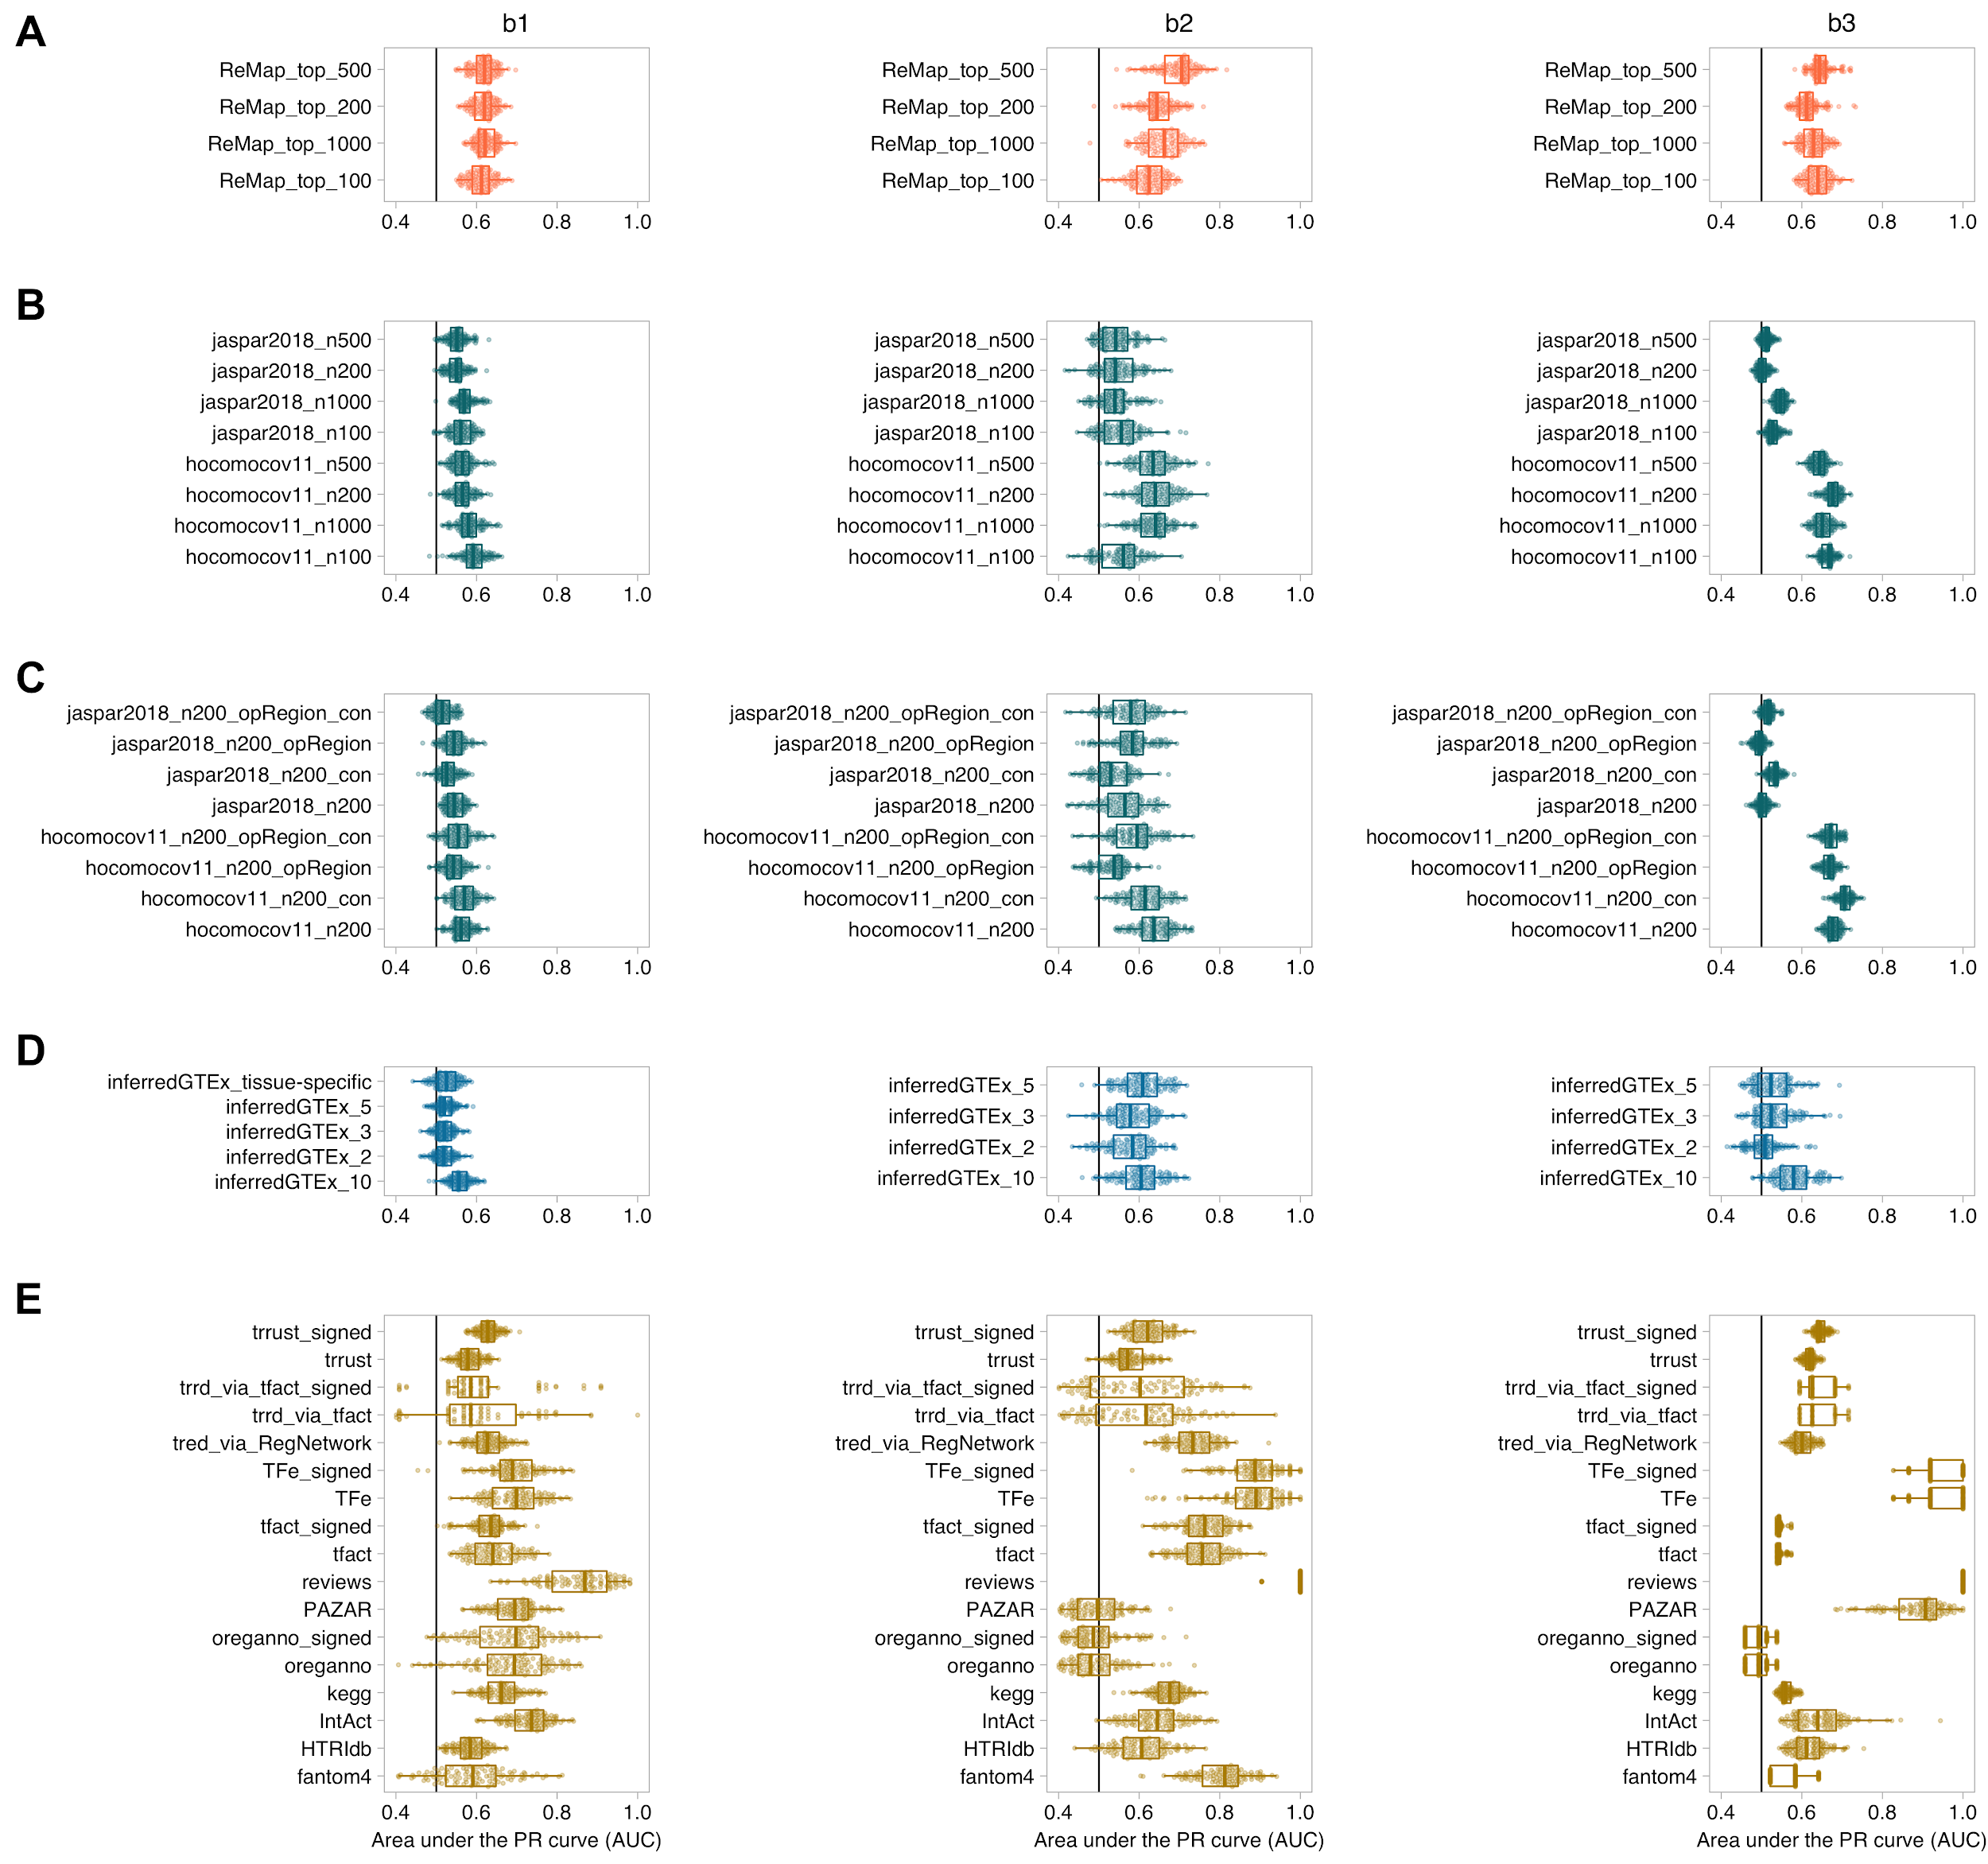

Supplemental Figure S6. Performance comparison (AUPRC) of the different TF-target interaction datasets investigated from each line of evidence. A) ChIP-seq: different cut-offs in the ReMap binding peaks (top 100, 200, 500 and 1000 hits). B) TFBS: different cut-offs in the Jaspar and HOCOMOCO TFBS hits (top 100, 200, 500 and 1000 hits). C) TFBS: inclusion of conservation (“_con”) and chromatin accessibility information (“_opRegion”) in the Jaspar and HOCOMOCO hits. D) ARACNe-inferred regulons: consensus versus tissue-specific GTEx inferred regulons. For the former, different number of consensus tissues (i.e. tissues supporting the TF-target interaction) are explored (n = 2, 3, 5 and 10). E) Curated databases. For those curated databases providing interaction MoR (or interaction sign), the corresponding unsigned and signed (“_signed”) versions are explored. Each column represents the results from a benchmark dataset (B1, B2 and B3, respectively). X-axis indicates the AUPRC from the activity rank’s position of the perturbed/essential TF against the same number of randomly selected negatives; Y-axis represents the regulon dataset.

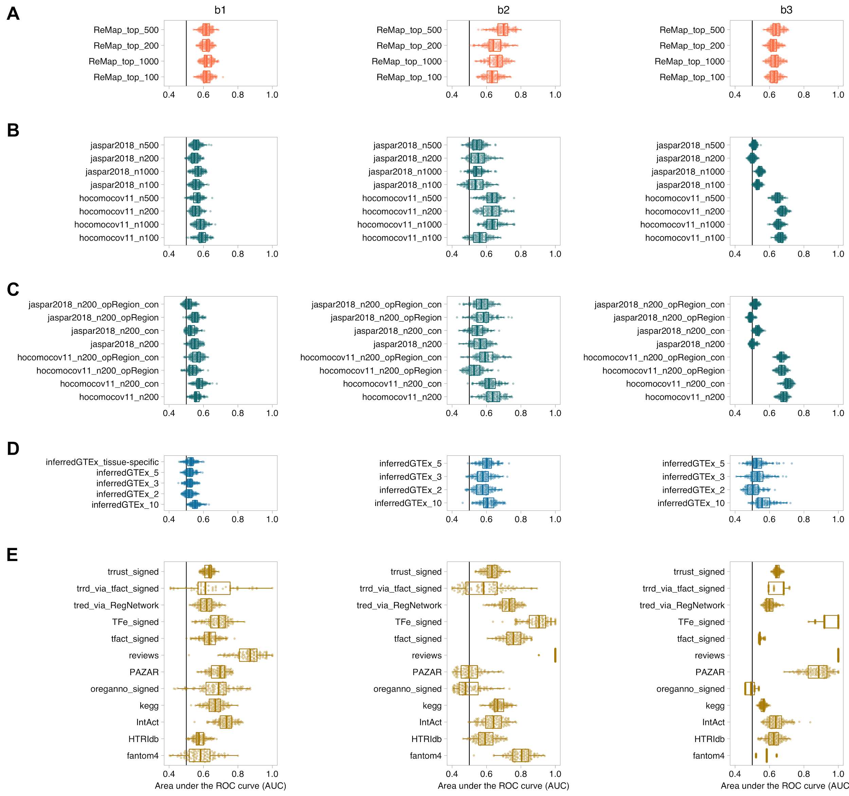
Supplemental Figure S7. Performance comparison (AUROC) of the different TF-target interaction datasets investigated from each line of evidence. Similar to Supplemental Figure S6.

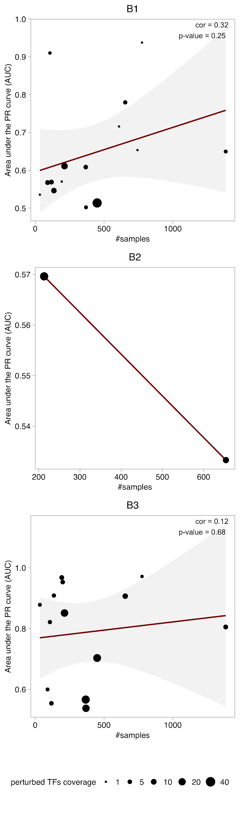
Supplemental Figure S8. Relationship between the number of samples used to infer tissue-specific regulons and their accuracy to the benchmark. Each scatter plot displays the results from the different benchmark datasets (B1, B2 and B3). Each dot represents a tissue evaluated in the benchmark. Dot size indicates the number of TFs in the benchmark covered per tissue. Only the tissues matching the samples in each benchmark are plotted.

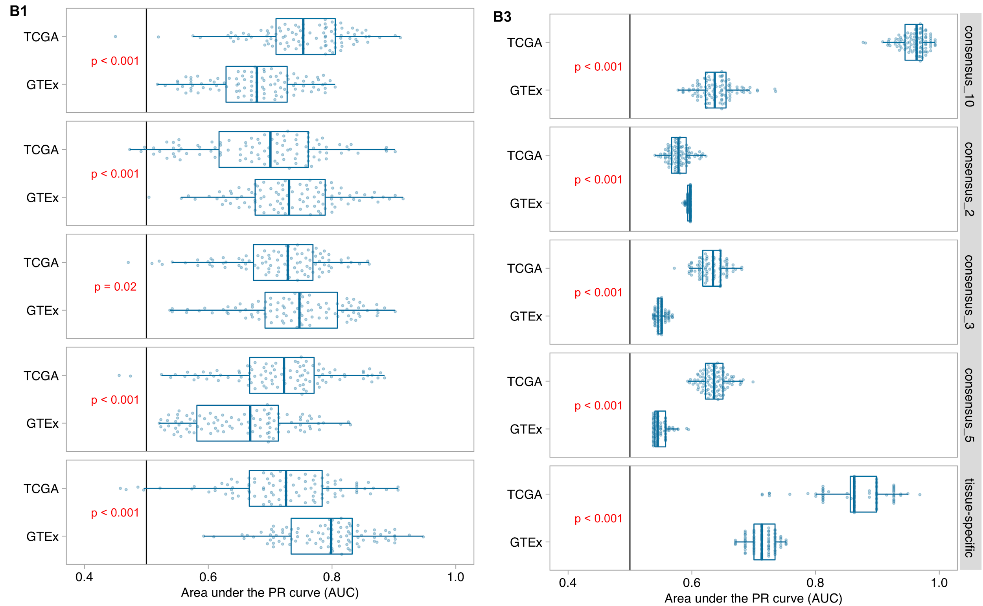
Supplemental Figure S9. Performance comparison of ARACNe-inferred networks from GTEx and TCGA expression (via aracne.networks R package) datasets. X-axis indicates the AUPRC from the activity rank’s position of the perturbed/essential TF against the same number of randomly selected negatives; Y-axis represents the regulons inferred from GTEx or TCGA expression data. Rows indicate the different filters used to build the regulons: tissue-specific, considering the TF-target interactions found in each tissue (GTEx) or cancer-type (TCGA); or “consensus” derived from the TF-targets interactions observed in 2, 3, 5 or 10 tissues/cancer-types, respectively. Columns indicate the benchmark dataset used (B1 and B3; results for B2 not shown due to limited data). Performance distributions have been compared using a t-test and the resulting p-value is indicated in red.

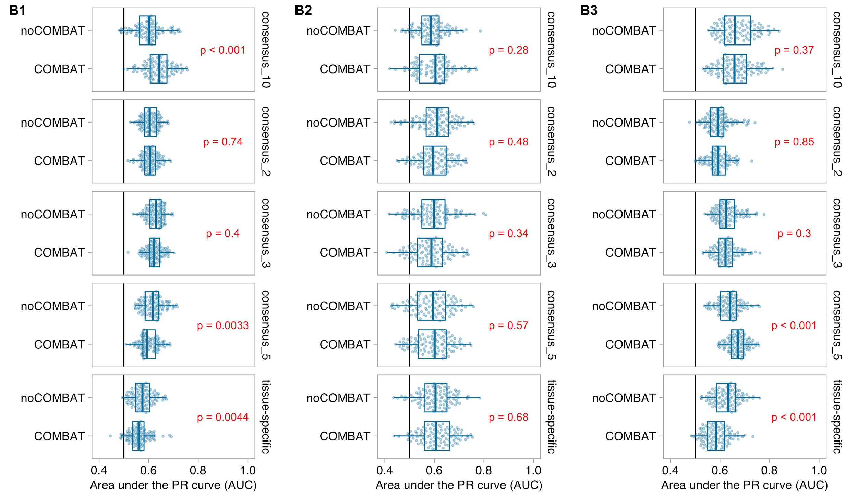
Supplemental Figure S10. Performance comparison of transcriptionally inferred GTEx networks batch and non-batch corrected (on the overlapping TFs). X-axis indicates the AUPRC from the activity rank’s position of the perturbed/essential TF against the same number of randomly selected negatives; Y-axis represents the regulons inferred from batch (COMBAT) and non-batch (noCOMBAT) corrected GTEx expression data. Rows indicate the different filters used to build the regulons: tissue-specific, considering the TF-target interactions found in each tissue; or “consensus” derived from the TF-targets interactions observed in 2, 3, 5 or 10 tissues, respectively. Columns indicate the benchmark dataset used. Performance distributions have been compared using a t-test and the resulting p-value is indicated in red.

References
Ehsani R, Bahrami S, Drabløs F. 2016. Feature-based classification of human transcription factors into hypothetical sub-classes related to regulatory function. BMC Bioinformatics 17: 459.
Lambert SA, Jolma A, Campitelli LF, Das PK, Yin Y, Albu M, Chen X, Taipale J, Hughes TR, Weirauch MT. 2018. The Human Transcription Factors. Cell 172: 650–665.
The UniProt Consortium. 2017. UniProt: the universal protein knowledgebase. Nucleic Acids Res 45: D158–D169.

