Supplemental material
Contents
Supplemental Methods 2
Commands used for alignment and SV calling 2
Supplemental Tables 3
Supplemental Figures 10
Supplemental Code 17

Supplemental Methods

Commands used for alignment and SV calling
The output of alignments is piped directly to samtools sort to generate sorted bam files.
NGMLR
zcat *.fastq.gz | ngmlr --presets ont -t {threads} -r {genome}

minimap2
minimap2 --MD -a -t {threads} {genome} *.fastq.gz

minimap2-pbsv
minimap2 -t {threads} -a --MD --eqx -L -O 5,56 -E 4,1 -B 5 --secondary=no -z 400,50 -r 2k -Y -R @RG\tID:rg1a\tSM:NA19240 {genome} *.fastq.gz

LAST
The index was built using a reference genome masked with WindowMasker (Morgulis et al., 2006). The substitution matrix was obtained from last-train (Hamada et al., 2017).
lastal -P8 -p training.par lastdb_GRCh38-wm *.fastq.gz | last-split -m1e-6 | maf-convert -f genome.dict sam /dev/stdin

Sniffles
Sniffles -m {alignment} -v {output-calls} -t {threads}
Sniffles -m {alignment} -v {output-genotypes} -t {threads} --Ivcf {output-calls}
NanoSV
NanoSV --bed {exons.bed} -t {threads} -s samtools {input.bam} -o {output.vcf}
pbsv
pbsv discover {alignment} variants.svsig.gz
pbsv call {genome} variants.svsig.gz {output}
SVIM
svim alignment {output} {alignment}
npInv
java -jar npInv1.21.jar --input {alignment.bam} --output {output.vcf}

Supplemental Tables

Supplemental table S1: Library prep metrics |  |  |  |  |  |  |  |  |  | Ligation |  | Sequencing
ID | Extraction | size  [kb] | Shearing | Size cutoff  [kb] | 260/280 | 260/230 | Kit | Active pores | Mass input  [µg] | Size  [kb] | Molarity  [fmol] | Mass [µg] | Molarity  [fmol]
P1 | PSS 8LX | 38.4 | NA | >10 | 1.82 | 2.32 | LSK109 | 7179 | 8.46 | 38.0 | 360.3 | 5.9 | 250
P2 | QIAamp | 40.6 | 20 kb | >8 | 1.85 | 2.43 | LSK109 | 7339 | 2.38 | 18.7 | 193.6 | 0.8 | 69.2
P3 | QIAamp | 40.6 | NA | >10 | 1.85 | 2.45 | LSK109 | 4224* | 2.24 | 41.9 | 109.2 | 0.6 | 23.3
P4 | QIAamp | 40.6 | NA | >10 | 1.86 | 2.32 | LSK108 | 7019 | 3.6 | 38.9 | 129.9 | 1 | 41.9
P5 | pool | 39.5 | 20 kb | >6 | 1.87 | 2.43 | LSK109 | 7154 | 4.3 | 15.8 | 374.6 | 1.2 | 123.2
M1 | QIAamp | 40.6 | NA | >10 | 1.82 | 2.32 | LSK109 | 899 | 7.15 | 33.6 | 289 | 3 | 144.5
M2 | QIAamp | 40.6 | NA | >10 | 1.82 | 2.52 | LSK109 | 1249 | 1.4 |  |  | 0.29 | 11.7

Extraction is specifying the DNA extraction method (sample P5 is a pool of both); size specifies average DNA smear size on Fragment Analyzer in kb after extraction (Advanced Analytical, Agilent, USA); Shearing specifies size to which sample was fragmented using Megaruptor if applicable (Diagenode, BE); Size cutoff specifies the lower limit used during BluePippin electrophoresis; 260/280 and 260/230 specify the purity of the aliquots after BluePippin size selection and AMPure XP final bead purification; Active pores specifies the number of active pores detected by mux-scan after loading the library; Mass lib prep specifies mass of DNA used at the start of library prep; size DNA specifies the average size of the fragments used in the ligation step, measured with Fragment Analyzer (Advanced Analytical, Agilent, USA); Mol DNA for ligation specifies amount of femto-moles used for each ligation reaction; Mass. specifies mass of each library loaded onto PromethION flow-cell; Mol seq. specifies molarity of library loaded on flow cell in fmol; *While loading a library onto PromethION flow cell an air bubble was introduced in one quadrant, causing decreased active pore numbers prior to sequencing.

Supplemental Table S2: number of variants identified per type, per dataset
Variant type | minimap2 |  |  | minimap2-pbsv |  |  | LAST | NGMLR
Variant type | Sniffles | NanoSV | SVIM | NanoSV | pbsv | SVIM | NanoSV | Sniffles | NanoSV | SVIM | pbsv
Insertion | 12918 | 37009 | 300252 | 39445 | 13693 | 252620 | 7396 | 10535 | 24268 | 71246 | 11177
Deletion | 11897 | 19356 | 58946 | 19676 | 11293 | 47176 | 14837 | 10688 | 17261 | 26956 | 10081
Duplication | 11 | 624 | 4024 | 613 | - | 4916 | 9324 | 67 | 1548 | 32361 | -
Inversion | 326 | - | 23 | - | 36 | 26 | - | 593 | - | 119 | 36
Undetermined | 948 | 4313 | - | 4508 | 5008 | - | 8360 | 574 | 4481 | - | 15144

Supplemental Table S3: precision and recall
Accuracy metrics of SVs as identified per aligner and variant caller, compared with the truth set (Chaisson et al., 2018).
Data | Aligner | Call set | Precision | Recall | F-measure
PromethION | NGMLR | NanoSV | 0.6417 | 0.6715 | 0.6562
PromethION | NGMLR | Sniffles | 0.7568 | 0.6579 | 0.7039
PromethION | NGMLR | SVIM | 0.6124 | 0.7236 | 0.6634
PromethION | NGMLR | pbsv | 0.4649 | 0.6292 | 0.5348
PromethION | NGMLR | high confidence | 0.8769 | 0.5237 | 0.6558
PromethION | NGMLR | high sensitivity | 0.3851 | 0.774 | 0.5143
PromethION | minimap2 | NanoSV | 0.6223 | 0.7023 | 0.6599
PromethION | minimap2 | Sniffles | 0.6859 | 0.6899 | 0.6879
PromethION | minimap2 | SVIM | 0.6179 | 0.7272 | 0.6681
PromethION | minimap2 | high confidence | 0.8215 | 0.6013 | 0.6944
PromethION | minimap2 | high sensitivity | 0.5121 | 0.7693 | 0.6149
PromethION | minimap2-pbsv | NanoSV | 0.6144 | 0.7185 | 0.6624
PromethION | minimap2-pbsv | SVIM | 0.6013 | 0.737 | 0.6623
PromethION | minimap2-pbsv | pbsv | 0.6153 | 0.6775 | 0.6449
PromethION | minimap2-pbsv | high confidence | 0.7902 | 0.6389 | 0.7065
PromethION | minimap2-pbsv | high sensitivity | 0.4635 | 0.7555 | 0.5745
PromethION | LAST | NanoSV | 0.596 | 0.5859 | 0.5909
Illumina | BWA-MEM | manta | 0.55 | 0.28 | 0.37
Illumina | BWA-MEM | lumpy | 0.18 | 0.04 | 0.07

Supplemental table S4: F-measure of aligners and variant callers agnostic to SV type
 | structural variant caller
aligner | NanoSV | Sniffles | pbsv | SVIM
LAST | 0.70 | NA | NA | NA
NGMLR | 0.74 | 0.75 | 0.56 | 0.72
minimap2 | 0.74 | 0.73 | NA | 0.72
minimap2-pbsv | 0.74 | NA | 0.68 | 0.72
NA: incompatible aligner or parameter settings for this structural variant caller

Supplemental Table S5: F-measure of aligners and variant callers limited to inversions
 | structural variant caller
aligner | Sniffles | pbsv | SVIM | npInv
NGMLR | 0.16 | 0.29 | 0.23 | 0.22
minimap2 | 0.17 | NA | 0.21 | 0.24
minimap2-pbsv | NA | 0.31 | 0.22 | 0.21
NA: incompatible aligner or parameter settings for this structural variant caller

Supplemental Table S6: F-measure of aligners and variant callers for gains and loss of sequence
aligner | SV caller | F-measure gain | F-measure loss
LAST | NanoSV | 0.62 | 0.77
minimap2 | NanoSV | 0.69 | 0.79
minimap2 | Sniffles | 0.72 | 0.75
minimap2 | SVIM | 0.66 | 0.73
minimap2-pbsv | NanoSV | 0.69 | 0.79
minimap2-pbsv | pbsv | 0.71 | 0.78
minimap2-pbsv | SVIM | 0.66 | 0.73
NGMLR | NanoSV | 0.68 | 0.80
NGMLR | Sniffles | 0.74 | 0.78
NGMLR | pbsv | 0.69 | 0.79
NGMLR | SVIM | 0.66 | 0.75

Supplemental Table S7: F-measure of minimal support parameter testing

Minimal support | F-measure
5 | 0.6733
10 | 0.7029
15 | 0.7127
20 | 0.7149
25 | 0.7066
30 | 0.6788
35 | 0.6166
40 | 0.5272
45 | 0.4511
50 | 0.4026
55 | 0.3711
60 | 0.3378
65 | 0.2915
70 | 0.2299

Supplemental table S8: accession IDs
 | Library identifier |  |  | ENA accession fastq |  | ENA accession fast5
Read data | P1-N |  |  | ERR3219853 |  | ERR3046934
Read data | P2-S |  |  | ERR3219854 |  | ERR3046935
Read data | P3-N |  |  | ERR3219855 |  | ERR3046936
Read data | P4-N |  |  | ERR3219856 |  | ERR3046937
Read data | P5-S |  |  | ERR3219857 |  | ERR3046938
 |  | Aligner | SV caller |  | EVA accession
Variant data |  | minimap2 | Sniffles |  | ERZ858036
 |  | minimap2 | NanoSV |  | ERZ858031
 |  | minimap2 | SVIM |  | ERZ858023
 |  | minimap2 | npInv |  | ERZ858024
 |  | minimap2-pbsv | pbsv |  | ERZ858025
 |  | minimap2-pbsv | SVIM |  | ERZ858032
 |  | minimap2-pbsv | NanoSV |  | ERZ858029
 |  | minimap2-pbsv | npInv |  | ERZ858028
 |  | NGMLR | Sniffles |  | ERZ858027
 |  | NGMLR | NanoSV |  | ERZ858026
 |  | NGMLR | pbsv |  | ERZ858030
 |  | NGMLR | SVIM |  | ERZ858035
 |  | NGMLR | npInv |  | ERZ858034
 |  | LAST | NanoSV |  | ERZ858033

Supplemental Figures
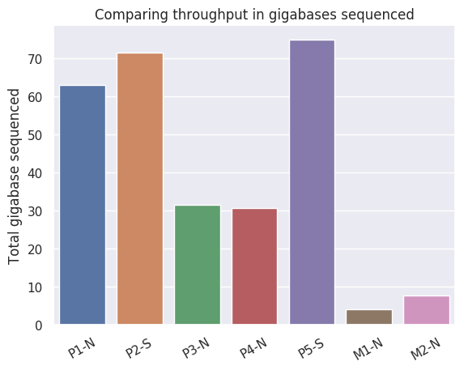
Supplemental figure S1: throughput in gigabases per library
P: PromethION; M: MinION;
N: non-sheared/native; S: sheared before library preparation

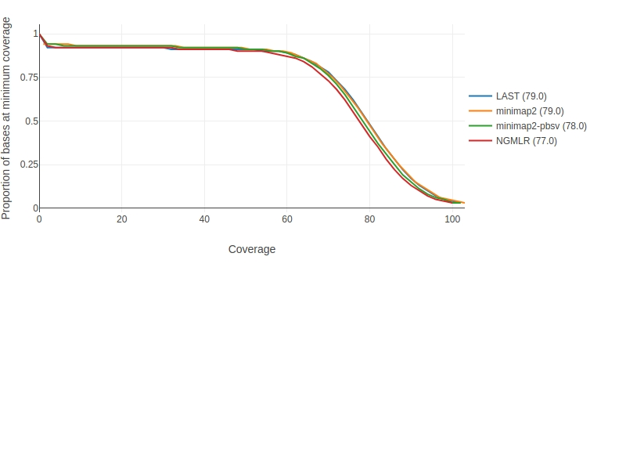
Supplemental figure S2: Read depth distribution
Read depth calculated using mosdepth for NA19240 PromethION datasets after alignment with LAST, mimimap2 with two parameter settings and NGMLR. Shows the proportion of the reference genome covered at least by a certain number of reads.

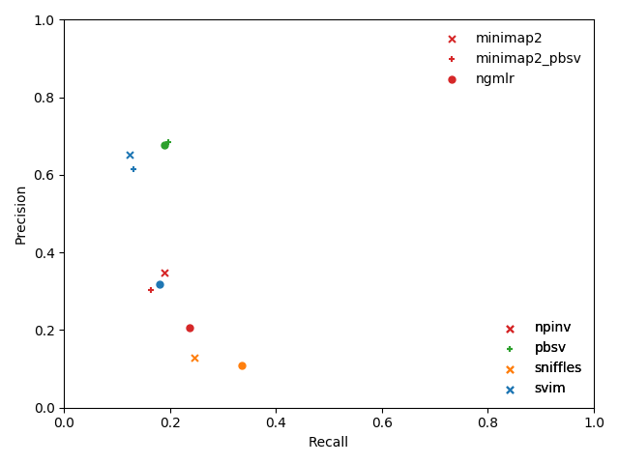
Supplemental Figure S3: Precision recall evaluation of inversions
Precision and recall for inversions separately were evaluated for all call sets. Symbols indicate aligners, colors indicate variant callers.

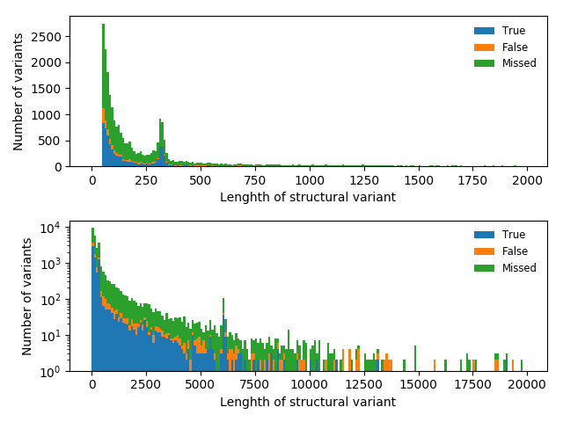
Supplemental figure S4: length of identified SVs
SVs identified using Manta after BWA-MEM alignment, compared to the truth set. The upper panel shows variants up to 2kb, the lower up to 20kb and uses a log transformation of the number of variants for visualization purposes.

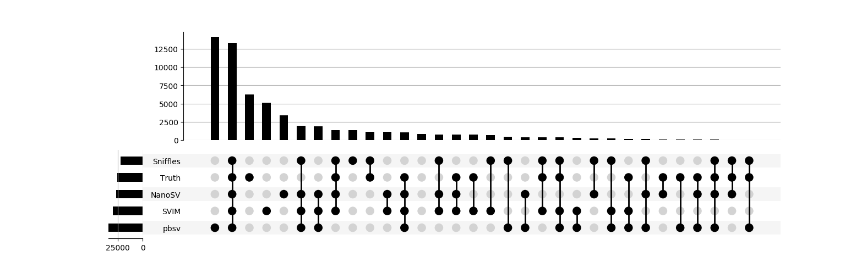
Supplemental Figure S5: UpSet plot of SV calls after NGMLR alignment
Showing the overlap between structural variants identified by the variant callers after NGMLR alignment and the truth set by Chaisson et al. 2018. A substantial proportion of variants shared by the variant callers is absent from the truth set.
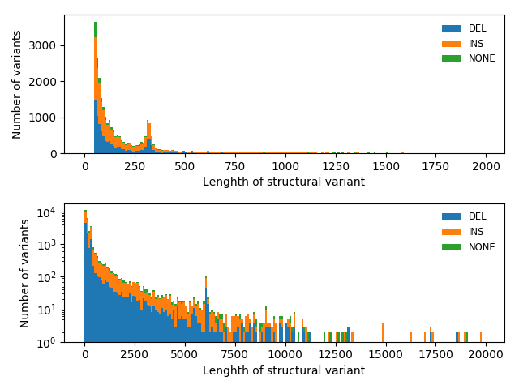
Supplemental figure S6: length of identified SVs in the truth set The upper panel shows variants up to 2kb, the lower up to 20kb and uses a log transformation of the number of variants for visualization purposes.

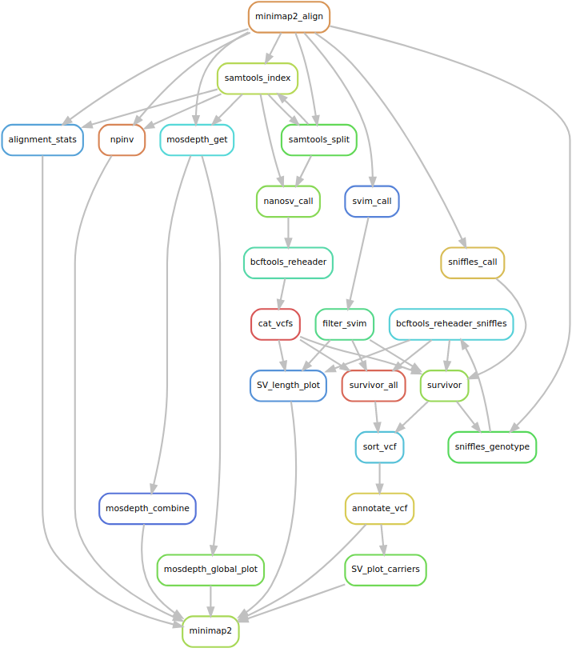
Supplemental Figure S7: Graphical representation of a workflow
Snakemake rule graph visualized using Graphviz, for minimap2 alignment. This graph shows the tools (rules) which are used sequentially to obtain the end result of annotated structural variants and visualizations.

Supplemental Code
All Python scripts for evaluation and plotting of our results are available on https://github.com/wdecoster/nano-snakemake/ and https://github.com/wdecoster/surpyvor and as Supplemental Code.

