Supplemental Material

Isolation of 5-EU-containing RNA and library preparation
Injected embryos were transferred to a 1.5 ml tube, homogenized in TRI-reagent, and frozen at –80°C. Once approximately 250 injected embryos were collected for each stage, lysates were thawed and combined appropriately. RNA was extracted with TRI-reagent (Thermo Fisher Scientific, Waltham, MA) as directed by the manufacturer’s protocol. The aqueous phase was extracted with one volume of acid phenol, then with one volume of chloroform, and then was ethanol precipitated. Approximately 3.0 μg of total RNA was poly(A)-selected using Dynabeads mRNA purification kit (Thermo Fisher Scientific) following the manufacturer’s protocol. Alternatively, for one sample at each time point, rRNA was depleted from 1.0 μg of total RNA using the Ribo-Zero Gold kit (Illumina, San Diego, CA).

5-EU-labeled RNA was biotinylated with a biotin-azide reagent in a typical copper(II)-catalyzed click chemical reaction. First, 25 mM CuSO4 and 25 mM tris-hydroxypropyltriazolylmethylamine (THPTA) were combined in a 16 μL reaction to activate the copper catalyst. 4 mM disulfide biotin azide (Click Chemistry Tools, Scottsdale, AZ) was added to a 10 μL reaction containing RNA, 50 mM HEPES pH 7.5, 2.5 mM CuSO4/THPTA, and 10 mM sodium ascorbate (final concentrations). After incubation for 1 h at room temperature, EDTA was added to a final concentration of 5 mM to stop the reaction, and unreacted biotin azide reagent was removed with a phenol/chloroform extraction.

The biotinylated RNA was isolated with a streptavidin pull-down. First, 100 μL Dynabeads MyOne Streptavidin C1 beads (Invitrogen, volume per pull-down) were batch washed with an equal volume of each of the following solutions: 1× B&W buffer (10 mM Tris-HCl pH 7.5, 1 mM EDTA, 2 M NaCl), solution A (0.1 M NaOH, 50 mM NaCl, 0.01% Tween-20), solution B (0.1 M NaCl, 0.01% Tween-20) and water. Washed beads were pre-blocked with 500 ng/μL yeast total RNA (Thermo Fisher Scientific) in 1× High Salt Wash Buffer (HSWB, 10 mM Tris-HCl pH 7.4, 1 mM EDTA, 100 mM NaCl, 0.01% Tween-20) in an end-over-end rotator for 30 min at room temperature. Beads were washed three times with 1× HSWB to remove unbound yeast RNA. Biotinylated RNA was resuspended in 1× HSWB and incubated an equal volume of the pre-blocked beads in an end-over-end rotator for 30 min at room temperature. The unbound RNA was collected from the beads as the flowthrough, and the beads were washed twice with 50°C RNAse-free water and twice with 50°C 10× HSWB.

To elute the bound RNA, the disulfide linkage binding the RNA to the beads was reduced with 0.5 M tris(2-carboxyethyl)phosphine hydrochloride (TCEP), pH 7.0 in an end-over-end rotator at 50°C for 20 min. TCEP was collected from the beads as eluate, and the beads were washed with water, which was collected and combined with the eluate. RNA from the eluate, flowthrough and input samples were prepared for sequencing using the SMARTer Stranded RNA-seq Kit (Takara Bio, Mountain View, CA).

Construction of synthetic spike-ins
Synthetic spike-in RNAs were in vitro transcribed from templates corresponding to Renilla luciferase, Firefly luciferase and AcGFP sequences using the MEGAscript T7 kit (Thermo Fisher Scientific) with 0.1 μM PCR product as the template. In the AcGFP reaction, 5-ethnyluridine-triphosphate (5-EUTP) was included at a 1:20 molar ratio with UTP. Spike-in RNAs were gel purified and stored at –80°C. RNAs were cap-labeled with α-³²P-GTP using the Vaccinia capping system (NEB) and gel purified prior to use. A fraction of each eluate and each corresponding input was resolved on a denaturing gel, and recovery of 5-EU-containing RNAs was estimated using a phosphorimager to quantify the ratio of the band intensities for the radiolabeled 5-EU-containing standard relative to the radiolabeled uridine-containing standard.

RNA-seq analysis
All libraries were sequenced on the Illumina HiSeq platform with 40 nt single-end reads. On average, the libraries were sequenced with 20.2 million reads, with some libraries receiving fewer reads (minimum 2.5 million reads) and other libraries receiving more reads (maximum 40 million reads). Reads were aligned to the human genome (UCSC hg38 reference assembly) using STAR v2.4 (Dobin et al. 2013) to quantify the number of HEK293 spike-in reads. This alignment used the standard ENCODE RNA-seq pipeline parameters. Unmapped reads were aligned to an index built from the Drosophila genome (UCSC dm6 reference assembly) and the sequences of our synthetic spike-ins using STAR. Alignment parameters were as follows: “--outFilterMultimapNmax 1 --outFilterMismatchNoverLmax 0.05 --outFilterIntronMotifs RemoveNoncanonicalUnannotated --outFilterType BySJout --outSJfilterReads Unique --alignIntronMax 25000." Drosophila transcript annotations were downloaded from UCSC (dm6 refFlat), and the longest transcript isoform was selected as the representative isoform. Aligned reads were assigned to genes by overlapping the aligned read positions with the transcript annotations using HTSeq (Anders et al. 2015). The expression of each gene was pseudo-counted by one read, and then RPKM (reads per kilobase per million uniquely mapped reads) values were calculated and normalized for the number of HEK293-mapping reads.

When annotating transcribed genes, genes were first filtered to remove those with an expression level < 2 RPKM in the eluate. The ratio of expression in the poly(A)-selected eluate compared to that in the matched flowthrough was calculated for each of the remaining genes, and those with eluate/flowthrough > 0.5 in both biological replicates were annotated as transcribed. For the RNA harvested from NC 7–9 embryos, transcribed genes were annotated as those above the threshold in the poly(A)-selected sample and the rRNA-depleted sample. Intron number, intron length, intron order, and primary-transcript length were calculated using the longest transcript isoform model. Gene Ontology analysis was done using GOrilla (Eden et al. 2009).

Expression of TEs
To quantify the expression from TEs, the sequencing data was processed using a strategy better suited for multi-mapping reads. Reads were first aligned to the human genome with STAR, as described. Unmapped reads were trimmed of the first 3 random nucleotides (from adapter) and pseudo-aligned to the Drosophila transcriptome using kallisto v0.44 (Bray et al. 2016). The Drosophila transcriptome included the sequences of host transcripts, TE transcripts, miRNAs hairpins, miscRNAs, and ncRNAs downloaded from FlyBase (FASTA files from release 6.16, FlyBase 2017_03). Kallisto parameters were as follows: "--single -b 30 -l 300 -s 70 --fr-stranded." TPM (transcripts per million) values were output from kallisto, normalized for the HEK293 spike-in, and pseudo-counted. Identical reads, which were presumably created during PCR amplification, were removed from the eluate sample FASTQ files with a custom script prior to kallisto processing.

To annotate transcribed TEs, TPM expression of TE isoforms was summed for every detected isoform in a family. TE families with expression < 2 TPM in the eluate were removed, and for each of the remaining families, the ratio of expression in the poly(A)-selected eluate compared to that in the matched flowthrough was calculated. TE families with eluate/flowthrough > 1.0 in both biological replicates were annotated as transcribed.

Calculating read density across the transcript body
Aligned reads from rRNA-depleted libraries were assigned to ORF annotations and de-duplicated with SAMtools (Li et al. 2009). Each transcript ORF was divided into 10 equally sized bins, and the number of reads was summed within each bin. For each ORF with a total read number greater than the median, the read numbers in each bin were down weighted such that their total matched the median read number. This normalization was done to ensure that most highly expressed genes did not dominate the metagene plots. This normalization was not performed in the NC 7–9 sample because in this sample no gene contributed more than three reads. For each set of zygotic genes, an equal number of genes with maternal transcripts were sampled (with replacement) to match the primary-transcript length distribution of the zygotic set. This sampling procedure was conducted 100 times. The cumulative density function and the interpolated median values were calculated with R (R Development Core Team 2015).

A modified approach was used to plot the read density of TE-mapping reads. Pseudo-aligned reads from rRNA-depleted libraries were assigned to TE isoforms as part of the kallisto output. Each TE isoform was divided into 10 equally sized bins, and binned reads were summed for all isoforms of a family. Normalization and sampling was as described for host mRNAs. Because some TE isoforms are not full length, for each family we only included reads that mapped to isoforms that were 70% of the length of the longest isoform.

Analysis of Zelda binding
Promoter regions were defined as 650 nt regions that spanned the TSS of the longest transcript isoform of each gene, starting 500 nt upstream of the TSS. Enhancer regions were downloaded from Kvon et al. (2014) and converted from dm3 to dm6 using the UCSC liftOver tool. Genomic coordinates of Zelda-bound regions identified by ChIP-seq in NC 8, NC 13, and NC 14 embryos were downloaded from Harrison et al. (2011) and converted from dm3 to dm6 using the UCSC liftOver tool. ChIP-seq regions that overlapped promoters or enhancers were identified with BEDTools v2.26 (Quinlan and Hall 2010), and in cases in which Zelda ChIP-seq signal overlapped multiple regulatory regions of the same gene, the region with the highest binding score was chosen for that gene.

Comparison with existing annotations
Of the 59 genes annotated as the early zygotic genes in De Renzis et al. (2007), two (CG13714 and CG1294) have been removed from FlyBase (version 2018_02) and were not considered further. Of the remaining 57, all but four (CG5704, CG33970, ppk21, pst) were included among the genes we annotated as transcribed in the minor wave, although in two cases we annotated an overlapping genes with a different name. In one case, we identified Sry-beta, whereas De Renzis et al. identified Sry-alpha. In the other case, we identified CR32218, which is in the intron of Su(Tpl), whereas De Renzis et al. identified Su(Tpl). These overlapping transcriptional units were counted as the same gene for the purposes of comparing early gene annotations.

Maternal Transcript Lists
Transcripts with expression > 0.5 RPKM in RNA-seq data from stage 14 oocytes (Kronja et al. 2014) were identified as maternally deposited. From this set of 6,677 transcripts, we removed those that we identified as being zygotically transcribed to generate a set of 4,873 predominantly maternal transcripts.

The list of 35 maternally deposited transcripts used in Figure 1D–G was curated from Dworkin and Dworkin-Rastl (1990) and Semotok and Lipshitz (2007) and included: bcd, nos, stg, twe, tor, rpA1, Hsp83, png, gnu, Tl, plu, osk, orb, pum, brat, smg, pgc, rp49, alphaTub84B, CycB, Tl, stau, aub, piwi, vas, tud, vls, faf, gcl, gd, Raf, dl, snk, swa, and exu.

Zygotic Transcript Lists
The set of zygotic transcripts used in Figure 1D–G are the 57 annotated by De Renzis (2007).

Calculating spice-site scores
Spice-site scores were calculated using MaxEntScan (Yeo and Burge 2004), using 9 bp around the 5′ splice site (3 nt downstream to 6 nt upstream) and 23 bp around the 3′ splice site (20 nt downstream to 3 nt upstream) as in Pai et al. (2017). Although these models were trained on mammalian splice sites, they are also effective for determining the quality of Drosophila splice sites (Pai et al. 2017).

Statistical analysis
All plots were made with the R package ggplot2 (Wickham 2016) except for the Venn diagram, which was made with the R package eulerR (Larsson 2018).

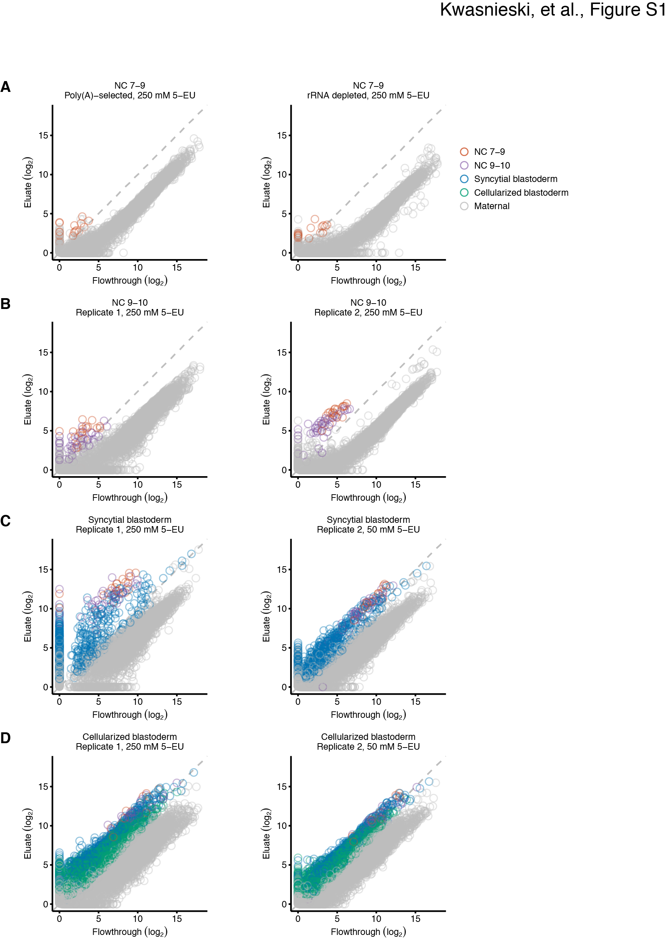
Supplemental Figure 1. Identification of activated genes in two biological replicates.
(A–D) These panels are as in Figure 2, but show results from both biological replicates. For RNA harvested from stage NC 7–9 embryos (A), a poly(A)-selected biological replicate was not available, and thus the results from analysis of rRNA-depleted RNA served as the replicate. Only points for genes with transcripts above the threshold in both replicates were identified as transcribed. RNA was analyzed from NC 7–9 (A), NC 9–10 (B), syncytial-blastoderm (C), and cellularized-blastoderm embryos (D).

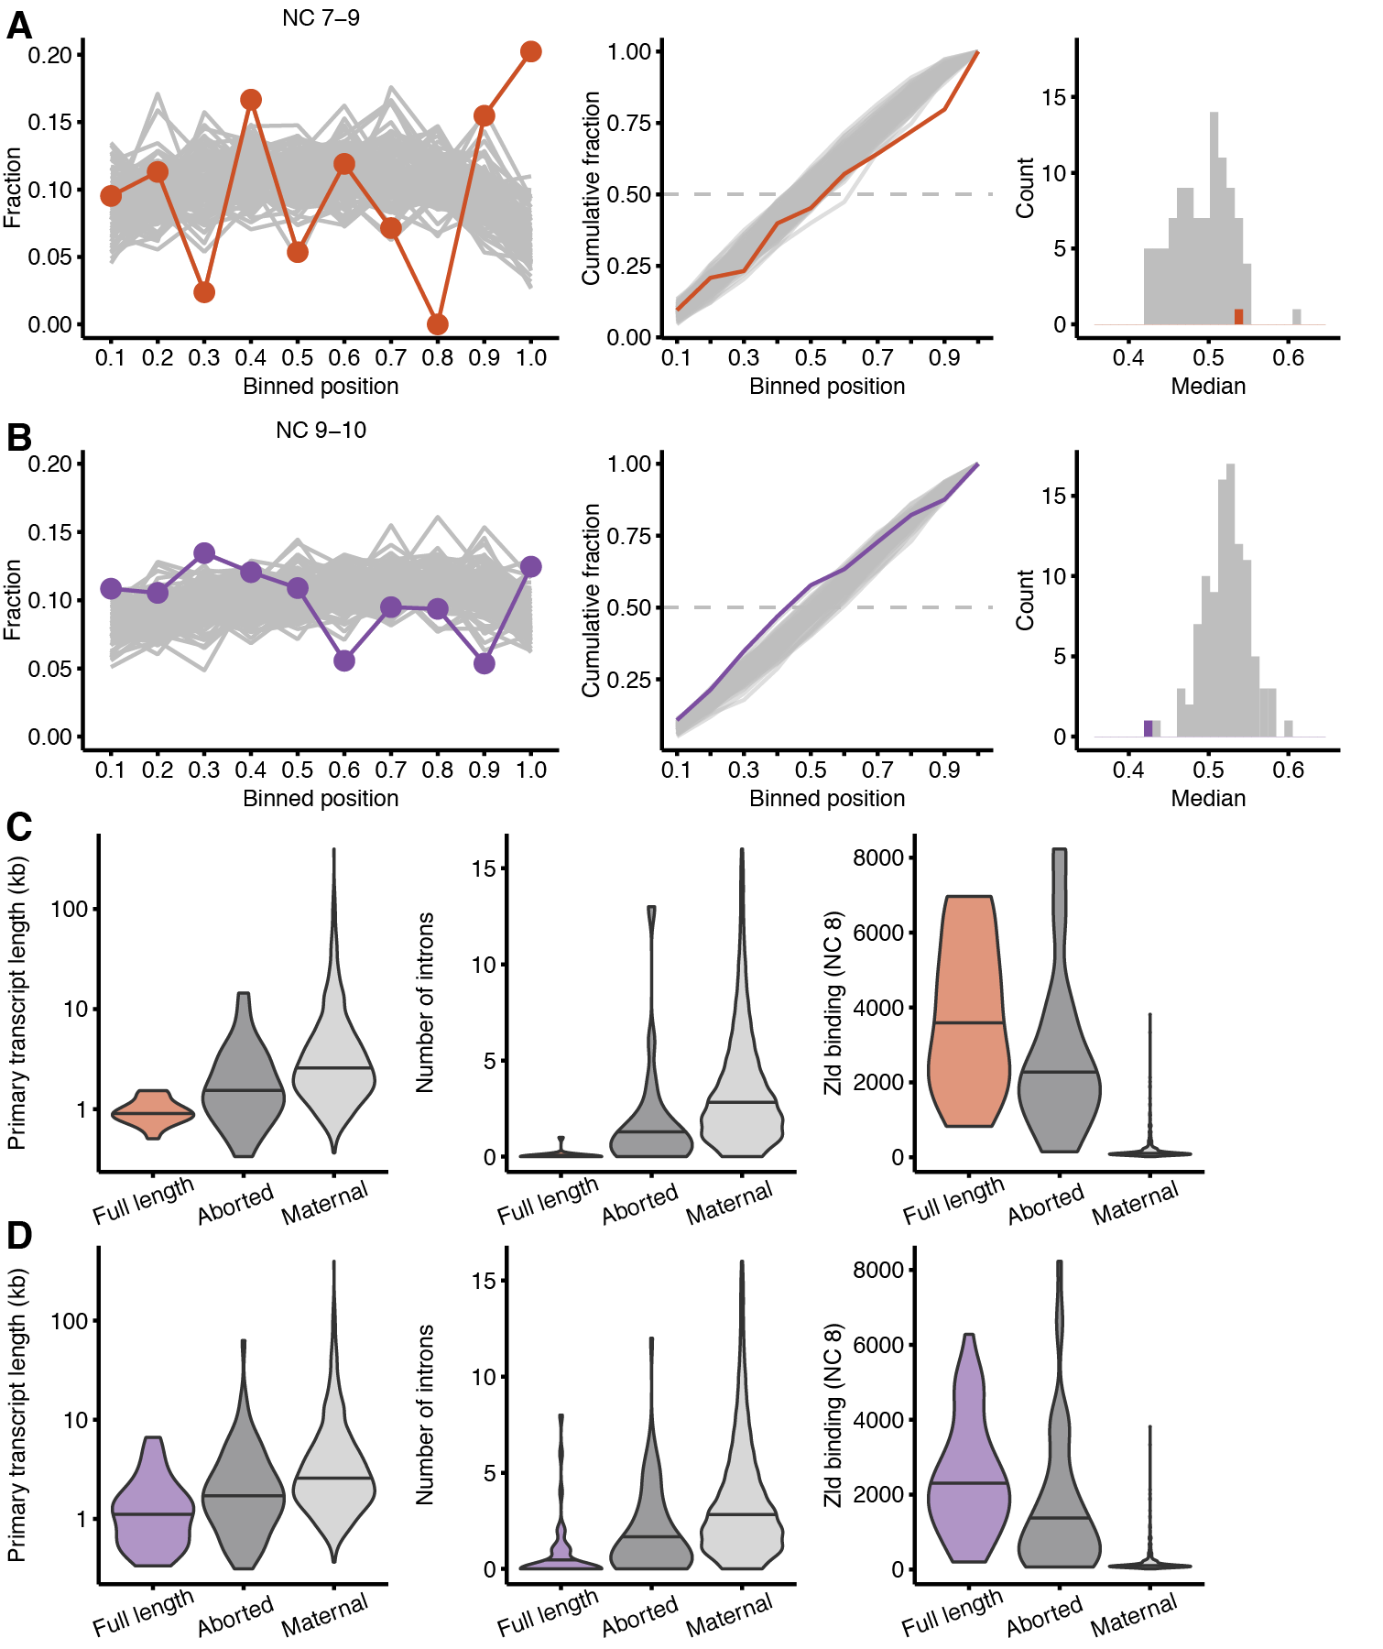
Supplemental Figure 2. Attributes of genes that are transcribed as abortive transcripts before they are identified as full-length transcripts.
(A–B) Examination of read density across transcripts from NC 7–9 (A) and NC 9–10 (B) rRNA-depleted samples as in Figure 4A–D, but focusing on genes that are primarily made into abortive transcripts and are processed into mature transcripts in later stages.
(C–D) Attributes of these transcripts from NC 7–9 (C) and NC 9–10 (D) as in Figure 2B–D, comparing genes transcribed into some mature transcripts (color), primarily aborted transcripts (dark grey), and maternally deposited transcripts (light grey).
In NC 7–9, aborted transcripts are detected from the following 23 genes: Bsg25A, CG10339, CG13465, CG14421, CG1674, CG17278, CG17672, CG31041, CG34214, CG34297, CG43659, CG7271, CR43159, CR43470, CR43824, CR45916, dpn, halo, link, noc, Ocho, slp1, and tld. In NC 9–10, aborted transcripts are detected from the following 89 genes: Arp53D, brk, CG11018, CG11668, CG12071, CG12420, CG12986, CG13084, CG13217, CG1324, CG13868, CG13871, CG14227, CG14457, CG14490, CG15128, CG15628, CG30062, CG30161, CG31826, CG32037, CG32260, CG33226, CG34214, CG34224, CG42762, CG43184, CG43725, CG4440, CG8960, comm2, Cpr60D, CR34044, CR43424, CR43432, CR43950, CR44504, CR44676, CR44677, CR44718, CR44753, CR44993, CR45270, CR45390, CR45435, CR45610, CR45916, CR46056, Cyp309a1, Cyp310a1, D, dpn, dpp, Dtg, E(spl)m7-HLH, Egfr, fd19B, GABA-B-R2, geko, gt, halo, Hand, hkb, hll, Inx3, Kr, link, Mabi, Mdr49, mt:ND2, noc, Obp56a, odd, opa, Or85f, Osi18, Pex7, pgant4, phyl, Ppa, s-cup, SdhBL, sosie, Spn42Dc, term, Tsp42Ed, twi, wntD, and wor.

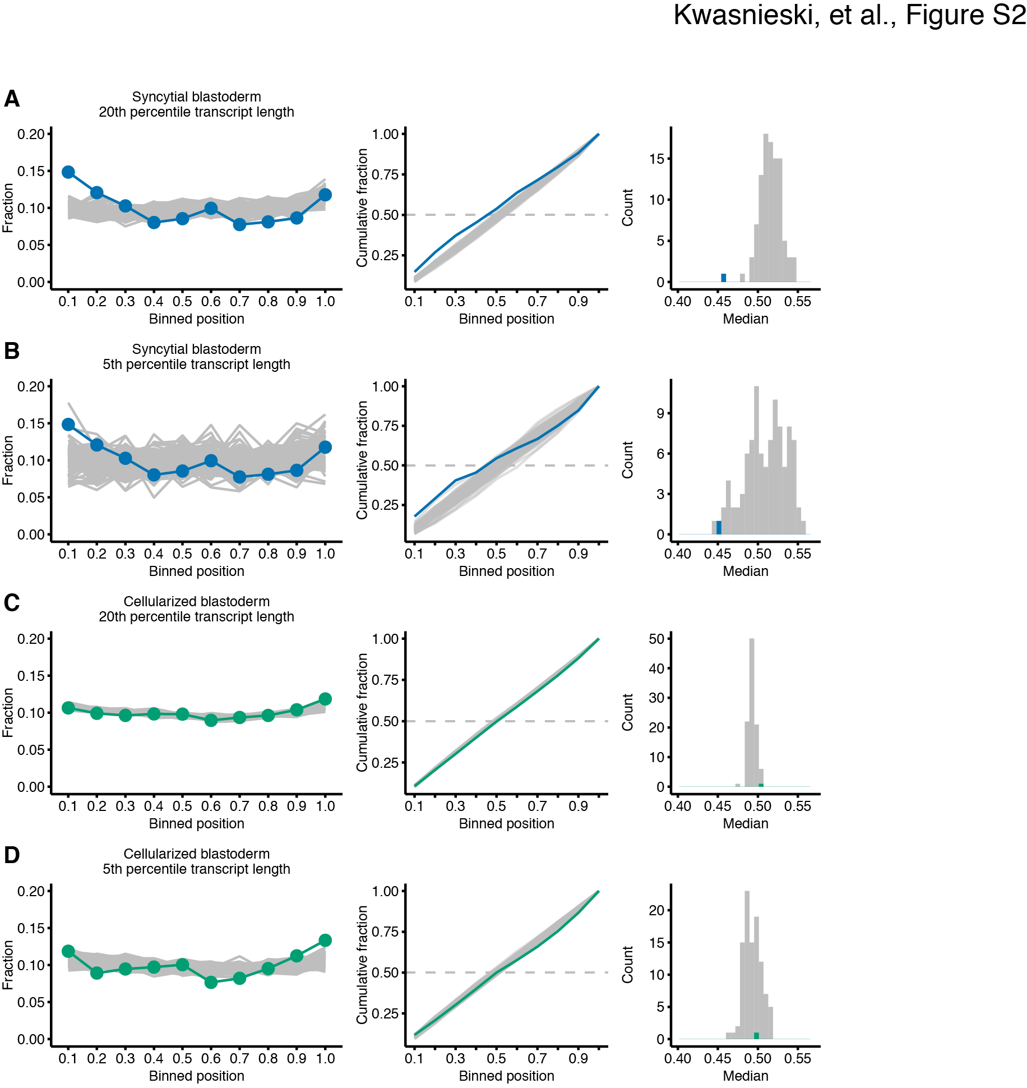
Supplemental Figure 3. Increased 5′ bias of long zygotic transcripts in the syncytial blastoderm.
(A–D) Examination of the results from the syncytial blastoderm (A–B) and cellularized blastoderm (C–D) as in Figure 4E–H, but focusing on transcripts in the 20th (A, C) and 5th (B, D) percentiles of primary-transcript length.

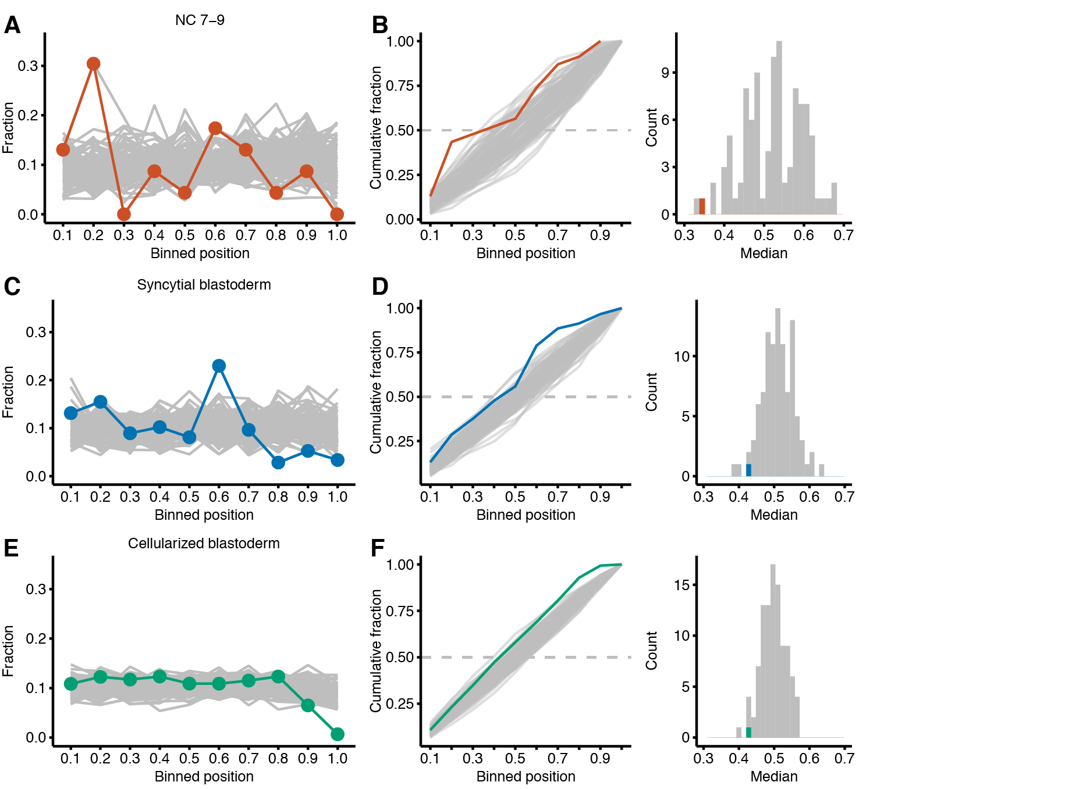
Supplemental Figure 4. 5′ bias of TE families transcribed in NC 7–9.
Analysis of the bias in read density of TE families expressed in NC 7–9 (A, B), the syncytial blastoderm (C, D) and the cellularized blastoderm (E, F). Only those TE families with one expressed isoform or multiple full-length isoforms were considered, because analyzing families that transcribe partial and full-length isoforms would confound the ability to detect a bias in read coverage.

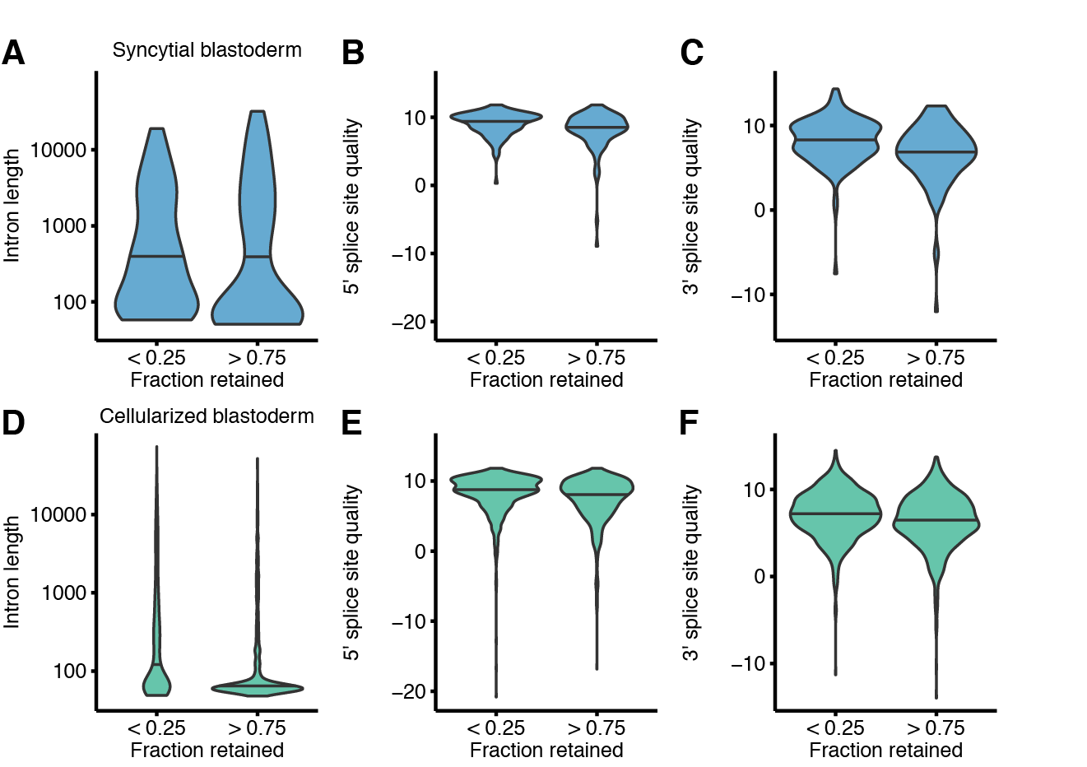
Supplemental Figure 5. Characteristics of retained introns.
Comparison of the intron length, 5′ splice-site quality, and 3′ splice-site quality of introns retained in > 75% of transcripts to well-spliced introns retained in < 25% of transcripts. All three metrics are significantly different for introns in the syncytial blastoderm and cellularized blastoderm samples (P <0.05, Mann–Whitney U test with Bonferroni correction). Splice-site quality was calculated using MaxEntScan (Yeo and Burge 2004).

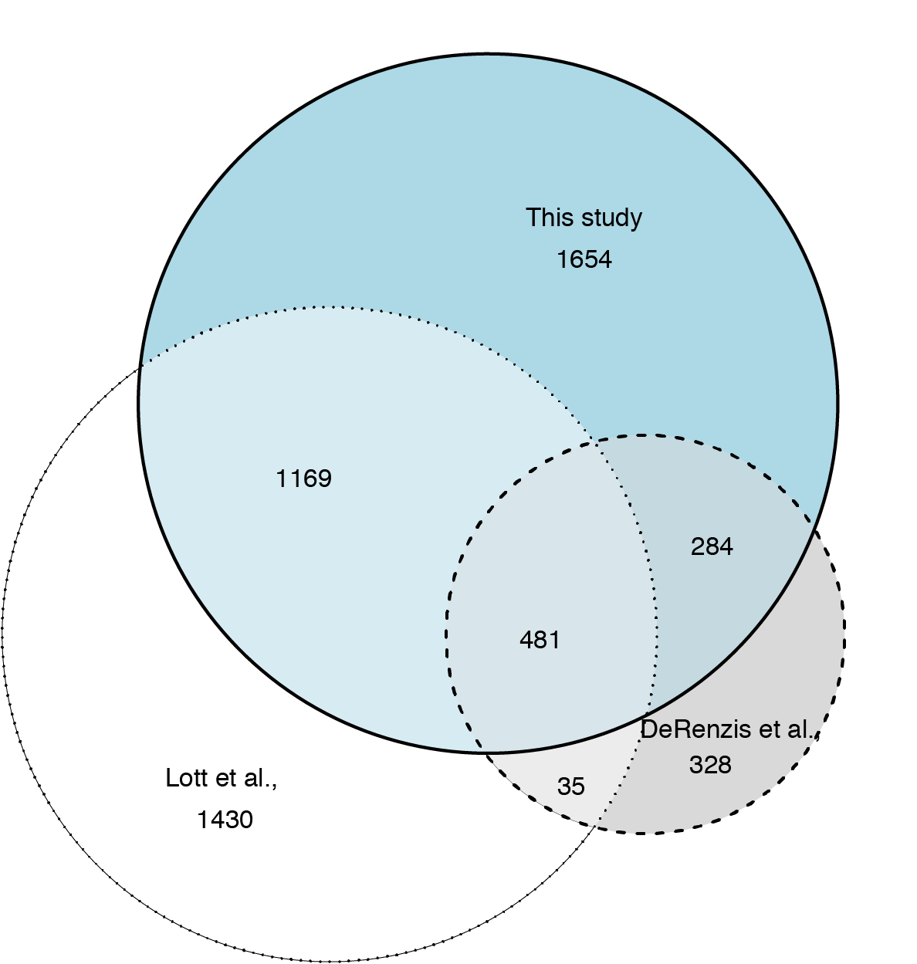
Supplemental Figure 6. Overlap of zygotic genes identified in this study with those identified in previous studies.
The Venn diagram plots the overlap between the 3,588 genes identified in this study, the 3,115 genes annotated as zygotic or maternal/zygotic using sequence polymorphisms (Lott et al. 2011) and the 1,128 primary zygotic genes annotated by monitoring gene-expression differences associated with chromosome-arm deletions (De Renzis et al. 2007).

Supplemental References
Anders S, Pyl PT, Huber W. 2015. HTSeq--a Python framework to work with high-throughput sequencing data. Bioinformatics 31: 166-169.
Bray NL, Pimentel H, Melsted P, Pachter L. 2016. Near-optimal probabilistic RNA-seq quantification. Nat Biotechnol 34: 525-527.
De Renzis S, Elemento O, Tavazoie S, Wieschaus EF. 2007. Unmasking activation of the zygotic genome using chromosomal deletions in the Drosophila embryo. PLoS Biol 5: e117.
Dobin A, Davis CA, Schlesinger F, Drenkow J, Zaleski C, Jha S, Batut P, Chaisson M, Gingeras TR. 2013. STAR: ultrafast universal RNA-seq aligner. Bioinformatics 29: 15-21.
Eden E, Navon R, Steinfeld I, Lipson D, Yakhini Z. 2009. GOrilla: a tool for discovery and visualization of enriched GO terms in ranked gene lists. BMC Bioinformatics 10: 48.
Kronja I, Yuan B, Eichhorn SW, Dzeyk K, Krijgsveld J, Bartel DP, Orr-Weaver TL. 2014. Widespread changes in the posttranscriptional landscape at the Drosophila oocyte-to-embryo transition. Cell Rep 7: 1495-1508.
Larsson J. 2018. Eulerr: Area-proportional Euler and Venn diagrams with ellipses. p. R package.
Li H, Handsaker B, Wysoker A, Fennell T, Ruan J, Homer N, Marth G, Abecasis G, Durbin R, Genome Project Data Processing S. 2009. The Sequence Alignment/Map format and SAMtools. Bioinformatics 25: 2078-2079.
Lott SE, Villalta JE, Schroth GP, Luo S, Tonkin LA, Eisen MB. 2011. Noncanonical compensation of zygotic X transcription in early Drosophila melanogaster development revealed through single-embryo RNA-seq. PLoS Biol 9: e1000590.
Pai AA, Henriques T, McCue K, Burkholder A, Adelman K, Burge CB. 2017. The kinetics of pre-mRNA splicing in the Drosophila genome and the influence of gene architecture. Elife 6: e32537.
Quinlan AR, Hall IM. 2010. BEDTools: a flexible suite of utilities for comparing genomic features. Bioinformatics 26: 841-842.
R Development Core Team. 2015. R: A language and environment for statistical computing. R Foundation for Statistical Computing.
Wickham H. 2016. ggplot2: Elegant graphics for data analysis. Springer-Verlag New York.
Yeo G, Burge CB. 2004. Maximum entropy modeling of short sequence motifs with applications to RNA splicing signals. J Comput Biol 11: 377-394.

