A new approach for rare variation collapsing on functional protein domains implicates specific genic regions in ALS

Supplementary Tables and Figures

 | Caucasian (N=3093) | Diversified Ethnicity (N=3239)
Male/Female, % | 59/41 | 59/41
Site of onset, % | (N=2667) | (N=2759)
Bulbar | 25.94 | 25.66
Spinal | 72.36 | 72.67
Other | 1.68 | 1.66
Age of onset (years), mean ± SD | 57.24 ± 12.75  (N=2685) | 57.17 ± 12.82  (N=2778)
Duration (months), mean ± SD | 34 ± 40.66  (N=1144) | 34 ± 39.89  (N=1178)

Supplementary Table S1. Demographics. The demographic features of the Caucasian and diversified cohorts, reflecting known epidemiological features of ALS, including male predominance and the distributions of age at onset and survival.

SupplementaryTableS2.xlsx
Supplementary Table S2. Domains summary for Caucasian population. Caucasian cases and controls frequencies of all the domains tested in a regional collapsing approach for a model that qualifies variants with MAF<0.1% in the ExAC database.

SupplementaryTableS3.xlsx
Supplementary Table S3. Age-At-Onset (AAO) analysis for 11,541 genes with more than two carriers. Comparing AAO between ALS cases that carry variants in a gene against the remaining ALS cases. 11,541 genes that have three or more carriers are considered.

Subsites | Number of LGALSL carriers | Sequencing Center | Ages at Onset | mean AAO
University of Massachusetts | 3 | Duke | 26,38,41 | 35
Stanford University | 1 | Duke | 37 | 37
Washington University | 2 | Duke | 43,57 | 50
Columbia University | 4 | HudsonAlpha | 34,46,46,49 | 43.75
McGill University | 1 | HudsonAlpha | 65 | 65
Massachusetts General Hospital | 1 | Duke | N/A | N/A

Supplementary Table S4. LGALSL carriers: recruiting centers and age-at-onset. LGALSL carriers by recruitment and sequencing centers, pertaining also the average age-at-onset per site.

Sequencing kit |  | Platform
 |  | GAIIx | HiSeq2000 and HiSeq2500
Exome | Exome-50/65MB | 59 | 958
Exome | Exome-Agilent |  | 277
Exome | Exome-IDTERPv1 |  | 586
Exome | Exome-MedExome |  | 250
Exome | Exome-Roche |  | 12203
Exome | Exome-VCRome |  | 14
Genome |  | 39 | 661

Supplementary Table S5. Sequencing kit and platform. The sequencing platforms and kits that used for sequencing of the diversified cohort (n=15,047).

Sequencing kit |  | Platform
 |  | GAIIx | HiSeq2000 and HiSeq2500
Exome | Exome-50/65MB | 56 | 1033
Exome | Exome-Agilent |  | 204
Exome | Exome-IDTERPv1 |  | 554
Exome | Exome-MedExome |  | 231
Exome | Exome-Roche |  | 8569
Exome | Exome-VCRome |  | 11
Genome |  | 30 | 591

Supplementary Table S6. Sequencing kit and platform. The sequencing platforms and kits that used for sequencing of the Caucasian cohort (n=11,279).

 | Case | Control
 | 10X Coverage | 10X Coverage
Exome | 0.95 ± 0.029  (N=3046) | 0.96 ± 0.024  (N=7612)
Genome | 0.96 ± 0.03  (N=47) | 0.96 ± 0.032  (N=574)
Total | 0.95 ± 0.029  (N=3093) | 0.96 ± 0.025  (N=8186)

Supplementary Table S7. European ancestry cohort coverage. The 10x coverage mean and standard deviation measured for cases (left) and controls (right) of Caucasian ancestry.

 | Case | Control
 | 10X Coverage | 10X Coverage
Exome | 0.95 ± 0.027  (N=3187) | 0.96 ± 0.02  (N=11160)
Genome | 0.96 ± 0.028  (N=52) | 0.96 ± 0.032  (N=648)
Total | 0.95 ± 0.027  (N=3239) | 0.96 ± 0.021  (N=11808)

Supplementary Table S8. Diversified population cohort coverage summary. The 10x coverage mean and standard deviation measured for cases (left) and controls (right) of diversified ancestries.

SupplementaryTableS9.xlsx
Supplementary Table S9. Genes summary for a model that qualifies ultra-rare variants (0% ExAC MAF). Case and control frequencies of all genes for a model considering only ultra-rare variants that are completely missing from the ExAC database.

SupplementaryTableS10.xlsx
Supplementary Table S10. Genes summary for a model that qualifies variants with ExAC MAF <0.01%. Case and control frequencies of all genes for a model qualifying only rare variants with MAF<0.01% in the ExAC database.

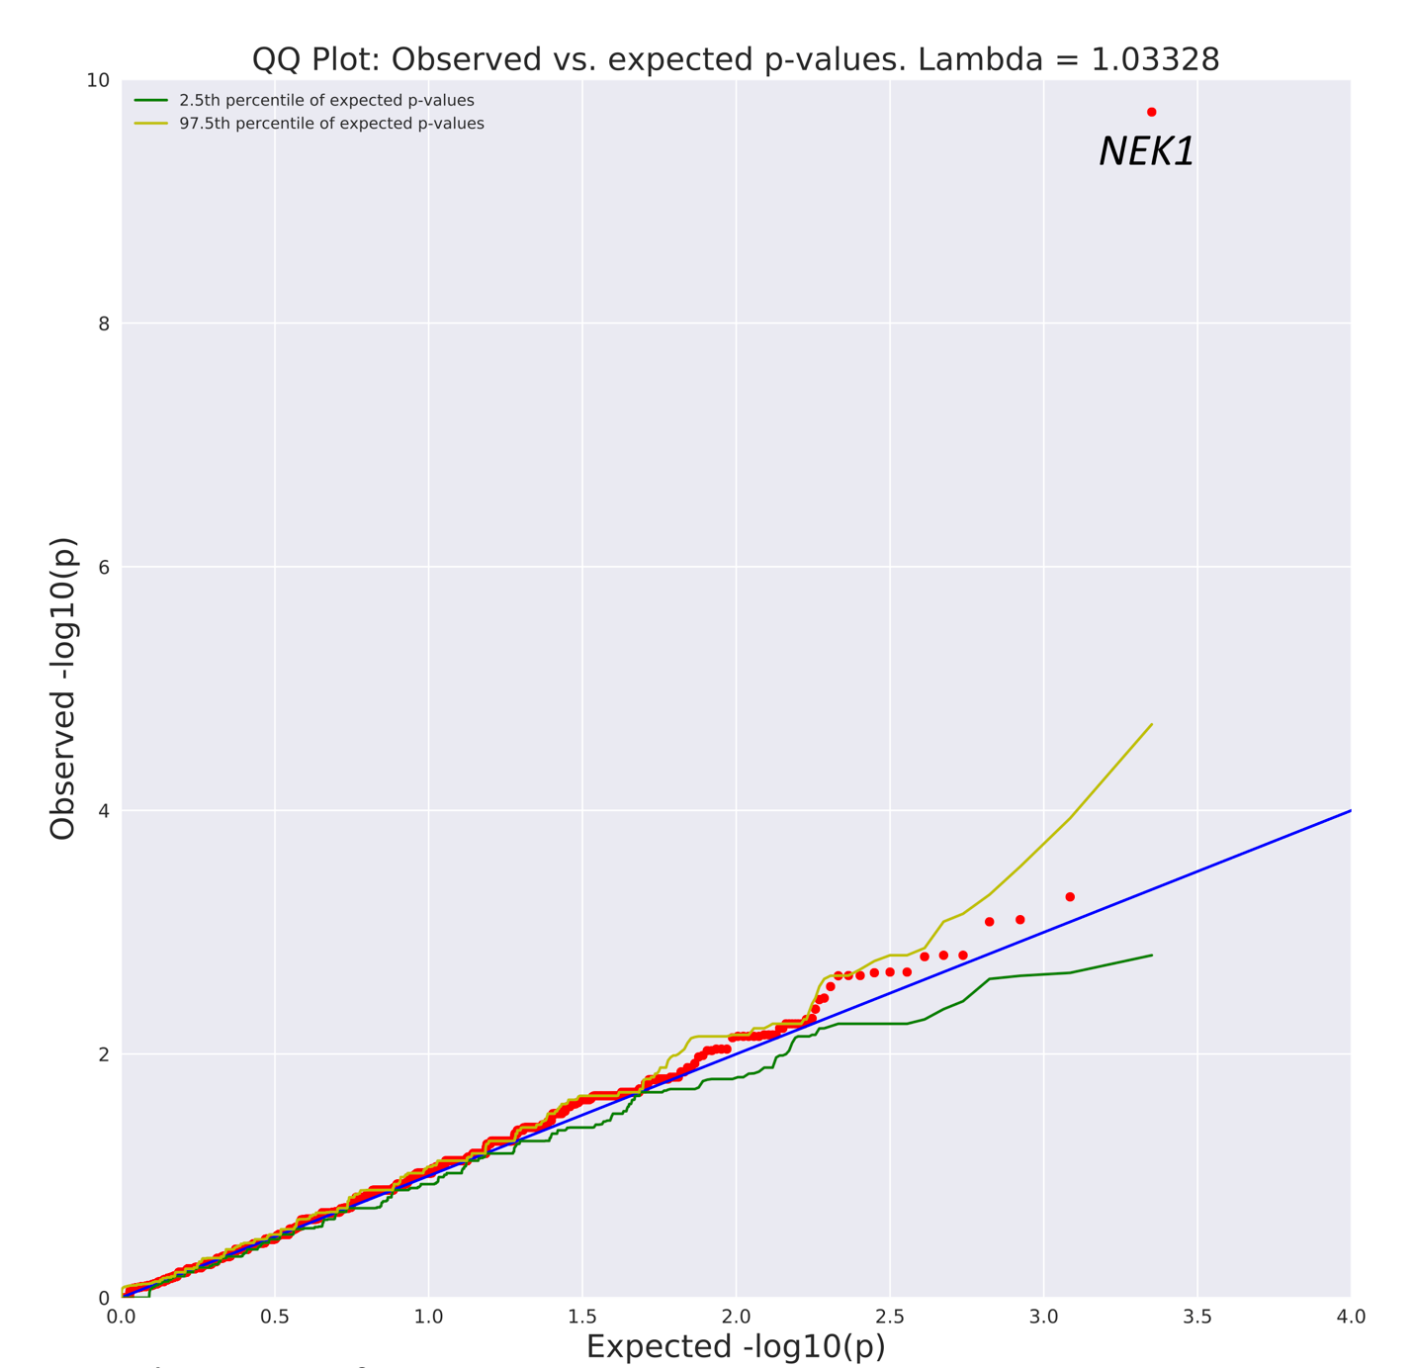 Supplementary Figure S1. Q-Q plot of gene level collapsing of LoF variants. A q-q plot presenting the results for a standard gene level collapsing of LoF variants in 3,093 cases and 8,186 controls of European ancestry. 14,501 covered genes passed QC with more than one case or control carrier for this test. NEK1 gene is labeled (1.85×10⁻¹⁰). The genomic inflation factor, lambda (λ), is 1.033.

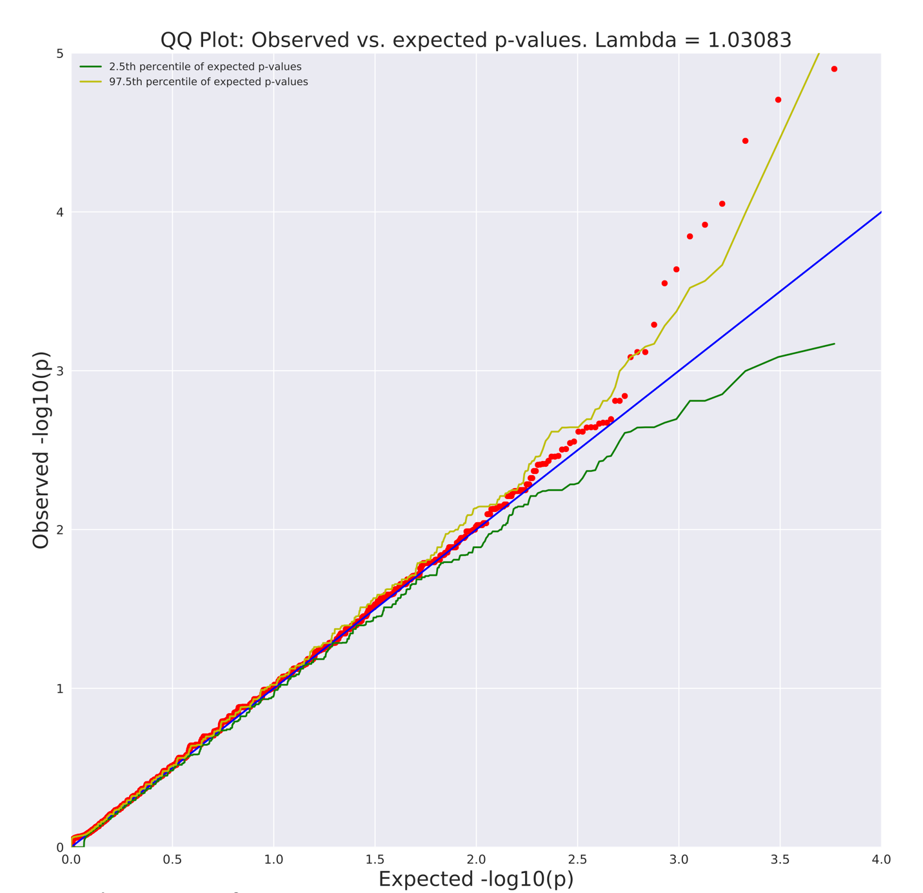
Supplementary Figure S2. Q-Q plot of gene level collapsing of rare synonymous variants. A q-q plot presenting the results of a standard gene level collapsing of rare synonymous variants in 3,093 cases and 8,186 controls of European ancestry. 17,699 covered genes passed QC with more than one case or control carrier for this test. No Genome-wide significant genes found. The genomic inflation factor, lambda (λ), is 1.03.

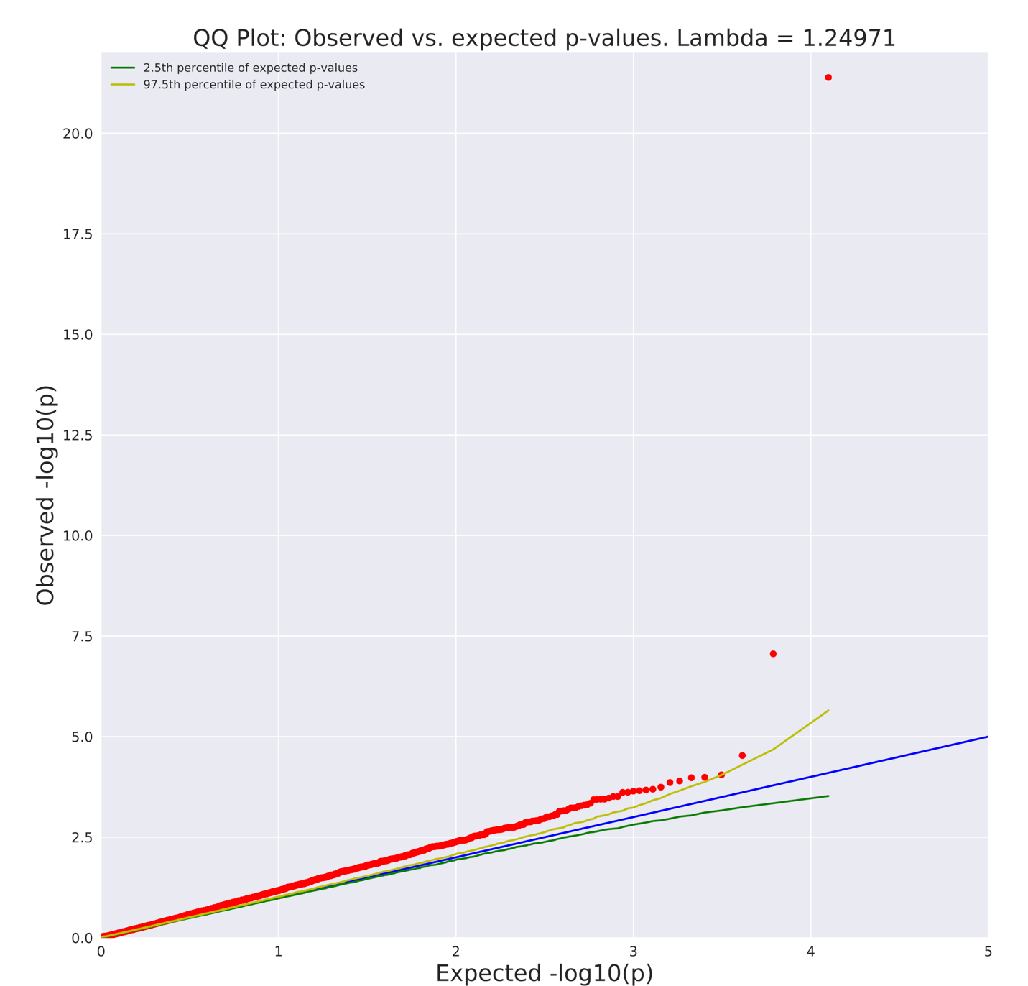
Supplementary Figure S3. Q-Q plot of a diversified population standard gene collapsing analysis. A q-q plot presenting the results of the standard gene-based collapsing of 3,239 cases and 11,808 controls from diversified ancestries. 18,135 genes passed QC with more than one case or control carrier for this test. Genome-wide significant genes are: SOD1 (p=4.13×10⁻²²), TARDBP (p=8.77×10⁻⁸). λ=1.25.

Supplementary Figure S4. Q-Q plot of a diversified population intolerance-informed analysis using Firth logistic regression. A q-q plot presenting the results of the gene-based intolerance-informed collapsing of 3,239 cases and 11,808 controls from diversified ancestries. Top genes are: SOD1 (p=1.1×10⁻¹⁶), TARDBP (p=1.8×10⁻⁷) and LGALSL (p=5.84×10⁻⁷). λ=1.04.
Supplementary Figure S5. Q-Q plot of a diversified population domain-based analysis. A q-q plot presenting the results of the domain-based collapsing of 3,239 cases and 11,808 controls from diversified ancestries. Genome-wide significant genes are: SOD1 (p=1.56×10⁻²⁰), TARDBP (p=4.32×10⁻¹¹). λ=1.11.

