SUPPLEMENTAL METHODS

We ran our nine-population global WGS demographic model five times, varying the rate parameters for each model. In all models, N_{e} was estimated independently on each lineage. In the “no rates” model, population size was not allowed to vary within a lineage. In the two models with “recent-all” rates were allowed to vary for each lineage where they were parameterized to increase moving forward in time based on our MSMC results (Figure 2 in the main text). In the three models with “ancestral” the Pacific (red) and Ancestral Range/Ghost (dark grey) lineages were allowed to vary, where they were parameterized to decrease moving forward in time in accordance with our MSMC results (Figure 2 in the main text). For the Ancestral Population/Ghost lineage, we allowed that to begin to vary until the SE Asia lineage diverged from the ancestral range as this was similar to our MSMC model. Finally, given the large parameter space that inclusion of the rate parameters created, we made the “recent- subset” model. In this model the Aleutian and Western North America lineages share a single recent range expansion parameter (orange), the Ancestral/Ghost population has a recent parameter after divergence of SE Asia (green), and the other six lineages share a growth rate parameter (dark brown and denoted as “Eastern China” in the table below for convenience). We acknowledge that the “recent- subset + ancestral” model lacks some biological reality as the MSMC models show independent rate parameters; however, it was the model with the highest likelihood (out of 50 iterations; see table below) likely owing to capturing both recent population growth and historic population declines without over parameterization.

In the figure below the colors denote the following: ghost- green; eastern China- dark brown; SE Asia- light brown; Aleutian- orange; Western North America- yellow; Northern Europe- purple; Western Europe- light blue; Expansion- medium blue; ancestral variation in ghost- dark grey; Pacific- red; no rate variation allowed and/or splitting event- medium grey.

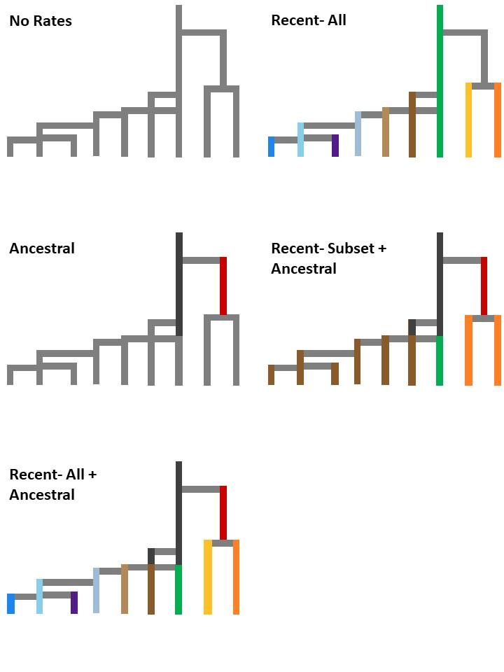

Parameter | Units | Recent- All + Ancestral | Recent Subset + Ancestral | Ancestral | No Rates | Recent- All
Naleu | 2N | 12838 | 9470 | 33959 | 28296 | 11736
Nchina | 2N | 34230 | 37439 | 31753 | 409532 | 380668
Nghost | 2N | 48511 | 61086 | 80393 | 585004 | 588535
Niran | 2N | 333 | 252 | 271 | 445 | 729
Nne | 2N | 3685 | 3427 | 3072 | 3944 | 3018
Nnyc | 2N | 2009 | 1476 | 2257 | 3052 | 2154
Nsea | 2N | 7291 | 7478 | 5886 | 5804 | 6915
Nwe | 2N | 4198 | 5334 | 3392 | 4628 | 4579
Nwna | 2N | 55548 | 37083 | 9067 | 72774 | 89180
Ranc |  | 9.76E-05 | 9.20E-05 | 9.78E-05 | n/a | n/a
Rpac |  | 3.39E-05 | 2.23E-05 | 3.74E-05 | n/a | n/a
Raleu |  | -6.33E-05 | -4.43E-05 | n/a | n/a | -6.63E-05
Rchina |  | -5.13E-05 | -2.50E-05 | n/a | n/a | -6.99E-06
Rghost |  | -3.67E-05 | -2.36E-05 | n/a | n/a | -4.38E-07
Riran |  | -2.02E-06 | n/a | n/a | n/a | -9.13E-05
Rne |  | -8.90E-05 | n/a | n/a | n/a | -3.97E-05
Rnyc |  | -2.58E-05 | n/a | n/a | n/a | -7.60E-05
Rsea |  | -3.34E-05 | n/a | n/a | n/a | -5.40E-05
Rwe |  | -6.65E-05 | n/a | n/a | n/a | -6.31E-05
Rwna |  | -5.97E-05 | n/a | n/a | n/a | -1.49E-06
Taleu | gen | 28732 | 26799 | 20189 | 96766 | 84516
Tchina | gen | 52619 | 71871 | 117179 | 744714 | 677126
Tiran | gen | 2376 | 2391 | 2237 | 2190 | 2509
Tne | gen | 1640 | 1881 | 1483 | 1768 | 2166
Tnyc | gen | 1389 | 1018 | 1298 | 1453 | 1145
Tsea | gen | 2595 | 3165 | 3500 | 2224 | 2572
Twe | gen | 2364 | 2377 | 2234 | 2167 | 2505
Twna | gen | 48461 | 49174 | 39721 | 176734 | 167081
RATE | mutations gen⁻¹ | 9.29E-08 | 9.67E-08 | 9.84E-08 | 9.89E-08 | 9.87E-08
MaxEstLhood |  | -31194879.15 | -31198463.67 | -31198967.19 | -35865777.58 | -35941091.64

